Discrete Sturctures
Assignment 02

From:
H . M. Mehmood Munir
P17-6075 (B)

To:
Dr. Nauman Azam

Example 6:
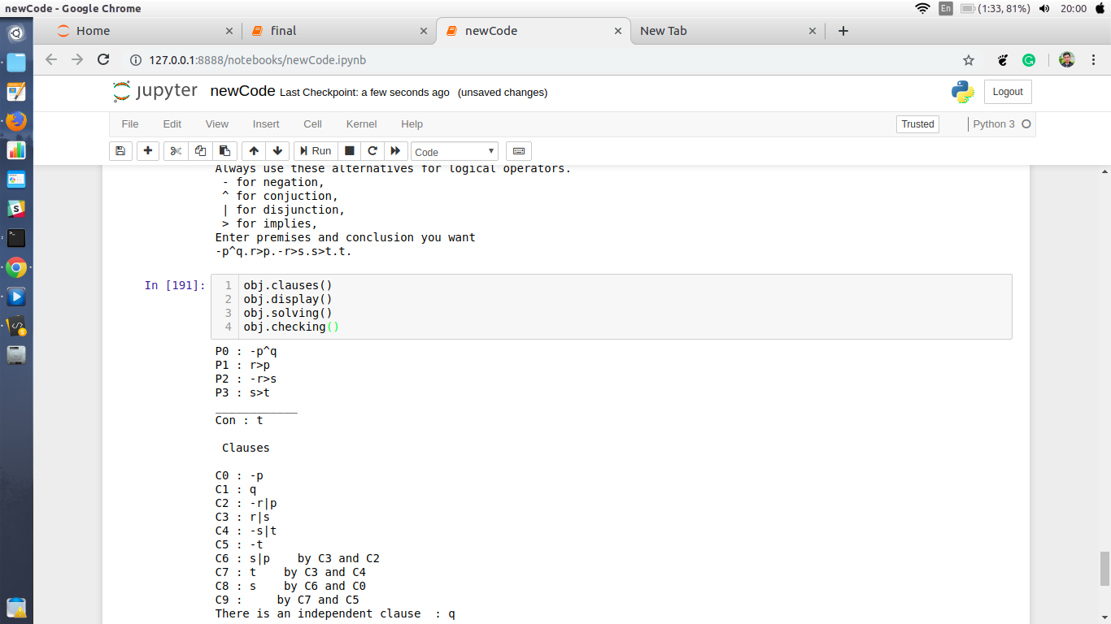
Example 07:
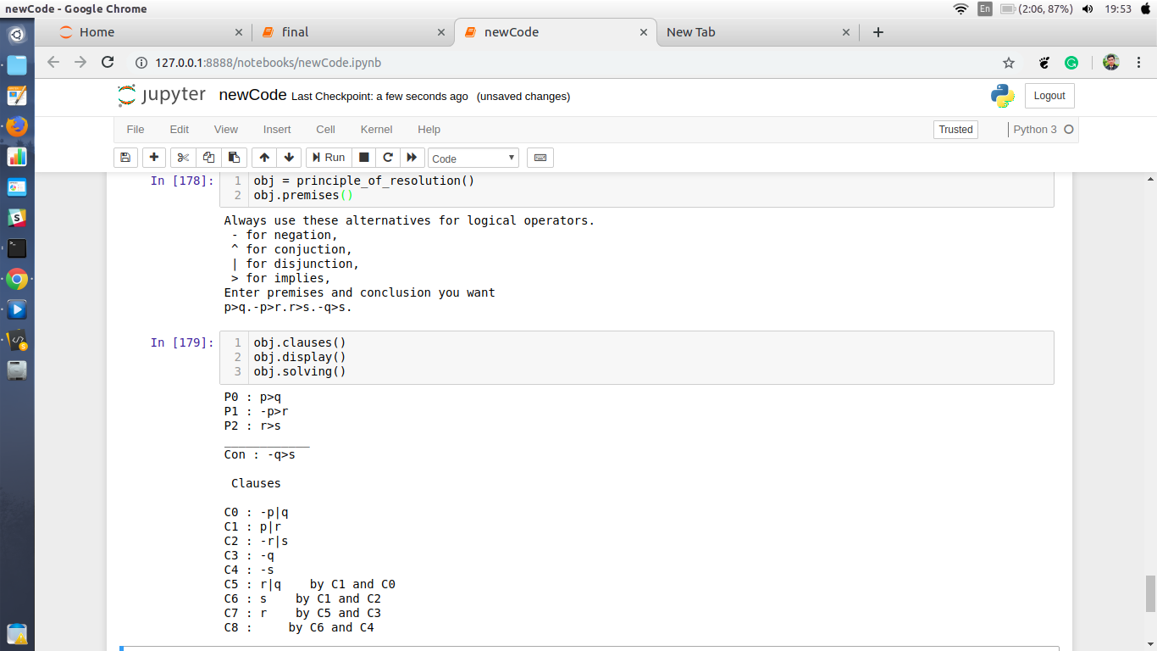

Example 09:
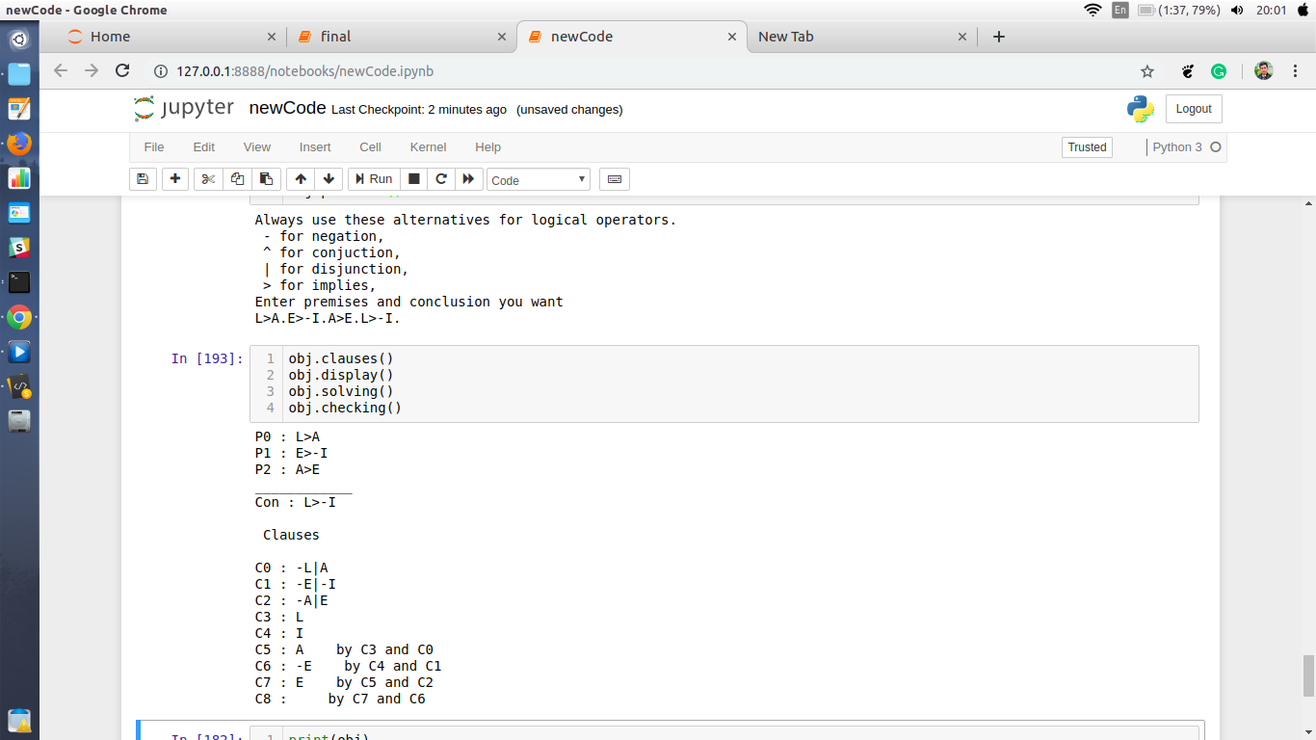

Code:

___________________________________
class principle_of_resolution:
def __init__(self):
self.premiseList = []
self.clauseList = []
self.independentClause = []
self.preConclusion = ''
self.conclusion = ''

def __str__(self):
return str("Premises : "+str(self.premiseList)+ '\n'+"Clauses : "+str(self.clauseList) +'\n'+"conclusion : "+str(self.conclusion))

def display(self):
for i in range(len(self.premiseList)):
print("P"+str(i)+" : "+self.premiseList[i])
print("____________")
print("Con : "+self.preConclusion)

print("\n Clauses\n")
for i in range(len(self.clauseList)):
print("C"+str(i)+" : "+self.clauseList[i])

#function to take input from user and convert it to premise and conclusion
def premises(self):
print("Always use these alternatives for logical operators.\n - for negation, \n ^ for conjuction,\n | for disjunction, \n > for implies, ")
print("Enter premises and conclusion you want ")
n = input()[:-1] #taking input
self.premiseList = n.split('.') #getting premises into list form
self.preConclusion = self.premiseList[-1] #taking out conclusion from premises
self.conclusion = "-(" +self.preConclusion + ")"
del self.premiseList[-1] #delete the conclusion

#function that resolve the premises into clauses
def clauses(self):
for i in self.premiseList:
if ">" in i:
prem = self.implies(i)
self.clauseList.append(prem)
elif "^" in i:
self.conjuction(i)
else:
self.clauseList.append(prem)
self.conclusion = self.negation(self.conclusion)
if len(self.premiseList) != 0:
if ">" in self.conclusion:
prem = self.implies(self.conclusion)
self.clauseList.append(prem)
elif "^" in self.conclusion:
self.conjuction(self.conclusion)
else:
self.clauseList.append(self.conclusion)
else:
return "you have no conclusion"

#function that applies the conjunction method
def conjuction(self, prem):
self.clauseList += prem.split('^')

#function that applies the implication method
def implies(self, prem):
if prem[0] == "-":
prem = prem.replace('-', "",1)
prem = prem.replace('>', "|")
return prem
prem = '-' + prem.replace('>','|')
return prem

#function that take premise as input and find negation of this premise and output will be produced
def negation(self,prem):
prem = prem.replace('-', '',1)
if '>' in prem:

#applying p>q = -p|q
if prem[prem.index('(')+1] == '-':
prem = prem.replace('-', '',1)
elif prem[prem.index('(')+1] != '-':
prem = self.insert_char(prem,prem.index('(')+1)
prem = prem.replace('(',"")
prem = prem.replace(')',"")
prem = prem.replace('>','|')

#applying demorgan Law in case of implies
if prem[0] == '-':
prem = prem.replace('-', '',1)
elif prem[0] != '-':
prem = self.insert_char(prem,0)
prem = prem.replace('|','^')
if prem[prem.index('^')+1] == '-':
prem = self.del_char(prem, prem.index("^")+1 )
elif prem[prem.index('^')+1] != '-':
prem = self.insert_char(prem,prem.index('^')+1)
return prem

elif '^' in prem:

#applying demorgan Law in case of conjunction
if prem[(prem.index('(')+1)] == '-':
prem = prem.replace('-', '',1)
elif prem[prem.index('(')+1] != '-':
prem = self.insert_char(prem,prem.index('(')+1)
prem = prem.replace('(',"")
prem = prem.replace(')',"")
prem = prem.replace('^','|')
if prem[(prem.index('|'))+1] == '-':
prem = self.del_char(prem, prem.index("|")+1 )
elif prem[prem.index('|')+1] != '-':
prem = self.insert_char(prem,prem.index('|')+1)
return prem

elif '|' in prem:
#applying demorgan Law in case of disjunction
if prem[prem.index('(')+1] == '-':
prem =prem.replace('-', '', 1)
elif prem[prem.index('(')+1] != '-':
prem = self.insert_char(prem,prem.index('(')+1)
prem =prem.replace('(',"")
prem =prem.replace(')',"")
prem =prem.replace('|','^')
if prem[(prem.index('^'))+1] == '-':
prem = self.del_char(prem, prem.index("^")+1 )
elif prem[(prem.index('^')+1)] != '-':
prem = self.insert_char(prem,prem.index('^')+1)
return prem
else:
prem = "-" + prem
if "(" in prem:
prem =prem.replace('(',"")
prem =prem.replace(')',"")
return prem

#function to insert a character in a string you have to give index and string in argument and character as well if you want by default function inserts hash('-')
def insert_char(self,string, index, char = '-'):
return string[:index] + char + string[index:]

#function to delete a character from a string you have to give index and string as input in the function parameters it will return
def del_char(self,string, index):
return string[:index] + string[index+1:]

def solving(self):
counterClause = len(self.clauseList)
for i in range(counterClause+3):
lst = self.clauseList[i].split('|')
for l in lst:
if len(l) == 1:
for j in range(len(self.clauseList)):
if i == j:
continue
elif l in self.clauseList[j]:
for k in range(len(self.clauseList[j])):
if self.clauseList[j][k] == l:
if k-1 >= 0 and self.clauseList[j][k-1] == '-' :
self.clauseList[j] = self.clauseList[j].replace(self.clauseList[j][k-1]+self.clauseList[j][k],'')
self.clauseList[i] = self.clauseList[i].replace(l,'')
if len(lst) == 2:
if l == lst[0]:
clause = lst[1] + self.clauseList[j]
print('C'+str(counterClause)+" : "+clause + " by C"+str(i)+" and C"+str(j))
self.clauseList[i] = self.clauseList[i].replace(self.clauseList[i],'')
self.clauseList[j] = self.clauseList[j].replace(self.clauseList[j],'')
self.clauseList.append(clause)
counterClause += 1

lst = []
break
else:
clause = lst[0] + self.clauseList[j]
print('C'+str(counterClause)+" : "+clause + " by C"+str(i)+" and C"+str(j))
self.clauseList[i] = self.clauseList[i].replace(self.clauseList[i],'')
self.clauseList[j] = self.clauseList[j].replace(self.clauseList[j],'')
self.clauseList.append(clause)
counterClause += 1
lst = []
break
else:
self.clauseList[j] = self.clauseList[j].replace('|','')
clause = self.clauseList[j]
print('C'+str(counterClause)+" : "+clause + " by C"+str(i)+" and C"+str(j))
self.clauseList[i] = self.clauseList[i].replace(self.clauseList[i],'')
self.clauseList[j] = self.clauseList[j].replace(self.clauseList[j],'')
self.clauseList.append(clause)
counterClause += 1
lst = []

break
else:
if len(self.clauseList[j]) == 1:
self.clauseList[i].replace(l,'')
if len(lst) == 2:
if l == lst[0]:
clause = lst[1] +"|"+self.clauseList[j]
print('C'+str(counterClause)+" : "+clause + " by C"+str(i)+" and C"+str(j))
self.clauseList[i] = self.clauseList[i].replace(self.clauseList[i],'')
self.clauseList[j] = self.clauseList[j].replace(self.clauseList[j],'')
self.clauseList.append(clause)
counterClause += 1
lst = []
break
else:
clause = lst[0] +"|"+self.clauseList[j]
print('C'+str(counterClause)+" : "+clause + " by C"+str(i)+" and C"+str(j))
self.clauseList[i] = self.clauseList[i].replace(self.clauseList[i],'')
self.clauseList[j] = self.clauseList[j].replace(self.clauseList[j],'')
self.clauseList.append(clause)
counterClause += 1
lst = []

break
else:
clause = self.clauseList[j]
print('C'+str(counterClause)+" : "+clause + " by C"+str(i)+" and C"+str(j))
self.clauseList[i] = self.clauseList[i].replace(self.clauseList[i],'')
self.clauseList[j] = self.clauseList[j].replace(self.clauseList[j],'')
self.clauseList.append(clause)
counterClause += 1
lst = []

break
elif len(self.clauseList[j]) > 2 and len(lst) == 2:
lst = []
break
elif len(self.clauseList[j]) > 2 and len(lst) == 1:
clause = self.clauseList[j]
print('C'+str(counterClause)+" : "+clause + " by C"+str(i)+" and C"+str(j))
self.clauseList[i] = self.clauseList[i].replace(self.clauseList[i],'')
self.clauseList[j] = self.clauseList[j].replace(self.clauseList[j],'')
self.clauseList.append(clause)
counterClause += 1
lst = []

break
else:
continue

elif len(l) == 2:
for j in range(len(self.clauseList)):
if i == j:
continue
elif l in self.clauseList[j]:
for k in range(len(self.clauseList[j])):
if self.clauseList[j][k] == l[1]:
if k-1 >= 0 and self.clauseList[j][k-1] == '-' :
self.clauseList[i] = self.clauseList[i].replace(l,'')
if len(lst) == 1 and len(self.clauseList[j]) == 2:
clause = lst[0]
print('C'+str(counterClause)+" : "+clause + " by C"+str(i)+" and C"+str(j))
self.clauseList[i] = self.clauseList[i].replace(self.clauseList[i],'')
self.clauseList[j] = self.clauseList[j].replace(self.clauseList[j],'')
self.clauseList.append(clause)
counterClause += 1
lst = []

break
elif len(lst) == 2 and len(self.clauseList[j]) == 2:
clause = lst[0] +'|'+lst[1]
print('C'+str(counterClause)+" : "+clause + " by C"+str(i)+" and C"+str(j))
self.clauseList[i] = self.clauseList[i].replace(self.clauseList[i],'')
self.clauseList[j] = self.clauseList[j].replace(self.clauseList[j],'')
self.clauseList.append(clause)
counterClause += 1
lst = []

break
else:
lst = []
break
else:
if len(self.clauseList[j]) == 1:
self.clauseList[i] = self.clauseList[i].replace(l,'')
if len(lst) == 2:
if l == lst[0]:
clause = lst[1]
print(clause)
print('C'+str(clauseCounter)+" : "+clause + " by C"+str(i)+" and C"+str(j))
self.clauseList[i] = self.clauseList[i].replace(self.clauseList[i],'')
self.clauseList[j] = self.clauseList[j].replace(self.clauseList[j],'')
self.clauseList.append(clause)
counterClause += 1
lst = []

break
else:
clause = lst[0]
print('C'+str(counterClause)+" : "+clause + " by C"+str(i)+" and C"+str(j))
self.clauseList[i] = self.clauseList[i].replace(self.clauseList[i],'')
self.clauseList[j] = self.clauseList[j].replace(self.clauseList[j],'')
self.clauseList.append(clause)
counterClause += 1
lst = []

break
else:
clause = ''
print('C'+str(counterClause)+" : "+clause + " by C"+str(i)+" and C"+str(j))
self.clauseList[i] = self.clauseList[i].replace(self.clauseList[i],'')
self.clauseList[j] = self.clauseList[j].replace(self.clauseList[j],'')
self.clauseList.append(clause)
counterClause += 1
lst = []

break
elif len(self.clauseList[j]) > 2 and len(lst) == 2:
self.clauseList[i] = self.clauseList[i].replace(l,'')
self.clauseList[j] = self.clauseList[j].replace(l[1],'')
self.clauseList[j] = self.clauseList[j].replace("|",'')
if l == lst[0]:
clause = lst[1]+"|"+self.clauseList[j]
print('C'+str(clauseCounter)+" : "+clause + " by C"+str(i)+" and C"+str(j))
self.clauseList[i] = self.clauseList[i].replace(self.clauseList[i],'')
self.clauseList.append(clause)
counterClause += 1
lst = []

break
else:
clause = lst[0]+"|"+self.clauseList[j]
print('C'+str(counterClause)+" : "+clause + " by C"+str(i)+" and C"+str(j))
self.clauseList[i] = self.clauseList[i].replace(self.clauseList[i],'')
self.clauseList[j] = self.clauseList[j].replace(self.clauseList[j],'')
self.clauseList.append(clause)
counterClause += 1
lst = []
break

elif len(self.clauseList[j]) > 2 and len(lst) == 1:
clause = self.clauseList[j]
print('C'+str(counterClause)+" : "+clause + " by C"+str(i)+" and C"+str(j))
self.clauseList[i] = self.clauseList[i].replace(self.clauseList[i],'')
self.clauseList[j] = self.clauseList[j].replace(self.clauseList[j],'')
self.clauseList.append(clause)
counterClause += 1
lst = []

break
else:
continue
break
else:
continue

def checking(self):
for i in self.clauseList:
if i != '':
print("There is an independent clause : "+i)
break

