**ITERATION 02**

**Dairy Farm Management**

**Client Name:**

Dr. Taimoor Khan

**Submitted by**:

Hafiz Mehmood Munir

Ali Husnain

Hafiz Bashir Ahmad

Faryal Ishfaq

Muhammad Hamza Qureshi

Mehboob Ali

**(Use Cases)**

**Admin Account:**

* The CEO/Admin of the Dairy Farm will be provided with admin account.
* Admin has access to all the data of employees and the management system.
* Admin can view and edit the data of the employees.

**Create Account:**

* Only the CEO/Admin can create the accounts of managers, employees, accountants and workers.
* The Admin will add the data of the users.
* The users can view their data and salaries etc, on their account.

**Account Login:**

* The account has its username and password to verify whether emplopyee’s data is available or not.
* The username can only contain letters or numbers.
* The password must contain special characters.
* Check if the username and password is available in the database.
* In case of invalid password for the username, the recovery is through phone number.

**Account Requirements:**

* To create a new account of accountant, employee or worker, the Name, Father Name, CNIC, Gender, Phone, Address are required to be mentioned by the user.
* The info for the username is stored in the database.
* For login, the user is asked to enter the username and password is required as input.

**Cow Expenses:**

* The buying of calves is managed by the Manager of the Cow’s department.
* The manager views the cow’s expanses and the data of the cows, including their registration number, age, health status and profitability etc.
* The accountants to calculate the expenses for the cows, including their food and vaccinations.
* The selling of aged cows or cows having bad health situation, when they cannot produce more milk and need to be sold for slaughtering. The profit after selling is also calculated by the accountant.

**Sales:**

* The milk is supplied to the customers via home delivery system, to shops in raw form and in packets to the market.
* The manager of the sales department has the data of the shops and customers.
* The accountants to calculate the profit/loss.

**Salaries:**

* The manager of the salaries department has the data of managers, accountants and employees.

**Communication Log: Date: 24th October, 2019**

**Meeting 01:**

**Members attended:**

All members attended.

**Agenda discussed:**

Login system requirement implementation.

**Agreed points:**

* CEO can create account for different manager to different module.
* Each manager can create account for different worker in this particular module.
* Every employee has own unique ***username*** and ***password***to login the system.

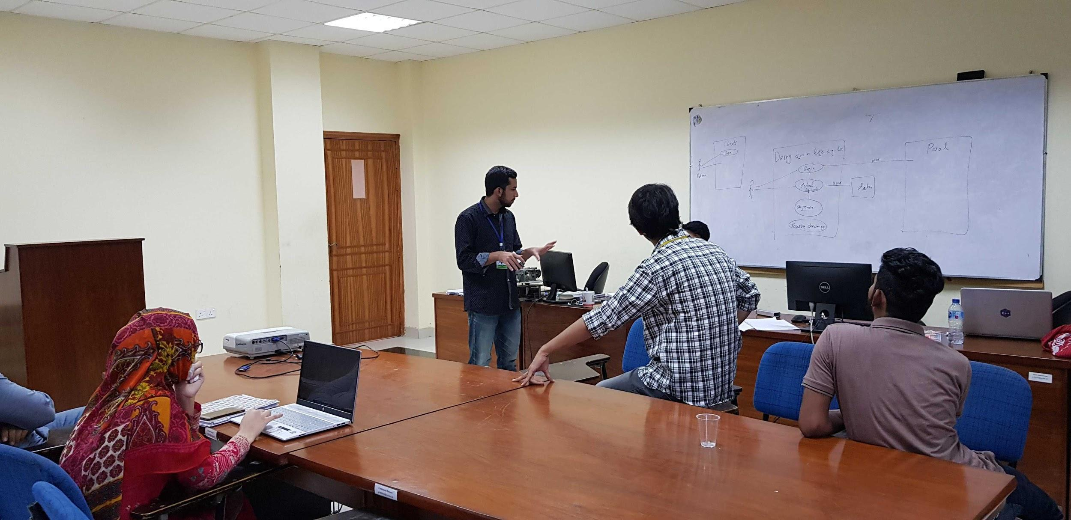

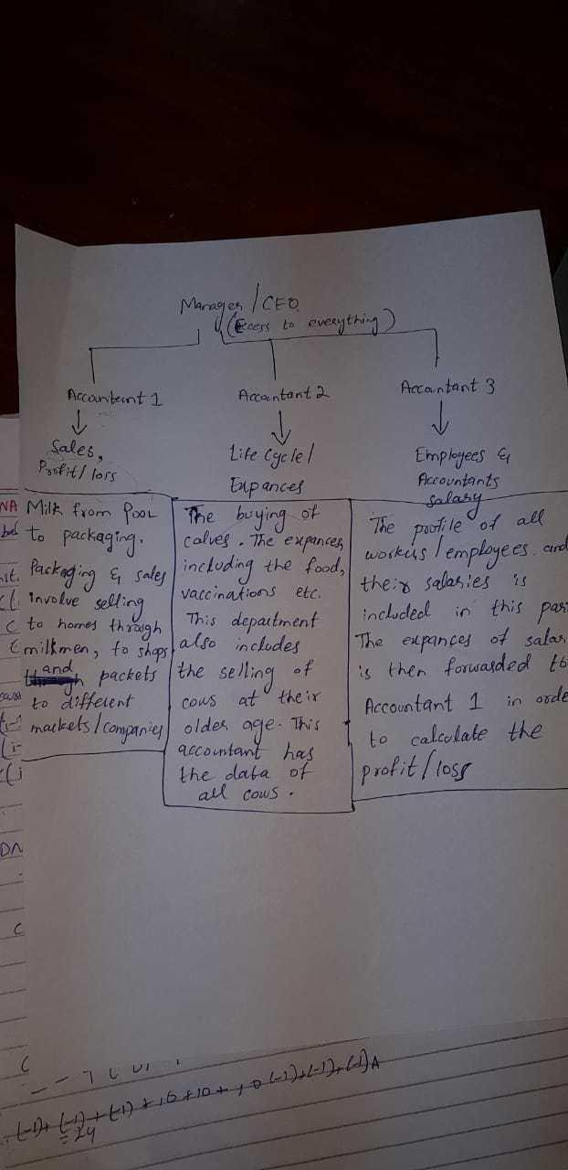

**Meeting 02: Date: 28th October, 2019**

**Members attended:**

All members attended.

**Agenda discussed:**

* Finalizing the Login system implementation and discussion on cow's data requirement.

**Agreed points:**

Use cases and use case diagrams activity diagram and domain model for the different modules.

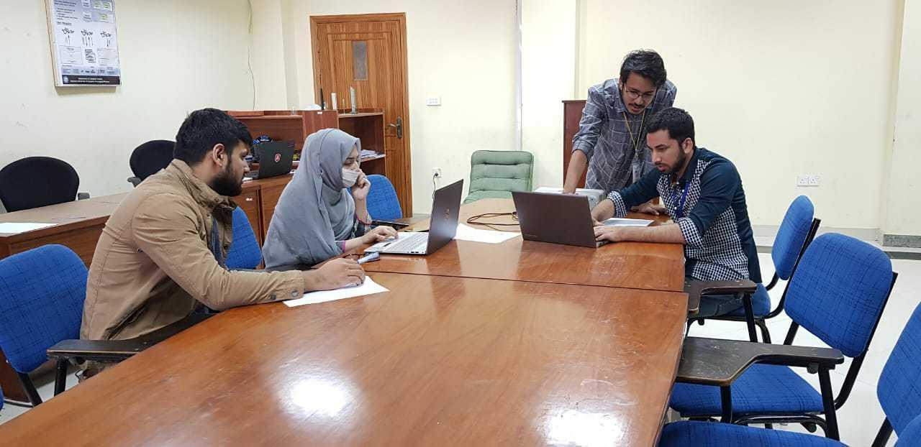

**Communication on Slack:**

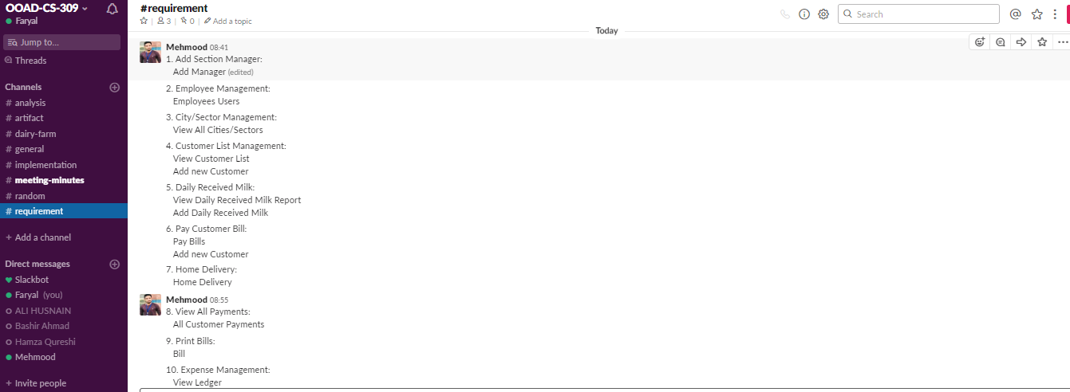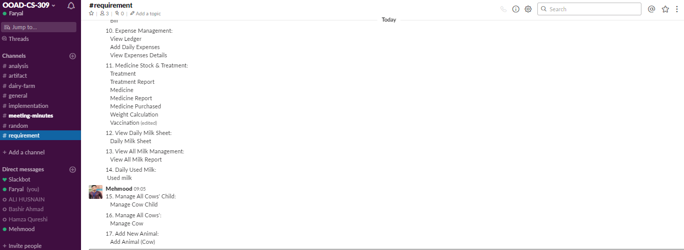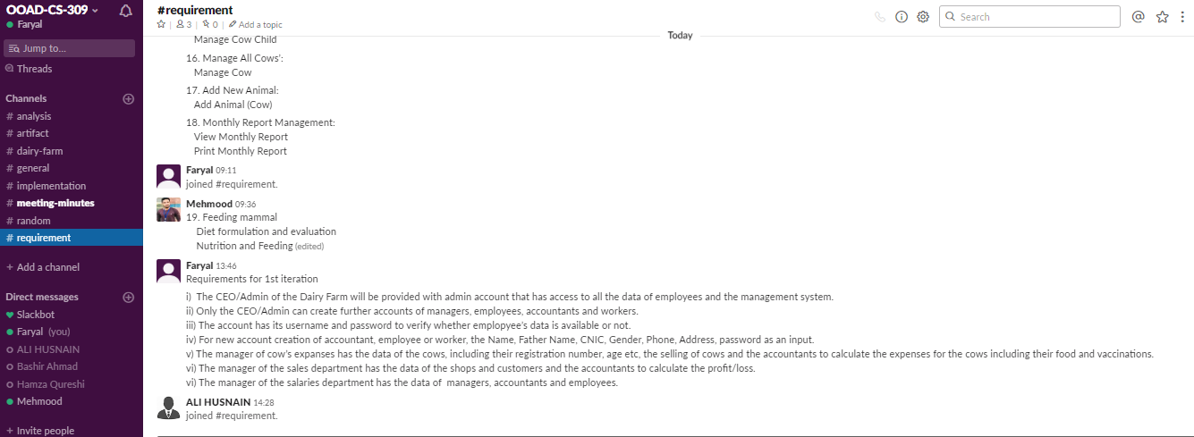

**Activity Diagrams:**

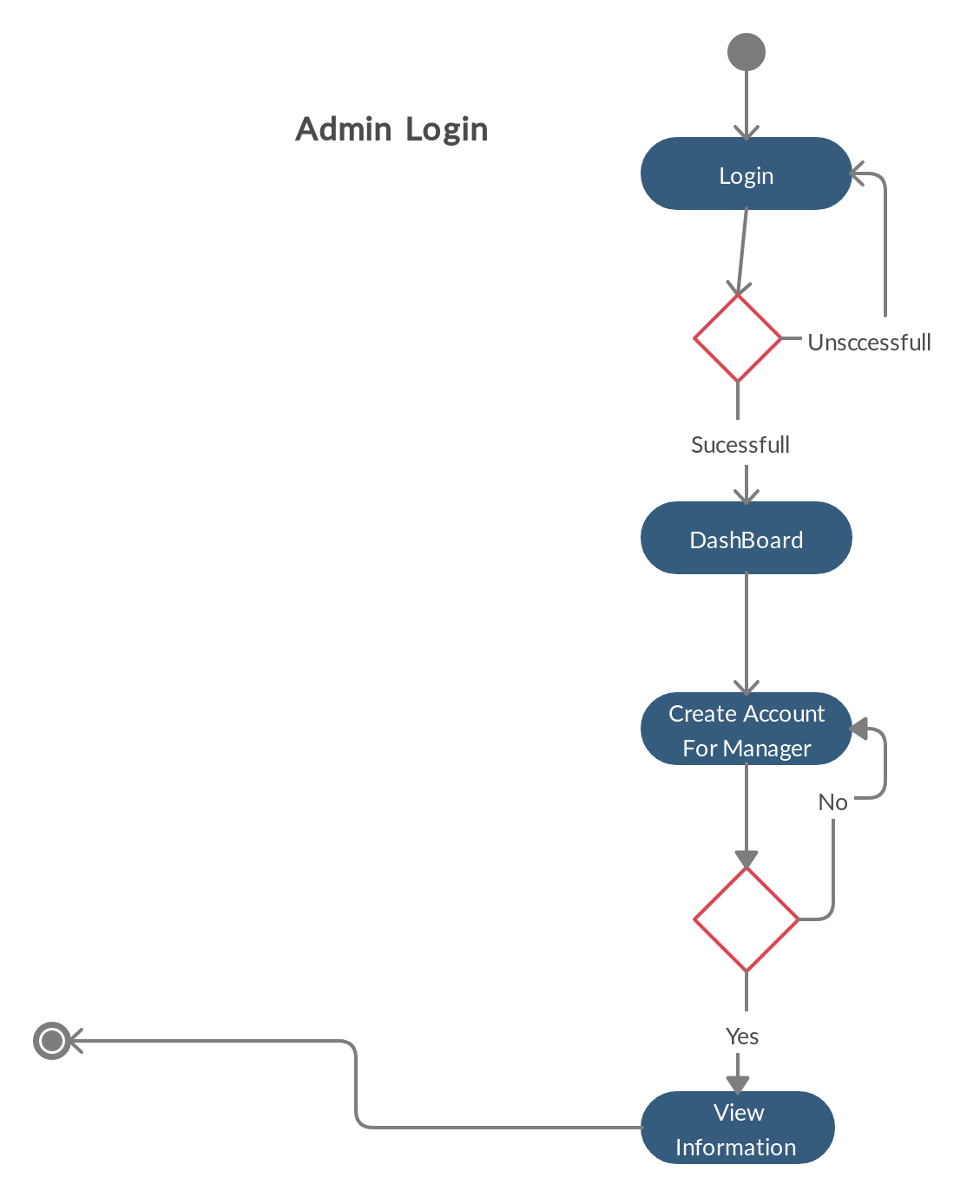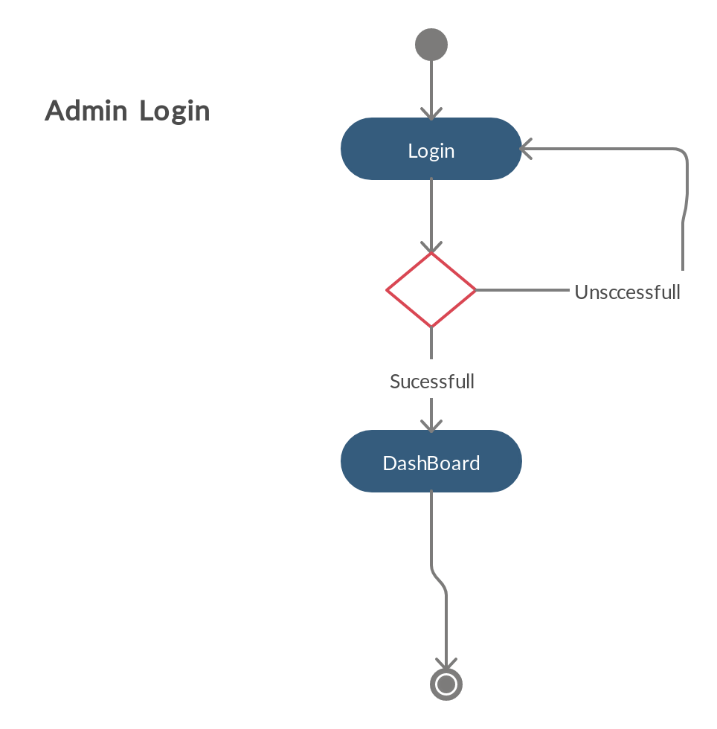

**Use Case Diagrams:**

