Windows message might popup, ignore for now.
Digital Sign and Publisher under process.
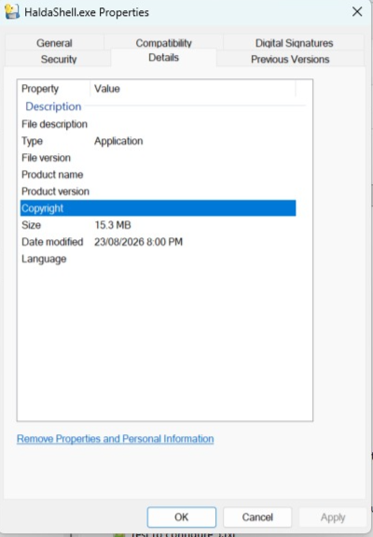

https://github.com/haldashell/XpNet/tree/main

- COM port add
- Asking dialog for log folder.
- Multiline PASTE acknowledgement.
- Multiline PASTE does not paste in the terminal as supposed to be ??
Example : PASTE should work as line by line, NOT all the line as serial
Not line 192.168.1.1 192.168.12.12
Should be 192.168.1.1 and then 2nd line 192.168.12.12
- Application Shortcut, need to map with destination application.
- How system will read my file ?

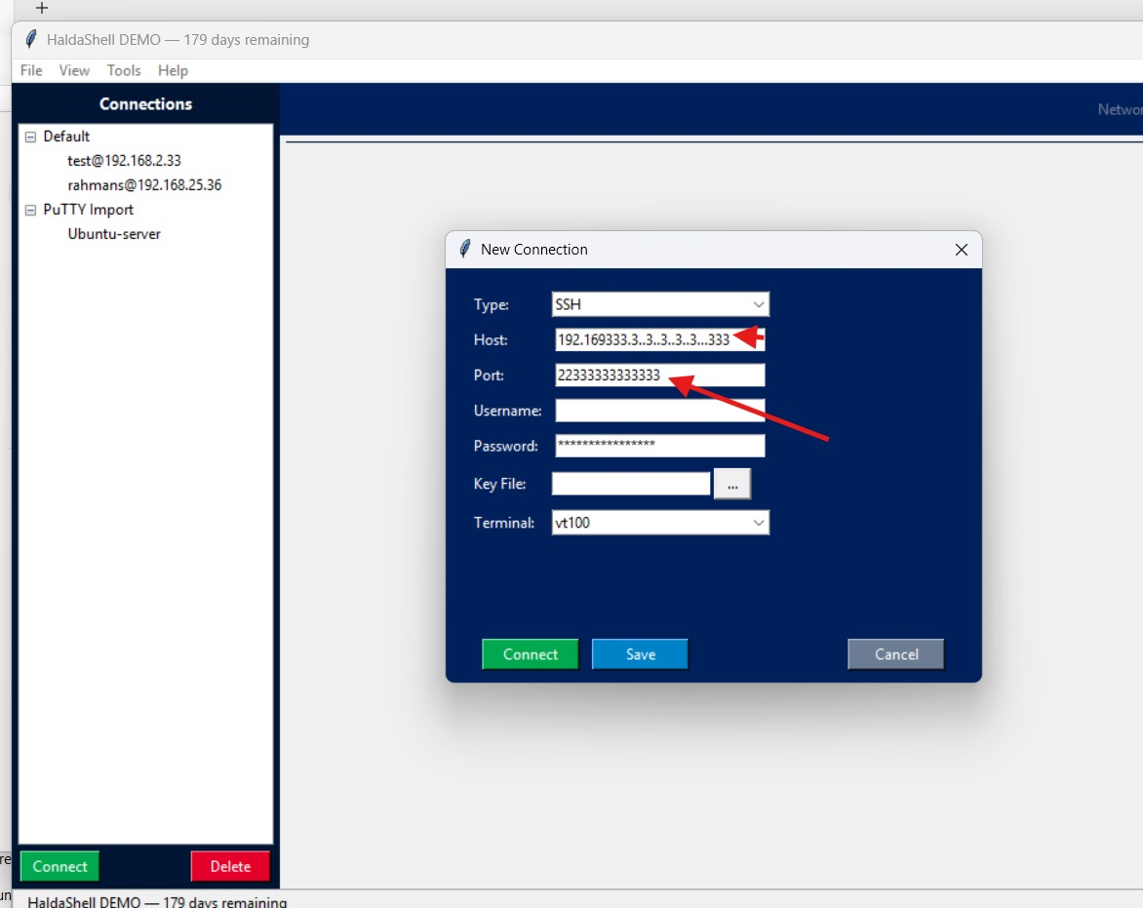
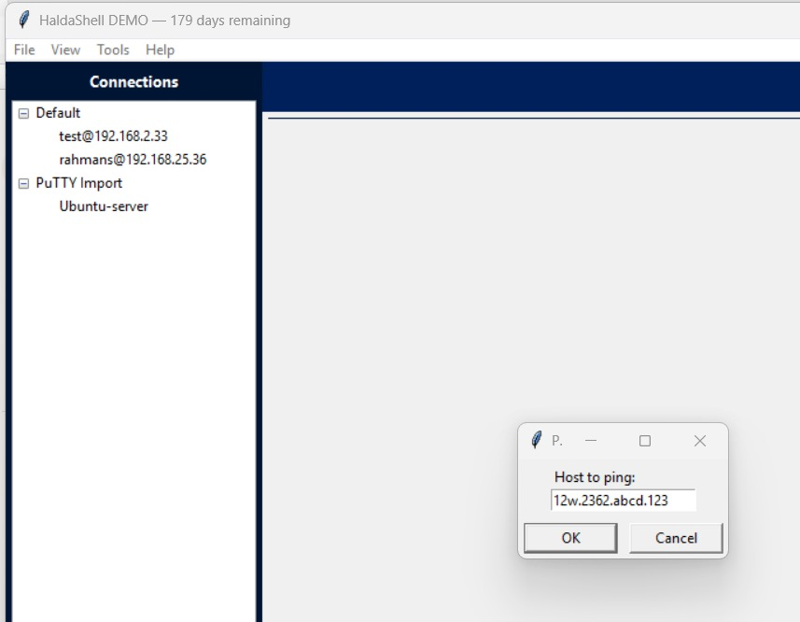
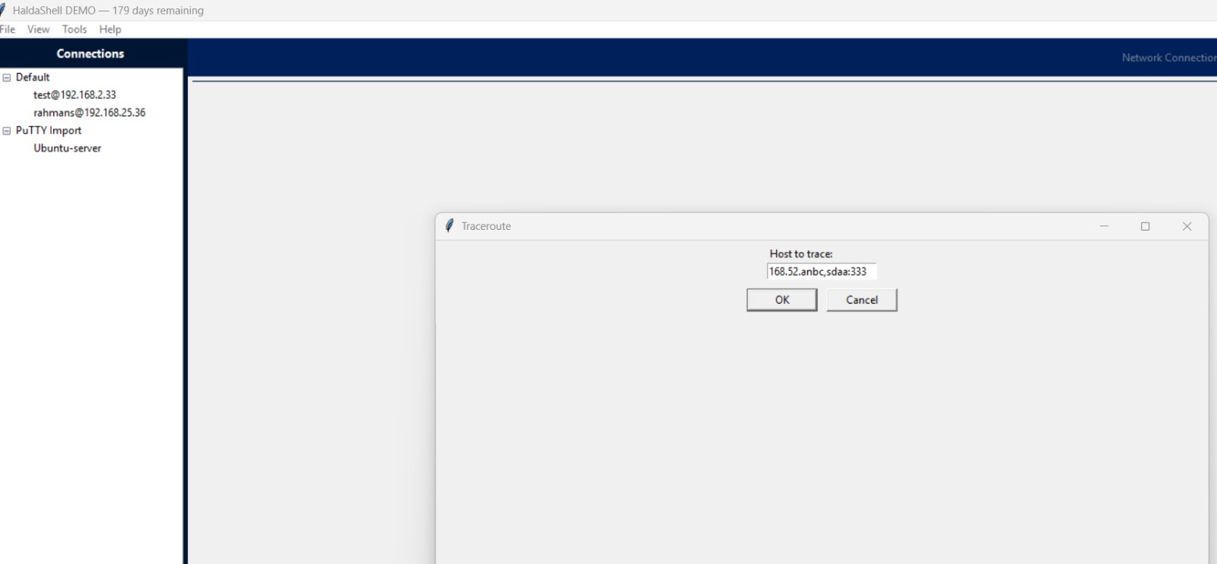
Textbox sanitization is not observed in any textbox
Just need to fine tune few UI issues
Toggle connection is not necessary / it should always be on the left
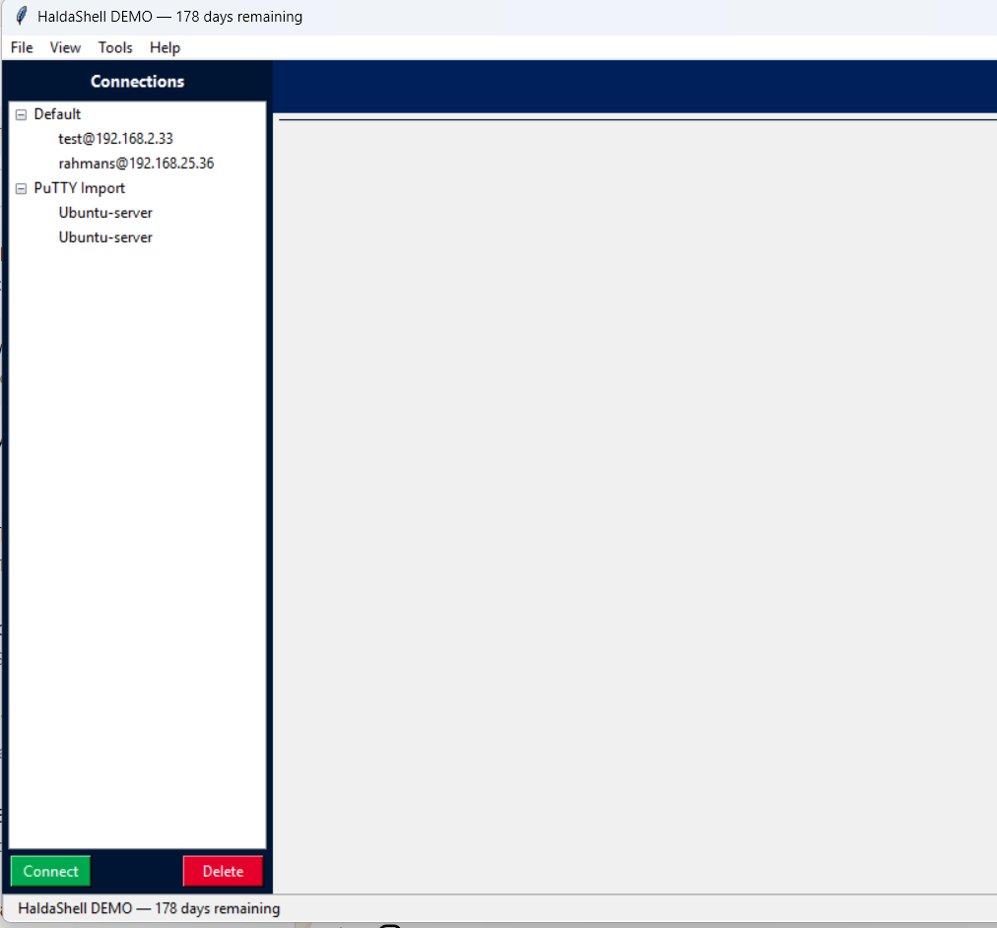

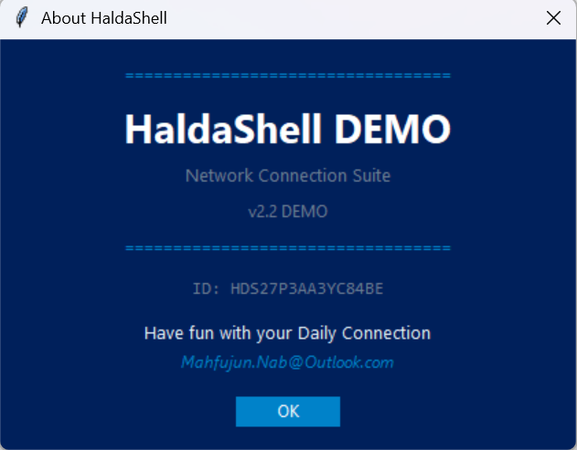
Address is wrong.

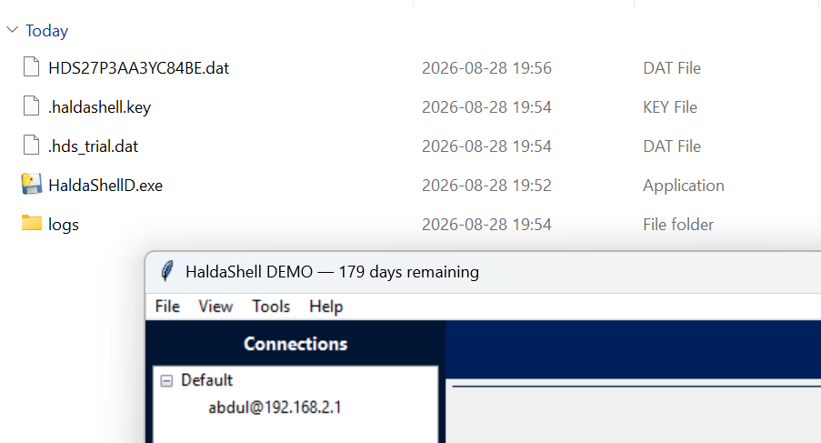

Logo need to change.

If a connection fails to connect, toggle bar hides again.
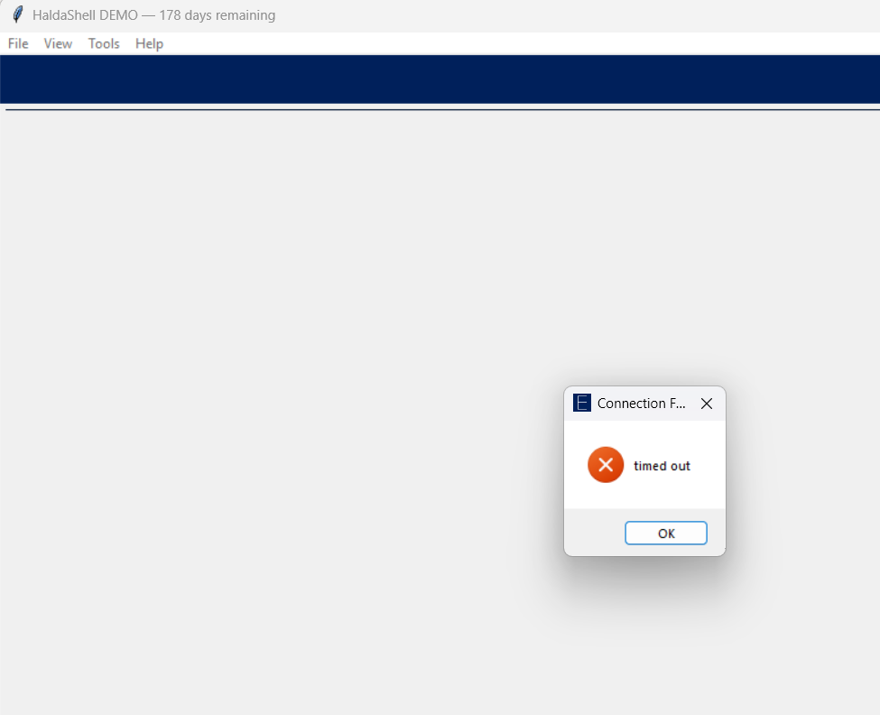

Error message is not clear:

