Unit 6 Math

Part 1. Remove the Prompt for Player Name

1. Give PlayerName a starting value of “New Player”
2. Create an HTML input for PlayerName
3. Create a button to load PlayerName
4. Create a function called newPlayer()
   1. Set PlayerName the value of the PlayerNameInput
   2. Set Wins = 0
   3. Set playerNameWelcome span to the new player name
      1. If not using the starter file create the span in the welcome section

Part 2. Roll The Dice

1. Create a function called roll() to create a random number between 1 and 6 and return the created value
2. Create 2 global variables:
   1. Dice1Value;
   2. Dice2Value;
3. add a click a button to call a new function called rollDice()
   1. calls row function twice
   2. stores the values in 2 global variables
   3. Call adjustDiceImage to set the images
4. Create a function called setDiceValue
   1. This adds the value of the two dice
   2. Update the html to say “You rolled <value>“
   3. Modify rollDice to call this

Part 3. Wins vs Attempts

1. Create a Attempts Global Variable and set it’s default to 0
2. Add code to the newPlayer function to set attempts to 0
3. Modify the addAttempt() function to do the following
   1. Increment the global attempts by 1
   2. Increment the global wins by 1
   3. Call setWins()
4. Modify setWins to Include attempts
   1. Example “Matt has 1 wins over 1 attempts”

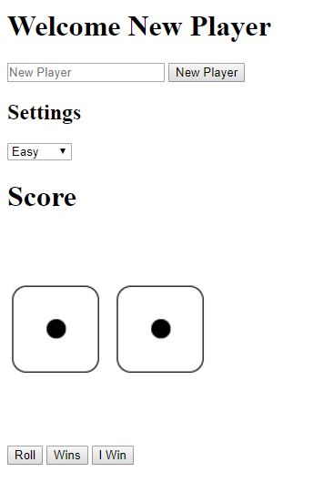

Start

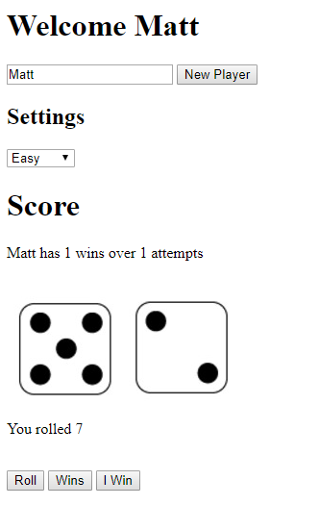

Example after “Roll” and “I Win”