Normalization Document

Amusement Park Management System
Milestone 2 — ERD Optimized & Normalization v.1.2

Submitted By: Haleema Gohar
Submitted to: Sir Ali Hassan
Subject: Database Lab
Semester: BSSE (A) – 4th Semester
Version: 1.2



INSTITUTE OF MANAGEMENT SCIENCES
HAYTABAD, PESHAWAR (2026)

Version Control Table:

Version | Milestone | Description | Status
1.0 | Project Proposal | Initial proposal of Amusement Park DBMS with problem statement, objectives, and basic planning | Completed
1.1 | Schema | Complete relational schema design, tables, keys, constraints, normalization, and SQL structure | Completed
1.2 | ERD Diagram | Entity Relationship Diagram showing table relationships and cardinality | Completed
1.3 | Normalization | Normalized Schema & ERD Optimization. Removed email, visit_date, and ticket_type from Customers. Migrated transactional tracking (ticket_type, valid_date) directly into the Tickets table to eliminate structural anomalies and support multi-visit customer profiles | Completed

1. Introduction

Normalization is the systematic process of organizing a relational database to reduce redundancy and ensure data integrity. Each stage, called a normal form, applies a specific rule to the schema. This document formally applies normalization from First Normal Form (1NF) through Third Normal Form (3NF) to every table in the Amusement Park Management System.
Where a table required a change, the change and reason are documented. Where a table already satisfied a normal form, a written justification is provided explaining why — a simple pass statement without explanation is not included.

2. Schema Overview
The schema consists of six tables:
Table | Primary Key | All Attributes
Customers | customer_id | customer_id, full_name, phone
Tickets | ticket_id | ticket_id, customer_id, ticket_type, price, valid_date
Rides | ride_id | ride_id, ride_name, ride_type, min_capacity, max_capacity, price_per_round, status, description
Ride_Bookings | booking_id | booking_id, customer_id, ride_id, booked_at, num_riders, amount_paid
Ride_Operations | operation_id | operation_id, ride_id, op_date, total_rounds, total_customers
Revenue | revenue_id | revenue_id, ride_id, rev_date, earnings, source

3. First Normal Form (1NF)
Requirements: every column stores atomic values; each column holds values of a single consistent type; every row is uniquely identified by a primary key; no repeating groups exist.

3.1 Customers
Satisfies 1NF. Following a real-world workflow optimization, the unnecessary email attribute was permanently removed. The remaining three attributes are strictly atomic: full_name stores a single identity string per row, and phone holds exactly one contact number. The surrogate primary key customer_id uniquely identifies each individual customer profile record. There are no repeating groups, composite fields, or multi-valued lists stored in any column.

3.2 Tickets
Satisfies 1NF. Each row represents a single, independent ticket transaction record. ticket_id serves as the primary key. ticket_type is implemented as an atomic ENUM datatype, price is a single scalar DECIMAL field, and valid_date is a single DATE column indicating when the pass is active for entry. The foreign key customer_id stores exactly one integer pointer mapping back to the customer profile—not a multi-valued list or array. All column values are atomic and single-typed.

3.3 Rides
Satisfies 1NF without change. ride_id uniquely identifies each ride. All attributes are atomic and single-valued. The status column is an ENUM (Active / Maintenance / Closed) ensuring controlled, indivisible values. The description column holds a single text string. min_capacity and max_capacity are separate integer columns — they are not combined into one field — which is the correct atomic representation.

3.4 Ride_Bookings
Satisfies 1NF without change. booking_id is the primary key. Each row records one booking event: one customer, one ride, one timestamp, one rider count, one payment amount. num_riders and amount_paid are both single numeric values. The two foreign keys (customer_id and ride_id) each store a single integer per row — they are not stored as a list even though a customer can book multiple rides, because each booking is its own row. This is the correct relational approach.

3.5 Ride_Operations
Satisfies 1NF without change. operation_id is the primary key. Each row records the daily operational summary for one specific ride on one specific date. total_rounds and total_customers are single integer values. A UNIQUE constraint on (ride_id, op_date) prevents duplicate summaries for the same ride on the same day, enforcing data integrity without violating 1NF.

3.6 Revenue
Satisfies 1NF without change. revenue_id is the primary key. Each row captures one revenue entry: one ride, one date, one earnings figure, one source type. The source column uses an ENUM (Booking / Walk-in / Group / Event). All values are atomic. No column stores a list or composite value.

3.7 Changes Made for 1NF
The schema was structurally modified to completely exclude the email attribute from the Customers entity to optimize high-throughput walk-in data entry workflows at the ticketing counters. Beyond this optimization, no structural atomicity adjustments were required. The schema satisfies 1NF through single-column surrogate primary keys, separate capacity integers, and strict scalar datatypes across all six tables.

4. Second Normal Form (2NF)
Requirements: satisfies 1NF, and every non-key attribute is fully functionally dependent on the entire primary key. Partial dependency — where a non-key attribute depends on only part of a composite primary key — violates 2NF. This condition only applies to tables with composite primary keys.

4.1 Composite Key Analysis
None of the six tables use a composite primary key. Every table uses a single-column surrogate INT AUTO_INCREMENT primary key. Since partial dependency by definition can only occur when the primary key has two or more columns, and since no table here has a composite primary key, all six tables satisfy 2NF directly.

4.2 Ride_Operations
The Ride_Operations table has a natural composite identifier: the combination of ride_id and op_date uniquely identifies one daily summary. However, the design deliberately uses a surrogate operation_id as the primary key, with a UNIQUE constraint on (ride_id, op_date) to enforce the business rule. This means the table has a single-column PK, which eliminates any possibility of partial dependency. This was a deliberate and justified design choice.

4.3 Changes Made for 2NF
No changes required. The use of surrogate single-column primary keys across all tables eliminated the possibility of partial dependencies by design.

5. Third Normal Form (3NF)
Requirements: satisfies 2NF, and no non-key attribute is transitively dependent on the primary key through another non-key attribute. In other words, no non-key column should determine another non-key column.

5.1 Customers
Satisfies 3NF with structural modifications. Originally, ticket_type, visit_date, and email were included in this profile table.
Removal of visit_date from Customers: A customer's profile is a permanent entity, whereas visiting the park is a repetitive operational transaction. Storing visit_date inside Customers means a returning visitor would either overwrite their past tracking data or force the desk operator to duplicate their profile row, violating normalization standards. Shifting this tracking to the Tickets table allows a single customer profile to log unlimited park visits over time.
Removal of ticket_type from Customers: Ticket classification (Adult, Child, Student) is an attribute of the sold financial product, not a fixed personal trait. Storing it in Customers prevents a parent from buying different ticket types for their family under one profile. Moving it to Tickets allows a single transaction to scale dynamically while preserving clean customer demographics.
Removal of email from Customers: High visitor throughput at entry gates is a primary amusement park operation. Forcing cashier staff to manually input complex string email addresses for walk-in families creates severe processing bottlenecks and introduces high data-entry error rates. Replacing it with a lean, phone-only requirement ensures fast lookups.
The remaining non-key fields (full_name, phone) now depend solely, directly, and non-transitively on customer_id.

5.2 Tickets
Satisfies 3NF with justification. At first glance, price may appear to depend on ticket_type (Adult tickets cost 1000, Child 500, etc.), which would create a transitive dependency chain: ticket_id
> ticket_type > price. However, price is stored explicitly per ticket row to capture the actual amount charged at the exact time of purchase. This allows for seasonal discounts or pricing adjustments over time without altering historical accounting records. Storing it here is a justified, intentional snapshot for data history.
Renaming Modification (Business Realignment): The column originally named purchase_date was explicitly renamed to valid_date during this version review to resolve the removal of visit_date from the Customers entity.

Why was purchase_date changed to valid_date?
From an amusement park's business operations stand point, the date a customer buys a ticket is not always the date they visit the park (for example, buying an entry ticket online on Thursday to use in the park on Sunday).
Since visit_date was purged from the Customers master profile table to fix severe insertion anomalies, the database needed a reliable attribute to track exactly which day a ticket is active. Renaming this field to valid_date inside the transactional Tickets table serves two critical operational purposes:
- It allows entry-gate scanners to immediately validate if the ticket is being used on the correct calendar day.
- It natively replaces the customer profile's old visit_date attribute, allowing a user to buy tickets for any future dates without causing database duplication or data degradation errors.

5.3 Rides
Satisfies 3NF. All attributes (ride_name, ride_type, min_capacity, max_capacity, price_per_round, status, description) are direct properties of the ride entity and depend solely on ride_id. min_capacity and max_capacity are both ride-level attributes — one does not determine the other. No transitive dependency exists.

5.4 Ride_Bookings
Satisfies 3NF. amount_paid is computed from num_riders multiplied by the ride's price_per_round. One might argue this creates a transitive dependency. However, price_per_round is not stored in Ride_Bookings — it is stored in the Rides table. Within Ride_Bookings, amount_paid depends on booking_id (i.e., it is a fact about that specific booking event), not on another non-key column within the same table. Storing it preserves the payment amount at the time of booking, independent of any future price changes.

5.5 Ride_Operations
Satisfies 3NF. total_rounds and total_customers are both direct operational facts about a specific ride on a specific day — they depend on operation_id. Neither column determines the other. There is no non-key to non-key dependency.

5.6 Revenue
Satisfies 3NF. rev_date, earnings, and source all depend directly on revenue_id. earnings does not depend on source or rev_date — it is a fact about that specific revenue entry. ride_id is a foreign key reference, not a non-key determinant.

5.7 Changes Made for 3NF
Structural changes were executed to achieve strict 3NF compliance and real-world operational logic. The attributes ticket_type and visit_date were completely removed from the Customers profile table to eliminate transitive redundancy, moving their logic directly into the Tickets transaction entity where they can scale iteratively over multiple customer visits.
The email field was also purged to streamline customer identity tracking for fast walk-in park workflows. Furthermore, storing price explicitly inside Tickets and amount_paid within Ride_Bookings are documented and justified as intentional snapshots needed to preserve historical financial ledger values against future seasonal or base rate modifications.
6. Redundancy Check
Each table was checked for redundant columns, repeated data, and overlapping attributes.

Table | Redundancy Check Result
Customers | Redundancy successfully removed. Purged email, ticket_type, and visit_date. The table now exclusively tracks permanent core customer profile details.
Tickets | ticket_type and valid_date now live uniquely in this table to log distinct daily transaction properties without duplicating customer data. No other overlap found
Rides | No redundant columns. All seven attributes describe unique, non-overlapping properties of the ride entity.
Ride_Bookings | amount_paid is a stored computed value — justified above in Section 5.4. No other redundancy found.
Ride_Operations | No redundant columns. total_customers in this table represents the operational daily count which may include walk-in customers not recorded in Ride_Bookings. It is not a duplicate of booking data.
Revenue | No redundant columns. earnings is stored as a financial snapshot per revenue event. source ENUM further distinguishes the revenue type and cannot be derived from other columns.

7. ERD Update Confirmation
Following the normalization review, structural modifications were successfully applied to the database schema. The ERD diagram has been updated to Version (1.3) to accurately reflect these real-world corrections. The following changes are confirmed:

- ticket_type and visit_date have been removed from the Customers entity.
- email has been removed from the Customers entity.
- ticket_type and valid_date are now mapped exclusively inside the Tickets entity.
- All five primary-to-foreign key relationships remain intact with correct 1:M (One-to-Many) cardinalities.

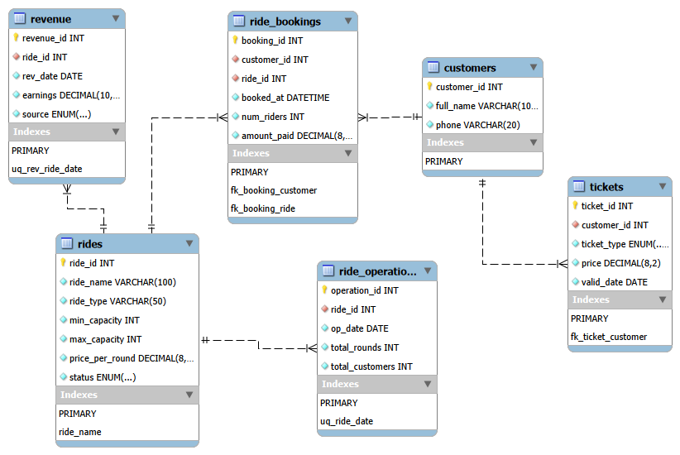
Updated ERD diagram v1.3

