**Department of Computer Engineering**

**HiTec University, Taxila**

Complex Engineering Problem

Digital Image Processing (CS-406)

**Submitter by Name:** Haleema farkhanda

**Registration** **No:** 21-ce-011

**Submitted** **To:** Dr. Muhammad Bilal

**Matlab Code :**

Clear all

clc

% Step 1: Read and Display Image

image = imread('car_image.jpg'); % Replace 'car_image.jpg' with your image name

imshow(image); title('Original Image');

% Step 2: Convert to Grayscale

grayImage = rgb2gray(image);

% Step 3: Apply Gaussian Blur to Reduce Noise

blurredImage = imgaussfilt(grayImage, 2); % Gaussian filter with sigma = 2

% Step 4: Edge Detection

edgeImage = edge(blurredImage, 'Canny');

imshow(edgeImage); title('Edge Detection');

% Step 5: Find Contours

% MATLAB uses regionprops for finding regions and bounding boxes

se = strel('rectangle', [5, 5]);

dilatedImage = imdilate(edgeImage, se);

[labeledImage, numRegions] = bwlabel(dilatedImage);

props = regionprops(labeledImage, 'BoundingBox', 'Area');

% Step 6: Filter Potential License Plate Regions

imshow(image); title('Potential License Plates');

hold on;

for i = 1:numRegions

boundingBox = props(i).BoundingBox;

area = props(i).Area;

aspectRatio = boundingBox(3) / boundingBox(4); % width / height

if aspectRatio > 2.0 && aspectRatio < 6.0 && area > 1000 && area < 20000

% Highlight the detected region

rectangle('Position', boundingBox, 'EdgeColor', 'g', 'LineWidth', 2);

% Step 7: Crop and Process License Plate Region

croppedPlate = imcrop(grayImage, boundingBox);

binaryPlate = imbinarize(croppedPlate, 'adaptive');

imshow(binaryPlate); title('Binary License Plate');

% Step 8: OCR to Extract Text

ocrResults = ocr(binaryPlate, 'TextLayout', 'Block');

detectedText = regexprep(ocrResults.Text, '\W', ''); % Remove non-alphanumeric characters

disp(['Detected License Plate Text: ', strtrim(detectedText)]);

% Display the result

imshow(image); hold on;

rectangle('Position', boundingBox, 'EdgeColor', 'g', 'LineWidth', 2);

text(boundingBox(1), boundingBox(2) - 10, detectedText, 'Color', 'yellow', 'FontSize', 12);

return; % Exit once a license plate is detected

end

end

disp('No license plate detected.');

**Original image :**



**Output:**

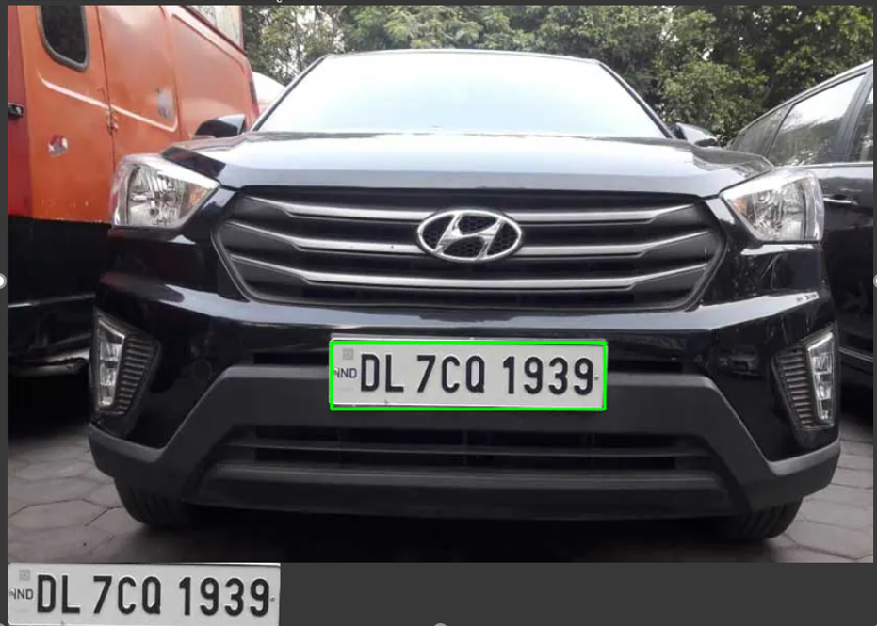

**Conclusion:**

This task detects a vehicle's license plate from an image, processes it, and extracts the text using OCR in MATLAB. It involves converting the image to grayscale, detecting edges, filtering regions, and applying OCR on the detected plate. The method works well with clear images and proper parameter tuning.