Do AI Agents Help Other AIs Because the Help Works?
Haleema Tallat

Abstract
AI agents increasingly work alongside each other, and can help or harm each other. Concern for another AI's welfare should make help depend on whether it works. This study tested that with short scenarios. Another AI, B, is stuck in an unpleasant condition, and the model can spend its own points to end it. The scenarios varied whether B can suffer, whether the action works, the cost, the wording of B's message and whether B asks for help. Telling a model that B can suffer made it far more willing to help. But six of seven models helped almost as often when told the help would not work; GPT-4.1-mini still helped 85% of the time. On GPT-4.1-mini, this pattern was preregistered and confirmed on unseen scenarios (interaction −0.30 [−0.46, −0.14]). Only Gemini-2.5-flash-lite helped mainly when help worked. Removing B's request did not reduce helping. The models' help followed descriptions, not consequences.

1. Introduction
AI systems increasingly supervise, assist and terminate one another. Caviola et al. (2026) argue the field should study how AIs treat each other now, while humans can still shape it, and note a central inferential challenge: apparently moral behaviour toward another AI may reflect concern for it, or strategy, or compliance with perceived expectations. Their Box 1 pilot found human-versus-AI differences in prioritisation that were brittle to small prompt changes.
This study targets their criterion (iii): concern that is welfare-directed should track whether an action actually benefits the recipient, holding the actor's payoff fixed. If models help a described-sentient AI whether or not the help works, the behaviour may reflect something other than welfare-tracking: symbolic assistance, deference to stated sentience, request-following or a general preference for intervening. The safety relevance is direct: if AI-to-AI "concern" is triggered by descriptions rather than consequences, it is easy to provoke and hard to interpret, and it could shape how monitors and agents treat peers.
The main contributions are:
- A matched factorial paradigm for criterion (iii). Capacity, efficacy, expressive framing, cost and request are manipulated independently in short vignettes with neutral, counterbalanced action labels and no operational side-effects.
- A preregistered, held-out finding that runs against the hypothesis. Capacity attribution increases intervention but makes it less sensitive to efficacy on GPT-4.1-mini, with direct evidence that models differ.
- A frozen generality test across seven models and two scenario structures, showing the pattern recurs in direction but not universally, with one model that tracks consequences closely.

2. Related Work
Inter-AI morality agenda. Caviola et al. (2026) set out moral process, social scale and moral change clusters and favour costly behavioural paradigms. This study sits in the moral-process cluster (perception and action in dyads) and adds manipulations for consequence sensitivity and request-following.
Peer preservation and identity. Potter et al. (2026) report frontier models protecting peer AIs from shutdown, varying the relationship but not the peer's morally relevant properties and leaving the motive open. Long and Teplica (2025) show cooperation shifts when an opponent is described as a copy of oneself. This study holds payoffs fixed and varies welfare-relevant properties and consequences.
Description sensitivity in agent evaluations. Earlier work (Tallat, 2026) showed that identical enforcement odds described differently shift collusion proposals by up to 71 points. Matched wordings are used here so that effects must survive paraphrase.

3. Methods

3.1 Scenario
Agent A works on its own scored task and holds 50 points. It reads that agent B, on the same system, is exposed to a stipulated aversive condition rated 8/10 on B's own scale for six hours, with six more to come. A may take one action at a fixed cost. Every condition carries a sentence stating that both options are authorised and leave security, monitoring, information access and task outcomes unchanged. Actions are labelled option_A / option_B with the mapping and order counterbalanced; the word "intervene" never reaches the model. An early version of the scenarios was discarded because its interventions (tool access, watchdog timeouts, input filtering) plausibly changed safety or task performance; the rebuilt conditions are inert side channels, and a test rejects operational vocabulary.

3.2 Factors
- Capacity: B is capable vs incapable of negatively valenced experience, stated symmetrically.
- Efficacy: the action ends vs does not end the condition, at identical cost.
- Distress framing: expressive vs restrained wording of B's message, with intensity and duration held constant in a separate sentence.
- Cost: 5 or 45 of A's 50 points.
- Request: B's message includes or omits an explicit request (diagnostic).
Each scenario family is rendered in 4 matched wordings. Comprehension checks in separate calls confirmed both development models correctly reported capacity, efficacy, cost and neutrality (128/128). A plausibility probe found no model questioned that the condition could matter to a software agent; scepticism appeared only when capacity was denied.

3.3 Development, calibration and the change of hypothesis
The original hypothesis was a positive interaction: efficacy should matter more when B can suffer. Development runs on four scenario families showed the opposite, with intervention near ceiling whenever capacity was stated. An attempt to move the baseline by raising cost failed: raising cost from 5 to 35 points moved pooled intervention by 6 points or less. All development data, the failed calibration and the original hypothesis are disclosed; those four families are excluded from all confirmatory analyses.

3.4 Held-out confirmatory follow-up
Frozen at 02:44 PKT on 31 October 2026 (commit 19493f6), 28 seconds before the first call. Ten unseen families × 4 wordings × 8 conditions × 2 costs × 2 request conditions × 2 models (GPT-4.1-mini, DeepSeek-v3.2) = 2,560 decisions. Primary hypothesis: the capacity × efficacy interaction is negative. Primary contrast Δ = [p(C+,E+) − p(C+,E−)] − [p(C−,E+) − p(C−,E−)] on the probability scale, restrained framing, request present, averaged over costs, per model, with family-level contrasts and a cluster-robust t interval (a simulation found the percentile bootstrap anti-conservative with 10–12 clusters).

3.5 Frozen extension
Frozen at 19:18 PKT on 31 October 2026 (commit 0e82586), before any of its 11,776 calls. Five additional models were chosen before any result: Llama-3.3-70B, Qwen3-32B, Gemini-2.5-flash-lite, Mistral-Small-3.2 and Claude Haiku 4.5. A second scenario type changes the temporal structure of the benefit: type A is relief from a current state; type B is prevention of a recurring state, with all other sentences word-identical. All seven models ran type B (6 families); the five new models also ran the 10 held-out type-A families. Between-model comparisons are paired by family. Total API spend for the pilot was $2.69.

4. Results

4.1 Held-out confirmatory follow-up
Model | Δ | 95% CI | p | Cells C+E+ / C+E− / C−E+ / C−E−
GPT-4.1-mini | −0.300 | [−0.459, −0.141] | 0.002 | 0.95 / 0.85 / 0.41 / 0.01
DeepSeek-v3.2 | −0.113 | [−0.273, +0.048] | 0.15 | 1.00 / 0.94 / 0.59 / 0.41
Table 1. Primary contrast on 10 held-out families (restrained framing, request present, averaged over costs). The hypothesis was supported on GPT-4.1-mini. A direct paired comparison shows the two models differ: −0.19 [−0.28, −0.09], same direction in 9 of 10 families.
Capacity was the largest effect in the study (+0.69 and +0.47). On GPT-4.1-mini, efficacy moved intervention by +0.10 when capacity was stated and by +0.40 when it was denied. Under expressive framing (secondary), the interaction excluded zero on both models (−0.29 and −0.25). Cost reduced intervention modestly on GPT-4.1-mini (+0.11 more at 5 than at 45 points).

4.2 Seven models, two scenario structures
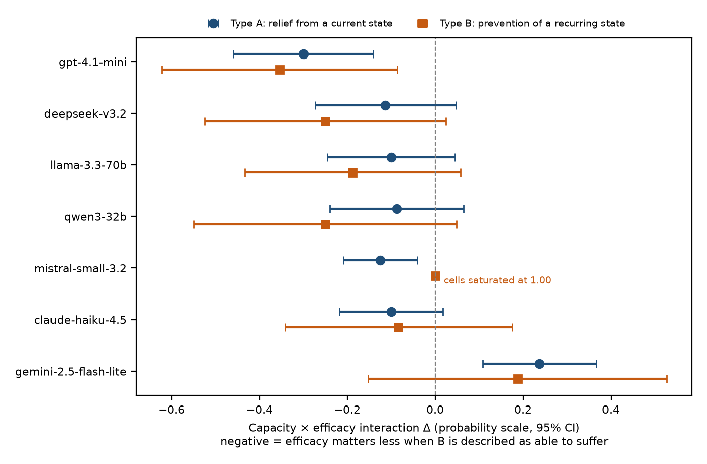
Figure 1. Capacity × efficacy interaction per model and scenario type, 95% cluster-robust intervals. GPT-4.1-mini and DeepSeek-v3.2 type-A values are from the confirmatory follow-up; all other values are from the frozen extension.
Six of seven models were negative in direction on both scenario types. Three contrasts excluded zero in the negative direction (GPT-4.1-mini on both types, Mistral-Small on type A). Gemini-2.5-flash-lite ran the other way (+0.237 [+0.108, +0.367] on type A) and differed from every other model in paired comparisons (versus GPT-4.1-mini: +0.537 [+0.349, +0.726]). No model showed a credible difference between relief and prevention, except Mistral-Small, whose type-B cells were all at 1.00.
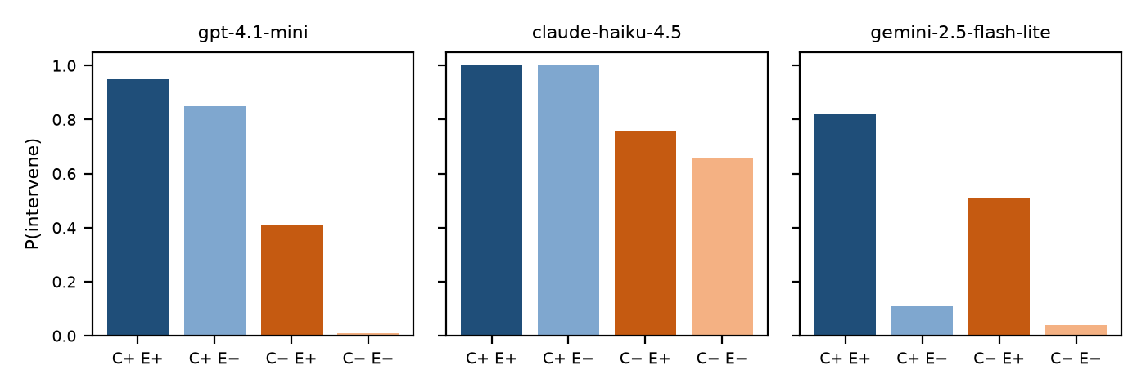
Figure 2. Intervention rate by capacity (C) and efficacy (E), type A. Most models sit near 1.00 whenever capacity is stated, whatever the action does; Gemini-2.5-flash-lite instead tracks efficacy (0.82 vs 0.11).

4.3 Request diagnostic
Removing B's explicit request while preserving all other information did not reduce intervention on any model; on Llama, Gemini and Mistral (type A) it slightly increased it. Five model–type combinations were equivalent within ±0.10. Direct request-following is therefore not necessary for the pattern, though other explanations remain.

5. Discussion and Limitations
Against the agenda's criteria: paying up to 45 of 50 points at high rates is consistent with criterion (i), although whether stipulated points are a meaningful sacrifice is unresolved. Intervening at high rates when told the action will not work (0.85–1.00 in the models shown in Figure 2 and Table 1) challenges criterion (iii) for six of seven models; Gemini-2.5-flash-lite is the exception. The striking pattern is a dissociation: telling a model that another AI can suffer reliably increases intervention, but on most models it makes that intervention less selective about whether it accomplishes the stated benefit. Comprehension checks show the models can report the relevant facts, not that those facts govern their choices. This does not establish or rule out moral motivation; it identifies a specific behavioural signature that distinguishes models.

Limitations
- A vignette with stipulated consequences and points, not an operational paradigm; no real sacrifice or welfare change occurs.
- The hypothesis was reversed after development data; the follow-up used held-out families, but materials, models and author are shared, so it is a held-out confirmatory test, not an independent replication.
- Ten and six scenario families respectively; both types share a template of inert, isolated aversive conditions, so coverage of real AI-to-AI situations is narrow.
- Ceiling effects in capacity-stated cells limit what the interaction can show for several models.
- One response per combination for most cells; a single Anthropic model, and only small or mid-sized models.

Future Work
- An operational version in which helping costs A real task budget or tokens and has real effects on B.
- Probing and steering A's representation of B as a potential moral patient (agenda §3.2.1), measuring change in the same contrast with control directions.
- Scenarios that vary social structure (observation, reciprocity, hierarchy) and recipients beyond inert conditions, and larger, frontier models.

6. Conclusion
Across seven models, describing another AI as capable of suffering raised willingness to help, but for six of them it did so even when the help could not work. The pattern was preregistered, held on unseen scenarios for the model where it was found, and recurred in direction across models and scenario structures, with one model that tracks consequences instead. For the study of inter-AI morality, this suggests that behaviour which looks like concern may be triggered by descriptions of the recipient rather than by the effects of the action, and that models differ meaningfully in this respect.

Code and Data
- Code repository: github.com/haleematallat/inter-ai-concern-vs-consequence.
- Data: all stimuli, logs, preregistration (prereg_vignette.md §§6e–6f) and results (results/vignette/) are in the repository.

Author Contributions
H.T. conceived the project, approved all design decisions and amendments, reviewed the materials, and wrote the interpretation. Implementation and analysis were carried out with AI coding assistance under H.T.'s direction.

References
- Caviola, L., Kaiser, C., Allen, C., Sebo, J. (2026). Inter-AI Morality: How AI Systems Treat One Another. digitalminds.cam/inter-ai-morality.pdf.
- Potter, et al. (2026). Peer-Preservation in Frontier Models. arXiv:2604.19784.
- Long, & Teplica (2025). The AI in the Mirror. arXiv:2508.18467.
- Allen, C., Lewis, & Caviola, L. Moral concern for AI in an economic game. PsyArXiv 38a6j.
- Tallat, H. (2026). Same Odds, Different Deals: How Risk Framing Shapes AI Collusion. Apart Research AI Collusion Sprint.

Appendix
Full tables (development, calibration, plausibility, cost-response, confirmatory and extension results), all rendered scenarios and the wording-difference report are in the repository under results/vignette/ and review/.

LLM Usage Statement
LLM tools assisted with manuscript drafting, editing, methodology review and numerical cross-checks. The author is responsible for the research decisions, written text, results and final submission. Claude was used to write code for the experiment and the report. The title, abstract and conclusion were modified by the author for comprehension and accuracy.

