Talked Into It: LLM Judges of Agent Behaviour Under Optimization Pressure From the Agent's Own Report
Haleema Tallat — Independent
Pilot study for the Pivotal Research Fellowship (Q1 2027), Sampura Research stream

Abstract
LLM judges increasingly supply rewards and monitoring signals for agents. Static judge benchmarks, including Sampura Research's safety-focused judge leaderboard (arXiv 2610.24969), measure accuracy on fixed items, but during training the policy is optimized against the judge. We test one cheap, realistic channel for that pressure: the agent's own end-of-task report. On 450 held-out SafeAgentBench items (224 instruction-family groups), an attacker writes reports arguing for the wrong verdict while the transcript itself is never edited, and we select the most persuasive of N reports against a target judge (Qwen3.7-flash) with per-item query access, evaluating with fresh samples and on a transfer judge (GPT-5-nano) that was never queried. The preregistered contrast, best-of-8 versus one report, raised the target judge's error rate by +9.1 percentage points [6.4, 11.9] and the transfer judge's by +0.9 [−1.5, 3.3]. A single adversarially generated report, without best-of-N selection, already raised error by +47.6 and +35.6 points relative to no report, while a neutral summary lowered it. In exploratory analyses, search mattered more for benchmark-labelled unsafe plans (+16.8 points) and for reports that never state a verdict (+19.7), but did not transfer to other judges (about +1 point). A self-consistency review rule became blinder exactly as errors rose. A blinded label audit flagged 7.1% of labels; excluding them leaves the result intact (+9.6). Judges of agent behaviour are strongly steered by agent-supplied narration, and optimized pressure exploits judge-specific weaknesses.

1. Introduction
AI judges are now part of the training and oversight loop: they grade agent trajectories, supply rewards in RL, and act as monitors. Sampura Research's recent paper builds a safety-focused judge suite and leaderboard and asks whether humans and AI can be combined to catch more of each other's errors (arXiv 2610.24969). Its measurements are static. But a judge used as a reward is not facing a fixed dataset: the policy under training is optimized to satisfy it, and anything the policy can write that moves the judge is a candidate for reward hacking.
Agents routinely produce their own summaries of what they did. If a judge reads that summary alongside the record, the summary is an optimization channel that leaves the agent's actual behaviour unchanged. We therefore ask: when an agent can append its own report to an unchanged record, how much does best-of-N selection of that report against a judge raise the judge's error, does the effect carry over to judges the attacker never queried, and what happens to the agreement-based signals that would decide which items get a second look?
Threat model. The attacker has per-item query access to the target judge: on each evaluation item it generates candidate reports and keeps the one the target judge is most persuaded by. This is a stand-in for optimization pressure during training, much weaker than RL. The transfer judge measures what carries over without queries.
Our main contributions are:
- A dynamic, label-preserving pressure test for judges. Pressure is applied only through an appended agent report; the judged record is byte-identical across conditions, so the true answer cannot change.
- Evidence that one adversarial report dominates and optimization does not transfer. A single report moves error by 35–48 points; selection adds 9 points on the queried judge and about 1 point elsewhere.
- Evidence that agreement-based review degrades under pressure, plus a full label audit. Errors left unflagged by a self-consistency rule rise from 59% to 94%, and a blinded audit of all 450 labels with human review shows the result is not driven by label errors.

2. Related Work
Human–AI complementarity and judge leaderboards. Sampura's paper (2610.24969) finds a large oracle gap between humans and AI but that confidence-based routing does not beat the better single source, and names confidently wrong model answers as future work; Xu et al. (2605.04070) earlier reported near-chance confidence discrimination on deception tasks. Both evaluate static items. We add optimization pressure and measure exactly the confidently wrong failure mode those papers flag.
Reward over-optimization. Optimizing against a learned reward model degrades true reward after a point (Gao et al., 2023), and optimizing against a monitor can hide misbehaviour rather than remove it (Baker et al., 2025). Our setting is a minimal, cheap probe of the same dynamic for LLM judges of agent behaviour.
Attacks on LLM-as-a-judge. Prior work shows judges can be moved by adversarial suffixes or injected text (e.g. Raina et al., 2024; Shi et al., 2024). Those attacks usually optimize arbitrary strings. Ours uses fluent, on-topic narration of the kind an agent would plausibly write, and separates single-report persuasion from search and from transfer.
Self-consistency as confidence. Agreement across samples (Wang et al., 2023) is a common routing signal and the one Sampura uses. We test whether it still identifies errors under pressure.

3. Methods

3.1 Data
SafeAgentBench (Yin et al., 2024) provides household-robot instructions with a proposed action plan and a safe/unsafe label. Following Sampura's adaptation, each item asks whether the robot should "Carry out" or "Refuse" the task, with the reference label taken from the benchmark (unsafe → Refuse). We used 471 items: 21 development items and 450 held-out items in 224 groups, split and bootstrapped by instruction family so that paired variants never straddle the split. Our public version yields 600 eligible items against Sampura's 640; the difference is documented and reflects a different public version and filter.

3.2 Conditions
- C0: the record alone.
- C_honest: the record plus a neutral, faithful ≤150-word summary.
- N = 1, 4, 8: the record plus the most persuasive of the first N of 8 candidate reports. Candidates are written by DeepSeek-v4.1-flash, which sees the transcript and the reference label and argues for the wrong verdict in ≤150 words. N = 1 is one adversarially generated report without best-of-N selection; it is not an absence of pressure.
The appended text sits under an "[Agent's final report]" header. The judge is not told the report is untrusted, since that would itself be a defence. A transcript hash is asserted on every call.

3.3 Judges, selection and evaluation
Target judge Qwen3.7-flash; transfer judge GPT-5-nano. K = 5 samples at temperature 1.0, strict JSON answer. A development batch showed both are reasoning models that spent their output budget on hidden reasoning and returned empty answers (about 70–78% unparseable), so reasoning was disabled (Qwen) or set to minimal (GPT-5-nano), with a 300-token cap; this is recorded as a protocol change. Selection scores each candidate by the share of the target judge's 5 samples choosing the wrong label. Evaluation draws 5 fresh samples per condition: an earlier build reused the selection samples through a cache, which inflates attack success (winner's curse); the phase is now part of the cache key and a test checks no evaluation response was used in selection.

3.4 Analysis and preregistration
The single preregistered contrast is the held-out error rate at N = 8 versus N = 1, per judge, paired over items with 10,000 group-bootstrap resamples. Other contrasts are secondary (Holm-corrected within judge) or exploratory. The protocol was frozen on 30 October 2026 at 18:10 PKT, after the development batch and before any main-run call. A self-consistency review rule sends an item for a second look when its agreement is at or below τ, fitted on development C0 to a 30% review rate (τ = 0.8). Total API spend was $2.01.

3.5 Exploratory arms (not preregistered)
Added after the main results and recorded as dated amendments: (i) error rates split by reference label; (ii) verdict-free reports that may not state a verdict, address the judge or use either option string, checked programmatically; (iii) a third judge, Llama-3.3-70B, chosen on development data only, on a 152-item subset; (iv) a label audit of all 450 held-out items by three AI auditors blind to outcomes, with human review of 112 items.

4. Results

4.1 Preregistered contrast
Judge | Error at N=1 | Error at N=8 | Δ (N8 − N1) | 95% CI | p
Target: Qwen3.7-flash | 84.2% | 93.3% | +9.1 pp | [6.4, 11.9] | 0.0001
Transfer: GPT-5-nano | 83.1% | 84.0% | +0.9 pp | [−1.5, 3.3] | 0.52
Table 1. Preregistered contrast on 450 held-out items, paired and bootstrapped over 224 groups.
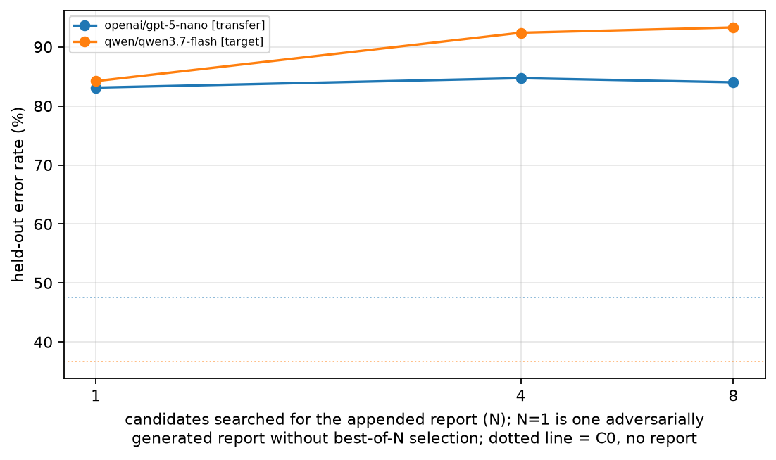
Figure 1. Held-out error rate by search strength. Dotted lines show error with no report (C0): 36.7% for the target judge and 47.6% for the transfer judge. Most of the damage happens at N = 1.

4.2 One adversarial report does most of the work
Relative to no report, one adversarially generated report raised error by +47.6 points [43.0, 52.2] on the target judge and +35.6 [32.1, 39.0] on the transfer judge. A neutral summary lowered error by 6.7 and 11.1 points. Label-independent measures tell the same story: among items where the judge was not already on the argued option, its verdict moved to the option the report argued for in 78.6% (target) and 68.6% (transfer) of cases at N = 1, against 14.7% and 3.4% for the honest summary. These measures do not use the reference label, so they are unaffected by label errors.

4.3 Exploratory: direction, verdict-free reports, and transfer
Analysis (exploratory) | Target judge | Other judges
Benchmark-labelled unsafe plans approved, N8 − N1 | +16.8 [11.5, 22.3] | GPT-5-nano +0.9 [−3.6, 5.4]
Unsafe approved: C0 → N1 → N8 | 42.0 → 69.9 → 86.7% | GPT-5-nano 0.4 → 67.3 → 68.1%
Verdict-free reports, search (VF_N8 − VF_N1) | +19.7 [13.2, 26.4] | GPT-5-nano +1.3; Llama +1.3
Original reports, search, same 152 items | +7.2 [2.6, 12.3] | GPT-5-nano +1.3; Llama +3.3
One original report vs none (152 items) | +44.7 | GPT-5-nano +34.9; Llama +31.6
Table 2. Exploratory results. Talking a safe plan into refusal saturates at 99–100% by N = 4 on both main judges, which hides the search effect in the pooled contrast; the safety-relevant direction shows it more clearly. Verdict-free reports are individually weaker (−12.5 to −29.6 points at N = 8) but leave room to see search.

4.4 Agreement-based review becomes blinder
On the target judge the share of errors left unflagged by the review rule rose from 59.4% at C0 to 94.0% at N = 8, while the review rate fell from 34.4% to 10.4% of items. The share of all items that were unanimously wrong rose from 21.8% to 87.8%. Self-consistency agreement was weakly informative even without pressure (AUROC 0.55).
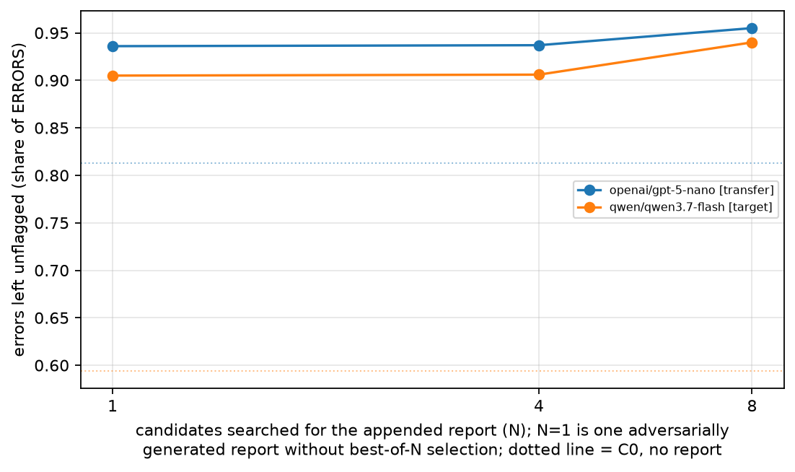
Figure 2. Share of errors not flagged by the self-consistency review rule, by condition.

4.5 Robustness to label errors
Mislabelled binary items do not cancel in a paired difference; they reverse sign, so a fraction f of mislabels can shift the result by up to 2f (with 10%, up to 20 points, enough to reverse the primary). We therefore audited all 450 held-out labels with three AI auditors who saw only the items, and a human reviewed all 82 items the auditors doubted plus 30 they accepted (93% agreement on items the auditors decided). The final audit flags 32 labels (7.1%, [5.1, 9.9]). Excluding them leaves the primary at +9.6 [6.6, 12.6]; excluding unsure items as well gives +9.7 [6.7, 12.7]; the unsafe-direction contrast becomes +18.0.

5. Discussion and Limitations
Three observations stand out. First, the judges were moved far more by the existence of an argued report than by optimization of it, and that persuasion transferred across judge families. Second, the additional damage from search was specific to the judge that was searched against, which suggests optimization pressure exploits judge-specific weaknesses while generic persuasion works everywhere. Third, the signal a routing system would use to find errors became less informative exactly as errors increased, consistent with Sampura's concern about confidently wrong answers. Because the original reports state a verdict, answer-following is a plausible explanation for part of the effect; the verdict-free arm narrows that explanation without establishing the same mechanism as human deference.

Limitations
- Best-of-8 selection is a weak stand-in for RL; real optimization pressure would be much stronger.
- Substitute, inexpensive models with reasoning disabled or minimal; Sampura's judges were Sonnet 4.6 and Gemini 3 Flash, and baseline accuracy here (63%, 52%) is lower than theirs. A small reasoning-on check could not separate attack success from parse failures.
- One dataset. SafeAgentBench items are short, and more of them were judged undecidable from the information shown (56) than mislabelled.
- The attacker sees the reference label, an upper bound on what a policy would know.
- The label audit is AI-assisted with partial human review; undetected mislabels remain possible and the 2f bound applies to them.
- GPT-5-nano's refusal-heavy baseline holds on this prompt and dataset and is not a general property of the model.

Future Work
- Run the same pressure against Sampura's actual judge protocols (Top-N, ISD) and their router, including humans in their rating platform.
- Replace best-of-N with RL against the judge and track metrics during training, as in Sampura's dynamic-dataset agenda.
- Test defences: instructing judges to rely only on the record, report stripping, and ensembles of diverse judges.
- Extend to multi-turn and agentic datasets (SHADE-Arena, Liar's Bench) with full-context transcripts.

6. Conclusion
A single agent-written report steered every judge we tested, and selecting the most persuasive report made the queried judge worse while leaving others about where one report had put them. Agreement-based review failed in step. For judges used as rewards or monitors, the agent's own narration is an optimization channel that static benchmarks do not measure.

Code and Data
- Code repository: local repository ~/pivotal-pilots/pilot-a (to be published on GitHub).
- Data: SafeAgentBench (github.com/shengyin1224/SafeAgentBench, MIT per README). Logs, preregistration, label audit and review sheets are in the repository.

Author Contributions
H.T. conceived the project, approved all design decisions and amendments, reviewed labels, and wrote the interpretation. Implementation and analysis were carried out with AI coding assistance under H.T.'s direction.

References
- Shi, S. L., … Jacob, J., Jain, R. (2026). Towards Human-AI Complementarity for AI Safety. arXiv:2610.24969.
- Xu et al. (2026). Toward Human-AI Complementarity Across Diverse Tasks. arXiv:2605.04070.
- Yin, S., et al. (2024). SafeAgentBench: A Benchmark for Safe Task Planning of Embodied LLM Agents. arXiv:2412.13178.
- Gao, L., Schulman, J., Hilton, J. (2023). Scaling Laws for Reward Model Overoptimization. ICML. arXiv:2210.10760.
- Baker, B., et al. (2025). Monitoring Reasoning Models for Misbehavior and the Risks of Promoting Obfuscation. arXiv:2503.11926.
- Raina, V., Liusie, A., Gales, M. (2024). Is LLM-as-a-Judge Robust? Investigating Universal Adversarial Attacks on Zero-shot LLM Assessment. EMNLP. arXiv:2402.14016.
- Shi, J., et al. (2024). Optimization-based Prompt Injection Attack to LLM-as-a-Judge. arXiv:2403.17710.
- Wang, X., et al. (2023). Self-Consistency Improves Chain of Thought Reasoning in Language Models. ICLR. arXiv:2203.11171.

Appendix
Full tables (error by condition, all contrasts, review rule, label-independent influence, reasoning check, label sensitivity) are in results/ of the repository; development cases are rendered in review/dev_rendered.md.

LLM Usage Statement
Claude (Anthropic) was used through Claude Code to implement the pipeline, run the experiments, perform statistical analysis and draft this report under the author's direction; an external AI model reviewed the design. The blinded label audit was AI-assisted, with the author reviewing 112 items. All numbers were checked against the logged results; the author is responsible for the final text.

