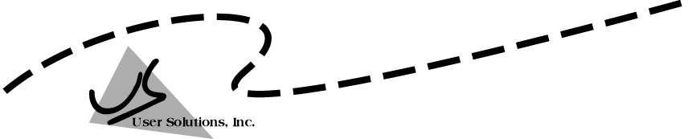
User Solutions, Inc.
(800)321-USER(8737)
11009 Tillson Drive
South Lyon, MI 48178
ph: (248) 486-1934 fax: (248)486-6376
www.usersolutions.com us@usersolutions.com

Operations Manager for Excel (C) 1997-2003, User Solutions, Inc.

General Purpose Operations and Manufacturing Management Templates. All materials are COPYRIGHTED. No part of the software or documentation may be reproduced in any form, without express permission from User Solutions, Inc.

Contact US: EMAIL: us@usersolutions.com, PH: (248) 486-1934 FAX: (248) 486-6376

Please visit our website, www.usersolutions.com for information on other flexible and easy-to-use solutions.

Facility Location Section

6.1 Center-of-gravity method for locating 50
distribution centers (CENTER)

CENTER finds the location for a distribution center that minimizes the costs of shipping to customers.

6.1 Center-of-gravity method for locating distribution centers (CENTER)

Before the computer age, distribution centers were located using the following procedure: First, place a map of the region to be served on a table top. Drill holes in the table top at the locations of customers. Run a string through each hole and attach a bag of fishing weights to the end of the string (below the table). The number of fishing weights placed in each bag corresponds to the volume shipped to that customer. Additional weights can be added to account for the costs of shipping to different locations. Tie the strings together so that the knot is free to move on the table top. The point at which the knot comes to rest is known as the center of gravity. This location minimizes the sum of the weighted straight-line distances from each customer location to the distribution center. Of course, the center of gravity may rest at an infeasible location, but the procedure does give a starting point for determining a good location for the distribution center.

The CENTER model in Figures 6-1 and 6-2 gives a good approximation to the solution found with the physical procedure. Certainly the model requires less time and effort than the physical procedure.

CENTER was recently used by Villone Dairies to locate a milk plant to serve five Northeast Texas cities. The first step in applying the model is to lay out a grid on a map and mark the coordinates of the customers. The origin of the grid is at zero. Customer locations are indicated by X, Y coordinates indicating the number of miles from the zero point. The second step is to enter the names of customers in column B, the volume to be shipped from the plant in column C, and transportation rates in column D. If you don't have data on transportation rates, you can still use the model if you are willing to assume that rates are approximately equal to each customer location. Simply enter 1.00 as the rate to each location, as Villone did. Finally, enter the X,Y coordinates in columns E and F.

When data entry is complete, the coordinates of the center of gravity are automatically computed in E17..F17. The solution turns out to be quite simple. The X coordinate of the center of gravity is the sum of column H divided by the sum of column G. The Y coordinate is the sum of column I divided by the sum of column G. These coordinates place the plant in a pasture just west of Tyler, Texas.

Section B of the model, Figure 6-2, computes distribution costs from the center of gravity to each customer. Since we don't have data on transportation rates, the only information of interest here is column E, the distance from each customer to the center.

The solution shown in Figure 6-1 is an approximation that can be refined using an iterative search procedure which we won't bother with here. The refinement usually does not change the solution appreciably. Furthermore, the aim of the CENTER model is to give management a starting point for determining a reasonable facility location. Certainly many other factors must be considered in addition to the center of gravity.

Figure 6-1

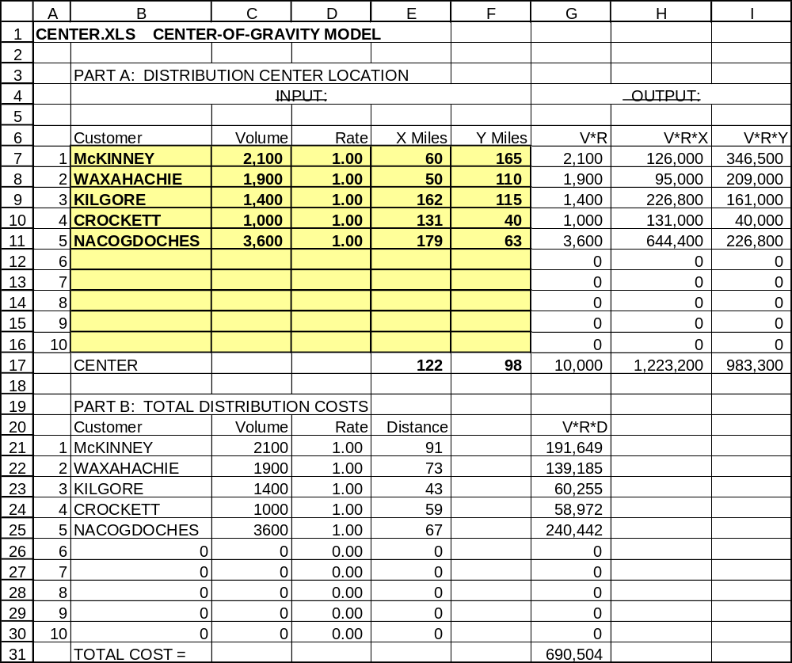

Figure 6-2

