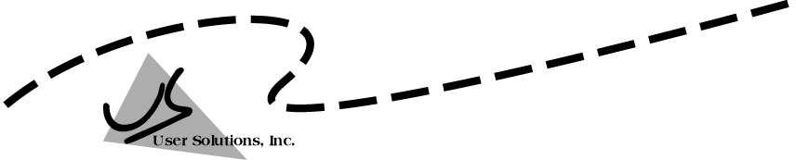
User Solutions, Inc.
(800)321-USER(8737)
11009 Tillson Drive
South Lyon, MI 48178
ph: (248) 486-1934 fax: (248)486-6376
www.usersolutions.com us@usersolutions.com

Operations Manager for Excel (C) 1997-2003, User Solutions, Inc.

General Purpose Operations and Manufacturing Management Templates. All materials are COPYRIGHTED. No part of the software or documentation may be reproduced in any form, without express permission from User Solutions, Inc.

Contact US: EMAIL: us@usersolutions.com, PH: (248) 486-1934 FAX: (248) 486-6376

Please visit our website, www.usersolutions.com for information on other flexible and easy-to-use solutions.

Production Planning Section

5.1 Aggregate production planning (APP) 42

5.2 Run-out time production planning (RUNOUT) 45

5.3 Learning curves (LEARN) 47

APP is a strategic planning model that helps management develop targets for aggregate production and inventory quantities, work force levels, and overtime usage for up to 12 months ahead. RUNOUT is a tactical model that balances production for a group of stock items, usually on a weekly basis. The aim is to give each item in the group the same run-out time, defined as the number of weeks stock will last at current demand rates. LEARN is a tool for projecting costs or production hours per unit as cumulative production increases.

5.1 Aggregate production planning (APP)

Aggregate production planning is the process of determining (1) the timing and quantity of production, (2) the level of inventories, (3) the number of workers employed, and (4) the amount of overtime used for up to 12 months ahead. Production and inventories are stated in overall or aggregate quantities, such as number of automobiles without regard to model or color or number of pairs of shoes without regard to style or size. Cost minimization is rarely the only goal in aggregate planning. Other considerations, such as stability of the workforce and maintenance of adequate inventory levels, are usually just as important.

The APP worksheet in Figure 5-1 was developed for Alief Precision Arms, a company that manufactures high-quality replicas of the Colt Single-Action Army revolver and several other Colt revolvers from the nineteenth century. The first step in using APP is to complete the input cells at the top of the worksheet. Alief has a current work force of 121 people. If we choose to operate with a level work force, the trial value is 190 people. There are 970 revolvers of various models in stock. On average, 20 man-hours are required to produce a revolver. The normal workday is 8 hours. On average, holding costs are $5.00 per unit per month. To hire a new worker, including paperwork and training, costs $975. Layoff cost is $1,280 per worker. The company pays $8.90 per hour for regular time and $13.35 for overtime. The shortage cost per unit of $82.50 is lost profit. Inventory costs are computed based on the average of the beginning and ending inventories for a month.

The second step in APP is to complete the data required in range B37..C48: the number of work days available and the demand forecast by month. Demand is stated as the number of revolvers without regard to model.

Now we are ready to experiment with production plans. The first option is a chase strategy in which production is equal to demand each month, with the work force adjusted monthly though hires and layoffs. Select Ctrl – Shift – S to produce the chase strategy shown in Figure 5-1. Production rates are calculated in columns G and H. The number of workers required by the production rates is calculated in column F. This is done using the hours per unit in cell E8 and the length of the workday in E9. If overtime is necessary, daily hours per worker and total hours for the month are computed in columns I and J. Hires and layoffs in columns K and L are based on the workers actually used in column E. For the chase strategy, we use only the number of workers required, with no overtime. Columns M - Q calculate inventory data for the plan. Inventory is constant throughout the chase strategy.

The cost of the chase strategy is $4,557,618. Under the workforce change columns, notice that 70 workers are hired immediately but they are gradually laid off over the next few months. Then we hire new workers monthly during months 5-9 only to endure layoffs again in months 10-12. Click on the first graph tab to see a plot of cumulative demand, cumulative production, end-of-month inventory, and monthly production.
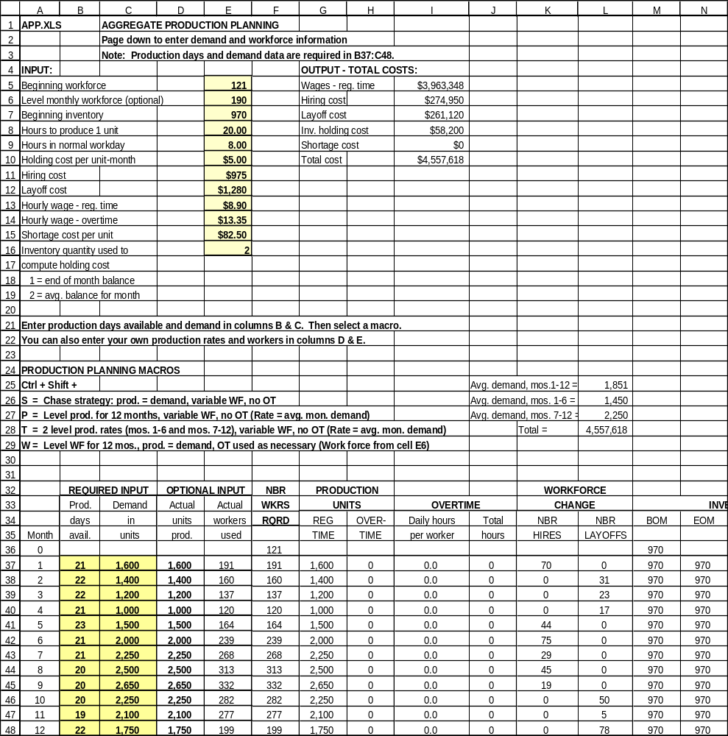
Figure 5-1

Another option is to level production over the planning horizon using Ctrl – Shift – P. This plan builds inventory to meet peak demand and is less expensive, with total costs of $4,318,930. End-of-month inventory builds to a peak of 3,525 units in month 5 and then gradually declines as we work though the peak season. The work force is more stable, although there are layoffs in months 2, 5, and 12. The layoffs in months 2 and 5 are relatively small although the layoff in month 12 is about 15% of the work force.

A refinement on the P macro is to use two level production rates with Ctrl – Shift – T. For the first 6 months, we produce at the average demand rate for the first half of the year. During the last 6 months, we switch to the average demand rate for the last half of the year. This is cheaper still, with total costs of $4,289,004. Compared to the single level production rate, inventories are lower and the work force is more stable.

We can also operate with a level work force of 190 people, with production equal to demand and overtime used as necessary. Select Ctrl – Shift – W to generate this plan. Total cost is only $3,534,531 but there is substantial overtime during the last half of the year, over 5 hours per worker per day in months 8 and 9. It might make sense to increase the level work force in cell E6. Change E6 to 210 workers and run the macro again. This increases costs to $3,912,879 but cuts the overtime burden substantially.

You can fine-tune this or any other plan by changing the actual units produced and actual workers used in columns D and E. If actual units produced in column D exceed regular time units in column G, the model automatically makes two adjustments: (1) the number of workers required is recomputed in column F, and (2) the model applies overtime as necessary to make up the difference between total units produced and those produced on regular time.

APP is a flexible model that can deal with a variety of complications in aggregate planning: (1) What if you don't like any of the plans? Enter your own choices month-by-month for total units produced and workers actually used. (2) What if you want to plan for less than 12 months? For example, suppose you want to plan for 6 months. Enter 0 in all unused cells (B43..E48) for days available, demand in units, actual units produced, and actual workers used. The model stops all calculations after month 6. The graph will look a little strange because production, demand, and inventory will fall to 0 in month 7. (3) What if you must maintain a minimum inventory level each month? Check the list of inventory values in column N. If any value falls below the minimum, increase total production in columns G and H as necessary. (4) What if the ending inventory for the plan must hit a target value? Again, adjust the production in columns G and H as necessary. (5) What if there is some limit on the amount of overtime worked per month, either in total or per worker? Check columns I and J for problems, then decrease production in columns G and H or increase the number of workers actually used in column F. The model will automatically hire new workers if necessary.
5.2 Run-out time production planning (RUNOUT)

Brookshire Cookware, Inc., in Brookshire, Texas, produces a line of 7 different pots and pans. All component parts are imported from Mexican suppliers and assembled and packaged in the Brookshire plant. Production planning is done weekly as demand forecasts are updated. For some time, Brookshire has had trouble maintaining a balanced inventory; some items run out of stock every week, while others are in excess supply.

The model in Figure 5-2 was recently implemented at Brookshire to help balance production. The aim is to give each inventory item the same run-out time, defined as the number of weeks the inventory will last at current demand rates. Of course, the demand forecasts change weekly, so run-out time is updated weekly. Management controls the model by specifying the number of hours to be worked next week on stock production in cell F4. Other inputs, starting at row 16, include the item description, the production hours required to produce 1 unit, the inventory on-hand in units, and the demand forecast for the next week in units.

In column F, the inventory on-hand is converted to equivalent production hours. Total inventory on-hand in hours is computed in cell F36 and repeated in cell F6. Next, column G converts the demand forecast to production hours. Total demand in hours is computed in cell G36 and repeated in cell F7. Cell F8 computes the target ending inventory in production hours as follows: stock production hours available + inventory on-hand in hours - demand forecast in hours. The run-out time (cell F9) is the target ending inventory in hours divided by the demand forecast in hours.

Next, run-out time in weeks (column H) for the current inventory is computed. The planned inventory in weeks is displayed in column I. Every item gets the same run-out time, so column I repeats cell F9. Target units in inventory in column J is planned inventory in weeks times the weekly demand forecast. Total units required is the sum of target units in inventory plus the demand forecast. Finally, the unit production plan in column L is total units required minus inventory on-hand. The unit plan is converted to hours in column M.

When inventory on-hand for an item exceeds total units required, the model sets the production plan for that item to 0. You should delete any item with production of 0 because the run-out time calculations are distorted by the excess stock. For example, in Figure 5-2, enter 300 for the teapots inventory in cell D20. Column H displays 5 weeks of stock and production totals 56.8 hours even though only 35 hours are available. To fix the model, erase the inputs for teapots.

It is easy to do what-if analysis with the RUNOUT model. To illustrate, Brookshire management wants to schedule overtime to get run-out time up to 1 week of stock for every item. How many hours of stock production are needed? Increase cell F4 until you get run-out time of 1 week. A total of 46 hours are required.
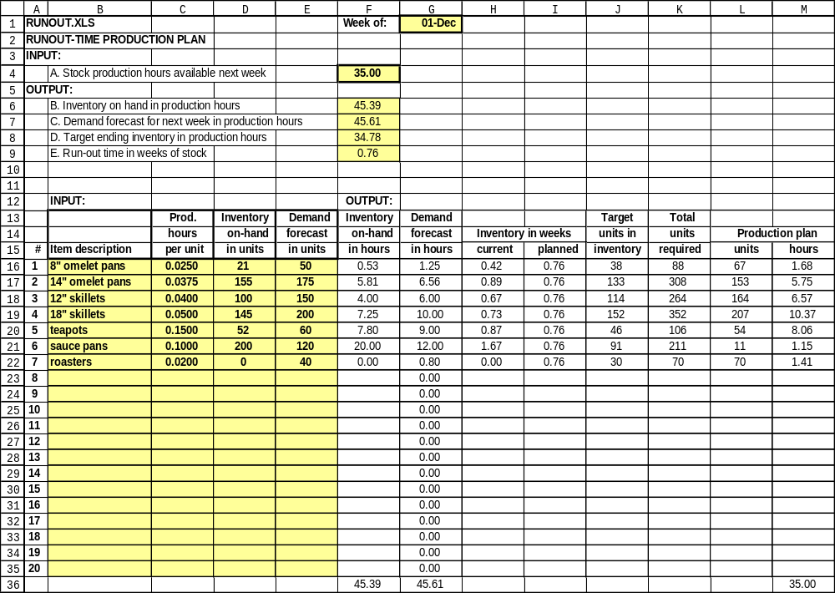
Figure 5-2

5.3 Learning curves (LEARN)

The learning curve is a widely-used model that predicts a reduction in direct labor hours or costs per unit as cumulative production increases. The most common model is used in LEARN (Figure 5-3):

Hours to produce a unit = (Hours to produce 1st unit) x (unit number)^{n}

n = (log of the slope) / (log of 2)

The slope or learning rate is always stated as a fraction less than 1.0. There is no theoretical justification for this model. The only justification is empirical: the model has been shown to make very accurate predictions of hours and costs per unit in a variety of industries, from airframe assembly to semiconductor manufacturing.

Conroe Space Systems, like other NASA contractors, uses the learning curve to plan production. In fact, learning curves are required in preparing bids to supply capital equipment for NASA and other Federal agencies. Recently, Conroe was awarded a contract to produce 20 air filtration systems in its Texas plant for the space shuttle. Based on past experience, Conroe estimated that 250 hours would be needed to produce the first unit. Thereafter, learning would proceed at a rate of 80%. These inputs in LEARN generate the output table in columns A and B. An interesting property of the learning curve is that doubling production reduces hours or costs per unit by a constant fraction, the slope. For example, in Figure 5-3, when production doubles from 1 to 2 units, the hours for unit 2 are 80% of the hours for unit 1 (250 x .80 = 200). When production doubles from 2 to 4 units, the hours for unit 4 are 80% of the hours for unit 2 (200 x .80 = 160).

When plotted on a linear scale as in Figure 5-3, all learning curves slope down and to the right. On a log-log scale, the learning curve is a straight line.

What-if analysis in LEARN is done by changing (1) the number of hours to produce the first unit in cell C4, (2) the percent slope in C5, or (3) the unit numbers in Column A of the output section. For example, suppose we need the hours for the 50th unit. Change any entry in column A to 50 and the result is 71 hours.
Figure 5-3
