
User Solutions, Inc.
(800)321-USER(8737)
11009 Tillson Drive
South Lyon, MI 48178
ph: (248) 486-1934 fax: (248)486-6376
www.usersolutions.com us@usersolutions.com

Operations Manager for Excel (C) 1997-2003, User Solutions, Inc.

General Purpose Operations and Manufacturing Management Templates. All materials are COPYRIGHTED. No part of the software or documentation may be reproduced in any form, without express permission from User Solutions, Inc.

Contact US: EMAIL: us@usersolutions.com, PH: (248) 486-1934 FAX: (248) 486-6376

Please visit our website, www.usersolutions.com for information on other flexible and easy-to-use solutions.

Scheduling Section

7.1 Job sequencing for a single work station (SKED1A) 54

7.2 Job sequencing for 2 work stations in series (SKED2A) 56
7.3 Job sequencing for 2 work stations in series (SKED3A) 58

SKED1A, SKED2A, and SKED3A schedule a group of jobs which can be done in any sequence. These models differ in the number of work stations required to process the jobs. SKED1A schedules jobs for a single work station. This station can be independent of all other processing or it can be part of a manufacturing system so complex that the only option is to schedule each work station independently. In SKED1A, you can choose to minimize flow time, the number of jobs that are late, or the maximum time late for any job. SKED2A and SKED3A are designed for flow shops of 2 or 3 work stations arranged in series. Each job receives exactly the same processing at each station. In such flow shops, there is no attempt to minimize lateness; instead, the objective is to minimize the total time needed to complete a batch of jobs.

7.1 Job sequencing for a single work station (SKED1AA)

The job sequencing models in this chapter were developed for Channelview Inspection Company, a firm introduced in Chapter 3. Channelview processes pipe for use in oil and gas fields. Customers deliver batches of pipe to Channelview for inspection and testing; they may also request cleaning and installation of end caps.

Let's start with the simplest case, scheduling a single work station. A large portion of Channelview's work involves a single station, the ultrasonic testing machine. Channelview has a backlog of 6 jobs (batches of pipe) that require ultrasonic testing. Alternative schedules to complete this work can be evaluated using the model shown in Figure 7-1. In the input section, job names, processing times, and due dates are entered. Times can represent minutes, hours, or days: It doesn't matter as long as the due dates represent the same time units.

There are 4 sequencing macros available to process these jobs. The Begin and End columns show when each job is scheduled to start and stop. Adjacent columns contain the number of time units late and a late job indicator that displays 0 if the job is early or on time and 1 if the job is late. The performance measures at the top of the worksheet show a variety of information. The total time to complete all jobs obviously does not depend on the schedule, so it will not change as you try alternative sequences. However, the other measures will change. Average completion time is the average time from the start of the schedule until each job is complete. Other measures include the maximum days any job is late and the number of late jobs. Try the alternative macros and you will get the results summarized below:

average max. days nbr. of

Sequence completion time late late jobs
F = FCFS 7.7 8.0 3
A = Min. average completion time 5.8 5.0 2
D = Min. max. days and job is late 6.8 4.0 3
N = Min. nbr. of late jobs 6.2 5.0 1

Jobs were assigned letter designations as they were received so sequence F is first-come, first-served (FCFS). FCFS is usually the worst alternative because there is no attempt to minimize any of the performance measures listed above. The objective in sequence A is to minimize average completion time. This is done by sorting jobs in ascending order of processing time. This should make sense. By doing the shortest jobs first, the average must be minimized compared to any other sequence. Sequence A is especially useful when you have cash flow problems and you want to get customer billings out the door quickly. Sequence D sorts by earliest due date and minimizes the maximum number of days that any job is late. It may be surprising to learn that such a simple procedure meets this objective. There is a mathematical proof that sequence D works, but you can convince yourself simply by doing some experimenting with the worksheet.
Figure 7-1
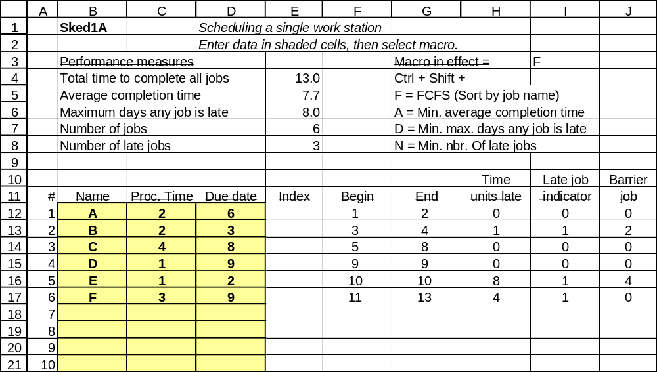
Finally, sequence N aims to minimize the number of late jobs. This is done by identifying and rescheduling "barrier" jobs. Barriers are jobs early in the schedule that prevent later jobs from being done on time; barriers are moved to the end of the schedule to free up time that can be used more profitably for other jobs. The algorithm for sequence N is:

1. Sort all jobs by due date.
2. Find the first late job in the schedule.
3. Find the length of the longest job from the beginning date through and
including the first late job. The job identified is the current barrier.
4. Move the current barrier to the end of the schedule.
5. Sort remaining jobs by due date.

You may have to run sequence N several times with a large collection of jobs. If you reach the point where there are less than 2 late jobs, the sequence is optimal and nothing more can be done.

7.2 Job sequencing for 2 work stations in series (SKED2A)

In addition to the single-work-station scheduling problem presented by the ultrasonic testing machine, Channelview also operates a flow shop with 2 work stations in series. This shop performs wire brushing at station 1 and hydrostatic testing at station 2. Every job that enters the hydro shop gets exactly the same processing at each station. The shop is scheduled using the SKED2A model shown in Figure 7-2. Unlike SKED1A, there is no consideration of lateness in SKED2A. The only objective that can be handled mathematically is to minimize makespan, defined as total time from the beginning of the schedule until the last job is complete.

Figure 7-2 shows data for 5 new batches of pipe. Times are given in hours. We want to get this set of jobs completed as soon as possible. How long will it take? The optimal solution is 12 hours. To get this solution, select Ctrl – Shift – J. How was this schedule developed? SKED2 uses a priority index to sort. The index is computed as follows for each job: If the time on station 1 is less than the time on station 2, the index is the time on station 1. Otherwise, the index is 1000 - the time on station 2. When Ctrl C is invoked, the jobs are sorted by index number in ascending order. This procedure gives exactly the same result as a widely-used manual method known as Johnson's rule:

1. List the jobs in a table.
2. Find the smallest processing time in the table.
3. If the smallest time is for the first station, place the job in the first
available position in the sequence. Otherwise, place the job in the last
available position. Ties are broken arbitrarily.
4. Remove the assigned job from the table and go to step 1.
Figure 7-2

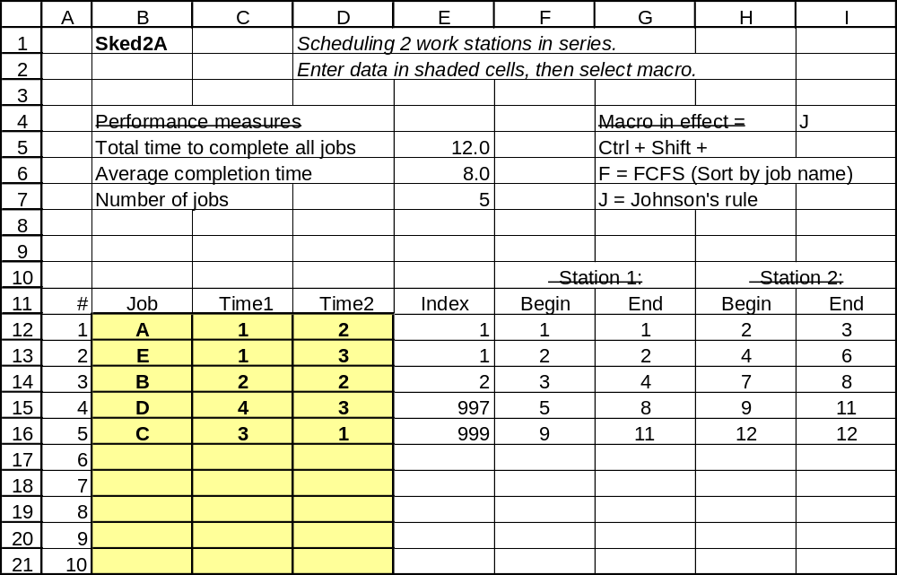

The logic underlying Johnson’s rule is straightforward. Always put the job with the smallest time on station 1 first. This allows station 2 to go to work as soon as possible. Always put the job with the smallest time on station 2 last. The reason is that processing can be finished as early as possible after the last operation on station 1. The result is that we minimize idle time. If you doubt this logic, try a schedule with jobs in first-come, first-served order. The Ctrl – Shift - F macro assumes that job letters are assigned in alphabetical order as jobs come in. The solution requires 16 hours, 33% more than the solution above, due to idle time in the schedule.

7.3 Job sequencing for 3 work stations in series (SKED3A)

Channelview also operates a 3-station flow shop managed with SKED3A illustrated in Figure 7-3. To schedule a 3-station shop, we construct an artificial 2-station shop for computational purposes and then apply Johnson's rule. In the output table, the times for stations 1 and 2 are added to form a set of artificial processing times. Times for stations 2 and 3 are added to form a second set of artificial processing times. These two sets of times are used in exactly the same manner as in SKED2A. The schedule provides the optimal makespan when at least one of two conditions is met:

(1) the minimum time on station 1 is greater than or equal to the maximum time on station 2, or
(2) the minimum time on station 3 is greater than or equal to the maximum time on station 2.

Even if the solution is not optimal, the scheduling procedure gives reasonable results.

In both SKED2A and SKED3A, there may be several alternative optimal solutions. Depending on how the jobs are sequenced before running the Ctrl – Shift – J macro, the worksheet may generate different sequences with the same makespan.
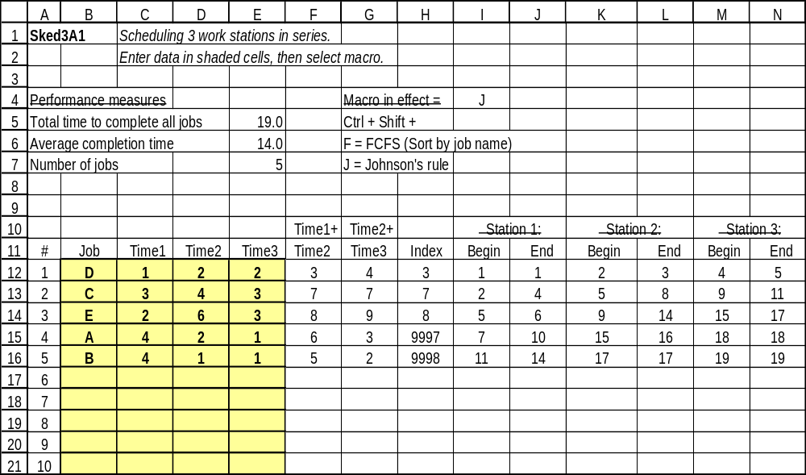
Figure 7-3

