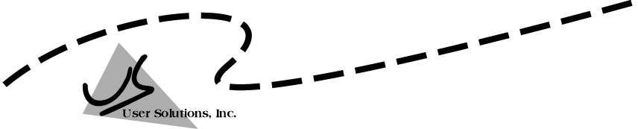
User Solutions, Inc.
(800)321-USER(8737)
11009 Tillson Drive
South Lyon, MI 48178
ph: (248) 486-1934 fax: (248)486-6376
www.usersolutions.com us@usersolutions.com

Operations Manager for Excel (C) 1997-2003, User Solutions, Inc.

General Purpose Operations and Manufacturing Management Templates. All materials are COPYRIGHTED. No part of the software or documentation may be reproduced in any form, without express permission from User Solutions, Inc.

Contact US: EMAIL: us@usersolutions.com, PH: (248) 486-1934 FAX: (248) 486-6376

Please visit our website, www.usersolutions.com for information on other flexible and easy-to-use solutions.

Quality Control Section

8.1 Acceptance sampling (ACCEPTSA) 62

8.2 Control chart for mean and range (MR-CHART) 65

8.3 Control chart for individual observations (I-CHART) 71

8.4 Control chart for percent defective (P-CHART) 73

8.5 Control chart for number of defects (CU-CHART) 75

8.6 Control limit calculator (LIMIT) 78

Sampling is the basis for most quality analysis. The ACCEPTSA model is used to sample incoming lots of material. The aim is to prevent lots containing unacceptable numbers of defective units from passing into the manufacturing system. In all of the control charts, the basic idea is to sample from a continuous production process at equal intervals of time and record some quality characteristic. Common quality characteristics are the mean and range (MR-CHART), the percent defective (P-CHART), and the number of defects per unit (CU-CHART). If the process is under control, the quality characteristics should vary about the population mean in a random manner. If a sample mean falls outside the control limits, there is a very small probability that this happened due to randomness or chance alone and the process should be investigated. You can also monitor individual quality observations rather than samples in I-CHART. If you do not want to prepare a complete control chart, use LIMIT to compute control limits for mean and range, percent defective, and defects per unit.
8.1 Acceptance sampling (ACCEPTSA)

Acceptance sampling is a procedure for screening lots of incoming material. We decide whether to accept or reject the entire lot based on the results of a sample. A sampling plan is defined by two parameters: sample size and acceptance number. The acceptance number is the maximum number of allowable defects in the sample. If the sample contains this number or fewer defects, the lot is accepted without further inspection. If the sample contains more than the maximum number of defects, the lot is rejected and a 100% inspection is conducted.

The sample size and acceptance number determine the risks faced by the producer and consumer of the lot. The producer's risk is the probability that a "good" lot will be rejected by the sampling process. Lots are defined as good if they contain no more than a certain level of defectives called the acceptable quality level (AQL). The consumer's risk is the probability that a "bad" lot will be accepted. Lots are called bad if they contain more than a certain level of defectives called the lot tolerance percent defective (LTPD). Using the binomial distribution, the ACCEPTSA worksheet (Figure 8-1) computes the producer's and consumer's risks, given the lot size, sample size, acceptance number, AQL, and LTPD.

ACCEPTSA was developed for Biggio Personal Computers, a manufacturer of IBM-compatible palmtop computers. Biggio needed the model to design a sampling plan for power supplies provided by a contractor. The power supplies arrived in lots of 1,000 units. Biggio defined bad lots as those with 5% defects (the LTPD) and wanted a consumer's risk of .10 that lots containing the LTPD would be accepted. The contractor defined good lots as those with 1% defects (the AQL) and wanted a producer's risk of .05 that lots containing the AQL would be rejected. Negotiations started at a sample size of 100 and an acceptance number of 2, which generate a producer's risk of .0803 and a consumer's risk of .1247. What can be done to make the risks hit the targets? Try increasing the sample size to 133 and the acceptance number to 3. The results are very close to the targets, with a producer's risk of .0461 and a consumer's risk of .1019.

In Figure 8-1, row 19 lists the probability of acceptance for each value of incoming quality or lot percentage defective shown in row 11. Select the OC tab in the workbook to see a graph of the values in row 19. This graph (Figure 8-2) is called an operating characteristic (OC) curve. Row 20 in Figure 8-1 computes the average outgoing quality or AOQ, the percentage of defectives that get past the sampling process, assuming that defective items found in samples are removed but not replaced with good items. Select the AOQ tab to graph the values in row 20 (Figure 8-3).

Experiment with the sample size and acceptance number and study the behavior of these graphs. If the sample size is increased with a fixed acceptance number, the OC curve becomes steeper, that is, the sampling plan becomes more discriminating. The effect is similar when the sample size is fixed but the acceptance number is decreased.
Figure 8-1

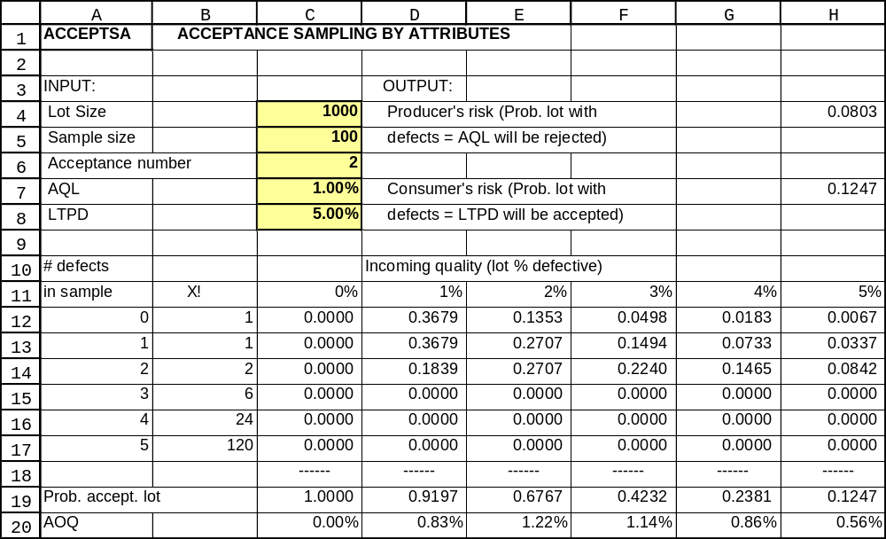
Figure 8-2

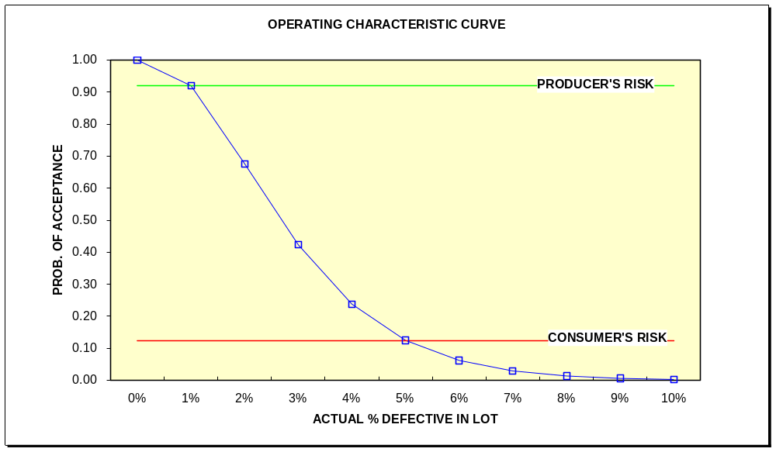
Figure 8-3

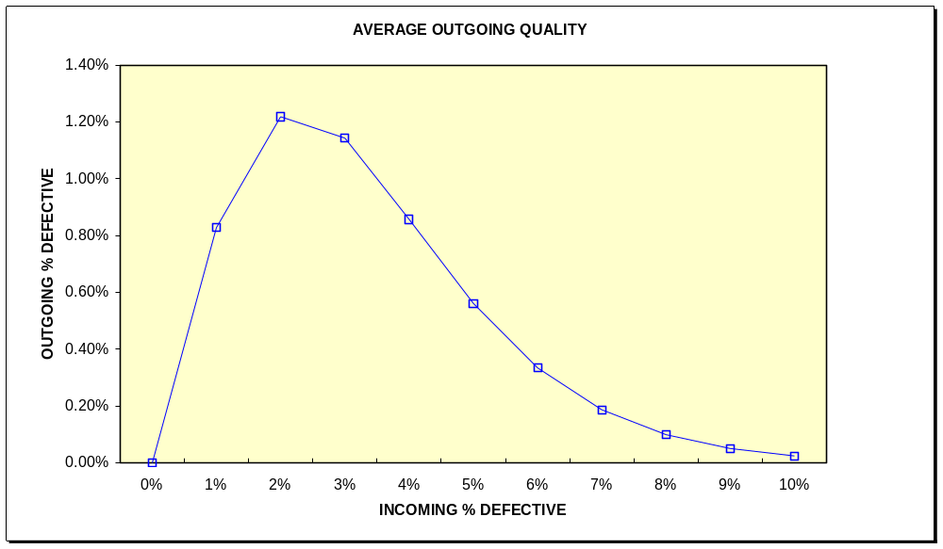
8.2 Control chart for mean and range (MR-CHART)

The basic idea in all quality control charts is to select a sample from a production process at equal intervals of time and record some quality characteristic. The most common quality characteristic is the mean of each sample. If the process is under control, the series of sample means should vary about the population mean in a random manner. That is, we should expect some natural variation in any process and there should be no real assignable cause to this variation. If the process is in control, almost all sample mean values should fall within control limits, almost always defined as the mean plus or minus 3 standard deviations. The standard deviation is a measure of the variation of a process. If all sample observations are constant, the standard deviation is zero; as variation increases, the standard deviation grows. The control charts in this chapter do not measure the standard deviation directly. Instead, the range (high value minus low value) of each sample is used as a simpler measure of variation. To establish control limits, the range is automatically converted to a standard deviation.

It is important to understand that the control chart is a management-by-exception tool. If a sample mean falls outside the control limits, there is a very small probability that this happened due to randomness or chance alone. In fact, with control limits set at 3 standard deviations, the probability is less than 1% that the sample mean occurred due to chance. There is a very large probability, more than 99%, that the sample mean is due to an assignable cause and an investigation should be conducted.

The control charts in SOM are classified as either variable or attribute charts. Variables are measurements on a continuous scale such as inches or pounds. What types of variables can be monitored with the variables control charts? Anything that can be measured and expressed in numbers, such as temperature, dimension, hardness number, tensile strength, weight, viscosity, etc. Variables are monitored in the MR-CHART worksheet for the mean and range of samples and in the I-CHART for individual observations. Attributes are discrete data such as the number of items in the sample that are defective or the number of defects in one unit of product. The P-CHART and CU-CHART models are available for attributes data.

Figure 8-4 shows MR-CHART, a model used at Texarkana Textiles Corporation (TTC), a specialty manufacturer of synthetic fibers located in Texarkana, Arkansas. The company supplies fibers to a NASA contractor, Alou Technology of Houston, which produces extra-vehicular life-support systems apparel (space suits) for astronauts. TTC's automated production system includes 6 stages: blending, molding, bonding, spinning, trimming, and packaging. The major quality concern is tensile strength after the trimming stage. Samples are taken after trimming using a tensile strength gauge. Figure 8-4 shows 16 samples of 4 measurements each. Observations are entered, starting at row 26, in thousands of pounds. As each sample is entered, the mean and range are automatically computed in columns G and H.

There are two required inputs in cells D9..D10. The first is the last sample number used to compute control limits. This feature allows you to base the control limits on a subset of the data and test them on the remainder. Although there are 16 samples available, we used only the first 15 to set control limits. This is because the last sample looks odd, with a sample mean much
Figure 8-4

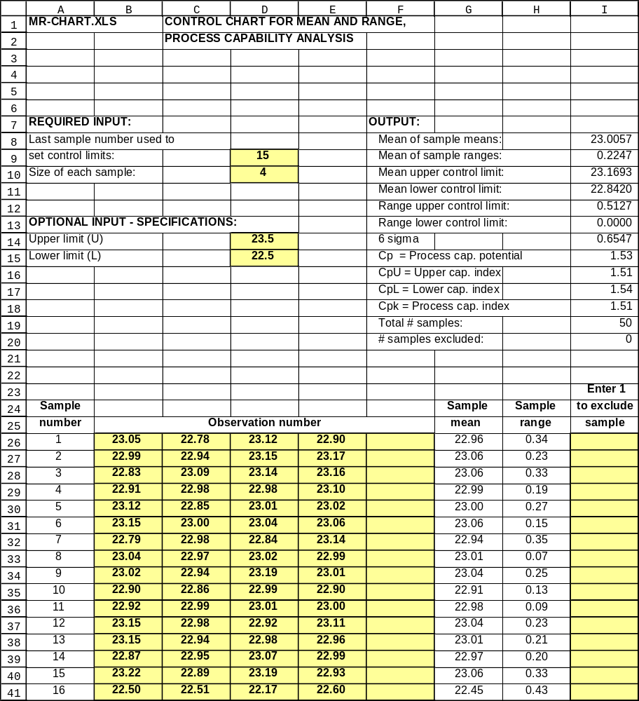

lower than the other samples. Thus we test the mean of the last sample by excluding it from control-limit calculations. The other required entry is the size of each sample, limited to the range 2 to 5. In practice, sample sizes of variables data greater than 5 are extremely rare. Most companies use sample sizes of 4 or 5 units because research shows that sample sizes in this range are usually large enough to detect significant within-sample variation but small enough to detect significant changes in the mean.

In the output section starting at row 8, the model computes the mean of the sample means and the mean of sample ranges. The control limits for the mean and range are computed as follows:
Mean upper control limit = Mean of sample means + A2 x Mean of sample ranges
Mean lower control limit = Mean of sample means - A2 x Mean of sample ranges

Range upper control limit = D4 x Mean of sample ranges
Range lower control limit = D3 x Mean of sample ranges

A2, D3, and D4 are standard conversion factors in quality control. They convert the mean of sample ranges to 3-standard-deviation control limits. The conversion factors are:
n A2 D3 D4 d2
2 1.880 0 3.267 1.128
3 1.023 0 2.574 1.693
4 0.729 0 2.282 2.059
5 0.577 0 2.114 2.316

MR-CHART computes A2, D3, and D4 in N1..O19. For sample sizes of 2-5 the D3 factor is always zero, so the range lower control limit is zero. The factor d2 is explained below.

The control charts for mean and range are plotted in Figures 8-5 and 8-6. Sample 16 is definitely unusual and TTC’s investigation and found an operator error in that sample. There are two options to exclude sample 16. We could simply erase it or we could enter 1 in cell I41. Whenever a 1 appears in column I, that sample is not used in control-limit calculations although it will continue to appear on the charts. To see the effect of column I, change cell D9 to 16 and enter 1 in cell I41—the control limits are unchanged.

Control charts for mean and range are designed to monitor sample averages, not observations for individual production units. It may be that sample averages stay inside control limits while individual observations within the samples are unacceptable. Thus we need to compare specifications for minimum and maximum values to individual observations. This comparison is called process capability analysis. The objective is to determine whether the production process is actually capable of meeting specifications for individual observations.

The first step in process capability analysis is to compute the “natural tolerance” of the production process or the range within which we can expect individual observations to vary most of the time. Natural tolerance is also called “6 sigma” because it is defined as 6 times the population standard deviation of the individual observations. The estimated population standard deviation is related to the mean of the sample ranges by a conversion factor called d2:
Figure 8-5
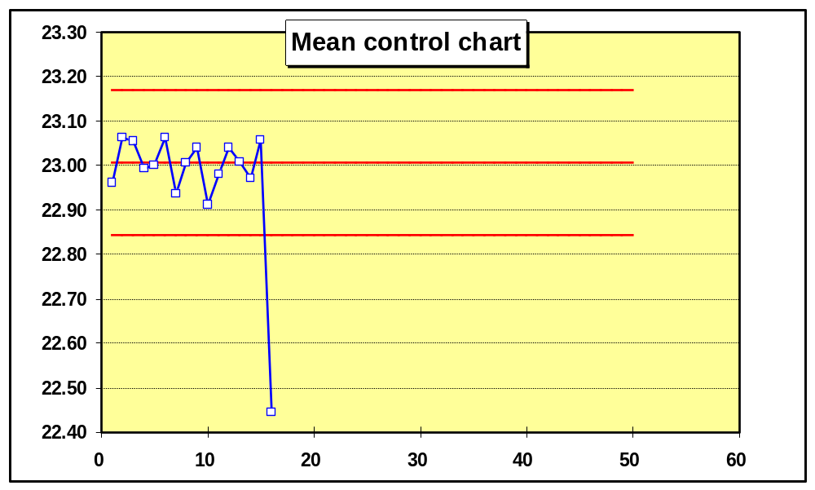

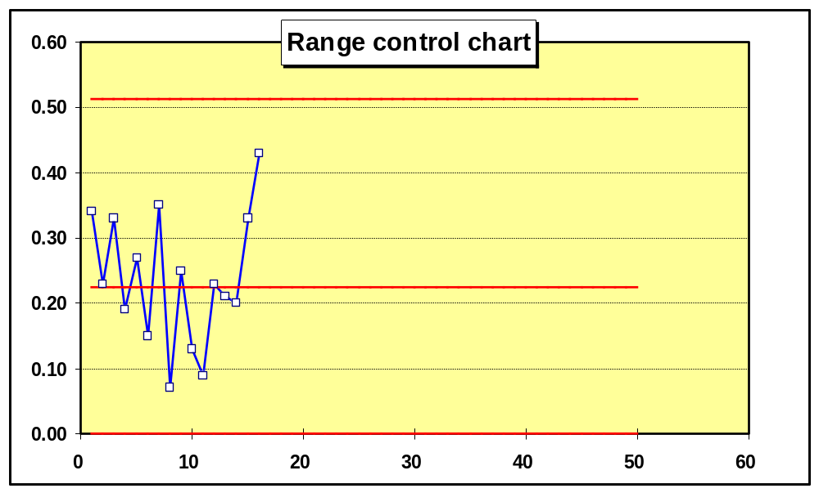
Figure 8-6

Estimated population standard deviation = Mean of sample ranges / d2

In range N1..O19, the factor d2 and the estimated population standard deviation are computed. The 6-sigma range or natural tolerance is then shown in cell I14. Given the assumption that the data are normally distributed, the 6-sigma range should include 99.7% of the individual observations, leaving only a 0.3% chance of getting an observation outside the natural tolerance.

To illustrate, Alou Technology provided the following specifications to TTC: tensile strength should be no less than 22,500 pounds and no more than 23,500 pounds. These limits are called L for lower limit and U for upper limit, respectively. Four process capability indices in cells I15..I18 help us evaluate whether TTC can meet the specifications:

C_{p} = Process capability potential = (U - L) / 6 sigma
C_{pU} = Upper capability index = (U - Mean) / 3 sigma
C_{pL} = Lower capability index = (Mean - L) / 3 sigma
C_{pk} = Process capability index = Minimum of C_{pU} and C_{pL}

If the process capability potential, C_{p}, is greater than 1.0, the specification limits are wider than the natural tolerance, and the process has the potential for meeting specifications if held in control at a mean of (U - L)/2. TTC's C_{p} is 1.53, an excellent value in most applications.

It may be surprising that it is possible to have a good C_{p} value but yet do a poor job in meeting specifications. How? The process could be off-center, with little overlap between the 6 sigma range and the U - L range. Thus the remaining indexes take centering into account. C_{pU} and C_{pL} relate the difference between the mean and the upper and lower specification limits. The minimum target value for each is 1.0. If either is less than 1.0, the process is violating a specification limit. TTC's indexes are excellent: C_{pU} is 1.51, while C_{pL} is 1.54. Since C_{pU} is smaller than C_{pL}, the process mean is closer to the upper limit, that is the process is slightly off- center. Notice that the mean in cell J10 is 23.0057 compared to the target of 23, a bit high. Finally, C_{pk} gives the worst case, the minimum of C_{pU} and C_{pL}.

The final chart in the worksheet plots individual observations within each sample for comparison to specifications. In Figure 8-7 (in the worksheet, this chart is located below the range chart), each sample is plotted vertically above the sample number. Upper and lower specification limits also appear on the chart. In sample number 16, notice that two observations fall right on the lower specification limit, while one observation is well below. A review of the process capability indexes should always be accompanied by a visual check on the data. Some observations can fall outside specifications without driving the mean and range charts out of control. The chart of individual observations may also show a tendency for the variation within samples to increase or you may find that the mean is drifting toward one of the specification limits.

Figure 8-7

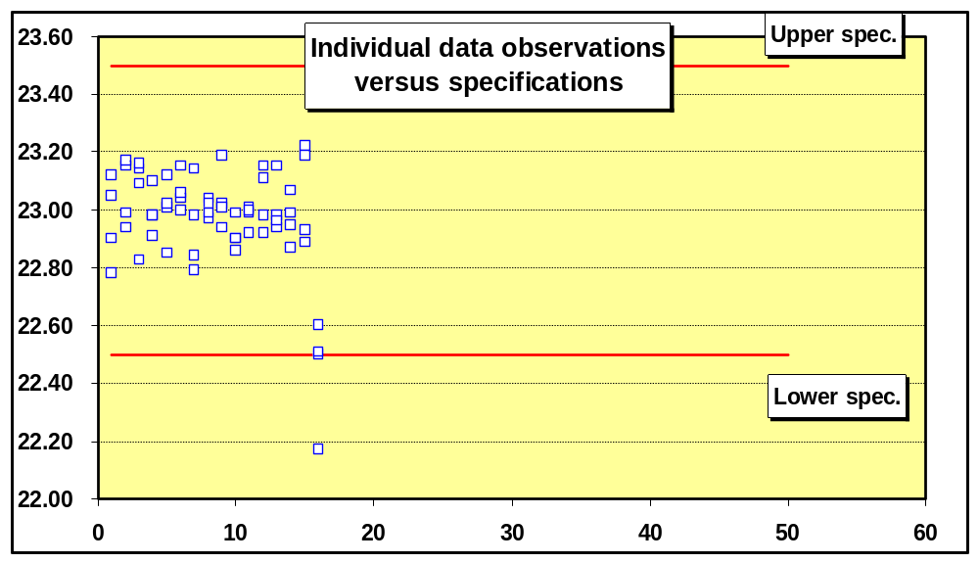

8.3 Individual observations (I-CHART)

The I-CHART is another variables control chart used to monitor individual observations (samples of one each) rather than larger samples. The I-CHART is most used in cases where a considerable period of time elapses between opportunities to collect quality observations. For example, there only be one quality observation per shift in operations with long lead times. Although the I-CHART is usually identified with manufacturing applications, it is widely used in casinos to monitor card, dice, and roulette games. The individual observations entered in the chart are typically the net cash profits recorded when a dealer settles his or her account with the house at the end of a work period.

The I-CHART model in Figure 8-8 was developed for the casino manager of the Galveston Queen, a gambling ship based in Galveston, Texas. There are three blackjack tables on the Queen, with dealers rotated on a staggered schedule every few hours. The 16 observations in range B18..B33 of the worksheet are net profits/losses recorded at the end of each dealer work period on the Queen's first Saturday night cruise. As you would expect, most observations are profits rather than losses, which places most of the natural tolerance of the process (the area between the control limits) well above the zero line on the graph. The 3-standard-deviation upper control limit is $15,030 compared to a lower control limit of -$3,221.

Control limits are based on a moving range of absolute values, defined as the difference between successive observations:

Moving range for observation 2 = |observation 2 - observation 1|
Moving range for observation 3 = |observation 3 - observation 2|
Moving range for observation 4 = |observation 4 - observation 3|
…

The brackets (||) on the right-hand sides of these equations mean that the absolute value of the difference is used. This procedure skips the moving range for observation 1 since there is no previous observation to subtract from it. Note that column C in Figure 8-8 does not show absolute values—these are computed in column Y (not shown).

Next, cell G10 computes the mean of the moving range. The estimated population standard deviation in cell J5 is based on the conversion factor d2:

Estimated population standard deviation = Mean of moving range / d2

Because the sample size is always 2 (the moving range is 2), the d2 factor is always 1.128. The control limits are:

Upper control limit = Mean of sample observations + 3 x Estimated pop. std. dev.

Lower control limit = Mean of sample observations - 3 x Estimated pop std. dev.

In most other control charts, the lower control limit is reset to zero rather than allowed to be negative. In I-CHART, the lower control limit may be negative. You can change a negative lower control limit to zero by entering zero in place of the formula in cell G12.

I-CHART monitors only the values of individual observations. It is possible to develop a second control chart to monitor the moving range. However, interpretation of moving range charts is difficult. Such charts are uncommon in practice and not considered here.

Figure 8-8
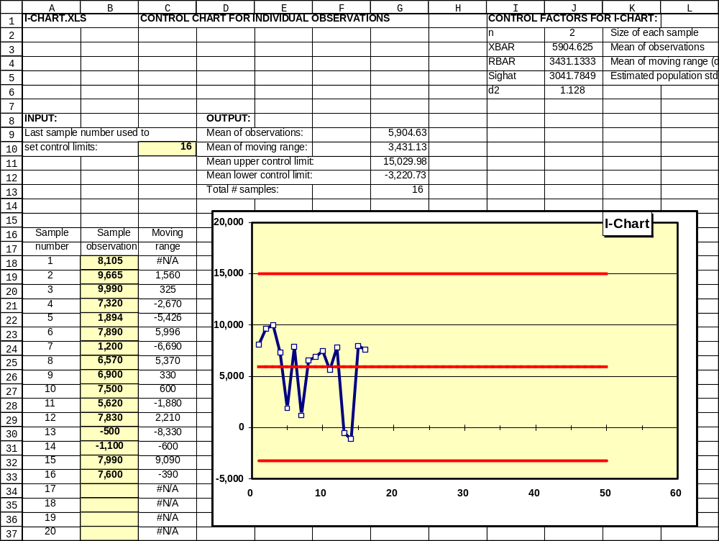

8.4 Control chart for percent defective (P-CHART)

P-CHART is the most versatile and popular control chart. To use P-CHART, quality inspectors classify sample items into two groups: good or bad. This can mean defective or non-defective, conforming or non-conforming to specifications, acceptable or unacceptable, or other definitions in which there are only two categories of results.

Brookshire Cookware Corporation, a producer of pots and pans located in Brookshire, Texas, uses P-CHART worksheets to monitor the quality of component parts received from its Mexican suppliers. At the end of each business day, Brookshire faxes a copy of each P-CHART to its suppliers. This feedback helps maintain a good working relationship with suppliers and alerts them to potential problems.

Brookshire is known for its line of teakettles, which have harmonicas inserted in the nozzles. When water boils, the harmonicas play one of several melodies, depending on the model. Since the harmonicas are major selling features, it is critical to ensure that they produce the correct tones. Brookshire conducts 100% inspections of harmonicas by blowing compressed air through them. A P-CHART to track defective harmonicas is shown in Figure 8-9. There are 30 samples, each with 500 units, as shown in column B. For each sample, the number of defective units is recorded in column C. To set control limits, you must also enter the last sample number in cell D10.

Percent defective and individual control limits are computed for each sample in columns E – G. Control limits are based on (1) the individual sample percent defective and (2) the overall mean percent defective for all samples computed in cell K2. Unlike MR-CHART, sample sizes can vary in P-CHART, making individual control limits for each sample necessary.

The control chart shows only one out-of-control point, sample number 24, with 9 defects, a sample percentage of 1.80%, compared to an upper control limit of 1.78%. Brookshire's production manager discussed this sample with the supplier, Reynosa Musica, who could find no cause for the problem. Next, the manager experimented with excluding the sample from control limit calculations. Enter a 1 in cell D41 and you will get a revised mean percent defective for all samples of 0.64% in cell K2, compared to 0.68% in the original worksheet. The upper control limit shrinks only marginally to 1.71%, compared to 1.78% in the original worksheet. Since there is no particular reason for the defective harmonicas in sample 24 and the sample makes little difference in the control limits, the manager decided to leave it in the control limit calculations.

The first step in developing control limits is to compute the mean percent defective for all samples in cell K2. The standard deviation of the mean percent defective is computed as follows:

Std. dev. of mean percent defective = [((Mean percent def.)(1 - Mean percent def.))/n]^{1/2}
Figure 8-9
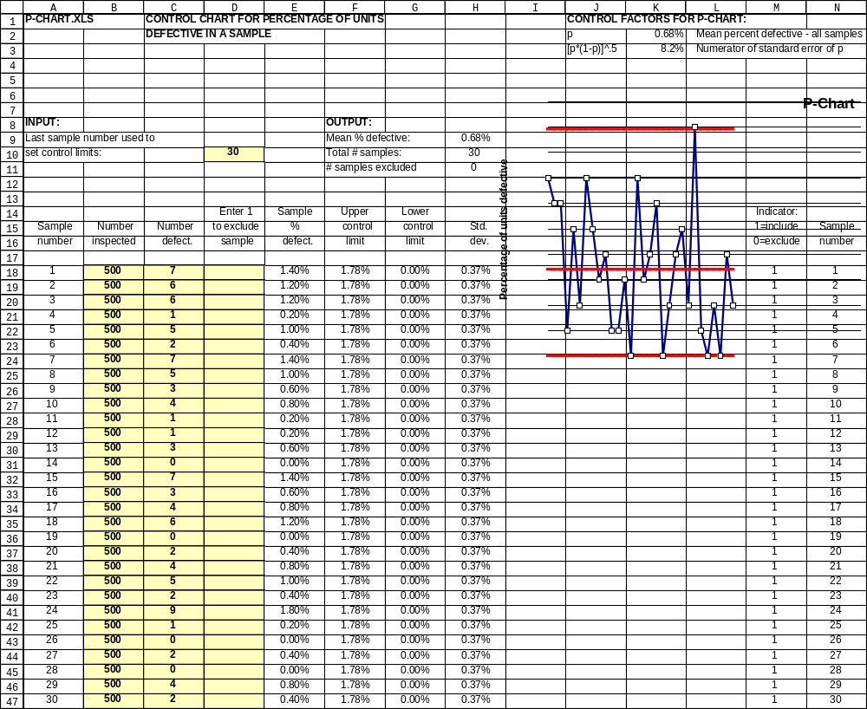

where n is the sample size. The numerator of this formula is computed in cell K3. The standard deviation values for each sample start at row 18 in column H. Each standard deviation is the fixed numerator divided by the square root of the individual sample size. The control limits in columns F and G are:

Upper control limit = Mean percent defective + 3 x Std. dev. of mean percent defective

Lower control limit = Mean percent defective - 3 x Std. dev. of mean percent defective

The mean percent defective is usually computed from the data. If you wish to use a known or standard value, enter that value as a decimal fraction in cell K2. No other modifications to the worksheet are necessary.

It should be obvious that some defects must occur in the samples observed before a P-CHART can be applied. The better the quality, the larger the sample must be in order to find some defects. For example, if only 0.1% of the product is defective, the sample size must be at least 1,000 units before there will be an average of one defect per sample. On the other hand, a sample of 10 units is adequate when there is a defect rate of 10%. Thus with excellent quality, the P-CHART is useful in detecting problems only if the sample is large; with poor quality, the P-CHART works well with small samples.

8.5 Control chart for number of defects (CU-CHART)

Occasionally, product classification as merely good or bad is not enough and variable measurements do not apply. For example, in evaluating the quality of a new automobile, there could be many defects but it would be misleading to classify the entire automobile as unacceptable. The solution in situations like this is another attributes chart, the CU-CHART (Figure 8-10), which monitors the number of defects per inspection unit. In general, the inspection unit is usually expected to have some defects and we wish to know whether the number of defects is excessive. CU-CHART is also valuable when dimensions or units of measure complicate quality assessments. For example, suppose that a coil of steel is 100 meters long and contains 7 lamination defects. What is the defect rate? It could be 7/100 = 7%. But the defects are small, each perhaps a centimeter in length. There are 10,000 centimeters in the coil so the defect rate becomes 0.07%. We could also compute the square centimeters in the area of the coil and compute yet another defect rate. The only sensible way around this problem with dimensions is to state quality in terms of total number of defects per inspection unit.

Three conditions must be satisfied to use CU-CHART. First, the definition of an inspection unit must be constant from one time period to the next. Second, there must be a very large number of opportunities for defects to occur in each unit produced. Third, the probability that a defect will occur at any particular location in each unit must be very small.

Figure 8-10
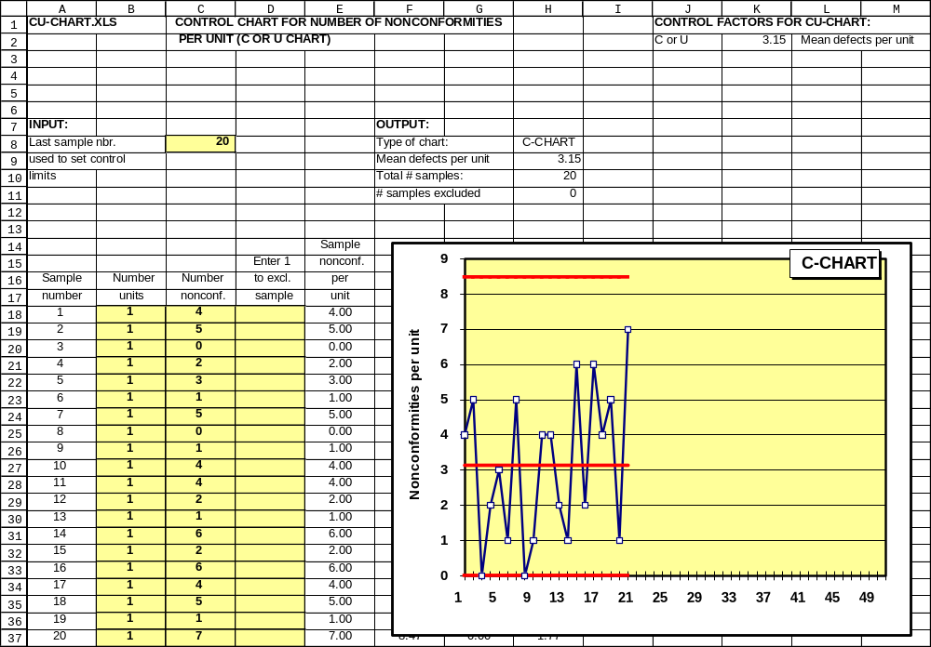

CU-CHART is really two models in one. C-CHART is standard quality-control jargon for a control chart of the number of defects per unit when each sample is exactly one unit. U-CHART is the name for a chart of defects per unit when the sample size is greater than one. The names come from common notation for the Poisson distribution: C denotes mean occurrences (usually defects) per unit for samples of size one, while U denotes mean occurrences per unit for larger sample sizes. A formula in cell H8 automatically supplies the correct name for the chart.

The example in Figure 8-10 is a C-CHART because the data are samples of one unit each of enameled pot bodies. Brookshire Cookware visually inspects the pots for enameling defects defined in the company quality assurance manual as "pits, cracks, lumps, chips, and splinters." The number of units in each sample and the number of defects in each unit are entered in columns B and C. Cell C8 contains the last sample number used to set control limits.

Mean defects per unit is computed in cell H9 and serves as the basis for the control limits, which are computed as follows:

Std. error of mean defects per unit = (Mean defects per unit/n)^{1/2}

Upper control limit = Mean defects per unit + 3 x Std. error of mean defects per unit

Upper control limit = Mean defects per unit + 3 x Std. error of mean defects per unit

where n is the sample size. Note that if n = 1, the standard error is just the square root of the mean. What if the value of mean defects per unit is known? Enter that value in cell K2 in place of the formula. The rest of the worksheet operates with no further changes needed. As in P-CHART, individual standard errors and control limits are computed for each sample and are found in columns F - H of the worksheet (not shown).

8.6 Control limit calculator (LIMIT)

LIMIT, shown in Figure 8-11, is a calculator for control limits in MR-CHART, P-CHART, and CU-CHART. All control limits are based on 3 standard deviations. If you want different limits, edit the control limit formulas. Change the number 3 in any formula to a new value. In the mean and range section, the size of each sample (B6) can vary from 2 to 25 units. Note that the grand mean (the mean of the sample means) must be entered in cell B7. In the percent defective section, the total number of defects (found in all samples) must be entered in cell E7. In the section for the number of defects per unit, the total number of defects (from all samples) must be entered in cell B18.

Figure 8-11

