
User Solutions, Inc.
(800)321-USER(8737)
11009 Tillson Drive
South Lyon, MI 48178
ph: (248) 486-1934 fax: (248)486-6376
www.usersolutions.com us@usersolutions.com

Operations Manager for Excel (C) 1997-2003, User Solutions, Inc.

General Purpose Operations and Manufacturing Management Templates. All materials are COPYRIGHTED. No part of the software or documentation may be reproduced in any form, without express permission from User Solutions, Inc.

Contact US: EMAIL: us@usersolutions.com, PH: (248) 486-1934 FAX: (248) 486-6376

Please visit our website, www.usersolutions.com for information on other flexible and easy-to-use solutions.

Analysis of Waiting Lines Section

9.1 Single-server queues (SINGLEQ) 80

9.2 Multiple-server queues (MULTIQ) 83

In almost every organization, there are examples of processes which generate waiting lines called queues. The worksheets in this chapter automate the most practical models for analyzing the behavior of queues. SINGLEQ includes 4 alternative models for a single queue processed by a single server or service facility. All models in SINGLEQ assume that arrivals to the queue are generated by a Poisson process. The models differ in the probability distribution that generates service times, the queue capacity or waiting space available, and the size of the source population feeding the queue. MULTIQ analyzes problems in which customers form a single queue processed by 2 or more servers. MULTIQ assumes that arrivals are Poisson, service times are exponential, and there is no restriction on queue capacity or the size of the source population.
9.1 Single server queues (SINGLEQ)

Figure 9-1 automates four single-server queuing models distinguished by the alternative assumptions listed at the top of the worksheet. Pay careful attention to assumptions to ensure that you apply the correct model. Operation of any model is easy: all you have to do is change the input parameters in rows 8-12. Inputs are not applicable in cells that display "xxxx."

The basic queuing model is in column D, with Poisson arrivals, exponential service times, and both infinite waiting capacity and source population. Let's use this model to analyze an operations problem faced by the Cattleman's National Bank of Angleton, Texas. Cattleman's runs a branch office, with one teller, in the student union at Rosharon State University. Cattleman's has received many complaints about waiting times on Friday, the peak business day at Rosharon. Stop-watch studies show that customer arrivals on Friday average 36 per hour, Poisson-distributed, and the teller serves 40 customers per hour, exponentially-distributed.

Just how bad is waiting time? Enter these arrival and service rates in SINGLEQ and the results indicate that the mean time in the queue is 0.225, while mean time in the system (waiting time plus service time) is 0.250. These numbers are interpreted as fractions of the time unit used to measure the arrival and service rates. The rates are per hour, so the mean time in the queue is 0.225 of an hour or 0.225 x 60 = 13.50 minutes. Mean time in the system is then 0.250 x 60 = 15.00 minutes. (In some queuing problems, arrivals and service rates are per day, so you would multiply by 24 hours to obtain the solution in hours. In other problems, rates might be per 15-minute interval, so you would multiply by 15 to get the solution in minutes.) The results also show that the mean number in the queue is 8.1 customers and the mean number in the system is 9.0. The probability that the server is idle is only .10, so the probability that the server is busy is .90. A table showing the probability that exactly N customers are in the system is available in the lower half of the worksheet.

Cattleman's is considering replacing the teller with a banking machine to reduce Friday waiting times. An analysis shows that more than 90% of Rosharon Friday transactions are cash withdrawals, that is, cashing of personal checks and withdrawals from savings accounts. A stop-watch study at other Cattleman's machine locations reveals that service time for cash withdrawals is not exponential. Thus we cannot use the basic model in column D. But we can use the model in column G, a variation of the basic model which allows for any service-time distribution. Column G requires the mean and standard deviation of service times. The stop-watch study gives a mean of 90 seconds and a standard deviation of 8 seconds. The service rate for model input is (60 x 60)/90 = 40 per hour, the same as the teller. The standard deviation is 8 seconds and must be converted for model input as follows: 8/(60 x 60) = .002222.

Entering these values in column G shows that the banking machine can cut the time in the queue to 0.113 x 60 = 6.78 minutes, about half the time for a human teller. Time in the system is .138 x 60 = 8.28 minutes, another substantial cut. Numbers of customers in the queue and system are also reduced. How can this be if the banking machine has the same service rate as the human teller? The answer is that machine service times are much less variable than with a human teller. Queuing statistics always improve when you reduce the variability of service times.
Figure 9-1

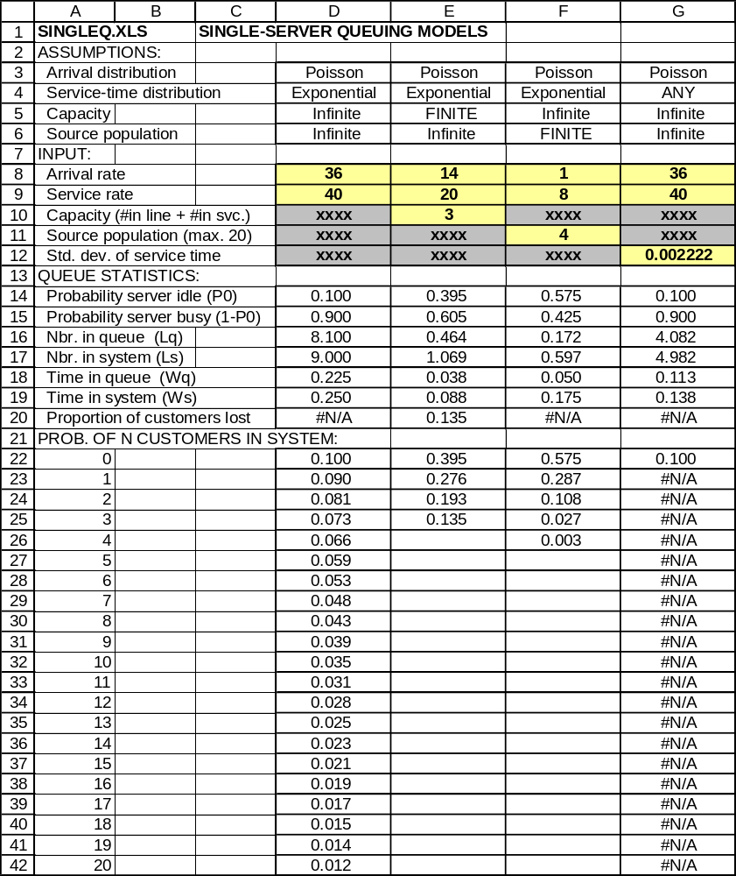

Unlike the basic model, in the any-service-time model it is impossible to compute the probability of any specific number of customers in the system, except when the system is empty. Otherwise, all queuing statistics in the basic model are available in the any-service-time model.

Another important variation of the basic model is shown in column E, where there is some maximum number of customers that can be in the system at any one time. The maximum includes customers waiting as well as in service. The finite-capacity model is useful in analyzing another Cattleman's location, a drive-in branch in the suburbs of Santa Fe. The branch has one teller window and space for 3 cars (1 in service and 2 in line). The branch is located on a busy street and when the system is full, customers are reluctant to wait in the street. Arrivals during peak business times are 14 per hour, with service at the rate of 20 per hour. How many customers are lost (forced to drive on because the waiting line is full)? Enter the arrival and service rates and a capacity of 3 in the model in column E and the proportion of customers lost is 0.135. What if Cattleman's expands the driveway to hold 4 cars (1 in service and 3 waiting)? The proportion lost falls to 0.087. Expansion to 5 cars reduces the proportion lost to 0.057.

The final single-server model in column F applies when the source population feeding the queue is limited. This model is widely used to analyze repair operations that support a specific population of equipment. For example, in the DeWalt Lubricants plant in Sugar Land, Texas, 4 machines fill 32-ounce cans of motor oil. The machines are the source population in the model and require frequent adjustment by a mechanic. Adjustment problems (arrivals) are Poisson at the rate of 1 per hour, and the mechanic can serve 8 per hour, exponentially-distributed. How much production time is lost per hour due to machines in service or waiting for adjustments? The answer is given by the time in the system of 0.175 x 60 = 10.50 minutes. DeWalt is considering adding a second bank of 4 filling machines identical to the present machines. If the single mechanic serves all 8 machines, what happens to lost production time? Assume that the arrival rate will double to 2 per hour. The source population is now 8. Enter these changes in SINGLEQ and the time in the system becomes 0.531 x 60 = 31.86 minutes.

Formulas for the basic single-server queuing model are straightforward. Let A be the mean arrival rate per unit time and M be the mean service rate. Queue statistics are computed as follows:
Mean number in the queue = A² / [M(M-A)]
Mean number in the system = A / (M-A)
Mean time in the queue = A / [M(M-A)]
Mean time in the system = 1 / (M-A)
Probability the server is busy = A / M

Formulas for the other single-server models and the multiple-server model are quite complex and not reviewed here.
9.2 Multiple-server queues (MULTIQ)

Many service facilities operate with a single waiting line that feeds several servers. Customers must wait on the first available server. The MULTIQ model in Figure 9-2 analyzes this type of system under the following assumptions: Poisson arrivals, exponential service times, and both infinite waiting capacity and source population. MULTIQ is a useful management tool at Cattleman's Bank, where all multiple-teller branches operate with a single waiting line. Cattleman's management attempts to keep customer time in the queue to 1 minute or less. This goal is achieved by changing the number of teller windows that are open as arrival rates change during the business day. In Cattleman's large commercial branch in Thompsons, Texas, arrivals are Poisson and average 40 per hour during the 9 AM - 10 AM period on Monday mornings. The service rate per teller is 20 per hour. How many teller windows must be open at 9 AM on Mondays?

In Figure 9-2, the time in the queue with 3 tellers is .022 x 60 = 1.32 minutes, so we must operate with 4 tellers. Enter this value and the result is time in the queue of .004 x 60 = .24 (about 14 seconds). Now try a number of servers equal to 2 in MULTIQ. The queue statistics display ERR. Why? The arrival rate of 40 is equal to the total service rate of 2 tellers x 20 = 40 per hour. All queuing systems blow up when arrival rates are equal to service rates. The reason is that servers can never catch up when arrivals vary above the mean. The same problem occurs in SINGLEQ if you set an arrival rate equal to a service rate.
Figure 9-2

