Design Analysis and Algorithm – Lab Work
Week 7

Write a program to implement job sequencing.

METHOD:

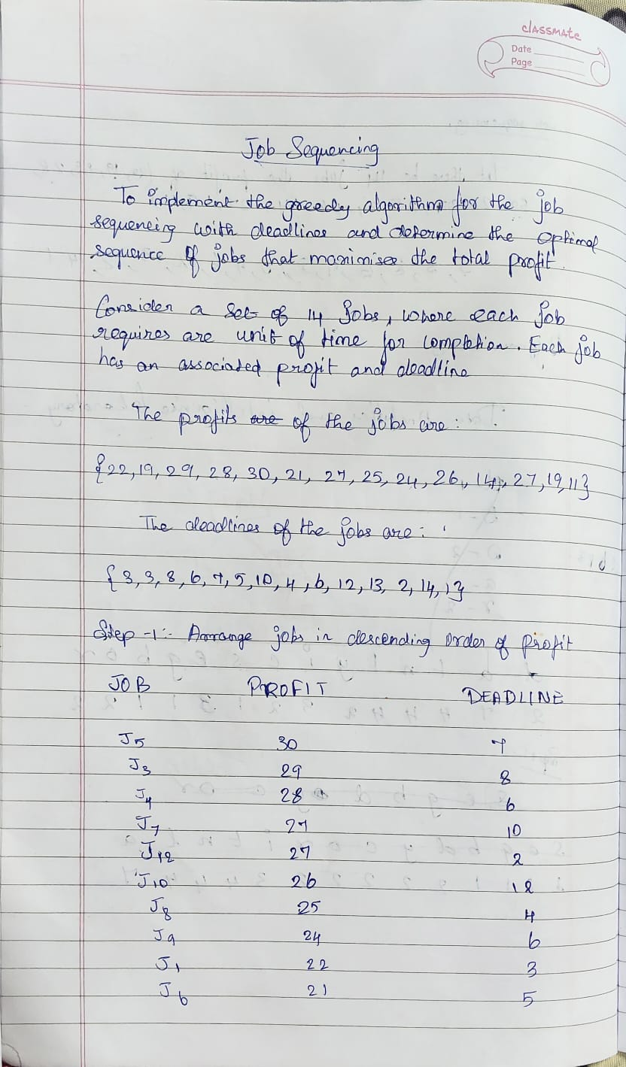

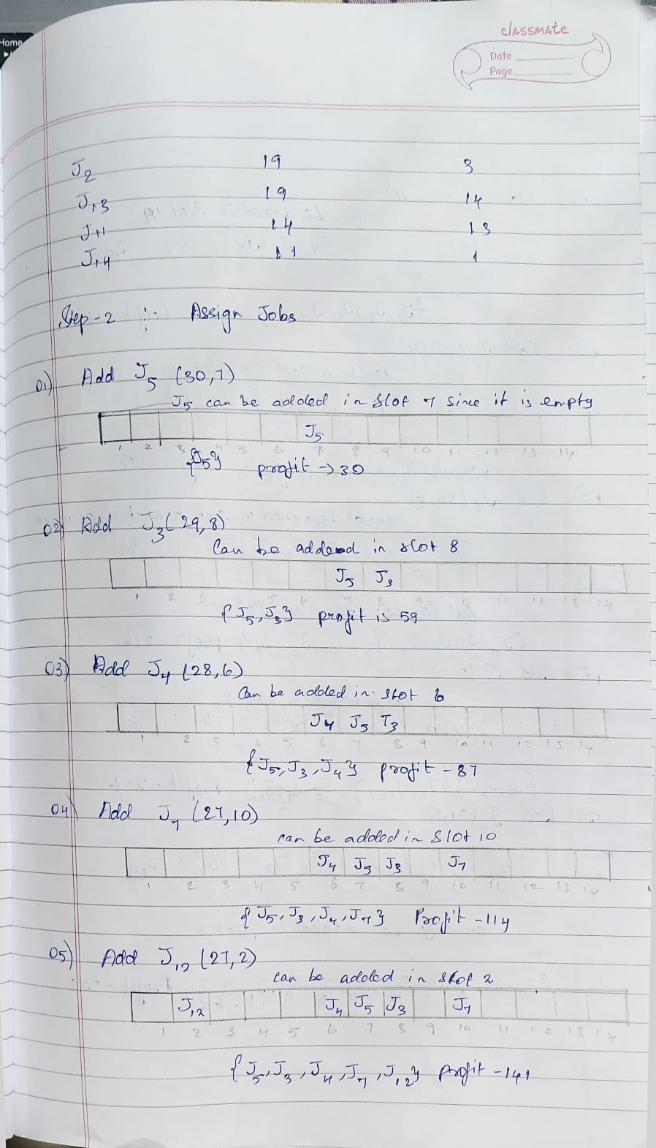
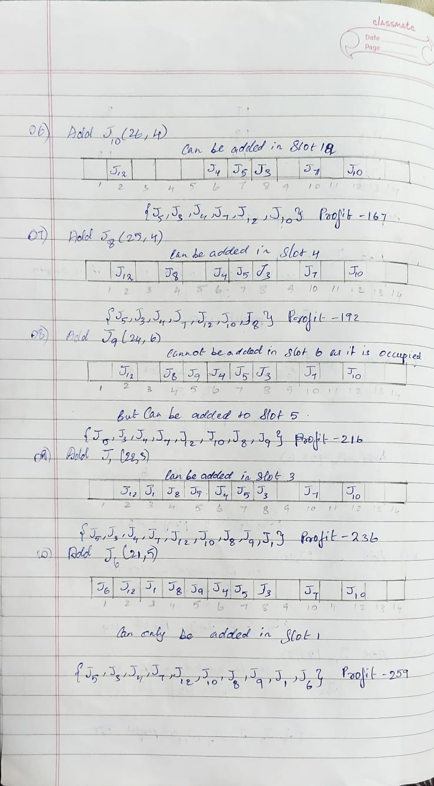
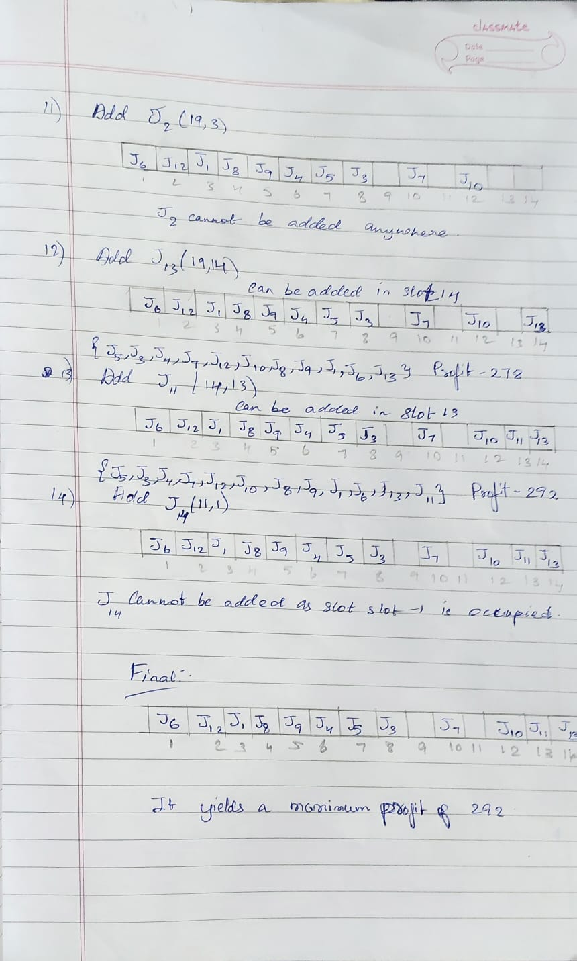

CODE:
#include <stdio.h>
#define LIMIT 50

struct Task
{
char name[5];
int due;
int gain;
};

void arrangeByProfit(struct Task list[], int count)
{
int a, b;
struct Task swapTemp;

for (a = 0; a < count - 1; a++)
{
for (b = a + 1; b < count; b++)
{
if (list[a].gain < list[b].gain)
{
swapTemp = list[a];
list[a] = list[b];
list[b] = swapTemp;
}
}
}
}

int main()
{
struct Task list[LIMIT];
int totalTasks, x, y, highestDeadline = 0;
int schedule[LIMIT];
int overallProfit = 0;

printf("Enter total number of tasks: ");
scanf("%d", &totalTasks);

for (x = 0; x < totalTasks; x++)
{
printf("Enter Task name, Profit value and Deadline: ");
scanf("%s %d %d", list[x].name,
&list[x].gain,
&list[x].due);

if (list[x].due > highestDeadline)
highestDeadline = list[x].due;
}

arrangeByProfit(list, totalTasks);

for (x = 0; x <= highestDeadline; x++)
schedule[x] = -1;

for (x = 0; x < totalTasks; x++)
{
for (y = list[x].due; y > 0; y--)
{
if (schedule[y] == -1)
{
schedule[y] = x;
overallProfit += list[x].gain;
break;
}
}
}

printf("\nSelected Task Order:\n");
for (x = 1; x <= highestDeadline; x++)
{
if (schedule[x] != -1)
printf("%s ", list[schedule[x]].name);
}

printf("\nMaximum Profit Earned: %d\n", overallProfit);|
#include <stdio.h>
#define LIMIT 50

struct Task
{
char name[5];
int due;
int gain;
};

void arrangeByProfit(struct Task list[], int count)
{
int a, b;
struct Task swapTemp;

for (a = 0; a < count - 1; a++)
{
for (b = a + 1; b < count; b++)
{
if (list[a].gain < list[b].gain)
{

return 0;
}

OUTPUT:

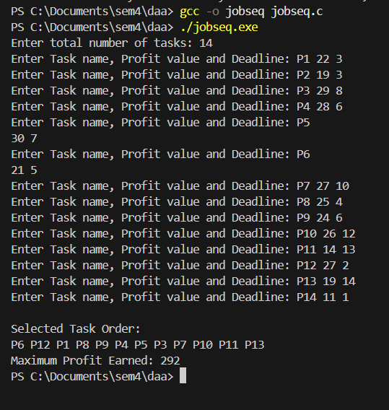

Time Complexity:
The Job Sequencing algorithm first sorts the jobs in decreasing order of profit and then assigns each job to the latest available slot before its deadline. The sorting step takes $O(n^{2})$time when simple sorting methods are used. During scheduling, each job may require checking multiple slots up to its deadline, which in the worst case also takes $O(n^{2})$time. Hence, the overall time complexity of the algorithm is $O(n^{2})$.

Space Complexity:
The algorithm uses additional space to store the job list and the slot array used for scheduling. These require space proportional to the number of jobs, resulting in a space complexity of $O(n)$. The algorithm is non-recursive, so no extra stack space is required.

