Design and
Analysis of Algorithms
-Space Complexity

Name:S.Halitha Begam
Roll-No:CH.SC.U4CSE24157
- Write a program to find sum of first n natural numbers, using user defined function.

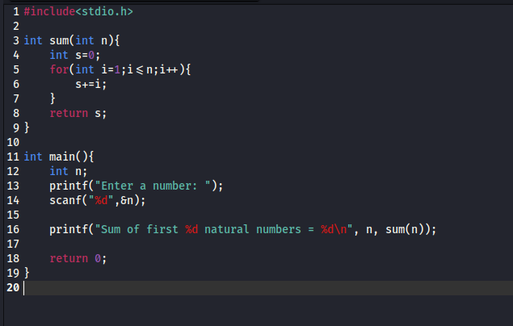
Code:

Output:
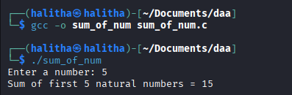

Space complexity:
Space here remains constant because only fixed variables (i, s, n) are used, regardless of the input size n.
Space Complexity=O(1)
- Write a program to find sum of squares of first n natural numbers.
Code:
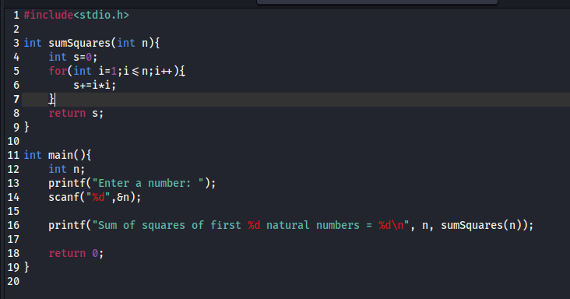

Output:
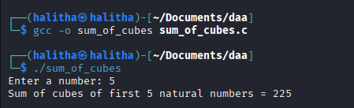

Space Complexity:
Space here remains constant too because here also only fixed variables (i, s, n) are used, regardless of the input size n.
Space Complexity=O(1)

- Write a program to find sum of cubes of first n natural numbers.

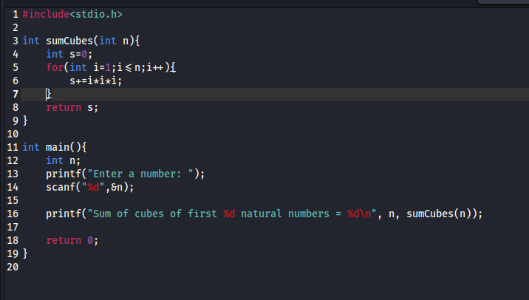
Code:

Output:

Space Complexity:
Space here remains constant too because here also only fixed variables (i, s, n) are used, regardless of the input size n.
Space Complexity=O(1)

- Write a program to find a factorial of the given integer using recursion.

Code:
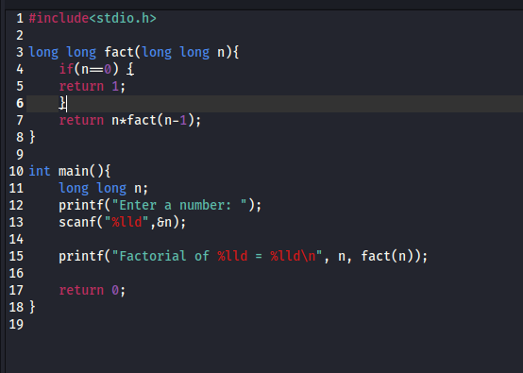

Output:

Space complexity:

Number of recursive calls is n so memory used is n.
Space Complexity=O(n)

- Write a program for transposing a 3X3 matrix.

Code:
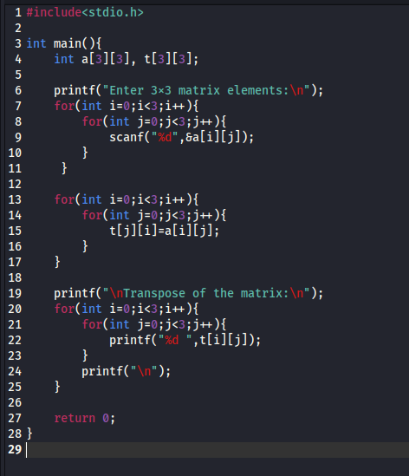
Output:
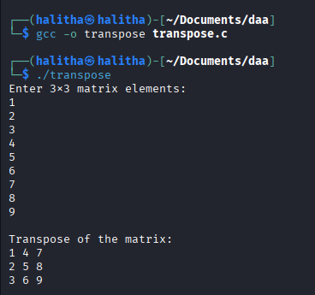

Space Complexity:

The matrix size is fixed here as (3×3) so space does not depend on input.
Space Complexity=O(1)

- Write a program to find fibonacci series.

Code:

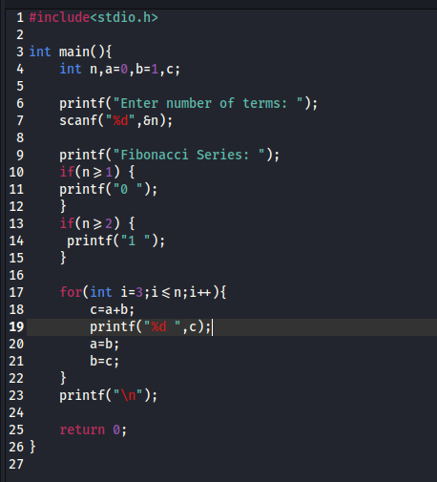

Output:

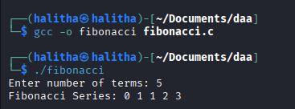

Space Complexity:

Only three variables (a, b, c) are repeatedly updated here .
No additional space or recursion is used.
Space Complexity=O(1)

