Design and
Analysis of Algorithms
-Sorting Techniques

Name:S.Halitha Begam
Roll-No:CH.SC.U4CSE24157
- Write a program to implement Bubble sort

Code:
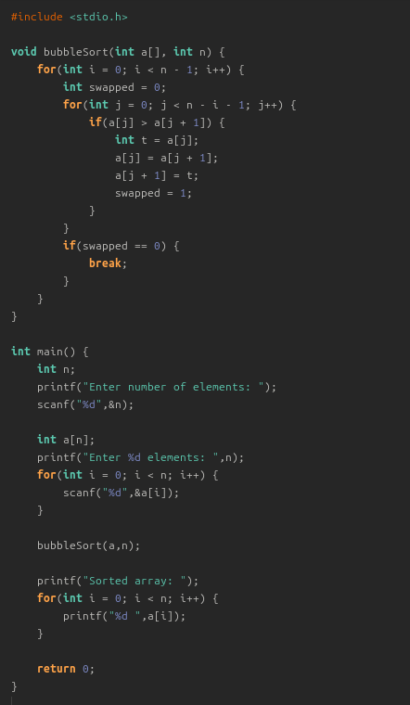

Output:
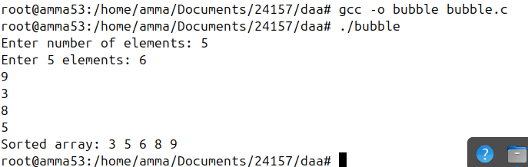

- Write a program to implement Insertion sort

Code:

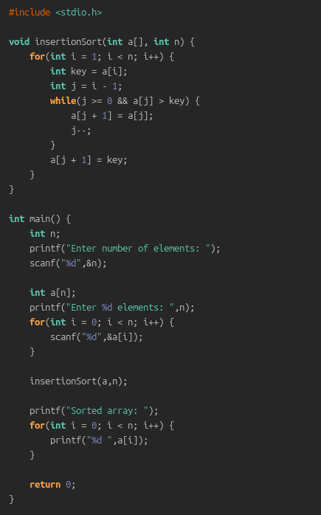

Output:
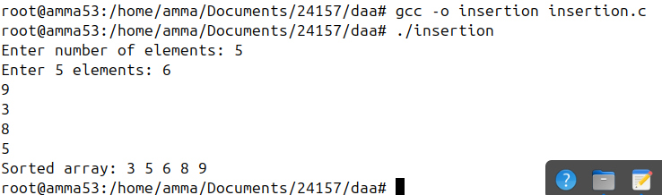

- Write a program to implement Selection sort

Code:
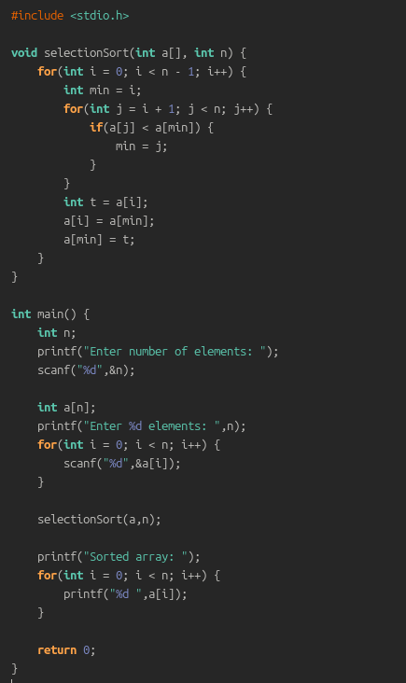

Output:
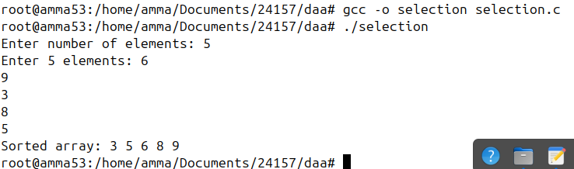

4a. Write a program to implement Heap sort(max)

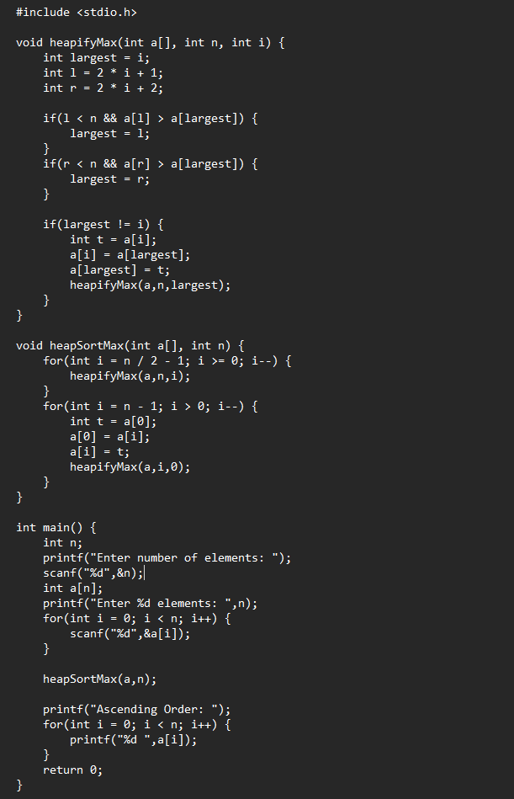

Output:
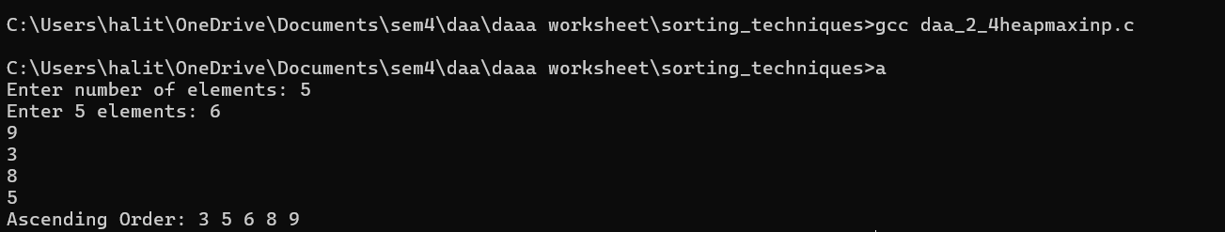

4b. Write a program to implement Heap sort(min)

Code:

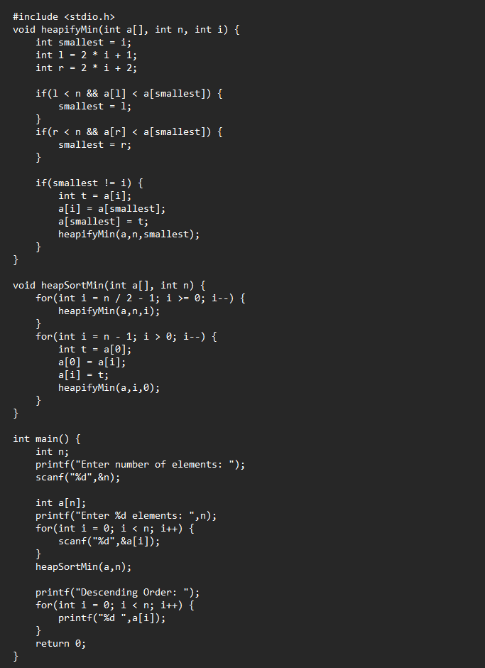

Output:
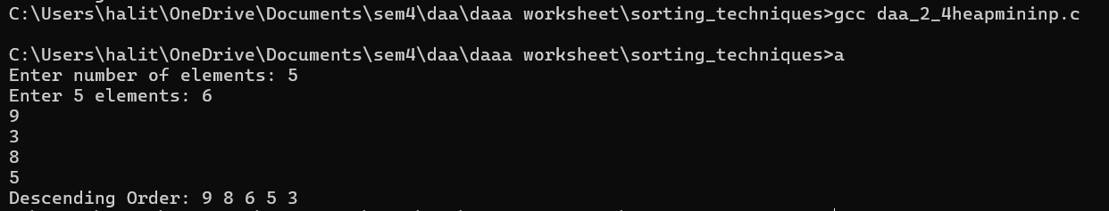

- Write a program to implement Bucket sort

Code:
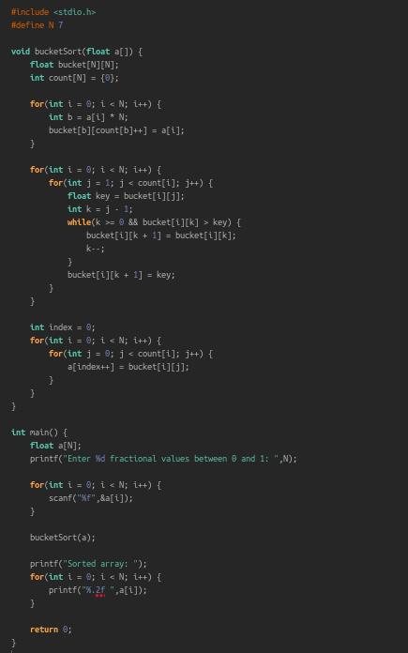

Output:
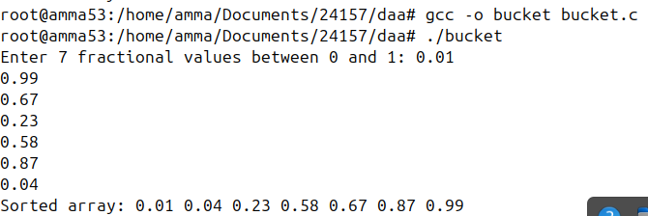

- Write a program to implement bfs
Code:
#include <stdio.h>
#include <stdlib.h>
#include <stdbool.h>

#define MAX 5

struct Vertex {
char label;
bool visited;
};

// Queue variables
int queue[MAX];
int rear = -1;
int front = 0;
int queueItemCount = 0;

// Graph variables
struct Vertex* lstVertices[MAX];
int adjMatrix[MAX][MAX];
int vertexCount = 0;

// Queue functions
void insert(int data) {
queue[++rear] = data;
queueItemCount++;
}

int removeData() {
queueItemCount--;
return queue[front++];
}

bool isQueueEmpty() {
return queueItemCount == 0;
}

// Graph functions
void addVertex(char label) {
struct Vertex* vertex = (struct Vertex*) malloc(sizeof(struct Vertex));
vertex->label = label;
vertex->visited = false;
lstVertices[vertexCount++] = vertex;
}

void addEdge(int start, int end) {
adjMatrix[start][end] = 1;
adjMatrix[end][start] = 1;
}

void displayVertex(int vertexIndex) {
printf("%c ", lstVertices[vertexIndex]->label);
}

int getAdjUnvisitedVertex(int vertexIndex) {
for (int i = 0; i < vertexCount; i++) {
if (adjMatrix[vertexIndex][i] == 1 && lstVertices[i]->visited == false) {
return i;
}
}
return -1;
}

void breadthFirstSearch() {
lstVertices[0]->visited = true;
displayVertex(0);
insert(0);

while (!isQueueEmpty()) {
int tempVertex = removeData();
int unvisitedVertex;
while ((unvisitedVertex = getAdjUnvisitedVertex(tempVertex)) != -1) {
lstVertices[unvisitedVertex]->visited = true;
displayVertex(unvisitedVertex);
insert(unvisitedVertex);
}
}

// Reset visited flags for next traversal
for (int i = 0; i < vertexCount; i++) {
lstVertices[i]->visited = false;
}
}

int main() {
// Initialize the adjacency matrix
for (int i = 0; i < MAX; i++) {
for (int j = 0; j < MAX; j++) {
adjMatrix[i][j] = 0;
}
}

addVertex('S'); // 0
addVertex('A'); // 1
addVertex('B'); // 2
addVertex('C'); // 3
addVertex('D'); // 4

addEdge(0, 1); // S - A
addEdge(0, 2); // S - B
addEdge(0, 3); // S - C
addEdge(1, 4); // A - D
addEdge(2, 4); // B - D
addEdge(3, 4); // C - D

printf("Breadth First Search: ");
breadthFirstSearch();

return 0;
}

Output:

- Write a program to implement dfs
Code: #include <stdio.h>
#include <stdlib.h>
#include <stdbool.h>

#define MAX 5

struct Vertex {
char label;
bool visited;
};

// Stack variables
int stack[MAX];
int top = -1;

// Graph variables
struct Vertex* lstVertices[MAX];
int adjMatrix[MAX][MAX];
int vertexCount = 0;

// Stack functions
void push(int item) {
stack[++top] = item;
}

int pop() {
return stack[top--];
}

int peek() {
return stack[top];
}

bool isStackEmpty() {
return top == -1;
}

// Graph functions
void addVertex(char label) {
struct Vertex* vertex = (struct Vertex*) malloc(sizeof(struct Vertex));
vertex->label = label;
vertex->visited = false;
lstVertices[vertexCount++] = vertex;
}

void addEdge(int start, int end) {
adjMatrix[start][end] = 1;
adjMatrix[end][start] = 1;
}

void displayVertex(int vertexIndex) {
printf("%c ", lstVertices[vertexIndex]->label);
}

int getAdjUnvisitedVertex(int vertexIndex) {
for (int i = 0; i < vertexCount; i++) {
if (adjMatrix[vertexIndex][i] == 1 && lstVertices[i]->visited == false) {
return i;
}
}
return -1;
}

void depthFirstSearch() {
lstVertices[0]->visited = true;
displayVertex(0);
push(0);

while (!isStackEmpty()) {
int unvisitedVertex = getAdjUnvisitedVertex(peek());
if (unvisitedVertex == -1) {
pop();
} else {
lstVertices[unvisitedVertex]->visited = true;
displayVertex(unvisitedVertex);
push(unvisitedVertex);
}
}

for (int i = 0; i < vertexCount; i++) {
lstVertices[i]->visited = false;
}
}

int main() {
for (int i = 0; i < MAX; i++) {
for (int j = 0; j < MAX; j++) {
adjMatrix[i][j] = 0;
}
}

addVertex('S'); // 0
addVertex('A'); // 1
addVertex('B'); // 2
addVertex('C'); // 3
addVertex('D'); // 4

addEdge(0, 1); // S - A
addEdge(0, 2); // S - B
addEdge(0, 3); // S - C
addEdge(1, 4); // A - D
addEdge(2, 4); // B - D
addEdge(3, 4); // C - D

printf("Depth First Search: ");
depthFirstSearch();

return 0;
}

Output:

