**MANUAL**

**BMI Calculator and Database Log**

1. Be sure to input the values correctly, since null or non-numeric values will cause an error, the date is automatically set

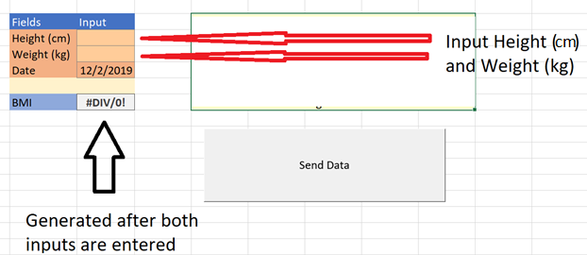

1. Clicking on Send Data will prompt this window

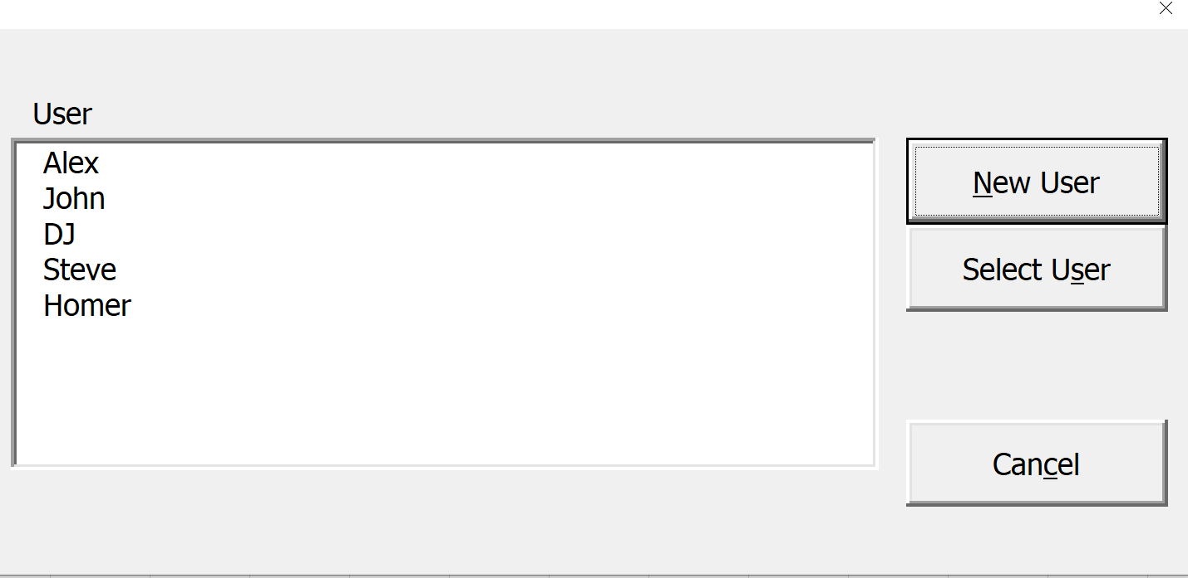

1. Select the appropriate user to record the data for. If no such user exists, click the New User Button to create a new user.
2. 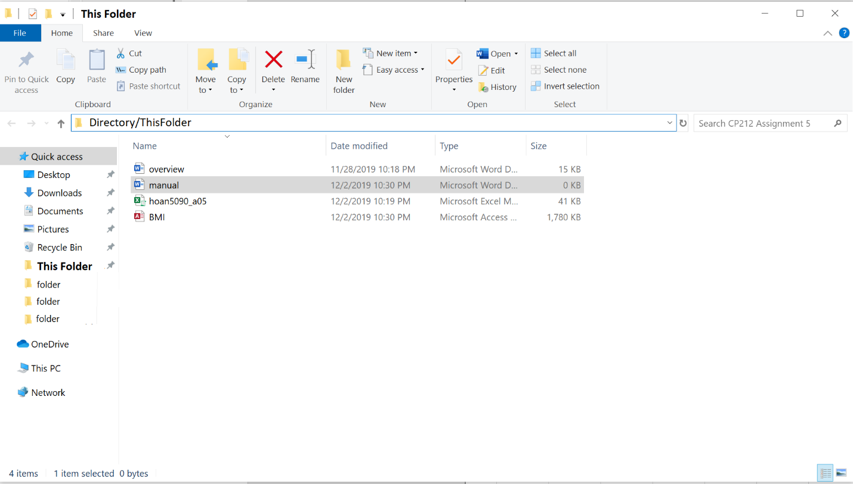

If you want to access your data, be sure to open the BMI.accdb file to view your log once updated.

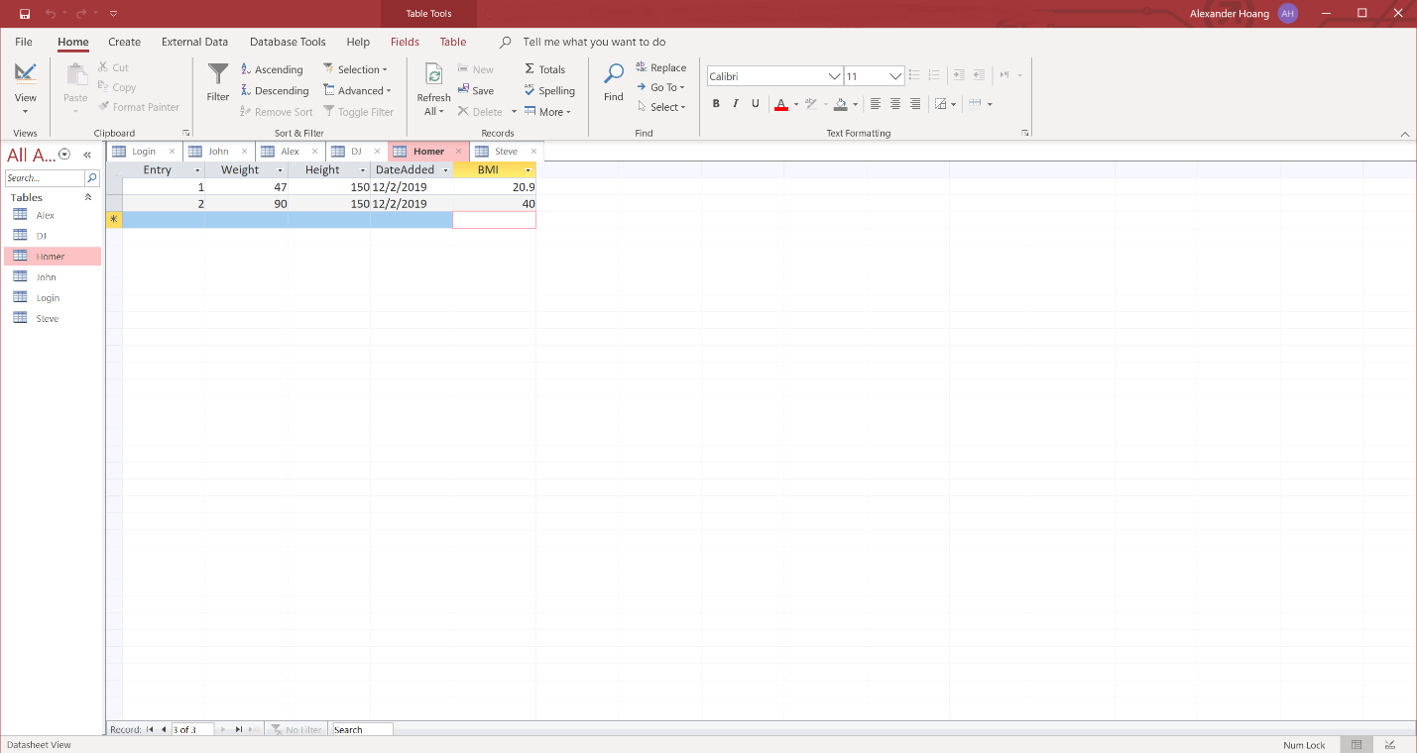

Errors:

Inputting in the Excel Sheet:

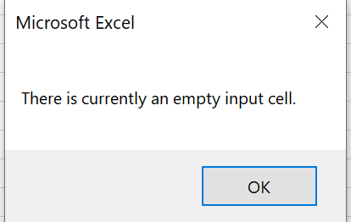

Occurs when there are one or more missing fields (weight and height)

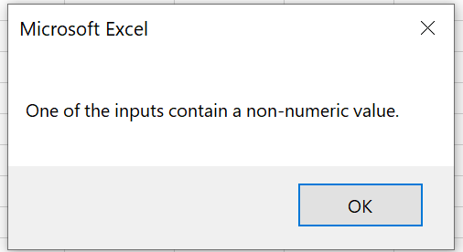

Non-numeric value is added

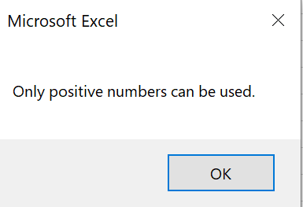

A 0 or negative value is inputted

Selecting Users

1. If new user is selected and no value is inputted or 2 or more words are sent, a prompt will notify the user of such error.
2. If there are no selected user, an error will occur

**END**