# Running the data logger

1. Navigate to the folder Documents/co2_log  
   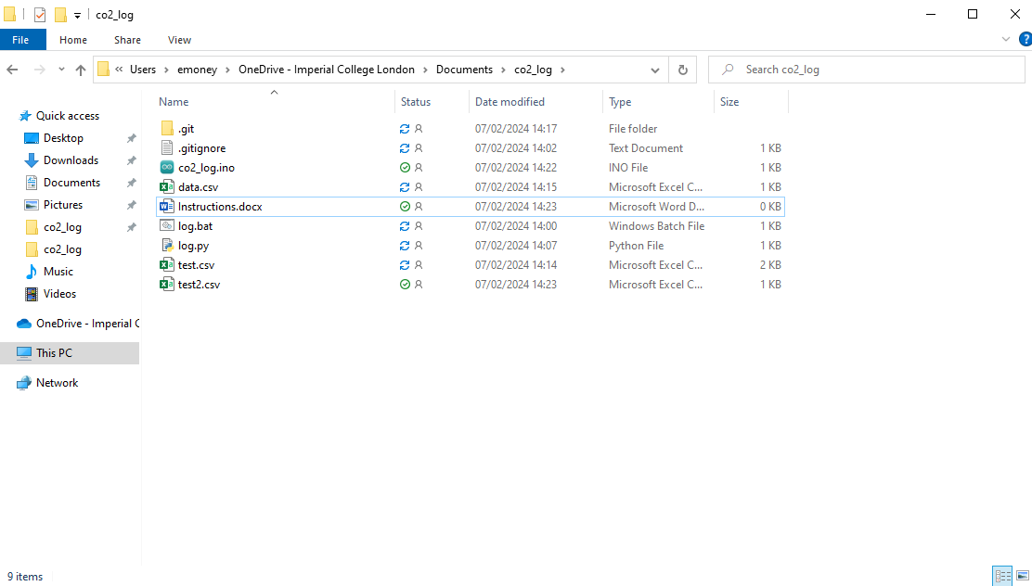
2. Run “log.bat”  
   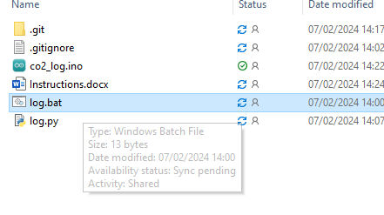
3. A window should pop-up where you can enter the filename  
   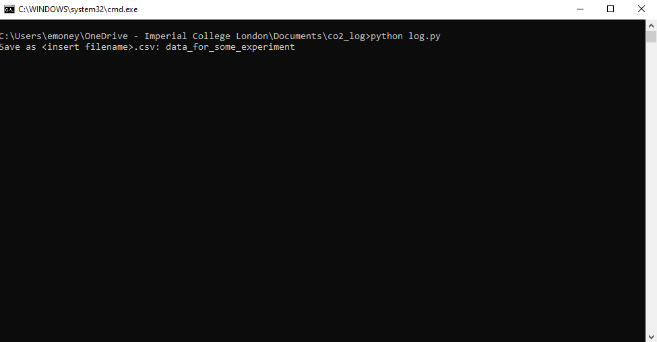
4. Values should pop-up in the format of milliseconds,ppm. Typical ambient values for a calibrated sensor should be around 400  
   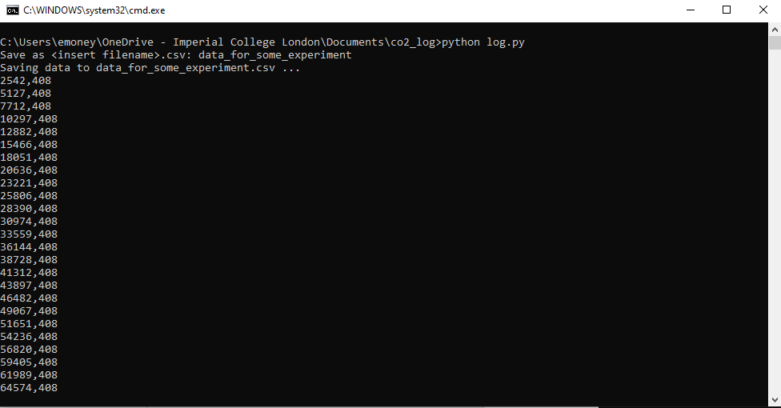
5. To stop logging simply close the window. The data should be saved and the file synced to OneDrive.  
   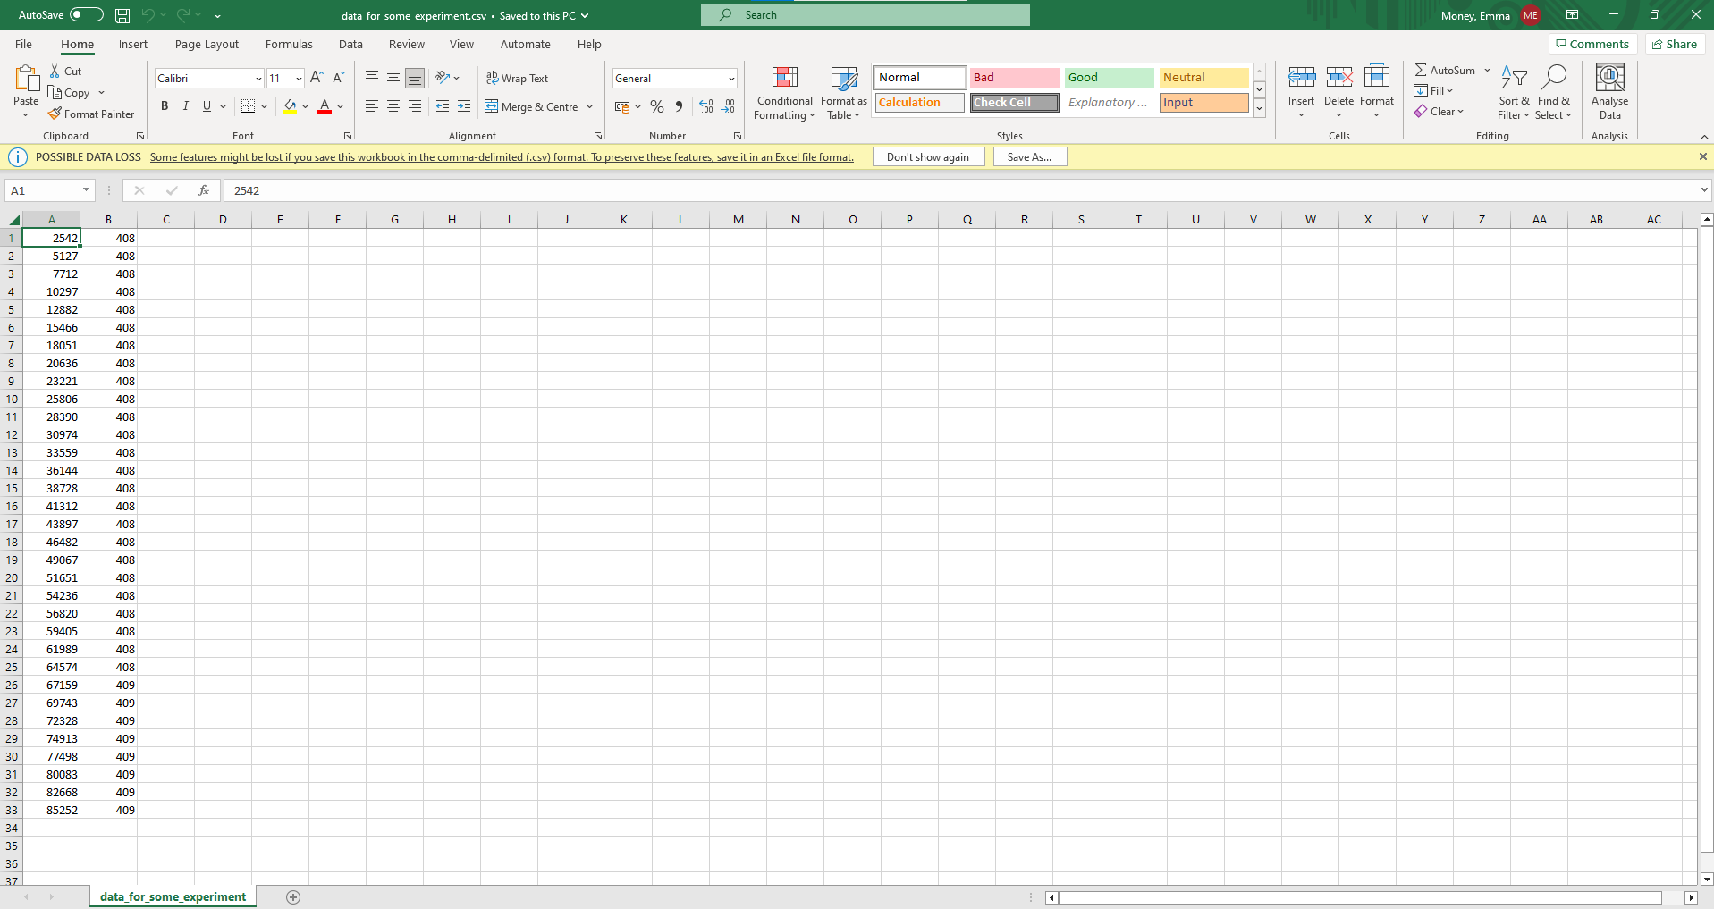

# Calibration

1. Before calibrating, plug in the Arduino to the computer and let it run at ambient conditions for roughly 20 minutes.
2. Open co2_log.ino  
   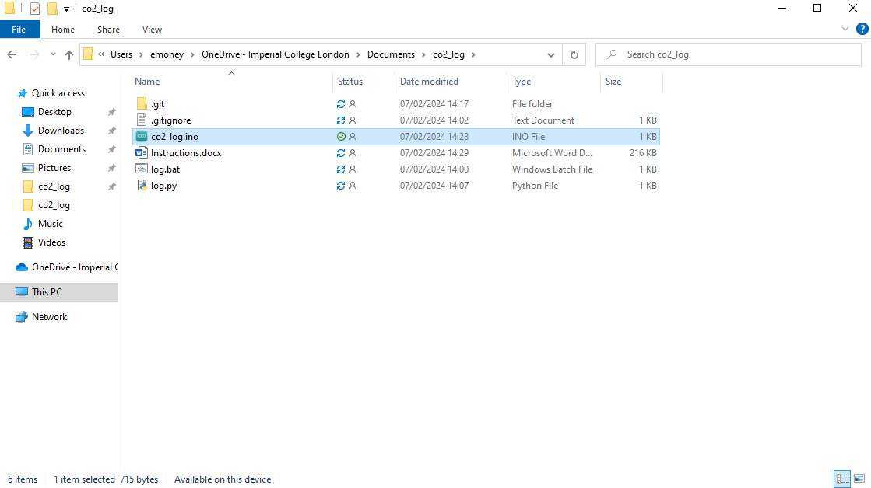
3. Double check that Arduino Uno is selected in the top left corner  
   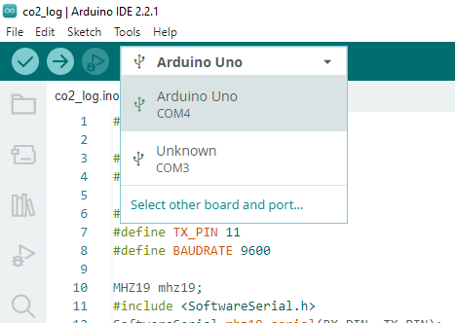
4. Change bool calibrate = false; to bool calibrate = true; (make sure the semi-colon isn’t accidentally deleted)  
   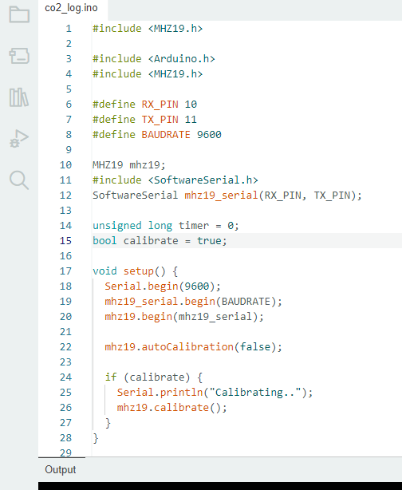
5. Press the upload button in the top left corner  
   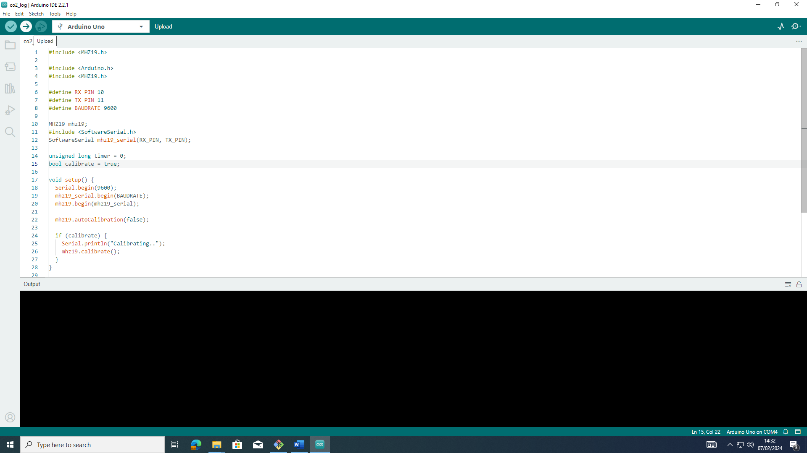
6. The Arduino should now be calibrated. To prevent accidental calibration while the Arduino is in a container with higher levels of CO2, change bool calibrate back to false  
   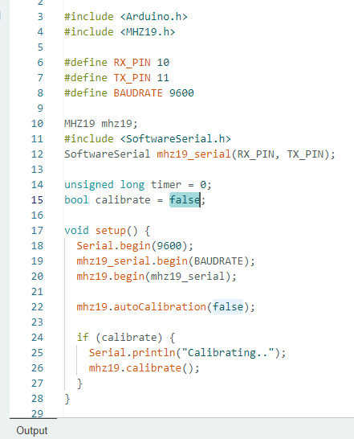

# Wires setup

1. The red wire connects to the Arduino on the port that says 5V. The red wire connects to the green wire coming out of the sensor.
2. The black wire connects to any one of the ports on the Arduino that says GND. The black wire connects to the yellow wire coming out of the sensor.
3. The white wire connects to the port that says ~10 on the Arduino (on the other side of 5V and GND). The white wire connects to the white wire coming out of the sensor.
4. The orange wire connects to the port that says ~11 on the Arduino. The orange wire connects to the blue wire coming out of the sensor.