[http://appleinsider.com/articles/12/09/11/apple_designers_reportedly_divided_over_use_of_skeuomorphic_uishttp://appleinsider.com/articles/12/09/11/apple_designers_reportedly_divided_over_use_of_skeuomorphic_uis](http://appleinsider.com/articles/12/09/11/apple_designers_reportedly_divided_over_use_of_skeuomorphic_uis)

Critics say Apple's use of skeuomorphic design is too pervasive, overstepping its intended purpose to simplify a user's experience and in some cases actually causes confusion. The Notes app's yellow sketchpad and the stitched-leather theme found in a number of newer iOS apps are examples of non-functional design.

Behar takes particular issue with the wooden bookshelves in Apple's iBooks and Newsstand apps.  
"The digital bookshelf doesn’t really work like a bookshelf," Behar said. "You’re throwing all this extraneous visual noise at me and it’s confusing. My brain, which is used to the physical bookshelf, is confused because of the differences in usability. It’s cute, but not particularly useful."

"I feel like [Apple] has concentrated too much on mimicking the visual skeuomorphic approach rather than concentrating on the actual functionality," said the former Apple designer. "To me, it’s lipstick on a pig. There’s no need to add glitter if the product can stand on its own."

<http://medialoot.com/blog/skeuomorphic-design/>

Sometimes, doing things the fun skeuomorphic way isn't always the most efficient. For example an app might require a 3 or 4 finger gesture for something that could have been achieved with a single tap.

Skeuomorphic designs that have superfluous images or decoration are basically wasting screen real-state that for some users, especially mobile users is in short supply.

* erwin schober

Mar 15, 2012 at 4:35 pm

though i think it can be very useful to easily understand an interface (like with the propellerhead interface for audio devices), i find this most often pretty annoying usability-vise. i don’t need to plug a virtual cable into a virtual mixing desk or flip a page in a virtual book..

* 
* Michael Junge
* Mar 20, 2012 at 7:03 am
* Thank you for a great article. To the list of Bad Points I’d add Risk of Bad Taste grin What I mean is that with a skeuomorphic design, as opposed to a more abstract or neutral design, you risk loosing clients/users to what they might think is an ugly or wrong design for the object it associates to in real life, which is clear in the love/hate case of Apple’s iCal an Address Book. I quickly had the leather look removed on my mac, allthough I never tamper with theese things. The leather look with the torn off paper edges was just too weird and, to me at least, totally useless. It doesn’t serve a functional or tactile purpose like the design of the synth and the Propellerhead instruments does, and it did not associate well to my real world - I would never choose a light brown leather calendar book in real life either grin
* 
* MCF
* Apr 19, 2012 at 11:35 am
* “Familiarity” is in the eye of the beholder.

<http://www.getyourcontent.com/1/86862-0/What-is-skeuomorphic-user.aspx>

* **Visual Noise:** Filling a user interface design with more and more detail might make it more visually interesting but this all adds to the traffic or noise of a UI design. In the end it is just more user interface design elements crying out for attention. The faux stitching in iCal has no added value and even if it weren't there users would not all of a sudden not realize that they are dealing with a calendar app!

<http://webdesign.tutsplus.com/articles/design-theory/skeuomorphism-in-interface-design/>

*an element of design or structure that serves little or no purpose in the artifact fashioned from the*[*new*](http://webdesign.tutsplus.com/articles/design-theory/skeuomorphism-in-interface-design/)*material but was essential to the object made from the original material –*[*Wikipedia*](http://en.wikipedia.org/wiki/Skeuomorph)

It is worth noting that Apple is particularly good at targeting this, generally, older and less technologically experienced user group.

With this in mind, it is necessary (as it always is) to consider your target audience when designing your new application or website

For example, a leather-look texture (with the obligatory stitching) can stimulate memories of how leather feels and smells and, in turn, connotes a feeling of refinement and luxury.

However, it doesn’t “feel” quite right. The shadow would indicate that either the object itself is curved or the surface that it is resting on is; but the lighting and shape of both suggests they aren’t. These little things can really make a difference, so attention to detail is crucial when creating skeuomorphic elements and imitating real-life.

When a user comes across a digital element that resembles something they are familiar with in the real-world, they will also expect it to behave it a similar manner as well. If the element doesn’t function as predicted, the user may become frustrated; especially if they are an inexperienced user.

<http://blog.jochmann.me/post/12490275509/skeuomorphism-design-thinking-apple>

Skeuomorphism in its essence is a design cue or pattern that is nonessential for the functionality of a design. However, it is reminiscent of a former design, where it originally was essential.

What is considered as luxurious in one culture may be perceived as tacky and cheap in another.

Do you think that a manual typewriter reference, a carriage return, will be understood to do what the return key on a keyboard does by people who grew up without typewriters? What appeal would a typewriter even have to them? These are properties you need to account for when choosing a real world reference.

<http://www.tumblr.com/tagged/interaction-design?before=1307583144>

“Take advantage of people’s knowledge of the world by using metaphors to convey concepts and features of your[*application*](http://www.tumblr.com/tagged/interaction-design?before=1307583144). Metaphors are the building blocks in the user’s mental model of a task.”

<http://www.youtube.com/watch?v=qarCPYKRbVc>

“for example it’s all derivatives. Skeuomorphism is by definition derivative work. There’s usually not a whole lot of originality going into things”

“and you could argue that if all the interface design is derivative of a physical object then how much actual design is going on?”

“Those applications look exactly like physical synthesizers and audio work stations, but how does that help you when your infinitely dexterous fingers are trapped behind a less than responsive glass touch screen or the often counter-intuitive mouse? It simply is not the best implementation”

<http://mattgemmell.com/2012/04/13/augmented-paper/>

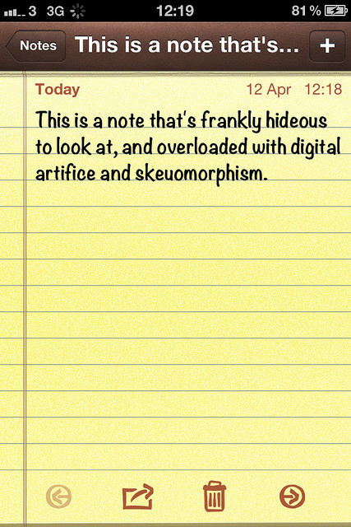

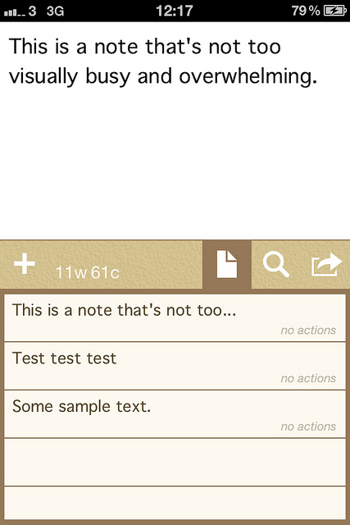

<http://timesofindia.indiatimes.com/tech/personal-tech/computing/Eight-days-with-Microsoft-Windows-8/articleshow/16892537.cms>

Windows 8 puts a lot of emphasis on Modern UI. And it discourages users from spending time in the Desktop mode, which has been reduced to an app