I/O and File Gymnastics

1. ssh hyoung4@my.cs.lmu.edu 15000:my.cs.lmu.edu:80



2. ssh [hyoung4@my.cs.lmu.edu](mailto:hyoung4@my.cs.lmu.edu)

screen

ping google.com

CTRL ad

CTRL d

ssh [hyoung4@my.cs.lmu.edu](mailto:hyoung4@my.cs.lmu.edu)

screen -r



3. du -d 1 | sort -n -r | head -n 2 | awk '{print$2}' > ~/Documents/gitRepos/cmsi387/homework/shell-gymnastics/gymnastics#3.txt

The first-level subdirectory in ~ that is taking up the most space is the /Desktop directory.

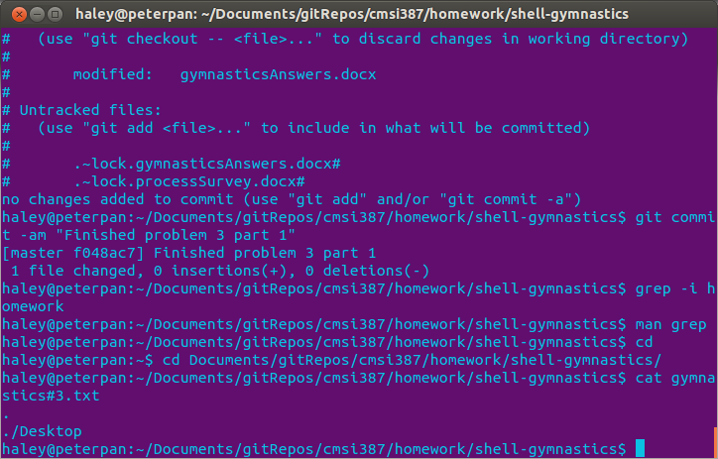

du | grep '\./Desktop'