1.Column('id', INTEGER, primary_key=True),

2.Column('col1', VARCHAR(200, collation='binary'))

3.实现主键自增：SQLAlchemy1.0需要autoincrement,1.1版本所有主键默认为自增。注意不能写autoincrement在1.1中，否则默认为： The autoincrement flag now defaults to "auto" which indicates autoincrement semantics by default for single-column integer primary keys only; for composite (multi-column) primary keys, autoincrement is never implicitly enabled; as always, autoincrement=True will allow for at most one of those columns to be an “autoincrement” column. autoincrement=True may also be set on a Column that has an explicit client-side or server-side default, subject to limitations of the backend database and dialect.

如果此主键还是别的表的外键，那么只有在autoincrement='ignore_fk'时，自增才能生效

4.default="默认"

ColumnDefault: [ColumnDefault](http://docs.sqlalchemy.org/en/latest/core/defaults.html#sqlalchemy.schema.ColumnDefault) is generated automatically whenever the default, onupdate arguments of [Column](http://docs.sqlalchemy.org/en/latest/core/metadata.html#sqlalchemy.schema.Column) are used. A [ColumnDefault](http://docs.sqlalchemy.org/en/latest/core/defaults.html#sqlalchemy.schema.ColumnDefault) can be passed positionally as well.

Column('foo', Integer, ColumnDefault(50))

相当于：Column('foo', Integer, server_default="50")

5.nullable=True: 允许为NULL

6.onupdate: **onupdate** – A scalar, Python callable, or [ClauseElement](http://docs.sqlalchemy.org/en/latest/core/sqlelement.html#sqlalchemy.sql.expression.ClauseElement) representing a default value to be applied to the column within UPDATE statements, which wil be invoked upon update if this column is not present in the SET clause of the update. This is a shortcut to using [ColumnDefault](http://docs.sqlalchemy.org/en/latest/core/defaults.html#sqlalchemy.schema.ColumnDefault) as a positional argument with for_update=True.

目测应该可以结合时间使用，每次onupdate后结合时间，onupdate=timestrump

参考：<http://docs.sqlalchemy.org/en/latest/core/metadata.html?highlight=autoin#column-table-metadata-api>

7.index:创建索引，提高查询效率

8. **onupdate** – A scalar, Python callable, or [ClauseElement](http://docs.sqlalchemy.org/en/latest/core/sqlelement.html#sqlalchemy.sql.expression.ClauseElement) representing a default value to be applied to the column within UPDATE statements, which wil be invoked upon update if this column is not present in the SET clause of the update. This is a shortcut to using [ColumnDefault](http://docs.sqlalchemy.org/en/latest/core/defaults.html#sqlalchemy.schema.ColumnDefault) as a positional argument with for_update=True.

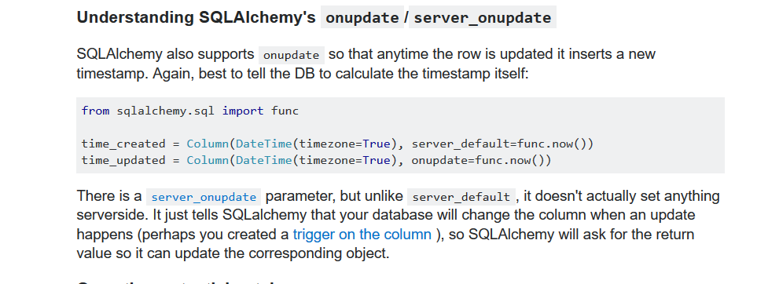

http://stackoverflow.com/questions/13370317/sqlalchemy-default-datetime