## A Project Phase-I Report

**on**

**“Forest Fire Detection Using Satellite Images”**

Submitted to the

Savitribai Phule Pune University

In partial fulfillment for the award of the Degree of

Bachelor of Engineering

in

Information Technology

by

## Vighnesh Tiwari

(4458)

Under the guidance of

## Dr. Sangeeta Jadhav

C:\Users\Admin\Desktop\Logo-AIT.gif

Department Of Information Technology

ARMY INSTITUTE OF TECHNOLOGY

DIGHI HILLS ,PUNE, MAHARASHTRA, INDIA

**(2019-2020)**

C:\Users\Admin\Desktop\Logo-AIT.gif

# CERTIFICATE

This is to certify that the project Phase –I report entitled **“Forest fire detection using satellite images”** being submitted by **Pawan Ashok Phalak (4436)** is a record of bonafide work carried out by him under the supervision and guidance of **Dr. Sangeeta Jadhav** in partial fulfillment of the requirement for **BE (Information Technology Engineering)** course of Savitribai Phule Pune University, Pune in the academic year 2019-2020.

Date: Place:

Name of the guide Dr. (Mrs) Sangeeta Jadhav

Guide Head of the Department

Dr. B.P.Patil Principal

|  |  |  |  |  |
| --- | --- | --- | --- | --- |
|  | | | **Contents** |  |
| Acknowledgement Abstract  List of Abbreviations  List of Figures | | |  | i ii  iii  iv |
| **Sr.** |  | **Chapter** | | **Page No** |
| 1 |  | Introduction to Project : Forest Fire Detection Using Satellite Images | |  |
|  | 1.1 | Introduction to Project | |  |
|  | 1.2  1.3 | Motivation behind project topic  Scope of the project | |  |
|  | 1.4 | Objective(s) of the work  1 | |  |
| 2 |  | Literature Survey | |  |
|  | 2.1 | Related work (of project) with citations | |  |
|  | 2.2 | Different Approaches of Implementation | |  |
| 3 |  | Problem Statement/definition | |  |
| 4 |  | Project Requirement specification | |  |
| 5 |  | Systems Proposed Architecture | |  |
| 6 |  | High level design of the project  6.1 Use case diagram  6.2 Class Diagram (Design level)  6.3 Activity Diagram  6.4 DFD level 0,1 and 2 | |  |
| 7 |  | System implementation-code documentation-algorithm, methodologies, protocols used. | |  |
| 8 |  | Project Plan | |  |
| 9 |  | Conclusion | |  |
| 10 |  | Bibliography in IEEE format | |  |
|  |  |  | |  |

## ACKNOWLEDGEMENT

I am highly indebted to my guide Dr. Sangeeta Jadhav for her guidance and constant supervision as well as for providing necessary information regarding the project report and also for her support in completing the project report.

I would like to express my special gratitude and thanks to Seminar Coordinator Prof Gajanan Walunjkar for giving me such attention and time. This acknowledgment would be incomplete without expressing my thanks to Dr. Sangeeta Jadhav, Head of the Department (Information Technology) for her support during the work. I would like to extend my heartfelt gratitude to my Principal, Dr. B.P.Patil who provided a lot of valuable support, mostly being behind the veils of college bureaucracy.

I would also like to express my gratitude towards my parents and friends for their kind co-operation and encouragement which help me in completion of this report. My thanks and appreciations also go to my colleague in developing the project report and people who have willingly helped me out with their abilities.

(Students Name & Signature)

**i**

**ABSTRACT**

Fires are one of the most common hazards occurring in the forests, and are considered as a serious threat to the forest resources, environment, and wildlife. Forest fires can occur as a result of natural as well as human induced/anthropogenic factors. Fire initiation and spread depend on several important factors such as the amount and frequency of precipitation,the presence of ignition agents and conditions like topography, temperature, lightning, fuel availability and distribution, relative humidity, and wind velocity.

Forest fires can cause loss of biodiversity, forest degradation soil erosion and atmospheric pollution. Fire emissions have significant impact on atmospheric and biochemical cycles and the Earth has radiation budget. Forest fire is a recurring phenomenon in the forests of India.

A significant number of forest \_res occurring in India are due to the anthropogenic activities. The Achankovil forest division, a part of the Western Ghats, is also prone to fire, with a total of 15 forest fires having been reported for the past 11 years.

In this region, any disturbance will negatively affect the rich existing biodiversity.The period of major risk for this area is from February to April, when the high temperature and low humidity along with high wind velocity, and the abundance of dry fuel increase the chances for the occurrence of forest fire.

This study intends to make an attempt to demarcate the forest fire risk zones of the Achankovil forest division. Five significant factors, viz., landcover type, slope, distance from settlement, distance from road, and elevation were chosen to generate the fire risk zone map. The risk zones of forest fires were delineated based on the Fire Risk Index (FRI) method.

## ii

**LIST OF ABBREVIATIONS**

AAA American Anthropology Association

ACS American Chemical Society Style

APA American Psychological Association

ASA American Sociological Association

ASCE American Society of Civil Engineers

ASME American Society of Mechanical Engineers

CBE/CSE Council of Biology Editors, now Council of Science

Editors

AAG Association of American Geographers

GSA Geological Society of America

IEEE Institute of Electrical and Electronics Engineers

MLA Modern Language Association

## **iii**

**LIST OF FIGURES**

|  |  |
| --- | --- |
| 0. | Literature Survey Report |
| 1. | System Proposed Architecture |
| 2. | Use case model diagram |
| 3. | Class Diagram |
| 4. | Activity Diagram |
| 5. | DFD Level 0 |
| 6. | DFD Level 1 |
| 7. | DFD Level 2 |
| 8. | Model Flow |

## **iv**

**CHAPTER 1**

**INTRODUCTION TO PROJECT TOPIC**

**Project Introduction**

Forest fire detection system deals with the process of identifying the fire in forest by satellite images and plotting the images based on their risk levels allowing the authority to easily handle the situation.

**Project aims**

To automatically detect the fire and if there is then how much it spread around the forest cover and demarcate the fire risk zones in forest division.

**Project objectives**

• To achieve the goal of forest fire detection, satellite images are used, each part is processed using the technology of pseudo-color to improve the quality of information.

• The human understandable separation between land, smoke and fire is made.

• Mask-RCNN is used for patches separation. Patches of fire, land and smoke and further automation in identification of fire is carried out by the use of concepts of googlenet, resnet50.

• Once patches are identified, the images can be used for risk map plot- ting.

## CHAPTER 2

**LITERATURE SURVEY**

## 2.1) Related work (of project) with citations

## 

## Fig 0 – Literature Survey

## Fires are one of the most common hazards occurring in the forests, and are considered as a serious

## threat to the forest resources, environment, and wildlife. Forest fires can occur as a result of natural

## as well as human induced/anthropogenic factors. Fire initiation and spread depend on several

## important factors such as the amount and frequency of precipitation,the presence of ignition agents

## and conditions like topography, temperature, lightning, fuel availability and distribution, relative

## humidity, and wind velocity.

## Forest fires can cause loss of biodiversity, forest degradation soil erosion and atmospheric

## pollution. Fire emissions have significant impact on atmospheric and biochemical cycles and the

## Earth has radiation budget. Forest fire is a recurring phenomenon in the forests of India.

## A significant number of forest \_res occurring in India are due to the anthropogenic activities. The

## Achankovil forest division, a part of the Western Ghats, is also prone to fire, with a total of 15

## forest fires having been reported for the past 11 years.

## In this region, any disturbance will negatively affect the rich existing biodiversity.The period of

## major risk for this area is from February to April, when the high temperature and low humidity

## along with high wind velocity, and the abundance of dry fuel increase the chances for the

## occurrence of forest fire.

## This study intends to make an attempt to demarcate the forest fire risk zones of the Achankovil

## forest division. Five significant factors, viz., landcover type, slope, distance from settlement,

## distance from road, and elevation were chosen to generate the fire risk zone map. The risk zones

## of forest fires were delineated based on the Fire Risk Index (FRI) method [1].

## **2.2) Different Approaches of Implementation**

## To achieve the goal of forest fire detection, satellite images are used, each part is processed using the technology of pseudo-color to improve the quality of information. The human understandable separation between land, smoke and fire is made. Mask-RCNN is used for patches separation. Patches of fire, land and smoke and further automation in identification of fire is carried out by the use of concepts of googlenet , resnet-50. Once patches are identified, the images can be used for risk map plotting [2].

## Pseudo Color Image Processing.

## Mask R-CNN.

## Google Net Architecture.

## Resenet Architecture.

## CHAPTER 3

**PROBLEM STATEMENT AND DEFINITION**

## **Project aims**

## To automatically detect the fire and if there is then how much it spread around the forest cover and demarcate the fire risk zones in forest division.

## **Project objectives**

## 1. To achieve the goal of forest fire detection, satellite images are used, each part is processed using the technology of pseudo-color to improve the quality of information.

## 2. The human understandable separation between land, smoke and fire is made.

## 3. Mask-RCNN is used for patches separation. Patches of fire, land and smoke and further automation in identification of fire is carried out by the use of concepts of googlenet , resnet-50.

## 4. Once patches are identified, the images can be used for risk map plotting.

## CHAPTER 4

## 

## PROJECT REQUIREMENT SPECIFICATION

**1. INTRODUCTION**

* Forest fire is a major concern as it causes huge damage to environment. Forest fire detection and coming up with optimal solution is a challenge.
* Technique that proved to be best for forest fire detection is pseudo-color processing for infrared forest-fire image.
* Imagery of the entire land surface of earth at 3-5 meter resolution are available and a coarse-resolution imagery from Landsat(30 meter pixels) or MODIS (250 meter pixels).

**1.1 PURPOSE**

* Forest Fires are not a sudden incidents they occur in steps and the focus is to detect it in latest possible stage.
* Detecting features directly from a raw image is not so efficient as compared to doing same after applying image processing over it.
* The colour quantized image give us best extracted features from any raw image which leads to a better model performance.
* Detecting nearby local areas to find the sensitivity of incident.
* Providing an optimal solution recover the fire.

**1.2 SCOPE**

* Scope of forest fire detection system deals with the image capturing and processing it to detect the thermal anomalies as fast as possible.
* The detected image is made to produce the sensitive areas in the forest that can easily catch fire.
* The web based user interface is made to display the results along with the backend of flask.

**1.3 DEFINITION, ACRONYMS, ABBREVIATION**

* SRD -> Software Requirement Specification
* CSS -> Cascading Style Sheets
* HTML -> Hyper Text Markup Language

**1.4 TECHNOLOGIES USED**

* Html
* CSS
* Javascript
* Flask
* Python lib. (open cv , numpy , pandas , keras , tensorflow)

**2. OVERALL DESCRIPTION**

**2.1 PRODUCT PERSPECTIVE**

The proposed Fire detection system will receive a satellite image and apply image processing algorithms to refine the images. Once it got refined it is used to detect thermal anomalies in images. The alert system is made to make the authorities alert about the danger and the optimized way to prevent it.

**2.2 SOFTWARE REQUIREMENTS**

* Front end:

1. HTML
2. CSS
3. JAVASCRIPT

* Back end:

1. Flask
2. Python
3. Open cv

**2.3 HARWARE REQUIREMENTS**

* 8GB RAM
* Nvidia GPU
* Windows 10/Ubuntu
* 1.2 Ghz Processor

**2.4.1 FUNCTIONAL REQUIREMENTS**

* **R.1: IMAGE UPLOAD:**

The button provided to the user to upload a satellite image. Image is then passed to the backend by the use of Ajax.

* **R.2: MAKE PREDICTION:**

The button provided to show the output generated at backend with labels.

* **R.3: SEGMENT VIEW:**

Button provided to view the images during image processing and the execution of algorithms.

**2.4.2 NON FUNCTIONAL REQUIREMENTS**

* **Usability requirement:**

The system shall allow the user to access the system from the web application. The system uses web based user interface. Since all users are familiar with general uses of web app, no specific training is required. The system is user friendly which makes the system easy.

* **Availability requirement:**

The system is available 100% for the user. The system shall be operational 24X7.

* **Efficiency requirement:**

Mean time to repair (MTTR)-even if the system fails the system will be recovered backup within hour or less.

* **Accuracy:**

The system should accurately provide real time information taking into consideration various concurrency issues. The system should provide 100% access reliability.

* **Performance requirement:**

The information is refreshed depending upon whether new image is uploaded. The system shall respond in quick time. The system shall be allowed to take more time when doing large processing jobs.

* **Reliability requirement:**

The system has to be 100% reliable due to the importance of data and damages that can be caused by incorrect or incomplete data.

**2.5 USER CHARACTERISTIC:**

**User module:** In user module, user will check the fire prediction and output images:

* Upload images
* Submit image
* Display predictions

**2.6 CONSTRAINTS:**

Any uploaded image should be in the correct format and the predicted outputs should be correctly calculated and displayed in less time.

## CHAPTER 5

## 

## SYSTEM PROPOSED ARCHITECTURE

## Pseudo-color processing is a technique that maps each of the grey levels of a black and white

## image into an assigned color. This colored image, when displayed, can make the identification of

## certain features easier for the observer. The mappings are computationally simple and fast.

## Natural color images are superior to false color images for presentation and visual interpretation

## purposes.

## When it comes to computer vision the colored images are more difficult to learn.

## Moreover blue wavelengths suffers the greatest scattering in the atmosphere, which follows an

## inverse dependence on wavelength to the fourth power. Some of high-resolution satellites cover

## only two visual spectral bands (green and red bands) plus one in the near-infrared region. As a

## result, a true color image cannot be formed by satellite.

## When forest fire breaks smoke covers the region of sky and it becomes difficult to detect fire via

## Satellite [3].

## Sensors of satellite needs some method to detect flames and smoke. Pseudo colors and its adjustment can tackle the problem of separation. The wild-fire image typically includes flame (burning part of the fire), some fire (out part of the fire), smoke coverage area, the background or not burning part of the fire.

## Flame can be divided into three parts: outer flame, inner flame, and center of the flame.

## The temperature of outer flame is the highest, followed with in flame, then the center of the flame,

## resulting in the gray level of flame image distributes in a certain form.

## It is unlikely that the ResNet model can make dramatic improvement from this point without a

## re-thinking of its optimization metric. The accuracy metric used to pick the best weights simply

## compares 1s and 0s and deter- mines how many are correct. Since it uses a simple rounding to

## label any given feature, all or most images will never have rare features for the accuracy

## calculation. As such, our optimizer has a difficult time finding weights to make the ac- curacy go

## over 0.96. We can use our variable thresholds to account for this when we make our predictions,

## but if the model hits a ceiling on optimization improvement we will not be able to identify the

## remaining four percent of accuracy. Main goal of using GoogLeNet is to detect the fire from satellite

## im- agery.For faster and real time detection of fire on satellite imagery , GoogleNet ensures efficiency of computation [4].

## 

## Fig1. System Proposed Architecture

## CHAPTER 6

## 

## HIGH LEVEL DESIGN OF PROJECT

**6.1 Use Case Model**

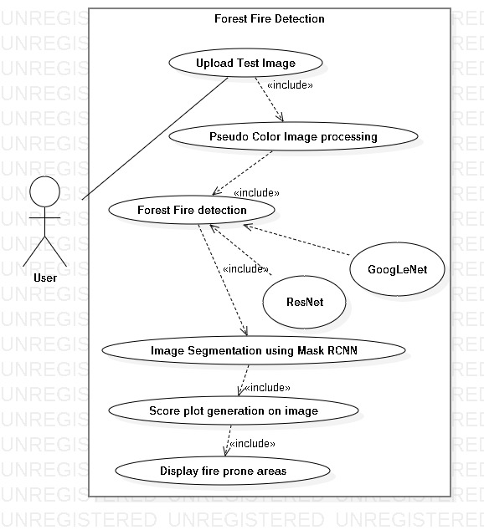

## Fig 2 – Use Case Model Diagram

**6.2 Class Diagram**

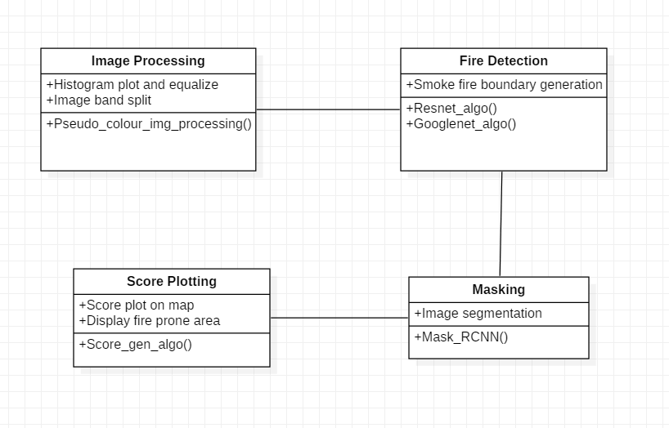

## Fig 3 - Class Diagram

## 6.3 Activity Diagram

## C:\Users\PAWAN\Desktop\BE PROJECT\Activity_Diagram.png

## Fig 4- Activity Diagram

## 6.4) DFD LEVEL 0,1 AND 2 DIAGRAM

## 6.4.1) L-0

## 

## Fig 5 – DFD Level L0

## 6.4.2) L-1

## 

## Fig 6 – DFD Level L1

## 6.4.3) L-2

## 

## Fig 6 – DFD Level L2

## 

## Fig 6 – DFD Level L2

## CHAPTER 7

**SYSTEM IMPLEMENTATION-CODE**

**DOCUMENTATION-ALGORITHM, METHODOLOGY**

**PROTOCOLS USED**

## 7.1) Code Implementation

## Code Implementation part is done in Python and model architecture and build using keras library.

## 

## Fig 7 – Model Layer Specification

## 7.2) Model Flow

## Fig 8 – Model Flow

## 7.3) Methodology

## Pseudo-color processing is a technique that maps each of the grey levels of a black and white

## image into an assigned color. This colored image, when displayed, can make the identification of

## certain features easier for the observer. The mappings are computationally simple and fast.

## Natural color images are superior to false color images for presentation and visual interpretation

## Purposes. When it comes to computer vision the colored images are more difficult to learn.

## Moreover blue wavelengths suffers the greatest scattering in the atmosphere, which follows an

## inverse dependence on wavelength to the fourth power. Some of high-resolution satellites cover

## only two visual spectral bands (green and red bands) plus one in the near-infrared region. As a

## result, a true color image cannot be formed by satellite. When forest fire breaks smoke covers the region of sky and it becomes difficult to detect fire via Satellite. Sensors of satellite needs some method to detect flames and smoke.

## Pseudo colors and its adjustment can tackle the problem of separation.

## The wild-fire image typically includes flame (burning part of the fire), some fire (out part of the

## fire), smoke coverage area, the background or not burning part of the fire.

## Flame can be divided into three parts: outer flame, inner flame, and center of the flame.

## The temperature of outer flame is the highest, followed with in flame, then the center of the flame,

## resulting in the gray level of flame image distributes in a certain form.

## 

## CHAPTER 8

## REFERENCES

[1] Patrick Helber Et al. A Novel Dataset and Deep Learning Benchmark for Land Use and Land Cover Classification,IEEE Conference on Computer Vision and Pattern Recognition Workshops, 1 Feb 2019.

[2] Grant J. Scott Et al., Training Deep Convolutional Neural Networks for LandâCover Classification of High-Resolution Imagery, IEEE GEOSCIENCE AND REMOTE SENSING LETTERS, VOL. 14, NO. 4, APRIL 2017

[3] KHAN MUHAMMAD Et al., Convolutional Neural Networks Based Fire De- tection in Surveillance Videos, IEEE ACCESS, April 23, 2018.

[4] Ziqi Zhu Et al., Extreme Weather Recognition using A Novel Finetuning Strat- egy and Optimized GoogLeNet , International Journal of Computer Vision , 2016.