ONLINE-7764: Scout time to first words (TTFT)
Initial investigation: what a week of dev core_turn logs shows
Item | Value
Ticket | ONLINE-7764: Measure and reduce Scout time to first words (TTFT) on core turns
Author | Sadaf Siddiqui
Date | 9 October 2026
Environment | dev (AWS us-west-2)
Log group | /aws/lambda/swo-genai-pov-ai-assistant-v2-dev
Data window | 1–8 October 2026 (UTC); synthetic turns excluded
Status | Investigation only. No code changed.

1. Summary
Teachers on dev wait a median of 4.6 seconds before Scout's first words appear, and 9.5 seconds at the 90th percentile. The target from the evaluation gate is under 2 seconds. Almost none of this time is spent building the page context (5 ms median). It is spent inside the model call, and in search-then-answer turns it is spent three times over: a first model call, the search, and a second model call.
Measure | Value | Source
Turns analysed | 459 | Q2
First words, p50 / p90 | 4.6 s / 9.5 s | Q2
Context build, p50 / p90 | 5 ms / 69 ms | Q2
First model call, p50 | 4.0 s | Q2
Plain answers (1 model call, no tool) | 261 turns (57%), 4.3 s p50 | Q4
Search-then-answer (search_curriculum) | 19 turns, 13.7 s p50 | Q4, Q5
Eval gate (15 Sept, Sonnet) | 3.2 s p50 against < 2 s: failed | Routing evidence PDF, p. 8

Next step: The existing fields cannot say which part of the model call is slow. ONLINE-7764 adds the missing timings (section 7) before any optimisation is chosen.

2. Background: why this was investigated
- The gap. The routing evidence document (Scout-model-routing-evidence.pdf, page 8, "Sonnet control", Gates table, row "Time to first visible text, p50") shows Sonnet at 3.2 s (warm 3.2 s, cold 3.4 s, n = 240) against a target of under 2 s: the gate is failed. Source file: ai-review-2026-09-15/eval/haiku-ctl-92ae3a0.md.
- The question. That figure comes from 288 scripted evaluation turns. The question was whether real dev traffic looks the same, and where the time goes.
- The trigger. On 5 October the first-content p95 alarm fired on dev (three 5-minute windows at 11.5 s, 11.5 s and 13.0 s against a 10 s threshold), which confirmed the monitoring was live and the data was available in CloudWatch. More notifications followed that day; the last one returned the alarm to OK at 18:01 UTC, when p95 fell to 6.9 s.
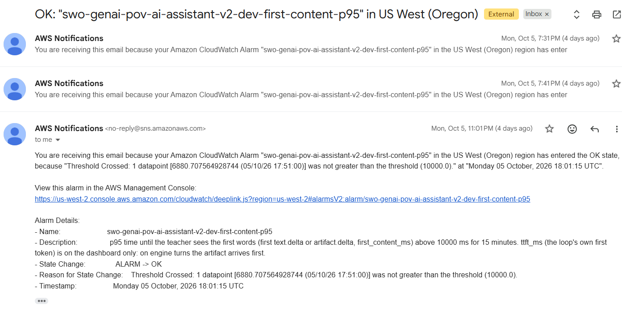
Screenshot: first-content-p95 alarm notifications on 5 Oct; the open one is ALARM → OK at 18:01 UTC

3. Data source and field definitions
Every Scout chat turn writes one core_turn log line (lambdas/ai_assistant/src/core/telemetry.py, _log_turn) to the Lambda's CloudWatch log group. The metric filters, dashboard and alarms come from infra/swo/modules/scout-core-v2/observability.tf and are applied in dev. The fields used here:
Field | Meaning
first_content_ms | Turn start until the first text or artifact reaches the teacher (what the teacher sees). Status labels such as "Searching the curriculum…" are not counted.
ttft_ms | Turn start until the model loop's own first text token.
total_ms | Whole turn, start to end.
ctx_build_ms | Time to build the page context (page card, article, history).
first_model_ms | Duration of the first model call, including the guardrail classifier wait before it.
model_ms / tools_ms | Total time in model calls / in tools across the turn.
model_steps | Number of model calls in the turn (0 = answered by a shortcut with no model call).
tools | List of tools the turn used; tools.0 is the first.
synthetic | 1 for scripted test traffic (excluded from every query here).

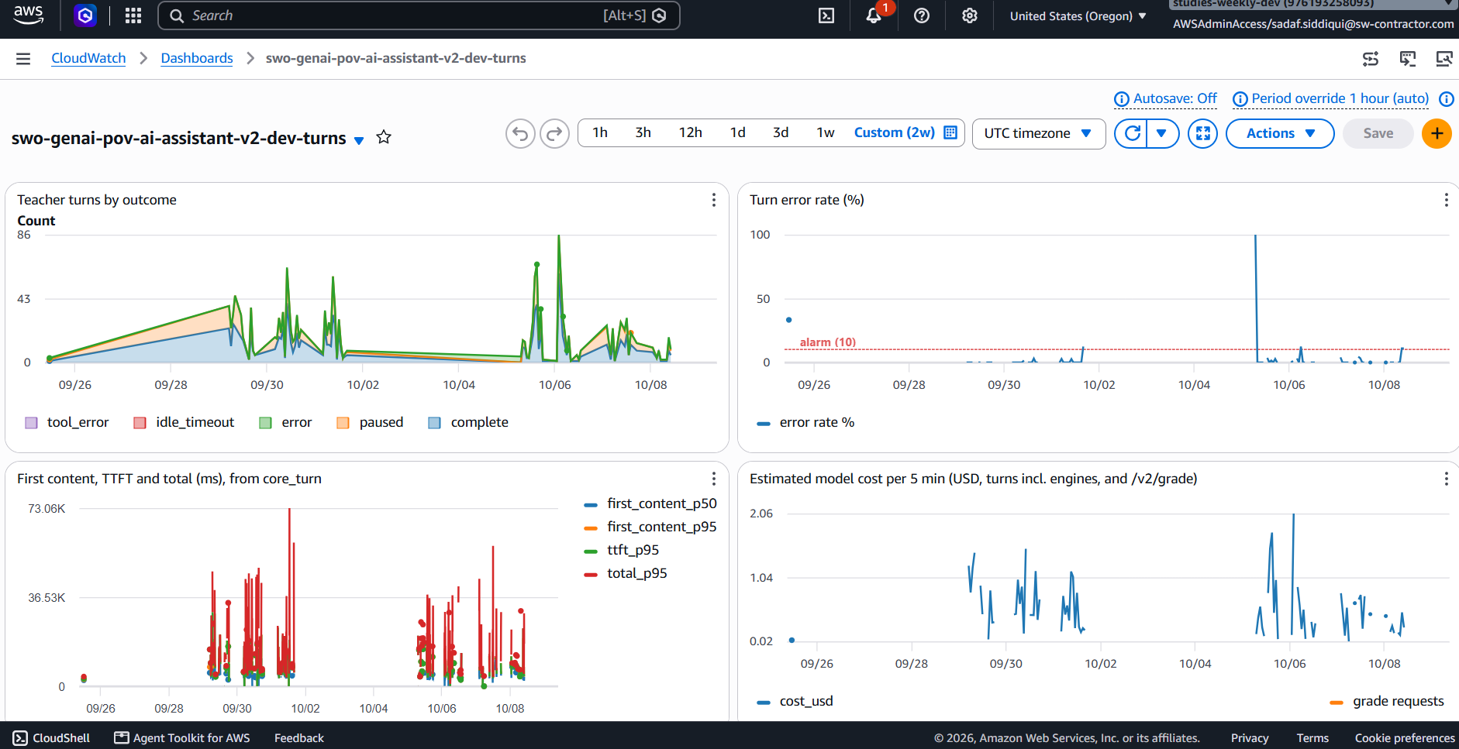
Screenshot: Dashboard swo-genai-pov-ai-assistant-v2-dev-turns (2 weeks): outcomes, error rate, latency and cost
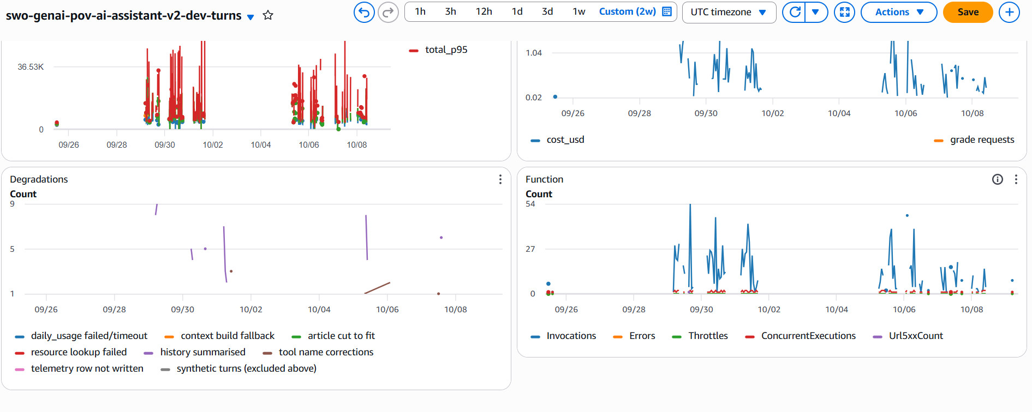
Screenshot: Same dashboard, lower half: degradations and Lambda function metrics

4. CloudWatch Logs Insights queries used
All queries run in us-west-2 against the log group above over the last 7 days. They exclude synthetic turns; Q2–Q4 also exclude grading requests (mode = 'grade') and turns with no visible text (first_content_ms ≤ 500 ms, which removes fixed replies and paused page actions that would pull the median down).
Note on the screenshots: The data tables and charts in section 5 come from the first run of each query (window 1–8 October). The screenshots below were taken when the queries were re-run on 9 October; the 7-day window had moved to 2–9 October, so 1 October dropped out and counts differ slightly (for example Q2: 415 turns instead of 459; Q5: 17 instead of 19; Q3 gains a43359c5 from 8 October and loses edd9f7d3 from 1 October). The medians move by only a few hundred milliseconds (e.g. Q2 first_p50 about 4.5 s, Q5 first_p50 about 13.8 s) and the conclusions do not change.

Q1. First content, TTFT and total time per 5 minutes (the dashboard query)
SOURCE "/aws/lambda/swo-genai-pov-ai-assistant-v2-dev" START=-604800s END=0s |
filter message = 'core_turn' and synthetic = 0
| stats pct(first_content_ms, 50) as first_content_p50, pct(first_content_ms, 95) as first_content_p95,
pct(ttft_ms, 95) as ttft_p95, pct(total_ms, 95) as total_p95
by bin(5m)

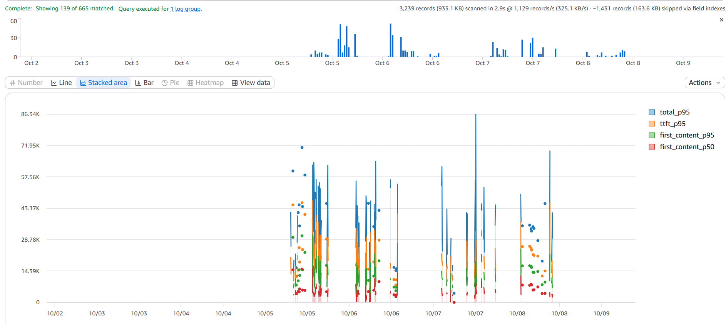
Screenshot: Q1 result in CloudWatch Logs Insights

Q2. Stage summary for the week: context build vs first model call
SOURCE "/aws/lambda/swo-genai-pov-ai-assistant-v2-dev" START=-604800s END=0s |
filter message = 'core_turn' and synthetic = 0 and mode != 'grade' and first_content_ms > 500
| stats count() as turns,
pct(first_content_ms, 50) as first_p50, pct(first_content_ms, 90) as first_p90,
pct(ctx_build_ms, 50) as ctx_p50, pct(ctx_build_ms, 90) as ctx_p90,
pct(first_model_ms, 50) as model1_p50,
avg(model_steps) as steps
by tools
| sort turns desc

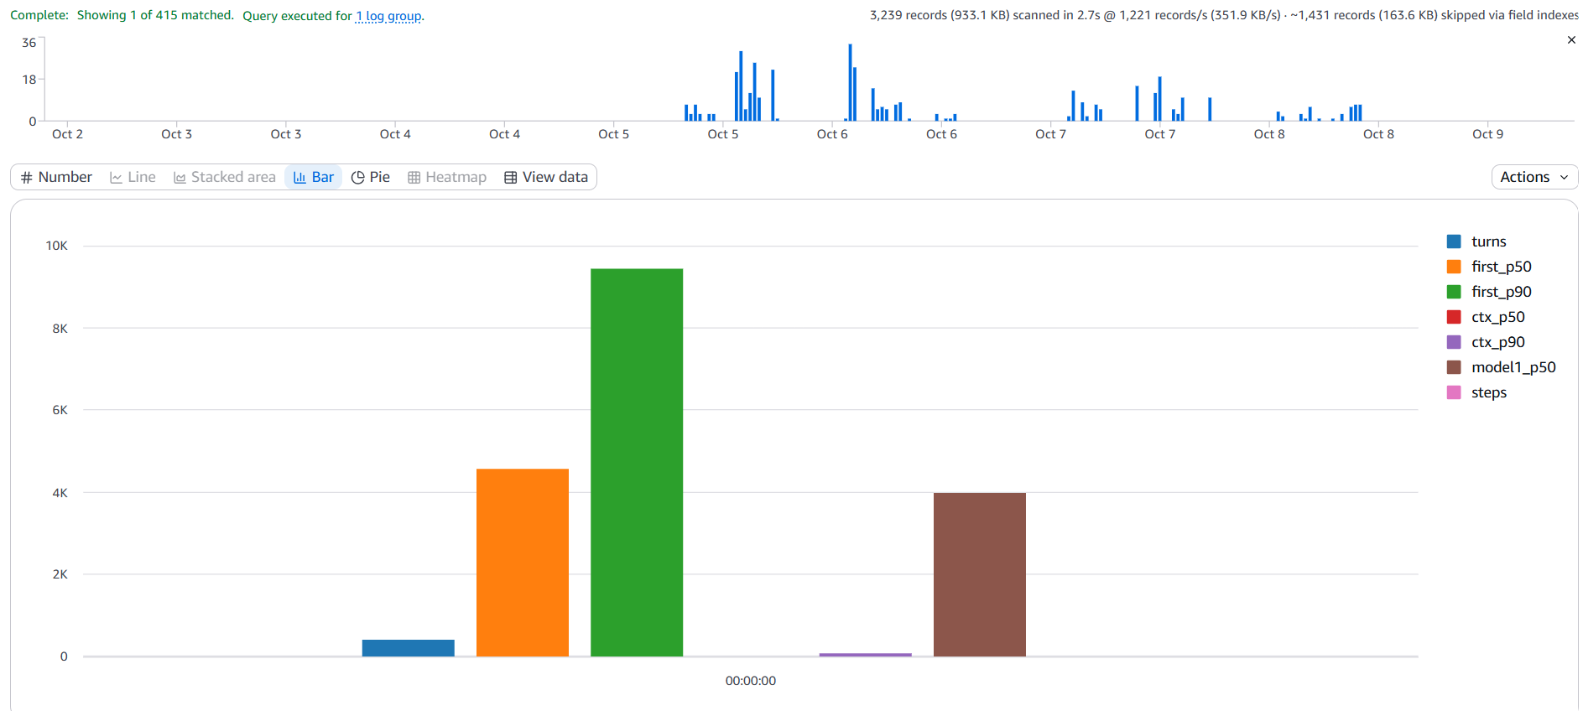
Screenshot: Q2 result in CloudWatch Logs Insights

Q3. The 20 slowest turns (first words after more than 10 s)
SOURCE "/aws/lambda/swo-genai-pov-ai-assistant-v2-dev" START=-604800s END=0s |
filter message = 'core_turn' and synthetic = 0 and mode != 'grade' and first_content_ms > 10000
| fields @timestamp, turn_id, thread_id, first_content_ms, ctx_build_ms, first_model_ms, tools, model_steps, outcome
| sort first_content_ms desc
| limit 20

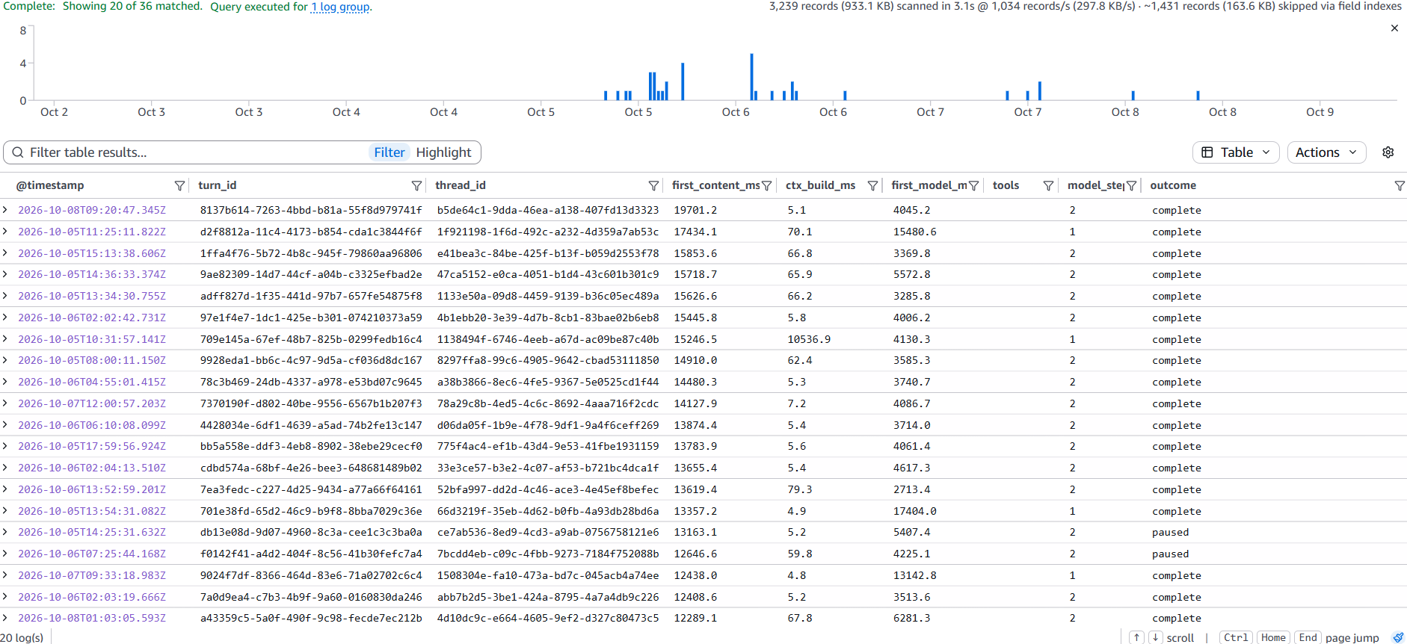
Screenshot: Q3 result in CloudWatch Logs Insights

Q4. Time to first words by turn kind (model calls + first tool)
SOURCE "/aws/lambda/swo-genai-pov-ai-assistant-v2-dev" START=-604800s END=0s |
filter message = 'core_turn' and synthetic = 0 and mode != 'grade' and first_content_ms > 500
| stats count() as turns, pct(first_content_ms, 50) as first_p50, pct(first_content_ms, 90) as first_p90
by model_steps, tools.0
| sort turns desc

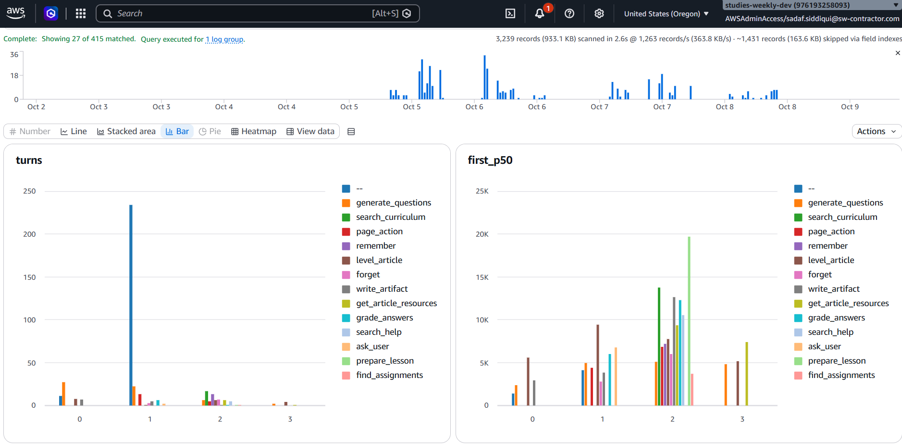
Screenshot: Q4 result in CloudWatch Logs Insights: turns and first_p50 by model calls and first tool
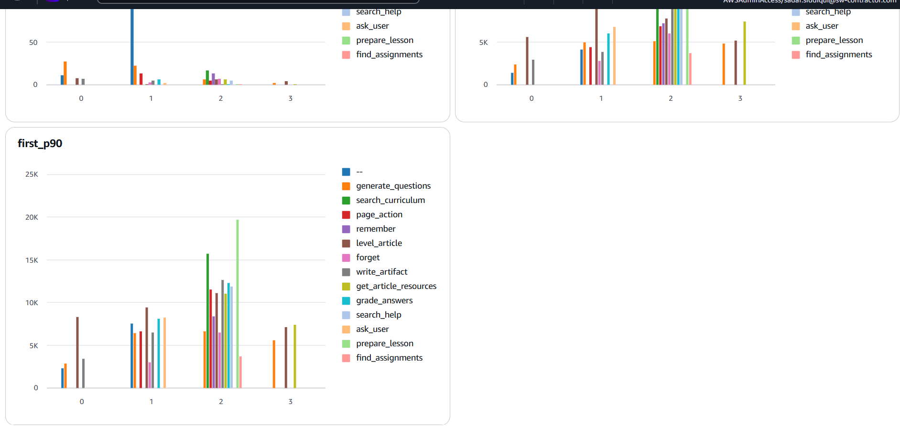
Screenshot: Q4 result, continued: first_p90 by model calls and first tool

Q5. Where a search-then-answer turn spends its time
SOURCE "/aws/lambda/swo-genai-pov-ai-assistant-v2-dev" START=-604800s END=0s |
filter message = 'core_turn' and synthetic = 0 and model_steps = 2 and tools.0 = 'search_curriculum'
| stats count() as turns, pct(first_model_ms, 50) as model1_p50, pct(tools_ms, 50) as tools_p50,
pct(model_ms, 50) as model_total_p50, pct(first_content_ms, 50) as first_p50

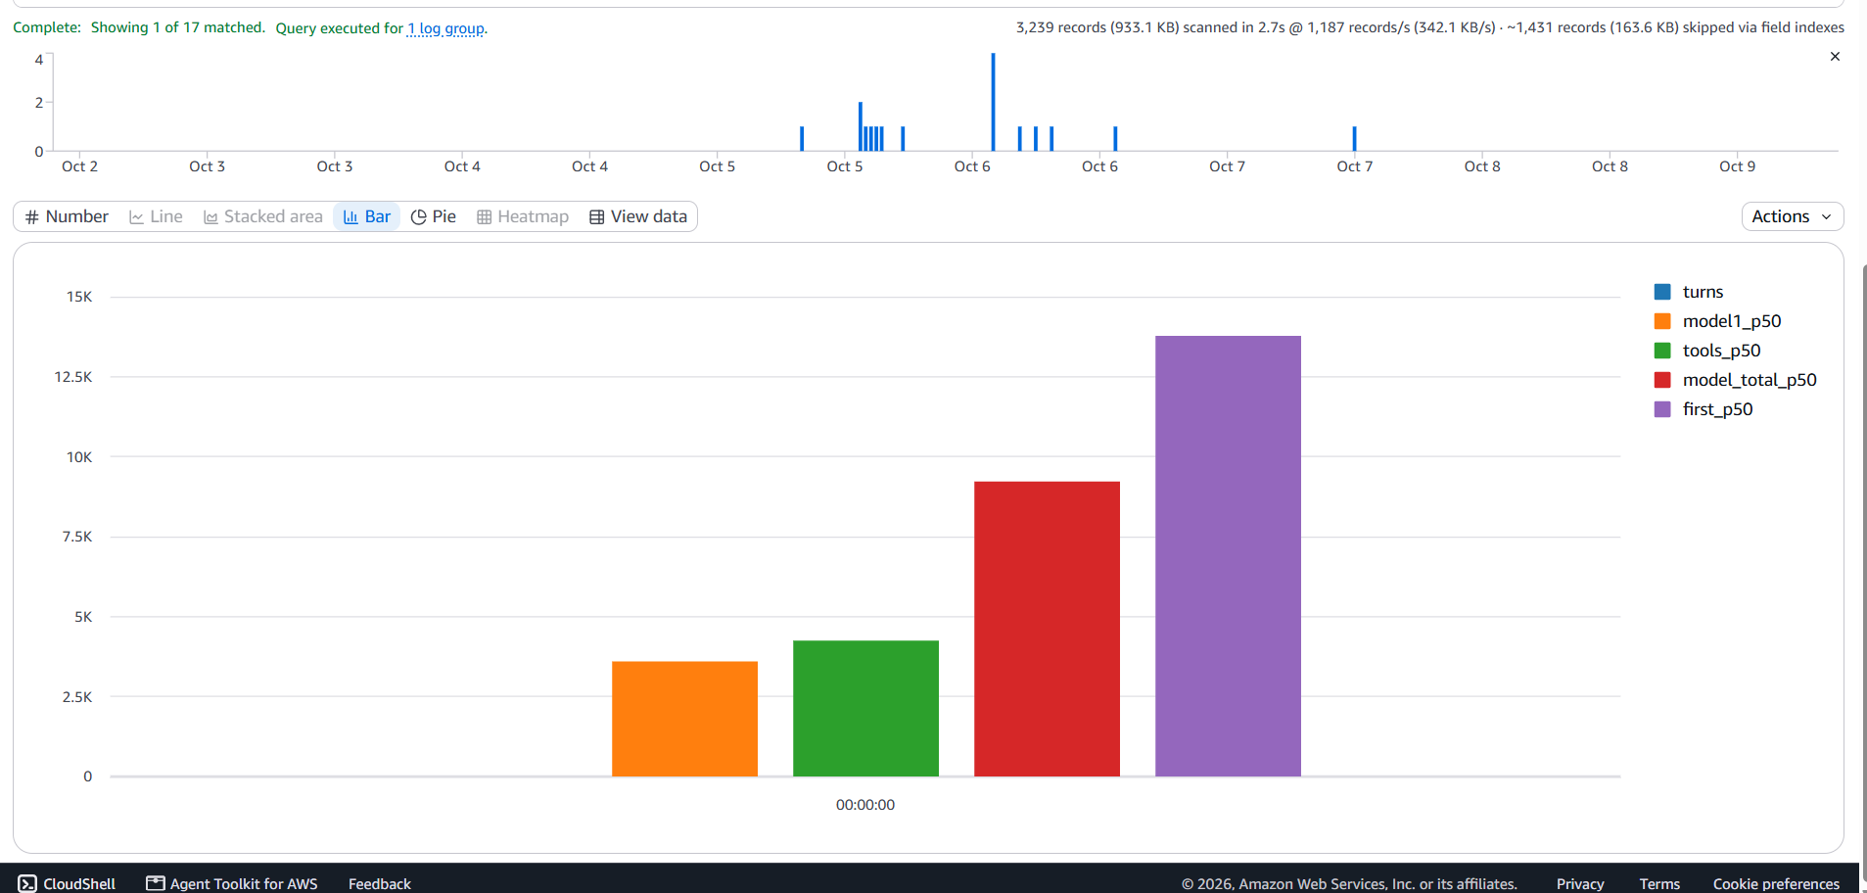
Screenshot: Q5 result in CloudWatch Logs Insights

5. Findings, step by step

Step 1. The monitoring is live and matches the alarm (Q1)
Q1 returns the 5-minute windows for the week. The windows at 14:15, 14:20 and 14:25 UTC on 5 October show p95 values of 11,518, 11,506 and 13,163 ms, exactly the three datapoints in the alarm email. The alarm reported real slow turns; it was not a broken alarm.

Step 2. Real dev turns are slower than the evaluation (Q1)
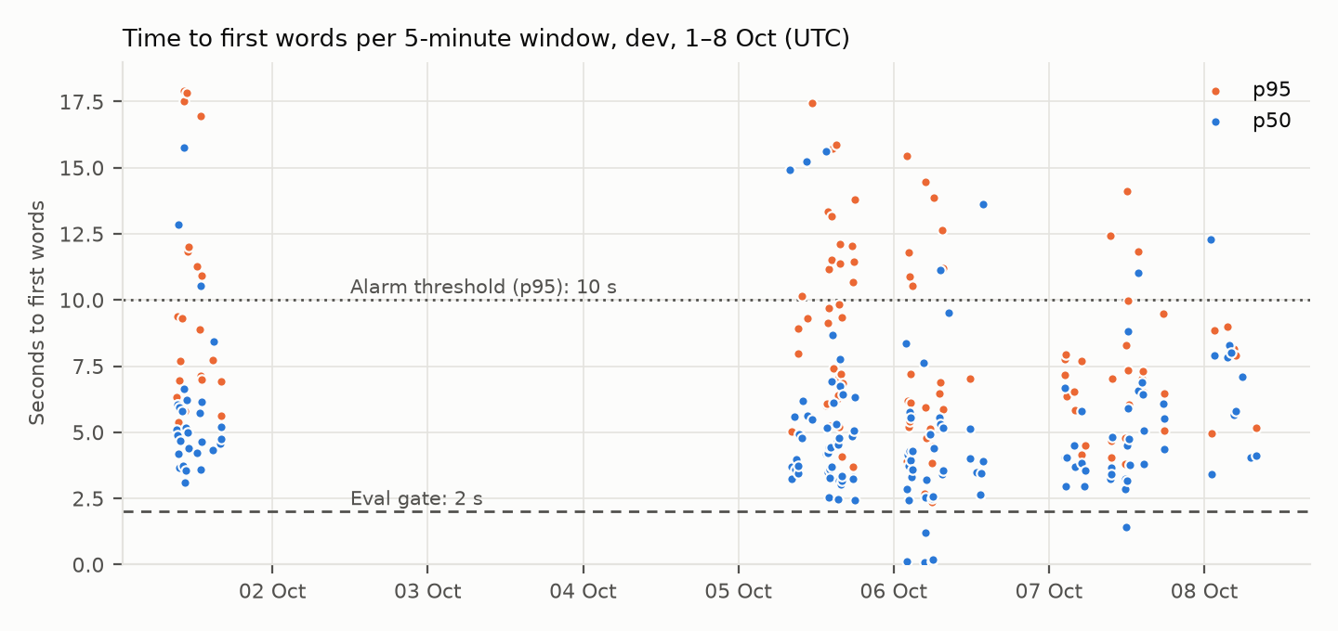
Figure 1. Each dot is one 5-minute window that had teacher turns. Windows with no visible text are left out. Full data in Appendix A.
- p50: most windows sit between 3 and 6 s, above the 3.2 s seen in the evaluation and well above the 2 s gate.
- p95: often 10–17 s, so the p95 alarm can fire on an ordinary working day.
- TTFT and first content move together: ttft_p95 is within about 40 ms of first_content_p95 in almost every window. The first thing teachers see is the model's own first token, so the time goes before the model starts writing.
- Low traffic: many windows have p50 equal to p95, meaning one turn in that window. Traffic is internal testers in roughly 02:00–18:00 UTC, so a single slow turn can move a 5-minute percentile.

Step 3. Context build is not the problem; the first model call is (Q2)
turns | first_p50 | first_p90 | ctx_p50 | ctx_p90 | model1_p50 | steps
459 | 4,632 ms | 9,513 ms | 5.3 ms | 69.2 ms | 4,035 ms | 1.07

Building the page context takes 5 ms at the median. The first model call takes 4.0 s, and almost every turn has a single model call. The tools column came back empty because tools is a list, which Logs Insights cannot group by; this row is therefore the total for all turns (Q4 fixes the grouping with tools.0).
first_model_ms covers four things that are not logged separately today: the guardrail classifier wait (core/loop.py:332), Sonnet's own time to first token, the Bedrock guardrail on the stream, and the sentence hold in leak.Screen (core/leak.py:237), which releases text only when a sentence is complete.

Step 4. The slowest turns fall into three patterns (Q3)
Time (UTC) | turn_id | first ms | ctx ms | model1 ms | steps | outcome
2026-10-08 09:20:47 | 8137b614 | 19701.2 | 5.1 | 4045.2 | 2 | complete
2026-10-05 11:25:11 | d2f8812a | 17434.1 | 70.1 | 15480.6 | 1 | complete
2026-10-01 12:59:25 | edd9f7d3 | 16959.9 | 3.5 | 4558.9 | 3 | complete
2026-10-05 15:13:38 | 1ffa4f76 | 15853.6 | 66.8 | 3369.8 | 2 | complete
2026-10-05 14:36:33 | 9ae82309 | 15718.7 | 65.9 | 5572.8 | 2 | complete
2026-10-05 13:34:30 | adff827d | 15626.6 | 66.2 | 3285.8 | 2 | complete
2026-10-06 02:02:42 | 97e1f4e7 | 15445.8 | 5.8 | 4006.2 | 2 | complete
2026-10-05 10:31:57 | 709e145a | 15246.5 | 10536.9 | 4130.3 | 1 | complete
2026-10-05 08:00:11 | 9928eda1 | 14910.0 | 62.4 | 3585.3 | 2 | complete
2026-10-06 04:55:01 | 78c3b469 | 14480.3 | 5.3 | 3740.7 | 2 | complete
2026-10-07 12:00:57 | 7370190f | 14127.9 | 7.2 | 4086.7 | 2 | complete
2026-10-06 06:10:08 | 4428034e | 13874.4 | 5.4 | 3714.0 | 2 | complete
2026-10-05 17:59:56 | bb5a558e | 13783.9 | 5.6 | 4061.4 | 2 | complete
2026-10-06 02:04:13 | cdbd574a | 13655.4 | 5.4 | 4617.3 | 2 | complete
2026-10-06 13:52:59 | 7ea3fedc | 13619.4 | 79.3 | 2713.4 | 2 | complete
2026-10-05 13:54:31 | 701e38fd | 13357.2 | 4.9 | 17404.0 | 1 | complete
2026-10-05 14:25:31 | db13e08d | 13163.1 | 5.2 | 5407.4 | 2 | paused
2026-10-06 07:25:44 | f0142f41 | 12646.6 | 59.8 | 4225.1 | 2 | paused
2026-10-07 09:33:18 | 9024f7df | 12438.0 | 4.8 | 13142.8 | 1 | complete
2026-10-06 02:03:19 | 7a0d9ea4 | 12408.6 | 5.2 | 3513.6 | 2 | complete

Pattern | Turns | What it looks like | Likely cause
A. Tool first, no words until the second call | 16 of 20 | 2–3 model calls; first call 2.7–5.6 s; first words at 12–20 s | The first call only decides to use a tool. Words wait for the tool and a second call. The lead-in sentence applies only to shortcut turns, not these.
B. One slow model call | 3 of 20 | 1 model call of 13–17 s (d2f8812a, 701e38fd, 9024f7df) | A retry after the idle watchdog, Bedrock throttling, or a slow guardrail label. Cannot tell apart today.
C. Slow context build | 1 of 20 | ctx_build_ms 10,537 ms (709e145a) against 5 ms normally | Likely the history summary written inside the turn, or a cold resource lookup.

Step 5. Plain answers are most of the traffic (Q4)
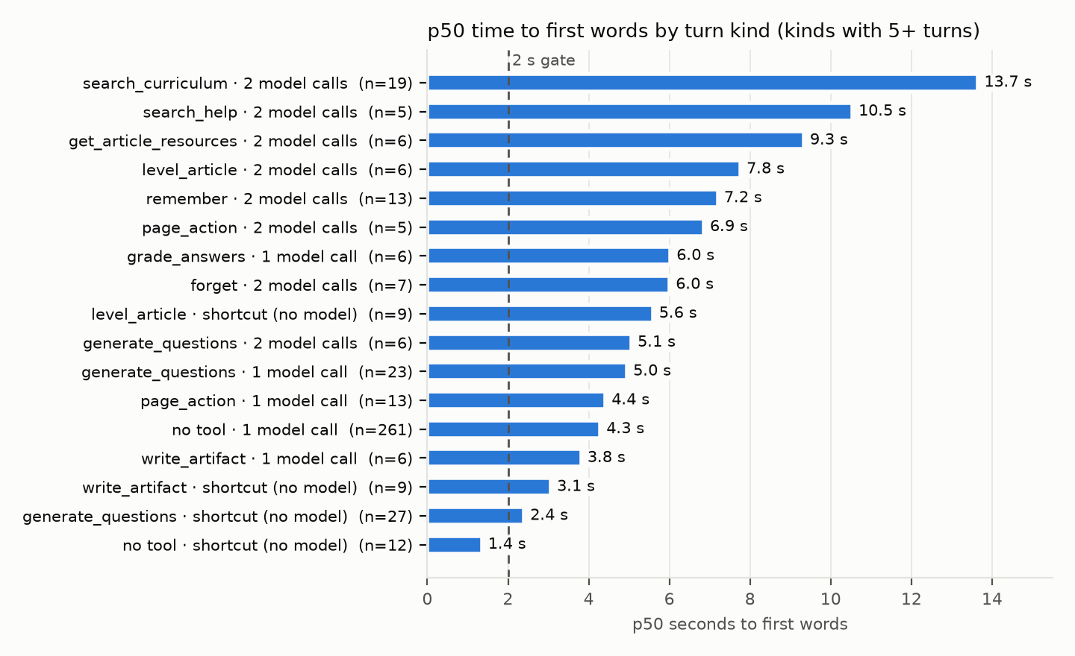
Figure 2. Turn kinds with at least 5 turns. A shortcut turn is answered without a model call deciding what to do.
model calls | first tool | turns | first p50 | first p90
1 | (none) | 261 | 4,289 ms | 7,559 ms
0 | generate_questions | 27 | 2,400 ms | 2,856 ms
1 | generate_questions | 23 | 4,953 ms | 6,399 ms
2 | search_curriculum | 19 | 13,655 ms | 15,719 ms
1 | page_action | 13 | 4,419 ms | 6,623 ms
2 | remember | 13 | 7,205 ms | 8,357 ms
0 | (none) | 12 | 1,355 ms | 2,327 ms
0 | level_article | 9 | 5,593 ms | 8,278 ms
0 | write_artifact | 9 | 3,064 ms | 4,582 ms
2 | forget | 7 | 6,009 ms | 6,495 ms
1 | write_artifact | 6 | 3,819 ms | 6,475 ms
2 | generate_questions | 6 | 5,063 ms | 6,664 ms
2 | level_article | 6 | 7,764 ms | 11,116 ms
2 | get_article_resources | 6 | 9,334 ms | 11,020 ms
1 | grade_answers | 6 | 6,027 ms | 8,135 ms
2 | search_help | 5 | 10,541 ms | 11,838 ms
2 | page_action | 5 | 6,855 ms | 11,506 ms
3 | level_article | 4 | 5,144 ms | 7,156 ms
1 | forget | 3 | 2,758 ms | 3,014 ms
3 | generate_questions | 2 | 4,808 ms | 5,605 ms
1 | ask_user | 2 | 6,778 ms | 8,226 ms
2 | suggest_standards | 2 | 10,539 ms | 11,271 ms
2 | grade_answers | 1 | 12,289 ms | 12,289 ms
2 | prepare_lesson | 1 | 19,701 ms | 19,701 ms
1 | draft_assignment | 1 | 5,717 ms | 5,717 ms
2 | write_artifact | 1 | 12,647 ms | 12,647 ms
0 | draft_assignment | 1 | 6,443 ms | 6,443 ms
2 | find_assignments | 1 | 3,695 ms | 3,695 ms
3 | get_article_resources | 1 | 7,416 ms | 7,416 ms
3 | build_teaching_set | 1 | 16,960 ms | 16,960 ms
1 | level_article | 1 | 9,431 ms | 9,431 ms

- Plain answers: 261 of 459 turns (57%) are one model call with no tool, at 4.3 s p50 and 7.6 s p90. This is where most of the waiting happens in total.
- Search-then-answer: search_curriculum with two model calls is the slowest common kind at 13.7 s p50 (19 turns). search_help, get_article_resources and suggest_standards follow at 9.3–10.5 s.
- Shortcut turns: shortcut generate_questions turns, which stream a Haiku lead-in sentence, show first words at 2.4 s. Shortcut turns with no tool (fixed replies) take 1.4 s.
- Caution: the lead-in turns are a different mix of requests from plain answers, so 2.4 s against 4.3 s does not show that an early sentence halves the wait. That comparison must be made within the same turn kind (decision D4).
- Already decided: level_article and search turns were deliberately left without a lead-in (runtime.py lead_in_for; commit 170dd087): level_article can still stop to ask for a grade, and a search lead-in named the wrong subject.

Step 6. A search turn splits into three similar parts (Q5)
turns | model1_p50 | tools_p50 | model_total_p50 | first_p50
19 | 3,585 ms | 4,081 ms | 9,231 ms | 13,655 ms

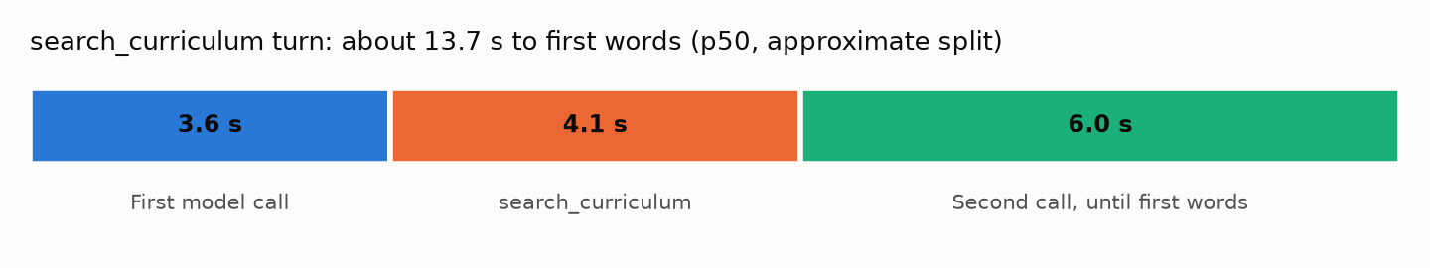
Figure 3. Approximate split: the medians come from different turns and do not add exactly. The third part is 13.7 − 3.6 − 4.1 s.
- First call, 3.6 s: Sonnet decides to search and writes no text.
- Search, 4.1 s: slow for a vector search, though the code already runs its queries in parallel (core/tools/search_curriculum.py:851–886). The time is likely in the OpenAI embedding call, resolve_outcome, or standards_context.
- Second call until first words, about 6 s: longer than a whole plain answer. The search results are new, uncached text, so Sonnet reads them before it starts, and the sentence hold and stream guardrail apply again.

Step 7. What the current fields cannot show
Every step above stops at the same point: the first model call and the search tool are single numbers. To choose a fix, these parts need their own timings:
Missing field | Separates out
guardrail_wait_ms | Waiting for the guardrail classifier label (core/loop.py:332)
first_raw_text_ms | First text chunk from Bedrock, before leak.Screen; the hold is first_content_ms minus this
model_retries | Idle-watchdog retries in ModelCaller (pattern B)
search_embed_ms / search_query_ms / search_resolve_ms / search_standards_ms | The stages inside search_curriculum
search_calls | Number of search_curriculum runs per turn

6. Caveats
- Dev traffic only: internal testers, low volume. Percentiles per 5 minutes are noisy; read the weekly figures.
- Medians are not additive: p50s from different turns do not add up exactly (Q5 split is approximate).
- first_content_ms excludes status labels: status labels appear before first_content_ms, so the teacher's experience in pattern A is a status line, not a blank screen. Check one such thread in the dev UI before choosing a fix.
- Dashboard query mixes turn types: the dashboard query (Q1) includes turns with no visible text (0 values) and grading requests; Q2–Q4 filter these out.
- Error-rate spike: the dashboard's error-rate widget shows one window at 100% around 5 October. That is outside this investigation (it is an error, not latency); it most likely matches the IndexError on dev fixed the same day under ONLINE-7578, but this was not checked.
- Alarm sensitivity: the first-content alarm has no minimum-turn guard, unlike the error-rate alarm, so a single slow turn can trigger it on dev.

7. Next step: ONLINE-7764
Agreed with Salman: a new branch off ONLINE-5385_scout_improvements with its own MR (not !74). Add only the missing fields in Step 7: durations and counts, no text, no behaviour change, existing checks must pass. The decisions the data will settle are written before collection:
# | Question | Outcome → next step
D1 | For plain answers, which is the main cause: guardrail wait, Sonnet's first raw text, or the sentence hold? | Guardrail → raise with Salman · Sonnet → prompt-size or caching ticket · Hold → change leak.Screen release · None → no ticket
D2 | For search turns, which stage is the main cause: embedding, queries, resolve, or standards context? | Optimize that stage only
D3 | Do retries explain the >10 s tail? | If ≥ 25% of tail turns retried → watchdog/retry ticket
D4 | Does a lead-in sentence shorten the wait? | Compare within the same turn kind only

Threshold: A stage counts as the main cause when it is at least 1 s at p50 and at least 40% of first_content_ms p50, within the same turn kind. After one week of dev data, the readout sub-task reports D1–D4 and opens fix tickets only where a threshold is met.

Appendix A. Q1 data: all 5-minute windows
Window (UTC) | first p50 | first p95 | ttft p95 | total p95
2026-10-08 08:00 | 4120.9 | 5167.5 | 5127.8 | 30924.5
2026-10-08 07:05 | 4041.2 | 4041.2 | 4006.8 | 6815.8
2026-10-08 05:55 | 7081 | 7081 | 7044.6 | 7097.1
2026-10-08 04:50 | 5789.3 | 7893.5 | 7851.1 | 12396
2026-10-08 04:30 | 5649.4 | 8134.7 | 8092.4 | 12828.7
2026-10-08 04:05 | 8007.7 | 8007.7 | 7970.7 | 8691.5
2026-10-08 03:55 | 8291.1 | 8291.1 | 8252.9 | 8924.1
2026-10-08 03:35 | 7823.4 | 8976.3 | 8937.4 | 9666.2
2026-10-08 01:30 | 7918 | 8841 | 8803.2 | 9530.2
2026-10-08 01:05 | 3428.6 | 4952.8 | 4950.1 | 23263.9
2026-10-08 01:00 | 12289.1 | 12289.1 | 12252.1 | 12985
2026-10-07 17:50 | 4371.3 | 5062.9 | 5055.5 | 30383.7
2026-10-07 17:45 | 5533.9 | 6477.9 | 6471.5 | 23073.7
2026-10-07 17:40 | 6068.3 | 9484.2 | 9434.8 | 10248.3
2026-10-07 14:40 | 5069.5 | 5069.5 | 5066.8 | 7642.9
2026-10-07 14:35 | 3792.9 | 6492.9 | 6491.4 | 6518.3
2026-10-07 14:30 | 6415 | 7319.3 | 7317.9 | 31929
2026-10-07 14:25 | 6897.8 | 7034.9 | 7032.5 | 7923.5
2026-10-07 13:50 | 6560.4 | 11837.7 | 11836.9 | 11864
2026-10-07 13:45 | 11020.1 | 11020.1 | 10981 | 12355.6
2026-10-07 12:25 | 3753.8 | 3753.8 | 3750.8 | 3771.6
2026-10-07 12:20 | 4740.9 | 6059.6 | 6058.7 | 6667.1
2026-10-07 12:15 | 5921.2 | 7355.5 | 7352.1 | 9211
2026-10-07 12:10 | 8810.9 | 9971.9 | 9969.2 | 57583.4
2026-10-07 12:05 | 3181.7 | 3181.7 | 3178.4 | 3878
2026-10-07 12:00 | 4486.3 | 14127.9 | 14124.2 | 23452.8
2026-10-07 11:55 | 1406.8 | 8277.8 | 8351.3 | 22075.4
2026-10-07 11:50 | 3256.3 | 3795.5 | 3792.8 | 7790.1
2026-10-07 11:45 | 2859.5 | 4775.7 | 4743.9 | 5603.9
2026-10-07 09:45 | 4807.8 | 7018.8 | 7016.3 | 21965.7
2026-10-07 09:40 | 3414.8 | 4043.6 | 4039.1 | 7313.9
2026-10-07 09:35 | 3656.4 | 4683.7 | 4681.6 | 5769.8
2026-10-07 09:30 | 3240 | 12438 | 12435.6 | 13256.1
2026-10-07 06:00 | 0 | 0 | 0 | 4180.5
2026-10-07 05:35 | 3541.8 | 4507.7 | 4503.6 | 4523.1
2026-10-07 05:30 | 2960.1 | 3530.6 | 3494.6 | 4415.6
2026-10-07 05:05 | 5814.1 | 7695.9 | 7690.2 | 8370
2026-10-07 05:00 | 3823.4 | 4139.8 | 4012 | 6292.3
2026-10-07 04:55 | 0 | 0 | 0 | 5117.7
2026-10-07 04:00 | 3689.4 | 5841.1 | 5838.9 | 6525.3
2026-10-07 03:55 | 4499.9 | 6540.1 | 6604.6 | 25376.6
2026-10-07 03:50 | 3716.6 | 3716.6 | 3678.8 | 5103.9
2026-10-07 02:40 | 4061 | 6344.1 | 6341.4 | 6561.6
2026-10-07 02:35 | 2941.5 | 7928.7 | 7926.6 | 8674.7
2026-10-07 02:30 | 4057.7 | 7156.1 | 7153.3 | 44057.4
2026-10-07 02:25 | 6663.6 | 7761.8 | 8021.9 | 30970.3
2026-10-06 13:50 | 13619.4 | 13619.4 | 13580.5 | 13643.1
2026-10-06 13:45 | 3895.9 | 3895.9 | 3861.2 | 4628.7
2026-10-06 13:30 | 3437.5 | 3437.5 | 3433.2 | 5053.5
2026-10-06 13:20 | 2650.9 | 2650.9 | 2645.6 | 6669.5
2026-10-06 12:45 | 3501 | 3501 | 3467.5 | 5575.4
2026-10-06 11:50 | 5144.3 | 5144.3 | 5140 | 40952.9
2026-10-06 11:45 | 3996.5 | 7017.6 | 6978.2 | 34399.8
2026-10-06 08:30 | 9517.7 | 9517.7 | 9477.6 | 13712.2
2026-10-06 07:40 | 3563.1 | 5866 | 5862.2 | 22359.7
2026-10-06 07:35 | 5173.6 | 11198.3 | 11194.2 | 37320.6
2026-10-06 07:30 | 3606.4 | 3606.4 | 3601.7 | 7889.1
2026-10-06 07:25 | 3398.6 | 12646.6 | 12645.2 | 12670.5
2026-10-06 07:15 | 5325.2 | 6887.4 | 6885.6 | 6907.9
2026-10-06 07:10 | 11115.7 | 11115.7 | 11074.7 | 11858.5
2026-10-06 07:00 | 5561 | 6474.8 | 6470 | 16246.8
2026-10-06 06:10 | 4389.1 | 13874.4 | 13868.1 | 14564.5
2026-10-06 06:05 | 2587.1 | 4465.8 | 4464.3 | 4483.3
2026-10-06 06:00 | 184.7 | 184.7 | 184.7 | 926.2
2026-10-06 05:55 | 2496.3 | 3829.6 | 3825.7 | 4456.2
2026-10-06 05:50 | 103 | 2375.4 | 2344.8 | 22913.9
2026-10-06 05:35 | 4922 | 5134.4 | 5128.8 | 30232.1
2026-10-06 05:00 | 3193.2 | 4777.4 | 4774.1 | 5393.1
2026-10-06 04:55 | 1211.1 | 14480.3 | 14478.5 | 15844.9
2026-10-06 04:50 | 2546.5 | 5935.3 | 5934.9 | 34590.7
2026-10-06 04:45 | 71.4 | 2674.3 | 2670.4 | 22523.4
2026-10-06 04:40 | 7609.9 | 7609.9 | 7571.6 | 8380.1
2026-10-06 02:55 | 3585.7 | 3585.7 | 3577.1 | 5213.4
2026-10-06 02:50 | 4279 | 10540.6 | 10538.3 | 11233.5
2026-10-06 02:45 | 3314.9 | 5675.9 | 5675.1 | 7581.3
2026-10-06 02:40 | 5566 | 7218.5 | 7214.2 | 16612.4
2026-10-06 02:35 | 3951.2 | 6120.7 | 6116.3 | 10436.2
2026-10-06 02:30 | 4296.9 | 5404.8 | 5403.9 | 24572.8
2026-10-06 02:25 | 5753.7 | 10879.3 | 10875.4 | 10898.6
2026-10-06 02:20 | 2424.8 | 5217.7 | 5214.4 | 30522.1
2026-10-06 02:15 | 3741.8 | 11785.8 | 11785.3 | 17379.1
2026-10-06 02:10 | 4146.6 | 6172.5 | 6167.7 | 6414.9
2026-10-06 02:05 | 123 | 3904.7 | 3903.7 | 4325
2026-10-06 02:00 | 2855.9 | 15445.8 | 15444.3 | 22100.8
2026-10-06 01:55 | 8357.1 | 8357.1 | 8317.3 | 9144.1
2026-10-05 18:00 | 6318.8 | 6318.8 | 6315.2 | 6590.3
2026-10-05 17:55 | 2427.8 | 13783.9 | 13778.5 | 33105.8
2026-10-05 17:50 | 5048.2 | 11465.1 | 11464.4 | 17113.4
2026-10-05 17:45 | 3234.6 | 10674.8 | 10672.3 | 12503.1
2026-10-05 17:40 | 3320.6 | 3702.7 | 3701.7 | 5115.8
2026-10-05 17:30 | 4867.7 | 12057 | 12056.8 | 16376.8
2026-10-05 16:05 | 6424.3 | 6855 | 6850.7 | 17629.9
2026-10-05 16:00 | 3340.2 | 9334.1 | 9331.8 | 10627
2026-10-05 15:55 | 3152.3 | 4068.8 | 4065.5 | 4213.3
2026-10-05 15:50 | 3013.9 | 7205 | 7201.3 | 8108.7
2026-10-05 15:45 | 6742.3 | 12129.1 | 12128.6 | 21262.9
2026-10-05 15:40 | 7764 | 11381.8 | 11377.7 | 11424.3
2026-10-05 15:35 | 3167.5 | 5186.2 | 5184.2 | 5976.4
2026-10-05 15:30 | 4779.5 | 9838.6 | 9837.8 | 30876.4
2026-10-05 15:25 | 2480.2 | 6399.2 | 6395.5 | 36152.7
2026-10-05 15:20 | 4525.5 | 7040.4 | 7036.8 | 16200.4
2026-10-05 15:15 | 4630.1 | 6251 | 6248.1 | 6856.6
2026-10-05 15:10 | 5313.2 | 15853.6 | 15809.2 | 16513.1
2026-10-05 14:40 | 6125.3 | 7415.7 | 7412.4 | 15774.5
2026-10-05 14:35 | 8663.7 | 15718.7 | 15680.4 | 16448.9
2026-10-05 14:25 | 6906.9 | 13163.1 | 13156.7 | 14222
2026-10-05 14:20 | 3695.1 | 11505.8 | 11499.4 | 23985.4
2026-10-05 14:15 | 4418.6 | 11518 | 11517.4 | 22089.8
2026-10-05 14:10 | 3283.1 | 3530.7 | 3528.6 | 5394.3
2026-10-05 14:05 | 3579.6 | 5224.2 | 5220 | 26308.4
2026-10-05 14:00 | 2533.1 | 9681.2 | 9679.9 | 36340
2026-10-05 13:55 | 4439.9 | 11165.7 | 11164.4 | 37601.5
2026-10-05 13:50 | 3485.5 | 13357.2 | 13356.5 | 22432.5
2026-10-05 13:45 | 4226.6 | 9132 | 9130 | 9833.5
2026-10-05 13:40 | 5165.1 | 6064.9 | 6061.7 | 21878.4
2026-10-05 13:35 | 4181.9 | 6027.1 | 6024.2 | 6219.8
2026-10-05 13:30 | 15626.6 | 15626.6 | 15587.2 | 16311.9
2026-10-05 11:25 | 5472.6 | 17434.1 | 17392.2 | 18092
2026-10-05 10:40 | 5610.1 | 9295.9 | 9294.6 | 19752
2026-10-05 10:30 | 15246.5 | 15246.5 | 15202.5 | 25304.7
2026-10-05 09:55 | 6171.7 | 6171.7 | 6135.3 | 16566.8
2026-10-05 09:45 | 4799 | 10152.9 | 10111.1 | 19648
2026-10-05 09:25 | 4935.5 | 4935.5 | 4931.7 | 26344.9
2026-10-05 09:15 | 3727.6 | 8912.8 | 8912.2 | 18287.9
2026-10-05 09:10 | 3464.8 | 7958.5 | 7956.4 | 7972.3
2026-10-05 08:55 | 3972.7 | 3972.7 | 3937.8 | 3990.3
2026-10-05 08:45 | 3605.7 | 3605.7 | 3572.8 | 4204.6
2026-10-05 08:40 | 5597.2 | 5597.2 | 5555.9 | 5621.2
2026-10-05 08:15 | 3683.2 | 5025 | 5021.7 | 5852.4
2026-10-05 08:10 | 3222.7 | 3222.7 | 3184.9 | 3484.3
2026-10-05 08:00 | 14910 | 14910 | 14873.4 | 15543.2
2026-10-05 07:25 | 0 | 0 | 12763.6 | 12779.5
2026-10-05 07:20 | 0 | 0 | 20721.2 | 20736
2026-10-01 16:05 | 4731.8 | 5619.9 | 5605.7 | 5636.6
2026-10-01 16:00 | 5214.9 | 6907.5 | 6906.7 | 6929.1
2026-10-01 15:55 | 4582.4 | 6871.8 | 6748 | 58949.9
2026-10-01 14:55 | 8420.8 | 8420.8 | 8283 | 9156.8
2026-10-01 14:45 | 4314 | 7744.6 | 7602.7 | 7806
2026-10-01 13:05 | 6140.5 | 6999.3 | 6998.1 | 14774.7
2026-10-01 13:00 | 4636.2 | 10921 | 10918.8 | 11184.2
2026-10-01 12:55 | 10539.3 | 16959.9 | 16955.4 | 36081.5
2026-10-01 12:50 | 3604.7 | 7123.9 | 7121.7 | 73064.8
2026-10-01 12:45 | 5717.3 | 8877 | 19074.4 | 20807.5
2026-10-01 12:25 | 0 | 0 | 0 | 5150.4
2026-10-01 12:20 | 4231.4 | 11271.1 | 14949.6 | 15758.1
2026-10-01 11:00 | 4396.3 | 12020.4 | 11884.2 | 14052.2
2026-10-01 10:50 | 5009.1 | 11817.3 | 11815.9 | 13478.4
2026-10-01 10:45 | 6204.7 | 17840.5 | 17710 | 37045.4
2026-10-01 10:40 | 3554.5 | 3554.5 | 3552.6 | 3573.7
2026-10-01 10:35 | 5166.4 | 6229.8 | 6169 | 22362.1
2026-10-01 10:25 | 3111 | 5803.7 | 5678.3 | 5821.3
2026-10-01 10:20 | 6625.8 | 17911.8 | 17907.7 | 20258.8
2026-10-01 10:15 | 15758.5 | 17509.9 | 17506.3 | 18159.3
2026-10-01 10:10 | 3734.7 | 5004.4 | 5002.5 | 5021.8
2026-10-01 10:05 | 5814.9 | 9291.6 | 9289.8 | 10183
2026-10-01 09:45 | 4662.8 | 7706.4 | 7724.6 | 13584.4
2026-10-01 09:40 | 5930.8 | 6944.9 | 6942.1 | 13934.3
2026-10-01 09:35 | 3674.2 | 4170.2 | 4168.4 | 6008.6
2026-10-01 09:30 | 12840.1 | 12840.1 | 12838.7 | 13572.6
2026-10-01 09:25 | 4191.9 | 5396.1 | 5393.5 | 5569.9
2026-10-01 09:20 | 4894.3 | 9386.2 | 9611.2 | 20633
2026-10-01 09:15 | 6059.7 | 6059.7 | 5916 | 14440.9
2026-10-01 09:10 | 5106.9 | 6321.2 | 6181.1 | 12227.4

Appendix B. The 5 October alarm
Item | Value
Alarm | swo-genai-pov-ai-assistant-v2-dev-first-content-p95
State change | OK → ALARM, 5 Oct 2026 14:29:15 UTC
Metric | ScoutCoreV2/swo-genai-pov-ai-assistant-v2-dev · FirstContentMs · p95 · 300 s period
Rule | Greater than 10,000 ms for 3 of the last 3 periods
Datapoints | 11,479 ms (14:14) · 11,465 ms (14:19) · 13,034 ms (14:24)
Back to OK | 18:01:15 UTC, ALARM → OK: 1 datapoint 6,881 ms (17:51) not above 10,000 ms
Defined in | infra/swo/modules/scout-core-v2/observability.tf (ttft_p95)

