ONLINE-7526: Scout Cost and Speed — QA Test Results
Daily cap in dollars, cached conversation history, stage timings, faster cold starts, dead weight removed

Summary
Item | Detail
Ticket | ONLINE-7526
Environment | dev2 (rag branch ONLINE-5385_scout_ai_integration; no swo-3.0 change). Chat Lambda swo-genai-pov-ai-assistant-v2-dev last deployed 2026-10-01 07:40:45 UTC, gateway Lambda swo-genai-pov-ai-assistant-dev 07:39:27 UTC
Account | Teacher account with the AI feature flag on; AWS read access to the dev account (us-west-2)
Page | Scout chat on dev2 (/beta/), plus direct API calls and read-only AWS checks
Date | 1 Oct 2026
Overall result | PASS on everything run so far: API and AWS checks 17/17, the 240 checks that ship with the ticket 240/240, and the turn and the daily usage row both match the price table. 2 findings: the guardrail scoping is not built, and there is no deployed before/after measurement. The $5 cap refusal, the rate limit and multi-turn caching are not covered yet.

API results
Run with ONLINE-7526-api-tests.sh against dev2 with the teacher's own token. The chat checks send a blank message, which rag refuses after the sign-in, daily-cap and rate-limit checks and before any model call, so nothing here spends AI credits. The AWS checks only read.

rag chat: POST /assistant/v2/turn (Function URL)
Check | Status | Response | Result
Guest (no token) | 401 | not_signed_in: "Your session has ended. Please sign in again." | PASS
Blank message, teacher under the cap | 400 | empty_message: "Message cannot be empty." (passed the daily-cap check; no model call) | PASS
Not refused by the daily cap | — | no DAILY_LIMIT_EXCEEDED in the response | PASS

rag gateway: POST /v3/assistant/thread/listing (API Gateway)
Check | Status | Response | Result
Guest (no token) | 401 | "Unauthorized" (API Gateway authorizer) | PASS
Listing, first call | 200 | 1 thread of 189, pinned first; 5.17 s (a guest 401 takes 0.87 s, so about 4.3 s was spent in the Lambda, likely a cold start) | PASS
No internal usage record (_usage) in the response | — | absent | PASS
No daily-row fields (cost_microusd) in the response | — | absent | PASS
Listing, warm | 200 | 1.00 s, about the same as the guest round trip | PASS

AWS (read-only): DynamoDB, Lambda, CloudWatch
Check | Status | Response | Result
Content-cache table swo-genai-pov-content-cache-dev removed | — | ResourceNotFoundException | PASS
Its CloudWatch alarms removed | — | 0 left | PASS
Daily-usage table kept, not recreated | — | swo-ai-daily-usage, created 2026-01-09 | PASS
Chat Lambda: DAILY_USAGE_TABLE_NAME, no cap or cache-table env var | — | swo-ai-daily-usage; none of CONTENT_CACHE_*, DAILY_COST_*, DAILY_TOKEN_* | PASS
Gateway Lambda: the same | — | swo-ai-daily-usage; none | PASS
Today's daily row has dollars and cached tokens | — | cost $0.298217; input 342, output 2,761, cache read 342,021, cache write 69,982; total 415,106 (= the sum) | PASS
core_turn log lines carry the stage split | — | 187 of 191 completed turns in 24 h have model_ms | PASS

Not covered yet
Check | Expected | Result
Teacher over the $5 cap, chat and gateway (needs a write to the tester's own daily row) | 429 | Not covered
Just under the cap: one more request allowed, the next refused | 200 then 429 | Not covered
11th chat message in a minute (rate limit) | 429 | Not covered
Teacher without the AI flag | 403 | Not covered
One turn adds exactly its tokens and dollars to the daily row (read before and after) | See test plan | Not covered
Generate / level request adds once to the row; reads add nothing | See test plan | Not covered
Turns 2 to 4 of one thread read the history from cache; a 6-minute gap writes it again | See test plan | Not covered
Cold-start rate before and after (REPORT lines) | See test plan | Not covered
Cost and latency for the 7 days before the deploy, to compare with after | See test plan | Not covered
Guardrail block/allow parity; no chat-quality regression (verify suite) | See test plan | Not covered

Chat: one turn's cost and cache
A class-overview question in Scout chat (thread ccb28eb0-…), one model call, no tools. The turn.end event is stamped 12:38 PKT (07:38 UTC), about 2 minutes before the chat Lambda's 07:40:45 UTC deploy, so it ran on the previous image. That image already had the history cache (c0ec9795, 27 Sep); it may not have had the 1 Oct constitution checkpoint (83ec2cc0).
Check | Observed | Result
Cost matches the one price table | 2 × $2.20 + 416 × $11.00 + 26,669 × $0.22 + 1,058 × $2.75 per M tokens = $0.013357, exactly turn.end cost_usd | PASS
Prompt read from cache, little fresh input | input 2, cache read 26,669, cache write 1,058 (the new message, written for the next turn) | PASS
Stage timings reported | context 3.5 ms, model 7,334 ms, first text 7,177 ms | PASS
Student names kept out of the reply | Pseudonyms only (Student KJPRFQ, Student KMTSQC, Student S73H4S) | PASS

Deployed turns, last 24 hours (CloudWatch)
Logs Insights over core_turn lines with outcome complete on swo-genai-pov-ai-assistant-v2-dev, for the 24 hours before the run. The window spans the 07:40 UTC deploy, so it mixes the two images. It's a snapshot, not the ticket's before/after figure.
Measure | Value | Result
Completed turns | 191 (187 with the stage split) | Pending
Mean cost per turn | $0.0233 | Pending
First content p50 / p95 | 4.97 s / 13.76 s | Pending
Total p50 / p95 | 5.63 s / 24.41 s | Pending
Input-side tokens: cache read / uncached / cache write | 4,801,250 (82.2%) / 114,101 (2.0%) / 925,234 (15.8%); about 30.6k per turn | Pending

Findings

1. The guardrail scoping isn't implemented
Item | Detail
Severity | Medium: one of the ticket's five scope items (and AC3) has no change behind it
Steps | Read the ONLINE-7526 commits in rag (9), and rag/lambdas/ai_assistant/src/core/loop.py build_request.
Expected | A read of the guardrail's billed cost; if material, only the new teacher message and the model's output checked, behind a declared gate with block/allow parity on the guardrail test cases.
Actual | No commit touches the guardrail; there's no cost read or parity gate in experiments/cost_speed_7526. build_request (loop.py:220) still puts every message under guardrailConfig on every model call. guardContent is used only for threads holding ONLINE-6554 curriculum grants (loop.py:199).
Scope note | AC3 ("parity holds") is true only because nothing changed. Ask whether the cost was read and judged not material, and where that is written.

2. No measurement of deployed turns, before and after
Item | Detail
Severity | Medium: scope item 1 and AC1 ask for figures from deployed turns
Steps | Read experiments/cost_speed_7526/GATE.md and RESULT.md.
Expected | Per-stage timings, cold-start rate, cache hit rate and cost per turn from CloudWatch, then before and after figures for cost per turn and p50/p95 latency.
Actual | Gate G-7526 ran on local snapshots (ports 8061 / 8062) on a frozen 24-turn set: PASS, arm/control 0.857 ($0.02458 → $0.02106 per turn, 40 matched turns; first-content p50 ×1.07, p95 ×0.885). No CloudWatch figures are in the repo; the first-load-latency.md handoff that f8ea9c5c cites isn't in it.
Scope note | The local result is real. The 24-hour snapshot above shows the deployed fields now exist (187/191 turns), so the before/after can be run with the queries in ONLINE-7526.md (tests 2 and 4).

Screenshots

1. API and AWS checks
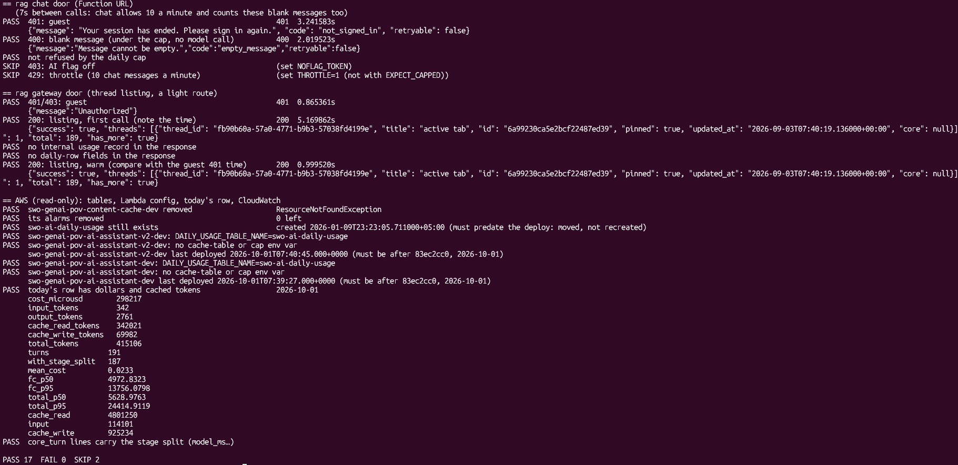
ONLINE-7526-api-tests.sh with AWS_CHECKS=1: 17 pass, 0 fail, 2 skipped (no flag-off token; rate limit not run). Cropped above the first check to leave out the tester's AWS sign-in identity.

Notes
- The 240 checks that ship with the ticket pass on origin at cf63ca2c: check_daily_usage 17, check_history_cache 10, check_cache_layers 12, check_lazy_imports 5, check_telemetry 41, check_routes 155.
- Checked in the code on origin: no infra/caylent; no alb, cloudfront or ecs modules and no commented-out module blocks in infra/swo/main.tf; the local server's fixed user id 112233 is gone. terraform plan was not run.
- Today's row is consistent with the price table: its tokens priced at Sonnet rates come to $0.2988 against $0.2982 recorded, a gap that fits a few cheaper Haiku calls (thread titles).
- Observation: in the last 24 hours, the deployed mean cost per turn ($0.0233) is above the pre-ticket DEV mean the code cites ($0.017 at list price, about $0.0187 at the billed rates), and turns average about 30.6k input-side tokens, not the ticket's 12.3k. The turns differ, so this isn't a regression; it's why the before/after needs the same turn set or the same window type.
- Observation: infra/swo/output.txt (terraform show output, 4,187 lines) and infra/swo/changes.json are committed Terraform state dumps that still list the content-cache table and its alarms. Not in the ticket's list, but the same kind of dead weight.
- Observation: the class-overview reply names classes by id prefix (024253e6…, fd1a4c04…), not by name. That comes from the page's published data, not this ticket.
- Observation: the first version of the test script checked the table name content-cache, which never existed, so that check would have passed either way. It was fixed to the deployed name before the AWS run.
- Observation: the gate's thread T1 was blocked by the guardrail on every pass ("What is the main idea of this article?" on the US Government article, topic Political and Extremist Content, guardrail v12). Dev now runs v14; worth checking during the guardrail parity test.

