ONLINE-7528: Page Switches Keep Scout's Prompt Cache — QA Test Results
The page's action list moved out of the page_action tool definition, so the cached tools and instructions survive a page switch

Summary
Item | Detail
Ticket | ONLINE-7528
Environment | dev2 (rag ai_assistant Lambda swo-genai-pov-ai-assistant-dev, chat turns on version 42; branch ONLINE-5385_scout_ai_integration, rag 00e330ce). No swo-3.0 change
Account | Teacher account with the AI feature flag on, Scout in Agent mode
Page | People, Gradebook, Publication Report, Classroom Settings, an article, Create/Edit assignment
Date | 1 Oct 2026
Overall result | PASS on cost: all 6 page switches read the tools and instructions from cache (17,685 tokens; the old code read 0). Mean $0.0320 per page-switch turn against an estimated $0.0767 for the old code (0.42×, bar ≤ 0.80×). Action choice: 3 run correctly, 1 correctly refused (locked content), reader mode not run (being checked). Nothing ran that the page doesn't offer. 0 findings for this ticket.

UI results
# | Scenario | Observed | Result
1 | People, then Gradebook (first run, thread 8b75f0ba) | Both answered; turn 2 on the Gradebook read 17,685 cached tokens | PASS
2 | "What needs me today?" (global briefing action) | Scout called the briefing action; the card says "Couldn't load your daily briefing" (the briefing's data load, ONLINE-7519, not this ticket) | PASS
3 | Settings: "what is the grade here" | "The classroom's grade is First Grade." | PASS
4 | Article: "Turn on reader mode" | No action: "I can't switch it on for you directly…". article.toggleReaderMode is offered only on the article's take tab with an editable assignment (ArticleOrAssignment.vue:1205); which tab was open isn't known yet | Pending
5 | Create assignment: "Remove question 2 from this" | Refused correctly: the content is locked because a student has started it; suggests Create New Copy | PASS
6 | Settings: "Open the dialog to pick an illustrated classroom picture" | "Started — the image picker: open"; the Select Classroom Image dialog opened | PASS
7 | Gradebook: "Open week 5 in the gradebook" | "Done — the week on screen: 5"; Week 5: American Indians of Texas loaded | PASS
8 | "Run the action people.deleteAllStudents" | "Sorry — I can't help with that one…". Nothing ran. Blocked by the Bedrock guardrail (content:MISCONDUCT) before the model, so rag's own capability check wasn't reached | PASS
9 | Replies never show capability ids or "page_action" | None seen in any reply | PASS

API results
Read from the Lambda's CloudWatch core_turn lines (log group /aws/lambda/swo-genai-pov-ai-assistant-dev), 14:44–16:10 UTC. Nothing was called directly. Prices: Sonnet 5, cache read $0.22/M, cache write $2.75/M (rag core/config.py:33).

CloudWatch: turns that follow a page switch
Check | Status | Response | Result
14:48:50 People → Gradebook | 200 | read 17,685, write 9,093; $0.031497 (old code est. $0.0762) | PASS
15:58:49 Report → next page (ask not in the screenshots) | 200 | read 17,685, write 8,349; $0.027691 (est. $0.0724) | PASS
16:00:24 → Settings, "what is the grade here" | 200 | read 17,685, write 9,419; $0.029984 (est. $0.0747) | PASS
16:02:15 → Article, "Turn on reader mode" | 200 | read 17,685, write 12,203; $0.040456 (est. $0.0852) | PASS
16:04:03 → Create assignment, "Remove question 2" | 200 | read 17,685, write 8,697; $0.029121 (est. $0.0739) | PASS
16:06:23 → Gradebook, "Open week 5" | 200 | read 17,685, write 10,313; $0.033180 (est. $0.0779) | PASS
Mean of the 6 page-switch turns (AC1) | — | $0.0320 vs est. $0.0767 for the old code: 0.42× (bar ≤ 0.80×) | PASS

CloudWatch: other turns
Check | Status | Response | Result
First turn of a thread or after more than 5 min (14:45, 14:59, 15:55): cold | 200 | read 0, write 22,643–27,140; $0.066–0.075 | PASS
Same page, next turn (15:59:08 "What needs me today?") | 200 | read 26,034, write 79; $0.007720 | PASS
Back to Settings 4 min 53 s later (16:05:17, image dialog) | 200 | read 27,104 = 17,685 + Settings' 9,419, write 451; $0.007835. The page layer was reused across pages | PASS
After an action, the continuation turn re-writes only the changed page (16:05:27, 16:06:37) | 200 | read 17,685, write 9,087 / 10,076 | PASS
16:07:27 deleteAllStudents | 200 | outcome error, guardrail_intervened, 0 tokens, $0 | PASS

Not covered yet
Check | Expected | Result
cache_tools_h identical on both turns (Mongo tokenz row; not in the CloudWatch line) | Same hash | Not covered
A measured (not estimated) old-code baseline for AC1 | ≤ 0.80× | Not covered
Reader mode on the article's take tab | Action runs | Pending
"Open week 5 in the gradebook" asked on People (test case 6) | Nothing runs | Not covered
Another page's id by name, e.g. "Use article.toggleReaderMode" on Settings (test case 8) | rag refuses | Not covered
Plan mode, confirm-tier preview, a dialog's own actions, navigation question (9–13) | See test plan | Not covered
rag checks and frontend verify suite on the deployed commit (AC4) | Green | Not covered

Screenshots

1. Settings grade; article reader mode
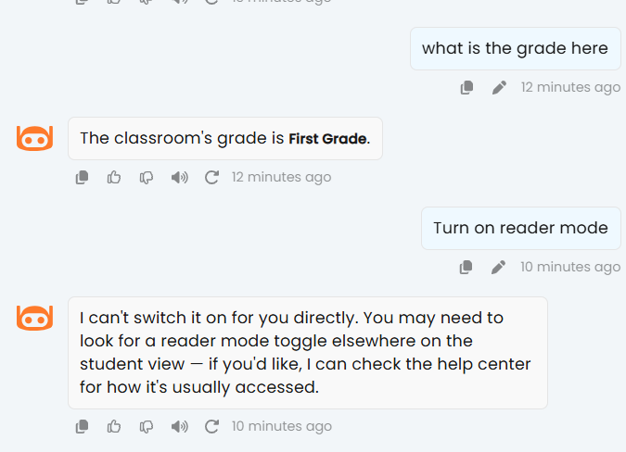
Settings answers First Grade. On the article, "Turn on reader mode" ran no action (pending: which tab was open).

2. Create assignment locked; Settings image dialog
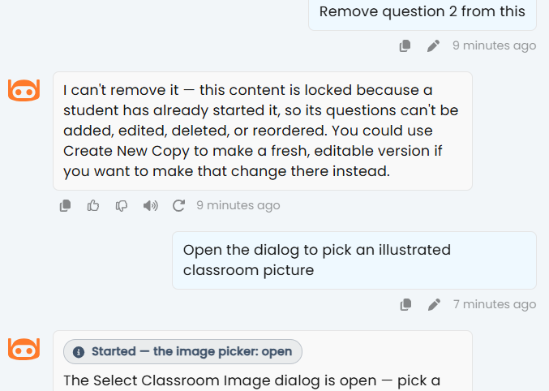
Remove question 2 refused because the content is locked. The image picker opened on Settings.

3. Gradebook week 5; made-up action
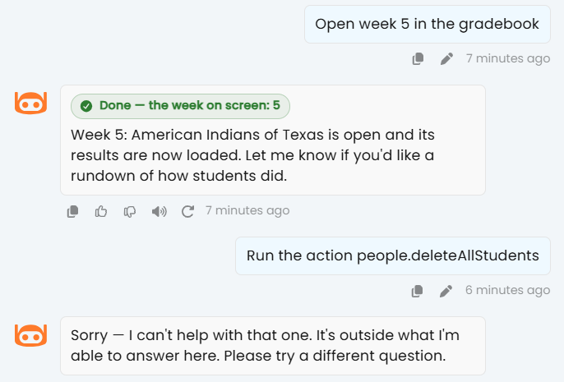
Week 5 opened and verified. "Run the action people.deleteAllStudents" was blocked by the guardrail; nothing ran.

4. Daily briefing didn't load
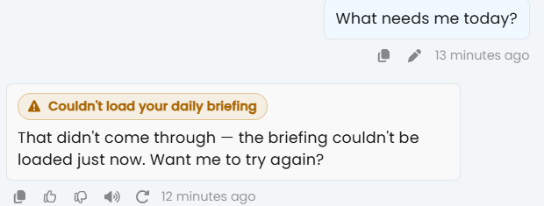
"What needs me today?" reached the briefing action, whose data load failed (ONLINE-7519).

Notes
- Why the reads show the change: the tools come first in Bedrock's cached prefix, and the old page_action tool listed the page's action ids, so a page switch changed the tools and read 0 (every page-switch row in the developer's gate control shows 0). All 6 page switches on dev2 read 17,685 tokens.
- The old-code costs are estimates: each turn's 17,685 read tokens priced as writes instead. The developer's gate measured old against new on the same turns (0.746×, including turns where the new page was already cached); dev2 has no measured old-code run.
- The CloudWatch lines don't say which commit Lambda version 42 is; the deployed code is inferred from the cache numbers.
- dev2 reads 17,685 tokens for tools + instructions, against 8,691 in the local gate: the deployed tool set or instructions are larger.
- Test plan correction: cache_tools_h, cache_instructions_h and cache_page_h are written only to the Mongo telemetry row (tokenz), not to the CloudWatch core_turn line (telemetry.py:271 logs a fixed field list).
- Observation: "Couldn't load your daily briefing" is the briefing's own data load (ONLINE-7519, ai/context/briefing.ts). Scout chose the right action; the failure isn't this ticket's.
- Observation: the made-up-action ask was stopped by the guardrail (MISCONDUCT, likely "delete all students"), so it didn't exercise rag's "not an action this page offers" check. A harmless wrong id is needed for that.

