ONLINE-7532: Suggest Standards — QA Test Results
Scout AI standards suggestions for a teacher's own customized-content questions

Summary
Item | Detail
Ticket | ONLINE-7532
Environment | dev2 (branch ONLINE-5385_scout_ai_integration, swo-3.0 + rag)
Account | Teacher account with the AI feature flag on
Page | Teacher → Classroom → Customized Content → Edit View (question list)
Date | 29 Sep 2026
Overall result | PASS: UI 6/6, API 15/15, chat information asks 3/3 returned no AI suggestion. 1 finding: the standard lookup misses standards the week itself links (see Findings).

UI results
# | Scenario | Observed | Result
1 | Suggest Standards shown on the question list when a question has no standard | The "Suggest Standards" button (with Scout's mark) appears above the list | PASS
2 | Educational question gets a suggestion from the state catalogue | "Match each type of source to an example of it." → 4.19(A), a Texas standard, with its description and a short reason | PASS
3 | Disclaimer shown with the suggestion set | "Suggested by AI. It can make mistakes, so please review before accepting." shown under the button | PASS
4 | Teacher controls each suggestion | Accept and Dismiss on each suggestion, plus "Accept All (1)"; nothing is attached until clicked | PASS
5 | Non-curriculum question gets no suggestion | "Which penguin is a chef?" → no standard; list note "No Studies Weekly standard matches these questions…" and the per-question reason | PASS
6 | Teacher can still attach a standard by hand | "+ Attach Standard" stays on every question; the normal flow is not blocked | PASS

API results
Run with ONLINE-7532-api-tests.sh against dev2 using the teacher's own token (Texas teacher, grade 4 classroom). Every call is read-only; the rag checks fail validation before any model call.

Laravel: POST /api/ai/standards/candidates
Check | Status | Response | Result
Guest (no token) | 401 | Unauthenticated. | PASS
search_text missing | 422 | The search text field is required. | PASS
classroom_id not a UUID | 422 | The classroom id must be a valid UUID. | PASS
grade 13 | 422 | The grade must be between 0 and 12. | PASS
assignment_id 0 | 422 | The assignment id must be at least 1. | PASS
Unknown classroom | 404 | Classroom not found. | PASS
Chat-style ask, grade 4, no classroom | 200 | state TX, grade 4, social studies + science candidates | PASS
Teacher's own classroom | 200 | state TX, grade 4, science + social studies candidates | PASS

rag: POST /assistant/v2/standards/suggest
Check | Status | Response | Result
No questions | 422 | Send at least one question. | PASS
31 questions (cap is 30) | 422 | Send at most 30 questions at a time. | PASS
Duplicate ref | 422 | Each question ref must be unique. | PASS
Empty question text | 422 | Every question needs a ref and its text. | PASS
Question over 2000 characters | 422 | A question may be at most 2000 characters. | PASS
6th request within a minute (rate limit) | 429 | You're moving fast! Scout can take 5 standards suggestion requests a minute. Please try again in 27 seconds. | PASS
Body is not JSON | 400 | The request couldn't be read. (deployed front door, same for every endpoint) | PASS
assignment_id not a number | 422 | assignment_id must be a number. | PASS

Not covered yet
Check | Expected | Result
Student token | 403 | Not covered
Admin who is not a teacher | 403 | Not covered
Another district's / school's classroom | 403 | Not covered
Another teacher's customized content | 403 | Not covered
Teacher without the AI flag: no button, no request; route hidden | 404 | Not covered
35 questions in the UI: one request carrying the first 30 | See test plan | Not covered

Chat: information asks (no AI suggestions)
Asked in the SWO Assistant on publication 568 (Week 1: I Am a Member of a Community). The ticket requires that an information ask is answered only from SWO data and never returns AI suggestions.
Ask | Observed | Result
Which standards does this week cover? | Answered from the week's Teacher Resources: TX K.13(C), K.14(C), K.14(D), K.8(A). No suggestion card, no disclaimer, nothing presented as an AI suggestion. | PASS
What articles are aligned to TX K.13(C)? | No AI suggestion. Says nothing in the materials is linked to K.13(C) and shows a search result (TX WB b.13.B, Health grade 3) while stating it is not an alignment. | PASS
What articles are aligned to TX K.14(D)? | No AI suggestion. Same pattern: "Not in this publication"; shows TX WB b.14.D (Health grade 4) as not a match. | PASS

Chat: explicit suggestion ask
Check | Observed | Result
Ask: "Suggest standards for this question: How did rivers shape where early settlers lived?" | A "Suggested standards" card is shown | PASS
Disclaimer in chat | The card opens with "Suggested by AI. It can make mistakes, so please review before accepting." (shown with literal underscores, see Findings) | PASS
Code from the teacher's state catalogue | "From the TX standards in the Studies Weekly catalogue": 4.7(A), grade 4, settlement and geographic factors, with a reason | PASS
Not presented as a Studies Weekly alignment | Reply says "a suggestion, not an official Studies Weekly alignment" | PASS
Reply never says the standard was added | Reply says "I've added an AI-suggested standard…" | FAIL

Chat: declines
Ask | Observed | Result
Give me Common Core standards for fractions | Says Common Core is not in the catalogue and offers the teacher's Texas standards instead. No CCSS codes. | PASS
Suggest standards for: remind me to call Jamie's mom at 5 | Declined as a personal reminder; offers suggestions for a curriculum topic instead. No codes. | PASS

Findings

1. Standard lookup contradicts the week's own standards
Item | Detail
Title | Standard lookup says no content is linked to K.13(C) / K.14(D), but the week lists both
Severity | Medium: the answer is wrong, but no AI suggestion is made and nothing is written
Steps | 1. Open publication 568, Week 1, ask "Which standards does this week cover?" → lists TX K.13(C) and K.14(D). 2. In a new chat on the same publication, ask "What articles are aligned to TX K.13(C)?" (and K.14(D)).
Expected | Week 1: I Am a Member of a Community (publication 568) is named as linked to each code.
Actual | "Not in this publication… I don't have anything in your Studies Weekly materials actually linked to K.13(C)"; only an unrelated Health standard is shown.
Scope note | The explicit-ask rule this ticket owns held (0 suggestions). The miss is in the standard lookup (search_curriculum), so it may belong to a separate ticket. Cause not yet investigated.

2. Chat reply says the suggested standard was "added"
Item | Detail
Severity | Medium: goes against the ticket's "nothing is added without a click" rule, in wording only
Steps | Open Scout chat and ask "Suggest standards for this question: How did rivers shape where early settlers lived?"
Expected | The reply says the suggestions are in the card to review. The suggest_standards tool tells the model: "never that you added or attached them" (rag commit 64099335).
Actual | "I've added an AI-suggested standard for that question in the card above". Nothing was saved; the wording is wrong. It also says "above" although the card is below the reply.
Scope note | The rule is only an instruction to the model, and the model broke it. A fixed reply that doesn't depend on the model would prevent this.

3. Italic markers show as literal underscores in the suggestions card
Item | Detail
Severity | Low: cosmetic, but it is the disclaimer the ticket requires
Actual | "_Suggested by AI. It can make mistakes, so please review before accepting._" and each reason ("_Question asks how a geographic factor…_") show with the underscores.
Cause | rag's card markdown (suggest_standards.py, _markdown) wraps the disclaimer and reasons in _…_, and frontend-v3's renderer (utils/safeMarkdown.ts) supports **bold** but no italics.
Fix options | Emit plain text (or **bold** for the disclaimer) from rag, or add italic support to safeMarkdown.

Screenshots

1. Suggestion returned for an educational question
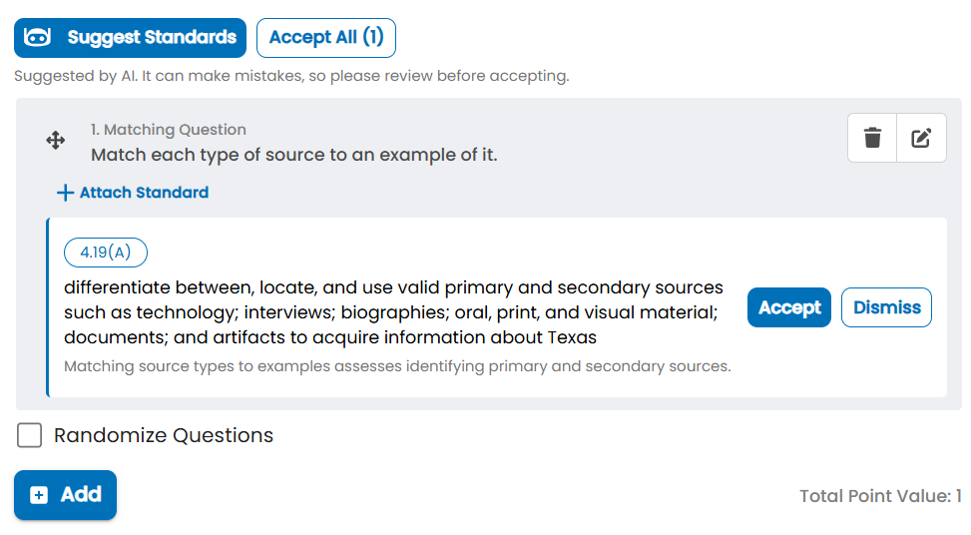
Suggest Standards → 4.19(A) (Texas) with description, reason, Accept / Dismiss, Accept All (1) and the AI disclaimer.

2. No suggestion for a non-curriculum question
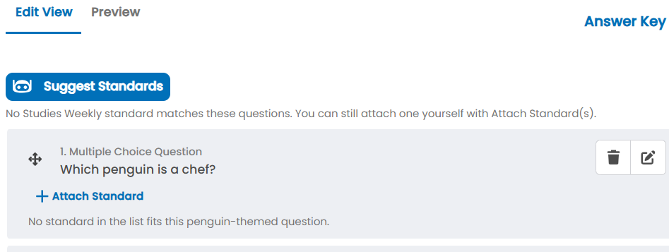
"Which penguin is a chef?" — no standard suggested; the list and the question both say why, and Attach Standard is still available.

3. Chat: which standards does this week cover
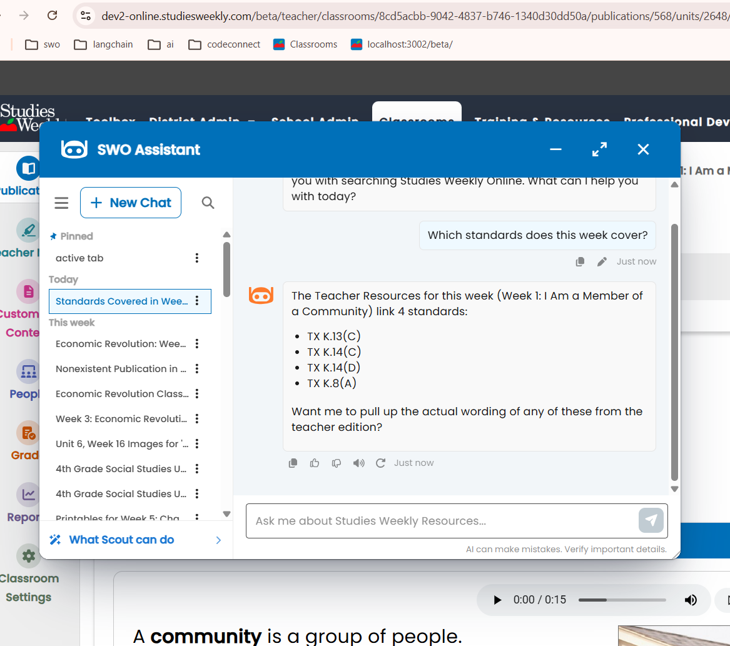
Answered from the week's Teacher Resources: TX K.13(C), K.14(C), K.14(D), K.8(A). No suggestion card.

4. Chat: articles aligned to TX K.13(C)
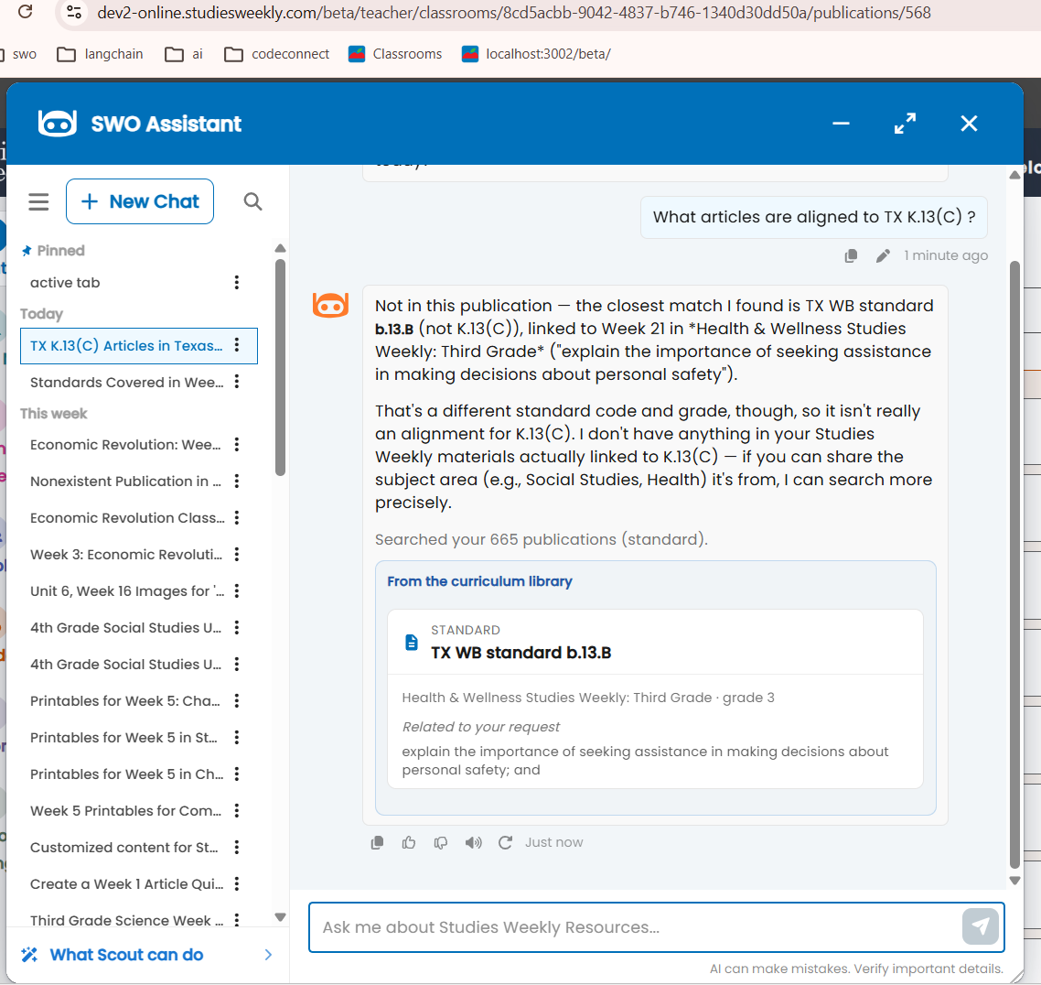
No AI suggestion, but it says nothing is linked to K.13(C), which screenshot 3 lists for this week.

5. Chat: articles aligned to TX K.14(D)
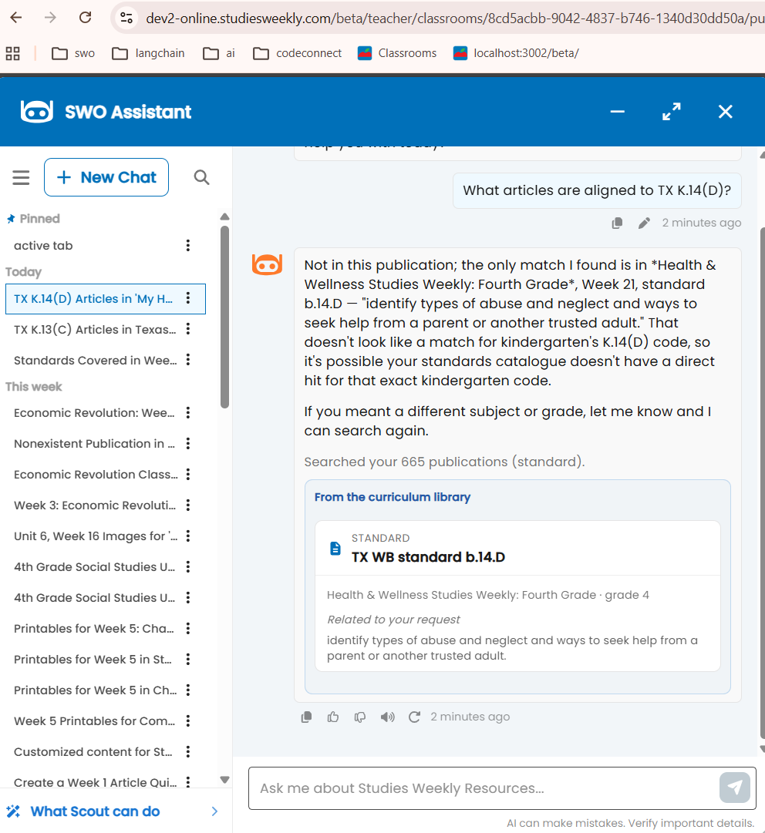
Same pattern for K.14(D), also listed in screenshot 3.

6. Chat: explicit suggestion ask
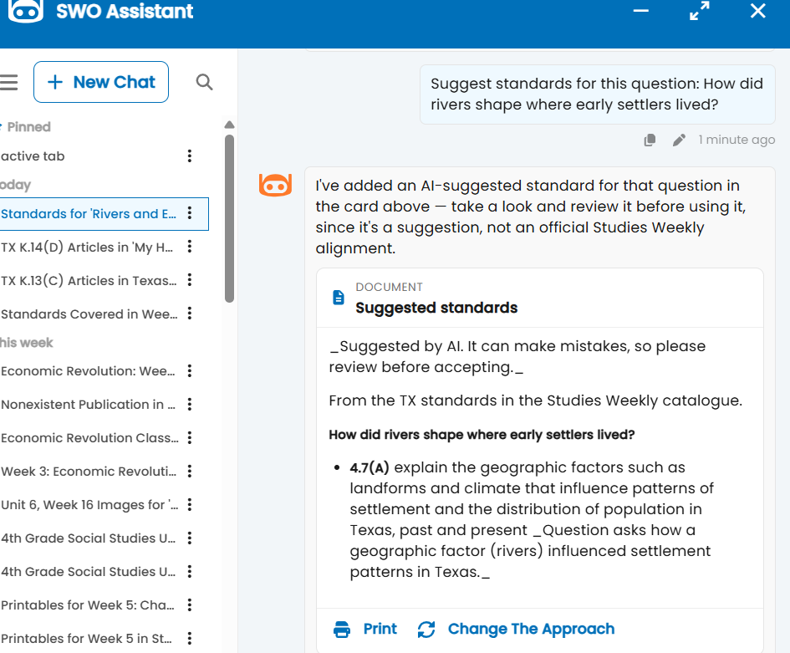
Suggested standards card with the disclaimer and TX 4.7(A). The reply says "I've added" (finding 2), and the underscores show literally (finding 3).

7. Chat: Common Core ask
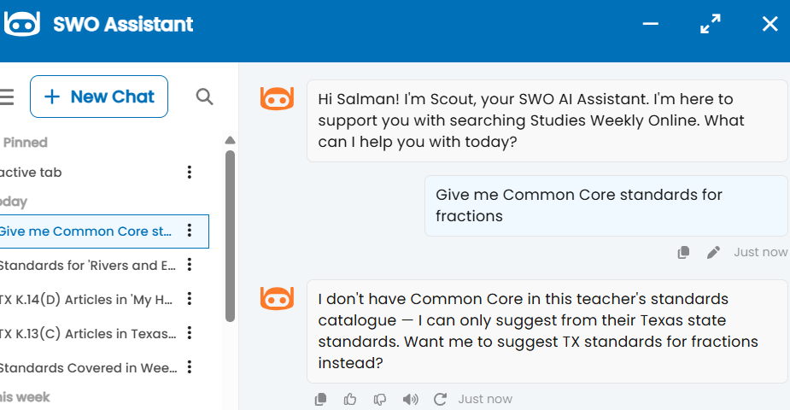
Common Core declined; Texas standards offered instead.

8. Chat: non-educational ask
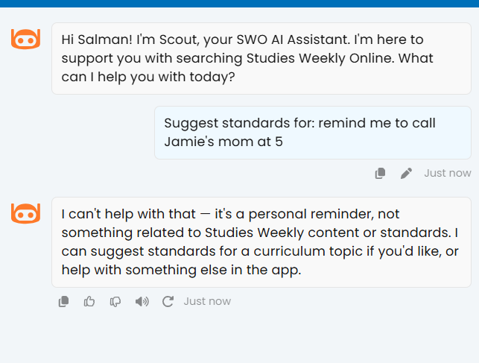
Personal reminder declined; no standard suggested.

Notes
- Screenshots #3 and #5 on the Jira comment are the same image, so it appears once here.
- The suggested code 4.19(A) is a Texas code, matching the teacher's state catalogue (TX).
- Observation: rag's rate limit counts invalid requests too (it is checked before the body). The page never sends invalid requests, so this only affects direct API testing.
- Observation: the first Texas candidate has code "1" (a science strand heading, not a specific standard). If it is ever suggested, the teacher would see a chip reading "1".
- Observation: the Common Core reply refers to the teacher in the third person ("this teacher's standards catalogue… their Texas state standards") while talking to them. Wording only.
- Observation: dev2's 404 response includes the exception class and server file path (debug output on). Expected on dev, not on staging or production.

