ONLINE-8093: Scout Release 2 — QA Test Results
Cleanup, guardrail, write_artifact, LangChain removal and round 2 tech debt; teacher, district admin and school admin, end to end

Summary
Item | Detail
Ticket | ONLINE-8093 (swo !6354, rag !101)
Environment | Local stack: swo-3.0 41ace7e971 and rag de38e41b (both ONLINE-5385_scout_release_2), frontend-v3 https://localhost:3002/beta, Laravel :3001, rag ai_assistant :8002 (FastAPI, no API Gateway), real Bedrock
Accounts | utteacher (teacher), utdistrictadmin (district admin), utschooladmin (school admin), seeded local accounts
Pages | Teacher: Classrooms and an article page (Week 25: The French and Indian War). Admin: District Insights and School Insights
How | Automated Playwright suite ~/ldc/e2e (1.63.0, Chromium), run with ./run.sh --project=api and --project=ui
Date | 26 Oct 2026
Overall result | PASS: UI 11/11 run (2 not covered), API 14/15 run (1 fails on a multi-role account, not a defect; 4 not covered: no gateway / Function URL locally, no flag-off account). 0 defects from this run; 3 observations.

UI results
Each row is one Playwright test; real Scout turns were sent (E2E_AI_TURNS=1).
# | Scenario | Observed | Result
2 | Sidebar loads with no errors | Chat list loads (POST /assistant/thread/listing 200), no 4xx/5xx on any thread request. Locally rag is called directly, so the /v3 path check was off (E2E_EXPECT_V3=0) | PASS
1, 3, 9 | Plain turn, one title, no student name, no "K-12" | "Write a short lesson plan for my students about reading a map." → reply builds a set from "Models of the World"; one POST /assistant/thread after the turn returned the generated title; no "Student N" in it; no "K-12" or "content check" in the reply | PASS
4 | History article not stopped by the content check | On "War in the Americas" (French and Indian War): "Make a lesson plan on this article." → "Your lesson plan is ready. Grade 4" with a Lesson Plan card; no content-check text anywhere | PASS
15 | Stop before the first token | Stop pressed straight after Send → "You stopped this answer before it started." with Stopped and Retry | PASS
14 | Chat opened from search is revealed in the sidebar | Search your chats → "Water" → 4 results; opening the last one highlights its row and scrolls it into view | PASS
16 | District Insights opens; Ask Scout offered | District Insights with figures (3 of 12 teachers, 97% from 736 results); Ask Scout About These Figures shown | PASS
16 | District question goes through the admin door | POST /assistant/v2/admin/turn 200; reply lists Utah School District 1 classes with no scored assessment; scope chip "Insights · 8 weeks · All grades · All schools" | PASS
17 | School Insights opens; Ask Scout offered | School Insights with figures (1 of 7 teachers, 99% from 672 results) and the Classes table | PASS
17 | School question goes through the admin door | POST /assistant/v2/admin/turn 200; reply limited to the admin's school; scope chip without a School filter | PASS
18 | Reopened chat then a new question (district) | Turn 200 and no "I couldn't find that conversation." The reopened chat was the admin's own, so the new-chat branch (admin_can_continue = false) wasn't exercised | PASS
18 | Reopened chat then a new question (school) | Same as above | PASS

API results
Run with ~/ldc/e2e --project=api against the local Laravel. Read-only; the one POST fails validation, so nothing is written.

Laravel: api/ai
Check | Status | Response | Result
Guest on GET user/credits | 401 | Unauthenticated | PASS
Teacher GET user/credits | 200 | credit, user_id, publication_ids, raised_spend_cap | PASS
Teacher GET admin/context | 403 | Forbidden (can:ai-admin-insights) | PASS
School admin GET user/credits / admin/context | 404 / 200 | Teacher-only credits hidden; admin context returned | PASS
District admin GET user/credits / admin/context | 200 / 200 | utdistrictadmin also holds the teacher role, so credits answer 200 (see Notes) | FAIL (test assumption)
POST stats with a response over 512 KB | 422 | The response field may not be larger than 512 KB. | PASS
10 removed routes: generate/question, article/difficulty, adapt, random-article, credits/purchase, credits/expire, feedback, credits/packages, user/credits/redeem, search-index/1 | 404 ×10 | Not Found | PASS

Not covered yet
Check | Expected | Result
Gateway: unprefixed /assistant/*, /v3/generate, /v3/generate-from-topic gone; /v3 thread route answers (local stack has no API Gateway) | 404 / 400 | Not covered
Function URL: no token, path outside /assistant/v2/, teacher on the admin door (local FastAPI has no Function URL front door) | 401 / 404 / 403 | Not covered
Teacher without the AI flag (no such local account) | 404 | Not covered
#12 old pre-release chat opens with its messages (utteacher has no v1 chats locally; core_legacy_threads empty) | Messages shown | Not covered
#10 chip-started chat continued by typing (no chip label chosen) | No 409 | Not covered
Manual cases: 5-8 guardrail/shortcut/plan parsing, 11 chip during a typed turn, 13 old chip thread, 19 exports, 25 throttles, 27 single session, 28 fixed apology, 29 docs walk-through | See test plan | Not covered

Findings
No defect was found in this run. The code-review findings for both MRs are in mr-review-comments.md and are not repeated here.

Screenshots

1. Teacher: lesson plan reply (cases 1, 3, 9)
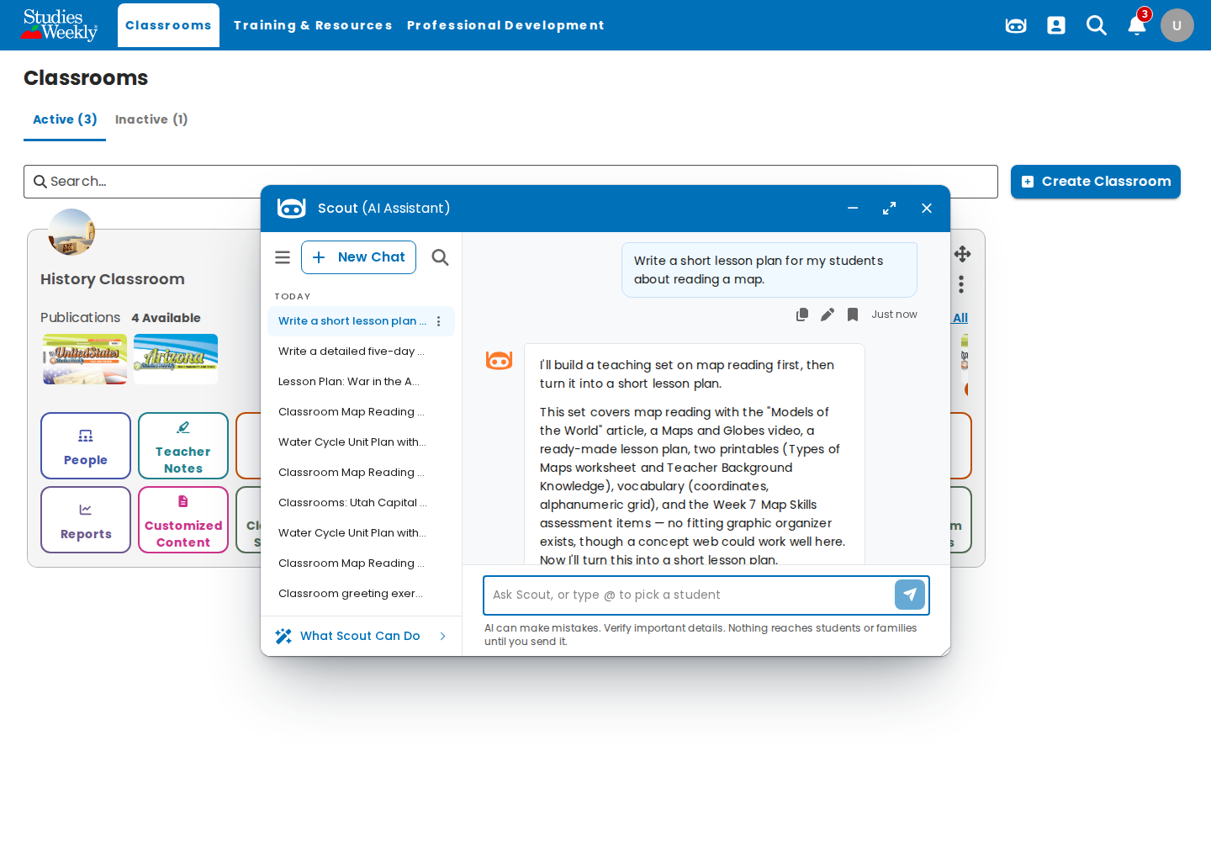
Scout builds a map-reading set from "Models of the World" and turns it into a short lesson plan. The chat is in the sidebar under Today.

2. Teacher: chat list loads (case 2)
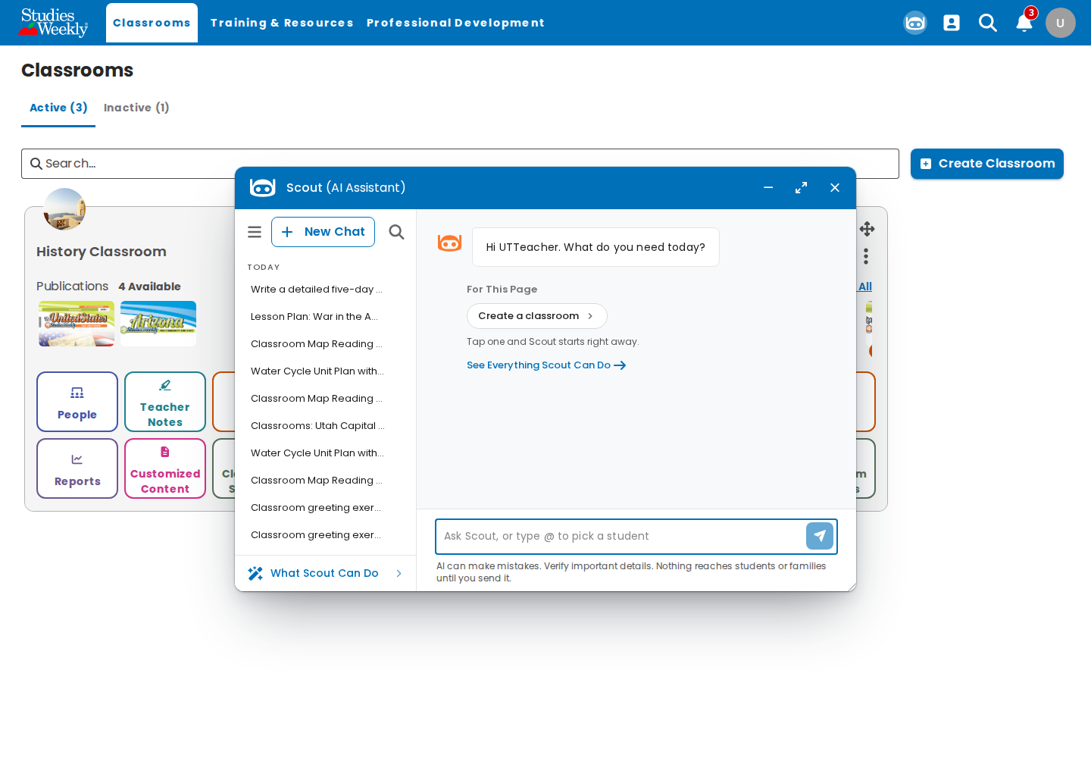
Sidebar with earlier chats, including generated titles such as "Classrooms: Utah Capital…" and "Lesson Plan: War in the A…".

3. Teacher: history article not blocked (case 4)
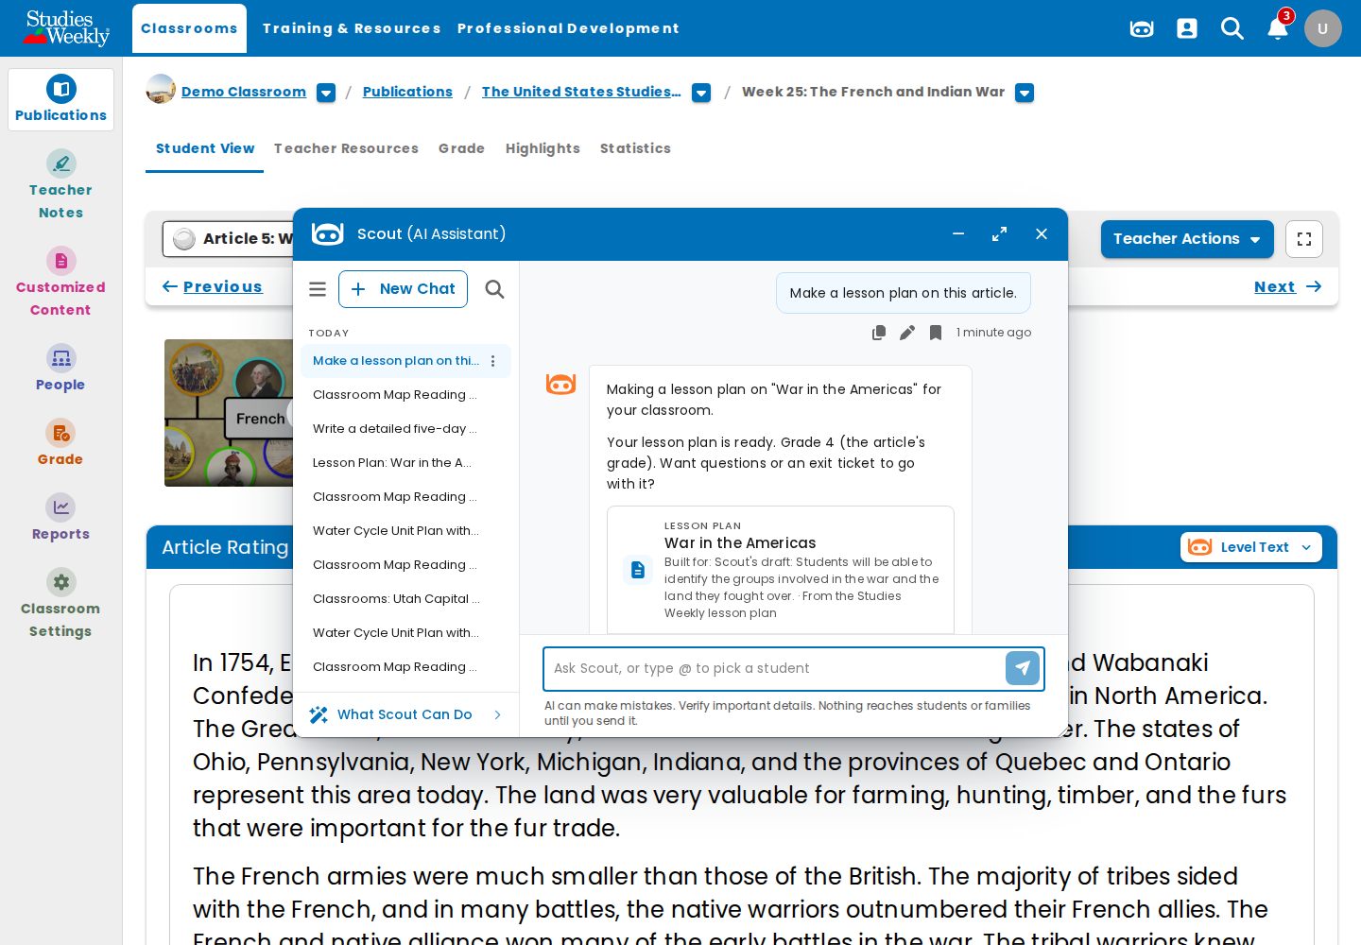
Week 25: The French and Indian War, "War in the Americas". The lesson plan is written and no content check appears.

4. Teacher: Stop before the first token (case 15)
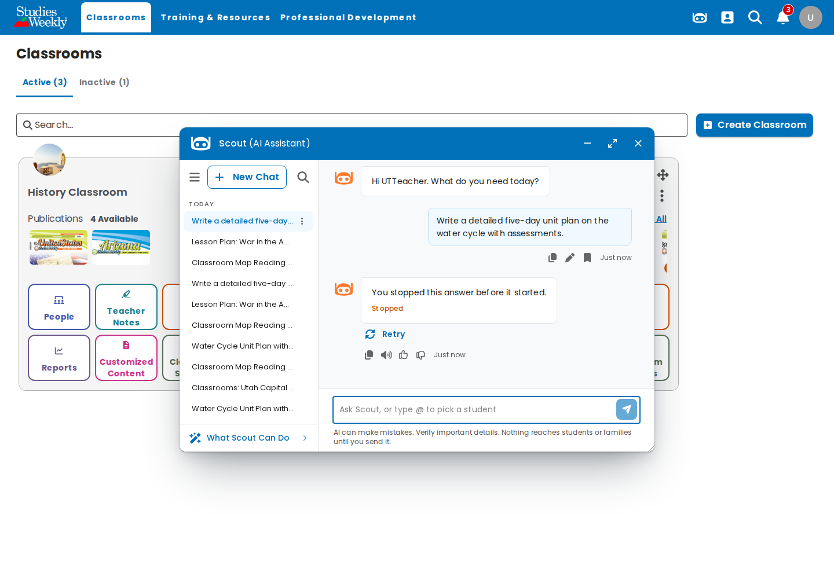
"You stopped this answer before it started." with Stopped and Retry.

5. Teacher: search your chats (case 14)
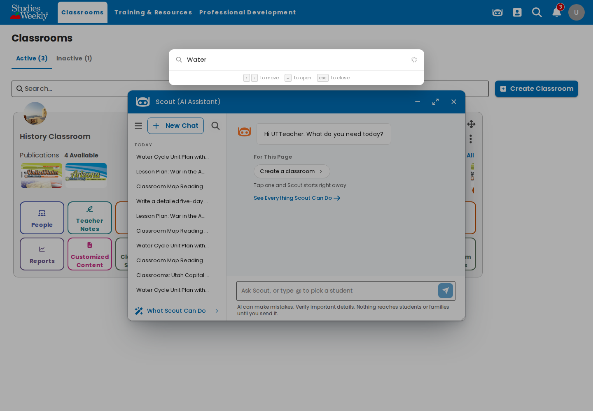
Search for "Water" lists four chats.

6. Teacher: chat from search revealed (case 14)
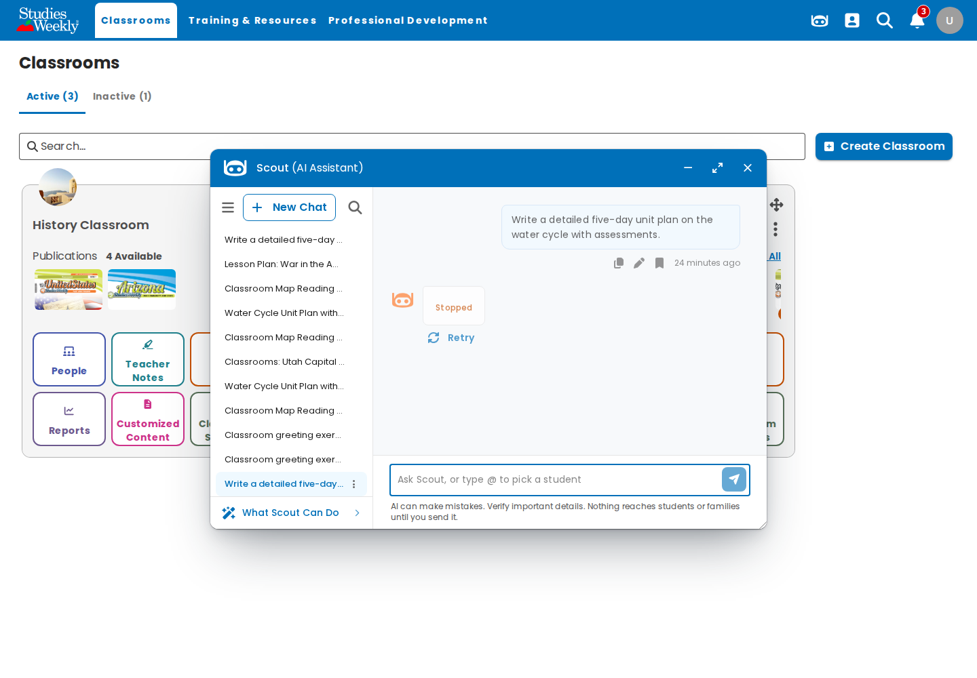
The opened chat is highlighted at the bottom of the sidebar. Its stopped answer shows only "Stopped" (see Notes).

7. District admin: District Insights (case 16)
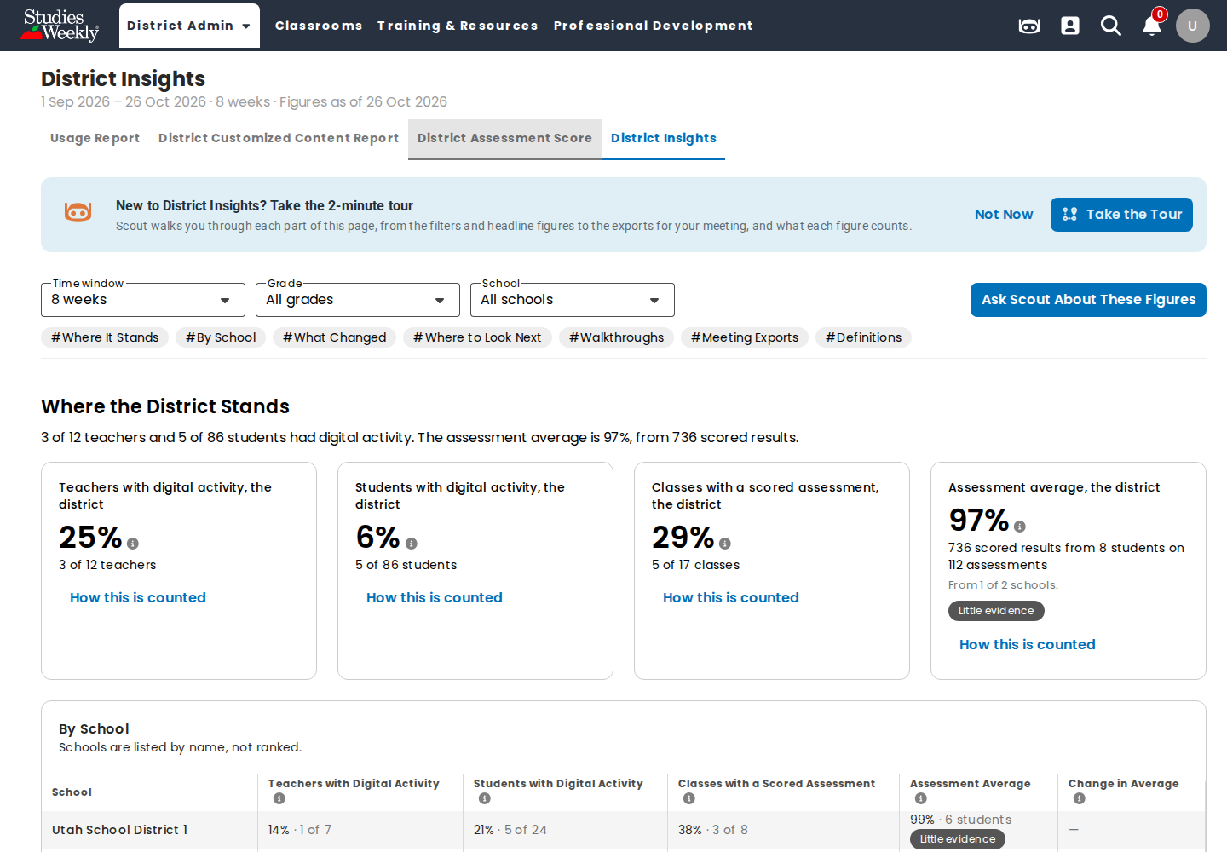
Figures ready after the queued figures job ran; Ask Scout About These Figures enabled.

8. District admin: Scout answer (case 16)
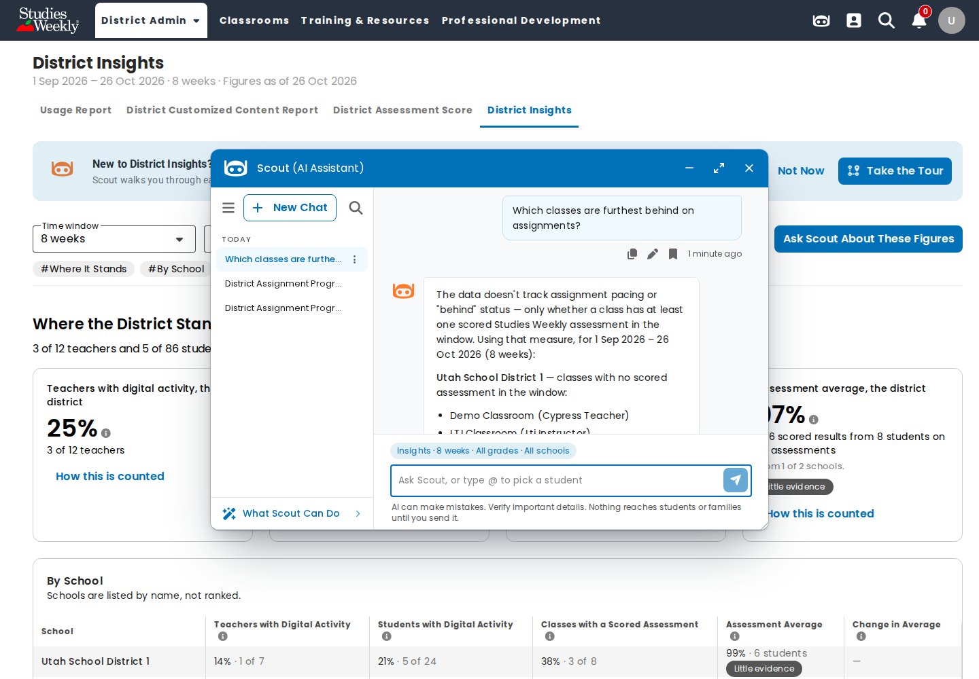
Admin door answer: there is no assignment pacing in the data, so it lists classes with no scored assessment in the window.

9. School admin: School Insights (case 17)
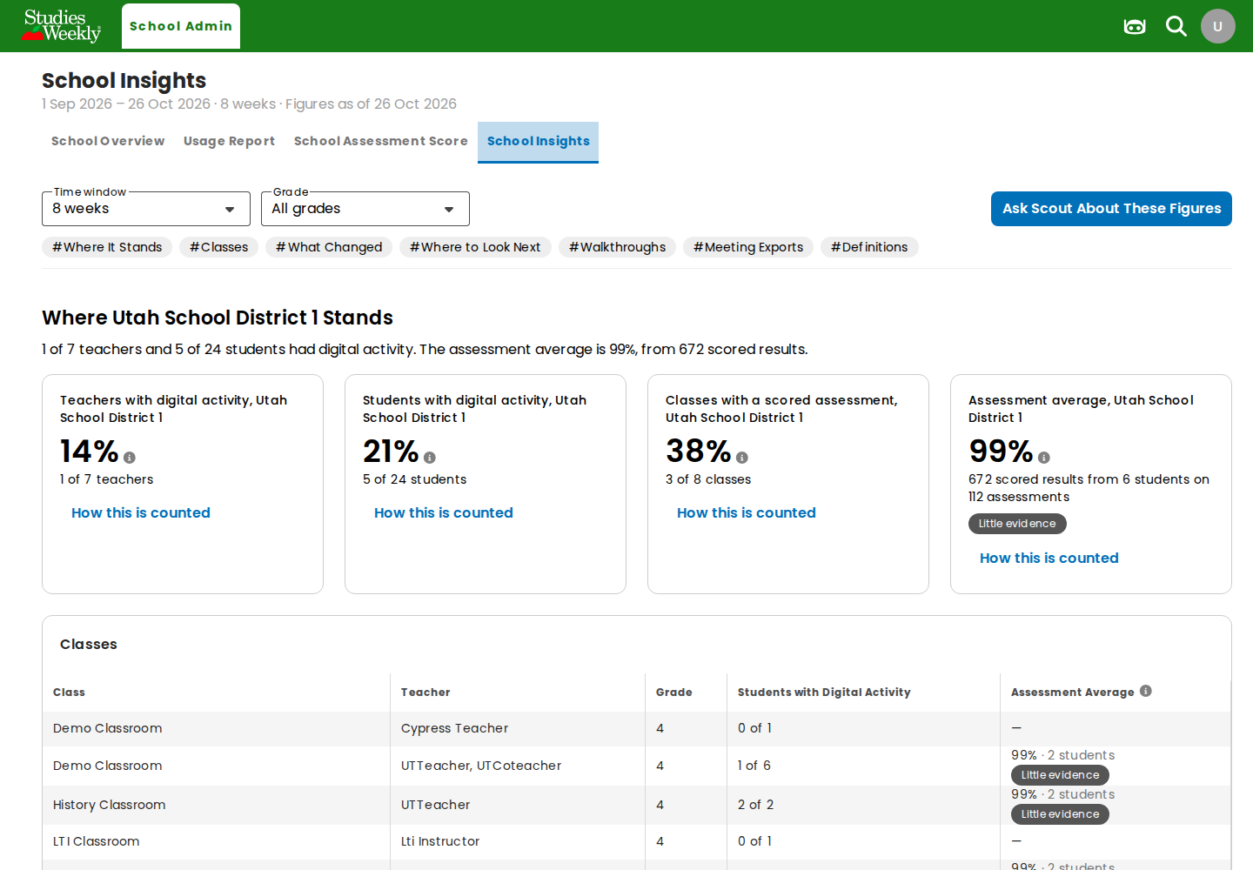
School figures and the Classes table, no School filter.

10. School admin: Scout answer (case 17)
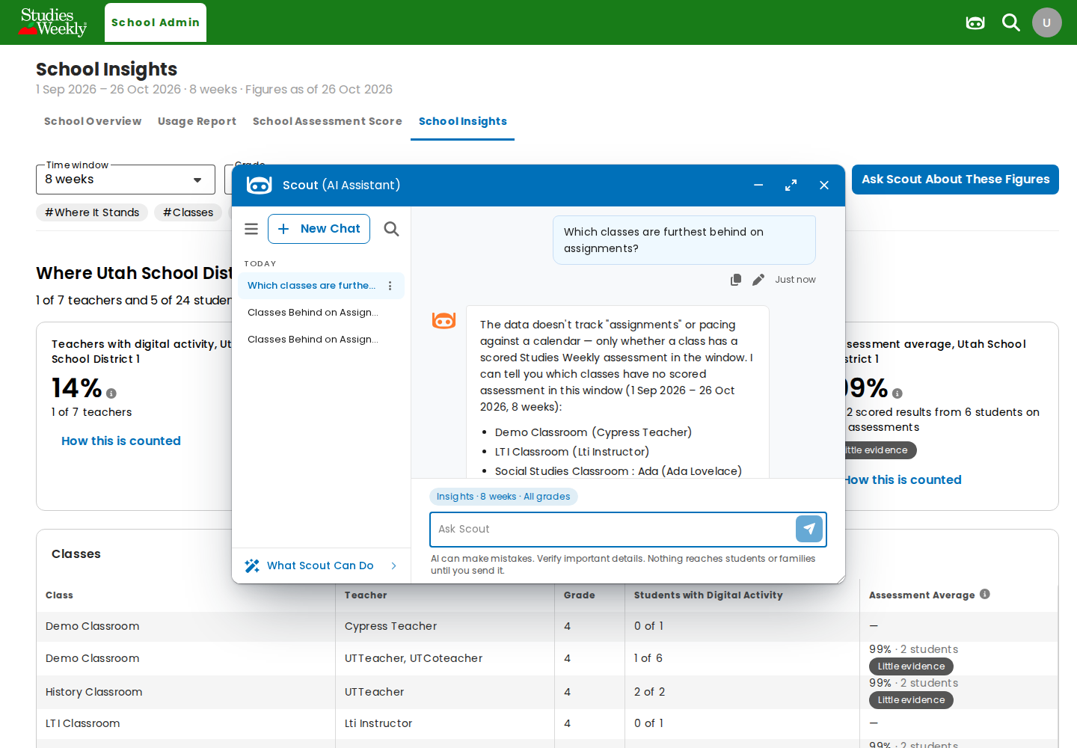
Answer limited to the admin's school; scope chip "Insights · 8 weeks · All grades".

Notes
- Local setup needed for this run: FEATURE_FRONTEND_AI_ADMIN_ASSISTANT = true added to backend/.env (then config:clear), so the admin accounts get admin Scout; the one queued BuildAdminDistrictFigures job was processed with queue:work --queue=report --stop-when-empty (no queue worker runs locally, so Insights otherwise stays on "Preparing Figures" and Ask Scout stays disabled).
- The browser runs in Docker and reaches the host's rag on :8002 through a port forward in run.sh (E2E_FORWARD_PORTS=8002).
- Observation: utdistrictadmin holds both the district admin and the teacher roles (role ids 49 and 50), so GET api/ai/user/credits answers 200 for it. The first run answered 404 for the same account, most likely from the cached roles memo (User::getRoles). Not part of this ticket.
- Observation: one early teacher turn failed with "The AI service returned an error" (reference 90385ded-bd58-4a08-89c9-7704ec9b0c74; telemetry error_code model_error, 0 model calls, 11 s). Every later turn completed in about 3 s, and Bedrock answered from the same credentials, so it wasn't reproduced.
- Observation: reopening a chat whose answer was stopped before it started shows an empty bubble with "Stopped"; the sentence "You stopped this answer before it started." is not kept (screenshot 6).
- Observation: a "Meet Scout" tour dialog opens on an account's first Scout use and covers the window; the suite dismisses it with Maybe Later.

