



**Table of Contents**

**Abstract 3**

**1. Introduction 3**

1.1 Motivation 4

1.2 Objective of Research 4

1.3 Data source used in the research 5

**2. Theoretical Framework 5**

2.1 Swing Trading Scenarios 5

2.1.1 Dip Trip 6

2.1.2 Coiled Spring 7

2.2 Regime Shift Model 7

2.2.1 KMeans Clustering Algorithm 7

2.3 Related Empirical Work Review 8

2.4 Data Description 10

**3. Methodology 11**

3.1 Implementation of Dip Trip 11

3.1.1 Advantages 11

3.1.2 Assumptions 12

3.1.3 Limitations 12

3.1.4 Steps to implement trading system 12

3.1.5 Exploratory Data Analysis 12

3.2 Implementation of Coiled Spring 13

3.2.1 Advantages 13

3.2.2 Assumptions 14

3.2.3 Limitations 14

3.2.4 Steps to implement trading system 15

3.2.5 Exploratory Data Analysis 15

3.3 Implementation of Regime Shift Model 16

3.3.1 Advantages 16

3.3.2 Assumptions 17

3.3.3 Limitations 17

3.3.4 Steps to implement trading system 17

3.3.5 Exploratory Data Analysis 18

**4. Results 23**

4.1 Performance Comparison of different Swing Trading Scenarios 23

**5. Discussion 26**

**6. Conclusion 27**

**7. Future Work 27**

**References 28**

**Appendix 29**

Appendix A: Python-Code/Jupyter-Notebooks 29

Appendix B: Trades generated using Dip Trip scenario 29

Appendix C: Trades generated using Coiled Spring scenario 29

Appendix D: Trades generated using Regime Shift scenario 30

Appendix E: Trades generated using Dip Trip + Regime Shift scenario 30

Appendix F: Trades generated using Dip Trip + Coiled Spring scenario 30

Appendix G: Trades generated using Regime Shift + Coiled Spring scenario 30

Appendix H: Trades generated using Dip Trip + Regime Shift + Coiled Spring scenario 30

**Medium/Long Term Trading Models:**

**Swing Trading with Dip Trip, Coiled Spring & Regime Shift Scenarios**

Rajeev Kumar Sahu1, Jasmine Xu Chen2, Kudakwashe Jisinau3

*WorldQuant University, Louisiana, USA4*

# Abstract

*This paper seeks to examine the swing trading strategies with prime focus on Dip Trip (buy & hold) and Coiled Spring scenarios. Based on a medium to long duration for NIFTY 50 index data, authors proposed a novel methodology for comparing and combining the trading signal generated and also detect regime shifts using K-means clustering algorithm. From a return perspective, the results suggest that the Dip Trip with passive trading outperformed all other trading scenarios with best return of 21.34%. From a risk perspective, the Dip Trip with Coiled Spring scenario is the best option with highest Sharpe ratio of 1.6. In addition, our proposed trading system detects the buy signal and sells at an all-time high. Finally, the paper concluded with a shortlist of the recommended trading system among the above mentioned scenarios.*

**Keywords:** Dip Trip, Coiled Spring, Regime Shift, KMeans Clustering, Rule Based Trading, Swing trading

1 *email:rajeev.nitrr@gmail.com*

2 *email:jasmine.chenxu@gmail.com*

3 *email:kudajisi@gmail.com*

4 *MScFE Capstone Research Project, March 2023*

# Introduction

For many years, the financial markets have been the subject of studies and research, leading to various theories being postulated. One perspective is that the markets are efficient, Fama (1970) [1] which implies that all necessary information is reflected in the prices and their future movements are unpredictable, a phenomenon called the random walk. On the other hand, there is growing evidence that markets are not efficient, suggesting that methods can be devised to predict market behaviour and improve profits or reduce risks.

Swing trading is a type of trading that involves exploiting short-term movements that can range from a few days to several weeks with the aim of profiting from price movements or ‘swings’, Farley (2001) [2]. Swing traders aim to profit from the periodic fluctuations in an asset's price, which are not random and can be somewhat predicted within a price range or channel. There are various subcategories of swing trading strategies, including coiled spring, dip trip, bear hug, finger finder, power spike amongst others. The potential for significant profits in financial markets has driven practitioners and academics to search for ways of accurately predicting stock prices and potential returns which is the motive of this paper.

Many swing traders rely on technical indicators provided by their brokers to achieve their goals of capturing a portion of potential price movements. Some traders may prefer volatile stocks with high levels of activity, while others may favour more stable stocks. Swing trading strategy typically involves two approaches: long and short. The long approach involves buying a stock at a specific point and selling it when the target is reached. The short approach involves selling the stock first and then purchasing it after the target is reached.

## 1.1 Motivation

There are two popular swing trading strategies within the equity market are "Dip Trip" and “Coiled Spring”. Dip trip is a trend following strategy that revolves around buying or adding to a long position in an active bull market. In other words, the Dip Trip scenario involves long equities that experience a dip in price and have high trading volume. Coiled Spring scenario is a trading strategy that executes a position at the interface between a range-bound market and a trending market, Thomsett (2017) [3]. This can be thought of as offsetting temporary movement in the direction opposite to the established trend. Swing trading opportunities result from relatively high volatility and fast price movement against inactivity and low volatility.

On the other hand, Regime shifts refer to significant changes in market conditions, such as shifts in volatility or trends, that can impact trading strategies. In swing trading, which aims to capture medium-term price movements, regime shifts can certainly play a role. For example, a swing trader may adjust their approach if they notice a regime shift from a period of low volatility and trend-following to a period of high volatility and mean-reverting. In this case, the trader may switch from trend-following to mean-reversion strategies or adjust their risk management to account for the increased volatility. Similarly, a swing trader may look for signs of regime shifts when selecting assets to trade, as some assets may be more susceptible to changes in market conditions than others.

For swing traders, usually market participants employ the above distinct methodologies to predict the future behaviour of markets or assets. However, we would like to incorporate the awareness of coiled spring and regime shifts with their potential impact on trading strategies since those can be a valuable tool for swing traders. In order to finalize the preferred solution, we need to consider not only return but also risk management.

## 1.2 Objective of Research

To build a robust and systematic plan for a swing trader can be of importance in ensuring positive portfolio returns from trading activities. By analysing and comparing various swing trading scenarios, we aim to construct a most suitable algorithmic trading system which utilises swing trading opportunities to maximize positive profitability in the Indian stock market. Over and above the trading system with different strategies, we also aim to consider the regime shift with time horizon impact for a better trading plan that ensures consistent yield. Our main objectives are as follows:

1. Analyse Coiled Spring and Dip Trip Swing trading scenarios and develop a profitable swing trading strategy with Indian nifty index (equity portfolio) returns and avoid specific counters to minimize the impact due to fundamental study.
2. Compare the results from the different (Coiled Spring and Dip Trip) Swing trading scenarios to recommend the favourable suggestion to be used for a better yield.
3. Draw a conducive trend series of the Indian index market performance with different bull and bear market segmentation.

## 1.3 Data source used in the research

In order to reduce the impact due to fundamental factors, the authors are inclined to use a index with moderate volatility with enough long duration, and thus, Nifty 50 index, a market capitalization-weighted index founded in 1996 with 50 of India's largest and most actively traded companies listed on the NSE are chosen. It reflects the performance of the Indian stock market as a whole and is one of the most widely followed indices in India which is often used as a benchmark for Indian mutual funds and exchange-traded funds (ETFs),

# Theoretical Framework

In these sections, authors have provided background on different terminologies and algorithms used in building the trading system for medium to long term trading.

## 2.1 Swing Trading Scenarios

Swing trading is a popular trading strategy that aims to capture medium to long-term gains by identifying price swings in the market. Here are the swing trading scenarios for medium to long term trading system:

1. ***Dip Trip:*** The Dip Trip strategy involves buying a stock or index when its price experiences a temporary dip or pullback, and selling it when the price recovers. This strategy requires careful analysis of the stock's fundamental and technical factors to identify buying opportunities when the price is low, and selling opportunities when the price has recovered.
2. ***Coiled Spring:*** The Coiled Spring scenario involves identifying a stock or index that has been trading in a narrow range for an extended period, indicating that the stock is in a state of consolidation. Once the stock breaks out of this range, traders can take advantage of the momentum and ride the price trend higher or lower.
3. ***Bear Hug:*** The Bear Hug strategy involves identifying stocks or indexes that are experiencing a downward trend or bear market. Traders can short sell these stocks or indexes when they reach resistance levels, and exit the trade when the price falls further.
4. ***Finger Finder:*** The Finger Finder strategy involves identifying stocks or indexes that are oversold or overbought, and then buying or selling them accordingly. Traders use technical indicators such as the Relative Strength Index (RSI) and Moving Average Convergence Divergence (MACD) to identify these opportunities.
5. ***Power Spike:*** The Power Spike strategy involves identifying stocks or indexes that are experiencing a sudden surge in trading volume, indicating that a significant price movement is likely. Traders can buy or sell these stocks or indexes based on the direction of the price movement.

Overall, swing trading requires a combination of technical analysis, market knowledge, and risk management to identify profitable trading opportunities in the medium to long term.

The other way of defining the swing trading scenarios for medium to long-term trading systems are as follows:

1. ***Pullback in a long-term uptrend:*** In this scenario, a stock or asset has been in a long-term uptrend, but experiences a temporary pullback or correction. The swing trader would look for a good entry point during the pullback, such as a support level or a technical indicator like the Relative Strength Index (RSI), and hold the position until the price recovers to its previous high or higher.
2. ***Breakout from a long-term range:***In this scenario, a stock or asset has been trading within a range for a long period of time, but breaks out of the range with a strong move in one direction. The swing trader would look for a good entry point on the breakout, such as a pullback to the top of the range or a retest of the breakout level, and hold the position until the price reaches a resistance level or shows signs of a reversal.
3. ***Momentum trade on a news event:*** In this scenario, a stock or asset experiences a significant price move due to a news event, such as a positive earnings report or a merger announcement. The swing trader would look for a good entry point on the momentum move, such as a pullback or consolidation, and hold the position until the momentum begins to fade or the price reaches a resistance level.
4. ***Technical breakout with a catalyst:*** In this scenario, a stock or asset breaks out of a technical pattern, such as a triangle or a head and shoulders pattern, with a catalyst such as a positive news event or a strong earnings report. The swing trader would look for a good entry point on the breakout and hold the position until the price reaches a resistance level or shows signs of a reversal.

Our study primarily concentrates on the Dip Trip strategy, which involves a pullback in a long-term uptrend, and the Coiled Spring scenario, where a breakout occurs in a long-term range. In the next section, we will delve into the details of Dip Trip and Coiled Spring.

### 2.1.1 Dip Trip

The Dip Trip Swing Trading scenario is a medium to long-term trading strategy that involves identifying stocks or assets that have experienced a temporary dip in price or a pullback, and then looking for potential opportunities to buy at a lower price before the stock or asset continues to trend upward.

In this scenario, a "dip" refers to a temporary decrease in the stock or asset price, often caused by negative news or events, profit-taking, or market volatility. Once the stock or asset has dipped, it presents a potential opportunity for traders to buy at a lower price, in anticipation of a future uptrend or price increase.

Here are the steps involved in implementing the Dip Trip Swing Trading scenario:

1. Identify a stock or asset that has a strong long-term growth potential. This could be based on fundamental analysis, technical analysis, or a combination of both.
2. Set a price target for the stock or asset based on your analysis. This price target should reflect the expected long-term growth potential of the stock or asset.
3. Monitor the stock or asset for dips in price that are not caused by any negative news or events. These dips are often caused by short-term market fluctuations or investor sentiment.
4. Buy the stock or asset when it dips below a certain threshold, such as 10% or 20%, from its recent high. This threshold should be based on your analysis of the stock or asset's historical volatility and the magnitude of the dip.
5. Hold the stock or asset until it reaches your price target or until it experiences a significant drop in price. If the stock or asset experiences a significant drop in price, sell it to limit your losses.
6. Repeat the process for other stocks or assets that meet your long-term growth criteria.

The Dip Trip strategy requires patience and discipline, as it may take some time for the stock or asset to reach your price target. It also requires careful monitoring of the stock or asset to ensure that any dips in price are not caused by negative news or events.

### 2.1.2 Coiled Spring

The Coiled Spring scenario is a medium to long-term trading strategy that involves identifying stocks or assets that have been trading within a narrow range for an extended period of time, and then looking for potential breakouts or breakdowns.

In this scenario, a "coiled spring" refers to a stock or asset that has been building up potential energy due to its prolonged consolidation or narrow trading range. Once the stock or asset breaks out of this range, it can release that energy in the form of a significant price move.

There are two potential outcomes in the Coiled Spring scenario:

1. ***Breakout:*** A breakout occurs when the stock or asset breaks above the upper boundary of its trading range. This could be due to positive news or events, improved market sentiment, or a change in investor perception. Once the stock or asset breaks out, it can continue to move higher, potentially reaching new highs.
2. ***Breakdown:*** A breakdown occurs when the stock or asset breaks below the lower boundary of its trading range. This could be due to negative news or events, deteriorating market sentiment, or a change in investor perception. Once the stock or asset breaks down, it can continue to move lower, potentially reaching new lows.

## 2.2 Regime Shift Model

The regime shift model is a statistical model used to analyze time-series data that exhibits changes in its underlying behavior over time. It is also known as a Markov-switching model because it uses a Markov process to model the changes in behavior or regime. The model can be used for a variety of applications, such as financial market analysis, climate modeling, and economic forecasting. For example, in financial market analysis, the model can be used to identify changes in market conditions that may affect the performance of investment portfolios.

In this analysis, with reference to Srivastava et. al. (2018) [4], we utilize the regime detection concept by using clustering machine learning methodology. Indeed it might not be the whole regime shift model, however the K-means clustering method served as the preliminary steps in data modeling. So we still make use of the time-series data, and group them to detect Bull/Bear market, and high/low variances.

The model itself can also be used to develop trading strategies that take advantage of the different regimes detected in the market. So if certain preferences are made, such as we only buy during bull markets with low variance, then this can be the foundation for a trading system. However, it's important to note that the regime shift model is just one tool in a data analyst's toolbox and should be used in conjunction with other analysis techniques to make informed decisions.

### 2.2.1 KMeans Clustering Algorithm

KMeans is a popular clustering algorithm that partitions data points into k clusters based on their similarity. The algorithm works by iteratively assigning each data point to the nearest centroid (mean) and then updating the centroid based on the newly assigned data points. The process continues until convergence or a maximum number of iterations is reached.

The steps of the KMeans algorithm are as follows:

1. Initialize k centroids randomly
2. Assign each data point to the nearest centroid
3. Recalculate the centroids based on the newly assigned data points
4. Repeat steps 2-3 until convergence or a maximum number of iterations is reached

The distance metric used to measure similarity between data points can vary, but the most common one is Euclidean distance. The choice of the number of clusters, k, is an important decision that affects the quality of the clustering. There are various methods to determine the optimal k, such as the elbow method or the silhouette method.

The KMeans algorithm uses the following formulas to assign data points to clusters and update the centroids:

1. Assigning data points to clusters:

For each data point x, calculate its distance to each centroid c:

***dist(x, c) = sqrt( (x1-c1)^2 + (x2-c2)^2 + ... + (xn-cn)^2 )***

*where*

*x1, x2, ..., xn are the features of data point x, and*

*c1, c2, ..., cn are the coordinates of centroid c.*

Assign data point x to the cluster with the nearest centroid:

**argmin(dist(x, c))**

1. Updating the centroids:

For each cluster, calculate the mean of the data points assigned to it:

***centroid_c = (1 / num_points_c) * sum(x_i)***

*where*

*x_i is a data point assigned to cluster c, and*

*num_points_c is the number of data points assigned to cluster c.*

Update the position of centroid c to the mean:

***c = centroid_c***

The KMeans algorithm continues to perform these two steps either until it reaches convergence or reaches the maximum allowable number of iterations. The objective of the algorithm is to reduce the sum of squares within-cluster, which is the sum of the squared distances between each data point and the centroid assigned to it.

## 2.3 Related Empirical Work Review

In swing trading domain Verma et. al. (2022) [5] study discuss the process of selecting market sector trends and sub-selecting stocks for swing trades using data obtained from various sources such as stock prices and market indicators from NSE and BSE in India. They employed a combination of technical approaches and fundamental approaches using various techniques such as trend analysis, volatility analysis, and momentum analysis to identify the best market sector for swing trading. Financial ratios and valuation metrics were used to sub-select the best stocks within the selected market sector. Their findings asserts that the market sector trend and sub-selection of stocks play a significant role in the success of swing trading and that swing trading is intended for modest profits of 5-10% rather than high profits of 20-25% or more.

Technical and fundamental approaches can complement each other in the process of stock selection for swing trading. We can confirm that this assertion is in line with Beyaz et al. (2018) [6] who also confirms that combining both the analysis will result in a better performing models. We can ascertain that traders should adopt a comprehensive approach that integrates technical and fundamental approaches to maximize their chances of success in swing trading.

Heping (2004) [7] proposed a new theory of intelligent finance, called "A Swingtum Theory," which expand on swing trading and momentum trading. The theory is based on the idea that financial markets exhibit natural oscillations between trends and swings, which can be exploited through the use of technical approaches and machine learning algorithms. The researcher provided empirical evidence to support the effectiveness of their approach based on backtesting results and out-of-sample testing. Their findings postulate that Swingtum theory is effective in generating excess returns above 4% compared to traditional trading strategies, as evidenced by backtesting results and out-of-sample testing. Further, this approach can be adopted in different market conditions, including bull and bear markets.

Totakura (2011) [8] investigated the effectiveness of swing trading in the Indian stock market using the Relative Strength Index (RSI) in selecting stocks for swing trades. The study uses a sample of 100 stocks listed on the NSE of India and analyses daily closing prices over a period of 2 years (2016-2018). The RSI is used to identify potential swing trading opportunities, which is defined as a trade that lasts for 2-10 days. The paper adopted a simple trading strategy where a long position is taken when the RSI is below 30 and a short position is taken when the RSI is above 70 while effectiveness of the strategy is evaluated using success rate, average return, and maximum drawdown metrics. The research suggest that the RSI is an effective tool for selecting stocks for swing trading with a success rate of around 70%, indicating that the strategy is profitable in the majority of cases. The average return of the strategy is also positive, and the maximum drawdown is relatively low, suggesting that the strategy is relatively safe. The author also performs a sensitivity analysis to test the robustness of the results and finds that the strategy performs well across different time periods and stocks making it most likely to be effective in the future.

From a quantitative research perspective, it is important to consider the impact of regime shift or regime switching when analysing volatility of stock returns in equity market. This will also improve not only model reliability and but also easier model interpretability results in different trading scenarios and time horizons which then leads to a more robust trading system being devised. Long (2007) [9] conducted a study to analyse stock return volatility with regime switching in the Vietnam stock market (VSM). Using daily stock index data collected from VSM for a 7-year period, the study incorporated the Arch/Garch model by using a set of dichotomous dummy variables. The study found that a full incorporation of the regime switching significantly reduced the estimated volatility from 0.9592 to 0.614. We can ascertain from this finding that abnormally high persistence of volatility can be misleading if estimated without considering regime shifting. As such we can also deduce that estimates can become more accurate if controlled for regime changes which implies that a better trading system can be devised which can be reliably depend upon.

Shyu and Hsia (2008) [10] used a switching regime Arch model to investigate the volatility of monthly returns on Taiwan stock market. Their study confirms that empirical results from the regime switching model offers a better statistical fit to the stock market. We can confirm from this paper that considering regime switching detection when devising trading system or trading strategies is crucial. Lin and Wesseh Jr. (2013) [11] also confirm the same hypothesis that regime switching should not be ignored at all costs. In their paper they proposed a pure Markov-switching volatility model to analyse weekly returns of the natural gas index and found out that regime-switching is clearly present and regime switching models performed noticeably better than traditional models regardless of evaluation criteria. As such when devising a system in any market for equities, commodities, foreign exchange, or derivatives, it is important to consider regime shifts.

Pra et al. (2018) [12] adopted liner and regime switching models to analyse the out-of-time performance of asset allocation based on statistical and economic approach. The authors found that when regimes are taken into consideration, the model predictability give high payoffs to long horizons and high-risk averse investors which implies that regime switching remain key in quantitative modeling.

Hammerschmid and Lohre (2017) [13] applied regime switching models to factors proxying macroeconomic regime and found that the ensuing of regime switching factor is very relevant in forecasting equity returns or risk premium. The study also confirms that the forecast exhibits significant out-of-sample model predictability which cascades into utility gains in portfolio strategy as expected.

The above literature provides an insight into the techniques used to perform and implement technical approaches in equity trading and systems. Majority of research conducted in this field has focused on fundamental or technical approaches as better investment or trading strategy and ascertain whether it is profitable/feasible to follow. No comprehensive study was carried out on specifically for swing trading scenarios and even in the Indian stock market that covers any swing trading scenario, dip trip or coiled spring. This study attempts to devise a rule based medium-long term swing trading system in the Indian equity market where Nifty 50 index is considered. A regime switching model is also considered and combined with the coiled spring and dip trip scenario to develop a more robust trading system from a risk and return perspective.

## 2.4 Data Description

The OHLCV data of Nifty 50 taken from Yahoo Finance using the Python Yahoo Finance library from Jan-2008 to Dec-2022 is a comprehensive dataset that includes the open, high, low, close, and volume information for each trading day of the Nifty 50 index. The additional volume information in the OHLCV data provides a more detailed view of the trading activity in the market, allowing traders to gain a better understanding of the market trends and the strength of the current market movements. This data is essential for developing trading strategies that consider the trading volume in addition to the price movements. By analysing the OHLCV data, traders can identify the entry and exit points for their trades, track market sentiment, and make more informed trading decisions. With the Python Yahoo Finance library, it is possible to easily access and manipulate large amounts of financial data, enabling traders to stay up to date with the market and adjust their strategies as needed.

Here's an example of what an OHLCV data table from Yahoo Finance might look like for the Nifty 50 index:

**Table 1: OHLCV data of Nifty 50 from 1st Dec 2022 to 8th Dec 2022**

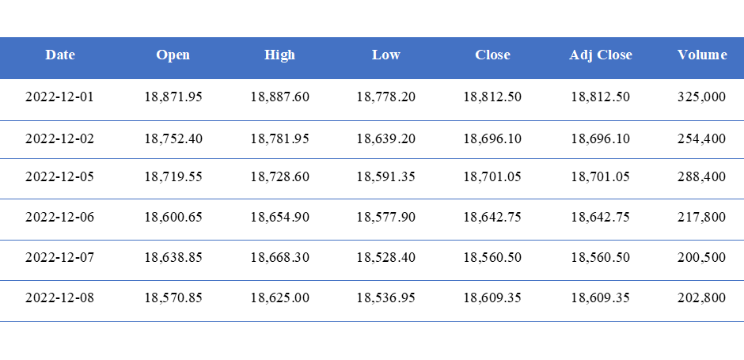The OHLCV data includes the open, high, low, close, and volume information for each trading day of the Nifty 50 index is shown in the Table 1. The "Adj Close'' column represents the adjusted close price for each trading day, which considers any corporate actions, such as stock splits or dividends, that may affect the price of the stock or index. The adjusted close price is used to calculate the returns of the stock or index over time and is often preferred over the raw close price for analysis and trading purposes.

As the Adj Close and Close price remain identical throughout the time series, we have decided to utilize the Close price for calculating the profits when creating the buy and sell signals with various strategies such as dip trip, coiled spring, and others.

# Methodology

Within this section, the authors have presented the rules and guidelines established for executing the Dip Trip, Coiled Spring, and Regime Shift Model for trading systems. Furthermore, the authors have provided insight into the assumptions and limitations taken into account when developing the swing trading system for medium to long-term trading.

This study incorporates a universal rule for the selling logic, which involves selling at a next new all-time high. Also, the close price is considered as the buy price, whenever the signals are generated using the implemented logic.

## 3.1 Implementation of Dip Trip

The "*Buy in the dip and hold until it reaches all time high*" strategy, employed in Dip trip, involves investors adding new long positions to assets during times of downward price pressure. The aim is to capitalize on the potential for the price to rebound and reach higher levels for profitability.

### 3.1.1 Advantages

The primary benefit of Dip Trip is that it is a form of passive trading with several advantages.

* Trading costs are lower because Dip Trip involves less frequent trading and requires less attention to daily market movements.
* Additionally, the impact of short-term volatility is reduced as investors focus on the long-term returns of their investments.

### 3.1.2 Assumptions

However, as Dip Trip can resemble the catching knife approach, there are several assumptions that need to be made, namely:

* The underlying counters remain fundamentally sound, with any drop confined to overall market sentiment or over-reaction.
* The borrowing cost to buy new shares is assumed to be zero, which is crucial in knife-catching situations where future drops are unpredictable.
* There are zero trading costs associated with any buy or sell activities.
* The buying price is assumed to be the closing price.

### 3.1.3 Limitations

Meanwhile, it's important to note the limitations and drawbacks of the Dip Trip trading system:

* It may result in missed opportunities to buy or sell assets at an even more attractive price.
* Holding onto a single trade for a prolonged period can expose investors to potential long-term risks and market shifts, such as changes in interest rates, economic conditions, or political instability.
* As there's no limit to the price drop, the borrowing cost can potentially become unlimited.

### 3.1.4 Steps to implement trading system

Below are the general steps to implement a Dip Trip trading system:

Step 1: **Identify market indicators** - To establish discipline, we need to identify a set of market indicators. We can calculate the all-time-high value from a given point in time and the pullback value by determining the difference between the closed and all-time-high prices. We can also use a pie chart to visualize the percentage of results that fall into each category.

Step 2: **Define market signals** - We categorize the pull-down value of the underlying index into four categories: less than 10%, 10-20%, 20-40%, and more than 40%.

Step 3: **Develop a trading strategy** - We will only purchase the asset when the pull-down value exceeds a predetermined threshold, such as 10%. If there is already a buy order in place, we will not open a new order unless a different pull-down category is reached. We will assume zero borrowing costs for new orders, and the order will only be closed once it reaches a new all-time-high.

### 3.1.5 Exploratory Data Analysis

The authors analysed the past trends of pullbacks and their frequency/percentage for various categories over the past 15 years before evaluating the performance of the dip trip strategy. They then presented this information in graphical form in figures 1 and 2.

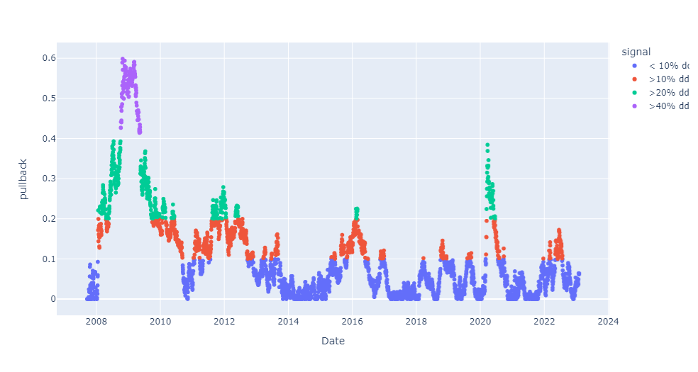

**Figure 1: Different pullback scenarios occurred in the Nifty 50 since 2008**

After analyzing the pie chart, we discovered that over 60% of trades are below 10%. Additionally, the relevant pullbacks account for approximately 40%. This indicates that dip trip signals are infrequent, and investors must exercise patience to wait for suitable buy signals in the market.

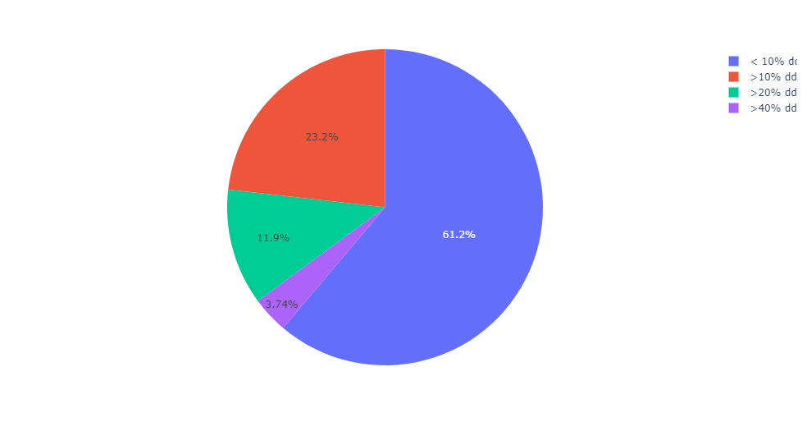

**Figure 2: Pie chart depicting the percentage of pullbacks in Nifty 50 happened in the past**

## 3.2 Implementation of Coiled Spring

Coiled spring swing trading is a trading strategy that involves identifying stocks that are undervalued but have the potential to increase in value in the medium to long term. The idea is to buy low and hold onto the stock until it reaches its potential, then sell for a profit.

### 3.2.1 Advantages

Some advantages of using this strategy for medium to long-term trading include:

* **Potential for higher returns:** By identifying undervalued stocks with high growth potential, coiled spring swing trading can result in higher returns compared to other trading strategies.
* **Reduced risk:** Coiled spring swing trading involves holding onto stocks for a longer period of time, reducing the impact of short-term market fluctuations and reducing the risk of loss.
* **Flexibility:** Coiled spring swing trading is a flexible strategy that can be applied to a wide range of stocks, making it suitable for a variety of trading styles and preferences.
* **Time-saving:** Compared to day trading or other short-term trading strategies, coiled spring swing trading requires less time and effort to monitor the market and make trades.

### 3.2.2 Assumptions

The assumptions of using coiled spring swing trading scenarios for medium to long term trading do not specify the number of candles to consider for pivot point computation or breakout/breakdown prediction. These are typically subjective decisions made by individual traders based on their trading style, preference, and experience.

However, some general guidelines that traders may consider when determining the number of candles to use for these calculations include:

* **Pivot point computation:** Pivot points are calculated based on the previous day's high, low, and close prices. Traders may consider using the previous day's price action to calculate pivot points, which typically involves using a single day's data or a few days' data.
* **Breakout/breakdown prediction:** The number of candles to consider for breakout or breakdown prediction can vary depending on the timeframe being traded. For example, traders using a daily chart may consider using a few weeks' or months' data to identify potential breakouts or breakdowns, while traders using a 1-hour chart may consider using a few days' data.

Ultimately, the number of candles to use for pivot point computation and breakout/breakdown prediction will depend on the trader's individual preferences, risk tolerance, and trading strategy. It is important to carefully consider these factors and test different approaches to determine what works best for each trader's unique situation.

### 3.2.3 Limitations

While coiled spring swing trading can be a profitable strategy for medium to long-term trading, there are several limitations that traders should keep in mind when using this approach:

* **Market volatility:** Coiled spring swing trading assumes that market trends are predictable and that undervalued stocks will eventually increase in value. However, the market can be volatile, and unexpected events can cause stocks to plummet in value, leading to losses for traders.
* **Time commitment:** While coiled spring swing trading requires less time and effort than day trading or other short-term trading strategies, it still requires a significant time commitment to research stocks, monitor the market, and make trades. Traders must be willing to commit the time required to be successful.
* **Limited diversification:** Coiled spring swing trading typically involves holding onto a relatively small number of stocks for an extended period of time, which can limit diversification and increase risk. Traders must be careful to maintain a diversified portfolio to minimize risk.
* **Reliance on fundamental analysis:** Coiled spring swing trading relies heavily on fundamental analysis, including financial statements, industry trends, and market factors that can impact stock prices. If a trader does not have a strong understanding of these factors, they may struggle to identify undervalued stocks with high growth potential.
* **Psychological factors:** Coiled spring swing trading can be emotionally challenging, as traders must be patient and disciplined in their approach. The temptation to sell stocks prematurely or to panic during periods of market volatility can lead to poor trading decisions and losses.

### 3.2.4 Steps to implement trading system

The steps for coiled spring swing trading scenario for medium to long-term tradingare as follows:

* **Identify potential opportunities:** Use fundamental analysis to identify undervalued stocks with high growth potential. Look for stocks with strong financials, solid management teams, and promising industry trends.
* **Analyze market trends:** Analyze market trends to determine the overall direction of the market and identify potential areas of opportunity. Look for stocks that are trading below their fair value or have been oversold.
* **Compute pivot points:** Determine the pivot points using the previous day's high, low, and close prices. Pivot points are levels of support and resistance that traders use to determine potential entry and exit points.
* **Identify potential breakouts/breakdowns:** Look for potential breakouts or breakdowns above or below the pivot point levels. Traders can use technical analysis indicators like moving averages, support and resistance levels, trend lines, and chart patterns to identify potential breakouts or breakdowns.
* **Determine entry and exit points:** Once you have identified potential breakouts or breakdowns, determine the best entry and exit points. Look for opportunities to buy low and sell high, and consider using technical indicators to help identify these points.
* **Place your trades:** Once you have determined your entry and exit points, place your trades. Consider using stop-loss orders to limit your losses and protect your profits.
* **Hold onto your stocks/instrument:** Coiled spring swing trading requires patience and discipline, so be prepared to hold onto your stocks for an extended period of time. Resist the urge to sell prematurely or make impulsive trading decisions based on short-term market fluctuations.

### 3.2.5 Exploratory Data Analysis

The two crucial steps for building a coiled spring trading scenario are:

1. Computing the high and low pivot points,
2. Identify the decisive price movement after breakout/breakdown

In the below figure, high and low pivot points are identified using the forward and backward two candles. How many candles to be used in building a trading system is a subjective decision of trader and is also based upon the timeframe one person wants to trade.

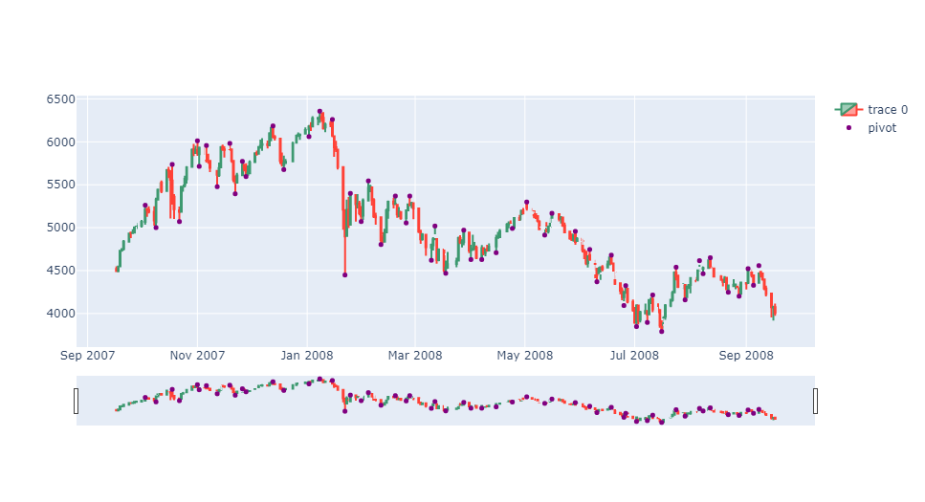

**Figure 3: Pivot points identified using 2 front and 2 back candles**

There are some situations/regimes in the market, where market start moving sideways or range bound. This phenomena is identified both in short term as well as in long term. Usually, this sideways or range bound movements are followed by decisive and emphatic price movement in either up or downward direction, which is called as break out or break down. One of such break down scenario in the short term timeframe is shown in the below figure.

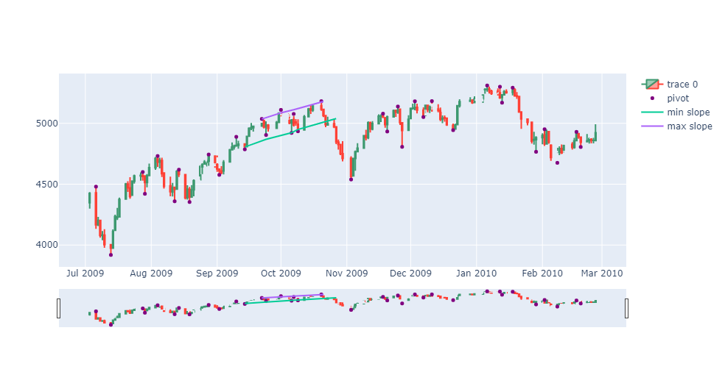

**Figure 4: Breakdown after a narrow range formation**

## 3.3 Implementation of Regime Shift Model

Regime shift trading system is a trading strategy with the intention to detect large, abrupt, or persistent changes in market regimes, and a popular interpretation in the stock market is the high and low volatility segment. A regime shift occurs when there is a significant change in market conditions, such as a shift from a bullish to a bearish market, or a shift from a stable to a volatile market. In the past history, we do know some by heart such as the 2008 world financial crisis that triggered a big regime shift change.

### 3.3.1 Advantages

* **Improved risk management:** Ideally regime shift trading is meant to avoid the unfavourable market regime when traders want to reduce their exposure to volatility or loss. Since some traders might want to avoid high volatility periods when the market conditions are changing so they could adjust their strategies accordingly.
* **Increased profitability:**  By adapting trading strategies to the current market regime, traders may be able to increase their profitability. This is because some strategies may be more effective in certain market conditions than in others, and there might be opportunities to be taken advantage of considering different regimes.
* **Flexibility & Agility:** Regime shift trading methodology is flexible and can be applied to different asset classes and timeframes. This makes it suitable for a range of traders, from day traders to long-term investors.

Overall, regime shift trading methodology can help traders to be more effective and profitable by adapting their strategies to the current market regime. However, it requires a deep understanding of market conditions and the ability to identify changes in market regimes accurately.

### 3.3.2 Assumptions

We assumed the choice of K as 4 cluster at beginning, and the value in scope is only for the ones with steady increasing or decreasing trend.

### 3.3.3 Limitations

Regime shifts contain abrupt, large-scale changes in the structure and function of ecosystems or social systems, often associated with tipping points, where small changes in drivers can lead to dramatic changes in the system. There are several limitations to identifying, predicting, and managing regime shifts:

* **Limited understanding:** Regime shifts are complex and can be influenced by many factors, including biophysical and social processes. However, our understanding of these processes is often limited, making it difficult to identify and predict regime shifts.
* **Nonlinear dynamics:** Regime shifts are characterized by non-linear dynamics, where small changes in drivers can lead to large and abrupt changes in the system. These nonlinearities can make it difficult to predict regime shifts and their timing.
* **Selection for K value:** K value selection can be tricky since it might lead to different results if we choose different K initial values since the K-means logic is very sensitive to the initial value selection. It might lead to different regime shift categories.

### 3.3.4 Steps to implement trading system

Here are the general steps to implement a regime shift trading system:

* **Identify market indicators:** We will need to identify a set of market indicators that can signal a regime shift, so we chose the mean and standard deviation of daily returns of past 250 days.
* **Define market regimes:** We will define the market regimes by using K-mean clustering to detect 4 clusters. Normally a bullish regime is when sustained price increases with low volatility, and high trading volume, and a bearish regime is vice versa, however for us we are mostly interested in how to avoid the extremely high and low volatility period to avoid risks, instead we would like to capture the medium cluster with moderate volatility.
* **Develop a trading strategy:** Based on above market indicators and regimes, we develop a trading strategy that only invests during the medium cluster (cluster 1 and 3) accordingly. We also intend to merge the signal with previous two methods dip trip and coiled spring in order to derive different trading systems. For the combined method, When the signal did not match each other, it will reject the trade signal, therefore it might make the buy order more “particular”.
* **Test the strategy:** We will split the overall historical market data counts with 4-6 splits to test the strategy to evaluate its performance, and the data is used for backtesting to simulate the trading strategy and measure the returns, risk, and drawdowns.

### 3.3.5 Exploratory Data Analysis

The regime shift modeling using KMeans clustering is based on how the daily returns on past 250 days have performed in the historical period. Initially, authors have analysed the past mean and std deviation of daily returns over the past 250 days and checked the behaviour pattern and found that there is a gradual change in those values which are smooth in nature but not the abrupt or highly fluctuating. The mean and standard deviation of daily returns are plotted in the below figures 5 and 6.

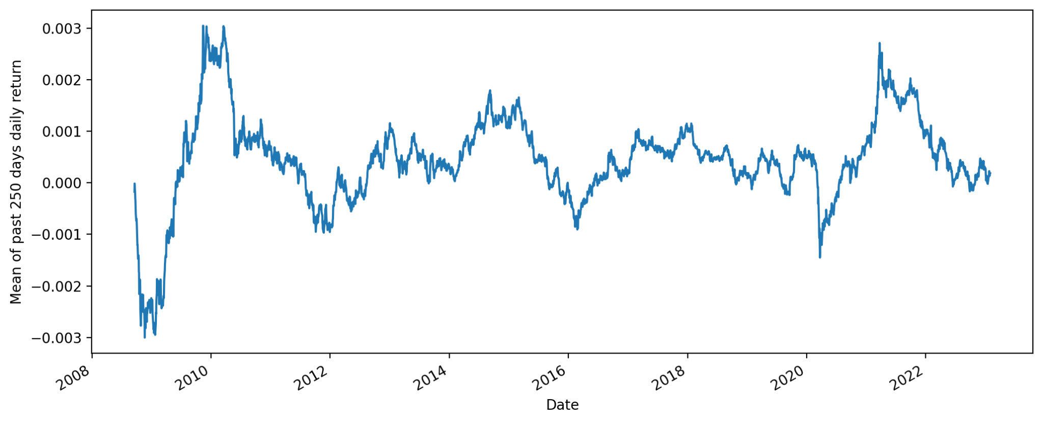

**Figure 5: Variation of Mean returns for the past 250 days of daily returns**

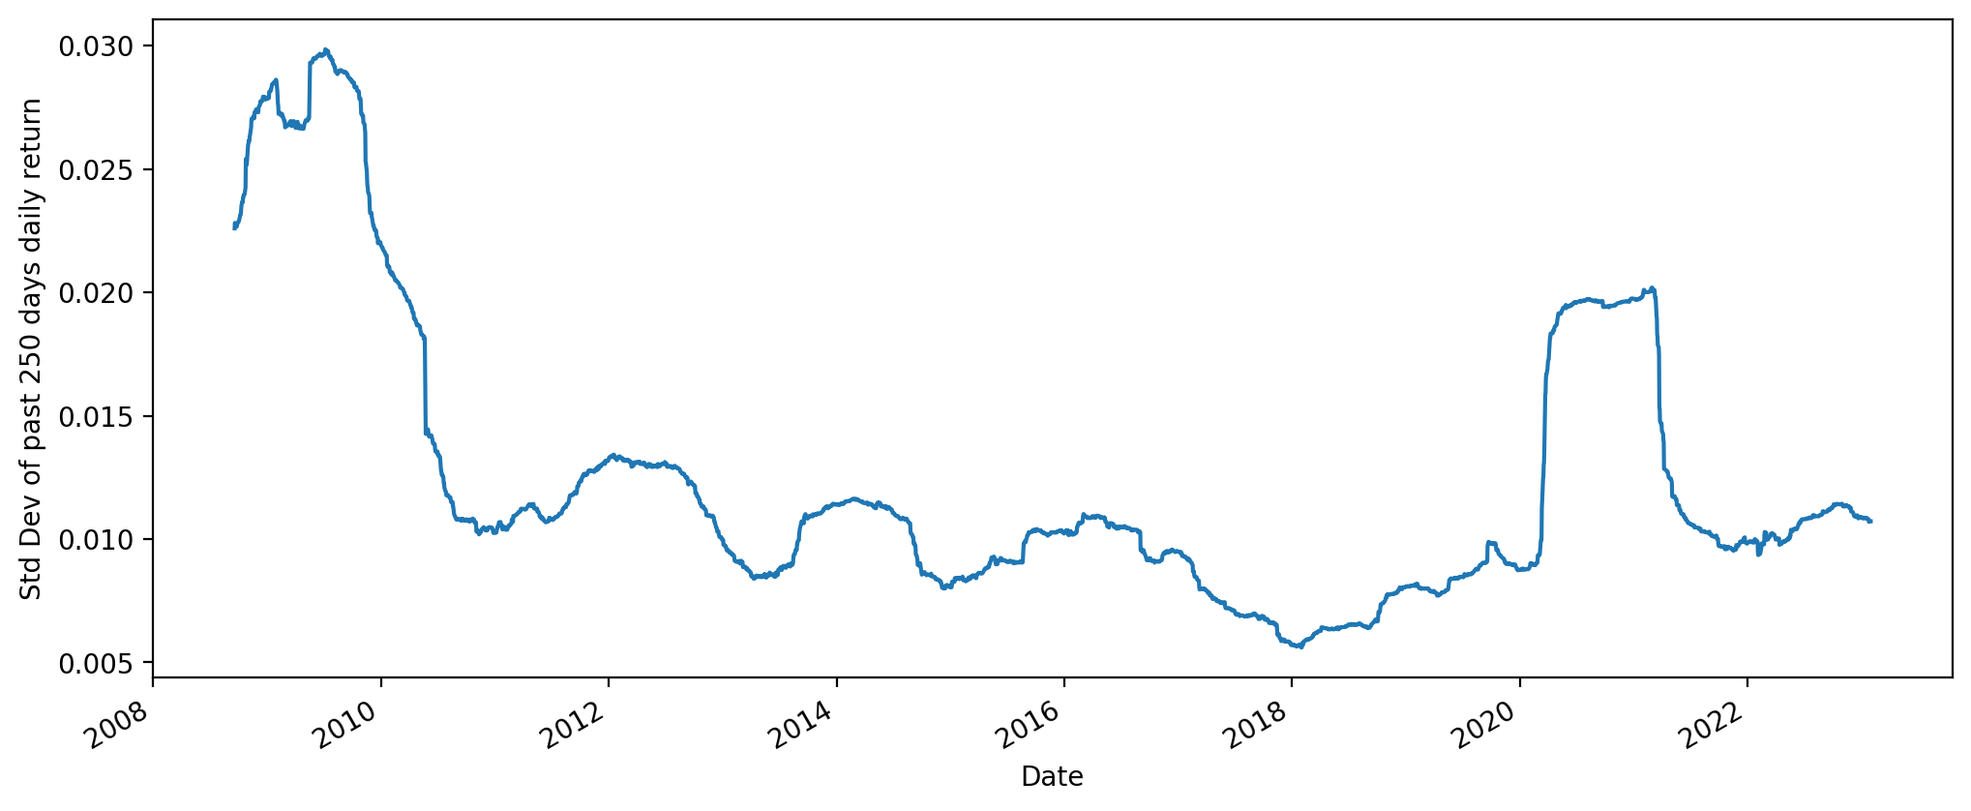

**Figure 6: Variation of Std Deviation of past 250 daily returns**

Based on the mean and standard deviation of daily returns can be categorised into 4 categories:

* Low mean return and low std deviation
* Medium mean return with low std deviation
* Negative returns with low std deviation
* Negative returns with high std deviation

Looking at the past pattern, one can form a rule to identify a particular regime. To make the rule more generic in nature, authors have used the KMeans algorithm to identify those categories. Also, to avoid any overfitting, the entire dataset is divided into two parts: training data (which consist of 60% of data) and testing data (which consist of remaining 40% data). The KMeans algorithm is trained on the 60% dataset of mean and std deviation of daily returns of past 250 days. Usually, data needs to be normalised, since KMeans algorithm is distance based algorithm. But in our case returns are already normalised, so further normalisation is not required.

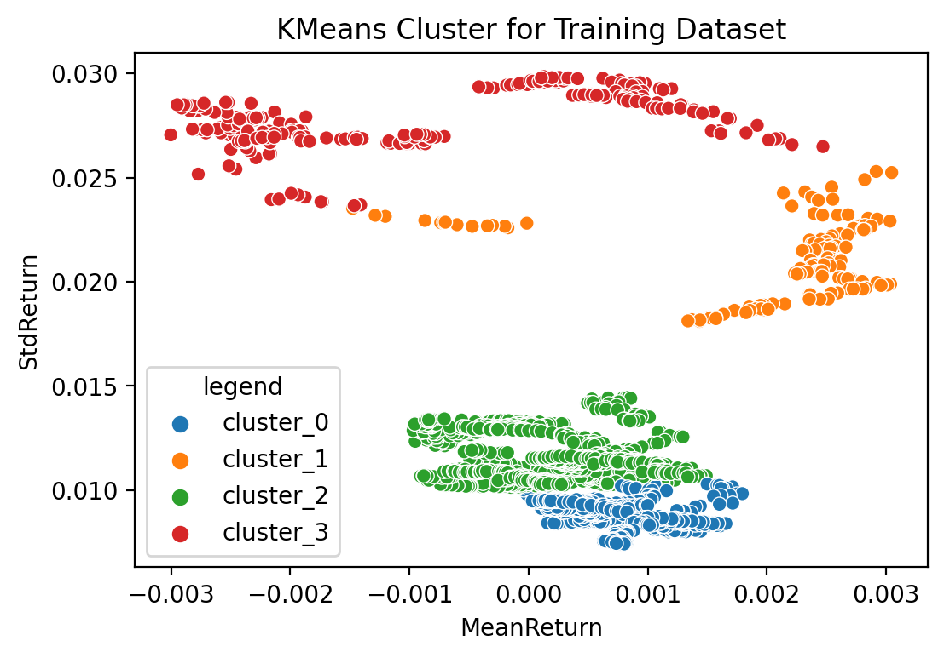

**Figure 7: KMeans Cluster for Training Dataset (60% data)**

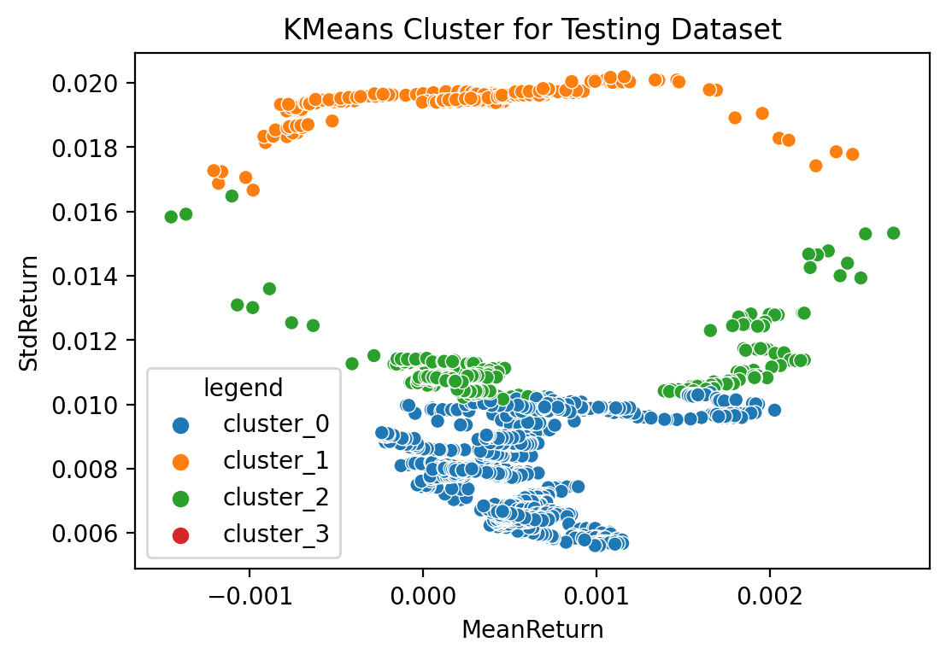

**Figure 8: KMeans Cluster for Testing Dataset (40% data)**

While analysing the KMeans clusters, training dataset consists of all the four clusters. But in the case of testing dataset, Nifty 50 didn’t fall too much, so, standard deviation of returns are not too much. Hence, cluster 3 is missing in the testing dataset.

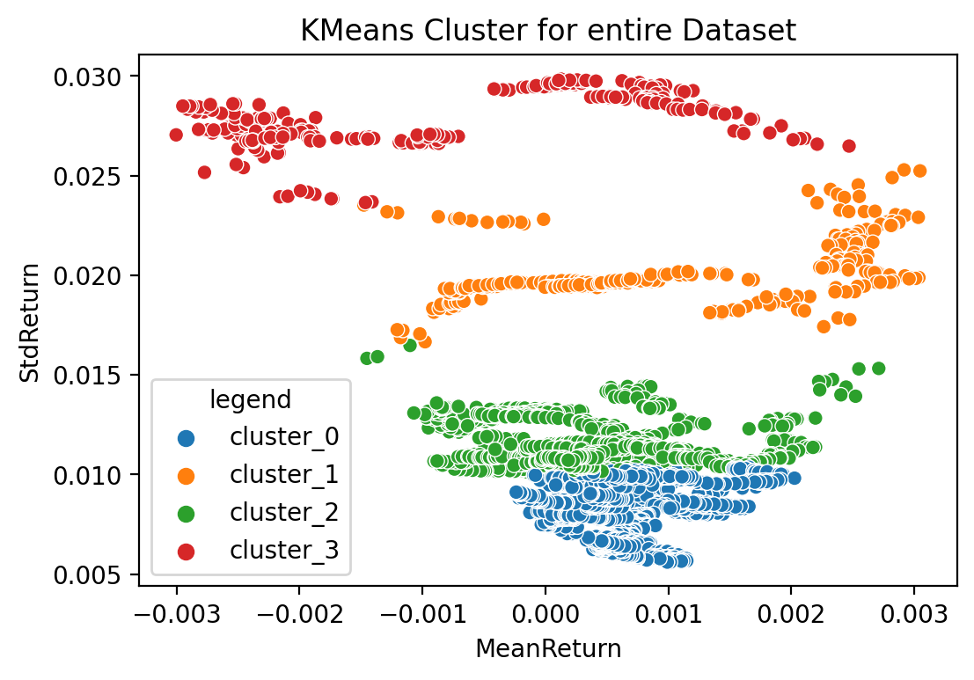

**Figure 9: KMeans Cluster for Entire Dataset**

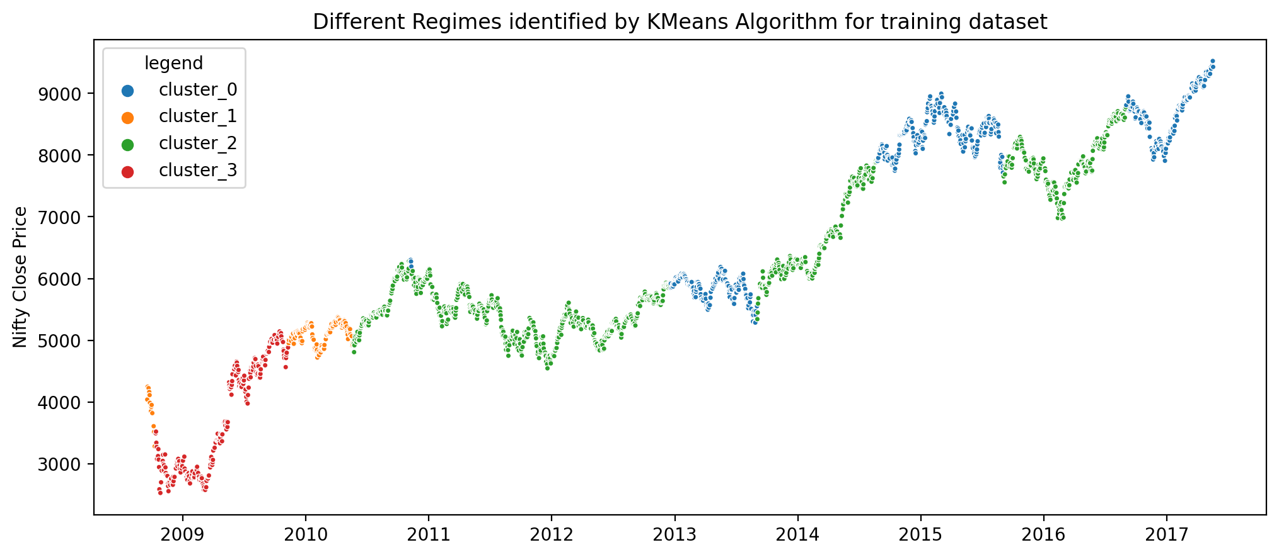

**Figure 10: Regimes identified by Kmeans Cluster for Training Dataset (60% data)**

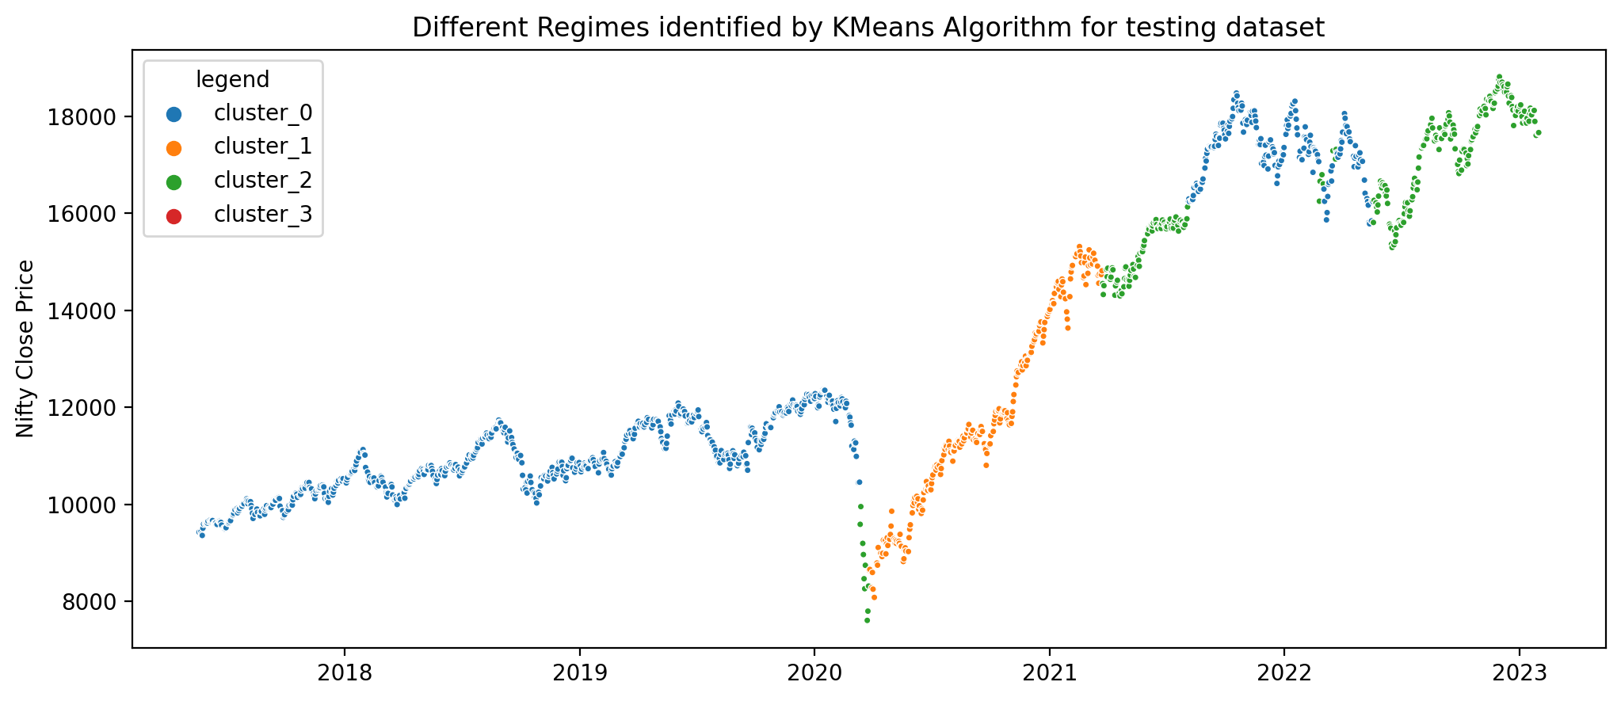

**Figure 11: Regimes identified by Kmeans Cluster for Testing Dataset (40% data)**

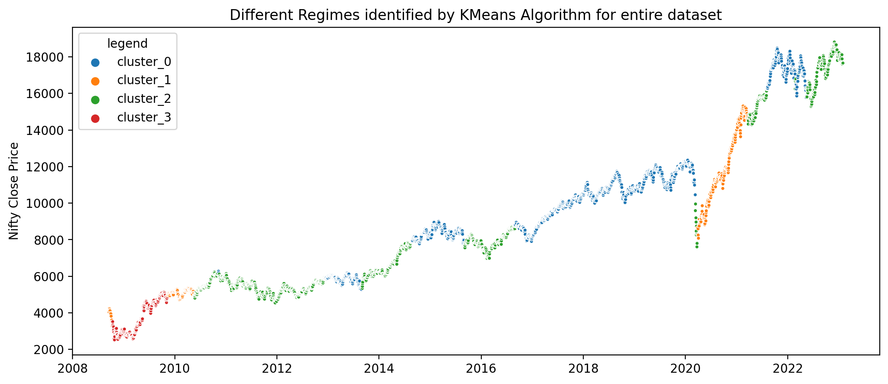

**Figure 12: Regimes identified by Kmeans Cluster for Entire Dataset**

After analysing the different clusters and regimes found using KMeans algorithm, there is a consistent behaviour pattern found in those regimes, which is summarised in the below table.

**Table 2: Summary of different regimes identified by KMeans Algorithm**

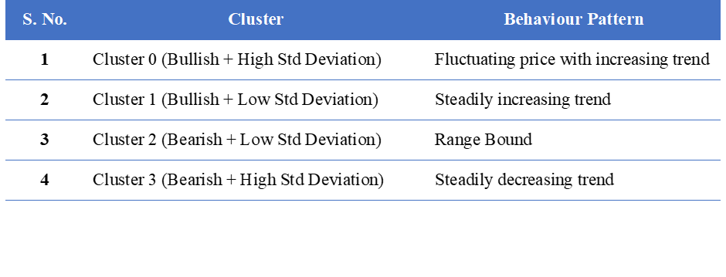

# Results

Within this section, the authors have conducted a comparative analysis of the performance of several swing trading scenarios, including their various combinations such as:

1. Dip Trip,
2. Coiled Spring,
3. Regime Shift Model,
4. Dip Trip + Regime Shift,
5. Dip Trip + Coiled Spring,
6. Regime Shift + Coiled Spring,
7. Dip Trip + Regime Shift + Coiled Spring

## 4.1 Performance Comparison of different Swing Trading Scenarios

Below is our result for comparison among the different scenarios:

* Count is the number of trades open and closed in the analyzed period.
* Mean is the average return generated in the particular scenario
* Min & Max are the minimum and maximum return earned in the particular scenario
* 25%, 50% and 75% are the percentile values of return earned in the particular scenario
* Sharpe ratio is calculated by subtracting the risk-free rate of return (such as the yield on a government bond) from the investment's return and then dividing the result by the investment's standard deviation of returns. Here, we considered the risk free rate to be zero.
* Simple return is the overall profit divided by the holding year.

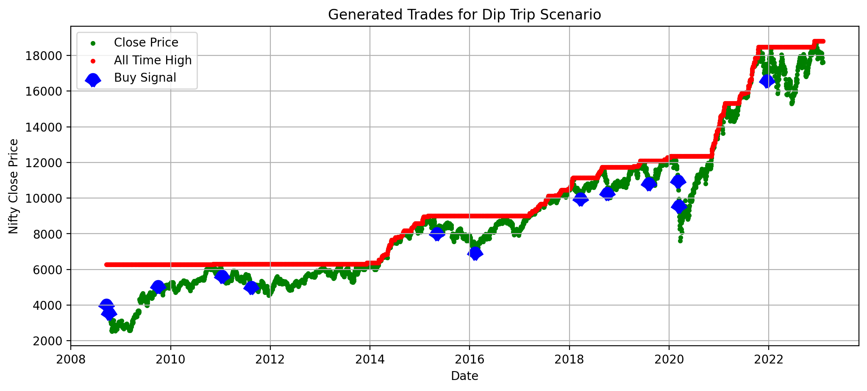

**Figure 13: Buy Signals of trade generated in Dip Trip Scenario**

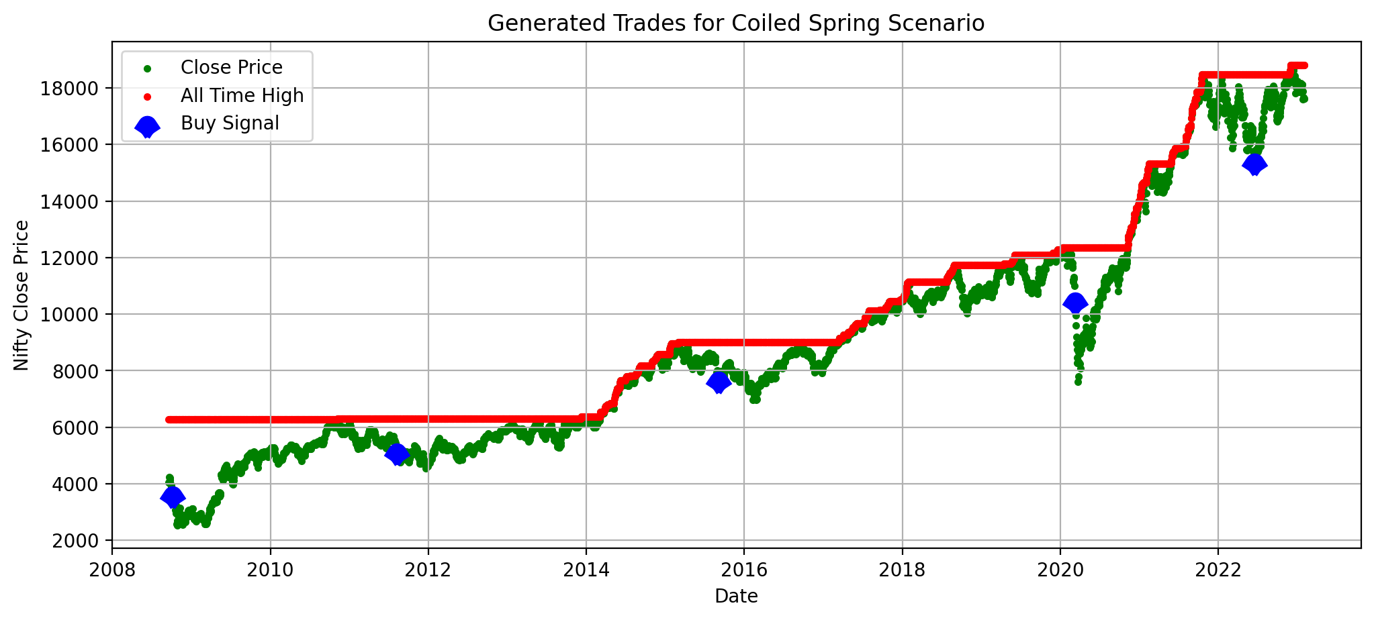

**Figure 14: Buy Signals of trade generated in Coiled Spring Scenario**

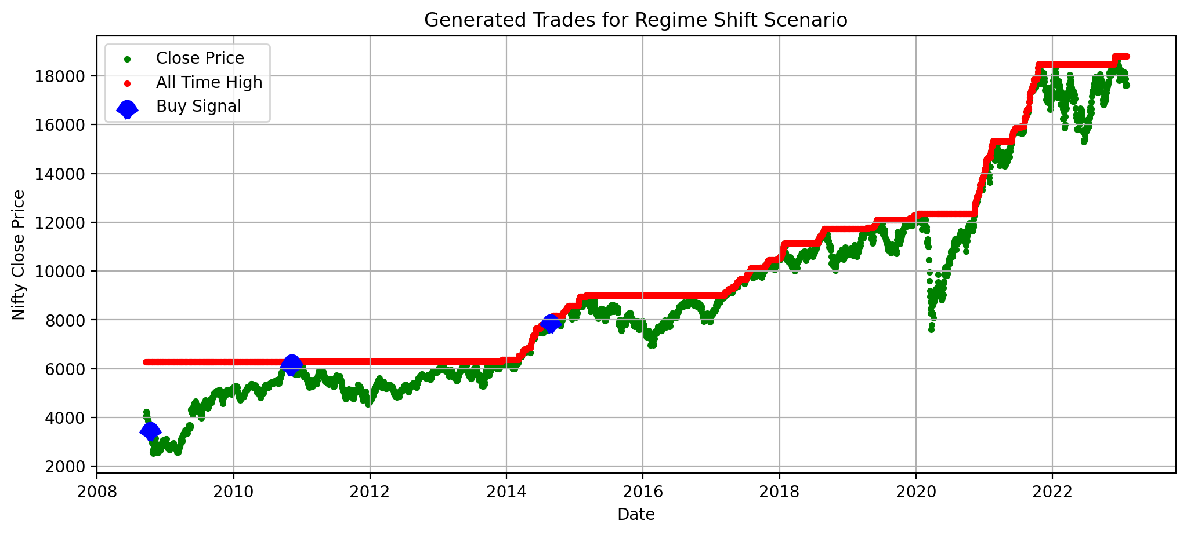**Figure 15: Buy Signals of trade generated in Regime Shift Scenario**

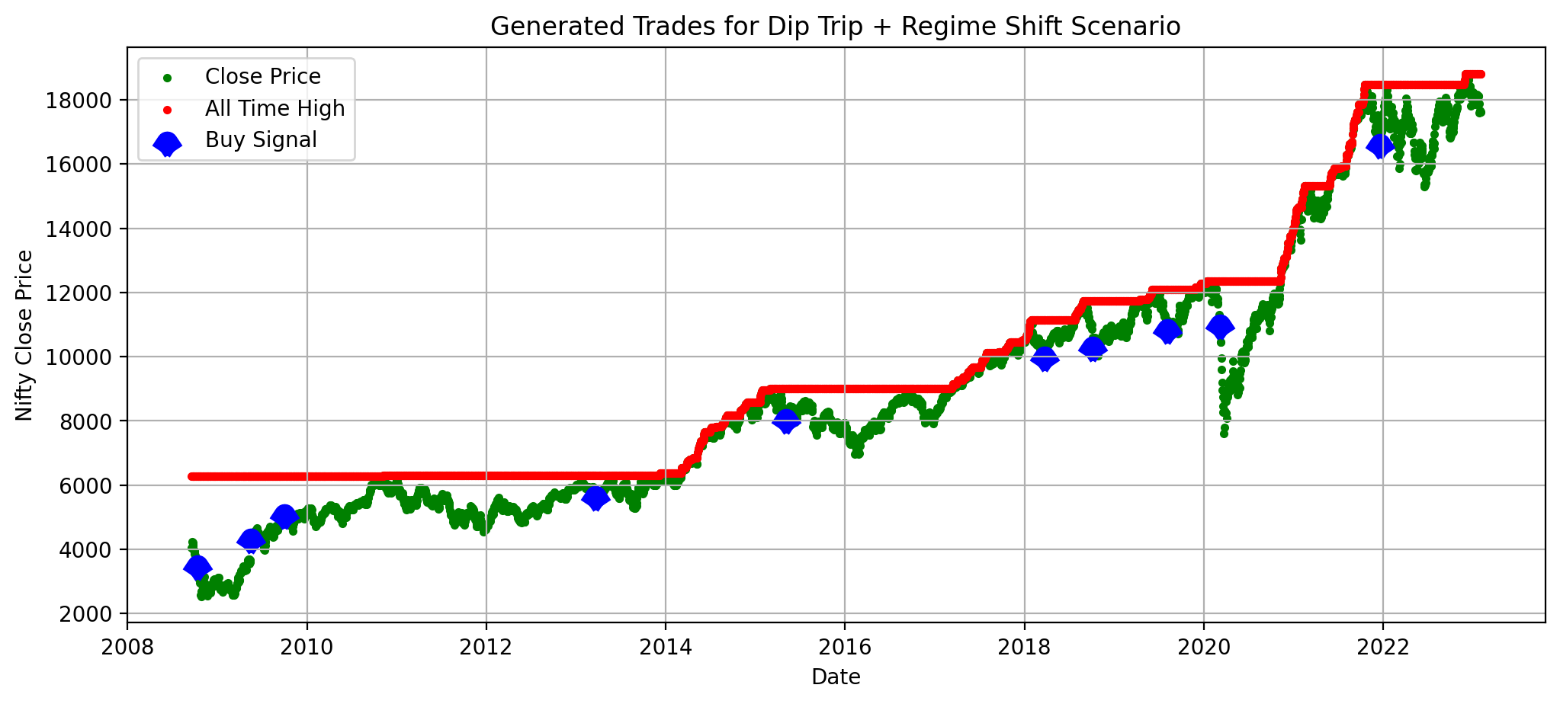**Figure 16: Buy Signals of trade generated in Dip Trip + Regime Shift Scenario**

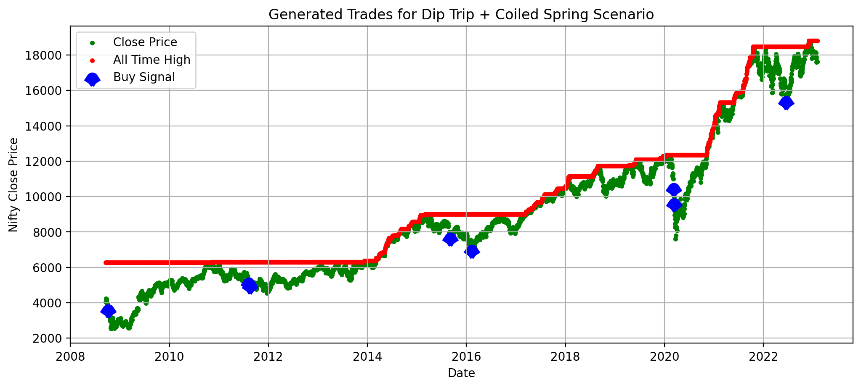

**Figure 17: Buy Signals of trade generated in Dip Trip + Coiled Spring Scenario**

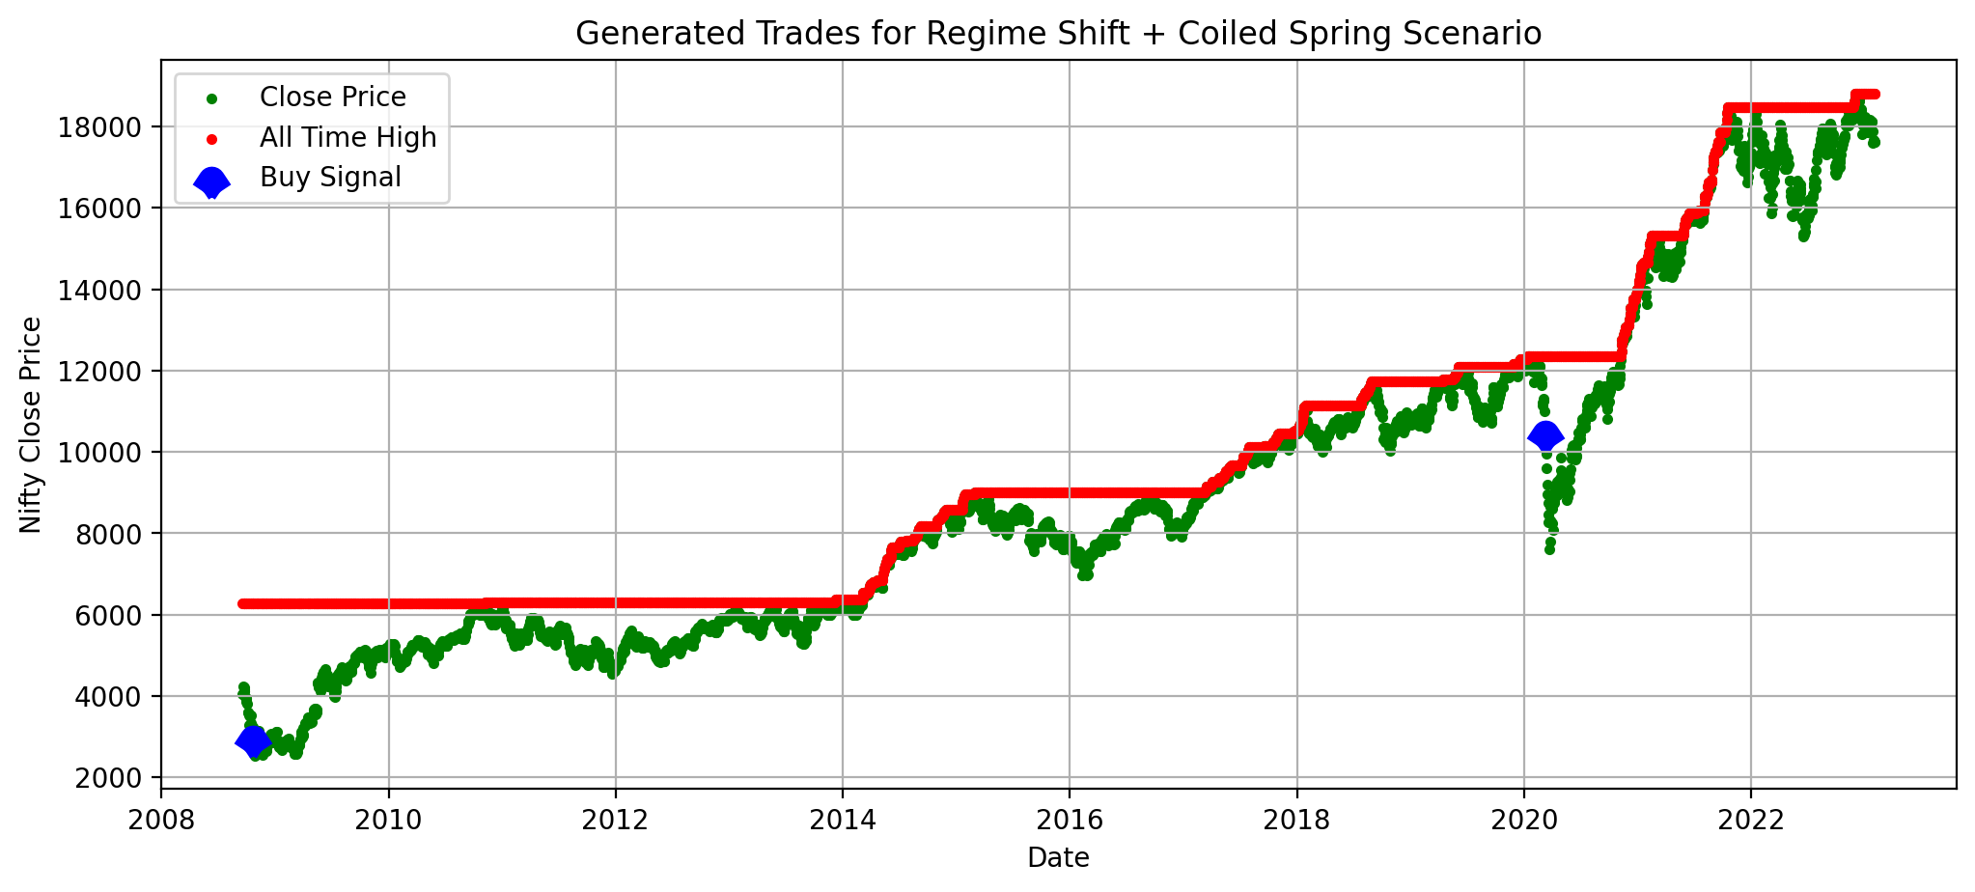**Figure 18: Buy Signals of trade generated in Regime Shift + Coiled Spring Scenario**

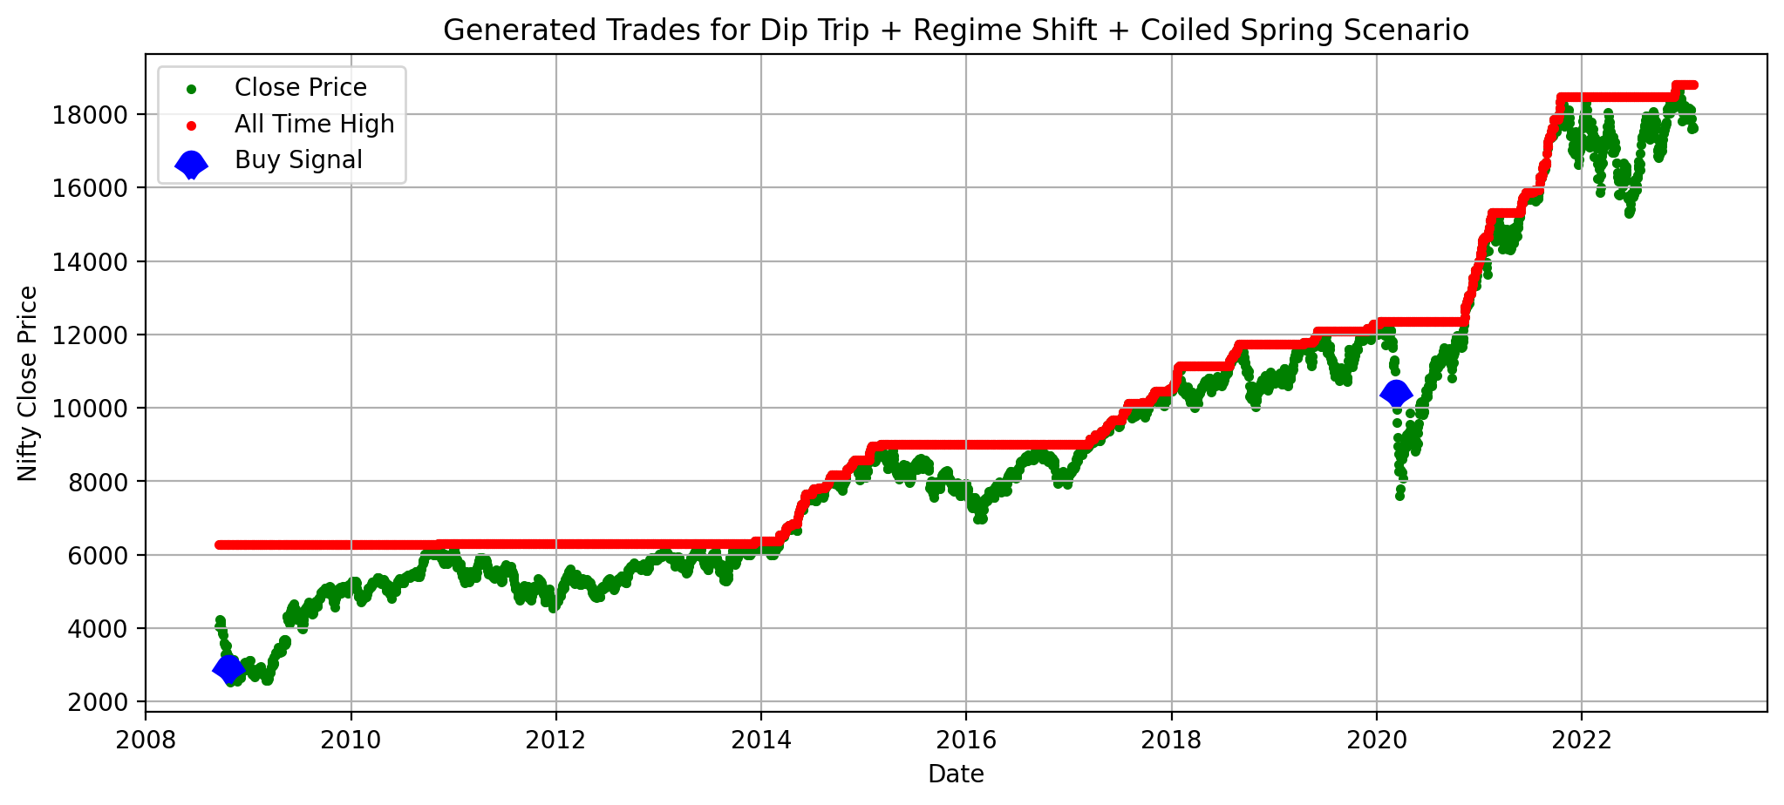**Figure 19: Buy Signals of trade generated in Dip Trip + Regime Shift + Coiled Spring Scenario**

The buy signals generated in the different swing trading scenarios are shown in the figures 12 to 19. Also, the individual trade details are provided in the Appendix B to H.

# Discussion

Dip trip is used widely by passive trading system traders, relatively straightforward to be implemented, and well known to the majority. However we would like to cross implement a more robust system considering the short term pattern (coiled spring) or different market regime to compare with the passive trading system.

From the return perspective, it is notable that pure dip trip method with passive trading underlying outran the rest of the trading scenarios with best return (21.34%), while pure regime shift is the worst performer with only 5% of the return.

From the risk perspective, we selected sharpe ratio to be used as the index parameter since it is widely known and acceptable. In the end, Dip trip with the coiled spring method is the best option with highest Sharpe Ratio (1.6), vs pure regime shift still the worst performer with around 0.5 sharpe ratio.

We could also observe the last two methods exhibit high mean and high standard deviation. To explain this, we believe it is because the more criteria we put in, the more restrictions it could impose on the trade, and in the end the less order being executed. Since the number of trade is pretty less (Only 2), this caused the system highly unstable to achieve high return with high risk.

**Table 3: Statistics of different Swing trading scenarios**

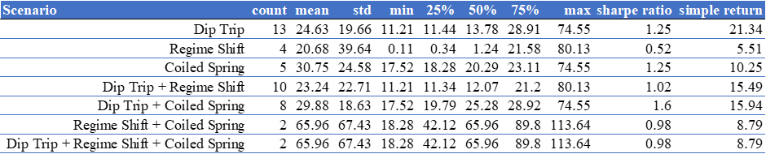

# Conclusion

This paper tried to enhance the existing literature review around swing trading in a few ways. Firstly, it has successfully implemented the simple passive trading mechanism - Dip Trip using python code to calculate the profitability for medium to long term duration based on Nifty 50 index as benchmark. Secondly, another relatively short-term swing trading scenario – Coiled Spring was designed using python to calculate the profitability using python based on the same counter. Thirdly, the paper attempted to implement the trading strategy to calculate profitability using python codes on the same counter to detect regime shift using K-means clustering, an unsupervised machine learning strategy. Last but most importantly, the author combined the technical buy signal associated with each of the individual system signals, and then merged them into four more permutations of methods for further comparison.

Based on the one counter data and with the assumption mentioned above, we conclude that passive trading still exhibits remarkable performance due to its stable return and relative less risks, while on the other hand, adding more restrictions to make it active trading might not receive the equivalent return, since dip trip is meant for long term while coiled spring is relatively short term and regime shifts are hard to capture the steady trend, and all these reasons pulled down the active trading performance.

# Future Work

One can attempt the following actions/tasks to determine whether we arrive at similar or different conclusions:

1. Authors have attempted to implement the dip trip and coiled spring scenario of Swing Trading. There are other swing trading scenarios which can be used to build a trading system such as *bear hug, finger finder, power spike, etc.*
2. Performance of the trading system can be checked on different indexes such as S&P 500, Dow Jones Industrial Average, FTSE100, Nikkei 225, etc.
3. Back testing of the trading system can be conducted to check its performance on different time periods such as 10 years, 15 years or 20 years, depending upon the data availability.
4. The variables used in the coiled spring scenario (such as how many candles to consider to identify the pivot points, and how many candles to consider to identify the possible break out or break down) can be varied.

# References

1. Fama, Eugene F. 1970. “Efficient Capital Markets: A Review of Theory and Empirical Work.” *Papers and Proceedings of the Twenty-Eighth Annual Meeting of the American Finance Association New York* 25, no. 2 (May): 383-417.
2. Farley, Alan S. 2001. *The Master Swing Trader: Tools and Techniques to Profit from Outstanding Short-Term Trading Opportunities*. N.p.: McGraw-Hill Education.
3. Thomsett, Michael C. 2017. Options for Swing Trading: Leverage and Low Risk to Maximize Short-Term Trading. N.p.: Palgrave Macmillan US, Chapter 6: 115-119.
4. Srivastava, Sonam, and Ritabrata Bhattacharyya. 2018. “Evaluating the Building Blocks of a Dynamically Adaptive Systematic Trading Strategy.” Social Science Research Network, (March), 1-21.
5. Verma, Vikrant, Mayank Gupta, and Kushagra Gupta. 2022. “Selection of Market Sector Trend and Sub-Selection of Stocks for Swing Trades.” Social Science Research Network, (October), 1-8.
6. Beyaz, Erhan, Firat Tekiner, Xiao-Jun Zeng, and John Keane. 2018. “Comparing Technical and Fundamental Indicators in Stock Price Forecasting.” IEEE 20th International Conference on High Performance Computing and Communications, (June).
7. Heping, Pan. 2004. “A swingtum theory of intelligent finance for swing trading and momentum trading.” *Paper presented at the First International Workshop on Intelligent Finance, IWIF1, Melbourne*, (December).
8. Totakura, Varun. 2011. “Selection of Stocks Using Relative Strength Index (RSI) In Indian Stock Market For Swing Trades.” Research Gate.
9. Long, Vuong T. 2007. “Empirical Analysis of Stock Return Volatility With Regime Change: The Case Of Vietnam Stock Market.” Vietnam Development Forum – Tokyo Presentation, 1-35.
10. Shyu, Yih-Wen, and Kuangyu Hsia. 2008. “Does stock market volatility with regime shifts signal the business cycle in Taiwan?” International Journal of Electronic Finance 2 (4): 433-450.
11. Lin, Boqiang, and Presley K. Wesseh Jr. 2013. “What causes price volatility and regime shifts in the natural gas market.” *Energy* 55 (April): 553-563.
12. Pra, Giulia D., Massimo Guidolin, Manuela Pedio, and Fabiola Vasile. 2018. “Regime Shifts in Excess Stock Return Predictability: An Out-of-Sample Portfolio Analysis.” The Journal of Portfolio Management 44, no. 3 (Winter): 10-24.
13. Hammerschmid, Regina, and Harald Lohre. 2017. “Regime Shifts and Stock Return Predictability.” *Social Science Research Network*, (November), 1-50.

# Appendix

## Appendix A: Python-Code/Jupyter-Notebooks

Available at

1. Dip Trip: <https://colab.research.google.com/drive/1LpcPj4r1HK0VeKeKOhEAQG7urXdVXU-T>
2. Coiled Spring:

<https://colab.research.google.com/drive/1U4_zRmk0XDx3CQRYk3Bm5HuC-emwbBlH>

1. Regime Shift:

<https://colab.research.google.com/drive/186xa_oAGiCwGT1gPZndZGLsQjYhN8Qwv>

1. Comparison of Dip Trip + Regime Shift + Coiled Spring

<https://colab.research.google.com/drive/12Wxfcuw984YntxXiB6cxHpk9-R1VKbpC>

## Appendix B: Trades generated using Dip Trip scenario

## 

## Appendix C: Trades generated using Coiled Spring scenario

## 

## Appendix D: Trades generated using Regime Shift scenario

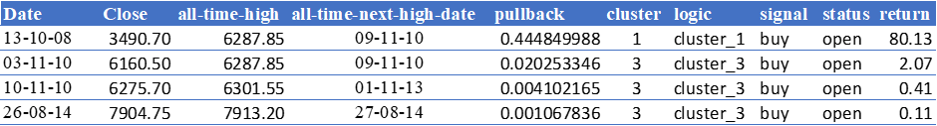

## Appendix E: Trades generated using Dip Trip + Regime Shift scenario

## 

## Appendix F: Trades generated using Dip Trip + Coiled Spring scenario

## 

## Appendix G: Trades generated using Regime Shift + Coiled Spring scenario

## 

## Appendix H: Trades generated using Dip Trip + Regime Shift + Coiled Spring scenario

