Final Report

Day 1: Cleaning issues & resolutions
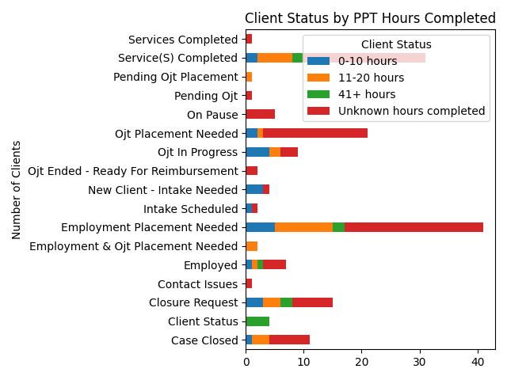
During the Week 4 data cleaning process, several issues were identified and resolved to improve accuracy and consistency. Dates across the dataset were found in inconsistent formats, in particular missing, invalid, or duplicated in “Latest Check-In Date”. These were standardized into the MM/DD/YYYY format, with errors flagged in the new Issues column. Categorical fields such as Resume Completed, Case Notes Submitted, and Client Status contained inconsistent values such as “Y,” “Yes,”, or blank values, so all entries were normalized into uniform “Yes/No” values. Duplicate records, particularly in the check-in fields, were marked and reconciled to ensure reliable tracking. In addition, missing or incomplete entries in areas such as service logs and coaching support were documented for follow-up. To maintain transparency, an Issues column was added to outline each detected problem, including missing, invalid, or duplicate data. Overall, these steps standardized dates, normalized categorical responses, removed duplicates, and created a clear record of outstanding issues, resulting in a cleaner, more reliable dataset for reporting and compliance monitoring.

Day 2: Engagement analysis
The engagement analysis shows that the majority of clients remain in early stages of progress, with most having less than 20 PPT hours recorded and a large portion showing unknown hours due to incomplete documentation. A significant number of clients, around 60, are still in need of employment placement or OJT placement, far exceeding those currently employed, in progress, or closed, highlighting the need for increased placement support. While resumes are largely on file, case note submissions are inconsistent, with only one client submitting notes without a resume, and several clients having neither. This indicates that, alongside improving documentation of PPT hours, additional follow-up is required to ensure clients are consistently submitting case notes while also maintaining updated resumes. Overall, the data reflects the need for stronger tracking, documentation, and placement activity to move clients from intake and placement-needed statuses toward employment and service completion.

Day 3: Text analysis insights
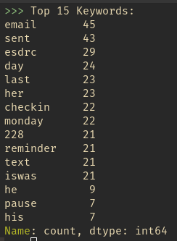
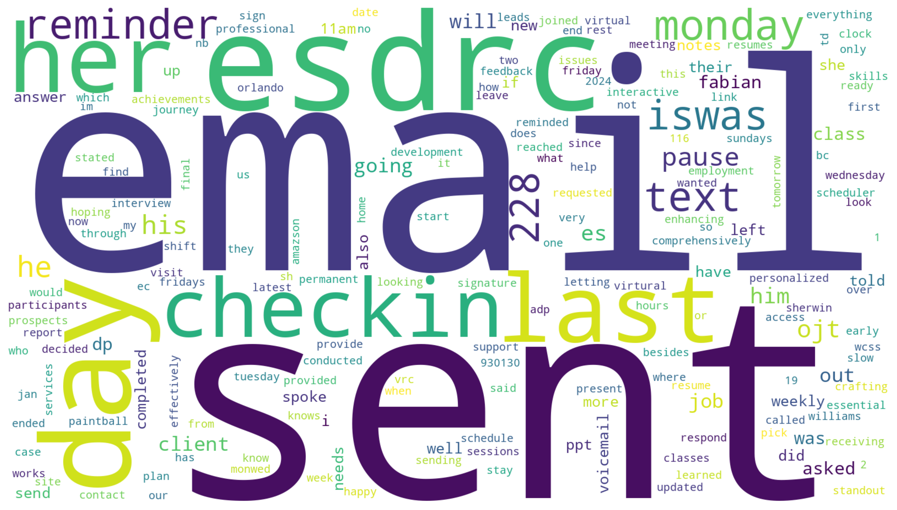
The text analysis of the notes reveals several clear themes tied to communication, scheduling, and client support. The most frequent keywords, such as email, sent, text, reminder, and checkin, show that consistent communication and timely follow-ups are central to the workflow. Much of the documentation centers on ensuring outreach is completed, whether by email or text, and confirming that reminders are delivered to keep tasks and meetings on track. Another key theme is scheduling and time management, highlighted by recurring mentions of days of the week (monday, day, weekly) and check-ins, which suggests a structured rhythm of follow-up interactions with clients. Beyond logistics, the notes strongly reflect client-facing activities, with frequent references to job, resume, interview, employment, and client. This indicates that the work largely supports professional development and employment readiness, helping individuals move forward in their career journeys. The repeated appearance of action-oriented words like completed, started, provided, asked, and decided underscores accountability and progress tracking, showing that updates are carefully recorded to monitor outcomes. Additionally, mentions of class and OJT (on-the-job training) emphasize the developmental and coaching components of the notes. Altogether, the analysis shows that the notes represent a highly structured and supportive system built on steady communication, accountability, and professional growth, ensuring clients are consistently engaged and guided through their employment development process

Day 4: Staff performance and workload
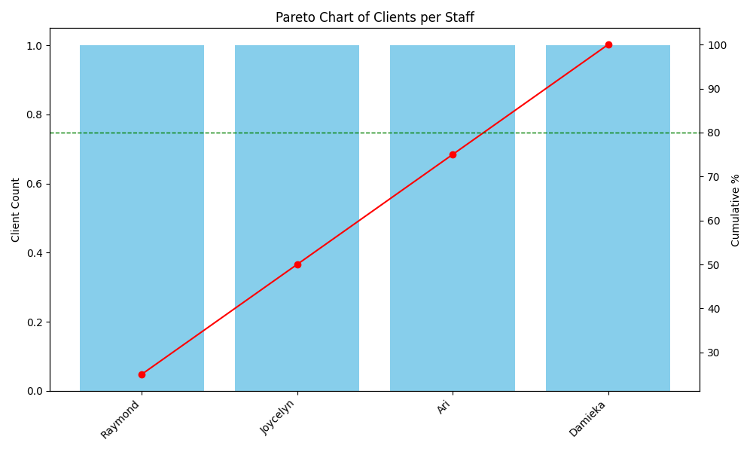
The Pareto analysis of staff performance highlights the distribution of client workload among four staff members: Raymond, Joycelyn, Ari, and Damieka. The findings reveal that each staff member managed an identical number of clients, with one client each, resulting in a perfectly even distribution. This creates a flat cumulative curve where the classic 80/20 Pareto principle is not evident. Instead of a concentration of clients with a small group, the workload is balanced evenly across all staff. This balance suggests that risks of burnout are minimized, and fairness in assignments is maintained. No single staff member is disproportionately carrying the caseload, which is positive for maintaining team morale and sustainability of service delivery. However, the evenness also indicates that no one staff member is contributing disproportionately to client outcomes or demonstrating outstanding productivity in terms of client volume. While workload distribution is even, future evaluations should go beyond raw client counts. CSI such as resume completion rates or successful outcomes per client should be integrated into performance measurement. This would enable deeper insights into the quality and impact of staff support, rather than focusing solely on quantity. By linking city-level CSI outcomes to staff assignments, organizations could better identify high-impact staff practices and replicate them in underperforming areas. In summary, the Pareto distribution shows equitable staff workload, which is fair and sustainable. The next step is to incorporate CSI-driven performance measures to ensure not only balanced workloads but also measurable impact on client success.

Day 4: City level trends
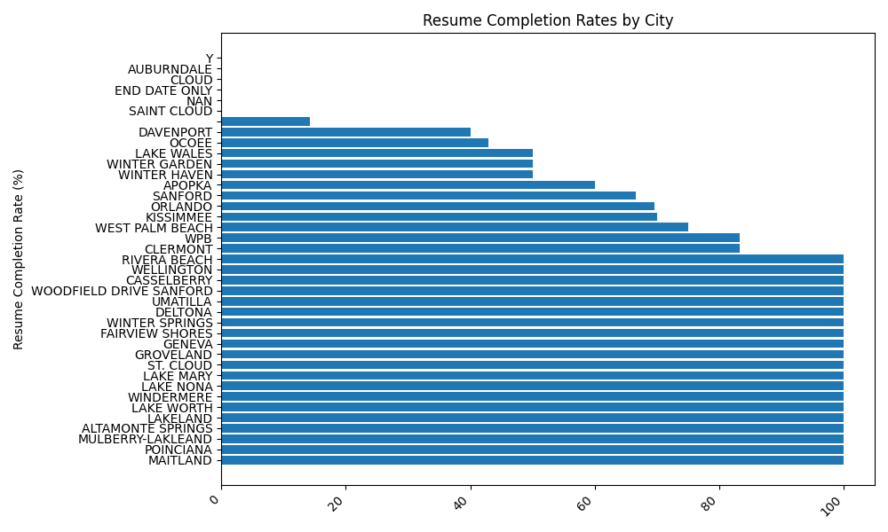
The analysis of resume completion rates across cities highlights striking differences in engagement and outcomes. High-performing locations such as Maitland, Poinciana, Mulberry-Lakeland, and Altamonte Springs show near-100% completion rates, reflecting strong community support, motivated participants, and effective local practices that should be documented and replicated. In contrast, mid-range cities including Orlando, Kissimmee, and Apopka cluster around 60–70% completion, suggesting steady but improvable engagement that could benefit from additional outreach and coaching to lift outcomes closer to top-tier benchmarks. At the other end of the spectrum, Davenport, Saint Cloud, and Auburndale report very low completion levels, some under 20%, indicating significant barriers such as weaker support systems, resource limitations, or reduced participant motivation. These disparities confirm that engagement differences are driven primarily by city-level conditions rather than staff workload, which has been shown to be evenly distributed. Moving forward, organizations should focus on transferring best practices from high-performing cities, tailoring interventions to address the specific challenges faced by underperforming areas, and continuously monitoring city-level trends. By linking staff practices with local outcomes, it becomes possible to identify strategies that work, promote equity across regions, and ultimately ensure that all participants have the support needed to succeed.

Recommendations for program effectiveness
To improve program effectiveness, the organization should prioritize improving data accuracy, client engagement, and performance tracking across sites. First, ongoing data cleaning protocols, such as standardized date formats, consistent categorical responses, and clear issue tracking, should be institutionalized to ensure reliable reporting and compliance. Client engagement must be elevated by increasing documentation of participation hours, resumes, and case notes, while providing stronger placement support to address the large number of clients still needing employment or OJT opportunities. Staff workload distribution is equitable, but performance measurement should extend beyond case counts to include CSI such as employment outcomes, resume completion, and service milestones, enabling recognition and replication of high-impact practices. At the city level, best practices from high-performing locations like Maitland and Poinciana should be adapted and transferred to underperforming sites such as Davenport and Saint Cloud, with interventions tailored to address local barriers. Strengthening communication protocols—through structured follow-ups, timely reminders, and consistent outreach—will also ensure clients remain engaged and supported in their career pathways. Together, these strategies create a more data-driven, client-centered, and outcome-focused framework that promotes equity across regions and enhances long-term program success.

