Add New Site - Documentaion

# Import Files Preparation

## File Names

Import files must use the following naming convention.

Name the files as follows:

randomizationsNN.csv (where NN is the study number) example: radomizatio01.csv

studyidsNN.csv

## Study Id’s Import File

In excel, select File – Save As, then select ‘CSV (Comma delimited) as the file type. (see picture below)

Name the file according to the naming convention above.

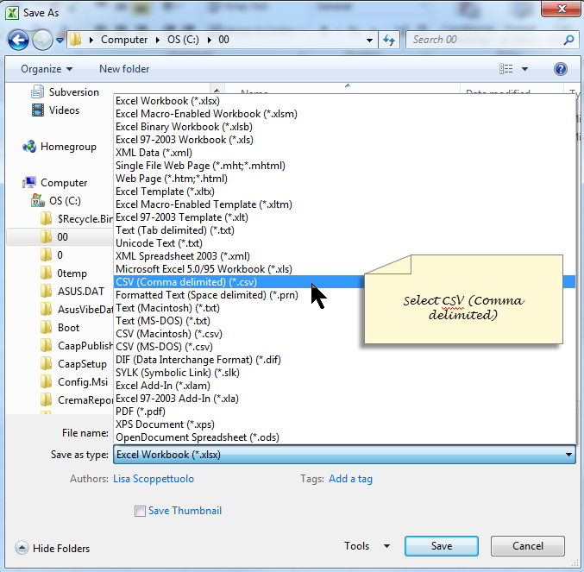

## Randomizations Import File

Open the master randomization assignment in excel. Delete the first 17 rows. (see picture below)

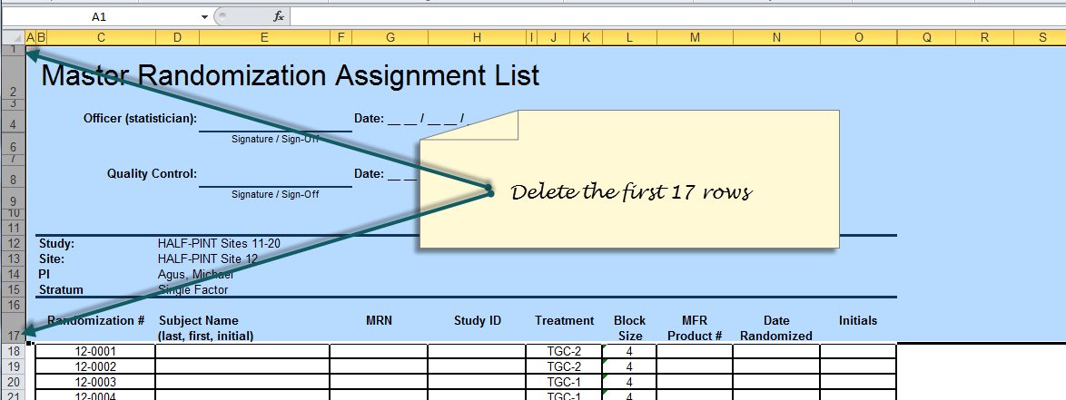

Then save as ‘CSV (Comma delimited) as the file type. Name the file according to the naming convention above.

# Add New Site Page

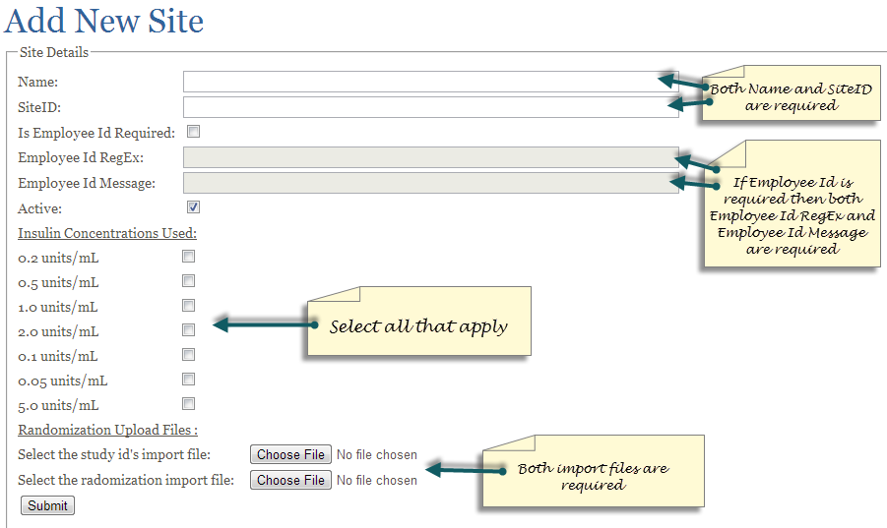

# Technical Specifications

## Validation

* Site Information
  + Name – required
  + Site Id – required
  + If employee id is required
    - Employee Id RegEx – required
    - Employee Id Message – required