About Dataset:

Content

Contains Genuine and Forged signatures of 30 people. Each person has 5 Genuine signatures which they made themselves and 5 Forged signatures someone else made.  
The naming of images is explained here.  
NFI-00602023 is an image of signature of person number 023 done by person 006. This is a forged signature. NFI-02103021 is an image of signature of person number 021 done by person 021. This is a genuine signature.

Source:

Kaggle ([link](https://www.kaggle.com/divyanshrai/handwritten-signatures))

Dataset Structure:

Training Dataset folder:

Dataset_Signature_Final\Dataset

Validation and Testing Dataset folder:

sample_Signature\sample_Signature

visualization:

Label = 1 (Matching signatures)

Label = 0 (Nonmatching signatures)

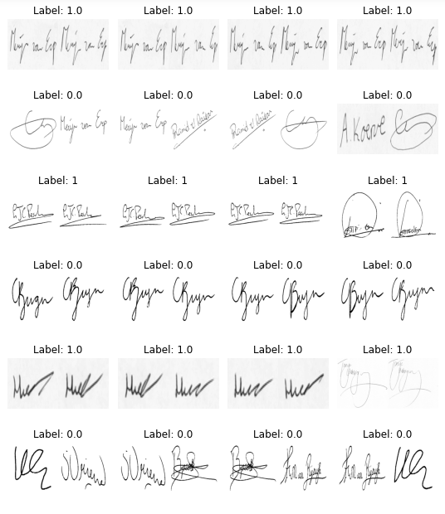

Model Structure:

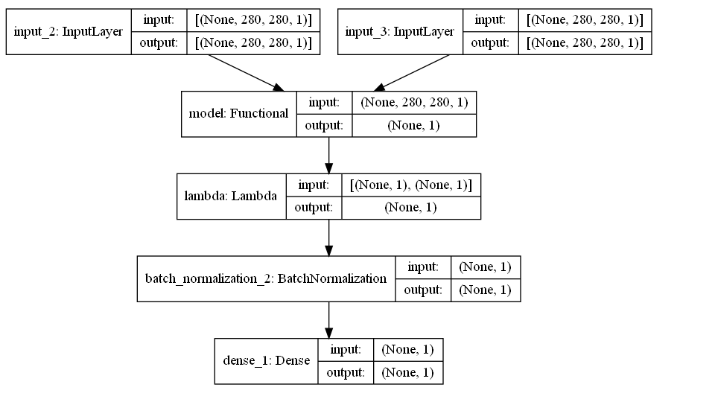

Training:

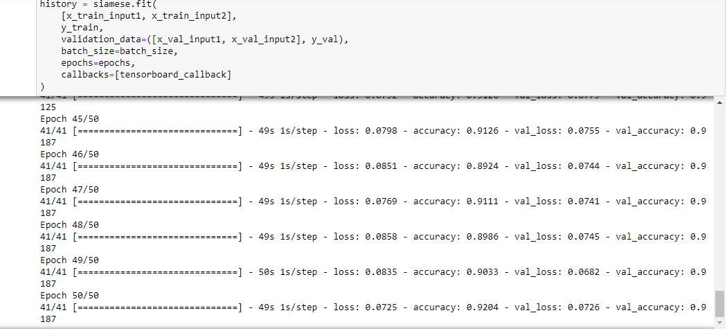

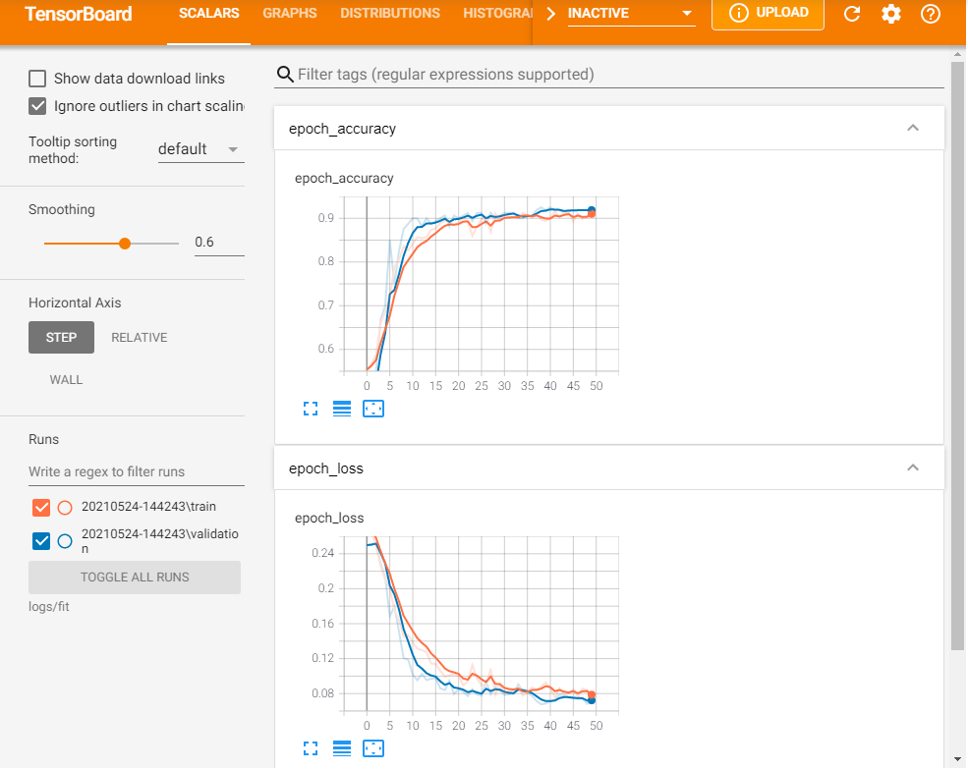

Prediction:

Matching:

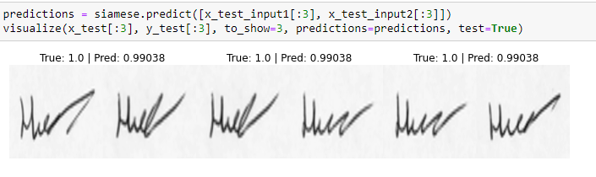

Nonmatching:

