Course: CS 223 Digital Design

Section: 6

PROJECT

Name: Halil AVCI

Student ID: 22003476

Date: 26/11/2023

RTL DESIGN

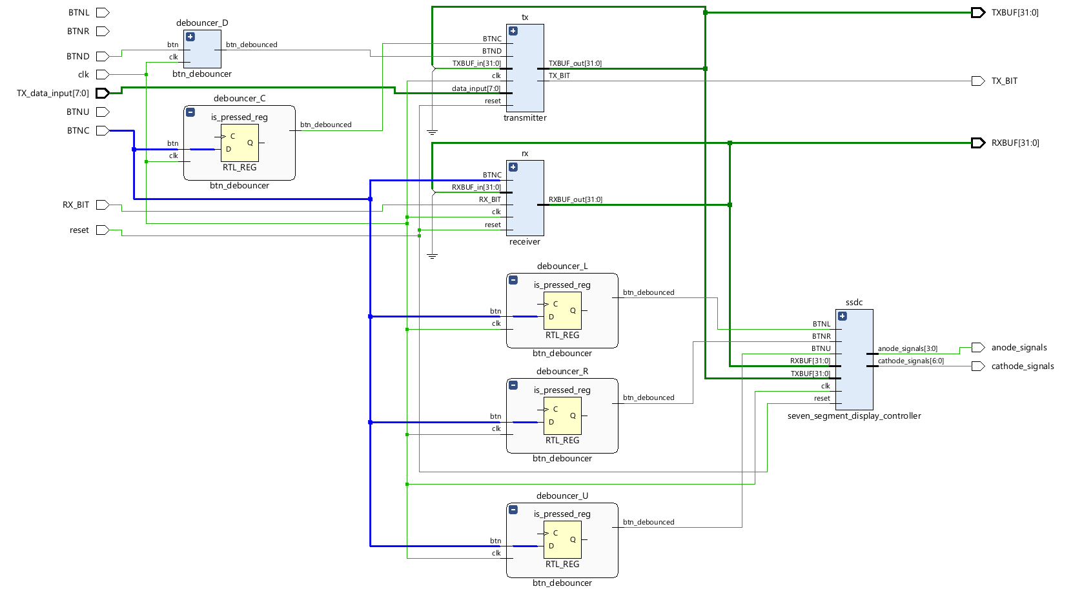

The UART, consists of transmitter, receiver, seven segment display controller, and button rebouncer. Transmitter transfers the input value bit by bit and manages the down and center buttons. When overloaded, It shifts and discards the oldest data. Receiver receives the bits and packs them into meaningful 1-byte of data. It has similar data storing system with the transmitter. Seven segment display controller takes inputs from RXBUF and TXBUF, and shows the intended value on the seven segment displayer in hexadecimal. Button rebouncer controls the button behaviors. It tracks the button bits. When button becomes 1 in 5 clock cycle consecutively, it turns on the button and assigns it to untill the user stops pushing the button.

CODE:

`timescale 1ns / 1ps

module UART #(parameter DATA_WIDTH = 8, STOP_BITS = 2, BAUD_RATE = 115200) (

input clk,

input logic reset,

input logic BTND,

input logic BTNC,

input logic BTNL,

input logic BTNR,

input logic BTNU,

input logic [DATA_WIDTH - 1:0] TX_data_input,

input logic RX_BIT,

output logic TX_BIT,

output logic anode_signals,

output logic cathode_signals,

output logic [4 * DATA_WIDTH - 1:0] TXBUF,

output logic [4 * DATA_WIDTH - 1:0] RXBUF

);

wire internal_TXBUF = TXBUF;

wire internal_RXBUF = RXBUF;

btn_debouncer debouncer_D(clk, BTND, debounced_BTND);

btn_debouncer debouncer_C(clk, BTNC, debounced_BTNC);

btn_debouncer debouncer_L(clk, BTNC, debounced_BTNL);

btn_debouncer debouncer_R(clk, BTNC, debounced_BTNR);

btn_debouncer debouncer_U(clk, BTNC, debounced_BTNU);

seven_segment_display_controller #(DATA_WIDTH) ssdc(

clk, reset,debounced_BTNL, debounced_BTNR, debounced_BTNU,

RXBUF, TXBUF, anode_signals, cathode_signals);

transmitter #(DATA_WIDTH, STOP_BITS, BAUD_RATE) tx(

clk, reset, debounced_BTND, debounced_BTNC,

TX_data_input, internal_TXBUF, TXBUF, TX_BIT);

receiver #(DATA_WIDTH, STOP_BITS, BAUD_RATE) rx(

clk, reset, BTNC, RX_BIT, internal_RXBUF, RXBUF);

endmodule

`timescale 1ns / 1ps

module btn_debouncer(

input clk,

input logic btn,

output logic btn_debounced

);

logic [4:0] counter;

logic is_pressed;

logic stable_value;

always@(posedge clk) begin

is_pressed <= btn;

counter <= {counter[3:0], is_pressed};

if (&counter)

stable_value <= 1'b1;

else

stable_value <= 1'b0;

end

assign btn_debounced = stable_value;

endmodule

`timescale 1ns / 1ps

module seven_segment_display_controller #(parameter DATA_WIDTH = 8) (

input clk,

input logic reset,

input logic BTNL,

input logic BTNR,

input logic BTNU,

input logic [4 * DATA_WIDTH - 1:0] RXBUF,

input logic [4 * DATA_WIDTH - 1:0] TXBUF,

output logic [3:0] anode_signals,

output logic [6:0] cathode_signals

);

logic [19:0] counter;

logic [1:0] LED_activation;

logic [1:0] display_options;

logic [15:0] data_to_display;

logic [3:0] digit_to_display;

logic change_display;

always@(posedge clk) begin

if (reset) begin

counter <= 0;

end

else begin

counter <= counter + 1;

end

end

assign LED_activation = counter[19:18];

always@(posedge clk) begin

if (BTNL || BTNR) begin

if (display_options[0])

display_options[0] <= 1'b0;

else

display_options[0] <= 1'b1;

change_display <= 1;

end

if (BTNU) begin

if (display_options[1])

display_options[1] <= 1'b0;

else

display_options[1] <= 1'b1;

change_display <= 1;

end

case (LED_activation)

2'b00: begin

anode_signals <= 4'b0111;

digit_to_display[3:0] <= data_to_display[15:12];

end

2'b01: begin

anode_signals <= 4'b1011;

digit_to_display[3:0] <= data_to_display[11:8];

end

2'b10: begin

anode_signals <= 4'b1101;

digit_to_display[3:0] <= data_to_display[7:4];

end

2'b11: begin

anode_signals <= 4'b1110;

digit_to_display[3:0] <= data_to_display[3:0];

end

default: begin

anode_signals <= 4'b0111;

digit_to_display[3:0] <= 4'b0000;

end

endcase

if (change_display) begin

change_display <= 0;

case (display_options)

2'b00: begin

data_to_display[15:0] <= TXBUF[4 * DATA_WIDTH - 1: 2 * DATA_WIDTH];

end

2'b01: begin

data_to_display[15:0] <= TXBUF[2 * DATA_WIDTH - 1:0];

end

2'b10: begin

data_to_display[15:0] <= RXBUF[4 * DATA_WIDTH - 1: 2 * DATA_WIDTH];

end

2'b11: begin

data_to_display[15:0] <= TXBUF[2 * DATA_WIDTH - 1:0];

end

default: begin

data_to_display[15:0] <= TXBUF[4 * DATA_WIDTH - 1: 2 * DATA_WIDTH];

end

endcase

end

case(digit_to_display)

4'b0000: cathode_signals = 7'b0000001; // "0"

4'b0001: cathode_signals = 7'b1001111; // "1"

4'b0010: cathode_signals = 7'b0010010; // "2"

4'b0011: cathode_signals = 7'b0000110; // "3"

4'b0100: cathode_signals = 7'b1001100; // "4"

4'b0101: cathode_signals = 7'b0100100; // "5"

4'b0110: cathode_signals = 7'b0100000; // "6"

4'b0111: cathode_signals = 7'b0001111; // "7"

4'b1000: cathode_signals = 7'b0000000; // "8"

4'b1001: cathode_signals = 7'b0000100; // "9"

4'b1010: cathode_signals = 7'b0001000; // "A"

4'b1011: cathode_signals = 7'b0000000; // "B"

4'b1100: cathode_signals = 7'b0110001; // "C"

4'b1101: cathode_signals = 7'b0000011; // "D"

4'b1110: cathode_signals = 7'b0110000; // "E"

4'b1111: cathode_signals = 7'b0111000; // "F"

default: cathode_signals = 7'b0000001; // "0"

endcase

end

endmodule

`timescale 1ns / 1ps

module transmitter #(parameter DATA_WIDTH = 8, STOP_BITS = 2, BAUD_RATE = 115200) (

input clk,

input logic reset,

input logic BTND,

input logic BTNC,

input logic [DATA_WIDTH-1:0] data_input,

input logic [4*DATA_WIDTH-1:0] TXBUF_in,

output logic [4*DATA_WIDTH-1:0] TXBUF_out,

output logic TX_BIT

);

logic state; //0:IDLE 1:TRANSFER

logic [3:0] data_counter;

logic [15:0] baud_counter;

logic [DATA_WIDTH + STOP_BITS:0] TX_LINE;

logic DIV = 100000000 / BAUD_RATE;

always_ff@(posedge clk) begin

if (reset) begin

state <= 0;

TX_LINE <= 1'b1;

TX_BIT <= 1'b1;

end

if (BTND) begin

TXBUF_out[4*DATA_WIDTH-1:8] <= TXBUF_in[4*DATA_WIDTH-9:0];

TXBUF_out[4*DATA_WIDTH-25:0] <= data_input;

TX_LINE <= {1'b0, data_input, 2'b1};

end

if (BTNC) begin

state <= 1;

end

if (state) begin

TX_BIT <= TX_LINE[DATA_WIDTH + STOP_BITS];

baud_counter <= baud_counter + 1;

if (baud_counter == DIV - 1) begin

data_counter <= data_counter + 1;

TX_LINE[10:1] <= TX_LINE[9:0];

baud_counter <= 0;

if (data_counter == 10) begin

state <= 0;

end

end

end

end

endmodule

`timescale 1ns / 1ps

module receiver #(parameter DATA_WIDTH = 8, STOP_BITS = 2, BAUD_RATE = 115200) (

input clk,

input logic reset,

input logic BTNC,

input logic RX_BIT,

input logic [4*DATA_WIDTH-1:0] RXBUF_in,

output logic [4*DATA_WIDTH-1:0] RXBUF_out

);

logic state; //0:IDLE 1:RECEIVE

logic [3:0] data_counter;

logic [15:0] baud_counter;

logic [9:0] data_received;

logic DIV = 100000000 / BAUD_RATE;

always_ff@(posedge clk) begin

if (reset) begin

state <= 0;

data_counter <= 0;

baud_counter <= 0;

end

if (!state) begin

if (!RX_BIT) begin

baud_counter <= baud_counter + 1;

end

else begin

baud_counter <= 0;

end

if (baud_counter == (DIV / 2)) begin //[15:1]

state <= 1;

data_counter <= 0;

baud_counter <= 0;

end

end

else begin

baud_counter <= baud_counter + 1;

if (baud_counter == DIV) begin

data_received <= {data_received[8:0], RX_BIT};

data_counter <= data_counter + 1;

baud_counter <= 0;

if (data_counter == 10) begin

RXBUF_out[4*DATA_WIDTH-1:8] <= RXBUF_in[4*DATA_WIDTH-9:0];

RXBUF_out[4*DATA_WIDTH-25:0] <= data_received[9:2];

state <= 0;

end

end

end

end

endmodule