EE587 Introduction to Robotics
Project Report I
Dragonfly kinematics and dynamics model generation

- Dragonfly analysis and assumptions
In this project a dragonfly insect is analyzed and a robotic structure will be proposed inspired by dragonfly. Dragonfly is a flying insect, shown in figure 1. This insect has some specialties among the other flying animals and insects. Mainly, its four airfoils are independent from each other and controlled by separate muscles. It gives the insect very high maneuverability. Also, its airfoils are very tiny and has a spot close to tip and front of airfoil. This spot is denser than the other parts of air foil. So, although dragonfly can only moves the airfoil up and down, the foil makes a motion on pitch axes. On an aerial robot main convention is that, heading direction is x-axis, left side of robot is y-axis and upside is z-axis. Roll-pitch-yaw are rotation according to x-y-z axises respectively. In this convention, the dragonfly can rotate its airfoil in Roll and also there is an additional Pitch motion comes from its structure.

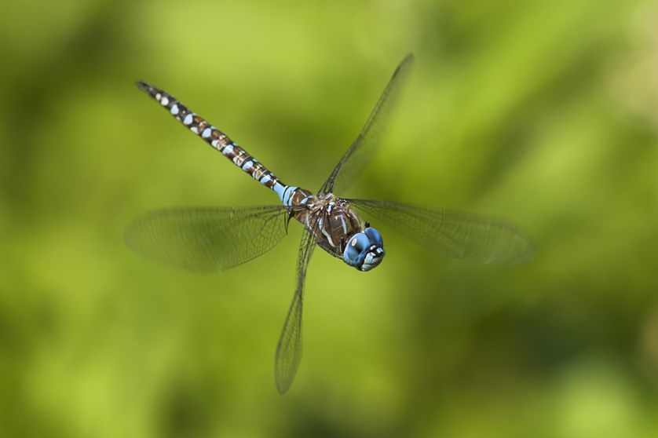
Figure 1: Dragonfly

Assumptions on Dragonfly robot:

- Robot centered coordinates: heading → x, left → y and upside → z.
- There is a body and tail connected to it with a revolute joint.
- There are four wings connected to body with two dof joints. Roll (x) and Pitch (y) rotations allowed according to robot centered coordinates.
- Airfoils are flat.
- Mass of airfoils are very small with respect to body, neglected when the dynamics of body been considered.
- The flicker of airfoils are very rapid, the average force is used when the dynamics of body been considered.
- Each airfoil can make an average equivalent force acting on body from center of gravity of airfoil at initial position of foil according to Roll and Pitch motion characteristics.
- Airfoil be exposed to air friction proportional to its velocity square and normal surface area which is controlled by roll and pitch angles.
- D-H parameters
In this section first D-H parameters are generated for the moving leaf, body, airfoils and tail of dragonfly separately. Secondly, the homogeneous matrices are derived from these D-H parameters.
Moving leaf is on an arbitrary point in 3D space. Thanks to our assumption about no rotating leaf it has three degree of freedom which are x, y, z Cartesian coordinates with respect to base. In order to represent this behavior 3 prismatic joints are considered as shown in figure 2. D-H parameters are shown in table 1. Frame-3L is placed at the center of leaf where the dragonfly will be landed safely.

Joint
1L | 90º | 0 |  | 90º
2L | 90º | 0 |  | 90º
3L | 90º | 0 |  | 90º
Table 1: D-H parametes of the moving leaf

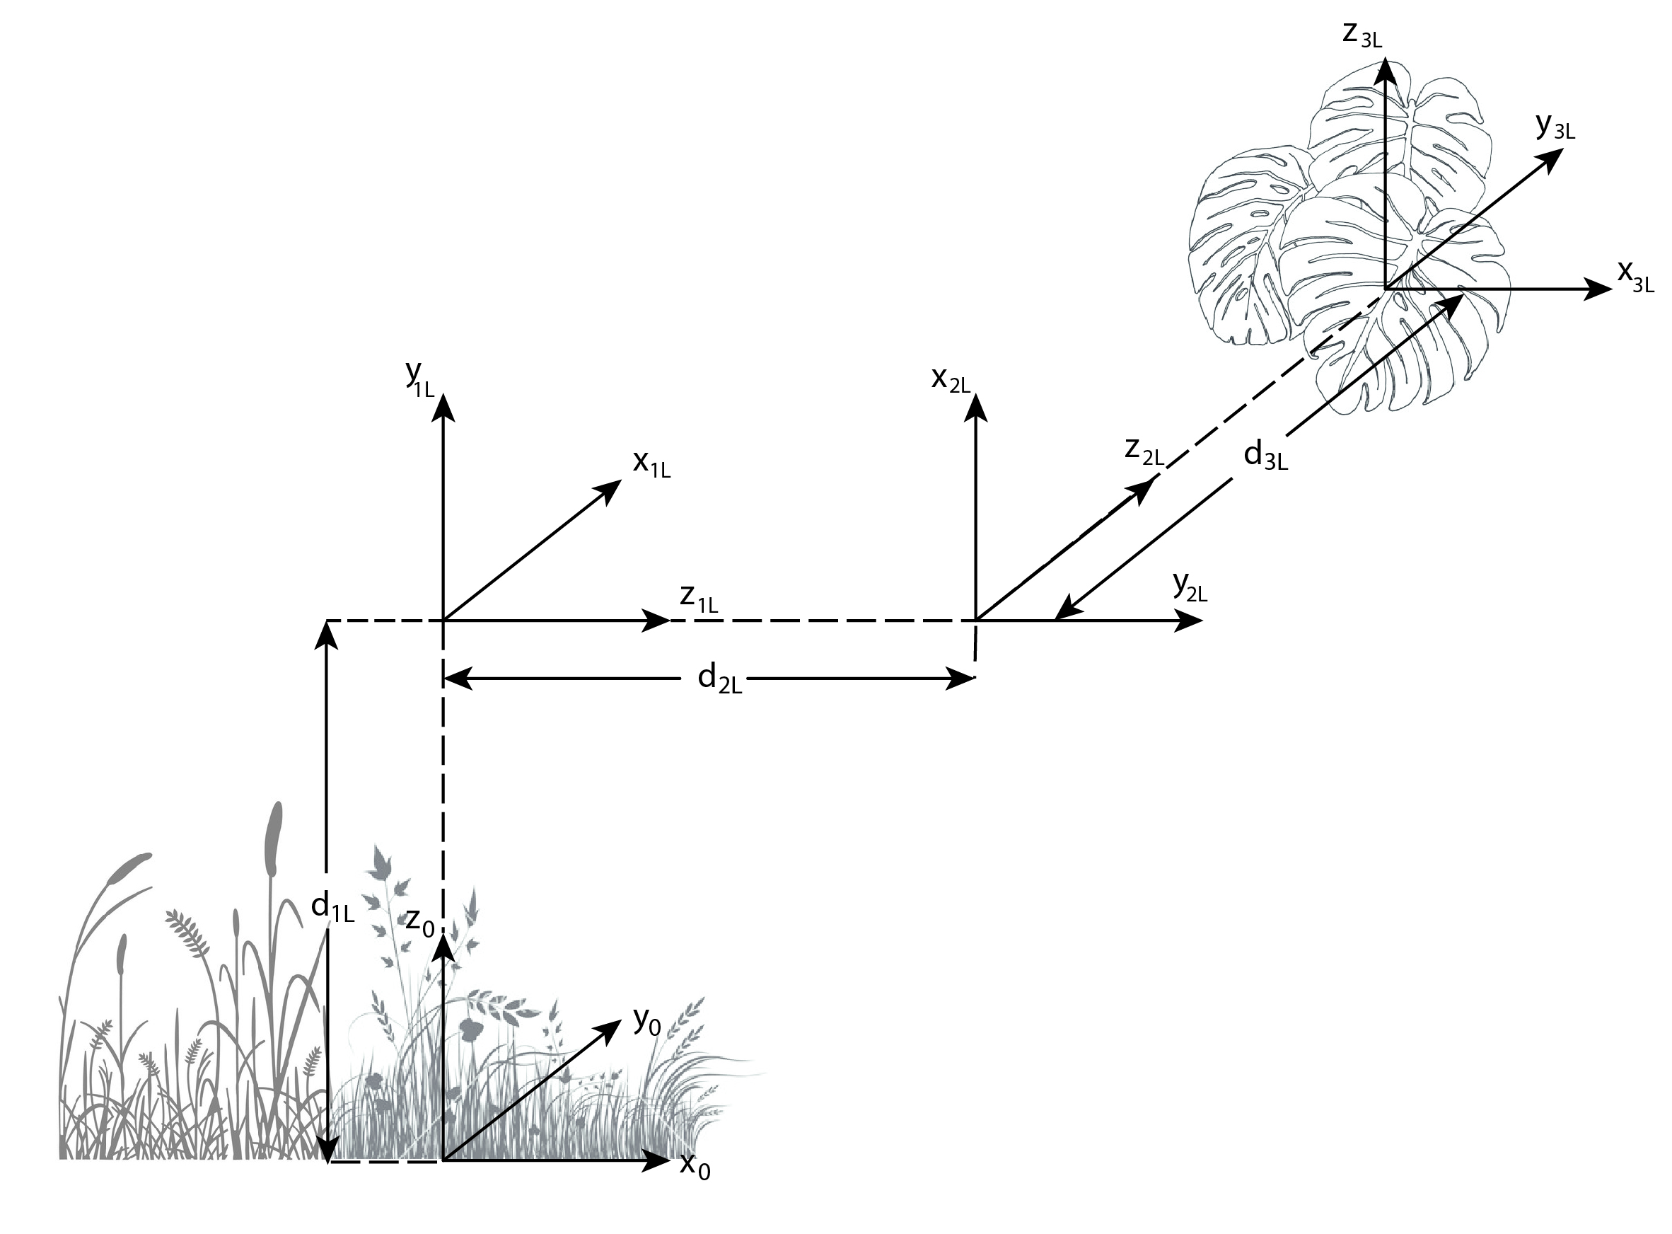
Figure 2: Virtual joints for leaf coordinates

Coordinate of dragonfly body is similar to the leaf. In addition, it has orientation also. First three virtual joints are representing the position same as the leaf and second three joints are representing the orientation of the body. Frame-6 is fixed to the body of dragon fly and as stated in assumptions its x, y, z axises are heading, left and upside of dragonfly respectively. Frame-7 is redundant, it is fixed with respect to frame-6 and no variables defined with it. However, it is the base for four airfoils of dragonfly. In figure 3 and figure 4, the frames for dragonfly body is shown. D-H parameters are shown in table 2.

Joint
1 | 90º | 0 |  | 90º
2 | 90º | 0 |  | 90º
3 | 90º | 0 |  | 90º
4 | 90º | 0 | 0 | 90º+
5 | 90º | 0 | 0 | 90º+
6 | 90º | 0 | 0 | 90º+
7 | 90º | 0 | 0 | 90º
Table 2: D-H parameters of center of gravity of Dragonfly body (7 is base for airfoils)

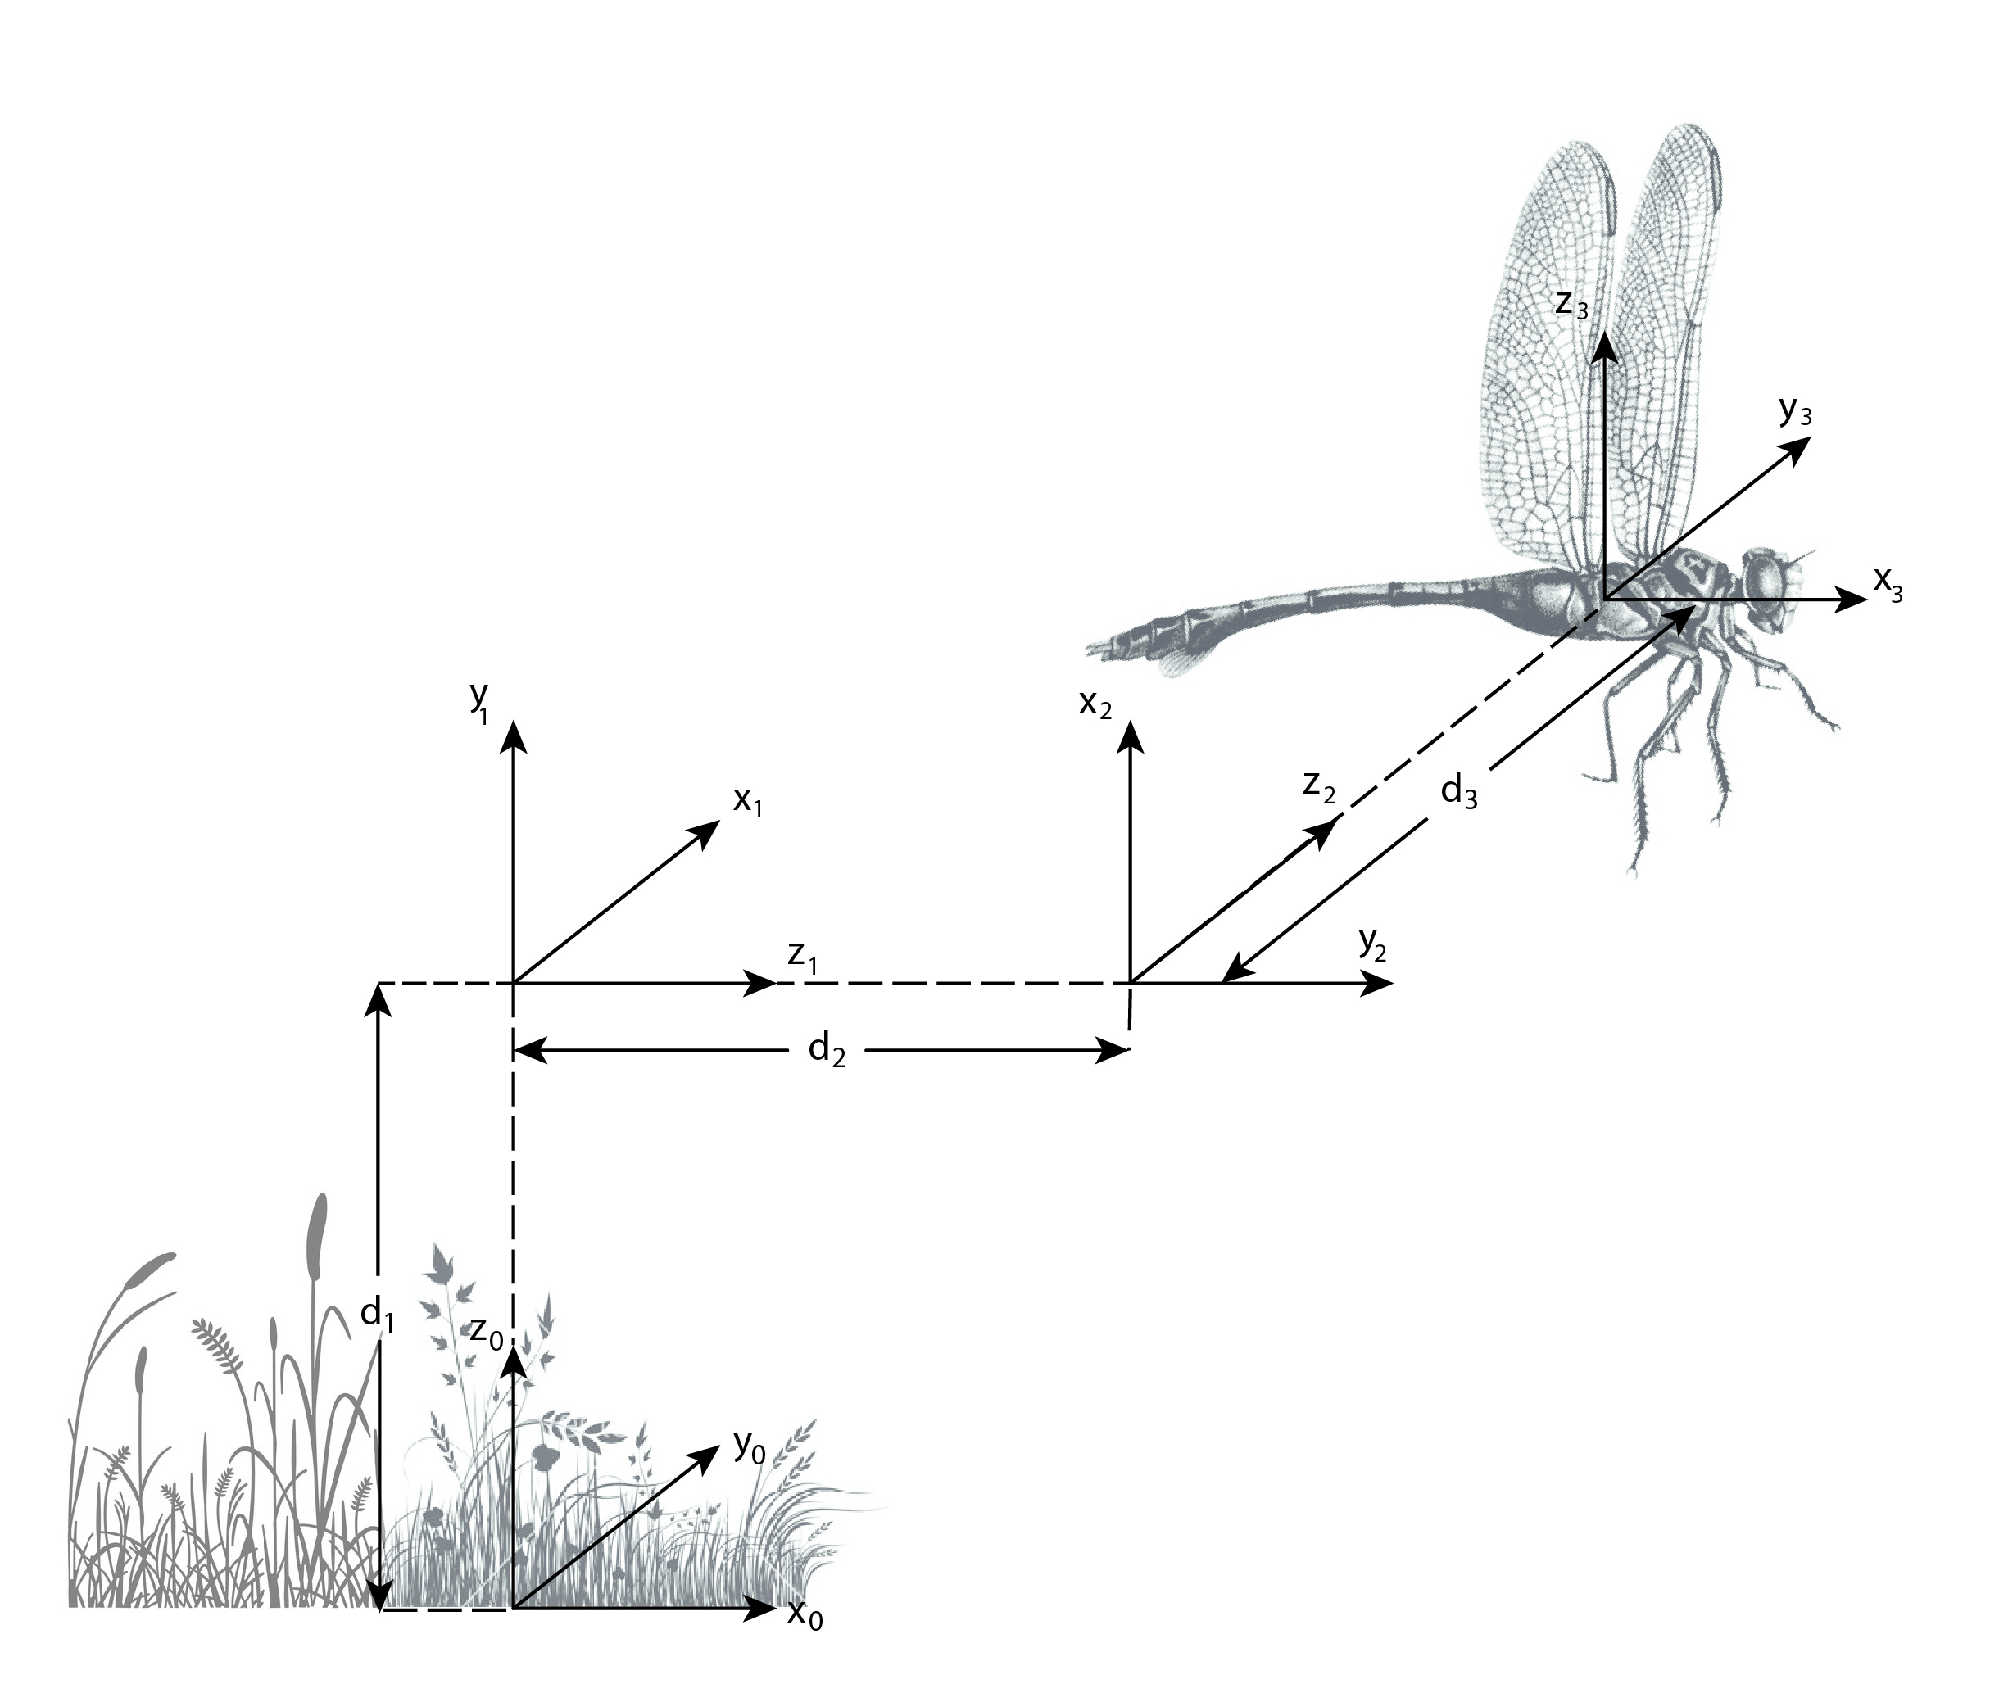
Figure 3: Virtual prismatic joints defining position of dragonfly
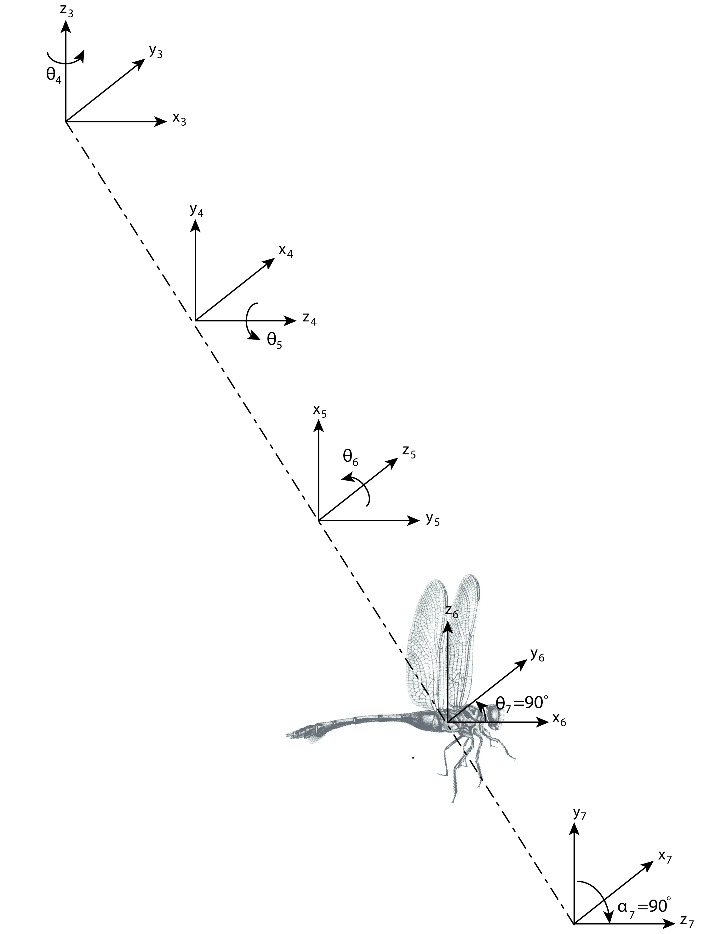
Figure 4: Virtual revolute joints defining orientation of dragonfly

There are four airfoils connected to the body of dragonfly. Each of them is connected with two revolute joint. They are named with first letters of right front(RF), right back(RB), left front(LF) and left back(LB). D-H parameters of each airfoil is shown in tables 3 to 6. In figures 5 to 8, coordinates are visualized.
Joint
8RF | -90º | 0 |  | 90º+
9RF | 0º | 0
Table 3: D-H parameters of right front airfoil

Joint
8RB | -90º | 0 |  | 90º+
9RB | 0º | 0
Table 4: D-H parameters of right back airfoil

Joint
8LF | -90º | 0 |  | 90º-
9LF | 0º | 0
Table 5: D-H parameters of left front airfoil
Joint
8LB | -90º | 0 |  | 90º-
9LB | 0º | 0
Table 6: D-H parameters of left back airfoil

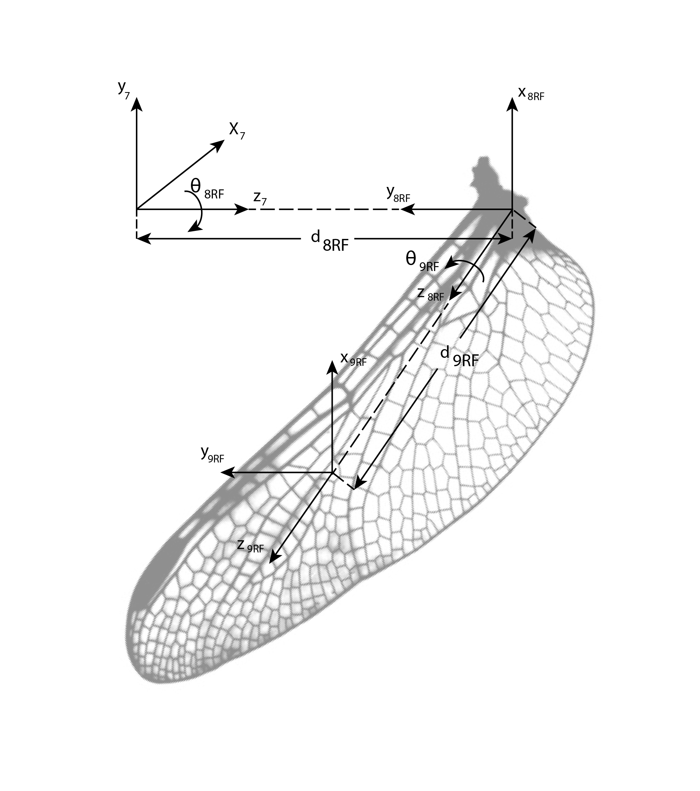
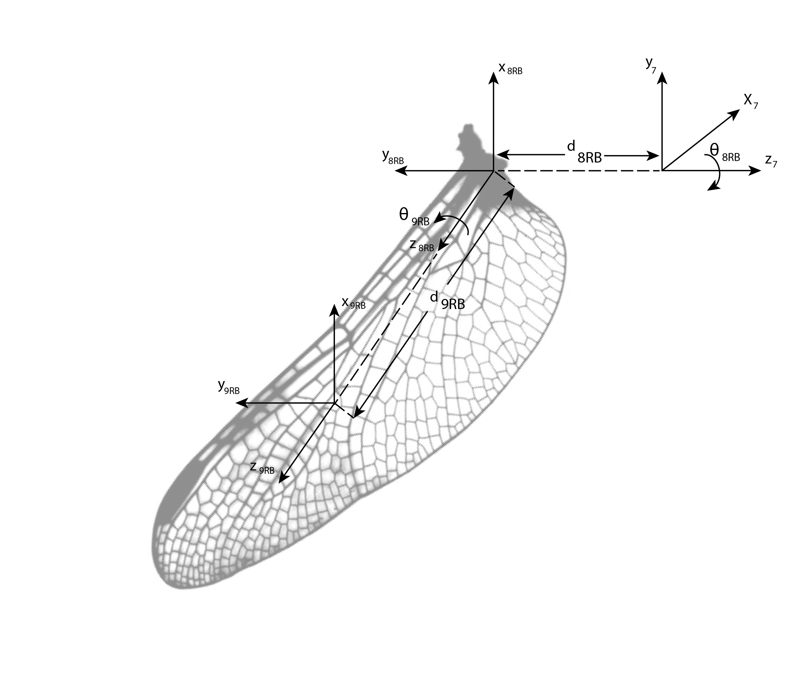
Figure 5 and 6: Coordinates for right wings(back and front)
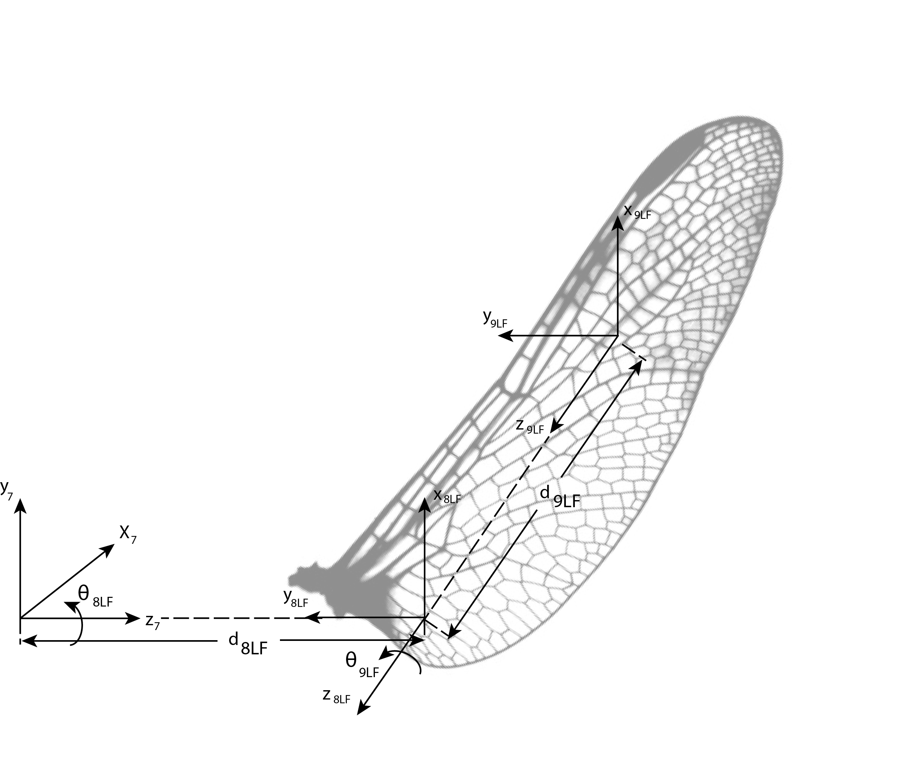
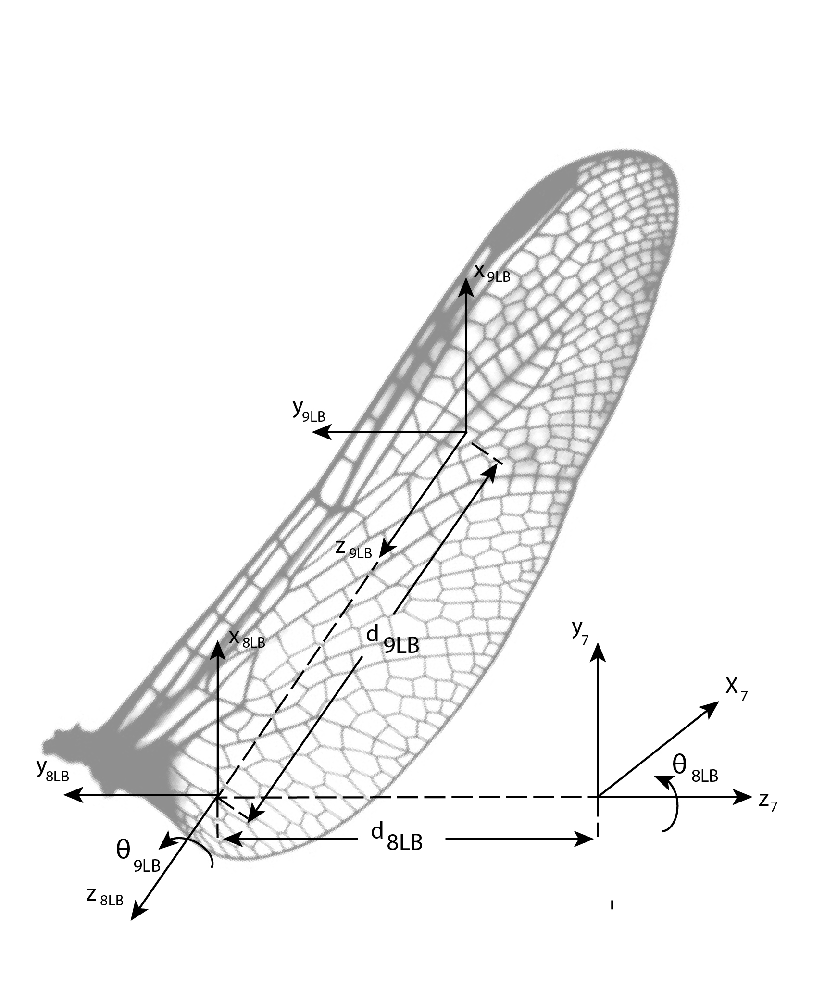
Figure 7 and 8: Coordinates for left wings (back and front)

Lastly, the tail is connected to the body of dragonfly with an only revolute joint. It can move up and down. D-H parameters for tail is shown in table 7. Here frame 7T is redundant there is no variable and it is obtained from frame 6. Frame 8T is centered at the center of mass of the tail.

Joint
7T | 90º |  | 0 | 0º
8T | 0º |  | 0
Table7: D-H parameters of tail (7T is base for tail, derived from frame#6)

For each row of D-H parameter tables, homogeneous transformation matrices are derived from the below formula.

All individual homogeneous transforms are listed below:

- Kinematics

Kinematics are observed in two different cases: flight of dragonfly and landing to a leaf.

  - Case 1: Flight

Here, we are interested in the position and orientation of dragonfly mainly. This 6-dof transformation is represented by 6 virtual joints in section 2 and transformations are generated accordingly. Also, I ordered the virtual links such that transforms are representing the position and transforms are representing the orientation with respect to world frame. Thanks to this ordering we can apply kinematic decoupling. The transformation matrices for both couplings are derived below. Now, we can put our dragonfly anywhere by applying inverse kinematics and finding virtual joint parameters.

Similarly, wings and tail are transformed with respect to dragonfly body. These are derived by the formulas;

  - Case 2: Landing on a moving leaf

In case of landing first we should construct the leaf to world transformation. It is derived as;
Here we want the dragonfly to land on the leaf. Which means both dragonfly and leaf becomes at the same point with respect to world frame. So, landing condition can be formulated as . Solving by inverse kinematics we want to make and .

- Dynamical model

In this section the dynamical model generation procedure is discussed. Dynamical model are solved in two subproblems thanks to the assumption on airfoil mass and speed. First we solve dynamics of each airfoil separately, considering they are connected to a fixed body since their speed is too high and mass is too low with respect to body. Then we formulate a net force on each airfoil and reflect them into dragonfly body dynamics.

  - Airfoil dynamics

Since all of the airfoils are similar and symmetric we only solve for one airfoil’s dynamic. As a convention I take as flapping angle and as wing inclination. Also, define the maximum and minimum values of flapping angle as and and average angle is . Lastly, we are interested with rate of change of flapping angle. However, we are assumed that wing inclination angle is constant through top to bottom or bottom to top.
Here we cannot apply Lagrange dynamics since the mass is negligibly small. So, the kinetic and potential energies are very low also with their derivatives with respect to friction observed by airfoils. So, we are applying torque commands to change flapping angle and it is projected to a force in 3D which is air friction.
We can decompose this force in x, y and z directions. Let the area of an airfoil becomes A. The averaged friction in one direction is proportional to cross-sectional area and square of velocity. First we consider the force through x direction of body frame(frame 6).

Here K_{x} is a constant. Also there is another force perpendicular to airfoil at . This force is decomposed in y and z directions of body frame according to the formulas below;

Here B is friction constant. It is different than K_{x} because the behavior is different in this directions.
Also, assume that when the airfoils goes from bottom to top, it arranges = 90 degrees such that there is no force applied.

  - Body dynamics

Body dynamics are solved according to average forces on airfoils. This part is continued on the next phase of project together with the Jacobian.

