Modeling Soil–Water–Atmosphere Interactions for Irrigation Scheduling and Design
Naziru Halilu$​^{1,2,*}$
$​^{1}$ Agricultural University of Athens, Athens, Greece
$​^{2}$ Public University of Navarre, Pamplona, Spain
ORCID: 0009-0006-2324-9599
$​^{*}$ Correspondence: halilunaziru73@gmail.com
Abstract
Irrigation software seldom shows which variables it represents, which relation produced a number, or where that relation holds. This article models the coupled soil–water–atmosphere system in an open, offline framework and makes it explorable through a set of result views. The column links the atmosphere, surface cover, soil structure, soil water and crop through water fluxes that close the balance, and through controls for soil, tillage, crop, mulch, rainfall, warming, irrigation and nitrogen. Three computing layers stand behind the views: a meta-model of a large simulation ensemble, a daily layered soil-water model, and closed-form surface, drip and sprinkler design modules. Every relation carries a provenance label and each layer is tested against an independent reference. Evaluated for ten soils, the same suction trigger uses very different shares of the plant-available water, and drainage differs widely under the same rainfall. Two limitations are exposed: leaf water potential is set by a conductivity floor rather than by the soil, and the drainage share of a mulch saving is understated in coarse soils. The reference tests reproduce published worked examples and advance times, preserve the ranking of the options tested, and conserve mass. Verification exposed three defects in the first release, all corrected in the current one. No field validation is claimed. The framework supplies a traceable map of the coupled system, of where each output can be relied on, and of the experiments that would validate it.
Keywords. soil–water–atmosphere modelling; soil–plant–atmosphere continuum; soil evaporation and mulch; irrigation decision support; simulation meta-model; software verification; irrigation scheduling and design; open science

List of symbols
Symbols, abbreviations and units of the soil–water–atmosphere engines and of the irrigation design modules, grouped by subject.
Symbol | Meaning | Unit
Symbol | Meaning | Unit
$h, θ, S_{e}$ | suction head, water content, effective saturation | cm, $−$, $−$
$θ_{s}=ϕ, θ_{r}$ | saturated (porosity) and residual water content | $−$
$α, n, m$ | van Genuchten shape parameters | cm$​^{−1}$, $−$, $−$
$K_{r}$ | Mualem relative hydraulic conductivity | $−$
$r_{c}, σ, γ_{c}$ | capillary radius of the largest water-filled pore, surface tension, contact angle | cm, N m$​^{−1}$, $−$
$P$ | precipitation | mm yr$​^{−1}$
$ET, I, D$ | annual evapotranspiration, irrigation and drainage at 1 m | mm yr$​^{−1}$
$E, T$ | soil evaporation, transpiration | mm yr$​^{−1}$
$E_{oth}, ΔS$ | other evaporation ($ET−T−E$), storage change | mm yr$​^{−1}$
$γ_{y}$ | year factor of the rainfall generator | $−$
$RH, ψ_{air}$ | relative humidity, water potential of the air | $−$, MPa
$e_{0,b}, e_{0}$ | bare-soil and mulched evaporative demand | mm d$​^{−1}$
$Q_{1}, Q\left(t\right), t_{1}, τ_{E}, ℓ$ | stage-1 storage, cumulative evaporation, stage-1 duration, stage-2 time scale, dry-layer depth | mm, mm, d, d, mm
$φ, c, γ_{P}, ΔT$ | mulch vapour-flux factor, mulch interception capacity, rainfall scale, warming | $−$, mm, $−$, K
$I$ | regime index (evaporation against drainage) | $−$
$η_{I}, η_{D}, η_{T}, η_{rest}$ | shares of saved evaporation going to less irrigation, more drainage, more transpiration, storage | $−$
$ΔE, ΔI, ΔD, ΔT_{tr}$ | changes of soil evaporation, irrigation, drainage and transpiration under mulch | mm yr$​^{−1}$
$p, p_{0}, p_{c}, τ_{c}$ | relative pore space, its value after tillage and when consolidated, consolidation rate | $−$, $−$, $−$, d$​^{−1}$
$Δ_{till}, Δ_{cons}$ | tillage and consolidation effects on drainage | mm yr$​^{−1}$
$C\left(d\right)$ | canopy cover | $−$
$R_{max}, R_{d}, β_{i}$ | maximum and current rooting depth, root density of layer $i$ | cm, cm, $−$
$T_{d}, q_{i}^{T}, a_{i}$ | daily transpiration demand, layer uptake, stress factor | mm d$​^{−1}$, mm d$​^{−1}$, $−$
$z_{50}, z_{90}$ | depths holding 50 and 90 % of root water uptake | cm
$ψ_{RZ},ψ_{root},ψ_{stem},ψ_{leaf}$ | water potential of root zone, root surface, stem and leaf | MPa
$N_{r}$ | nitrogen rate (per cent of standard) | %
$N_{L}, Y$ | nitrogen leaching, grain yield | kg ha$​^{−1}$, Mg ha$​^{−1}$
$κ_{N}$ | nitrate cost of drainage | kg N ha$​^{−1}$ mm$​^{−1}$
$h^{*}$, $f^{*}$ | critical suction and soil-independent depletion at which irrigation is triggered ($f^{*}=0.45$) | cm, $−$
$f, f_{T}$ | depletion fraction; its value at the trigger | $−$
$N_{y}$ | growing-season days on which the sensor is beyond the trigger | d
$w_{i}, s_{i}, f_{i}, W_{max}$ | layer water, relative content, depletion; layer capacity | mm, $−$, $−$, mm
$Z_{n}$ | net irrigation depth | mm
$k_{t}$ | transpiration calibration factor | $−$
$Q, Q_{max}$ | furrow inflow and its maximum non-erosive value | m$​^{3}$ min$​^{−1}$
$L, t_{L}, t_{L/2}$ | furrow length; advance times to $L$ and $L/2$ | m, min
$x=pt^{r}$ | power-law advance curve | m
$T_{req}$ | required infiltration (intake opportunity) time | min
$K_{s}, ψ_{f}, Δθ$ | saturated conductivity, wetting-front suction, moisture deficit (surface layer) | mm h$​^{−1}$, mm, $−$
$k, A$ | Kostiakov coefficient and exponent | m min$​^{−A}$, $−$
$σ_{y}, σ_{z}, r$ | surface-flow shape factors, advance exponent | $−$
$ρ_{1}, ρ_{2}$ | coefficients of the power-law furrow geometry of Wynn R. Walker and Skogerboe (1987) ($A=ρ_{1}y^{ρ_{2}}$) | $−$
$E_{a}$ | application efficiency | fraction or %
$E_{s}, DP, RO$ | storage efficiency, deep percolation, runoff | $−$
$h_{f}, H_{0}$ | friction loss along a drip lateral; inlet head | m
$Δx_{e}$ | emitter spacing along a drip lateral | m
$c_{v}, x_{e}$ | emitter coefficient of variation, emitter exponent | $−$, $−$
$E_{u}$ | drip emission uniformity | $−$
$q, d, h_{n}, R_{w}$ | sprinkler discharge, nozzle diameter, pressure head, wetted radius | L min$​^{−1}$, mm, m, m
CU | Christiansen uniformity coefficient of a sprinkler pattern | fraction or %
$ρ$ | Spearman rank correlation | $−$
$R^{2}$, nRMSE | coefficient of determination; RMSE as a percentage of the held-out mean | $−$, %
SWAFL | the software framework presented here (SWAFL Desktop) | $−$
Engine 1, Engine 2 | annual meta-model; daily bucket model | $−$

Introduction
Irrigation consumes most of the world’s freshwater withdrawals, and improving its management is widely seen as a route to water security (Fereres and Soriano 2007; Playán and Mateos 2006; Geerts and Raes 2009). Between a body of soil-water science and a farmer’s decision about when, how much and by which method to irrigate lies a layer of software: schedulers, sensor dashboards, design calculators and crop-water models (Datta and Taghvaeian 2023; García et al. 2020; H. G. Jones 2004). That layer is where science is either translated faithfully or lost. Three weaknesses recur. First, opacity: a tool reports a number, but the user cannot tell which equation produced it, whether the equation is from the literature or is an in-house heuristic, and what data it was fitted to. Second, unverified fidelity: tools are tested on cases chosen by their authors, and the test results are seldom published in a form that a third party can re-run (Hutton et al. 2016; Wilkinson et al. 2016). Third, conflation of purposes: a screening emulator that is rank-faithful is sometimes presented, and used, as an absolute predictor (Bennett et al. 2013; Moriasi et al. 2007; Oreskes, Shrader-Frechette, and Belitz 1994).
Process-based crop and soil models such as Daisy (Hansen et al. 1991, 2012; Abrahamsen and Hansen 2000; Holbak et al. 2026), HYDRUS (Šimůnek, van Genuchten, and Šejna 2008, 2016), DSSAT (J. W. Jones et al. 2003), APSIM (Keating et al. 2003) and AquaCrop (Steduto et al. 2009) are the scientific backbone, but they are not decision tools for a user who needs an answer in seconds without installing a simulation environment. Emulators (surrogates) bridge the gap (Razavi, Tolson, and Burn 2012; Asher et al. 2015; Sacks et al. 1989; Kennedy and O’Hagan 2001), but the surrogate literature is concerned mainly with statistical accuracy; the question of traceability, that is, whether each output can be tied back to the equations, the sources and the simulation data, receives less attention. Meanwhile classical irrigation-design theory (volume-balance advance and recession in surface irrigation (Wynn R. Walker and Skogerboe 1987; Elliott and Walker 1982), lateral hydraulics and emission uniformity in drip systems (Keller and Karmeli 1974; Keller and Bliesner 1990; Scaloppi and Allen 1993), nozzle and pattern analysis in sprinkler systems (Christiansen 1942; Keller and Bliesner 1990; Playán et al. 2005)) is published in textbooks as closed-form equations and worked examples. These worked examples are a free and under-used source of verification data.
This article models soil–water–atmosphere interactions for irrigation scheduling and design in SWAFL Desktop, an offline application that integrates (i) a meta-model of a large designed ensemble of process-model simulations, (ii) a daily bucket model for dates and schedules, and (iii) closed-form design layers, under three design principles: every number is equation-traceable; every equation carries a provenance label; and every claim of fidelity is backed by a re-runnable test. The software is then verified against published worked examples, held-out simulations, mass closure and independent numerical solvers, and the tests are used to locate the limits of each layer. The article is therefore both a software description and a verification study, and its emphasis is on what can and cannot be trusted.
Verification is organised around the claims that the software makes. Traceability comes first: every output must lead to a numbered equation and a labelled provenance. The closed-form design layers are then checked against published worked examples, and the annual meta-model against held-out simulations, with rank and absolute fidelity assessed separately. The daily model is tested for mass conservation and for agreement with the annual model. Finally, the accuracy of the numerical solvers is mapped across their stated operating range.
After a summary of the software architecture and design principles (Section 2), the article sets out the coupled system that the framework represents: its compartments, state variables, fluxes and controls, and the relations that link them, from pore structure and retention through evaporation, interception and mulch to roots, transpiration and the water potential from soil to air, drainage, nitrogen and the feedbacks between them (Section 3). It then describes how the numbers are computed (Section 4), evaluates the system variables for ten soils, presents the result views and the sensitivity of the outputs to the controls (Sections 5.1–5.2.0.5), and reports the verification of each computing layer (Sections 5.3–5.4.0.4).
This article makes no claim of field validation, of agronomic benefit, or of user-study usability; none of these have been carried out, and no field measurements exist in the project repository to support them. The claim is limited to traceability and to the verification results reported, and to the identification of limitations.

Levels of evidence.
Four levels of evidence are kept apart. Computational reproducibility, the regeneration of every reported number from archived code and data, is established. Verification, agreement with published worked examples, held-out simulations and independent numerical solutions, is the subject of this article. Predictive validity against measurements is not claimed. Field transferability, which requires sensor-scheduled plots, catch-can and lateral measurements and a user study, is identified as the next step, and the operating envelopes reported here define the conditions in which those measurements are most informative.

What is new.
The application joins three kinds of engine that are normally separate (a meta-model of a 10 190-run Daisy ensemble, a daily 40-layer water balance and closed-form hydraulic modules for surface, drip and sprinkler design) in one offline program. Its distinguishing feature is traceability: a ledger of 134 numbered equations, each with a label of origin (literature, data-driven or engineered), so that every output can be followed to its equation and its source. The design modules reproduce the worked examples of FAO-45 and standard texts within 3 %, the meta-model ranks held-out scenarios with Spearman 0.64 to 0.97, ${10}^{5}$ scenarios are swept in about 2 s, and one command re-runs every check.

Software architecture and design principles
SWAFL Desktop is an Electron application written in JavaScript that runs offline on Windows, macOS and Linux; the installer and source are in the repository. All computation is in the engine and design modules and carries no external service calls; the simulation tables are embedded as JSON. The Manual documents every control, panel and equation (134 numbered equations), and the code reproduces the equations as written. summarises the architecture: an evidence layer (archived simulation data), two engines, three design layers, an equation-traceable dashboard and decision outputs.
Schematic overview of the main processes in SWAFL Desktop. Boxes indicate storages and solid lines flows; dashed black lines are flows out of the system, dotted lines are flows of information and dashed grey lines exchange of information between modules. Dashed purple boxes with a triangle are the drop-down controls and driving variables of the Properties panel, and the drivers of soil hydraulic properties (SHP). Dashed red lines and numbered circles mark the seven feedback loops. Pink indicates water, orange the crop, light brown nitrogen and rust soil structure and hydraulic state; purple hexagons are processes and information (Engines 1 and 2, trigger, design layers) and peach boxes are design layers and results. The brown line is the soil surface, with groundwater hatched at the base.
Each dashboard tile, chart and arrow is produced by an equation printed in the Manual with a number, and the code comments cite the number. The traceability chain is tile $→$ function $→$ equation $→$ source. Appendix 8 lists the equations used in this article together with their manual numbers, provenance and source.
Each equation is labelled [Literature] (taken from a cited source, implemented as written), [Data-driven] (a constant or table derived from the Daisy ensemble), or [Engineered] (a heuristic or simplification fixed by the developer, e.g. the spray-pattern shapes). The labels allow users and reviewers to see which parts of the software rest on published science and which on judgement. An audit of the first release of the manual found the labels applied inconsistently (some equations labelled, many not); every one of the 134 numbered equations now carries its label (Section 5.4.0.4).
Each layer is accompanied by a test whose expected output comes from outside the software: a published worked example, a held-out simulation, a mass balance or an independent numerical solver. The scripts are in the repository (Appendix 9).
Engine 1 is an annual meta-model: it composes, by multiplication of ratios and addition of differences, 20-year-mean results of Daisy simulations to produce ET, soil evaporation, transpiration, irrigation, yield, drainage and nitrogen leaching for the chosen soil, tillage, mulch, rainfall scale, warming, trigger, sensor depth, method and nitrogen rate. Engine 2 is a daily 40-layer bucket model over 20 years of generated weather; it produces dates, depths, the animated field and schedules, and it is calibrated and scaled so that its 20-year means equal Engine 1’s. The design layers use hydraulics rather than data; they borrow soil, crop and trigger from the engines.

Choices that could be questioned.
Three are stated with their reasons. (i) One weather record and 20-year means. Every run of the ensemble uses the same 20 years of weather (1980 to 1999), so that a difference between two runs is a difference of the controls and not of the weather; the cost is that the meta-model describes this climate only, which is a limit of the evidence and not of the method, and the same limit is stated for the reach of a trigger in Paper 4. (ii) A floor on the relative conductivity. The van Genuchten–Mualem conductivity of a drying layer falls to a very small fraction of its saturated value (for the sand of the ensemble, below ${10}^{−21}$ at $−15000$ cm), and a resistance computed from it would be infinite in the soil-to-air view. A floor keeps the resistance finite; its price is that the leaf water potential becomes nearly the same in every soil, which is why that view is declared qualitative (Section 6.5). (iii) A daily engine scaled to an annual one. The daily bucket model is scaled so that its 20-year means equal those of the meta-model, because the ensemble measures annual means and a daily model that disagreed with them would give dates and schedules for a different soil than the one the annual numbers describe.

The coupled soil–water–atmosphere system and its variables
This section sets out what the framework represents before it describes how the numbers are computed (Section 4). The modelled system is a field column of 1 m depth, from the air above the canopy to the lower boundary at which drainage is counted, with five compartments: the atmosphere, the soil surface and its cover, the soil matrix and its structure, the soil water, and the crop. The compartments exchange water through six fluxes (precipitation, irrigation, transpiration, soil evaporation, other evaporation and drainage, [eq:balance]), which together with the storage change close the balance, and are driven by twelve controls. Every state variable, flux and control is named in [tab:compartments,tab:controls], with the relation that produces it and the provenance label of that relation; the relations themselves follow in Sections 3.1.0.2–3.4.0.6. Manual equation numbers are given in brackets so that each relation can be followed into the Manual.

System boundary and the governing balance
Over any period the water entering the column equals the water leaving it plus the change in storage,
$$P+I=T+E+E_{oth}+D+ΔS,$$
where $P$ is precipitation, $I$ irrigation, $T$ transpiration, $E$ soil evaporation, $E_{oth}$ the remaining evaporation (water intercepted by the canopy, evaporation from mulch and litter, and a term that the Daisy partition does not attribute), $D$ the drainage across 1 m (negative values denote net capillary rise) and $ΔS$ the change in profile storage. On the annual scale [eq:balance] is closed by Engine 1 ([eq:E1close]); on the daily scale by Engine 2 ([eq:scale]). Nitrate leaching $N_{L}$ is carried with $D$, and grain yield $Y$ with $T$. lists the state variables and fluxes of each compartment.
State variables and fluxes of the modelled soil–water–atmosphere system, by compartment; the soil matrix and soil structure rows form the soil compartment, and the lower boundary (drainage) and the management decision are listed separately. Source: E1 = Engine 1 (annual), E2 = Engine 2 (daily), D = Daisy output stored in the software, R = relation evaluated by the layer. Provenance: L literature, D data-driven, E engineered.
Compartment | Variable (symbol) | Unit | Relation (manual) | Source; provenance
Compartment | Variable (symbol) | Unit | Relation (manual) | Source; provenance
Atmosphere | rainfall scale $γ_{P}$; temperature shift $ΔT$ | $−$; K | controls (3) | input
 | annual precipitation $P=P_{base}γ_{P}$ | mm yr$​^{−1}$ | [eq:E1close] (5.12) | E1; D
 | daily rainfall $R$, year factor $γ_{y}$ | mm d$​^{−1}$, $−$ | [eq:rain] (5.15) | E2; E
 | bare-soil evaporative demand $e_{0,b}$ | mm d$​^{−1}$ | [eq:e0] (5.26) | R; E
 | relative humidity RH; air water potential $ψ_{air}$ | $−$; MPa | [eq:psiair] (7.5) | R; L
Surface and cover | mulch vapour-flux factor $φ$; interception capacity $c$ | $−$; mm | controls | input
 | interception per shower $I_{c}$; throughfall $T_{f}$ | mm | [eq:interc] (5.16) | E2; E
 | stage-1 storage $Q_{1}$; stage-2 time scale $τ_{E}$; stage-1 duration $t_{1}$ | mm; d; d | [eq:twostage] (9.2–9.3) | R; E
 | cumulative evaporation $Q\left(t\right)$; drying-front depth $ℓ$ | mm | [eq:twostage,eq:front] (9.3–9.5) | R; E
 | annual soil evaporation $E$; other evaporation $E_{oth}$ | mm yr$​^{−1}$ | [eq:E1E,eq:E1close] (5.4, 5.12) | E1; D
 | regime index $I$ | $−$ | [eq:regime] (9.8) | R; E
Soil matrix | sand, silt, clay fractions | % | measured texture | D
 | porosity $ϕ=θ_{s}$; residual content $θ_{r}$ | $−$ | [eq:poros] (8.2) | R; E
 | van Genuchten $α$, $n$; effective saturation $S_{e}$; relative conductivity $K_{r}$ | cm$​^{−1}$, $−$ | [eq:vgP3,eq:mualemP3] (5.1–5.2) | R; L
 | capillary radius of the largest water-filled pore $r_{c}$ | cm | [eq:jurin] (8.4) | R; L
 | available-water capacity AWC | mm cm$​^{−1}$ | 7 | E
Soil structure | tillage system; consolidation rate $τ_{c}$ | $−$; d$​^{−1}$ | controls | input
 | relative pore space $p\left(t\right)$ | $−$ | [eq:pore] (8.1) | R; E
 | tillage and consolidation effects on drainage $Δ_{till}$, $Δ_{cons}$ | mm yr$​^{−1}$ | [eq:drivers] (8.5) | D
Soil water | layer storage $w_{i}$; relative content $s_{i}$; depletion $f_{i}$ (40 layers of 2.5 cm) | mm; $−$; $−$ | [eq:layer] (Section 5.3) | E2; E
 | suction $h$, water content $θ$, depletion $f$ | cm, $−$, $−$ | [eq:vgP3,eq:depl] (5.1, 5.3) | R; L
 | sensor suction record, days beyond the trigger $N_{y}$ | cm; d | [eq:Ny] (6.1–6.2) | D
 | share of root zone beyond the trigger | $−$ | [eq:share] (7.6) | D; E
 | wetting front; redistribution flux $q_{i}$ | cm; mm d$​^{−1}$ | [eq:redis] (5.17) | E2; E
 | storage change $ΔS$, $ΔS_{d}$ | mm | [eq:E1close,eq:scale] (5.12, 5.25) | E1, E2; L
Crop | canopy cover $C\left(d\right)$ | $−$ | [eq:cover] (5.13–5.14) | E2; E
 | maximum and current rooting depth $R_{max}$, $R_{d}$; root density $β_{i}$ | cm; $−$ | [eq:rmax,eq:rd,eq:rootdens] (5.18–5.20) | E2; E
 | transpiration demand $T_{d}$; layer uptake $q_{i}^{T}$; stress factor $a_{i}$ | mm d$​^{−1}$ | [eq:transp] (5.22–5.23) | E2; E
 | depths holding 50 % and 90 % of uptake $z_{50}$, $z_{90}$ | cm | [eq:zp] (8.7) | R; E
 | water potential of root zone, root, stem and leaf $ψ_{RZ},ψ_{root},ψ_{stem},ψ_{leaf}$ | MPa | [eq:psisoil,eq:spac] (7.1–7.4) | R; L, E
 | annual transpiration $T$; yield $Y$; irrigation efficiency IE | mm yr$​^{−1}$; Mg ha$​^{−1}$; kg m$​^{−3}$ | [eq:E1T,eq:E1Y] (5.5, 5.8) | E1; D
Lower boundary | drainage $D$; nitrate leaching $N_{L}$ | mm yr$​^{−1}$; kg ha$​^{−1}$ | [eq:E1D,eq:E1N] (5.9–5.10) | E1; D
 | nitrate cost of drainage $κ_{N}$ | kg ha$​^{−1}$ per mm | [eq:kappaN] (10.2) | R; D
Management | trigger suction $h_{T}$; trigger depletion $f_{T}$; critical depletion $f^{*}$ | cm; $−$; $−$ | [eq:depl,eq:invdepl] (5.3, 6.3) | R; L
 | net irrigation depth $Z_{n}$; annual irrigation $I$ | mm; mm yr$​^{−1}$ | [eq:Zn,eq:E1I] (5.27, 5.7) | R, E1; L, D
 | fate of evaporation saved by mulch $η_{I},η_{D},η_{T},η_{rest}$ | $−$ | [eq:fate] (9.6–9.7) | R; D

Driving variables and controls.
Every control is an index into the list of values at which simulations exist, so that no displayed value lies between runs (3). Changing a control re-evaluates every view; the last column of 3 states which variables respond.
The twelve controls of the framework, their values and defaults, and the variables that respond. Run set: the Daisy experiment from which the response is read.
Control | Values | Default | Responding variables (run set)
Control | Values | Default | Responding variables (run set)
Soil | ten soils S01–S10 | S01 | all: $\left(α,n\right)$, AWC, baseline vector, trigger anchor; intake parameters of the design layers (E5 baseline)
Tillage | conventional, reduced, no-till | conventional | $p_{0}$; $D$, $E$, $Y$ (E5)
Consolidation rate $τ_{c}$ | , 0.0025, 0.005, 0.01, 0.02 d$​^{−1}$ |  | $p\left(t\right)$; $D$ (E5); no effect under no-till
Crop | cereal (simulated); release 1.1.0: 48 library crops (FAO-56 transfer), release 1.0.0: legume, vegetable (scaled) | cereal | calendar, $C\left(d\right)$, $R_{max}$; $Y×f_{crop}$
Mulch factor $φ$ | , 0.2, …, 1.0 | (bare) | $E$, $I$, $D$, $Y$ (E7, E14); $e_{0}$
Interception capacity $c$ | , 1, 2, 4 mm | mm | $E$ (E7, E14)
Rainfall scale $γ_{P}$ | $×$0.5, 0.6, …, 1.4 | $×$1.0 | all (E11, E14); $R$, $I_{c}$
Temperature shift $ΔT$ | $−1.0$, $−0.5$, …, $+3.5$ K |  | $E$, $T$, $I$, $Y$ (E11); $e_{0,b}$, RH
Irrigation method | surface; overhead; drip at 10–20, 20–30, 40–50, 50–60 cm | surface | $I$, $D$, $Y$ (E4); dose placement; $β_{i}$ near the emitter
Trigger suction $h_{T}$ | $−50$ to $−10 000$ cm (20 values) | $−300$ cm | $I$, $Y$, $D$ (E2); irrigation dates; $R_{max}$; $Z_{n}$
Sensor depth $z_{s}$ | , 10, …, 100 cm | cm | $I$, $Y$ (E3); irrigation dates
Nitrogen rate | to 150 % of standard (10 values) | % | $Y$, $N_{L}$ (E13); $R_{max}$

Soil matrix: texture, porosity, retention and conductivity.
Each soil is described by its measured texture and an effective van Genuchten pair $\left(α,n\right)$ (7). Porosity and residual water content follow an engineered texture relation [8.2],
$$ϕ=θ_{s}=clip\left(0.36+0.0016 clay+0.0009 silt; 0.34, 0.50\right), θ_{r}=0.01+0.0006 clay,$$
with clay and silt in per cent, and the water content, effective saturation and relative conductivity follow the van Genuchten–Mualem relations [eq:vgP3,eq:mualemP3] (van Genuchten 1980; Mualem 1976) [5.1–5.2, 8.3]. The relation between suction and the pores that hold water is the capillary (Young–Laplace) law [8.4],
$$r_{c}=\frac{2σcosγ_{c}}{ρ_{w}gh}≈\frac{0.149 cm^{2}}{h},$$
with surface tension $σ=0.0728$ N m$​^{−1}$ and contact angle $γ_{c}≈0$ (Hillel 1998): a pore of radius $r$ is water-filled when $r≤r_{c}\left(h\right)$ and empties at $h=0.149/r$ cm (with $r$ in cm). The pore views draw this rule on a modelled section whose grain classes follow the measured texture; the section illustrates the mechanism and is not a pore-network simulation (Blunt 2017).
Plant-available water is the water held between field capacity (100 cm) and the wilting point (15 849 cm) (Allen et al. 1998), and the depletion $f$ of [eq:depl] [5.3] expresses the soil-water state as the share of that water already used. The same suction therefore corresponds to different depletions in different soils: $−300$ cm uses 24 % of the plant-available water of the silty clay loam and 84 % of that of the sand (8).

Soil structure, tillage and consolidation.
After tillage the loosened topsoil re-settles. The structure views describe the relative pore space $p$ (1 for freshly loosened soil) by a first-order relaxation towards a consolidated value $p_{c}=0.30$ [8.1],
$$p\left(t\right)=p_{c}+\left(p_{0}−p_{c}\right) e^{−τ_{c}t}, p_{0}=1.00 \left(\text{conventional}\right), 0.72 \left(\text{reduced}\right), p=0.42 \left(\text{no-till}\right),$$
with $t$ in days since tillage and $τ_{c}$ the consolidation rate, so that loose pores have a half-life $ln2/τ_{c}$ of 693 d at 0.001 d$​^{−1}$ and 35 d at 0.02 d$​^{−1}$. The exponential form is the first-order consolidation used in the structure sub-model on which Daisy’s tillage effect is based (Flanagan and Nearing 1995); $p_{0}$, $p_{c}$ and the no-till value are presentation constants, and the hydrological effect of tillage is read from the simulations, not from [eq:pore]. For each soil the drivers of a change in hydraulic properties are summarised as the tillage effect and the consolidation effect on annual drainage [8.5],
$$Δ_{till}=D\left(conv,τ_{c}^{*}\right)−D\left(no\text{-}till,τ_{c}^{*}\right), Δ_{cons}=D\left({till}^{*},τ_{fast}\right)−D\left({till}^{*},τ_{slow}\right),$$
with the current settings starred and $D$ taken from the E5 runs; ordinary least-squares lines of each effect on clay content [8.6] show how the response to structure varies across textures (Strudley, Green, and Ascough 2008; Leuther and Schlüter 2021).

Soil water in depth and time
In the daily model the profile is 40 layers of $Δz=2.5$ cm. Layer $i$ holds plant-available water $w_{i}$ between 0 and $W_{max}=AWC Δz$, and its relative content and depletion are
$$s_{i}=\frac{w_{i}}{W_{max}}, f_{i}=1−s_{i}, h_{i}=max\{30, h\left(f_{i}\right)\},$$
where $h\left(f\right)$ is the inverse of [eq:depl] [eq:invdepl]; the 30 cm floor is engineered. Infiltrating water fills the top layer and cascades downwards; the excess leaving layer 40 is drainage and the deepest wetted layer is the wetting front. Between neighbouring layers a slow redistribution moves water towards the drier layer [5.17],
$$q_{i}=0.08 \left(w_{i+1}−w_{i}\right),$$
which is displayed as capillary rise when it is upward and larger than $0.03 W_{max}$. The tipping-bucket structure conserves water exactly but is not a Richards solution, which is why its drainage is scaled to Engine 1 ([eq:scale]).
The sensor views use the Daisy-simulated daily suction at 20 cm for the 20 seasons, irrigated and rainfed. For year $y$ the number of growing-season days on which the sensor is beyond the trigger, and the share of such days removed by irrigation, are [6.1–6.2]
$$N_y(h_T)=\#\{d\in\text{season of }y:\ h_d>|h_T|\},\qquad X=100\Bigl(1-\frac{\bar N_{\mathrm{irr}}}{\bar N_{\mathrm{rainfed}}}\Bigr),
\label{eq:Ny}$$
over the 183 days from 1 April, and the profile view reports the share of the 0–60 cm root zone that is beyond the trigger [7.6],
share=i: zi≤60, hi>hT​Δzii: zi≤60​Δzi.

Atmosphere and the soil surface

Evaporative demand.
The bare-soil demand used by the evaporation view combines a season-mean of 4.2 mm d$​^{−1}$ with a seasonal weight, a warming factor of 7 % per kelvin, a cloud factor and the dryness of the year [5.26],
$$\begin{matrix}e_{0,b}=​ & 4.2 \left(1+0.07ΔT\right) \frac{0.35+0.325\left[1+sin\frac{2π\left(doy−100\right)}{365}\right]}{0.675} \\ & ×clip\left(1−0.12\left(γ_{P}−1\right);0.85,1.12\right)\sqrt{γ_{y}} mm d^{−1},\end{matrix}$$
and under mulch and canopy the demand is $e_{0}=e_{0,b} φ \left(1−0.4C\right)$. The warming factor is close to the Clausius–Clapeyron rate of the saturation vapour pressure; the constants are engineered.

Two-stage drying of the surface.
After a wetting the surface loses water at the atmospheric rate while capillary flow keeps it wet (stage 1), and then at a rate limited by vapour diffusion through a growing dry layer (stage 2), with cumulative loss rising roughly as $\sqrt{t}$ (Philip 1957; Ritchie 1972; Lehmann, Assouline, and Or 2008; Or et al. 2013). The evaporation view implements [9.2–9.3]
$$t_{1}=\frac{Q_{1}−q_{0}}{e_{0}}, Q\left(t\right)=q_{0}+\left\{\begin{matrix}e_{0}t, & t≤t_{1}, \\ \left(Q_{1}−q_{0}\right)+2e_{0}τ_{E}\left(\sqrt{1+\left(t−t_{1}\right)/τ_{E}}−1\right), & t>t_{1},\end{matrix}\right.$$
whose derivative is the rate $e\left(t\right)=e_{0}[1+\left(t−t_{1}\right)/τ_{E}]^{−1/2}$ in stage 2. The stage-1 storage is the water held in the top $L_{1}=40$ mm between an initial and a surface-dry suction, $Q_{1}=max\{2, \left[θ\left(h_{i}\right)−θ\left(h_{s}\right)\right]L_{1}\left(0.6+0.4γ_{P}\right)\}$ with $h_{i}=0.25\left(1.5−0.5γ_{P}\right)/α$ and $h_{s}=4/α$; the stage-2 time scale is $τ_{E}=0.006+0.03\left(clay+silt\right)/100$ d; and $q_{0}$ is the loss already avoided when drip places the water below the surface ($q_{0}=\left(1−w_{f}\right)0.95Q_{1}$, $w_{f}=clip\left(1−z_{d}/50;0.05,1\right)$, zero for surface methods). Because $h_{i}$ and $h_{s}$ scale with $1/α$, $Q_{1}$ samples the steep part of every retention curve. The dry-layer depth and the suction profile below it are [9.4–9.5]
$$\begin{gathered}\ell(t)=\min\Bigl\{60,\ \frac{Q(t)-Q_1}{\Delta\theta}\Bigr\}\ \mathrm{mm},\\
\log_{10}h(z)=\log_{10}h_s+\bigl(\log_{10}h_i-\log_{10}h_s\bigr)\bigl(1-e^{-(z-\ell)/\lambda_E}\bigr),\end{gathered}
\label{eq:front}$$
with $Δθ=clip\left(θ\left(h_{i}\right)−θ\left({10}^{4}\right);0.05,0.4\right)$ and $λ_{E}=L_{1}/3$; the pores that hold water at each depth follow [eq:jurin]. All constants of [eq:twostage,eq:front] are engineered, and the annual soil evaporation of the framework is the Daisy value of [eq:E1E], not this curve.

Interception and mulch.
The canopy and litter catch the first $I_{c}$ mm of each shower ([eq:interc]). A mulch acts through $φ$ on the vapour flux and through $c$ on interception; its effect on the annual fluxes is the difference between Engine 1 evaluated bare and mulched [9.1],
$$ΔE=E_{1.0}−E_{φ}, ΔI=I_{1.0}−I_{φ}, ΔD=D_{φ}−D_{1.0}, ΔT_{tr}=T_{φ}−T_{1.0},$$
and the regime map classifies each combination of mulch and rainfall by the index [9.8]
$$I=\frac{E−D}{max\{1,E+D\}},$$
with evaporation dominating where $I>0.05$, drainage where $I<−0.05$, and the boundary in between.

Air.
The water potential of the air follows the thermodynamic relation with relative humidity [7.5] (Nobel 2009),
$$ψ_{air}=\frac{RT_{K}}{V_{w}}lnRH≈135.3 lnRH MPa, RH=clip\left(0.66−0.03ΔT; 0.35, 0.90\right),$$
with $R$ the gas constant, $T_{K}≈293$ K and $V_{w}=18×{10}^{−6}$ m$​^{3}$ mol$​^{−1}$; at RH $=0.66$ the air is at $−56$ MPa.

The crop: canopy, roots, uptake and the water-potential path

Canopy.
The cereal follows the four-year rotation of the simulations (spring barley, winter barley, winter rape, winter wheat). Canopy cover rises logistically, $C\left(d\right)=\{1+exp\left[−\left(d−d_{mid}\right)/s\right]\}^{−1}$ with $s=13$ d for spring crops [5.13], follows a two-phase curve for winter crops [5.14], and declines linearly from the peak to harvest:
$$C\leftarrow C\,\max\Bigl\{0,\ 1-\frac{d-d_{\mathrm{pk}}}{d_{\mathrm{harv}}-d_{\mathrm{pk}}}\Bigr\}\quad(d>d_{\mathrm{pk}}).
\label{eq:cover}$$

Roots.
The maximum rooting depth responds to texture, trigger and nitrogen [5.18],
$$R_{\max}=\mathrm{clip}\Bigl(R_c(0.85+0.3\,\mathrm{sand})\Bigl[1+0.12\log_{10}\frac{|h_T|}{300}\Bigr]\Bigl[1-0.18\,\frac{N_r-100}{100}\Bigr];\,25,\,100\Bigr)\ \mathrm{cm},
\label{eq:rmax}$$
with $R_{c}=95$ cm for the cereal, sand as a fraction and $N_{r}$ the nitrogen rate in per cent, so that drier triggers deepen the roots and high nitrogen rates make them shallower. While the canopy grows, the rooting depth advances towards water [5.19],
$$R_d\leftarrow\max\Bigl\{R_d,\ \min\bigl\{R_{\max}\,\mathrm{clip}\bigl(\tfrac{C-0.04}{0.96};0,1\bigr)^{0.8},\ R_{\max},\ R_d+1.7(0.35+\bar s_{\mathrm{wet}})\kappa_r\bigr\}\Bigr\},
\label{eq:rd}$$
where ${\overset{‾}{s}}_{wet}$ is the mean relative content of the four layers below the root front and $κ_{r}=1.3$ when the topsoil is dry; roots die back after harvest and are pruned by drought. Root density decreases exponentially with depth, increases with wetness and, under drip, concentrates around the emitter [5.20],
$$\beta_i\propto\exp\Bigl(-\frac{z_i}{\lambda_rR_d+8}\Bigr)(0.45+0.9s_i)\Bigl[1+3e^{-((z_i-z_d)/12)^2}\Bigr]_{\text{drip}},\qquad z_i\le R_d,\qquad \sum_i\beta_i=1,
\label{eq:rootdens}$$
with $λ_{r}=0.32$ for the cereal. The demand is divided among layers by availability-weighted root density, with the linear stress factor $a_{i}$ of [eq:transp] in the spirit of the FAO-56 coefficient (Allen et al. 1998; Feddes, Kowalik, and Zaradny 1978). The depth that holds a share $u$ of the annual uptake $U_{i}$ of layer $i$ is [8.7]
$$z_u=k_u\Delta z,\qquad k_u=\min\Bigl\{k:\ \frac{\sum_{i\le k}U_i}{\sum_iU_i}\ge u\Bigr\},\qquad u=0.5,\ 0.9,
\label{eq:zp}$$
averaged over the 20 years.

The water-potential path.
The continuum from soil to air is a chain of series resistances in the catenary description of van den Honert (1948). The root-zone potential is the root-density-weighted mean of the layer suctions of [eq:layer] [7.1],
ψRZ=−9.807×10−5 i​βihii​βi MPa,
and with the day’s transpiration $E_{t}$ (mm d$​^{−1}$) [7.2–7.4]
$$\begin{matrix}R_{soil}=0.03 max\{K_{r},0.002\}^{−0.55}, R_{root}=0.10, R_{xyl}=0.05, R_{leaf}=0.08, \\ ψ_{root}=ψ_{RZ}−E_{t}R_{soil}, ψ_{stem}=ψ_{root}−E_{t}R_{root}, \\ ψ_{leaf}=clip\left(ψ_{stem}−E_{t}\left(R_{xyl}+R_{leaf}\right);−3.2,0\right),\end{matrix}$$
with resistances in MPa per mm d$​^{−1}$, $K_{r}$ the relative conductivity at the root-zone suction ([eq:mualemP3]) and the transpiration terms set to zero when canopy cover is below 0.05; stomata are drawn as closing when $ψ_{leaf}<−1.6$ MPa. The physical relations are [eq:psiair] and the retention and conductivity functions; the resistances are engineered.

Drainage, nitrogen and the fate of conserved water.
Water that a mulch keeps in the soil can reduce irrigation, raise transpiration, drain below the root zone or remain in storage. The fate view divides each millimetre of evaporation saved among these destinations [9.6–9.7],
$$\begin{matrix}η_{I}=\frac{max\{ΔI,0\}}{max\{ΔE,0.1\}}, η_{D}=\frac{max\{ΔD,0\}}{max\{ΔE,0.1\}}, \\ η_{T}=\frac{max\{ΔT_{tr},0\}}{max\{ΔE,0.1\}}, η_{rest}=max\{0,1−η_{I}−η_{D}−η_{T}\},\end{matrix}$$
with the differences of [eq:mulchdelta] evaluated at each rainfall scale, which is the annual counterpart of the loss fate of an evaporation saving. Nitrate moves with drainage, and the nitrate cost of a millimetre of drainage is the one-step difference [10.2]
$$κ_{N}=\frac{N_{L}^{\left(γ_{P}+0.1\right)}−N_{L}}{D^{\left(γ_{P}+0.1\right)}−D} \left[kg N ha^{−1} mm^{−1}\right].$$

Coupling: the seven feedback loops.
The compartments act on each other through seven loops, marked by numbered circles in 1: (1) temperature and the crop, (2) rain and soil water, (3) mulch and evaporation, (4) the sensor trigger and irrigation, (5) drainage and nitrate leaching, (6) nitrogen and roots, and (7) tillage structure and drainage. The loop view quantifies each by moving its control one step on its list and re-evaluating Engine 1; the printed effect is the change of the outputs listed in 4, and the drawn arrow width is $w_{k}=5+clip\left(μ_{k};0,4\right)$ pixels [10.1] with $μ_{k}$ the arrow-width input of the table. The effects are one-step differences of simulated results, not partial derivatives, so a step at the end of a list may be smaller than a step in its middle; loops between soil moisture and the atmosphere at regional scale (Entekhabi, Rodriguez-Iturbe, and Castelli 1996; Koster et al. 2004; Seneviratne et al. 2010) are outside the column and are not represented.
The seven feedback loops: control step, printed effect and arrow-width input $μ$.
Loop | Control step | Printed effect | $μ$
1 | temperature $±0.5$ K | $ΔYf_{crop}$, $ΔI$ | $8\left|ΔY\right|$
2 | rainfall scale $±0.1$ | $ΔD$, $ΔI$ | $\left|ΔD\right|/12$
3 | one step stronger mulch | $ΔE$, $ΔI$ | $\left|ΔE\right|/14$
4 | trigger one step drier or wetter | $ΔI$, $ΔYf_{crop}$ | $\left|ΔI\right|/8$
5 | one more millimetre of drainage | $κ_{N}$ ([eq:kappaN]) | $\left|ΔD\right|/10$
6 | nitrogen $±15$ % | $ΔN_{L}$, $ΔYf_{crop}$ | $\left|ΔN_{L}\right|/8$
7 | consolidation rate one step | $ΔD$ | $\left|ΔD\right|/2$

From the soil-water state to the irrigation decision.
The decision links the state of the soil to the action. A sensor at depth $z_{s}$ reads the suction of layer $j_{s}=round\left(z_{s}/Δz\right)$, and irrigation is due when its depletion reaches the trigger depletion $f_{T}=f\left(\left|h_{T}\right|\right)$ of [eq:depl]. Because the same suction means different dryness in different soils, the trigger can also be set as a soil-independent depletion $f^{*}$, whose suction in each soil is the inverse [6.3]
$$h\left(f^{*}\right)=\{h: f\left(h\right)=f^{*}\},$$
found by bisection; with $f^{*}=0.45$, the depletion beyond which the simulated yield falls by more than 5 %, this gives the soil-specific settings of 7 (143 cm for sand to 729 cm for silty clay loam). The net depth that refills the root zone from the trigger back to field capacity is [5.27]
$$Z_{n}=clip\left(f_{T}⋅AWC⋅R_{max}; 25, 150\right) mm,$$
the readily-available-water idea of FAO-56 practice (Allen et al. 1998), which carries the soil, crop and trigger into the surface, drip and sprinkler design layers (Sections 4.4–4.4.0.2). The relative yield at the trigger is $Y\left(h_{T}\right)/\max_{h}Y\left(h\right)$ over the E2 runs of the soil [6.5].

Materials and methods

Evidence layer, the simulation ensemble
The evidence layer is a designed ensemble of 10 190 Daisy runs (Hansen et al. 2012; Holbak et al. 2026) in 17 experiments on ten soils (sand to silty clay loam; Ap and Bt horizons) with 20 years of Taastrup weather; twelve experiments cover all ten soils and five (E8, E11, E12, E14, E15) the coarse loam only. The experiments used by Engine 1 are summarised in 5, and the output variables of every run are listed in 6. Daisy solves the Richards equation with van Genuchten–Mualem hydraulics (van Genuchten 1980; Mualem 1976) coupled to a structure model for tillage effects (Flanagan and Nearing 1995). For Engine 1 the effective parameters $\left(α,n\right)$ were set so that the soil passes through the anchors of the project’s trigger table; for the standard textures they correspond to the class means of Carsel and Parrish (1988) (Table 7).

The data in the repository.
Every output of every run is open. The folder Data/Comprehensive_Summary of the repository holds, for each of the 17 experiments, one compressed table with every value of every Daisy log of every run, year by year (the annual water balance, the nitrogen balance, the harvest and the crop state), the one-row-per-run summary of all 10 190 runs with the settings read from each set-up file, the per-experiment summary, and the script that made them from the log files; the 20-year means of these tables reproduce the run table used here within 2 %. The complete raw archive is on Zenodo (Halilu 2026a).
Experiments used by Engine 1, the number of soils they cover and the equation family that consumes them.
Experiment | Varied factors | Soils | Used for
E2 | trigger suction | 10 | trigger correction [eq:corr]
E3 | sensor depth | 10 | sensor-depth correction [eq:corr]
E4 | irrigation method (overhead, surface, drip at eight depths from 5–10 to 50–60 cm) | 10 | method correction [eq:corr]
E5 | tillage $×$ structural consolidation | 10 | baseline vector $b$ for [eq:E1E,eq:E1T,eq:E1ET,eq:E1I,eq:E1Y,eq:E1D,eq:E1N]
E7 | mulch vapour-flux factor $×$ interception capacity | 10 | soil evaporation $\overset{‾}{E}$
E11 | warming $×$ evaporation factor $×$ rain | 1 (S01) | warming ratios and increments
E13 | N rate $×$ water strategy | 10 | nitrogen correction
E14 | mulch $×$ capacity $×$ rain | 1 (S01) | mulch ratios and increments
Output variables of each Daisy run (20-year means, 1980–1999) that form the evidence layer. The complete run table is in the Data folder of the repository and on Zenodo.
Variable | Unit | Meaning
rain_mm, irrigation_mm | mm yr$​^{−1}$ | precipitation $P$ and irrigation $I$
ET_mm | mm yr$​^{−1}$ | actual evapotranspiration
transpiration_mm, soil_evap_mm, canopy_evap_mm | mm yr$​^{−1}$ | reported components of ET ($T$, $E$, interception)
drainage_1m_mm | mm yr$​^{−1}$ | flux across 1 m (negative: net capillary rise)
water_stress_d | d yr$​^{−1}$ | days of crop water stress
yield_Mg_ha | Mg ha$​^{−1}$ | grain yield $Y$
N_fertiliser_kg_ha, N_leached_kg_ha | kg ha$​^{−1}$ yr$​^{−1}$ | nitrogen applied and leached ($N_{L}$)
IE_kg_m3, DPF, NLF | kg m$​^{−3}$, $−$, $−$ | irrigation efficiency, $D/\left(P+I\right)$, $N_{L}$/N applied
daily suction at 20 cm; 1994 profiles | cm | sensor record (V1) and profile view (V2), irrigated and rainfed (coarse loam, coarse sand, standard settings); in release 1.1.0 other settings and soils add the difference between two Engine 2 runs (settings minus standard) to the record as depletion
Effective van Genuchten parameters used by Engine 1 and the available-water capacity (AWC, mm of water per cm of soil, an engineered texture-class constant), with the critical suction $h^{*}$ at the soil-independent depletion $f^{*}=0.45$.
ID | Soil | $α$ (cm$​^{−1}$) | $n$ | AWC | $h^{*}$ (cm)
S01 | Coarse loam | 0.0961 | 1.353 | 1.5 | 387
S02 | Coarse sand | 0.0536 | 1.600 | 0.5 | 262
S03 | Sand | 0.1450 | 2.680 | 0.6 | 143
S04 | Loamy sand | 0.1240 | 2.280 | 0.9 | 160
S05 | Sandy loam | 0.0750 | 1.890 | 1.2 | 195
S06 | Loam | 0.0360 | 1.560 | 1.7 | 284
S07 | Silt loam | 0.0200 | 1.410 | 2.0 | 401
S08 | Sandy clay loam | 0.0590 | 1.480 | 1.4 | 311
S09 | Clay loam | 0.0190 | 1.310 | 1.6 | 503
S10 | Silty clay loam | 0.0100 | 1.230 | 1.7 | 729
Retention and relative conductivity follow van Genuchten (1980) and Mualem (1976):
$$\begin{matrix}S_{e}\left(h\right) & ={\left[1+{\left(α\left|h\right|\right)}^{n}\right]}^{−m}, m=1−1/n, θ\left(h\right)=θ_{r}+\left(θ_{s}−θ_{r}\right)S_{e}\left(h\right), \\ K_{r}\left(S_{e}\right) & =S_{e}^{1/2}{\left[1−{\left(1−S_{e}^{1/m}\right)}^{m}\right]}^{2}.\end{matrix}$$
Plant-available water is defined between field capacity (suction 100 cm) and wilting point (15 849 cm), the FAO convention (Allen et al. 1998):
$$f\left(h\right)=\frac{S_{e}\left(100\right)−S_{e}\left(\left|h\right|\right)}{S_{e}\left(100\right)−S_{e}\left(15849\right)}, f_{used}=min\{1,max\{0,f\}\},$$
where $f=0$ is field capacity and $f=1$ the wilting point. The inverse $h\left(f\right)$ is obtained by bisection on $\log_{10}\left|h\right|∈\left[0,4.6\right]$ (60 halvings). A trigger suction $h_{T}$ therefore corresponds to a depletion fraction $f_{T}=f_{used}\left(\left|h_{T}\right|\right)$.

Engine 1, the annual meta-model
Let $b=\left(E_{b},T_{b},{ET}_{b},I_{b},Y_{b},D_{b},N_{b}\right)$ be the 20-year-mean Daisy results (soil evaporation, transpiration, evapotranspiration, irrigation, yield, drainage, nitrogen leaching) for the chosen soil, tillage and consolidation rate (E5), $φ$ the mulch strength, $c$ the mulch capacity, $γ_{P}$ the rainfall scale and $ΔT$ the warming. Define mulch lookups $M\left(φ,γ_{P}\right)$ from E14, warming lookups $W\left(ΔT,γ_{P}\right)$ from E11, and the shorthand
$$\begin{matrix}now & =M\left(φ,γ_{P}\right), & ref & =M\left(φ,1\right), & nm & =M\left(1,γ_{P}\right), & bare & =M\left(1,1\right), \\ tN & =W\left(ΔT,γ_{P}\right), & tB & =W\left(0,γ_{P}\right), & tR & =W\left(0,1\right).\end{matrix}$$
The engine composes ratios (taken as 1 where the denominator is below ${10}^{−6}$), clipped to guard against extrapolation, as
$$\begin{matrix}E & =\overset{‾}{E}\left(soil,φ,c\right)\left[{now.E}/{ref.E}\right]\left[{tN.E}/{tB.E}\right]\left[{E_{b}}/{E_{b,ref}}\right], \\ T & =T_{b}\left[{now.T}/{bare.T}\right]clip\left({tN.T}/{tB.T}0.3,2.5\right), \\ ET & ={ET}_{b}\left[{now.ET}/{bare.ET}\right]clip\left({tN.ET}/{tB.ET}0.5,2\right), \\ I & =I_{b}\left[{now.I}/{bare.I}\right]clip\left({tN.I}/{tB.I}0.4,2.5\right), \\ Y & =Y_{b}\left[{tN.Y}/{tR.Y}\right]\left[{now.Y}/{nm.Y}\right], \\ D & =D_{b}+\left(now.D−bare.D\right)+\left(tN.D−tB.D\right), \\ N_{L} & =N_{b}+\left(now.N−bare.N\right)+\left(tN.N−tB.N\right).\end{matrix}$$
Here $\overset{‾}{E}\left(soil,φ,c\right)$ is the linear interpolation in $φ$ of the simulated soil evaporation of E7 at capacity $c$, closed at $φ=1$ by the bare-soil value, and $E_{b,ref}$ is the E5 soil evaporation of the soil under conventional tillage at a consolidation rate of 0.005 d$​^{−1}$, so that the last factor transfers the effect of the chosen tillage and consolidation rate. Fluxes are combined multiplicatively and drainage and leaching additively, because ratios of small numbers (drainage near zero) are unstable. Four set-specific corrections then act in turn; for each family $F∈\{$trigger (E2), sensor depth (E3), method (E4), nitrogen (E13; yield and $N_{L}$ only)$\}$ with key $κ$ and baseline key $κ_{0}$ (trigger $−300$ cm, sensor depth 20 cm, surface method, 100 % nitrogen),
$$\begin{matrix}Q←Qclip\left({r_{κ}.Q}/{r_{κ_{0}}.Q}0.05,6\right) \left(Q∈\{E,T,ET,I,Y\}\right), \\ D←D+\left(r_{κ}.D−r_{κ_{0}}.D\right), N_{L}←N_{L}+\left(r_{κ}.N−r_{κ_{0}}.N\right).\end{matrix}$$
Finally non-negativity, a soil-dependent yield ceiling $Y≤Y_{max}\left(soil\right)$ (the largest simulated yield), rain $P=P_{base}γ_{P}$ and a closure window are enforced:
$$\begin{matrix}ET∈\left[P+I−D−30, P+I−D+15\right] \left(\text{otherwise clipped }E,T\text{ scaled equally}\right), \\ E_{oth}=max\left(0,ET−T−E\right), ΔS=P+I−ET−D,\end{matrix}$$
and irrigation efficiency $IE=100Y/I$ (kg m$​^{−3}$, since 1 mm $=10$ m$​^{3}$ ha$​^{−1}$). The combination of mulch and warming uses the product of ratios, which assumes that their effects are independent; no experiment crosses the two factors, so this assumption is untested (Section 6). The meta-model contains no fitted parameters of its own: it is a deterministic lookup/composition over the simulation tables, so its accuracy is limited by (a) the discretisation of the lookups, (b) the validity of the independence assumption and (c) the consistency of the baselines of the different experiments, a point that proved decisive in the verification (Section 5.3.0.2).

Engine 2, the daily bucket model
The soil is $N=40$ layers of thickness $Δz=2.5$ cm, each holding $w_{i}$ (mm) up to the plant-available capacity $W_{max}=AWCΔz$, initial value $0.72W_{max}$; the run is 20 years of 365 days. Canopy cover follows the logistic curves of [eq:cover]; rainfall is generated with wet-day probability 0.28 and depth
$$R=min\{70, μ_{0}γ_{y}\left(−lnU\right)\}, U∼Uniform\left(0,1\right), μ_{0}=\frac{P}{0.28⋅365},$$
an exponential distribution capped at 70 mm, seeded by a hash of the soil name so every run is reproducible; the year factor $γ_{y}=clip\left({\left(m_{med}/m_{y}\right)}^{0.3}0.65,1.45\right)$ makes years wetter or drier according to the dryness $m_{y}$ of the 20-year rainfed suction record. The canopy and litter catch the first $I_{c}$ mm of every shower,
$$I_{c}=μ_{0}ln\frac{1}{r}, r=\frac{max\{40,P−P_{other}\}}{P}, T_{f}=max\{0,R−I_{c}\},$$
where the choice of $I_{c}$ makes the expected interception over the exponential distribution equal to the annual interception of Engine 1. Water enters the top layer and cascades down (any layer exceeding $W_{max}$ passes the excess down; the excess leaving layer 40 is drainage), and a slow redistribution moves water toward the drier neighbour ([eq:redis]). Soil evaporation is the annual $E$ distributed seasonally and reduced by canopy shade, taken from the top four layers; transpiration demand is the annual $T$ spread by cover, times a calibration factor $k_{t}$, and divided among layers by availability-weighted root density,
Td=ktTyrCdΣC, qiT=Tdβiaij​βjaj, ai=clipsi−0.150.60,1,
where $β_{i}$ is the root density of [eq:rootdens], $s_{i}=w_{i}/W_{max}$ and $a_{i}$ is a linear stress function in the spirit of the FAO-56 coefficient (Allen et al. 1998). with $Σ_{C}$ the sum of the daily canopy cover over a year (so that $T_{d}$ is in mm d$​^{−1}$). Irrigation of dose $d=clip\left(I/1015,35\right)$ mm, with $I$ the annual irrigation of Engine 1 (about ten events a year by construction), is applied when canopy cover exceeds 0.2, in the day-of-year window 95–250, the minimum spacing is met, and the sensor-layer depletion reaches $f_{T}$. The factor $k_{t}∈\left[0.6,8\right]$ is calibrated by eight bisection steps on the first eight years so that the mean annual irrigation matches Engine 1’s within 6 %. The daily fluxes shown on the dashboard are scaled so that their 20-year means equal Engine 1’s:
$$\begin{matrix}S_{P}=\frac{P}{\overline{P_{sim}}}, S_{E}=\frac{E}{\overline{E_{sim}}}, S_{T}=\frac{T}{\overline{T_{sim}}}, S_{D}=\frac{D}{\overline{D_{sim}}}, \\ ΔS_{d}=T_{f}+I−E−T−D,\end{matrix}$$
and $ΔS_{d}$ closes the daily balance. Drainage and the wetting front are tipping-bucket results, not Richards solutions; that is why they are scaled to Engine 1.

Surface-irrigation layer
Texture determines water contents by the pedotransfer functions of Saxton and Rawls (2006); the wetting-front suction $ψ_{f}$ comes from the van Genuchten parameters; and Green–Ampt infiltration (Green and Ampt 1911) gives cumulative infiltration $F\left(t\right)$,
$$F−ψ_{f}Δθln\left(1+\frac{F}{ψ_{f}Δθ}\right)=K_{s}\frac{t}{60} \left(t\text{ in min}\right), Δθ=max\{0.05,0.95θ_{s}−θ_{0}\},$$
with $K_{s}$ in mm h$​^{−1}$ and $F$, $ψ_{f}$ in mm, solved by Newton iteration. The Kostiakov intake law (Kostiakov 1932)
$$Z\left(τ\right)=kτ^{A} \left(Z\text{ in m}, τ\text{ in min}\right)$$
is fitted by least squares on the log–log plot of $F\left(τ\right)/1000$ at 25 geometrically spaced times between 10 and 600 min, and the fit quality $R^{2}$ is displayed. The inlet flow area follows Manning’s equation (Manning 1891), $Q=\frac{1}{n}AR_{h}^{2/3}S^{1/2}$, $R_{h}=A/P$.
The advance of the stream follows the volume-balance method (Wynn R. Walker and Skogerboe 1987; Elliott and Walker 1982):
$$Qt=σ_{y}A_{0}x+σ_{z}kt^{A}wx ⇒ x\left(t\right)=\frac{Qt}{σ_{y}A_{0}+σ_{z}kt^{A}w}, σ_{z}=\frac{A+r\left(1−A\right)+1}{\left(1+A\right)\left(1+r\right)},$$
with $σ_{y}=0.8$ the surface-storage shape factor, $w$ the width, and $r$ the exponent of the power-law advance $x=pt^{r}$, obtained iteratively from the times $t_{L}$ and $t_{L/2}$ at which the front reaches $L$ and $L/2$: $r=ln2/ln\left(t_{L}/t_{L/2}\right)$. The time to infiltrate the required depth $Z_{n}$ is $t_{st}={\left(Z_{n}/k\right)}^{1/A}$, the cut-off time is $t_{co}=t_{L}+t_{st}$ (for the $E_{s}=1$ rule), and the infiltrated depth along the field is $Z\left(x\right)=k{\left[t_{co}−t_{x}\left(x\right)\right]}^{A}$.
By trapezoidal integration of $Z\left(x\right)$ over $N=300$ intervals,
$$\begin{matrix}V_{app}=Qt_{co}, V_{req}=Z_{n}Lw, V_{inf}=w\int_{0}^{L}{Z}dx, \\ V_{st}=w\int_{0}^{L}{min}\left(Z,Z_{n}\right)dx, V_{dp}=w\int_{0}^{L}{max}\left(Z−Z_{n},0\right)dx, V_{ro}=max\left(V_{app}−V_{inf},0\right),\end{matrix}$$
Ea=VstVapp, Es=VstVreq, DP=VdpVapp, RO=VroVapp,CU=1001−1N+1i​Zi−ZZ%,
following Wynn R. Walker and Skogerboe (1987), Burt et al. (1997) and Christiansen (1942); because $V_{app}=V_{inf}+V_{ro}$ and $V_{inf}=V_{st}+V_{dp}$ the identity $E_{a}+DP+RO=1$ holds exactly and is printed as a built-in closure check.

Drip-irrigation layer.
Friction head loss in the lateral segment feeding emitter $j$ uses the Hazen–Williams equation (Williams and Hazen 1905), and discharge depends on local head through the power-law emitter equation of Keller and Karmeli (1974):
hf,j=10.67ΔxeQj1.852C1.852D4.871, Qj=i>j​qi,qj=qhjH0xe, hj=hj−1−hf,j−1, h0=H0,
with $Δx_{e}$ the emitter spacing, $C=140$ and $x_{e}=0.5$ (turbulent orifice), 0.6 (tape) or 0.05 (pressure-compensating emitter, with a minimum head of 8 m). Because flows depend on heads and heads on flows, the system is solved by fixed-point iteration from the uniform start $q_{j}=q$, with under-relaxation after the fourth pass, until the largest relative change in any emitter flow is below ${10}^{−7}$ (at most 500 passes); version 1 used four passes. Emission uniformity follows the design equation
$$E_{u}=clip\left\{\left(1−\frac{1.27c_{v}}{\sqrt{n_{e}}}\right)\frac{q_{min}}{\overset{‾}{q}}0.3,1\right\}, σ_{q}=\sqrt{c_{v}^{2}+σ_{P}^{2}},$$
with $c_{v}$ the manufacturing coefficient of variation, $n_{e}$ the number of emitters per plant and $σ_{P}$ the relative standard deviation of hydraulic delivery along the lateral. The wetted bulb is modelled as a half-ellipsoid whose aspect ratio is an engineered function of $K_{s}$ and the discharge; five representative emitters at the standard-normal quantiles $z∈\{−1.28,−0.52,0,0.52,1.28\}$ deliver $V_{i}=max\{0.02\overset{‾}{V},\overset{‾}{V}\left(1+σ_{q}z_{i}\right)\}$, from which deep percolation, evaporation and storage are computed, and the efficiencies satisfy $E_{a}+DP+EV=1$. The automatic run time is the time at which the driest emitters deliver the need, $t=clip\{V_{req}/\left(\overset{‾}{q}E_{u}\right)0.05,96\}$ h.

Sprinkler layer.
Nozzle discharge follows the orifice (Torricelli) equation with coefficient 0.95 and the wetted radius an empirical range law (Keller and Bliesner 1990) with an angle function:
$$\begin{matrix}q=0.95A_{n}\sqrt{2gh_{n}}×6×{10}^{4} Lmin^{−1}, \\ R_{w}=c_{R}\sqrt{dh_{n}}f_{α}\left(α\right), f_{α}={\left[\frac{max\{0.05,sin3.1α\}}{0.9763}\right]}^{0.45},\end{matrix}$$
with $d$ in mm, the pressure head $h_{n}$ in m, $A_{n}=π{\left(d/2000\right)}^{2}$, $c_{R}$ a coefficient per sprinkler type, and $α$ the trajectory angle in degrees. The radial pattern shape $\hat{p}\left(x\right)$, $x=r/R_{e}$, is engineered for each type (e.g. $1−x^{1.3}$ for impact sprinklers), wind elongates the pattern ($R_{e}\left(θ\right)=R_{w}clip\{1+0.022ucosθ0.7,1.4\}$), overlap is the sum over neighbours on the sprinkler grid, and the Christiansen coefficient of uniformity (Christiansen 1942) is CU=1−k​ak−a/na. Wind drift and evaporation loss follow an engineered function of wind, pressure, temperature and trajectory angle; intake and runoff use the Kostiakov law with a ponding-time criterion; and the layout, pipes (Blasius friction (Blasius 1913), with Christiansen’s outlet factor) and a ten-point checklist implement the textbook decision logic (Keller and Bliesner 1990), including the maximum allowable application rate by soil and slope and the number of laterals operated simultaneously.

Evaluation of the system variables.
The variables of Section 3 were evaluated for each of the ten soils with the shipped engine (swa_vars.js), at one reference state: conventional tillage, consolidation rate 0.005 d$​^{−1}$, bare soil ($φ=1$, $c=1$ mm), unscaled rainfall, no warming, nitrogen 100 %, surface method, common trigger $−300$ cm, sensor at 20 cm and the cereal rotation (the state of the sensitivity runs, Section 5.2.0.5). For each soil the script records the Engine 1 balance, the hydraulic variables, a full 20-year Engine 2 run (rooting depth, uptake by layer, events, doses, wetting depth, $k_{t}$), the water-potential path averaged over crop days of day-of-year 120–210 in all years, the two-stage evaporation at the season-mean demand of 4.2 mm d$​^{−1}$, the fate of the evaporation saved by a straw mulch ($φ=0.4$, $c=4$ mm) and the nitrate cost of drainage for a $+0.1$ rainfall step.

Verification design
Four verification families were run, each with an expected output from outside the software.
- Published worked examples. Surface-irrigation Examples 6.1 (furrow) and 6.4 (border) of Wynn R. Walker and Skogerboe (1987) and a sprinkler design example from the textbook, with the soil parameters, flows, lengths and required depth of the examples, comparing the software’s advance times, efficiencies, required times, maximum non-erosive flows and decision logic with the printed results (relative error $=100\left(software−book\right)/book$).
- Held-out simulations. 1 000 runs of E12 (coarse loam: sensor depth $×$ trigger $×$ rain scale) were not used to build Engine 1’s lookups; the engine was queried at the same factor levels (the cell is selected by indices of the lookups, so no interpolation occurs). Metrics: $R^{2}$, RMSE, bias, Spearman $ρ$ and normalised RMSE (RMSE over the observed mean). “Raw” predictions and “re-anchored” predictions are reported, the latter being those in which the engine’s baseline cell (rain scale 1, baseline trigger and depth) is aligned to Daisy’s baseline cell, multiplicatively for fluxes and additively for drainage and nitrogen leaching, as a diagnostic of anchor inconsistency.
- Mass closure and agreement of the daily and annual models. The unscaled Engine 2 core was run on 60 random states to measure the closure residual as a percentage of inflow, and its calibrated annual irrigation was compared with Engine 1 over a realistic grid of 10 soils $×$ 5 triggers $×$ 2 methods (cereal crop).
- Independent numerical solvers. The drip-lateral solution was compared with an independent converged solver (many iterations) over 400 random configurations covering emitter type, spacing, lateral length, diameter, inlet head and coefficient of variation.
In addition, run times were measured in Node.js on a cloud container (single call medians), and the manual was audited for equation count and provenance labels.

Derivations and error propagation
This section sets out the short derivations behind the closed-form layers, so that each can be audited line by line, and the elementary error analysis that explains which deviations in the verification were to be expected.
Assume a sharp wetting front at depth $L_{f}$ with suction head $ψ_{f}$ and a saturated transmission zone of conductivity $K_{s}$. Darcy’s law across the wetted zone gives the infiltration rate
$$f=\frac{\mathrm dF}{\mathrm dt}=K_s\Bigl(1+\frac{\psi_f\Delta\theta}{F}\Bigr),\qquad F=L_f\Delta\theta,
\label{eq:GAode}$$
and separating variables, $\int_{0}^{F}{(}1+ψ_{f}Δθ/F′)^{−1}dF′=K_{s}t$, yields [eq:GA] (Green and Ampt 1911). Two limits are used as sanity checks in the code: for small $t$ the logarithm expands as $F−ψ_{f}Δθln\left(1+F/ψ_{f}Δθ\right)≈F^{2}/\left(2ψ_{f}Δθ\right)$, so $F≈\sqrt{2K_{s}ψ_{f}Δθ t}$ (sorptivity-dominated, $F∝t^{1/2}$); for large $t$, $F→K_{s}t$ (gravity-dominated). The Kostiakov exponent $A$ fitted to $F\left(τ\right)$ over 10–600 min is therefore expected to lie between $0.5$ and $1$ (the fitted exponents have not been tabulated for the ten soils; the interface displays them with the fit $R^{2}$). Because [eq:GAode] is monotone, the Newton iteration of the code converges from the starting value $F_{0}=\sqrt{2K_{s}ψ_{f}Δθt}+K_{s}t$.
Let the advance front be at $x\left(t\right)$ and the inflow be $Q$. Conservation of volume over $\left[0,t\right]$ states that the inflow equals the volume stored on the surface plus the volume infiltrated:
$$Qt=σ_{y}A_{0} x+σ_{z} Z\left(t\right) w x,$$
where $A_{0}$ is the flow cross-section at the inlet, $σ_{y}$ the surface-storage shape factor (the ratio of the mean to the inlet cross-section along the wetted length) and $σ_{z}$ the sub-surface shape factor. For a power-law advance $x=pt^{r}$ and Kostiakov intake, the infiltrated volume per unit width is $\int_{0}^{x}{Z}\left(t−t_{x}\right) dx$, which evaluates to $σ_{z}Z\left(t\right)x$ with $σ_{z}$ as in [eq:vb] (Elliott and Walker 1982; Wynn R. Walker and Skogerboe 1987). Solving [eq:vbderiv] for $x$ gives [eq:vb], and the exponent $r$ is found from the two measured (or predicted) times $t_{L/2}$ and $t_{L}$ by $r=ln2/ln\left(t_{L}/t_{L/2}\right)$, since $x∝t^{r}$ implies $L/\left(L/2\right)={\left(t_{L}/t_{L/2}\right)}^{r}$. Because $σ_{z}$ depends on $r$ and $r$ on the times, the solution is a fixed point, found by iteration; the code reports non-convergence rather than returning a number.
Let $V_{inf}=V_{st}+V_{dp}$, which holds by construction since $min\left(Z,Z_{n}\right)+max\left(Z−Z_{n},0\right)=Z$ pointwise. If the infiltrated volume does not exceed the applied volume, $V_{ro}=V_{app}−V_{inf}≥0$, so
$$E_{a}+DP+RO=\frac{V_{st}+V_{dp}+V_{ro}}{V_{app}}=\frac{V_{inf}+V_{app}−V_{inf}}{V_{app}}=1.$$
The identity fails only when the numerical $V_{inf}$ exceeds $V_{app}$, which signals a violated volume balance and is flagged in the interface. The same argument gives $E_{a}+DP+EV=1$ for the drip layer, where evaporation takes the place of runoff.
For $n$ catch-can depths $a_{k}$ with mean $\overset{‾}{a}$, the Christiansen coefficient $CU=1−∑\left|a_{k}−\overset{‾}{a}\right|/\left(n\overset{‾}{a}\right)$ equals one minus the relative mean absolute deviation (Christiansen 1942). For normally distributed depths the mean absolute deviation is $σ\sqrt{2/π}$, so $CU≈1−0.80 σ/\overset{‾}{a}$; this relation allows the coefficient of variation to be inferred from a reported CU and was used to translate the “CU $≥85$ %” check into a coefficient of variation of at most $0.19$. For the drip layer, [eq:Eu] of Keller and Karmeli (1974) treats the lowest quartile of emitters; the factor $1.27$ is the standardised mean of the lowest quarter of a normal distribution, so that $1−1.27 c_{v}$ is the ratio of the low-quarter mean to the mean discharge, and division by $\sqrt{n_{e}}$ accounts for the averaging of $n_{e}$ emitters per plant; $n_{e}=1$ gives the most conservative estimate.
For a lateral of $N$ emitters at spacing $s_{e}$, the flow in the segment that feeds emitter $j$ (counting from the inlet) is i≥j​qi, and the head at emitter $j$ is the inlet head less the accumulated losses. With uniform emitters and the exponent $x_{e}$, the total head loss for a pipe of length $L$ with outlet factor $F_{c}$ is approximated by Christiansen’s factor
$$h_{f}≈F_{c} \frac{10.67 L Q_{0}^{1.852}}{C^{1.852}D^{4.871}}, F_{c}=\frac{1}{2.852}+\frac{1}{2N}+\frac{\sqrt{1.852−1}}{6N^{2}},$$
which tends to $1/2.852=0.351$ for large $N$ and is the textbook shortcut used as an independent plausibility check on the segment-by-segment iteration. Because $q_{j}∝h_{j}^{x_{e}}$ with $x_{e}<1$, the loop head $→$ flow $→$ loss $→$ head is a contraction when the relative loss $h_{f}/H_{0}$ is small, with contraction ratio of the order $x_{e} h_{f}/H_{0}$; four iterations then reduce the initial error by a factor of order ${\left(x_{e}h_{f}/H_{0}\right)}^{4}$, which is of order ${10}^{−4}$ (about $2×{10}^{−4}$ for $x_{e}=0.6$) for $h_{f}/H_{0}≤0.2$ and much larger for $h_{f}/H_{0}≥0.5$ (where the ratio is of order $0.3$). This simple analysis predicts the qualitative result of 15 before any numerical test, and it explains why the failures occur only in poorly designed laterals.
Engine 1 returns products of ratios, [eq:E1E,eq:E1T,eq:E1ET,eq:E1I,eq:E1Y]. If each ratio carries an independent relative error $δ_{i}$, the relative error of the product is $δ≈\sqrt{∑δ_{i}^{2}}$; with the three to five factors per flux and ratio errors of a few per cent this gives a few per cent, so random error cannot explain the $+53$ mm bias reported in Section 5.3.0.2, which is consistent with a systematic baseline offset ($δ_{b}=\left(720−673\right)/673=7 \%$ for ET and $\left(282−228\right)/228=24 \%$ for irrigation). The additive treatment of drainage and leaching propagates absolute errors, $σ_{D}^{2}=∑σ_{i}^{2}$, and because the mean drainage is small (35 mm) a modest absolute error is a large relative one, which explains the normalised RMSE of 48.7 % despite $R^{2}=0.82$. Finally, the closure window of [eq:E1close] bounds the storage drift to $−15≤ΔS≤30$ mm yr$​^{−1}$, which over a 20-year simulation could accumulate to a few hundred millimetres in the extreme. The window is not a rare safeguard: in the held-out test of Section 5.3.0.2 it is active in 680 of the 1 000 cells (482 at the upper and 198 at the lower bound of ET), so in that experiment Engine 1’s ET is mostly set by the closure $P+I−D$ and not by the ET ratios, which is consistent with its weak ET skill ($R^{2}=−0.11$ after re-anchoring, $ρ=0.84$). The user-facing balance reports $ΔS$, so the clipping is visible.
Rank correlation is invariant to monotone transformations, whereas $R^{2}$ and RMSE are not. A systematic multiplicative or additive offset shifts RMSE and $R^{2}$ but leaves Spearman’s $ρ$ unchanged; this is why the raw irrigation $R^{2}$ of 0.18 becomes 0.79 after re-anchoring while $ρ$ is 0.96 in both cases. A screening emulator is judged by whether it orders the options correctly, a budgeting model by whether it reproduces the magnitude, and the verification therefore reports both families of metric (Moriasi et al. 2007; Bennett et al. 2013).

Results

State and fluxes of the coupled system in ten soils
The variables of Section 3 were evaluated for the ten soils at the reference state of Section 4.4.0.3. gives the soil and surface variables, 9 the annual water, nitrogen and yield balance, and 10 the crop, water-potential and mulch variables; 2 shows them together.
Soil and surface variables of the ten soils. Texture as sand/silt/clay (%); $θ_{s}$, $θ_{r}$ from [eq:poros]; $S_{e}\left(100\right)$ effective saturation at field capacity; $f\left(300\right)$ depletion reached at a suction of 300 cm ([eq:depl]); $Q_{1}$ stage-1 storage, $τ_{E}$ stage-2 time scale, $t_{1}$ stage-1 duration and $Q\left(12\right)$ cumulative evaporation after 12 days at $e_{0}=4.2$ mm d$​^{−1}$ ([eq:twostage]).
ID | Soil | Texture | $θ_{s}$ | $θ_{r}$ | $S_{e}\left(100\right)$ | $f\left(300\right)$ | $Q_{1}$ (mm) | $τ_{E}$ (d) | $t_{1}$ (d) | $Q\left(12\right)$ (mm)
S01 | Coarse loam | 45/35/20 | 0.423 | 0.022 | 0.444 | 0.38 | 6.0 | 0.022 | 1.4 | 9.9
S02 | Coarse sand | 88/8/4 | 0.374 | 0.012 | 0.356 | 0.50 | 7.8 | 0.010 | 1.9 | 10.4
S03 | Sand | 92/5/3 | 0.369 | 0.012 | 0.011 | 0.84 | 12.7 | 0.008 | 3.0 | 15.0
S04 | Loamy sand | 82/12/6 | 0.380 | 0.014 | 0.040 | 0.76 | 11.9 | 0.011 | 2.8 | 14.5
S05 | Sandy loam | 65/25/10 | 0.399 | 0.016 | 0.165 | 0.63 | 10.5 | 0.017 | 2.5 | 13.7
S06 | Loam | 40/40/20 | 0.428 | 0.022 | 0.466 | 0.47 | 8.4 | 0.024 | 2.0 | 12.3
S07 | Silt loam | 20/65/15 | 0.443 | 0.019 | 0.686 | 0.37 | 7.1 | 0.030 | 1.7 | 11.5
S08 | Sandy clay loam | 55/15/30 | 0.421 | 0.028 | 0.417 | 0.44 | 7.4 | 0.019 | 1.8 | 10.9
S09 | Clay loam | 30/35/35 | 0.448 | 0.031 | 0.753 | 0.31 | 5.6 | 0.027 | 1.3 | 9.9
S10 | Silty clay loam | 10/55/35 | 0.465 | 0.031 | 0.878 | 0.24 | 4.6 | 0.033 | 1.1 | 9.4
Annual balance of the ten soils from Engine 1 (mm yr$​^{−1}$, 20-year means; [eq:balance]): precipitation $P$, irrigation $I$, transpiration $T$, soil evaporation $E$, other evaporation $E_{oth}$, drainage $D$ and storage change $ΔS$; yield $Y$ (Mg ha$​^{−1}$), nitrate leaching $N_{L}$ (kg ha$​^{−1}$ yr$​^{−1}$) and the regime index $I$ ([eq:regime]).
ID | $P$ | $I$ | $T$ | $E$ | $E_{oth}$ | $D$ | $ΔS$ | $Y$ | $N_{L}$ | $I$
S01 | 464 | 282 | 239 | 175 | 307 | 27.6 | $−1.7$ | 6.63 | 14.6 | $+0.73$
S02 | 464 | 414 | 237 | 118 | 362 | 163.6 | $−2.2$ | 6.45 | 62.5 | $−0.16$
S03 | 464 | 278 | 202 | 58 | 408 | 76.5 | $−3.3$ | 4.98 | 85.2 | $−0.14$
S04 | 464 | 293 | 215 | 74 | 402 | 70.1 | $−4.3$ | 5.46 | 61.1 | $+0.03$
S05 | 464 | 298 | 230 | 102 | 378 | 57.8 | $−5.4$ | 6.20 | 30.8 | $+0.28$
S06 | 464 | 302 | 238 | 138 | 344 | 50.4 | $−4.6$ | 6.58 | 10.1 | $+0.46$
S07 | 464 | 305 | 239 | 159 | 322 | 52.1 | $−3.3$ | 6.62 | 7.8 | $+0.51$
S08 | 464 | 299 | 237 | 124 | 357 | 50.0 | $−5.6$ | 6.54 | 9.0 | $+0.43$
S09 | 464 | 306 | 239 | 155 | 326 | 54.0 | $−4.9$ | 6.62 | 4.4 | $+0.48$
S10 | 464 | 303 | 239 | 161 | 320 | 51.7 | $−5.0$ | 6.62 | 1.3 | $+0.51$
Crop, water-potential and mulch variables of the ten soils. Engine 2 (20 years): maximum rooting depth $R_{max}$ ([eq:rmax]), mean of the yearly deepest roots ${\overset{‾}{R}}_{d}$, depths holding 50 and 90 % of uptake ([eq:zp]), irrigation events per year, dose $d$ (mm), median wetting depth of an irrigation (cm) and calibration factor $k_{t}$. Water-potential path ([eq:psisoil,eq:spac]), means over crop days of day-of-year 120–210: $ψ_{RZ}$, $ψ_{leaf}$ (MPa) and share of days with $ψ_{leaf}<−1.6$ MPa. Straw mulch ($φ=0.4$, $c=4$ mm) against bare soil: evaporation saved $ΔE$ (mm yr$​^{−1}$) and its fate shares ([eq:fate]).
ID | $R_{max}$ | ${\overset{‾}{R}}_{d}$ | $z_{50}$ | $z_{90}$ | Events | $d$ | Front | $k_{t}$ | $ψ_{RZ}$ | $ψ_{leaf}$ | Closed | $ΔE$ | $η_{I}$ | $η_{D}$ | $η_{T}$
 | (cm) | (cm) | (cm) | (cm) | (yr$​^{−1}$) | (mm) | (cm) |  | (MPa) | (MPa) | (%) | (mm)
S01 | 94 | 90 | 19.2 | 47.0 | 10.1 | 28.2 | 45.0 | 1.64 | $−0.049$ | $−2.24$ | 74 | 127 | 0.27 | 0.06 | 0.14
S02 | 100 | 96 | 24.5 | 64.8 | 12.1 | 35.0 | 100.0 | 1.12 | $−0.039$ | $−2.28$ | 75 | 102 | 0.50 | 0.07 | 0.14
S03 | 100 | 96 | 27.0 | 52.4 | 10.2 | 27.8 | 55.0 | 2.05 | $−0.020$ | $−2.11$ | 71 | 50 | 0.69 | 0.15 | 0.30
S04 | 100 | 92 | 20.4 | 39.5 | 9.9 | 29.3 | 42.5 | 1.93 | $−0.024$ | $−2.21$ | 73 | 60 | 0.60 | 0.12 | 0.27
S05 | 99 | 92 | 17.9 | 35.6 | 9.9 | 29.8 | 37.5 | 1.81 | $−0.033$ | $−2.27$ | 75 | 77 | 0.48 | 0.09 | 0.22
S06 | 92 | 87 | 16.0 | 35.8 | 10.2 | 30.2 | 32.5 | 1.81 | $−0.044$ | $−2.24$ | 74 | 100 | 0.37 | 0.07 | 0.18
S07 | 86 | 83 | 15.8 | 36.6 | 10.5 | 30.5 | 32.5 | 1.81 | $−0.056$ | $−2.26$ | 74 | 117 | 0.32 | 0.06 | 0.15
S08 | 96 | 92 | 19.0 | 43.2 | 10.2 | 29.9 | 45.0 | 1.76 | $−0.045$ | $−2.29$ | 75 | 91 | 0.41 | 0.08 | 0.20
S09 | 89 | 86 | 19.8 | 54.2 | 10.4 | 30.6 | 70.0 | 1.70 | $−0.047$ | $−2.16$ | 72 | 114 | 0.33 | 0.06 | 0.16
S10 | 84 | 80 | 18.5 | 51.1 | 10.3 | 30.3 | 100.0 | 1.35 | $−0.043$ | $−1.80$ | 58 | 119 | 0.32 | 0.06 | 0.15
Soil–water–atmosphere variables of the ten soils at the reference state. (a) Retention curves $θ\left(h\right)$ ([eq:vgP3,eq:poros]); sand, coarse loam and silty clay loam highlighted; dotted lines are field capacity (FC, 100 cm) and the wilting point (WP, 15 849 cm). (b) Annual balance: sinks stacked ($T$, $E$, $E_{oth}$, $D$) against the input $P+I$ (black marks). (c) Cumulative evaporation after a wetting at the season-mean demand ([eq:twostage]); dots mark the end of stage 1. (d) Mean annual root water uptake by depth from Engine 2 (unscaled); dotted lines mark $z_{90}$. (e) Water potential of the root zone, the root surface and the leaf ([eq:psisoil,eq:spac]), crop days of day-of-year 120–210; the dashed line is the stomatal-closure threshold of the view; the air is at $−56$ MPa. (f) Fate of the soil evaporation saved by a straw mulch ([eq:fate]); in sand the three positive shares sum to 1.14, so the remainder is zero.

Soil and surface.
The soils span the full range of the retention behaviour: at field capacity the sand retains 1 % of its drainable water ($S_{e}\left(100\right)=0.011$) and the silty clay loam 88 %, and the common trigger of $−300$ cm uses 24 to 84 % of the plant-available water. The surface variables follow the retention curve. Stage-1 storage ranges from 4.6 mm in the silty clay loam to 12.7 mm in the sand, and stage 1 lasts 1.1 to 3.0 days at the season-mean demand. Stage 1 is therefore longest in the coarse soils, because the window between $h_{i}$ and $h_{s}$ scales with $1/α$ and the narrow pore-size distribution of sands releases more water within it; this agrees in direction with the pore-scale analysis of Lehmann, Assouline, and Or (2008), in which coarse media with a narrow pore-size distribution sustain capillary supply to the surface over a larger characteristic length. In stage 2 the order reverses (the longer time scale $τ_{E}$ of fine soils), so cumulative loss after 12 days ranges only from 9.4 to 15.0 mm.

Annual balance.
With the same rainfall (464 mm yr$​^{−1}$) the soils differ chiefly in how the water leaves (9, 2b). Transpiration is nearly constant in the loams and clays (237–239 mm) and lower in sand and loamy sand (202 and 215 mm); soil evaporation falls from 175 mm in the coarse loam to 58 mm in the sand; drainage rises from 28 mm in the coarse loam to 164 mm in the coarse sand, which carries the largest irrigation (414 mm) and nitrate leaching of 62 kg ha$​^{−1}$, exceeded only by the sand (85 kg ha$​^{−1}$). The storage change of $−1.7$ to $−5.6$ mm yr$​^{−1}$ lies inside the closure window of [eq:E1close]. The regime index separates evaporation-dominated loams and clays ($I=+0.28$ to $+0.73$) from drainage-dominated coarse sand and sand ($−0.16$ and $−0.14$), with the loamy sand on the boundary ($+0.03$); mulch is therefore expected to pay in the former and to feed drainage in the latter. The term $E_{oth}$ is large, 307–408 mm yr$​^{−1}$ or 43–61 % of ET. It is the remainder $ET−T−E$ of the simulations and contains canopy interception together with an evaporation term that is not attributed in the Daisy partition; the field view labels it “interception”, which overstates what is known about it.

Crop and water-potential path.
Maximum rooting depth ranges from 84 cm (silty clay loam) to the 100 cm limit in the sandy soils, and half of the uptake comes from the top 16–27 cm in every soil, with 90 % from the top 36–65 cm (10, 2d). At the common trigger the calibrated daily model irrigates 9.9–12.1 times a year with doses of 28–35 mm; both follow largely from the dose rule $d=clip\left(I/10;15,35\right)$ mm of Engine 2 and the Engine 1 annual irrigation, not from the bucket dynamics. The median wetting depth of an irrigation ranges from 32.5 cm in the loam and silt loam to the 1 m boundary in the coarse sand and silty clay loam. The water-potential path exposes a property of the engineered resistances. The root zone is wet ($ψ_{RZ}=−0.020$ to $−0.056$ MPa, irrigated profiles), yet the mean leaf potential is $−1.80$ to $−2.29$ MPa and falls below the closure threshold on 58–75 % of mid-season crop days. The cause is the soil resistance: at the root-zone suction the Mualem relative conductivity is below the floor of $0.002$ in [eq:spac] on most days (mean $K_{r}≤0.0034$), so $R_{soil}$ sits at its cap of 0.92 MPa per mm d$​^{−1}$ and dominates the path in nine of the ten soils; in the silty clay loam the mean $K_{r}$ (0.0034) is just above the floor, and the leaf potential is correspondingly less negative ($−1.80$ MPa). The resistances were chosen to give leaf potentials of about $−1$ to $−1.5$ MPa for a transpiring cereal; the evaluation shows that they do not, and that the leaf potential is set by the floor and not by the soil. The view is therefore an illustration of the series-resistance concept, and its numbers should not be read as plant water status.

Mulch.
A straw mulch saves 50 (sand) to 127 mm yr$​^{−1}$ (coarse loam) of soil evaporation, of which 27–69 % becomes less irrigation and 14–30 % more transpiration (10, 2f). The extra drainage is 7.3 mm yr$​^{−1}$ in every soil, and the nitrate cost of drainage ([eq:kappaN]) is 0.38 kg N ha$​^{−1}$ mm$​^{−1}$ in every soil. Both are identical because Engine 1 adds the drainage and leaching increments of mulch and rainfall from experiments E14 and E11, which were run on the coarse loam only (5); the evaporation saving is soil-specific because it is read from E7, which covers ten soils. The consequence is that the drainage share of the saving ($η_{D}=0.06$–0.15) is much smaller in the coarse soils than the drainage share of 0.61–0.71 that the ten-soil mulch experiment E7 gives directly for the coarse sand, sand, loamy sand and sandy loam, so the fate partition of the software understates drainage in sandy soils. The one-step nitrate cost likewise differs from the regression slope of 1.06 kg N ha$​^{−1}$ mm$​^{−1}$ across the water strategies of E13, which is a different quantity (across soils and strategies at fixed nitrogen rate). Both limitations follow from the single-soil design of E11 and E14 and are stated in Section 6.5.

Result views of the explorer and the evidence behind each
The explorer presents the coupled soil–water–atmosphere system of Section 3 as seventeen result views grouped by question: the field and the soil, irrigation timing, system design, mulch, and the system as a whole. Every view is a rendering of numbered relations in the Manual, and each relation carries its provenance label. reproduce the result panels only (screenshots of the drawing area, with the interface chrome removed; full-window captures of every view are in Appendix 10), and 11 gives for every view the physical process shown, the governing relations with their literature origin, and the test in this article that supports it.

Soil and field.
The field view closes the annual water balance of the root zone, $P+I=E+T+D+ΔS$, with the fluxes taken from the Daisy ensemble (Hansen et al. 2012; Abrahamsen and Hansen 2000) and the crop term referenced to the FAO-56 framework (Allen et al. 1998). The soil-water view shows the water-content and suction profile, converting between the two with the van Genuchten–Mualem retention and conductivity functions (van Genuchten 1980; Mualem 1976) that close Richards’ equation (Richards 1931) in widely used solvers (Šimůnek, van Genuchten, and Šejna 2008). The pore view shows how tillage and consolidation change the structural porosity that controls drainage, in line with X-ray evidence on pore networks and their temporal dynamics (Strudley, Green, and Ascough 2008; Blunt 2017; Leuther and Schlüter 2021). The profile view displays the hydraulic drivers by texture, derived from pedotransfer functions (Saxton and Rawls 2006; Schaap, Leij, and van Genuchten 2001) and from the global soil-hydraulic data compilations that now underpin such functions (Vereecken et al. 2016; Weber et al. 2024). The evaporation view follows the two-stage description of soil drying (Ritchie 1972; Philip 1957), in which a capillary-supplied first stage gives way to a vapour-diffusion-limited second stage, as established by pore-scale and macroscopic work (Lehmann, Assouline, and Or 2008; Or et al. 2013; Shokri and Or 2011). The root view distributes uptake over depth with a sink-term formulation (Feddes, Kowalik, and Zaradny 1978) scaled to the reference demand (Allen et al. 1998).

Irrigation timing.
The two timing views express the trigger as depletion of plant-available water, the quantity used in the FAO-56 management-allowed-depletion concept (Allen et al. 1998), and translate it into a sensor suction at the chosen depth. Sensor-based scheduling is reviewed by Datta and Taghvaeian (2023), and the sensitivity of schedules to deficit strategy by Fereres and Soriano (2007). Collapsing ten soils onto one depletion curve is the result that distinguishes the framework from soil-specific suction thresholds: across the E2 runs of the irrigated soils the pooled $R^{2}$ of relative irrigation rises from 0.48 against suction to 0.75 against depletion, and that of relative yield from 0.23 to 0.70, with yield falling beyond $f^{*}=0.45$ (Section 3.4.0.6).

System design.
The surface view reproduces the volume-balance design procedure of W. R. Walker (1989) and Elliott and Walker (1982), with Green–Ampt infiltration (Green and Ampt 1911), Kostiakov intake (Kostiakov 1932) and Manning flow resistance (Manning 1891); the results are compared with the worked examples in [tab:ws,tab:border], and the efficiency definitions follow Burt et al. (1997). The drip view solves the lateral hydraulics with a Hazen–Williams friction law (Williams and Hazen 1905), uniformity as defined by Keller and Karmeli (1974) and the bulb geometry of Warrick and Yitayew (1988) and Schwartzman and Zur (1986); it is tested against an independent solver in 15. The sprinkler view builds the spray pattern, the overlap and the Christiansen coefficient (Christiansen 1942) from nozzle hydraulics (Keller and Bliesner 1990), with ballistic and drift losses following Playán et al. (2005) and Dechmi et al. (2003), and is compared with the textbook design checks.

Mulch and the whole system.
The mulch views separate the three effects of a surface cover on evaporation, rain interception and soil warming. Their sign and size agree with field and modelling evidence for straw and residue mulches (Balwinder-Singh et al. 2011; Zheng et al. 2021; Vuaille et al. 2024; Kang et al. 2025), and the regime map shows where the saving is recoverable, which is the question of hydraulic memory. The closing views connect the chain from the soil surface to the atmosphere through the catenary description of water flow from soil to leaf (van den Honert 1948; Nobel 2009) and the energy-limited and water-limited regimes of evaporation (Roderick and Farquhar 2002; Seneviratne et al. 2010), and then follow the feedbacks between soil moisture and the atmosphere (Entekhabi, Rodriguez-Iturbe, and Castelli 1996; Koster et al. 2004). No earlier open tool known to the literature reviewed here shows all of these processes under one set of controls with every number traceable to a labelled relation and a stated test.
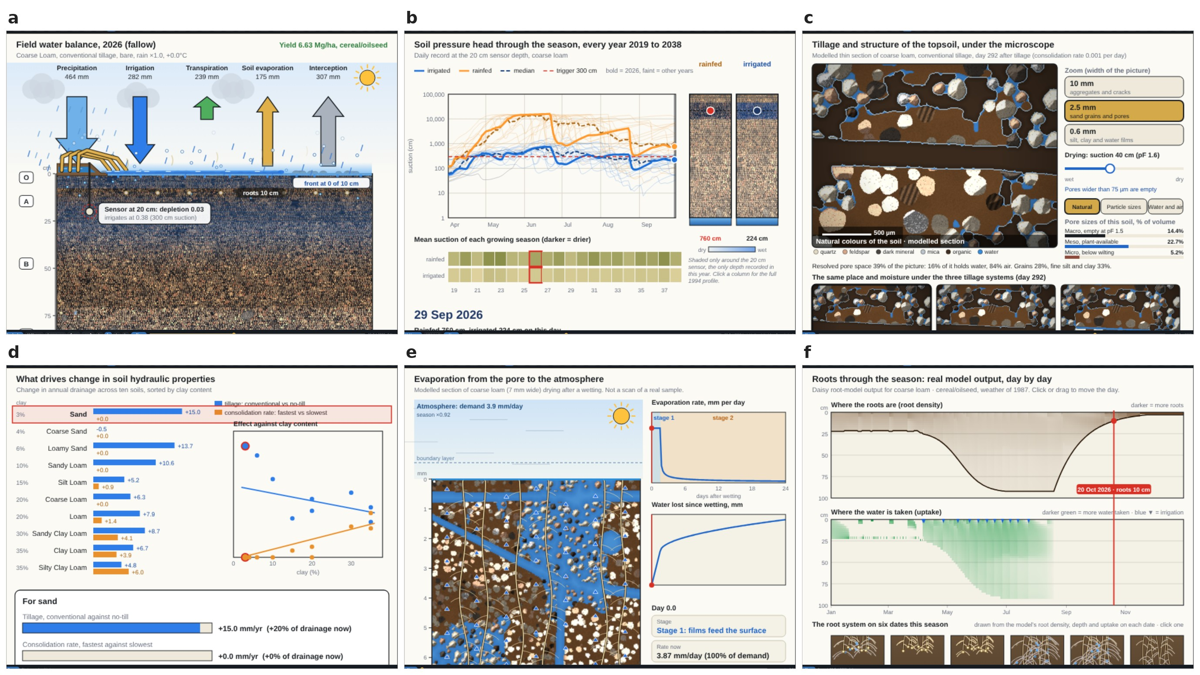
Result views of the explorer for the soil and the field (coarse loam, conventional tillage, cereal rotation). (a) Field water balance of the root zone; (b) soil-water pressure-head profile; (c) pores and tillage; (d) soil hydraulic drivers by texture; (e) evaporation from the pore to the atmosphere; (f) root density and uptake. Governing relations are listed in 11.
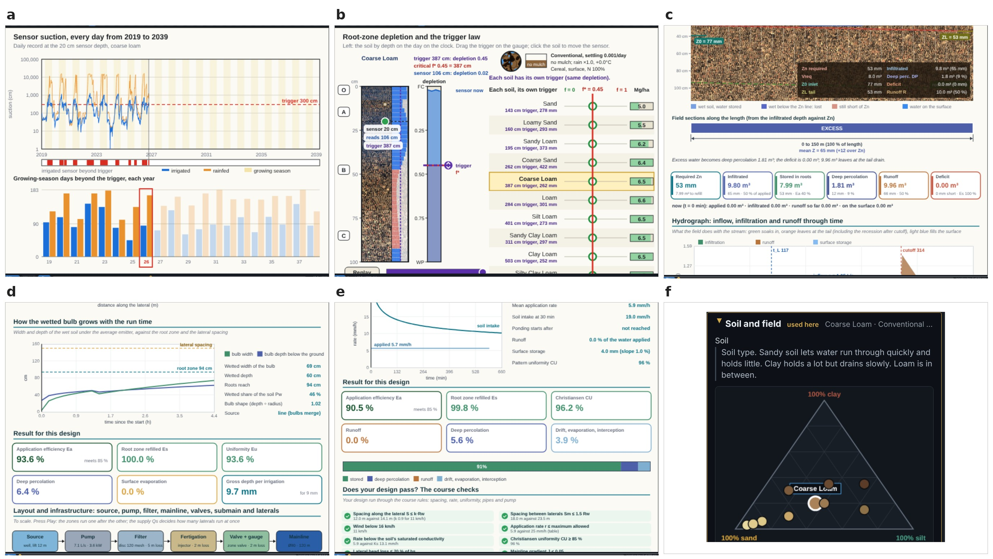
Result views for irrigation timing and design. (a) Sensor and trigger; (b) irrigation rule collapsing ten soils onto one depletion curve; (c) surface irrigation; (d) drip irrigation; (e) sprinklers; (f) soil selection on the texture triangle, which drives every view.
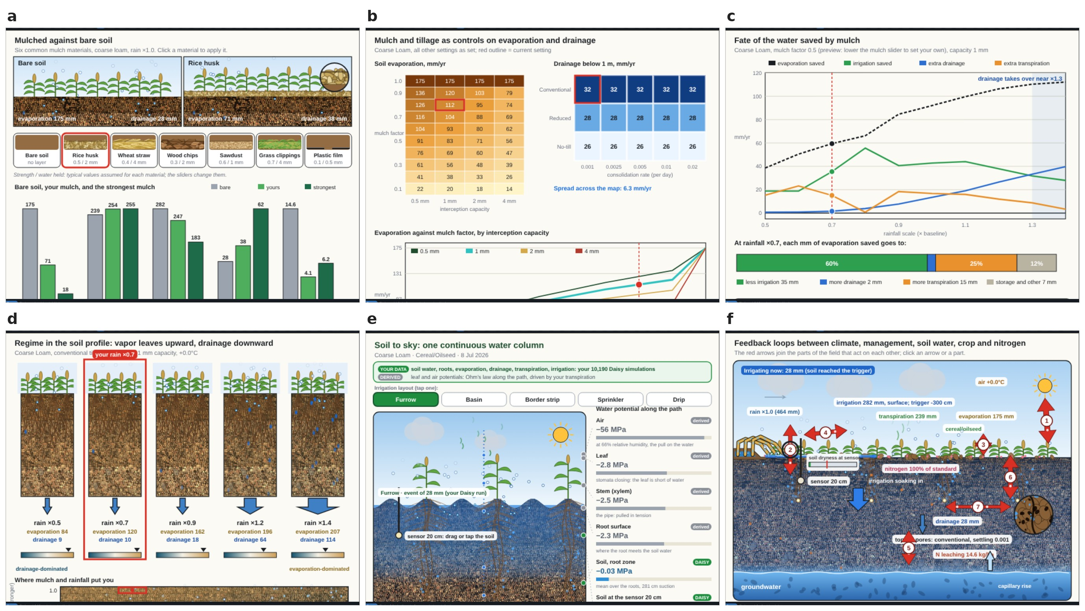
Result views for mulch and the whole system. (a) Mulch against bare soil; (b) mulch strength; (c) fate of the saved water; (d) regime map of where mulch pays; (e) soil to sky; (f) how the effects connect.
Result views, governing relations and verification. Equation numbers in brackets refer to the Manual; provenance labels are L (literature), D (data-driven), E (engineered).
View | Result shown | Governing relations [manual]; origin | Evidence in this article
View | Result shown | Governing relations | Evidence
Field | annual and daily water balance, yield, leaching | [eq:balance,eq:E1close,eq:scale] [5.4–5.12, 5.24–5.25] (D, E, L) | Engine 2 closure (median 0.1 %); Engine 1 rank fidelity; 9
S1 Soil to sky | water potential from deep soil to air | [eq:psisoil,eq:spac,eq:psiair] [7.1–7.5] (L, E) | 10: leaf potential set by the conductivity floor
V1 When to irrigate | sensor suction against trigger | [eq:Ny] [6.1–6.2] (D) | Engine 2 calibration grid
N1 Irrigation rule | depletion trigger, ten soils | [eq:depl,eq:invdepl,eq:Zn] [5.3, 6.3–6.5, 5.27] (L, D) | data collapse of E2: pooled $R^{2}$ 0.48 $→$ 0.75 (irrigation), 0.23 $→$ 0.70 (yield)
V2 Water in the soil | pressure-head profile, share beyond trigger | [eq:vgP3,eq:share] [5.1–5.2, 7.6] (L, E) | Engine 2 closure; agreement with Engine 1
V3 Pores and tillage | pore space, water- and air-filled pores | [eq:pore,eq:poros,eq:jurin] [8.1–8.4] (E, L) | drainage response of Engine 1 (held-out tests)
V7 Soil hydraulic drivers | tillage and consolidation effects by texture | [eq:drivers] [8.5–8.6] (D) | ledger audit of provenance
R1 Roots | rooting depth, uptake by depth | [eq:rmax,eq:rd,eq:rootdens,eq:transp,eq:zp] [5.18–5.23, 8.7] (E) | Engine 2 closure; 10
E1 Evaporation | stage-1 and stage-2 evaporation, drying front | [eq:e0,eq:twostage,eq:front] [5.26, 9.2–9.5] (E) | 8; sensitivity
V4, V6 Mulch | evaporation, irrigation, drainage under mulch | [eq:E1E,eq:mulchdelta] [5.4–5.9, 9.1] (D, E) | Engine 1 held-out tests; sensitivity (5.2.0.5)
N2, N3 Saved water, regime map | fate of saved water; dominant loss | [eq:fate,eq:regime] [9.6–9.8] (D, E) | 10: drainage share understated in coarse soils
V5 How it connects | seven coupled effects | 4, [eq:kappaN] [10.1–10.2] (E, D) | sensitivity analysis
S2 Surface irrigation | advance, intake, efficiencies | [eq:GA,eq:kost,eq:vb,eq:vols,eq:eff] [11.4–11.19] (L) | FAO-45 advance times within 0.5 %; textbook procedure: median 0.08 % ([tab:ws,tab:border]); steady-intake term corrected in 1.1.0 (third defect)
S3 Drip irrigation | lateral head loss, bulb, uniformity | [eq:HW,eq:Eu] [12.3–12.19] (L, E) | independent solver, $3.2×{10}^{−7}$ for $h_{f}/H_{0}≤0.6$; Christiansen factor to 0.01 % (15)
S4 Sprinklers | nozzle, pattern, overlap, checklist | [eq:nozzle] [13.1–13.23] (L, E) | diameter within 1 %, nozzle discharge within 1.3 %, decision logic as the textbook

Sensitivity of the outputs to the input controls.
One-at-a-time sensitivity runs were made on the shipped engine from a reference state (soil S01, conventional tillage, consolidation rate 0.005 d$​^{−1}$, bare soil, surface method, trigger $−300$ cm, sensor depth 20 cm, unscaled rainfall, no warming, nitrogen 100 %), moving one control to the two settings listed in 6a,b. The reference state gives 282 mm of irrigation and 27.6 mm of drainage per year. Rainfall dominates: scaling rainfall by 0.7 raises irrigation to 430 mm and lowers drainage to 10.6 mm, and scaling by 1.3 lowers irrigation to 189 mm and raises drainage to 87.7 mm. The irrigation method is the next strongest control of irrigation: drip at 20–30 cm lowers it to 201 mm and raises drainage to 31.1 mm, which is the E4 result for this soil (simulated irrigation 162 mm under drip at 20–30 cm against 228 mm under surface irrigation, ratio 0.71), whereas overhead irrigation leaves irrigation and drainage almost unchanged ($−0.3$ and $+1.1$ mm) but lowers transpiration from 239 to 141 mm, because in E4 the canopy intercepts and evaporates part of the overhead application. The trigger suction follows (335 mm at $−150$ cm against 208 mm at $−1000$ cm), then warming ($−1$ °C: 224 mm; $+2$ °C: 314 mm) and the mulch vapour-flux factor (218–258 mm for factors 0.4–0.7). Sensor depth (315 to 270 mm for 10 to 40 cm) and tillage have smaller effects. Nitrogen rate leaves irrigation and drainage unchanged because its correction ([eq:corr]) acts on yield and nitrogen leaching only, a design property of the annual model. Soil changes the outputs as much as the strongest management controls (6c): irrigation ranges from 278 mm (S03) to 414 mm (S02) and drainage from 27.6 mm (S01) to 164 mm (S02).
For the design layers, the same procedure was applied to the sprinkler and drip solvers (6d–f). In the sprinkler layer, the operating pressure controls uniformity (CU 0.82 at 200 kPa, 0.96 at 300 kPa and 0.96 at 400 kPa, with the range coefficient corrected in Section 5.3), whereas raising wind speed from 0 to 5 m s$​^{−1}$ changes CU by less than 0.01 but reduces application efficiency by 0.02 at 200 kPa (0.75 to 0.73) and by 0.04 at 300 and 400 kPa (0.92 to 0.88 and 0.89 to 0.84); the absence of a wind effect on CU is a limitation of the engineered wind term (Section 5.4). In the drip layer, emission uniformity decreases with lateral length and with smaller diameter or lower inlet head, as expected from friction loss; beyond the design range ($h_{f}/H_{0}>0.2$, dashed in 6d,e) the converged solver gives a monotonic $E_{u}$ except for the longest, narrowest laterals (loss ratios above 0.6, where the head reaches the model’s 0.5 m floor and the layer prints its warning); these portions of the curves should not be interpreted as predictions.
One-at-a-time sensitivity of SWAFL Desktop outputs. (a) Engine 1 annual irrigation and (b) drainage change for each control moved to the two settings listed under its name (blue: first setting; orange: second setting) from the reference state; nitrogen rate leaves both unchanged. (c) Irrigation and drainage by soil. (d) Drip emission uniformity against lateral length by lateral diameter and (e) by inlet head; dashed where $h_{f}/H_{0}>0.2$. (f) Sprinkler application efficiency against wind speed at 200, 300 and 400 kPa (CU in the legend).

Surface irrigation against published worked examples
Examples 6.1 (furrow) and 6.4 (border) of Wynn R. Walker and Skogerboe (1987) were computed with a stand-alone reference implementation of the textbook volume-balance procedure (lib/wsmodel.js), which uses the book’s power-law description of the furrow section and its intake functions. These two examples therefore verify the procedure and its arithmetic; the surface layer shipped in SWAFL Desktop, which describes the furrow by a trapezoidal section, is compared with Example 6.1 at the end of this subsection and with a second source in Section 5.4.
The example specifies a 200 m furrow of slope $S_{0}=0.008$ and roughness $n=0.04$, with infiltration $Z=0.0028τ^{0.534}+0.00022τ$ (first irrigation) and $Z=0.0021τ^{0.331}+0.00015τ$ (later irrigations), furrow-geometry coefficients $ρ_{1}=0.325$ and $ρ_{2}=2.734$. compares 16 quantities. The maximum error is 1.81 % (advance time at $Q=0.10$ m$​^{3}$ min$​^{−1}$ for the first irrigation: 81.65 versus 80.2 min), the median error 0.08 %, and the required infiltration times (378.73 and 868.5 min) agree to better than 0.01 %. For the later irrigation at $Q=0.10$ the application efficiency recomputed by the software is 33.5 % while the copy of the book used shows 53.0 %, which is inconsistent with the printed trend (the neighbouring values at $Q=0.075$ and 0.0625 are 44.2 % and 52.5 % and the efficiency increases as the flow falls); this entry was excluded from the comparison and is flagged.
Surface-irrigation Example 6.1 (Wynn R. Walker and Skogerboe 1987): published and computed quantities. $T_{req}$: required infiltration time (min); $t_{L}$: advance time to the end of the furrow (min) at flow $Q$ (m$​^{3}$ min$​^{−1}$); $E_{a}$: application efficiency (%). Error $=100\left(\text{SWAFL}−\text{book}\right)/\text{book}$.
Irrigation | Quantity | Book | SWAFL | Error (%)
first irrigation | Treq | 378.73 | 378.73 | +0.00
first irrigation | tL Q=0.1 | 80.2 | 81.65 | +1.81
first irrigation | Ea Q=0.1 | 65.4 | 65.16 | $−$0.36
first irrigation | tL Q=0.075 | 198.6 | 198.67 | +0.04
first irrigation | Ea Q=0.075 | 69.3 | 69.28 | $−$0.04
first irrigation | tL Q=0.0625 | 441.6 | 442.27 | +0.15
first irrigation | Ea Q=0.0625 | 58.5 | 58.46 | $−$0.06
later irrigation | Treq | 868.5 | 868.52 | +0.00
later irrigation | tL Q=0.1 | 26.2 | 26.16 | $−$0.16
later irrigation | tL Q=0.075 | 36 | 36.05 | +0.14
later irrigation | Ea Q=0.075 | 44.2 | 44.22 | +0.05
later irrigation | tL Q=0.0625 | 46.3 | 46.35 | +0.11
later irrigation | tL Q=0.05 | 68.2 | 68.23 | +0.04
later irrigation | Ea Q=0.05 | 64.1 | 64.05 | $−$0.08
later irrigation | tL Q=0.0375 | 143.5 | 143.64 | +0.10
later irrigation | Ea Q=0.0375 | 79.1 | 79.04 | $−$0.08
Verification against Example 6.1. (a) Advance time $t_{L}$, (b) application efficiency $E_{a}$ (published versus SWAFL; grey line is 1:1), (c) relative differences of the 16 quantities (blue: advance and required times; green: efficiencies).
For the border-strip example the software gives $T_{req}$ (first irrigation) of 146.40 against 146.4 min, $T_{req}$ (later) 162.23 against 162.8 min ($−0.35$ %), maximum non-erosive flow $Q_{max}=1.883$ against 1.88 m$​^{3}$ min$​^{−1}$m$​^{−1}$ ($+0.17$ %), the advance time for $Q=0.14$ and $L=360$ m of 158.68 against approximately 158 min ($+0.43$ %) and the inlet area $A_{0}=0.03034$ against 0.0303 m$​^{2}$ ($+0.13$ %). All are within 0.5 %.

The shipped surface layer and Example 6.1.
To test the shipped advance solver itself, Example 6.1 was run through it with the book’s intake, length, slope and roughness and with the inlet flow area of the book’s furrow geometry, so that only the solver differs from the reference implementation (v_surface_shipped.js). In release 1.0.0, where the stream advances quickly, the shipped solver agreed with the book within $−1.7$ to $+4.0$ % (first irrigation at $Q=0.10$; later irrigation at $Q=0.05$–0.10 m$​^{3}$ min$​^{−1}$), but where advance was slow it was too fast: $−9.8$ % for the later irrigation at $Q=0.0375$ and $−14.7$ and $−29.0$ % for the first irrigation at $Q=0.075$ and 0.0625. The cause is a single term. In the volume balance the infiltration of the steady-intake component $f_{0}$ during advance is divided by $\left(1+r\right)$, with $r$ the advance exponent; the code of release 1.0.0 used a fixed $r=0.55$, whereas the textbook procedure uses the current, iterated $r$, which is 0.32–0.45 in the slow cases (and 0.48–0.76 where advance is fast). With $r$ iterated, the shipped solver reproduces the reference implementation to 0.002 % and the book to between $−0.2$ and $+1.8$ % in all eight cases (v_surface_shipped.js runs both versions). This is the third defect found by the verification; it matters only when $f_{0}>0$ and advance is slow. It is corrected in release 1.1.0, which iterates $r$.
The design problem (180 m $×$ 180 m field, sprinklers spaced $12×15$ m, required net depth $Z_{n}=42$ mm, application efficiency 0.7 so a gross depth of 60 mm, an irrigation interval of 10 d, 16 h d$​^{−1}$ of operation, farm supply 21 m$​^{3}$ h$​^{−1}$, silty loam, 10 % slope) tests decision logic rather than a smooth function. The maximum allowable application rate is 8 mm h$​^{−1}$ and the maximum discharge $q_{max}=1.44$ m$​^{3}$ h$​^{−1}$, as in the book; the layout yields $N=15$ sprinklers per lateral and $N_{m}=12$ lateral positions. With a discharge of 0.675 m$​^{3}$ h$​^{−1}$ the book’s logic permits one set per day, which would require $N_{d}=12$ days for one lateral and is rejected (12 days exceeds the 10-day interval), and the software follows. With $q=1.35$ m$​^{3}$ h$​^{−1}$ (two sets per day) one lateral needs $N_{d}=6$ days with an inflow of 20.25 m$​^{3}$ h$​^{−1}$, which is within the supply; with 2.03 (three sets per day) the supply constraint rejects the option. The software selects $n=1$ lateral for $q=1.35$ and $n=2$ for the lower discharge, as in the textbook. A nozzle of 4.8 mm at a head of 24 m yields 1.343 m$​^{3}$ h$​^{−1}$ against the book’s 1.36 ($−1.3$ %). One discrepancy was found in the first version: the wetted diameter predicted for this nozzle was 24.7 m (radius 12.3 m) whereas the book’s range table gives 28.7 m, a deficit of 14 % caused by the range coefficient $c_{R}=1.15$ in [eq:nozzle], which had been chosen rather than taken from the source. The Keller and Bliesner (1990) range relation for impact sprinklers has the coefficient 1.35; with it the software returns a radius of 14.49 m and a wetted diameter of 28.98 m ($+1$ %), and the coefficient was changed in the shipped code and manual (Table 13.1). The range coefficients of the other three sprinkler types (rotating spray, micro-sprinkler, big gun) remain engineered and have not been verified against published data.
Border Example 6.4 (Wynn R. Walker and Skogerboe (1987)) and the sprinkler example: published and computed values.
Quantity | Book | SWAFL | Error (%)
$T_{req}$, first irrigation (min) | 146.4 | 146.399 | $−0.00$
$T_{req}$, later irrigation (min) | 162.8 | 162.230 | $−0.35$
$Q_{max}$ (m$​^{3}$ min$​^{−1}$ m$​^{−1}$) | 1.88 | 1.883 | $+0.17$
$t_{L}$ at $Q=0.14$, $L=360$ m (min) | $≈$158 | 158.677 | $+0.43$
$A_{0}$ (m$​^{2}$) | 0.0303 | 0.03034 | $+0.13$
Sprinkler: nozzle discharge, 4.8 mm at 24 m (m$​^{3}$ h$​^{−1}$) | 1.36 | 1.343 | $−1.3$
Sprinkler: wetted diameter (m), version 1 | 28.7 | 24.7 | $−14$
Sprinkler: wetted diameter (m), corrected | 28.7 | 28.98 | $+1.0$
Sprinkler: maximum rate $u_{max}$ (mm h$​^{−1}$) | 8 | 8 | 0
Sprinkler: $q_{max}$ (m$​^{3}$ h$​^{−1}$) | 1.44 | 1.44 | 0

Engine 1 against held-out simulations.
Engine 1 was queried at the factor levels of the 1 000 E12 runs (coarse loam, surface method). Without alignment, the engine’s baseline differs from Daisy’s baseline for this experiment: the engine’s baseline (derived from the E5 irrigated set) has ET of 720 and irrigation of 282 mm yr$​^{−1}$ whereas the E2/E3/E12 baseline is 673 and 228 mm yr$​^{−1}$, so raw predictions are biased by $+53$ mm for ET and $+71$ mm for irrigation (14, 8). This is a baseline offset between experiment families, not a random error: the engine composes ratios taken within one family on a baseline from another family. After aligning the engine’s baseline cell with Daisy’s (re-anchoring), the normalised RMSE for off-axis cells (all cells except the baseline row and column, which are partly used in the engine’s construction) is 6.2 % for ET, 18.9 % for irrigation, 48.7 % for drainage (a small mean, 35 mm), 10.1 % for soil evaporation, 8.7 % for transpiration, 34.6 % for nitrogen leaching and 27.9 % for yield. The $R^{2}$ values are 0.79 (irrigation), 0.82 (drainage), 0.71 (soil evaporation), 0.33 (nitrogen leaching), 0.10 (transpiration), $−0.11$ (ET) and $−2.33$ (yield); the negative values for ET and yield arise because the variance of these outputs within E12 is small (the coefficient of variation of ET across the cells is 5.9 %), so any constant offset dominates, and for yield the engine’s discrete lookup structure and ceiling produce a stepped response that the simulation does not show (8d). Rank correlations are higher than the $R^{2}$ values: Spearman $ρ$ is 0.96 for irrigation, 0.97 for soil evaporation, 0.92 for drainage, 0.84 for ET, 0.70 for yield, and 0.64 for transpiration and nitrogen leaching.
Engine 1 against 1 000 held-out E12 runs (coarse loam), off-axis cells. Raw: as shipped; re-anchored: baseline aligned. nRMSE: RMSE as % of the observed mean; $ρ$: Spearman rank correlation.
 | Raw |  |  | Re-anchored
2-4(lr)5-7 Variable | $R^{2}$ | RMSE | bias | $R^{2}$ | nRMSE (%) | bias | $ρ$
ET (mm) | $−2.06$ | 69.5 | $+53.1$ | $−0.11$ | 6.2 | $+5.5$ | 0.84
Irrigation (mm) | 0.18 | 97.4 | $+71.4$ | 0.79 | 18.9 | $+8.3$ | 0.96
Drainage (mm) | 0.72 | 21.7 | $+14.6$ | 0.82 | 48.7 | $+6.2$ | 0.92
Soil evaporation (mm) | 0.71 | 15.4 | $−7.9$ | 0.71 | 10.1 | $−7.9$ | 0.97
Transpiration (mm) | $−1.01$ | 29.3 | $+21.4$ | 0.10 | 8.7 | $+4.0$ | 0.64
Yield (Mg ha$​^{−1}$) | $−1.82$ | 1.51 | $−0.79$ | $−2.33$ | 27.9 | $−1.15$ | 0.70
N leached (kg ha$​^{−1}$) | $−0.84$ | 18.5 | $−14.7$ | 0.33 | 34.6 | $−0.3$ | 0.64
Engine 1 versus Daisy for the 1 000 held-out E12 runs. Orange: as shipped; blue: re-anchored. (a) ET, (b) irrigation, (c) drainage, (d) yield, (e) transpiration, (f) soil evaporation, (g) nitrogen leached. Grey lines are 1:1.
The practical reading is that Engine 1 is a rank-faithful screening emulator: it orders scenarios correctly (irrigation $ρ=0.96$, drainage 0.92, soil evaporation 0.97) and gets the response to trigger, depth and rainfall in the right direction, but its absolute values depend on which experiment family anchors the baseline, and its yield output should not be used quantitatively. The independence assumption for mulch and warming cannot be tested because no experiment crosses them.

Engine 2 closure and agreement with Engine 1.
The unscaled daily core closes the water balance to within 0.1 % of inflow (median) and at most 0.7 % over 60 random states (9a). On a 100-scenario grid the calibrated irrigation closes with residual of median 0.04 % and maximum 0.23 % of inflow.
On a realistic grid of 10 soils $×$ 5 triggers $×$ 2 methods (cereal crop), the calibrated mean annual irrigation of Engine 2 agrees with Engine 1 within 10 % in 90 of 100 scenarios (76 within 6 %). The ten disagreements are all in coarse soils at dry triggers: sand (S03) at $−500$ and $−1000$ cm (both methods; simulated irrigation 0 versus target 278 mm), loamy sand (S04) at $−500$ (337 versus 293 mm) and $−1000$ cm (0 versus 293 mm), and sandy loam (S05) at $−1000$ cm (8–11 versus 15 mm). The ten cases are of three kinds. In sand at $−500$ and $−1000$ cm and in loamy sand at $−1000$ cm (six cases) the bucket model never reaches the trigger suction, because its layers drain below it, so no irrigation is applied; the Engine 1 value (278 mm for sand at $−300$ cm and drier triggers in the Daisy set) reflects the simulation’s own scheduler behaviour. In loamy sand at $−500$ cm (two cases) the trigger is reached rarely, the calibration factor rises to $k_{t}=3.8$ and the model over-irrigates (337 against 293 mm). In sandy loam at $−1000$ cm (two cases) the absolute difference is small (8–11 against 15 mm) but exceeds 10 % of the target. An earlier test on randomly drawn states, including legume and vegetable crops, gave much poorer agreement (61 % mean error in irrigation), which is why the realistic grid is reported with its scope: cereal crop, two methods. The unscaled partition (E/T split) and drainage of Engine 2 do not match Engine 1 (9c shows unscaled drainage scattering around the 1:1 line by factors of two to five), which is why the displayed series are scaled by [eq:scale]; this makes the displayed means correct by construction and the timing within the year plausible but unverified.
Engine 2. (a) Closure residual of the unscaled daily core over 60 random states. (b) Mean annual irrigation of Engine 2 against Engine 1 for the 100 scenarios of the realistic grid (10 soils $×$ 5 triggers $×$ 2 methods, cereal), including the failures at zero. (c) Unscaled Engine 2 drainage against Engine 1 for the same scenarios.

Drip, sprinkler and surface layers against the literature
The design layers are not specific to surface irrigation, and each was therefore tested against published relations or examples outside the software.

Drip lateral.
Two published results were used. First, the lateral loss along a pipe with $N$ equally spaced outlets equals the full-length Hazen–Williams loss multiplied by the Christiansen reduction factor $F=1/\left(m+1\right)+1/\left(2N\right)+\sqrt{m−1}/\left(6N^{2}\right)$ with $m=1.852$ (Christiansen 1942; Keller and Bliesner 1990). For $N=5$ to 400 the software’s lateral loss agrees with this factor and with the exact discrete sum to 0.01 % or better. Second, the lateral solver was compared with an independent vectorised solver on 400 random configurations (10). The first version, which used four iterations, deviated from the independent solution by up to 0.13 % for $h_{f}/H_{0}≤0.2$, by up to 81 % for $0.2<h_{f}/H_{0}≤0.6$ and by up to 89 % above that. The solver was rebuilt to iterate to convergence; it now agrees with the independent solution to a relative error of $3.2×{10}^{−7}$ in total head loss for $h_{f}/H_{0}≤0.6$ (324 configurations), and the warning described below is shown for every configuration with $h_{f}/H_{0}>0.2$ (156 of 400) and for every configuration in which the iteration does not converge (31 of 400, all with $h_{f}/H_{0}>0.6$). Above $h_{f}/H_{0}=0.6$ the maximum difference is 31 % and occurs where the head reaches the 0.5 m floor of the model, a regime in which the lateral is not a usable design. The 20 % limit is the usual design criterion for laterals (Keller and Karmeli 1974; Keller and Bliesner 1990); when it is exceeded, the drip layer now prints a red warning stating the loss as a share of the inlet head.

Sprinkler.
Four relations were tested: orifice discharge (Torricelli, within 1.3 % of the book value for the textbook nozzle), the range relation (corrected as described above, $+1$ %), the Christiansen uniformity coefficient and the spacing rule of at most 65 % of the wetted diameter (Keller and Bliesner 1990). With the corrected radius, a square layout at 65 % spacing gives CU $=85.7$ %, at 60 % 92.9 % and at 70 % 78.7 % (11b), consistent with the rule that this spacing yields about 85 %. One limitation was found: the engineered wind term changes CU by less than 0.2 percentage points at a wind speed of 3 m s$​^{−1}$, whereas wind is known to degrade uniformity; the wind response of the sprinkler layer should not be used for design.

Surface irrigation, second source.
The shipped surface layer was compared with the worked border examples of FAO Irrigation Paper 45 (W. R. Walker 1989), which use the Kostiakov–Lewis intake $Z=kτ^{a}+f_{0}τ$ and the surface shape factor $σ_{y}=0.77$ of that source. The shipped layer had no steady-intake term, so $f_{0}$ was added to it as an optional parameter (zero by default, so results with the pure Kostiakov law are unchanged). For the 200 m and 100 m open-end borders ($Z_{req}=8$ cm) the required intake times are 388.5 and 678.9 min, identical to the published values, and the minimum unit flows $0.0226$ and $0.032$ m$​^{3}$ min$​^{−1}$ m$​^{−1}$ from $Q_{min}=0.000357LS_{0}^{1/2}/n$ agree (0.0226 and 0.0319). Thirteen published advance times, for unit flows of 0.009 to 0.09 m$​^{3}$ min$​^{−1}$ m$​^{−1}$, are reproduced with errors from $−0.2$ to $+0.5$ % (mean absolute 0.13 %; 11a); before the correction of the steady-intake term described above the errors were $−2.2$ to $+2.9$ % (mean absolute 1.7 %). The published cut-off and recession times were not compared, because the FAO procedure uses a different cut-off rule from the software’s options, so the efficiency tables of that source were not tested.
Drip-lateral solver versus an independent converged solver (400 random configurations). (a) Relative difference in total head loss for the four-pass solver of version 1 and the converged solver, against the loss ratio $h_{f}/H_{0}$ (dashed: design limit 0.2; dotted: 0.6); (b) number of iterations of the converged solver; crosses mark configurations that did not converge.
Checks against published sources. (a) Thirteen advance times of the FAO Irrigation Paper 45 border examples (published against SWAFL; grey line 1:1). (b) Christiansen coefficient of uniformity of the impact-sprinkler layer against spacing as a share of the wetted diameter, without wind and at 3 m s$​^{−1}$; dashed: 65 % spacing rule, dotted: CU of 85 %.
Drip lateral solver of version 1 (four passes) and the converged solver against an independent solver, by loss ratio $h_{f}/H_{0}$ (400 random configurations). Maximum relative error in $h_{f}$ and maximum absolute error in $E_{u}$.
 |  | Version 1 |  | Converged
3-4(lr)5-6 $h_{f}/H_{0}$ | Configurations | $h_{f}$ (%) | $E_{u}$ | $h_{f}$ (%) | $E_{u}$
$≤0.2$ | 244 | 0.13 | $4.6×{10}^{−5}$ | $3.2×{10}^{−5}$ | $2.6×{10}^{−8}$
0.2–0.6 | 80 | 81.2 | 0.133 | $2.5×{10}^{−5}$ | $9.2×{10}^{−8}$
$>0.6$ | 76 | 89.1 | 0.444 | 31 | 0.080

Run time and documentation audit.
Single-call medians in Node.js were 0.021 ms for Engine 1, 0.25 ms for the drip layer, 1.7 ms for the sprinkler layer and 0.14 s for a 20-year daily Engine 2 simulation. Interactive operation (slider movement) is therefore limited by rendering, not by computation, and a design-space sweep of ${10}^{5}$ Engine 1 evaluations takes about 2 s.
The Manual contains 134 numbered equations (124 carry a tag and ten are rows of aligned groups). Each now carries its provenance label directly beneath it, and a ledger of all 134 is given in the manual’s appendices: 38 are [Literature], 18 are [Data-driven] and 78 are [Engineered]. The labelling was done by reading each equation against its cited source; it records where a relation comes from and does not certify that it is correct. The equations used in this article, including those of the system variables of Section 3, are classified in Appendix 8. The engineered ones comprise the root and canopy curves, rainfall and interception generators, wetted-bulb geometry, spray patterns, wind-drift loss and similar heuristics. An independent reader can therefore see that the sprinkler pattern and drift functions have no external validation, whereas the surface layer relies on published equations.

Discussion

What the system variables add
Representing the whole column, and not only the irrigation decision, changes what a user can ask of the framework. The evaluation for ten soils (Section 5.1) shows the chain from pore structure to the decision in numbers: retention sets how much of the plant-available water a fixed suction consumes (24 to 84 % at $−300$ cm), which is why the trigger is better expressed as a depletion; the same retention window sets how long the surface stays wet after a wetting, longest in the coarse soils (Lehmann, Assouline, and Or 2008); and under one rainfall the soils divide between evaporation-dominated and drainage-dominated regimes, which decides whether a mulch saving is recovered as less irrigation or lost to drainage. These are the couplings that soil-physics reviews identify as decisive for water use and that a decision tool usually hides (Or et al. 2013; Vereecken et al. 2016).
The same evaluation is a test of the engineered relations that no worked example covers, and it found two defects of representation. The leaf water potential of the soil-to-air view is controlled by the floor on the relative conductivity, so it is nearly the same in every soil and more negative than the resistances were chosen to produce; a conductance scaled by saturated conductivity and root length, as in sink-term models (Feddes, Kowalik, and Zaradny 1978), would replace the floor. The fate of a mulch saving inherits the coarse-loam drainage increments of E14, so it understates the drainage share in sandy soils, which the ten-soil mulch experiment E7 resolves directly; composing the mulch drainage response from E7 instead would remove the defect. Both are reported as limitations of the released version (Section 6.5), and both illustrate why the variables of an explanatory view need the same scrutiny as the outputs used for decisions.

What the evidence supports
Taken together the four verification families support four statements. (i) The closed-form design layers implement the published relations: the textbook surface procedure reproduces a worked example to a median of 0.08 % and a maximum of 1.8 %, and the shipped surface layer, with the one-term correction of its steady-intake term (release 1.1.0), reproduces 13 FAO-45 advance times within $−0.2$ to $+0.5$ % and the slow-advance cases of Example 6.1 within $−0.2$ to $+1.8$ % (before the correction, up to $−29$ %); the drip lateral matches the Christiansen factor to 0.01 % and an independent solver to $3×{10}^{−7}$ within $h_{f}/H_{0}≤0.6$; the sprinkler decision logic, nozzle discharge, wetted diameter ($+1$ %) and spacing rule match the textbook. (ii) Engine 1 is a useful screening emulator, with high rank fidelity for irrigation, soil evaporation and drainage, with absolute values that depend on the baseline family; yield and nitrogen estimates are best used for ranking. (iii) Engine 2 conserves mass and reproduces Engine 1’s annual irrigation in most realistic scenarios, but not in sandy soils at dry triggers, and its partition is scaled rather than simulated. (iv) Numerical sub-solvers can be accurate in their design range and inaccurate outside it, as the first drip solver was; the failure mode should be flagged to the user, and the revised drip layer does so.
The evidence does not support claims that the software predicts field irrigation requirements, that it improves yields or water productivity, or that it is easier to use than alternatives. The evidence of fidelity is relative to the process model (Daisy) and to textbook examples; Daisy itself has been evaluated in the literature (Hansen et al. 2012; Holbak et al. 2026) but the ten virtual soils here were not compared with field data. A field comparison (lysimeters or sensor-scheduled plots against the software’s schedule and design table) and a user study would be needed to make such claims.
Traceability lets a reviewer or a user ask the right questions: which equation produced this number, where did it come from, and how was it tested? It also made the verification possible, since the test for each layer could be written against a named equation. The cost is documentation: the Manual (with a screenshot atlas in which every screen, every state of every control and every part of every scrolled drawing carries numbered arrows and is paired with its equations, and 134 numbered equations) must be kept synchronised with the code, and, as the label audit of the first release showed, this discipline is easily lost. It is recommended that provenance labels be treated as part of the code review, enforced by a check that every numbered equation carries a label and a source, and that a published-example test accompanies every closed-form layer (Jakeman, Letcher, and Norton 2006; Refsgaard and Henriksen 2004).
The annual meta-model avoids fitting any parameter by composing simulated ratios; the advantage is that it cannot produce results outside the simulated envelope without clipping, and that its behaviour is explainable by the tables. The disadvantage is revealed by the held-out test: ratios from one experiment family applied to the baseline of another transmit the inconsistency between the baselines. The inconsistency here arises because the baseline for E5 (tillage and structure) used the irrigated cereal setting with different trigger and depth from the baseline of E2, E3 and E12. Two remedies are possible: re-anchor all families to a common baseline run that is part of every experiment (a design remedy), or calibrate an anchor offset per family (a statistical remedy). The first is preferable, as it removes the cause.
The combination of mulch and warming multiplies ratios taken from separate experiments. The independence assumption is plausible but the drainage response to evaporation changes may depend on climate (warming and rainfall can change the recoverable share of an evaporation saving), which suggests that the mulch effect is not independent of climate for the drainage and irrigation fluxes. A crossed experiment would test this.
Reviews of irrigation decision-support tools identify recurring needs for physics-informed and process-based components, for open and FAIR software, for uncertainty handling, and for shared benchmarks and reproducible releases, and note that accuracy is often demonstrated against calculated or simulated targets and not against operational endpoints (Umutoni and Samadi 2024; Zhang et al. 2021). The present contribution addresses the needs for open, process-based and reproducible software at the level of the individual equation: provenance labels, a published map from displayed quantity to equation, and verification against references that exist outside the software, including a published design textbook. It does not address sustained multi-season savings or cross-site transfer, which are outside the scope of this verification, and the verification reported here should be read as a necessary step before field validation. The verification suite also clarifies the roles of the three computing components in a decision. The closed-form design layers are suited to design calculations in which the user supplies the field geometry, soil intake and supply, because their outputs are determined by the equations and were reproduced against published values. The annual meta-model is suited to comparison of management options, because it preserves their ordering with a rank correlation of 0.64 to 0.97 across the variables tested, and because each of its outputs is a composition of simulated ratios that can be inspected. The daily model is suited to the timing and size of events within a season and to the visualisation of the field water balance; its seasonal means are tied to the annual meta-model by construction, and its within-season timing is a model result that a field experiment would test.
Equation traceability is a property that can be audited in any decision tool. A reviewer can select a displayed quantity, locate its equation in the manual, check the equation against its source, and re-run the test that supports it; the procedure requires no access to the developers. The audit of the manual shows where the procedure applies most strongly (the surface and drip layers, whose equations are published), and where the provenance rests on engineered functions (spray patterns, wind drift, wetted-bulb geometry). This distinction is useful to users: a user relying on the surface layer relies on published theory that has been reproduced against its textbook; a user relying on the sprinkler pattern relies on an engineered shape and should confirm it with manufacturer data. The wetted radius, which the first version under-predicted by 14 % for the example nozzle until its coefficient was replaced by the published value, illustrates the point, since the range law is a coefficient on a general expression and a manufacturer’s table is the proper reference for a specific nozzle (Keller and Bliesner 1990; Playán et al. 2005).
Field evaluation is the step that converts verification into validation. A suitable design compares the software’s recommended triggers and doses with sensor-scheduled plots on contrasting soils, records applied water, drainage below the root zone and yield, and evaluates the software with the efficiency and bias statistics that are standard for model evaluation (Moriasi et al. 2007; Nash and Sutcliffe 1970; Bennett et al. 2013). For the design layers, field evaluations of surface advance, drip emission uniformity and sprinkler catch-can uniformity provide the corresponding data (Wynn R. Walker and Skogerboe 1987; Burt et al. 1997; Playán et al. 2005). The open availability of the code, the manual and the verification scripts allows such an evaluation to be carried out by any group and compared with the results reported here.
Equation-traceable software has teaching and extension uses in addition to its use for decisions. A student can follow a number from the dashboard to the equation, to the source, to the test, and can modify the inputs to see how the number responds. A practitioner can obtain a transparent first estimate before commissioning a field-specific simulation. For both uses the relevant feature is that the numerical behaviour of each layer is documented together with its range of verified operation, so that the tool states what it can be relied on for (Wilkinson et al. 2016; Hutton et al. 2016).

Operating envelopes established by independent verification
A tool that exposes its equations earns trust only if each layer is tested against something outside itself and the test is reported with the range in which it holds. The verification programme therefore delivers, for every layer, an operating envelope: the inputs and the decision purpose for which agreement with an external reference has been shown, with the mechanism that fixes its edge. Verification separates errors in the implementation of a relation from limitations of the relation and of the reference against which it is judged (Oreskes, Shrader-Frechette, and Belitz 1994; Refsgaard and Henriksen 2004), and a deviation bears on fitness for purpose only relative to that purpose: a bias is immaterial for ranking options and decisive for budgeting water (Bennett et al. 2013; Moriasi et al. 2007). The envelopes below are the substantive result of the work, and they are what allows each layer to be used with a stated confidence.

Engine 1 and a diagnosed anchoring effect with a design remedy.
Before alignment Engine 1 over-predicts ET by 53 mm and irrigation by 71 mm yr$​^{−1}$ in the held-out experiment (14). The structure of the error identifies its cause. A random error averages out over 1 000 runs; a constant offset does not, and after one baseline cell is aligned the biases fall to $+5.5$ and $+8.3$ mm yr$​^{−1}$ while the rank correlations are unchanged (0.84 and 0.96). The offset therefore belongs to the construction, ratios formed within one experiment family and applied to the baseline of another, and not to the ratios. In the literature on computer-model calibration this is a systematic model discrepancy, which Kennedy and O’Hagan (2001) argued should be represented explicitly and not treated as independent noise. Reviews of surrogate modelling likewise stress that a surrogate inherits the properties of the design that trained it, and that the design should cover the region of use (Sacks et al. 1989; Razavi, Tolson, and Burn 2012; Asher et al. 2015). The proposed design remedy, one common baseline cell in every experiment family, is the direct expression of that principle. That the offset was invisible in the tables used to build the engine and appeared only in an independent experiment is the usual case for held-out testing over internal consistency checks (Oreskes, Shrader-Frechette, and Belitz 1994; Bennett et al. 2013). Until the remedy is built in, absolute Engine 1 values carry the offset, and the supported use is the comparison of options within a family.

Engine 1 and rank fidelity as the decision-relevant skill.
After re-anchoring, $R^{2}$ is $−0.11$ for ET and $−2.33$ for yield while $ρ$ is 0.84 and 0.70 (14). The two statistics answer different questions and are compatible. $R^{2}$ here is measured against the mean of the held-out observations; the coefficient of variation of ET across the cells of E12 is only 5.9 %, so an RMSE of 6.2 % of the mean is comparable to the spread to be explained, and a small residual bias then dominates the ratio. Correlation-type measures can be insensitive to additive and proportional errors (Legates and McCabe 1999), which is why model-evaluation guidance asks for several complementary statistics and not one (Moriasi et al. 2007; Bennett et al. 2013). Reporting rank and absolute metrics separately is therefore not hedging. Rank agreement is the relevant statistic when the decision is a choice between options, as in screening and factor prioritisation (Saltelli et al. 2008); absolute error is the relevant statistic when a quantity is budgeted. Yield is the exception that the data support: its bias ($−1.15$ Mg ha$​^{−1}$), the stepped response produced by the engine’s lookup structure and the weakest useful rank correlation (0.70) define the role of yield as a ranking output, which is how the software presents it.

Engine 2 and an envelope mapped to sensor practice.
The ten scenarios in which Engine 2 and Engine 1 disagree are all coarse soils at triggers of $−500$ or $−1000$ cm (sand, loamy sand and, at $−1000$ cm, sandy loam); in six of them the bucket model never reaches the trigger because its layers drain below it, so no irrigation is applied, and in the other four it reaches the trigger too rarely to calibrate (over-irrigation in loamy sand at $−500$ cm, 8–11 against 15 mm in sandy loam at $−1000$ cm). These triggers lie outside the range in which sensor-based scheduling is practised in coarse soils. Extension guidance for tensiometers places irrigation triggers for sandy soils at about 20–30 kPa and for silty clay loams at 50–60 kPa, and notes that the instrument functions reliably only to about 80 kPa, beyond which the water column breaks (Alam and Rogers 1997). A trigger of $−500$ cm ($≈49$ kPa) is therefore well above the usual range for sand and loamy sand, and $−1000$ cm ($≈98$ kPa) is beyond the working range of the instrument whose signal the trigger law represents. The disagreement thus marks the boundary of the daily-bucket formulation in a regime that practice avoids, and the zero-irrigation outcome is an explicit failure rather than a silent error, whereas the over-irrigation in loamy sand at $−500$ cm is not flagged and should be. It also reflects that the field-capacity convention of 100 cm suction, adopted from Allen et al. (1998), is a convention whose appropriateness varies with the soil (Twarakavi, Sakai, and Šimůnek 2009; Assouline and Or 2014). The practical consequences are to flag triggers beyond the sensor range for a given texture and to read the Engine 1 value, which is the Daisy scheduler’s own result, for those cells. The unscaled partition of Engine 2 does not match Engine 1, and its unscaled drainage scatters around Engine 1 by factors of two to five. Mass closure is a necessary condition and not evidence that the partition is right, since agreement in totals does not confirm the process representation (Oreskes, Shrader-Frechette, and Belitz 1994); this is why the displayed series are scaled to Engine 1 and why timing within the year is labelled plausible but unverified.

Drip lateral and a convergence-controlled solver with a declared range.
The first solver used four fixed iterations. Its error was at most 0.13 % for $h_{f}/H_{0}≤0.2$, but up to 81 % for $0.2<h_{f}/H_{0}≤0.6$ and 89 % above (15). The conventional design criterion limits lateral loss to about 20 % of the operating head (Keller and Karmeli 1974; Keller and Bliesner 1990), so the defect lay where a lateral would normally be redesigned, but a user could still reach that region by changing inputs, and a design tool must report its own range of validity. Iterations of this kind typically converge more slowly as the loss ratio grows, so a fixed number of passes stops short; iterating to convergence removed the defect within $h_{f}/H_{0}≤0.6$ ($3.2×{10}^{−7}$). The residual 31 % above 0.6 occurs where the head reaches the model’s 0.5 m floor, a configuration that is not a usable design and that triggers a warning. The independent solver used here is numerical, which tests the implementation of the iteration. The lateral-hydraulics literature offers analytical and alternative numerical solutions that would add evidence of a different kind (Warrick and Yitayew 1988; Scaloppi and Allen 1993).

Sprinkler with a published range law and a calm-condition uniformity bound.
The first version gave a wetted diameter of 24.7 m against the textbook 28.7 m ($−14$ %). The range law is a general expression with an empirical coefficient, and the textbook value follows the coefficient published with it (Keller and Bliesner 1990); adopting it gives 28.98 m ($+1.0$ %). The error was therefore one of the parameter, not of the structure, and it identifies the reliance that a user can place on the layer: for a specific nozzle the manufacturer’s range and pressure table is the proper reference. The wind term is a different case. It changes CU by less than 0.2 percentage points at $3$ m s$​^{−1}$, whereas field experiments find wind to be the dominant influence on uniformity: in a solid-set maize field wind speed explained a large share of the variation in CU, with CU of about 80 % for single events against 88 % over the season, and yield variability followed that of applied water above 2 m s$​^{−1}$ (Dechmi et al. 2003); wind drift and evaporation losses have been quantified in solid sets and moving laterals (Playán et al. 2005). The engineered wind response is therefore too weak, which is why it is marked as not for design: the CU the layer returns is an upper bound for calm conditions.

Surface irrigation and agreement at the precision of the published tables.
The residuals of the reference implementation against the textbook (median 0.08 %, maximum 1.81 %) and of the shipped layer against FAO-45 (13 advance times, $−0.2$ to $+0.5$ % after the correction) have identifiable sources: printed values are rounded or tabulated at limited precision, and the volume-balance method with fixed shape factors is itself an approximation to the advance process (Wynn R. Walker and Skogerboe 1987; Elliott and Walker 1982). Their size matters only against the uncertainty of the inputs. Soil variability contributes more to the variability of furrow infiltration within a single field than does intake opportunity time (Childs, Wallender, and Hopmans 1993), so errors of a few per cent in advance time are small beside the uncertainty in the intake parameters that a user must supply. One printed value, the later-irrigation $E_{a}$ at $Q=0.10$ m$​^{3}$ min$​^{−1}$ (53.0 % in the copy used against 33.5 % computed), was excluded because it breaks the monotone trend of its neighbours (44.2 % and 52.5 % at lower flows). The exclusion is a judgement and is disclosed as such; had the entry been kept, the maximum error would be $−36.7$ %. The entry should be checked against a physical copy of the source, and the software value is the one consistent with the trend.

Mulch and warming as a specified crossed experiment.
Combining mulch and warming multiplies ratios taken from separate experiments. No experiment crosses the two factors, and one-factor-at-a-time designs cannot detect interactions (Saltelli et al. 2008); the drainage response to an evaporation change may itself depend on climate. The multiplicative composition is therefore a transparent, falsifiable hypothesis for drainage and irrigation, and a crossed factorial of mulch and warming is the experiment that tests it.
Read together, the envelopes sort the software’s outputs by the kind of reliance they support. Closed-form design outputs (surface advance, drip lateral loss, sprinkler discharge and diameter) are reproduced against external references to within a few per cent inside stated ranges, including slow surface advance with steady intake since the correction of the third defect. Screening outputs (Engine 1 irrigation, evaporation and drainage) preserve the ranking of management options. Scheduling outputs (Engine 2) conserve mass to 0.1 % (median) and match the annual irrigation across the realistic part of the trigger range. Each envelope has a mechanism, a stated test and a reported edge, and no edge is hidden inside an aggregate statistic. Documenting where each layer holds is itself a methodological contribution: it converts a decision tool from a black box that is believed into an instrument whose range of use can be checked by a reader.

End-to-end workflow from question to decision
To make the traceability concrete, one decision is followed through the software, naming at each step the equation that produces the displayed quantity and the test that supports it.
- Choose the soil and crop setting. The soil sets $\left(α,n\right)$, the porosity and retention of Section 3.1.0.2 and the baseline vector $b$ (7, E5). Support. class means of Carsel and Parrish (1988); the baseline is Data-driven.
- Set the trigger and sensor depth. The trigger suction $h_{T}$ is converted to a depletion fraction by [eq:depl]. Support. FAO convention (Allen et al. 1998); the inverse is a monotone bisection.
- Read the annual consequences. Engine 1 returns $E,T,ET,I,Y,D,N_{L}$ by [eq:E1E,eq:E1T,eq:E1ET,eq:E1I,eq:E1Y,eq:E1D,eq:E1N,eq:corr]. Support. held-out test (14); the interface should be read as a ranking of options, and absolute yield is not to be used.
- Inspect the seasonal timing. Engine 2 produces dates and doses with [eq:rain,eq:interc,eq:transp,eq:scale]. Support. mass closure and annual agreement (Section 5.3.0.3); timing within the year is plausible but unverified.
- Select an application method. The surface, drip or sprinkler layer is opened with the soil, depth and trigger carried over. Support. [tab:ws,tab:border,tab:drip].
- Read the design check. Closure identities ([eq:effclose]) are printed, and the drip layer prints a red warning when the lateral loss exceeds 20 % of the inlet head or the iteration does not converge (Section 5.4).
- Record. The configuration and the equation numbers (manual) allow the decision to be reconstructed by hand.
This chain is deliberately shallow: each displayed number is at most three function calls from its equation, so a reader can reproduce a value with a calculator.
A user comparing two triggers for coarse loam can conclude, with the rank fidelity reported, which uses less irrigation and by roughly how much relative to the other; they should not quote the absolute millimetres as a field requirement. A user designing a furrow can use the volume-balance outputs as a textbook calculation. A user designing a sprinkler layout can rely on the corrected wetted radius for the impact type (within 1 % of the textbook nozzle), should check the manufacturer’s tables for the other three sprinkler types, and should treat the uniformity coefficient as an upper bound for calm conditions. A user designing a long drip lateral should verify that the head loss does not exceed 20 % of the inlet head.

Domain of validity and the field-validation programme
- Validation status. The verification has not yet been extended to field or user data, and uncertainty propagation is not included. It is against published worked examples and relations, which tests that equations are implemented as written; it does not test that they describe a given field. The published examples are few (two for surface irrigation, one for sprinkler design, relations only for drip), and no field data for drip or sprinkler systems exist in the repository.
- One climate (Taastrup) and one cereal rotation in the simulations behind Engine 1; the daily model and the design modules run on any weather that the user chooses (see the release paragraph above), but the meta-model does not extrapolate to it. Release 1.0.0 scaled the cereal result by fixed legume and vegetable multipliers; release 1.1.0 replaces them by 48 library crops (field crops, vegetables, trees, vines and palms) to which the cereal result is transferred by the ratio of two daily FAO-56 root-zone balances on the same weather years, so the values of these crops are transfers and not Daisy simulations.
- Engine 1 baseline offset between experiment families; yield is used for ranking.
- Engine 2 partition and drainage are scaled to Engine 1; irrigation is not matched in sand and loamy sand at dry triggers.
- Sprinkler range coefficient verified only for the impact type (+1 % in diameter); the coefficients of the rotating-spray, micro-sprinkler and big-gun types, the pattern shapes, the wind term (which barely changes CU) and the drift function are engineered and unverified.
- Drip laterals with loss above 60 % of the inlet head are not solved reliably (flagged by a warning), and the wetted-bulb geometry is engineered and untested against measured wetting patterns.
- Single-soil experiments. E11 (warming and rain) and E14 (mulch and rain) cover the coarse loam only, so the drainage and leaching increments of mulch and rainfall, and the nitrate cost of drainage, are the same in every soil; the drainage share of a mulch saving is understated in sandy soils.
- Water-potential path. The soil resistance is at its cap on most crop days, so the leaf potential is set by the conductivity floor and not by the soil; the soil-to-air view is qualitative.
- Partition of evaporation. $E_{oth}$ (43–61 % of ET) is the remainder of the simulated partition and includes an unattributed term; the field view labels it interception.
- Documentation. Provenance labels record origin, not correctness.
- Surface layer. In release 1.0.0 the steady-intake term of the advance volume balance used a fixed advance exponent of 0.55, which under-predicted slow advance when $f_{0}>0$ (up to $−29$ % in Example 6.1); release 1.1.0 iterates the exponent, which removes the error. Examples 6.1 and 6.4 verify the textbook procedure through a reference implementation; the shipped layer is verified against FAO-45.
- Engine 2 over-irrigates without a warning in loamy sand at $−500$ cm.
- Atmosphere. The evaporative demand and relative humidity of the explanatory views are engineered (no radiation, vapour-pressure-deficit or wind term), and the available-water capacity of the daily model is a texture-class constant that is not derived from the van Genuchten retention used for depletion (e.g. sand 0.6 mm cm$​^{−1}$).
- Textbook Example 6.1: one printed value (later-irrigation $E_{a}$ at $Q=0.10$) does not follow the monotone trend of its neighbours in the printed table and was excluded from the comparison.
Process-based models (HYDRUS, DSSAT, APSIM, AquaCrop, Daisy) and decision platforms emphasise physical or biological realism and require setup and data; SWAFL emphasises immediacy and transparency at the cost of fidelity. A reasonable workflow is to use a process model for site-specific prediction and an equation-traceable emulator for scenario screening, teaching and design checks, and to use verification suites such as the one presented here to document the boundary between the two (Razavi, Tolson, and Burn 2012; Asher et al. 2015). The method of verifying against textbook worked examples is generic and could be applied to other design software.

Recommendations for decision-support software.
(1) Label provenance per equation. (2) Test every closed-form layer against a published worked example and publish the test. (3) Test every emulator against held-out simulations and report rank and absolute metrics separately. (4) Check solver convergence and warn users when the design is outside the validated range. (5) Publish failure cases. (6) Version the data and the code together, with an archive DOI (Wilkinson et al. 2016).

The engines in the program and in its manual
Every engine and module of this paper is a part of SWAFL Desktop 1.1.0 and is documented in its technical manual (Halilu 2026b), which is generated with the program, so that its tables of factors, parameters and equations are made from the code and cannot drift from it. The correspondence is direct: the two engines (The two computing engines, p. 46), the irrigation-control, field-water-balance, soil-structure and mulch layers (pp. 54–115), the design modules for surface, drip and sprinkler irrigation (pp. 116–146), the Dashboard and how each of its numbers is produced (p. 147), the search for the most efficient inputs (p. 165), the weather and the real field (pp. 178–213), and a provenance ledger and an equation reference that give the numbered equations of this paper with their labels (pp. 1129 and 1138). A screenshot atlas (p. 246) places every screen of the program beside its governing equations, and the program opens the manual at the section of the screen in use. The Daisy workbench extends the engines with simulated outputs that can be read in twenty kinds of figure (12): series over time and their smoothing, monthly, yearly and cumulative values, anomalies, the seasonal course with its spread, every year on one calendar, monthly box plots, calendar heat maps, distributions, exceedance curves, scatter plots with fitted lines, and depth–time maps and profiles.
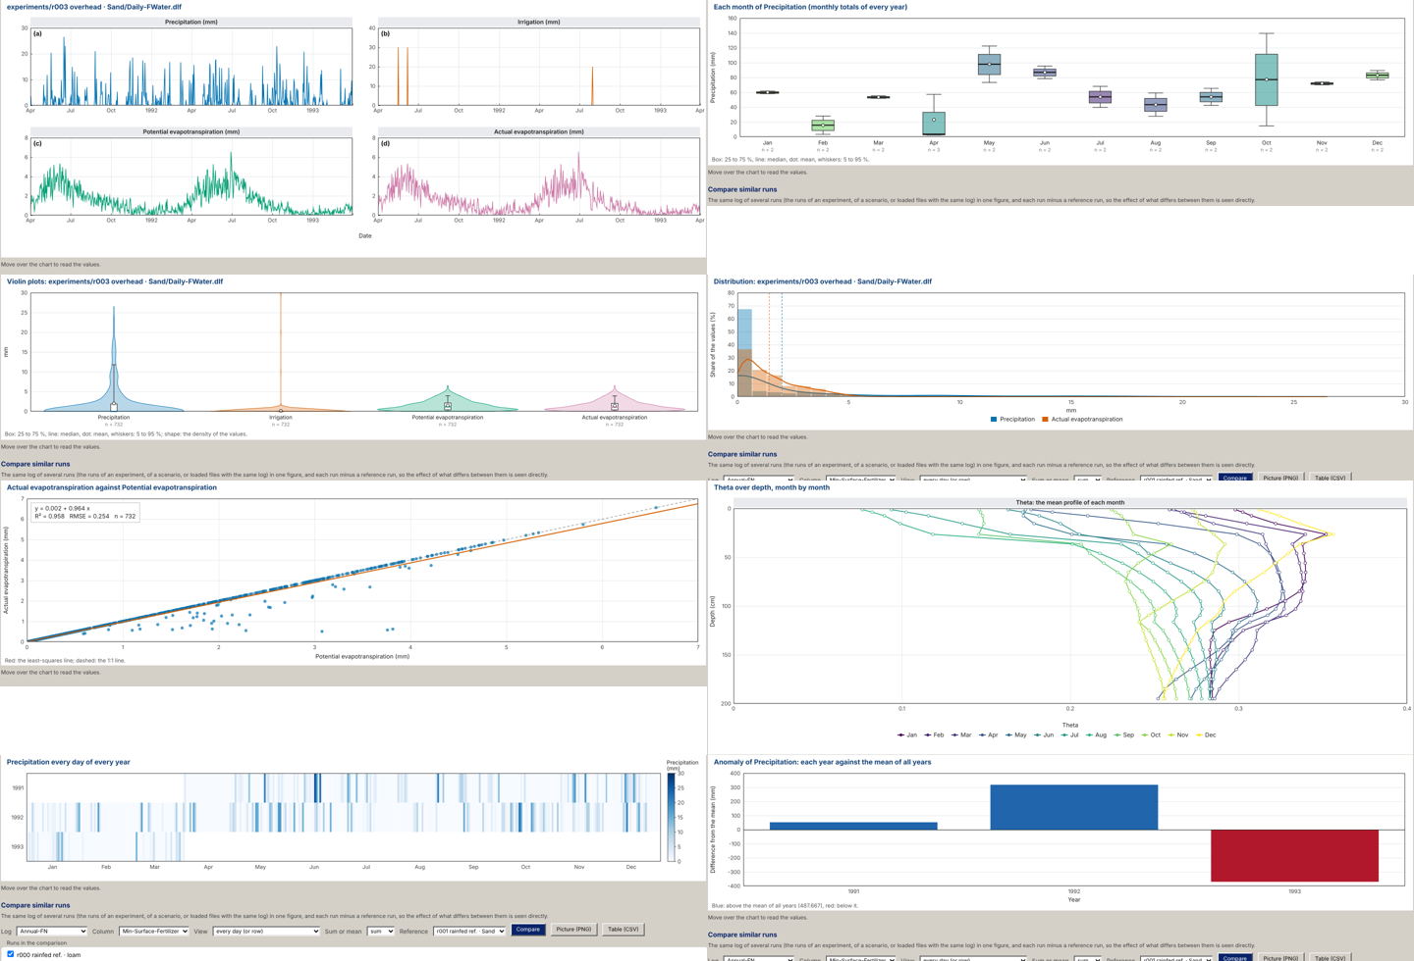
Eight of the twenty kinds of figure of the Log plots of release 1.1.0, drawn from the daily logs of one Daisy run: small multiples, monthly box plots, violin plots, histogram with density, scatter with the least-squares line, R$​^{2}$ and RMSE, the mean profile of each month, a calendar heat map and the anomaly of each year (screen captures).

What is new, item by item.
sets each contribution of this article against what was established before it, so that what is taken from the literature and what is added here can be told apart.
What this article adds, item by item: what was established before, what is new here, and the evidence in this article.
# | Established before | New in this article | Evidence here
# | Established before | New in this article | Evidence here
 | Irrigation tools compute schedules and designs from standard procedures (Allen et al. 1998; Steduto et al. 2009; Šimůnek, van Genuchten, and Šejna 2016) but seldom show which relation produced a number or where it holds. | A ledger in which every numbered equation carries its origin (literature, fitted to data, engineered) and every number of the interface leads to one of them. | equations labelled: 38 literature, 18 fitted, 78 engineered (8).
 | Meta-models of process models speed up screening (Razavi, Tolson, and Burn 2012; Asher et al. 2015). | A meta-model of a designed Daisy ensemble whose rank fidelity and absolute offset are both measured on held-out runs. | Spearman 0.64 to 0.97 on held-out simulations; off-axis nRMSE 6.2 % (ET) and 18.9 % (irrigation) after re-anchoring.
 | Surface, drip and sprinkler design procedures are textbook (Wynn R. Walker and Skogerboe 1987; Keller and Karmeli 1974; Christiansen 1942). | The procedures implemented and checked against published worked examples, with three defects found and removed by that check. | Median error 0.08 %, maximum 1.81 %; a fixed advance exponent that under-predicted slow advance by up to 29 % removed; drip solver reliable to a head loss of 60 %.
 | A suction trigger is set from tables (Allen et al. 1998). | The coupled column shows how one trigger means different things in different soils. | A $−300$ cm trigger uses 24 to 84 % of the plant-available water; drainage ranges from 28 to 164 mm yr$​^{−1}$ under the same rain.
 | – | Two limitations of the system exposed by its own evaluation. | The leaf water potential is set by a conductivity floor; the drainage share of a mulch saving is understated in coarse soils.
 | – | Scenario sweeps fast enough for interactive use while staying traceable. | ${10}^{5}$ scenarios in about 2 s on a laptop.

Conclusions
SWAFL Desktop models the coupled soil–water–atmosphere system of a field column, with five compartments, six water fluxes and the storage change, twelve controls and the relations that link pore structure, retention, evaporation, mulch, roots, the water-potential path, drainage, nitrogen and seven feedback loops to the irrigation decision, and it shows that an offline decision tool can be built in which every output is tied to a numbered equation, a provenance label and a re-runnable check. Evaluated for ten soils, the variables show the coupling quantitatively: a common $−300$ cm trigger uses 24–84 % of the plant-available water, stage-1 evaporation lasts 1.1–3.0 days, and drainage ranges from 28 to 164 mm yr$​^{−1}$ under the same rainfall; the same evaluation found that the leaf water potential is set by a conductivity floor and that the drainage share of a mulch saving is understated in coarse soils. The checks show that the textbook surface procedure and the shipped sprinkler layer reproduce published worked examples and that the shipped surface layer reproduces published advance times (surface: median error 0.08 %, maximum 1.81 % for the reference implementation against one source and $−0.2$ to $+0.5$ % for the shipped layer against a second; drip lateral loss to 0.01 % of the Christiansen factor; sprinkler wetted diameter $+1$ %), that its annual meta-model is a rank-faithful but anchor-sensitive screening emulator (Spearman 0.64–0.97; off-axis nRMSE 6.2 % for ET and 18.9 % for irrigation after re-anchoring), that its daily model conserves mass and reproduces the annual irrigation in 90 % of realistic scenarios but not in sand at dry triggers, and that its drip solver, now iterated to convergence, is reliable up to a head loss of 60 % of the inlet head and warns beyond 20 %. Verification exposed three defects: the sprinkler range coefficient and the drip iteration count, which were corrected in the first released code, and a fixed advance exponent in the surface layer’s steady-intake term, which under-predicted slow advance (up to $−29$ % in Example 6.1) and is removed in release 1.1.0 by iterating the exponent; the provenance labelling is now complete for all 134 equations. The baseline offset, the unverified range coefficients of three sprinkler types, the wind term, the single-soil mulch and warming increments and the conductivity floor of the water-potential path remain open. Field validation remains the necessary next step and is not claimed here.

Release 1.1.0
This paper describes the engines and design modules. Release 1.1.0 also contains a graphical Daisy workbench, a bridge from Daisy output to the decision layers, a library of 48 crops, deterministic phenotyping, a field sketch, Sentinel-2 indices, zone-by-zone variable-rate irrigation and field reports. The weather of the application is a choice and not a fixed record: the built-in benchmark record, seven bundled Daisy stations in five countries, a file of the user (CSV, Excel, Daisy DWF, DLF or DAI), online weather of any place on Earth from the Open-Meteo archive, or DMI open data can be used, and any working date from 1980 to 2100 can be set. The 10 190 simulations behind Engine 1 remain those of one weather record (Taastrup, 1980 to 1999). The working date of the application is now the date of the toolbar, which moved the Engine 2 closure maximum of 9a from 0.78 to 0.70 % of inflow (the median, 0.1 %, is unchanged).

Software, data and code availability
Software. SWAFL Desktop (version 1.1.0) is open source; the Software source is in the project repository (https://github.com/halilunaziru73-creator/Coupled-Water-Fluxes-Pore-Scale-Dynamics-Precision-Irrigation-Mulching-Feedback-Loops/tree/main/Software) and the program for Windows is SWAFL.exe (https://github.com/halilunaziru73-creator/Coupled-Water-Fluxes-Pore-Scale-Dynamics-Precision-Irrigation-Mulching-Feedback-Loops/releases/latest/download/SWAFL.exe).
Manual. The Manual (https://github.com/halilunaziru73-creator/Coupled-Water-Fluxes-Pore-Scale-Dynamics-Precision-Irrigation-Mulching-Feedback-Loops/raw/main/Software/v1.1.0/SWAFL_Desktop/docs/manual_v1.1.0/SWAFL_Manual_v1.1.0.pdf) documents every control, view and equation and labels the provenance of all 134 numbered equations; it can be reviewed or downloaded as a PDF.
Data. The complete Daisy ensemble outputs (all 10 190 runs, raw and derived) are archived on Zenodo, doi: 10.5281/zenodo.23043626. The raw run table, and a linked list of every data file used, are in the Data folder of the repository (https://github.com/halilunaziru73-creator/Coupled-Water-Fluxes-Pore-Scale-Dynamics-Precision-Irrigation-Mulching-Feedback-Loops/tree/main/Data).
Full simulation outputs. Every value of every log of every run (the annual water and nitrogen balances, the harvests and the crop state, year by year), one compressed table per experiment (E00_Baselines to E16_Edge_Cases), the one-row-per-run summary of all 10 190 runs (00_summary_all_simulations), the per-experiment summary (00_SUMMARY_ALL_EXPERIMENTS) and the script that made them (summarize_results3.py) are in the folder Data/Comprehensive_Summary of the repository (https://github.com/halilunaziru73-creator/Coupled-Water-Fluxes-Pore-Scale-Dynamics-Precision-Irrigation-Mulching-Feedback-Loops/tree/main/Data/Comprehensive_Summary); their 20-year means reproduce the run table within 2 %.
Supplementary Material. The Supplementary Material of this article gives the derivation of every equation, the mechanisms behind the results, the data of the analyses and the origin of every table and figure.
The data of every table and figure. One Excel workbook, Data/Manuscript_Data/SWAFL_Manuscripts_Data.xlsx, holds the data of this work and its equations written as live Excel formulas connected to the data (sheets Equations and EQ_*): the run tables, the per-experiment summary, the derived results behind every table and figure, and a map that names, for each table and figure, the script that makes it, its input and its output. The map is also in Data/Manuscript_Data/README.md, and the workbook is rebuilt by Data/Manuscript_Data/make_workbook.py.
Code. The verification scripts (Node.js with Playwright, driving the shipped engine) and the analysis and figure scripts (Python) are in the Code folder (https://github.com/halilunaziru73-creator/Coupled-Water-Fluxes-Pore-Scale-Dynamics-Precision-Irrigation-Mulching-Feedback-Loops/tree/main/Manuscripts). The folder Manuscripts/reproducibility is a self-contained package: pinned software versions (Python 3.13.16, NumPy 2.5.3, SciPy 1.18.1, pandas 3.0.5, scikit-learn 1.9.1, statsmodels 0.15.0, Matplotlib 3.11.2, Pillow 12.3.0, Node.js 22.22.0, Playwright 1.56.0), fixed random seeds in every stochastic step, SHA-256 checksums, and one command (run_all.sh) that regenerates all results and figures and then compares every regenerated value with the archived result and with the headline numbers printed in the manuscript. Each table and figure names the script that produced it (Appendix 9). Daisy itself was not re-run for this package, no field measurements are used, and small intermediate arrays and the interface screenshots are archived rather than regenerated; these limits are listed in README_REPRODUCE.md.

Author contributions
N.H.: software, verification, writing.

Funding
No funding was received for this work.

Competing interests
The author declares no competing interests.

Equation ledger
Equations of this article, their manual numbers, provenance and source.
Eq. | Manual | Content | Provenance | Source
Eq. | Manual | Content | Provenance | Source
[eq:vgP3] | 5.1 | van Genuchten retention | Literature | van Genuchten (1980)
[eq:mualemP3] | 5.2 | Mualem relative conductivity | Literature | Mualem (1976)
[eq:depl] | 5.3 | depletion fraction between 100 and 15 849 cm | Literature | Allen et al. (1998)
[eq:E1E]–[eq:E1N] | 5.4–5.10 | ratio/lookup composition for $E,T,ET,I,Y,D,N_{L}$ | Data-driven | Daisy ensemble
[eq:corr] | 5.11 | set-specific corrections | Data-driven | E2, E3, E4, E13
[eq:E1close] | 5.12 | non-negativity, ceiling, closure window | Engineered | –
[eq:rain] | 5.15 | rainfall generator | Engineered | –
[eq:interc] | 5.16 | interception | Engineered | –
[eq:transp] | 5.22–5.23 | transpiration and stress | Engineered (Literature form) | Allen et al. (1998)
[eq:scale] | 5.24–5.25 | scaling and daily closure | Engineered | –
– | 11.1–11.2 | Saxton–Rawls pedotransfer | Literature | Saxton and Rawls (2006)
– | 11.3 | wetting-front suction | Engineered | –
[eq:GA] | 11.4–11.5 | Green–Ampt | Literature | Green and Ampt (1911)
[eq:kost] | 11.6–11.7 | Kostiakov fit | Literature | Kostiakov (1932)
– | 11.8 | Manning | Literature | Manning (1891)
[eq:vb] | 11.9–11.11 | volume balance | Literature | Wynn R. Walker and Skogerboe (1987; Elliott and Walker 1982)
– | 11.12–11.13 | alternative advance laws | Engineered | course notes
[eq:vols,eq:eff] | 11.15–11.19 | depths, volumes, efficiencies, CU | Literature | Wynn R. Walker and Skogerboe (1987; Burt et al. 1997; Christiansen 1942)
– | 11.20–11.21 | hydrograph and recession | Engineered | –
[eq:HW] | 12.3–12.5 | Hazen–Williams, emitter equation | Literature | Williams and Hazen (1905; Keller and Karmeli 1974)
[eq:Eu] | 12.7–12.8 | emission uniformity | Literature | Keller and Karmeli (1974)
– | 12.9–12.15 | wetted bulb and losses | Engineered | –
– | 12.16–12.19 | emitter spread and efficiencies | Engineered | –
[eq:nozzle] | 13.2–13.3 | nozzle, wetted radius | Literature / Engineered | Keller and Bliesner (1990)
– | 13.4–13.7 | pattern, wind, overlap, CU | Engineered | Christiansen (1942)
– | 13.8 | wind drift and evaporation | Engineered | –
– | 13.9–13.12 | intake, ponding, efficiencies | Engineered | –
– | 13.13–13.23 | checklist, pipes, pump | Literature | Keller and Bliesner (1990; Blasius 1913)
System variables (Section 3)
[eq:balance] | 5.12, 5.25 | water-balance identity | Literature | –
[eq:cover] | 5.13–5.14 | canopy cover | Engineered | –
[eq:redis] | 5.17 | layer redistribution | Engineered | –
[eq:rmax,eq:rd,eq:rootdens] | 5.18–5.20 | rooting depth and root density | Engineered | –
[eq:e0] | 5.26 | evaporative demand under warming | Engineered | –
[eq:Zn] | 5.27 | net irrigation depth | Literature (engineered clip) | Allen et al. (1998)
[eq:Ny] | 6.1–6.2 | days beyond the trigger | Data-driven | Daisy daily output
[eq:invdepl] | 6.3–6.4 | inverse depletion; net depth per soil | Literature | van Genuchten (1980; Allen et al. 1998)
– | 6.5 | relative yield at the trigger | Data-driven | E2
[eq:layer,eq:psisoil] | 7.1 | layer suction, root-zone potential | Literature (engineered floor) | van Genuchten (1980)
[eq:spac] | 7.2–7.4 | series resistances, root, stem, leaf potential | Engineered | van den Honert (1948)
[eq:psiair] | 7.5 | air water potential | Literature | Nobel (2009)
[eq:share] | 7.6 | share of root zone beyond the trigger | Engineered | –
[eq:pore] | 8.1 | pore space and consolidation | Engineered | Flanagan and Nearing (1995)
[eq:poros] | 8.2 | porosity and residual content | Engineered | –
– | 8.3 | retention $θ\left(h\right)$ | Literature | van Genuchten (1980)
[eq:jurin] | 8.4 | capillary radius | Literature | Hillel (1998)
[eq:drivers] | 8.5–8.6 | tillage and consolidation effects; regression on clay | Data-driven | E5
[eq:zp] | 8.7 | depth holding a share of uptake | Engineered | –
[eq:mulchdelta] | 9.1 | mulch effects on the fluxes | Data-driven | E7, E11, E14
[eq:twostage] | 9.2–9.3 | two-stage evaporation | Engineered | Ritchie (1972; Philip 1957)
[eq:front] | 9.4–9.5 | drying front and suction profile | Engineered | –
[eq:fate] | 9.6–9.7 | fate of saved evaporation | Data-driven | E7, E11, E14
[eq:regime] | 9.8 | regime index | Engineered | –
4 | 10.1 | feedback-loop arrow width | Engineered | –
[eq:kappaN] | 10.2 | nitrate cost of drainage | Data-driven | E11

Verification tests and reproducibility map
The Supplementary Material traces every result back to the data: for each number it names the experiment and runs used, the filter applied, the computation, and the script, result file and workbook sheet that reproduce it; the workbook repeats the algebra as live Excel formulas.
Test and result to script map. Scripts are in Manuscripts/reproducibility/ (p3_js/ for the Node.js scripts that drive the shipped engine, analysis/ for Python); outputs are archived in Manuscripts/results/.
Test or result | What is compared or computed | Script $→$ output
System variables of ten soils ([tab:swa-hyd,tab:swa-bal,tab:swa-plant], 2) | Engine 1, Engine 2, water-potential path, evaporation, mulch fate | swa_vars.js $→$ p3_swa_vars.json; p3_swa_fig.py
Furrow Example 6.1 (12) | $T_{req}$, $t_{L}$, $E_{a}$ against the book (reference implementation lib/wsmodel.js) | v_surface.js $→$ p3_surface.json, p3_ws61.csv
Example 6.1 through the shipped surface layer | $t_{L}$ as shipped and with the iterated advance exponent | v_surface_shipped.js $→$ p3_surface_shipped.json
Border Example 6.4 (13) | $T_{req}$, $Q_{max}$, $t_{L}$, $A_{0}$ | v_border.js $→$ p3_border.json
FAO-45 border examples (11a) | advance times | run_fao.js $→$ fao_out.json
Sprinkler example and spacing (13, 11b) | decision logic, nozzle, diameter, CU | v_sprinkler.js, run_spr.js $→$ p3_sprinkler.json, spr_out.json
Engine 1 held-out (14, 8) | 000 E12 runs | make_e12.py, e1_heldout.js $→$ e12.json, e12_pred.json
Engine 2 closure and calibration (9) | random states; 100 scenarios | e2_closure.js, e2_grid.js $→$ p3_e2_closure.json, p3_e2_grid.json
Drip lateral solver (15, 10) | independent solver, 400 configurations; Christiansen factor | v_drip.js, run_drip.js $→$ p3_drip_swafl.json, drip_out.json
Sensitivity (6) | one-at-a-time runs | e1_sens.js, l_sens.js $→$ p3_e1_sens.json, p3_l_sens.json
Run time | median call time | bench.js $→$ p3_bench.json
Depletion collapse of E2 (pooled $R^{2}$, 11) | cubic fits against suction and depletion | Results/08_Scripts/novel.py (figure N1 in Results/00_Novel_Contributions)
Figures |  | p3_figs.py, p3_lit_figs.py, p3_sens_fig.py, p3_swa_fig.py, p3_fig01_workflow_v9.py
All steps, checks and limits |  | run_all.sh, compare_results.py, audit_numbers.py, README_REPRODUCE.md

Interface screenshots of every view
All interface screenshots of the project are collected here, grouped as the result views of Section 5.2. Each is a full-window capture of SWAFL Desktop (version 1.1.0, window of 2000$×$1125 points at twice the pixel density); the full-resolution files (4000$×$2250 px) are in Manuscripts/figures/shots/ of the repository, and every screen is documented, with numbered arrows on each element, in the Manual.
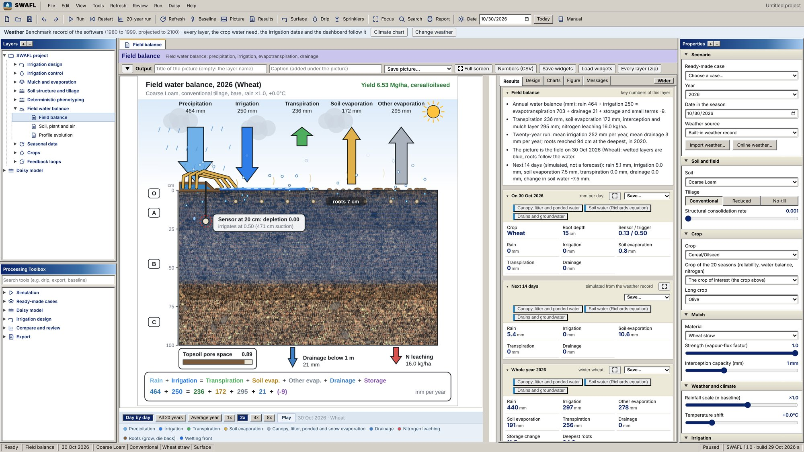  Field balance, the home view: daily fluxes on the field clock, the soil profile with sensor, roots and wetting front, and the closed budget ([eq:balance]). |  | 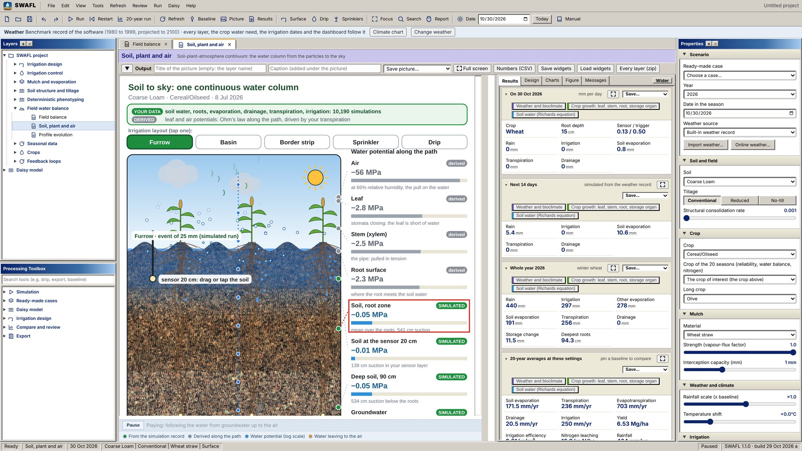  Soil, plant and air: layouts of the five irrigation methods and the water potential along the path from the deep soil to the air ([eq:psisoil,eq:spac,eq:psiair]).
SWAFL Desktop: field and the soil–plant–air path.
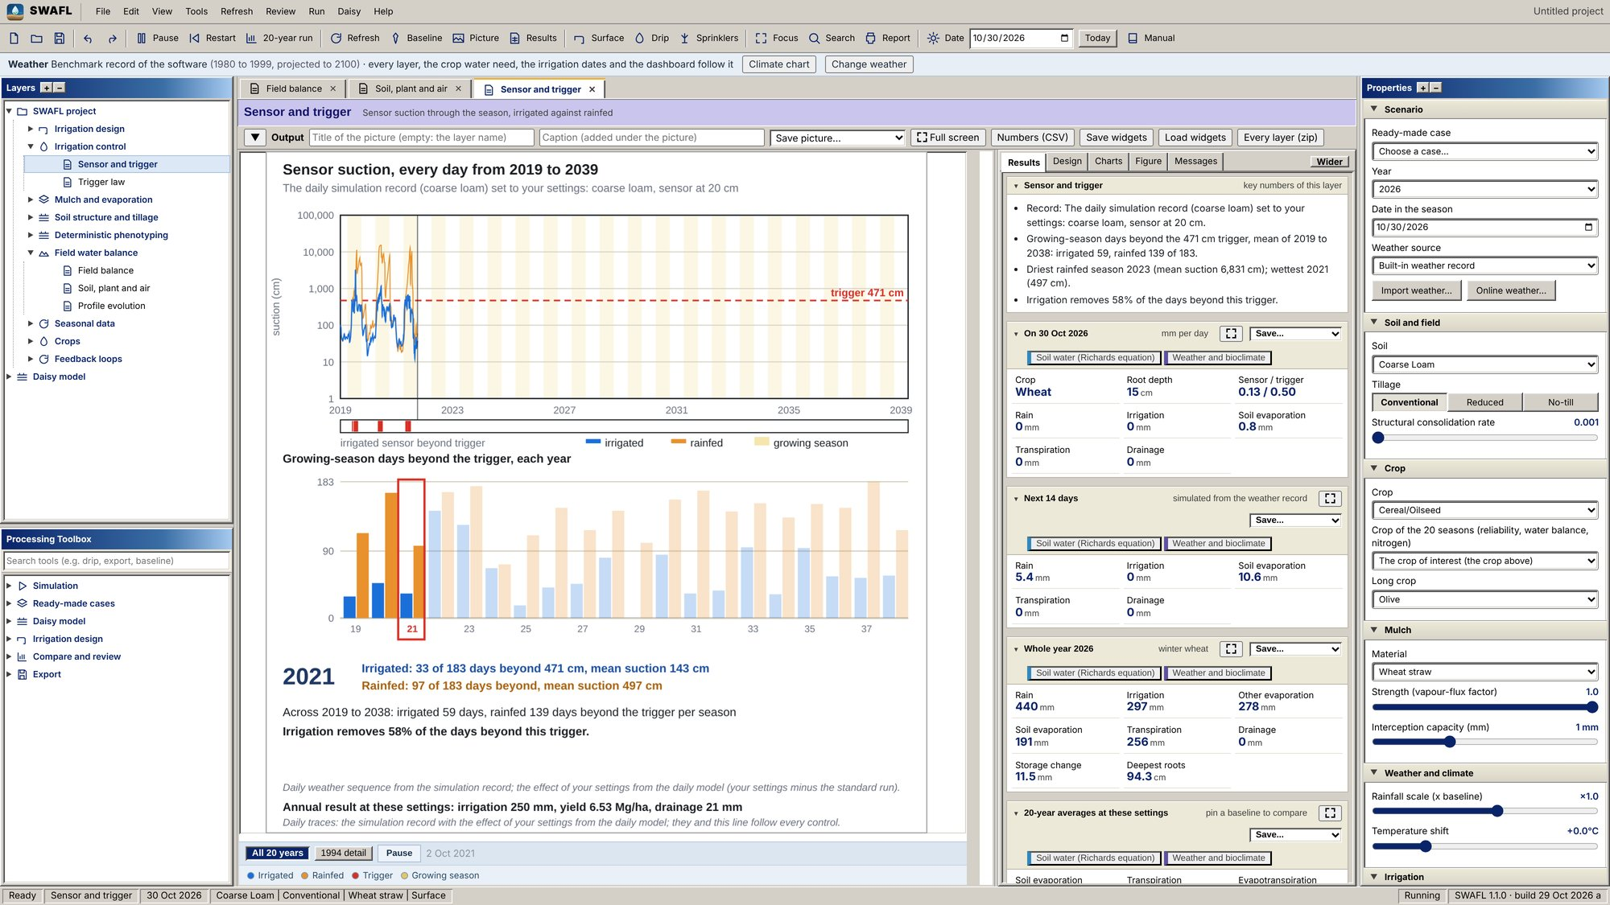  Sensor and trigger: 20 years of daily suction at the sensor, irrigated and rainfed, against the trigger, and the days beyond the trigger per year ([eq:Ny]). |  | 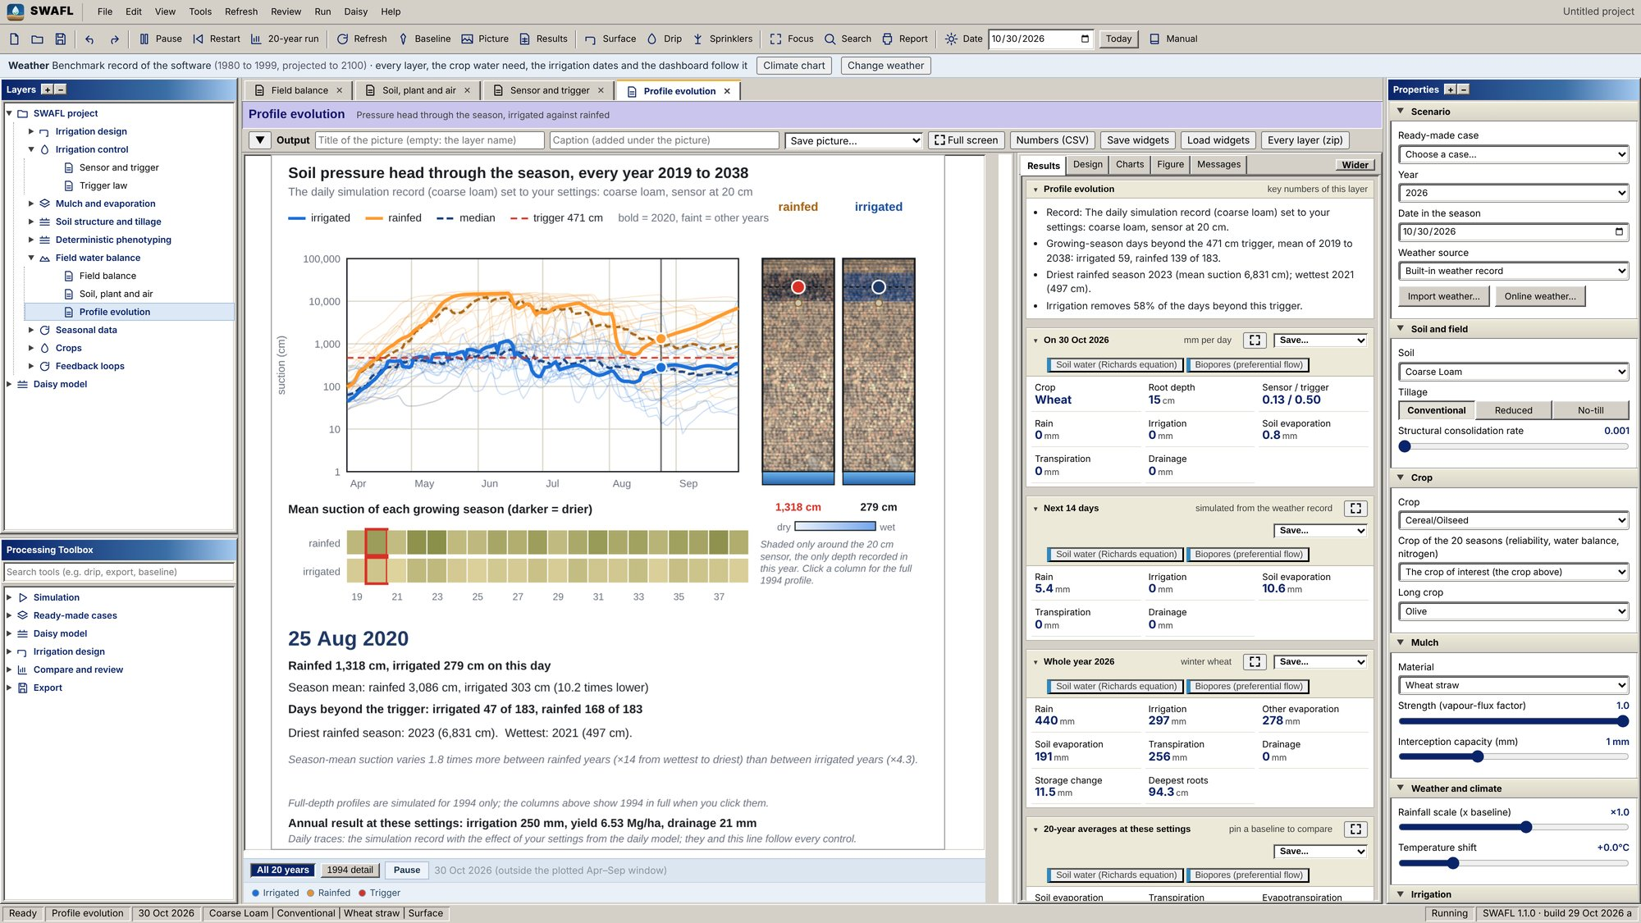  Profile evolution: pressure-head profile through the season, irrigated and rainfed, and the share of the root zone beyond the trigger ([eq:share]).
SWAFL Desktop: soil water and irrigation timing.
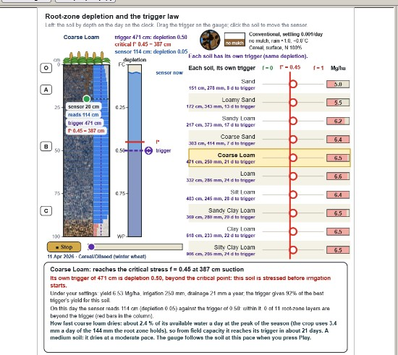
Trigger law: root-zone depletion of ten soils on one axis with the critical depletion $f^{*}$, each soil’s own trigger suction and yield, and the gauge of the sensor through the season ([eq:depl,eq:invdepl,eq:Zn])
SWAFL Desktop: trigger law.
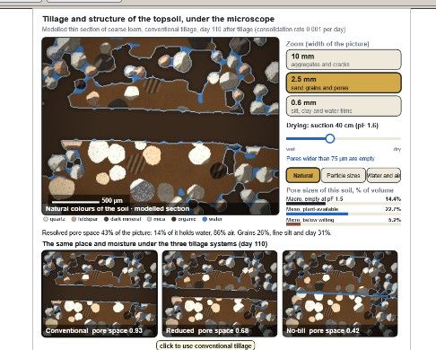  Tillage and structure: modelled thin section of the topsoil with the water- and air-filled pores at the chosen suction, the pore sizes, and the same place under conventional, reduced and no tillage ([eq:jurin]) |  | 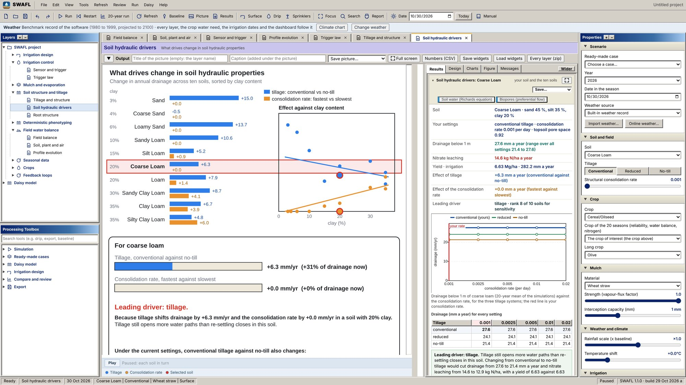  Soil hydraulic drivers: tillage and consolidation effects on drainage for the ten soils and their regressions on clay content ([eq:drivers]).
SWAFL Desktop: soil structure and hydraulic drivers.
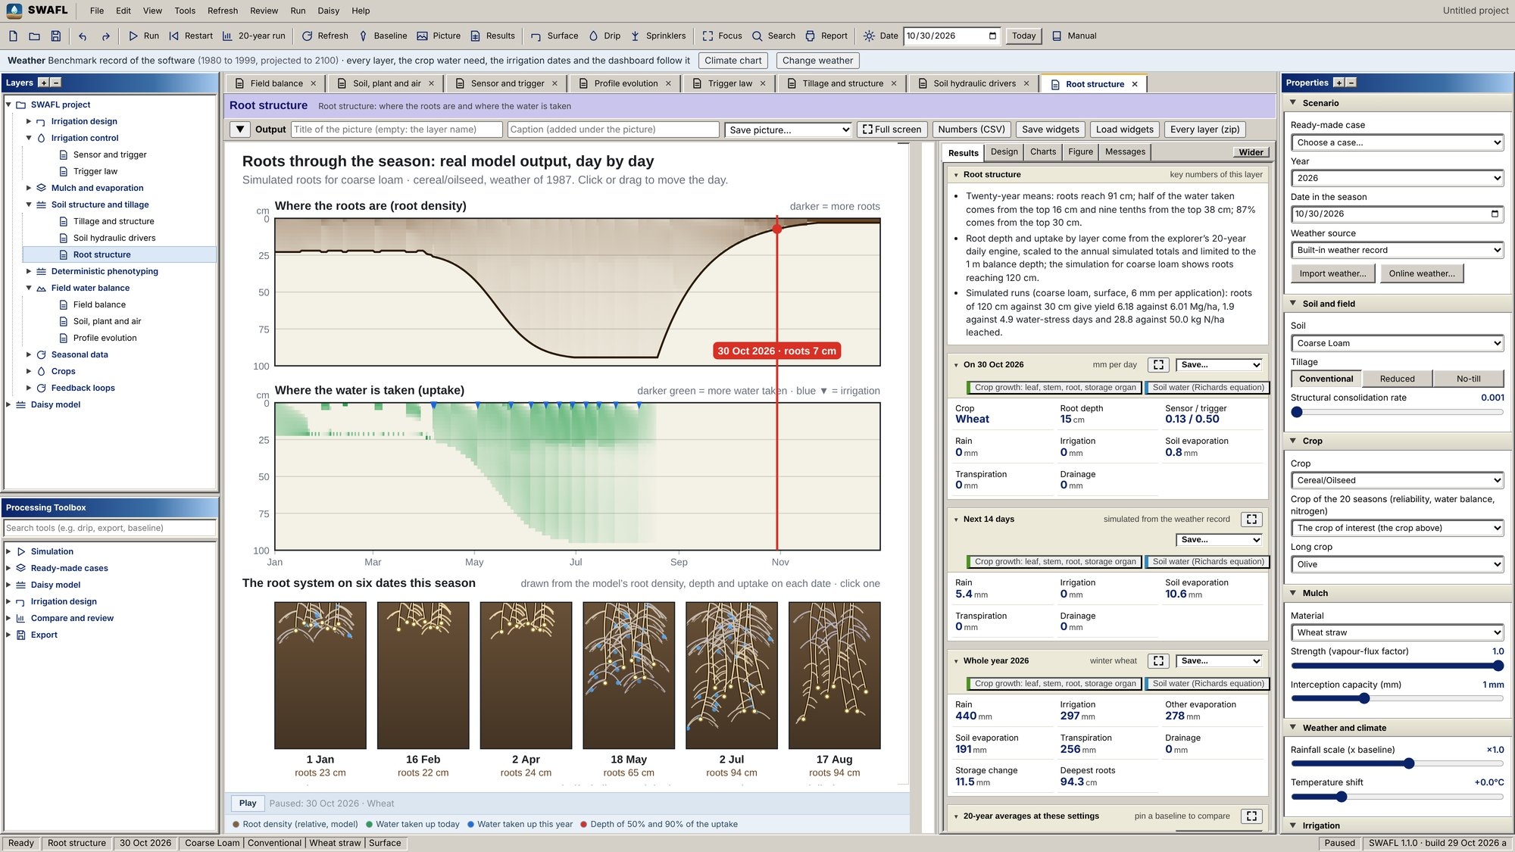
Root structure: rooting depth and the depths holding 50 and 90 % of uptake in the ten soils ([eq:rmax,eq:rd,eq:rootdens,eq:zp]), with the E15 rooting-depth heat maps.
SWAFL Desktop: roots.
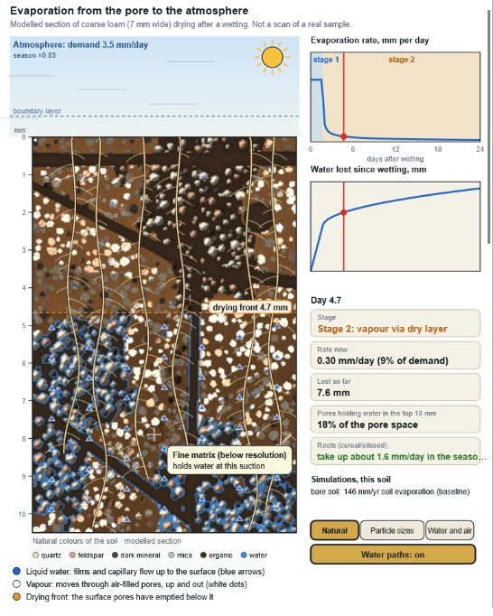  Evaporation from the pore to the atmosphere: a modelled section of coarse loam drying after a wetting, the drying front, stage-1 and stage-2 evaporation and the water lost since wetting ([eq:twostage,eq:front]) |  | 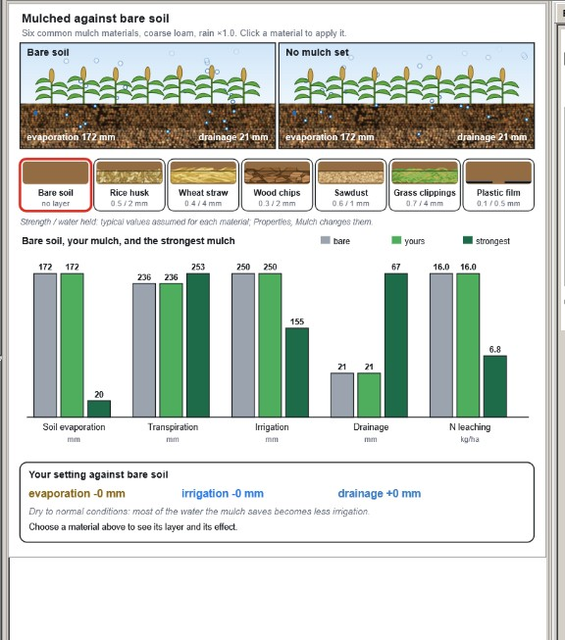  Mulch against bare soil: six mulch materials, and soil evaporation, transpiration, irrigation, drainage and nitrate leaching under bare soil, the chosen mulch and the strongest mulch ([eq:mulchdelta])
SWAFL Desktop: evaporation and mulch.
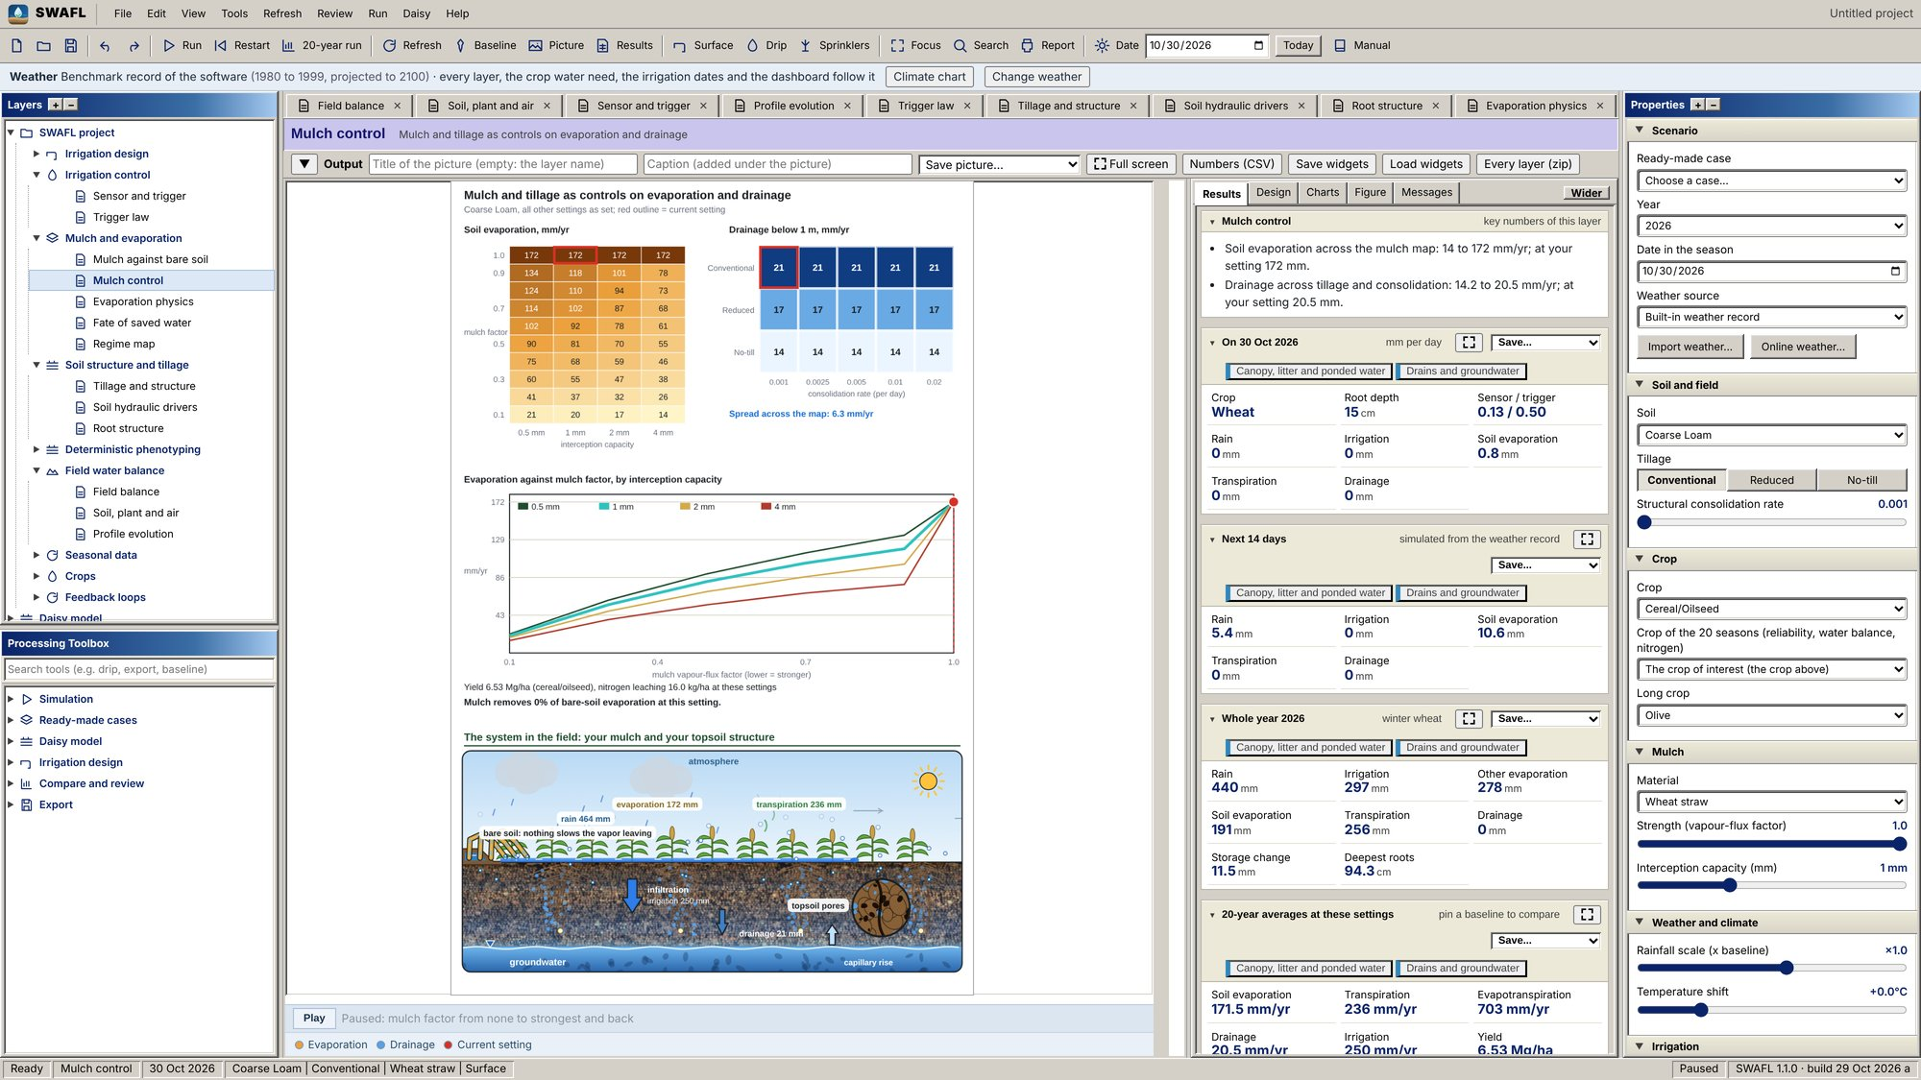  Mulch control: soil evaporation by mulch factor and interception capacity, and drainage by tillage and consolidation rate. |  | 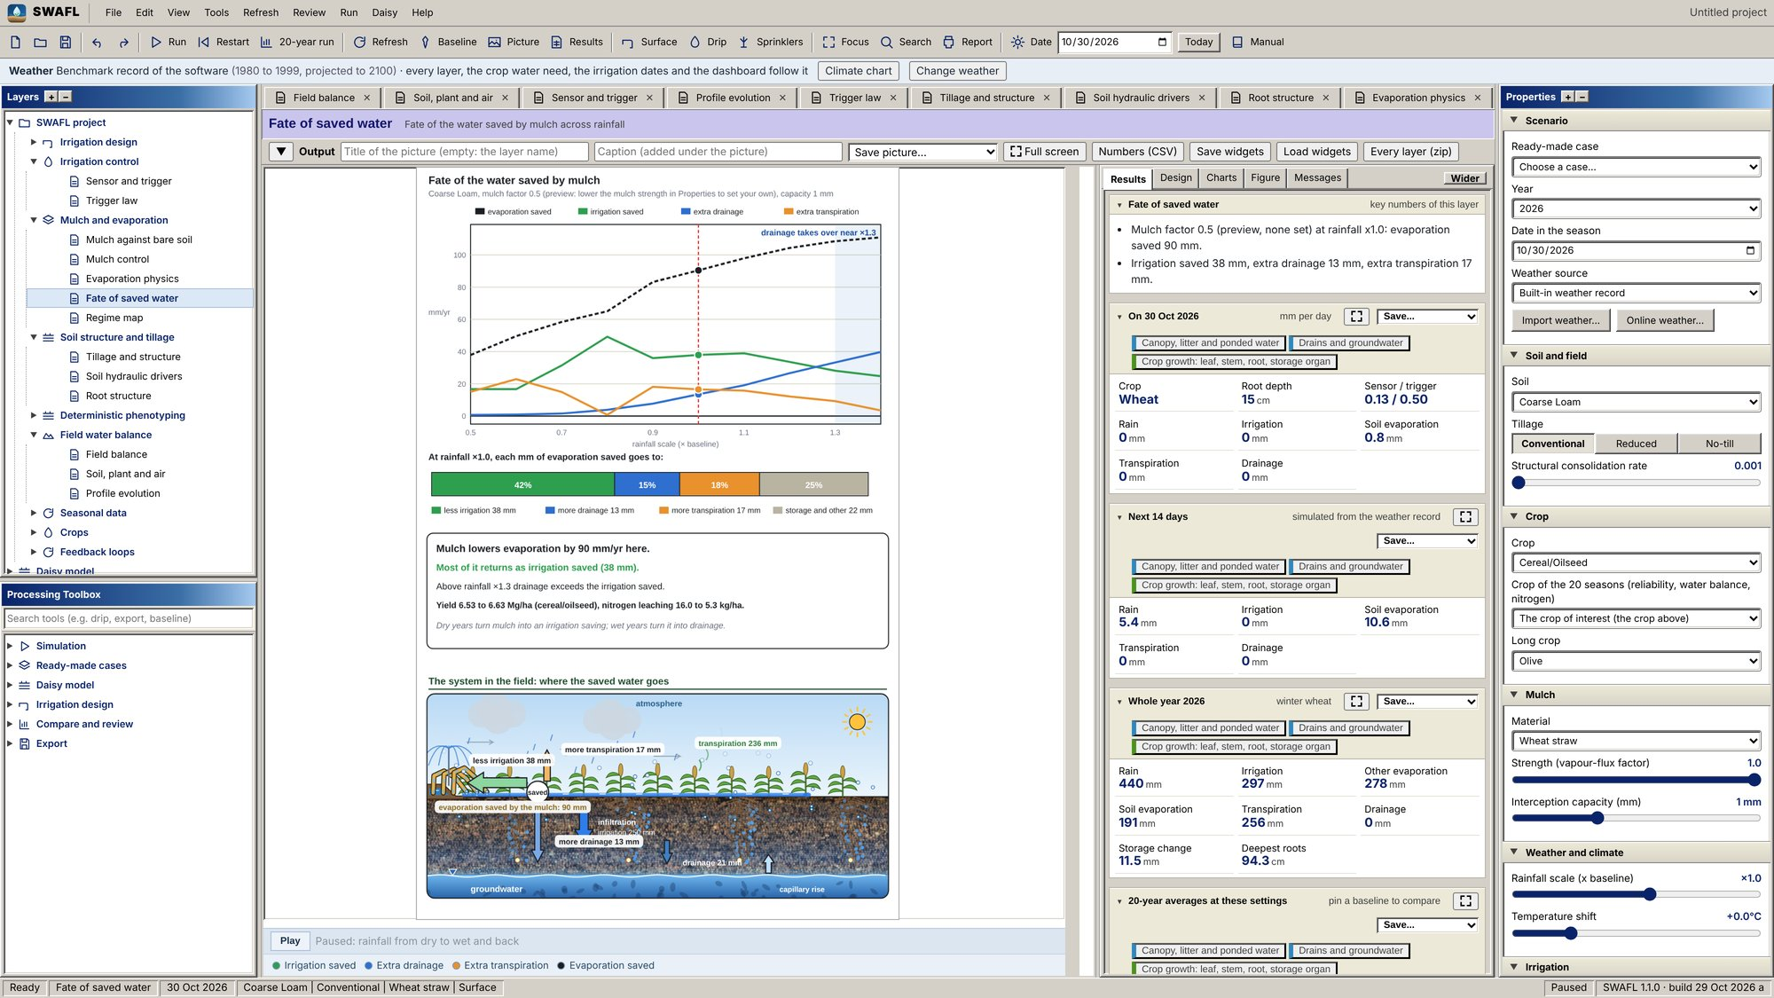  Fate of saved water: evaporation saved, irrigation saved, extra drainage and extra transpiration against the rainfall scale ([eq:fate]).
SWAFL Desktop: mulch control and the fate of saved water.
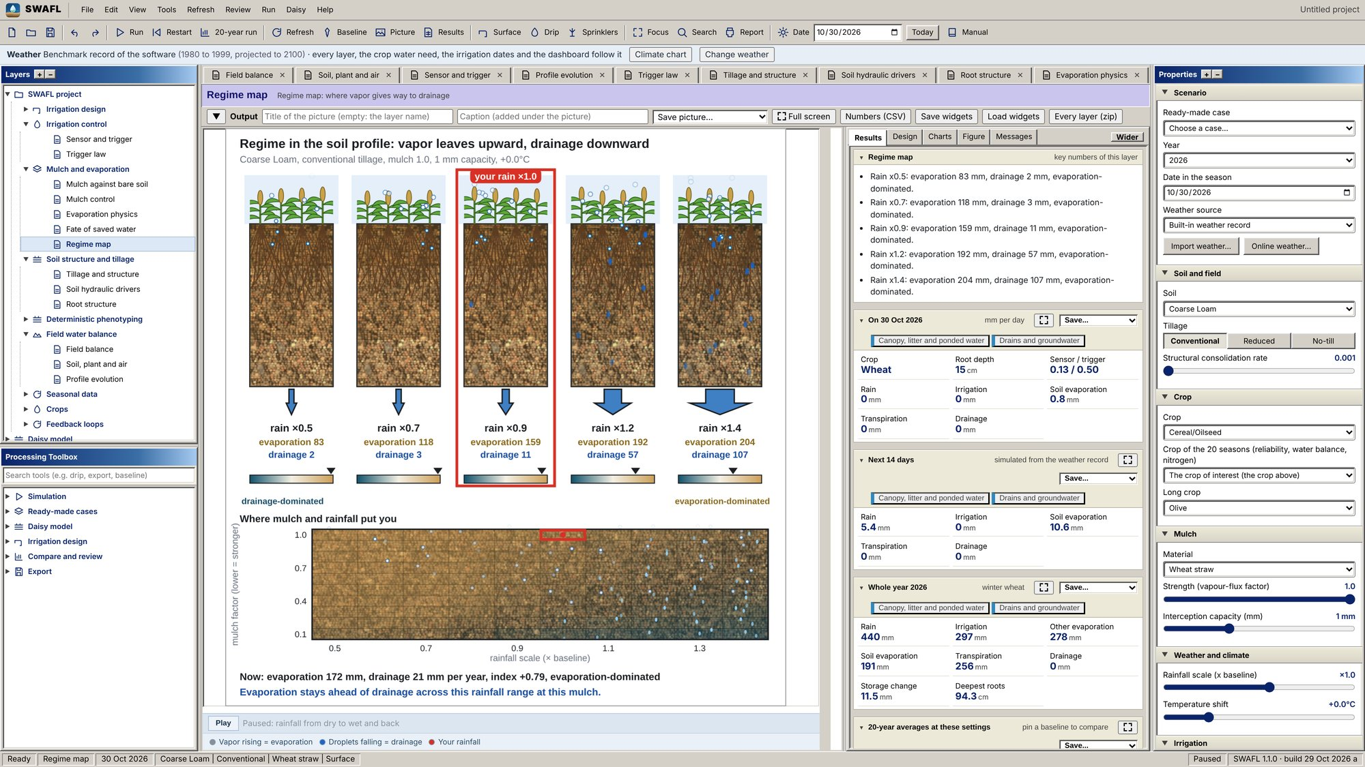  Regime map: mulch factor against rainfall scale coloured by the dominant loss ([eq:regime]). |  | 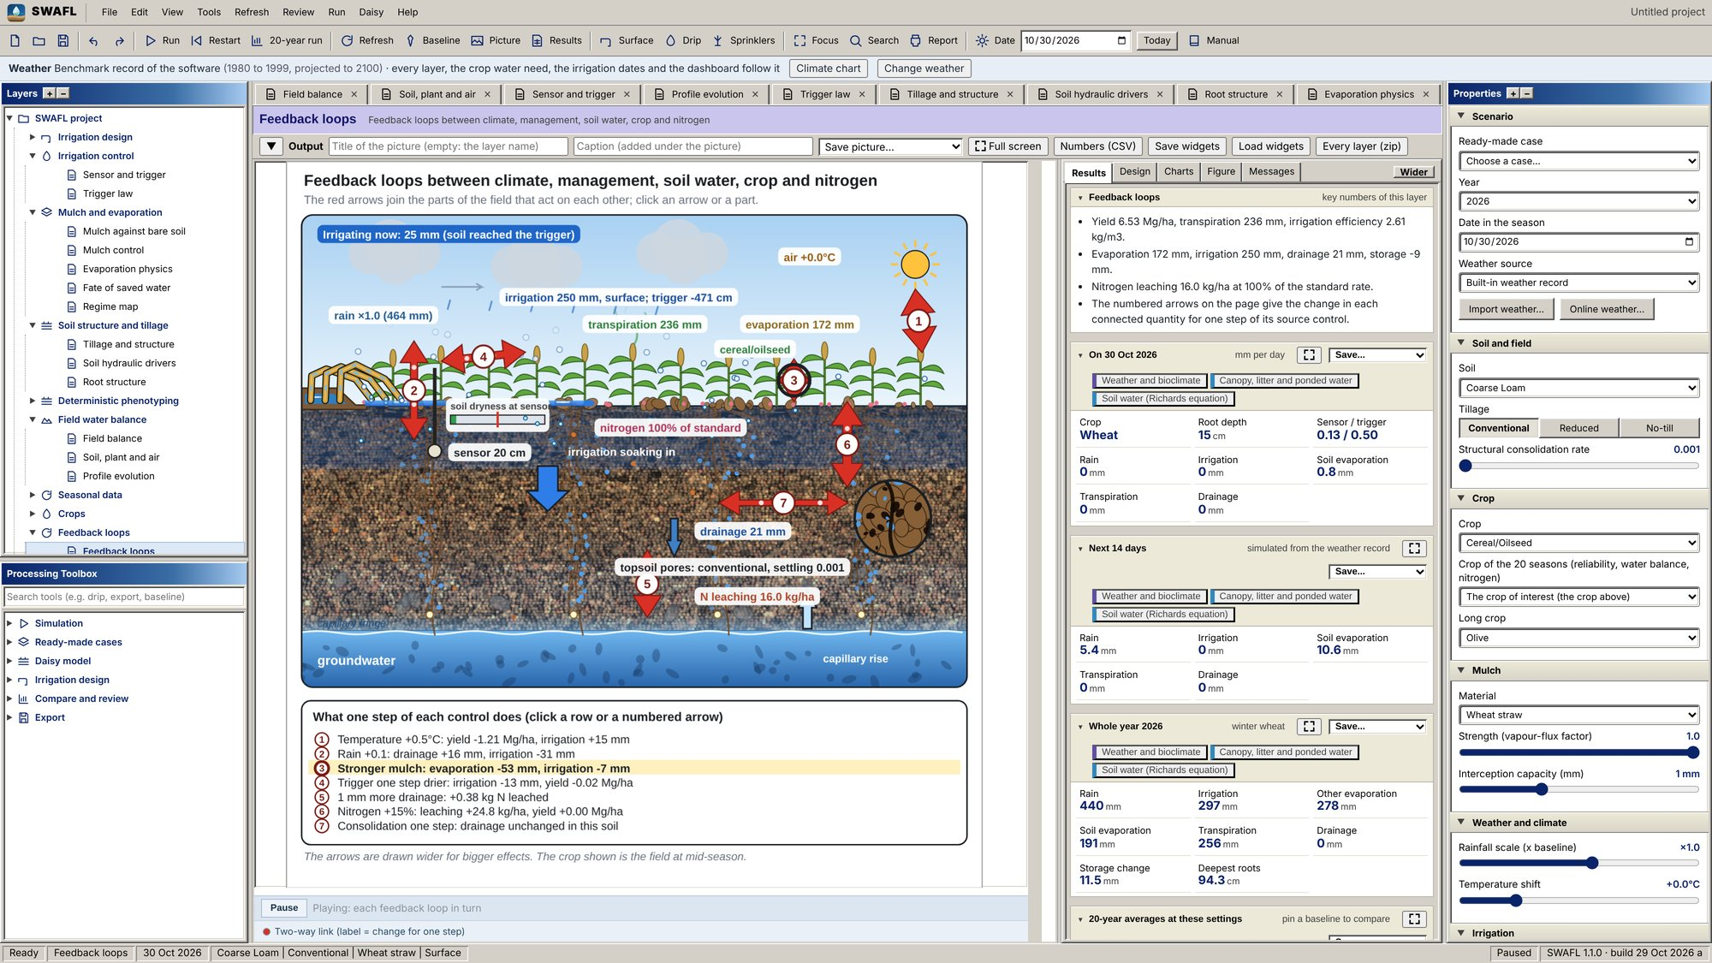  Feedback loops: the seven loops with arrow widths scaled by the effect of one control step (4).
SWAFL Desktop: regime map and feedback loops.
  Surface-irrigation layer: start from your soil or a textbook design (A7, A9, A11, D1), border strip, furrow or basin, intake from the soil or by $k$ and $A$, the cutoff rule, and the inputs carried from the soil, root zone and trigger of the DSS (Section 4.4) |  | 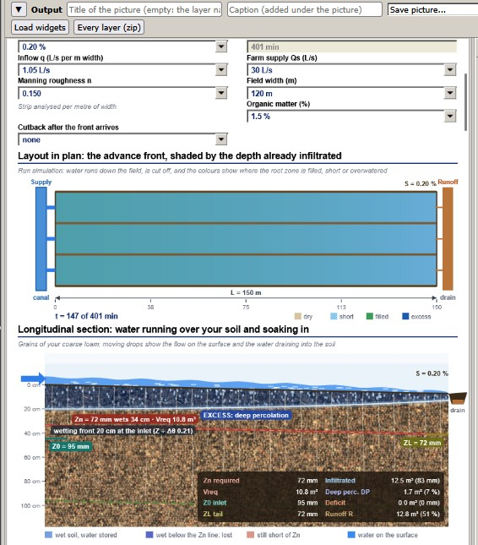  Surface irrigation: layout in plan with the advance front shaded by the depth already infiltrated, and the longitudinal section with the wetting front, the required depth $Z_{n}$, deep percolation and runoff ([eq:vb,eq:vols])
SWAFL Desktop: surface irrigation.
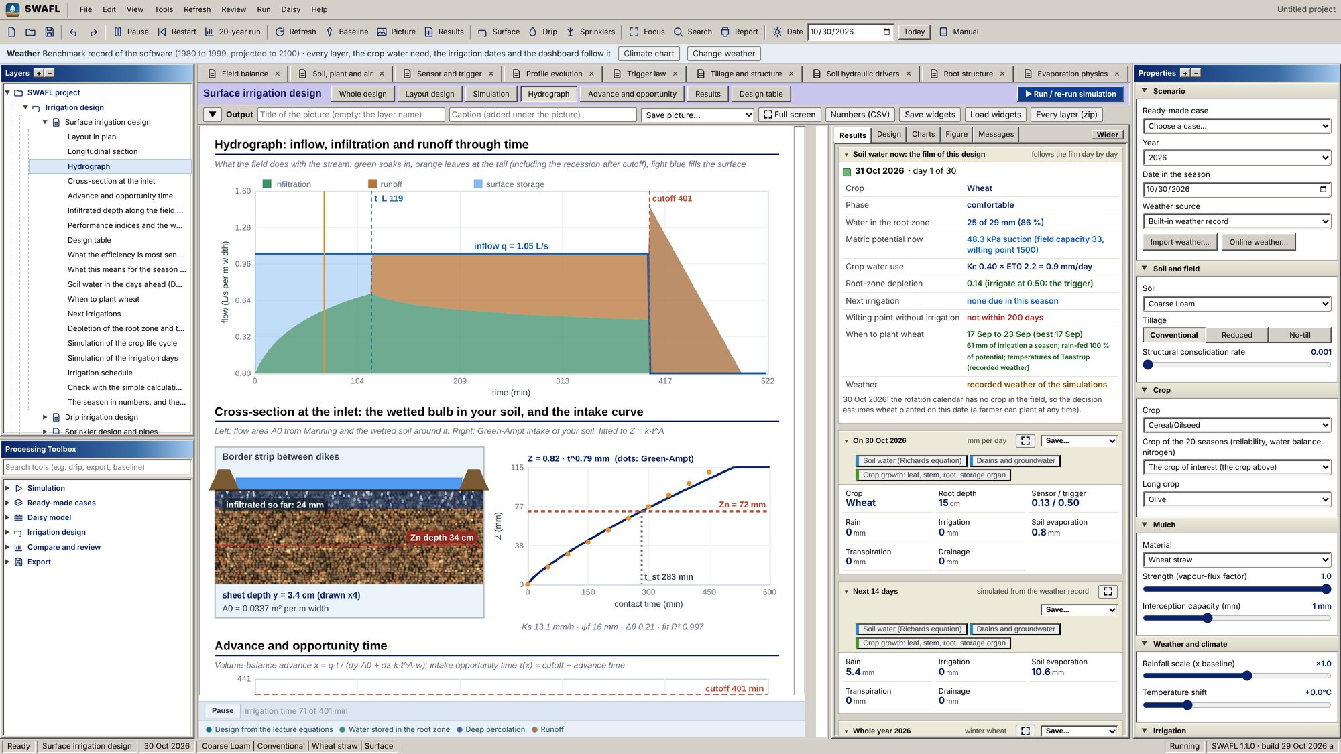  Surface irrigation: hydrograph of inflow, infiltration and runoff through time. |  | 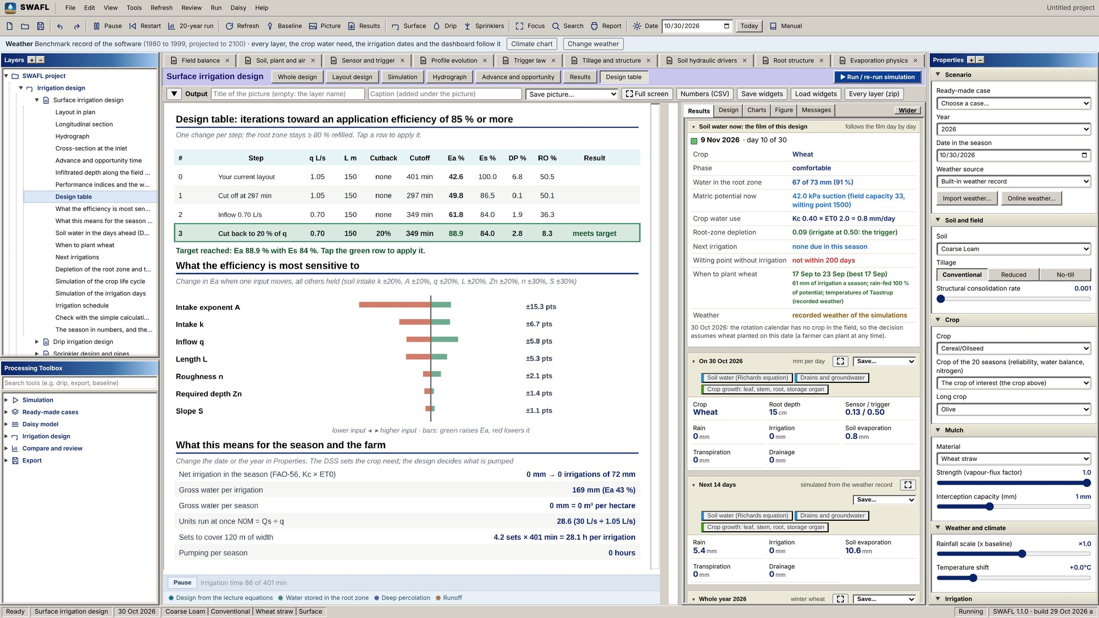  Surface irrigation: design table of options with application and storage efficiency, deep percolation and runoff ([eq:eff]).
SWAFL Desktop: surface irrigation, schedule and design table.
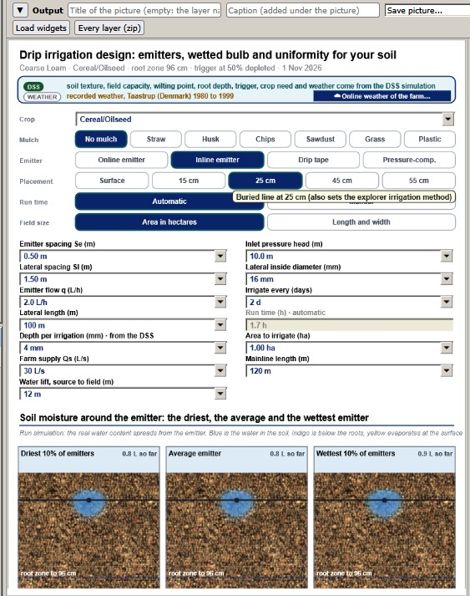  Drip-irrigation layer: crop, mulch, emitter type and placement, the design inputs, and the soil moisture around the driest, the average and the wettest emitter (Section 4.4.0.1) |  | 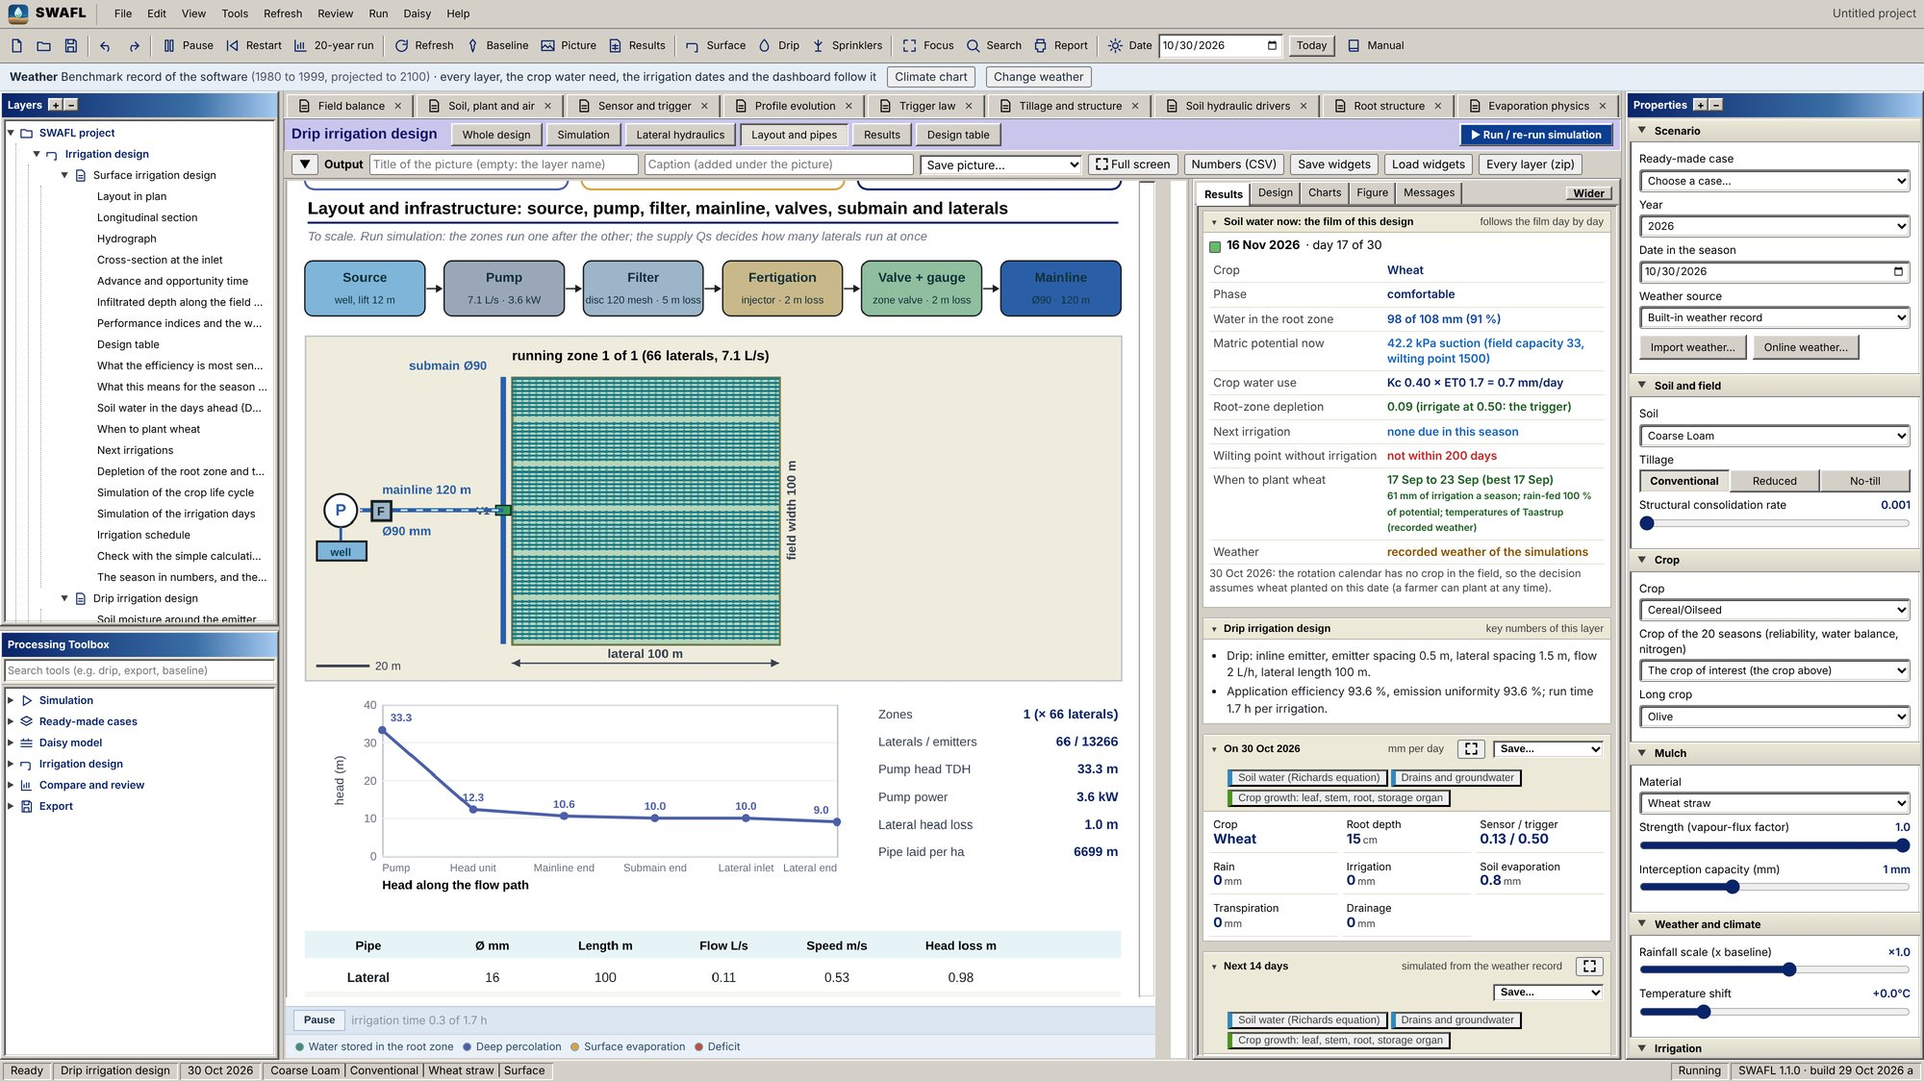  Drip irrigation: field layout and infrastructure.
SWAFL Desktop: drip irrigation.
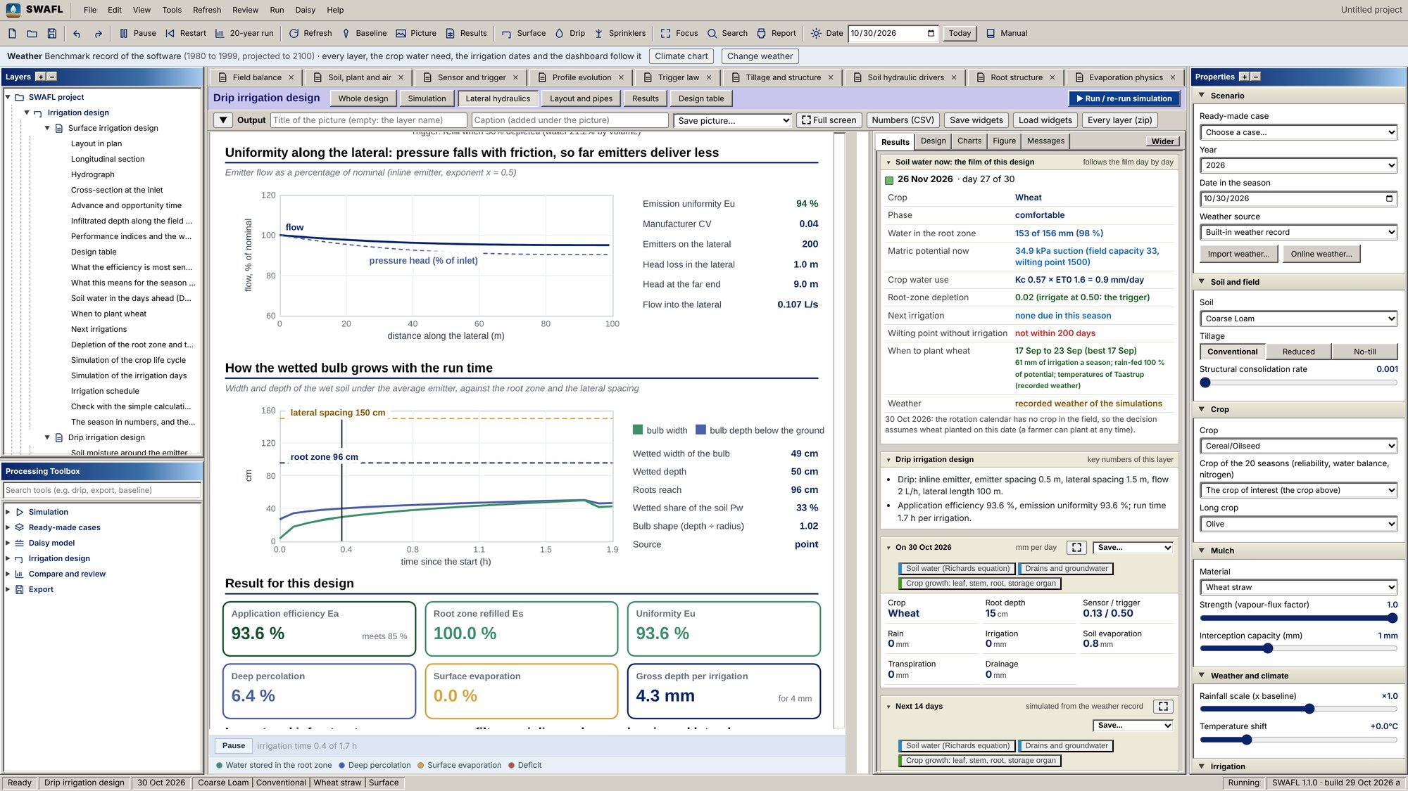  Drip irrigation: head and emitter flow along the lateral ([eq:HW]) with the 20 % loss warning. |  | 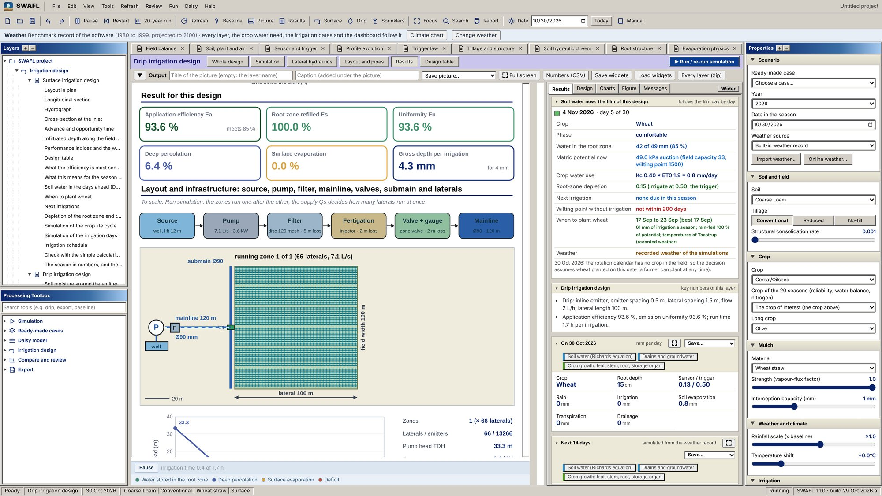  Drip irrigation: result summary with emission uniformity ([eq:Eu]) and efficiencies.
SWAFL Desktop: drip irrigation, lateral and results.
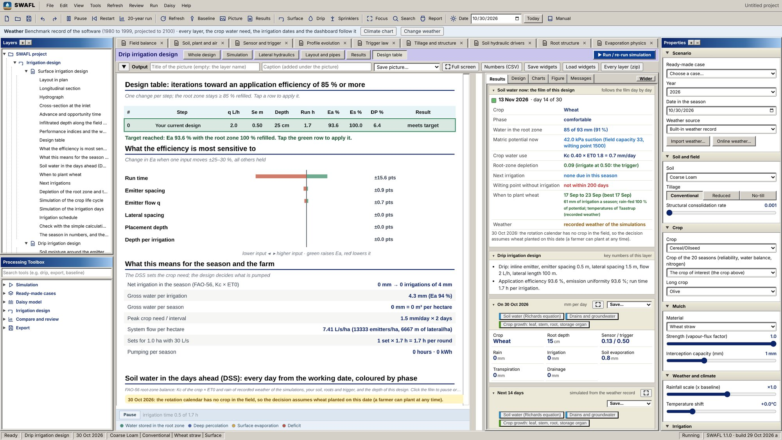
Drip irrigation: design table, iterations toward an application efficiency of 85 % or more.
SWAFL Desktop: drip irrigation, design table.
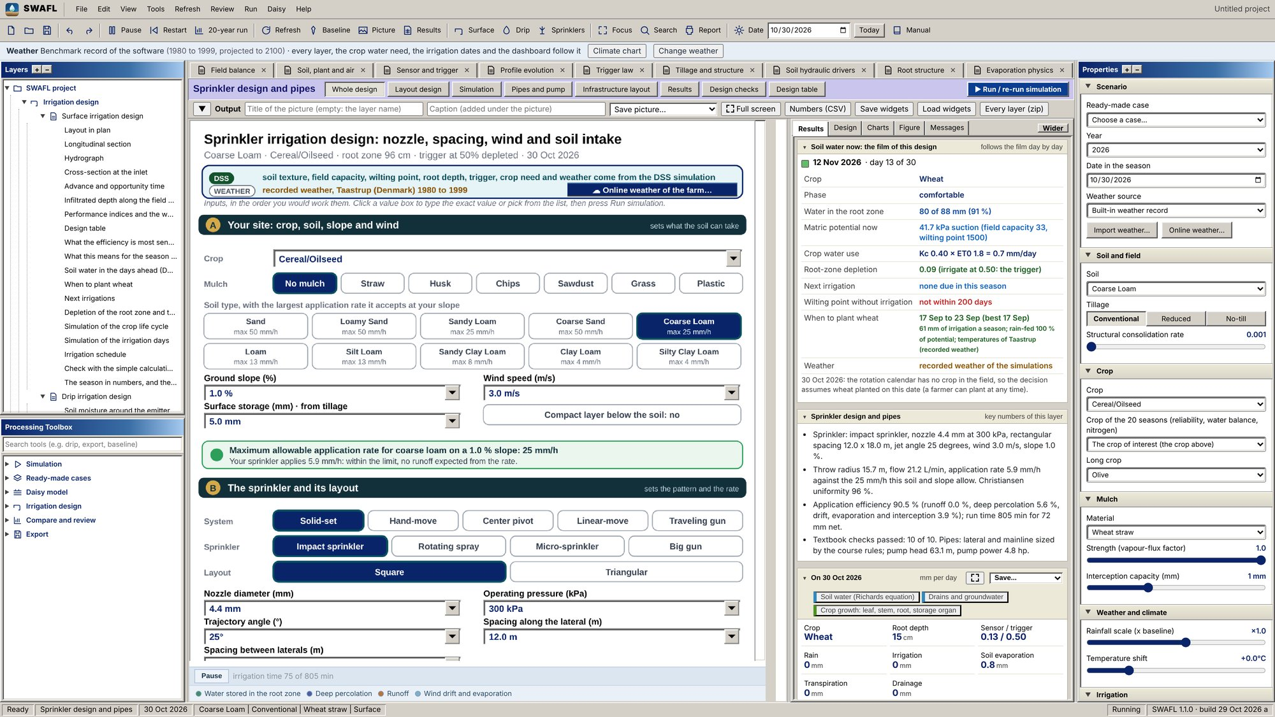  Sprinkler layer: nozzle, wetted radius, pattern, overlap and uniformity ([eq:nozzle]; Section 4.4.0.2). |  | 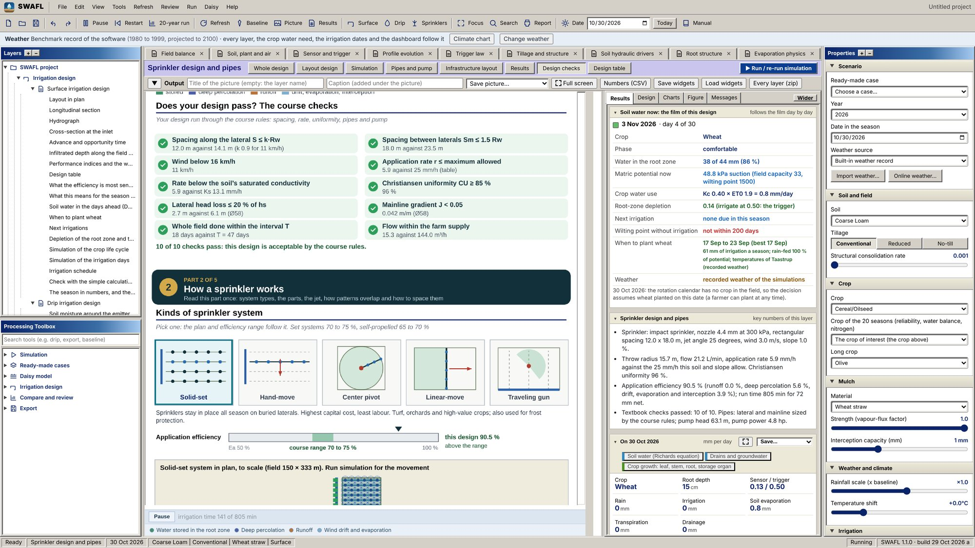  Sprinkler design: textbook decision checklist (sprinkler class, spacing, application rate, sets per day).
SWAFL Desktop: sprinkler irrigation.
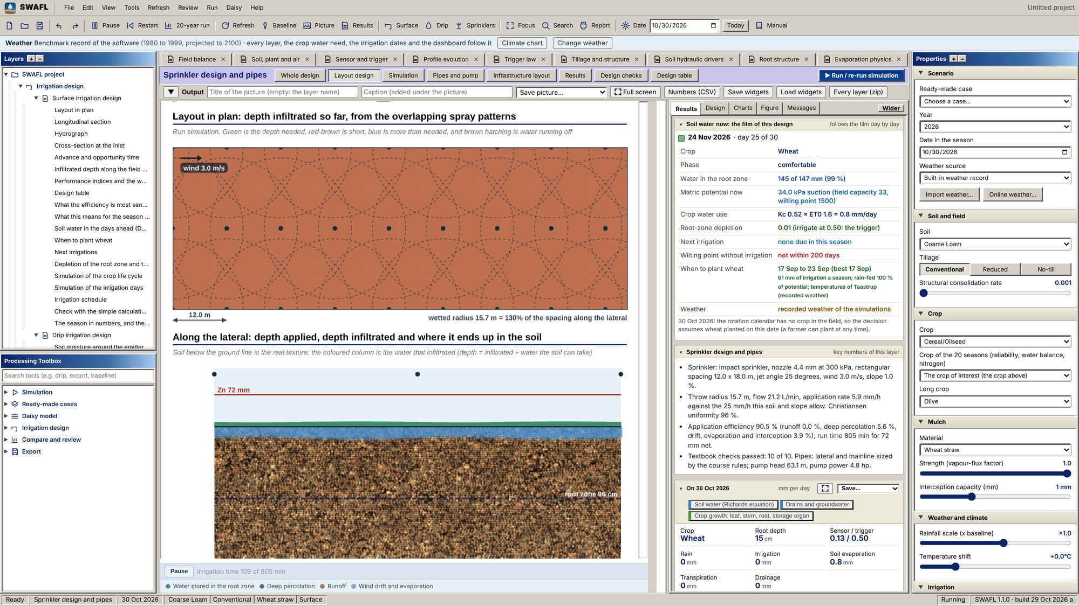  Sprinkler: layout in plan, with the depth infiltrated from the overlapping spray patterns. |  | 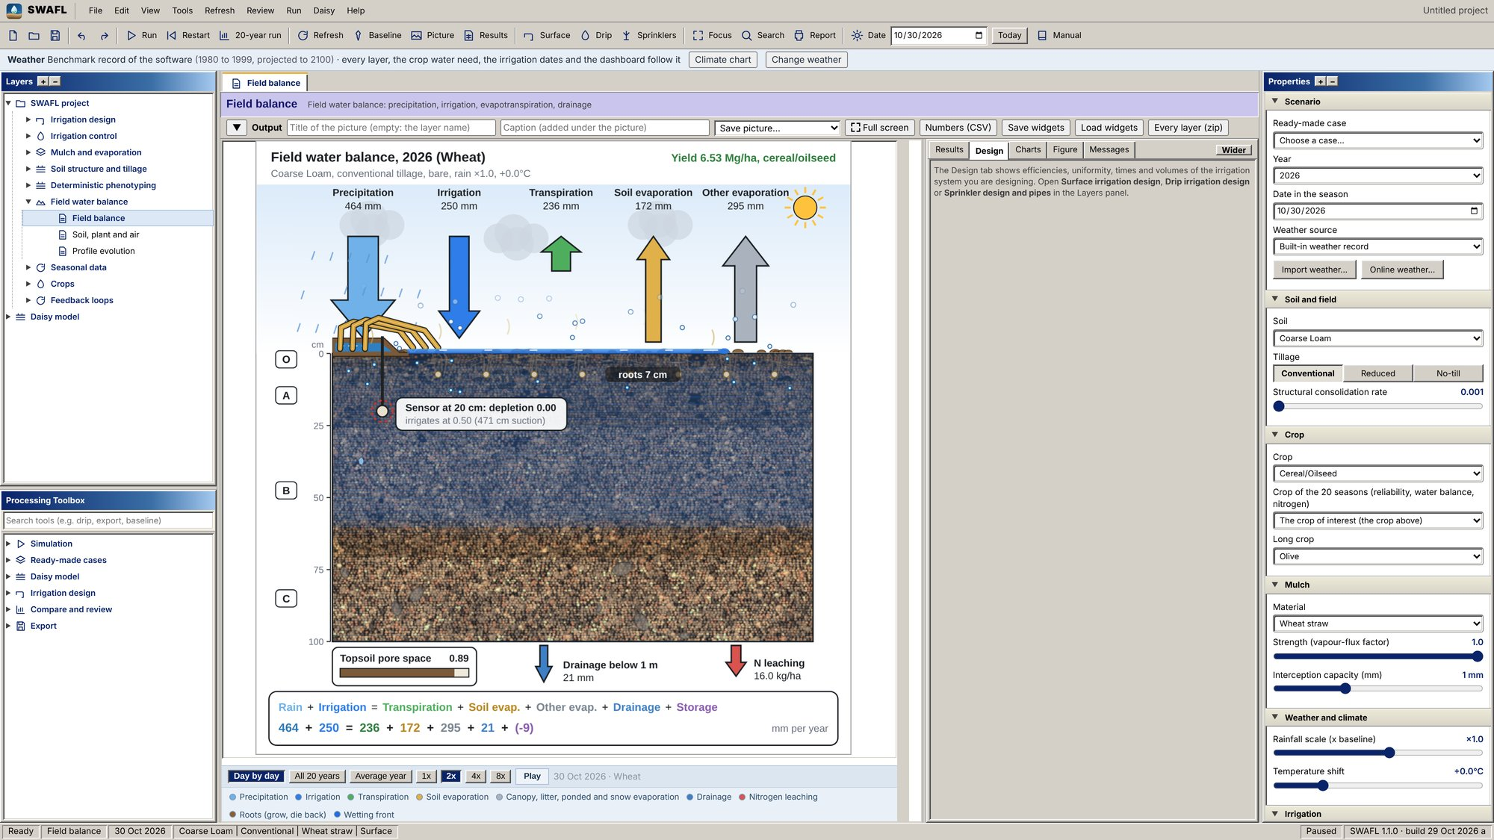  Dashboard with the design tab open beside the field-balance layer.
SWAFL Desktop: sprinkler intake and the dashboard.
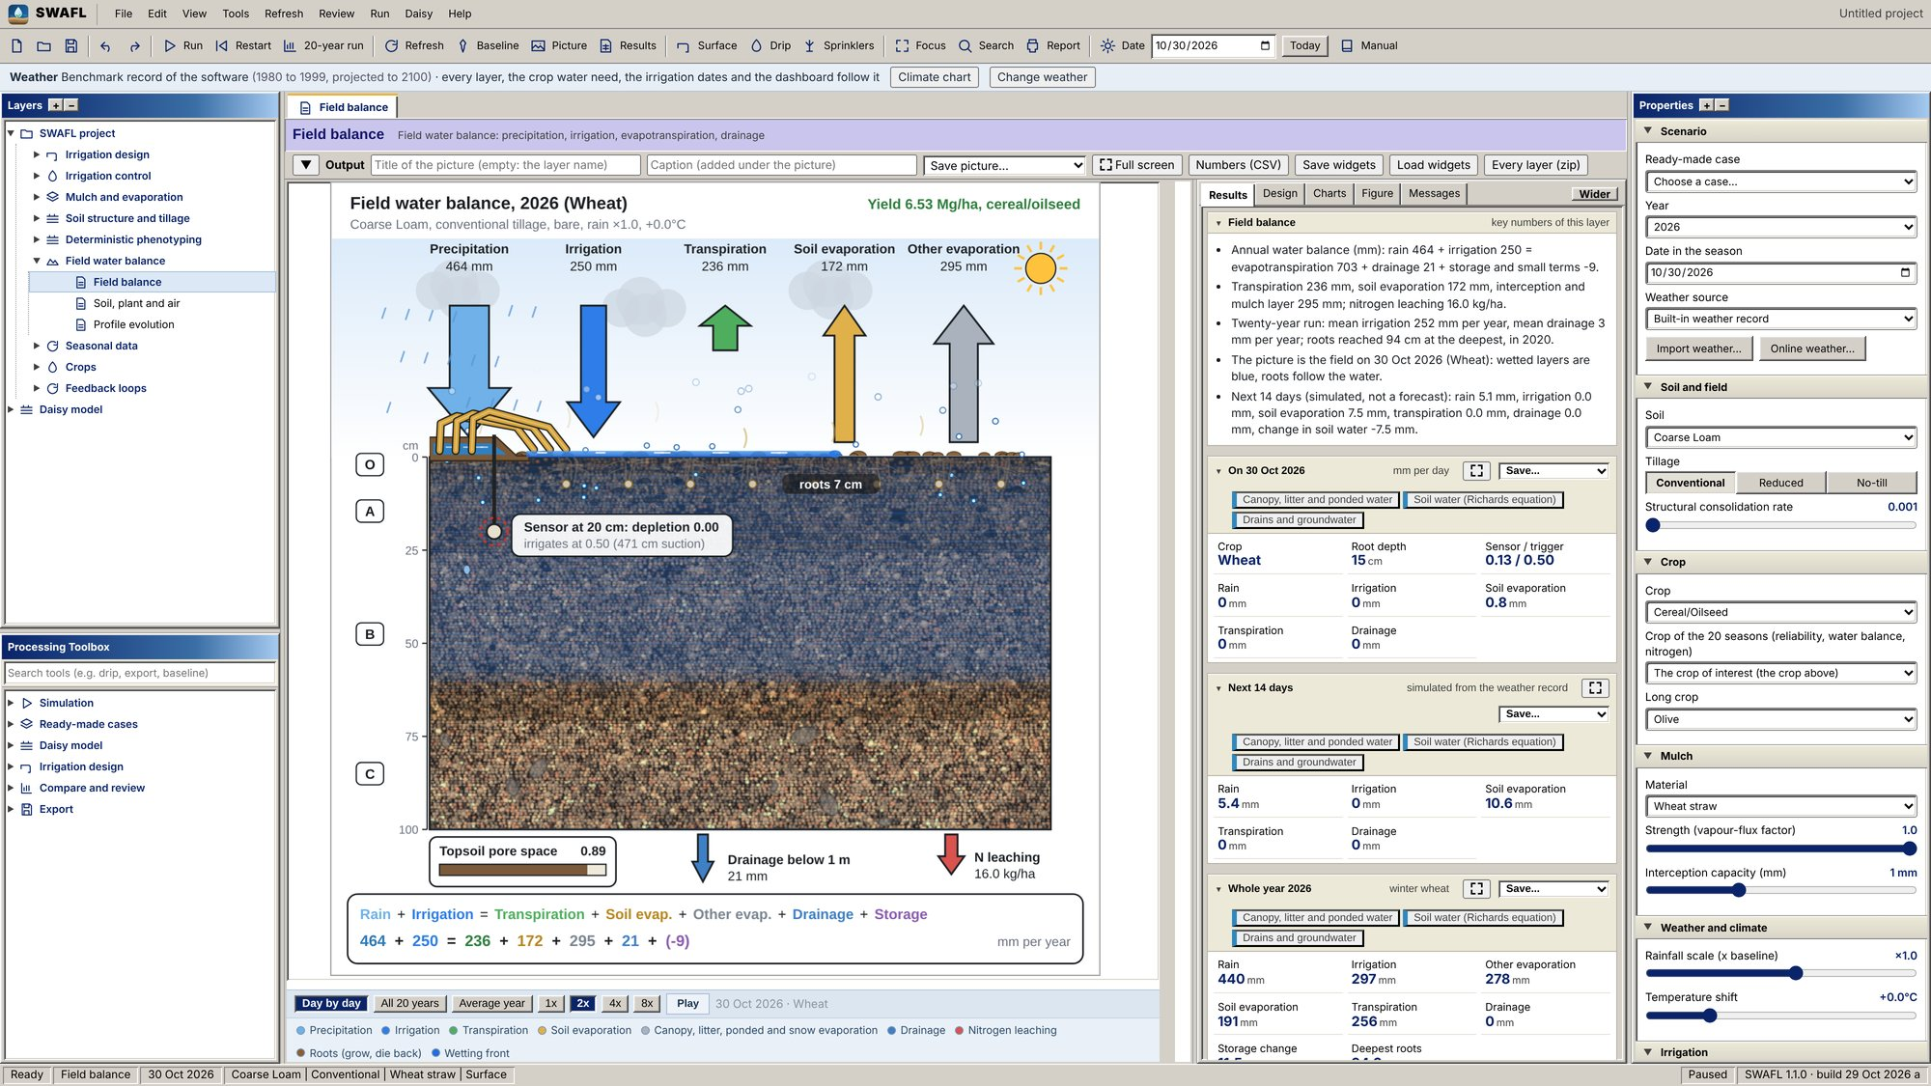  Dashboard, results tab: annual and daily flux tiles of the field water balance. |  | 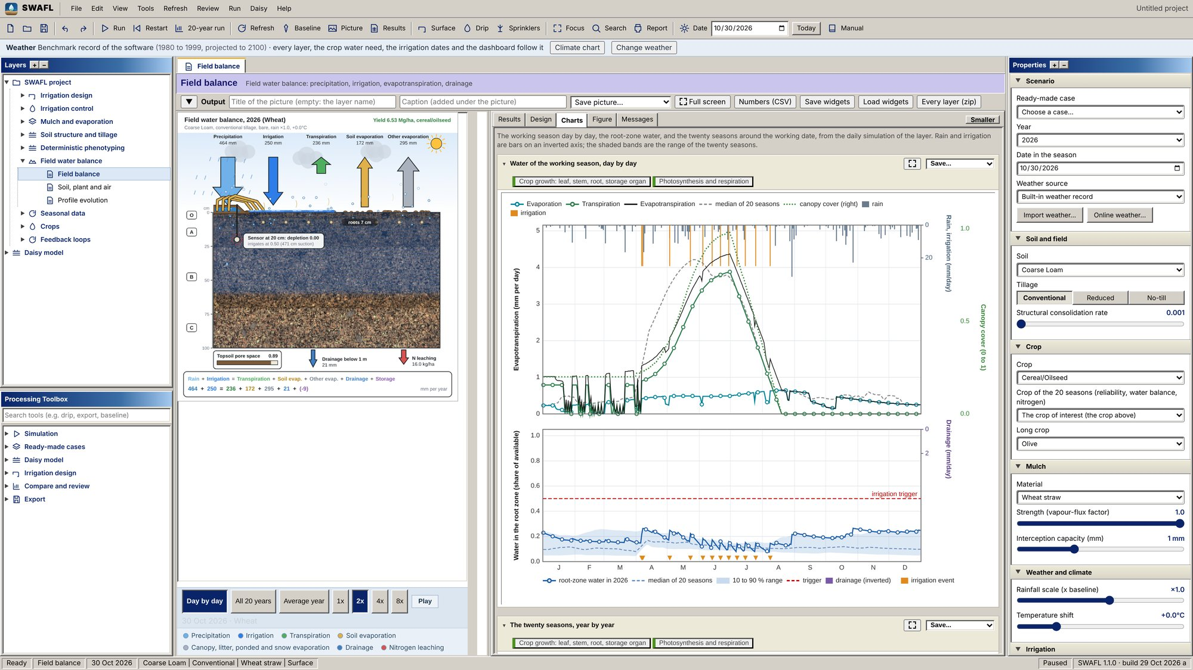  Dashboard, charts tab: seasonal rainfall, irrigation, drainage, evaporation and transpiration.
SWAFL Desktop: dashboard.
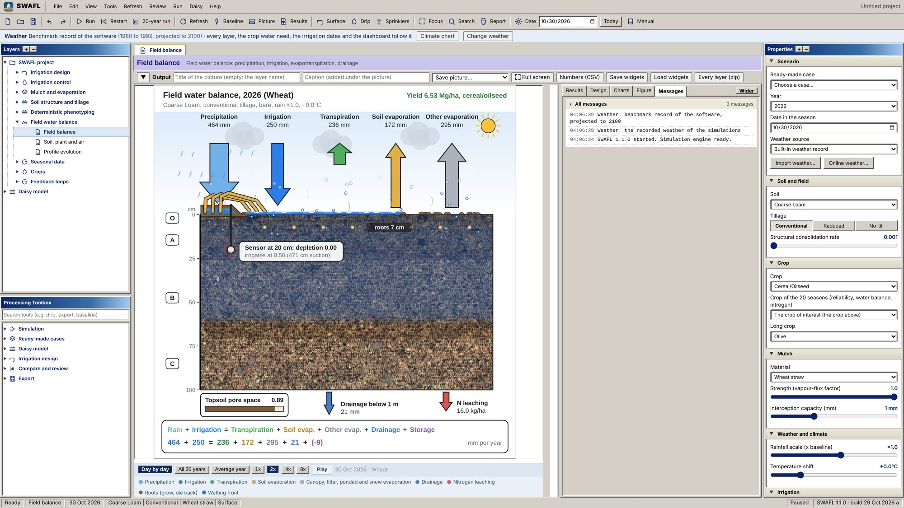
Dashboard, messages tab: the decision messages and warnings of the current state.
SWAFL Desktop: dashboard messages.
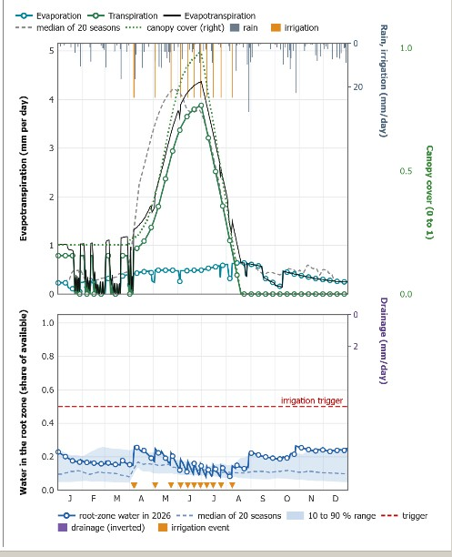  Field balance, charts: evaporation, transpiration and evapotranspiration of 2026 against the median of 20 seasons, with rain, irrigation and canopy cover, and the root-zone water against the trigger with the 10 to 90 % range and the irrigation events. | 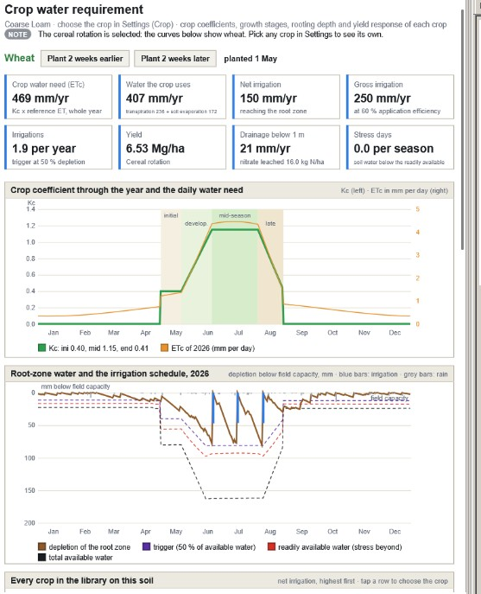  Crop water requirement: crop coefficient and daily need through the year, and the root-zone depletion with the trigger, the readily and the totally available water and the irrigations of 2026.
SWAFL Desktop: the field water balance and the crop water requirement through the year (screen captures of release 1.1.0).
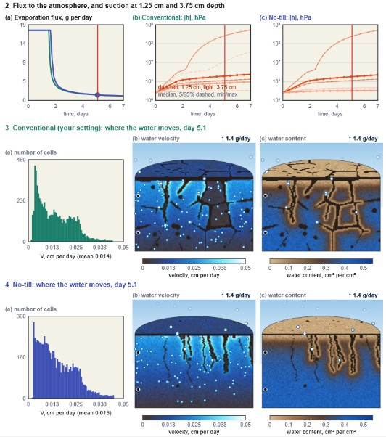
SWAFL Desktop: pore-scale drying of the topsoil under conventional and no tillage: the evaporation flux and the suction at 1.25 and 3.75 cm, and the distribution, velocity and content of the water on day 5.1 (screen capture of release 1.1.0).
Abrahamsen, Per, and Søren Hansen. 2000. “Daisy: An Open Soil-Crop-Atmosphere System Model.” Environmental Modelling and Software 15: 313–30.
Alam, Mahbub, and Danny H. Rogers. 1997. “Tensiometer Use in Scheduling Irrigation.” L-796. Manhattan, KS: Kansas State University Agricultural Experiment Station; Cooperative Extension Service.
Allen, Richard G., Luis S. Pereira, Dirk Raes, and Martin Smith. 1998. “Crop Evapotranspiration: Guidelines for Computing Crop Water Requirements.” FAO Irrigation and Drainage Paper 56. Rome: FAO. https://www.fao.org/4/x0490e/x0490e00.htm.
Asher, M. J., B. F. W. Croke, A. J. Jakeman, and L. J. M. Peeters. 2015. “A Review of Surrogate Models and Their Application to Groundwater Modeling.” Water Resources Research 51: 5957–73. https://doi.org/10.1002/2015WR016967.
Assouline, Shmuel, and Dani Or. 2014. “The Concept of Field Capacity Revisited: Defining Intrinsic Static and Dynamic Criteria for Soil Internal Drainage Dynamics.” Water Resources Research 50. https://doi.org/10.1002/2014WR015475.
Balwinder-Singh, Philip L. Eberbach, Elizabeth Humphreys, and Sat Sharan Kukal. 2011. “The Effect of Rice Straw Mulch on Evapotranspiration, Transpiration and Soil Evaporation of Irrigated Wheat in Punjab, India.” Agricultural Water Management 98: 1847–55. https://doi.org/10.1016/j.agwat.2011.05.007.
Bennett, Neil D., Barry F. W. Croke, Giorgio Guariso, Joseph H. A. Guillaume, Serena H. Hamilton, Anthony J. Jakeman, et al. 2013. “Characterising Performance of Environmental Models.” Environmental Modelling and Software 40: 1–20. https://doi.org/10.1016/j.envsoft.2012.09.011.
Blasius, Heinrich. 1913. “Das Ähnlichkeitsgesetz Bei Reibungsvorgängen in Flüssigkeiten.” Forschungsarbeiten Auf Dem Gebiete Des Ingenieurwesens 131: 1–41.
Blunt, Martin J. 2017. Multiphase Flow in Permeable Media: A Pore-Scale Perspective. Cambridge: Cambridge University Press. https://doi.org/10.1017/9781316145098.
Burt, Charles M., Albert J. Clemmens, Theodor S. Strelkoff, Kenneth H. Solomon, Ron D. Bliesner, Lawrence A. Hardy, Terry A. Howell, and Dean E. Eisenhauer. 1997. “Irrigation Performance Measures: Efficiency and Uniformity.” Journal of Irrigation and Drainage Engineering 123: 423–42. https://doi.org/10.1061/(ASCE)0733-9437(1997)123:6(423).
Carsel, Robert F., and Rudolph S. Parrish. 1988. “Developing Joint Probability Distributions of Soil Water Retention Characteristics.” Water Resources Research 24: 755–69. https://doi.org/10.1029/WR024i005p00755.
Childs, J. L., W. W. Wallender, and J. W. Hopmans. 1993. “Spatial and Seasonal Variation of Furrow Infiltration.” Journal of Irrigation and Drainage Engineering 119: 74–90. https://doi.org/10.1061/(ASCE)0733-9437(1993)119:1(74).
Christiansen, J. E. 1942. “Irrigation by Sprinkling.” Bulletin 670. Berkeley: University of California Agricultural Experiment Station.
Datta, Suat, and Saleh Taghvaeian. 2023. “Soil Water Sensors for Irrigation Scheduling in the United States: A Systematic Review of Literature.” Agricultural Water Management 278: 108148. https://doi.org/10.1016/j.agwat.2023.108148.
Dechmi, F., E. Playán, J. Cavero, et al. 2003. “Wind Effects on Solid Set Sprinkler Irrigation Depth and Yield of Maize (Zea Mays).” Irrigation Science 22: 67–77. https://doi.org/10.1007/s00271-003-0071-9.
Elliott, Ronald L., and Wynn R. Walker. 1982. “Field Evaluation of Furrow Infiltration and Advance Functions.” Transactions of the ASAE 25: 396–400.
Entekhabi, Dara, Ignacio Rodriguez-Iturbe, and Fabio Castelli. 1996. “Mutual Interaction of Soil Moisture State and Atmospheric Processes.” Journal of Hydrology 184: 3–17. https://doi.org/10.1016/0022-1694(95)02965-6.
Feddes, Reinder A., Piotr J. Kowalik, and Henryk Zaradny. 1978. Simulation of Field Water Use and Crop Yield. Wageningen: Pudoc.
Fereres, Elias, and María Auxiliadora Soriano. 2007. “Deficit Irrigation for Reducing Agricultural Water Use.” Journal of Experimental Botany 58: 147–59. https://doi.org/10.1093/jxb/erl165.
Flanagan, Dennis C., and Mark A. Nearing. 1995. “USDA Water Erosion Prediction Project: Hillslope Profile and Watershed Model Documentation.” NSERL Report No. 10. West Lafayette, IN: USDA-ARS National Soil Erosion Research Laboratory.
García, Laura, Lorena Parra, Jose M. Jimenez, Jaime Lloret, and Pascal Lorenz. 2020. “IoT-Based Smart Irrigation Systems: An Overview on the Recent Trends on Sensors and IoT Systems for Irrigation in Precision Agriculture.” Sensors 20: 1042. https://doi.org/10.3390/s20041042.
Geerts, Sam, and Dirk Raes. 2009. “Deficit Irrigation as an on-Farm Strategy to Maximize Crop Water Productivity in Dry Areas.” Agricultural Water Management 96: 1275–84. https://doi.org/10.1016/j.agwat.2009.04.009.
Green, W. Heber, and G. A. Ampt. 1911. “Studies on Soil Physics: 1. The Flow of Air and Water Through Soils.” The Journal of Agricultural Science 4: 1–24. https://doi.org/10.1017/S0021859600001441.
Halilu, Naziru. 2026a. “Coupled Water Fluxes and Pore Scale Dynamics Under Joint Precision Irrigation and Evaporation Control Mulching: Ensemble of 10 190 Daisy Simulations.” Zenodo dataset. https://doi.org/10.5281/zenodo.23043626.
———. 2026b. SWAFL Desktop 1.1.0: Technical Manual (1155 Pages).
Hansen, Søren, Per Abrahamsen, Christian T. Petersen, and Merete Styczen. 2012. “Daisy: Model Use, Calibration, and Validation.” Transactions of the ASABE 55: 1317–35. https://doi.org/10.13031/2013.42244.
Hansen, Søren, Hans E. Jensen, Niels E. Nielsen, and Henrik Svendsen. 1991. “Simulation of Nitrogen Dynamics and Biomass Production in Winter Wheat Using the Danish Simulation Model DAISY.” Fertilizer Research 27: 245–59. https://doi.org/10.1007/BF01051131.
Hillel, Daniel. 1998. Environmental Soil Physics. San Diego: Academic Press.
Holbak, Maja, Per Abrahamsen, Celine R. Grønning, Tobias Klöffel, Magdalena V. Schwartzkopff, Merete E. Styczen, Simon F. Svane, and Efstathios Diamantopoulos. 2026. “The Daisy Model: A Tool for Simulating Agricultural Systems — Recent (2012–2025) Developments, Calibrations and Validations.” Agricultural Systems 238: 104846. https://doi.org/10.1016/j.agsy.2026.104846.
Hutton, Christopher, Thorsten Wagener, Jim Freer, Dawei Han, Chris Duffy, and Berit Arheimer. 2016. “Most Computational Hydrology Is Not Reproducible, so Is It Really Science?” Water Resources Research 52: 7548–55. https://doi.org/10.1002/2016WR019285.
Jakeman, Anthony J., Rebecca A. Letcher, and John P. Norton. 2006. “Ten Iterative Steps in Development and Evaluation of Environmental Models.” Environmental Modelling and Software 21: 602–14. https://doi.org/10.1016/j.envsoft.2006.01.004.
Jones, Hamlyn G. 2004. “Irrigation Scheduling: Advantages and Pitfalls of Plant-Based Methods.” Journal of Experimental Botany 55: 2427–36. https://doi.org/10.1093/jxb/erh213.
Jones, James W., Gerrit Hoogenboom, Cheryl H. Porter, Kenneth J. Boote, William D. Batchelor, L. A. Hunt, et al. 2003. “The DSSAT Cropping System Model.” European Journal of Agronomy 18: 235–65. https://doi.org/10.1016/S1161-0301(02)00107-7.
Kang, Wenrong, Yongyong Zhang, Wenzhi Zhao, and Shaoxiong Wu. 2025. “The Effect of Gravel Mulch on Soil Evaporation and Resistance: Experimental Findings and Modeling.” Journal of Soil Science and Plant Nutrition 25 (1): 1135–48. https://doi.org/10.1007/s42729-024-02190-1.
Keating, Brian A., Peter S. Carberry, Graeme L. Hammer, Merv E. Probert, Michael J. Robertson, Dean Holzworth, et al. 2003. “An Overview of APSIM, a Model Designed for Farming Systems Simulation.” European Journal of Agronomy 18: 267–88. https://doi.org/10.1016/S1161-0301(02)00108-9.
Keller, Jack, and Ron D. Bliesner. 1990. Sprinkle and Trickle Irrigation. New York: Van Nostrand Reinhold.
Keller, Jack, and David Karmeli. 1974. “Trickle Irrigation Design Parameters.” Transactions of the ASAE 17: 678–84.
Kennedy, Marc C., and Anthony O’Hagan. 2001. “Bayesian Calibration of Computer Models.” Journal of the Royal Statistical Society: Series B 63: 425–64. https://doi.org/10.1111/1467-9868.00294.
Koster, Randal D., Paul A. Dirmeyer, Zhichang Guo, Gordon Bonan, Edmond Chan, Peter Cox, C. T. Gordon, et al. 2004. “Regions of Strong Coupling Between Soil Moisture and Precipitation.” Science 305: 1138–40. https://doi.org/10.1126/science.1100217.
Kostiakov, Alexei N. 1932. “On the Dynamics of the Coefficient of Water-Percolation in Soils and on the Necessity for Studying It from a Dynamic Point of View for Purposes of Amelioration.” In Transactions of the 6th Commission of the International Society of Soil Science, Part a, 17–21. Moscow.
Legates, David R., and Gregory J. McCabe. 1999. “Evaluating the Use of ‘Goodness-of-Fit’ Measures in Hydrologic and Hydroclimatic Model Validation.” Water Resources Research 35: 233–41. https://doi.org/10.1029/1998WR900018.
Lehmann, Peter, Shmuel Assouline, and Dani Or. 2008. “Characteristic Lengths Affecting Evaporative Drying of Porous Media.” Physical Review E 77: 056309. https://doi.org/10.1103/PhysRevE.77.056309.
Leuther, Frederic, and Steffen Schlüter. 2021. “Impact of Freeze-Thaw Cycles on Soil Structure and Soil Hydraulic Properties.” SOIL 7: 179–91. https://doi.org/10.5194/soil-7-179-2021.
Manning, Robert. 1891. “On the Flow of Water in Open Channels and Pipes.” Transactions of the Institution of Civil Engineers of Ireland 20: 161–207.
Moriasi, Daniel N., Jeffrey G. Arnold, Michael W. Van Liew, Ronald L. Bingner, R. Daren Harmel, and Tamie L. Veith. 2007. “Model Evaluation Guidelines for Systematic Quantification of Accuracy in Watershed Simulations.” Transactions of the ASABE 50: 885–900. https://doi.org/10.13031/2013.23153.
Mualem, Yechezkel. 1976. “A New Model for Predicting the Hydraulic Conductivity of Unsaturated Porous Media.” Water Resources Research 12: 513–22. https://doi.org/10.1029/WR012i003p00513.
Nash, J. Eamonn, and J. V. Sutcliffe. 1970. “River Flow Forecasting Through Conceptual Models Part I—a Discussion of Principles.” Journal of Hydrology 10: 282–90. https://doi.org/10.1016/0022-1694(70)90255-6.
Nobel, Park S. 2009. Physicochemical and Environmental Plant Physiology. 4th ed. Burlington, MA: Academic Press.
Or, Dani, Peter Lehmann, Ebrahim Shahraeeni, and Nima Shokri. 2013. “Advances in Soil Evaporation Physics—a Review.” Vadose Zone Journal 12 (4). https://doi.org/10.2136/vzj2012.0163.
Oreskes, Naomi, Kristin Shrader-Frechette, and Kenneth Belitz. 1994. “Verification, Validation, and Confirmation of Numerical Models in the Earth Sciences.” Science 263: 641–46. https://doi.org/10.1126/science.263.5147.641.
Philip, John R. 1957. “The Theory of Infiltration: 4. Sorptivity and Algebraic Infiltration Equations.” Soil Science 84: 257–64.
Playán, Enrique, and Luciano Mateos. 2006. “Modernization and Optimization of Irrigation Systems to Increase Water Productivity.” Agricultural Water Management 80: 100–116. https://doi.org/10.1016/j.agwat.2005.07.007.
Playán, Enrique, Rafael Salvador, José M. Faci, Nery Zapata, Antonio Martínez-Cob, and Ignacio Sánchez. 2005. “Day and Night Wind Drift and Evaporation Losses in Sprinkler Solid-Sets and Moving Laterals.” Agricultural Water Management 76: 139–59. https://doi.org/10.1016/j.agwat.2005.01.015.
Razavi, Saman, Bryan A. Tolson, and Donald H. Burn. 2012. “Review of Surrogate Modeling in Water Resources.” Water Resources Research 48: W07401. https://doi.org/10.1029/2011WR011527.
Refsgaard, Jens Christian, and Hans Jørgen Henriksen. 2004. “Modelling Guidelines—Terminology and Guiding Principles.” Advances in Water Resources 27: 71–82. https://doi.org/10.1016/j.advwatres.2003.08.006.
Richards, Lorenzo A. 1931. “Capillary Conduction of Liquids Through Porous Mediums.” Physics 1: 318–33. https://doi.org/10.1063/1.1745010.
Ritchie, Joe T. 1972. “Model for Predicting Evaporation from a Row Crop with Incomplete Cover.” Water Resources Research 8: 1204–13. https://doi.org/10.1029/WR008i005p01204.
Roderick, Michael L., and Graham D. Farquhar. 2002. “The Cause of Decreased Pan Evaporation over the Past 50 Years.” Science 298: 1410–11. https://doi.org/10.1126/science.1075390.
Sacks, Jerome, William J. Welch, Toby J. Mitchell, and Henry P. Wynn. 1989. “Design and Analysis of Computer Experiments.” Statistical Science 4: 409–23. https://doi.org/10.1214/ss/1177012413.
Saltelli, Andrea, Marco Ratto, Terry Andres, Francesca Campolongo, Jessica Cariboni, Debora Gatelli, Michaela Saisana, and Stefano Tarantola. 2008. Global Sensitivity Analysis: The Primer. Chichester: Wiley.
Saxton, Keith E., and Walter J. Rawls. 2006. “Soil Water Characteristic Estimates by Texture and Organic Matter for Hydrologic Solutions.” Soil Science Society of America Journal 70: 1569–78. https://doi.org/10.2136/sssaj2005.0117.
Scaloppi, Edson J., and Richard G. Allen. 1993. “Hydraulics of Irrigation Laterals.” Journal of Irrigation and Drainage Engineering 119: 91–115. https://doi.org/10.1061/(ASCE)0733-9437(1993)119:1(91).
Schaap, Marcel G., Feike J. Leij, and Martinus Th. van Genuchten. 2001. “Rosetta: A Computer Program for Estimating Soil Hydraulic Parameters with Hierarchical Pedotransfer Functions.” Journal of Hydrology 251: 163–76. https://doi.org/10.1016/S0022-1694(01)00466-8.
Schwartzman, Moshe, and Benny Zur. 1986. “Emitter Spacing and Geometry of Wetted Soil Volume.” Journal of Irrigation and Drainage Engineering 112: 242–53. https://doi.org/10.1061/(ASCE)0733-9437(1986)112:3(242).
Seneviratne, Sonia I., Thierry Corti, Edouard L. Davin, Martin Hirschi, Eric B. Jaeger, Irene Lehner, Boris Orlowsky, and Adriaan J. Teuling. 2010. “Investigating Soil Moisture–Climate Interactions in a Changing Climate: A Review.” Earth-Science Reviews 99: 125–61. https://doi.org/10.1016/j.earscirev.2010.02.004.
Shokri, Nima, and Dani Or. 2011. “What Determines Drying Rates at the Onset of Diffusion Controlled Stage-2 Evaporation from Porous Media?” Water Resources Research 47: W09513. https://doi.org/10.1029/2010WR010284.
Šimůnek, Jiří, Martinus Th. van Genuchten, and Miroslav Šejna. 2008. “Development and Applications of the HYDRUS and STANMOD Software Packages and Related Codes.” Vadose Zone Journal 7: 587–600. https://doi.org/10.2136/vzj2007.0077.
———. 2016. “Recent Developments and Applications of the HYDRUS Computer Software Packages.” Vadose Zone Journal 15 (7). https://doi.org/10.2136/vzj2016.04.0033.
Steduto, Pasquale, Theodore C. Hsiao, Dirk Raes, and Elias Fereres. 2009. “AquaCrop—the FAO Crop Model to Simulate Yield Response to Water: I. Concepts and Underlying Principles.” Agronomy Journal 101: 426–37. https://doi.org/10.2134/agronj2008.0139s.
Strudley, Mark W., Timothy R. Green, and James C. Ascough. 2008. “Tillage Effects on Soil Hydraulic Properties in Space and Time: State of the Science.” Soil and Tillage Research 99: 4–48. https://doi.org/10.1016/j.still.2008.01.007.
Twarakavi, Navin K. C., Masaru Sakai, and Jiří Šimůnek. 2009. “An Objective Analysis of the Dynamic Nature of Field Capacity.” Water Resources Research 45: W10410. https://doi.org/10.1029/2009WR007944.
Umutoni, Lisa, and Vidya Samadi. 2024. “Application of Machine Learning Approaches in Supporting Irrigation Decision Making: A Review.” Agricultural Water Management 294: 108710. https://doi.org/10.1016/j.agwat.2024.108710.
van den Honert, T. H. 1948. “Water Transport in Plants as a Catenary Process.” Discussions of the Faraday Society 3: 146–53. https://doi.org/10.1039/DF9480300146.
van Genuchten, Martinus Th. 1980. “A Closed-Form Equation for Predicting the Hydraulic Conductivity of Unsaturated Soils.” Soil Science Society of America Journal 44: 892–98. https://doi.org/10.2136/sssaj1980.03615995004400050002x.
Vereecken, Harry, Andrea Schnepf, Jan W. Hopmans, Mathieu Javaux, Dani Or, Tiina Roose, Jan Vanderborght, et al. 2016. “Modeling Soil Processes: Review, Key Challenges, and New Perspectives.” Vadose Zone Journal 15 (5). https://doi.org/10.2136/vzj2015.09.0131.
Vuaille, Jessica, Per Abrahamsen, Signe M. Jensen, Efstathios Diamantopoulos, Tobias S. Wacker, and Christian T. Petersen. 2024. “Modelling Pesticide Degradation and Leaching in Conservation Agriculture: Effect of No-till and Mulching.” Science of the Total Environment 929: 172559. https://doi.org/10.1016/j.scitotenv.2024.172559.
Walker, W. R. 1989. “Guidelines for Designing and Evaluating Surface Irrigation Systems.” Irrigation and Drainage Paper 45. Rome: Food; Agriculture Organization of the United Nations. https://www.fao.org/4/t0231e/t0231e00.htm.
Walker, Wynn R., and Gaylord V. Skogerboe. 1987. Surface Irrigation: Theory and Practice. Englewood Cliffs, NJ: Prentice-Hall.
Warrick, A. W., and M. Yitayew. 1988. “Trickle Lateral Hydraulics. I: Analytical Solution.” Journal of Irrigation and Drainage Engineering 114: 281–88. https://doi.org/10.1061/(ASCE)0733-9437(1988)114:2(281).
Weber, Tobias K. D., Lutz Weihermüller, Attila Nemes, Michel Bechtold, Aurélie Degré, Efstathios Diamantopoulos, Simone Fatichi, et al. 2024. “Hydro-Pedotransfer Functions: A Roadmap for Future Development.” Hydrology and Earth System Sciences 28: 3391–3433. https://doi.org/10.5194/hess-28-3391-2024.
Wilkinson, Mark D., Michel Dumontier, IJsbrand Jan Aalbersberg, Gabrielle Appleton, Myles Axton, Arie Baak, et al. 2016. “The FAIR Guiding Principles for Scientific Data Management and Stewardship.” Scientific Data 3: 160018. https://doi.org/10.1038/sdata.2016.18.
Williams, Gardner S., and Allen Hazen. 1905. Hydraulic Tables. New York: John Wiley; Sons.
Zhang, J., K. Guan, B. Peng, C. Jiang, W. Zhou, Y. Yang, M. Pan, et al. 2021. “Challenges and Opportunities in Precision Irrigation Decision-Support Systems for Center Pivots.” Environmental Research Letters. https://doi.org/10.1088/1748-9326/abe436.
Zheng, Jing, Junliang Fan, Fucang Zhang, and Qianlai Zhuang. 2021. “Evapotranspiration Partitioning and Water Productivity of Rainfed Maize Under Contrasting Mulching Conditions in Northwest China.” Agricultural Water Management 243: 106473. https://doi.org/10.1016/j.agwat.2020.106473.

