Supplementary Material
Soil Hydraulic Memory and the Recoverability of Evaporation Savings and the Closure of the Water Balance in a Simulation Study with Daisy
Derivations of the equations, the mechanisms behind the results, the data, and the origin of every table and figure
Naziru Halilu$​^{1,2,*}$
$​^{1}$ Agricultural University of Athens, Athens, Greece
$​^{2}$ Public University of Navarre, Pamplona, Spain
ORCID: 0009-0006-2324-9599
$​^{*}$ Correspondence: halilunaziru73@gmail.com

What is new in this article
What this article adds, item by item: what was established before, what is new here, and the evidence in this article.
# | Established before | New in this article | Evidence here
# | Established before | New in this article | Evidence here
 | Drainage and evaporation compete for stored water; their rates follow from the van Genuchten–Mualem functions and from stage-1/stage-2 evaporation theory (van Genuchten 1980; Mualem 1976; Lehmann, Assouline, and Or 2008; Or et al. 2013). | Hydraulic memory, the share of released stored water that drains, defined as a measurable quantity and predicted for a soil not used in the fit by a one-parameter rate-competition law. | Spans 0.02 to 0.85 over ten soils; ordered by $n$ ($ρ=0.95$) and $K_{s}$ ($ρ=0.97$); leave-one-soil-out RMSE 0.058, below every structural predictor.
 | Water saved from evaporation is counted as water gained, while system-scale studies warn that savings can be illusory (Perry, Steduto, and Karajeh 2017; Grafton et al. 2018). | A soil- and climate-specific recoverable share of an evaporation saving, $ρ_{R}=1−ψ_{D}$, with the drainage that is not recovered quantified per soil. | No recovery in sand, 0.20 in loamy sand; warming shifts the drainage share by $−0.16$, a wetter climate by $+0.42$; nitrogen (negative control) has no effect.
 | Equation discovery recovers laws from data (Schmidt and Lipson 2009; Brunton, Proctor, and Kutz 2016; Udrescu and Tegmark 2020); energy- and water-balance closure gaps are known for flux towers (Wilson et al. 2002; Foken 2008). | A blind invariant search with a permutation null and positive and negative controls, applied to the outputs of a process model, recovering its water balance and exposing an unclosed evaporative term. | Balance coefficients within 5 % of the exact values; an unattributed term of 164 mm yr$​^{−1}$ (30 % of ET); storage non-closure of 16 % in two experiments.
 | Emulators make process models fast but their safe targets are rarely stated (Razavi, Tolson, and Burn 2012; Asher et al. 2015). | A map of which flux of the balance can be emulated by a compact law and which cannot. | A three-term ET law equals gradient boosting out of sample ($R^{2}=0.898$ by experiment, 0.904 by soil); drainage resists every law tried.
 | Savings are judged against the reported soil evaporation. | The two analyses change each other: against the reported soil evaporation alone, the drainage share of an evaporation change is misjudged. | Misjudged in most soils and of the wrong sign in two.

How this supplement is organised
Each of the following sections gathers everything about one result of the article under one heading: the problem and the author’s contribution with its pinpointed equation, the worked numbers that can be checked on a calculator or in the workbook, graphs that mark the exact points, the figures of the article with their numbered labels, the derivations, and why it happens. The terms, the constants, the tables, the path from the data to every result, the data themselves and the origin of every item follow at the end. Sections 3.4, 4.17 and 7.3 re-derive established results (van Genuchten 1980; Mualem 1976) and standard statistical tools for completeness. The memory fate (4.18), the loss fates and the recoverable share (5.9), the rate-competition law of hydraulic memory (4.19), the invariant search applied to a process model (6.9), the closure residual and the unattributed term (6.10) and the compensation coefficient (5.10) are definitions and results of this article.

The soils, the experiments and the data
The soil hydraulic functions and the experiments from which every number of the article is computed.

Reading Figure 2 of the article
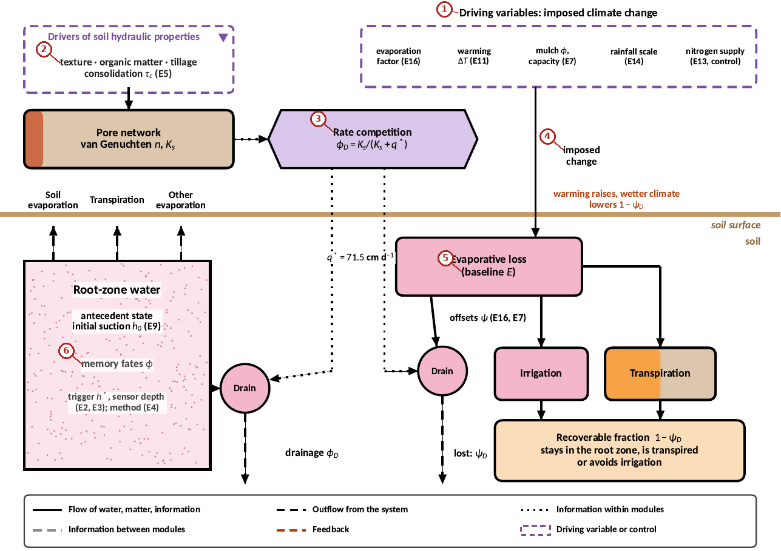
What the numbered labels point to.
- “Driving variables: imposed climate change”: a heading or control of this screen; the caption above says which layer it belongs to.
- “texture organic matter - tillage”: a heading or control of this screen; the caption above says which layer it belongs to.
- “Rate competition”: a heading or control of this screen; the caption above says which layer it belongs to.
- “imposed”: a heading or control of this screen; the caption above says which layer it belongs to.
- “(baseline E)”: a heading or control of this screen; the caption above says which layer it belongs to.
- “memory fates”: a heading or control of this screen; the caption above says which layer it belongs to.
What it shows. Conceptual and analytical framework. Antecedent storage released from the root zone can leave as drainage, soil evaporation, transpiration or other evaporation (memory fates $ϕ$, estimated from E9). An imposed change in evaporative loss is offset by drainage, irrigation or transpiration (loss fates $ψ$, estimated from E16 and E7). The recoverable fraction of an evaporation saving is $1−ψ_{D}$. Boxes indicate storages and solid lines flows; dashed black lines are flows out of the system, dotted lines flows of information; dashed purple boxes are drivers of soil hydraulic properties and the imposed climate changes. Pink indicates water, orange the crop, light brown the soil and rust the pore network; the purple hexagon is the rate-competition process and peach boxes are results. The brown line is the soil surface.
How to read the labels, symbols and colours. Boxes are storages, solid lines flows, dashed black lines flows leaving the system, dotted lines information; pink is water, orange the crop, brown the soil, rust the pore network; the purple hexagon is the rate competition.
What affects it, and why it happens. Released stored water leaves by four routes; which route wins is set by the competition between drainage (conductivity) and withdrawal (roots and surface). The same competition decides the fate of an evaporation saving, which is why the two kinds of fates are linked.
How it is made. Figure drawn by the script from the input data. Script: Manuscripts/reproducibility/make_a4.py. Input: Data/daisy_ensemble.csv.gz.

Reading Figure 3 of the article
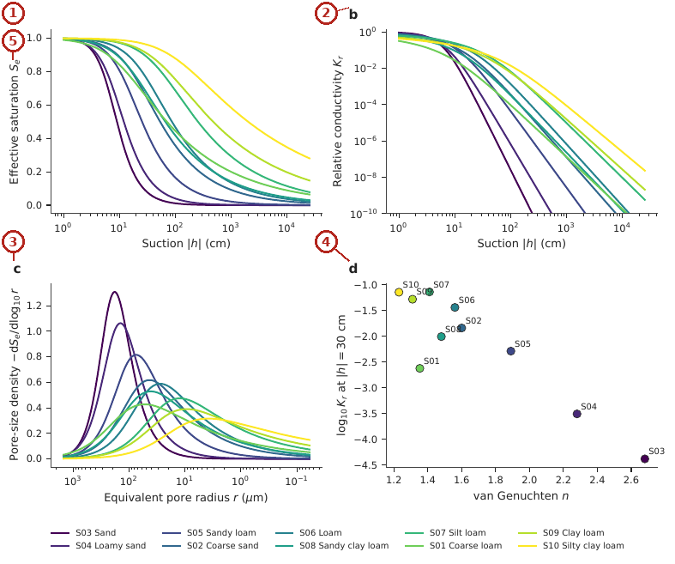
What the numbered labels point to.
- Panel (a): see the caption above.
- Panel (b): see the caption above.
- Panel (c): see the caption above.
- Panel (d): see the caption above.
- Panel (e): see the caption above.
What it shows. Hydraulic properties of the ten soils from Eq. (1) and Eq. (2) of the article. The ordering by shape parameter $n$ is the ordering on which the main results are organised.
How to read the labels, symbols and colours. Retention and conductivity curves of the ten soils from the van Genuchten–Mualem functions, coloured by soil.
What affects it, and why it happens. The curves are ordered by $n$: coarse soils drain within a narrow range of suction and lose conductivity fast; fine soils drain gradually. This ordering organises all later results.
How it is made. Figure drawn by the script from the input data. Script: Manuscripts/reproducibility/analysis/p1_figs_a.py. Input: Data/daisy_ensemble.csv.gz.

Reading Figure 4 of the article
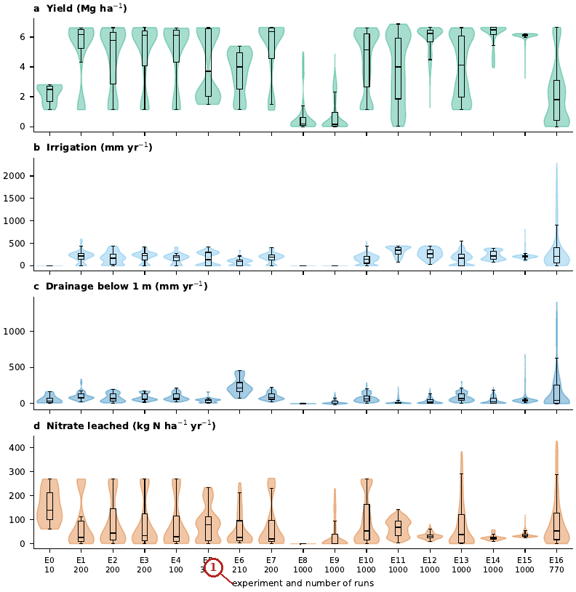
What the numbered labels point to.
- “experiment and number of runs”: a heading or control of this screen; the caption above says which layer it belongs to.
What it shows. The data of the ensemble: yield, irrigation, drainage and nitrate leaching of the 10 041 valid runs, by experiment (violins: distribution; boxes: quartiles). Source: 00_summary_all_simulations.csv.gz in Data/Comprehensive_Summary; script reproducibility/analysis/data_overview.py.
How to read the labels, symbols and colours. Violins show the distribution of yield, irrigation, drainage and nitrate leaching of the valid runs of each experiment; boxes the quartiles; the number under each experiment is its number of runs.
What affects it, and why it happens. Experiments that vary irrigation (E1, E2, E10, E13, E15) spread irrigation and drainage widely; rainfed experiments have no irrigation. Drainage and leaching move together because nitrate leaves with drained water.
How it is made. Figure drawn by the script from the input data. Script: Manuscripts/reproducibility/analysis/data_overview.py. Input: Data/daisy_ensemble.csv.gz.

Derivation: The retention and conductivity functions
With the capillary law $r∝1/h$, Mualem (1976) expressed the relative conductivity of a bundle of connected capillaries as
$$K_{r}\left(S_{e}\right)=S_{e}^{λ}{\left[\int_{0}^{S_{e}}{h}{\left(x\right)}^{−1}dx/\int_{0}^{1}{h}{\left(x\right)}^{−1}dx\right]}^{2}.$$
Inserting the inverse of the van Genuchten curve, $h\left(x\right)=α^{−1}{\left(x^{−1/m}−1\right)}^{1/n}$, and substituting $y=x^{1/m}$ gives $\int_{0}^{S_{e}}{h^{−1}}dx=αm\int_{0}^{S_{e}^{1/m}}{y^{m−1+1/n}}{\left(1−y\right)}^{−1/n}dy$. With $m=1−1/n$ the power of $y$ vanishes and the integral is $α\left[1−{\left(1−S_{e}^{1/m}\right)}^{m}\right]$; dividing by its value at $S_{e}=1$ ($α$) and squaring yields the Mualem conductivity of the paper, $K=K_{s}S_{e}^{λ}{\left[1−{\left(1−S_{e}^{1/m}\right)}^{m}\right]}^{2}$. For large $αh$, $S_{e}≃{\left(αh\right)}^{−\left(n−1\right)}$ and $K_{r}≃m^{2}{\left(αh\right)}^{−\left[2n+λ\left(n−1\right)\right]}$: the conductivity of a soil with large $n$ falls faster with suction, which is the property that orders hydraulic memory.

Hydraulic memory and its rate law
How much of the water stored at the start of a season leaves by drainage, transpiration or evaporation, and the one-parameter law that predicts it.

Contribution 1: hydraulic memory as a measurable share
After a wet spring, a soil releases stored water over the season. Does that water feed the crop, or does it drain away? Soil physics says both happen, but gives no single number per soil that can be measured, compared and predicted.
(a) Define the storage release of a run, $\overset{‾}{R}=ET+D−P_{r}−I$ (water given away by the store). (b) In experiment E9 the starting wetness is varied at fixed rainfall, so $\overset{‾}{R}$ varies while the weather does not. (c) Within each rainfall level, regress each flux on $\overset{‾}{R}$; pool the levels (Section 4.18). (d) Because the four fluxes add to $\overset{‾}{R}$ plus a constant, their slopes add to one.
How it is derived, line by line $$\begin{array}{@{}l@{}}\textbf{1. Storage release of run } c\textbf{:}\\[1pt]
\qquad \bar R_c=\mathit{ET}_c+D_c-P_{r,c}-I_c\\[1pt]
\textbf{2. Model each flux within rainfall group } P\textbf{:}\\[1pt]
\qquad x_c=a_P+\phi_x\bar R_c+e_c\\[1pt]
\textbf{3. Least squares over } a_P\textbf{:}\\[1pt]
\qquad a_P=\bar x_P-\phi_x\overline{\bar R}_P\\[1pt]
\textbf{4. Least squares over } \phi_x\textbf{:}\\[1pt]
\qquad \phi_x=\frac{\sum_P\sum_c(\bar R_c-\overline{\bar R}_P)(x_c-\bar x_P)}{\sum_P\sum_c(\bar R_c-\overline{\bar R}_P)^2}\\[1pt]
\textbf{5. Fluxes add to } \bar R+\text{const}\textbf{:}\\[1pt]
\qquad \textstyle\sum_x\phi_x=1
\end{array}$$ The result, with its parts marked
$$\underbrace{\phi_x}_{\tikz[baseline=(c.base)]\node[circle,draw=red!70!black,text=red!70!black,line width=0.6pt,inner sep=0.7pt,minimum size=1.15em,font=\scriptsize\bfseries\sffamily](c){1};}=\frac{\sum_P\sum_{c\in P}\overbrace{(\bar R_c-\overline{\bar R}_P)}^{\tikz[baseline=(c.base)]\node[circle,draw=red!70!black,text=red!70!black,line width=0.6pt,inner sep=0.7pt,minimum size=1.15em,font=\scriptsize\bfseries\sffamily](c){2};}(x_c-\bar x_P)}{\sum_P\sum_{c\in P}(\bar R_c-\overline{\bar R}_P)^2}$$
$$\underbrace{\phi_{E_s}+\phi_T+\phi_D+\phi_{\mathrm{oth}}=1}_{\tikz[baseline=(c.base)]\node[circle,draw=red!70!black,text=red!70!black,line width=0.6pt,inner sep=0.7pt,minimum size=1.15em,font=\scriptsize\bfseries\sffamily](c){3};}$$
$$\underbrace{\phi_D=0.02\ \text{to}\ 0.85}_{\tikz[baseline=(c.base)]\node[circle,draw=red!70!black,text=red!70!black,line width=0.6pt,inner sep=0.7pt,minimum size=1.15em,font=\scriptsize\bfseries\sffamily](c){4};}$$
(c)1; The memory fate of flux $x$: the share of one released millimetre that leaves by $x$. It is a number between 0 and 1 for each soil, so soils can be ranked and compared.
(c)2; Deviations are taken within each rainfall level $P$, so the effect of the weather is removed and only the effect of the stored water is measured.
(c)3; The four shares add to one exactly, because a released millimetre must leave by one of them; this is a built-in check of the calculation.
(c)4; The drained share ranges from 0.02 (silty clay loam: almost all released water is used) to 0.85 (sand: almost all drains). This forty-fold range is the soil’s hydraulic memory.

Contribution 2: a one-parameter law for hydraulic memory
Can the drained share of a soil that was never simulated be predicted from one measured property?
Stored water leaves by two competing first-order routes, drainage at a rate proportional to $K_{s}$ and withdrawal by roots and surface at a rate proportional to $q^{*}$ (Section 4.19); the share taken by drainage is the ratio of its rate to the sum.
How it is derived, line by line $$\begin{array}{@{}l@{}}\textbf{1. Two first-order sinks:}\\[1pt]
\qquad \mathrm{d}S/\mathrm{d}t=-(k_D+k_W)S,\ k_D\propto K_s,\ k_W\propto q^\ast\\[1pt]
\textbf{2. Solve:}\\[1pt]
\qquad S=S_0e^{-(k_D+k_W)t}\\[1pt]
\textbf{3. Drained water:}\\[1pt]
\qquad \textstyle\int_0^\infty k_DS\,\mathrm{d}t=S_0\,k_D/(k_D+k_W)\\[1pt]
\textbf{4. Share drained:}\\[1pt]
\qquad \phi_D=K_s/(K_s+q^\ast)
\end{array}$$ The result, with its parts marked
$$\underbrace{\phi_D}_{\tikz[baseline=(c.base)]\node[circle,draw=red!70!black,text=red!70!black,line width=0.6pt,inner sep=0.7pt,minimum size=1.15em,font=\scriptsize\bfseries\sffamily](c){1};}=\frac{\overbrace{K_s}^{\tikz[baseline=(c.base)]\node[circle,draw=red!70!black,text=red!70!black,line width=0.6pt,inner sep=0.7pt,minimum size=1.15em,font=\scriptsize\bfseries\sffamily](c){2};}}{K_s+\underbrace{q^\ast}_{\tikz[baseline=(c.base)]\node[circle,draw=red!70!black,text=red!70!black,line width=0.6pt,inner sep=0.7pt,minimum size=1.15em,font=\scriptsize\bfseries\sffamily](c){3};}}$$
$$\underbrace{q^\ast=71.5\ \mathrm{cm\,d^{-1}}}_{\tikz[baseline=(c.base)]\node[circle,draw=red!70!black,text=red!70!black,line width=0.6pt,inner sep=0.7pt,minimum size=1.15em,font=\scriptsize\bfseries\sffamily](c){4};}$$
$$\underbrace{\text{LOSO RMSE}=0.058}_{\tikz[baseline=(c.base)]\node[circle,draw=red!70!black,text=red!70!black,line width=0.6pt,inner sep=0.7pt,minimum size=1.15em,font=\scriptsize\bfseries\sffamily](c){5};}$$
(c)1; The predicted memory fate.
(c)2; The saturated conductivity is the only soil input; it sets how fast released water can drain.
(c)3; $q^{*}$ is one constant for all soils: the effective rate of withdrawal by evaporation and roots, expressed as a conductivity.
(c)4; $q^{*}$ is two orders of magnitude above the mean evapotranspiration, which shows where the competition is decided: in the wet, fast-draining phase just after the store is filled, not over the season.
(c)5; Predicting each soil from the other seven, the error was 0.058, smaller than with $n$ (0.100) or any other structural predictor.

Worked numbers, part 1: the water balance of a soil column
Over a year, water in (rain $P$ and irrigation $I$) equals water out (evapotranspiration $ET$, drainage $D$ below 1 m, runoff $Q$) plus the change of water stored, $ΔS$: $P+I=ET+D+ΔS+Q$. Example. Coarse loam without irrigation: $P=464.4$, $ET=466.8$, $D=6.1$ mm; $ET+D−P=8.5$ mm came from storage.

Worked numbers, part 2: the storage release
$\overset{‾}{R}=ET+D−P−I$ is the water the soil gave away from its store. Starting the run wetter makes $\overset{‾}{R}$ larger; the experiment E9 does this on purpose with ten starting suctions.

Worked numbers, part 3: the memory fate
Plot drainage against $\overset{‾}{R}$ for the runs with the same rainfall: the slope is the share of each released millimetre that drained, $ϕ_{D}$. The same slope for transpiration, soil and other evaporation gives $ϕ_{T}$, $ϕ_{E_{s}}$, $ϕ_{oth}$, and the four add to 1 because the released water must leave by one of them. Example (three runs). If $\overset{‾}{R}=10$, 20, 30 mm and $D=1$, 4, 7 mm, the slope is $\left(7−1\right)/\left(30−10\right)=0.3$: 30 % of released water drains.

Worked numbers, part 4: why drainage wins in coarse soils, the rate law
Released water leaves by two routes that compete: drainage, fast when the saturated conductivity $K_{s}$ is large, and withdrawal by roots and the surface, with a fixed rate $q^{*}$. The share that drains is $ϕ_{D}=K_{s}/\left(K_{s}+q^{*}\right)$, with $q^{*}=71.5$ cm d$​^{−1}$. Example. Sand, $K_{s}=712.8$: $712.8/\left(712.8+71.5\right)=0.91$ (observed 0.85). Silty clay loam, $K_{s}=1.68$: $1.68/73.18=0.023$ (observed 0.022).

The constant $q^{*}$ of the rate-competition law: how it is determined
Step 1. The memory fate $ϕ_{D}$ of each soil was measured from experiment E9 (Contribution 1). Step 2. For eight soils, a saturated conductivity $K_{s}$ was taken from the class means of Carsel and Parrish (1988); the two soils without a single texture class (coarse loam, coarse sand) were left out. Step 3. The law $ϕ_{D}=K_{s}/\left(K_{s}+q^{*}\right)$ was fitted to the eight pairs $\left(K_{s},ϕ_{D}\right)$ by least squares: $q^{*}=71.5$ cm d$​^{−1}$, $R^{2}=0.971$.
Uncertainty. Bootstrap over soils (5 000 resamples): 58 to 105 cm d$​^{−1}$ (95 %). Leaving each soil out: 66 to 80 cm d$​^{−1}$. The shape of the law is more certain than the exact value.
What it depends on. $q^{*}$ is the effective rate at which roots and the surface withdraw released water, expressed in the units of a conductivity. It therefore depends on the crop (root density, transpiration) and on the climate (evaporative demand), which were one cereal rotation and one weather series here. It does not depend on the soil: one value serves all eight soils.
Caution. $K_{s}$ is a literature class value, not the conductivity of the Daisy horizons; this limitation passes to $q^{*}$.

Reading Figure 6 of the article
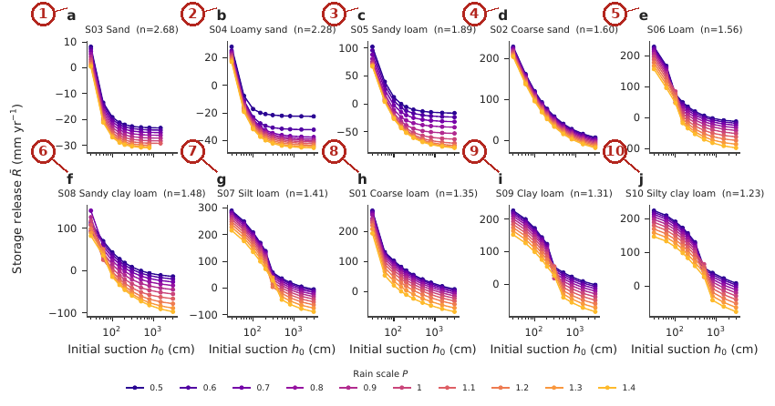
What the numbered labels point to.
- Panel (a): see the caption above. Why: The released storage grows with the initial wetness and levels off once the profile cannot hold more; coarse soils level off at wetter starts because they hold little water at any suction.
- Panel (b): see the caption above. Why: The released storage grows with the initial wetness and levels off once the profile cannot hold more; coarse soils level off at wetter starts because they hold little water at any suction.
- Panel (c): see the caption above. Why: The released storage grows with the initial wetness and levels off once the profile cannot hold more; coarse soils level off at wetter starts because they hold little water at any suction.
- Panel (d): see the caption above. Why: The released storage grows with the initial wetness and levels off once the profile cannot hold more; coarse soils level off at wetter starts because they hold little water at any suction.
- Panel (e): see the caption above. Why: The released storage grows with the initial wetness and levels off once the profile cannot hold more; coarse soils level off at wetter starts because they hold little water at any suction.
- Panel (f): see the caption above. Why: The released storage grows with the initial wetness and levels off once the profile cannot hold more; coarse soils level off at wetter starts because they hold little water at any suction.
- Panel (g): see the caption above. Why: The released storage grows with the initial wetness and levels off once the profile cannot hold more; coarse soils level off at wetter starts because they hold little water at any suction.
- Panel (h): see the caption above. Why: The released storage grows with the initial wetness and levels off once the profile cannot hold more; coarse soils level off at wetter starts because they hold little water at any suction.
- Panel (i): see the caption above. Why: The released storage grows with the initial wetness and levels off once the profile cannot hold more; coarse soils level off at wetter starts because they hold little water at any suction.
- Panel (j): see the caption above. Why: The released storage grows with the initial wetness and levels off once the profile cannot hold more; coarse soils level off at wetter starts because they hold little water at any suction.
What it shows. Storage release $\overset{‾}{R}$ (mm yr$​^{−1}$) versus initial suction $h_{0}$ in the E9 lattice, one panel per soil (a–j, ordered by decreasing van Genuchten $n$). Lines are rain scales $P=0.5$–1.4 (colour bar). Wetter starts (small $h_{0}$) release more storage; the response saturates early in coarse soils and extends over the full $h_{0}$ range in fine soils.
How to read the labels, symbols and colours. Storage release $\overset{‾}{R}$ against the starting suction $h_{0}$ (log axis), one panel per soil ordered by $n$; line colour is the rain scale $P$.
What affects it, and why it happens. A wetter start (small $h_{0}$) gives more water to release. In coarse soils the response saturates early because little water is held above the starting suction; in fine soils it extends over the whole range.
How it is made. Figure drawn by the script from the input data. Script: Manuscripts/reproducibility/analysis/p1_figs_a.py. Input: Data/daisy_ensemble.csv.gz.

Reading Figure 7 of the article
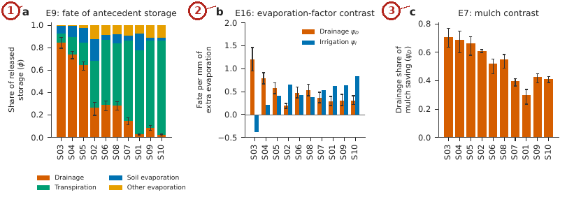
What the numbered labels point to.
- Panel (a): Memory fates $ϕ$ of released antecedent storage (E9; error bars: bootstrap 95 % CI for drainage). Why: Released water drains where the conductivity is high (coarse soils) and stays for evaporation and transpiration where it is low.
- Panel (b): Loss fates $ψ_{D}$ (drainage) and $ψ_{I}$ (irrigation) of an evaporation-factor increase (E16). Why: An increase of evaporation is paid partly by less drainage and partly by more irrigation; coarse soils pay with drainage because that is where water was going.
- Panel (c): Drainage share of the evaporation saving from mulch (E7). Soils are ordered by decreasing $ϕ_{D}$. Why: A mulch saving goes where extra water goes in each soil, so the same order of soils appears.
What it shows. (a) Memory fates $ϕ$ of released antecedent storage (E9; error bars: bootstrap 95 % CI for drainage). (b) Loss fates $ψ_{D}$ (drainage) and $ψ_{I}$ (irrigation) of an evaporation-factor increase (E16). (c) Drainage share of the evaporation saving from mulch (E7). Soils are ordered by decreasing $ϕ_{D}$.
How to read the labels, symbols and colours. (a) Memory fates $ϕ$ (shares of released storage) stacked by soil, with bootstrap intervals of $ϕ_{D}$; (b) loss fates $ψ_{D}$ and $ψ_{I}$ of an evaporation-factor increase; (c) drained share of a mulch saving. Soils ordered by $ϕ_{D}$.
What affects it, and why it happens. The same soils drain most in all three panels because drainage wins the rate competition where conductivity is high; in fine soils the released or saved water stays for the crop or reduces irrigation.
How it is made. Figure drawn by the script from the input data. Script: Manuscripts/reproducibility/analysis/p1_figs_b.py. Input: Data/daisy_ensemble.csv.gz.

Reading Figure 17 of the article
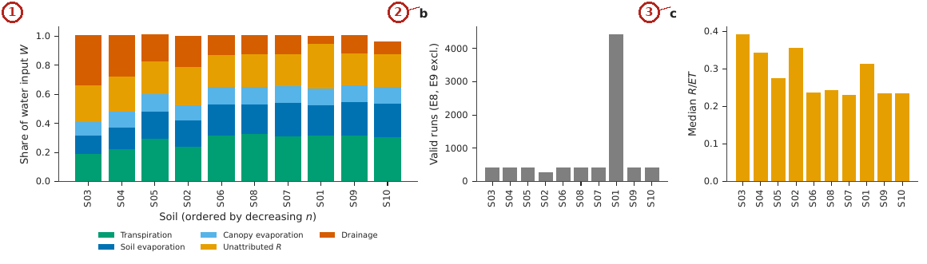
What the numbered labels point to.
- Panel (a): Mean fate shares of water input $W$, soils ordered by decreasing $n$. Why: Coarse soils send more input to drainage because they hold little and conduct fast.
- Panel (b): Number of valid runs per soil. Why: The number of valid runs is near-equal because the design is balanced; coarse sand loses most to solver failures.
- Panel (c): Median share of the unattributed term in ET. Why: The unattributed share is larger where ponding and interception are larger.
What it shows. Water fates by soil in the 15 near-equilibrium experiments (E8, E9 excluded). (a) Mean fate shares of water input $W$, soils ordered by decreasing $n$. (b) Number of valid runs per soil. (c) Median share of the unattributed term in ET.
How to read the labels, symbols and colours. (a) Mean shares of the water input by soil (stacked), ordered by $n$; (b) runs per soil; (c) median unattributed share of ET.
What affects it, and why it happens. Coarse soils send more of the input to drainage and less to transpiration and evaporation, as the rate competition predicts.
How it is made. Figure drawn by the script from the input data. Script: Manuscripts/reproducibility/analysis/p2_fig7.py. Input: Data/daisy_ensemble.csv.gz.

Reading Figure 8 of the article
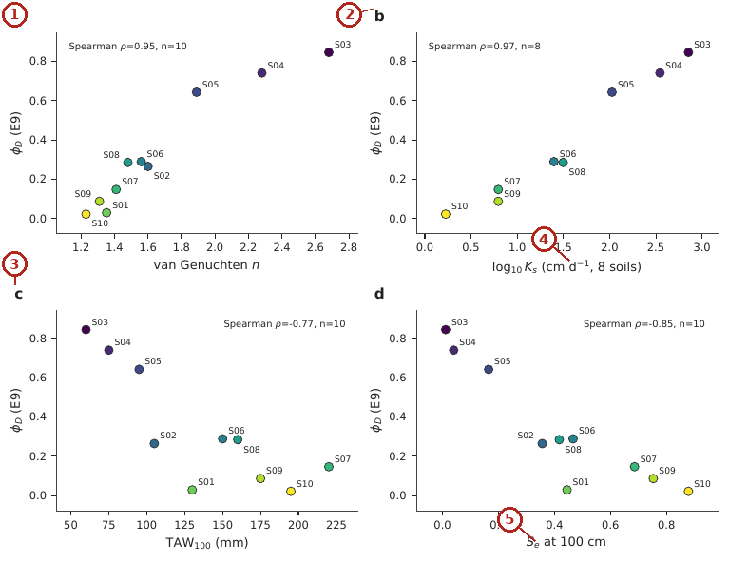
What the numbered labels point to.
- Panel (a): van Genuchten $n$. Why: Large $n$ means uniform pores that drain together, so more released water drains.
- Panel (b): $\log_{10}K_{s}$ (eight soils). Why: Higher conductivity lets water reach the bottom before roots and the surface can use it.
- Panel (c): $TAW$ to 1 m. Why: A soil that holds more available water keeps released water in reach of the roots.
- Panel (d): effective saturation at 100 cm. Spearman $ρ$ given in each panel. Why: A soil still wet at 100 cm holds water in fine pores where it drains slowly.
- Panel (e): see the caption above.
What it shows. Relationship between the memory fate $ϕ_{D}$ (E9) and four soil-level predictors: (a) van Genuchten $n$, (b) $\log_{10}K_{s}$ (eight soils), (c) $TAW$ to 1 m, (d) effective saturation at 100 cm. Spearman $ρ$ given in each panel.
How to read the labels, symbols and colours. $ϕ_{D}$ against four soil properties ($n$, $\log_{10}K_{s}$, $TAW$, $S_{e}\left(100\right)$); each point a soil; Spearman $ρ$ in each panel.
What affects it, and why it happens. $ϕ_{D}$ rises with $n$ and $K_{s}$ (faster drainage) and falls with $TAW$ and $S_{e}\left(100\right)$ (more water held at field capacity), all expressions of the pore-size distribution.
How it is made. Figure drawn by the script from the input data. Script: Manuscripts/reproducibility/analysis/p1_figs_b.py. Input: Data/daisy_ensemble.csv.gz.

Reading Figure 9 of the article
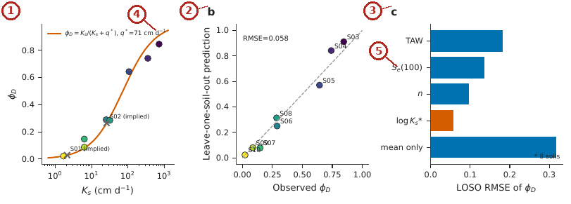
What the numbered labels point to.
- Panel (a): $ϕ_{D}$ against $K_{s}$ with the fitted curve $K_{s}/\left(K_{s}+q^{*}\right)$; crosses mark implied $K_{s}$ for S01 and S02. Why: The curve rises with $K_{s}$ and saturates because drainage can at most take all released water; it is steepest where $K_{s}≈q^{*}$.
- Panel (b): Leave-one-soil-out predictions against observations (RMSE 0.058). Why: Points close to the 1:1 line show the law predicts soils it was not fitted to.
- Panel (c): LOSO RMSE of each predictor of $ϕ_{D}$ (asterisk: eight soils; the other predictors are shown for all ten soils, and like-for-like eight-soil values are given in Table 9 of the article). Why: The law has the smallest error because it uses the property that sets the drainage rate itself.
- Panel (d): see the caption above.
- Panel (e): see the caption above.
What it shows. Rate-competition law. (a) $ϕ_{D}$ against $K_{s}$ with the fitted curve $K_{s}/\left(K_{s}+q^{*}\right)$; crosses mark implied $K_{s}$ for S01 and S02. (b) Leave-one-soil-out predictions against observations (RMSE 0.058). (c) LOSO RMSE of each predictor of $ϕ_{D}$ (asterisk: eight soils; the other predictors are shown for all ten soils, and like-for-like eight-soil values are given in Table 9 of the article).
How to read the labels, symbols and colours. (a) $ϕ_{D}$ against $K_{s}$ (log axis) with the curve $K_{s}/\left(K_{s}+q^{*}\right)$; crosses: implied $K_{s}$ of two soils without literature values. (b) Left-out predictions against observations, 1:1 line. (c) Error of each predictor when soils are left out.
What affects it, and why it happens. The curve is S-shaped on the log axis because drainage wins when $K_{s}≫q^{*}$ and loses when $K_{s}≪q^{*}$; it predicts left-out soils better than any single structural property.
How it is made. Figure drawn by the script from the input data. Script: Manuscripts/reproducibility/analysis/p1_figs_b.py. Input: Data/daisy_ensemble.csv.gz.

Reading Figure 11 of the article
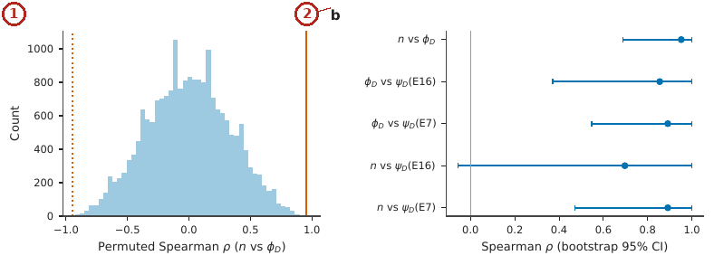
What the numbered labels point to.
- Panel (a): Permutation distribution of Spearman $ρ$ between $n$ and $ϕ_{D}$ (solid line: observed; dotted: its mirror). Why: Random reassignment of soils almost never gives a correlation as strong as the observed one, so the order is not chance.
- Panel (b): Bootstrap 95 % intervals of five rank associations (10 000 resamples). Why: The intervals stay away from zero, so the associations are stable to resampling the soils.
What it shows. Robustness of the key associations. (a) Permutation distribution of Spearman $ρ$ between $n$ and $ϕ_{D}$ (solid line: observed; dotted: its mirror). (b) Bootstrap 95 % intervals of five rank associations (10 000 resamples).
How to read the labels, symbols and colours. (a) Distribution of Spearman $ρ$ under random permutation (histogram) and the observed value (line); (b) bootstrap intervals of five rank associations.
What affects it, and why it happens. The observed $ρ$ lies far outside the permutation distribution and the intervals exclude zero, so the associations are not chance.
How it is made. Figure drawn by the script from the input data. Script: Manuscripts/reproducibility/analysis/p1_figs_d.py. Input: Data/daisy_ensemble.csv.gz.

Reading Figure 21 of the article
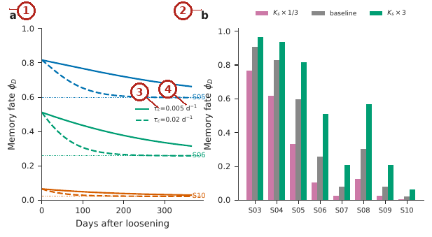
What the numbered labels point to.
- Panel (a): A threefold loosening of $K_{s}$ relaxing exponentially to the consolidated value, for the sand S05, loam S06 and silty clay loam S10; solid lines $τ_{c}=0.005$ d$​^{−1}$, dashed lines $τ_{c}=0.02$ d$​^{−1}$, dotted lines the consolidated baselines. Why: Loosening raises $K_{s}$, so more stored water drains, until consolidation lowers $K_{s}$ again.
- Panel (b): Memory fate for the eight soils with literature $K_{s}$ at one third of, equal to and three times the baseline $K_{s}$. Why: Moving $K_{s}$ up or down moves a soil along the S-curve of the law.
- Panel (c): see the caption above.
- Panel (d): see the caption above.
What it shows. Implied change of the memory fate with soil structure over time and with management, from the fitted rate-competition law (Eq. (8) of the article, $q^{*}=71.5$ cm d$​^{−1}$). These are illustrative scenarios under assumed multipliers and rates, not simulation results. (a) A threefold loosening of $K_{s}$ relaxing exponentially to the consolidated value, for the sand S05, loam S06 and silty clay loam S10; solid lines $τ_{c}=0.005$ d$​^{−1}$, dashed lines $τ_{c}=0.02$ d$​^{−1}$, dotted lines the consolidated baselines. (b) Memory fate for the eight soils with literature $K_{s}$ at one third of, equal to and three times the baseline $K_{s}$.
How to read the labels, symbols and colours. (a) $ϕ_{D}$ through time after a threefold loosening of $K_{s}$ that relaxes back, for three soils and two rates (lines); (b) $ϕ_{D}$ at one third, equal and three times the baseline $K_{s}$.
What affects it, and why it happens. These are implications of the law, not simulations: loosening raises $K_{s}$, so more stored water drains until the soil consolidates.
How it is made. Figure drawn by the script from the input data. Script: Manuscripts/reproducibility/analysis/p1_fig13_time.py. Input: Data/daisy_ensemble.csv.gz.

Reading Figure 22 of the article
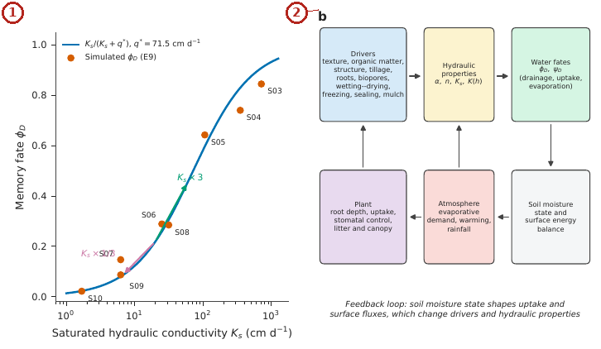
What the numbered labels point to.
- Panel (a): Memory fate $ϕ_{D}$ as a function of saturated conductivity $K_{s}$: simulated values for the eight soils with literature $K_{s}$ (points) and the rate-competition law (line); arrows show the implied change for a threefold increase or decrease in $K_{s}$ from 20 cm d$​^{−1}$ (law implication, not simulation). Why: A threefold change of $K_{s}$ moves the memory most where the curve is steep ($K_{s}$ near $q^{*}$).
- Panel (b): Conceptual feedback among drivers, hydraulic properties, water fates, soil moisture state, atmosphere and plants. Why: Drivers change the hydraulic properties, which change the fates, which change the soil water that feeds back on plants and atmosphere.
What it shows. Drivers of soil hydraulic properties and their coupling to the soil–plant–atmosphere continuum. (a) Memory fate $ϕ_{D}$ as a function of saturated conductivity $K_{s}$: simulated values for the eight soils with literature $K_{s}$ (points) and the rate-competition law (line); arrows show the implied change for a threefold increase or decrease in $K_{s}$ from 20 cm d$​^{−1}$ (law implication, not simulation). (b) Conceptual feedback among drivers, hydraulic properties, water fates, soil moisture state, atmosphere and plants.
How to read the labels, symbols and colours. (a) $ϕ_{D}$ against $K_{s}$ with the law and arrows for a threefold change; (b) diagram of feedbacks among drivers, properties, fates, moisture, atmosphere and plants.
What affects it, and why it happens. Any driver that changes $K_{s}$ (tillage, organic matter, compaction) moves a soil along the curve and changes its memory.
How it is made. Figure drawn by the script from the input data. Script: Manuscripts/reproducibility/run_all.sh. Input: Data/daisy_ensemble.csv.gz.

Reading Figure 23 of the article
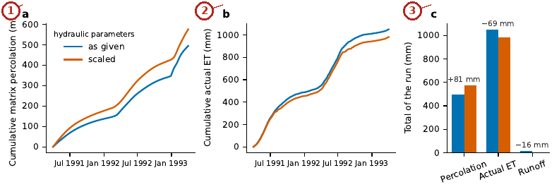
What the numbered labels point to.
- Panel (a): Cumulative matrix percolation. Why: Higher conductivity and steeper retention let more water percolate.
- Panel (b): cumulative actual evapotranspiration. Why: Water that percolates is not evaporated, so cumulative ET falls.
- Panel (c): totals of the two seasons with the difference. Daily logs of Daisy, unchanged; script reproducibility/fig_vg_check.py. Why: The totals change in opposite directions: drainage gains what evapotranspiration and runoff lose.
What it shows. One Daisy 7.1.14 run of the loam written by SWAFL 1.1.0 with the van Genuchten–Mualem parameters of every horizon as given (blue) and scaled toward a faster-draining soil (orange: $K_{sat}×4$, $α×2$, $\left(n−1\right)×1.3$, $θ_{s}×1.1$, $l+1$). (a) Cumulative matrix percolation, (b) cumulative actual evapotranspiration, (c) totals of the two seasons with the difference. Daily logs of Daisy, unchanged; script reproducibility/fig_vg_check.py.
How to read the labels, symbols and colours. Blue: the loam as given; orange: scaled toward faster drainage. (a) Cumulative percolation, (b) cumulative ET, (c) totals with differences.
What affects it, and why it happens. Higher conductivity and steeper retention move water from evapotranspiration and runoff to percolation, the same competition as the law.
How it is made. Figure drawn by the script from the input data. Script: Manuscripts/reproducibility/fig_vg_check.py. Input: Data/daisy_ensemble.csv.gz.

Derivation: The water balance and the storage release
Over a period, mass conservation of the soil column with surface runoff $Q_{r}$ is $P_{r}+I=ET+D+ΔS+Q_{r}$. Rearranging,
$$\overset{‾}{R}≡ET+D−P_{r}−I=−\left(ΔS+Q_{r}\right),$$
so the storage release is positive when the column loses stored water (or sheds no runoff) and supplies the fluxes. In the initial-moisture experiment, a wetter initial state raises the stored water that is released over the run, which is the variation used to measure the memory fates.

Derivation: The memory fate as a pooled within-group slope
Within a group of runs with the same rainfall scale $P$, write each flux as $x_{c}=a_{P}+ϕ_{x}{\overset{‾}{R}}_{c}+e_{c}$. Minimising P​c∈P​ec2 over the group intercepts $a_{P}$ gives $a_{P}={\overset{‾}{x}}_{P}−ϕ_{x}{\overline{\overset{‾}{R}}}_{P}$, and then over $ϕ_{x}$
ϕx=P​c∈P​Rc−RPxc−xPP​c∈P​Rc−RP2.
Because the four fluxes add to $ET+D=\overset{‾}{R}+P_{r}+I$ and $P_{r}+I$ is constant within a group, the deviations of the four fluxes add to the deviation of $\overset{‾}{R}$, and the four slopes add to one: $ϕ_{E_{s}}+ϕ_{T}+ϕ_{D}+ϕ_{oth}=1$. Each $ϕ_{x}$ is therefore the share of a released millimetre that leaves by flux $x$.

Derivation: The rate-competition law
Let stored water $S$ above field capacity leave by two parallel first-order sinks, drainage with rate constant $k_{D}∝K_{s}/L$ and withdrawal by evaporation and uptake with $k_{W}∝q^{*}/L$, where $L$ is a common length. Then $dS/dt=−\left(k_{D}+k_{W}\right)S$ and the drainage leaving over the release is
$$\int_{0}^{∞}{k_{D}}S dt=\frac{k_{D}}{k_{D}+k_{W}}S_{0} ⇒ ϕ_{D}=\frac{K_{s}}{K_{s}+q^{*}}.$$
The law is bounded in $\left[0,1\right]$, tends to 0 for an impermeable soil and to 1 for a free-draining one, and is the only one-parameter form with these limits that is linear in $K_{s}$ at small $K_{s}$. By the Buckingham theorem, $ϕ_{D}=F\left(K_{s}/q^{*},n,αh^{*}\right)$; the law keeps the first group only.

Why it happens

Why hydraulic memory differs between soils.
Water released from storage leaves by the faster of two routes. In coarse soils (large $n$, high $K_{s}$) the conductivity at field capacity is high, so released water drains before roots and the surface can use it; in fine soils the conductivity is low and the same water stays near the roots and the surface, where it is transpired or evaporated.

Why the memory transfers to other experiments.
The same competition decides where any extra water goes, whether it comes from initial storage, from a lower evaporation factor or from a mulch; the share is a property of the soil’s conductivity, not of the source of the water.

The recoverable share of an evaporation saving
What becomes of water saved from evaporation by a lower evaporation factor or a mulch.

Contribution 3: the recoverable share of an evaporation saving
A mulch saves evaporation. Is the saved water gained for the crop or the irrigation account, or is it lost to drainage?
Paired runs that differ only in the evaporation factor (E16) or in the mulch level (E7) were differenced; the water balance gives $ψ_{T}+ψ_{D}+ψ_{I}≈1$ for the fates of the evaporation change; the recoverable share is what does not drain.
How it is derived, line by line $$\begin{array}{@{}l@{}}\textbf{1. Balance of an evaporation change:}\\[1pt]
\qquad \delta\mathit{ET}_{\mathrm{nt}}+\delta T+\delta D-\delta I\simeq0\\[1pt]
\textbf{2. Divide by } \delta\mathit{ET}_{\mathrm{nt}}\textbf{:}\\[1pt]
\qquad \psi_T+\psi_D+\psi_I\simeq1\\[1pt]
\textbf{3. Only the drained part is not recovered:}\\[1pt]
\qquad \rho_R=1-\psi_D
\end{array}$$ The result, with its parts marked
$$\underbrace{\rho_R}_{\tikz[baseline=(c.base)]\node[circle,draw=red!70!black,text=red!70!black,line width=0.6pt,inner sep=0.7pt,minimum size=1.15em,font=\scriptsize\bfseries\sffamily](c){1};}=1-\underbrace{\psi_D}_{\tikz[baseline=(c.base)]\node[circle,draw=red!70!black,text=red!70!black,line width=0.6pt,inner sep=0.7pt,minimum size=1.15em,font=\scriptsize\bfseries\sffamily](c){2};}$$
Soil | $ρ_{R}$ (evaporation factor, E16) | $ρ_{R}$ (mulch, E7)
Sand | (c)3; $−0.21$ (none) | 0.29
Loamy sand | 0.20 | 0.31
Loam | 0.53 | 0.48
Silty clay loam | 0.69 | 0.59
(c)1; The share of a saved millimetre of evaporation that is recovered (as transpiration or as less irrigation).
(c)2; The loss fate: the share of the saving that drains instead. It follows the same order as the memory fate of Contribution 1, which links the two experiments.
(c)3; In sand nothing is recovered: the saving drains (the negative value shows that drainage even exceeds the saving within the uncertainty of the regression). A mulch on sand saves evaporation but not water for the crop.

Worked numbers, part 5: the recoverable share of an evaporation saving
When a mulch or a lower evaporation demand saves evaporation, the saved water goes to transpiration, to less irrigation, or to drainage. Only the part that does not drain is recovered: $ρ_{R}=1−ψ_{D}$. Example. Loamy sand, $ψ_{D}=0.80$ in the edge-case experiment: $ρ_{R}=0.20$; only a fifth of a saving is recovered.

Reading Figure 10 of the article
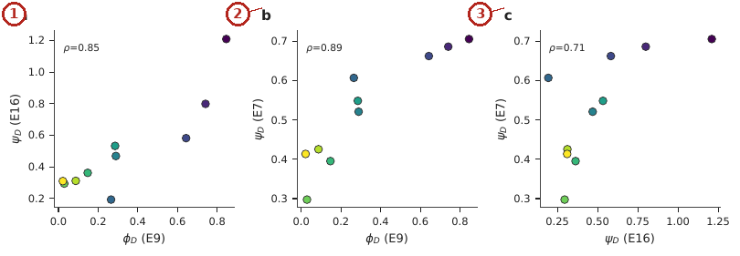
What the numbered labels point to.
- Panel (a): $ψ_{D}$ from E16 against $ϕ_{D}$ from E9. Why: Soils that drain released water also drain an evaporation change: the same competition decides both.
- Panel (b): $ψ_{D}$ from the mulch lattice E7 against $ϕ_{D}$. Why: The mulch saving follows the same order for the same reason.
- Panel (c): E7 against E16. Each point is a soil, coloured by $n$ (as in Fig. 8 of the article). Why: The two independent experiments agree with each other, so the share is a soil property.
What it shows. Cross-experiment transfer. (a) $ψ_{D}$ from E16 against $ϕ_{D}$ from E9; (b) $ψ_{D}$ from the mulch lattice E7 against $ϕ_{D}$; (c) E7 against E16. Each point is a soil, coloured by $n$ (as in Fig. 8 of the article).
How to read the labels, symbols and colours. Each point is a soil coloured by $n$: (a) $ψ_{D}$ of E16 against $ϕ_{D}$ of E9; (b) $ψ_{D}$ of E7 against $ϕ_{D}$; (c) E7 against E16.
What affects it, and why it happens. Points line up because the same soil property decides where extra water goes, whatever its source (stored water, less evaporation, mulch).
How it is made. Figure drawn by the script from the input data. Script: Manuscripts/reproducibility/analysis/p1_figs_c.py. Input: Data/daisy_ensemble.csv.gz.

Reading Figure 12 of the article
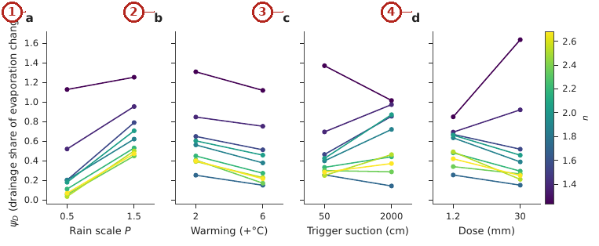
What the numbered labels point to.
- Panel (a): rainfall scale. Why: More rain keeps the profile wetter, where drainage is fast, so more of a saving drains.
- Panel (b): warming. Why: Warming raises the demand, so saved water is used before it drains.
- Panel (c): trigger suction. Why: A drier trigger keeps the profile drier between irrigations, so less of a saving drains.
- Panel (d): irrigation dose. Why: Larger doses wet the profile more, so more of a saving drains.
What it shows. Modifiers of the drainage share $ψ_{D}$ in E16. Each line is a soil (colour: $n$); (a) rainfall scale, (b) warming, (c) trigger suction, (d) irrigation dose.
How to read the labels, symbols and colours. $ψ_{D}$ against four modifiers (rain scale, warming, trigger, dose), one line per soil coloured by $n$.
What affects it, and why it happens. More rain keeps the profile wet and raises drainage of a saving; warming raises demand so more saved water is used; trigger and dose move the profile wetness and therefore the share.
How it is made. Figure drawn by the script from the input data. Script: Manuscripts/reproducibility/analysis/p1_figs_c.py. Input: Data/daisy_ensemble.csv.gz.

Reading Figure 13 of the article
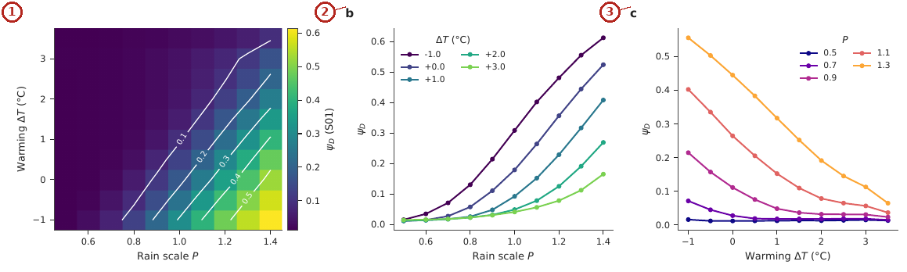
What the numbered labels point to.
- Panel (a): $ψ_{D}$ over rain scale and warming (white contours). Why: The drained share rises with rain and falls with warming, so the colour changes across the diagonal.
- Panel (b): $ψ_{D}$ against $P$ for selected warming levels. Why: At each warming level the share rises with rain (wetter profile).
- Panel (c): $ψ_{D}$ against warming for selected rain scales. Why: At each rain level the share falls with warming (higher demand).
What it shows. Climate surface of the drainage share $ψ_{D}$ for coarse loam (S01) from the E11 lattice. (a) $ψ_{D}$ over rain scale and warming (white contours), (b) $ψ_{D}$ against $P$ for selected warming levels, (c) $ψ_{D}$ against warming for selected rain scales.
How to read the labels, symbols and colours. (a) Colour map of $ψ_{D}$ for coarse loam over rain scale and warming, white contours; (b, c) sections at selected levels.
What affects it, and why it happens. $ψ_{D}$ rises with rain (wetter profile, faster drainage) and falls with warming (higher demand wins the competition).
How it is made. Figure drawn by the script from the input data. Script: Manuscripts/reproducibility/analysis/p1_figs_e.py. Input: Data/daisy_ensemble.csv.gz.

Reading Figure 24 of the article
What it shows. Recoverable fraction $1−ψ_{D}$ by soil for the E16 and E7 contrasts.
How to read the labels, symbols and colours. Recoverable fraction $1−ψ_{D}$ by soil for the two contrasts.
What affects it, and why it happens. Coarse soils recover least because the saving drains.
How it is made. Figure drawn by the script from the input data. Script: Manuscripts/reproducibility/analysis/p1_figs_c.py. Input: Data/daisy_ensemble.csv.gz.

Reading Figure 20 of the article
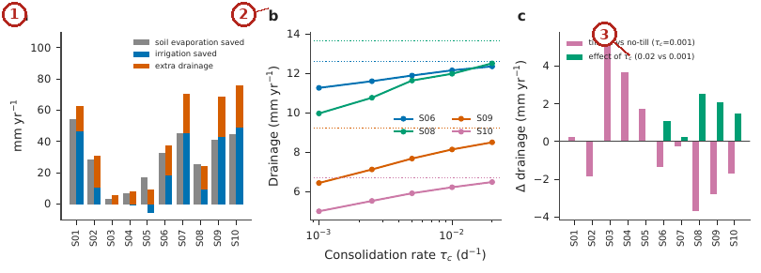
What the numbered labels point to.
- Panel (a): Run set E7, strong against weak mulch (vapour-flux factor 0.3 against 0.9, capacity 2 mm): evaporation saved, irrigation saved and extra drainage by soil. Why: A strong mulch saves evaporation; in coarse soils much of the saving drains instead of reducing irrigation.
- Panel (b): Run set E5, rainfed drainage of four finer soils against the consolidation rate $τ_{c}$ for conventional tillage (solid) and the no-till value (dotted). Why: Faster consolidation closes pores sooner, so drainage returns toward the untilled value.
- Panel (c): Effect of tillage ($τ_{c}=0.001$ against no-till) and of faster consolidation ($τ_{c}=0.02$ against 0.001) on rainfed drainage, all ten soils. Why: Tillage loosens the soil and changes drainage; the size depends on texture.
What it shows. Simulation evidence on structure, time and mulching (Daisy ensemble, mean annual values). (a) Run set E7, strong against weak mulch (vapour-flux factor 0.3 against 0.9, capacity 2 mm): evaporation saved, irrigation saved and extra drainage by soil. (b) Run set E5, rainfed drainage of four finer soils against the consolidation rate $τ_{c}$ for conventional tillage (solid) and the no-till value (dotted). (c) Effect of tillage ($τ_{c}=0.001$ against no-till) and of faster consolidation ($τ_{c}=0.02$ against 0.001) on rainfed drainage, all ten soils.
How to read the labels, symbols and colours. (a) For each soil, evaporation saved, irrigation saved and extra drainage of a strong mulch; (b) rainfed drainage against the consolidation rate for four soils; (c) effect of tillage and of faster consolidation on drainage.
What affects it, and why it happens. A mulch saves evaporation, but in coarse soils much of it drains; tillage loosens the soil and changes drainage until consolidation returns it toward the untilled state.
How it is made. Figure drawn by the script from the input data. Script: Manuscripts/reproducibility/analysis/p1_fig14_ens.py. Input: Data/daisy_ensemble.csv.gz.

Reading Figure 19 of the article
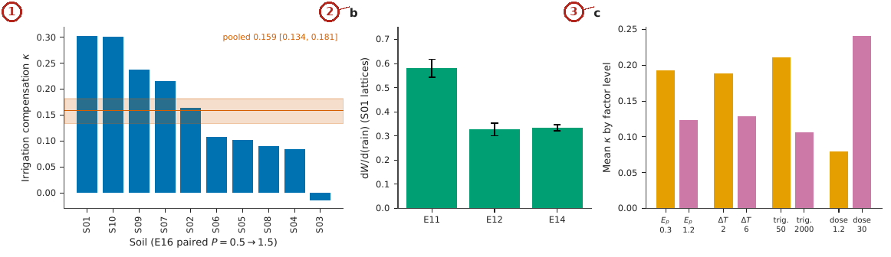
What the numbered labels point to.
- Panel (a): Per-soil $κ$ in E16 (paired $P=0.5→1.5$) with the pooled estimate and bootstrap interval. Why: Where extra rain drains, irrigation falls by less than the rain, so $κ<1$, most in coarse soils.
- Panel (b): Slope of water input on rain in single-soil lattices (95 % intervals). Why: Single-soil lattices show the same slope below one.
- Panel (c): Mean $κ$ by factor level in E16. Why: Management that keeps the profile wetter lowers $κ$.
What it shows. Irrigation compensation $κ$ is not universal. (a) Per-soil $κ$ in E16 (paired $P=0.5→1.5$) with the pooled estimate and bootstrap interval. (b) Slope of water input on rain in single-soil lattices (95 % intervals). (c) Mean $κ$ by factor level in E16.
How to read the labels, symbols and colours. (a) Per-soil compensation $κ$ with the pooled estimate; (b) slope of input on rain in single-soil lattices; (c) mean $κ$ by factor level.
What affects it, and why it happens. Where extra rain drains, irrigation falls by less than the rain, so $κ<1$; the value depends on soil and on management.
How it is made. Figure drawn by the script from the input data. Script: Manuscripts/reproducibility/analysis/p2_fig6.py. Input: Data/daisy_ensemble.csv.gz.

Derivation: Loss fates and the recoverable share
Between two levels of the evaporation factor the change of the non-transpirational evapotranspiration $δ{ET}_{nt}$ must be balanced by the other fluxes. With storage changes negligible over 20 years, $δ{ET}_{nt}+δT+δD−δI≃0$, hence
$$ψ_{T}+ψ_{D}+ψ_{I}≃1, ψ_{x}=∓\frac{δx}{δ{ET}_{nt}},$$
the signs chosen so that each $ψ$ is positive when the flux compensates the evaporation change. Of a millimetre of evaporation saved, $ψ_{D}$ leaves as drainage and is not recovered by the crop or the irrigation account; the recoverable share is $ρ_{R}=1−ψ_{D}$.

Derivation: Irrigation compensation
With the same balance, a change of rainfall $ΔP_{r}$ at fixed trigger is offset partly by irrigation: $κ=−ΔI/ΔP_{r}$. When drainage and evapotranspiration do not change, $κ=1$; when part of the extra rain drains, $κ<1$.

Why it happens

Why warming raises and wetter climates lower the recoverable share.
Warming raises the evaporative demand, so the withdrawal side of the competition is faster and less of a saved millimetre drains. A wetter climate keeps the profile closer to field capacity, where drainage is fast, so more of a saving drains.

Why nitrogen has no effect.
The nitrogen rate changes the crop’s growth but not the hydraulic properties, and in these runs it changes the water fluxes too little to move the shares; it therefore serves as a negative control.

Why judging a saving against soil evaporation alone misleads.
A mulch changes soil evaporation and also the unattributed evaporation; if only the reported soil evaporation is used as the denominator, the drainage share of the change is computed against the wrong total and can change sign.

The model’s own water balance
The balance found in the runs without being told, and the evaporation the model does not attribute.

Contribution 4: discovering the model’s water balance without being told
Can an automatic method find the conservation law hidden in a process model’s outputs, and use it to detect what the outputs leave out?
The 20-year fluxes $P_{r}$, $I$, $ET$ and $D$ of all valid runs were centred and stacked as a matrix; its singular-value decomposition gives the combination of columns closest to zero; a permutation of each column gives the distribution under no structure; the vector was rescaled so that ET has coefficient $−1$.
How it is derived, line by line $$\begin{array}{@{}l@{}}\textbf{1. Fluxes of all runs as a centred matrix:}\\[1pt]
\qquad \mathbf F\ (\text{rows: runs; columns: }P_r,I,\mathit{ET},D)\\[1pt]
\textbf{2. Seek the combination closest to zero:}\\[1pt]
\qquad \min_{\|\mathbf c\|=1}\|\mathbf F\mathbf c\|^2=\mathbf c^\top\mathbf F^\top\mathbf F\mathbf c\\[1pt]
\textbf{3. Solution:}\\[1pt]
\qquad \mathbf c=\text{right singular vector with the smallest singular value}\\[1pt]
\textbf{4. Rescale so that } c_{\mathit{ET}}=-1\textbf{:}\\[1pt]
\qquad \mathbf c=(1.037,0.957,-1,-1.036)
\end{array}$$ The result, with its parts marked
$$\underbrace{\mathbf c}_{\tikz[baseline=(c.base)]\node[circle,draw=red!70!black,text=red!70!black,line width=0.6pt,inner sep=0.7pt,minimum size=1.15em,font=\scriptsize\bfseries\sffamily](c){1};}=(c_{P_r},c_I,c_{\mathit{ET}},c_D)=(\underbrace{1.037}_{\tikz[baseline=(c.base)]\node[circle,draw=red!70!black,text=red!70!black,line width=0.6pt,inner sep=0.7pt,minimum size=1.15em,font=\scriptsize\bfseries\sffamily](c){2};},\ 0.957,\ -1,\ \underbrace{-1.036}_{\tikz[baseline=(c.base)]\node[circle,draw=red!70!black,text=red!70!black,line width=0.6pt,inner sep=0.7pt,minimum size=1.15em,font=\scriptsize\bfseries\sffamily](c){3};})$$
$$\underbrace{R=\mathit{ET}-T-E_s-E_c=164\ \mathrm{mm\,yr^{-1}}}_{\tikz[baseline=(c.base)]\node[circle,draw=red!70!black,text=red!70!black,line width=0.6pt,inner sep=0.7pt,minimum size=1.15em,font=\scriptsize\bfseries\sffamily](c){4};}$$
(c)1; The right singular vector of the flux matrix with the smallest singular value: the linear combination of fluxes that is closest to zero for all 10 041 runs.
(c)2; Rain and irrigation enter with $+1$ and evapotranspiration and drainage with $−1$, within 5 %: the method recovered $P_{r}+I−ET−D≈0$, the water balance, without being given it.
(c)3; The small departures from $±1$ measure what the four fluxes do not contain (storage change and runoff), which is how the closure residual was found.
(c)4; Evapotranspiration minus its reported parts is 164 mm a year, 30 % of ET. The full outputs show this is evaporation of ponded water (21.6 % of ET), litter (7.6 %) and snow (2.7 %), which the run table did not report.

Worked numbers, part 6: checking the model’s own bookkeeping
If the outputs of the model obey the balance of Part 1, the columns $P$, $I$, $ET$ and $D$ of all runs are linked by one linear relation. The singular-value decomposition finds the combination of columns that is closest to zero; it gave coefficients within 5 % of $\left(1,1,−1,−1\right)$, so the method finds the balance without being told it.

Worked numbers, part 7: the unattributed evaporation
$ET$ minus transpiration, soil evaporation and canopy evaporation should be zero; in the run table it averaged 164 mm a year (30 % of $ET$). The full outputs show it is evaporation of ponded water, litter and snow, which the run table did not report separately.

Reading Figure 1 of the article
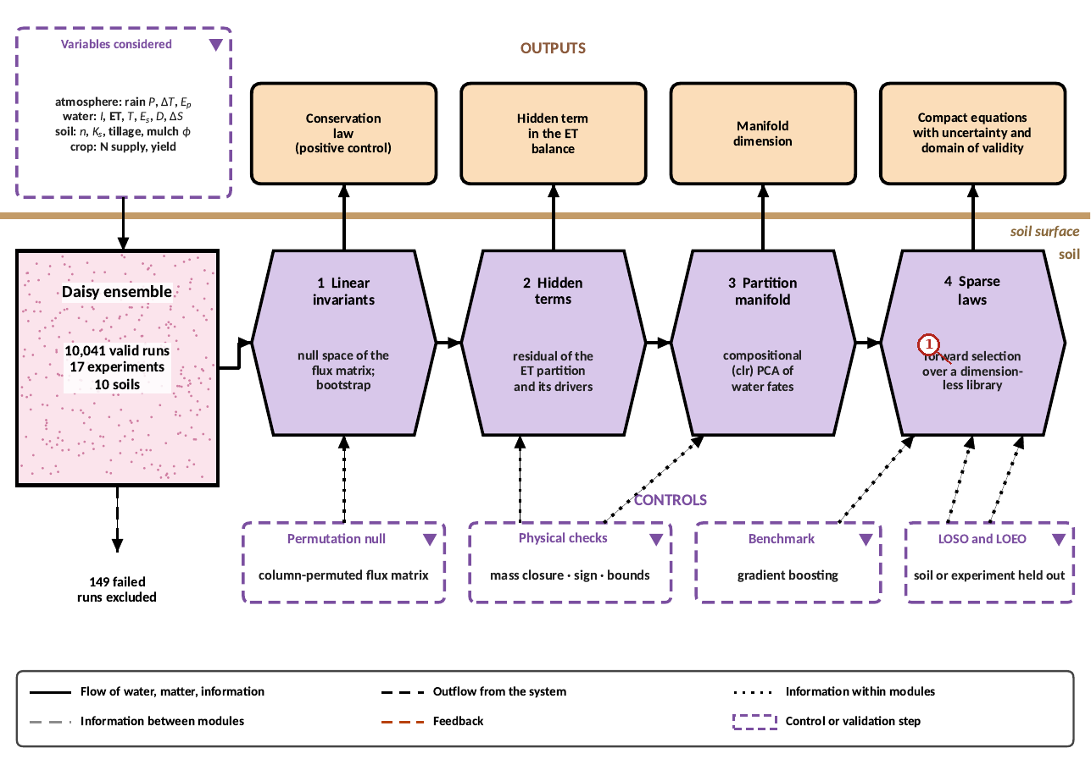
What the numbered labels point to.
- Panel (a): see the caption above.
What it shows. Pipeline for interpretable discovery. The pipeline recovers the known water balance as a positive control, audits partitions, measures the dimension of the partition manifold and fits sparse laws with LOSO/LOEO validation against gradient boosting. Controls (dashed purple boxes) are shown at the bottom and outputs at the top; purple hexagons are processing blocks, the pink stippled box is the data store, peach boxes are outputs and dotted lines are flows of information. The 149 runs excluded as numerical failures are analysed in Section 2.2 of the article.
How to read the labels, symbols and colours. Flow diagram: purple hexagons are processing blocks, the pink stippled box the data store, peach boxes the outputs, dashed purple boxes the controls; dotted lines are flows of information.
What affects it, and why it happens. The diagram has no data; it shows the order of the analysis: the data are first used to recover the known balance (a positive control) before any new law is accepted.
How it is made. Figure drawn by the script from the input data. Script: Manuscripts/reproducibility/make_a4.py. Input: Data/daisy_ensemble.csv.gz.

Reading Figure 14 of the article
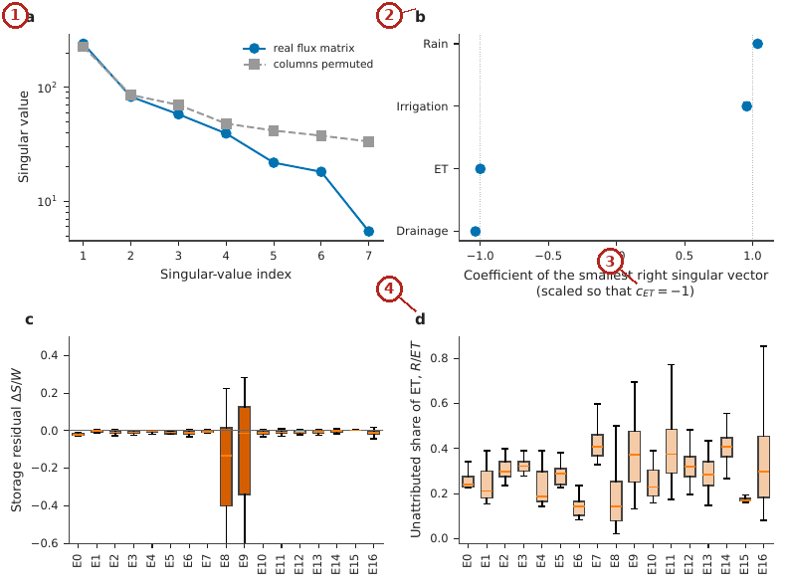
What the numbered labels point to.
- Panel (a): Singular values of the seven-flux matrix for the real data and for column-permuted data. Why: One singular value is far below the permuted ones because the four fluxes obey one linear balance.
- Panel (b): Coefficients of the smallest right singular vector (scaled so $c_{ET}=−1$) with bootstrap intervals. Why: The coefficients are close to $+1$ for inputs and $−1$ for outputs because that balance is conservation of water.
- Panel (c): Storage residual $ΔS/W$ by experiment: E8 and E9 do not close. Why: Experiments with perturbed initial storage do not close because their storage change is large and not in the four fluxes.
- Panel (d): Unattributed share of ET, $R/ET$, by experiment. Why: The unattributed share differs by experiment because ponding, litter and snow evaporation differ with rain and management.
What it shows. Linear invariants. (a) Singular values of the seven-flux matrix for the real data and for column-permuted data. (b) Coefficients of the smallest right singular vector (scaled so $c_{ET}=−1$) with bootstrap intervals. (c) Storage residual $ΔS/W$ by experiment: E8 and E9 do not close. (d) Unattributed share of ET, $R/ET$, by experiment.
How to read the labels, symbols and colours. (a) Singular values of the flux matrix, real against permuted data; (b) coefficients of the smallest singular vector with intervals; (c) storage residual by experiment; (d) unattributed share of ET by experiment.
What affects it, and why it happens. One singular value is far smaller than under permutation: the balance is a real linear invariant. Its coefficients are near $±1$; the residuals show where the outputs do not close (E8, E9 with perturbed starting storage) and how large the unattributed evaporation is.
How it is made. Figure drawn by the script from the input data. Script: Manuscripts/reproducibility/analysis/p2_figs.py. Input: Data/daisy_ensemble.csv.gz.

Reading Figure 15 of the article
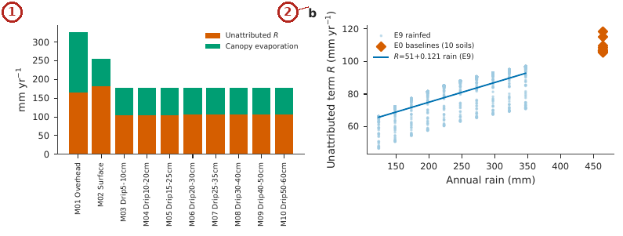
What the numbered labels point to.
- Panel (a): $R$ and canopy evaporation in E4 by irrigation method. Why: Overhead irrigation raises the unattributed term because intercepted and ponded water evaporates.
- Panel (b): $R$ against annual rain in E9 (rainfed, light points), with the linear fit and the ten E0 baselines. Why: More rain means more ponded and intercepted water, so the term rises with rain.
What it shows. The unattributed term $R$. (a) $R$ and canopy evaporation in E4 by irrigation method. (b) $R$ against annual rain in E9 (rainfed, light points), with the linear fit and the ten E0 baselines.
How to read the labels, symbols and colours. (a) Unattributed term $R$ and canopy evaporation by irrigation method; (b) $R$ against annual rain with a linear fit.
What affects it, and why it happens. $R$ grows with rain and with overhead irrigation because it contains evaporation of ponded and intercepted water and of litter.
How it is made. Figure drawn by the script from the input data. Script: Manuscripts/reproducibility/analysis/p2_figs.py. Input: Data/daisy_ensemble.csv.gz.

Reading Figure 16 of the article
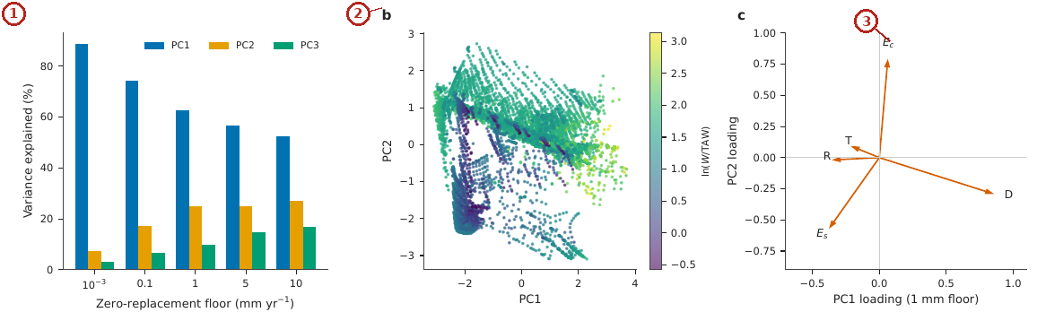
What the numbered labels point to.
- Panel (a): Variance explained by the first three clr-PCA components for five zero-replacement floors. Why: Most variance is in the first two components because the partition is controlled by a few factors (input and storage).
- Panel (b): Scores on the first two components (1 mm floor) coloured by $ln\left(W/TAW\right)$. Why: Runs are ordered by input relative to storage capacity along the main component.
- Panel (c): Loadings of the five fates on the first two components. Why: Drainage and transpiration load in opposite directions because they compete for the same water.
What it shows. Partition manifold and its sensitivity to zero handling. (a) Variance explained by the first three clr-PCA components for five zero-replacement floors. (b) Scores on the first two components (1 mm floor) coloured by $ln\left(W/TAW\right)$. (c) Loadings of the five fates on the first two components.
How to read the labels, symbols and colours. (a) Variance explained by the first three components of the log-ratio fates for five zero floors; (b) scores coloured by $ln\left(W/TAW\right)$; (c) loadings of the five fates.
What affects it, and why it happens. Two components carry most of the variance: the partition of water lies near a low-dimensional surface organised by water input relative to storage capacity.
How it is made. Figure drawn by the script from the input data. Script: Manuscripts/reproducibility/analysis/p2_fig4.py. Input: Data/daisy_ensemble.csv.gz.

Reading Figure 5 of the article
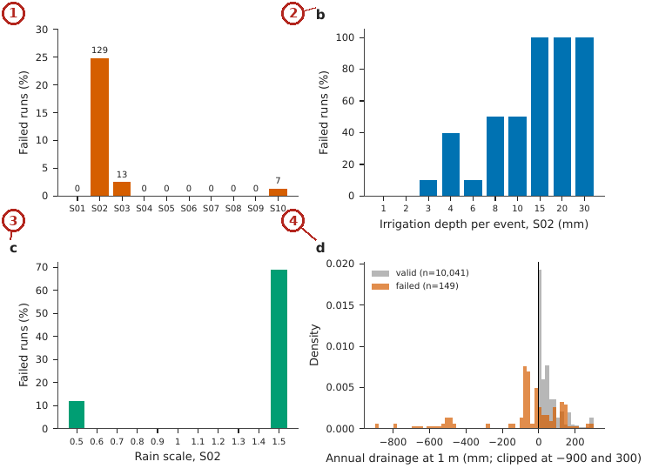
What the numbered labels point to.
- Panel (a): Failed runs per soil, as a percentage of the 519 runs per soil (counts above bars). Why: Coarse sand fails most: its very high conductivity makes wetting fronts so steep that the solver cannot keep the step small enough.
- Panel (b): Failed fraction in S02 against irrigation depth per event in E10. Why: Larger doses make steeper fronts in the coarse sand, so more runs fail.
- Panel (c): Failed fraction in S02 against rain scale. Why: More rain does the same as larger doses: steeper, more frequent fronts.
- Panel (d): Annual drainage at 1 m for valid and failed runs, normalised as densities; negative drainage of several hundred millimetres occurs only in failed runs. Why: Negative drainage of hundreds of millimetres is physically impossible in these columns; it is the signature of a failed solution, which is why failed runs are excluded.
What it shows. Pattern of the 149 failed runs. (a) Failed runs per soil, as a percentage of the 519 runs per soil (counts above bars). (b) Failed fraction in S02 against irrigation depth per event in E10. (c) Failed fraction in S02 against rain scale. (d) Annual drainage at 1 m for valid and failed runs, normalised as densities; negative drainage of several hundred millimetres occurs only in failed runs.
How to read the labels, symbols and colours. (a) Share of failed runs per soil; (b, c) failed share of coarse sand against dose and rain scale; (d) density of annual drainage for valid and failed runs.
What affects it, and why it happens. Failures concentrate in coarse sand with large doses or much rain, where the solver meets steep fronts; failed runs show impossible negative drainage of hundreds of millimetres, which is why they are excluded.
How it is made. Figure drawn by the script from the input data. Script: Manuscripts/reproducibility/analysis/p2_figfail.py. Input: Data/daisy_ensemble.csv.gz.

Derivation: The invariant search by singular-value decomposition
Arrange the 20-year mean fluxes of all runs as the rows of a matrix $F$ (columns $P_{r},I,ET,D$, centred). A linear invariant is a vector $c$ with $Fc≈0$. The best such vector in the least-squares sense, with $∥c∥=1$, minimises $∥Fc∥^{2}=c^{⊤}F^{⊤}Fc$, which is the eigenvector of $F^{⊤}F$ with the smallest eigenvalue, that is the right singular vector of $F$ with the smallest singular value. Rescaled so that the $ET$ coefficient is $−1$, it is the discovered balance; the permutation null shuffles each column independently and so destroys any true invariant, which gives the distribution of the smallest singular value under no structure.

Derivation: The closure residual and the unattributed term
With $W=P_{r}+I$, the residual $ε=\left(W−ET−D\right)/W≃\left(ΔS+Q_{r}\right)/W$ is the share of the input not leaving by evapotranspiration or drainage. The unattributed evapotranspiration is $R=ET−T−E_{s}−E_{c}$; in the full outputs it equals the evaporation of ponded water, litter and snow (data folder, closure within 1.1 mm).

Why it happens

Why an evaporative term is unattributed.
The reported components cover transpiration, soil evaporation and canopy evaporation; evaporation of ponded water, litter and snow is part of evapotranspiration but not of those components, so it appears as a residual in the run table.

A compact law for evapotranspiration
The sparse law found in log-ratio coordinates.

Contribution 5: a compact law for evapotranspiration
Log and dimensionless candidate terms were added one at a time by forward selection; a term was kept only if the cross-validated $R^{2}$ (experiments or soils left out) rose by more than 0.003; the selected law was compared with gradient boosting on the same folds.
How it is derived, line by line $$\begin{array}{@{}l@{}}\textbf{1. Candidates (log or dimensionless):}\\[1pt]
\qquad \ln W,\ n,\ \ln(1+I),\dots\\[1pt]
\textbf{2. Forward selection, keep a term if } R^2_{\mathrm{cv}}\textbf{ rises by }>0.003\textbf{:}\\[1pt]
\qquad \{\ln W,\ n,\ \ln(1+I)\}\\[1pt]
\textbf{3. Least squares on } \ln\mathit{ET}\textbf{:}\\[1pt]
\qquad \ln\mathit{ET}=2.503+0.646\ln W-0.299n+0.029\ln(1+I)
\end{array}$$ The result, with its parts marked
$$\ln\mathit{ET}=2.503+\underbrace{0.646\ln W}_{\tikz[baseline=(c.base)]\node[circle,draw=red!70!black,text=red!70!black,line width=0.6pt,inner sep=0.7pt,minimum size=1.15em,font=\scriptsize\bfseries\sffamily](c){1};}\underbrace{-0.299\,n}_{\tikz[baseline=(c.base)]\node[circle,draw=red!70!black,text=red!70!black,line width=0.6pt,inner sep=0.7pt,minimum size=1.15em,font=\scriptsize\bfseries\sffamily](c){2};}+\underbrace{0.029\ln(1+I)}_{\tikz[baseline=(c.base)]\node[circle,draw=red!70!black,text=red!70!black,line width=0.6pt,inner sep=0.7pt,minimum size=1.15em,font=\scriptsize\bfseries\sffamily](c){3};}$$
$$\underbrace{R^2=0.898\ \text{and}\ 0.904}_{\tikz[baseline=(c.base)]\node[circle,draw=red!70!black,text=red!70!black,line width=0.6pt,inner sep=0.7pt,minimum size=1.15em,font=\scriptsize\bfseries\sffamily](c){4};}$$
(c)1; The elasticity of ET to the water input $W=P_{r}+I$ is 0.65, less than one: a part of every extra millimetre drains instead of evaporating.
(c)2; A larger $n$ (coarser soil) lowers ET at the same input: coarse soils lose more to drainage, the same mechanism as Contribution 1.
(c)3; Irrigation has a small effect of its own beyond its part of $W$: it is applied when the root zone is dry, at the time the crop can use it; the coefficient is small, so most of the effect of irrigation is already carried by $W$.
(c)4; Out-of-sample skill on experiments and on soils left out, equal to gradient boosting: ET can be emulated by three terms, while drainage could not be emulated by any law tried.

Reading Figure 18 of the article
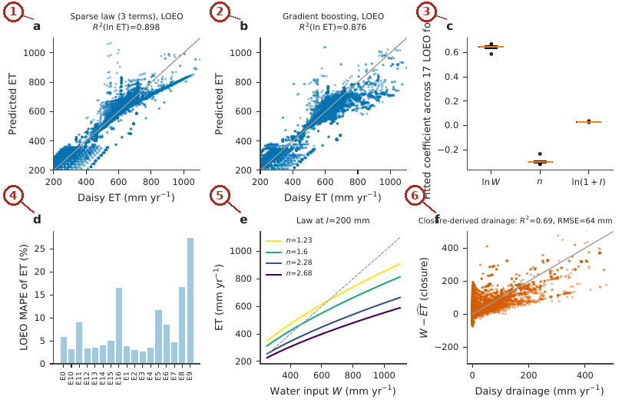
What the numbered labels point to.
- Panel (a): Leave-one-experiment-out predictions of the three-term law versus Daisy ET. Why: ET follows input and soil smoothly, so a three-term law predicts withheld experiments.
- Panel (b): Gradient-boosting benchmark. Why: A flexible learner does no better, so the law is not missing structure.
- Panel (c): Fitted coefficients across the 17 LOEO folds. Why: Coefficients barely change between folds, so the law is stable.
- Panel (d): LOEO MAPE by experiment. Why: Errors are larger in experiments with extreme inputs (very dry or very wet).
- Panel (e): The law at $I=200$ mm for four soils (grey dashed: ET $=W$). Why: ET rises with input but less than one to one, and coarse soils (large $n$) evaporate less of it.
- Panel (f): Drainage derived from closure, $W−\hat{ET}$, versus Daisy drainage ($R^{2}=0.69$, RMSE 64 mm; E8 and E9 excluded). Why: Drainage from closure inherits all errors of ET, so it is less accurate.
What it shows. Compact ET law. (a) Leave-one-experiment-out predictions of the three-term law versus Daisy ET. (b) Gradient-boosting benchmark. (c) Fitted coefficients across the 17 LOEO folds. (d) LOEO MAPE by experiment. (e) The law at $I=200$ mm for four soils (grey dashed: ET $=W$). (f) Drainage derived from closure, $W−\hat{ET}$, versus Daisy drainage ($R^{2}=0.69$, RMSE 64 mm; E8 and E9 excluded).
How to read the labels, symbols and colours. (a) Left-out predictions of the three-term law against Daisy ET; (b) the same for gradient boosting; (c) coefficients across folds; (d) error by experiment; (e) the law at 200 mm irrigation for four soils, dashed ET$=W$; (f) drainage from closure against Daisy drainage.
What affects it, and why it happens. ET follows a smooth law of input and soil, so a compact law matches a flexible learner; drainage from closure is less accurate because errors of ET are passed to it in full.
How it is made. Figure drawn by the script from the input data. Script: Manuscripts/reproducibility/analysis/p2_figs2.py. Input: Data/daisy_ensemble.csv.gz.

Derivation: Log-ratio coordinates and the sparse law
Fluxes that share a total are compositional; the centred log-ratio clrxi=lnxi−15j​lnxj removes the constraint. The sparse laws regress $lny$ on a small set of log or dimensionless candidates chosen by forward selection; out-of-sample skill is $R_{cv}^{2}=1−∑{\left(lny_{i}−{\hat{lny}}_{i}^{\left(−g\right)}\right)}^{2}/∑{\left(lny_{i}−\overline{lny}\right)}^{2}$, with each prediction made by a model fitted without the group $g$ (experiment or soil) of run $i$.

Why it happens

Why evapotranspiration follows a compact law and drainage does not.
Evapotranspiration is limited by energy and by water and is smooth in its inputs over 20 years. Drainage is a threshold process (water drains only above field capacity) whose annual total depends on the timing of rain and irrigation events, which the long-term means do not contain.

Every term of the author’s equations

Memory fate, $ϕ_{x}$ (pooled within-rainfall slope of flux $x$ on $\overset{‾}{R}$)
Term | What it means | Unit | Where the value comes from | When it rises
$\overset{‾}{R}$ | storage release $ET+D−P_{r}−I$ of a run | mm yr$​^{−1}$ | run table (E9) | –
$P$ | rainfall scale that defines a group of runs | – | design of E9 | –
$x_{c}$ | a flux ($T$, $E_{s}$, $D$, other) of run $c$ | mm yr$​^{−1}$ | run table | –
$ϕ_{x}$ | share of a released millimetre that leaves by $x$ | – | computed; the four add to 1 | –

Rate-competition law, $ϕ_{D}=K_{s}/\left(K_{s}+q^{*}\right)$
Term | What it means | Unit | Where the value comes from | When it rises
$K_{s}$ | saturated conductivity of the soil | cm d$​^{−1}$ | literature (eight soils) | $ϕ_{D}$ rises toward 1
$q^{*}$ | effective withdrawal rate by roots and surface | cm d$​^{−1}$ | fitted once (71.5) | $ϕ_{D}$ falls

Recoverable share, $ρ_{R}=1−ψ_{D}$
Term | What it means | Unit | Where the value comes from | When it rises
$ψ_{D}$ | share of an evaporation saving that drains | – | paired runs of E16 or E7 | $ρ_{R}$ falls
$ρ_{R}$ | share of the saving recovered as transpiration or less irrigation | – | computed | –

Discovered balance, $c=\left(c_{P_{r}},c_{I},c_{ET},c_{D}\right)$
Term | What it means | Unit | Where the value comes from | When it rises
$F$ | matrix of centred 20-year fluxes, one row per run | mm yr$​^{−1}$ | run table | –
$c$ | right singular vector with the smallest singular value | – | singular-value decomposition | –
$R$ | unattributed evapotranspiration $ET−T−E_{s}−E_{c}$ | mm yr$​^{−1}$ | run table | the departure of $c$ from $±1$ grows

Compact ET law, $lnET=2.503+0.646lnW−0.299n+0.029ln\left(1+I\right)$
Term | What it means | Unit | Where the value comes from | When it rises
$W$ | water input $P_{r}+I$ | mm yr$​^{−1}$ | run table | $ET$ rises with elasticity 0.65
$n$ | van Genuchten shape parameter of the soil | – | soil table | $ET$ falls (more drainage)
$I$ | irrigation | mm yr$​^{−1}$ | run table | $ET$ rises slightly beyond its part of $W$

How every constant is obtained, what it depends on, and how sensitive the results are

Every other constant of the article
Constant | Value | How it was obtained | What it depends on; sensitivity
$λ$, Mualem connectivity |  | conventional value (Mualem 1976) | used only in the diagnostics
$α$, $n$, $TAW$ | Table 3 of the article | profile-averaged values of the project documentation | the soil
Forward-selection threshold |  | chosen: a term is kept only if it raises the cross-validated $R^{2}$ by more than 0.003 | a smaller threshold adds terms that do not generalise
ET-law coefficients 2.503, 0.646, $−0.299$, 0.029 | – | least squares on $lnET$ of the valid runs | stable across the 17 leave-one-experiment-out folds (Fig. 18c)
Balance coefficients 1.037, 0.957, $−1$, $−1.036$ | – | smallest right singular vector of the centred flux matrix, scaled so $c_{ET}=−1$ | bootstrap intervals in Fig. 14b
Bootstrap resamples | 000 or 10 000 | chosen for stable 95 % intervals | fixed random seeds

How each table of the article is produced

Table 1 of the article.
Symbols, abbreviations and units of hydraulic memory and of the accounting audit.
How it is made. Descriptive table (definitions, design, parameters or tests); no computation.

Table 2 of the article.
Experiments of the ensemble used in this paper. “Valid” counts exclude runs that failed to complete. Experiments marked $*$ are the primary ones for the diagnostics defined here.
How it is made. Descriptive table (definitions, design, parameters or tests); no computation.

Table 3 of the article.
Soil set. $n$ and $α$: effective van Genuchten parameters; $TAW$: total available water to 1 m used in the project documentation; $S_{e}\left(100\right)$: effective saturation at 100 cm suction from Eq. (1) of the article.
How it is made. Table typed from the result file (27 of its numbers found there). Script: Manuscripts/reproducibility/p3_js/run_drip.js. Input: Data/daisy_ensemble.csv.gz.

Table 4 of the article.
The data of this study: the 17 Daisy experiments of Data/Comprehensive_Summary (10190 runs, 10041 valid; 20 years, 1980–1999, of Taastrup weather). Means of the valid runs; $Y$ yield (Mg ha$​^{−1}$), $I$ irrigation, $D$ drainage at 1 m and $ET$ (mm yr$​^{−1}$), $N_{L}$ nitrate leached (kg N ha$​^{−1}$ yr$​^{−1}$), $t$ run time of Daisy (s). Every row is one file of the folder, linked.
How it is made. Table written by the script (tex/data_table.tex). Script: Manuscripts/reproducibility/analysis/data_overview.py. Input: Data/Comprehensive_Summary/00_summary_all_simulations.csv.gz.

Table 5 of the article.
Descriptive statistics of the 10 041 valid runs (mm yr$​^{−1}$; yield in Mg ha$​^{−1}$ not shown).
How it is made. Table typed in the manuscript from the result files of the script. Script: p2_robust.py. Input: Data/daisy_ensemble.csv.gz.

Table 6 of the article.
Soil parameters used as predictors (effective van Genuchten values from the project documentation; $TAW$ in mm to 1 m).
How it is made. Table typed from the result file (11 of its numbers found there). Script: Manuscripts/reproducibility/audit_numbers.py. Input: Data/daisy_ensemble.csv.gz.

Table 7 of the article.
Candidate library $Θ$ (log-transformed or dimensionless).
How it is made. Descriptive table (definitions, design, parameters or tests); no computation.

Table 8 of the article.
Memory fates (E9) and loss fates (E16, E7) by soil. $ϕ_{D},ϕ_{T},ϕ_{E_{s}}$: drainage, transpiration and soil-evaporation shares of released antecedent storage; $ψ_{D}$, $ψ_{I}$: drainage and irrigation shares of an evaporation change; $ρ_{R}^{16}=1−ψ_{D}^{E16}$.
How it is made. Table typed from the result file (55 of its numbers found there). Script: Manuscripts/reproducibility/p3_js/run_drip.js. Input: Data/daisy_ensemble.csv.gz.

Table 9 of the article.
Leave-one-soil-out (LOSO) predictive error of $ϕ_{D}$ by predictor.
How it is made. Table typed from the result file (8 of its numbers found there). Script: Manuscripts/reproducibility/p3_js/run_drip.js. Input: Data/daisy_ensemble.csv.gz.

Table 10 of the article.
Rank associations among soil-level diagnostics ($n=10$ soils). CI: percentile bootstrap.
How it is made. Table typed from the result file (14 of its numbers found there). Script: p1_stats.py. Input: Data/daisy_ensemble.csv.gz.

Table 11 of the article.
Paired effects of E16 factors on the drainage share $ψ_{D}$ of an evaporation change. “Up” counts soils in which $ψ_{D}$ is higher at the second level. $p$: exact two-sided sign test across soils.
How it is made. Table typed from the result file (8 of its numbers found there). Script: Manuscripts/reproducibility/analysis/p1_figs_c.py. Input: Data/daisy_ensemble.csv.gz.

Table 12 of the article.
Hypothesis register. the test and outcome of every formulation examined. Verdicts refer to the ten-soil simulated ensemble.
How it is made. Table typed from the result file (7 of its numbers found there). Script: Manuscripts/reproducibility/p3_js/run_drip.js. Input: Data/daisy_ensemble.csv.gz.

Table 13 of the article.
Four-flux null vector fitted within each experiment (scaled to $c_{ET}=−1$); “–” marks a flux with no variation in the experiment (irrigation in E0, E8, E9). $\hat{σ}=σ_{q}/\sqrt{N}$ is the residual scale in units of the column root-mean-square.
How it is made. Table typed from the result file (34 of its numbers found there). Script: Manuscripts/reproducibility/p3_js/run_drip.js. Input: Data/daisy_ensemble.csv.gz.

Table 14 of the article.
Unattributed term $R$ by experiment. median $R$ (mm yr$​^{−1}$), median share of ET, and median storage residual $ΔS/W$.
How it is made. Table typed from the result file (22 of its numbers found there). Script: Manuscripts/reproducibility/run_all.sh. Input: Data/daisy_ensemble.csv.gz.

Table 15 of the article.
Sensitivity of the clr-PCA to the zero-replacement floor (variance explained, %).
How it is made. Table typed in the manuscript from the result files of the script. Script: p2_a.py. Input: Data/daisy_ensemble.csv.gz.

Table 16 of the article.
Leave-one-experiment-out performance of Eq. (19) of the article by experiment: MAPE (%) and mean error (predicted minus Daisy, mm yr$​^{−1}$).
How it is made. Table typed in the manuscript from the result files of the script. Script: (see the reproducibility appendix of the paper). Input: Data/daisy_ensemble.csv.gz.

Table 17 of the article.
Closure residual $ε=\left(W−ET−D\right)/W$ by experiment (per cent of water input): median signed, median absolute and 95th percentile of absolute residual.
How it is made. Table typed from the result file (18 of its numbers found there). Script: Manuscripts/reproducibility/run_all.sh. Input: Data/daisy_ensemble.csv.gz.

Table 18 of the article.
LOEO residuals of the ET law by soil (predicted minus Daisy, mm yr$​^{−1}$). MAPE: mean absolute percentage error; RMSE in mm yr$​^{−1}$.
How it is made. Table typed in the manuscript from the result files of the script. Script: (see the reproducibility appendix of the paper). Input: Data/daisy_ensemble.csv.gz.

Table 19 of the article.
Forward-selection path for the ET law. LOEO $R_{cv}^{2}$ after each added term; and for other targets (first terms).
How it is made. Table typed from the result file (12 of its numbers found there). Script: Manuscripts/reproducibility/p3_js/run_drip.js. Input: Data/daisy_ensemble.csv.gz.

Table 20 of the article.
ET (mm yr$​^{−1}$) predicted by Eq. (19) of the article for three water inputs $W$ with irrigation $I$.
How it is made. Table typed from the result file (3 of its numbers found there). Script: Manuscripts/reproducibility/analysis/p4_exact.py. Input: Data/daisy_ensemble.csv.gz.

Table 21 of the article.
Sparse laws and benchmark. cross-validated $R^{2}$ on the log scale. Selected terms in order of selection.
How it is made. Table typed from the result file (23 of its numbers found there). Script: Manuscripts/reproducibility/p3_js/run_drip.js. Input: Data/daisy_ensemble.csv.gz.

Table 22 of the article.
Closure-derived drainage $W−\hat{ET}$ (LOEO ET law) against Daisy drainage by drainage class (E8, E9 excluded). Bias = predicted minus Daisy.
How it is made. Table typed in the manuscript from the result files of the script. Script: (see the reproducibility appendix of the paper). Input: Data/daisy_ensemble.csv.gz.

Table 23 of the article.
Compensation $κ=−ΔI/ΔP_{r}$ and the response of ET and drainage to rain, per soil in E16.
How it is made. Table typed from the result file (19 of its numbers found there). Script: Manuscripts/reproducibility/run_all.sh. Input: Data/daisy_ensemble.csv.gz.

Table 24 of the article.
Drainage share of the change of evaporation in the mulch experiment E7 (20 combinations per soil), computed against the closed non-transpiration term $E_{nt}=ET−T$ (as in the memory analysis) and against the reported soil evaporation $E_{s}$ alone. $f_{E_{s}}$ is the share of the change of $E_{nt}$ that is carried by $E_{s}$.
How it is made. Table typed from the result file (24 of its numbers found there). Script: Manuscripts/reproducibility/run_all.sh. Input: Data/daisy_ensemble.csv.gz.

Table 25 of the article.
Drivers of soil hydraulic properties, their expected effect on $K_{s}$ and on the memory fate through Eq. (8) of the article, and their treatment in this study.
How it is made. Descriptive table (definitions, design, parameters or tests); no computation.

Table 26 of the article.
Qualitative reading of the diagnostics for management. $ρ_{R}$ from E16 (Table 8 of the article); “mulch” column from E7.
How it is made. Table typed from the result file (8 of its numbers found there). Script: Manuscripts/reproducibility/audit_numbers.py. Input: Data/daisy_ensemble.csv.gz.

Table 27 of the article.
What this article adds, item by item: what was established before, what is new here, and the evidence in this article.
How it is made. Table typed from the result file (9 of its numbers found there). Script: Manuscripts/reproducibility/p3_js/run_drip.js. Input: Data/daisy_ensemble.csv.gz.

Table 28 of the article.
E9 reference values at $P=1$. storage release $\overset{‾}{R}$ (mm yr$​^{−1}$), drainage $D$ and transpiration $T$ for wet ($h_{0}=30$ or 100 cm) and dry ($h_{0}=1500$ or 3000 cm) starts. Negative $D$ denotes net capillary rise across the 1 m boundary; “–” marks a failed run (S03 at 3000 cm).
How it is made. Table typed in the manuscript from the result files of the script. Script: (see the reproducibility appendix of the paper). Input: Data/daisy_ensemble.csv.gz.

Table 29 of the article.
Closure of the loss fates. $Δ{ET}_{nt}$: mean paired change in non-transpirational evapotranspiration for $E_{p}=0.3→1.2$ (mm yr$​^{−1}$); $ψ_{D},ψ_{I},ψ_{T}$: shares; $Σ$: their sum (the remainder is storage and runoff); span E7: range of ${ET}_{nt}$ across the mulch lattice (mm yr$​^{−1}$).
How it is made. Table typed from the result file (34 of its numbers found there). Script: Manuscripts/reproducibility/run_all.sh. Input: Data/daisy_ensemble.csv.gz.

From the data to every result: experiments, runs and computations

Where every number starts.
All simulated numbers come from one set of 10 190 Daisy runs, organised in seventeen experiments (E0 to E16), each of which varies a few factors on the same ten soils (S01 to S10) under the same weather series (Taastrup, Denmark). Every run writes 20-year mean annual fluxes (rain, irrigation, evapotranspiration and its parts, drainage at 1 m, yield, nitrogen); one row per run is stored in Data/Comprehensive_Summary/00_summary_all_simulations.csv.gz (sheet All_runs_summary of the workbook) and, for the ensemble analyses, in Data/daisy_ensemble.csv.gz (sheet Ensemble_runs). A run is used only when its status is ok (10 041 runs); the 149 runs whose solver failed are kept in the files but never enter a result. The workbook repeats the per-run algebra as live Excel formulas (the green columns at the end of All_runs_summary: other evaporation, balance residual, differences from the rainfed run of the same soil, water productivity), and the sheet Column_Equations lists the equation behind every calculated column. The rainfed run of each soil (experiment E0) is the reference against which every irrigated or treated run is compared (sheet Baselines_E0).
Result | Experiment and runs | How it is computed from the runs | Script, file, workbook
Storage release $\overset{‾}{R}$ of every run | all valid runs | $\overset{‾}{R}=ET+D−P_{r}−I$ (mm a year given away by the soil store) | load.py (column draw); live formula balance_residual_mm $=−\overset{‾}{R}$ in All_runs_summary
Memory fates $ϕ_{D},ϕ_{T},ϕ_{E}$ of each soil | E9_Soil_Moisture_Rain (987 valid runs): initial suction $h_{0}$ $×$ rainfall scale $P$ on each soil | within each rainfall level, each flux is regressed on $\overset{‾}{R}$ (only the starting wetness differs inside a level); the slopes are pooled over levels, ϕ=P​∑x−xy−y/P​∑x−x2; 1 000 bootstrap resamples give the intervals | p1_core.py; p1_table.csv; sheet R_p1_table
Storage at field capacity, capFC | E9 at $P=1$ | release of the run started at 100 cm minus that of the run started at 1 500 cm | p1_core.py
Rate-competition constant $q^{*}=71.5$ cm/d | $ϕ_{D}$ of eight soils (E9) and $K_{s}$ of their texture classes (Carsel and Parrish 1988) | least-squares fit of $ϕ_{D}=K_{s}/\left(K_{s}+q^{*}\right)$ on $\log_{10}q^{*}$; 5 000 bootstrap resamples (58–105), leave-one-out (66–80) | p1_rate_law.py; p1_rate_law.json; live law and chart in EQ_P1, CH_P1
Recoverable share of an evaporation saving | E16_Edge_Cases (740 valid runs): runs paired on all factors but the evaporation factor (0.3 against 1.2); E7_Mulching (200 runs): 20 mulch cells per soil | E16: $ψ_{X}=−∑ΔX/∑ΔE$ over the pairs, with $ΔE$ the change of non-transpired evaporation; E7: slope of each flux on that evaporation across the cells; recoverable share $1−ψ_{D}$ | p1_core.py; columns psiD_E16, psiD_E7; live formulas r_E16, r_E7 in R_p1_table2
Hydraulic descriptors $S_{e}\left(100\right)$, $S_{e}\left(30\right)$, $logK_{r}\left(30\right)$ | $α$, $n$ of each soil | van Genuchten–Mualem at 100 and 30 cm | p1_stats.py; live formulas in R_p1_table2
Rank tests between memory and recoverability | the ten soils | Spearman and Kendall correlations of the per-soil numbers | p1_stats.py, p1_figs_d.py; p1_rank.json
Balance vector $(1.037,\allowbreak 0.957,\allowbreak -1,\allowbreak -1.036)$ | all valid runs of the ensemble | the 20-year $P_{r}$, $I$, $ET$, $D$ of every run stacked as a matrix; singular-value decomposition; the smallest right singular vector, scaled so that ET has $−1$; permutation of each column for the null | p2_a.py, p2_laws.py; p2_laws.json
Unattributed evaporation (164 mm, 30 %) | all valid runs | $R=ET−T−E_{s}−E_{c}$ per run; mean and share of ET; its law by experiment | p2_R.py; p2_R.json
Compact law for ET | all valid runs (E8 and E9 excluded in a sensitivity run) | log-ratio coordinates of the fluxes; forward selection of terms kept only if the cross-validated $R^{2}$ (experiments or soils left out) rises by more than 0.003; compared with gradient boosting | p2_et.py, p2_nested.py; p2_etlaw.json

The data
lists the 17 experiments of the data folder and 1 shows their outputs. The tables that follow are the result files of the analyses of the paper, printed in full or up to 220 rows; each is also in the workbook Data/Manuscript_Data/SWAFL_Manuscripts_Data.xlsx, and every run is in Data/Comprehensive_Summary.
The data of this study: the 17 Daisy experiments of Data/Comprehensive_Summary (10190 runs, 10041 valid; 20 years, 1980–1999, of Taastrup weather). Means of the valid runs; $Y$ yield (Mg ha$​^{−1}$), $I$ irrigation, $D$ drainage at 1 m and $ET$ (mm yr$​^{−1}$), $N_{L}$ nitrate leached (kg N ha$​^{−1}$ yr$​^{−1}$), $t$ run time of Daisy (s). Every row is one file of the folder, linked.
Exp. | File | Runs | Valid | Factors varied | $Y$ | $I$ | $D$ | $ET$ | $N_{L}$ | $t$
E0 | Baselines | 10 | 10 | soil | 2.19 | 0 | 55 | 418 | 158 | 231
E1 | Doses | 200 | 189 | soil, rate, dose | 5.13 | 198 | 98 | 564 | 79 | 195
E2 | TriggerPressure | 200 | 197 | soil, trigger | 4.70 | 169 | 80 | 559 | 90 | 139
E3 | SensorDepth | 200 | 200 | soil, sensor depth | 4.94 | 199 | 86 | 583 | 86 | 146
E4 | Methods | 100 | 96 | soil, method | 5.01 | 164 | 88 | 542 | 83 | 147
E5 | SHP Dynamics | 300 | 300 | soil, method, tillage | 4.13 | 152 | 43 | 579 | 84 | 189
E6 | Mediterranean Pollution | 210 | 193 | soil, method, trigger, N rate | 3.64 | 84 | 239 | 620 | 62 | 118
E7 | Mulching | 200 | 200 | soil, mulch | 5.29 | 183 | 96 | 555 | 74 | 161
E8 | Rain Intensity Moisture | 1000 | 1000 | initial suction, rain scale | 0.68 | 0 | -1 | 282 | -0 | 6
E9 | Soil Moisture Rain | 1000 | 987 | soil, initial suction, rain scale | 0.75 | 0 | 19 | 247 | 33 | 7
E10 | Amount Timing Soil | 1000 | 954 | soil, rate, dose, window | 4.42 | 139 | 76 | 532 | 97 | 146
E11 | Temp Evap Rain | 1000 | 1000 | rain scale, warming, demand | 3.81 | 324 | 18 | 754 | 66 | 151
E12 | Sensor Trigger Rain | 1000 | 1000 | trigger, sensor depth, rain scale | 5.88 | 260 | 35 | 670 | 32 | 155
E13 | N Water Soil | 1000 | 975 | soil, method, rate, dose, trigger, N rate | 4.00 | 162 | 83 | 547 | 79 | 207
E14 | Mulch Rain | 1000 | 1000 | rain scale, mulch | 6.15 | 235 | 43 | 634 | 25 | 173
E15 | Method Depth Amount | 1000 | 1000 | method, rate, dose, root depth | 6.02 | 217 | 61 | 619 | 37 | 157
E16 | Edge Cases | 770 | 740 | soil, method, rate, dose, trigger, sensor depth, rain scale, warming, N rate, demand | 2.17 | 344 | 185 | 600 | 93 | 224
Yield, irrigation, drainage and nitrate leaching of the valid runs, by experiment.

p1_audit_link.json
Source: Manuscripts/results/p1_audit_link.json; 46 values. Workbook sheet R_p1_audit_link.
quantity | value
E7.S01.psiD_Ent | 0.2975
E7.S01.psiD_Es | 0.3089
E7.S01.share_of_dEnt_in_Es | 0.5618
E7.S01.n | 20
E7.S02.psiD_Ent | 0.6073
E7.S02.psiD_Es | 0.3798
E7.S02.share_of_dEnt_in_Es | 0.4582
E7.S02.n | 20
E7.S03.psiD_Ent | 0.7062
E7.S03.psiD_Es | -0.9307
E7.S03.share_of_dEnt_in_Es | -0.3733
E7.S03.n | 20
E7.S04.psiD_Ent | 0.6867
E7.S04.psiD_Es | -0.3497
E7.S04.share_of_dEnt_in_Es | -0.3967
E7.S04.n | 20
E7.S05.psiD_Ent | 0.6628
E7.S05.psiD_Es | 0.157
E7.S05.share_of_dEnt_in_Es | 0.06688
E7.S05.n | 20
E7.S06.psiD_Ent | 0.5212
E7.S06.psiD_Es | 0.4076
E7.S06.share_of_dEnt_in_Es | 0.4787
E7.S06.n | 20
E7.S07.psiD_Ent | 0.3955
E7.S07.psiD_Es | 0.4209
E7.S07.share_of_dEnt_in_Es | 0.5235
E7.S07.n | 20
E7.S08.psiD_Ent | 0.5489
E7.S08.psiD_Es | 0.359
E7.S08.share_of_dEnt_in_Es | 0.3922
E7.S08.n | 20
E7.S09.psiD_Ent | 0.4257
E7.S09.psiD_Es | 0.441
E7.S09.share_of_dEnt_in_Es | 0.5036
E7.S09.n | 20
E7.S10.psiD_Ent | 0.4137
E7.S10.psiD_Es | 0.4541
E7.S10.share_of_dEnt_in_Es | 0.4989
E7.S10.n | 20
E7_summary.median_share_of_dEnt_in_Es | 0.4684
E7_summary.median_abs_diff_psiD | 0.1517
E7_summary.max_abs_diff_psiD | 1.637
E7_summary.n_soils | 10
E7_summary.n_soils_diff_gt_0p1 | 6
E7_summary.n_soils_sign_flip | 2

p1_core.json
Source: Manuscripts/results/p1_core.json; 270 values, first 220 shown. Workbook sheet R_p1_core.
quantity | value
memory.S01.fE | 0.1451
memory.S01.fT | 0.75
memory.S01.fD | 0.02912
memory.S01.fO | 0.07576
memory.S01.ci.soil_evap_mm | 0.113, 0.2002
memory.S01.ci.transpiration_mm | 0.7102, 0.7721
memory.S01.ci.drainage_1m_mm | 0.02449, 0.03256
memory.S01.ci.oth | 0.06013, 0.09077
memory.S01.capFC | 82.79
memory.S01.cap60 | 112.6
memory.S01.n | 100
memory.S02.fE | 0.1927
memory.S02.fT | 0.4187
memory.S02.fD | 0.265
memory.S02.fO | 0.1236
memory.S02.ci.soil_evap_mm | 0.1604, 0.2324
memory.S02.ci.transpiration_mm | 0.4009, 0.4444
memory.S02.ci.drainage_1m_mm | 0.1982, 0.313
memory.S02.ci.oth | 0.1086, 0.1398
memory.S02.capFC | 104
memory.S02.cap60 | 145.7
memory.S02.n | 100
memory.S03.fE | 0.07403
memory.S03.fT | 0.07982
memory.S03.fD | 0.8455
memory.S03.fO | 0.0006454
memory.S03.ci.soil_evap_mm | 0.06681, 0.08221
memory.S03.ci.transpiration_mm | 0.04333, 0.1216
memory.S03.ci.drainage_1m_mm | 0.7959, 0.89
memory.S03.ci.oth | 0.0002684, 0.001096
memory.S03.capFC | 4.172
memory.S03.cap60 | 9.87
memory.S03.n | 87
memory.S04.fE | 0.09992
memory.S04.fT | 0.1535
memory.S04.fD | 0.7409
memory.S04.fO | 0.005727
memory.S04.ci.soil_evap_mm | 0.093, 0.1086
memory.S04.ci.transpiration_mm | 0.1329, 0.1871
memory.S04.ci.drainage_1m_mm | 0.7008, 0.7655
memory.S04.ci.oth | 0.004453, 0.007196
memory.S04.capFC | 13.19
memory.S04.cap60 | 25.76
memory.S04.n | 100
memory.S05.fE | 0.1277
memory.S05.fT | 0.2043
memory.S05.fD | 0.643
memory.S05.fO | 0.02492
memory.S05.ci.soil_evap_mm | 0.1174, 0.1419
memory.S05.ci.transpiration_mm | 0.1839, 0.2358
memory.S05.ci.drainage_1m_mm | 0.5987, 0.6723
memory.S05.ci.oth | 0.02044, 0.0298
memory.S05.capFC | 41.33
memory.S05.cap60 | 71.37
memory.S05.n | 100
memory.S06.fE | 0.04019
memory.S06.fT | 0.5825
memory.S06.fD | 0.2892
memory.S06.fO | 0.08811
memory.S06.ci.soil_evap_mm | 0.02569, 0.05774
memory.S06.ci.transpiration_mm | 0.554, 0.6231
memory.S06.ci.drainage_1m_mm | 0.239, 0.3242
memory.S06.ci.oth | 0.07656, 0.1007
memory.S06.capFC | 131.8
memory.S06.cap60 | 183.1
memory.S06.n | 100
memory.S07.fE | 0.04151
memory.S07.fT | 0.7155
memory.S07.fD | 0.1473
memory.S07.fO | 0.09566
memory.S07.ci.soil_evap_mm | 0.0304, 0.05195
memory.S07.ci.transpiration_mm | 0.6886, 0.7481
memory.S07.ci.drainage_1m_mm | 0.1124, 0.1754
memory.S07.ci.oth | 0.0862, 0.1052
memory.S07.capFC | 208.1
memory.S07.cap60 | 248.9
memory.S07.n | 100
memory.S08.fE | 0.07846
memory.S08.fT | 0.5547
memory.S08.fD | 0.2852
memory.S08.fO | 0.08163
memory.S08.ci.soil_evap_mm | 0.06028, 0.1076
memory.S08.ci.transpiration_mm | 0.5128, 0.593
memory.S08.ci.drainage_1m_mm | 0.2427, 0.3188
memory.S08.ci.oth | 0.07191, 0.09251
memory.S08.capFC | 57.04
memory.S08.cap60 | 84.54
memory.S08.n | 100
memory.S09.fE | 0.02717
memory.S09.fT | 0.7744
memory.S09.fD | 0.08702
memory.S09.fO | 0.1114
memory.S09.ci.soil_evap_mm | 0.01397, 0.03822
memory.S09.ci.transpiration_mm | 0.7541, 0.7978
memory.S09.ci.drainage_1m_mm | 0.06404, 0.1082
memory.S09.ci.oth | 0.1008, 0.1222
memory.S09.capFC | 167.5
memory.S09.cap60 | 194.4
memory.S09.n | 100
memory.S10.fE | 0.02489
memory.S10.fT | 0.8416
memory.S10.fD | 0.02197
memory.S10.fO | 0.1115
memory.S10.ci.soil_evap_mm | 0.01344, 0.0364
memory.S10.ci.transpiration_mm | 0.829, 0.8548
memory.S10.ci.drainage_1m_mm | 0.01336, 0.03072
memory.S10.ci.oth | 0.1015, 0.1211
memory.S10.capFC | 173
memory.S10.cap60 | 190.1
memory.S10.n | 100
rec16.S01.psiD | 0.2946
rec16.S01.psiI | 0.6189
rec16.S01.psiT | 0.1113
rec16.S01.psiS | 0.02473
rec16.S01.dE | 218.5
rec16.S01.ci.psiD | 0.1943, 0.3918
rec16.S01.ci.psiI | 0.448, 0.7595
rec16.S01.ci.psiT | -0.04115, 0.3197
rec16.S01.ci.psiS | 0.00506, 0.04393
rec16.S01.ci.dE | 179.2, 257.9
rec16.S01.n | 32
rec16.S02.psiD | 0.193
rec16.S02.psiI | 0.6578
rec16.S02.psiT | 0.157
rec16.S02.psiS | 0.007809
rec16.S02.dE | 143.6
rec16.S02.ci.psiD | 0.1389, 0.2439
rec16.S02.ci.psiI | 0.3244, 0.858
rec16.S02.ci.psiT | -0.02457, 0.4575
rec16.S02.ci.psiS | 0.004907, 0.0132
rec16.S02.ci.dE | 99.58, 201.3
rec16.S02.n | 13
rec16.S03.psiD | 1.21
rec16.S03.psiI | -0.3839
rec16.S03.psiT | 0.1785
rec16.S03.psiS | 0.004424
rec16.S03.dE | 99.64
rec16.S03.ci.psiD | 0.955, 1.46
rec16.S03.ci.psiI | -0.8056, -0.05112
rec16.S03.ci.psiT | 0.01523, 0.4111
rec16.S03.ci.psiS | -0.001305, 0.01098
rec16.S03.ci.dE | 86.72, 112.8
rec16.S03.n | 32
rec16.S04.psiD | 0.7993
rec16.S04.psiI | 0.2189
rec16.S04.psiT | -0.007351
rec16.S04.psiS | 0.01086
rec16.S04.dE | 115
rec16.S04.ci.psiD | 0.6691, 0.9158
rec16.S04.ci.psiI | 0.1352, 0.3027
rec16.S04.ci.psiT | -0.1054, 0.1089
rec16.S04.ci.psiS | 0.005401, 0.01805
rec16.S04.ci.dE | 99.12, 129.1
rec16.S04.n | 32
rec16.S05.psiD | 0.5821
rec16.S05.psiI | 0.4146
rec16.S05.psiT | 0.01543
rec16.S05.psiS | 0.0121
rec16.S05.dE | 141.1
rec16.S05.ci.psiD | 0.4566, 0.6966
rec16.S05.ci.psiI | 0.2391, 0.5755
rec16.S05.ci.psiT | -0.1053, 0.177
rec16.S05.ci.psiS | 0.003533, 0.02239
rec16.S05.ci.dE | 115.9, 167.7
rec16.S05.n | 32
rec16.S06.psiD | 0.469
rec16.S06.psiI | 0.4334
rec16.S06.psiT | 0.1068
rec16.S06.psiS | 0.009196
rec16.S06.dE | 191.5
rec16.S06.ci.psiD | 0.3626, 0.5992
rec16.S06.ci.psiI | 0.1834, 0.607
rec16.S06.ci.psiT | -0.0311, 0.3117
rec16.S06.ci.psiS | -0.003642, 0.02676
rec16.S06.ci.dE | 139.4, 247.3
rec16.S06.n | 32
rec16.S07.psiD | 0.3625
rec16.S07.psiI | 0.5278
rec16.S07.psiT | 0.1168
rec16.S07.psiS | 0.007042
rec16.S07.dE | 217.6
rec16.S07.ci.psiD | 0.2597, 0.4852
rec16.S07.ci.psiI | 0.2777, 0.7039
rec16.S07.ci.psiT | -0.03777, 0.348
rec16.S07.ci.psiS | -0.009443, 0.02719
rec16.S07.ci.dE | 168.3, 271.5
rec16.S07.n | 32
rec16.S08.psiD | 0.533
rec16.S08.psiI | 0.3857
rec16.S08.psiT | 0.09111
rec16.S08.psiS | 0.009891
rec16.S08.dE | 152.5
rec16.S08.ci.psiD | 0.4093, 0.6608
rec16.S08.ci.psiI | 0.1227, 0.5953
rec16.S08.ci.psiT | -0.07816, 0.3433
rec16.S08.ci.psiS | -0.005323, 0.02717
rec16.S08.ci.dE | 114.9, 190.4
rec16.S08.n | 32
rec16.S09.psiD | 0.3117
rec16.S09.psiI | 0.645
rec16.S09.psiT | 0.04777
rec16.S09.psiS | 0.004532
rec16.S09.dE | 217.4
rec16.S09.ci.psiD | 0.1979, 0.4445
rec16.S09.ci.psiI | 0.3863, 0.806
rec16.S09.ci.psiT | -0.07744, 0.2568
rec16.S09.ci.psiS | -0.01091, 0.02484
rec16.S09.ci.dE | 165.6, 267.7
rec16.S09.n | 32
rec16.S10.psiD | 0.3103
rec16.S10.psiI | 0.838
rec16.S10.psiT | -0.01707
rec16.S10.psiS | 0.1312
rec16.S10.dE | 222.1
rec16.S10.ci.psiD | 0.217, 0.4126
rec16.S10.ci.psiI | 0.6104, 1.033
rec16.S10.ci.psiT | -0.1507, 0.1387
rec16.S10.ci.psiS | 0.05407, 0.1948
rec16.S10.ci.dE | 176.8, 272.6
rec16.S10.n | 32

p1_ens_structure.json
Source: Manuscripts/results/p1_ens_structure.json; 50 values. Workbook sheet R_p1_ens_structure.
quantity | value
dE.S01 | 54.3
dE.S02 | 28.7
dE.S03 | 3.4
dE.S04 | 6.9
dE.S05 | 17
dE.S06 | 32.8
dE.S07 | 45.3
dE.S08 | 25.5
dE.S09 | 41.2
dE.S10 | 44.8
dD.S01 | 16.5
dD.S02 | 20.8
dD.S03 | 6.1
dD.S04 | 7.9
dD.S05 | 9.5
dD.S06 | 19.5
dD.S07 | 25.4
dD.S08 | 15.4
dD.S09 | 25.8
dD.S10 | 27.1
dI.S01 | 46.6
dI.S02 | 10.4
dI.S03 | 0
dI.S04 | -0.4
dI.S05 | -5.5
dI.S06 | 18.1
dI.S07 | 45.1
dI.S08 | 9.2
dI.S09 | 42.8
dI.S10 | 49.1
tillage_offset.S01 | 0.27
tillage_offset.S02 | -1.82
tillage_offset.S03 | 5.34
tillage_offset.S04 | 3.69
tillage_offset.S05 | 1.76
tillage_offset.S06 | -1.32
tillage_offset.S07 | -0.25
tillage_offset.S08 | -3.69
tillage_offset.S09 | -2.79
tillage_offset.S10 | -1.7
tc_effect.S01 | 0
tc_effect.S02 | 0
tc_effect.S03 | 0
tc_effect.S04 | 0
tc_effect.S05 | 0
tc_effect.S06 | 1.09
tc_effect.S07 | 0.23
tc_effect.S08 | 2.54
tc_effect.S09 | 2.06
tc_effect.S10 | 1.48

p1_loso_summary.json
Source: Manuscripts/results/p1_loso_summary.json; 5 values. Workbook sheet R_p1_loso_summary.
quantity | value
TAW | 0.1825
$S_e$(100) | 0.1358
$n$ | 0.09716
$/log K_s$* | 0.05811
mean only | 0.3178

p1_mech.json
Source: Manuscripts/results/p1_mech.json; 5 values. Workbook sheet R_p1_mech.
quantity | value
hstar | 6.712
q | 15.41
pred | 0.8355, 0.7637, 0.6336, 0.3368, 0.1148, 0.2433, 0.08474, 0.02309
loo | 0.8219, 0.7791, 0.63, 0.3715, 0.1108, 0.2334, 0.08459, 0.02309
soils | S03, S04, S05, S06, S07, S08, S09, S10

p1_modifiers.json
Source: Manuscripts/results/p1_modifiers.json; 20 values. Workbook sheet R_p1_modifiers.
quantity | value
fP.mean | 0.4193
fP.pos | 9
fP.n | 9
fP.p | 0.003906
fT.mean | -0.1612
fT.pos | 0
fT.n | 10
fT.p | 0.001953
fh.mean | 0.1364
fh.pos | 7
fh.n | 10
fh.p | 0.1602
fD.mean | -0.04023
fD.pos | 2
fD.n | 10
fD.p | 0.3223
fN.mean | -0.008285
fN.pos | 2
fN.n | 10
fN.p | 0.06445

p1_rank.json
Source: Manuscripts/results/p1_rank.json; 20 values. Workbook sheet R_p1_rank.
quantity | value
$n$ vs $/phi_D$.rho | 0.9515
$n$ vs $/phi_D$.lo | 0.6883
$n$ vs $/phi_D$.hi | 1
$n$ vs $/phi_D$.p | 0.00015
$/phi_D$ vs $/psi_D$(E16).rho | 0.8545
$/phi_D$ vs $/psi_D$(E16).lo | 0.3703
$/phi_D$ vs $/psi_D$(E16).hi | 1
$/phi_D$ vs $/psi_D$(E16).p | 0.00195
$/phi_D$ vs $/psi_D$(E7).rho | 0.8909
$/phi_D$ vs $/psi_D$(E7).lo | 0.5472
$/phi_D$ vs $/psi_D$(E7).hi | 1
$/phi_D$ vs $/psi_D$(E7).p | 0.00135
$n$ vs $/psi_D$(E16).rho | 0.697
$n$ vs $/psi_D$(E16).lo | -0.0566
$n$ vs $/psi_D$(E16).hi | 1
$n$ vs $/psi_D$(E16).p | 0.03185
$n$ vs $/psi_D$(E7).rho | 0.8909
$n$ vs $/psi_D$(E7).lo | 0.4717
$n$ vs $/psi_D$(E7).hi | 1
$n$ vs $/psi_D$(E7).p | 0.001

p1_rate_law.json
Source: Manuscripts/results/p1_rate_law.json; 17 values. Workbook sheet R_p1_rate_law.
quantity | value
q_star_cm_d | 71.46
R2 | 0.9715
boot_ci95 | 58.38, 105.2
n_boot | 4999
jackknife_range | 65.83, 79.97
loso_rmse_rate_law | 0.05811
loso_8.mean_only | 0.3384
loso_8.TAW | 0.08835
loso_8.Se100 | 0.06407
loso_8.n | 0.1004
loso_8.log10Ks_linear | 0.06183
loso_10.mean_only | 0.3178
loso_10.TAW | 0.1825
loso_10.Se100 | 0.1358
loso_10.n | 0.09716
loo_pred | 0.9116, 0.8418, 0.5702, 0.2502, 0.07804, 0.3136, 0.08007, 0.02297
soils | S03, S04, S05, S06, S07, S08, S09, S10

p1_table.csv
Source: Manuscripts/results/p1_table.csv; 10 rows. Workbook sheet R_p1_table.
Unnamed: 0 | phiD_E9 | phiT_E9 | phiE_E9 | capFC | psiD_E16 | psiI_E16 | psiT_E16 | dE16
S01
S02
S03
S04
S05
S06
S07
S08
S09
S10

p1_table2.csv
Source: Manuscripts/results/p1_table2.csv; 10 rows. Workbook sheet R_p1_table2.
Unnamed: 0 | phiD_E9 | phiT_E9 | phiE_E9 | capFC | psiD_E16 | psiI_E16 | psiT_E16 | dE16
S01
S02
S03
S04
S05
S06
S07
S08
S09
S10

p2_R.json
Source: Manuscripts/results/p2_R.json; 27 values. Workbook sheet R_p2_R.
quantity | value
R_model.terms | lnI, n, cap, dT
R_model.coef.const | 3.355
R_model.coef.lnI | 0.1944
R_model.coef.n | 0.4917
R_model.coef.cap | 0.1454
R_model.coef.dT | 0.2383
R_model.se.const | 0.02376
R_model.se.lnI | 0.001882
R_model.se.n | 0.01289
R_model.se.cap | 0.004217
R_model.se.dT | 0.00723
R_model.r2 | 0.6111
R_model.path[0] | lnI, 0.5509
R_model.path[1] | n, 0.5356
R_model.path[2] | cap, 0.5169
R_model.path[3] | dT, 0.5137
R_model.loeo_rmse_ln | 0.5137
R_sparse.R2 | 0.3028
R_sparse.rmse | 80.54
R_sparse.R2ln | 0.4092
R_GBM_all.R2 | 0.4956
R_GBM_all.rmse | 68.51
R_GBM_all.R2ln | 0.4268
R_GBM_sel.R2 | 0.5095
R_GBM_sel.rmse | 67.56
R_GBM_sel.R2ln | 0.4665
R_sparse_LOSO_R2ln | 0.4275

p2_a.json
Source: Manuscripts/results/p2_a.json; 46 values. Workbook sheet R_p2_a.
quantity | value
svd.sv | 240.3, 82.6, 57.95, 39.37, 21.84, 18.17, 5.461
svd.null[0].k | 1
svd.null[0].sv | 5.461
svd.null[0].vec.rain_mm | 0.8956
svd.null[0].vec.irrigation_mm | 0.8343
svd.null[0].vec.ET_mm | -1
svd.null[0].vec.transpiration_mm | 0.3675
svd.null[0].vec.soil_evap_mm | 0.1207
svd.null[0].vec.canopy_evap_mm | -0.1216
svd.null[0].vec.drainage_1m_mm | -0.9325
svd.null[1].k | 2
svd.null[1].sv | 18.17
svd.null[1].vec.rain_mm | -0.3585
svd.null[1].vec.irrigation_mm | -0.2111
svd.null[1].vec.ET_mm | -0.1925
svd.null[1].vec.transpiration_mm | 0.7876
svd.null[1].vec.soil_evap_mm | 0.4982
svd.null[1].vec.canopy_evap_mm | 1
svd.null[1].vec.drainage_1m_mm | 0.1799
svd.null[2].k | 3
svd.null[2].sv | 21.84
svd.null[2].vec.rain_mm | -0.03927
svd.null[2].vec.irrigation_mm | 0.03899
svd.null[2].vec.ET_mm | -0.02946
svd.null[2].vec.transpiration_mm | -0.3726
svd.null[2].vec.soil_evap_mm | 0.2027
svd.null[2].vec.canopy_evap_mm | 1
svd.null[2].vec.drainage_1m_mm | -0.0192
balance (W-ET-D) | 47.83, 5.435, 81.74
ET partition (ET-T-Es-Ec) | 190, 129, 334.7
clrpca | 0.8858, 0.07317, 0.03278, 0.008299, 0
clr_load.transpiration_mm.0 | -0.218
clr_load.transpiration_mm.1 | 0.035
clr_load.transpiration_mm.2 | -0.22
clr_load.soil_evap_mm.0 | -0.334
clr_load.soil_evap_mm.1 | -0.557
clr_load.soil_evap_mm.2 | -0.449
clr_load.canopy_evap_mm.0 | -0.034
clr_load.canopy_evap_mm.1 | 0.801
clr_load.canopy_evap_mm.2 | -0.21
clr_load.R.0 | -0.285
clr_load.R.1 | -0.079
clr_load.R.2 | 0.839
clr_load.drainage_1m_mm.0 | 0.871
clr_load.drainage_1m_mm.1 | -0.2
clr_load.drainage_1m_mm.2 | 0.04

p2_dpf.json
Source: Manuscripts/results/p2_dpf.json; 38 values. Workbook sheet R_p2_dpf.
quantity | value
exogenous.terms | lnW/_TAW, lnalpha, Ifrac, dT
exogenous.hist[0] | lnW/_TAW, 0.1926
exogenous.hist[1] | lnalpha, 0.2601
exogenous.hist[2] | Ifrac, 0.422
exogenous.hist[3] | dT, 0.4334
exogenous.loeo | 0.4334
exogenous.loso | 0.2171
exogenous.r2 | 0.5752
exogenous.coef.const | -12.1
exogenous.coef.lnW_TAW | 4.411
exogenous.coef.lnalpha | -1.214
exogenous.coef.Ifrac | -5.565
exogenous.coef.dT | -0.9978
exogenous.se.const | 0.1018
exogenous.se.lnW_TAW | 0.03957
exogenous.se.lnalpha | 0.0273
exogenous.se.Ifrac | 0.1049
exogenous.se.dT | 0.03043
exogenous.gbm_loeo | 0.4975
with_partition.terms | lnW/_TAW, lnalpha, Ifrac, dT
with_partition.hist[0] | lnW/_TAW, 0.1926
with_partition.hist[1] | lnalpha, 0.2601
with_partition.hist[2] | Ifrac, 0.422
with_partition.hist[3] | dT, 0.4334
with_partition.loeo | 0.4334
with_partition.loso | 0.2171
with_partition.r2 | 0.5752
with_partition.coef.const | -12.1
with_partition.coef.lnW_TAW | 4.411
with_partition.coef.lnalpha | -1.214
with_partition.coef.Ifrac | -5.565
with_partition.coef.dT | -0.9978
with_partition.se.const | 0.1018
with_partition.se.lnW_TAW | 0.03957
with_partition.se.lnalpha | 0.0273
with_partition.se.Ifrac | 0.1049
with_partition.se.dT | 0.03043
with_partition.gbm_loeo | 0.5906

p2_et.json
Source: Manuscripts/results/p2_et.json; 90 values. Workbook sheet R_p2_et.
quantity | value
lnET.terms | lnW, n, lnI1
lnET.hist[0] | lnW, 0.8008
lnET.hist[1] | n, 0.8947
lnET.hist[2] | lnI1, 0.8982
lnET.loeo | 0.8982
lnET.loso | 0.9037
lnET.r2 | 0.9082
lnET.coef.const | 2.503
lnET.coef.lnW | 0.6458
lnET.coef.n | -0.2992
lnET.coef.lnI1 | 0.02932
lnET.se.const | 0.02691
lnET.se.lnW | 0.005084
lnET.se.n | 0.004524
lnET.se.lnI1 | 0.001125
lnET.gbm_loeo | 0.8789
lnET.gbm_loso | 0.8936
lnET.rmse_loeo | 0.143
lnT.terms | lnW, n
lnT.hist[0] | lnW, 0.5805
lnT.hist[1] | n, 0.6409
lnT.loeo | 0.6409
lnT.loso | 0.6524
lnT.r2 | 0.6712
lnT.coef.const | -1.329
lnT.coef.lnW | 1.127
lnT.coef.n | -0.5007
lnT.se.const | 0.06105
lnT.se.lnW | 0.00874
lnT.se.n | 0.01243
lnT.gbm_loeo | 0.6415
lnT.gbm_loso | 0.6592
lnT.rmse_loeo | 0.4588
lnEs.terms | n, mulch, lnrain
lnEs.hist[0] | n, 0.07031
lnEs.hist[1] | mulch, 0.2369
lnEs.hist[2] | lnrain, 0.3084
lnEs.loeo | 0.3084
lnEs.loso | 0.3484
lnEs.r2 | 0.4363
lnEs.coef.const | 3.271
lnEs.coef.n | -0.7698
lnEs.coef.mulch | -0.3804
lnEs.coef.lnrain | 0.4616
lnEs.se.const | 0.06683
lnEs.se.n | 0.01217
lnEs.se.mulch | 0.006953
lnEs.se.lnrain | 0.01089
lnEs.gbm_loeo | 0.5468
lnEs.gbm_loso | 0.4758
lnEs.rmse_loeo | 0.4803
lnEc.terms | lnW, lnrain, Ifrac
lnEc.hist[0] | lnW, 0.6408
lnEc.hist[1] | lnrain, 0.6513
lnEc.hist[2] | Ifrac, 0.6677
lnEc.loeo | 0.6677
lnEc.loso | 0.6695
lnEc.r2 | 0.7035
lnEc.coef.const | -13.32
lnEc.coef.lnW | -0.4701
lnEc.coef.lnrain | 3.157
lnEc.coef.Ifrac | 4.24
lnEc.se.const | 0.1448
lnEc.se.lnW | 0.1351
lnEc.se.lnrain | 0.1263
lnEc.se.Ifrac | 0.2092
lnEc.gbm_loeo | 0.6914
lnEc.gbm_loso | 0.8059
lnEc.rmse_loeo | 0.9389
lnY.terms | lnW, lnI1, lnrain, mulch
lnY.hist[0] | lnW, 0.5314
lnY.hist[1] | lnI1, 0.5492
lnY.hist[2] | lnrain, 0.5992
lnY.hist[3] | mulch, 0.604
lnY.loeo | 0.604
lnY.loso | 0.6169
lnY.r2 | 0.6354
lnY.coef.const | -9.681
lnY.coef.lnW | -0.162
lnY.coef.lnI1 | 0.3226
lnY.coef.lnrain | 1.716
lnY.coef.mulch | 0.1489
lnY.se.const | 0.1806
lnY.se.lnW | 0.05911
lnY.se.lnI1 | 0.008161
lnY.se.lnrain | 0.04756
lnY.se.mulch | 0.01476
lnY.gbm_loeo | 0.6501
lnY.gbm_loso | 0.7425
lnY.rmse_loeo | 0.9531

p2_etlaw.json
Source: Manuscripts/results/p2_etlaw.json; 31 values. Workbook sheet R_p2_etlaw.
quantity | value
sparse_loeo | 0.8982
sparse_loso | 0.9037
gbm_loeo | 0.876
gbm_loso | 0.8812
coef_mean | 2.508, 0.6448, -0.2984, 0.02945
coef_sd | 0.0771, 0.01676, 0.01733, 0.002268
coefS_mean | 2.498, 0.6465, -0.2993, 0.02912
coefS_sd | 0.07797, 0.0124, 0.007435, 0.002257
rmse_mm_loeo | 68.82
mape_loeo | 9.179
by_exp[0] | E0/_Baselines, 10, 5.834, -25.17
by_exp[1] | E10/_Amount/_Timing/_Soil, 954, 3.256, 1.285
by_exp[2] | E11/_Temp/_Evap/_Rain, 1000, 8.999, -62.58
by_exp[3] | E12/_Sensor/_Trigger/_Rain, 1000, 3.268, -15.24
by_exp[4] | E13/_N/_Water/_Soil, 975, 3.532, -3.65
by_exp[5] | E14/_Mulch/_Rain, 1000, 4.024, 7.484
by_exp[6] | E15/_Method/_Depth/_Amount, 1000, 4.978, 28.96
by_exp[7] | E16/_Edge/_Cases, 740, 16.6, 34.49
by_exp[8] | E1/_Doses, 189, 3.76, 9.833
by_exp[9] | E2/_TriggerPressure, 197, 3.002, -6.6
by_exp[10] | E3/_SensorDepth, 200, 2.648, -8.047
by_exp[11] | E4/_Methods, 96, 3.557, 9.425
by_exp[12] | E5/_SHP/_Dynamics, 300, 11.7, -63.8
by_exp[13] | E6/_Mediterranean/_Pollution, 193, 8.457, 41.52
by_exp[14] | E7/_Mulching, 200, 4.66, 10.62
by_exp[15] | E8/_Rain/_Intensity/_Moisture, 1000, 16.72, -11.34
by_exp[16] | E9/_Soil/_Moisture/_Rain, 987, 27.4, 12.89
closureD.r2 | 0.6877
closureD.rmse | 63.71
closureD.n | 8054
closureD.negshare | 0.04817

p2_laws.json
Source: Manuscripts/results/p2_laws.json; 12 values. Workbook sheet R_p2_laws.
quantity | value
svd4.vec | 1.037, 0.9575, -1, -1.036
svd4.lo | 1.031, 0.9396, -1, -1.052
svd4.hi | 1.045, 0.9738, -1, -1.023
svd4.sv | 176.6, 75.65, 56.89, 5.92
svd4_perm_minSV | 33.33
svd4_noE89.vec | 1.021, 0.9688, -1, -1.019
svd4_noE89.sv | 158.9, 67.04, 49.48, 3.007
closure.all_median_abs | 0.009134
closure.p95 | 0.3515
closure.noE89_median | 0.006472
closure.noE89_p95 | 0.02268
closure.E89_median | 0.1643

p2_laws2.json
Source: Manuscripts/results/p2_laws2.json; 81 values. Workbook sheet R_p2_laws2.
quantity | value
comp_lattice[0].exp | E11_Temp_Evap_Rain
comp_lattice[0].n | 1000
comp_lattice[0].irrigation_mm_slope | -0.4193
comp_lattice[0].irrigation_mm_se | 0.01881
comp_lattice[0].ET_mm_slope | 0.4302
comp_lattice[0].ET_mm_se | 0.02525
comp_lattice[0].drainage_1m_mm_slope | 0.1333
comp_lattice[0].drainage_1m_mm_se | 0.006955
comp_lattice[0].W_slope | 0.5807
comp_lattice[0].W_se | 0.01881
comp_lattice[1].exp | E12_Sensor_Trigger_Rain
comp_lattice[1].n | 1000
comp_lattice[1].irrigation_mm_slope | -0.673
comp_lattice[1].irrigation_mm_se | 0.01357
comp_lattice[1].ET_mm_slope | 0.07769
comp_lattice[1].ET_mm_se | 0.009059
comp_lattice[1].drainage_1m_mm_slope | 0.2316
comp_lattice[1].drainage_1m_mm_se | 0.006128
comp_lattice[1].W_slope | 0.327
comp_lattice[1].W_se | 0.01357
comp_lattice[2].exp | E14_Mulch_Rain
comp_lattice[2].n | 1000
comp_lattice[2].irrigation_mm_slope | -0.6656
comp_lattice[2].irrigation_mm_se | 0.006611
comp_lattice[2].ET_mm_slope | -0.01901
comp_lattice[2].ET_mm_se | 0.009262
comp_lattice[2].drainage_1m_mm_slope | 0.3204
comp_lattice[2].drainage_1m_mm_se | 0.005513
comp_lattice[2].W_slope | 0.3344
comp_lattice[2].W_se | 0.006611
comp16.S01.kappa | 0.3033
comp16.S01.dET | 0.5118
comp16.S01.dD | 0.186
comp16.S01.n | 32
comp16.S02.kappa | 0.1641
comp16.S02.dET | 0.346
comp16.S02.dD | 0.4954
comp16.S02.n | 8
comp16.S03.kappa | -0.0141
comp16.S03.dET | 0.4732
comp16.S03.dD | 0.5502
comp16.S03.n | 32
comp16.S04.kappa | 0.08366
comp16.S04.dET | 0.4733
comp16.S04.dD | 0.4532
comp16.S04.n | 32
comp16.S05.kappa | 0.1021
comp16.S05.dET | 0.5515
comp16.S05.dD | 0.3576
comp16.S05.n | 32
comp16.S06.kappa | 0.1082
comp16.S06.dET | 0.6193
comp16.S06.dD | 0.2813
comp16.S06.n | 32
comp16.S07.kappa | 0.2158
comp16.S07.dET | 0.5423
comp16.S07.dD | 0.2464
comp16.S07.n | 32
comp16.S08.kappa | 0.08991
comp16.S08.dET | 0.6131
comp16.S08.dD | 0.3076
comp16.S08.n | 32
comp16.S09.kappa | 0.2382
comp16.S09.dET | 0.5154
comp16.S09.dD | 0.2529
comp16.S09.n | 32
comp16.S10.kappa | 0.3016
comp16.S10.dET | 0.4768
comp16.S10.dD | 0.2369
comp16.S10.n | 32
kappa16_pool.est | 0.1589
kappa16_pool.lo | 0.1336
kappa16_pool.hi | 0.1813
kap_by.fEp.0.3 | 0.1927
kap_by.fEp.1.2 | 0.1232
kap_by.fT.2.0 | 0.188
kap_by.fT.6.0 | 0.1289
kap_by.fh.50.0 | 0.211
kap_by.fh.2000.0 | 0.1067
kap_by.fD.1.2 | 0.0791
kap_by.fD.30.0 | 0.2408

p2_nested.json
Source: Manuscripts/results/p2_nested.json; 18 values. Workbook sheet R_p2_nested.
quantity | value
r2 | 0.8946
sets[0] | lnW, n, lnI1
sets[1] | lnW, n, lnI1
sets[2] | lnW, n, lnI1
sets[3] | lnW, n, lnI1
sets[4] | lnW, n, lnI1
sets[5] | lnW, n, lnI1
sets[6] | lnW, n, lnI1
sets[7] | lnW, n
sets[8] | lnW, n, lnI1
sets[9] | lnW, n, lnI1
sets[10] | lnW, n, lnI1
sets[11] | lnW, n, lnI1
sets[12] | lnW, n, lnI1
sets[13] | lnW, n
sets[14] | lnW, n, lnI1
sets[15] | lnW, n, lnI1
sets[16] | lnW, n, lnI1

p2_pca.json
Source: Manuscripts/results/p2_pca.json; 4 values. Workbook sheet R_p2_pca.
quantity | value
evr | 0.8858, 0.07317, 0.03278
load[0] | -0.2184, -0.3338, -0.03369, -0.2851, 0.8709
load[1] | 0.03458, -0.5574, 0.8013, -0.07872, -0.1997
load[2] | -0.2197, -0.4488, -0.2104, 0.8393, 0.03956

p2_pca_sens.json
Source: Manuscripts/results/p2_pca_sens.json; 10 values. Workbook sheet R_p2_pca_sens.
quantity | value
sens.0.001 | 0.8858, 0.07317, 0.03278, 0.008299
sens.0.1 | 0.7435, 0.1732, 0.06629, 0.01701
sens.1 | 0.6274, 0.2481, 0.09837, 0.02614
sens.5 | 0.565, 0.2511, 0.1481, 0.03581
sens.10 | 0.5233, 0.271, 0.168, 0.03776
clip1_evr | 0.6274, 0.2481, 0.09837
clip1_load[0] | -0.1982, -0.3672, 0.06212, -0.338, 0.8413
clip1_load[1] | 0.08674, -0.5565, 0.7747, -0.01804, -0.2869
clip1_load[2] | -0.2647, -0.4327, -0.2259, 0.826, 0.09732
cor_PC1 | 0.4828, 0.454, 0.9791

p2_robust.json
Source: Manuscripts/results/p2_robust.json; 121 values. Workbook sheet R_p2_robust.
quantity | value
terms | lnW, n, lnI1
bootstrap.n_resamples | 2000
bootstrap.law_loeo | 0.8982
bootstrap.gbm3_loeo | 0.8662
bootstrap.diff | 0.03198
bootstrap.diff_mean | 0.03612
bootstrap.ci95 | 0.004383, 0.0867
without_E8_E9.n_runs | 8054
without_E8_E9.n_experiments | 15
without_E8_E9.loeo | 0.8818
without_E8_E9.loso | 0.8811
without_E8_E9.rmse_mm | 65.88
without_E8_E9.mape_pct | 5.787
without_E8_E9.steps[0].terms | lnW
without_E8_E9.steps[0].loeo | 0.5998
without_E8_E9.steps[0].rmse_mm | 137.9
without_E8_E9.steps[1].terms | lnW, n
without_E8_E9.steps[1].loeo | 0.8567
without_E8_E9.steps[1].rmse_mm | 73.84
without_E8_E9.steps[2].terms | lnW, n, lnI1
without_E8_E9.steps[2].loeo | 0.8818
without_E8_E9.steps[2].rmse_mm | 65.88
without_E8_E9.gbm3_loeo | 0.7781
table1.rain_mm.mean | 417
table1.rain_mm.sd | 143.3
table1.rain_mm.q25 | 297.4
table1.rain_mm.median | 464.4
table1.rain_mm.q75 | 464.4
table1.irrigation_mm.mean | 179.7
table1.irrigation_mm.sd | 191.4
table1.irrigation_mm.q25 | 0
table1.irrigation_mm.median | 178.2
table1.irrigation_mm.q75 | 268.4
table1.W.mean | 596.7
table1.W.sd | 251
table1.W.q25 | 464.4
table1.W.median | 654.5
table1.W.q75 | 722.1
table1.ET_mm.mean | 546.1
table1.ET_mm.sd | 195.7
table1.ET_mm.q25 | 385.9
table1.ET_mm.median | 611.5
table1.ET_mm.q75 | 670.7
table1.drainage_1m_mm.mean | 60.09
table1.drainage_1m_mm.sd | 105.8
table1.drainage_1m_mm.q25 | 2.803
table1.drainage_1m_mm.median | 33.51
table1.drainage_1m_mm.q75 | 77.62
table1.R.mean | 163.7
table1.R.sd | 96.47
table1.R.q25 | 102.8
table1.R.median | 129
table1.R.q75 | 222.5
R_by_experiment.E0_Baselines.runs | 10
R_by_experiment.E0_Baselines.R_median | 106.9
R_by_experiment.E0_Baselines.R_ET_median | 0.2398
R_by_experiment.E0_Baselines.dS_W_median | -0.02058
R_by_experiment.E10_Amount_Timing_Soil.runs | 954
R_by_experiment.E10_Amount_Timing_Soil.R_median | 118.3
R_by_experiment.E10_Amount_Timing_Soil.R_ET_median | 0.2295
R_by_experiment.E10_Amount_Timing_Soil.dS_W_median | -0.01078
R_by_experiment.E11_Temp_Evap_Rain.runs | 1000
R_by_experiment.E11_Temp_Evap_Rain.R_median | 296.3
R_by_experiment.E11_Temp_Evap_Rain.R_ET_median | 0.3751
R_by_experiment.E11_Temp_Evap_Rain.dS_W_median | -0.009339
R_by_experiment.E12_Sensor_Trigger_Rain.runs | 1000
R_by_experiment.E12_Sensor_Trigger_Rain.R_median | 217.6
R_by_experiment.E12_Sensor_Trigger_Rain.R_ET_median | 0.3186
R_by_experiment.E12_Sensor_Trigger_Rain.dS_W_median | -0.008244
R_by_experiment.E13_N_Water_Soil.runs | 975
R_by_experiment.E13_N_Water_Soil.R_median | 124.5
R_by_experiment.E13_N_Water_Soil.R_ET_median | 0.284
R_by_experiment.E13_N_Water_Soil.dS_W_median | -0.006363
R_by_experiment.E14_Mulch_Rain.runs | 1000
R_by_experiment.E14_Mulch_Rain.R_median | 262.1
R_by_experiment.E14_Mulch_Rain.R_ET_median | 0.409
R_by_experiment.E14_Mulch_Rain.dS_W_median | 0.0008958
R_by_experiment.E15_Method_Depth_Amount.runs | 1000
R_by_experiment.E15_Method_Depth_Amount.R_median | 103.2
R_by_experiment.E15_Method_Depth_Amount.R_ET_median | 0.1689
R_by_experiment.E15_Method_Depth_Amount.dS_W_median | 0.003355
R_by_experiment.E16_Edge_Cases.runs | 740
R_by_experiment.E16_Edge_Cases.R_median | 157
R_by_experiment.E16_Edge_Cases.R_ET_median | 0.2964
R_by_experiment.E16_Edge_Cases.dS_W_median | -0.01008
R_by_experiment.E1_Doses.runs | 189
R_by_experiment.E1_Doses.R_median | 117.6
R_by_experiment.E1_Doses.R_ET_median | 0.2123
R_by_experiment.E1_Doses.dS_W_median | -0.001241
R_by_experiment.E2_TriggerPressure.runs | 197
R_by_experiment.E2_TriggerPressure.R_median | 167.5
R_by_experiment.E2_TriggerPressure.R_ET_median | 0.2979
R_by_experiment.E2_TriggerPressure.dS_W_median | -0.008657
R_by_experiment.E3_SensorDepth.runs | 200
R_by_experiment.E3_SensorDepth.R_median | 201.8
R_by_experiment.E3_SensorDepth.R_ET_median | 0.3213
R_by_experiment.E3_SensorDepth.dS_W_median | -0.008657
R_by_experiment.E4_Methods.runs | 96
R_by_experiment.E4_Methods.R_median | 103.4
R_by_experiment.E4_Methods.R_ET_median | 0.1863
R_by_experiment.E4_Methods.dS_W_median | -0.003341
R_by_experiment.E5_SHP_Dynamics.runs | 300
R_by_experiment.E5_SHP_Dynamics.R_median | 161.5
R_by_experiment.E5_SHP_Dynamics.R_ET_median | 0.2882
R_by_experiment.E5_SHP_Dynamics.dS_W_median | -0.007413
R_by_experiment.E6_Mediterranean_Pollution.runs | 193
R_by_experiment.E6_Mediterranean_Pollution.R_median | 70.43
R_by_experiment.E6_Mediterranean_Pollution.R_ET_median | 0.1435
R_by_experiment.E6_Mediterranean_Pollution.dS_W_median | -0.01191
R_by_experiment.E7_Mulching.runs | 200
R_by_experiment.E7_Mulching.R_median | 226.3
R_by_experiment.E7_Mulching.R_ET_median | 0.4091
R_by_experiment.E7_Mulching.dS_W_median | -0.005667
R_by_experiment.E8_Rain_Intensity_Moisture.runs | 1000
R_by_experiment.E8_Rain_Intensity_Moisture.R_median | 39.29
R_by_experiment.E8_Rain_Intensity_Moisture.R_ET_median | 0.1438
R_by_experiment.E8_Rain_Intensity_Moisture.dS_W_median | -0.1335
R_by_experiment.E9_Soil_Moisture_Rain.runs | 987
R_by_experiment.E9_Soil_Moisture_Rain.R_median | 81.23
R_by_experiment.E9_Soil_Moisture_Rain.R_ET_median | 0.3736
R_by_experiment.E9_Soil_Moisture_Rain.dS_W_median | -0.01399

p2_s02_excl.json
Source: Manuscripts/results/p2_s02_excl.json; 27 values. Workbook sheet R_p2_s02_excl.
quantity | value
terms | lnW, n, lnI1
full.loeo | 0.8982
full.loso | 0.9037
full.coef.const | 2.503
full.coef.lnW | 0.6458
full.coef.n | -0.2992
full.coef.lnI1 | 0.02932
full.R_mean | 163.7
full.R_share_of_ET | 0.2998
without_S02.n_runs | 9651
without_S02.loeo | 0.8972
without_S02.loso | 0.9037
without_S02.coef.const | 2.461
without_S02.coef.lnW | 0.6519
without_S02.coef.n | -0.2972
without_S02.coef.lnI1 | 0.02947
without_S02.R_mean | 163.1
without_S02.R_share_of_ET | 0.2988
without_S02_S03.n_runs | 9145
without_S02_S03.loeo | 0.8931
without_S02_S03.loso | 0.8976
without_S02_S03.coef.const | 2.548
without_S02_S03.coef.lnW | 0.6419
without_S02_S03.coef.n | -0.3168
without_S02_S03.coef.lnI1 | 0.03039
without_S02_S03.R_mean | 165.4
without_S02_S03.R_share_of_ET | 0.2958

Reproducing every number
Sheet EQ_P1 computes Part 4, Part 5 and the storage release of each soil from the runs; the scripts of Manuscripts/reproducibility regenerate every number of the article.

Where every table and figure comes from
Item | How it is made | Script(s) | Input and output
Table 1 | Descriptive table (definitions, design, parameters or tests); no computation | -
Figure 1 | Figure drawn by the script from the input data | Manuscripts/reproducibility/make_a4.py; Manuscripts/reproducibility/analysis/p2_figs.py; Manuscripts/reproducibility/analysis/p2_fig1_new.py | Data/daisy_ensemble.csv.gz (10 190 runs); Manuscripts/figures/p2/fig01_pipeline_A4.pdf
Table 2 | Descriptive table (definitions, design, parameters or tests); no computation | -
Table 3 | Table typed from the result file (27 of its numbers found there) | Manuscripts/reproducibility/p3_js/run_drip.js; Manuscripts/reproducibility/analysis/p3_lit_figs.py; Manuscripts/reproducibility/analysis/make_supplement_data.py | Data/daisy_ensemble.csv.gz (10 190 runs); Manuscripts/results/drip_out.json
Figure 2 | Figure drawn by the script from the input data | Manuscripts/reproducibility/make_a4.py; Manuscripts/reproducibility/analysis/p1_figs_d.py; Manuscripts/reproducibility/analysis/p1_fig1_new.py | Data/daisy_ensemble.csv.gz (10 190 runs); Manuscripts/figures/p1/fig01_framework_A4.pdf
Figure 3 | Figure drawn by the script from the input data | Manuscripts/reproducibility/analysis/p1_figs_a.py | Data/daisy_ensemble.csv.gz (10 190 runs); Manuscripts/figures/p1/fig02_hydraulics.pdf
Table 4 | Table written by the script (tex/data_table.tex) | Manuscripts/reproducibility/analysis/data_overview.py | Data/Comprehensive_Summary/00_summary_all_simulations.csv.gz
Figure 4 | Figure drawn by the script from the input data | Manuscripts/reproducibility/analysis/data_overview.py | Data/daisy_ensemble.csv.gz (10 190 runs); Manuscripts/figures/data/fig_data_overview.pdf
Table 5 | Table typed in the manuscript from the result files of the script | p2_robust.py; p2_robust.js | Data/daisy_ensemble.csv.gz (10 190 runs)
Table 6 | Table typed from the result file (11 of its numbers found there) | Manuscripts/reproducibility/audit_numbers.py; Manuscripts/reproducibility/p3_js/e1_heldout.js; Manuscripts/reproducibility/analysis/p3_figs.py | Data/daisy_ensemble.csv.gz (10 190 runs); Manuscripts/results/e12_pred.json
Figure 5 | Figure drawn by the script from the input data | Manuscripts/reproducibility/analysis/p2_figfail.py | Data/daisy_ensemble.csv.gz (10 190 runs); Manuscripts/figures/p2/figS_failed.pdf
Table 7 | Descriptive table (definitions, design, parameters or tests); no computation | -
Figure 6 | Figure drawn by the script from the input data | Manuscripts/reproducibility/analysis/p1_figs_a.py | Data/daisy_ensemble.csv.gz (10 190 runs); Manuscripts/figures/p1/fig03_memory_grid.pdf
Figure 7 | Figure drawn by the script from the input data | Manuscripts/reproducibility/analysis/p1_figs_b.py | Data/daisy_ensemble.csv.gz (10 190 runs); Manuscripts/figures/p1/fig04_fates.pdf
Table 8 | Table typed from the result file (55 of its numbers found there) | Manuscripts/reproducibility/p3_js/run_drip.js; Manuscripts/reproducibility/analysis/p3_lit_figs.py; Manuscripts/reproducibility/analysis/make_supplement_data.py; p1_core.py; p1_core.js | Data/daisy_ensemble.csv.gz (10 190 runs); Manuscripts/results/drip_out.json
Figure 8 | Figure drawn by the script from the input data | Manuscripts/reproducibility/analysis/p1_figs_b.py | Data/daisy_ensemble.csv.gz (10 190 runs); Manuscripts/figures/p1/fig05_predictors.pdf
Figure 9 | Figure drawn by the script from the input data | Manuscripts/reproducibility/analysis/p1_figs_b.py; p1_rate_law.py; p1_rate_law.js | Data/daisy_ensemble.csv.gz (10 190 runs); Manuscripts/figures/p1/fig06_mechanism.pdf
Table 9 | Table typed from the result file (8 of its numbers found there) | Manuscripts/reproducibility/p3_js/run_drip.js; Manuscripts/reproducibility/analysis/p3_lit_figs.py; Manuscripts/reproducibility/analysis/make_supplement_data.py; p1_rate_law.py; p1_rate_law.js | Data/daisy_ensemble.csv.gz (10 190 runs); Manuscripts/results/drip_out.json
Figure 10 | Figure drawn by the script from the input data | Manuscripts/reproducibility/analysis/p1_figs_c.py | Data/daisy_ensemble.csv.gz (10 190 runs); Manuscripts/figures/p1/fig08_replication.pdf
Figure 11 | Figure drawn by the script from the input data | Manuscripts/reproducibility/analysis/p1_figs_d.py | Data/daisy_ensemble.csv.gz (10 190 runs); Manuscripts/figures/p1/fig10_robustness.pdf
Table 10 | Table typed from the result file (14 of its numbers found there) | p1_stats.py; p1_figs_d.py; p1_rank.js | Data/daisy_ensemble.csv.gz (10 190 runs); Results/07_Derived_Data_Tables/pareto_runs.csv
Figure 12 | Figure drawn by the script from the input data | Manuscripts/reproducibility/analysis/p1_figs_c.py | Data/daisy_ensemble.csv.gz (10 190 runs); Manuscripts/figures/p1/fig07_modifiers.pdf
Table 11 | Table typed from the result file (8 of its numbers found there) | Manuscripts/reproducibility/analysis/p1_figs_c.py; p1_modifiers.js | Data/daisy_ensemble.csv.gz (10 190 runs); Manuscripts/results/p1_modifiers.json
Figure 13 | Figure drawn by the script from the input data | Manuscripts/reproducibility/analysis/p1_figs_e.py | Data/daisy_ensemble.csv.gz (10 190 runs); Manuscripts/figures/p1/fig11_e11_surface.pdf
Table 12 | Table typed from the result file (7 of its numbers found there) | Manuscripts/reproducibility/p3_js/run_drip.js; Manuscripts/reproducibility/analysis/p3_lit_figs.py; Manuscripts/reproducibility/analysis/make_supplement_data.py | Data/daisy_ensemble.csv.gz (10 190 runs); Manuscripts/results/drip_out.json
Figure 14 | Figure drawn by the script from the input data | Manuscripts/reproducibility/analysis/p2_figs.py; p2_a.py; p2_laws.py; p2_a.js; p2_laws.js | Data/daisy_ensemble.csv.gz (10 190 runs); Manuscripts/figures/p2/fig02_invariants.pdf
Table 13 | Table typed from the result file (34 of its numbers found there) | Manuscripts/reproducibility/p3_js/run_drip.js; Manuscripts/reproducibility/analysis/p3_lit_figs.py; Manuscripts/reproducibility/analysis/make_supplement_data.py | Data/daisy_ensemble.csv.gz (10 190 runs); Manuscripts/results/drip_out.json
Figure 15 | Figure drawn by the script from the input data | Manuscripts/reproducibility/analysis/p2_figs.py; p2_R.py; p2_R.js | Data/daisy_ensemble.csv.gz (10 190 runs); Manuscripts/figures/p2/fig03_hidden_term.pdf
Table 14 | Table typed from the result file (22 of its numbers found there) | Manuscripts/reproducibility/run_all.sh; Manuscripts/reproducibility/audit_numbers.py; Manuscripts/reproducibility/analysis/p1_core.py; p2_robust.py; p2_robust.js | Data/daisy_ensemble.csv.gz (10 190 runs); Manuscripts/results/p1_core.json
Figure 16 | Figure drawn by the script from the input data | Manuscripts/reproducibility/analysis/p2_fig4.py; Manuscripts/reproducibility/analysis/p2_figs.py; p2_a.py; p2_pca.js; p2_pca_sens.js | Data/daisy_ensemble.csv.gz (10 190 runs); Manuscripts/figures/p2/fig04_manifold.pdf
Table 15 | Table typed in the manuscript from the result files of the script | p2_a.py; p2_figs.py; p2_fig4.py; p2_pca.js; p2_pca_sens.js | Data/daisy_ensemble.csv.gz (10 190 runs)
Figure 17 | Figure drawn by the script from the input data | Manuscripts/reproducibility/analysis/p2_fig7.py | Data/daisy_ensemble.csv.gz (10 190 runs); Manuscripts/figures/p2/fig07_fates_by_soil.pdf
Figure 18 | Figure drawn by the script from the input data | Manuscripts/reproducibility/analysis/p2_figs2.py | Data/daisy_ensemble.csv.gz (10 190 runs); Manuscripts/figures/p2/fig05_ET_law.pdf
Table 16 | Table typed in the manuscript from the result files of the script | (see the reproducibility appendix of the paper) | Data/daisy_ensemble.csv.gz (10 190 runs)
Table 17 | Table typed from the result file (18 of its numbers found there) | Manuscripts/reproducibility/run_all.sh; Manuscripts/reproducibility/make_e12.py; Manuscripts/reproducibility/audit_numbers.py | Data/daisy_ensemble.csv.gz (10 190 runs); Manuscripts/results/e12.json
Table 18 | Table typed in the manuscript from the result files of the script | (see the reproducibility appendix of the paper) | Data/daisy_ensemble.csv.gz (10 190 runs)
Table 19 | Table typed from the result file (12 of its numbers found there) | Manuscripts/reproducibility/p3_js/run_drip.js; Manuscripts/reproducibility/analysis/p3_lit_figs.py; Manuscripts/reproducibility/analysis/make_supplement_data.py | Data/daisy_ensemble.csv.gz (10 190 runs); Manuscripts/results/drip_out.json
Table 20 | Table typed from the result file (3 of its numbers found there) | Manuscripts/reproducibility/analysis/p4_exact.py; Manuscripts/reproducibility/analysis/p4_reach.py; Manuscripts/reproducibility/analysis/make_supplement_data.py | Data/daisy_ensemble.csv.gz (10 190 runs); Manuscripts/results/p4_tableA1_reach.csv
Table 21 | Table typed from the result file (23 of its numbers found there) | Manuscripts/reproducibility/p3_js/run_drip.js; Manuscripts/reproducibility/analysis/p3_lit_figs.py; Manuscripts/reproducibility/analysis/make_supplement_data.py; p2_et.py; p2_dpf.py; p2_figs2.py; p2_nested.py; p2_et.js; p2_dpf.js; p2_etlaw.js; p2_nested.js; p2_s02_excl.py; p2_s02_excl.js | Data/daisy_ensemble.csv.gz (10 190 runs); Manuscripts/results/drip_out.json
Table 22 | Table typed in the manuscript from the result files of the script | (see the reproducibility appendix of the paper) | Data/daisy_ensemble.csv.gz (10 190 runs)
Figure 19 | Figure drawn by the script from the input data | Manuscripts/reproducibility/analysis/p2_fig6.py; p2_laws2.py; p2_laws2.js | Data/daisy_ensemble.csv.gz (10 190 runs); Manuscripts/figures/p2/fig06_compensation.pdf
Table 23 | Table typed from the result file (19 of its numbers found there) | Manuscripts/reproducibility/run_all.sh; Manuscripts/reproducibility/analysis/p2_fig6.py; Manuscripts/reproducibility/analysis/p2_laws2.py | Data/daisy_ensemble.csv.gz (10 190 runs); Manuscripts/results/p2_laws2.json
Table 24 | Table typed from the result file (24 of its numbers found there) | Manuscripts/reproducibility/run_all.sh; Manuscripts/reproducibility/make_e12.py; Manuscripts/reproducibility/audit_numbers.py | Data/daisy_ensemble.csv.gz (10 190 runs); Manuscripts/results/e12.json
Figure 20 | Figure drawn by the script from the input data | Manuscripts/reproducibility/analysis/p1_fig14_ens.py | Data/daisy_ensemble.csv.gz (10 190 runs); Manuscripts/figures/p1/fig14_ensemble_structure.pdf
Figure 21 | Figure drawn by the script from the input data | Manuscripts/reproducibility/analysis/p1_fig13_time.py | Data/daisy_ensemble.csv.gz (10 190 runs); Manuscripts/figures/p1/fig13_time_management.pdf
Figure 22 | Figure drawn by the script from the input data | Manuscripts/reproducibility/run_all.sh; Manuscripts/reproducibility/analysis/p1_fig12_drivers.py | Data/daisy_ensemble.csv.gz (10 190 runs); Manuscripts/figures/p1/fig12_drivers.pdf
Table 25 | Descriptive table (definitions, design, parameters or tests); no computation | -
Table 26 | Table typed from the result file (8 of its numbers found there) | Manuscripts/reproducibility/audit_numbers.py; Manuscripts/reproducibility/p3_js/e1_heldout.js; Manuscripts/reproducibility/analysis/p3_figs.py | Data/daisy_ensemble.csv.gz (10 190 runs); Manuscripts/results/e12_pred.json
Figure 23 | Figure drawn by the script from the input data | Manuscripts/reproducibility/fig_vg_check.py | Data/daisy_ensemble.csv.gz (10 190 runs); Manuscripts/figures/p1/fig15_vg_check.pdf
Table 27 | Table typed from the result file (9 of its numbers found there) | Manuscripts/reproducibility/p3_js/run_drip.js; Manuscripts/reproducibility/analysis/p3_lit_figs.py; Manuscripts/reproducibility/analysis/make_supplement_data.py | Data/daisy_ensemble.csv.gz (10 190 runs); Manuscripts/results/drip_out.json
Figure 24 | Figure drawn by the script from the input data | Manuscripts/reproducibility/analysis/p1_figs_c.py | Data/daisy_ensemble.csv.gz (10 190 runs); Manuscripts/figures/p1/fig09_recoverable.pdf
Table 28 | Table typed in the manuscript from the result files of the script | (see the reproducibility appendix of the paper) | Data/daisy_ensemble.csv.gz (10 190 runs)
Table 29 | Table typed from the result file (34 of its numbers found there) | Manuscripts/reproducibility/run_all.sh; Manuscripts/reproducibility/audit_numbers.py; Manuscripts/reproducibility/analysis/p1_core.py | Data/daisy_ensemble.csv.gz (10 190 runs); Manuscripts/results/p1_core.json
Asher, M. J., B. F. W. Croke, A. J. Jakeman, and L. J. M. Peeters. 2015. “A Review of Surrogate Models and Their Application to Groundwater Modeling.” Water Resources Research 51: 5957–73. https://doi.org/10.1002/2015WR016967.
Brunton, Steven L., Joshua L. Proctor, and J. Nathan Kutz. 2016. “Discovering Governing Equations from Data by Sparse Identification of Nonlinear Dynamical Systems.” Proceedings of the National Academy of Sciences 113: 3932–37. https://doi.org/10.1073/pnas.1517384113.
Carsel, Robert F., and Rudolph S. Parrish. 1988. “Developing Joint Probability Distributions of Soil Water Retention Characteristics.” Water Resources Research 24: 755–69. https://doi.org/10.1029/WR024i005p00755.
Foken, Thomas. 2008. “The Energy Balance Closure Problem: An Overview.” Ecological Applications 18: 1351–67. https://doi.org/10.1890/06-0922.1.
Grafton, R. Quentin, John Williams, Chris J. Perry, François Molle, Claudia Ringler, Pasquale Steduto, et al. 2018. “The Paradox of Irrigation Efficiency.” Science 361: 748–50. https://doi.org/10.1126/science.aat9314.
Lehmann, Peter, Shmuel Assouline, and Dani Or. 2008. “Characteristic Lengths Affecting Evaporative Drying of Porous Media.” Physical Review E 77: 056309. https://doi.org/10.1103/PhysRevE.77.056309.
Mualem, Yechezkel. 1976. “A New Model for Predicting the Hydraulic Conductivity of Unsaturated Porous Media.” Water Resources Research 12: 513–22. https://doi.org/10.1029/WR012i003p00513.
Or, Dani, Peter Lehmann, Ebrahim Shahraeeni, and Nima Shokri. 2013. “Advances in Soil Evaporation Physics—a Review.” Vadose Zone Journal 12 (4). https://doi.org/10.2136/vzj2012.0163.
Perry, Chris, Pasquale Steduto, and Fawzi Karajeh. 2017. “Does Improved Irrigation Technology Save Water? A Review of the Evidence.” FAO Report, Food and Agriculture Organization of the United Nations. https://www.fao.org/3/I7090EN/i7090en.pdf.
Razavi, Saman, Bryan A. Tolson, and Donald H. Burn. 2012. “Review of Surrogate Modeling in Water Resources.” Water Resources Research 48: W07401. https://doi.org/10.1029/2011WR011527.
Schmidt, Michael, and Hod Lipson. 2009. “Distilling Free-Form Natural Laws from Experimental Data.” Science 324: 81–85. https://doi.org/10.1126/science.1165893.
Udrescu, Silviu-Marian, and Max Tegmark. 2020. “AI Feynman: A Physics-Inspired Method for Symbolic Regression.” Science Advances 6: eaay2631. https://doi.org/10.1126/sciadv.aay2631.
van Genuchten, Martinus Th. 1980. “A Closed-Form Equation for Predicting the Hydraulic Conductivity of Unsaturated Soils.” Soil Science Society of America Journal 44: 892–98. https://doi.org/10.2136/sssaj1980.03615995004400050002x.
Wilson, Kell, Allen Goldstein, Eva Falge, Marc Aubinet, Dennis Baldocchi, Paul Berbigier, Christian Bernhofer, et al. 2002. “Energy Balance Closure at FLUXNET Sites.” Agricultural and Forest Meteorology 113: 223–43. https://doi.org/10.1016/S0168-1923(02)00109-0.

