Naziru Halilu$​^{1,2,*}$
$​^{1}$ Agricultural University of Athens, Athens, Greece
$​^{2}$ Public University of Navarre, Pamplona, Spain
ORCID: 0009-0006-2324-9599
$​^{*}$ Correspondence: halilunaziru73@gmail.com
Abstract
The tools needed to plan irrigation on one field are usually separate programs, each with its own inputs and none showing where its numbers come from, and process models such as Daisy reach a decision only through hand-made steps in which the origin of a number is lost. This article describes SWAFL Desktop, an open, offline-first suite that joins a map, satellite data, crop-water calculation, hydraulic design, simulation and phenotyping in one application under one rule: every number leads to a numbered equation with a provenance label. A graphical workbench runs the Daisy model itself. Designs are built from the Daisy reference, from prepared experiments of a published simulation ensemble or from imported set-ups; every factor and value is checked against a catalogue of what Daisy can vary, the run budget set by the user is never exceeded, and every run is kept, file by file, next to Daisy. The outputs are read into a summary of the range of every result and the effect of every input, a ranking of the combinations and journal-style figures of every quantity of every log, and a run that fails is explained by the root cause of the Daisy message. The whole suite, with the Daisy program and the manual, is packed in one portable executable that needs no installation and no network. A bridge hands the runs to the decision layers under a second rule: a layer draws a Daisy result only from a Daisy run. Daisy was run end to end for the library scenarios, for deficit irrigation and for new soil-hydraulic sensitivity factors, which moved water from runoff and evapotranspiration to deep percolation as expected, and a defect that stopped every run on a horizon of the Daisy samples was found and removed. The computing parts agree with independent references, a defect in the denitrification function was corrected, and a virtual phenotyping experiment is exactly reproducible and closes its water balance.
Keywords. decision support; irrigation design and scheduling; Daisy model; graphical user interface; question planner; model coupling; Sentinel vegetation indices; plant phenotyping; offline software; equation traceability; verification; open science

Introduction
Irrigation planning on a farm combines at least five kinds of work. The field has to be found, outlined and described (its area, slope, soil, water source). Its crop has to be monitored, today by satellite. The irrigation system has to be designed and checked hydraulically. The schedule (when, how much) has to be calculated from the weather, the crop and the soil. And the decision has to be put against what a process model says would happen if the soil, the weather or the management were different. Each kind of work has good tools: web maps and the Sentinel-2 archive (Drusch et al. 2012), crop-water calculators built on the FAO procedures (Allen et al. 1998; Doorenbos and Kassam 1979), hydraulic design methods (Keller and Bliesner 1990; Walker 1989), simulation models for crops and soil water (Jones et al. 2003; Keating et al. 2003; Steduto et al. 2009; Šimůnek, van Genuchten, and Šejna 2008; S. Hansen et al. 2012). They rarely share inputs, they often need a connection to the internet or a licence, and in many of them the path from an input to an output cannot be followed.
Process-based models of the soil–plant–atmosphere system are the main tools for asking what would happen to the water, the crop and the nitrogen of a field if the management or the climate changed. Daisy is one of them. It couples the water and heat flow in the soil, the soil organic matter and the nitrogen, the crop and the surface, and it has been described, calibrated and tested in a long series of papers (S. Hansen et al. 1990, 2012; Abrahamsen and Hansen 2000; Holbak et al. 2026). Comparable models are used for crops and irrigation (Jones et al. 2003; Keating et al. 2003; Steduto et al. 2009) and for the flow of water and solutes (Šimůnek, van Genuchten, and Šejna 2008, 2016). What these models have in common is that a simulation is specified in a text file, run by a program, and read from files. That is natural for a model developer. It is a barrier for the person who has a question about a field: how much of the water that a mulch saves is lost to drainage, which trigger suction suits a sandy soil, what a smaller nitrogen dose does to the nitrate that leaves the root zone.
The barrier has a second part. A set of simulations that answers a question (a factorial design over the trigger, the sensor depth and the rain, say) is itself a piece of work that is rarely recorded with the answer. A published ensemble of 10 190 Daisy runs in 17 experiments (Halilu 2026a) makes the design of the study explicit, but a reader who wants to repeat one experiment on a laptop, with another soil or another weather, has no easy way to do so.
This article describes one application that joins these steps and the Daisy model, and the tests that were made of it for release 1.1.0. Its design goals are four. Offline first: the core computes without a connection; open data (satellite scenes, maps, weather, soil, elevation) are used when a connection exists, and the program says what it used and what it could not reach. Traceable: every output leads to a numbered equation, and every equation carries a label of its origin, so that a reader can tell what is taken from the literature, what was fitted to data, and what was designed for the software. One project: the soil, crop, weather, mulch, irrigation and date are set once and every layer uses them. Open: the source, the manual, the data and the check scripts are public (Software, data and code availability).1.0 and reports what was tested.

Contributions.
(1) The architecture of a suite in which the field, the design, the schedule, the process model and the phenotyping share one project and one rule of traceability. (2) The tools for the real field, and the way they fall back when data are not available. (3) A graphical workbench that runs Daisy itself, with designs checked against a catalogue of what Daisy can vary and an exact budget of runs, a decision base read from the Daisy manual, prepared experiments with their cost of reduction, and a soil-column solver, response curves and calibration that run without Daisy. (4) A bridge with five small parts and a rule of origin, and a comparison of the three routes from Daisy to a decision. (5) A deterministic phenotyping layer and a crop library with a stated source for every coefficient. (6) A verification of every computing part against files or solvers not made by the suite, which found the defect of the shared denitrification function, and a statement of what was not tested.

What is new.
The new element is the chain under two rules, closed from the field to the model output and back. Under the rule of traceability, a field sketch, Sentinel-2 indices and image analysis, management zones, closed-form design of three irrigation systems, a crop library, a daily water balance and a deterministic virtual phenotyping layer share one project. Under the rule of origin, a design is checked against the catalogue of Daisy and kept within the number of runs the user sets, Daisy is run and every file it writes is kept untouched next to it, and the runs are read back into three things that process-model interfaces rarely give together: a summary of the range of every result with the effect of every input on every result, journal-style figures of every quantity Daisy wrote, and the root cause of every run that failed, located at the line of the set-up. The results reach decision layers that show a Daisy result only from a Daisy run. Each computing part is tested against an independent reference, Daisy itself was run end to end, and the tests are reported together with the limits of what they show.

Materials and methods

The suite

Architecture.
shows the architecture. The user works in one window with a tree of layers on the left, the picture or design of the layer in the middle, a dashboard on the right and a panel of project properties. The dashboard of every layer has the same five tabs (results, design, charts, figure, messages), so that a result is read in the same place whichever layer made it. A single Run button starts a layer; the results of a layer wait for a new run when a setting of the project is changed, so that nothing moves while the settings are being made. The date of the toolbar is the working date of the whole suite and can be set to any day from 1980 to 2100: the weather of 1980 to 1999 is a recorded baseline, that of 2000 to 2100 is projected from a chosen baseline year (a typical, dry, wet or specific year), and the user is told that projections are simulations and not forecasts.

One file, nothing to install.
The Windows program is the single file SWAFL.exe, built as a portable Electron executable (electron-builder, target portable): it is run by a double click, asks for no installation and no administrator rights, and needs no Node.js, no Python and no network. Everything the suite uses is packed inside the file: the Electron runtime, the application (the shell, the two engines and the design modules, all JavaScript, with the library of 48 crops, the soil classes and the built-in weather record), the Daisy 7.1.14 program itself with its library (about 47 MB, run from its own folder inside the package, so the installer that the Daisy site offers is never needed), and the manual as a PDF. At the start the file unpacks to a temporary folder of the user and the window opens on the packed copy; projects, runs and reports are saved to files chosen by the user and not into the package. The same code also runs in a web browser from a local server, and the optional online services (weather, satellite, soil) are the only parts that need a connection. The consequence is that a user with a single file on a machine that is not connected has the field, the design, the Daisy model, the decision layers and the manual together, which is not the case for any of the separate tools that the suite replaces.
Architecture of SWAFL Desktop 1.1.0 in the style of the process map of Daisy. Every arrow is a dependency found in the code: the field tools (green) call the engines and write to the project; the project (blue bar) carries the state of the Properties panel and the weather to the five computing parts (brown); these feed the layers (blue); the layers and the workbench shell talk through one bridge; the Daisy workbench (dashed frame) hands its runs to the Daisy layers.

The layers.
lists the 22 layers. The first three are closed-form design modules for surface (border, furrow, basin), drip and sprinkler irrigation, with a layout drawing, a pipe network, pump and hydraulic grade line, design checks, an optimiser for the surface layout and a schedule that ends in a message on when to irrigate with the interval, the application efficiency and the storage efficiency. The layers of irrigation control, mulch and evaporation, and soil structure explore the findings of the Daisy ensemble (a depletion-based trigger law, the fate of the water that a mulch saves, a regime map of evaporation against drainage). The water-balance layers use the daily model; the seasonal layers run it over 20 seasons. Two more layers, the Daisy decision table and the fate of a chemical, show only the results of Daisy runs made in the workbench.
The 22 decision layers of release 1.1.0 by group, and the two layers of Daisy output.
Group | Id | Layers
Irrigation design |  | surface (sid), drip (drip) and sprinkler (spr) design
Irrigation control |  | sensor and trigger (v1); trigger law (n1)
Mulch and evaporation |  | mulch against bare soil (v4); mulch control (v6); evaporation physics (e1); fate of saved water (n2); regime map (n3)
Soil structure and tillage |  | tillage and structure (v3); soil hydraulic drivers (v7); root structure (r1)
Deterministic phenotyping |  | phenotyping of a plant under well-watered and drought treatments (dph)
Field water balance |  | field balance (field); soil, plant and air (spac); profile evolution (v2)
Seasonal data |  | reliability over 20 seasons (yby); full water balance (wb2); nitrogen budget (nb)
Crops |  | crop water requirement (crop)
Feedback loops |  | seven soil–atmosphere feedback loops (v5)
Daisy output |  | decision table (dsum); fate of a chemical (chem)

Traceability.
The manual of the release has about 470 numbered equations and 482 statements of provenance. Counted by label, 159 are marked as literature, 69 as data-driven and 287 as engineered (some equations carry two labels). A reader of a layer is told which equation produced a number, and which of the three origins it has. The label “engineered” means that the form of the relation was chosen for the software and has not been fitted to data or taken from a source; it is the largest class, and it is the class for which the verification of this article matters most.

The real field

Sketch.
The field sketch is a drawing tool in which the user states the field (its corners on a grid or a rectangle by length and width, the ground slope, the direction of the laterals or furrows), places the water source, the inlet, the greenhouse, plant beds and areas that are not irrigated, and gets the area, the perimeter and the irrigated area. A five-step question list leads from the field to the crop, soil, water system and running; the sketch becomes the design of a layer with one click.

Satellite indices and image analysis.
When the field is demarcated on the map (Esri World Imagery, OpenStreetMap), the suite searches the Sentinel-2 L2A catalogue (Element 84 Earth Search, with Microsoft Planetary Computer as the second source), reads the bands B02, B04, B05, B08 and B11 for the field only, removes the baseline offset and the pixels of cloud, shadow and snow with the scene classification, and computes for every 10 m cell
$$\begin{matrix}NDVI & =\frac{ρ_{N}−ρ_{R}}{ρ_{N}+ρ_{R}}, & EVI & =2.5\frac{ρ_{N}−ρ_{R}}{ρ_{N}+6ρ_{R}−7.5ρ_{B}+1}, & SAVI & =\frac{\left(1+L\right)\left(ρ_{N}−ρ_{R}\right)}{ρ_{N}+ρ_{R}+L}, \\ NDRE & =\frac{ρ_{N}−ρ_{RE}}{ρ_{N}+ρ_{RE}}, & NDWI & =\frac{ρ_{N}−ρ_{SW}}{ρ_{N}+ρ_{SW}} & & \left(L=0.5\right),\end{matrix}$$
after Rouse et al. (1974), A. Huete et al. (2002), A. R. Huete (1988), Barnes et al. (2000) and Gao (1996). From the photograph of the field the visible-band indices VARI, GLI, ExG and NGRDI are averaged (Gitelson et al. 2002; Woebbecke et al. 1995), and a land cover (dense and sparse vegetation, bare soil, water, buildings and roads, shadow) is read by $k$-means clustering of six colour and texture features followed by named rules; this is classical computer vision and not a trained network, and the label of the equation says so. The field is split into five management zones by natural breaks of the smoothed index. A series of the scenes of the last twelve months (the least cloudy of each month, with a scene accepted when at least 30 % of the field is clear) gives for each cell a stability, a change since the previous scene and a trend, and groups the cells into three to six monitoring zones.
Open data complete the site: the water features around the field (OpenStreetMap) and their distance, the elevation and slope (Copernicus DEM), and the soil texture (SoilGrids; Poggio et al. (2021)). The suite suggests where to take the water from and which irrigation system suits the field, with the reasons. If a service cannot be reached, the program says what it could not reach and uses the simulated indices of the suite, which mix the reflectance of crop and soil by the crop cover of the daily model.

Zone-by-zone irrigation, report and prescriptions.
For each management zone the FAO-56 root-zone balance (Allen et al. 1998) is run with the zone’s soil (SoilGrids at its centre, the nearest soil of the suite), its observed cover (the crop development of the daily model scaled by the zone’s NDVI against the field’s) and the weather in use, which gives its own dates and depths of irrigation and the volume compared with that of one depth for the whole field. The result goes into a field report (PDF) and into prescription files (GeoJSON and CSV with the zone, date, net and gross depth of each cell). Further tools of the same panel are described in the next subsection.

Terrain, ephemeral gullies, soil loss and sensors.
The terrain of the field and its surroundings is read from open elevation tiles (Terrarium tiles of AWS Terrain Tiles, which come from SRTM, Copernicus and national lidar where available), smoothed, and its sinks are filled by priority flood; D8 flow directions and the upslope area $A$ give the channels, the watershed of any point and a hillshade, which the program draws as contours with flow arrows and as a three-dimensional surface. Ephemeral gullies are predicted where the local slope $S$ and the contributing area pass the topographic threshold of cultivated fields, $S=0.025A^{−0.4}$ (Vandaele et al. 1996), and run down the flow lines; the satellite photograph is then searched along the predicted lines for linear features with a Hessian ridge and valley filter (Frangi et al. 1998), and a line that has such a feature is marked as seen in the photograph. This is classical image analysis and not a trained network. Soil loss is estimated with the revised universal soil loss equation, $A_{loss}=RKLSCP$, in which the rainfall erosivity $R$ comes from the annual rain (Renard and Freimund 1994), the erodibility $K$ from the soil texture and organic carbon (Sharpley and Williams 1990), the slope-length factor $LS$ from the upslope area and the slope (Moore and Wilson 1992), the cover factor $C$ from the NDVI of the field (Knijff, Jones, and Montanarella 1999), and $P=1$ unless a conservation practice is chosen. These tools were run on the real field of 2.2.0.5; they were not compared with a mapped gully or a measured loss.

A real field.
The chain was run on a field of 5.853 ha (perimeter 992 m, 17 corners) demarcated on the Esri World Imagery near Zaria, Kaduna State, Nigeria ([fig:zaria1,fig:zaria2]). The Sentinel-2 L2A catalogue (Element 84 Earth Search) held ten scenes with less than 30 % cloud over the last 90 days; the newest, S2A_32PLT_20261030 of 30 October 2026, had no cloud over the tile, and all 589 cells of 10 m inside the field were clear. The field had a mean NDVI of 0.296 (sparse or stressed vegetation, $−0.1$ to 0.9) and a mean GNDVI of 0.415, with a ratio of near infrared to red of 1.9 in its spectral signature. SoilGrids gave a sandy clay loam (sand 52 %, silt 25 %, clay 23 %, 0 to 60 cm), the Copernicus DEM an elevation of 612 to 620 m and a slope of 1.93 % falling to the south-west. Of the water features of OpenStreetMap, the Galma River, 288 m south of the field with a lift of about 9 m, ranked first (score 80 of 100); the next sources lay 1.6 to 2.2 km away. The terrain gave contours every metre, flow lines and channels from 0.5 ha, the soil-loss map a field mean of 8.0 t ha$​^{−1}$ yr$​^{−1}$ against a tolerable 2 t ha$​^{−1}$ yr$​^{−1}$, with nine predicted ephemeral gullies (614 m) and November, August and September as the months of risk, and the retention curves mapped from SoilGrids a field capacity of 25.8 %, a wilting point of 14.6 % and an available water of 11.2 % by volume, so that the driest cells reach the trigger in 3.5 days against 6.7 on average. None of these maps was checked on the ground.
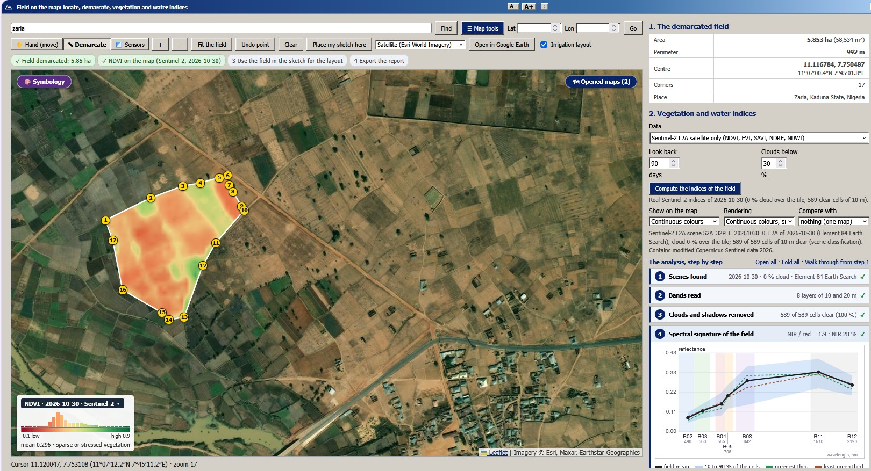  The demarcated field (5.85 ha) with the NDVI of the Sentinel-2 scene of 30 October 2026 cut to its outline, the legend with the histogram of the field, and the analysis step by step with the spectral signature of the field. | 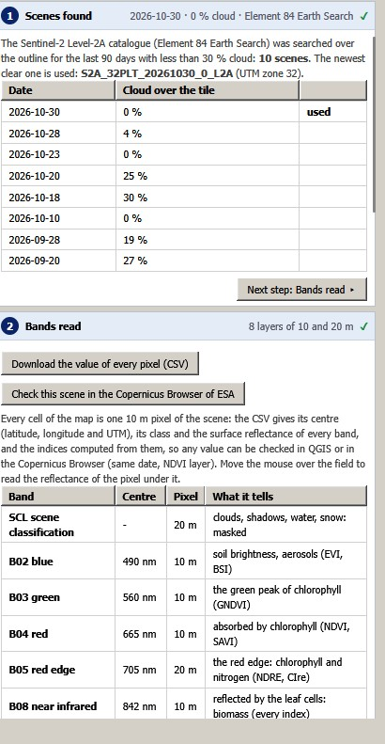  The scenes found and the bands read. | 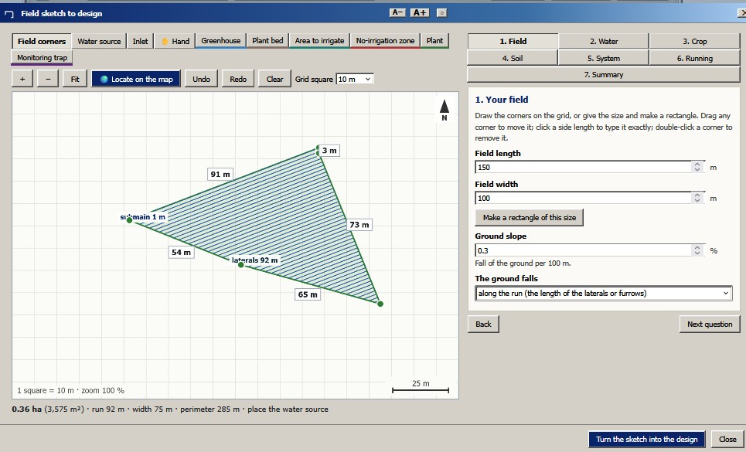  The field sketch that carries a field into the designs.
A real field near Zaria, Nigeria: demarcation and satellite indices (screen captures of release 1.1.0).
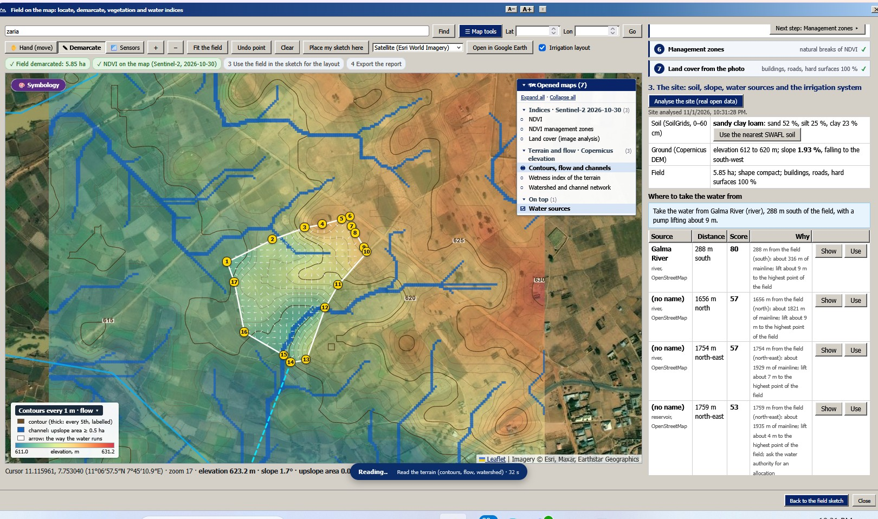  Contours every metre, flow arrows and channels, and the ranked water sources. | 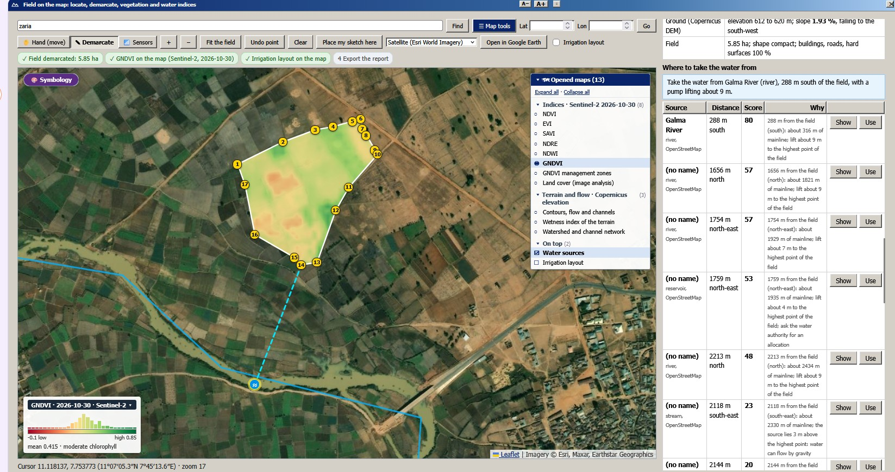  GNDVI and the line to the best water source, the Galma River (288 m). | 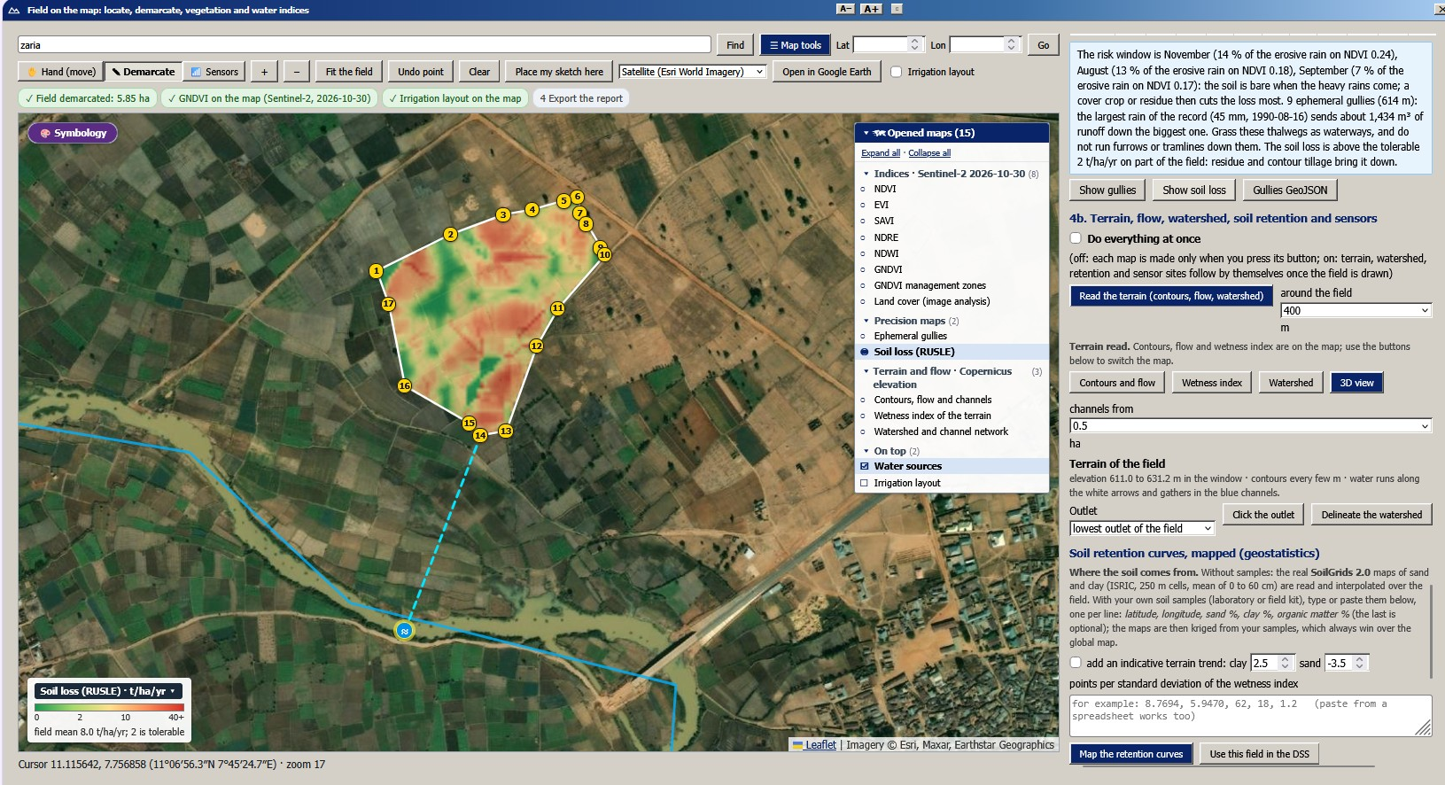  Soil loss (RUSLE), field mean 8.0 t ha$​^{−1}$ yr$​^{−1}$, and the months of risk. | 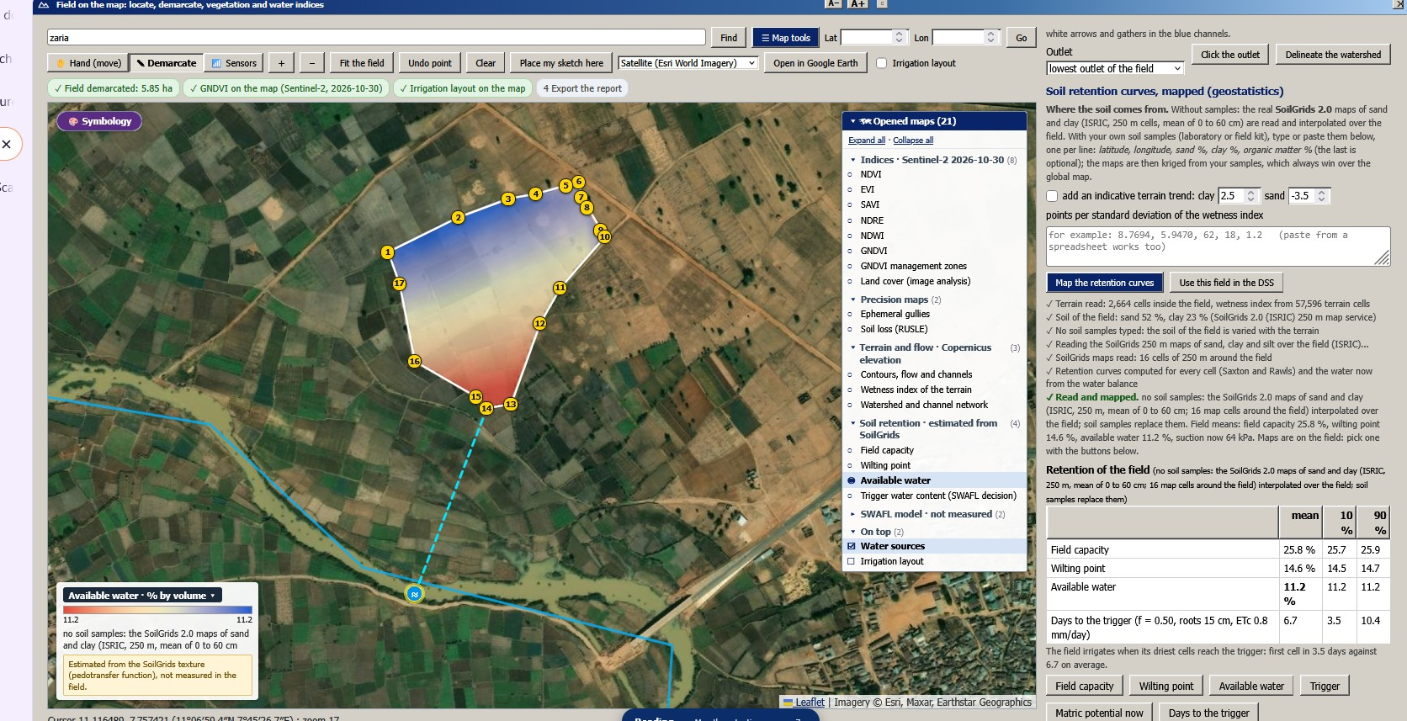  Available water from the retention curves mapped from SoilGrids (11.2 % by volume) and the days to the trigger.
The same field: terrain, water source, erosion and soil water retention from open data (screen captures of release 1.1.0).
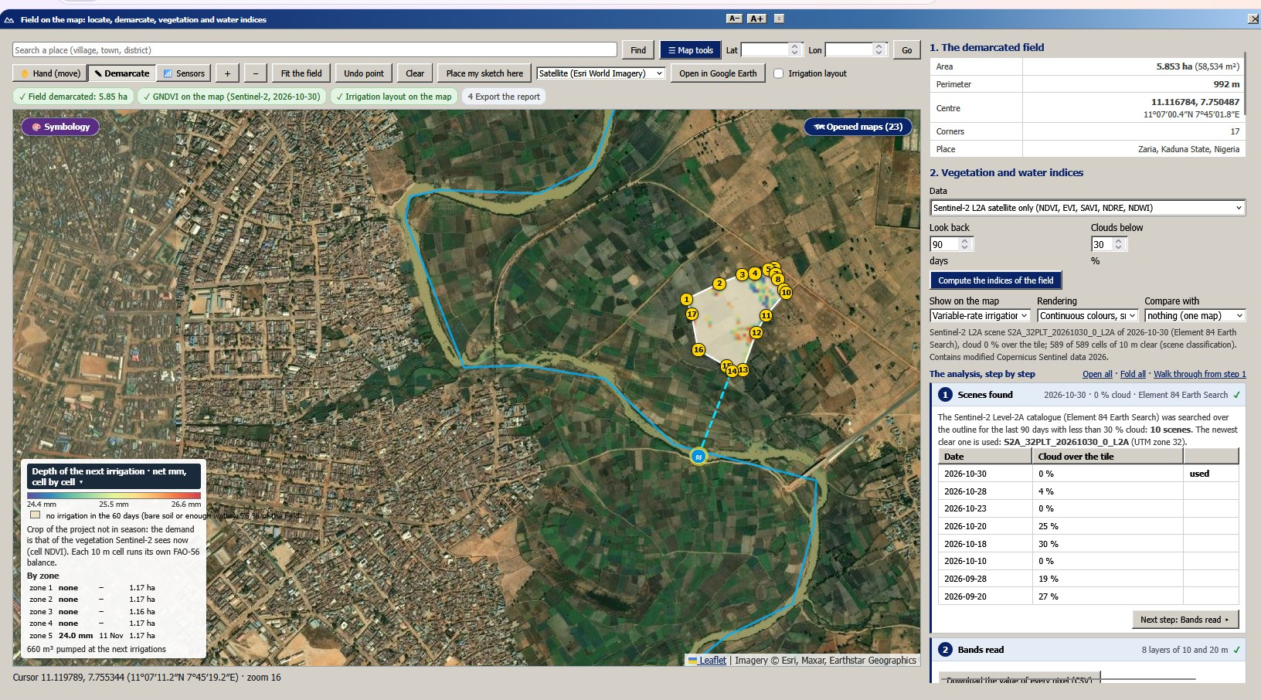
Depth of the next irrigation on the Zaria field, cell by cell, from the FAO-56 balance of each 10 m cell (real screenshot).

Crops.
The library has 48 crops, 19 field crops (cereals, roots and tubers, legumes, oil crops, cotton) with a crop coefficient for the initial, mid-season and late-season stages, four stage lengths, height, rooting depth, the depletion fraction $p$ and, where tabulated, the yield response factor $K_{y}$ (Doorenbos and Kassam 1979; Allen et al. 1998), and 29 perennial crops (tree, vine and berry crops) with several planting densities or training systems, each with its ground cover, height, mid-season and end-season coefficient. The daily crop coefficient follows the piecewise curve of FAO-56,
$$\small K_c(t)=\begin{cases}K_{ini}, & t<L_1\\ K_{ini}+(K_{mid}-K_{ini})\dfrac{t-L_1}{L_2}, & L_1\le t<L_1+L_2\\ K_{mid}, & L_1+L_2\le t<L_1+L_2+L_3\\ K_{mid}+(K_{end}-K_{mid})\min \left(1,\dfrac{t-L_1-L_2-L_3}{L_4}\right), & \text{otherwise,}\end{cases}$$
which for evergreen crops is repeated each year. Every coefficient has a source field; where the root depth or the stages are not tabulated for a crop the group default is used and marked (11 crops); the yield response factor is tabulated for 11 crops and not tabulated for 37.

Deterministic phenotyping
The phenotyping layer is a virtual experiment. One plant of a chosen crop (modelled as maize, sorghum, wheat or common bean) and genotype grows for 140 days after emergence in the soil, tillage, weather and management of the project, twice: well-watered and under a drought treatment (a pulse, a terminal, an intermittent or no drought). The model has no random numbers, so the same controls always give the same plant. Light capture and biomass follow Monteith (1977), limited by transpiration as in Tanner and Sinclair (1983); reference evapotranspiration is FAO-56 Penman–Monteith (Monteith 1965; Allen et al. 1998); soil water uses the van Genuchten curve (van Genuchten 1980) and root uptake the stress function of Feddes, Kowalik, and Zaradny (1978); leaf water potential, turgor and expansion follow a pressure–volume curve and Lockhart (1965), stomata Jarvis (1976), canopy temperature and the crop water stress index Jackson et al. (1981), and the root system grows by rules after Pagès et al. (2014), with carbon allocated by functional equilibrium. The traits that are read out (projected shoot area, convex hull, solidity, senescence, canopy temperature depression, relative water content, root angle, depth and length) are those defined in the two books on phenotyping that the layer starts from (Lorence and Medina-Jimenez 2022; Panguluri and Kumar 2013), which define the traits and not the equations. The constants of four species and seven genotypes are typical and editable values of the layer, not data of an experiment. The layer reaches the project: the crop and its library values, the soil, the weather and the toolbar date (which sets the season and a drought outlook for the next days), the mulch, the irrigation and the nitrogen rate. The user can load measured traits, compare, calibrate and export them.
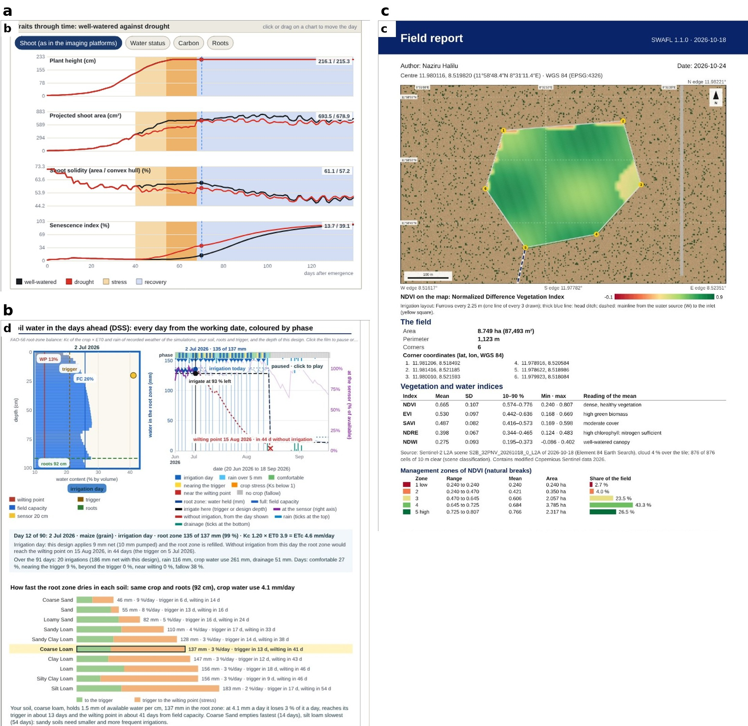
(a) Traits through time, well-watered against drought, with the phases of the stress marked. (b) Soil water in the days ahead with the irrigation decision of the design. (c) The field report (page 1).
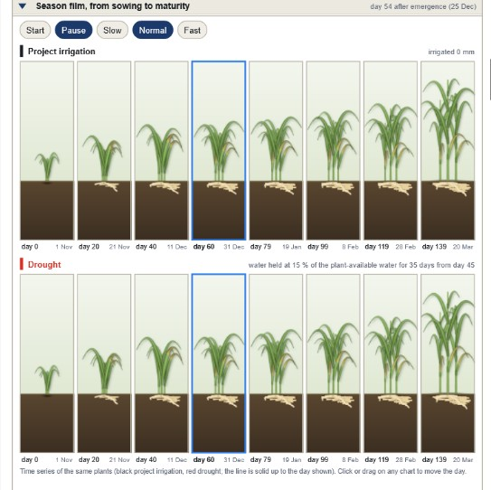
The season film of the phenotyping layer: the same plants from sowing to maturity every 20 days, under the irrigation of the project (top) and under a drought that holds the water at 15 % of the plant-available water for 35 days from day 45 (bottom), with shoots and roots drawn from the state of the model (screen capture of release 1.1.0).

Weather as a choice.
The weather of a project is chosen from five sources and carries into every layer and into the Daisy runs: the built-in benchmark record (Taastrup, Denmark), seven bundled Daisy stations (Taastrup, Foulum and Jyndevad in Denmark, Bologna in Italy, Jadwisin in Poland, Bratislava in Slovakia and Valecov in the Czech Republic), a file of the user (CSV, Excel, Daisy DWF, DLF or DAI), online weather of any place on Earth from the Open-Meteo archive (ERA5 based; complete years only) and DMI open data with the user’s own key. Any working date from 1980 to 2100 can be set in the toolbar: dates up to 1999 use the recorded baseline, later dates are projected from a baseline year that the user chooses (typical, dry, wet or a specific year), and projections are simulations and not forecasts. The online sources could not be reached in the environment of the tests.

The workbench

Design principles.
Four principles shaped the workbench. Questions before syntax: the first thing a user does is to state a question, by choosing a scenario, a combination of the Daisy reference or a prepared experiment, and the set-up file is the result and not the starting point. Everything that runs is shown first: a design lists its runs, their settings and an estimate of the time before anything is run. One source of data: the weather and the soil of the site are entered once and every tab uses them. No hidden steps between a result and a decision: the last step of the path hands the results of the runs to the layers of the decision-support suite (the bridge below).

Structure.
The workbench is a window of the application with six groups of tabs (7). The guided path has nine steps: weather and soil of the site; the library of soils, crops and fertilisers; scenarios; experiments; the process map; log plots; mass balance; run comparison; and the hand-over to the SWAFL layers. A second row holds the tools of model development, which are outside the path: the set-up editor for .dai files, the soil column, the response curves, calibration, and the documentation. The documentation tab holds 107 reference topics, 27 combinations of factors with a recommended design, and a manual of the model. The bundled sample data are seven weather records (Taastrup, Foulum, Jyndevad, Bologna, Jadwisin, Valecov, Bratislava), ten annual or daily logs of the Daisy project, and the horizon, crop, fertiliser and action library read from its .dai files. Daisy 7.1.14 for Windows is bundled with the application and is the program that runs the set-ups; the workbench writes the set-up and reads the logs back.
Modules of the Daisy workbench and the hand-over, in the style of the process map of Daisy. The chain runs from the planner and the decision base through the experiments, Daisy and the parsers to the hand-over; the modules below the dotted line are used before Daisy is started.
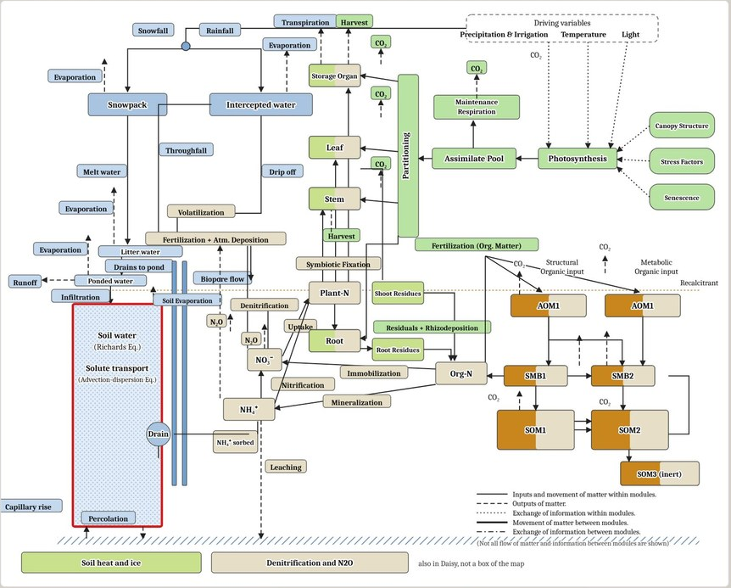
The process map of Daisy. Each process is a button that opens the figures it produces from a run.
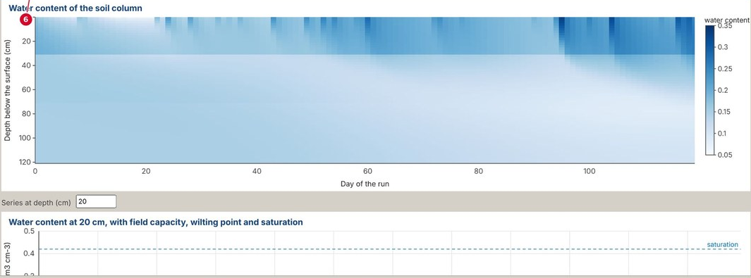
Water content of a soil column through time, computed by the Richards solver of the workbench.
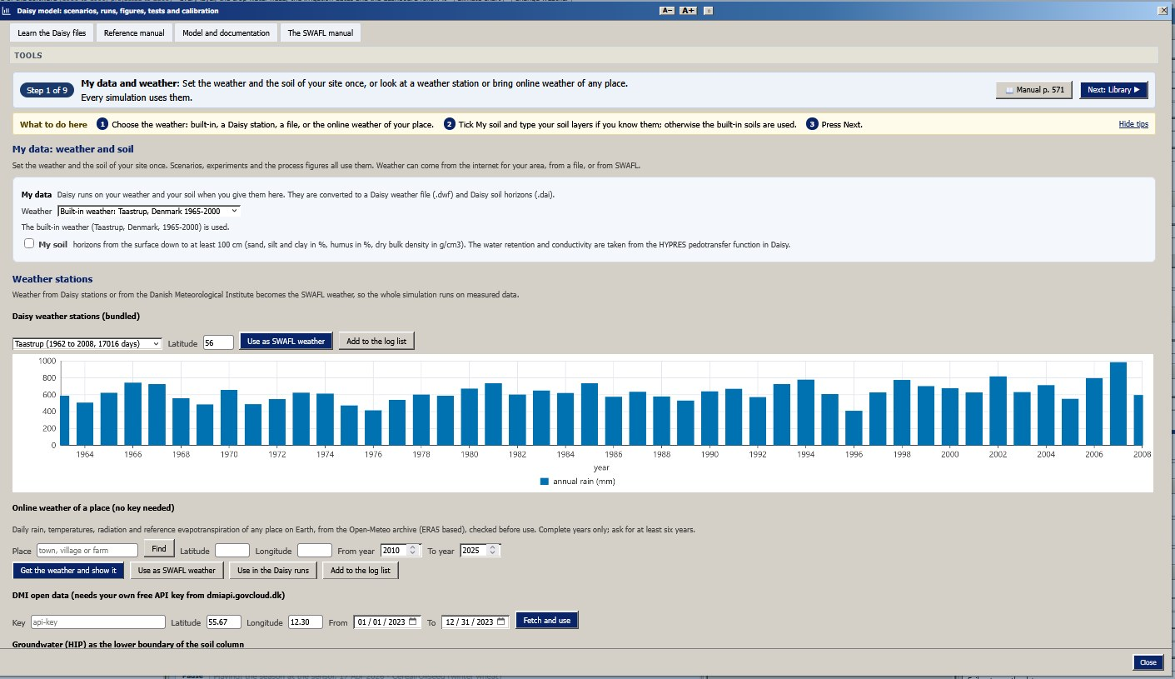  Step 1: my data and weather (manual p. 760). | 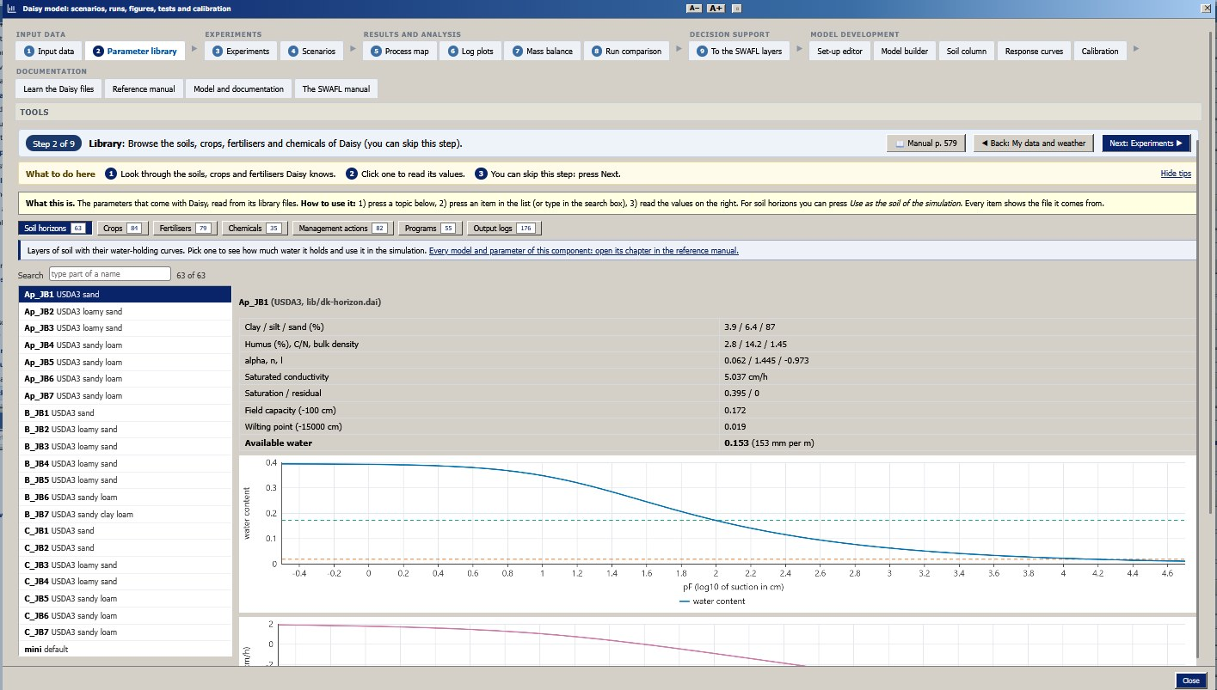  Step 2: library of soils, crops and fertilisers (p. 583). |  | 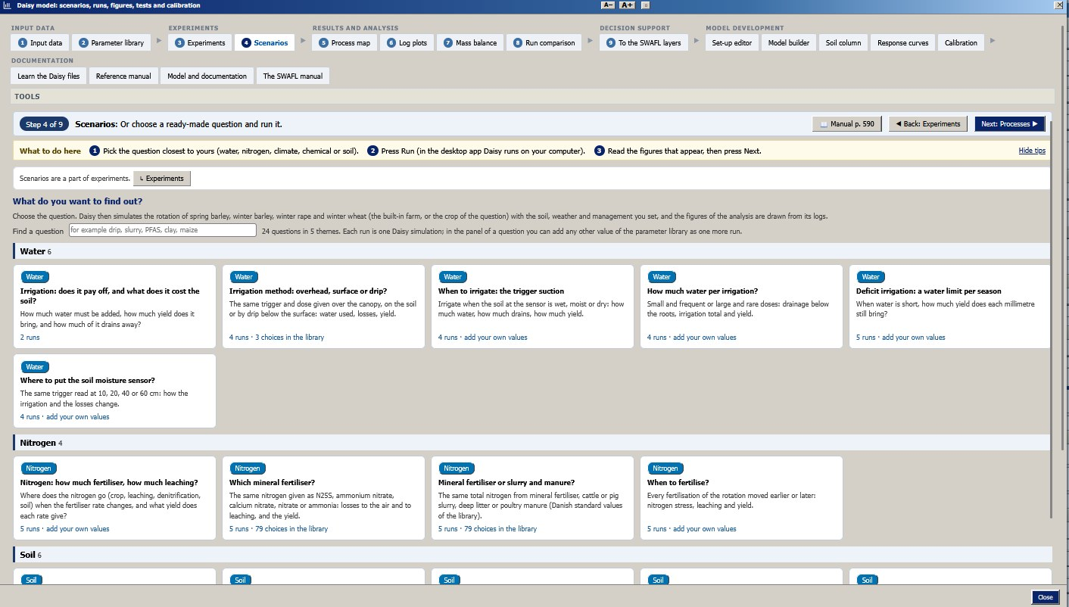  Step 4: scenarios, a question and its runs (p. 762). | 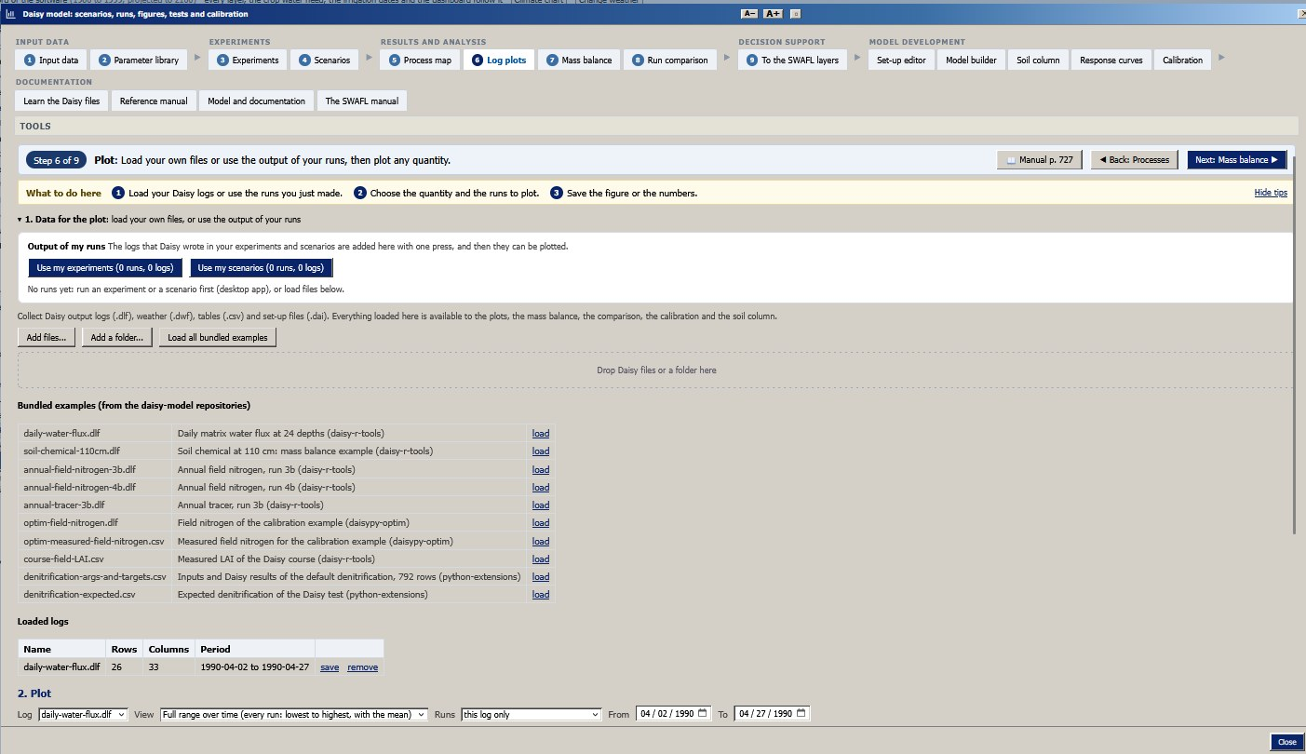  Step 6: log plots of the runs (p. 763). |  | 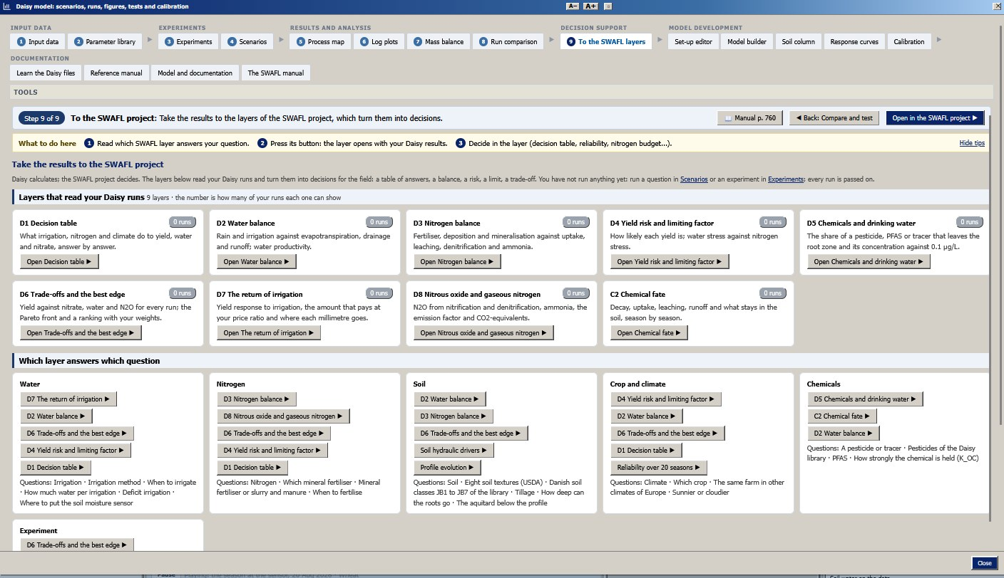  Step 9: to the SWAFL layers, which layer answers which question (p. 764). | 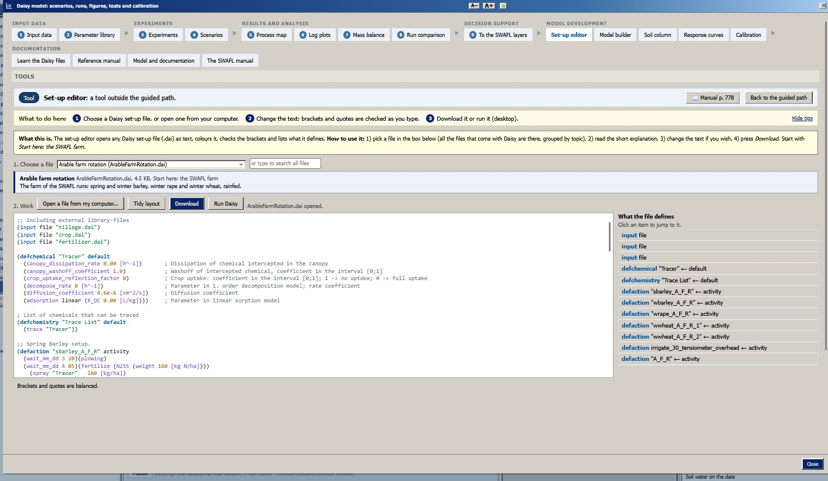  Tool: set-up editor with bracket check (p. 783). |  | 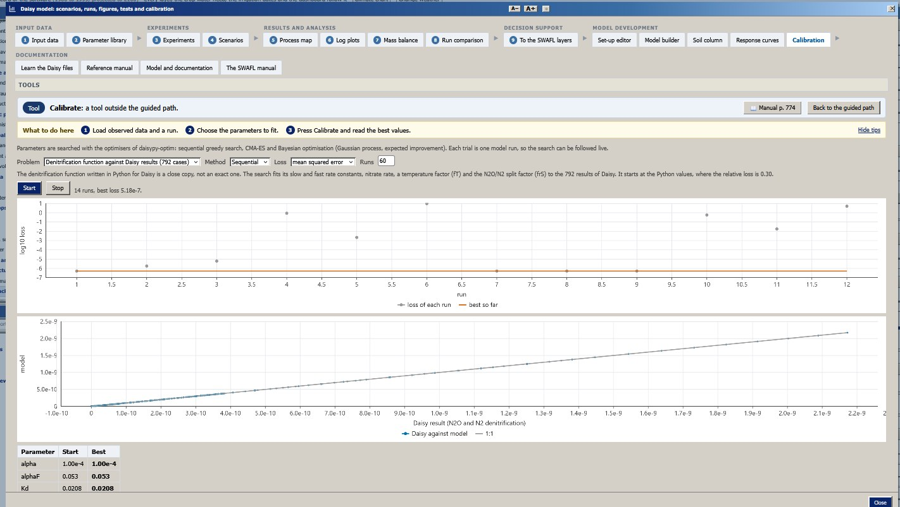  Tool: calibration (daisypy-optim) (p. 779). | 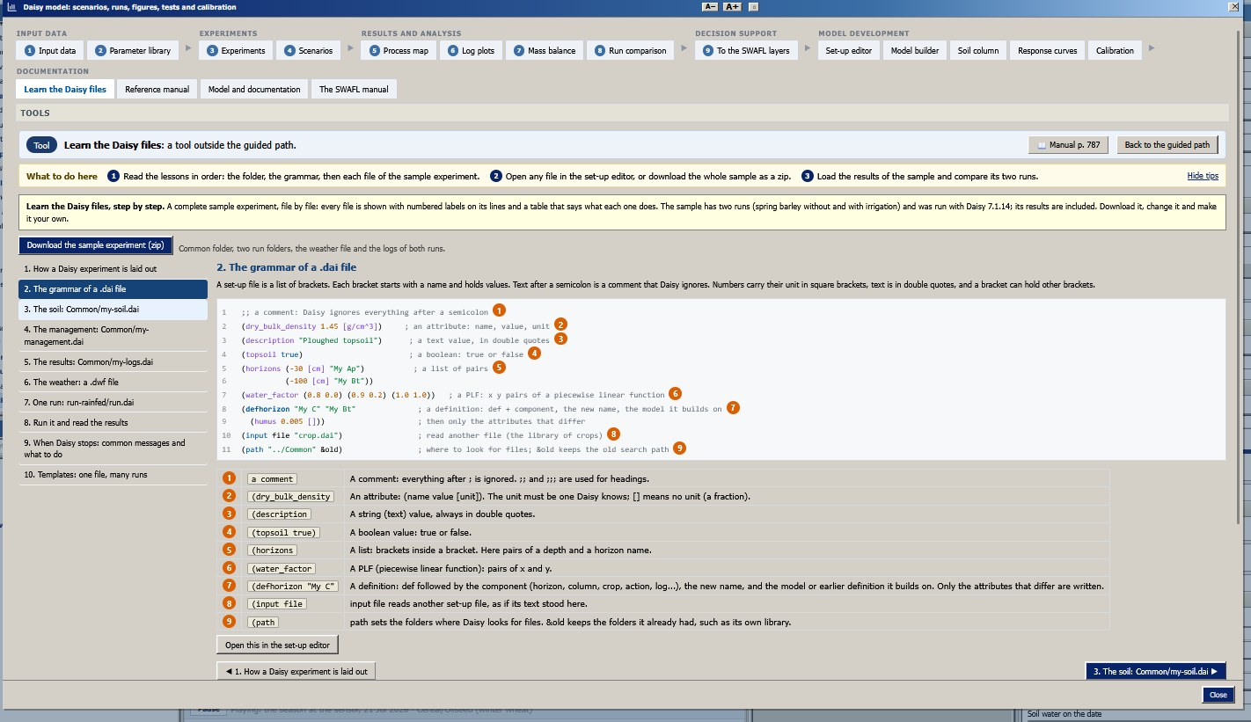  Tool: learn the Daisy files, the grammar of a .dai file (p. 792).
The guided path of the Daisy workbench and three of its tools (real screenshots of release 1.1.0). Each step carries its step number, a one-line “what to do here”, the manual page and Back and Next buttons.
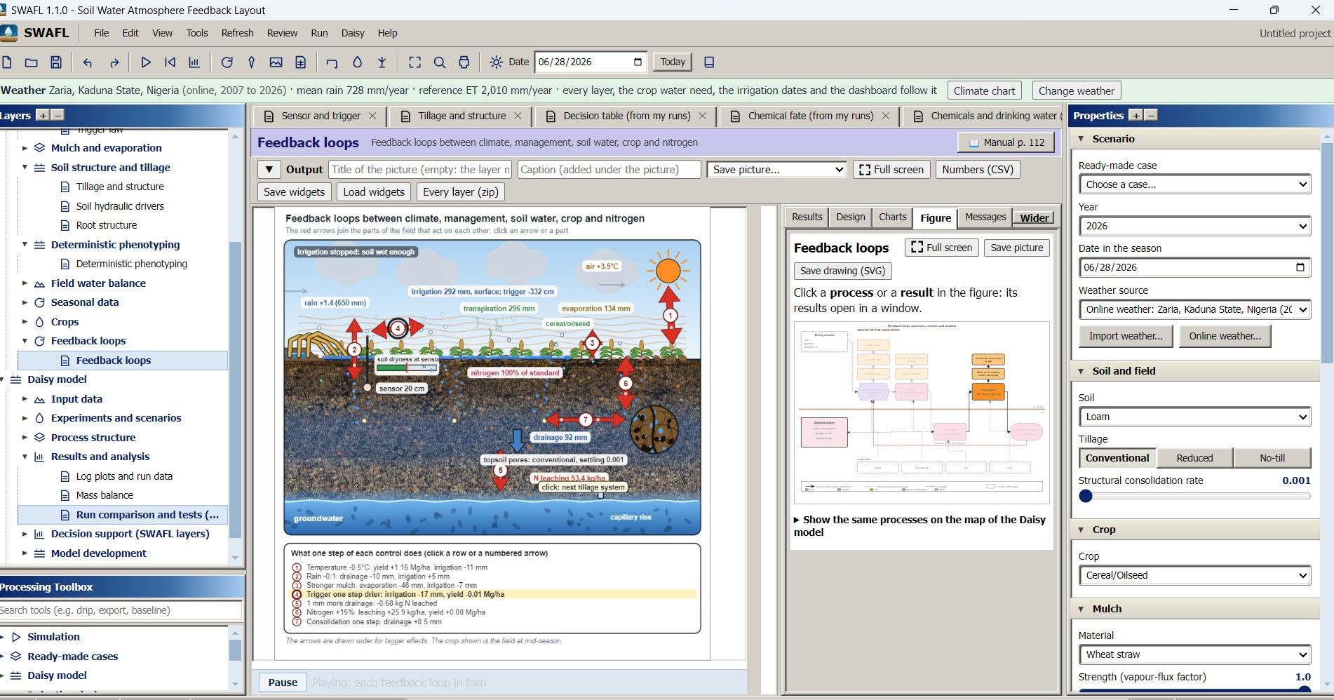
The main window with the online weather of Zaria, Nigeria (2007–2026): Layers tree, the feedback-loops layer with the controls of the season, the Properties panel and the Processing toolbox (real screenshot).

Experiments and scenarios.
A scenario is a prepared question with a recommended set of runs: irrigation strategy, nitrogen fertilisation and leaching, climate, the fate of a chemical, and the effect of the soil. An experiment is a factorial design that the user builds from factors. The 53 factors cover the weather (rain scale, temperature shift), the soil (a library horizon or a texture class), irrigation (method, trigger suction, sensor depth, dose, window), nitrogen (rate), the crop (rooting depth), tillage and the parameters of soil structure. For a design the workbench lists every run, with its settings, before it is started, shows the number of runs against a limit and the estimated time, and writes the set-ups. For the 17 experiments of the published ensemble a prepared design is offered, each with its own figures and its own folder of results. The same factor definitions are used to read the results of an ensemble (the bundled ensemble file with the 10 190 runs) as marginal means, grids, sensitivities and Pareto fronts.

Question, reference and provenance

The planner.
The user writes what is to be found out (“how does the irrigation trigger of $−100$ to $−800$ cm change drainage on a sandy loam in Bologna over 10 years?”) and a plan comes back: the factors and their levels, the design (factorial, one at a time or paired), the weather station, the soil, the years, the responses to look at and the questions that remain, each with its options. Two engines produce the same plan. The built-in reader works offline and anywhere: it recognises the soils, stations, factors and responses of the catalogue by their names and meanings, reads quantities with units (“10, 30 and 60 cm”, “20 %”, “2 degrees”), ranges with steps and numbers of years, and keeps every number inside the range of its factor. Release 1.1.0 has no online assistant and no free-text request box: plans come from the reference, the prepared experiments, the experiments of the study or imported plans, and the same guard checks every one of them (a factor that is not in the catalogue is left out and noted, levels are limited to the range of the factor, a soil, station or response that is not in the catalogue is removed), so the workbench cannot ask Daisy for something that Daisy cannot vary.

The decision base from the reference manual.
The choices of an experiment are tied to the Daisy reference manual (version 7.1.14), which is embedded as its 107 chapters with the title, introduction and, for each model, the name, first line of the description and the names of the parameters (999 sections). For each factor the base records the section of the manual that the choice comes from, and it proposes the combinations worth running first for the weather and the soil of the user; no experiment of an earlier study is used to make the proposal. A table of 32 parameters of the reference records, for each, the manual default and whether a change altered the yield, water or nitrogen outputs in a test of Daisy 7.1.14 on the farm of the application (the parameter was written into a run at the manual default and at half and double that value); 12 of the 32 did. This test is recorded in the source of the workbench and was not repeated in this study, in which Daisy could not be run.

Provenance of figures and runs.
Every figure that the workbench draws carries a citation line that names Daisy 7.1.14 (S. Hansen et al. 2012; Holbak et al. 2026) and the weather, the soil and the options of the run that made it, below the figure and burnt into the picture when it is saved, and the list of references of the workbench is built from the same source. Every run keeps all the files that Daisy wrote (the .dlf logs, the .csv files, daisy.log) exactly as written and never changed by the application, each with a download button, a .zip of the outputs, a .zip that also holds the set-up, and the folder on the computer where the desktop application keeps the run. The summary of a run that the decision layers read is made by the same code for the bundled results and for the run just made, so the two are comparable.

Calculators that run without Daisy.
The workbench computes in the browser the van Genuchten and Mualem hydraulics of the Daisy horizons and a one-dimensional Richards solver (the soil column below), the Daisy denitrification function, and the methods of the Daisy optimisation tools for calibration: a sequential search, a covariance-matrix evolution strategy with rank-one and rank-$μ$ updates (N. Hansen and Ostermeier 2001) and Bayesian optimisation (Mockus, Tiesis, and Zilinskas 1978). It also reads the open data of the Danish Meteorological Institute (with the user’s own key) and finds the closest station. The weather of the area of any place on Earth can be fetched from the Open-Meteo archive (ERA5 based) and written as a Daisy weather file, and the user’s own files are read as CSV, Excel, DWF, DLF or DAI. Weather is therefore a choice made for every project and every run, and not a record fixed in the program.

The bridge

Parts.
shows the bridge. A scenario or an experiment of the workbench is turned into a Daisy set-up and run by Daisy 7.1.14. Daisy writes its logs as tab-separated files (.dlf) with a header, a row of names, a row of units and one row per output interval. The bridge has five parts.
Reads a log into a list of names and rows. Numeric columns become numbers; the crop name stays text. The first row of an annual log is written at the start of the simulation and is not a season; the summariser drops it.
Reduces the logs of a run to one record with a value per season: harvest of the crop (dry matter of the storage organ, water stress, nitrogen stress), precipitation, irrigation, actual and potential evapotranspiration, runoff, percolation below 1 m (matrix and biopore flow), and the nitrogen terms of [eq:nsum]. For a run of a chemical it adds the budget of [eq:chem].
Maps the soil of a Daisy run to the soil of the suite (for example usda:siltloam to Silt Loam, S07), so that the other layers show the same soil. Eight soils are mapped (sand, loamy sand, sandy loam, loam, silt loam, sandy clay loam, clay loam, silty clay loam); the two coarse soils that are special to the study (Coarse Loam, Coarse Sand) and an own soil table have no counterpart, and the layers then keep the soil of the project.
For each of five questions (irrigation, nitrogen, climate, a chemical, the soil) lists the layers that answer it with a sentence on what each shows (2). The hand-over tab of the workbench opens the first of them.
Holds, in the engine of the suite, the label of the weather and soil of the run, the summarised runs, their settings (irrigation, nitrogen factor, rain factor, temperature shift) and the mapped soil. The decision layers read only this object.
The bridge from a Daisy run to a decision. Heavy arrows are the path of a run, dashed arrows are outputs and the dashed arrow at the left is the return path of the weather of the project to Daisy.
Questions of the workbench and the layers that answer them.
Question | Layers
Irrigation: does it pay? | Daisy decision table (dsum); reliability over 20 seasons (yby); full water balance (wb2); sensor and trigger (v1)
Nitrogen: how much fertiliser? | decision table; nitrogen budget (nb)
Climate: warmer, drier, wetter | decision table; reliability over 20 seasons
A chemical: sorption and decay | fate of a chemical (chem)
The soil: how much does texture matter? | soil hydraulic drivers (v7); profile evolution (v2); decision table
Own set-up | decision table (own runs next to the others when the names match)

What the summariser computes.
For season $s$ the nitrogen terms are sums of columns of the annual nitrogen log (kg N ha$​^{−1}$):
$$\begin{matrix}N_{s}^{fert} & =N_{surf}+N_{soil}+N_{org}, & N_{s}^{up} & =N_{uptake}, \\ N_{s}^{den} & =N_{denit}+N_{N_{2}Onitrif}, & N_{s}^{L} & =N_{matrixleach}+N_{bioporeleach} \left(\text{at }100 cm\right),\end{matrix}$$
together with the mineralisation, the deposition and the volatilisation. The chemical budget uses the annual tracer log (kg ha$​^{−1}$; the log is in g):
$$ΔM_{s}=A_{s}−U_{s}−L_{s}−R_{s}−X_{s}, L_{s}=L_{matrix}+L_{biopore}+L_{soildrain}+L_{bioporedrain},$$
where $A$ is the spray, $U$ the crop uptake, $R$ the runoff, $X$ the decay (soil, surface and litter), and $ΔM$ the change of the amount in the soil from one season to the next. A depth profile of the concentration is added from the daily concentration log. The weather and soil of the run are described by a one-line label, shown at the top of every Daisy layer (“Daisy 7.1.14, run in the Daisy workbench: weather Taastrup, Denmark; soil loam; years 1979 to 2000”).

The rule of origin.
A decision layer that shows a Daisy quantity draws it from a live run or not at all. Before a run, the two layers of Daisy output (the decision table and the fate of a chemical) show the sentence “no Daisy run yet”, say what is needed to fill them, and offer a button to the scenarios of the workbench; they do not substitute bundled or estimated numbers. The other layers of the suite, which are driven by Engine 1 and Engine 2, say in their own header that they show the meta-model and the daily model. The rule is a small feature, but it settles a question that every coupled tool has to answer: when a number is on the screen, is it from the model it is labelled with? In a test with the application opened afresh (p5_empty_state.js) both layers showed this sentence and no figure, and the engine held no live object.

The experiment engine and its outputs
Runs. A design combines the levels of every factor (every combination, one factor at a time, or pairs). The number of runs set by the user is a ceiling that includes the rainfed references: when the combinations are more, a balanced choice (a Latin hypercube over the levels, every level used about equally often), a random choice, a spread choice or the first combinations are taken, with a seed so that the same plan always gives the same runs. Every run is a folder of its own (its set-up, its .dai files with the place where every value was written, and the files Daisy wrote) inside the folder SWAFL runs next to the Daisy that ran it. Soil-hydraulic sensitivity. Five factors change the van Genuchten–Mualem parameters of every horizon of the soil file of the run: $K_{sat}$, $α$ and $θ_{s}$ are multiplied, $n−1$ is multiplied so that $n$ stays above one, and $l$ is shifted; only the numbers inside each (hydraulic M_vG ...) block change. Summary (19). For every result the range over all runs is given (lowest, highest, mean, coefficient of variation, best and worst run), and for every input the effect on every result: for a number the change of the mean from its lowest to its highest level, for a choice from the level with the lowest mean to the level with the highest, also as a share of the mean, with the means at every level. Combinations are ranked by a weighted score in which every result is scaled from the worst run (0) to the best (1). Figures. Every quantity of every log becomes a figure in the layout of a journal figure: one panel for each level of one factor, one line for each level of another, the other factors averaged, and a band for the spread (10 to 90 % of the seasons and runs for the course through the year; lowest to highest run otherwise); monthly and yearly totals for fluxes and means for states; cumulative series; depth–time maps with one colour scale and depth profiles. For a complete factorial the figures by factor are drawn; for a fraction, every run is its own row and the main effects carry their standard error and number of runs. Diagnosis. A run without results is diagnosed from the message of Daisy: the line file:line:column is located in the set-up of the run and shown with its neighbours, and the cause is classed as a name Daisy does not know, a numerical problem of the solver (no convergence, a value that is not a number, a negative amount of water or solute), a value outside the accepted range, a missing file, the weather, a duplicate definition, a line that cannot be read, or a stop without a message; runs that fail for the same cause are reported together with the change that removes it.

The data in the repository.
Every output of every run is open. The folder Data/Comprehensive_Summary of the repository holds, for each of the 17 experiments, one compressed table with every value of every Daisy log of every run, year by year (the annual water balance, the nitrogen balance, the harvest and the crop state), the one-row-per-run summary of all 10 190 runs with the settings read from each set-up file, the per-experiment summary, and the script that made them from the log files; the 20-year means of these tables reproduce the run table used here within 2 %. The complete raw archive is on Zenodo (Halilu 2026a).

Checks of the workbench

Design size and fidelity.
Each experiment of the study was a full-factorial grid with 10 levels per factor, which gave 200 to 1 000 runs per experiment. A laptop cannot repeat that in a working session, so each prepared experiment is offered as a compact design with 3 to 6 levels per factor (4). The size of every compact design was obtained from the workbench code, and the time of the study from the recorded wall-clock time of every run in the archive of the study (run_seconds). The time of a compact design was estimated as its number of runs times the median run time of its experiment.
To ask what the reduction costs, the marginal mean of five responses (yield, irrigation, drainage at 1 m, irrigation efficiency, nitrate leached) was computed for each numeric factor of each experiment from the full ensemble, and then rebuilt by linear interpolation between the marginal means at the levels of the compact design (the nearest study level to each compact level; the suction of the trigger interpolated on a logarithmic scale). The root-mean-square difference between the rebuilt and the full curve, as a percentage of the range of the full curve, measures the information that the compact design cannot see by itself. It is a stricter test than the practical use, in which the user chooses levels where the response is steep, but it has no free parameter.

Soil column.
The soil column solves the one-dimensional Richards equation for vertical flow in the mixed form
$$\frac{∂θ}{∂t}=−\frac{∂q}{∂z}−S\left(h,z\right), q=K\left(h\right)\left(1−\frac{∂h}{∂z}\right),$$
where the depth $z$ is positive downward, $q$ is the downward flux and $S$ the root sink. The retention curve and the conductivity are those of van Genuchten (1980) and Mualem (1976),
$$S_{e}={\left[1+{\left(α\left|h\right|\right)}^{n}\right]}^{−m}, m=1−1/n, θ=θ_{r}+\left(θ_{s}−θ_{r}\right)S_{e}, K=K_{s}S_{e}^{ℓ}{\left[1−{\left(1−S_{e}^{1/m}\right)}^{m}\right]}^{2},$$
with $ℓ=0.5$ unless the horizon gives another value. The root sink is the potential transpiration distributed over a linearly decreasing root density and reduced by the stress function of Feddes, Kowalik, and Zaradny (1978), which is 1 between suctions of 25 and 500 cm, falls linearly to 0 at 15 000 cm and rises linearly from 0 at the surface to 1 at 25 cm. The equation is discretised by finite volumes on nodes with implicit time steps and Picard iteration with the mass-conserving capacity term of Celia, Bouloutas, and Zarba (1990); the time step grows when the iteration converges in five iterations or fewer and shrinks when it takes more than ten. The upper boundary takes the rain less the evaporation demand as a flux until the surface node would be positive, when it becomes a ponded boundary ($h=0$) and the excess runs off; when the soil is air-dry ($h<−{10}^{4}$ cm) the evaporation is reduced to what the soil can give. The lower boundary is free drainage, a water table at a given depth, or a closed bottom. The tool returns the daily infiltration, runoff, evaporation, transpiration, drainage and storage and the daily mass-balance error $ϵ=ΔS−\left(I−E−T−D\right)$ (in mm).
To test it, three soils were set up from van Genuchten parameters of loam-type classes (3), as a 100 cm column at a suction of 300 cm, with 200 mm of rain on day 1 and five dry days, free drainage, node spacings of 4, 2, 1 and 0.5 cm. For sand and loam the rain rate is below the saturated conductivity, so the upper boundary is a flux; an independent reference was calculated with the method of lines (scipy BDF with a banded Jacobian, 0.5 cm nodes, relative tolerance ${10}^{−6}$) and the same flux. The silty clay loam has a saturated conductivity of 0.07 cm h$​^{−1}$, so the surface ponds; for it only the convergence with the node spacing and the run time are reported.
Soils used for the test of the soil column (van Genuchten parameters, $ℓ=0.5$).
Soil | $α$ (cm$​^{−1}$) | $n$ | $K_{s}$ (cm h$​^{−1}$) | $θ_{s}$ | $θ_{r}$
Sand | 0.145 | 2.68 | 29.7 | 0.43 | 0.045
Loam | 0.036 | 1.56 | 1.04 | 0.43 | 0.078
Silty clay loam | 0.010 | 1.23 | 0.07 | 0.50 | 0.089

Response curves: denitrification.
The response-curve tool draws the denitrification function that Daisy uses by default in the form given in its Python extensions. The water-filled pore space $w=θ/θ_{s}$ gives a piecewise-linear moisture factor $f_{w}\left(w\right)$ (zero at $w=0$, 0.01 at 0.4, 0.07 at 0.5, 0.17 at 0.57, 0.32 at 0.64, 0.51 at 0.71, 0.66 at 0.76, 0.79 at 0.81, 0.9 at 0.85 and 1 from 0.9). The potential rate is $f_{T}\left[α_{F}C_{F}+α\left(C−C_{F}\right)\right]$ with the fast and the total carbon dioxide production $C_{F}$ and $C$ and the factors $α_{F}=0.0530$ and $α={10}^{−4}$. The actual rate is limited by the nitrate, $D=min\left(f_{w}r_{S},K_{d}N\right)+min\left(f_{w}r_{F},K_{d}N\right)$ with $K_{d}=0.0208$ h$​^{−1}$. The loss is divided between the two gases by a ratio $r$,
$$D_{N_{2}O}=\frac{D}{1+r}, D_{N_{2}}=\frac{D}{1+1/r}, r=min\left(r_{NO_{3}},r_{CO_{2}}\right)r_{w},$$
where $r_{NO_{3}}=25\left[1−1/2−1/πarctan(0.01π\left(N_{m}−190\right))\right]$ depends on the nitrate concentration $N_{m}$ (mg per kg of soil), $r_{CO_{2}}=13+{30.78}/πarctan\left(0.07π\left(C_{m}−13\right)\right)$ on the carbon dioxide production over a 30 cm layer, $C_{m}$, and $r_{w}=1.4×{13}^{−17/{13}^{2.2w}}$ on the water-filled pore space. The Daisy project stores 792 inputs of this function with the outputs that a Daisy run gave for them. The workbench function was compared with all 792.

Calibration.
The calibration tool minimises a loss (mean squared error, mean absolute error or sum of squared deviations) between a model output and a target over up to a few parameters with bounds. Three optimisers are offered, after the choices of the Daisy optimisation project: a sequential search in which each parameter takes a few values in turn and the single best change is kept; the covariance-matrix-adaptation evolution strategy (N. Hansen and Ostermeier 2001); and a Bayesian search with a Gaussian-process surrogate and expected improvement (Mockus, Tiesis, and Zilinskas 1978). To test them, the three parameters $α_{F}$, $K_{d}$ and $α$ of the denitrification function were estimated from the 792 stored outputs (the loss is the mean squared error of the logarithm of the N$​_{2}$ loss), starting from values 3 times too high, with a budget of 150 evaluations and five seeds. The correct values are known, so the recovery can be measured as the error in decades.

Reproducibility.
The Supplementary Material traces every result back to the data: for each number it names the experiment and runs used, the filter applied, the computation, and the script, result file and workbook sheet that reproduce it; the workbook repeats the algebra as live Excel formulas. All checks are scripts in Manuscripts/reproducibility/p456 (6). The design sizes are obtained by loading the workbench code in Node.js; the ensemble analysis is in Python.

Planner test.
Eight questions in plain words were written, each with the factors, the station and the soil that the plan has to contain (for example a trigger range on a sandy loam in Bologna, a nitrogen cut in Foulum, rain at plus and minus 20 % on a loamy sand at Jyndevad). The offline reader was run on each (p7_planner_checks.js); the guard of the online route was run on an invented answer that holds an unknown factor, a rain scale of 0.1 and 9, an unknown station and soil and an unknown response.

Tests of the bridge

Parsers.
The six Daisy logs bundled with the suite (annual field nitrogen, two runs; annual tracer; daily water flux; the nitrogen log of a calibration example; a soil chemical log with 11 665 rows) were read by the parser of the bridge and, independently, by pandas. For every numeric column the sum was compared; the largest relative difference is reported.

Nitrogen summaries.
The two annual nitrogen logs hold ten seasons of a rotation, with the same fertiliser and different set-ups (runs 3b and 4b). For each season the summariser was compared with the sum of the corresponding log columns of [eq:nsum], and the closure column of the log (Daisy’s own error term) was read.

Chemical budget.
The annual tracer log was passed through the summariser with chemistry, and the residual of [eq:chem] was computed for each of the ten seasons from the summarised amounts.

Denitrification.
The function that the workbench shares with Daisy was compared with the 792 inputs and stored outputs of the Daisy denitrification test (the function and its defect are described with the workbench checks).

Time and agreement of the three routes.
The Daisy time of the ensemble and of its experiments was summed from the recorded run times (run_seconds); the time of Engine 1 was measured by evaluating it for ${10}^{5}$ scenarios on the same computer.

Tests of the suite.

All layers.
The application was opened in Chromium (Playwright) and each of the 22 layers was opened, run through the Run button (or the Run simulation button of the design layers) and read: errors of the page script were recorded, the text of the results tab and the number of charts in the results and the charts tabs were counted. The layers with Daisy output were opened in a fresh application to see their empty state.

Crop library.
For each of the 110 combinations of crop and density the library gives parameters; the constraints tested were: $K_{mid}≥K_{ini}$, $0.3<K_{mid}<1.4$, positive stages, a season length of 60 to 365 days, $0.1<p<0.8$, $0.2<K_{y}<1.6$ where tabulated, a root depth of 20 to 400 cm, a daily $K_{c}$ curve whose maximum equals the largest of the three coefficients, and no daily jump of more than 0.05.

Phenotyping model.
The model was run in the application with a patched entry point that records every run the layer makes (56 runs when the layer opens), and directly for maize in a warm and in a hot, dry season with the seven genotypes, well-watered and under a drought pulse (onset day 40, 28 days at 30 % of the plant-available water, rain-out shelter): 28 runs, each run twice. Determinism is the maximum absolute difference between all stored daily series of the two runs. The soil water balance is $S_{end}−\left(S_{0}+P+I−T−E_{s}−D\right)$ with the totals of the run.

Results

The workbench

Prepared designs and what the reduction costs.
Fourteen of the 17 experiments are reproduced as compact designs of 6 to 72 runs (4); the three that are not (mulching, rain intensity and moisture, mulch and rain) are available through their published runs. The 368 runs of the compact designs stand for 7 990 runs of the study, 4.6 %, and for 361 hours of Daisy time in the study against about 15 hours (a factor of 25). The whole study took 17.5 days of Daisy wall-clock time on the machines that ran it (mean 148 s, median 145 s per run), which is the reason why a prepared design cannot be the full design.
The 17 experiments of the study and their prepared designs in the workbench. Hours are the sum of the Daisy wall-clock run times of the study (run_seconds) and the estimate for the compact design (runs $×$ the median run time of the experiment). The experiments marked $−$ are not offered as designs; their published runs are bundled.
Experiment | Question | Study runs | Study (h) | Compact runs | Compact (h)
E0 | Baselines | 10 | 0.6 | 9 | 0.6
E1 | Dose and duration | 200 | 11.0 | 17 | 0.9
E2 | Trigger pressure | 200 | 7.7 | 21 | 0.8
E3 | Sensor depth | 200 | 8.1 | 21 | 0.8
E4 | Methods | 100 | 4.1 | 6 | 0.2
E5 | Soil structure dynamics (SHP) | 300 | 15.8 | 72 | 3.5
E6 | Mediterranean pollution | 210 | 6.9 | 30 | 0.8
E7 | Mulching | 200 | 8.9 | $−$ | $−$
E8 | Rain intensity and moisture | 1000 | 1.7 | $−$ | $−$
E9 | Soil moisture and rain | 1000 | 2.0 | 40 | 0.1
E10 | Amount, timing and soil | 1000 | 70.4 | 20 | 0.7
E11 | Temperature, evaporation, rain | 1000 | 42.0 | 16 | 0.7
E12 | Sensor, trigger, rain | 1000 | 42.9 | 30 | 1.2
E13 | N, water, soil | 1000 | 57.4 | 32 | 1.9
E14 | Mulch and rain | 1000 | 48.0 | $−$ | $−$
E15 | Method, depth, amount | 1000 | 43.6 | 30 | 1.3
E16 | Edge cases | 770 | 48.2 | 24 | 1.2
Total |  | 10190 | 419 | 368 | 14.7
The marginal curves are recovered with a median error of 13.2 % of their range over the 51 combinations of experiment, factor and response (90th percentile 29.9 %, largest 36.1 %; 13a). The error is similar for the five responses (median 11.0 to 16.9 %). It is smallest where the compact design has as many levels as the response needs (sensor depth, E3, 4.9 %; trigger suction in E2, 7.3 %) and largest where three levels must describe a response that bends (the dose in E10, 30 %; the sensor depth in the three-level E12, 21 %). The result says that the compact designs are for orientation and for the comparison of options, and that a curve that matters for a decision should be run with more levels where it bends; the workbench makes this a matter of one setting.
(a) Error of the marginal curves rebuilt from the levels of the compact designs (median over five responses, per experiment and factor). (b) Daisy run time of the study designs and of the compact designs, by experiment (logarithmic scale).

The soil column.
In sand and loam the solver conserves mass: the largest daily error is below 0.001 mm at every node spacing. The drainage below 1 m after 6 days differs from the reference by 0.46 mm in sand (152.14 against 152.60 mm; 0.3 %) and by 0.50 mm in loam (54.62 against 55.12 mm; 0.9 %), and the final storage by 0.42 and 0.50 mm, 0.45 and 0.16 % of the store (5, 14a,b). The result hardly depends on the node spacing: the drainage varies by 0.03 mm in sand and 0.05 mm in loam between 4 and 0.5 cm. The solver is therefore not sensitive to the default spacing of 2 cm in these two soils, and the remaining difference to the reference is a difference of method (a time-step control against a high-order integrator) that is small against any parameter uncertainty.
The Richards solver of the workbench against an independent reference (method of lines, scipy BDF, 0.5 cm nodes). A 100 cm column, initial suction 300 cm, 200 mm of rain on day 1, five dry days, free drainage. $D$ is the drainage below 1 m and $S$ the final storage in mm, for the reference (ref) and the workbench (wb, 0.5 cm nodes); the spread (mm) is the range over node spacings of 4, 2, 1 and 0.5 cm.
Soil | $D_{ref}$ | $D_{wb}$ | Spread | $S_{ref}$ | $S_{wb}$
Sand | 152.60 | 152.14 | 0.03 | 93.12 | 93.54
Loam | 55.12 | 54.62 | 0.05 | 314.94 | 315.44
The silty clay loam shows the limit. With the surface ponded, the infiltration of the 200 mm depends on the node spacing (24.4, 22.5 and 21.8 mm at 4, 2 and 1 cm), the mass-balance error rises to 0.05 to 0.07 mm per day, and the run time at 1 cm is 182 s against 21 s at 2 and 4 cm, with 1.3 million Picard iterations (14c). The infiltration into a dry, fine-textured soil has a sharp front that the node spacing of 1 to 4 cm cannot resolve, and the surface condition switches between flux and ponding. For such a soil the solver gives the right order of magnitude but not a converged number; the tool shows its mass-balance error and the iteration count so that this can be seen.
Soil column. (a) Drainage below 1 m with the node spacing; dashed lines are the reference. (b) Final storage minus the reference. (c) Infiltration of 200 mm of rain into a ponded silty clay loam (left axis) and run time (right axis), showing the lack of convergence.

The denitrification function and a defect that the check found.
The first comparison with the 792 stored outputs showed that the function of release 1.1.0 gave 60 % of the stored N$​_{2}$ and N$​_{2}$O loss (median relative error 40 % for both gases; 15). The Python extension of the Daisy project, which the workbench function had been ported from, gives the same 60 % against the same file, so the port was faithful to the extension; the extension applies the correction for the pressure head ($×0.6/f_{h}$) to the carbon dioxide production, whereas the stored Daisy outputs were produced from inputs that had already been corrected. Taking the inputs as the values that Daisy passes to the function, and using the uncorrected value $Cf_{h}/0.6$ only in the regulation of the N$​_{2}$O fraction ([eq:n2o]), reproduces all 792 rows of N$​_{2}$ and of N$​_{2}$O with a largest relative difference of $2.9×{10}^{−15}$ for N$​_{2}$ and $1.7×{10}^{−15}$ for N$​_{2}$O. The corrected form is the default of release 1.1.0, and the form of the extension is kept as an option for a user who passes uncorrected production rates. The finding illustrates why the stored outputs of a model are a better test than its published equations.
Denitrification function against the 792 stored Daisy outputs. (a) N$​_{2}$ loss; the 1:1 line is black. (b) Histogram of the relative error of the N$​_{2}$O loss before and after the correction.

Calibration.
Starting from a loss of 0.20, the three optimisers reached a median loss of $6×{10}^{−4}$ (sequential, 16 evaluations), $4×{10}^{−6}$ (evolution strategy, 154) and $8×{10}^{−8}$ (Bayesian, 150) in the logarithm of the flux. They recovered $α_{F}$ to 0.03, 0.001 and 0.0002 decades (median over five seeds), but they did not recover $K_{d}$ or $α$: the median errors are 0.45 to 0.54 decades for $K_{d}$ and 0.48 to 0.68 decades for $α$. The 792 rows span a narrow range of suction ($−112$ to $−94$ cm) and a nearly constant nitrate content, so that probably many combinations of the two parameters give almost the same outputs. The run times are 4 ms (sequential), 37 ms (evolution strategy) and 1.7 s (Bayesian). The tool therefore does what an optimiser can do and shows, in the history of the search, the combinations that are equally good; it cannot make a parameter identifiable that the outputs do not constrain.

The planner.
The offline reader returned the factors, station and soil that were expected for all 8 of 8 test questions (6; the catalogue holds 54 factors, 10 soils and 8 stations). The guard of the online route removed the unknown factor and noted it, limited the rain scale from 0.1, 1 and 9 to 0.4, 1 and 1.6, the range of the factor, and removed the unknown station, soil and response. The guard is the one applied to every plan of release 1.1.0, which has no online assistant.
Test questions of the planner and the factors that the offline reader returned (all of the expected factors, station and soil were present in every case).
Question | Factors returned | Expected
How does the irrigation trigger of -100 to -800 cm change drainage on a sandy loam in Bologna over 10 years? | irrig, trig | yes
What happens to nitrate leaching if I cut the nitrogen dose by 20 % in Foulum? | nfac, mm | yes
Compare 20 % less rain and 20 % more rain at Jyndevad on a loamy sand | precip | yes
Warming of 2 degrees and 4 degrees in Poland, Jadwisin | temp | yes
Is drip irrigation better than rainfed on a silt loam in the Czech Republic? | irrig, method | yes
Effect of the sensor depth 10, 30 and 60 cm on the irrigation trigger | irrig, trig, z | yes
Pesticide half-life of 20 and 60 days and sorption koc of 50 and 200 l/kg | koc, half | yes
What if the rooting depth is 60 and 120 cm in Bratislava? | root | yes

The bridge

Parsing and summarising.
The six logs were read with relative differences between the two readers of at most $3×{10}^{−15}$ (largest log) and 0 for the calibration log, which is a single row. The seasonal nitrogen summaries differ from the log columns by at most 0.049 kg ha$​^{−1}$ in the uptake, 0.049 in the mineralisation, 0.005 in the denitrification and the leaching, and 0 in the fertiliser; these differences are the rounding of the summary to 0.1 (nitrogen) or 0.01 kg ha$​^{−1}$, and the Daisy error column is 0 in all 20 seasons. In the chemical budget the residual of [eq:chem] is 0.12 kg ha$​^{−1}$ or less in each of ten seasons and 0.47 over the ten, 0.02 % of the 2 290 kg ha$​^{−1}$ applied, which are the rounding of the log values. The terms of the budget can be trusted to the precision of the log.
The two nitrogen runs show what the layers are for. Their mean fertiliser is the same (229 kg N ha$​^{−1}$ per season), the crop takes up 341 and 339 kg N ha$​^{−1}$, but the leaching below 1 m is 4.4 in run 3b and 17.0 in run 4b, a factor of 3.9, and the denitrification is 15.8 and 14.5 (7). A person who compared only the uptake would see no difference. The bridge reports all terms of the budget side by side, and the nitrogen layer shows them season by season.
Mean seasonal nitrogen budget of the two bundled annual nitrogen logs as reported by the bridge (kg N ha$​^{−1}$, ten seasons).
Run | Fertiliser | Mineralisation | Deposition | Crop uptake | Denitrification | Leaching
3b | 229.0 | 136.0 | 13.2 | 341.5 | 15.8 | 4.4
4b | 229.0 | 134.9 | 13.2 | 338.5 | 14.5 | 17.0

The denitrification defect.
The first comparison of the shared denitrification function with the 792 stored outputs gave a median relative error of 40 %, because the rescaling of the carbon dioxide production for the pressure head was applied to inputs that Daisy had already rescaled. After the correction the largest relative difference is $2.9×{10}^{−15}$ (N$​_{2}$) and $1.7×{10}^{−15}$ (N$​_{2}$O) (workbench checks). The function is used in the workbench to draw the response curves and, through the bridge, in the reading of the gaseous nitrogen losses.

Three routes from Daisy to a decision.
The study ran 10 190 simulations in 17 experiments in 17.5 days of Daisy time (mean 148 s, median 145 s per run). Evaluating Engine 1 for ${10}^{5}$ scenarios takes about 2 s, that is $2×{10}^{−5}$ s per scenario, a factor of $7×{10}^{6}$ against the median Daisy run. The compact experiments of the workbench stand in between, 368 runs in about 15 hours (workbench checks). The three routes are not alternatives of one kind but answer different questions (8, 16).
The three routes from Daisy to a decision.
 | Ensemble and Engine 1 | Compact experiment (workbench) | Own live run
Soil and weather | ten soils, one weather record, the design of the study | as chosen in the workbench (library or own soil, bundled or own weather) | own soil table and weather
Time | microseconds per scenario | about 0.2 to 4 hours per experiment | minutes per run
Needs Daisy | no | yes (Windows) | yes (Windows)
Answers | ranking of options, response curves, regime maps within the design | the shape of a response for the chosen conditions | the budget of one set-up, for the layers of the suite
Main limit | fixed design; offset of absolute levels | coarse levels (workbench) | one run, one set-up
(a) Daisy wall-clock time of the 17 experiments of the study (total 17.5 days). (b) Time of the study, of the compact designs of the workbench and of Engine 1 for ${10}^{5}$ scenarios (logarithmic scale).
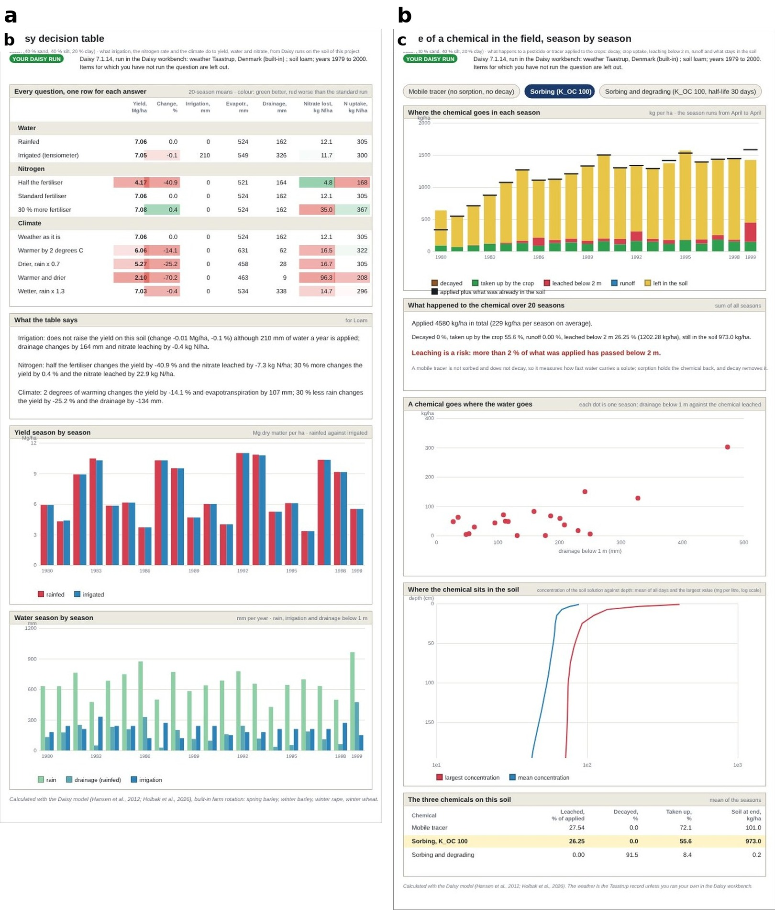
Results of the hand-over. (a) The Daisy decision table with the labels of the run (rainfed and irrigated, half and 30 % more fertiliser, warmer and drier climates). (b) The fate of a chemical for a mobile, a sorbing and a sorbing and degrading tracer.

Agreement of the fast route with Daisy.
The agreement of Engine 1 with Daisy was tested on 1 000 runs of the sensor, trigger and rain experiment (E12, coarse loam) that were not used to build its lookups: the ranking of the trigger, sensor-depth and rainfall options is preserved (Spearman 0.64 to 0.97) and the absolute level has a diagnosed offset. This is the evidence that the first route can be used to choose between options. It is not evidence that the second and third routes agree with the first for a soil outside the study; for those the user is told, in the header of the layer, which weather and soil were used.

End-to-end runs with Daisy.
Daisy 7.1.14 (the Windows build, under Wine on Linux) ran the set-ups written by the workbench for the scenarios that take manures, pesticides, PFAS, crops and soils from the Daisy library, for the variants of deficit irrigation, and for the soil-hydraulic factors; each finished and wrote its logs. Scaling $K_{sat}$ by 4, $α$ by 2, $n−1$ by 1.3 and $θ_{s}$ by 1.1 and shifting $l$ by $+1$ on the loam raised matrix percolation of the first season from 177 to 222 mm and of the second from 317 to 353 mm, removed the runoff (9.3 and 6.4 mm before), and lowered actual evapotranspiration from 547 to 513 mm, the direction expected from a faster-draining soil. A horizon of the Daisy samples (KarJyn_B of test-prd.dai) stopped every run at line 292 with Unknown ’log’ model ’crop’: the sample file carried the logs of its own run, which need a log model the runs do not load. The diagnosis (20) located the line and classed the cause; the workbench now takes only the definitions from such a file, and the same run then finished in 6 s with all its logs.
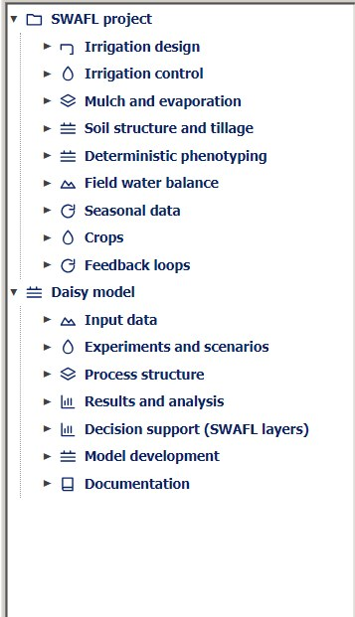  The Layers panel: the nine groups of the SWAFL project and the seven of the Daisy model. | 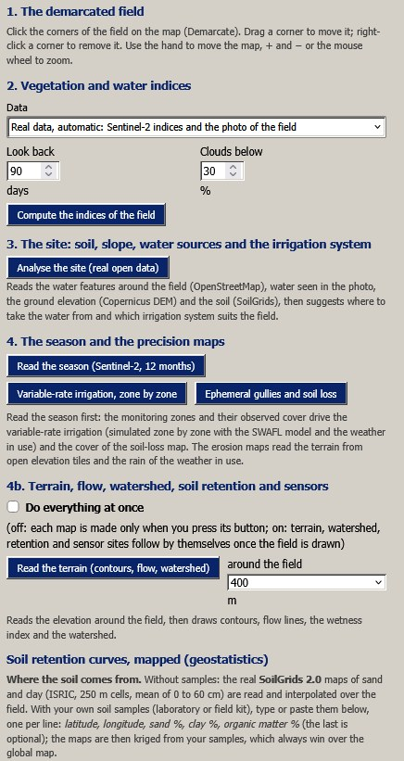  The panel of the real field, sections 1 to 4b. | 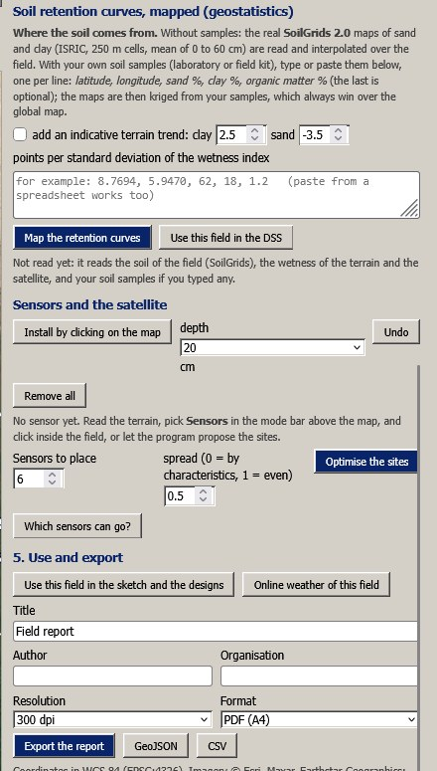  Soil retention mapped, sensors, and export.
The interface of release 1.1.0 as it appears to the user (screen captures).
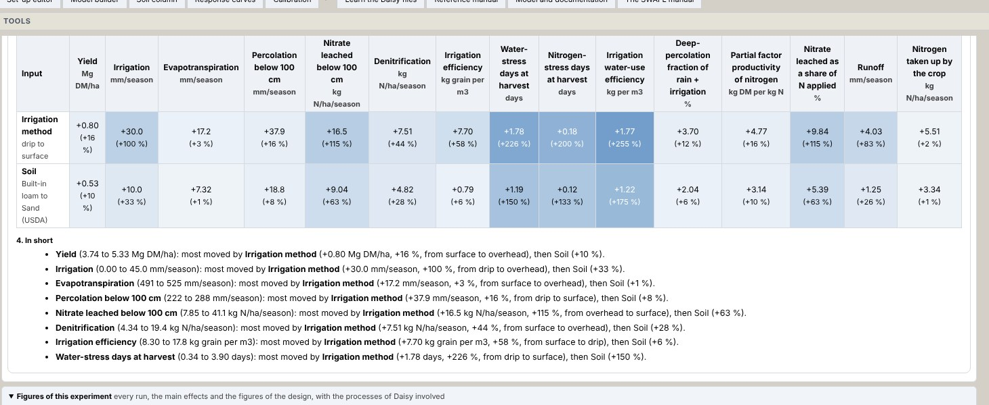  The summary of an experiment: the effect of every input on every result (blue rises, red falls; in brackets the share of the mean) and the summary in words. | 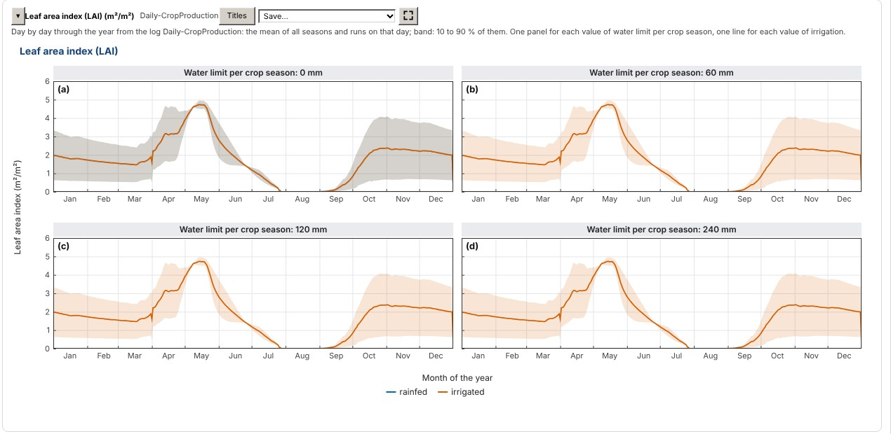  One of the figures of every log: leaf area index through the year, one panel per water limit, rainfed and irrigated, the mean of the seasons with 10 to 90 % as the band.
Outputs of the experiment engine drawn from Daisy runs (screen captures of the workbench).
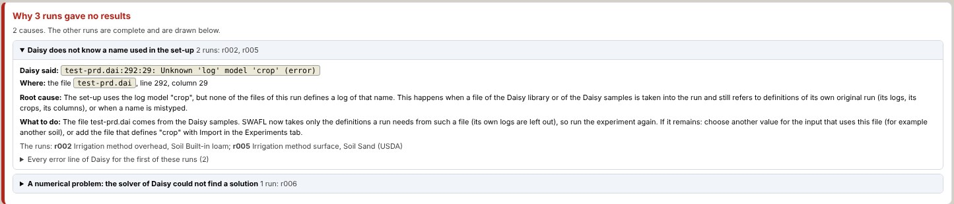  The root cause of runs that gave no results, grouped by cause, with the place in the set-up and what to do. | 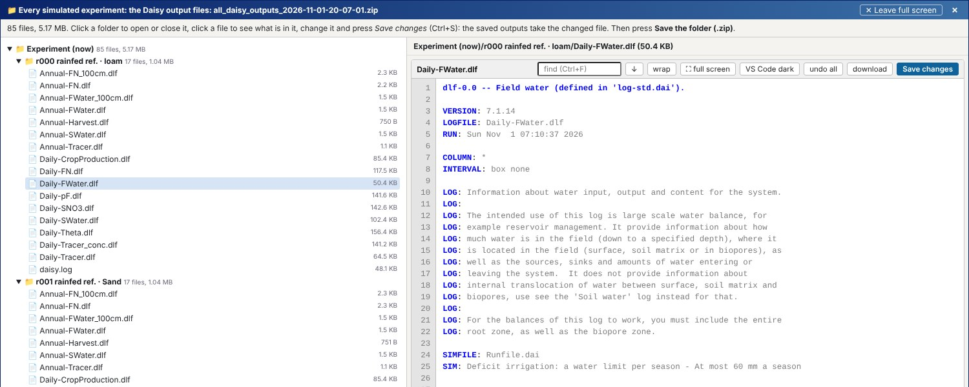  Every file Daisy wrote, experiment by experiment and run by run, in a full-screen viewer.
Diagnosis and provenance of the runs (screen captures).

The suite

Layers.
All 22 layers opened and ran with no error of the page script. The results tab of each layer had a text of 1 346 to 3 419 characters (median 1 670; the phenotyping layer shows its results on the picture and in its own sections) and four to 16 charts; the three design layers have eight in the charts tab, the seasonal layers 16, 10 and 6 (yield reliability, full water balance, nitrogen budget). The Daisy layers showed no figure before a Daisy run, as designed.

Crop library.
Of the 110 combinations, 97 satisfy all constraints. The 13 that do not are evergreen tree crops (citrus in six densities, olive in six, date palm in one young planting) for which the library gives a mid-season coefficient below the initial coefficient, which for evergreen crops is the end-of-season value; the youngest olive plantings also have a mid-season coefficient of 0.25 to 0.30, below the general range. These values follow the source (a low ground cover of young trees) and are not errors of the code, but the layer draws a curve that falls from the initial to the mid-season value, which is unusual and is stated here.

Phenotyping.
The 56 runs of the layer and the 28 runs of the experiment were identical when repeated (maximum difference 0 in every stored series), and the soil water balance closed with a largest residual of $4×{10}^{−5}$ mm. In the warm season the drought pulse reduced the grain mass by 27 to 42 % and in the hot, dry season by 14 to 42 % (9, 21). The genotype with the largest loss in both seasons is the shallow, dense one (42 %), whose root system reaches 109 to 84 cm instead of 120 cm; the water saver, which closes its stomata early, has the smallest absolute yield but one of the smallest losses (27 and 14 %), and the deep-rooting genotype loses the least in the hot season among those with a full yield (15 %). The osmotic adjuster gives the same grain mass as the reference in this setting: its adjustment changes the water potential and not the dry matter of the pulse. These are the contrasts that the model was built to show, and they follow from its equations; they are not predictions of real genotypes, whose constants are those of the layer.
Deterministic phenotyping layer: maize in a warm and in a hot, dry season, seven genotypes, well-watered bench against a drought pulse (onset day 40, 28 days, 30 % of the plant-available water, rain-out shelter). Grain dry mass in model units; the penalty is the loss by the drought.
 | Warm season |  |  | Hot, dry season
2-4(lr)5-7 Genotype | Well-watered | Drought | Loss (%) | Well-watered | Drought | Loss (%)
Reference | 515 | 345 | 33 | 331 | 246 | 26
Deep rooting | 486 | 329 | 32 | 312 | 264 | 15
Shallow, dense | 516 | 298 | 42 | 330 | 193 | 42
Stay-green | 542 | 377 | 30 | 353 | 253 | 28
Water saver | 331 | 242 | 27 | 146 | 125 | 14
Water spender | 562 | 336 | 40 | 395 | 288 | 27
Osmotic adjuster | 515 | 345 | 33 | 331 | 245 | 26
Grain dry mass at maturity of seven genotypes, well-watered and under a drought pulse, in a warm (a) and a hot, dry (b) season.
Daily crop coefficient curves of the library ([eq:kc]) at the default sowing date, (a) five annual crops, (b) three perennial crops (medium density).

Discussion

What the suite offers.
A person can go from a point on the map to a drawn field, to satellite indices and zones, to a design, a schedule, a simulation of the options and a report, in one window and with the same soil, crop and weather throughout, and can follow every number to an equation and its origin. For Daisy, a user can ask a question, see the runs that would answer it, run them and read the answer next to the study, without writing a file; the set-up editor, the process map and the calibration tool remain in reach for the developer.

What the checks say about trust.
The checks are of three kinds. Those that compare a part with an independent computation (the Richards reference, the parsers of the logs, the worked examples of the design modules) give agreement to the precision of the method. The check against the stored outputs of Daisy found a real defect, which would have given too little denitrification to every user of the curve tool, and this was visible only because stored outputs were used and not the equations. The sweep of the layers shows that they run, not that every number is right. The cheapest way to find the defects of a graphical tool is to compare each of its parts with something that was not made with it, and the defects found in this and the earlier release were none of them visible on the screen.

Why two rules.
The rule of traceability costs the work of writing every equation down; its benefit is that a disagreement with the suite can be located, and that a reader who disagrees with a choice can change it. A bridge between a model and a tool has two kinds of risk. One is translation (a column read wrongly, a unit lost), which the tests above address. The other is substitution: a layer that shows a number from a different source under the name of the model. The rule that a Daisy layer shows a Daisy number or nothing removes the second kind by design, and the label of the run keeps it visible. The design is not specific to Daisy: a parser of the logs of another model, a summariser to seasonal terms, a map of soils and a map of questions to layers are the parts of any such bridge.

Limits.
(i) No field measurement is used anywhere; the verification is against worked examples, held-out simulations, independent solvers and stored model output, so the suite is shown to be consistent and not shown to be right for a field. (ii) Daisy 7.1.14 was run end to end (the Windows build under Wine on Linux) for the scenarios, the deficit-irrigation variants, the soil-hydraulic factors and a horizon of the Daisy samples, but not for every factor and combination; the full agreement of the runs of the workbench with the published study was not tested, and the interface itself was tested in a browser with the outputs of real Daisy runs rather than in the desktop application on Windows. (iii) The data services (Sentinel-2, OpenStreetMap, elevation, SoilGrids) were exercised on one real field (2.2.0.5) with a cloud-free scene, so the handling of a cloudy season, other climates and the online weather remain to be tested, and none of the maps was compared with measurements on the ground. (iv) The compact designs lose a median of 13 % of the shape of a marginal curve, three experiments are not offered as designs, and the soil column is slow and not converged for a ponded fine soil. (v) The phenotyping model is built from forms of the literature with typical constants and has not been fitted or tested against phenotyping data, and the crop coefficients are those of FAO-56 and of a review, so a local calibration is the user’s task. (vi) The bundled logs have ten seasons of one rotation, and logs with other crops, a long fallow or irrigation were not exercised; the summariser reduces a run to seasons, so a question that depends on the day needs the daily logs, which the workbench plots but the layers do not read. (vii) The calibration of a model on its own outputs cannot show that the calibration works on measurements. (viii) The interface was tested in one browser engine; the Windows application, its installer and the bundled Daisy were not tested here, and Daisy is bundled for Windows only. (ix) The largest class of equations (287 of the labelled) is engineered and has only the tests of this article.

The manual inside the program
The suite is documented in a technical manual of 1 154 pages in 43 chapters (Halilu 2026b) that is part of the program. It is built from the code: the tables of the factors of the Experiments tab, the tested parameters of the Daisy reference, the scenarios and the library are written by scripts from the same files the program reads, and an index of its 1 073 sections is made with it, so the program opens the manual at the section of the tab or the layer in use (F1, a Manual button on every tab of the workbench and above every layer, a searchable list of sections). The manual follows the path of this article: the window and every control (pp. 30–45), the two engines and the layers (pp. 46–158), the design modules and the search for efficient inputs (pp. 116–177), the real field (p. 182, including the field near Zaria of 2.2.0.5), the crop library and the seasonal data (pp. 214–231), and the Daisy workbench (pp. 569–1123: input data, experiments and scenarios, the best combinations, results and analysis, the bridge to the layers, the 107 reference topics, the tested parameters, the factors and responses, the Daisy library and the weather stations), closed by the symbols, the provenance ledger and the equation reference. Each new part of release 1.1.0 described here (the experiment engine, the summary of effects, the figures of every log, the diagnosis of failed runs, the viewer of every output) has its section with screen captures, and a chapter lists the changes from version 1.0 (p. 234).

What is new, item by item.
sets each contribution of this article against what was established before it, so that what is taken from the literature and what is added here can be told apart.
What this article adds, item by item: what was established before, what is new here, and the evidence in this article.
# | Established before | New in this article | Evidence here
# | Established before | New in this article | Evidence here
 | Daisy is run from text set-up files (S. Hansen et al. 2012); field, design, satellite and model tools are separate programs. | A graphical workbench that checks every design against a catalogue of what Daisy can vary, keeps an exact run budget, keeps every run and explains every failure by its root cause. | End-to-end Daisy 7.1.14 runs of the library scenarios, deficit irrigation and the soil-hydraulic factors; a defect that stopped every run on a sample horizon found and removed.
 | Decision tools show numbers without their origin. | Two auditable rules: every number leads to an equation with its origin, and a Daisy layer shows a Daisy result only from a Daisy run. | All layers opened without a page error; Daisy layers show nothing before a run (3.2.0.5).
 | Shared model functions are trusted once published. | A check of a shared function against stored Daisy results that found a defect. | The denitrification function corrected after comparison with 792 Daisy results.
 | Sentinel-2 indices, SoilGrids and elevation models are used separately (Drusch et al. 2012; Poggio et al. 2021). | One offline chain from a field outlined on a satellite image to indices, water sources, terrain, soil loss, retention maps, a design and a schedule. | Run on a real 5.85 ha field near Zaria, Nigeria (2.2.0.5).
 | Sensitivity to hydraulic parameters is studied with dedicated codes (Šimůnek, van Genuchten, and Šejna 2016). | Factors that scale the van Genuchten–Mualem parameters of every horizon of a Daisy run inside the workbench. | One season’s matrix percolation rose from 177 to 222 mm and runoff vanished with the scaled parameters.
 | – | A manual made with the program and opened at the page in use (Halilu 2026b). | Every control, view and equation documented; page links from each screen.
 | Daisy and the tools around it are installed one by one, each with its own set-up and dependencies. | The model, the workbench, the decision layers and the manual packed in one portable executable that runs offline with no installation. | The structure of the package (Electron runtime, application, Daisy 7.1.14 program, manual) described in the section on the suite.

Conclusions
SWAFL Desktop 1.1.0 is a single offline application that joins the field, the satellite, the design, the schedule, the Daisy process model and the plant, with traceability of its equations. The workbench makes Daisy usable through a question-first path in which a checked design is run within an exact budget, every run is kept and explained (its summary of effects, its figures, the root cause of a failure), and the experiments of a large published ensemble become repeatable in about an hour each instead of days. The bridge hands the runs to the decision layers under one rule, that a Daisy layer shows a Daisy result only from a Daisy run, reads the logs exactly, closes the chemical budget, and offers three routes from Daisy to a decision that differ by orders of magnitude in time. Each computing part was verified against an independent reference or against stored Daisy output, and the verification found and removed the defect of the shared denitrification function. What remains is the repetition of the published experiments run by run, the test of the data services on a connected machine and of the installer on Windows, and the comparison of the layers and of the runs with measurements on real fields; each is a defined piece of work and none is claimed.

Software, data and code availability
Software. SWAFL Desktop (version 1.1.0) is open source; the Software source is in the project repository (https://github.com/halilunaziru73-creator/Coupled-Water-Fluxes-Pore-Scale-Dynamics-Precision-Irrigation-Mulching-Feedback-Loops/tree/main/Software) and the program for Windows is SWAFL.exe (https://github.com/halilunaziru73-creator/Coupled-Water-Fluxes-Pore-Scale-Dynamics-Precision-Irrigation-Mulching-Feedback-Loops/releases/latest/download/SWAFL.exe). The whole workbench also runs in a browser, with nothing to install (link in the repository README).
Manual. The Manual (https://github.com/halilunaziru73-creator/Coupled-Water-Fluxes-Pore-Scale-Dynamics-Precision-Irrigation-Mulching-Feedback-Loops/raw/main/Software/v1.1.0/SWAFL_Desktop/docs/manual_v1.1.0/SWAFL_Manual_v1.1.0.pdf) documents every control, screen and equation of the release, with labelled screenshots.
Data. The complete Daisy ensemble outputs (all 10 190 runs, raw and derived) are archived on Zenodo, doi: 10.5281/zenodo.23043626; the run table and a summary of every experiment are in the Data folder (https://github.com/halilunaziru73-creator/Coupled-Water-Fluxes-Pore-Scale-Dynamics-Precision-Irrigation-Mulching-Feedback-Loops/tree/main/Data).
Full simulation outputs. Every value of every log of every run (the annual water and nitrogen balances, the harvests and the crop state, year by year), one compressed table per experiment (E00_Baselines to E16_Edge_Cases), the one-row-per-run summary of all 10 190 runs (00_summary_all_simulations), the per-experiment summary (00_SUMMARY_ALL_EXPERIMENTS) and the script that made them (summarize_results3.py) are in the folder Data/Comprehensive_Summary of the repository (https://github.com/halilunaziru73-creator/Coupled-Water-Fluxes-Pore-Scale-Dynamics-Precision-Irrigation-Mulching-Feedback-Loops/tree/main/Data/Comprehensive_Summary); their 20-year means reproduce the run table within 2 %.
Supplementary Material. The Supplementary Material of this article gives the derivation of every equation, the mechanisms behind the results, the data of the analyses and the origin of every table and figure.
The data of every table and figure. One Excel workbook, Data/Manuscript_Data/SWAFL_Manuscripts_Data.xlsx, holds the data of this work and its equations written as live Excel formulas connected to the data (sheets Equations and EQ_*): the run tables, the per-experiment summary, the derived results behind every table and figure, and a map that names, for each table and figure, the script that makes it, its input and its output. The map is also in Data/Manuscript_Data/README.md, and the workbook is rebuilt by Data/Manuscript_Data/make_workbook.py.
Code. Every check reported here has a script in Manuscripts/reproducibility/p456 (Node.js scripts that load the shipped code or drive the shipped application, Python scripts for the analysis of the ensemble and the figures); README_REPRODUCE.md lists the steps. Daisy itself could not be run in the environment used for these checks, no field measurements are used, and the screenshots are archived rather than regenerated.

Author contributions
N.H. designed the suite and the workbench, wrote the software and the checks, analysed the data and wrote the article.

Funding
No funding was received for this work.

Competing interests
The author declares no competing interests.

Acknowledgements
The Daisy model is developed and maintained at the University of Copenhagen. The author thanks the maintainers of the open-source libraries cited.

Checks and scripts of the workbench
Check to script map (scripts in Manuscripts/reproducibility/p456).
Check | What is compared | Script $→$ output
Design sizes (4) | presets against the ensemble | p4_design_sizes.js $→$ out_p4_design.json
Fidelity and run time (13) | interpolated against full marginals; run_seconds | p4_design_fidelity.py $→$ out_p4_fidelity.csv, out_p4_runtime.csv
Soil column (5, 14) | workbench against scipy BDF | p4_richards.js, p4_richards_ref.py
Denitrification (15) | stored outputs | p5_bridge_checks.js
Calibration | recovery of three parameters | p4_calibration.js
Figures and tables |  | p456_figs_schematics.py, p456_figs_data.py, p456_tables.py

Checks and scripts of the bridge
Check to script map (scripts in Manuscripts/reproducibility/p456).
Check | What is compared | Script $→$ output
Parsers and nitrogen summaries | bridge against pandas | p5_bridge_checks.js, p5_bridge_checks.py $→$ out_p5_bridge.json
Chemical budget | residual of [eq:chem] | p5_chem_closure.js $→$ out_p5_chem.json
Denitrification | stored outputs | p5_bridge_checks.js $→$ out_p5_bridge_js.json
Run time | run_seconds of the ensemble | p4_design_fidelity.py $→$ out_p4_runtime.csv
Empty state of the Daisy layers | application opened afresh | p5_empty_state.js
Figures |  | p456_figs_schematics.py, p456_figs_data.py

Checks of the planner
The test of the planner is Manuscripts/reproducibility/p456/p7_planner_checks.js, with the output out_p7_planner.json.

Checks and scripts of the suite
Check to script map (scripts in Manuscripts/reproducibility/p456).
Check | What is compared | Script $→$ output
All layers | open, run, read | p6_layer_sweep.js $→$ out_p6_sweep.json
Crop library | constraints and $K_{c}$ curves | p6_crop_checks.js $→$ out_p6_crops.json
Phenotyping | determinism, closure, genotypes | p6_pheno_checks.js $→$ out_p6_pheno.json
Figures and tables |  | p456_figs_schematics.py, p456_figs_data.py, p456_tables.py
Abrahamsen, Per, and Søren Hansen. 2000. “Daisy: An Open Soil-Crop-Atmosphere System Model.” Environmental Modelling and Software 15: 313–30.
Allen, Richard G., Luis S. Pereira, Dirk Raes, and Martin Smith. 1998. “Crop Evapotranspiration: Guidelines for Computing Crop Water Requirements.” FAO Irrigation and Drainage Paper 56. Rome: FAO. https://www.fao.org/4/x0490e/x0490e00.htm.
Barnes, Edward M., Thomas R. Clarke, Stephen E. Richards, et al. 2000. “Coincident Detection of Crop Water Stress, Nitrogen Status and Canopy Density Using Ground-Based Multispectral Data.” In Proceedings of the 5th International Conference on Precision Agriculture. Bloomington, MN.
Celia, Michael A., Efthimios T. Bouloutas, and Rebecca L. Zarba. 1990. “A General Mass-Conservative Numerical Solution for the Unsaturated Flow Equation.” Water Resources Research 26: 1483–96. https://doi.org/10.1029/WR026i007p01483.
Doorenbos, Jan, and Amir H. Kassam. 1979. Yield Response to Water. Rome: FAO Irrigation; Drainage Paper 33.
Drusch, Matthias, Umberto Del Bello, Sebastien Carlier, et al. 2012. “Sentinel-2: ESA’s Optical High-Resolution Mission for GMES Operational Services.” Remote Sensing of Environment 120: 25–36.
Feddes, Reinder A., Piotr J. Kowalik, and Henryk Zaradny. 1978. Simulation of Field Water Use and Crop Yield. Wageningen: Pudoc.
Frangi, Alejandro F., Wiro J. Niessen, Koen L. Vincken, and Max A. Viergever. 1998. “Multiscale Vessel Enhancement Filtering.” In Medical Image Computing and Computer-Assisted Intervention (MICCAI 1998), 1496:130–37. Lecture Notes in Computer Science. Springer.
Gao, Bo-Cai. 1996. “NDWI—a Normalized Difference Water Index for Remote Sensing of Vegetation Liquid Water from Space.” Remote Sensing of Environment 58: 257–66.
Gitelson, Anatoly A., Yoram J. Kaufman, Robert Stark, and Donald Rundquist. 2002. “Novel Algorithms for Remote Estimation of Vegetation Fraction.” Remote Sensing of Environment 80: 76–87.
Halilu, Naziru. 2026a. “Coupled Water Fluxes and Pore Scale Dynamics Under Joint Precision Irrigation and Evaporation Control Mulching: Ensemble of 10 190 Daisy Simulations.” Zenodo dataset. https://doi.org/10.5281/zenodo.23043626.
———. 2026b. SWAFL Desktop 1.1.0: Technical Manual (1155 Pages).
Hansen, Nikolaus, and Andreas Ostermeier. 2001. “Completely Derandomized Self-Adaptation in Evolution Strategies.” Evolutionary Computation 9: 159–95.
Hansen, Søren, Per Abrahamsen, Christian T. Petersen, and Merete Styczen. 2012. “Daisy: Model Use, Calibration, and Validation.” Transactions of the ASABE 55: 1317–35. https://doi.org/10.13031/2013.42244.
Hansen, Søren, Hans E. Jensen, Niels E. Nielsen, and Henrik Svendsen. 1990. “DAISY: Soil Plant Atmosphere System Model.” Copenhagen: The Royal Veterinary; Agricultural University, Copenhagen; NPO Report A10, Danish Environmental Protection Agency.
Holbak, Maja, Per Abrahamsen, Celine R. Grønning, Tobias Klöffel, Magdalena V. Schwartzkopff, Merete E. Styczen, Simon F. Svane, and Efstathios Diamantopoulos. 2026. “The Daisy Model: A Tool for Simulating Agricultural Systems — Recent (2012–2025) Developments, Calibrations and Validations.” Agricultural Systems 238: 104846. https://doi.org/10.1016/j.agsy.2026.104846.
Huete, Alfredo R. 1988. “A Soil-Adjusted Vegetation Index (SAVI).” Remote Sensing of Environment 25: 295–309.
Huete, Alfredo, Kamel Didan, Tomoaki Miura, E. Patricia Rodriguez, Xiang Gao, and Laerte G. Ferreira. 2002. “Overview of the Radiometric and Biophysical Performance of the MODIS Vegetation Indices.” Remote Sensing of Environment 83: 195–213.
Jackson, Ray D., Sherwood B. Idso, Robert J. Reginato, and Paul J. Pinter. 1981. “Canopy Temperature as a Crop Water Stress Indicator.” Water Resources Research 17: 1133–38. https://doi.org/10.1029/WR017i004p01133.
Jarvis, Paul G. 1976. “The Interpretation of the Variations in Leaf Water Potential and Stomatal Conductance Found in Canopies in the Field.” Philosophical Transactions of the Royal Society of London B 273: 593–610.
Jones, James W., Gerrit Hoogenboom, Cheryl H. Porter, Kenneth J. Boote, William D. Batchelor, L. A. Hunt, et al. 2003. “The DSSAT Cropping System Model.” European Journal of Agronomy 18: 235–65. https://doi.org/10.1016/S1161-0301(02)00107-7.
Keating, Brian A., Peter S. Carberry, Graeme L. Hammer, Merv E. Probert, Michael J. Robertson, Dean Holzworth, et al. 2003. “An Overview of APSIM, a Model Designed for Farming Systems Simulation.” European Journal of Agronomy 18: 267–88. https://doi.org/10.1016/S1161-0301(02)00108-9.
Keller, Jack, and Ron D. Bliesner. 1990. Sprinkle and Trickle Irrigation. New York: Van Nostrand Reinhold.
Knijff, J. M. van der, R. J. A. Jones, and L. Montanarella. 1999. “Soil Erosion Risk Assessment in Italy.” EUR 19044 EN. European Commission, European Soil Bureau.
Lockhart, James A. 1965. “An Analysis of Irreversible Plant Cell Elongation.” Journal of Theoretical Biology 8: 264–75.
Lorence, Argelia, and Karla Medina-Jimenez. 2022. Plant Phenotyping: Methods and Protocols. New York: Humana.
Mockus, Jonas, Vytautas Tiesis, and Antanas Zilinskas. 1978. “The Application of Bayesian Methods for Seeking the Extremum.” Towards Global Optimization 2: 117–29.
Monteith, John L. 1965. “Evaporation and Environment.” Symposia of the Society for Experimental Biology 19: 205–34.
———. 1977. “Climate and the Efficiency of Crop Production in Britain.” Philosophical Transactions of the Royal Society of London B 281: 277–94.
Moore, I. D., and J. P. Wilson. 1992. “Length-Slope Factors for the Revised Universal Soil Loss Equation: Simplified Method of Estimation.” Journal of Soil and Water Conservation 47: 423–28.
Mualem, Yechezkel. 1976. “A New Model for Predicting the Hydraulic Conductivity of Unsaturated Porous Media.” Water Resources Research 12: 513–22. https://doi.org/10.1029/WR012i003p00513.
Pagès, Loïc, Grégory Bécsel, Xavier Draye, et al. 2014. “Calibration and Evaluation of ArchiSimple, a Simple Model of Root System Architecture.” Ecological Modelling 290: 76–84.
Panguluri, Siva K., and A. Ashok Kumar. 2013. Phenotyping for Plant Breeding: Applications of Phenotyping Methods for Crop Improvement. New York: Springer.
Poggio, Laura, Luis M. de Sousa, Niels H. Batjes, Gerard B. M. Heuvelink, Bas Kempen, Eloi Ribeiro, and David Rossiter. 2021. “SoilGrids 2.0: Producing Soil Information for the Globe with Quantified Spatial Uncertainty.” SOIL 7: 217–40.
Renard, K. G., and J. R. Freimund. 1994. “Using Monthly Precipitation Data to Estimate the R-Factor in the Revised USLE.” Journal of Hydrology 157: 287–306.
Rouse, John W., Robert H. Haas, John A. Schell, and Donald W. Deering. 1974. “Monitoring Vegetation Systems in the Great Plains with ERTS.” NASA Special Publication 351: 309–17.
Sharpley, A. N., and J. R. Williams. 1990. “EPIC: Erosion/Productivity Impact Calculator, 1. Model Documentation.” Technical Bulletin 1768. U.S. Department of Agriculture.
Šimůnek, Jiří, Martinus Th. van Genuchten, and Miroslav Šejna. 2008. “Development and Applications of the HYDRUS and STANMOD Software Packages and Related Codes.” Vadose Zone Journal 7: 587–600. https://doi.org/10.2136/vzj2007.0077.
———. 2016. “Recent Developments and Applications of the HYDRUS Computer Software Packages.” Vadose Zone Journal 15 (7). https://doi.org/10.2136/vzj2016.04.0033.
Steduto, Pasquale, Theodore C. Hsiao, Dirk Raes, and Elias Fereres. 2009. “AquaCrop—the FAO Crop Model to Simulate Yield Response to Water: I. Concepts and Underlying Principles.” Agronomy Journal 101: 426–37. https://doi.org/10.2134/agronj2008.0139s.
Tanner, Champ B., and Thomas R. Sinclair. 1983. “Efficient Water Use in Crop Production: Research or Re-Search?” In Limitations to Efficient Water Use in Crop Production, 1–27. Madison, WI: American Society of Agronomy.
van Genuchten, Martinus Th. 1980. “A Closed-Form Equation for Predicting the Hydraulic Conductivity of Unsaturated Soils.” Soil Science Society of America Journal 44: 892–98. https://doi.org/10.2136/sssaj1980.03615995004400050002x.
Vandaele, K., J. Poesen, G. Govers, and B. van Wesemael. 1996. “Geomorphic Threshold Conditions for Ephemeral Gully Incision.” Geomorphology 16: 161–73.
Walker, W. R. 1989. “Guidelines for Designing and Evaluating Surface Irrigation Systems.” Irrigation and Drainage Paper 45. Rome: Food; Agriculture Organization of the United Nations. https://www.fao.org/4/t0231e/t0231e00.htm.
Woebbecke, David M., George E. Meyer, Kenneth Von Bargen, and David A. Mortensen. 1995. “Color Indices for Weed Identification Under Various Soil, Residue, and Lighting Conditions.” Transactions of the ASAE 38: 259–69.

