Supplementary Material
The Reach of Suction-Triggered Irrigation and the Marginal Fate of Irrigation Water with Closed Forms from the van Genuchten–Mualem Parameters
Derivations of the equations, the mechanisms behind the results, the data, and the origin of every table and figure
Naziru Halilu$​^{1,2,*}$
$​^{1}$ Agricultural University of Athens, Athens, Greece
$​^{2}$ Public University of Navarre, Pamplona, Spain
ORCID: 0009-0006-2324-9599
$​^{*}$ Correspondence: halilunaziru73@gmail.com

Highlights
- A closed form from $α$, $n$ and $ℓ$ gives the largest suction a crop can impose at a sensor: the reach of a trigger.
- It predicts held-out soils within a factor of 2.3; triggers beyond it never fire and leave the crop rainfed.
- Of each irrigation millimetre, 38 % is transpired and 16 % drains; the rest evaporates.
- The drained share rises with the dose on a soil-independent scale of about 4 mm.
- Data (every log of every run), code, software and a 1155-page manual are open.

What is new in this article
What this article adds, item by item: what was established before, what is new here, and the evidence in this article.
# | Established before | New in this article | Evidence here
# | Established before | New in this article | Evidence here
 | Field capacity has intrinsic definitions from the hydraulic parameters (Twarakavi, Sakai, and Šimůnek 2009; Assouline and Or 2014); uptake becomes limited by the conductance of the soil around the roots (Gardner 1960; Carminati and Javaux 2020). | A closed form for the dry-end counterpart, the reach of a suction trigger, with one constant shared by all soils. | Held-out soils within a factor of 2.3 (LOSO 0.18 decades); a threshold on absolute conductivity rejected.
 | Triggers of 300 to 600 cm are tabulated for field crops (Allen et al. 1998). | These triggers lie beyond the reach of coarse soils: they never fire and the crop stays rainfed. | Sand and loamy sand at 300 cm: rainfed yield; a deeper sensor does not help (E3).
 | – | A reach-scaled trigger $h_{t}/h_{c}$ that places the irrigation responses of all soils on one axis. | Between-soil scatter falls from 54 % to 32 % of the total.
 | Pulsing, discharge and hydraulic properties change losses below the root zone, shown case by case (Elmaloglou and Diamantopoulos 2007, 2008, 2009). | The marginal fate of an irrigation millimetre across soils, doses, seasons and methods. | transpired, 0.25 soil evaporation, 0.19 other evaporation, 0.16 drained.
 | – | A dose scale of the drained share that does not depend on the soil, and a soil-specific plateau. | $d_{D}=4.1±0.6$ mm, $ρ=0.07$ with $n$; plateau 0.10 to 0.45.
 | Interception losses of sprinklers are known. | Overhead irrigation adds no transpiration: intercepted water replaces it. | $η_{T}=−0.08$ (all soils) and $−0.01$ (coarse loam).
 | Flow can be out of equilibrium with the retention curve (Ross and Smettem 2000; Diamantopoulos and Durner 2012). | A criterion, $Π_{τ}=τ/t_{i}$, for when this changes the firing of a trigger (proposed, not tested). | Derivation in Section 7.3.

How this supplement is organised
Each of the following sections gathers everything about one result of the article under one heading: the problem and the author’s contribution with its pinpointed equation, the worked numbers that can be checked on a calculator or in the workbook, graphs that mark the exact points, the figures of the article with their numbered labels, the derivations, and why it happens. The terms, the constants, the tables, the path from the data to every result, the data themselves and the origin of every item follow at the end. Sections 4.17 and 4.18 re-derive the van Genuchten–Mualem pair and its dry-end asymptote, which are established mathematics (van Genuchten 1980; Mualem 1976). Everything from 4.19 on is new in this article: the reach of a trigger and its properties, the alternative laws and their test, the interval-censored fit, the marginal-fate identity applied across soils, doses, seasons and methods, the dose law, and the non-equilibrium criterion for triggers (the relaxation equation itself is established (Ross and Smettem 2000)).

The reach of a suction trigger
How far a crop can dry the soil at the sensor, why the limit exists, how the single constant $κ$ is found from experiment E2, and how the closed form is checked.

Contribution 1: the reach of a suction trigger
A farmer on a sandy field installs a matric-potential sensor at 20 cm and sets the common trigger of 300 cm. All season the controller never opens the valve, the crop wilts, and the yield equals that of a field that was never irrigated. The sensor works. Why is the trigger never reached, and how dry a trigger can be used on any soil, from its van Genuchten parameters alone?
(a) Roots dry a layer only as fast as the soil delivers water to them; the delivery is proportional to the conductivity $K=K_{s}K_{r}$ (Gardner 1960). (b) Postulate: the sensor’s soil stops drying when the relative conductivity has fallen to one value $κ$, the same for all soils, $K_{r}\left(h_{c}\right)=κ$. (c) At the dry end, $K_{r}≃m^{2}{\left(αh\right)}^{−\left[2n+ℓ\left(n−1\right)\right]}$ (Section 4.18). (d) Insert (c) into (b): $m^{2}{\left(αh_{c}\right)}^{−E}=κ$ with $E=2n+ℓ\left(n−1\right)$. (e) Divide by $m^{2}$, raise to $−1/E$, divide by $α$.
How it is derived, line by line $$\begin{array}{@{}l@{}}\textbf{1. Postulate (uptake stops at one relative conductivity):}\\[1pt]
\qquad K_r(h_{\mathrm{c}})=\kappa\\[1pt]
\textbf{2. Dry-end form of Mualem (Section \ref{der:s4:2}):}\\[1pt]
\qquad K_r(h)\simeq m^2(\alpha h)^{-E}\\[1pt]
\textbf{2b. Slope of the dry end:}\\[1pt]
\qquad E=2n+\ell(n-1)\\[1pt]
\textbf{3. Insert 2 into 1:}\\[1pt]
\qquad m^2(\alpha h_{\mathrm{c}})^{-E}=\kappa\\[1pt]
\textbf{4. Divide by } m^2\textbf{:}\\[1pt]
\qquad (\alpha h_{\mathrm{c}})^{-E}=\kappa/m^2\\[1pt]
\textbf{5. Raise both sides to } -1/E\textbf{:}\\[1pt]
\qquad \alpha h_{\mathrm{c}}=(m^2/\kappa)^{1/E}\\[1pt]
\textbf{6. Divide by } \alpha\textbf{:}\\[1pt]
\qquad h_{\mathrm{c}}=\alpha^{-1}(m^2/\kappa)^{1/E}
\end{array}$$ The result, with its parts marked
$$h_{\mathrm{c}}\;=\;\underbrace{\frac{1}{\alpha}}_{\tikz[baseline=(c.base)]\node[circle,draw=red!70!black,text=red!70!black,line width=0.6pt,inner sep=0.7pt,minimum size=1.15em,font=\scriptsize\bfseries\sffamily](c){1};}\;\Bigl(\underbrace{m^{2}}_{\tikz[baseline=(c.base)]\node[circle,draw=red!70!black,text=red!70!black,line width=0.6pt,inner sep=0.7pt,minimum size=1.15em,font=\scriptsize\bfseries\sffamily](c){2};}\Big/\underbrace{\kappa}_{\tikz[baseline=(c.base)]\node[circle,draw=red!70!black,text=red!70!black,line width=0.6pt,inner sep=0.7pt,minimum size=1.15em,font=\scriptsize\bfseries\sffamily](c){3};}\Bigr)^{\textstyle\overbrace{1/[\,2n+\ell(n-1)\,]}^{\tikz[baseline=(c.base)]\node[circle,draw=red!70!black,text=red!70!black,line width=0.6pt,inner sep=0.7pt,minimum size=1.15em,font=\scriptsize\bfseries\sffamily](c){4};}}$$
$$\underbrace{\kappa=3.47\times10^{-10}}_{\tikz[baseline=(c.base)]\node[circle,draw=red!70!black,text=red!70!black,line width=0.6pt,inner sep=0.7pt,minimum size=1.15em,font=\scriptsize\bfseries\sffamily](c){5};}$$
$$\underbrace{\text{error on soils left out}\le\text{a factor of }2.3}_{\tikz[baseline=(c.base)]\node[circle,draw=red!70!black,text=red!70!black,line width=0.6pt,inner sep=0.7pt,minimum size=1.15em,font=\scriptsize\bfseries\sffamily](c){6};}$$
(c)1; $1/α$ is the suction at which the soil starts to drain. It only rescales the reach: two soils with the same $n$ have reaches in the ratio of their $1/α$. This is why, at equal $n$, a soil that starts draining later (small $α$) can be dried further.
(c)2; $m^{2}={\left(1−1/n\right)}^{2}$ comes from the tail of the Mualem integral. It changes slowly with $n$ (0.035 to 0.39 over the ten soils) and enters under the root of order $E$, so its effect is small; it is kept because it makes the formula exact at the dry end.
(c)3; $κ$ is the single constant of the law: the relative conductivity at which the crop can no longer dry the soil at the sensor within a season. It is a property of the crop and its uptake, not of the soil, which is why one value serves ten soils. It was fitted once and tested by leaving soils out.
(c)4; The exponent $1/E$ with $E=2n+ℓ\left(n−1\right)$ is the heart of the result. $E$ is the slope of $logK_{r}$ against $logh$ at the dry end. In sand ($n=2.68$) $E=6.2$: the conductivity collapses within a narrow band of suction, so the reach is short (199 cm). In silty clay loam ($n=1.23$) $E=2.6$: the conductivity fades slowly, so the reach is long ($1.3×{10}^{5}$ cm). The pore-size distribution, through $n$, decides how far a crop can dry a soil.
(c)5; $κ=3.47×{10}^{−10}$ means the soil at the reach conducts about three billion times less than when saturated; with saturated conductivities of 1 to 700 cm d$​^{−1}$ this is far below a millimetre per day, which is why uptake stops there.
(c)6; The law was tested on soils it had not seen: each soil was removed, $κ$ refitted on the other nine, and the removed soil predicted. Five predictions fell inside the observed interval and none was off by more than a factor of 2.3. A threshold on absolute conductivity, the obvious alternative, failed (it spans more than three decades).

Contribution 2: a rule for blind triggers
Which of the tabulated triggers can be used on which soil, before any season is lost?
The irrigation of every soil fell to zero between $h_{t}/h_{c}=0.5$ and 1 (Fig. 3b of the article). A trigger therefore fires reliably only below half the reach. Compute $h_{c}$ (Contribution 1), halve it, and compare with the trigger.
How it is derived, line by line $$\begin{array}{@{}l@{}}\textbf{1. Observation (Fig.~3b):}\\[1pt]
\qquad \text{irrigation}\to0\ \text{for}\ 0.5\le h_{\mathrm{t}}/h_{\mathrm{c}}\le1\\[1pt]
\textbf{2. Keep a margin below the first value:}\\[1pt]
\qquad h_{\mathrm{t}}/h_{\mathrm{c}}<\tfrac12\\[1pt]
\textbf{3. Multiply by } h_{\mathrm{c}}\textbf{:}\\[1pt]
\qquad h_{\mathrm{t}}<\tfrac12h_{\mathrm{c}}
\end{array}$$ The result, with its parts marked
$$\underbrace{h_{\mathrm{t}}}_{\tikz[baseline=(c.base)]\node[circle,draw=red!70!black,text=red!70!black,line width=0.6pt,inner sep=0.7pt,minimum size=1.15em,font=\scriptsize\bfseries\sffamily](c){1};}\;<\;\underbrace{\tfrac12}_{\tikz[baseline=(c.base)]\node[circle,draw=red!70!black,text=red!70!black,line width=0.6pt,inner sep=0.7pt,minimum size=1.15em,font=\scriptsize\bfseries\sffamily](c){2};}\,\underbrace{h_{\mathrm{c}}(\alpha,n,\ell)}_{\tikz[baseline=(c.base)]\node[circle,draw=red!70!black,text=red!70!black,line width=0.6pt,inner sep=0.7pt,minimum size=1.15em,font=\scriptsize\bfseries\sffamily](c){3};}$$
Soil | $h_{c}$ (cm) | $h_{c}/2$ (cm) | 300 cm trigger
Sand (S03) | 199 | 100 | (c)4; blind: never fires
Loamy sand (S04) | 426 | 213 | (c)4; blind: never fires
Sandy loam (S05) | 1 618 | 809 | fires
Loam (S06) | 9 209 | 4 605 | fires
Silty clay loam (S10) | 128 260 | 64 130 | fires
(c)1; The trigger chosen by the user, in cm of suction at the sensor.
(c)2; The factor one half is a safety margin read from the data, not a fitted constant: below it every soil still irrigates.
(c)3; The reach from the soil’s own parameters; no season of trial and error is needed.
(c)4; The two blind soils are exactly those in which the simulated 300 cm trigger never irrigated and the yield stayed at its rainfed value (1.13 and 1.38 Mg ha$​^{−1}$, against 3.04 and 4.54 at 50 cm).

Contribution 3: one axis for all soils
Irrigation-against-trigger curves of ten soils lie far apart. Can one scale bring them together, so that one rule applies to all?
The reach of each soil was computed with Contribution 1, every trigger of experiment E2 was divided by it, and the irrigation was divided by its soil maximum. The collapse was measured as the share of the variance of the normalised irrigation that remains within ten bins of the scaled trigger.
How it is derived, line by line $$\begin{array}{@{}l@{}}\textbf{1. The reach marks where irrigation ends:}\\[1pt]
\qquad \text{end of irrigation at } h_{\mathrm{t}}\approx h_{\mathrm{c}}\\[1pt]
\textbf{2. Measure every trigger in units of its soil's reach:}\\[1pt]
\qquad x=h_{\mathrm{t}}/h_{\mathrm{c}}\\[1pt]
\textbf{3. Then every soil ends near the same value:}\\[1pt]
\qquad x\approx0.5\ \text{to}\ 1
\end{array}$$ The result, with its parts marked
$$\underbrace{x}_{\tikz[baseline=(c.base)]\node[circle,draw=red!70!black,text=red!70!black,line width=0.6pt,inner sep=0.7pt,minimum size=1.15em,font=\scriptsize\bfseries\sffamily](c){1};}=\frac{h_{\mathrm{t}}}{h_{\mathrm{c}}},\qquad \text{scatter between soils: }\underbrace{54\,\%}_{\tikz[baseline=(c.base)]\node[circle,draw=red!70!black,text=red!70!black,line width=0.6pt,inner sep=0.7pt,minimum size=1.15em,font=\scriptsize\bfseries\sffamily](c){2};}\to\underbrace{32\,\%}_{\tikz[baseline=(c.base)]\node[circle,draw=red!70!black,text=red!70!black,line width=0.6pt,inner sep=0.7pt,minimum size=1.15em,font=\scriptsize\bfseries\sffamily](c){3};}$$
(c)1; The trigger measured in units of the soil’s reach: $x=1$ means “at the reach” in every soil.
(c)2; Share of the variance of the normalised irrigation that lies between soils when the raw trigger is used.
(c)3; The same share on the reach scale. The reach removes where irrigation ends; what remains is how fast it fades before the end, which depends on retention, not on conductivity.

Worked numbers, part 1: what a retention curve says
A soil holds water in pores of many sizes. When the soil dries, the large pores empty first because water is held in them by weaker capillary forces. The suction $h$ (in cm of water) measures how strongly the remaining water is held: 0 cm means saturated, 100 cm is about field capacity, 15 000 cm is about the wilting point. The effective saturation $S_{e}$ is the fraction of the movable water still in the soil (1 = full, 0 = empty). The van Genuchten curve links the two:
$$S_{e}=[1+{\left(αh\right)}^{n}]^{−m}, m=1−1/n.$$
$α$ (1/cm) tells at which suction the soil starts to drain, $n$ tells how sharply it drains: a sand has a large $n$ (it drains almost all at once), a clay a small $n$ (it drains slowly over a wide range). Example (sand, $α=0.145$, $n=2.68$). $m=1−1/2.68=0.627$. At $h=100$ cm: $αh=14.5$; ${14.5}^{2.68}=1 293$; $1+1 293=1 294$; $1 {294}^{−0.627}=0.011$. The sand at field capacity holds only 1.1 % of its movable water.

Worked numbers, part 2: what the conductivity curve says
Water moves through filled pores. As the soil dries, fewer and thinner pores carry water, so the relative conductivity $K_{r}$ (1 = saturated) falls very fast. Mualem’s formula gives
$$K_r=S_e^{1/2}\Bigl[1-\bigl(1-S_e^{1/m}\bigr)^{m}\Bigr]^{2}.$$
Example (sand at 100 cm). $S_{e}=0.0112$, $S_{e}^{1/m}={0.0112}^{1.595}=7.7×{10}^{−4}$; $1−7.7×{10}^{−4}=0.99923$; ${0.99923}^{0.627}=0.99952$; $1−0.99952=4.8×{10}^{−4}$; squared $=2.3×{10}^{−7}$; times $\sqrt{0.0112}=0.106$ gives $K_{r}≈2.5×{10}^{−8}$. At field capacity the sand already conducts 40 million times less than when saturated.

Worked numbers, part 3: why a crop cannot dry a soil beyond a certain suction
Roots can only take water as fast as the soil brings it to them, and the soil brings water in proportion to its conductivity. Once $K_{r}$ falls below a tiny value $κ$, the soil around the roots stops delivering water, the crop is stressed, and the soil at the sensor does not dry any further. The suction where this happens is the reach $h_{c}$ of the soil. A trigger set drier than the reach is never read by the sensor, so the field is never irrigated.

Worked numbers, part 4: a simple formula for the conductivity of a dry soil
When the soil is dry ($αh$ much larger than 1), the 1 in the retention curve can be neglected, and the conductivity becomes a straight line on a log–log plot:
$$K_{r}≈m^{2}{\left(αh\right)}^{−E}, E=2n+1/2\left(n−1\right).$$
Check (sand). $E=2\left(2.68\right)+0.5\left(1.68\right)=6.2$; $m^{2}=0.393$; at $h=100$ cm, ${14.5}^{−6.2}=6.3×{10}^{−8}$; $0.393×6.3×{10}^{−8}=2.5×{10}^{−8}$, the same as Part 2.

Worked numbers, part 5: solve for the reach
Set $K_{r}\left(h_{c}\right)=κ$ in Part 4 and solve for $h_{c}$: take both sides to the power $−1/E$, then divide by $α$:
$$h_{\mathrm{c}}=\frac1\alpha\Bigl(\frac{m^2}{\kappa}\Bigr)^{1/E}.$$
The constant $κ$ is found once from the simulations (Part 6) and is the same for every soil: $κ=3.47×{10}^{−10}$. Example (sand). $m^{2}/κ=0.393/3.47×{10}^{−10}=1.13×{10}^{9}$. Its natural logarithm is 20.85; divided by $E=6.2$ gives 3.363; $e^{3.363}=28.9$; divided by $α=0.145$ gives $h_{c}=199$ cm. Example (loam, $α=0.036$, $n=1.56$). $m=0.359$, $m^{2}=0.129$, $E=3.4$; $ln\left(0.129/3.47×{10}^{−10}\right)=19.73$; $19.73/3.4=5.80$; $e^{5.80}=331$; $331/0.036=9 209$ cm. So the sand’s reach is 199 cm and the loam’s is 9 209 cm: a 300 cm trigger works on loam but is never reached on sand.

Worked numbers, part 6: how $κ$ was found and tested
For each soil the simulations give an interval for the reach: the driest trigger that still irrigates (at least 5 mm a year) and the next drier trigger, which does not. For sand that is 100 to 150 cm. A value of $κ$ is tried, the reach of every soil is computed with Part 5, and the distance (in powers of ten) between each prediction and its interval is squared and added; $κ$ is changed until this sum is smallest. To test the formula fairly, each soil is left out in turn, $κ$ is found from the other nine, and the left-out soil is predicted. The worst prediction was a factor of 2.3 from its interval. In the workbook, change $κ$ in cell B2 of EQ_P4_reach and watch every reach and error change.

Exact points: where the conductivity meets $κ$
This graph places the two worked examples of the guide on the curves. The reach is not read off by eye: it is the suction where the conductivity curve of the soil crosses the horizontal line $K_{r}=κ$.
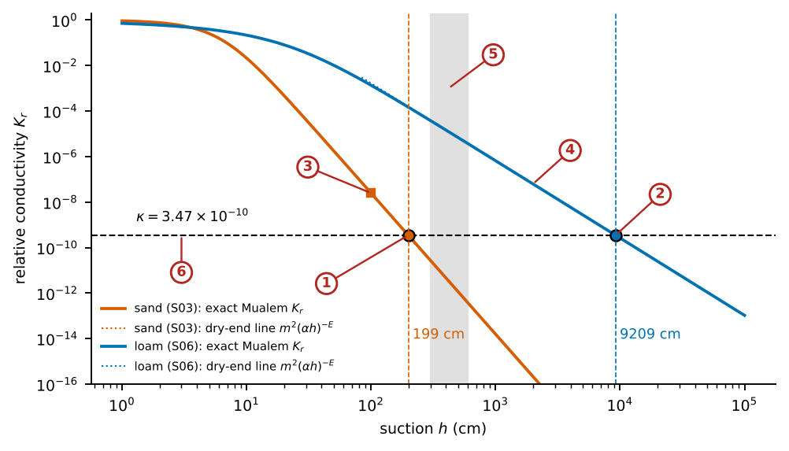
What the numbered labels point to, with the exact values.
- Sand: the exact curve crosses the dashed line $K_{r}=κ$ at $h_{c}=199$ cm (dot). This is [eq:s-hc] with $α=0.145$, $n=2.68$, $ℓ=0.5$.
- Loam: the crossing is at $h_{c}=9 209$ cm, just below ${10}^{4}$ cm, with $α=0.036$, $n=1.56$.
- Sand at field capacity (100 cm): $K_{r}=2.5×{10}^{−8}$, a fraction of the saturated conductivity that is already tiny; the worked example of Part 2 of the guide.
- Dotted lines: the dry-end straight line $m^{2}{\left(αh\right)}^{−E}$. It lies on the exact curve wherever $αh≫1$, which is why the closed form of the reach is accurate.
- Grey band (300–600 cm): the usual triggers. They lie beyond the reach of sand and well inside the reach of loam.
- The constant $κ$: the relative conductivity below which a crop can no longer dry the soil at the sensor within a season; one value for all ten soils.
How the exact points are obtained from the data. The curves are the Mualem conductivity computed from $α$ and $n$ of each soil (Table A1 of the article, Manuscripts/results/p4_tableA1_reach.csv). $κ$ is the fitted constant of p4_numbers.json (key kappa), obtained from experiment E2 as shown in the next graph. The two crossings are computed with [eq:s-hc]; the same numbers are in the workbook sheet EQ_P4_reach, cells of S03 and S06.

Exact points: how the single constant $κ$ is found
The loss counts, for every soil, how many decades the predicted reach lies outside the interval observed in the simulations (zero when inside), squared and summed. The constant is the value of $κ$ at the bottom of this curve.
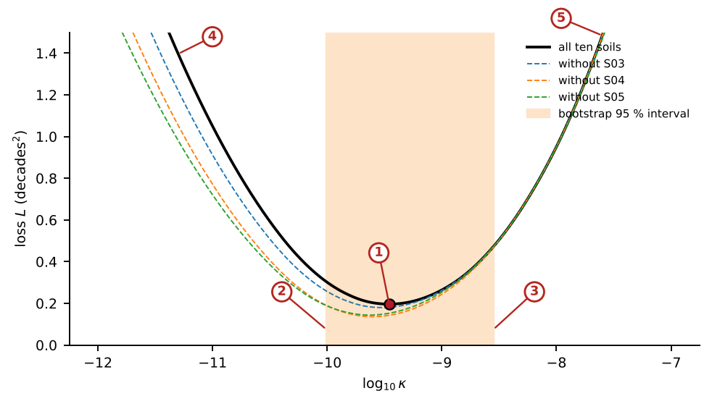
What the numbered labels point to, with the exact values.
- The minimum: $\log_{10}κ=−9.46$, $κ=3.47×{10}^{−10}$, loss $L=0.196$ decades$​^{2}$. At this value 5 soils lie outside their interval: S01 by 0.11 decade, S02 by 0.27 decade, S03 by 0.12 decade, S04 by 0.23 decade, S05 by 0.21 decade; the other 5 lie inside.
- Left edge of the bootstrap interval, $κ=9.8e−11$: resampling the ten soils with replacement 1 000 times and refitting.
- Right edge, $κ=2.8e−09$. The interval spans 1.5 decades, but the reach changes only by a factor 1.45 to 2.45 per decade of $κ$.
- Too small a $κ$ puts every predicted reach too far into the dry range: the soils with a finite interval (sand, loamy sand, sandy loam) are missed and the loss rises.
- Too large a $κ$ predicts reaches that are too short: soils whose triggers fire up to ${10}^{4}$ cm are missed.
How the exact points are obtained from the data. The observed intervals are the columns reach_observed_low_cm and reach_observed_high_cm of Table A1, from experiment E2 (next graph). The predicted reach for each trial $κ$ is [eq:s-hc]. The minimum was found with the Nelder–Mead method in p4_reach.py (function fitm); the bootstrap and the curves without one soil are in p4_numbers.json under constants. The flat bottom of the curve is why $κ$ is uncertain by a decade while the reaches are not: every reach depends on $κ$ only through the power $1/\left[2n+ℓ\left(n−1\right)\right]$.

The constant $κ$ of the reach: how it is determined
$κ$ is the relative conductivity $K_{r}=K/K_{s}$ at which the crop can no longer dry the soil at the sensor within a season. It is the only constant of [eq:s-hc]. It is not measured directly: it is found from the simulated triggers, in five steps.
Step 1: the experiment. Experiment E2 (197 valid runs) sets the trigger to 20 values from 50 to 10 000 cm on each of the ten soils. Everything else is fixed: the sensor at 20 cm, a dose of 2.4 mm per event, surface application, the crop file crops_conv_N100.dai (the cereal rotation of the ensemble under conventional tillage with 100 kg N ha$​^{−1}$), and 20 years of Taastrup weather (1980–1999).
Step 2: when does a trigger fire? A trigger is counted as firing on a soil if it brings at least 5 mm of irrigation a year (20-year mean).
Step 3: the observed reach of each soil. For each soil the reach lies between the driest trigger that still fires ($h_{lo}$) and the next drier one, which does not ($h_{hi}$); if even 10 000 cm fires, only $h_{lo}$ is known. Sand: 100–150 cm; loamy sand: 200–250 cm; sandy loam: 800–1 000 cm; loam and sandy clay loam: 5 000–10 000 cm; the five finer or coarse-loamy soils: above 10 000 cm.
Step 4: one $κ$ for all soils. For a trial $κ$, [eq:s-hc] gives a reach for every soil. Its distance to the observed interval is measured in decades (zero if inside, the distance to the nearer end if outside), squared and added over the ten soils.
Step 5: the best $κ$. The sum is minimised over $\log_{10}κ$ with the Nelder–Mead method. The minimum is at $κ=3.47×{10}^{−10}$.
Test | Result | What it means
Bootstrap over soils (1 000 resamples) | $κ$ between $1.0×{10}^{−10}$ and $2.8×{10}^{−9}$ (95 %) | $κ$ is known to about one decade
Leaving each soil out | $2.3×{10}^{−10}$ to $7.3×{10}^{−10}$ | no single soil decides $κ$
Firing threshold 1 or 2 mm | $2.7×{10}^{−10}$ | a stricter count changes $κ$ little
Firing threshold 5 mm (used) | $3.5×{10}^{−10}$
Firing threshold 10 mm | $7.3×{10}^{−10}$
Firing threshold 20 mm | $1.3×{10}^{−9}$
Firing threshold 40 mm | $2.5×{10}^{−9}$ | a looser count raises $κ$
(c)1; Because $h_{c}∝κ^{−1/E}$, a tenfold error in $κ$ changes the reach by the factor ${10}^{1/E}$: 1.45 in sand, 1.56 in loamy sand, 1.73 in sandy loam, 1.97 in loam and 2.45 in silty clay loam. The reach is least sensitive exactly in the coarse soils where it matters most (where it decides whether a 300 cm trigger works).
(c)2; Moving the firing threshold from 5 to 20 mm a year raises $κ$ about fourfold and shortens the reaches by a factor of 1.2 (sand) to 1.4 (silty clay loam); sand and loamy sand remain blind to a 300 cm trigger with any threshold tested.
Not the soil. One value fits ten soils from sand to silty clay loam within a factor of 2.3, and the soil enters only through $α$, $n$ and $ℓ$.
The crop: yes, in principle. $κ$ expresses when the roots can no longer extract water from the soil around the sensor. It depends on the root length density at the sensor depth, the potential transpiration of the crop and the lowest root water potential the crop can sustain. A crop with denser or deeper roots, or one that tolerates lower water potentials, can dry the soil further, which means a smaller $κ$ and a longer reach. All runs of E2 used one cereal rotation, so the size of this effect was not measured.
The climate: yes. A higher evaporative demand stresses the crop earlier; the weather was one series (Taastrup), so this was not measured either.
The sensor depth and the dose: yes. The sensor was at 20 cm, where the roots are dense; a deeper sensor sees fewer roots and dries less (in E3 a deeper sensor did not make sand irrigate at 300 cm). The dose was 2.4 mm.
In practice. $κ$ is a constant of the crop–climate–sensor system, not of the soil. For another crop or climate it is determined in the same way, with a trigger experiment of the kind of E2 on two or three soils, which the Daisy workbench of SWAFL Desktop can run.

Exact points: the observed reach in experiment E2
Experiment E2 runs the same crop rotation and weather with one suction trigger at a time. Each dot is one run: its trigger and the irrigation it brought per year.
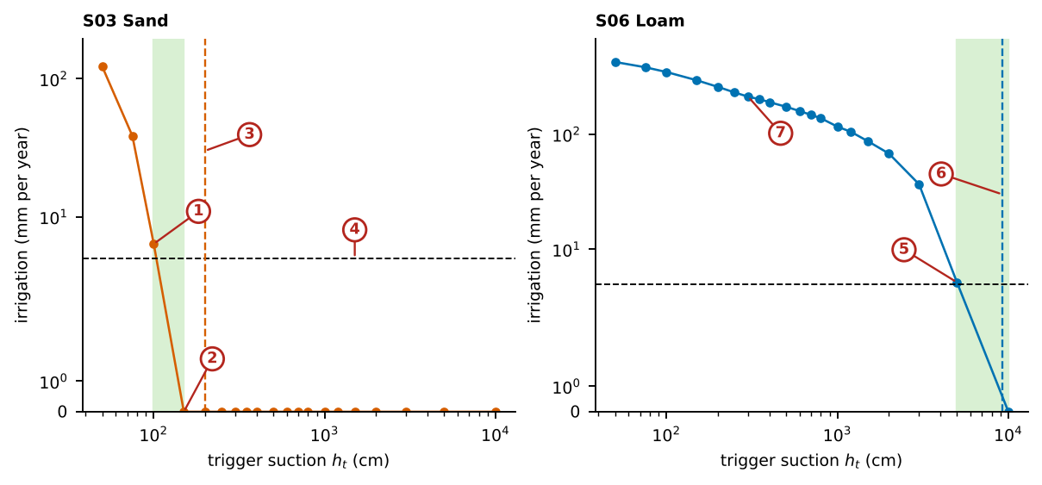
What the numbered labels point to, with the exact values.
- Sand, the driest trigger that still fires: 100 cm brings 6.36 mm a year, above the 5 mm line.
- Sand, the next trigger, 150 cm, brings 0.0 mm: it never fires. The observed reach lies between the two (green band, 100–150 cm).
- The reach predicted by the closed form, 199 cm (dashed): a third above the band, the largest miss among the soils with a finite interval.
- The 5 mm a year threshold that defines “fires; with 1, 10, 20 or 40 mm the fitted $κ$ becomes 2.7, 7.3, 13 or 25 $×{10}^{−10}$.
- Loam, the driest trigger that fires: 5000 cm brings 5.16 mm a year.
- Predicted reach of loam, 9 209 cm: inside the observed band 5 000–10 000 cm.
- Loam at the usual 300 cm trigger: 212 mm a year of irrigation, the trigger works.
How the exact points are obtained from the data. E2 is the experiment E2_TriggerPressure of Data/Comprehensive_Summary/00_summary_all_simulations.csv.gz: 10 soils $×$ 20 triggers (20 to 10 000 cm), sensor at 20 cm, dose 2.4 mm, crop file crops_conv_N100.dai, weather Taastrup 1980–1999. For each soil the script p4_reach.py takes the column set_trigger_potential_cm (sign changed) and irrigation_mm; the largest trigger with at least 5 mm a year is the lower end of the interval, the next larger trigger the upper end. These points are in p4_fig3_trigger_runs.csv.

Reading Figure 1 of the article
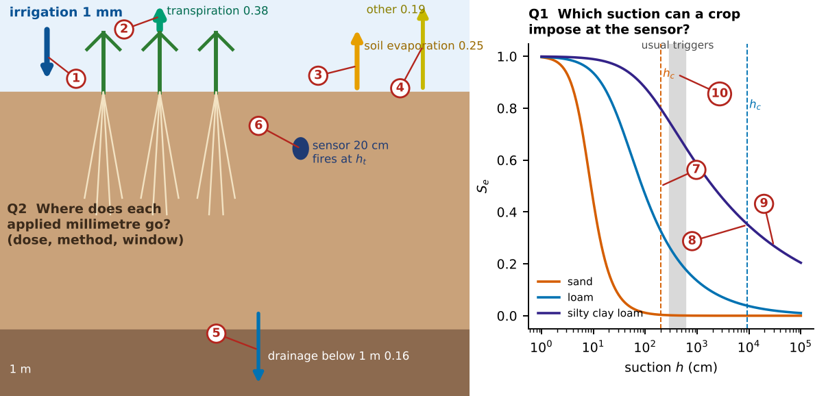
What the numbered labels point to.
- One millimetre of irrigation applied to the surface; the arrows that leave the column are its fates, with widths in proportion to their shares.
- Transpiration (0.38 of each millimetre): the only fate that makes yield.
- Soil evaporation (0.25): water evaporated from the wetted surface with the energy also available to the crop.
- Other evaporation (0.19): intercepted water, ponds and litter.
- Drainage below 1 m (0.16): water lost to the crop that also carries nitrate.
- The sensor at 20 cm: irrigation starts when the suction it reads exceeds the trigger.
- The reach of sand (199 cm, the dashed orange line): there its conductivity has collapsed; the usual triggers (grey band) lie beyond it and never fire.
- The reach of loam (9 209 cm, the dashed blue line just below ${10}^{4}$ cm): its gentler curve lets a crop dry it far further, so the usual triggers lie well inside its reach and fire.
- Silty clay loam: its reach (128 260 cm) lies beyond the right edge of the axis (${10}^{5}$ cm), so no dashed line is drawn; every usual trigger fires.
- Grey band: the triggers usually tabulated (300 to 600 cm).
What it shows. The two questions. Q1 (right): a trigger $h_{t}$ fires only if the crop can dry the soil at the sensor to $h_{t}$; the reach $h_{c}$ (dashed) is 199 cm in sand and $9×{10}^{3}$ cm in loam, so the usual triggers (grey) lie beyond the reach of sand. Q2 (left): the fate of an irrigation millimetre, averaged over the 744 irrigated runs of experiment E10 (arrow widths to scale).
How to read the labels, symbols and colours. Left: a soil column with three crops; the blue arrow is one millimetre of irrigation and the coloured arrows leaving the column are its fates, drawn with widths in proportion to their shares (green transpiration, orange soil evaporation, yellow other evaporation, blue drainage below 1 m). The dark dot is the sensor at 20 cm. Right: effective saturation $S_{e}$ against suction $h$ (log axis) for sand, loam and silty clay loam; the dashed vertical line of each colour is that soil’s reach $h_{c}$; the grey band is the range of triggers usually tabulated (300 to 600 cm).
What affects it, and why it happens. The sand curve falls to almost zero within a few tens of centimetres, so its conductivity collapses early and its reach (199 cm) lies to the left of the usual triggers: such a trigger is never read. In the loam the reach lies far to the right, so the same triggers work. The arrow widths show that less than half of an applied millimetre is transpired because the same energy also evaporates water from the soil and from intercepted or ponded water.
How it is made. Schematic drawn by the script with numbers from the results. Script: Manuscripts/reproducibility/analysis/p4_concept.py. Input: Data/Comprehensive_Summary/00_summary_all_simulations.csv.gz.

Reading Figure 2 of the article
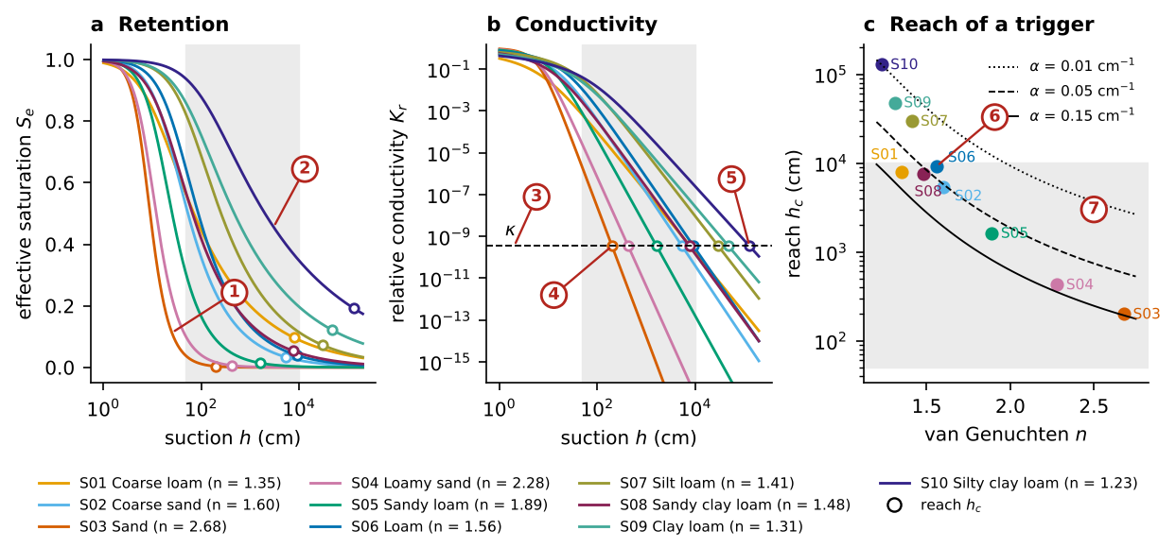
What the numbered labels point to.
- Sand: its retention curve drops almost to zero within a few tens of centimetres of suction, because its pores are nearly all the same size (large n = 2.68).
- Silty clay loam: the curve falls slowly over five decades of suction, because its pores span many sizes (small n = 1.23).
- The dashed line is the constant $κ=3.47×{10}^{−10}$: the relative conductivity at which a crop can no longer dry the soil at the sensor.
- The reach of sand (199 cm) is where its conductivity curve crosses $κ$; the steep curve crosses early.
- The reach of silty clay loam (128 260 cm): its gentle curve crosses $κ$ only far in the dry range.
- Each point is the reach of one soil from Eq. (4); the reach falls as n grows. The three lines are Eq. (4) for three values of $α$: a smaller $α$ gives a longer reach.
- Grey band: the range of triggers tested in the simulations (50 to 10 000 cm). Soils whose reach lies inside the band have a trigger beyond which irrigation stops.
What it shows. (a) Retention and (b) relative conductivity of the ten soils (Eq. (1) and Eq. (2) of the article); circles mark the reach of Eq. (4) of the article and the dashed line the fitted $κ=3.5×{10}^{−10}$; grey: the range of triggers tested. (c) Reach against $n$ for the ten soils, with Eq. (4) of the article for three values of $α$.
How to read the labels, symbols and colours. (a) $S_{e}$ against $h$ for the ten soils (colours in the legend, with each soil’s $n$). (b) Relative conductivity $K_{r}$ against $h$, both on log scales; the dashed line is $κ$. Open circles in (a) and (b) mark each soil’s reach. Grey shading: the range of triggers tested in the simulations (50 to 10 000 cm). (c) Reach against $n$ (log scale) for the ten soils (labelled points) and Eq. (4) of the article for three values of $α$ (dotted, dashed and solid lines).
What affects it, and why it happens. The reach is where each conductivity curve in (b) crosses the dashed line $κ$. Curves of large $n$ (sands) fall steeply and cross early; curves of small $n$ (silty clay loam) fall gently and cross late. In (c) the reach therefore falls with $n$, and for equal $n$ a smaller $α$ (soil that starts draining later) gives a longer reach, which is why the three lines are ordered.
How it is made. Figure drawn by the script from the input data. Script: Manuscripts/reproducibility/analysis/p4_reach.py. Input: Data/Comprehensive_Summary/00_summary_all_simulations.csv.gz.

Reading Figure 3 of the article
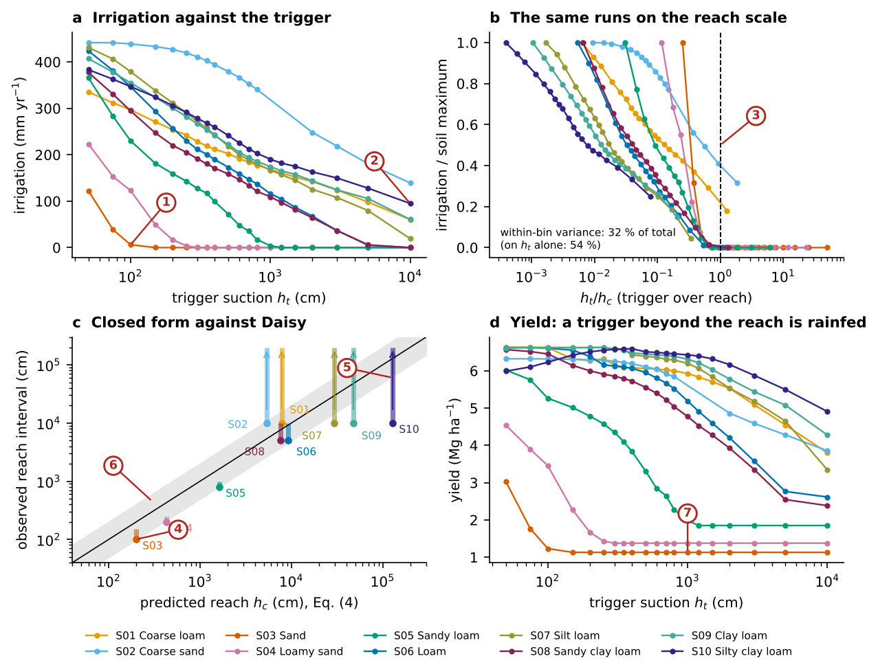
What the numbered labels point to.
- Sand: irrigation falls to zero at 100 to 150 cm. Every drier trigger, including the common 300 cm, is never reached.
- Silty clay loam still irrigates at 10 000 cm, because its conductivity fades slowly and the crop can keep drying the soil.
- The dashed line is the reach (trigger / reach = 1). On this scaled axis every soil stops irrigating between 0.5 and 1.
- Sand: the bar is the observed interval (100 to 150 cm) and the dot its lower end; the prediction of Eq. (4) (199 cm) lies within a factor of two.
- An arrow means that even the driest trigger tested (10 000 cm) still fired, so only a lower bound of the reach is known.
- Grey band: within a factor of two of the 1:1 line (black). Points in the band are predicted well.
- Sand beyond its reach: the yield stays at the rainfed value (1.13 Mg/ha) because the field is never irrigated.
What it shows. The reach of a suction trigger in experiment E2 (197 runs). (a) Irrigation against the trigger. (b) The same runs against the reach-scaled trigger $h_{t}/h_{c}$, irrigation divided by its soil maximum: every soil stops at $h_{t}/h_{c}≈0.5$ to 1. (c) Predicted reach (Eq. (4) of the article) against the observed interval (bars; arrows: only a lower bound); grey band: within a factor of 2. (d) Yield against the trigger: beyond the reach the crop is rainfed.
How to read the labels, symbols and colours. (a) Annual irrigation (mm) against the trigger suction (log axis), one line per soil. (b) The same irrigation divided by each soil’s maximum, against the trigger divided by the reach; the dashed line is $x=1$. (c) Predicted reach (Eq. (4) of the article) against the observed interval: bars span the interval, arrows mean only a lower bound is known, the black line is 1:1 and the grey band a factor of two. (d) Yield against the trigger.
What affects it, and why it happens. Irrigation falls as the trigger becomes drier and stops at a cliff whose position follows the soil’s conductivity (a). On the scaled axis every soil stops between 0.5 and 1 (b), because the reach captures where uptake stops. Points near the 1:1 line in (c) show the closed form places the cliffs within a factor of about two. In (d) yields stay at the rainfed value for triggers beyond the reach (sand, loamy sand), because the field is never irrigated.
How it is made. Figure drawn by the script from the input data. Script: Manuscripts/reproducibility/analysis/p4_reach.py. Input: Data/Comprehensive_Summary/00_summary_all_simulations.csv.gz.

Derivation: The van Genuchten–Mualem pair from a capillary bundle
A soil is idealised as a bundle of capillaries whose radii are distributed so that the water-filled fraction at suction $h$ is the effective saturation $S_{e}$. The capillary (Young–Laplace) law relates the radius $r$ of the largest filled pore to the suction, $r=2σcosγ/\left(ρ_{w}gh\right)$, so $h∝1/r$. Mualem (1976) wrote the relative conductivity of such a medium as the product of a tortuosity–connectivity term $S_{e}^{ℓ}$ and the square of a normalised integral of the pore radius over the filled pores:
$$K_{r}\left(S_{e}\right)=S_{e}^{ℓ}{\left[\frac{\int_{0}^{S_{e}}{h}{\left(x\right)}^{−1} dx}{\int_{0}^{1}{h}{\left(x\right)}^{−1} dx}\right]}^{2}.$$
van Genuchten (1980) chose the retention function $S_{e}={\left[1+{\left(αh\right)}^{n}\right]}^{−m}$, whose inverse is
$$h\left(x\right)=\frac{1}{α}(x^{−1/m}−1)^{1/n}.$$
Substituting [eq:s-inv] and $y=x^{1/m}$ ($x=y^{m}$, $dx=m y^{m−1}dy$):
$$\int_{0}^{S_{e}}{\frac{dx}{h\left(x\right)}}=αm\int_{0}^{S_{e}^{1/m}}{(}y^{−1}−1)^{−1/n}y^{m−1} dy=αm\int_{0}^{S_{e}^{1/m}}{y^{ m−1+1/n}}{\left(1−y\right)}^{−1/n} dy.$$
With the restriction $m=1−1/n$ the exponent of $y$ vanishes and ${\left(1−y\right)}^{−1/n}={\left(1−y\right)}^{m−1}$, so the integral is elementary:
$$\int_0^{S_e}\frac{\mathrm{d}x}{h(x)}=\alpha m\int_0^{S_e^{1/m}}(1-y)^{m-1}\mathrm{d}y=\alpha\Bigl[1-\bigl(1-S_e^{1/m}\bigr)^{m}\Bigr].$$
The denominator of [eq:s-mualem] is the same expression at $S_{e}=1$, that is $α$, and the closed form of the paper follows:
$$K_r(S_e)=S_e^{\ell}\Bigl[1-\bigl(1-S_e^{1/m}\bigr)^{m}\Bigr]^{2}. \label{eq:s-kr}$$
This is why the restriction $m=1−1/n$ is not a convenience: it is the condition under which the Mualem integral has a closed form.

Derivation: The dry-end asymptote of the conductivity
For $αh≫1$, ${\left(αh\right)}^{n}$ dominates the bracket of the retention function and
$$S_e=\bigl[1+(\alpha h)^n\bigr]^{-m}=(\alpha h)^{-mn}\bigl[1+(\alpha h)^{-n}\bigr]^{-m}=(\alpha h)^{-(n-1)}\Bigl[1-m(\alpha h)^{-n}+O\bigl((\alpha h)^{-2n}\bigr)\Bigr],$$
since $mn=n−1$. Write $u=S_{e}^{1/m}$, which is small. The binomial expansion ${\left(1−u\right)}^{m}=1−mu−{m\left(1−m\right)}/2u^{2}+O\left(u^{3}\right)$ gives
$$1-(1-u)^{m}=mu\Bigl[1+\tfrac{1-m}{2}u+O(u^2)\Bigr].$$
Inserting into [eq:s-kr],
$$K_r=m^{2}\,S_e^{\ell+2/m}\Bigl[1+(1-m)S_e^{1/m}+\dots\Bigr].$$
The exponent is $\left(ℓ+2/m\right)\left(n−1\right)=ℓ\left(n−1\right)+2n$, because $\left(n−1\right)/m=n$. Hence
$$K_r(h)=m^{2}(\alpha h)^{-[2n+\ell(n-1)]}\Bigl[1+\varepsilon(h)\Bigr],\qquad \varepsilon(h)=O\bigl((\alpha h)^{-n}\bigr)+O\bigl((\alpha h)^{-n}\bigr), \label{eq:s-asym}$$
where both correction terms are of the order ${\left(αh\right)}^{−n}$ (the first from the retention bracket, the second from $S_{e}^{1/m}={\left(αh\right)}^{−n}\left[1+…\right]$). For the soils of the paper the reach lies at $αh_{c}$ between 29 and 1 280, where ${\left(αh_{c}\right)}^{−n}$ is below ${10}^{−3}$: the asymptote is exact to better than one per mille at the reach.

Derivation: The reach of a trigger

The physical condition.
During a drying cycle the crop takes water from the layer that holds the sensor at a rate $u$ limited by the conductance of the soil between the bulk soil and the root surface (Gardner 1960). For a cylindrical root of radius $r_{0}$ in a soil cylinder of radius $r_{1}$, steady radial flow gives
$$u≃\frac{2πL_{v}}{ln\left(r_{1}/r_{0}\right)}\int_{h_{root}}^{h}{K}\left(h′\right) dh′ ≈ \frac{2πL_{v}}{ln\left(r_{1}/r_{0}\right)} K\left(h\right) Δh,$$
with $L_{v}$ the root length density and $Δh$ the head drop to the root. Because $K$ falls by many decades while $Δh$ is bounded by the plant (the wilting point), $u$ collapses once $K\left(h\right)$ is small enough, and the soil at the sensor stops drying within the time of a season. The suction where this happens is the reach $h_{c}$.

One constant for all soils.
If the reach is reached at one value $κ$ of the relative conductivity, $K_{r}\left(h_{c}\right)=κ$, [eq:s-asym] gives
$$\begin{gathered}m^{2}(\alpha h_{\mathrm{c}})^{-[2n+\ell(n-1)]}=\kappa\\ \Longrightarrow\quad \boxed{\;h_{\mathrm{c}}=\frac{1}{\alpha}\Bigl(\frac{m^{2}}{\kappa}\Bigr)^{1/[2n+\ell(n-1)]}\;}\end{gathered} \label{eq:s-hc}$$

Properties.
(i) $α$ only rescales the reach: $αh_{c}$ depends on $n$, $ℓ$ and $κ$ alone. (ii) The logarithmic sensitivity to $n$ is
$$\frac{∂ln\left(αh_{c}\right)}{∂n}=\frac{2}{m n^{2} \left[2n+ℓ\left(n−1\right)\right]}−\frac{\left(2+ℓ\right)ln\left(m^{2}/κ\right)}{{\left[2n+ℓ\left(n−1\right)\right]}^{2}},$$
whose second term dominates (with $κ=3.5×{10}^{−10}$, $ln\left(m^{2}/κ\right)≈18$ to 21), so the reach shortens steeply as $n$ grows: from $αh_{c}≈1 280$ at $n=1.23$ to $29$ at $n=2.68$. (iii) A larger $ℓ$ shortens the reach because the conductivity collapses faster. (iv) For $n→1$ the exponent tends to 2 and $m→0$, so the reach tends to $α^{−1}{\left(m^{2}/κ\right)}^{1/2}$, which vanishes slowly: very broad pore-size distributions are still reachable far into the dry range, as observed for the silty clay loam.

Derivation: The alternative laws

Fixed saturation.
If the reach were set by a water content, $S_{e}\left(h_{c}\right)=S_{c}$, inverting the retention function gives $h_{c}=α^{−1}{\left(S_{c}^{−1/m}−1\right)}^{1/n}$. It ignores the conductivity and predicts the coarse soils worst (Table 2 of the paper).

Power law in $n−1$.
$αh_{c}=A{\left(n−1\right)}^{−B}$ is an empirical two-parameter law; it fits slightly better but has no derivation.

Absolute conductivity.
$K\left(h_{c}\right)=K_{s}K_{r}\left(h_{c}\right)=q_{c}$ would give $h_{c}=α^{−1}{\left(m^{2}K_{s}/q_{c}\right)}^{1/\left[2n+ℓ\left(n−1\right)\right]}$. With literature $K_{s}$ the conductivity at the observed reaches spans more than three decades, so a single $q_{c}$ is rejected.

Derivation: Fitting interval-censored reaches
For each soil the data give an interval $[ h_{lo},h_{hi})$: $h_{lo}$ is the driest trigger that still brings at least 5 mm of irrigation a year and $h_{hi}$ the next drier trigger, or $+∞$ when even the driest trigger fires. The loss of a prediction $\hat{h}$ is the squared distance in decades to the interval,
$$L\left(\hat{h}\right)=\left\{\begin{matrix}{\left(\log_{10}h_{lo}−\log_{10}\hat{h}\right)}^{2}, & \hat{h}<h_{lo}, \\ 0, & h_{lo}≤\hat{h}≤h_{hi}, \\ {\left(\log_{10}\hat{h}−\log_{10}h_{hi}\right)}^{2}, & \hat{h}>h_{hi},\end{matrix}\right.$$
summed over soils and minimised over $\log_{10}κ$ (Nelder–Mead). Leave-one-soil-out validation refits $κ$ without the soil and evaluates $L$ on it; the reported error is $\sqrt{L}$ in decades and the worst factor is ${10}^{max\sqrt{L}}$.

Why it happens

Why a trigger has a reach.
The crop can only dry the soil at the sensor as fast as the soil delivers water to the roots. That delivery scales with the conductivity, which falls by many orders of magnitude as the soil dries. In a soil with a narrow pore-size distribution (large $n$, sands) the conductivity collapses within a narrow band of suction just past the air entry, so the crop stops drying the soil there; whatever trigger is set beyond that band is never read. In a soil with a broad distribution (small $n$, silty clay loams) the conductivity fades slowly over many decades of suction and the crop can still dry the soil at very high suctions.

Why a deeper sensor does not help.
Below the sensor depth of the experiments the root density is smaller, so the soil dries even less, and in sands the deeper soil is also wetted by drainage from above. A deeper sensor therefore reads lower suctions, not higher ones.

Why scaling by the reach collapses the curves only in part.
The reach sets where irrigation ends, because it is fixed by the conductivity. How irrigation fades before the reach depends on how often the soil reaches a given suction in a season, which depends on the water held between field capacity and that suction, a retention property that differs from the conductivity property that sets the reach.

The fate of an irrigation millimetre
Where each applied millimetre goes, computed from irrigated runs and their rainfed twins, by soil, method and season.

Contribution 4: the fate of an irrigation millimetre
Of every millimetre of water pumped onto a field, how much does the crop transpire, and where does the rest go? The answer must hold for many soils, doses, seasons and methods, not for one case.
Write the 20-year balance of an irrigated run and of its rainfed twin (same soil and weather), subtract them, and divide by the irrigation $I$ (Section 5.6).
How it is derived, line by line $$\begin{array}{@{}l@{}}\textbf{1. Balance of the irrigated run:}\\[1pt]
\qquad P+I=T+E_s+E_o+D+\Delta S+Q\\[1pt]
\textbf{2. Balance of the rainfed twin:}\\[1pt]
\qquad P=T_0+E_{s,0}+E_{o,0}+D_0+\Delta S_0+Q_0\\[1pt]
\textbf{3. Subtract 2 from 1 (}P\textbf{ cancels):}\\[1pt]
\qquad I=(T-T_0)+(E_s-E_{s,0})+(E_o-E_{o,0})\\ \qquad\quad+(D-D_0)+(\Delta S+Q-\Delta S_0-Q_0)\\[1pt]
\textbf{4. Divide by } I\textbf{:}\\[1pt]
\qquad 1=\eta_T+\eta_{E_s}+\eta_{E_o}+\eta_D+\eta_S
\end{array}$$ The result, with its parts marked
$$1=\underbrace{\eta_T}_{\tikz[baseline=(c.base)]\node[circle,draw=red!70!black,text=red!70!black,line width=0.6pt,inner sep=0.7pt,minimum size=1.15em,font=\scriptsize\bfseries\sffamily](c){1};\ 0.38}+\underbrace{\eta_{E_s}}_{\tikz[baseline=(c.base)]\node[circle,draw=red!70!black,text=red!70!black,line width=0.6pt,inner sep=0.7pt,minimum size=1.15em,font=\scriptsize\bfseries\sffamily](c){2};\ 0.25}+\underbrace{\eta_{E_o}}_{\tikz[baseline=(c.base)]\node[circle,draw=red!70!black,text=red!70!black,line width=0.6pt,inner sep=0.7pt,minimum size=1.15em,font=\scriptsize\bfseries\sffamily](c){3};\ 0.19}+\underbrace{\eta_D}_{\tikz[baseline=(c.base)]\node[circle,draw=red!70!black,text=red!70!black,line width=0.6pt,inner sep=0.7pt,minimum size=1.15em,font=\scriptsize\bfseries\sffamily](c){4};\ 0.16}+\underbrace{\eta_S}_{\tikz[baseline=(c.base)]\node[circle,draw=red!70!black,text=red!70!black,line width=0.6pt,inner sep=0.7pt,minimum size=1.15em,font=\scriptsize\bfseries\sffamily](c){5};\ 0.03},\qquad \eta_X=\frac{\sum(X-X_0)}{\sum I}$$
Soil | transpired | soil evap. | other evap. | drained
Sandy loam | 0.64 | 0.11 | 0.14 | 0.07
Loam | 0.41 | 0.22 | 0.17 | 0.15
Coarse loam | 0.38 | 0.32 | 0.19 | 0.08
Coarse sand | 0.23 | 0.19 | 0.26 | (c)6; 0.32
(c)1; Only 38 % of irrigation becomes transpiration, the only flux that makes yield. Transpiration is capped by the energy reaching the canopy and by its cover.
(c)2; A quarter evaporates from the wetted soil surface: water applied to bare or partly covered soil uses the same energy as transpiration.
(c)3; Another fifth evaporates from ponded water, litter and intercepted water, the term usually left out of irrigation accounts.
(c)4; Sixteen per cent drains below 1 m and is lost to the crop (and carries nitrate).
(c)5; The small remainder changes storage or runs off; it closes the balance and is a check of the calculation.
(c)6; In coarse sand drainage is the largest single loss: the soil passes extra water on before the crop can use it.

Contribution 6: overhead irrigation adds no transpiration
The identity of Contribution 4 was applied to the method experiments: E4 (surface, overhead and subsurface on every soil) and E15 (the three methods on coarse loam over all rates, doses and rooting depths), each run against its rainfed twin.
How it is derived, line by line $$\begin{array}{@{}l@{}}\textbf{1. Identity of Contribution 4 for overhead runs:}\\[1pt]
\qquad \eta_T=\textstyle\sum(T-T_0)/\sum I\\[1pt]
\textbf{2. Data of E4 (all soils):}\\[1pt]
\qquad \textstyle\sum(T-T_0)<0\\[1pt]
\textbf{3. Hence:}\\[1pt]
\qquad \eta_T^{\text{overhead}}=-0.08
\end{array}$$ The result, with its parts marked
$$\underbrace{\eta_T^{\text{overhead}}}_{\tikz[baseline=(c.base)]\node[circle,draw=red!70!black,text=red!70!black,line width=0.6pt,inner sep=0.7pt,minimum size=1.15em,font=\scriptsize\bfseries\sffamily](c){1};}=-0.08\ \text{(all soils)}$$
$$\underbrace{\eta_{E_o}^{\text{overhead}}}_{\tikz[baseline=(c.base)]\node[circle,draw=red!70!black,text=red!70!black,line width=0.6pt,inner sep=0.7pt,minimum size=1.15em,font=\scriptsize\bfseries\sffamily](c){2};}=0.79$$
(c)1; A negative marginal transpiration: the crop transpires slightly less with overhead irrigation than without.
(c)2; Most of the water is intercepted by the canopy and evaporates with the energy that would have driven transpiration; interception replaces transpiration instead of adding to it. Subsurface application avoids this (0.51 transpired) but drains more (0.23).

Worked numbers, part 7: where an irrigation millimetre goes
Compare an irrigated run with the same soil and weather without irrigation (the rainfed baseline). The differences in each water flux, divided by the irrigation, tell what each millimetre became. Example: one run on coarse loam (dose 10 mm, April to October). Irrigation $I=222.5$ mm a year. Transpiration rose from 147.6 to 223.0 mm, $+75.4$ mm, so $η_{T}=75.4/222.5=0.34$. Drainage rose from 6.1 to 39.5 mm, so $η_{D}=33.4/222.5=0.15$. Soil evaporation rose from 146.4 to 228.8 mm, so $η_{E_{s}}=0.37$. Other evaporation (ET minus transpiration minus soil evaporation) rose from 172.8 to 193.3 mm, so $η_{E_{o}}=0.09$. The four add to 0.95; the remaining 0.05 went to storage and runoff. Pooling the 100 irrigated runs of that soil. Add all transpiration (21 328 mm), subtract 100 times the rainfed value ($100×147.6=14 762$), and divide by all irrigation (17 277 mm): $η_{T}=6 567/17 277=0.38$. The sheet EQ_P4_fate does exactly this with SUMIFS for every soil.

Exact points: the fate of the irrigation of one run
The worked example of the guide (coarse loam, dose 10 mm, April to October) drawn as one bar. Each segment is the difference between a flux of the irrigated run and the same flux of the rainfed run of the same soil and weather.
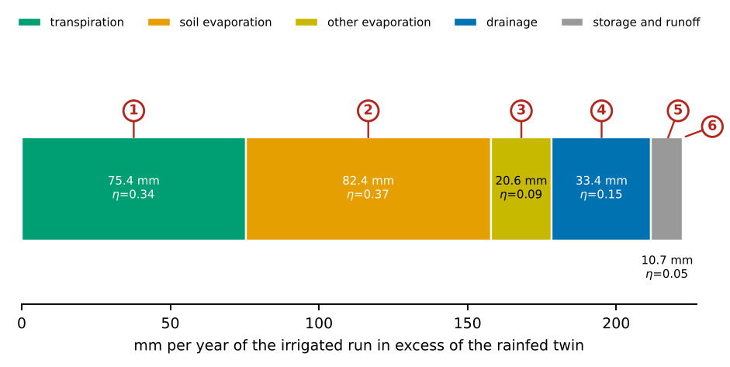
What the numbered labels point to, with the exact values.
- Transpiration: 223.0 $−$ 147.6 = 75.4 mm; $η_{T}=75.4/222.5=0.34$.
- Soil evaporation: 82.4 mm more than the rainfed twin; $η_{E_{s}}=0.37$, the largest share in this run because the surface is wetted every few days.
- Other evaporation (interception, ponds, litter): 20.6 mm; $η_{E_{o}}=0.09$.
- Drainage below 1 m: 39.5 $−$ 6.1 = 33.4 mm; $η_{D}=0.15$.
- The rest, 10.7 mm, is the change of storage and runoff, obtained by difference so that the shares add to one.
- The whole bar is the irrigation of the run, $I=222.5$ mm a year: one bar is one irrigated millimetre scaled up.
How the exact points are obtained from the data. The irrigated run is in experiment E10 and its rainfed twin in E0 (baseline of the same soil) of 00_summary_all_simulations.csv.gz; the columns used are irrigation_mm, transpiration_mm, soil_evap_mm, ET_mm (other evaporation $=$ ET $−$ transpiration $−$ soil evaporation) and drainage_1m_mm; storage and runoff are $I−ΔET−ΔD$. The article pools all irrigated runs of E10 of a soil (irrigation above 20 mm a year) before dividing; the workbook sheet EQ_P4_fate repeats the pooled calculation with SUMIFS formulas.

Reading Figure 4 of the article
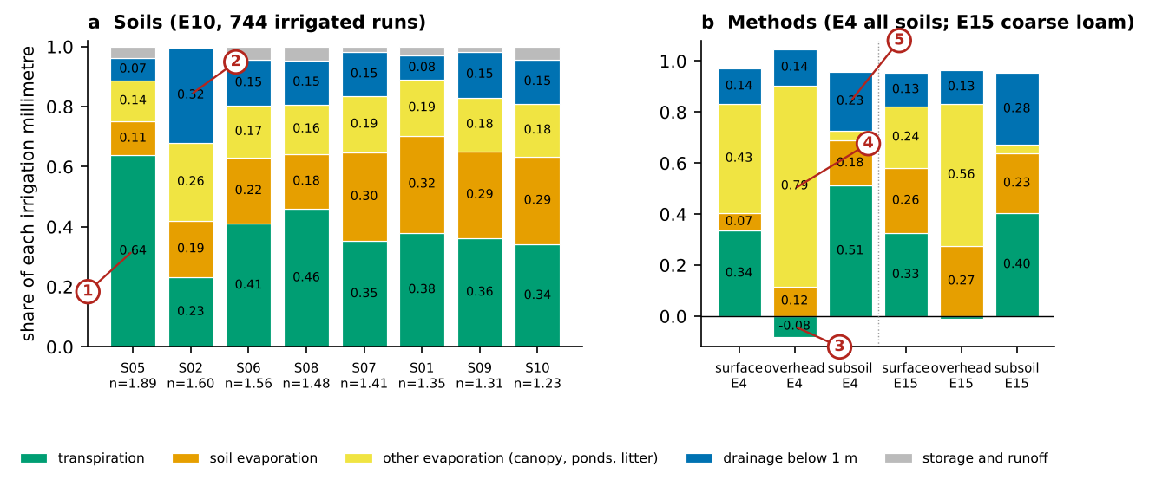
What the numbered labels point to.
- Sandy loam transpires the largest share of each irrigation millimetre (0.64): it holds the water near the roots and loses little to the surface.
- Coarse sand: drainage below 1 m is the largest single loss (0.32), because the soil passes extra water on before the crop can use it.
- Overhead irrigation: the transpired share is negative (-0.08). Water intercepted by the canopy evaporates with the energy that would have driven transpiration.
- Most of the overhead water (0.79) leaves as other evaporation: canopy interception, ponds and litter.
- Subsurface application transpires most (0.51) but also drains most (0.23), because it wets the profile from within.
What it shows. The fate of an irrigation millimetre, Eq. (5) of the article. (a) By soil (E10, 744 irrigated runs; sand and loamy sand are never irrigated at the 300 cm trigger of E10), ordered by $n$. (b) By method, on all soils (E4) and on coarse loam over all rates, doses and rooting depths (E15).
How to read the labels, symbols and colours. Stacked bars of the shares of each irrigation millimetre: green transpiration, orange soil evaporation, yellow other evaporation (canopy, ponds, litter), blue drainage below 1 m, grey storage and runoff; numbers inside the bars are the shares. (a) By soil, ordered by $n$ (label under each bar). (b) By method, on all soils (E4) and on coarse loam (E15); bars below zero are negative shares.
What affects it, and why it happens. Transpiration is limited by the energy reaching the canopy and by cover, so it takes less than half of the water. Coarse sand passes water on quickly, so drainage is its largest loss. Overhead irrigation wets the canopy; the intercepted water evaporates with the energy that would have driven transpiration, so the transpiration share is negative. Subsurface application avoids interception but wets the profile from within and drains more.
How it is made. Figure drawn by the script from the input data. Script: Manuscripts/reproducibility/analysis/p4_reach.py. Input: Data/Comprehensive_Summary/00_summary_all_simulations.csv.gz.

Derivation: The marginal fate of irrigation
For a run with irrigation $I$ and its rainfed twin (same soil, weather and crop), the 20-year water balances are
$$P+I=T+E_{s}+E_{o}+D+ΔS+Q, P=T_{0}+E_{s,0}+E_{o,0}+D_{0}+ΔS_{0}+Q_{0}.$$
Subtracting and dividing by $I$ gives the identity of the paper,
$$1=\underset{η_{T}}{\underset{⏟}{\frac{T−T_{0}}{I}}}+\underset{η_{E_{s}}}{\underset{⏟}{\frac{E_{s}−E_{s,0}}{I}}}+\underset{η_{E_{o}}}{\underset{⏟}{\frac{E_{o}−E_{o,0}}{I}}}+\underset{η_{D}}{\underset{⏟}{\frac{D−D_{0}}{I}}}+\underset{η_{S}}{\underset{⏟}{\frac{ΔS−ΔS_{0}+Q−Q_{0}}{I}}}.$$
The shares are marginal, not average: a share can be negative (overhead irrigation lowers transpiration) or exceed the average loss fraction. Pooling a group of runs uses the ratio of sums, $η_{X}=∑\left(X−X_{0}\right)/∑I$, which weights each run by its irrigation and is therefore the share of the group’s total irrigation.

Why it happens

Why less than half of an irrigation millimetre is transpired.
Transpiration is limited by the energy available to the canopy and by the canopy cover. Water applied to a wet surface or to a canopy that does not cover the ground evaporates from the soil, from the ponded surface and from intercepted water, using the same energy; water applied beyond the storage of the root zone drains.

Why overhead irrigation adds no transpiration.
Water intercepted by the canopy evaporates with the energy that would otherwise drive transpiration, so the canopy transpires less while it is wet. The intercepted evaporation replaces transpiration rather than adding to it, and the marginal transpiration is nil or slightly negative.

Why early-season irrigation is more productive.
Early in the season the canopy is growing and its demand rises, so applied water is transpired; late in the season the cereal ripens and is harvested, and the same water is evaporated from bare soil or drains.

The dose law
How the share of a dose that drains grows with the size of the dose, and why the dose scale is nearly the same in every soil.

Contribution 5: the dose law
Small and frequent doses are recommended to reduce deep percolation. How small is small, and does the answer depend on the soil?
For each soil the drained share was computed at ten doses (1 to 30 mm). A form was sought that is zero for a vanishing dose and levels off for a large one; the simplest is the saturating exponential, fitted per soil ($R^{2}$ 0.92 to 0.96 on seven soils).
How it is derived, line by line $$\begin{array}{@{}l@{}}\textbf{1. A vanishing dose cannot drain:}\\[1pt]
\qquad \eta_D(0)=0\\[1pt]
\textbf{2. A large dose drains a soil-specific share:}\\[1pt]
\qquad \eta_D(\infty)=\eta_\infty\\[1pt]
\textbf{3. The extra share drained per extra mm falls in proportion to what is left:}\\[1pt]
\qquad \frac{\mathrm{d}\eta_D}{\mathrm{d}d}=\frac{\eta_\infty-\eta_D}{d_D}\\[1pt]
\textbf{4. Integrate with 1:}\\[1pt]
\qquad \eta_D(d)=\eta_\infty\bigl(1-e^{-d/d_D}\bigr)
\end{array}$$ The result, with its parts marked
$$\eta_D(d)=\underbrace{\eta_\infty}_{\tikz[baseline=(c.base)]\node[circle,draw=red!70!black,text=red!70!black,line width=0.6pt,inner sep=0.7pt,minimum size=1.15em,font=\scriptsize\bfseries\sffamily](c){1};}\Bigl(1-e^{-d/\underbrace{d_D}_{\tikz[baseline=(c.base)]\node[circle,draw=red!70!black,text=red!70!black,line width=0.6pt,inner sep=0.7pt,minimum size=1.15em,font=\scriptsize\bfseries\sffamily](c){2};}}\Bigr)$$
$$\underbrace{\eta_D\approx\eta_\infty\,d/d_D\ \ (d\ll d_D)}_{\tikz[baseline=(c.base)]\node[circle,draw=red!70!black,text=red!70!black,line width=0.6pt,inner sep=0.7pt,minimum size=1.15em,font=\scriptsize\bfseries\sffamily](c){3};}$$
$$\underbrace{d_D=4.1\pm0.6\text{ mm},\ \rho(d_D,n)=0.07}_{\tikz[baseline=(c.base)]\node[circle,draw=red!70!black,text=red!70!black,line width=0.6pt,inner sep=0.7pt,minimum size=1.15em,font=\scriptsize\bfseries\sffamily](c){4};}$$
(c)1; The plateau: the share of a large dose that drains. It differs between soils (0.10 to 0.20, and 0.45 in coarse sand) because it is the outcome of a race between drainage and uptake, which the soil’s conductivity decides.
(c)2; The dose scale: the dose at which 63 % of the plateau is reached. It is about 4 mm in every soil.
(c)3; For small doses the drained share grows in proportion to the dose: a dose much smaller than $d_{D}$ hardly drains, but in exchange most of it evaporates (60 to 72 % at 1 mm).
(c)4; $d_{D}$ is not related to $n$ or to any soil property: it is set by the atmosphere and the crop. Four millimetres is about one day of crop water use, so a dose below one day’s use is consumed before it can move below the roots.

Worked numbers, part 8: the dose law
A small dose is used by the crop and the surface on the same day and cannot reach the deep soil; a large dose can. The share that drains therefore starts near zero and grows towards a ceiling $η_{∞}$:
$$η_{D}\left(d\right)=η_{∞}\left(1−e^{−d/d_{D}}\right).$$
Example (loam, $η_{∞}=0.197$, $d_{D}=3.9$ mm). For a 1 mm dose: $1/3.9=0.26$, $e^{−0.26}=0.77$, $1−0.77=0.23$, times 0.197 gives 0.045. For 10 mm: $e^{−2.6}=0.074$, so $0.197×0.926=0.18$. For 30 mm: almost the ceiling, 0.197. The dose scale $d_{D}$ was about 4 mm on every soil, close to one day of crop water use; the ceiling differs between soils (0.10 to 0.45).

Exact points: the dose law of loam
The worked example of Part 8 of the guide on its curve: the share of each irrigation millimetre that drains, against the dose applied at each event.
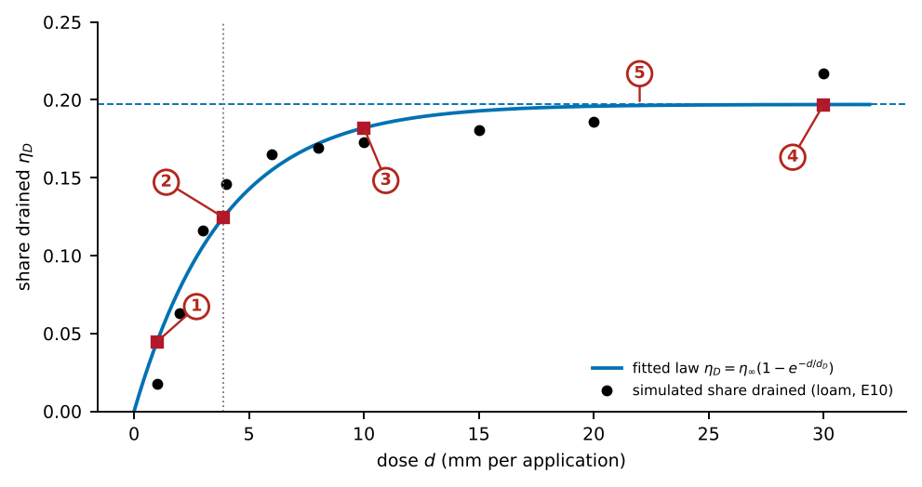
What the numbered labels point to, with the exact values.
- $d=1$ mm: $1−e^{−1/3.9}=0.23$; $η_{D}=0.045$. A small dose is used the same day and almost nothing drains.
- $d=d_{D}=3.9$ mm: by definition $η_{D}=η_{∞}\left(1−e^{−1}\right)=0.63 η_{∞}=0.125$.
- $d=10$ mm: $η_{D}=0.182$, already 92 % of the plateau.
- $d=30$ mm: $η_{D}=0.197$, practically the plateau.
- The plateau $η_{∞}=0.197$ of loam: the share of a large dose that drains, set by the race between drainage and uptake.
How the exact points are obtained from the data. The black dots come from experiment E10 (E10_Amount_Timing_Soil): the irrigated runs of loam are grouped by the dose per event (column set_dose_mm_per_event, 1 to 30 mm, all irrigation windows pooled), and for each dose the summed extra drainage over the rainfed twin (E0) is divided by the summed irrigation. They are stored in p4_fig5_dose.csv. The curve is the least-squares fit of the two parameters $η_{∞}$ and $d_{D}$ (scipy.optimize.curve_fit in p4_reach.py); the fitted values and their standard errors are in p4_numbers.json under constants.dose_fit. The workbook sheet EQ_P4_dose evaluates the law at any dose.

Reading Figure 5 of the article
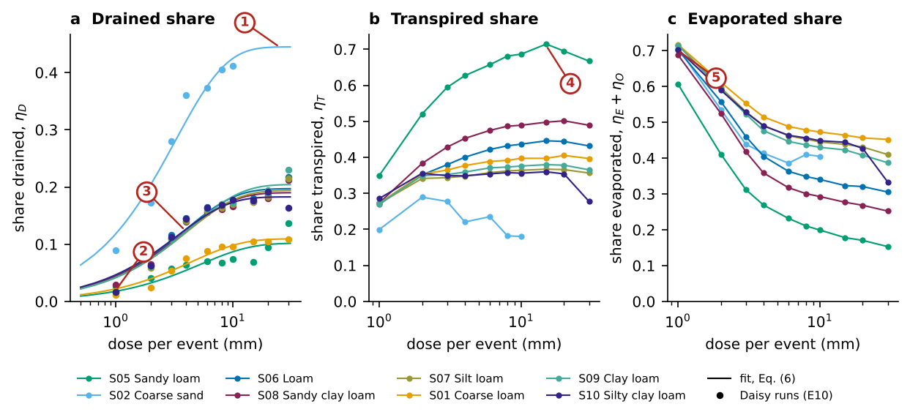
What the numbered labels point to.
- Plateau of coarse sand (0.45): the share of a large dose that drains. It is set by the soil, which passes water on fast.
- Doses of 1 to 2 mm hardly drain (0.01 to 0.09): they are used near the surface on the day they are applied.
- The dose scale $d_{D}$ (about 4 mm in every soil): at d = $d_{D}$ the drained share reaches 63 % of its plateau. It is about one day of crop water use.
- The transpired share rises with the dose and peaks at 15 to 20 mm, because less of a larger dose is lost from the wet surface.
- At 1 mm, 60 to 72 % of the dose evaporates: small doses trade drainage for evaporation.
What it shows. The dose (E10, all ten windows pooled). (a) Drained share with Eq. (6) of the article per soil. (b) Transpired share. (c) Evaporated share (soil and other evaporation).
How to read the labels, symbols and colours. Horizontal axes: dose per event (mm, log scale). (a) Drained share $η_{D}$: points are the Daisy runs (E10, pooled over windows), lines the fit of Eq. (6) of the article. (b) Transpired share. (c) Evaporated share (soil plus other evaporation). Colours: soils, named in the legend.
What affects it, and why it happens. A dose smaller than one day of crop water use is consumed near the surface before it can drain, so $η_{D}$ is near zero at 1 to 2 mm and the evaporated share is large. As the dose grows, more water reaches below the roots and the drained share rises to a plateau set by how fast the soil drains (highest in coarse sand). The transpired share rises with the dose because less of the water is lost from the surface.
How it is made. Figure drawn by the script from the input data. Script: Manuscripts/reproducibility/analysis/p4_reach.py. Input: Data/Comprehensive_Summary/00_summary_all_simulations.csv.gz.

Derivation: The dose law
Let a dose $d$ be applied when the root zone has a deficit. Part of the dose is used by the crop and the surface before it can move below the roots; the rest can drain. If the water that can be used before redistribution grows with the dose and saturates, and the drained share of the remainder is a soil property $η_{∞}$, the simplest form with the right limits is
$$η_{D}\left(d\right)=η_{∞}\left(1−e^{−d/d_{D}}\right), η_{D}→η_{∞}\frac{d}{d_{D}} \left(d≪d_{D}\right), η_{D}→η_{∞} \left(d≫d_{D}\right).$$
The small-dose limit is linear because a vanishing dose cannot drain; the large-dose limit is the share of any extra water that the soil passes on. The dose scale $d_{D}$ is the dose at which $1−e^{−1}=63 \%$ of the plateau is reached. The form is phenomenological: it was chosen for its limits and tested against the data (coefficient of determination 0.92 to 0.96 on seven soils), not derived from the Richards equation.

Why it happens

Why the dose scale does not depend on the soil.
The water that a dose can lose to drainage is the part that the crop and the surface do not use before it redistributes below the roots. The crop uses about one day of evapotranspiration in that time whatever the soil, so the dose scale is set by the atmosphere and the crop and not by the soil.

Why the plateau depends on the soil.
Once a dose is large, the share that drains is the share of the excess that the soil passes on before the crop uses it, a race between drainage and uptake. Coarse sand passes water fast (high conductivity at field capacity), fine soils hold it, so the plateau is highest in coarse sand.

When the lag of a sensor matters
The non-equilibrium criterion for a suction trigger.

Contribution 7: when a sensor’s lag matters
The relaxation law of Ross and Smettem (2000) was solved for a steady drying rate $r$: the water content lags by $rτ$; dividing by the water capacity $C\left(h\right)$ turns this into a suction error; comparing the lag with the interval between irrigations gives the dimensionless number (Section 7.3).
How it is derived, line by line $$\begin{array}{@{}l@{}}\textbf{1. Relaxation toward equilibrium:}\\[1pt]
\qquad \partial_t\theta=(\theta_{\mathrm{eq}}-\theta)/\tau\\[1pt]
\textbf{2. Steady drying } \partial_t\theta_{\mathrm{eq}}=-r\textbf{:}\\[1pt]
\qquad \theta=\theta_{\mathrm{eq}}+r\tau\\[1pt]
\textbf{3. Convert the water-content lag to suction:}\\[1pt]
\qquad \delta h=r\tau/C(h)\\[1pt]
\textbf{4. Compare the lag with the interval:}\\[1pt]
\qquad \Pi_\tau=\tau/t_i
\end{array}$$ The result, with its parts marked
$$\underbrace{\Pi_\tau}_{\tikz[baseline=(c.base)]\node[circle,draw=red!70!black,text=red!70!black,line width=0.6pt,inner sep=0.7pt,minimum size=1.15em,font=\scriptsize\bfseries\sffamily](c){1};}=\frac{\underbrace{\tau}_{\tikz[baseline=(c.base)]\node[circle,draw=red!70!black,text=red!70!black,line width=0.6pt,inner sep=0.7pt,minimum size=1.15em,font=\scriptsize\bfseries\sffamily](c){2};}}{\underbrace{t_i}_{\tikz[baseline=(c.base)]\node[circle,draw=red!70!black,text=red!70!black,line width=0.6pt,inner sep=0.7pt,minimum size=1.15em,font=\scriptsize\bfseries\sffamily](c){3};}},\qquad \delta h\simeq\frac{r\tau}{\underbrace{C(h)}_{\tikz[baseline=(c.base)]\node[circle,draw=red!70!black,text=red!70!black,line width=0.6pt,inner sep=0.7pt,minimum size=1.15em,font=\scriptsize\bfseries\sffamily](c){4};}}$$
(c)1; A dimensionless number: if it is much smaller than one, the equilibrium reach of Contribution 1 holds.
(c)2; The relaxation time of the water content towards the retention curve (minutes to hours).
(c)3; The interval between irrigations. Daily scheduling gives $Π_{τ}≈0.02$; pulses every half hour give $Π_{τ}≈2$.
(c)4; The water capacity $C=−dθ/dh$. It is smallest on the steep dry limb of a sand, so the same lag gives the largest error exactly where the reach is shortest. This criterion is proposed, not tested: Daisy solves equilibrium flow.

Worked numbers, part 9: when the sensor’s lag matters
In fast wetting and drying the water content can lag behind the value of the retention curve by a time $τ$. If the schedule irrigates every $t_{i}$ days, the lag matters only when $Π_{τ}=τ/t_{i}$ is not small. Example: $τ=1$ h and irrigation every 2 days gives $Π_{τ}=1/48=0.02$, negligible; pulses every 30 min give $Π_{τ}=2$, important.

Derivation: Dynamic non-equilibrium and the lag of a sensor
In the effective approach of Ross and Smettem (2000) and Diamantopoulos, Iden, and Durner (2012) the water content relaxes towards the equilibrium content of the retention curve with a time constant $τ$:
$$\frac{∂θ}{∂t}=\frac{θ_{eq}\left(h\right)−θ}{τ}.$$
During a drying phase in which $θ_{eq}$ falls at a steady rate $r=−dθ_{eq}/dt$, the solution after the transient is $θ=θ_{eq}+rτ$, so the soil is wetter than equilibrium by $rτ$, and a sensor that infers suction from the equilibrium curve under-reads the suction by
$$δh≃\frac{rτ}{C\left(h\right)}, C\left(h\right)=−\frac{dθ_{eq}}{dh}.$$
Over a schedule interval $t_{i}$ the drying is $rt_{i}$, so the relative error in the time of firing is of order $Π_{τ}=τ/t_{i}$, the criterion of the paper. Where $C\left(h\right)$ is small (the steep dry limb of a sand), $δh$ is large for the same $rτ$, so non-equilibrium matters most where the reach is shortest.

The trigger law in the software
The screens of the software that apply the results, with the equations behind every number shown.

Reading Figure 6 of the article
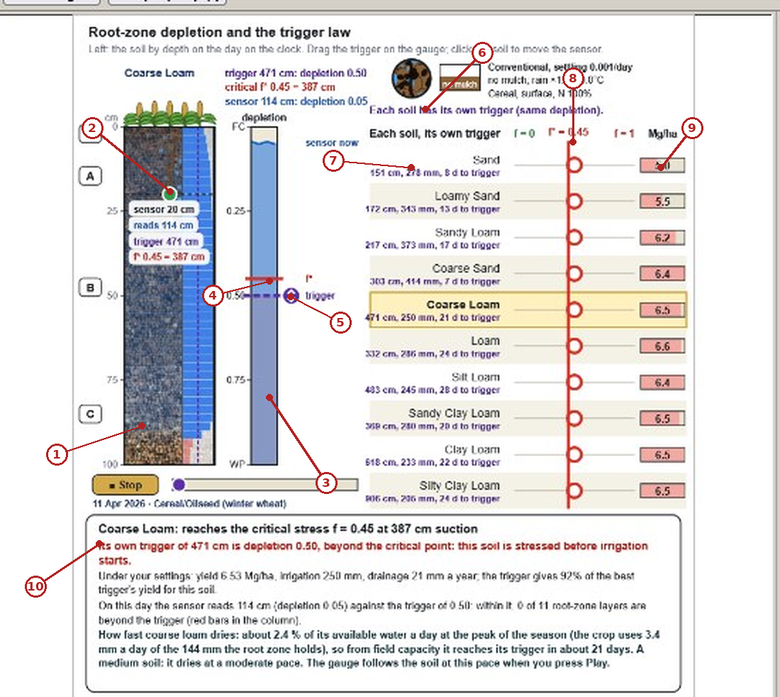
What the numbered labels point to (picture 1 of 3: Trigger law layer: depletion, sensor and the trigger of every soil.).
- The soil column of the chosen soil (coarse loam) from 0 to 100 cm, coloured by its water content on the day shown; the roots are drawn to their depth.
- The sensor at 20 cm (green dot). Its box reads the suction of the day (114 cm), the trigger (471 cm) and the critical suction $h^{*}$ of $f^{*}=0.45$ (387 cm) for this soil.
- The depletion gauge: $f=0$ at field capacity (FC, top) to $f=1$ at the wilting point (WP, bottom). The blue fill is the water left on the day.
- The red line $f^{*}$: the depletion beyond which the simulated yield falls by more than 5 %; the same 0.45 for every soil.
- The trigger (purple dot) at depletion 0.50. Dragging it moves the trigger; it sits below the red line, so this setting stresses the crop before irrigating.
- Header of the right panel: each soil gets its own trigger for the same depletion, because the same depletion is reached at a different suction in every soil.
- One soil row (sand): the suction at which this soil reaches the same depletion, the simulated irrigation of a year with that trigger and the days from field capacity to the trigger, “151 cm, 278 mm, 8 d to trigger”.
- The red column $f^{*}=0.45$; the circle on each row marks where the trigger of the left panel lies on that soil’s depletion scale.
- Yield boxes (Mg/ha): the simulated yield with that soil’s trigger. Equal yields across soils are the point of soil-specific triggers.
- The diagnosis in words: the trigger, the critical point, the season totals and how fast the soil dries (2.4 % of its available water a day; trigger reached in about 21 days).
Equations behind this screen. The numbers on the screen are computed as follows.
- Depletion of a soil at suction $h$ (0 at field capacity, 1 at the wilting point): $f\left(h\right)=\frac{S_{e}\left(100\right)−S_{e}\left(h\right)}{S_{e}\left(100\right)−S_{e}\left(15 849\right)}$, with $S_{e}\left(h\right)={\left[1+{\left(αh\right)}^{n}\right]}^{−\left(1−1/n\right)}$; 100 cm is field capacity and 15 849 cm ($pF=4.2$) the wilting point.
- Critical suction of a soil for the common depletion $f^{*}=0.45$: $S_{e}^{*}=S_{e}\left(100\right)−f^{*}\left[S_{e}\left(100\right)−S_{e}\left(15 849\right)\right]$, then $h^{*}=α^{−1}[{\left(S_{e}^{*}\right)}^{−1/m}−1]^{1/n}$, $m=1−1/n$. For coarse loam this gives 387 cm, the number in the sensor box.
- The trigger of a soil for depletion $f_{t}$ is found the same way with $f_{t}$ in place of $f^{*}$ (471 cm for $f_{t}=0.50$); the program solves $f\left(h\right)=f_{t}$ by bisection on $\log_{10}h$.
- Readily available water: $RAW=f_{t}⋅TAW$, with $TAW$ the available water of the root zone (144 mm here).
- Days from field capacity to the trigger: $t=f_{t} TAW/ET_{c}$; for coarse loam $0.50×144/3.4≈21$ days, as written in the diagnosis.
- The reach of the article decides whether the trigger can ever be read: if $h_{t}>h_{c}$ ([eq:s-hc]) the crop cannot dry the soil to the trigger and the trigger is blind.
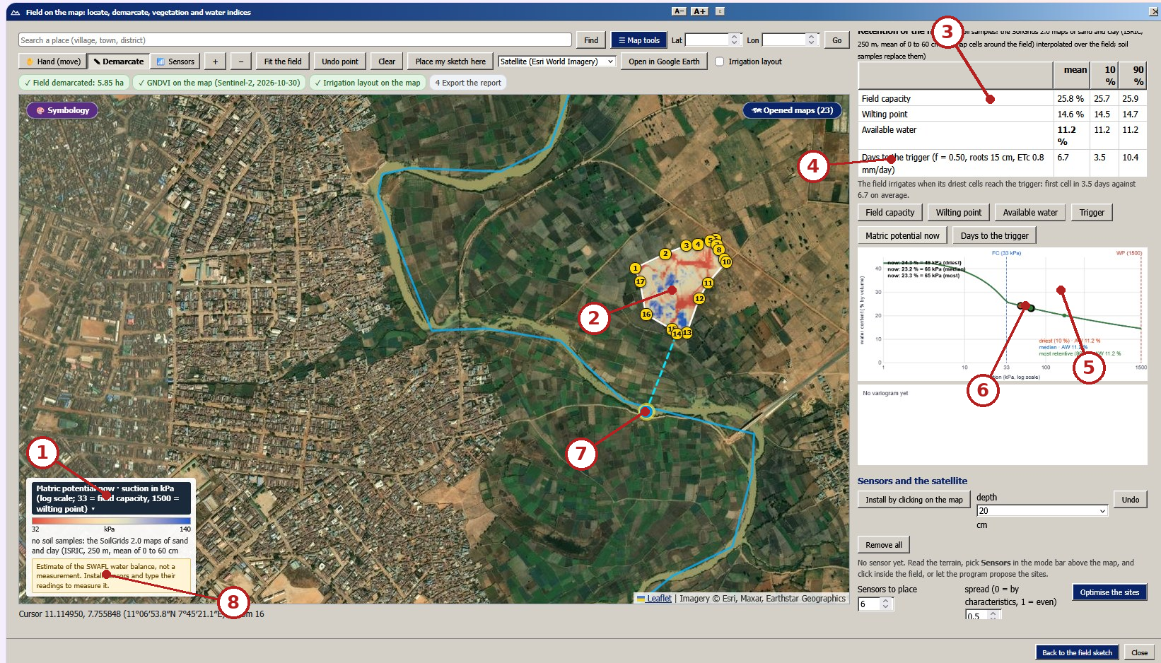
What the numbered labels point to (picture 2 of 3: Matric potential on a 5.85 ha field near Zaria, from mapped retention curves.).
- Legend of the map: matric potential now as suction in kPa on a log scale (33 kPa = field capacity, 1 500 kPa = wilting point); red is dry, blue is wet.
- The field, divided into map cells; each cell has its own retention curve and its own water content now, so the suction varies within the field.
- Retention of the field: field capacity, wilting point and available water, as the mean of the cells and the 10 % and 90 % cells.
- Days to the trigger ($f=0.50$, roots 15 cm, $ET_{c}=0.8$ mm/day): 6.7 days on average, 3.5 for the driest cells.
- The retention curves of the driest, median and most retentive cells: water content against suction (kPa, log scale), with field capacity and wilting point as vertical lines.
- The state points: where each of the three cells is today on its curve (the “now lines give the water content and suction).
- The water source chosen for the field (river intake), joined to the field by the dashed line.
- The note that the map is an estimate from the SWAFL water balance; sensors placed on the map replace the estimate by measurements.
Equations behind this screen. The numbers on the screen are computed as follows.
- Field capacity and wilting point of each cell from its sand $S$, clay $C$ and organic matter $OM$ (fractions, SoilGrids 2.0, 0–60 cm) by the regressions of Saxton and Rawls (2006): $θ_{33}$ and $θ_{1500}$.
- Slope of the retention curve: $λ=\frac{ln1500−ln33}{lnθ_{33}−lnθ_{1500}}$; for $ψ≥33$ kPa, $θ\left(ψ\right)=θ_{33} {\left(ψ/33\right)}^{−λ}$.
- Available water $AW=θ_{33}−θ_{1500}$, and the trigger water content $θ_{t}=θ_{33}−f \left(θ_{33}−θ_{1500}\right)$.
- Matric potential now, the inverse of the curve: $ψ=33 {\left(θ/θ_{33}\right)}^{−1/λ}$ kPa, with $θ$ the water content of the cell from the water balance (or from sensors when installed).
- Days to the trigger: $t=max\left(0, \left(θ−θ_{t}\right) z_{r}⋅10/ET_{c}\right)$ with $z_{r}$ in cm and $ET_{c}$ in mm/day. With $AW=0.112$, $f=0.5$, $z_{r}=15$ cm, $ET_{c}=0.8$: at field capacity $t=0.5×0.112×150/0.8=10.5$ days; the mean 6.7 days is shorter because the cells are already below field capacity.
- Units: 1 kPa $≈$ 10.2 cm of water, so 33 kPa $≈$ 337 cm and 1 500 kPa $≈$ 15 300 cm, the same limits as the suction scale of the article.
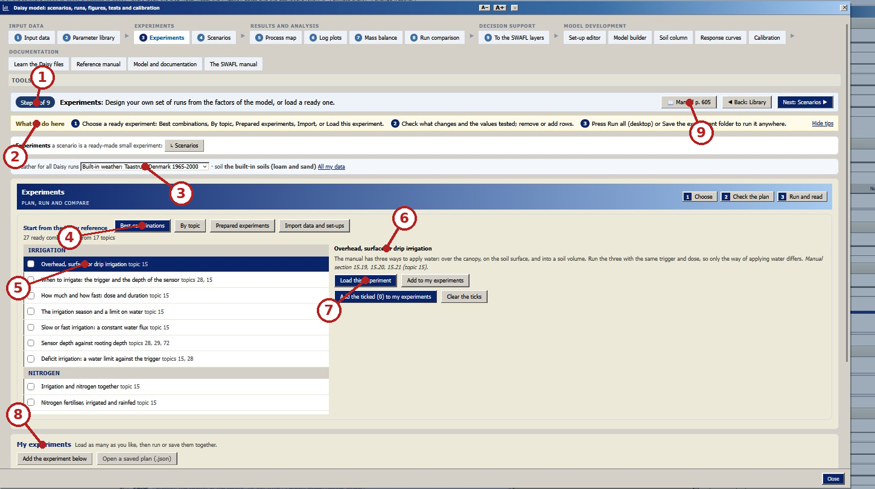
What the numbered labels point to (picture 3 of 3: Daisy workbench, step 3 of 9: ready-made experiments (trigger and sensor depth, dose, method) and the user’s own.).
- Step 3 of 9 of the work flow: experiments, between the parameter library (step 2) and the scenarios (step 4).
- What to do here: choose a ready experiment, check the factors and levels, then run all or save the folder.
- The weather and soils of every run of the experiment (built-in weather Taastrup, Denmark).
- Best combinations: 27 ready experiments from 17 topics of the Daisy reference manual.
- One ready experiment, “Overhead, surface or drip irrigation”, the comparison of methods used in the article.
- Its description: the three methods are run with the same trigger and dose, so only the way of applying water differs.
- Load this experiment: puts its factors and levels in the plan, where rows can be removed or added.
- My experiments: several loaded experiments are run or saved together.
- Link to the page of the Daisy manual that documents these settings (p. 605).
Equations behind this screen. The numbers on the screen are computed as follows.
- Number of Daisy runs of an experiment with factors of $n_{1},n_{2},…$ levels and a budget $B$: N=mini​ni, B.
- If i​ni>B, a Latin hypercube of $B$ runs is drawn so that each level of factor $i$ is used $⌊N/n_{i}⌋$ or $⌈N/n_{i}⌉$ times.
- Every run is one full Daisy simulation; its annual fluxes (transpiration, soil evaporation, drainage, irrigation, yield) are what the article compares between methods with the rainfed twin, $η_{X}=∑\left(X−X_{0}\right)/∑I$.
What it shows. The analysis in SWAFL Desktop 1.1.0 (real screenshots of the release). Panels: (a) Trigger law layer: depletion, sensor and the trigger of every soil. (b) Matric potential on a 5.85 ha field near Zaria, from mapped retention curves. (c) Daisy workbench, step 3 of 9: ready-made experiments (trigger and sensor depth, dose, method) and the user’s own.
How to read the labels, symbols and colours. (a) The trigger-law layer: on the left the soil column with the sensor (dot) and the depletion bar; on the right one row per soil with its own trigger (red marks), the yield (boxes) and a gauge of the season. (b) The matric potential of the Zaria field, cell by cell; the colour bar is in kPa (33 = field capacity, 1500 = wilting point). (c) The ready-made experiments of the Daisy workbench.
What affects it, and why it happens. The trigger law shows each soil’s own trigger because each soil reaches the same depletion at a different suction; the suction map varies with the soil texture mapped from SoilGrids; the workbench runs new experiments on any soil. These are screens of the software, not results; they show where a user finds the reach and the triggers of each soil, how the suction varies over a real field (with the soil texture from SoilGrids), and how new trigger, dose and method experiments are run.
How it is made. Screen capture of SWAFL Desktop 1.1.0 (not regenerated).

Every term of the author’s equations

Reach of a suction trigger, $h_{c}=α^{−1}{\left(m^{2}/κ\right)}^{1/\left[2n+ℓ\left(n−1\right)\right]}$
Term | What it means | Unit | Where the value comes from | When it rises
$h_{c}$ | reach: the driest suction a crop can impose at the sensor; the output | cm | computed | –
$α$ | inverse of the suction at which the soil starts to drain | cm$​^{−1}$ | retention curve of the soil (Table A1) | $h_{c}$ falls in proportion ($h_{c}∝1/α$)
$n$ | pore-size uniformity: large in sands, small in clays | – | retention curve of the soil | $h_{c}$ falls steeply (the exponent grows)
$m$ | $1−1/n$, the second shape parameter | – | from $n$ | $h_{c}$ rises slightly
$ℓ$ | pore-connectivity (tortuosity) exponent of Mualem | – | conventional value 0.5 | $h_{c}$ falls (conductivity collapses faster)
$κ$ | relative conductivity at which the crop stops drying the soil | – | fitted once to all soils ($3.47×{10}^{−10}$) | $h_{c}$ falls
$E=2n+ℓ\left(n−1\right)$ | slope of $logK_{r}$ against $logh$ at the dry end | – | from $n$ and $ℓ$ | $h_{c}$ falls

Reach-scaled trigger, $x=h_{t}/h_{c}$
Term | What it means | Unit | Where the value comes from | When it rises
$h_{t}$ | trigger suction set on the controller | cm | user or table | the trigger moves toward the reach
$x$ | trigger as a fraction of the reach; irrigation ends near $x=0.5$ to 1 | – | computed | less irrigation; none for $x>1$

Marginal fate, $η_{X}=∑\left(X−X_{0}\right)/∑I$
Term | What it means | Unit | Where the value comes from | When it rises
$I$ | irrigation of a run, 20-year mean | mm yr$​^{−1}$ | run table | –
$X$ | a flux of the irrigated run: $T$, $E_{s}$, $E_{o}$ or $D$ | mm yr$​^{−1}$ | run table | $η_{X}$ rises
$X_{0}$ | the same flux of the rainfed twin (same soil and weather) | mm yr$​^{−1}$ | experiment E0 | $η_{X}$ falls
$η_{X}$ | share of each irrigation millimetre that becomes $X$ | – | computed | –

Dose law, $η_{D}=η_{∞}\left(1−e^{−d/d_{D}}\right)$
Term | What it means | Unit | Where the value comes from | When it rises
$d$ | irrigation depth per event | mm | design of the schedule | $η_{D}$ rises toward $η_{∞}$
$η_{∞}$ | share of a large dose that drains (plateau) | – | fitted per soil (0.10 to 0.45) | $η_{D}$ rises at every dose
$d_{D}$ | dose scale: 63 % of the plateau is reached at $d=d_{D}$ | mm | fitted per soil (about 4) | $η_{D}$ falls at small doses

Sensor lag, $Π_{τ}=τ/t_{i}$ and $δh≃rτ/C\left(h\right)$
Term | What it means | Unit | Where the value comes from | When it rises
$τ$ | relaxation time of the water content toward the retention curve | h | measured (not in Daisy) | $Π_{τ}$ and $δh$ rise
$t_{i}$ | interval between irrigations | h or d | schedule | $Π_{τ}$ falls
$r$ | drying rate of the equilibrium water content | h$​^{−1}$ | crop demand | $δh$ rises
$C\left(h\right)$ | water capacity $−dθ/dh$ | cm$​^{−1}$ | retention curve | $δh$ falls

How every constant is obtained, what it depends on, and how sensitive the results are

Every other constant of the article
Constant | Value | How it was obtained | What it depends on; sensitivity
$ℓ$, Mualem connectivity |  | conventional value of Mualem (1976), not fitted | pore structure; a larger $ℓ$ steepens the dry-end conductivity and shortens the reach
Firing threshold | mm yr$​^{−1}$ | chosen: the smallest amount clearly above the numerical noise of the 20-year means | see the table above: $κ$ changes 2.7 to $25×{10}^{−10}$ for 1 to 40 mm
Factor $1/2$ of the blind rule |  | read from the data: the driest trigger that still fires lies at $h_{t}/h_{c}=0.47$ (loamy sand), 0.49 (sandy loam), 0.50 (sand), 0.54 (loam) and 0.66 (sandy clay loam) | a margin, not a fitted constant; below one half every soil still irrigates
$α$, $n$ of each soil | Table A1 | effective (profile-averaged) values of the soils of the ensemble | the soil; see the terms table
$K_{s}$ (only to test the absolute-conductivity law) | to 712.8 cm d$​^{−1}$ | class means of Carsel and Parrish (1988) for eight soils | not used by [eq:s-hc]
$η_{∞}$ of the dose law | to 0.45 | nonlinear least squares per soil over ten doses (standard errors 0.005 to 0.03) | the soil: how fast it drains once wetted
$d_{D}$ of the dose law | to 5.2 mm | same fit (standard errors 0.5 to 1.8 mm; sandy loam least certain) | the crop and the atmosphere (one day of water use), not the soil ($ρ=0.07$ with $n$)
Rainfed baseline $X_{0}$ | per soil | experiment E0, same soil and weather without irrigation | the weather and the crop
Validity of the dry-end form | $αh_{c}≥29$ | checked for every soil: the neglected terms are below ${\left(αh_{c}\right)}^{−n}<{10}^{−3}$ | holds for all ten soils

How each table of the article is produced

Table 1 of the article.
The experiments of the analysis, from Data/Comprehensive_Summary (10190 runs, 10041 valid; 20 years, 1980–1999, of Taastrup weather). Means of the valid runs; $Y$ yield (Mg ha$​^{−1}$), $I$ irrigation, $D$ drainage at 1 m and $ET$ (mm yr$​^{−1}$), $N_{L}$ nitrate leached (kg N ha$​^{−1}$ yr$​^{−1}$), $t$ run time of Daisy (s). Every row is one file of the folder, linked.
How the output is produced. One row per experiment used. The script counts the runs of each experiment in the summary of all runs, keeps those with status ok, lists the factors that take more than one value, and averages yield, irrigation, drainage, ET, nitrate leaching and Daisy run time over the valid runs.
How it is made. Table written by the script (tex/data_table.tex). Script: Manuscripts/reproducibility/analysis/data_overview.py. Input: Data/Comprehensive_Summary/00_summary_all_simulations.csv.gz.

Table 2 of the article.
Closed forms for the reach of a trigger, fitted to the interval-censored reaches of ten soils (E2) and validated leaving one soil out.
How the output is produced. One row per candidate law. For each law the script finds the constant(s) that minimise the squared distance (in decades) between the predicted reach and the observed interval of every soil; it then removes each soil in turn, refits, and records the error on the removed soil. “Inside counts the soils predicted within their interval; “worst factor is $10$ to the largest error.
How it is made. Table written by the script. Script: Manuscripts/reproducibility/analysis/p4_reach.py. Input: Data/Comprehensive_Summary/00_summary_all_simulations.csv.gz.

Table 3 of the article.
What this article adds, item by item: what was established before, what is new here, and the evidence in this article.
How the output is produced. A descriptive table: each row sets a contribution against prior work and names the figure or number that supports it.
How it is made. Descriptive table (claims and the evidence cited in the text); no computation.

Table 4 of the article.
Observed reach interval (E2) and the predictions of Eq. (4) of the article for the ten soils. Yields in Mg ha$​^{−1}$.
How the output is produced. One row per soil: the van Genuchten parameters, the observed interval of the reach from experiment E2 (driest trigger that still irrigates at least 5 mm a year, and the next drier one), the reach from Eq. (4) of the article with the fitted $κ$, and the yields at a 300 cm trigger, without irrigation and with the best trigger. The same table is live in sheet EQ_P4_reach.
How it is made. Table written by the script. Script: Manuscripts/reproducibility/analysis/p4_reach.py. Input: Data/Comprehensive_Summary/00_summary_all_simulations.csv.gz.

Table 5 of the article.
Scripts and inputs of every item. The data of every table and figure are also in the workbook Data/Manuscript_Data/SWAFL_Manuscripts_Data.xlsx.
How it is made. Descriptive table (this map in short); no computation.

From the data to every result: experiments, runs and computations

Where every number starts.
All simulated numbers come from one set of 10 190 Daisy runs, organised in seventeen experiments (E0 to E16), each of which varies a few factors on the same ten soils (S01 to S10) under the same weather series (Taastrup, Denmark). Every run writes 20-year mean annual fluxes (rain, irrigation, evapotranspiration and its parts, drainage at 1 m, yield, nitrogen); one row per run is stored in Data/Comprehensive_Summary/00_summary_all_simulations.csv.gz (sheet All_runs_summary of the workbook) and, for the ensemble analyses, in Data/daisy_ensemble.csv.gz (sheet Ensemble_runs). A run is used only when its status is ok (10 041 runs); the 149 runs whose solver failed are kept in the files but never enter a result. The workbook repeats the per-run algebra as live Excel formulas (the green columns at the end of All_runs_summary: other evaporation, balance residual, differences from the rainfed run of the same soil, water productivity), and the sheet Column_Equations lists the equation behind every calculated column. The rainfed run of each soil (experiment E0) is the reference against which every irrigated or treated run is compared (sheet Baselines_E0).
Result | Experiment and runs | How it is computed from the runs | Script, file, workbook
Observed reach of each soil (interval) | E2_TriggerPressure: 10 soils $×$ 20 triggers (20 to 10 000 cm), sensor 20 cm, dose 2.4 mm, crop file crops_conv_N100.dai; 197 valid runs | For each soil the runs are sorted by trigger suction $h_t=-\texttt{set\_\allowbreak{}trigger\_\allowbreak{}potential\_\allowbreak{}cm}$; the driest trigger with irrigation_mm $≥5$ is the lower end, the next drier trigger the upper end; “inf” when every trigger fires | p4_reach.py; p4_tableA1_reach.csv; sheets R_p4_tableA1_reach, R_p4_fig3_trigger_runs
Constant $κ$ and its uncertainty | the ten intervals above | Nelder–Mead minimum of the summed squared distance (decades) of the predicted reach [eq:s-hc] from each interval; bootstrap over soils (1 000 resamples); leave-one-soil-out refits; refits with fire thresholds 1 to 40 mm | p4_reach.py (functions fitm, fit_kappa); p4_numbers.json keys kappa, constants
Reach of each soil, $h_{c}$ | $α$, $n$ of each soil (Daisy soil files) and $κ$ | [eq:s-hc] with $ℓ=0.5$ | live formula: EQ_P4_reach!G6:G15 and R_p4_tableA1_reach column reach_Eq4_cm
Collapse of the irrigation curves on $h_{t}/h_{c}$ | E2 | $x=h_{t}/h_{c}$; $I_{norm}=I/\max_{\text{soil}}I$; variance within ten bins of $logx$ over the total variance, and the Spearman correlation | p4_reach.py; live formulas in R_p4_fig3_trigger_runs
Comparison of the three laws | E2 intervals | each law fitted as $κ$; error of each soil when it is left out of the fit | p4_table2_laws.csv; sheet R_p4_table2_laws
Fate of an irrigation millimetre, per soil and pooled | E10_Amount_Timing_Soil (954 valid runs; the 300 cm trigger, doses and windows varied), only runs with $I>20$ mm; rainfed twin from E0 | per run $ΔX=X−X_{0}$ for $X=T$, $E_{s}$, $E_{o}=ET−T−E_{s}$, $D$, and $ΔS=I−ΔET−ΔD$; per soil $η_{X}=∑ΔX/∑I$ | p4_reach.py; p4_fig4a_fate_by_soil.csv; live SUMIFS in R_p4_fig4a_fate_by_soil and EQ_P4_fate
Fate by method | E4_Methods (96 valid runs, all soils) and E15_Method_Depth_Amount (coarse loam) | same shares, grouped by set_irrigation_method (overhead, surface, subsoil) | p4_fig4b_fate_by_method.csv; live SUMIFS in R_p4_fig4b_fate_by_method
Dose law, $η_{∞}$ and $d_{D}$ | E10, irrigated runs, grouped by set_dose_mm_per_event (all windows pooled) | per dose $η_{D}=∑ΔD/∑I$; least-squares fit of $η_{∞}\left(1−e^{−d/d_{D}}\right)$ per soil (curve_fit); standard errors from the covariance matrix | p4_fig5_dose.csv; observed shares as live SUMIFS and the fitted curve as a formula in R_p4_fig5_dose, EQ_P4_dose
Timing of irrigation | E10, grouped by set_irrigation_window | $η_{T}$ and $η_{D}$ per window, pooled over soils | p4_window.csv; live SUMIFS in R_p4_window
Sensor depth | E3_SensorDepth (200 runs) | maximum irrigation of sand and loamy sand over the sensor depths | p4_numbers.json key E3_sand_irrigation
Software screens | the SWAFL Desktop suite | the equations under each screen in Section “Reading every figure” | –

The data
lists the 17 experiments of the data folder and 1 shows their outputs. The tables that follow are the result files of the analysis, printed in full or up to 220 rows; every one is also a sheet of the workbook Data/Manuscript_Data/SWAFL_Manuscripts_Data.xlsx, and every run is in Data/Comprehensive_Summary.
The data of this study: the 17 Daisy experiments of Data/Comprehensive_Summary (10190 runs, 10041 valid; 20 years, 1980–1999, of Taastrup weather). Means of the valid runs; $Y$ yield (Mg ha$​^{−1}$), $I$ irrigation, $D$ drainage at 1 m and $ET$ (mm yr$​^{−1}$), $N_{L}$ nitrate leached (kg N ha$​^{−1}$ yr$​^{−1}$), $t$ run time of Daisy (s). Every row is one file of the folder, linked.
Exp. | File | Runs | Valid | Factors varied | $Y$ | $I$ | $D$ | $ET$ | $N_{L}$ | $t$
E0 | Baselines | 10 | 10 | soil | 2.19 | 0 | 55 | 418 | 158 | 231
E1 | Doses | 200 | 189 | soil, rate, dose | 5.13 | 198 | 98 | 564 | 79 | 195
E2 | TriggerPressure | 200 | 197 | soil, trigger | 4.70 | 169 | 80 | 559 | 90 | 139
E3 | SensorDepth | 200 | 200 | soil, sensor depth | 4.94 | 199 | 86 | 583 | 86 | 146
E4 | Methods | 100 | 96 | soil, method | 5.01 | 164 | 88 | 542 | 83 | 147
E5 | SHP Dynamics | 300 | 300 | soil, method, tillage | 4.13 | 152 | 43 | 579 | 84 | 189
E6 | Mediterranean Pollution | 210 | 193 | soil, method, trigger, N rate | 3.64 | 84 | 239 | 620 | 62 | 118
E7 | Mulching | 200 | 200 | soil, mulch | 5.29 | 183 | 96 | 555 | 74 | 161
E8 | Rain Intensity Moisture | 1000 | 1000 | initial suction, rain scale | 0.68 | 0 | -1 | 282 | -0 | 6
E9 | Soil Moisture Rain | 1000 | 987 | soil, initial suction, rain scale | 0.75 | 0 | 19 | 247 | 33 | 7
E10 | Amount Timing Soil | 1000 | 954 | soil, rate, dose, window | 4.42 | 139 | 76 | 532 | 97 | 146
E11 | Temp Evap Rain | 1000 | 1000 | rain scale, warming, demand | 3.81 | 324 | 18 | 754 | 66 | 151
E12 | Sensor Trigger Rain | 1000 | 1000 | trigger, sensor depth, rain scale | 5.88 | 260 | 35 | 670 | 32 | 155
E13 | N Water Soil | 1000 | 975 | soil, method, rate, dose, trigger, N rate | 4.00 | 162 | 83 | 547 | 79 | 207
E14 | Mulch Rain | 1000 | 1000 | rain scale, mulch | 6.15 | 235 | 43 | 634 | 25 | 173
E15 | Method Depth Amount | 1000 | 1000 | method, rate, dose, root depth | 6.02 | 217 | 61 | 619 | 37 | 157
E16 | Edge Cases | 770 | 740 | soil, method, rate, dose, trigger, sensor depth, rain scale, warming, N rate, demand | 2.17 | 344 | 185 | 600 | 93 | 224
Yield, irrigation, drainage and nitrate leaching of the valid runs, by experiment.

p4_tableA1_reach.csv
Source: Manuscripts/results/p4_tableA1_reach.csv; 10 rows. Workbook sheet R_p4_tableA1_reach.
id | soil | alpha_1_per_cm | n | TAW_mm | reach_observed_low_cm | reach_observed_high_cm | reach_Eq4_cm | yield_at_300
S01 | Coarse loam |  |  |  | 1e+04 | inf
S02 | Coarse sand |  |  |  | 1e+04 | inf
S03 | Sand
S04 | Loamy sand
S05 | Sandy loam
S06 | Loam |  |  |  |  | 1e+04
S07 | Silt loam |  |  |  | 1e+04 | inf | 2.961e+04
S08 | Sandy clay loam |  |  |  |  | 1e+04
S09 | Clay loam |  |  |  | 1e+04 | inf | 4.776e+04
S10 | Silty clay loam |  |  |  | 1e+04 | inf | 1.283e+05

p4_table2_laws.csv
Source: Manuscripts/results/p4_table2_laws.csv; 3 rows. Workbook sheet R_p4_table2_laws.
law | theta | loso_rmse_log10 | inside_of_10 | worst_factor
mualem | -9.46 | 0.1753 | 5 | 2.3
power | 1.832 3.12 | 0.1431 | 4 | 2.368
Sc | -1.489 | 0.2303 | 4 | 3.217

p4_fig4a_fate_by_soil.csv
Source: Manuscripts/results/p4_fig4a_fate_by_soil.csv; 8 rows. Workbook sheet R_p4_fig4a_fate_by_soil.
soil | transpired | soil_evaporation | other_evaporation | drained | storage_runoff
S01
S02
S05
S06
S07
S08
S09
S10

p4_fig4b_fate_by_method.csv
Source: Manuscripts/results/p4_fig4b_fate_by_method.csv; 6 rows. Workbook sheet R_p4_fig4b_fate_by_method.
experiment | method | transpired | soil_evaporation | other_evaporation | drained
E4 | overhead
E4 | subsoil
E4 | surface
E15 | overhead
E15 | subsoil
E15 | surface

p4_window.csv
Source: Manuscripts/results/p4_window.csv; 10 rows. Workbook sheet R_p4_window.
window | etaT | etaD | I
4/1-10/1 | 0.344 | 0.209 | 1.85e+04
4/1-6/1 | 0.641 | 0.072 | 7917
4/1-7/1 | 0.477 | 0.153 | 1.262e+04
4/15-10/1 | 0.352 | 0.19 | 1.714e+04
5/1-10/1 | 0.348 | 0.164 | 1.592e+04
5/1-7/15 | 0.431 | 0.129 | 1.219e+04
5/15-10/1 | 0.34 | 0.157 | 1.538e+04
6/1-10/1 | 0.326 | 0.148 | 1.328e+04
6/1-8/15 | 0.362 | 0.119 | 1.097e+04
7/1-9/15 | 0.234 | 0.136 | 8153

p4_fig5_dose.csv
Source: Manuscripts/results/p4_fig5_dose.csv; 77 rows. Workbook sheet R_p4_fig5_dose.
soil | dose_mm | drained | transpired | evaporated | fit_plateau | fit_dose_scale_mm | fit_R2
S01
S01
S01
S01
S01
S01
S01
S01
S01
S01
S02
S02
S02
S02
S02
S02
S02
S05
S05
S05
S05
S05
S05
S05
S05
S05
S05
S06
S06
S06
S06
S06
S06
S06
S06
S06
S06
S07
S07
S07
S07
S07
S07
S07
S07
S07
S07
S08
S08
S08
S08
S08
S08
S08
S08
S08
S08
S09
S09
S09
S09
S09
S09
S09
S09
S09
S09
S10
S10
S10
S10
S10
S10
S10
S10
S10
S10

p4_fig3_trigger_runs.csv
Source: Manuscripts/results/p4_fig3_trigger_runs.csv; 197 rows. Workbook sheet R_p4_fig3_trigger_runs.
soil | trigger_cm | irrigation_mm | yield_Mg_ha | trigger_over_reach | Inorm
S01_CoarseLoam
S01_CoarseLoam
S01_CoarseLoam | 1e+04
S01_CoarseLoam
S01_CoarseLoam
S01_CoarseLoam
S01_CoarseLoam
S01_CoarseLoam
S01_CoarseLoam
S01_CoarseLoam
S01_CoarseLoam
S01_CoarseLoam
S01_CoarseLoam
S01_CoarseLoam
S01_CoarseLoam
S01_CoarseLoam
S01_CoarseLoam
S01_CoarseLoam
S01_CoarseLoam
S01_CoarseLoam
S02_CoarseSand
S02_CoarseSand | 1e+04
S02_CoarseSand
S02_CoarseSand
S02_CoarseSand
S02_CoarseSand
S02_CoarseSand
S02_CoarseSand
S02_CoarseSand
S02_CoarseSand
S02_CoarseSand
S02_CoarseSand
S02_CoarseSand
S02_CoarseSand
S02_CoarseSand
S02_CoarseSand
S02_CoarseSand
S03_Sand
S03_Sand
S03_Sand | 1e+04
S03_Sand
S03_Sand
S03_Sand
S03_Sand
S03_Sand
S03_Sand
S03_Sand
S03_Sand
S03_Sand
S03_Sand
S03_Sand
S03_Sand
S03_Sand
S03_Sand
S03_Sand
S03_Sand
S03_Sand
S04_LoamySand
S04_LoamySand
S04_LoamySand | 1e+04
S04_LoamySand
S04_LoamySand
S04_LoamySand
S04_LoamySand
S04_LoamySand
S04_LoamySand
S04_LoamySand
S04_LoamySand
S04_LoamySand
S04_LoamySand
S04_LoamySand
S04_LoamySand
S04_LoamySand
S04_LoamySand
S04_LoamySand
S04_LoamySand
S04_LoamySand
S05_SandyLoam
S05_SandyLoam
S05_SandyLoam | 1e+04
S05_SandyLoam
S05_SandyLoam
S05_SandyLoam
S05_SandyLoam
S05_SandyLoam
S05_SandyLoam
S05_SandyLoam
S05_SandyLoam
S05_SandyLoam
S05_SandyLoam
S05_SandyLoam
S05_SandyLoam
S05_SandyLoam
S05_SandyLoam
S05_SandyLoam
S05_SandyLoam
S05_SandyLoam
S06_Loam
S06_Loam
S06_Loam | 1e+04
S06_Loam
S06_Loam
S06_Loam
S06_Loam
S06_Loam
S06_Loam
S06_Loam
S06_Loam
S06_Loam
S06_Loam
S06_Loam
S06_Loam
S06_Loam
S06_Loam
S06_Loam
S06_Loam
S06_Loam
S07_SiltLoam
S07_SiltLoam
S07_SiltLoam | 1e+04
S07_SiltLoam
S07_SiltLoam
S07_SiltLoam
S07_SiltLoam
S07_SiltLoam
S07_SiltLoam
S07_SiltLoam
S07_SiltLoam
S07_SiltLoam
S07_SiltLoam
S07_SiltLoam
S07_SiltLoam
S07_SiltLoam
S07_SiltLoam
S07_SiltLoam
S07_SiltLoam
S07_SiltLoam
S08_SandyClayLoam
S08_SandyClayLoam
S08_SandyClayLoam | 1e+04
S08_SandyClayLoam
S08_SandyClayLoam
S08_SandyClayLoam
S08_SandyClayLoam
S08_SandyClayLoam
S08_SandyClayLoam
S08_SandyClayLoam
S08_SandyClayLoam
S08_SandyClayLoam
S08_SandyClayLoam
S08_SandyClayLoam
S08_SandyClayLoam
S08_SandyClayLoam
S08_SandyClayLoam
S08_SandyClayLoam
S08_SandyClayLoam
S08_SandyClayLoam
S09_ClayLoam
S09_ClayLoam
S09_ClayLoam | 1e+04
S09_ClayLoam
S09_ClayLoam
S09_ClayLoam
S09_ClayLoam
S09_ClayLoam
S09_ClayLoam
S09_ClayLoam
S09_ClayLoam
S09_ClayLoam
S09_ClayLoam
S09_ClayLoam
S09_ClayLoam
S09_ClayLoam
S09_ClayLoam
S09_ClayLoam
S09_ClayLoam
S09_ClayLoam
S10_SiltyClayLoam
S10_SiltyClayLoam
S10_SiltyClayLoam | 1e+04
S10_SiltyClayLoam
S10_SiltyClayLoam
S10_SiltyClayLoam
S10_SiltyClayLoam
S10_SiltyClayLoam
S10_SiltyClayLoam
S10_SiltyClayLoam
S10_SiltyClayLoam
S10_SiltyClayLoam
S10_SiltyClayLoam
S10_SiltyClayLoam
S10_SiltyClayLoam
S10_SiltyClayLoam
S10_SiltyClayLoam
S10_SiltyClayLoam
S10_SiltyClayLoam
S10_SiltyClayLoam

p4_numbers.json
Source: Manuscripts/results/p4_numbers.json; 362 values, first 220 shown. Workbook sheet R_p4_numbers.
quantity | value
runs_total | 10190
runs_valid | 10041
E2_runs | 197
reach.mualem.theta | -9.46
reach.mualem.loso_err_log10 | 0.169, 0.362, 0.134, 0.26, 0.25, 0, 0, 0, 0, 0
reach.mualem.loso_rms_log10 | 0.1753
reach.mualem.loso_inside | 5
reach.mualem.loso_max_factor | 2.3
reach.mualem.pred.S01 | 7837
reach.mualem.pred.S02 | 5373
reach.mualem.pred.S03 | 199
reach.mualem.pred.S04 | 425.9
reach.mualem.pred.S05 | 1618
reach.mualem.pred.S06 | 9209
reach.mualem.pred.S07 | 2.961e+04
reach.mualem.pred.S08 | 7580
reach.mualem.pred.S09 | 4.776e+04
reach.mualem.pred.S10 | 1.283e+05
reach.power.theta | 1.832, 3.12
reach.power.loso_err_log10 | 0, 0.374, 0.172, 0.009, 0.139, 0.086, 0, 0.092, 0, 0
reach.power.loso_rms_log10 | 0.1431
reach.power.loso_inside | 4
reach.power.loso_max_factor | 2.368
reach.power.pred.S01 | 1.82e+04
reach.power.pred.S02 | 6235
reach.power.pred.S03 | 92.83
reach.power.pred.S04 | 253.5
reach.power.pred.S05 | 1302
reach.power.pred.S06 | 1.151e+04
reach.power.pred.S07 | 5.481e+04
reach.power.pred.S08 | 1.136e+04
reach.power.pred.S09 | 1.38e+05
reach.power.pred.S10 | 6.654e+05
reach.Sc.theta | -1.489
reach.Sc.loso_err_log10 | 0, 0.317, 0.284, 0.243, 0.117, 0.138, 0, 0.507, 0, 0
reach.Sc.loso_rms_log10 | 0.2303
reach.Sc.loso_inside | 4
reach.Sc.loso_max_factor | 3.217
reach.Sc.pred.S01 | 1.723e+05
reach.Sc.pred.S02 | 5662
reach.Sc.pred.S03 | 53.02
reach.Sc.pred.S04 | 117.4
reach.Sc.pred.S05 | 628.3
reach.Sc.pred.S06 | 1.268e+04
reach.Sc.pred.S07 | 2.145e+05
reach.Sc.pred.S08 | 2.147e+04
reach.Sc.pred.S09 | 3.353e+06
reach.Sc.pred.S10 | 2.987e+08
kappa | 3.47e-10
blind_300 | S03, S04
yield_E2.S01.rainfed | 2.597
yield_E2.S01.best | 6.624
yield_E2.S01.at300 | 6.158
yield_E2.S02.rainfed | 1.633
yield_E2.S02.best | 6.32
yield_E2.S02.at300 | 6.254
yield_E2.S03.rainfed | 1.132
yield_E2.S03.best | 3.038
yield_E2.S03.at300 | 1.132
yield_E2.S04.rainfed | 1.378
yield_E2.S04.best | 4.544
yield_E2.S04.at300 | 1.378
yield_E2.S05.rainfed | 1.851
yield_E2.S05.best | 6.02
yield_E2.S05.at300 | 4.351
yield_E2.S06.rainfed | 2.615
yield_E2.S06.best | 6.623
yield_E2.S06.at300 | 6.123
yield_E2.S07.rainfed | 2.813
yield_E2.S07.best | 6.628
yield_E2.S07.at300 | 6.573
yield_E2.S08.rainfed | 2.384
yield_E2.S08.best | 6.566
yield_E2.S08.at300 | 5.853
yield_E2.S09.rainfed | 2.773
yield_E2.S09.best | 6.622
yield_E2.S09.at300 | 6.584
yield_E2.S10.rainfed | 2.75
yield_E2.S10.best | 6.59
yield_E2.S10.at300 | 6.575
collapse_raw_h | 0.5407
collapse_scaled | 0.3167
spearman_scaled | -0.8339
E10_runs | 954
E10_runs_irrigated | 744
fate_E10.S01.dT | 0.38
fate_E10.S01.dE | 0.323
fate_E10.S01.dO | 0.186
fate_E10.S01.dD | 0.08
fate_E10.S01.dS | 0.03
fate_E10.S02.dT | 0.232
fate_E10.S02.dE | 0.186
fate_E10.S02.dO | 0.261
fate_E10.S02.dD | 0.316
fate_E10.S02.dS | 0.004
fate_E10.S05.dT | 0.638
fate_E10.S05.dE | 0.113
fate_E10.S05.dO | 0.137
fate_E10.S05.dD | 0.075
fate_E10.S05.dS | 0.038
fate_E10.S06.dT | 0.409
fate_E10.S06.dE | 0.22
fate_E10.S06.dO | 0.174
fate_E10.S06.dD | 0.152
fate_E10.S06.dS | 0.045
fate_E10.S07.dT | 0.352
fate_E10.S07.dE | 0.295
fate_E10.S07.dO | 0.187
fate_E10.S07.dD | 0.148
fate_E10.S07.dS | 0.018
fate_E10.S08.dT | 0.459
fate_E10.S08.dE | 0.184
fate_E10.S08.dO | 0.164
fate_E10.S08.dD | 0.147
fate_E10.S08.dS | 0.045
fate_E10.S09.dT | 0.363
fate_E10.S09.dE | 0.287
fate_E10.S09.dO | 0.181
fate_E10.S09.dD | 0.153
fate_E10.S09.dS | 0.016
fate_E10.S10.dT | 0.341
fate_E10.S10.dE | 0.292
fate_E10.S10.dO | 0.177
fate_E10.S10.dD | 0.147
fate_E10.S10.dS | 0.044
fate_E10_all.dT | 0.377
fate_E10_all.dE | 0.252
fate_E10_all.dO | 0.186
fate_E10_all.dD | 0.156
fate_E10_all.dS | 0.029
dose.S01.inf | 0.109
dose.S01.dD | 4.425
dose.S01.r2 | 0.949
dose.S01.dose_maxT | 20
dose.S01.dose_best | 2
dose.S02.inf | 0.445
dose.S02.dD | 3.234
dose.S02.r2 | 0.955
dose.S02.dose_maxT | 2
dose.S02.dose_best | 2
dose.S05.inf | 0.102
dose.S05.dD | 5.21
dose.S05.r2 | 0.658
dose.S05.dose_maxT | 15
dose.S05.dose_best | 15
dose.S06.inf | 0.197
dose.S06.dD | 3.887
dose.S06.r2 | 0.931
dose.S06.dose_maxT | 15
dose.S06.dose_best | 2
dose.S07.inf | 0.194
dose.S07.dD | 4.106
dose.S07.r2 | 0.929
dose.S07.dose_maxT | 15
dose.S07.dose_best | 2
dose.S08.inf | 0.19
dose.S08.dD | 3.85
dose.S08.r2 | 0.945
dose.S08.dose_maxT | 20
dose.S08.dose_best | 8
dose.S09.inf | 0.204
dose.S09.dD | 4.388
dose.S09.r2 | 0.926
dose.S09.dose_maxT | 15
dose.S09.dose_best | 2
dose.S10.inf | 0.183
dose.S10.dD | 3.394
dose.S10.r2 | 0.923
dose.S10.dose_maxT | 15
dose.S10.dose_best | 2
dose_predictors.n.rho_dD | 0.07143
dose_predictors.n.rho_inf | 0.02381
dose_predictors.taw.rho_dD | -0.2381
dose_predictors.taw.rho_inf | 0.1905
dose_predictors.se100.rho_dD | -0.1667
dose_predictors.se100.rho_inf | 0.1905
dose_predictors.dep300.rho_dD | 0.119
dose_predictors.dep300.rho_inf | -0.04762
dose_predictors.store.rho_dD | 0.1667
dose_predictors.store.rho_inf | 0.1905
dose_table.S01.dD | 4.425
dose_table.S01.inf | 0.1094
dose_table.S01.n | 1.353
dose_table.S01.taw | 130
dose_table.S01.se100 | 0.4445
dose_table.S01.dep300 | 0.3794
dose_table.S01.store | 14.8
dose_table.S02.dD | 3.234
dose_table.S02.inf | 0.4448
dose_table.S02.n | 1.6
dose_table.S02.taw | 105
dose_table.S02.se100 | 0.3563
dose_table.S02.dep300 | 0.4964
dose_table.S02.store | 15.64
dose_table.S05.dD | 5.21
dose_table.S05.inf | 0.1017
dose_table.S05.n | 1.89
dose_table.S05.taw | 95
dose_table.S05.se100 | 0.1647
dose_table.S05.dep300 | 0.6274
dose_table.S05.store | 17.88
dose_table.S06.dD | 3.887
dose_table.S06.inf | 0.1971
dose_table.S06.n | 1.56
dose_table.S06.taw | 150
dose_table.S06.se100 | 0.4663
dose_table.S06.dep300 | 0.4678
dose_table.S06.store | 21.05
dose_table.S07.dD | 4.106
dose_table.S07.inf | 0.194
dose_table.S07.n | 1.41
dose_table.S07.taw | 220
dose_table.S07.se100 | 0.6859
dose_table.S07.dep300 | 0.3665
dose_table.S07.store | 24.19
dose_table.S08.dD | 3.85
dose_table.S08.inf | 0.19
dose_table.S08.n | 1.48
dose_table.S08.taw | 160
dose_table.S08.se100 | 0.417

Reproducing every number
Open Data/Manuscript_Data/SWAFL_Manuscripts_Data.xlsx: the yellow cells are the inputs, the green cells the formulas of Parts 1 to 8. Or run Manuscripts/reproducibility/analysis/p4_reach.py, which reads every run and writes every number and figure of the article.

Where every table and figure comes from
Item | How it is made | Script(s) | Input and output
Figure 1 | Schematic drawn by the script with numbers from the results | Manuscripts/reproducibility/analysis/p4_concept.py | Data/Comprehensive_Summary/00_summary_all_simulations.csv.gz; Manuscripts/figures/paper4/fig1_concept.pdf; numbers Manuscripts/results/p4_numbers.json
Table 1 | Table written by the script (tex/data_table.tex) | Manuscripts/reproducibility/analysis/data_overview.py | Data/Comprehensive_Summary/00_summary_all_simulations.csv.gz
Figure 2 | Figure drawn by the script from the input data | Manuscripts/reproducibility/analysis/p4_reach.py | Data/Comprehensive_Summary/00_summary_all_simulations.csv.gz; Manuscripts/figures/paper4/fig2_curves_reach.pdf; data Manuscripts/results/p4_tableA1_reach.csv
Table 2 | Table written by the script | Manuscripts/reproducibility/analysis/p4_reach.py | Data/Comprehensive_Summary/00_summary_all_simulations.csv.gz; Manuscripts/results/p4_table2_laws.csv (sheet R_p4_table2_laws)
Figure 3 | Figure drawn by the script from the input data | Manuscripts/reproducibility/analysis/p4_reach.py | Data/Comprehensive_Summary/00_summary_all_simulations.csv.gz; Manuscripts/figures/paper4/fig3_trigger_reach.pdf; data Manuscripts/results/p4_fig3_trigger_runs.csv, p4_tableA1_reach.csv
Figure 4 | Figure drawn by the script from the input data | Manuscripts/reproducibility/analysis/p4_reach.py | Data/Comprehensive_Summary/00_summary_all_simulations.csv.gz; Manuscripts/figures/paper4/fig4_marginal_fate.pdf; data Manuscripts/results/p4_fig4a_fate_by_soil.csv, p4_fig4b_fate_by_method.csv
Figure 5 | Figure drawn by the script from the input data | Manuscripts/reproducibility/analysis/p4_reach.py | Data/Comprehensive_Summary/00_summary_all_simulations.csv.gz; Manuscripts/figures/paper4/fig5_dose.pdf; data Manuscripts/results/p4_fig5_dose.csv
Figure 6 | Screen capture of SWAFL Desktop 1.1.0 (not regenerated) | - | Manuscripts/figures/shots_jpg/real_trigger_law.jpg; zaria_matric_potential.jpg; wb_step3_experiments.jpg
Table 3 | Descriptive table (claims and the evidence cited in the text); no computation | -
Table 4 | Table written by the script | Manuscripts/reproducibility/analysis/p4_reach.py | Data/Comprehensive_Summary/00_summary_all_simulations.csv.gz; Manuscripts/results/p4_tableA1_reach.csv (sheet R_p4_tableA1_reach)
Table 5 | Descriptive table (this map in short); no computation | -
Allen, Richard G., Luis S. Pereira, Dirk Raes, and Martin Smith. 1998. “Crop Evapotranspiration: Guidelines for Computing Crop Water Requirements.” FAO Irrigation and Drainage Paper 56. Rome: FAO. https://www.fao.org/4/x0490e/x0490e00.htm.
Assouline, Shmuel, and Dani Or. 2014. “The Concept of Field Capacity Revisited: Defining Intrinsic Static and Dynamic Criteria for Soil Internal Drainage Dynamics.” Water Resources Research 50. https://doi.org/10.1002/2014WR015475.
Carminati, A., and M. Javaux. 2020. “Soil Rather Than Xylem Vulnerability Controls Stomatal Response to Drought.” Trends in Plant Science 25 (9): 868–80.
Carsel, Robert F., and Rudolph S. Parrish. 1988. “Developing Joint Probability Distributions of Soil Water Retention Characteristics.” Water Resources Research 24: 755–69. https://doi.org/10.1029/WR024i005p00755.
Diamantopoulos, E., and W. Durner. 2012. “Dynamic Nonequilibrium of Water Flow in Porous Media: A Review.” Vadose Zone Journal 11 (3): vzj2011.0197. https://doi.org/10.2136/vzj2011.0197.
Diamantopoulos, E., S. C. Iden, and W. Durner. 2012. “Inverse Modeling of Dynamic Nonequilibrium in Water Flow with an Effective Approach.” Water Resources Research 48 (3).
Elmaloglou, S., and E. Diamantopoulos. 2007. “Wetting Front Advance Patterns and Water Losses by Deep Percolation Under the Root Zone as Influenced by Pulsed Drip Irrigation.” Agricultural Water Management 90 (1–2): 160–63.
———. 2008. “The Effect of Intermittent Water Application by Surface Point Sources on the Soil Moisture Dynamics and on Deep Percolation Under the Root Zone.” Computers and Electronics in Agriculture 62 (2): 266–75.
———. 2009. “Effects of Hysteresis on Redistribution of Soil Moisture and Deep Percolation at Continuous and Pulse Drip Irrigation.” Agricultural Water Management 96 (3): 533–38.
Gardner, W. R. 1960. “Dynamic Aspects of Water Availability to Plants.” Soil Science 89 (2): 63–73.
Mualem, Yechezkel. 1976. “A New Model for Predicting the Hydraulic Conductivity of Unsaturated Porous Media.” Water Resources Research 12: 513–22. https://doi.org/10.1029/WR012i003p00513.
Ross, P. J., and K. R. J. Smettem. 2000. “A Simple Treatment of Physical Nonequilibrium Water Flow in Soils.” Soil Science Society of America Journal 64: 1926–30.
Twarakavi, Navin K. C., Masaru Sakai, and Jiří Šimůnek. 2009. “An Objective Analysis of the Dynamic Nature of Field Capacity.” Water Resources Research 45: W10410. https://doi.org/10.1029/2009WR007944.
van Genuchten, Martinus Th. 1980. “A Closed-Form Equation for Predicting the Hydraulic Conductivity of Unsaturated Soils.” Soil Science Society of America Journal 44: 892–98. https://doi.org/10.2136/sssaj1980.03615995004400050002x.

