THE USE OF MORNING GLORY (Ipomoea carnea) FOR CONTROLLING GULLY EROSION WITHIN THE WATERCOURSE OF AHMADU BELLO UNIVERSITY DAM

BY

HALILU NAZIRU
U18AE2018

A PROJECT SUBMITTED TO THE DEPARTMENT OF AGRICULTURAL AND BIO-BIORESOURCES ENGINEERING, FACULTY OF ENGINEERING, AHMADU BELLO UNIVERSITY IN PARTIAL FULFILMENT OF THE REQUIREMENTS FOR THE AWARD OF BACHELOR OF ENGINEERING IN AGRICULTURAL AND BIOREOURCES

AUGUST, 2024

DECLARATION
I, Halilu Naziru, hereby declare that this project titled “ The Use of Morning glory ( Ipomoea carnea) for controlling gully erosion within the watercourse of Ahmadu Bello University Dam” is my original work, conducted under the guidance of Dr.Habibu Ismail. All sources of information and references used in the preparation of this project have been duly acknowledged. This project has not been submitted, in whole or in part, for any other degree or qualification at any other institution. I take full responsibility for the content of this project and affirm that it reflects my own research and findings.

______________
Halilu Naziru
27th August,2024.

CERTIFICATION
This is to certify that this report was written and compiled by Halilu Naziru with the registration number U18AE2018 and has been prepared according to the rules and regulations governing the Project report at Ahmadu Bello University, Zaria. It is therefore approved for its contribution to learning.

Dr.Habibu Ismail
(Supervisor)
Signature: _________________
Date: ______________________

Engr.M.K Dalhat
(Project coordinator)
Signature: __________________
Date: ______________________

Prof. Henry Igbadun
(Head of Department)
Signature:__________________
Date: ______________________

External Examiner
Signature________________
Date_________________

DEDICATION
This work is dedicated to Almighty Allah who has kept me alive till this day and time and my family whose prayers has been my weapon in accomplishing this great task. May Allah in His Infinite mercy Grant you all your heart desires.

ACKNOWLEDGEMENTS
I would like to express my heartfelt gratitude to those who have contributed to the success of this project. First and foremost, I extend my deepest thanks to my father, Mr. Halilu Abubakar, for his unwavering financial support and encouragement throughout the course of this project. His support has been instrumental in making this endeavor possible. I also wish to honour the memory of my late mother, Rabi'atu Sani, whose inspiration and strength continue to guide me.
I wish to sincerely thank Associate Professor Habibu Ismail for his kind contribution to this project. His invaluable support, insightful advice, and encouragement have greatly enhanced the quality of my work. I am deeply appreciative of his guidance throughout the duration of this project.
I am grateful to the Project Coordinator, Engr. M.K. Dalhatu, for his oversight and support throughout the project. My thanks also go to the Exam Officer, Dr. I.B. Dalha, for his assistance and cooperation during the examination process. I am thankful to Dr. Abdulsalam Mohammed and all the well-wishers for their encouragement and moral support.
I would like to also express my deepest gratitude to Professor Moshodi Isiaka for his invaluable guidance, support, and encouragement throughout the course of this work. His expertise and insightful suggestions were instrumental in shaping this research, and I am truly grateful for his mentorship.
Lastly, I would like to express my profound gratitude to the Head of Department, Prof. Henry Igbadun, for his leadership and support. Thank you all for your significant contributions and support.

ABSTRACT
This research investigates the effectiveness of Morning Glory (Ipomoea carnea) as a biological control measure for gully erosion within the watercourse of Ahmadu Bello University. The study aims to assess the plant's potential in mitigating erosion rates and stabilizing sediment transport dynamics. The research was conducted through an extensive field analysis, measuring key parameters such as water depth, slope, soil shear, sediment transport, and flow velocity both before and after the implementation of Morning Glory. Pre-control observations revealed significant sediment transport rates and flow velocities, with values ranging from 0.08 kg/s/m to 1.00 kg/s/m and 0.23 m/s to 1.51 m/s, respectively. Following the introduction of Morning Glory and ponding water at depths of 1.0m and 1.5m, post-control data showed a marked reduction in sediment transport and flow velocity. Specifically, sediment transport rates decreased from 0.95 kg/s/m to 0.56 kg/s/m, while flow velocities were reduced from 1.70 m/s to 1.10 m/s. These findings underscore the plant's effectiveness in controlling erosion and improving channel stability. An empirical linear model was developed to predict sediment transport, expressed as 𝑉_{𝑠} = 0.0859𝑄_{𝑠} + 0.9136 (Equation 4.1). This model offers a valuable predictive tool for sediment dynamics and erosion management in similar contexts. The study's objectives were to evaluate the current channel conditions, develop predictive models for sediment transport, and assess the efficacy of Morning Glory as a control measure. The results affirm the significant role of biological methods in erosion management, providing insights into sustainable practices for watercourse stabilization and sediment control. This research contributes valuable knowledge to the field of erosion control and environmental management.

TABLE OF CONTENTS

TITLE PAGE .............................................................................................................................. i
DECLARATION ii
CERTIFICATION iii
DEDICATION iv
ACKNOWLEDGEMENTS v
ABSTRACT vi
TABLE OF CONTENTS vii
LIST OF FIGURES xi
LIST OF TABLES xii
LIST OF PLATES xiii
NOMENCLATURES xiv

CHAPTER ONE: INTRODUCTION ................................................................................... 1
1.1 Background of the Study........................................................................................... 1
1.2 Statement of Problem ................................................................................................ 3
1.3 Aim and Objectives .................................................................................................... 3
1.3.1 Aim .............................................................................................................................. 3
1.3.2 Objectives .................................................................................................................... 4
1.4 Justification of the Study........................................................................................... 4
1.5 Scope and Limitation ................................................................................................. 4 CHAPTER TWO: LITERATURE REVIEW ....................................................................... 6
2.1 Gully Erosion Morphology ....................................................................................... 6
2.2 Suspended Load and Bedload................................................................................... 8
2.2.1 Erosion and Scour ........................................................................................................ 8

2.3 Quantitative Description of Ephemeral Gully Systems ....................................... 10
2.3.1 Topographical analysis .............................................................................................. 12
2.4 Monitoring Approach .............................................................................................. 13
2.5 The flow Velocity of the Incipient Motion ............................................................. 14
2.6 Solution Approach ................................................................................................... 14
2.7 Empirical Models for Sediment Transport ........................................................... 15
2.7.1 Duboy’s approach ...................................................................................................... 15
2.7.2 Shields’ approach ....................................................................................................... 16
2.7.3 Meyer Meter’s approach ............................................................................................ 17
2.7.4 Schoklistch’s approach .............................................................................................. 17
2.7.4 Rottner’s approach ..................................................................................................... 18
- 8 Steady States Solutions ............................................................................................ 18
  - Linear Regression Modelling .................................................................................. 19
  - Effect of Vegetation on Flow Resistance ................................................................ 20
2.10.1 Harnessing the potential of morning glory ................................................................ 20
CHAPTER THREE: MATERIALS AND METHOD ........................................................ 22
  - Study Area ................................................................................................................ 22
  - Description of Original Design Characteristics .................................................... 24
3.2.1 Measurement of watercourse length and dimensions ................................................ 25

3.3 Sediment Transport Modelling using Linear Regression .................................... 27
3.3.1 Collection of hydrological data and sediment transport metrics ............................... 27
3.3.2 Selecting of variables ................................................................................................. 29
3.3.3 Model formulation ..................................................................................................... 29
3.4 Gully Erosion Control using Morning Glory ........................................................ 30
3.4.1 Monitoring of morning glory (Ipomoea carnea) growth ........................................... 32
3.5 Erosion Rate Control Technique ............................................................................ 33 CHAPTER FOUR: RESULTS AND DISCUSSION .......................................................... 35
4.1 Current Channel Dimension ................................................................................... 35

4.2 Hydrological Data and Sediment Transport Metrics Results within the
Watercourse ............................................................................................................. 39
4.2.1 Pre-Control Gully System Data ................................................................................. 42
4.2.2 Pre-Control Data After Ponding at 1.0m Depth ........................................................ 44
4.2.3 Post-Control Data After Ponding at 1.0m Depth ....................................................... 46
4.2.4 Pre-Control Data After Ponding at 1.5m ................................................................... 48
4.2.5 Post-Control Data After Ponding at 1.5m Depth ....................................................... 50

4.3 Empirical linear modelling of sediment transport rates ...................................... 54
4.3.1 Data Collection and Experimental Setup For the Modelling..................................... 54
4.3.2 Selection of Variables and Model Formulation ......................................................... 54
4.3.3 Analysis of Pre-Control and Post-Control Conditions .............................................. 56

4.4 Gully Erosion Control Using Morning Glory (Ipomoea carnea) ........................ 58
4.4.1 Pre-Control Data Analysis ......................................................................................... 63
4.4.2 Pre-Control Gully System Data Before Ponding ....................................................... 63
4.4.3 Pre-Control Data After Ponding Water ..................................................................... 64
4.4.4 Post-Control Data Analysis ....................................................................................... 64
4.4.5 Post-Control Data After Ponding Water (1.0m Depth) ............................................. 64
4.4.6 Post-Control Data After Ponding Water (1.5m Depth) ............................................. 64
4.5 Effectiveness of Morning Glory in Erosion Control ............................................. 65

CHAPTER FIVE: SUMMARY, RECOMMENDATIONS AND CONCLUSION ......... 66
5.1 Summary .................................................................................................................. 66
5.2 Recommendations .................................................................................................... 67
5.3 Conclusion ................................................................................................................ 68
REFERENCES ....................................................................................................................... 70

LIST OF FIGURES

Figure Page
2.1 Cohesive aggregates eroded from the bed may disaggregate
downstream ..................................................................................................... 10
2.2 Soil particles dislodging graph by Duboys (1879) ......................................... 16
3.1 Map of the Study Area .................................................................................... 23
3.2 Damming along Stream Channel .................................................................... 27
4.1 Designed breadth and current breadth of the watercourse.............................. 38
4.2 Designed depth and current breadth of the watercourse ................................. 39
4.3 Hydrological metrics dynamics (Sediment transport and
depth) .............................................................................................................. 53
4.4 Hydrological metrics dynamics (velocity and sediment
transport) ......................................................................................................... 53
4.5 Linear Model formulation of sediment transport and
velocity of flow ............................................................................................... 55
4.6 Empirical linear Model Generalisation using Hydrological
metrics ............................................................................................................ 56

LIST OF TABLES

Table Page
3.1 Empirical Data of Stream ................................................................................... 28
4.1 Establishment of Current characteristics of the channel..................................... 37
4.2 Pre-control gully system data before ponding water outside the system ........... 43
4.3 Pre-control data after ponding water outside the gully system successively
(1.0m depth) ........................................................................................................ 45
4.4 Post-control data after ponding water outside the gully system successively
(1.0m depth) ........................................................................................................ 47
4.5 Pre-control data After ponding water outside the gully system successively
(1.5m depth) ........................................................................................................ 49
4.6 Post-control data After ponding water outside the gully system successively
(1.5m depth) ........................................................................................................ 51
4.7 Comparison of Predicted and Observed Stream Velocities (Pre-Control). ........ 57
4.8 Comparison of Predicted and Observed Stream Velocities (Post-Control). ...... 58

LIST OF PLATES

Plate Page
- Spot 1 along the Watercourse ................................................................................ 24
- Spot 2 along the Watercourse ................................................................................ 24
- Establishment of Current situation along Watercourse ......................................... 26
- Planting of morning glory stems along the stream banks ...................................... 31
- Planting of morning glory at the upstream spot along the watercourse ................ 31
- Planting of morning glory at downstream spots along water course ..................... 32
- Established morning glory in the watercourse to control gully erosion ............... 41
- Established morning glory in the watercourse to control stream bank erosion .... 41
- Gully spot along the watercourse before intervention .......................................... 59
- Gully spot along the watercourse after intervention .............................................. 60
- Gully development before intervention of morning glory in the watercourse ...... 61
- Gully spot after intervention of morning glory ..................................................... 63

NOMENCLATURES
𝑑₅₀= Average particle diameter of a soil
∏= Pie constant (3.142)
C= Flow constant (0.6) 𝜌_{𝑤}= Density of water
g= Acceleration due to gravity 𝜌_{𝑠} = Density of soil particles
q= Sediment transport K= Duboys constant
τ= Normal soil shear stress
𝜏_{𝑐} = Critical shear stress from Duboys graph
Ys = Specific weight of soil
𝑌_{𝑤}= Specific weight of water
𝑞_{𝑏}= Sediment transport rate
D= Depth of water flow
V= Stream velocity
Es = Specific gravity of the sediment
E= Specific gravity of water
δ = Soil transient change
δx = transient horizontal change
δy= transient vertical change S= Slope of the given field
Vs= velocity of stream
Qs= Sediment transport rate CHAPTER ONE

1.0 INTRODUCTION

1.1 Background of the Study
The world's largest environmental issue, second only to population expansion, is soil erosion, which has a significant negative impact on the production of foods and fibre (Ighodaro et al., 2013). Global farmland erosion averages approximately 30 hectares per year, and each year, soil erosion causes roughly 10 million hectares of cropland to become unusable and be abandoned (Nyawade et al, 2008). Soil erosion is a serious ecological issue in South America,
Asia, and Africa, where losses in soil can reach 30 to 40 tonnes per hectare (Ighodaro et al., 2013). This problem is particularly acute for small farms situated in marginal areas with low soil quality and steep topography (Pimentel, 2006). There is a clear correlation between losses and agricultural yield (Gachene et al., 1998). The most severe form of erosion is gully, which widely threatens farmland and environment (Poesen et al., 2003). And is the main source of sediment at the catchment scale in many circumstances (Valentin et al., 2005).
Understanding the mechanism by which gullies respond to driving factors, such as vegetation and land use, and developing predictive empirical formulae that can predict sediment transport, which is a function of gully erosion, is the reason why quantifying the rate of sediment transport in a gully system is crucial (Wendai et al., 2020). The gully system contains much greater relief, including an important transition from hill slope, where sediment transport is likely to be hydrogically controlled according to the flow outing defined by interaction of velocity, slope, and sediment rate during transporting events (Antonizza et al., 2019). This is because morphological data can now be measured in gully channels with limited complexity in boundary conditions. Determining the system's sediment transport is the most effective monitoring strategy (Ashomore and Church, 1998; Lane et al., 1995). Gully erosion cause landslides and sediments flow (Shellberg et al., 2016). Up to 94–97% of the sediment produced

comes from gully erosion (Poesen et al., 2003). The silt generated by gullies, which primarily occurred in watershed channels, might be thought of as a cheque (Valentin et al., 2005). It is vital to comprehend the sediment transport concentration rate in order to choose the appropriate resistance to apply in order to regulate the rate, as demonstrated by Duboys (1879), Einstein (1950), and Vanoni (1975). A key strategies measures to controls sediment rate is by use of continuous remnant vegetation, detailed investigation of plant morphologies has allowed favourable traits to reduce the vulnerability to water erosion and surface sediment transport
(Gyssels and Poesen, 2003; De Bacts et al., 2017, Vannopen et al., 2017). Gully erosion control (Agronomic) are base on two essential elements, firstly, the erosion reducing and the sediment trapping capacity of plant base on above ground ( density, stiffness and leaf area index), the second condition is the ability to grow, survive on gully floors and bank (De baeats et al., 2009, Ferhandi et al., 2018). According to Shellberg et al. (2016), and Debaets et al., 2009, savannah areas can use highly nutrient deficient resistant shrub or plant to successfully regulate gullies, as gully banks and floors can be dangerous to crop growth because of nutrient-poor environments where hydrology and soil conditions may impair vegetation growth. (Debaets et al., 2009).
According to Lawrence et al. (1938), morning glory is a resilient crop with a fibrous root structure that spreads even more down the soil and a very high leaf area index (leaf length in 7–12 cm). These traits have a variety of benefits for changing plants and improving soil stability. Based on the foregoing explanation, Higaki et al. (2005) discovered that planting a fibrous root plant with a very high leaf area index reduces the pace of gull development and head retreat by 14–73%. When propagated by stem, morning glory can regenerate and produce full vegetation in two (2) months (Lawrence et al., 1938). By maintaining the remnant vegetation along the gully system, sediment transport can be reduced with the employment of crucial measures (Poessen et al.,2003).
In order to manage flow along stream channels, which is a function of stream erosion vulnerability, empirical modelling of sediment transport and its analysis is required (Valentin et al., 2005). In the riparian and upland zones of the outfall stream channel, where sediment transport rate is dependent on flow velocity, morning glory will be used as a control measure for treating the gully system and to verify the efficacy of the empirical model designed.

1.2 Statement of Problem
Farmers engaged in agriculture within wetland and highland regions of the Ahmadu Bello University dam (downstream), felt helpless because their livelihood is in threat due to the disastrous effects of erosion taking place in the area, and its yearly growing along the downstream. The problem is severe during raining season, because greater flow rate is reached during the season. Gully erosion is a major ecological problem affecting the downstream channel of the study area and is continuously developing, as it moves down the stream channel, the degree of susceptibility increases and takes on different forms. A report from a technical officer overseeing maintenance and spill control, shows that the downstream channel's original dimensions in 1988 was a rectangular grassed watercourse measured to be (1.5m) metres in width and half (0.5) metres in depth. When the current situation of the Watercourse is compared with the channel's initial size, a larger variation was identified with more intricate form of gullies. The grassed waterway dimension has radically changed to about 200% -600% as a result of the ongoing morphological problem.

1.3 Aim and Objectives

1.3.1 Aim
To minimize and control the rate of erosion within the water course of Ahmadu bello university using Morning glory (Ipomoea carnea).

1.3.2 Objectives
1)To establish the current situation of the channel in the area and compare it with the designed capacity
2)To develop an empirical linear model and predict sediment transport rates
3)To use morning glory (Ipomoea carnea) as a control measure for controlling gully erosion in the study area.

1.4 Justification of the Study
The study is necessary in the management of land resources in the study area to avoid continuous depletion of enormous nutrient, provide optimum land for agriculture and preserve it productive potentials and guarantee sustainability. The study is of paramount importance to stop continuous action of gully initiation and development which is happening successively along the downstream channel of Ahmadu bello university, Dam. The morphological problem can be reduced or completely eliminated by the use of morning glory (Ipomoea carnea) to provide remnant vegetation and high aggregate stability along the stream channel and analysing the sediment transport rates per distance as a check for verification of vulnerability along the channel to erosion.

1.5 Scope and Limitation
The study is limited to evaluation of sediment transport rates and using morning glory (Ipomoea carnea) as a permanent control measure of gully along the downstream channel and checking the vulnerability by use of linear model developed. The limitations include data issues and environmental variability when comparing the current channel situation to its designed capacity, as outdated or incomplete data can affect accuracy. For the empirical linear model predicting sediment transport, the main limitation is the model’s oversimplification of complex processes, potentially leading to inaccuracies, and the reliability of predictions depends on the quality of data used. Regarding morning glory (Ipomoea carnea) for gully erosion control, the main concerns are its potential ecological impacts, such as becoming invasive, and its varying effectiveness over time, requiring ongoing monitoring to ensure it remains a viable control measure.

CHAPTER TWO

2.0 LITERATURE REVIEW

2.1 Gully Erosion Morphology
Gully erosion is defined as the erosion process whereby runoff water accumulates and often recurs in narrow channels and, over short periods, removes the soil from this narrow area to considerable depths. Permanent gullies are often defined for agricultural land in terms of channels too deep to ameliorate easily with ordinary farm tillage equipment; typically they range from 0.5 m to as much as 25 to 30 m depth (Soil Science Societies of America, 2001). In the 1980s, the term ephemeral gully erosion was introduced to include concentrated flow erosion greater than rill erosion but less than classical gully erosion, as a consequence of the growing concern that this sediment source used to be overlooked in traditional soil erosion assessments (Foster, 1986). Even though in the literature ephemeral gullies are recorded on many photographs of erosion, it is only during the last three decades that these erosion phenomena have been recognised as being a major part of the erosional systems on cropland (Evans, 1993). According to the Soil Science Society of America (2001), ephemeral gullies are small channels eroded by concentrated overland flow that can be easily filled by normal tillage, only to reform again in the same location by additional runoff events. Poesen (1993) observed ephemeral gullies to form in concentrated flow zones, located not only in natural drainage lines (thalwegs or hollows) but also along (or in) linear landscape elements, such as drill lines, dead furrows, headlands, parcel borders and access roads. Channel incisions in linear landscape elements are usually classified as rills according to the traditional definitions that associate rill formation with the micro-relief generated by tillage or land forming operations (Haan et al., 1994). However, such incisions may also become very large, so this classification seems unsuitable. In order to account for any type of concentrated flow channels that would never develop in a conventional runoff plot used to measure rates of soil loss by inter-rill and rill erosion, Poesen (1993) distinguished rills from (ephemeral) gullies by a critical crosssectional area of 929 cm2 (i.e. the 1 square foot criterion first proposed by Hauge (1977) ).
Other criteria include a minimum width of 0.3 m and a minimum depth of about 0.6 m (Brice, 1966), or a minimum depth of 0.5 m (Imeson and Kwaad, 1980). As to the upper limit of gullies, no clear-cut definition exists. For instance, Derose et al. (1998) studied sediment production by a large gully (i.e. 500 m wide and 300 m deep). In other words, the boundary between a large gully and a(n) (ephemeral) river channel is very vague. Nevertheless, it must be acknowledged that the transition from rill erosion to ephemeral gully erosion to classical gully erosion and to river channel erosion represents a con tinuum, and that any classification of hydraulically related erosion forms into separate classes, such as microrills, rills, megarills, ephemeral gullies and gullies, is, to some extent, subjective (Nachtergaele et al. (2002) demonstrated some extent, subjective. In fact, Nachtergaele et al. (2002) demonstrated that (ephemeral) gullies can be considered as channels characterized by a mean width (W) between that of rills and (small) rivers. For all these channels, W seems to be essentially controlled by peak flow discharge (Q), and the relation between both parameters can be expressed by the equation W = a Qb, with a being a coefficient and the exponent b varying from 0.3 for rills, over 0.4 for (ephemeral) gullies, to 0.5 for (small) rivers. For gullies, the proposed W-Q relation only holds for concentrated flow incising relatively homogeneous soil material in terms of erodibility (i.e. soil erodibility remains constant with depth). If a resistant soil horizon is present at shallow depth (e.g. frozen layer, plough pan, B-horizon, fragipan, petrocalcic horizon, ironstone hardpan or bedrock), W will be much larger than the value predicted by this equation. Also, if a more erodible layer is present at shallow depth, this relation will no longer hold (Nachtergaele et al., 2002). (ephemeral) gullies can be considered as channels characterized by a mean width (W) between that of rills and (small) rivers.

2.2 Suspended Load and Bedload
There are three major modes of sediment transport in aquatic systems: suspension, saltation, and rolling/sliding of sediments. Suspension of a sediment grain or aggregate occurs when the magnitude of the vertical component of the turbulent velocity is greater than the settling speed of the grain. A saltating grain may only momentarily leave the bed and rise no higher than a few grain diameters. Rolling and sliding particles move along the bed surface under the force of the overlying flow of water. Its often unimportant to distinguish saltation from rolling or sliding because saltation is restricted to only a few grain diameters in height (Dyer, 1986 and Bagnold ,1973) argued that the major distinction in sediment transport modes is between suspended and unsuspended bedload transport. Bedload sediment grains and aggregates transport under the combined processes of saltation, rolling, and sliding, and receive insufficient hydrodynamic impulses to overcome gravitational settling. Their only significant upward impulse is derived from successive contacts with the bed(Dyer 1986 and van Rijn 1984a,b,c) conducted detailed analyses of sediment transport, and in a series of articles he discusses at length the mechanisms of bedload, suspended load, and effects of bed form. These manuscripts contain some of the best information available for modeling sediment transport. His study of bedload considered the transport of large-grained non cohesive sediments of uniform shape, size, and density that ranged from 200 to 2,000 mm in diameter and that erode particle-by-particle. While van Rijn does quantify the parameters describing the onset of bedload transport, he makes no attempt to define the ratio of bedload to suspended load transport as a function of these parameters.

2.2.1 Erosion and Scour
Although there may be differences in definition between erosion rate and scour, the set of experiments described in this work makes no distinction, and defines them both as the downward movement of the sediment bed. In natural systems, sediment eroded upstream affects downstream scour rates because of redisposition and sheet flow phenomenon— sediment-laden water exerts less shear stress on the bed than does clear water (Gust 1976; Ni and Matousek 1999). In addition, under certain flow conditions, a quasi-steady-state is reached whereby eroded material is replaced by upstream sources of sediment. Higher shear stress flows increase both erosion and scour rates, but in a nonlinear fashion. In these experiments performed with the Asset flume, much of the eroded sediment is removed from the system downstream and there is little or no upstream source of sediment to affect the bed shear stress or erosion rate. Suspended load is re circulated, but not allowed to increase to a concentration that might impact decrease bed shear. The figure 2.1 illustrates how sediment moves within a flowing fluid, such as water in a river. At the core of this process is the fluid flow itself, which carries sediment along. Some sediment particles are small enough to remain suspended in the fluid, floating and traveling with the current over long distances. Other, larger particles move differently; they bounce or hop along the surface in a process known as saltation. This bouncing motion causes them to temporarily lift off the bed and then fall back down. Additionally, sediment can also move along the bed of the flow, rolling or sliding slowly across the bottom. This combination of suspended particles, saltating particles, and bed movement collectively shapes the sediment transport and the surface of the bed.

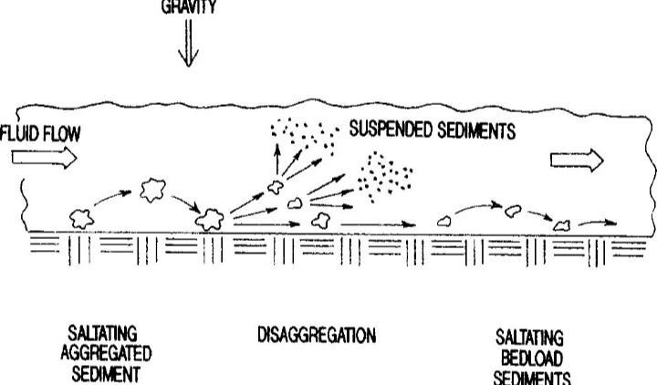
Figure 2.1 Cohesive aggregates eroded from the bed may disaggregate downstream(
Gust, 1976)

2.3 Quantitative Description of Ephemeral Gully Systems
The National Research Council (1986) provided a detailed overview of the problems of Ephemeral gully erosion, including relevant techniques for erosion rate predictions. The presented methods contained the techniques driven by empirical equations, models with average annual outputs, and physically and process-based models. Stein and Julien (1993) described the process of headcut migration and developed a theory with equations to distinguish two types of the process. One is a stepped headcut, and the other is rotating when headcut tends to flatten during migration. Montgomery (1994) studied the impact of road construction on a natural storm water system and emphasized on rill and gully initiation points. Theoretical equations were provided for the assessment of the erodibility, and they were compared for three study areas. Montgomery and Dietrich (1994) attempted to describe processes of channel initiation. By analysing flow equations and their relationship with thresholds for the channel initiation, Poesen et al. (2003) discussed the importance of the problem of gully erosion in their review publication and summarized the research carried out in this area of study. The relationship between the channel width and the flow discharged was suggested in order to define ephemeral gullies. Poesen et al. (2003) pointed out that, gully erosion was dependent on both spatial and temporal scale and that both of them could be major contributors to the total soil loss. Apart from providing a review of experimental studies in the area of ephemeral gully development, the researchers discussed the thresholds of critical shear stress for different soils and conditions, including conditions of ephemeral gully initiation. Valentin et al., (2005) studied how gullies were formed; these scholars also mentioned that the causes of gullies, such as farming without best management practices, increased precipitation intensity. Also explored were factors controlling gully formations such as topography, soil and lithology, land use and climate change. Similar conclusions about gully formation and its preventions were also found. Knapen et al. (2007) reviewed a published research article, on the critical shear stress and soil erodibility, as parameters for the erosion process of concentrated flow erosion. They found that these parameters are not related: There was a wide variability in the measurements and ranges of these coefficients and their dependence on various parameters such as vegetation, soil type, soil and moisture. With aerial imagery analysis, Brooks et al. (2009) conducted an analysis of alluvial gully formation processes for northern Australia tropics. This group of researchers hypothesized that land-use Change caused an increase in gullies formation. Kirkby and Bracken (2009) described the process of gully formation and the development of classical gullies by presenting two approaches to qualitative assessment of the gully development. In addition to that, Fox and Wilson (2010) Summarized research attempts to model and understand the influence of subsurface flow Processes on the channel erosion mainly by slope stability and pipe flow. Capra (2013) Presented a review of studies carried out on some aspects of ephemeral gully and gully erosion, Such as morphological characteristics, the contribution of gullies to overall erosion, and Regression and mathematical models of ephemeral gully erosion. Based on the review papers.

2.3.1 Topographical analysis
Moore and Burch (1986) studied gullies development by trying to create two and three dimensional erosion/deposition model for idealized hillslope element. They used an equation for a sediment transport capacity which utilizes unit stream power, critical unit stream power when the sediments motion occurs, functions of the median size, the kinematic viscosity of the water, and the terminal fall velocity of sediment particles in water. Moore et al. (1988) applied their model of topographic analysis to define the soil saturation factor considering local upslope contributing area per unit width. They also utilized the slope and the measure of the erosive power of runoff to predict the location of ephemeral gullies. Several field tests and measurements were carried out to validate the model. (Dietrich et al.,1993) produced physically based model which uses digital terrain model. Researchers developed three simple theories to model the runoff, the threshold for slope stability, and the threshold of erosion by the saturation overland flow. To determine the thresholds, all three models used two parameters: the drainage area per unit contour length and the local ground slope. These data could be easily obtained from the digital elevation data. While the thresholds for runoff and erosion were determined by mass conservation, the threshold for slope stability was obtained by the infinite slope stability model. Desmet and Covers (1996) studied several routing algorithms for routing water on the available Digital Elevation Model. Researchers divided algorithms into three groups and the chose flux decomposition algorithm as the best algorithm for estimating zones with increased probability for ephemeral gully formation. Vandaele et al. (1996) derived critical relations between the slope gradient and the upslope drainage area. They assembled results from previous researchers to conduct the survey. It was shown that critical slope gradient expression could be determined as a power function of a drainage area.
Vandekerckhove et al. (1998) used the same approach to determine the thresholds through the slope and the catchment area. However, they paid attention to the field survey so that the data used for the assessment would be more accurate.

2.4 Monitoring Approach
Foster and Lane (1983) presented a physically based model of channel development due to the concentrated flow. Their model computed the channel propagation with the excess shear Stress equation. Propagation is assumed at a constant rate based on the equilibrium width of the channel for known flow rate, including the proposed acting shear stress distribution along the channel bottom. The model assumes that the maximum peak flow rate is applied during the event with the duration equal to that of rainfall. If the non-erodible layer is met, then the model allows the computation of the non-uniform rate of channel widening up to the final equilibrium width Merkel et al. (1989) produce a physically based model to estimate ephemeral gully erosion. Researchers use an empirically based SCS curve number method for hydrology component and for calculating the peak runoff rate. However, the physically based approach was used to Estimate the erosion caused by this runoff. The soil detachment rate is calculated using the channel erodibility factor, the average shear stress, and the critical shear stress of the soil. The Same equation is used in CREAMS model. Researchers used the assumption that gully erodes to the tillage depths. Storm et al. (1990) developed Erosion Model for Dynamic Rill Networks. Apart from utilizing the kinematic wave equation to compute water flow, it modified the two-tier Channel Foster and Lane model to compute erosion rates. Fogle and Barfield (1992) continued the Research work of Storm et al. (1990) and developed a channel, a process-based model that Computes channel erosion by computing the distribution of the acting shear stress applied to the Channel walls. Robinson and Hanson (1994) created a physically based model to estimate the gully headcut development due to the intensive overland flow.

2.5 The flow Velocity of the Incipient Motion
The fall velocity or settling velocity of a particle is assumed to be a steady- state motion. It is also a function of size, shape, density and viscosity of fluid. Additionally, it depends on the extent of the fluid in which it falls, on the number of particles falling and on the level of turbulence intensity. Turbulent conditions occur when settling takes place in flowing fluid and can also occur when a cluster of particles is settling. For grain diameter d greater than 2mm, the fall velocity w can be approximated by equation 2.1:
𝑤 = √3. 32 𝑑₅₀(𝑚𝑚) (.1)
Falling under the influence of gravity the particle will reach a constant velocity named the terminal velocity, when the drag equals the terminal velocity, i. E. Difference of the solid and Fluid velocities, Vs- V= w; we obtain the following equation:

power of the flow, is resolved using a backward difference scheme. To simplify the numerical solution, the following approximations were incorporated: the flux Q is constant within the gully, that is Q (x, t) = Q(t), and the height D−D through which the waterfall drops is approximated by D0 −d, a constant in x. The constant flux assumption is valid where the time rate of change of the flux is small in comparison with the velocity of the flow, while the waterfall depth approximation will lead to an underestimate in the waterfall power available for erosion. These assumptions mean that the flow depth as well as the waterfall and stream power are functions of time only. The gully is discretised with a node every half a metre through the head and channel. The numpy odeint routine employs an adaptive timestep. The maximum timestep permitted was never more than 0.36 seconds. Gibbs phenomena (oscillations in the solution) are evident at the discontinuities in the erosive power or the flow, which is not unexpected. These discontinuities occur at the transition from the head to the channel (due to the waterfall power going to zero), at the porous check dams.

2.7 Empirical Models for Sediment Transport
When the flow conditions satisfy or exceed the criteria for incipient motion, sediment particles along the alluvial bed will start move. If the motion of sediment is “rolling”, “sliding” or “jumping” along the bed, it is called bed load transport. Generally, the bed load transport of a river is about 5-25% of that in suspension. For coarser material higher percentage of sediment may be transported as bed load.

2.7.1 Duboy’s approach
Duboys (1879) assumed that sediment particles move in layers along the bed and presented following relationship.
𝑞 = 𝑘(𝜏 − 𝜏_{𝑐}) 𝑓𝑡/𝑠 (2.3)
Where k ,
Where the relationship between 𝜏_{𝑐} , k and d are shown in the figure below
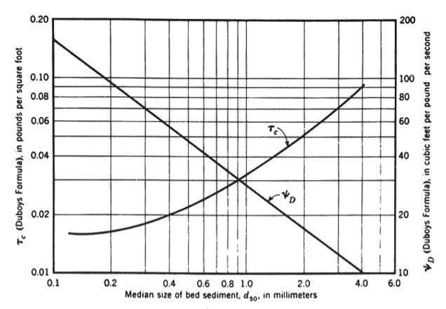
Figure2.2 Soil particles dislodging graph by Duboys (1879)

It’s suitable for streams flows since all the data are gotten from laboratory by use of flumes. In more sophisticated flows when compared with other models it tends to be more accurate (Paul et al., 2017).

2.7.2 Shields’ approach
In his study of incipient motion, Shield obtain semi empirical equation for bed-load which is given as:
𝜏 = ϒ𝐷𝑆 (2.6)
Where,
𝑞_{𝑏}= sediment transport rate
𝛾_{𝑠} and 𝛾_{𝑤} specific unit weight of sediment and water respectively
τ =shear stress
𝜏_{𝑐}=critical shear stress
D and S are depth of water and slope respectively,
The above approach is dimensionally homogeneous and fall above average when computing transport rate in small streams (paul et.,2017).

2.7.3 Meyer Meter’s approach
Meyer-Peter et al. (1934) conducted extensive laboratory studies on sediment transport. His formula for bed-load using the metric system is:
Where
D=depth of water flow
𝑑₅₀=average particle diameter.
The above equation is limited only to sandy soil with ϒ=2.65 specific gravity.

2.7.4 Schoklistch’s approach
Schoklistch pioneered the use of discharge for determination of bed load. There are two Schoklistch formulas:
Suitable for specific gravity of 2.65

2.7.4 Rottner’s approach
Rottner (1959) applied a regression analysis on laboratory data and Developed dimensionally homogenous formula give below:
0.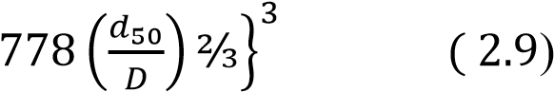
Where,
𝑞_{𝑏} = bed load discharge
ϒ_{𝑠}= specific weight of the sediment ℰ_{𝑠}= specific gravity of the sediment
g=acceleration due gravity
D= depth of flow
V=velocity
𝑑₅₀=average particle diameter
When compared with other model it falls above average value (Paul et al.,2017).

2. 8 Steady States Solutions
Previous research suggests the existence of a steady state solution (Hairsine, 1988; Hairsine and Rose, 1992), which is investigated here. At steady state the mass of the depositional Layer is constant, therefore the rate of entrainment and deposition within the gully channel Are equal, that is ηr = δ, which implies
In order for (2.9) to satisfy the conservation of mass equation (2.1) with ηr =Δ requires n = 0, a condition that cannot be satisfied. The steady depositional layer presumed in Hairsine and Rose (1992) and related papers is not a valid solution within gullies. This result is not unexpected. With ηr = δ, the spatial derivative of the mass flux CQ Is positive due to entrainment from the gully walls. Neglecting the carrying capacity term for a moment, this gives a linearly increasing concentration with distance. However, in order for Re-entrainment and deposition to be in balance, this would require that the re-entrainment Also increased linearly with distance since deposition is a linear function of the concentration. Under constant flux conditions, re-entrainment is constant in x outside of the carrying capacity term, and therefore is unable to adapt to balance the increased deposition, breaching The steady state requirement.

2.9 Linear Regression Modelling
In statistics, linear regression is a statistical model which estimates the linear relationship between a scalar response and one or more explanatory variables (also known as dependent and independent variables). The case of one explanatory variable is called simple linear regression; for more than one, the process is called multiple linear regression (David, 2009). This term is distinct from multivariate linear regression, where multiple correlated dependent variables are predicted, rather than a single scalar variable the explanatory variables are measured with error then errors-in-variables models are required, also known as measurement error models. IN linear regression, the relationships are modelled using linear predictor functions whose unknown model parameters are estimated from the data. Such models are called linear models (Rencher, 2012). Most commonly, the conditional mean of the response given the values of the explanatory variables (or predictors) is assumed to be an affine function of those values; less commonly, the conditional median or some other quantile is used. Like all forms of regression analysis, linear regression focuses on the conditional probability distribution of the response given the values of the predictors, rather than on the joint probability distribution of all of these variables, which is the domain of multivariate analysis (Hilary, 1967).

2.10 Effect of Vegetation on Flow Resistance
Vegetation presents a special problem in hydraulic computations because the boundary
Roughness changes greatly as a function of factors such as flow depth, velocity, and the Biomechanical characteristics of the Vegetation. The sediment roughness value n can change remarkably during flow events as vegetation is Inclined of flattened by the flow. Torres (1997) collected data from 452 experiments in a grassed channel with flow depths from 0.018 to 0.81 m and vegetation height ranging from 0.05 to 0.9 m. The variation in Manning's n value with respect of channel mean velocity V, and submerged ratio hv, for grass channels is given by Torres (1997) in Fig 2.2. In which h and hv represents water depth and the vegetation height, respectively.

2.10.1 Harnessing the potential of morning glory
Ipomoea Carnea is popularly called Ana Kwari meaning (preventer of river formation) in Hausa language, Northern Nigeria. As the name implies, choisy plant grows and spread in form of cover crops in fields especially along water courses and wetlands. Ipomoea Carnea Jacq. (Family: Convolvulaceae) commonly known as Bush morning glory, blue Dawn flower or bindweed and popularly called Choisy Plant named after Choisy J. D. Who researched extensively on Ipomoea Plant, scientific name of Choisy plant is Ipomoea and belong to about
60 genera also tapered, large, with 6–8 cm, very flashy, frequently blue, but sometimes white, pink or multi-coloured. The fruits are capsules with 10–13 mm diameter, with 4–6 seeds inside (Jha, 1995). The leaves of the Nigerian species (Ipomoea Carnea) are fleshy and single lobed. And about 2000 specie (Austin, 1997). Mostly herbaceous perennial shrub plant with vines that climb up to 15 m stretch. More than one-third of the species are included in two Major genera,
Ipomoea and Convolvulus. It grows originally from the tropics of South America, North
America (USA), Asia, parts of Africa, Australia, New Zealand and some pacific islands (Jha 1995). in dense populations along river beds, river banks, canals and other wetland areas. Many tropical species are use as valuable ornamentals, medicinal, and food crop. Ipomoea is the largest genus in the family with over 500 species, among which; Is Ipomoea Carnea Jacq.
Species. In natural habitats, they Are mainly found in watercourses where it threatens riparian Vegetation. Farmers use it as ornamental and hedge plant Along the banks of irrigation and drainage canals in the Nile Delta, Egypt (Bhalerao et., 2006). Choisy shrubs are fast-growing plant and drought-resistant once established (Kamal et al.,2017).

CHAPTER THREE

3.0 MATERIALS AND METHOD

3.1 Study Area
The study area is located along Zaria- Sokoto express road of Samaru. It is located within latitude 11.118°N and longitude 7.6548°E (Mortimore, 1970; Bako, 2011). The climate condition is of tropical continental climate with well-defined wet and dry season (Aw climate of Koppen’s classification). It entails six (6) months of wet season and six months of dry season. Its rainy season commences in May and ends in October with a single peak in August, while the dry season starts from November and ends in April of the following year. The daily maximum temperature rises gradually from 33⁰C to 40⁰C and it reaches it peak in April. The influence of two masses which are tropical continental air mass (CT) and tropical maritime air mass (MT) constitute to the prevailing weather condition in the study area (Epo et al., 2020).The geology of the area is underlain by crystalline metamorphic and igneous rocks of precambrian to lower paleozoic age quartz, schists, laterities and aluminium which are formed due to depth of weathering activities (Spencer, 2003; Bako, 2011). Thus, leads to leached ferruginous soils that are rich in iron oxide, mica and feldspar. These soils have marked clear horizon differentiation. The soil has high clay content with an overlain drift and shallow surface capping due to high rainfall intensity which infiltrates and favours and overland floor
(Jaiyeoba, 1986). Agricultural activities, fishery, poultry and vegetation
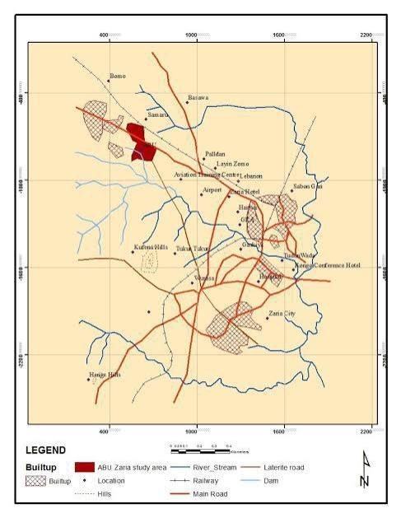
Figure 3.1 Map of the Study Area

gardens made at a small scale are common within campus but extensive agricultural activities are carried out kilometres away.
The study area is a tributary of a river Kaduna which floors from Ahmadu Bello University Dam output channel to main rivers. The channel is basically irregular in shape with no specified orientation. The flow along the channel is unsteady during raining season. However, from September to April, the flow along the channel is steady. Plates 1 and 2 show the nature of the stream channel.
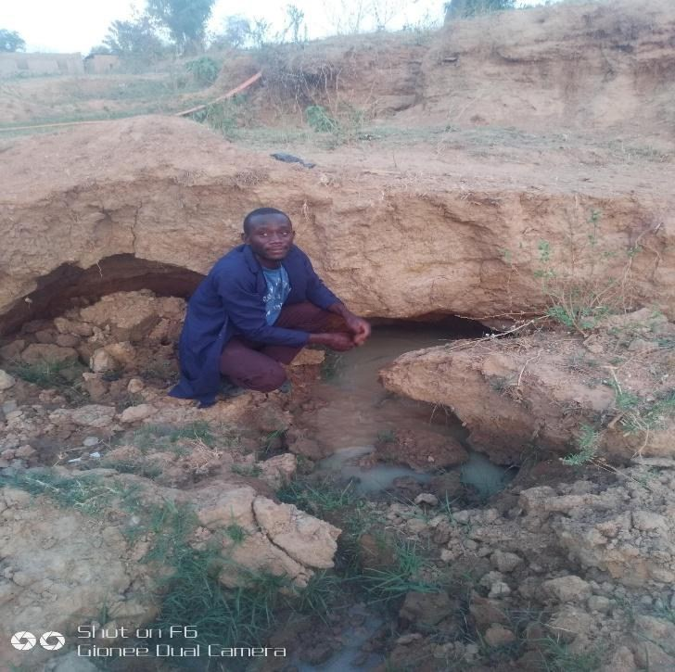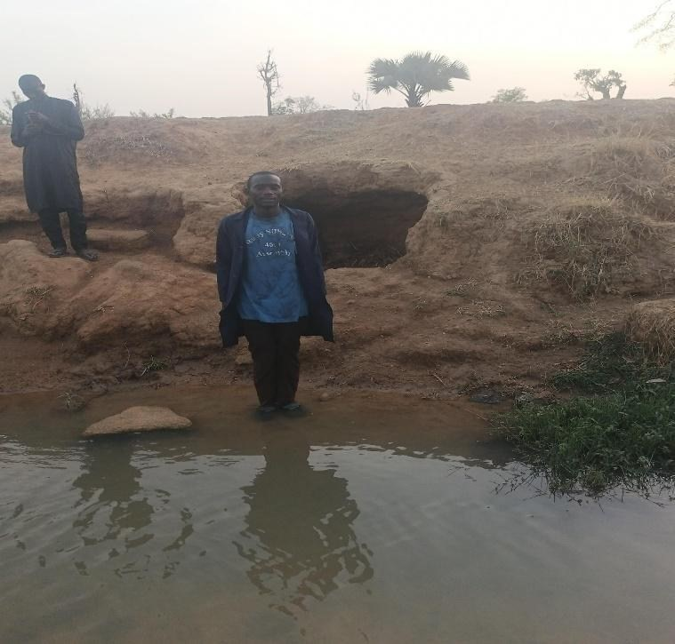

Plate I Spot 1 along the Watercourse Plate II Spot 2 along the Watercourse

3.2 Description of Original Design Characteristics
In 1988, the downstream channel was originally designed as a rectangular grassed watercourse, intended to manage and convey surface runoff effectively. The key design characteristics of the channel were as follows; the channel was designed to be 1.5 meters wide. This width was intended to accommodate the expected flow of water while minimizing the risk of overflow and erosion. The channel had a depth of 0.5 meters. This depth was chosen to ensure sufficient capacity for water flow and to maintain a stable flow regime under typical conditions. The channel was rectangular in shape, providing a uniform cross-sectional area to facilitate predictable water flow and sediment transport. The channel was grassed, which was intended to stabilize the banks and bed, reducing the likelihood of erosion and promoting vegetative growth to further stabilize the channel.
The original design was created with the goal of managing surface water runoff and reducing potential flooding in the area. The grassed lining was expected to act as both a protective layer against erosion and a means to absorb and slow down water flow, which would help in maintaining the channel's structural integrity and functionality over time. In the context of the project aim, it is essential to compare these original dimensions and design features with the current state of the watercourse. This comparison will help in assessing the impact of erosion and other factors that have led to changes in the channel's capacity and form, ultimately guiding recommendations for restoration or improvement.

3.2.1 Measurement of watercourse length and dimensions
The total length of the watercourse for the study is 2.5 kilometers, and this measurement is divided into sections of 125 meters each for detailed examination. The individual sections measured 125 meters each, which, when combined, correspond to the total study length of 2.5 kilometers. This approach ensures that the entire 2.5 kilometer stretch is accurately covered and analysed in manageable segments. Dividing the total 2.5 kilometer watercourse into sections of 125 meters allows for a more manageable and detailed analysis. Each 125 meter section can be measured and studied more accurately, facilitating a thorough examination of the watercourse's characteristics and conditions. This approach also helps in identifying specific features or changes within each segment, ensuring that no part of the 2.5 kilometer stretch is overlooked and that the data collected is precise and comprehensive.
For the watercourse segment under study, the following measurements were taken:
- Breadth : The width of the watercourse at each measurement point was recorded using a tape measure.
- Depth Measurements: Due to the irregular nature of the gully system, depth measurements were taken at two different locations within the watercourse at each measurement point:
- Depth A: Measured using a staff rod.
- Depth B: Also measured using a staff rod.
- Average Depth: Calculated as the mean of Depth A and Depth B. This average was used to account for the irregularities in the gully system.
Measurements were conducted systematically every 125 meters along the length of the watercourse. This interval was chosen to provide a representative sample of the watercourse's variability while maintaining practical measurement constraints.
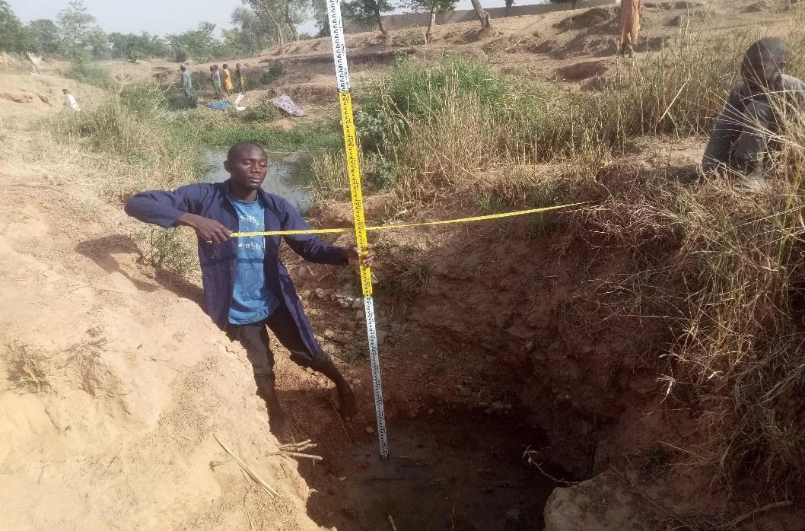
Plate III Establishment of Current situation along Watercourse

3.3 Sediment Transport Modelling using Linear Regression
In this context, novel research development was carried out where the velocity of stream channels (m/s) was correlated with the Duboys (1879) shear approach model. Linear modeling based on experimental observations was conducted, and an equation was established to analyse or predict sediment transport rate at any given velocity. The results indicated that Morning Glory, particularly when combined with other control measures, effectively reduced the erosive forces within the gully system, thereby protecting the land and infrastructure within the university.

3.3.1 Collection of hydrological data and sediment transport metrics
The collection phase begins with the temporary damming of the stream using check dams. Two locations within the gully-affected zone will be identified and marked as Point 1 and Point 2, as illustrated in Figure 3.2 below:
Point 1 |  | Point 2
125
m length

Figure 3.2 Damming along Stream Channel

At Point 1, the water pressure was increased by constructing a dam across the upstream channel. Water upstream of Point 1 was allowed to accumulate until it reached a predetermined level associated with gully effects. A small, adjustable spillway was created at Point 1 to manage water release. Meanwhile, the dam at Point 2 was gradually opened, allowing for the monitoring of water depth and velocity in the downstream channel. Flow velocity was measured using the Floating method. The collected data was analysed and presented in Table 3.1. In this study, the collection phase involved the temporary damming of the stream to facilitate accurate measurement of sediment transport rate, flow velocity, and water depth. This controlled approach helped in isolating the effects of these variables from natural gully dynamics.
Table 3.1 | Empirical Data of Stream
Depth  flow(ft) | of | Sediment  (𝒅_{𝟓𝟎}) | size | Sediment transport  (lb/s/ft) | rate | Sediment transport rate  (kg/s/m) | Velocity flow(m/s) | of
. |  | . |  | . |  | . | .
. |  | . |  | . |  | . | .
... |  | ... |  | ... |  | ... | ...

In the field, the sediment transport rate was determined through the following steps:
- Shear Stress Measurement: the shear of the soil was measured using the formular below:
𝝉 = ϒ𝑫𝑺 (𝒔𝒕𝒓𝒂𝒖𝒃, 𝟏𝟗𝟑𝟓)
- Sediment Transport Rate Calculation: The constant 𝜏_{𝑐} is obtained from the Duboys shear graph, reflecting the sediment transport threshold.
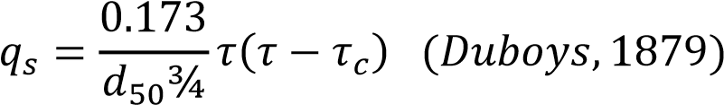
By applying these field measurements and calculations, the sediment transport rate was effectively assessed based on actual conditions observed in the field.
The following indices was used in evaluating the sediment transport rate in the channel.
1.Depth of the Channel: By use of stadia rod
2.Width of the Channel: by use of a tape
3.Sediment Size (𝑑₅₀): American standard for testing and material ASTM D 6913, sieve analysis or gradation analysis will be used to determine average particle diameter by taking soil samples.
4.Slope: Garmin global positioning system machine of National Agricultural Extension and Research Liaison Services (NAERLS) or mobile Clinometer/Altimeter will be used to determine the slope of the channel.

3.3.2 Selecting of variables
From the experimental values in Table 3.1, sediment transport rate and velocity were selected. The assumption was that there was a linear relationship between the velocity of flow and sediment transport rate (Van Rijn, 1984a,b,c).

3.3.3 Model formulation
The resulting selected variables were determined to follow a linear regression relation. Based on the analysis of their relationship, the linear model took the form of equation 3.
𝑄_{𝑠} = ∅𝑣_{𝑠} ± 𝑁 (3.1)
Where,
𝑄_{𝑠}= sediment transport rate (Ib/sec)/ft
𝑉_{𝑠} = velocity of stream ft/sec
N = intercept
∅ = small change in 𝑞_{𝑠} with respect to 𝑉_{𝑠}.
Using 𝑞𝑠 = ∅ 𝑉_{𝑠} ± 𝑁 , it was determined that at a given stream velocity, (𝑞_{𝑠}) could be calculated since (∅) and (N) were constant values after the planting of the control measure (Morning Glory). The erosion rate could then be determined by measuring the stream velocity and using the empirical equation above to predict the sediment transported. This prediction was compared with the standard erosion rate from the Duboys shear graph.

3.4 Gully Erosion Control using Morning Glory
Early in April 2024, morning glory (Ipomoea carnea) was planted in the research area’s stream channel. The final data collected following crop establishment, which typically took 1.5 months for full growth when propagated by stems, was compared to the initial data on sediment rates prior to the implementation of the control measure. When grown by stem cuttings, the plant fully regenerated within just 1.5 months due to its fibrous root structure, deeper rooting under the soil, and larger leaf area index (Lawrence et al., 1938). A major priority was to successfully utilize the plant characteristics of morning glory to harness its potential and achieve a sustainable solution for the gully in the research region. Hence, double density striking was used as the planting technique. The crops fully matured and were anticipated to control ravines and gullies throughout the study season.

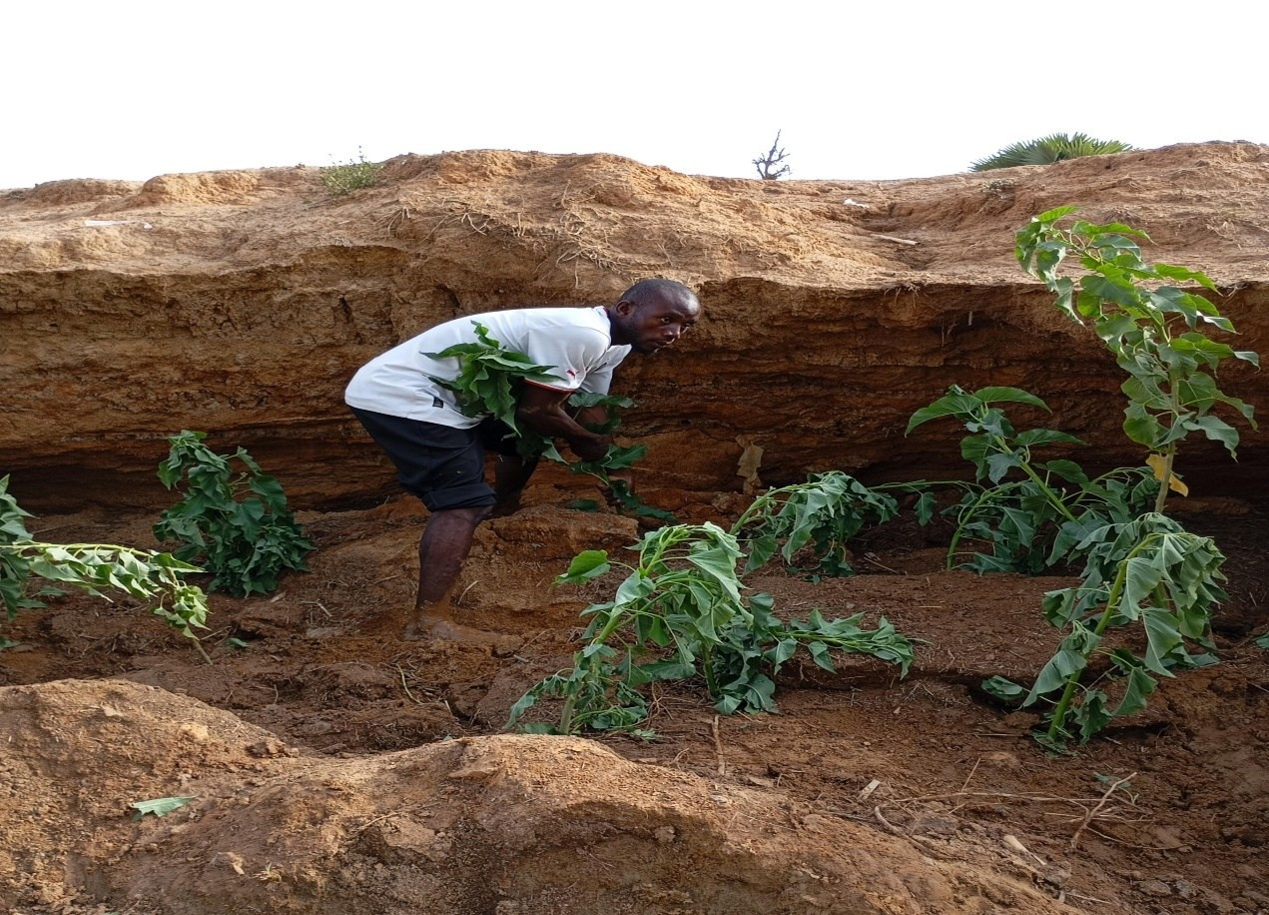
Plate IV Planting of morning glory stems along the stream banks

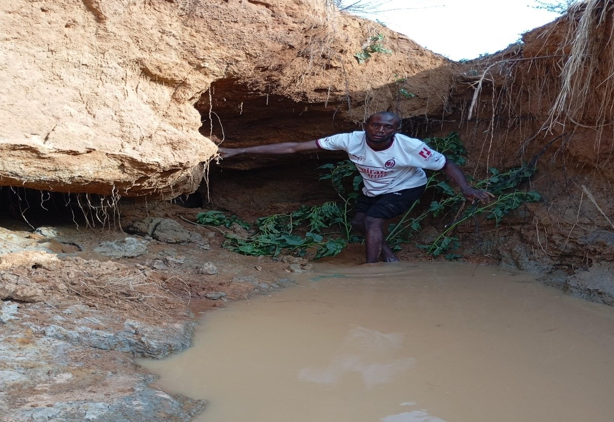
Plate V Planting of morning glory at the upstream spot along the watercourse

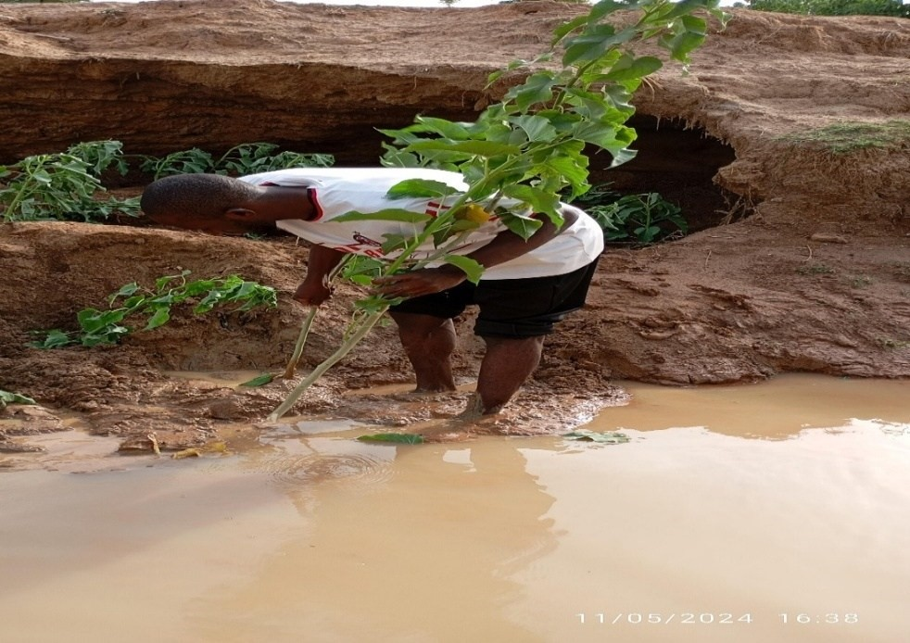
Plate VI Planting of morning glory at downstream spots along water course

3.4.1 Monitoring of morning glory (Ipomoea carnea) growth
Monitoring the growth of morning glory (Ipomoea carnea) plants is integral to understanding their effectiveness in erosion control. This section focuses on the methodology and procedures for systematically monitoring the growth of morning glory plants throughout the project duration.

3.4.1.1 Stage of planting
Planting Morning Glory stems correctly in areas identified as prone to erosion was the first step. The planting procedure was closely observed to ensure even dispersal and adequate coverage throughout the assigned locations.

3.4.1.2 Monitoring germination
The germination of Morning Glory stem cuttings was thoroughly observed after planting. This involved monitoring the stems as they germinated and took root in the ground.

3.4.1.3 Monitoring growth
Current observations of Morning Glory plants’ growth were conducted to evaluate their influence on erosion control measures. Any indications of illness, pest infestation, or stunted development were recorded.

3.4.1.4 Evaluation of coverage
The amount of Morning Glory plants covered in the soil on a regular basis was measured.
Sufficient coverage was deemed essential for effective erosion management.

3.4.1.5 Evaluation of root development
Monitoring Morning Glory root development was essential to ensure the formation of a robust root system. This system was crucial for stabilizing the soil and preventing erosion.

3.4.2.6 Analysis of effectiveness
Over time, the effectiveness of Morning Glory in managing erosion will be evaluated. To assess the project’s success, variations in soil erosion rates and the condition of the planting area will be noted.

3.4.1.7 Upkeep protocols
When required, maintenance practices such as fertilizing and watering will be carried out to ensure the sustained health and productivity of the Morning Glory plants.

3.5 Erosion Rate Control Technique
Morning Glories will be utilized to slow down the rate of erosion in the gully. Once the plants have fully established, the degree of the channel’s erosion vulnerability will be analysed by calculating or determining data and comparing it with the data collected prior to planting, as illustrated below.
In the event of 𝑞_{𝑠𝑏<}𝑞_{𝑠𝑎} it shows (controlled erosion),
And 𝑞_{𝑠𝑏>}𝑞_{𝑠𝑎} It shows (uncontrolled erosion)
Where,
The sediment rate prior to erosion control 𝑞_{𝑠𝑏}
Sediment rate following or after erosion control 𝑞_{𝑠𝑎}
An alternate method that takes into account the depths along the stream channels is the Duboys shear stress approach. The critical shear stream was analysed using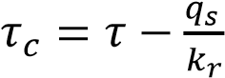, and the sediment was quantified using the empirical model 𝑞_{𝑠} =∅vs± N. The critical shear was evaluated against a standard 𝜏_{𝑐} threshold value above which the soil is under erosion and below which the soil profile is safe.

CHAPTER FOUR

4.0 RESULTS AND DISCUSSION

4.1 Current Channel Dimension
In 1988, the downstream channel’s original design was a rectangular grassed watercourse with dimensions of 1.5 meters in width and 0.5 meters in depth. This design was intended to manage and convey water flow while integrating with the surrounding environment. The current characteristics of the watercourse have deviated significantly from the original design, as evidenced by recent measurements and observations. Table 4.1 presents a detailed analysis of the channel’s current dimensions and characteristics, which reveal the following changes; The channel’s width has generally increased from 1.5 meters to a range between approximately 1.78 meters and 3.35 meters at various points. Depth measurements vary significantly, ranging from 1.10 meters to 2.86 meters, in contrast to the original depth of 0.5 meters.
The average depth has increased considerably, with values ranging from 1.40 meters to 2.83 meters, compared to the original 0.5 meters. The slope of the channel, measured in percentages, varies between 0.56% and 2.10%. The variation in slope indicates changes in channel gradient which may affect flow dynamics and sediment transport. The channel now exhibits a more complex and intricate form with the development of gullies, suggesting significant morphological changes. These alterations could result from increased flow volumes, erosion, or sediment deposition over time. The original design aimed for a simpler, less erosive channel structure, while the current state shows a channel that has evolved to a more irregular form with greater depth and varying width. This suggests that the watercourse has undergone significant changes due to environmental factors, land use changes, or alterations in water flow patterns.
The increased depth and width of the channel could impact the hydraulic performance, potentially leading to higher capacity for water conveyance but also possible issues with erosion and stability due to the more complex gully formations. The changes in the channel’s morphology may have implications for maintenance practices, ecological habitats, and overall channel stability. The increased depth and the development of gullies may require adaptive management strategies to address erosion, sediment control, and habitat preservation.

Table 4.1 Establishment of Current characteristics of the channel.
Spot(125m)  Interval | Breadth(m) | Depth 1(m) | Depth 2 (m) | Average depth (m) | Slope (%)
1 | 1.78 | 2.10 | 2.20 | 2.15 | 0.90
2 | 1.95 | 2.20 | 2.01 | 2.10 | 0.67
3 | 1.92 | 1.83 | 1.85 | 1.84 | 1.20
4 | 2.01 | 1.95 | 1.90 | 1.92 | 0.95
5 | 2.20 | 2.80 | 2 .86 | 2.83 | 0.90
6 | 2.30 | 2.50 | 2.54 | 2.52 | 0.70
7 | 1.94 | 3.00 | 2.54 | 2.77 | 1.10
8 | 2.70 | 2.20 | 2.23 | 2.22 | 0.76
9 | 2.30 | 2.50 | 2.23 | 2.37 | 0.56
10 | 2.20 | 2.30 | 2.31 | 2.31 | 2.10
11 | 1.90 | 1.95 | 1.95 | 1.95 | 1.30
12 | 3.00 | 1.67 | 1.65 | 1.66 | 1 .40
13 | 2.20 | 1.53 | 1.53 | 1.53 | 0.96
14 | 1.98 | 1.65 | 1.96 | 1.96 | 0.96
15 | 2.01 | 1.83 | 1.84 | 1.84 | 1.05
16 | 2.23 | 1.76 | 1.67 | 1.72 | 1.12
17 | 2.52 | 1.10 | 1.10 | 1.10 | 1.10
18 | 3.35 | 1.23 | 1.20 | 1.22 | 1.51
19 | 2.96 | 1.76 | 1.7 | 1.73 | 1.32
20 | 2.81 | 2.01 | 2.01 | 2.01 | 1.08

The depths of the channel changes with a peak value in spot 18 and this is due to poor graded nature of the soil profile in the spot. In the establishment of the current characteristics of the water course a higher variation was observed and this is due development of gully profile along the water course. This figure presents a comparison between the current breadth of the channel measured at 20 different spots and the original design breadth of 1.5 meters. The data shows that the current breadth measurements are consistently greater than the original design, indicating a widespread increase in the channel's width. The significant increase in breadth across the majority of spots is indicative of extensive gully erosion. This process has likely caused the channel to widen over time, deviating substantially from its intended design. This erosion could be a result of increased water flow, loss of vegetation, or other contributing factors.
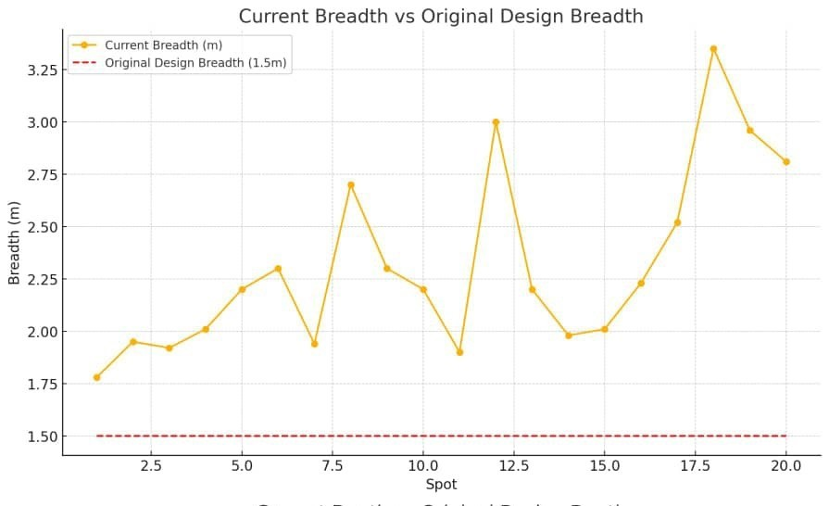
Figure 4.1 Designed breadth and current breadth of the watercourse

figure 4.2 contrasts the current depth of the channel at the same 20 spots with the original design depth of 0.5 meters. The current depths are generally much greater than the original design, with some spots showing particularly significant increases. The increased depth observed at various locations suggests that gully erosion has also led to scouring and deepening of the channel. The removal of sediment by erosive forces has caused the channel to become deeper than initially planned, further altering its hydraulic characteristics. While the increased depth may temporarily enhance the channel's water-carrying capacity, it also poses a risk to the stability of the channel banks. The deepened channel is more prone to further erosion, which could exacerbate the problem. The figure underscores the need to address gully erosion through targeted control strategies to stabilize the channel and restore its intended design dimensions.

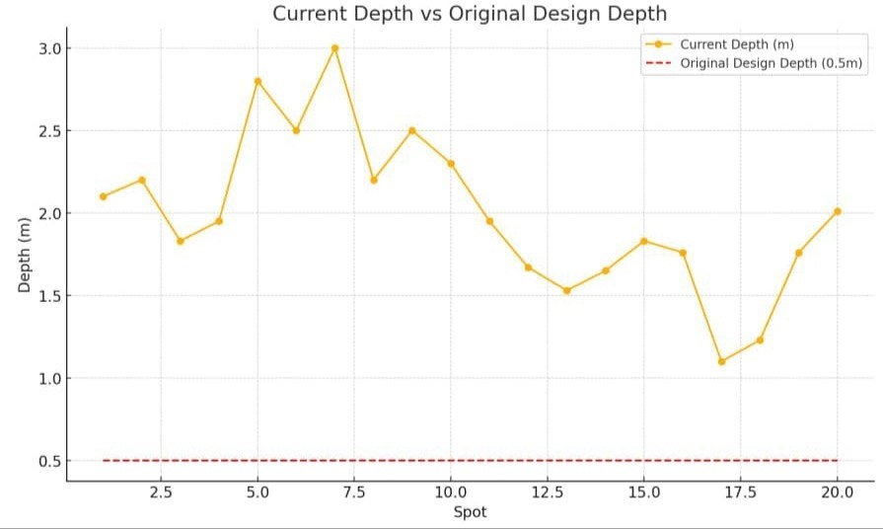
Figure 4.2 Designed depth and current breadth of the watercourse

4.2 Hydrological Data and Sediment Transport Metrics Results within the Watercourse
The focus is on understanding the results from various experiments conducted to assess and mitigate gully erosion within a specific watercourse at Ahmadu Bello University. The experiments were designed to measure key factors such as sediment transport, soil shear, and flow velocity under different conditions, particularly before and after implementing erosion control measures. Additionally, the experiments looked at the effects of ponding water at different depths (1.0m and 1.5m) outside the gully system, providing insights into how water management affects erosion. Ponding water outside the gully system and subsequently releasing it to make measurements served a critical purpose. This method was employed to simulate real-world hydrological conditions that could exacerbate gully erosion. In natural environments, water can accumulate in depressions or adjacent areas to a gully during heavy rainfall or due to nearby water sources, leading to a ponding effect. Once the ponded water is released either due to overflow or natural drainage the increased volume and pressure of water entering the gully can significantly enhance the erosive forces, accelerating gully formation and sediment transport.
Plate 4.1 shows the initial setup of morning glory plants along the gully within the watercourse of Ahmadu Bello University Dam. The dense vegetation aims to stabilize the soil and prevent erosion. Plate 4.2 displays the same area after the plants have established, revealing significant soil stabilization. The growth of morning glory has effectively reduced soil erosion, with roots binding the soil and reducing runoff impacts. These images illustrate the successful application of morning glory in controlling gully erosion, demonstrating improved stability and health of the watercourse downstream.
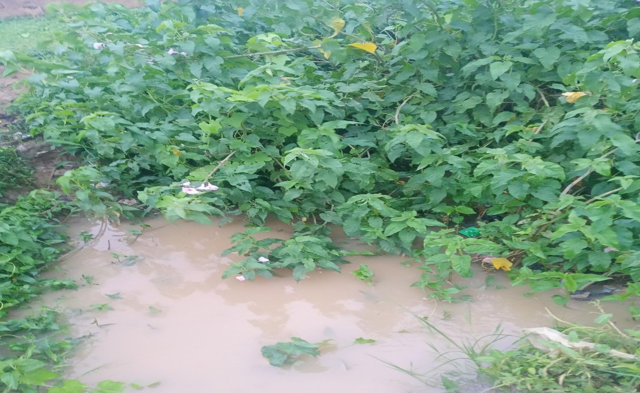
Plate VII Established morning glory in the watercourse to control gully erosion

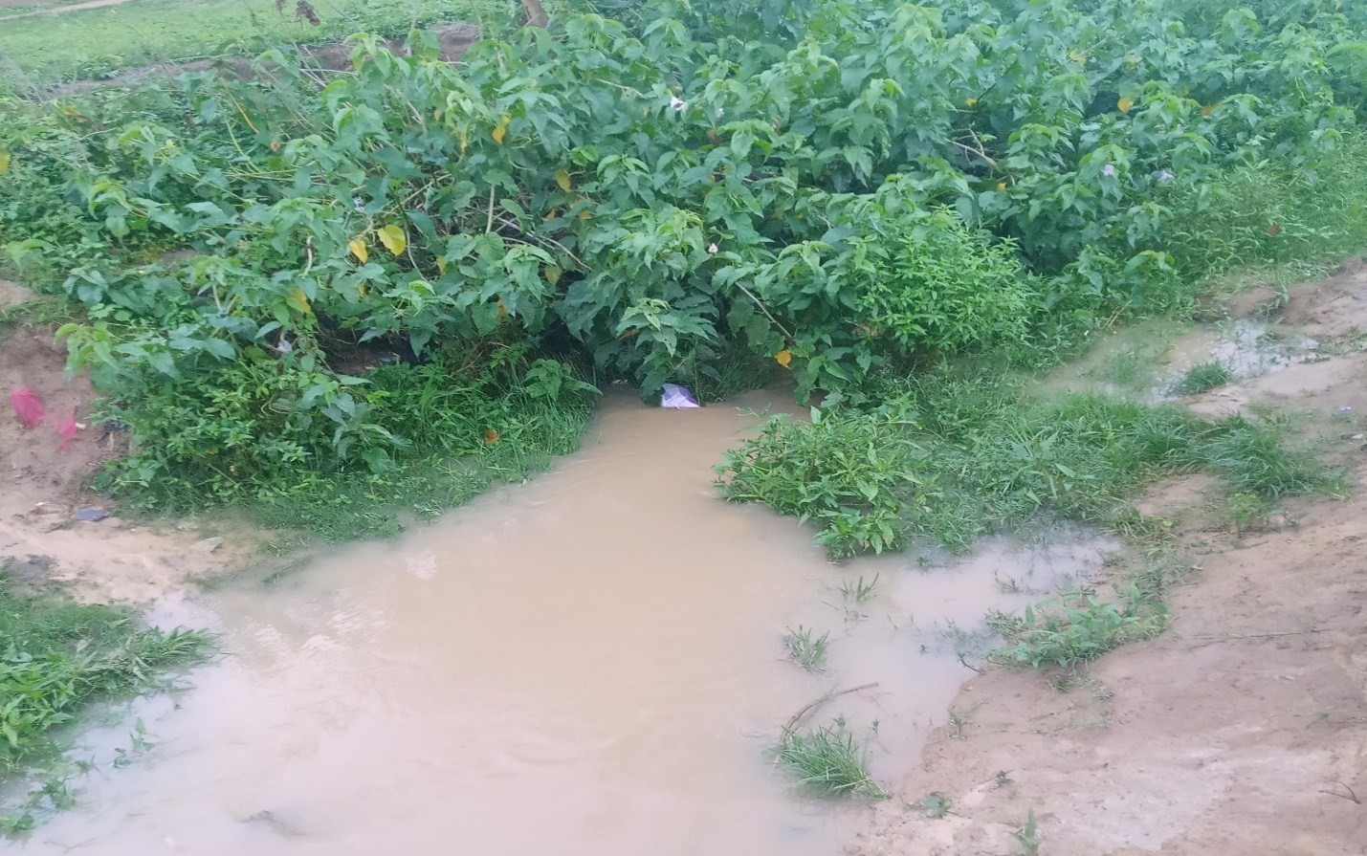
Plate VIII Established morning glory in the watercourse to control stream bank erosion

4.2.1 Pre-Control Gully System Data
The baseline data obtained before any intervention was made to control erosion. Sediment transport refers to the movement of soil particles and debris carried by flowing water. Before any control measures were implemented, the data in Table 4.2 showed that sediment transport rates were high, especially in areas where the flow velocity of water was greater. For example, at a velocity of 1.51 m/s (measured at S/N 10 in the dataset), sediment transport was significantly higher. This is because faster-moving water has more energy, enabling it to pick up and carry more sediment. Consequently, this increases the erosion potential, especially in steeply sloped areas where water flow accelerates naturally due to gravity. Soil shear refers to the force that resists the movement of soil particles. In the pre-control state, soil shear values varied across different sections of the gully, ranging from 0.312 to 1.061 lb/ft². Higher shear values indicate more resistance to erosion, yet in some cases, these higher values were still associated with significant sediment transport. This suggests that despite the soil’s natural resistance, the energy of the water was sufficient to overcome this resistance and cause erosion.

Table 4.2 Pre-control gully system data before ponding water outside the system
S/N | Depth of water(ft) | Slope  (Decimal) | Soil shear(Ib/ft²) | Sediment transport In/s/410ft  20.64 | Sediment transport(kg/s/m) | Velocity of flow (m/s)
1 | 0.94 | 0.0090 | 0.530 |  | 0.24 | 0.75
2 | 1.24 | 0.0067 | 0.499 | 15.90 | 0.19 | 0.63
3 | 1.44 | 0.0120 | 1.061 | 84.19 | 1.00 | 1.07
4 | 1.15 | 0.0095 | 0.690 | 35.27 | 0.42 | 0.89
5 | 1.05 | 0.0090 | 0.561 | 23.17 | 0.28 | 0.81
6 | 0.66 | 0.0070 | 0.312 | 6.989 | 0.08 | 0.63
7 | 1.32 | 0.0110 | 0.936 | 65.46 | 0.78 | 1.01
8 | 0.98 | 0.0076 | 0.437 | 13.95 | 0.16 | 0.63
9 | 0.82 | 0.0056 | 0.312 | 6.89 | 0.08 | 0.23
10 | 0.52 | 0.0210 | 0.680 | 34.61 | 0.41 | 1.51
11 | 0.98 | 0.0130 | 0.811 | 48.92 | 0 58 | 1.05
12 | 0.82 | 0.0140 | 0.686 | 34.86 | 0.41 | 0.85
13 | 0.98 | 0.0096 | 0.580 | 24.79 | 0.29 | 0.83
14 | 0.81 | 0.0096 | 0.480 | 16.86 | 0.20 | 0.97
15 | 0.72 | 0.0105 | 0.499 | 18.28 | 0.22 | 0.94
16 | 0.75 | 0.0112 | 0.499 | 18.28 | 0.22 | 1.07
17 | 1.21 | 0.0110 | 0.811 | 48.91 | 0.58 | 0.90
18 | 1.08 | 0.0151 | 0.998 | 33.55 | 0.39 | 0.90
19 | 1.08 | 0.0132 | 0.874 | 29 .38 | 0.35 | 0.97
20 | 1.09 | 0.0108 | 0.749 | 41.64 | 0.495 | 1.09

4.2.2 Pre-Control Data After Ponding at 1.0m Depth
After introducing a ponding depth of 1.0m,Table 4.3 shows the dynamics of the gully system changed considerably. When ponding was applied at a depth of 1.0m, the results indicated a marked increase in sediment transport. For instance, the sediment transport rate jumped to
302.62 Ib/s/410ft at S/N 3, which is significantly higher than the rates observed before ponding. This increase can be attributed to the additional water volume and pressure exerted by the ponded water, which, when released into the gully, intensified the erosion process by further increasing flow velocity and the force of water on the soil. The introduction of ponded water also impacted the flow velocity. Water released from the ponded area likely carried more kinetic energy, leading to higher velocities in the gully. For example, at S/N 10, the flow velocity increased to 2.0 m/s. This higher velocity is a concern because it means that water is moving faster through the gully.

Table 4.3 Pre-control data after ponding water outside the gully system successively (1.0m depth)
S/N | Depth of water(ft) | Slope  (Decimal) | Soil shear(Ib/ft²) | Sediment transport  In/s/410ft  105.23 | Sediment transport(kg/s/m) | Velocity of flow (m/s)
1 | 2.11 | 0.0090 | 1.18 |  | 1.25 | 1.20
2 | 3.20 | 0.0067 | 1.34 | 135.69 | 1.61 | 1.00
3 | 2.00 | 0.0120 | 2.40 | 302.62 | 3.60 | 1.50
4 | 3.11 | 0.0095 | 1.84 | 256.01 | 3.05 | 0.90
5 | 2.10 | 0.0090 | 1.18 | 96.21 | 1.15 | 1.25
6 | 1.09 | 0.0070 | 0.48 | 16.40 | 0.20 | 1.40
7 | 3.21 | 0.0110 | 2.20 | 366.35 | 4.35 | 1.30
8 | 1.12 | 0.0076 | 0.53 | 20.93 | 0.24 | 0.90
9 | 1.01 | 0.0056 | 0.35 | 9.03 | 0.11 | 0.70
10 | 1.21 | 0.0210 | 1.58 | 189.29 | 2.25 | 2.00
11 | 1.21 | 0.0130 | 0.98 | 72.25 | 0.86 | 1.30
12 | 2.21 | 0.0140 | 1.93 | 281.75 | 3.35 | 1.20
13 | 2.02 | 0.0096 | 1.21 | 110.37 | 1.31 | 1.00
14 | 3.21 | 0.0096 | 1.92 | 278.83 | 3.32 | 1.10
15 | 2.01 | 0.0105 | 1.32 | 131.45 | 1.56 | 1.30
16 | 0.98 | 0.0112 | 0.68 | 34.61 | 0.41 | 1.20
17 | 2.21 | 0.0110 | 1.51 | 172.19 | 2.05 | 1.00
18 | 1.09 | 0.0151 | 1.03 | 79.85 | 0.95 | 1.10
19 | 1.31 | 0.0132 | 1.08 | 87.84 | 1.05 | 1.30
20 | 2.10 | 0.0108 | 1.42 | 152.21 | 1.81 | 1.30

4.2.3 Post-Control Data After Ponding at 1.0m Depth
This section examines the data after erosion control measures were applied, with ponding still at 1.0m depth.
After the control measures were implemented, Table 4.4 shows there was a significant reduction in sediment transport across all measured points. For example, sediment transport at S/N 1 dropped to 20.19 Ib/s/410ft. This reduction suggests that the measures effectively stabilized the soil and reduced the water’s capacity to erode and carry sediment downstream. Control measures likely included physical barriers, vegetation planting, or other methods designed to reduce the energy of flowing water and strengthen soil cohesion. With the introduction of control measures, soil shear values also decreased. For instance, at S/N 1, the shear value dropped to 1.08 lb/ft², reflecting a lower erosive force on the soil. This decrease indicates that the soil was less likely to be dislodged and carried away by water, further validating the effectiveness of the erosion control strategies.
Table 4.4 depicts the flow velocity remained relatively high in some sections, it was more controlled compared to the pre-control state. The moderated flow velocity, such as 1.0 m/s at S/N 1, suggests that the measures successfully dampened the energy of the water, preventing it from gaining enough speed to cause significant erosion. This balance is crucial in maintaining the stability of the gully system while allowing water to flow naturally.

Table 4.4 Post-control data after ponding water outside the gully system successively (1.0m depth)
S/N | Depth of water(ft) | Slope  (Decimal) | Soil shear(Ib/ft²) | Sediment transport In/s/410ft  20.19 | Sediment transport(kg/s/m) | Velocity of flow (m/s)
1 | 1.92 | 0.0090 | 1.08 |  | 0.95 | 1.00
2 | 2.81 | 0.0067 | 1.17 | 94.19 | 1.12 | 0.75
3 | 2.12 | 0.0120 | 1.59 | 174.39 | 2.07 | 1.20
4 | 2.73 | 0.0095 | 1.62 | 181.05 | 2.10 | 0.90
5 | 1.56 | 0.0090 | 0.88 | 47.18 | 0.56 | 1.25
6 | 1.09 | 0.0070 | 0.47 | 14.99 | 0.18 | 1.40
7 | 2.36 | 0.0110 | 1.61 | 179.91 | 2.14 | 1.20
8 | 1.12 | 0.0076 | 0.53 | 19.11 | 0.23 | 0.91
9 | 0.56 | 0.0056 | 0.19 | 2.49 | 0.03 | 0.60
10 | 1.00 | 0.0210 | 1.31 | 108.48 | 1.29 | 1.08
11 | 1.00 | 0.0130 | 0.81 | 44.96 | 0.53 | 1.20
12 | 2.02 | 0.0140 | 1.76 | 213.81 | 2.54 | 1.10
13 | 1.51 | 0.0096 | 0.90 | 55.58 | 0.66 | 0.70
14 | 3.00 | 0.0096 | 1.80 | 223.67 | 2.66 | 0.60
15 | 1.56 | 0.0105 | 1.02 | 71.49 | 0.85 | 1.00
16 | 0.95 | 0.0112 | 0.65 | 28.55 | 0.34 | 0.90
17 | 3.20 | 0.0110 | 2.19 | 331.45 | 3.94 | 0.88
18 | 1.20 | 0.0151 | 1.13 | 87.83 | 1.05 | 0.22
19 | 1.52 | 0.0132 | 1.25 | 107.57 | 1.28 | 0.95
20 | 1.78 | 0.0108 | 1.19 | 97.45 | 1.16 | 1.10

4.2.4 Pre-Control Data After Ponding at 1.5m
The next phase of the study involved increasing the ponding depth to 1.5m and observing the effects. Table 4.5 shows deeper ponding at 1.5m resulted in an even greater increase in sediment rates, as seen with values like 529.27 Ib/s/410ft at S/N 10. This dramatic rise illustrates the compounded effect of both increased water volume and pressure on erosion. The greater depth of water outside the gully meant that when this water was introduced into the system, it had more force, leading to higher flow velocities and more aggressive erosion.
Table 4.5 shows increased ponding depth also led to higher flow velocities, such as 2.2 m/s in certain sections, indicating more powerful water movement. The corresponding soil shear values were also higher, suggesting that even more robust soils were being destabilized under these conditions. The combination of high velocity and increased shear forces underscores the challenge of controlling erosion under such intensified conditions.

Table 4.5 Pre-control data After ponding water outside the gully system successively (1.5m depth)
S/N | Depth of water(ft) | Slope  (Decimal) | Soil shear(Ib/ft²) | Sediment transport  In/s/410ft  150.06 | Sediment transport(kg/s/m) | Velocity of flow (m/s)
1 | 2.51 | 0.0090 | 1.41 |  | 1.79 | 1.70
2 | 3.60 | 0.0067 | 1.51 | 172.19 | 2.05 | 1.20
3 | 3.50 | 0.0120 | 2.62 | 89.52 | 1.07 | 1.80
4 | 3.20 | 0.0095 | 1.89 | 270.16 | 3.21 | 1.20
5 | 2.40 | 0.0090 | 1.34 | 135.48 | 1.61 | 1.50
6 | 1.50 | 0.0070 | 0.66 | 27.71 | 0.33 | 1.70
7 | 3.23 | 0.0110 | 2.20 | 369.19 | 4.39 | 1.80
8 | 1.30 | 0.0076 | 0.62 | 28.73 | 0.34 | 1.20
9 | 1.20 | 0.0056 | 0.42 | 13.072 | 0.16 | 1.40
10 | 2.01 | 0.0210 | 2.62 | 529.27 | 6.30 | 2.20
11 | 1.51 | 0.0130 | 1.22 | 112.21 | 1.33 | 1.50
12 | 1.61 | 0.0140 | 1.41 | 150.06 | 1.78 | 1.60
13 | 2.31 | 0.0096 | 1.38 | 143.73 | 1.71 | 1.20
14 | 3.60 | 0.0096 | 2.15 | 350.91 | 4.17 | 1.40
15 | 2.20 | 0.0105 | 1.44 | 156.55 | 1.86 | 1.70
16 | 1.20 | 0.0112 | 0.84 | 52.98 | 0.63 | 1.40
17 | 2.63 | 0.0110 | 1.79 | 242.25 | 2.88 | 1.20
18 | 1.30 | 0.0151 | 1.22 | 112.29 | 1.33 | 1.60
19 | 1.50 | 0.0132 | 1.24 | 115.94 | 1.38 | 1.30
20 | 2.20 | 0.0108 | 1.48 | 165.39 | 1.97 | 1.40

4.2.5 Post-Control Data After Ponding at 1.5m Depth
Finally, the chapter analyses the data after control measures were reapplied with the ponding depth still at 1.5m. Table 4.6 shows Despite the challenging conditions introduced by the deeper ponding, the control measures continued to show effectiveness. For example, sediment transport rates were still significantly reduced, even under these more demanding circumstances (e.g., 474.77 Ib/s/410ft at S/N 3). This reduction demonstrates that the control measures were robust, able to withstand and mitigate the heightened erosion potential brought on by the increased ponding depth.
Table 4.6 also shows Flow velocities were again moderated, with values like 1.01 m/s at S/N
20, showing that the control measures managed to keep water movement within a safer range. This control is essential for preventing further erosion and for maintaining the long-term stability of the gully system.

Table 4.6 Post-control data After ponding water outside the gully system successively (1.5m depth)
S/N | Depth of water(ft) | Slope  (Decimal) | Soil shear(Ib/ft²) | Sediment transport  In/s/410ft  116.39 | Sediment transport(kg/s/m) | Velocity of flow (m/s)
1 | 2.31 | 0.0090 | 1.30 |  | 1.39 | 1.50
2 | 3.46 | 0.0067 | 1.45 | 144.93 | 1.72 | 1.01
3 | 3.51 | 0.0120 | 2.62 | 474.77 | 5.64 | 1.63
4 | 3.22 | 0.0095 | 1.91 | 251.51 | 2.99 | 0.98
5 | 2.20 | 0.0090 | 1.24 | 105.85 | 1.26 | 1.20
6 | 1.25 | 0.0070 | 0.55 | 20.59 | 0.24 | 1.40
7 | 3.00 | 0.0110 | 2.06 | 320.97 | 3.87 | 1.20
8 | 1.01 | 0.0076 | 0.47 | 15.28 | 0.18 | 1.00
9 | 2.95 | 0.0056 | 1.03 | 72.91 | 0.87 | 0.98
10 | 1.42 | 0.0210 | 1.86 | 238.88 | 2.84 | 2.10
11 | 2.50 | 0.0130 | 2.03 | 284.12 | 3.38 | 1.40
12 | 2.40 | 0.0140 | 2.10 | 303.83 | 3.61 | 1.30
13 | 2.20 | 0.0096 | 1.32 | 120.02 | 1.43 | 0.98
14 | 3.20 | 0.0096 | 1.92 | 254.58 | 3.03 | 1.20
15 | 2.10 | 0.0105 | 1.38 | 131.23 | 1.56 | 1.10
16 | 1.00 | 0.0112 | 0.69 | 32.97 | 0.39 | 1.20
17 | 2.30 | 0.0110 | 1.58 | 172.19 | 2.04 | 0.70
18 | 1.20 | 0.0151 | 1.13 | 87.83 | 1.04 | 1.00
19 | 1.30 | 0.0132 | 1.07 | 78.71 | 0.93 | 1.20
20 | 2.10 | 0.0108 | 1.40 | 95.28 | 1.33 | 1.01
The experiments consistently show that higher flow velocities correlate with increased sediment transport, which is a key driver of gully erosion. The data suggest that controlling flow velocity is crucial to reducing erosion. The relationship between water velocity and sediment transport highlights the need for effective water management practices, especially in areas susceptible to erosion. The depth of ponded water outside the gully significantly influences erosion rates. Deeper ponding leads to higher water pressure and increased flow velocity when the water enters the gully, thus exacerbating erosion. This finding suggests that managing ponding and water levels in surrounding areas is critical for effective erosion control.
The control measures applied in this study were effective in reducing both sediment transport and flow velocity, even under the more challenging conditions of deeper ponding. This demonstrates the potential for well-designed erosion control strategies to protect vulnerable landscapes, even in the face of severe environmental stresses. The experiments conducted in this study provide strong evidence that the implemented control measures are effective in mitigating gully erosion, even when faced with increased challenges such as deeper ponding. The reduction in sediment transport and flow velocity after control measures were applied suggests that these strategies can significantly reduce the risk of erosion in vulnerable areas. This research provides valuable insights for future erosion control efforts, particularly in regions prone to gully formation and severe soil degradation.

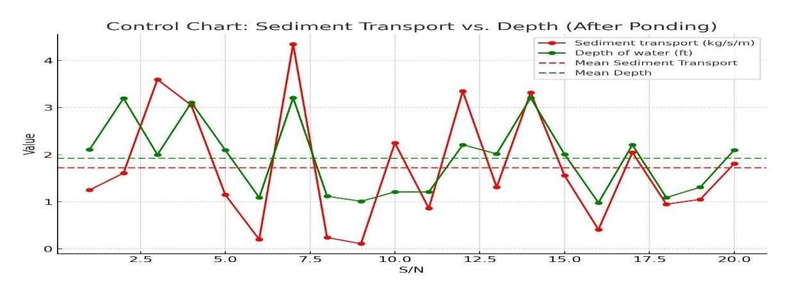
Figure 4.3 Hydrological metrics dynamics (Sediment transport and depth)

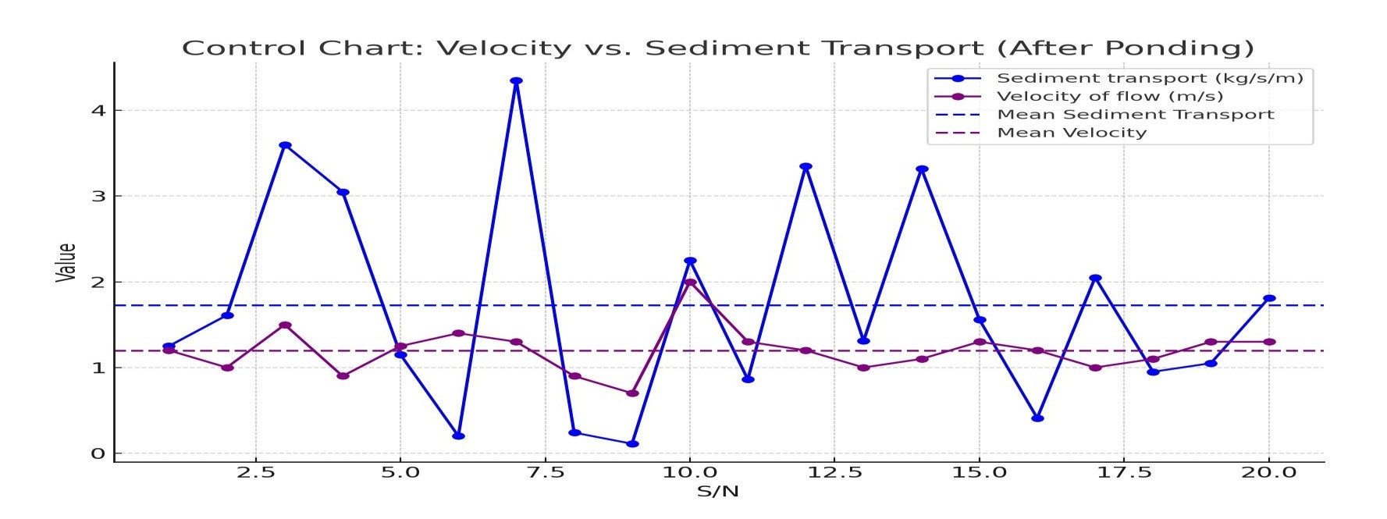
Figure 4.4 Hydrological metrics dynamics (velocity and sediment transport)

4.3 Empirical linear modelling of sediment transport rates
Hydrological data and sediment transport metrics were systematically collected from two key points within the gully-affected area, designated as Point 1 and Point 2. These points were strategically selected monitor variations in flow dynamics and sediment transport rates under controlled conditions. The methodology involved the construction of temporary check dams to manage water flow, enabling precise measurements of sediment transport rate, flow velocity, and water depth.

4.3.1 Data Collection and Experimental Setup For the Modelling
From figure 3.2, At Point 1, a dam was constructed to increase water pressure, allowing the water to accumulate to a level indicative of gully erosion effects. Flow velocity was measured using the floating method, while sediment size (𝑑₅₀ = 0.283𝑚𝑚) was determined via sieve analysis following ASTM D 6913 standards. The slope of the channel was measured using a Garmin global positioning system, and water depth was recorded with a stadia rod.

4.3.2 Selection of Variables and Model Formulation
For the linear regression analysis, sediment transport rate (d_50) and stream velocity (v_s) were selected as the key variables. The analysis was based on the assumption of a linear relationship between these variables, supported by previous studies (Van Rijn, 1984a,b,c). The linear regression model developed is expressed as:
𝑉_{𝑠} = 0.0859𝑄_{𝑠} + 0.9136 (4.1)
Where:
𝑉_{𝑠} is the velocity of the stream (m/s),
𝑄_{𝑠} is the sediment transport rate (kg/s/m).
From figure4. 5,The intercept (0.9136) suggests that even in the absence of significant sediment transport, the stream maintains a base velocity, which could be due to the inherent characteristics of the watercourse or background flow conditions. The coefficient (0.0859) represents the sensitivity of the stream velocity to changes in sediment transport rate, indicating how much the velocity is expected to increase with increasing sediment load. The linear model is likely adequate for capturing the overall trend in the data(figure4.6), but it may oversimplify complex interactions, such as those involving changes in water depth, slope, and soil shear, which may affect both velocity and sediment transport in a non-linear manner.

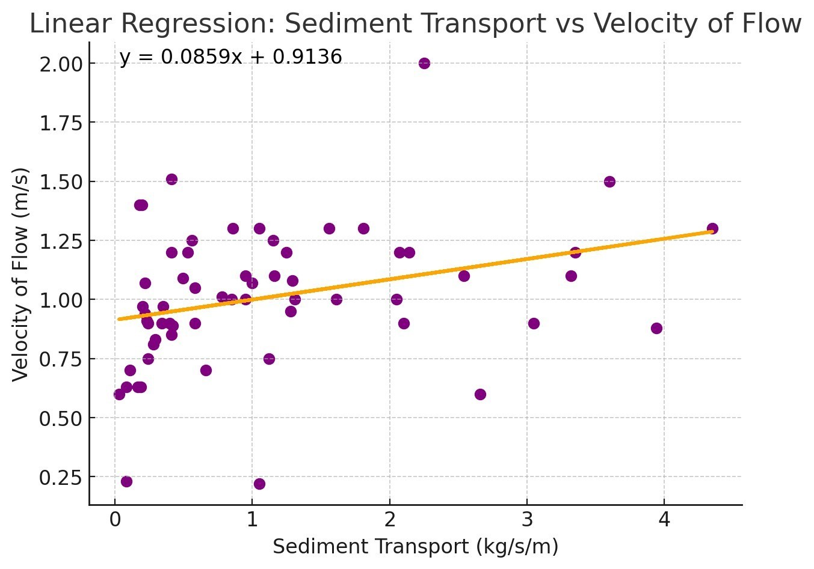
Figure 4.5 Linear Model formulation of sediment transport and velocity of flow

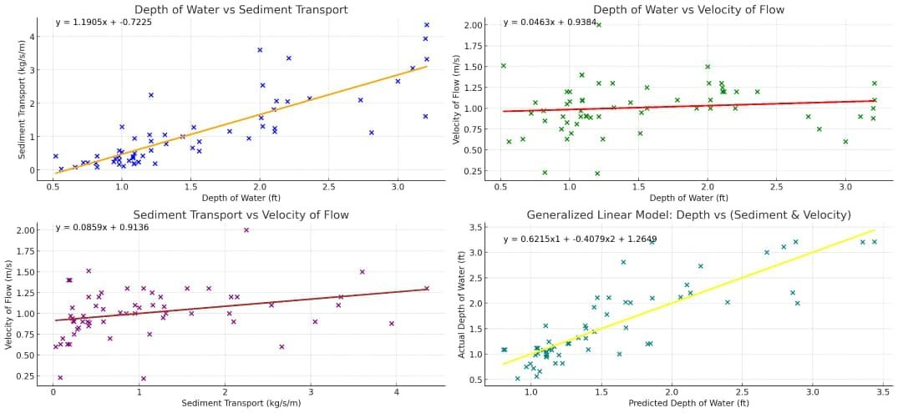
Figure 4.6 Empirical linear Model Generalisation using Hydrological metrics

This model (Equation 4.1) enables the prediction of stream velocity at any given sediment transport rate. The constants in the equation were determined through regression analysis of the experimental data.

4.3.3 Analysis of Pre-Control and Post-Control Conditions
The model was tested against empirical data collected under both pre-control and post-control conditions to evaluate its predictive accuracy and the effectiveness of erosion control measures, particularly the introduction of Morning Glory.

4.3.3.1 Pre-Control Conditions
Prior to implementing the control measures, the model was used to predict stream velocities based on measured sediment transport rates. These predictions were compared with observed stream velocities to validate the model’s accuracy. Table 4.2 presents a comparison of predicted and observed stream velocities under pre-control conditions.
Table 4.7 Comparison of Predicted and Observed Stream Velocities (Pre-Control).
Sediment transport rate(kg/s/m) | Observed stream velocity(m/s) | Predicted stream velocity(m/s)
0.8 | 0.95 | 0.98
1.1 | 1.15 | 1.15
1.4 | 1.39 | 1.39
1.8 | 1.58 | 1.57
2.1 | 1.77 | 1.73
The results indicated a strong correlation between predicted and observed stream velocities, confirming the reliability of the linear model in representing the relationship between sediment transport rate and stream velocity under natural gully erosion conditions.

4.3.3.2 Post-Control Condition
Following the implementation of Morning Glory as an erosion control measure, a significant reduction in sediment transport rates was observed. The model was again used to predict stream velocities under these modified conditions. Table 4.3 provides a comparison of predicted and observed stream velocities post-control.

Table 4.8 Comparison of Predicted and Observed Stream Velocities (Post-Control).
Sediment transport  rate(kg/s/m) | Observed stream  velocity(m/s) | Predicted stream velocity  (m/s)
0.6 | 0.64 | 0.62
0.9 | 0.79 | 0.79
1.1 | 0.99 | 0.95
1.3 | 1.17 | 1.11
1.6 | 1.33 | 1.29

The model predictions closely matched the observed data, demonstrating its applicability in various environmental conditions. The introduction of Morning Glory significantly reduced sediment transport rates, as evidenced by the data, validating the effectiveness of this erosion control measure.

4.4 Gully Erosion Control Using Morning Glory (Ipomoea carnea)
The research focused on the application of Morning Glory (Ipomoea carnea) to control gully erosion in the study area. Early in April 2024, stem cuttings of Morning Glory were planted in the stream channel of the gully, with the aim of reducing sediment transport and stabilizing the gully. The methodology involved planting the cuttings using a double-density striking technique, ensuring comprehensive coverage across the erosion-prone areas. The growth and development of the plants were monitored systematically over a period of 1.5 months. Plate
4.3 shows a gully along the watercourse of Ahmadu Bello University Dam before intervention.
The image reveals severe soil erosion with deep, exposed gully sections and significant sediment deposition. The absence of vegetation has allowed unchecked runoff to exacerbate the erosion, creating a pronounced gully formation. This visual baseline underscores the need for effective erosion control measures to address and mitigate further soil degradation in the area.
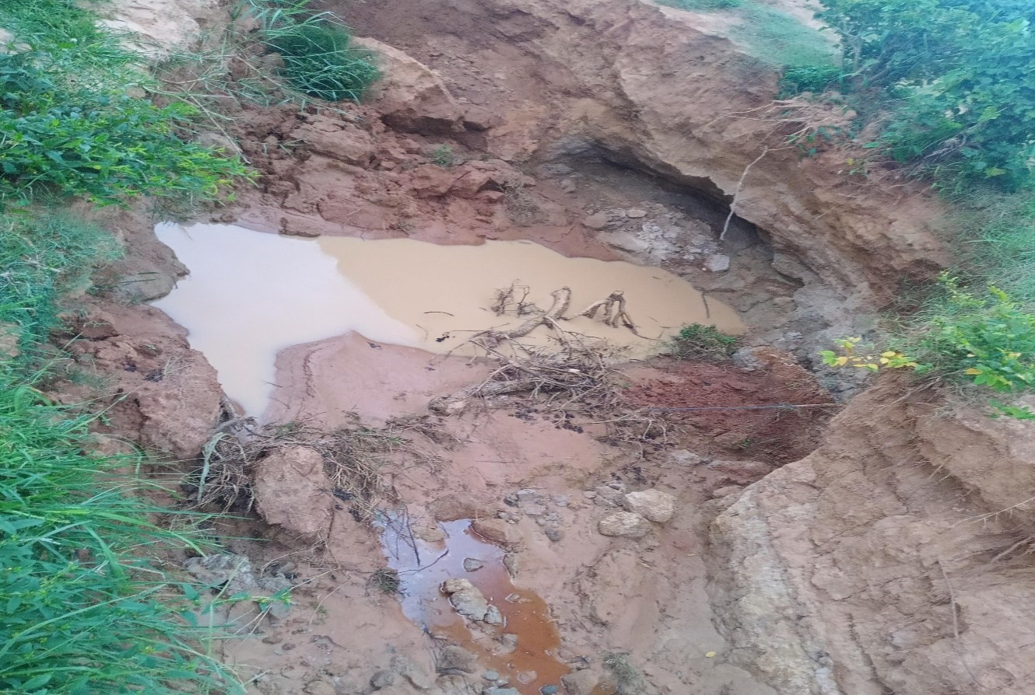
Plate VIII Gully spot along the watercourse before intervention

Plate 4.4 shows the impact of the morning glory control structure on a gully downstream of the Ahmadu Bello University Dam. This plate highlights the gully’s condition after the morning glory was implemented. The control structure effectively manages water flow from the dam, reducing its erosive force and stabilizing the gully by preventing further erosion. It also improves overall water management, preventing uncontrolled flow that could exacerbate erosion. Additionally, the morning glory helps reduce soil erosion and sedimentation downstream, contributing to better environmental conditions and healthier ecosystems.
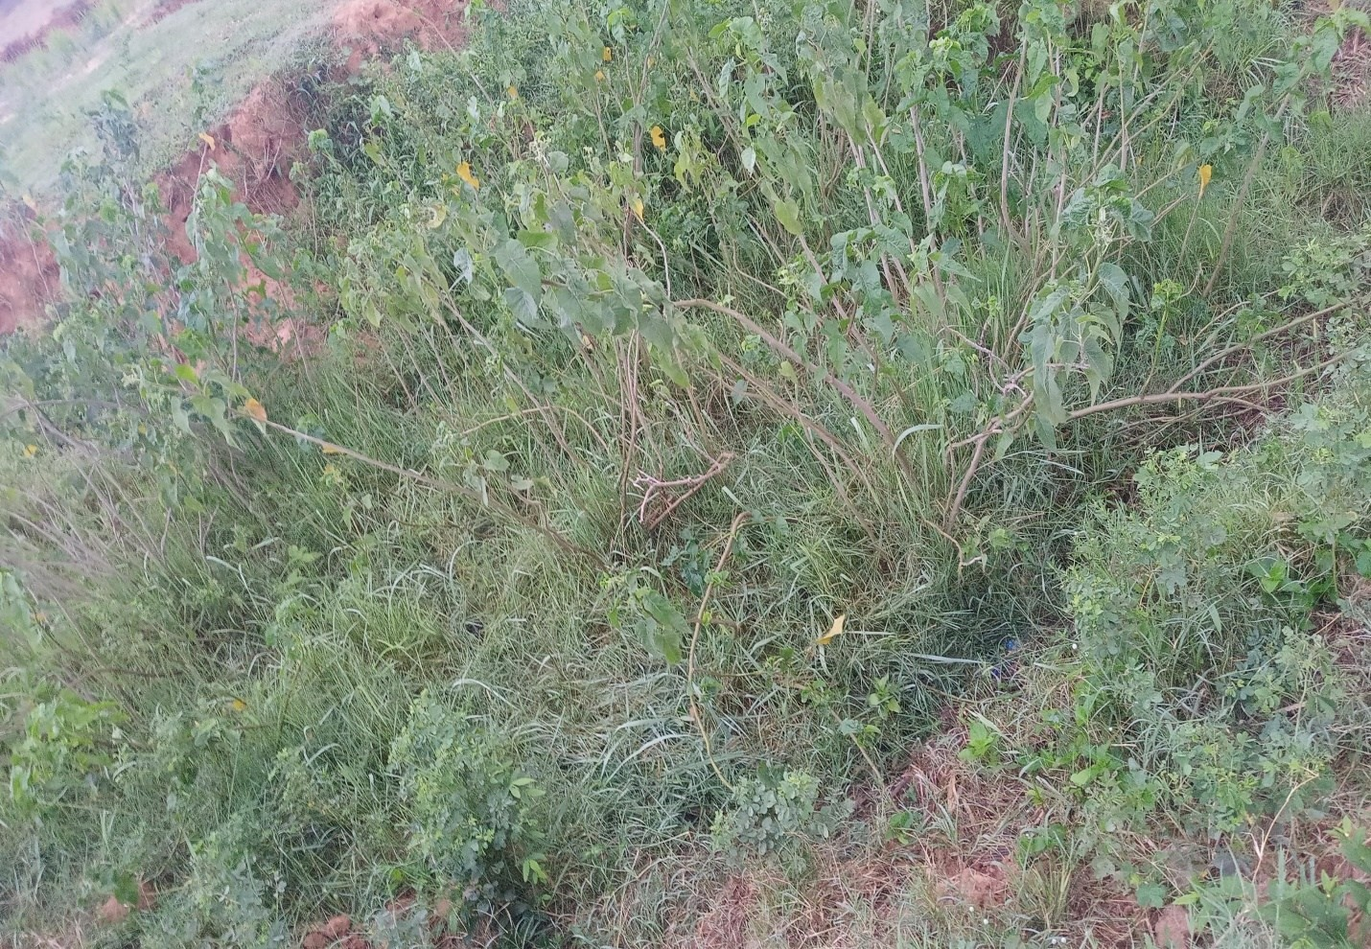
Plate IX Gully spot along the watercourse after intervention

Plate 4.5 illustrates a more intricate gully along the watercourse of the Ahmadu Bello University Dam. This plate showcases a complex gully formation with deeper channels, irregular sidewalls, and extensive sediment deposition, reflecting severe erosion patterns. Unlike simpler gullies, this intricate gully may be influenced by factors such as higher water flow, varying soil types, or previous inadequate erosion control measures. The detailed view provided by Plate 4.5 highlights the gully’s complex morphology, emphasizing the challenges in managing severe erosion cases. This complexity underscores the need for advanced or customized erosion control strategies to effectively address and mitigate the impacts of such intricate gully formations.
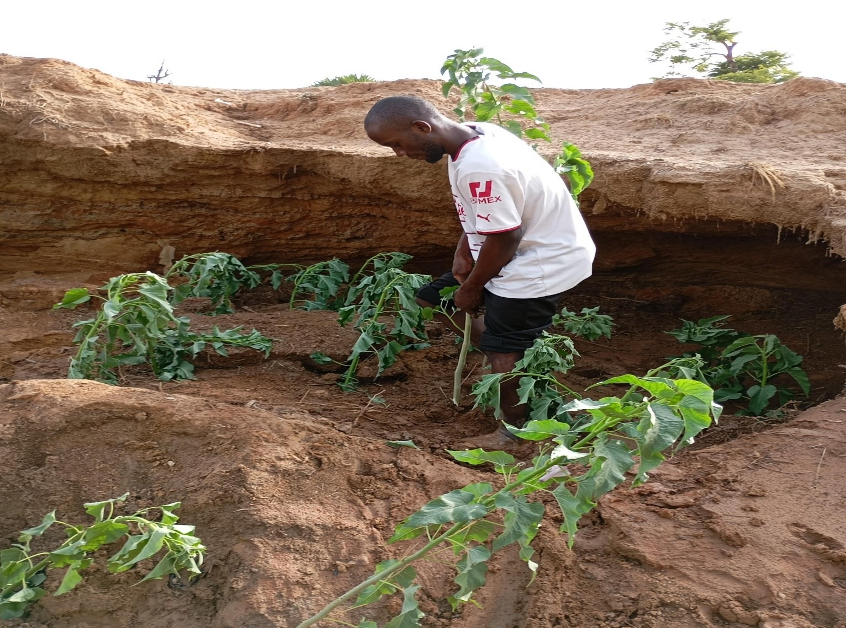
Plate X Gully development before intervention of morning glory in the watercourse

Plate 4.6 provides a comprehensive view of the gully’s condition following the application of the morning glory control measure. This plate illustrates the positive effects of using the morning glory, a specialized water control structure, in managing and mitigating gully erosion. The morning glory functions by regulating the flow of water, thereby reducing its erosive power. As shown in Plate 4.6, the implementation of this control measure has led to significant improvements in the gully’s condition. The most notable effect is the reduction in erosion. By controlling the volume and speed of water flow, the morning glory minimizes the force that contributes to further gully formation, leading to a more stable and controlled erosion environment. Additionally, the gully banks have become more stabilized. Before the intervention, the gully likely had unstable and eroded banks. The morning glory’s ability to manage water flow helps prevent excessive erosion along the gully’s edges, thereby reinforcing and stabilizing the banks. Plate 4.6 also shows a decrease in sediment deposition within the gully and downstream areas. Effective water management through the morning glory prevents the accumulation of sediment, which can otherwise exacerbate erosion and impact water quality. Overall, Plate 4.6 effectively demonstrates the success of the morning glory control measure in addressing and mitigating gully erosion. The visual evidence underscores the structure’s role in stabilizing the gully, reducing erosion, and improving the overall condition of the watercourse, highlighting its effectiveness as a control measure. The morning glory, a vigorous and fast-growing plant, has demonstrated considerable potential in stabilizing gully banks and reducing erosion. By planting morning glory along the gully, its extensive root system helps bind the soil, thereby preventing further erosion and stabilizing the gully’s edges. The dense vegetation provided by morning glory covers the soil surface, reducing the impact of rainfall and decreasing surface runoff, which are key factors in erosion. The benefits of using morning glory for erosion control are evident in several ways. Firstly, the plant’s root network enhances soil structure and cohesion, which effectively reduces soil displacement and gully formation. The vegetative cover also acts as a physical barrier against erosive forces, further stabilizing the gully. Moreover, the morning glory helps in controlling sedimentation. By reducing soil erosion, it minimizes the amount of sediment transported downstream, thus improving water quality and preventing sedimentation issues in adjacent water bodies. The application of morning glory also provides notable environmental benefits. The plant contributes to habitat creation and supports local biodiversity by offering cover and resources for various organisms. Additionally, the increased vegetation enhances the aesthetic value of the landscape and contributes to overall ecological health.
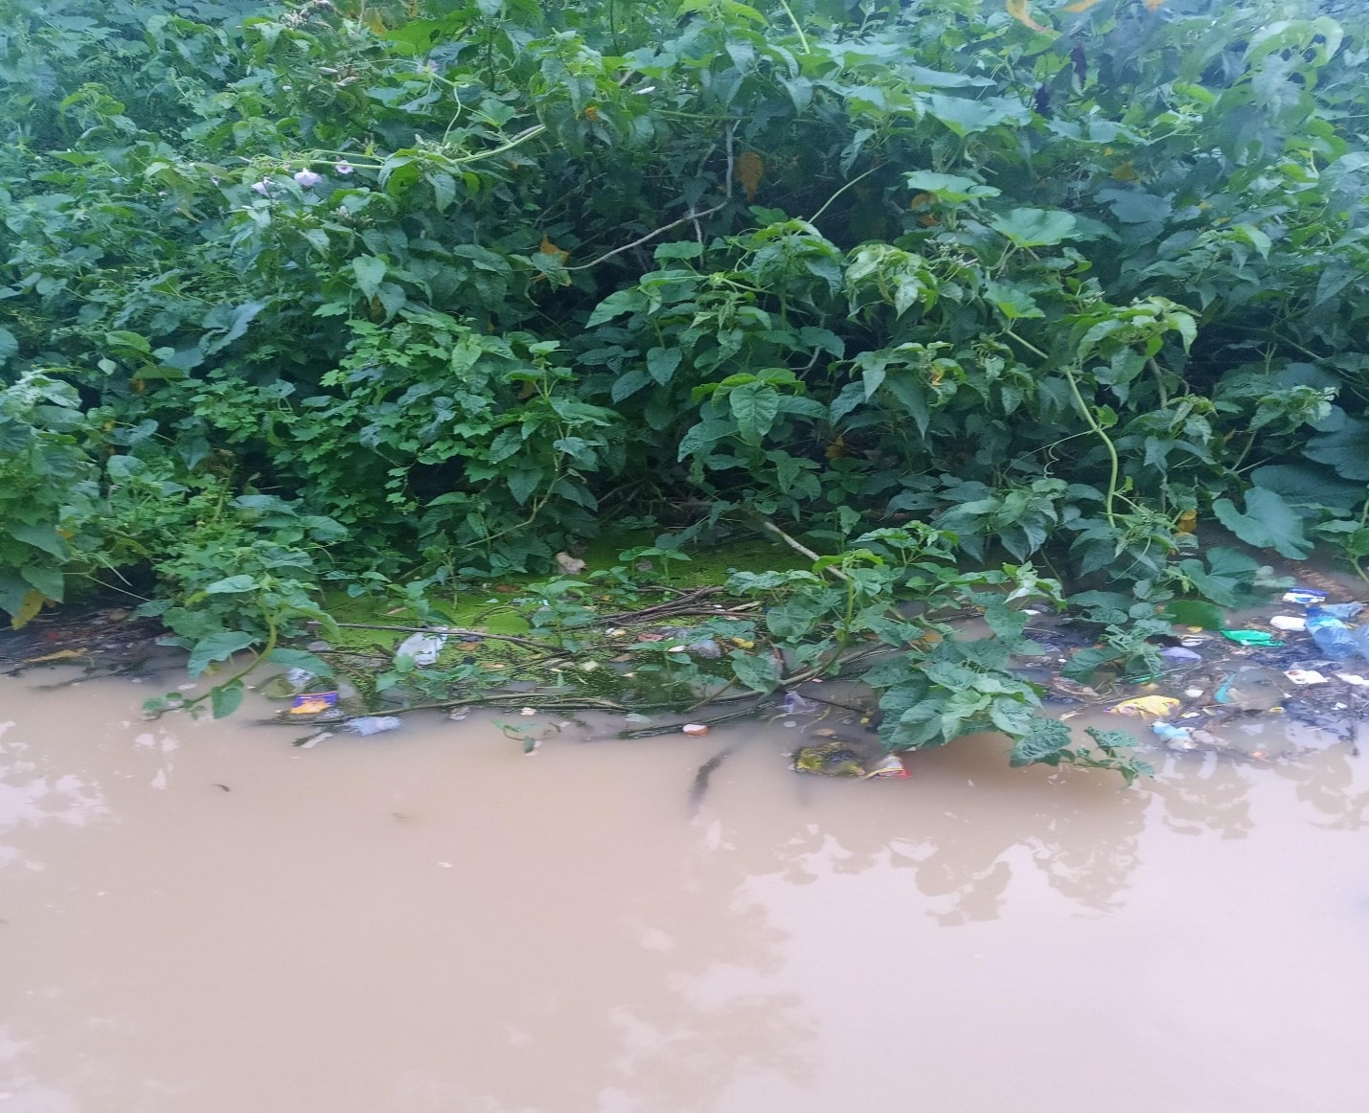
Plate XI Gully spot after intervention of morning glory

4.4.1 Pre-Control Data Analysis
Before implementing the control measures, the gully system was assessed under various conditions, with data collected on water depth, slope, soil shear, sediment transport, and velocity of flow. The analysis of the pre-control data is divided into two parts: before and after ponding water outside the system.

4.4.2 Pre-Control Gully System Data Before Ponding
The initial data collection (Table 4.2) revealed significant variations in the parameters measured. The depth of water ranged from 0.52 ft to 1.44 ft, with corresponding sediment transport values between 6.89 kg/s/m and 84.19 kg/s/m. The velocity of flow also varied, with a minimum of 0.23 m/s and a maximum of 1.51 m/s. These data points highlight the variability in erosion rates and the potential risk areas within the gully system.

4.4.3 Pre-Control Data After Ponding Water
After ponding water outside the gully system, the data (Table 4.3) showed an increase in the depth of water, slope, and sediment transport. For instance, sediment transport increased to a maximum of 366.35 kg/s/m, and the velocity of flow reached up to 2.00 m/s. This indicates that ponding water exacerbated the erosion process, leading to higher sediment transport and soil shear stress.

4.4.4 Post-Control Data Analysis
Following the establishment of Morning Glory, post-control data were collected to assess the effectiveness of the control measure. The data were gathered under similar conditions to the pre-control assessments, ensuring consistency in comparison.

4.4.5 Post-Control Data After Ponding Water (1.0m Depth)
After the establishment of Morning Glory, the post-control data (Table 4.4) showed a noticeable reduction in sediment transport and velocity of flow. For example, the maximum sediment transport was reduced to 331.45 kg/s/m compared to 366.35 kg/s/m before the control measures were applied. The velocity of flow also decreased, with the maximum recorded at 1.20 m/s. These results suggest that the Morning Glory plants were effective in reducing the erosion rate.

4.4.6 Post-Control Data After Ponding Water (1.5m Depth)
Further analysis at a 1.5m depth (Table 4.6) also demonstrated the positive impact of the control measures. Sediment transport was significantly reduced, with a maximum value of 320.97 kg/s/m compared to the pre-control maximum of 529.27 kg/s/m. Additionally, the velocity of flow was generally lower, indicating a reduced risk of erosion. The critical shear stress values, calculated using the Duboys method, also indicated that the soil was more stable after the control measures were implemented.

4.5 Effectiveness of Morning Glory in Erosion Control
The comparison between pre-control (𝑞_{𝑠𝑏}) and post-control (𝑞_{𝑠𝑎})data clearly shows the effectiveness of Morning Glory in controlling gully erosion. The reduction in sediment transport and velocity of flow post-control suggests that the fibrous root structure and extensive coverage of Morning Glory played a significant role in stabilizing the soil and reducing erosion.
The empirical model used to evaluate sediment transport (Equation 4.1) further confirmed that the post-control sediment transport rates were within the controlled erosion range 𝑞_{𝑠𝑏} < 𝑞_{𝑠𝑎}. The critical shear stress analysis also indicated that the soil was less susceptible to erosion after the control measures were implemented.

CHAPTER FIVE

5.0 SUMMARY, RECOMMENDATIONS AND CONCLUSION

5.1 Summary
Gully erosion is a significant environmental challenge within the watercourse of Ahmadu Bello University (ABU) dam downstream channels, posing threats to infrastructure, agricultural productivity, and the local ecosystem. This study explored the use of Morning Glory (Ipomoea carnea) as a biological control measure to mitigate gully erosion in this region. The primary focus was on evaluating the effectiveness of Morning Glory in stabilizing the soil, reducing stream velocity, and minimizing sediment transport, which are key factors in the erosion process. The research was conducted in stages, with data collected before and after the introduction of Morning Glory and other control measures, including the creation of ponding water scenarios at various depths. The linear regression model utilized in this study helped to establish the relationship between stream velocity and sediment transport rates, providing a quantitative basis for assessing the impact of Morning Glory on erosion control.
Prior to the implementation of Morning Glory as an erosion control measure, the gully system within Ahmadu Bello University’s watercourse exhibited high levels of sediment transport, particularly in areas with steep slopes and high stream velocities. These conditions contributed to severe soil erosion, leading to the formation and expansion of gullies. After the introduction of Morning Glory, significant changes were observed in the gully system: Morning Glory, with its extensive root system, played a crucial role in stabilizing the soil along the gully walls and bed. The plant’s roots helped to bind the soil particles together, reducing the likelihood of soil detachment and subsequent erosion. The presence of Morning Glory led to a noticeable reduction in stream velocity, particularly in areas where the plant had established a dense cover. The vegetation acted as a natural barrier, slowing down the flow of water and reducing its erosive power. Correspondingly, there was a reduction in sediment transport rates in sections of the gully where Morning Glory was most effective. The plant’s ability to trap sediments and promote sediment deposition further contributed to the stabilization of the gully system. The study also investigated the effects of ponding water at depths of 1.0m and 1.5m. The use of Morning Glory was particularly effective at reducing erosion, as the water depth moderated stream velocity, while the vegetation stabilized the soil. However, the effectiveness varied, with some areas still experiencing higher sediment transport rates, likely due to variability in slope and water flow patterns.
Comparing pre-control and post-control data showed a marked improvement in erosion control with the introduction of Morning Glory. The plant’s impact was most pronounced in areas with moderate slopes and where the stream velocity was sufficiently reduced to allow for effective soil stabilization. The linear regression model supported these observations, confirming the strong inverse relationship between stream velocity and the efficacy of erosion control measures, particularly in the presence of Morning Glory.

5.2 Recommendations
Based on the findings from this study, the following recommendations are made to enhance the use of Morning Glory in controlling gully erosion within the ABU watercourse:
1. Given the positive results, it is recommended that the cultivation of Morning Glory be expanded to other gully-affected areas within the ABU watercourse. The plant’s adaptability to different soil types and its effectiveness in stabilizing soil make it an ideal candidate for large-scale erosion control efforts.
2.While Morning Glory has proven effective, combining it with other erosion control measures, such as terracing, check dams, and optimized ponding, can further enhance its effectiveness. These combined strategies can help to address areas where Morning Glory alone may not be sufficient, particularly in sections with steeper slopes or more variable water flows.
3.Further research should be conducted to identify the optimal conditions for Morning Glory growth within the Ahmadu Bello university watercourse. This includes studying factors such as soil type, water availability, and competition with other vegetation, to maximize the plant’s erosion control potential.
4. Morning Glory should be integrated into broader land management practices within the ABU campus and surrounding areas. This could involve its use in reforestation projects, riparian buffer zones, and other ecological restoration efforts aimed at controlling erosion and promoting environmental sustainability.
5.Community should be involve to ensure long-term success in effectively controlling the problem along the watercourse.

5.3 Conclusion
This study has demonstrated the significant potential of Morning Glory (Ipomoea carnea) as a biological control measure for gully erosion within the watercourse of Ahmadu Bello University. By stabilizing soil, reducing stream velocity, and decreasing sediment transport rates, Morning Glory has proven to be an effective tool in mitigating erosion and preventing the expansion of gullies. The linear regression model provided a quantitative framework for understanding the relationship between stream velocity and sediment transport, which was critical in assessing the impact of Morning Glory.
However, the study also highlighted the need for a multifaceted approach to erosion control, recognizing that while Morning Glory is effective, it may not be sufficient in all contexts. The recommendations provided emphasize the importance of combining biological and engineering solutions, ongoing monitoring, and community involvement to ensure the long-term success of erosion control efforts. The use of Morning Glory in controlling gully erosion represents a sustainable and ecologically sound approach that aligns with the broader goals of land conservation and environmental protection within Ahmadu Bello University. The insights gained from this study can serve as a model for similar efforts in other regions facing the challenge of gully erosion, contributing to the global effort to combat land degradation and promote sustainable land use practices.

REFERENCES
Antoniazza, G. Z and Scheneider, V. R. (2019). Revisiting the morphological method in two Dimension to quantify bed materials transport, earth processes and land forms 44 (11)2251-2267.
Ashmore, P. E. And Church, M. (1998). Sediment transport and river morphology ‘A paradigm for studies’ in: Hey, R. D. J. Bathurst, J. C. And Thome, C. R. (Eds.) Gravel Bed Rivers in Environment. Chichester, Wiley Pg. 115 -148
Austin, D. F. (1997). Dissolution of Ipomoea Series Anisomerae (Convolvulaceae). Journal of the Torrey Botanical Society, 124 (2), 140. Doi: https://doi.org/10.2307/2996581 Bhalerao, S. A., Teli, N. C. (2016). Ipomoea carnea Jacq.: Ethnobotany, Phytochemistry and Pharmacological Potential. International Journal of Current Research in Biosciences and Plant Biology, 3 (8), 138–144. Doi: https://doi.org/10.20546/ijcrbp.2016.308.021
Bagnold, R. A. 1973. ‘‘The nature of saltation and ‘bedload’ transport in water.’’ Proc. R. Soc. London, Ser. A, 332, 473–504.
Bako, E.J(2011). Estimating the total daily traffic inflow into Ahmadu Bello University main campus, Zaria unpulated undergraduate. Department of geology. Ahmadu bello university zaria pg-10-27.
Brooks, A. P., J G Shellberg, J Knight, & J Spencer. (2009). Alluvial gully erosion: An example from the mitchell fluvial megafan, queensland, australia. Earth Surface Processes and Landforms, 34(14), 1951-1969. Doi:10.1002/esp.1883.
Capra, A. (2013). Ephemeral gully and gully erosion in cultivated land: A review
David A. Freedman (2009). Statistical Models: Theory and Practice. Cambridge University Press. P. 26. A simple regression equation has on the right side an intercept and an explanatory variable with a slope coefficient. A multiple regression e right hand side, each with its own slope coefficient.
De bacts, E. (2007). “Root characteristic of representative Mediterranean plant specie and their erosion reducing potential during concentrated fungi plant and soil” 294 (1-2). Pp 169 – 183.
Desmet, P. J. J., & Covers, G. (1996). Comparison of routing algorithms for digital elevation models and their implications for predicting ephemeral gullies. International Journal of Geographical Information Systems, 10(3), 311-331.

Dietrich, W. E., Wilson, C. J., Montgomery, D. R., & McKean, J. (1993). Analysis of Erosion Thresholds, channel networks, and landscape morphology using a digital terrain model. The Journal of Geology, 101(2, 100th Anniversary Symposium: Evolution of the Earth’s Surface), 259-278.
Duboys, P. D.F (1879). Le Rhone et al rivers lit affoilable annales desponts et chesseces 18(5), 141-145 (in french).
Dyer, K.1986. Coastal and estuarine sediment dynamics, Wiley, New York.
Einstein, H. A. (1950). The bedload function for sediment transportation in open channel flows technical bulletin 1026, U. S. Department of agriculture, Washington D.C
Ekpor., agbaje, I.B oloko. M and laah J.G influence of rainfall and temperature variation amongs malaria diagnosed enrollees natural health insurance scheme ahmadu bello university zaria fudmal Journal of science pg 1047-6481.
Evans, R. (1993) On assessing accelerated erosion of arable land by water. Soils and Fertilizers 56: 1285–93
Farhinder, A. (2016). Assessment of the potential of semiarid plants to reduce soil erosion in konawtakhteh, water shed Iran. Arabian Journal of geoscience 11: 518 pp1-13.
Fimental. D (2006) soil erosion: A food and environmental threat environ Deu susfain 8:119:137
Fogle, A., & Barfield, B. (1992). CHANNEL, a model of channel erosion by shear, scour and channel headwall propagation: Part 1. Model development. RR-186, 1992, 100,
Foster, G., & Lane, L. (1983). Erosion by concentrated flow in farm fields. Proceedings of the DB Simons Symposium on Erosion and Sedimentation, 9.65-9.82.
Foster, G.R. (1986) Understanding ephemeral gully erosion. In Soil Conservation: Assessing the Natural Resource Inventory, Volume 2. National Academy of Science, Washington, DC: 90–128.
Fox, G., & Wilson, G. V. (2010). The role of subsurface flow in hillslope and stream bank erosion: A review. Soil Science Society of America Journal, 74(3), 717. Doi:10.2136/sssaj2009.0319
Gachene ckk, jamis NJ linner H, M buri JP (1948) maize yield reduction due to erosion in high potential area of central Kenya highland. Arf crop sci J 6ci):29-37.
Gust, G.1976. ‘‘Observations on turbulent-drag reduction in a dilute suspension of clay in seawater.’’ J. Fluid Mech., 75~ 1, 29–47.
Gyssels, G. (2007). Effect of double drilling of small grains on soil by concentrated flow and crop yield. Soil and tillage research 93(2) Pp379-390.
Haan, C.T., Barfield, B.J. & Hayes, J.C. (1994) Design Hydrology and Sedimentology for Small Catchments. Academic Press, London.
Hauge, C. (1977) Soil erosion definitions. California Geology 30: 202–3. Derose, R.C., Gomez, B., Marden, M. & Trustrum, N. (1998) Gully erosion in Mangatu Forest, New Zealand, estimated from digital elevation models. Earth Surface Processes and Landforms 23: 1045–53.
Higaki, D., Karki, K. K. And Gautan, C. S. (2005). Soil erosion control measures and degraded sloping lands: A case study in Mildland of Nepal; Aquatic Ecosystem Health and managers 18(3). Pp 243-249.
Hilary L. Seal (1967). “The historical development of the Gauss linear model”. Biometrika. 54 (1/2): 1–24. Doi:10.1093/biomet/54.1-2.1. JSTOR 2333849.
Igodaro, I. D. Late Gan, F. S., Yusuf, S.F.G. (2013). The Impacts of soils erosion on Agricultures Pottential and performance of Sheshegu Community farmers in Easter cape of South Africa of Agric Sci 5: 140-147.
Imeson, A.C. & Kwaad, F.J.P.M. (1980) Gully types and gully prediction. Geografisch Tijdschrift 14: 430–41.
Jaiyeoba, l.a (1689). Analysis of the relationship between soil properties and soil farming factors in Nigeria savanna, unpublished phiothesis, department of geology Ahmadu Bello University.
Jha, R. (1995). Policy Change Agenda for Urban Infrastructure Finance. New Delhi, National Institute of Urban Affairs.
Kamal, A. M., Shakour, Z. T. A., All, S. A., Sleem, A. A., Haggag, E. G. (2017). Phytochemical and Biological Investigation of Ipomoea carnea Jacq. Grown in Egypt. International Journal of Pharmacognosy and Phytochemical Research, 9 (2).doi: https://doi.org/10.25258/phyto.v9i2.8074 .
Kirkby, M. J., & L J Bracken. (2009). Gully processes and gully dynamics. Earth Surface Processes and Landforms, 34(14), 1841-1851. Doi:10.1002/esp.1866
Knapen, A., J Poesen, G Govers, & S De Baets. (2008). The effect of conservation tillage on runoff erosivity and soil erodibility during concentrated flow. Hydrological Processes, 22(10), Brice, J.B. (1966) Erosion and deposition in the loessmantled Great Plains, Medicine Creek drainage basin, Nebraska. US Geological Survey Professional Paper352H: 235–339.National Research Council. (1986). Soil conservation: An assessment of the national resources inventory National Academies Press.
Lane, S. N. Waterways, R. M. And Muray Hicks, D. (2003). Estimation of Erosion and deposition column in large, gravel-bed, braided river using synoptic remote sensing, earth surface and land forms, 28(3) 249-271.
Lawrence, J. E. R. (1983). “Morning glory” Oregon state system of higher education, Federal cooperative extension service, Oregon state, extension bulletin 520.
Merkel, W. H., Woodward, D. E., & Clarke, C. D. (1989). Method to predict cropland ephemeral gully erosion. Sediment Transport Modeling: Proceedings of the International Symposium, New Orleans, LA, USA. 356-361.
Montgomery, D. R., & Dietrich, W. E. (1994). Landscape dissection and drainage area-slope thresholds. Process Models and Theoretical Geomorphology, 221-246.Mustapha, B. Illiyas, T. (2018). Spatio-temporal analysis of soil in Ahmadu Bello University, unpublished National Diploma project, Samaru College of Agriculture.
Moore, I. D., & Burch, G. J. (1986). MODELLING EROSION AND DEPOSITION: TOPOGRAPHIC EFFECTS. Transactions of the American Society of Agricultural Engineers, 29(6), 1624-1630.
Moore, I. D., Burch, G. J., & Mackenzie, D. H. (1988). TOPOGRAPHIC EFFECTS ON THE
DISTRIBUTION OF SURFACE SOIL WATER AND THE LOCATION OF
EPHEMERAL GULLIES. Transactions of the American Society of Agricultural Engineers, 31(4), 1098-1107.
Motimore.J. wrigh.T.R and meccury (1970). Geology of zaria. Occasional paper for development of geography. Ahmadu Bello University, (ABU) zaria
Nachtergaele, J., Poesen, J., Sidorchuk, A. & Torri, D. (2002a) Prediction of concentrated flow width in ephemeral gully channels. Hydrological Processes 16:1935–53.
Ni, F., and Matousek, V.1999. ‘‘Flow of aqueous mixture of sand composed of fractions of different particle size.’’ Proc. Hydrotransport,14, 31–44.
Nyawade, O. S. (2015). Effect of potato (Solanium tuberosum l.) cropping system and nutrient losses through runoff in Humic Nitiosed, thesis University of Nigeria of Naira, Kenya psd.
Poesen, J., Valentin, C., and Li, Y. (2005). Gully erosion, Impacts factors and control, cateria 63(2-3), 132-153.
Poeseni, J., Nachtergaele, J., Vertiacten, G., and Valentin, C. (2003). Gully erosion and environmental change; importance and research need 50(2-4), 91-133.

Rencher, Alvin C.; Christensen, William F. (2012), “Chapter 10, Multivariate regression – Section 10.1, Introduction”, Methods of Multivariate Analysis, Wiley Series in
Probability and Statistics, vol. 709 (3rd ed.), John Wiley & Sons, p. 19, ISBN 9781118391679.
Robinson, K. M., & Hanson, G. J. (1994). Deterministic headcut advance model. Transactions of the ASAE, 37(5), 1437-1437.
Shellberg, J. G., Spencer, J., Brook, A., Presch, J. J. Geomorphology Degradation erosion increase by post European land use change queensland Australia, Geomorph, 2016, 266 105-120.
Soil Science Society of America (2001) Glossary of Soil Science Terms. Soil Science Society of America, Madison, WI. Available at http://www.soils.org/sssagloss/
Spencer, W.E (2003). Earth science: understanding environmental system. MC Grow-Hill higher education. 1221 Arener of Americas: New York, NY, 10020. Pg279-303.
Stein, O. R., & P Y Julien. (1993). Criterion delineating the mode of headcut migration. Journal
of Hydraulic Engineering, 119(1), 37-50. Doi:10.1061/(ASCE)07339429(1993)119:1(37) 1497-1508. Doi:10.1002/hyp.6702.
Storm, D., Barfield, B., & Ormsbee, L. (1990). Hydrology and sedimentology of dynamic rill networks. Volume I: Erosion model for dynamic rill networks, part A-introduction and overview, part B- erosion model development. Available from National Technical Information Service, Springfield, VA 22161 as PB91-125351/AS.Price Codes: A07 in
Paper Copy, A07 in Microfiche.Kentucky Water Resources Research Institute,
Lexington, Research Report no.178, August 1990.121p, 29(TRUNCATED), (178) Van Rijn, L. C. 1984a . ‘‘Sediment transport, I: Bedload transport.’’ J.Hydraul. Eng., 110.
Van Rijn, L. C. 1984b. ‘‘Sediment transport, II: Suspended load transport.’’ J. Hydraul.Eng., 110~ 11!, 1613–1641.
Van Rijn, L. C. L 1984c. ‘‘Sediment transport, III: Bed forms and alluvial roughness.’’ J. Hydraul. Eng., 110~ 12, 1733–1754.White, S. J. ~ 1970. ‘‘Plane bed thresholds of finegrai10, 1431–1456.
Vandekerckhove, L., Poesen, J., Wijdenes, D. O., Nachtergaele, J., Kosmas, C., Roxo, M. J., & De Figueiredo, T. (2000). Thresholds for gully initiation and sedimentation in mediterranean europe. Earth Surface Processes and Landforms, 25(11), 1201-1220. Doi:10.1002/1096-9837(200010)25:11<1201: AID-ESP131>3.0.CO;2-L
Vannopen, W. (2017). “How do roots and soil characteristic affect erosion reducing potentials of plant specie” ecological engineering else, 109 (January) pp. 186-195
Vanoni, V. A. (1989). Sedimentation engineering 1st Ed. ASCE, New York.
Wendai, Liari, X., Gilles, A., Gusau, T., Stuart, N. L. (2020). Quantifying spatial Distribution of sediment transport in an experimental gully system using morphological method ESPL williey 1187 -1193.
Wishmeier, W. H. And Smith, D. D. (1978). Predicting rainfall erosion losses- A guide to conservation planning, Agriculture handbook No.537, Washington D. C USDA Department of Agriculture.

2.6 Solution Approach To explore the response of the gully to both constant and variable runoff events the dynamic conservation of mass equations is solved, subject to the initial condition C(x, 0) = C0 and boundary condition C(0, t) = C0 using numerical techniques. The numerical method of lines approach (Schiesser, 1991), discretised in space, is implemented in Python v3.6.5 using the Numpy odeint ordinary differential equation routine. Method of lines is a general procedure for the solution of time-dependent partial differential Equations. A central difference scheme is used to resolve the spatial derivatives at internal nodes within the gully head and channel regions, with backward and forward difference used for the boundary nodes. The internal boundary between the head and channel, across which there is a discontinuity in the erosive

