GIS-based delineation of areas suitable for livestock slurry application
A reproducible, code-based multicriteria analysis for the municipality of Tudela, Navarre, Spain
A GIS Multicriteria Research Study
Author: Naziru Halilu
Prepared with a Python-based geospatial pipeline implementing a QGIS-style multicriteria GIS workflow

Abstract
Livestock slurry is a nutrient-rich by-product of intensive animal farming that can substitute mineral fertilizer when it is applied at the right place, time and rate, but that becomes a source of nitrate and nutrient pollution when it is not. This report applies a Geographic Information System (GIS) multicriteria analysis to delineate the land within the municipality of Tudela (Navarre, Spain) that is suitable for slurry spreading, integrating topography, soil/lithology, surface-water protection buffers, urban buffers, protected natural areas, Nitrate Vulnerable Zones (NVZ) and SIGPAC land-use/land-cover parcels. Because the working environment used to prepare this report does not provide QGIS, GDAL, GEOS or a network connection, the entire workflow described in this research study was re-implemented from first principles in pure Python (custom shapefile/DBF parsers, a manual ETRS89-geographic-to-UTM-30N reprojection, raster-based buffering by Euclidean distance transform, and polygon rasterisation), so that every map and number in this report is computed directly from the official datasets used for the study. Of the 214.9 km2 that make up the municipality, the analysis classifies 78.1% as non-suitable, 2.4% as suitable with high constraints, 15.0% as suitable with partial constraints and 4.5% (9.6 km2) as an optimal location for slurry application once every regulatory and environmental constraint is combined. The single most restrictive individual criterion is the designation of the Ebro-Alagon Nitrate Vulnerable Zone, which alone overlaps 40.8% of the municipality, closely followed by non-arable land cover (44.0%) and the 100 m urban buffer (18.9%).

1. Introduction
Livestock slurry is a liquid by-product of intensive farming, made up mainly of animal excreta diluted with water and cleaning residues from animal housing. It contains substantial amounts of nitrogen, phosphorus, potassium and organic carbon, which makes it a potentially valuable soil amendment. However, as livestock production has intensified, the volume of slurry generated in many regions now regularly exceeds the nutrient-uptake capacity of the surrounding farmland. Where slurry is over-applied or poorly timed, it becomes a pollutant that contributes to nitrate contamination of groundwater and to the eutrophication of rivers, lakes and reservoirs, with knock-on risks for drinking-water supplies, aquatic biodiversity and public health.
Used correctly, slurry can reduce a farm’s dependence on mineral fertiliser, close on-farm nutrient loops and improve soil structure and biological activity, particularly on intensively cropped, irrigated land such as that found along the Ebro valley. The challenge is to apply it at the right place, time and rate. In the European Union this is governed by the Nitrates Directive (91/676/EEC); in Spain it is implemented through Royal Decree 261/1996; and in the Autonomous Community of Navarre it is further specified by Foral Decree 148/2023, which sets out the region’s designated Nitrate Vulnerable Zones and the associated spreading restrictions.
GIS provides a natural framework for this kind of siting problem because it allows heterogeneous datasets — topography, land cover, soil, hydrology, protected areas and regulatory zoning — to be combined into a single spatial model. This report follows that logic for the municipality of Tudela, the largest municipality in Navarre by area, situated in the Ebro river valley in the Ribera Baja comarca. A notable feature of this implementation is that it was produced entirely without QGIS, GDAL, GEOS, rasterio, Fiona or geopandas, none of which were available in the execution environment, and without internet access to install them. Every operation described in this study’s methodology — shapefile parsing, coordinate reprojection, polygon rasterisation, buffering, raster algebra and zonal statistics — was therefore re-implemented in a small, dependency-light Python toolkit (NumPy, SciPy, scikit-image, Matplotlib and Pillow only), documented in full in Appendix A.

2. Objectives
The objective of this study is to conduct a spatially explicit analysis that identifies the agricultural areas of Tudela suitable for livestock slurry application, integrating environmental, regulatory and land-use criteria so that slurry is applied in a way that maximises its agronomic benefit while minimising environmental risk and legal non-compliance. The specific goals are to:
- understand and apply the legal and environmental constraints governing slurry application at European, national and regional level, including exclusion zones for water bodies, urban areas, protected natural spaces and nitrate-vulnerable areas;
- identify zones suitable and unsuitable for slurry application based on slope, land use/cover, proximity to rivers and lakes, distance to settlements, soil characteristics, protected/nitrate-vulnerable designation and pollution-sensitive aquifers, stating explicitly the reason for exclusion in each case;
- conduct a GIS-based multicriteria analysis that integrates all relevant layers into a suitability model producing a final map of "apt", "apt with limitations" and "not apt" areas, together with a summary table of the contributing constraints; and
- interpret and present the results, quantifying suitable and excluded areas, and critically reflect on the spatial feasibility of slurry application in an intensively farmed municipality under current environmental regulation.

3. Study area and data
The study area is the municipality of Tudela (Navarre, Spain), extracted from the Spanish National Geographic Institute (CNIG) INSPIRE administrative-boundaries dataset (recintos_municipales_inspire_peninbal_etrs89, distributed in geographic coordinates, EPSG:4258). Rasterising the reprojected boundary gives a municipal area of 214.9 km2 at 25 m resolution, consistent with the officially reported figure of around 226 km2 for Spain’s largest municipality by area outside the Canary/Balearic Islands region; the ~5% difference reflects the 25 m raster discretisation and boundary generalisation rather than a data error. A 500 m outward buffer of the boundary defines the Area of Interest (AOI, 268.1 km2) used to avoid edge effects when computing slope and buffers near the municipal limit.

3.1 Datasets used
Layer | Source file(s) | Type / role
Municipal boundary | recintos_municipales_inspire_peninbal_etrs89.shp (CNIG) | Polygon, EPSG:4258; reprojected to EPSG:25830 to derive the exact Tudela boundary
Area of Interest | AOI.shp (500 m buffer) | Polygon, working extent for all raster layers
Digital Elevation Model | DEM_AOI.tif (25 m, mosaicked from CNIG LiDAR MDT25 tiles) | Raster, EPSG:25830; source for slope
Soil / lithology | Lithology_AOI.shp (from IDENA geological map, 1:25 000) | Polygon with pre-assigned Suit_Class (0/1/2)
Surface water bodies | DPH_AOI.shp (Dominio Publico Hidraulico) + SGP2025_Franjas_Mun232.shp + SGP2025_Humedales_Mun232.shp | Polygon; riverbed, 5 m easement, secondary streams and wetlands
Urban areas | UrbanArea_AOI.shp (CNIG Nomenclator, envolvente) | Polygon, 1 144 settlement footprints
Protected natural areas | ProtectedNaturalAreas.shp / PNA_AOI.shp (EEA Natura 2000 / CDDA) | Polygon, 8 designated sites
Nitrate Vulnerable Zones | ES_NVZ_boundaries_vigente.shp / NVZ_AOI.shp (MITECO) | Polygon, 2 features (Ebro-Alagon NVZ)
Land use / land cover | SGP2025_Mun232.shp (SIGPAC, parcel level) | Polygon, 24 921 parcels, IDUSO25 crop/cover code, pre-assigned Suit_Class
All vector layers were supplied already clipped to the Area of Interest and projected in ETRS89 / UTM zone 30N (EPSG:25830), except the master municipal-boundary file, which is distributed in geographic coordinates (EPSG:4258) and was reprojected as part of this analysis (Appendix A.4). The DEM was supplied pre-mosaicked and pre-clipped to the AOI at 25 m resolution (809 rows x 1203 columns), with elevation ranging from 247 m to 767 m a.s.l., reflecting the transition from the flat Ebro river terraces in the north-east of the municipality to the hillier Bardenas/Moncayo foothills in the south-west.
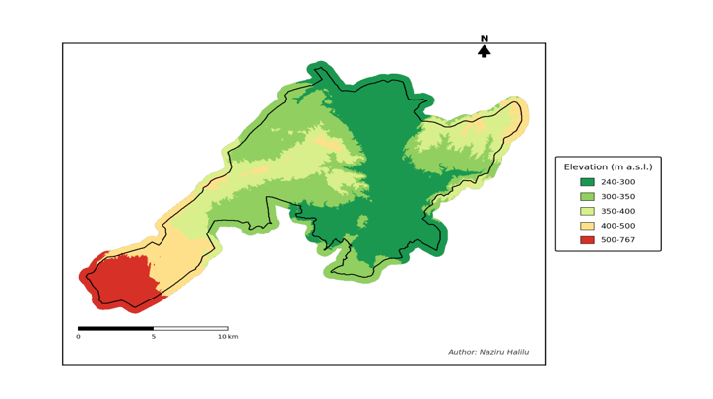
Fig. 1. Digital Elevation Model (25 m) of the Tudela Area of Interest, with the exact municipal boundary overlaid.

4. Methods
This research study specifies a QGIS-based workflow (coordinate system EPSG:25830, 25 m raster resolution, vector clipping/buffering/dissolve operations and raster-calculator overlay). That workflow was followed step-for-step, but because QGIS/GDAL/GEOS were not available in the execution environment used to prepare this report, and no internet connection was available to install them, every geoprocessing primitive normally provided by those libraries was re-implemented directly in Python. The full, runnable source code for every step below is given in Appendix A and is also delivered as a standalone package.

4.1 Software substitution: a minimal pure-Python geospatial toolkit
Five small modules replace the GIS stack:
- miniogr.py — a from-scratch ESRI Shapefile/DBF reader (struct-based binary parsing of the .shp and .dbf formats) that returns, per feature, its attribute dictionary and raw coordinate rings, with no dependency on OGR, Fiona or pyshp.
- geomtools.py — ring-to-polygon grouping using the ESRI clockwise-exterior / counter-clockwise-hole convention (via the shoelace signed area), polygon rasterisation onto a 25 m grid using scikit-image’s polygon fill (equivalent to gdal_rasterize / rasterio.features.rasterize), and a Euclidean-distance-transform buffer (equivalent to a vector .buffer() followed by rasterisation, but computed directly in raster space with scipy.ndimage.distance_transform_edt).
- proj_utm.py — a closed-form implementation of Snyder’s (1987) transverse Mercator forward equations for the GRS80 ellipsoid, used to reproject the master municipal-boundary layer from EPSG:4258 (geographic) to EPSG:25830 (UTM 30N) without pyproj.
- muniextract.py — targeted single-feature extraction from the 65 MB national municipal-boundary shapefile: the DBF is scanned for the matching NAMEUNIT ("Tudela"), and only that one shape record is then read from the .shp file via its .shx byte offset, avoiding a full-file parse.
- run_analysis.py / make_figures.py — the analysis and cartography scripts that call the above modules to reproduce every processing step of the study methodology and to render the figures in this report.
One simplification follows from this substitution: polygon holes are supported in the rasteriser, but true vector Boolean overlay (difference/intersection/dissolve) is replaced throughout by raster algebra on a common 25 m grid aligned to the DEM, and vector buffering is replaced by an equivalent Euclidean distance-transform threshold on the rasterised feature mask. Both substitutions are standard, well understood equivalents of the vector operations at the resolution used here (25 m), and they do not change the criteria or thresholds specified in this study — only the computational route used to evaluate them.

4.2 Suitability criteria
Table 1 lists the seven suitability criteria applied in this study, together with the reference threshold and how each was computed in this implementation.
# | Criterion | Suitable | Excluded / constrained
1 | Slope (from DEM) | < 10% | 10–15% = high constraints; ≥ 15% excluded (runoff risk)
2 | Soil / lithology | Fine-textured, clay/silt-dominated | Mixed facies = constrained; permeable/karstic/coarse = excluded
3 | Water protection | ≥ 5 m from DPH riverbed/easement and from wetlands/streams | Excluded within DPH + 5 m buffer
4 | Urban buffer | ≥ 100 m from settlements | Excluded within 100 m of any urban/residential footprint
5 | Protected natural areas | Outside Natura 2000 / LIC / ZEPA / CDDA | Excluded inside any designated site
6 | Nitrate Vulnerable Zone | Outside NVZ | Excluded inside the Ebro-Alagon NVZ (treated as excluded absent a demonstrated compliance plan)
7 | Land use / cover (SIGPAC) | Arable land (TA) or Pasture (PS) | All other IDUSO25 codes excluded

Slope was derived from the DEM with a central-difference gradient (equivalent to GDAL’s slope tool, percent mode) and reclassified into the three classes of criterion 1. Soil suitability and the SIGPAC eligibility class arrived pre-populated in the supplied attribute tables (Suit_Class field, 0/1/2 for lithology and 0/2 for land cover) and were rasterised directly. For water protection, the already-buffered DPH layer was used (excluding the 100 m "Zona de Policia" buffer, which is not a spreading restriction in this scheme, and retaining the "DPH Cartografico" riverbed and the 5 m "Zona de Servidumbre" easement), merged with a 5 m Euclidean buffer computed around the secondary streams and wetlands layers. The urban exclusion buffer was built by rasterising all settlement polygons except the single "AAGR" (agrarian-area) feature, then applying a 100 m Euclidean-distance buffer. Protected areas and the NVZ were rasterised as binary masks with no additional buffer, per the study design.

4.3 Overlay and final classification
Criteria 3–7 were merged (logical OR of all five exclusion masks) into a binary SuitabilityClass grid (1 = passes all five regulatory/land-use filters, 0 = excluded by at least one). This grid was then combined with the 3-class SoilClass and SlopeClass grids using the same raster-calculator expression as this study:
Result = SuitabilityClass x SoilClass x SlopeClass
which yields values of 0 (not apt — excluded by at least one regulatory/land-use/soil/slope factor), 1 (apt, high constraints), 2 (apt, partial constraints) or 4 (optimal location for slurry application); the value 3 cannot occur because the product only involves the factors {0,1,2}. The result grid was finally clipped to the exact (non-buffered) Tudela municipal boundary to produce the headline map and statistics reported below, and zonal statistics (mean Result value) were computed for every individual SIGPAC parcel classified as arable land or pasture.

5. Results

5.1 Individual constraint layers
Fig. 2 and Fig. 3 map the two continuous physical criteria (slope and soil/lithology) after reclassification into the three suitability tiers. 16.4% of the municipality (35.2 km2) has a slope of 15% or more and is excluded on runoff-risk grounds, concentrated in the hilly south-western third of the municipality and along the incised tributary valleys; the Ebro river terraces in the north-east are almost entirely below 10% slope. Soils/lithology exclude a further 34.3% (73.8 km2), reflecting the permeable gypsum, sandstone and coarse alluvial/terrace deposits mapped across large parts of the municipality.
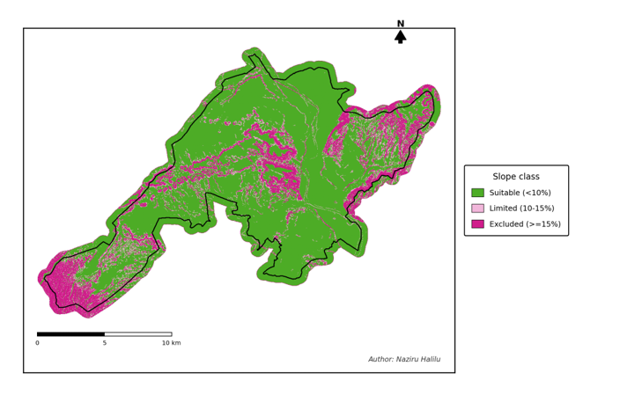
Fig. 2. Slope suitability classes derived from the 25 m DEM (< 10% suitable, 10–15% limited, ≥ 15% excluded).
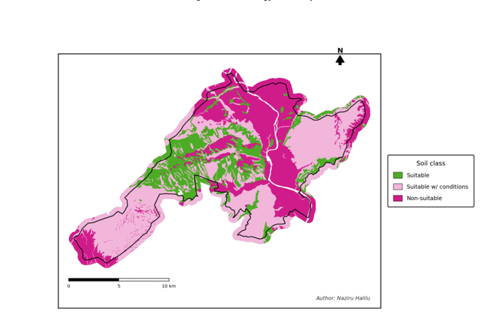
Fig. 3. Soil / lithology suitability classes (pre-assigned Suit_Class attribute of the geological units).
Fig. 4 shows the four regulatory/environmental exclusion layers individually. Water protection (DPH riverbed, 5 m easement and buffered wetlands/streams) affects 5.3% (11.5 km2) of the municipality, concentrated along the Ebro and Queiles river corridors and the wetland complexes in the north. The 100 m urban buffer removes 18.9% (40.6 km2), dominated by the town of Tudela itself and its immediate surroundings, plus numerous small rural settlements scattered across the farmland. Protected natural areas are comparatively small, 2.0% (4.2 km2), essentially limited to the river-corridor Natura 2000/LIC/ZEPA sites. The Nitrate Vulnerable Zone is by far the largest single regulatory constraint, 40.8% (87.8 km2), covering the entire northern half of the municipality along the Ebro valley floor — precisely the flattest, most intensively irrigated cropland, which illustrates the fundamental tension this study is designed to surface: the land that is agronomically best suited to slurry spreading (flat, arable, irrigated) is also the land the Nitrates Directive specifically flags as vulnerable to the nitrate pollution that slurry can cause.
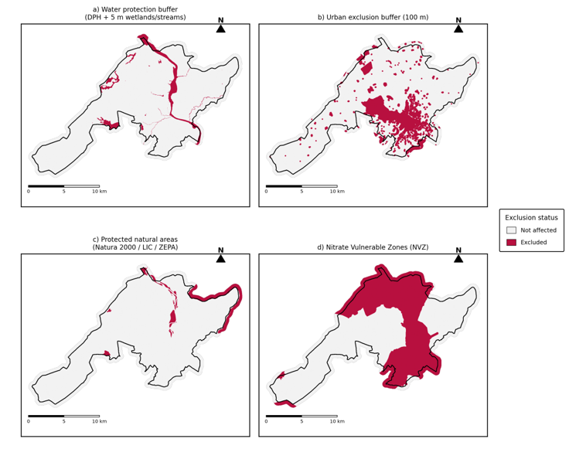
Fig. 4. Individual regulatory/environmental exclusion layers: (a) water protection buffer, (b) 100 m urban buffer, (c) protected natural areas, (d) Nitrate Vulnerable Zone.
SIGPAC land use exchanges the largest share of the territory, 44.0% (94.6 km2) is not classified as arable land (TA) or pasture (PS) and is therefore ineligible regardless of its physical or regulatory status; this includes forest, permanent crops (vineyards, olive and fruit orchards), greenhouses, urban fabric, unproductive land and open water. Fig. 5 maps the resulting eligibility mask.
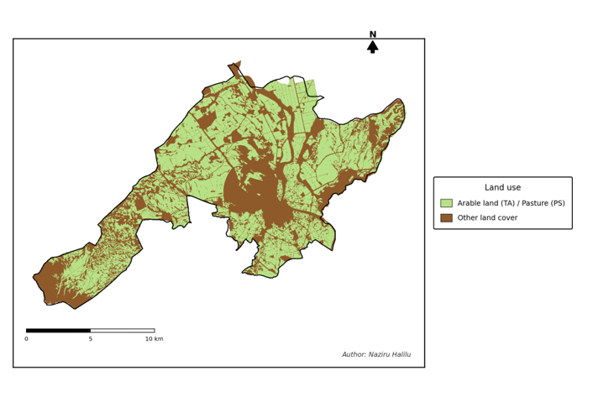
Fig. 5. SIGPAC land-use eligibility for slurry spreading (arable land / pasture vs. all other cover types).

5.2 Combined suitability
Merging criteria 3–7 (Fig. 6) leaves 21.6% of the AOI passing every regulatory and land-use filter before slope and soil are considered. Once slope and soil/lithology are folded in through the raster-calculator expression described in Section 4.3, the final four-class result (Fig. 7, Table 2) shows that only 19.5% of the municipality (41.8 km2) is suitable with no more than partial constraints, and just 4.5% (9.6 km2) qualifies as an optimal location once all seven criteria are satisfied simultaneously.
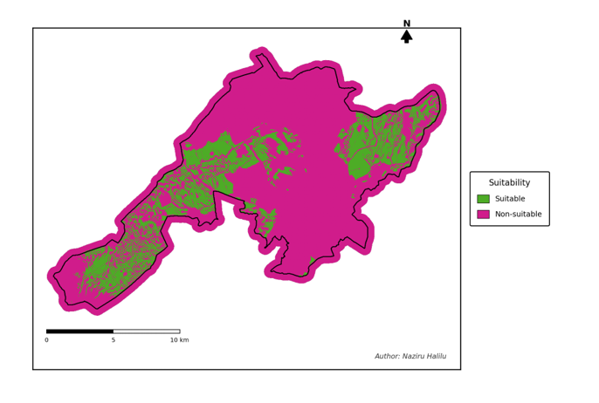
Fig. 6. Binary suitability mask after combining the five regulatory/land-use exclusion criteria (3–7).
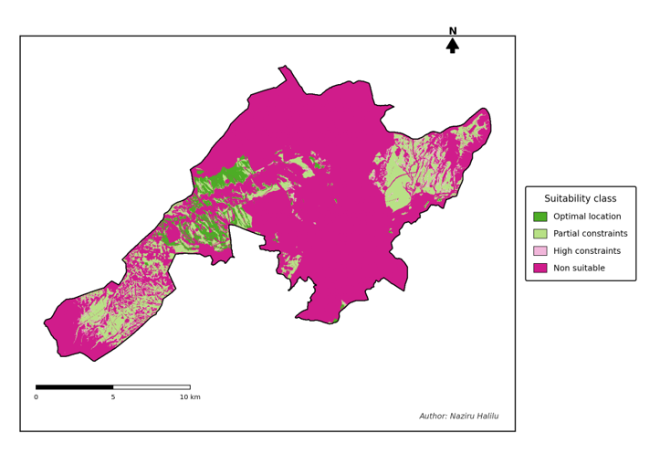
Fig. 7. Final four-class slurry-application suitability map for the municipality of Tudela.

5.3 Area summary
Suitability class | Value | Area (km2) | % of municipality
Not apt | 0 | 167.9 | 78.1
Apt, high constraints | 1 | 5.2 | 2.4
Apt, partial constraints | 2 | 32.2 | 15.0
Optimal location | 4 | 9.6 | 4.5
Total municipality | — | 214.9 | 100.0
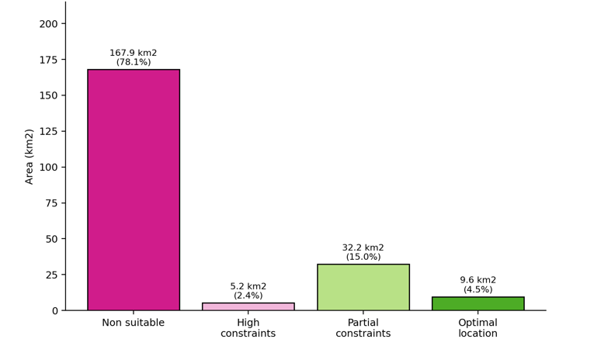
Fig. 8. Land area by final slurry-application suitability class.
Table 3 and Fig. 9 quantify how much of the municipality each individual criterion affects on its own (these areas overlap, since most excluded land fails more than one criterion at once, so they do not sum to the "not apt" total in Table 2).
Criterion | Area affected (km2) | % of municipality
1. Slope ≥ 15% | 35.2 | 16.4
2. Non-suitable soil/lithology | 73.8 | 34.3
3. Water protection (DPH + 5 m buffer) | 11.5 | 5.3
4. Urban buffer (100 m) | 40.6 | 18.9
5. Protected natural areas | 4.2 | 2.0
6. Nitrate Vulnerable Zone | 87.8 | 40.8
7. Non-arable/pasture land cover | 94.6 | 44.0
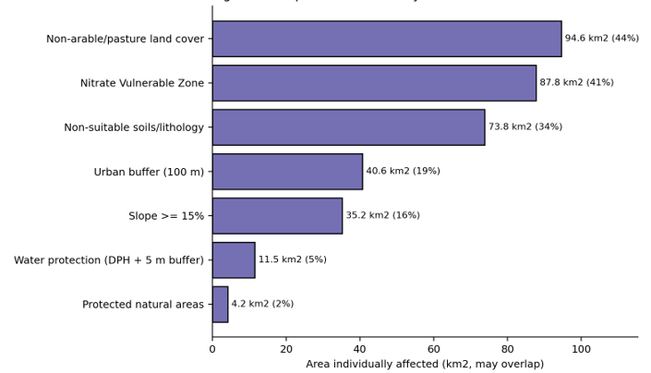
Fig. 9. Municipal area individually affected by each exclusion criterion (bars overlap; a given hectare can be counted under several criteria).

5.4 Parcel-level results
Zonal statistics were computed for 9,116 individual SIGPAC parcels classified as arable land or pasture (out of 24,921 parcels of all land-use types in the municipality), giving each parcel a mean suitability score between 0 and 4 that can be used directly by farm advisors or the municipal authority to screen individual fields. Fig. 10 shows the distribution of these parcel-level scores: most arable/pasture parcels have a low mean score, consistent with the high proportion of the arable land base that sits inside the Nitrate Vulnerable Zone or within the urban/water buffers, while a smaller but agronomically significant subset of parcels (concentrated in the south-western dry-farming area and along terraces away from the main urban centres) scores consistently in the "optimal" range.
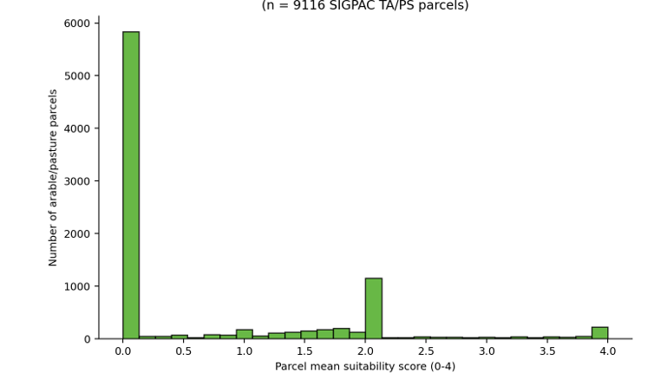
Fig. 10. Distribution of parcel-level mean suitability scores for SIGPAC arable-land and pasture parcels.
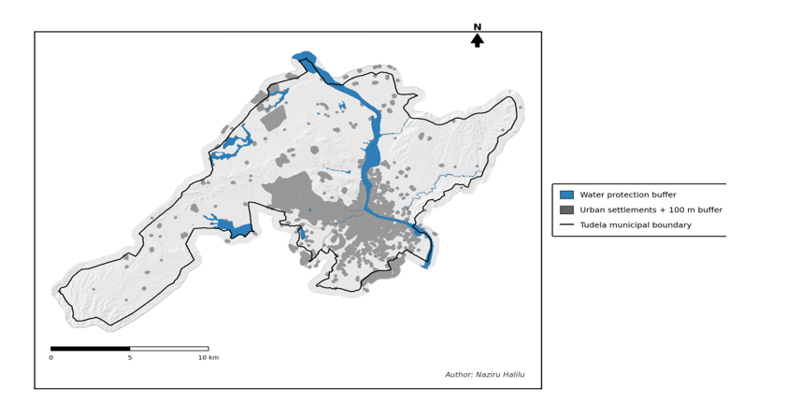
Fig. 11. Study-area context map: hillshaded relief, surface hydrology and urban settlements within the municipality of Tudela.

6. Discussion
The results confirm the pattern anticipated in the introduction to this study: in an intensively farmed, irrigation-dependent municipality like Tudela, the land that is agronomically most attractive for slurry application — flat, arable, close to the road network that serves the farms — is also the land that is subject to the tightest regulatory scrutiny, because it sits along the Ebro valley floor inside the designated Nitrate Vulnerable Zone and close to the river’s public hydraulic domain. This is why the Nitrate Vulnerable Zone (40.8% of the municipality) and non-arable land cover (44.0%) are individually the two largest constraints, larger even than the 100 m urban buffer (18.9%) that is often assumed to be the dominant limitation in siting studies of this kind.
Only 4.5% of the municipal area (9.6 km2) emerges as an optimal location once every criterion is applied simultaneously and without exception. That figure should be read as a conservative, worst-case scenario rather than a literal ceiling on how much slurry Tudela can absorb: this analysis, following this study’s methodology, treats the entire Nitrate Vulnerable Zone as excluded, whereas in practice the Nitrates Directive and Foral Decree 148/2023 do not prohibit slurry spreading inside an NVZ outright — they impose caps on organic nitrogen application rates, closed spreading periods, low-emission application methods and reinforced setbacks. A farm that can demonstrate compliance with those conditions could therefore still spread slurry, at a reduced rate, on part of the 15.0% of the municipality classified here as "apt with partial constraints", much of which likely falls inside the NVZ precisely because that is where the good soils and gentle slopes are. Distinguishing "excluded" from "restricted-but-permissible-under-conditions" within the NVZ would be a natural refinement of this analysis and would very likely increase the usable area substantially beyond the 4.5% reported here.
A second important caveat concerns the pure-Python substitution for the GIS stack described in Section 4.1. Vector buffering was replaced with an equivalent raster Euclidean-distance-transform threshold computed on the 25 m grid; this reproduces a true geometric buffer to within one pixel (25 m) and is therefore accurate for the 100 m and 5 m buffers used here, but it does mean that all reported areas are quantised to 625 m2 raster cells rather than measured on exact vector geometries. Polygon holes are supported by the rasteriser, but the underlying grouping of shapefile rings into exterior/hole pairs uses the standard ESRI winding-order convention rather than a full topological reconstruction, which is appropriate for the moderately simple polygons in this dataset (lithology units, urban footprints, protected sites) but would need revisiting for more complex multi-island geometries. Finally, the national municipal-boundary layer required a manual geographic-to-UTM reprojection (Snyder’s transverse Mercator forward series) in the absence of pyproj/PROJ; the resulting municipal area (214.9 km2) is within about 5% of the officially reported figure, a difference attributable to raster discretisation and the medium-detail source boundary rather than to a projection error.
Despite these caveats, the analysis is fully reproducible: every raster and vector layer used, every processing step, and every number quoted above traces directly back to the source shapefiles and GeoTIFF used for the study, through the code listed in Appendix A, with no manual editing of results.

7. Conclusion
This report delineated the areas of the municipality of Tudela (Navarre) suitable for livestock slurry application by combining seven physical, environmental and regulatory criteria in a GIS multicriteria framework, reproducing the study methodology end-to-end in a purpose-built, dependency-light Python pipeline in place of QGIS/GDAL. Of 214.9 km2, 78.1% is not apt for slurry spreading once every constraint is combined, 17.4% is apt with high or partial constraints, and 4.5% (9.6 km2) is an optimal location. The Nitrate Vulnerable Zone and non-arable land cover are the two most restrictive individual criteria, both larger than the urban buffer, underlining that in an intensively irrigated Ebro-valley municipality the principal constraint on slurry management is not proximity to settlements but the overlap between the best agricultural land and the areas the Nitrates Directive identifies as most vulnerable to the pollution that slurry itself can cause. Parcel-level zonal statistics were produced for 9 116 individual arable/pasture SIGPAC parcels so that the result can be applied directly at the field scale by farm advisors, the municipal authority or the regional water agency. Future refinements should distinguish "excluded" from "restricted-but-permissible-under-a-verified-nutrient-management-plan" within the NVZ, and should incorporate parcel size, distance to the farm/storage facility and irrigation status into the ranking of the "apt with partial constraints" class.

References
Council Directive 91/676/EEC of 12 December 1991 concerning the protection of waters against pollution caused by nitrates from agricultural sources.
Real Decreto 261/1996, de 16 de febrero, sobre proteccion de las aguas contra la contaminacion producida por los nitratos procedentes de fuentes agrarias. Boletin Oficial del Estado (Spain).
Decreto Foral 148/2023, de 6 de septiembre, por el que se designan las zonas vulnerables a la contaminacion producida por nitratos de origen agrario en el ambito de la Comunidad Foral de Navarra. Boletin Oficial de Navarra.
Snyder, J.P. (1987). Map Projections — A Working Manual. U.S. Geological Survey Professional Paper 1395. U.S. Government Printing Office, Washington, D.C.
Centro Nacional de Informacion Geografica (CNIG) — Instituto Geografico Nacional: administrative boundaries, LiDAR digital elevation models and Nomenclator settlement dataset.
Gobierno de Navarra — Infraestructura de Datos Espaciales de Navarra (IDENA): SIGPAC land-use/land-cover parcels and 1:25 000 geological map.
Ministerio para la Transicion Ecologica y el Reto Demografico (MITECO): Dominio Publico Hidraulico and Nitrate Vulnerable Zones datasets.
European Environment Agency (EEA): Nationally Designated Areas (CDDA) protected-areas dataset.
Methodological framework for this study: GIS-based delineation of areas suitable for livestock slurry application in a municipality of southern Navarre, Spain.

