GIS-Based Delineation and Continuous Modelling of Areas Suitable for
Livestock Slurry Application in Tudela, Navarre, Spain
An Integrated Boolean-Overlay, Regression-Kriging and Deep-Learning Assessment
Merged research report combining a rule-based GIS multicriteria overlay with a continuous-surface geostatistical / deep-learning extension
Author: Naziru Halilu
Continuous-surface extension prepared for peer review; authorship of that component withheld pending review

Abstract
Livestock slurry is a nutrient-rich by-product of intensive animal farming that can substitute mineral fertiliser when applied at the right place, time and rate, but that becomes a source of nitrate and nutrient pollution when it is not. This report merges two complementary analyses of the same case study — the municipality of Tudela (Navarre, Spain) — into a single, integrated slurry-application suitability assessment.
The first analysis is a seven-criterion GIS multicriteria (Boolean) overlay combining topography, soil/lithology, surface-water protection buffers, urban buffers, protected natural areas, the Ebro-Alagon Nitrate Vulnerable Zone (NVZ) and SIGPAC land-use/land-cover parcels, reproduced end-to-end in a dependency-light, pure-Python geospatial pipeline (no QGIS/GDAL/GEOS available). Of the 214.9 km² municipality, this overlay classifies 78.1% as not apt, 2.4% as apt with high constraints, 15.0% as apt with partial constraints and 4.5% (9.6 km²) as an optimal location once every regulatory and environmental constraint is combined simultaneously. The Ebro-Alagon NVZ (40.8% of the municipality) and non-arable land cover (44.0%) are individually the two largest constraints, both larger than the 100 m urban buffer (18.9%).
The second analysis directly extends the first study's own recommendation — that the NVZ, which the Boolean overlay treats as a hard exclusion, is in reality a rate-restriction rather than an outright prohibition. Within the 5.35% of the municipality (14.35 km²) that passes every other hard constraint (the “candidate zone”), a continuous fuzzy weighted-linear-combination Suitability Index (SI, 0–100) is defined, with the NVZ folded in as a graduated 0.70 regulatory penalty rather than an exclusion. This continuous surface is reconstructed from a spatially block-cross-validated network of 550 pseudo-observations using regression kriging (linear and random-forest trend variants) and two deep-learning surrogates (a multilayer perceptron and a patch-based convolutional neural network). The random-forest regression-kriging model (RK-RF) gave the best held-out performance (RMSE = 7.78, R² = 0.77) and the lowest residual spatial autocorrelation, outperforming the deep-learning surrogates (RMSE ≈ 9.9, R² ≈ 0.62) and classical linear-trend kriging (RMSE = 11.0, R² = 0.53). Permutation importance confirms NVZ status, slope and distance to surface water as the dominant covariates — the same NVZ dominance the Boolean overlay identifies independently, a useful cross-validation between the two methodologies.
Merged together, the two analyses describe suitability at two complementary spatial scales: a coarse, legally auditable four-class map across the whole municipality, and a fine-grained, uncertainty-quantified continuous surface within the most agronomically promising 5.35% of it. A new integrated final map and a set of covariate-relationship figures, produced specifically for this merged report, tie the two scales together.

Contents

1. Introduction
Livestock slurry is a liquid by-product of intensive farming, made up mainly of animal excreta diluted with water and cleaning residues from animal housing. It contains substantial amounts of nitrogen, phosphorus, potassium and organic carbon, which makes it a potentially valuable soil amendment. However, as livestock production has intensified, the volume of slurry generated in many regions now regularly exceeds the nutrient-uptake capacity of the surrounding farmland. Where slurry is over-applied or poorly timed, it becomes a pollutant that contributes to nitrate contamination of groundwater and to the eutrophication of rivers, lakes and reservoirs, with knock-on risks for drinking-water supplies, aquatic biodiversity and public health.
Used correctly, slurry can reduce a farm's dependence on mineral fertiliser, close on-farm nutrient loops and improve soil structure and biological activity, particularly on intensively cropped, irrigated land such as that found along the Ebro valley. The challenge is to apply it at the right place, time and rate. In the European Union this is governed by the Nitrates Directive (91/676/EEC); in Spain it is implemented through Royal Decree 261/1996; and in the Autonomous Community of Navarre it is further specified by Foral Decree 148/2023, which sets out the region's designated Nitrate Vulnerable Zones and the associated spreading restrictions.
GIS provides a natural framework for this kind of siting problem because it allows heterogeneous datasets — topography, land cover, soil, hydrology, protected areas and regulatory zoning — to be combined into a single spatial model. The conventional tool for doing so is GIS-based multicriteria decision analysis (GIS-MCDA): criteria are reclassified onto a common scale and combined by Boolean overlay, weighted linear combination or an outranking procedure, and mapped as a small number of discrete suitability classes. Site-suitability studies specifically for manure and slurry application follow this template internationally, from expert-system reasoning over Dutch soil and terrain data to raster-GIS overlays in Louisiana and logistics-optimised manure routing in Catalonia.
This report brings together two analyses that both take Tudela — the largest municipality in Navarre by area, situated in the Ebro river valley in the Ribera Baja comarca — as their case study, and that were designed to be read as a pair:
- Part I (Sections 4.1–4.3 and 5.1–5.3) reproduces a standard seven-criterion GIS-MCDA Boolean overlay entirely without QGIS, GDAL, GEOS, rasterio, Fiona or geopandas — none of which were available in that analysis's execution environment, and without internet access to install them. Shapefile parsing, coordinate reprojection, polygon rasterisation, buffering, raster algebra and zonal statistics were re-implemented in a small, dependency-light Python toolkit (NumPy, SciPy, scikit-image, Matplotlib and Pillow only).
- Part II (Sections 4.4–4.8 and 5.4–5.8) targets the single most consequential simplification that Part I's own discussion flags: that treating the entire Nitrate Vulnerable Zone as excluded is a conservative, worst-case assumption, because the Nitrates Directive and Foral Decree 148/2023 in fact cap organic-nitrogen application rates within an NVZ rather than banning spreading outright. Using a full geospatial and machine-learning stack (geopandas, rasterio, PyKrige, TensorFlow), Part II relaxes that exclusion to a graduated regulatory penalty inside a hard-constraint-compliant candidate zone, and reconstructs a continuous suitability surface there using regression kriging and deep-learning surrogates, with formal predictive-uncertainty quantification.
Section 5.9 and the newly produced figures in that section (Figs. 22–23) combine the outputs of both parts into a single integrated final assessment.

2. Objectives
The objective of this merged report is to conduct a spatially explicit, two-scale analysis that identifies the agricultural areas of Tudela suitable for livestock slurry application, integrating environmental, regulatory and land-use criteria at the whole-municipality scale, and then reconstructing a continuous, uncertainty-quantified suitability surface within the most promising sub-area. The specific goals are to:
- understand and apply the legal and environmental constraints governing slurry application at European, national and regional level, including exclusion zones for water bodies, urban areas, protected natural spaces and nitrate-vulnerable areas;
- identify zones suitable and unsuitable for slurry application across the whole municipality based on slope, land use/cover, proximity to rivers and lakes, distance to settlements, soil characteristics, protected/nitrate-vulnerable designation, stating explicitly the reason for exclusion in each case;
- conduct a GIS-based multicriteria analysis that integrates all relevant layers into a four-class suitability model (“optimal”, “apt with partial constraints”, “apt with high constraints”, “not apt”), together with a summary table of the contributing constraints;
- within the sub-area that passes every hard constraint except the NVZ exclusion, replace the discrete classification with a continuous fuzzy suitability index, and reconstruct that index from a sampled observation network using regression kriging and deep-learning surrogates, benchmarked against one another with spatial cross-validation;
- quantify which individual covariates and criteria most influence suitability at each scale, and check whether the two independent methodologies agree; and
- produce a single, final, integrated suitability map that presents both the coarse regulatory classification and the fine-grained continuous refinement together, and critically reflect on the spatial feasibility of slurry application in an intensively farmed municipality under current environmental regulation.

3. Study area and data
The study area is the municipality of Tudela (Navarre, Spain), extracted from the Spanish National Geographic Institute (CNIG) INSPIRE administrative-boundaries dataset (recintos_municipales_inspire_peninbal_etrs89, EPSG:4258). Rasterising the reprojected boundary gives a municipal area of 214.9 km² at 25 m resolution, consistent with the officially reported figure of around 226 km² for Spain's largest municipality by area outside the Canary/Balearic Islands region; the ~5% difference reflects the 25 m raster discretisation and boundary generalisation rather than a data error. A 500 m outward buffer of the boundary defines the Area of Interest (AOI, 268.1 km²) used throughout both parts of the analysis to avoid edge effects when computing slope and buffers near the municipal limit. Elevation within the AOI ranges from 247 m to 767 m a.s.l., reflecting the transition from the flat Ebro river terraces in the north-east to the hillier Bardenas/Moncayo foothills in the south-west (Fig. 1).
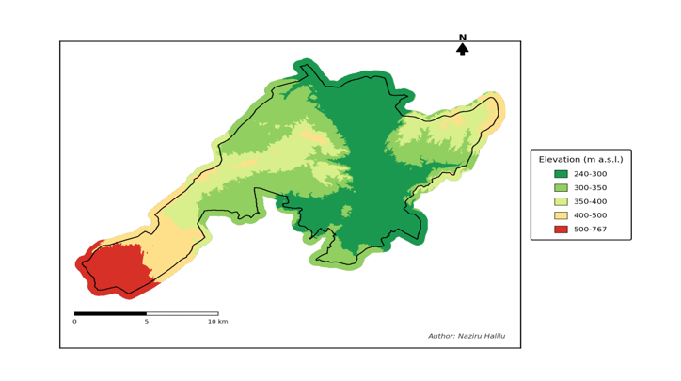
Fig. 1. Digital Elevation Model (25 m) of the Tudela Area of Interest, with the exact municipal boundary overlaid.
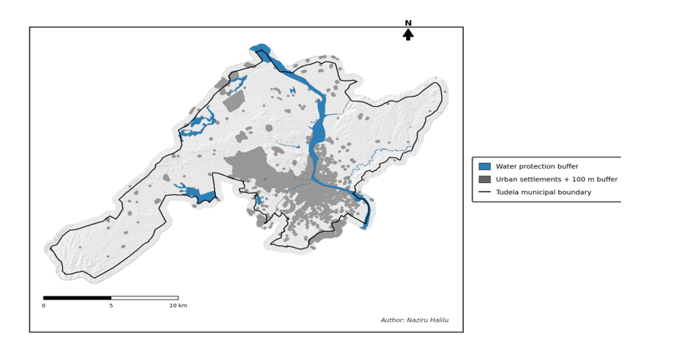
Fig. 2. Study-area context map: hillshaded relief, surface hydrology and urban settlements within the municipality of Tudela.

3.1 Datasets used
Both parts of the analysis draw on the same nine official vector/raster layers, all supplied pre-clipped to the Area of Interest and projected in ETRS89 / UTM zone 30N (EPSG:25830), except the master municipal-boundary file, distributed in geographic coordinates (EPSG:4258) and reprojected as part of Part I:
Layer | Source file(s) | Type / role
Municipal boundary | recintos_municipales_inspire_peninbal_etrs89.shp (CNIG) | Polygon, EPSG:4258; reprojected to EPSG:25830 to derive the exact Tudela boundary
Area of Interest | AOI.shp (500 m buffer) | Polygon, working extent for all raster layers
Digital Elevation Model | DEM_AOI.tif (25 m, CNIG LiDAR MDT25) | Raster, EPSG:25830; source for slope
Soil / lithology | Lithology_AOI.shp (IDENA geological map, 1:25 000) | Polygon with pre-assigned Suit_Class (0/1/2)
Surface water bodies | DPH_AOI.shp + Franjas + Humedales (MITECO) | Polygon; riverbed, 5 m easement, streams and wetlands
Urban areas | UrbanArea_AOI.shp (CNIG Nomenclator) | Polygon, 1 144 settlement footprints
Protected natural areas | ProtectedNaturalAreas.shp / PNA_AOI.shp (EEA) | Polygon, 8 designated sites
Nitrate Vulnerable Zone | ES_NVZ_boundaries_vigente.shp / NVZ_AOI.shp (MITECO) | Polygon, 2 features (Ebro-Alagon NVZ)
Land use / land cover | SGP2025_Mun232.shp (SIGPAC, parcel level) | Polygon, 24 921 parcels, pre-assigned Suit_Class
The DEM was supplied pre-mosaicked and pre-clipped to the AOI at 25 m resolution (809 rows × 1203 columns).

4. Methods
This report follows a QGIS-style workflow (coordinate system EPSG:25830, 25 m raster resolution, vector clipping/buffering/dissolve operations and raster-calculator overlay) in both parts, but the two parts differ in how that workflow was executed. Part I's execution environment provided no QGIS, GDAL, GEOS, rasterio, Fiona or geopandas and no internet connection to install them, so every geoprocessing primitive was re-implemented directly in Python (Section 4.1). Part II's execution environment had the full stack available (geopandas, rasterio, PyKrige, TensorFlow) and used it directly (Sections 4.4–4.8). This difference is noted here transparently because it means the two parts are two independent computational implementations of a shared set of source layers and criteria, which strengthens rather than weakens the cross-validation reported in Section 6.

4.1 Part I — software substitution: a minimal pure-Python geospatial toolkit
Five small modules replace the GIS stack for Part I:
- miniogr.py — a from-scratch ESRI Shapefile/DBF reader (struct-based binary parsing) with no dependency on OGR, Fiona or pyshp.
- geomtools.py — ring-to-polygon grouping via the ESRI winding-order convention, polygon rasterisation on the 25 m grid using scikit-image's polygon fill, and Euclidean-distance-transform buffering with scipy.ndimage.distance_transform_edt.
- proj_utm.py — a closed-form implementation of Snyder's (1987) transverse Mercator forward equations (GRS80 ellipsoid), used to reproject the municipal-boundary layer from EPSG:4258 to EPSG:25830 without pyproj.
- muniextract.py — targeted single-feature extraction from the 65 MB national municipal-boundary shapefile via its .shx byte offset, avoiding a full-file parse.
- run_analysis.py / make_figures.py — the analysis and cartography scripts that reproduce every processing step and render Part I's figures.
Vector Boolean overlay (difference/intersection/dissolve) is replaced throughout Part I by raster algebra on the common 25 m grid, and vector buffering by an equivalent Euclidean distance-transform threshold; both are standard, well-understood equivalents at 25 m resolution and do not change the criteria or thresholds themselves, only the computational route used to evaluate them.

4.2 Suitability criteria and the Boolean overlay
Table 1 lists the seven suitability criteria applied in Part I's hard-constraint overlay, together with the reference threshold and how each was computed.
# | Criterion | Suitable | Excluded / constrained
1 | Slope (from DEM) | < 10% | 10–15% = high constraints; ≥ 15% excluded (runoff risk)
2 | Soil / lithology | Fine-textured, clay/silt-dominated | Mixed facies = constrained; permeable/karstic/coarse = excluded
3 | Water protection | ≥ 5 m from DPH riverbed/easement, streams, wetlands | Excluded within DPH + 5 m buffer
4 | Urban buffer | ≥ 100 m from settlements | Excluded within 100 m of any urban/residential footprint
5 | Protected natural areas | Outside Natura 2000 / LIC / ZEPA / CDDA | Excluded inside any designated site
6 | Nitrate Vulnerable Zone | Outside NVZ | Part I: excluded absent a demonstrated compliance plan. Part II: retained as a continuous 0.70 rate-penalty, not an exclusion (Section 4.4)
7 | Land use / cover (SIGPAC) | Arable land (TA) or Pasture (PS) | All other IDUSO25 codes excluded
Slope was derived from the DEM with a central-difference gradient (equivalent to GDAL's slope tool, percent mode) and reclassified into the three classes of criterion 1. Soil suitability and the SIGPAC eligibility class arrived pre-populated in the supplied attribute tables and were rasterised directly. For water protection, the already-buffered DPH layer was used (excluding the 100 m “Zona de Policia” buffer, retaining the DPH Cartografico riverbed and the 5 m Zona de Servidumbre easement), merged with a 5 m buffer around secondary streams and wetlands. The urban exclusion buffer rasterised all settlement polygons except the single “AAGR” (agrarian-area) feature, then applied a 100 m Euclidean-distance buffer. Protected areas and the NVZ were rasterised as binary masks with no additional buffer, per the study design.
Result = SuitabilityClass × SoilClass × SlopeClass
where SuitabilityClass is a binary regulatory/land-use mask (1 = passes all five regulatory/land-use filters, 0 = excluded by at least one), and SoilClass and SlopeClass are the three-class grids above. This yields values of 0 (not apt), 1 (apt, high constraints), 2 (apt, partial constraints) or 4 (optimal location); the value 3 cannot occur because the product only involves the factors {0,1,2}. The result grid was clipped to the exact (non-buffered) Tudela municipal boundary to produce Part I's headline map and statistics, and zonal statistics (mean Result value) were computed for every SIGPAC parcel classified as arable land or pasture.

4.3 From Part I to Part II: relaxing the NVZ exclusion
Part I's own discussion (reproduced in Section 6) identifies that treating the entire NVZ as excluded is conservative: the Nitrates Directive and Foral Decree 148/2023 cap organic-nitrogen application rates, close spreading periods, and require low-emission methods and reinforced setbacks within an NVZ — they do not prohibit spreading outright. Part II operationalises exactly this refinement. The six remaining hard constraints (slope, soil, water protection, urban buffer, protected areas, land-use eligibility) are combined by Boolean AND to delineate a candidate zone (5.35% of the AOI, 14.35 km², 22 953 cells), and the NVZ is instead folded into a continuous suitability index as a graduated penalty rather than a further exclusion (Section 4.4).

4.4 Part II — continuous fuzzy suitability index
Within the candidate zone, a continuous Suitability Index (SI, range 0–100) is built as a weighted linear combination of four fuzzy membership functions:
SI = 100 × P_{nvz} × (0.30·f_{slope} + 0.25·f_{water} + 0.20·f_{urban} + 0.25·f_{prot})
where f_slope = clip(1 − slope(%)/15, 0, 1) gives full membership to flat land and zero membership at the 15% hard threshold; f_water and f_prot increase with distance from the corresponding hard buffer, saturating at 300 m and 1000 m respectively; f_urban increases beyond the 100 m hard buffer and saturates at 500 m; and P_nvz is a regulatory penalty factor equal to 0.70 inside the Nitrate Vulnerable Zone and 1.0 outside it, reflecting the reduced permissible nitrogen load rather than an outright prohibition. The weights (0.30/0.25/0.20/0.25) follow common practice of giving the largest share to the criterion with the most direct agronomic/erosion-risk relevance (slope) while keeping the buffer-distance criteria comparably weighted. The resulting SI surface has mean 76.4 and SD 15.0 across the candidate zone (Fig. 12), and is treated as the reference “latent” suitability surface that the pseudo-observation network samples and that regression kriging and the deep-learning models attempt to reconstruct from covariates alone.
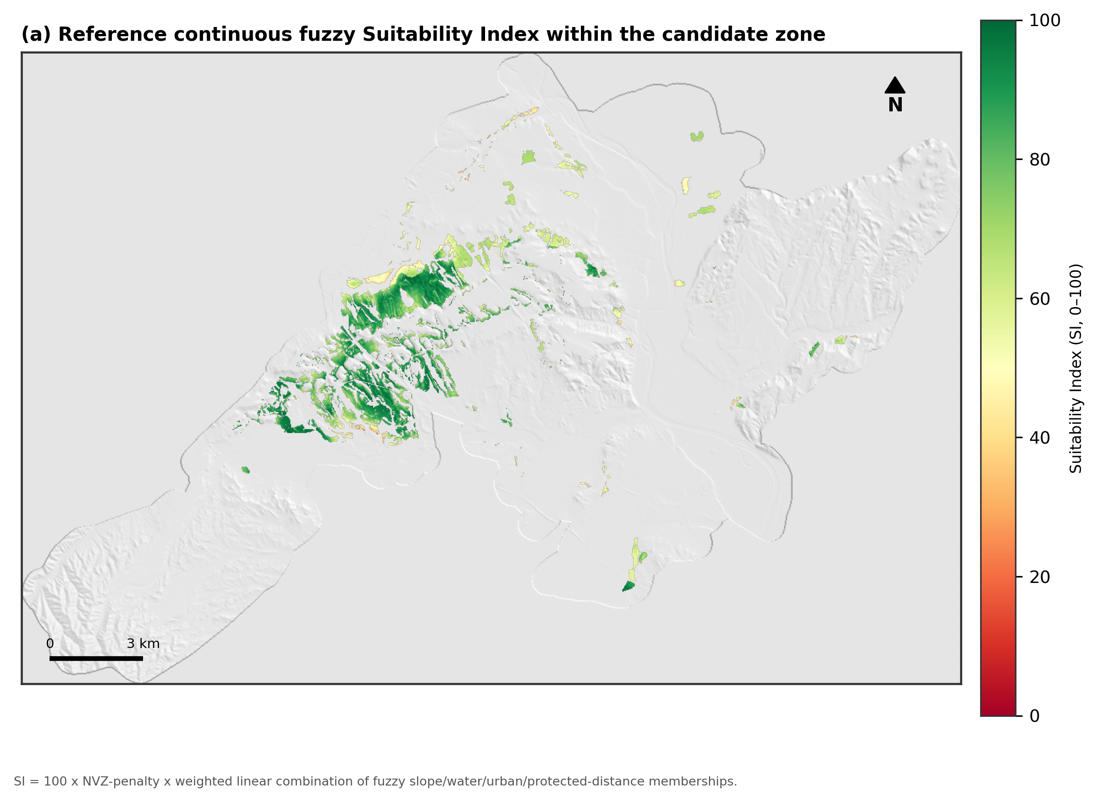
Fig. 12. Reference continuous fuzzy Suitability Index within the candidate (hard-constraint-compliant) zone.

4.5 Pseudo-observation network and spatial cross-validation
No physical field-verified slurry-suitability monitoring network exists for Tudela. Following the synthetic benchmarking design used to validate spatial-interpolation and machine-learning methods in the digital soil mapping literature, 550 pseudo-observation points were drawn at random locations within the candidate zone. At each point, the reference SI value was sampled and heteroscedastic Gaussian noise (SD = 3.0 + 0.06×SI) was added to emulate realistic field- or expert-assessment error. Points were partitioned into training and held-out test sets by spatial blocking: the area was tiled into 2×2 km blocks, and 25% of blocks were withheld entirely as the test set (127 points, 9 of 35 blocks), so spatial autocorrelation between nearby points could not inflate apparent accuracy.
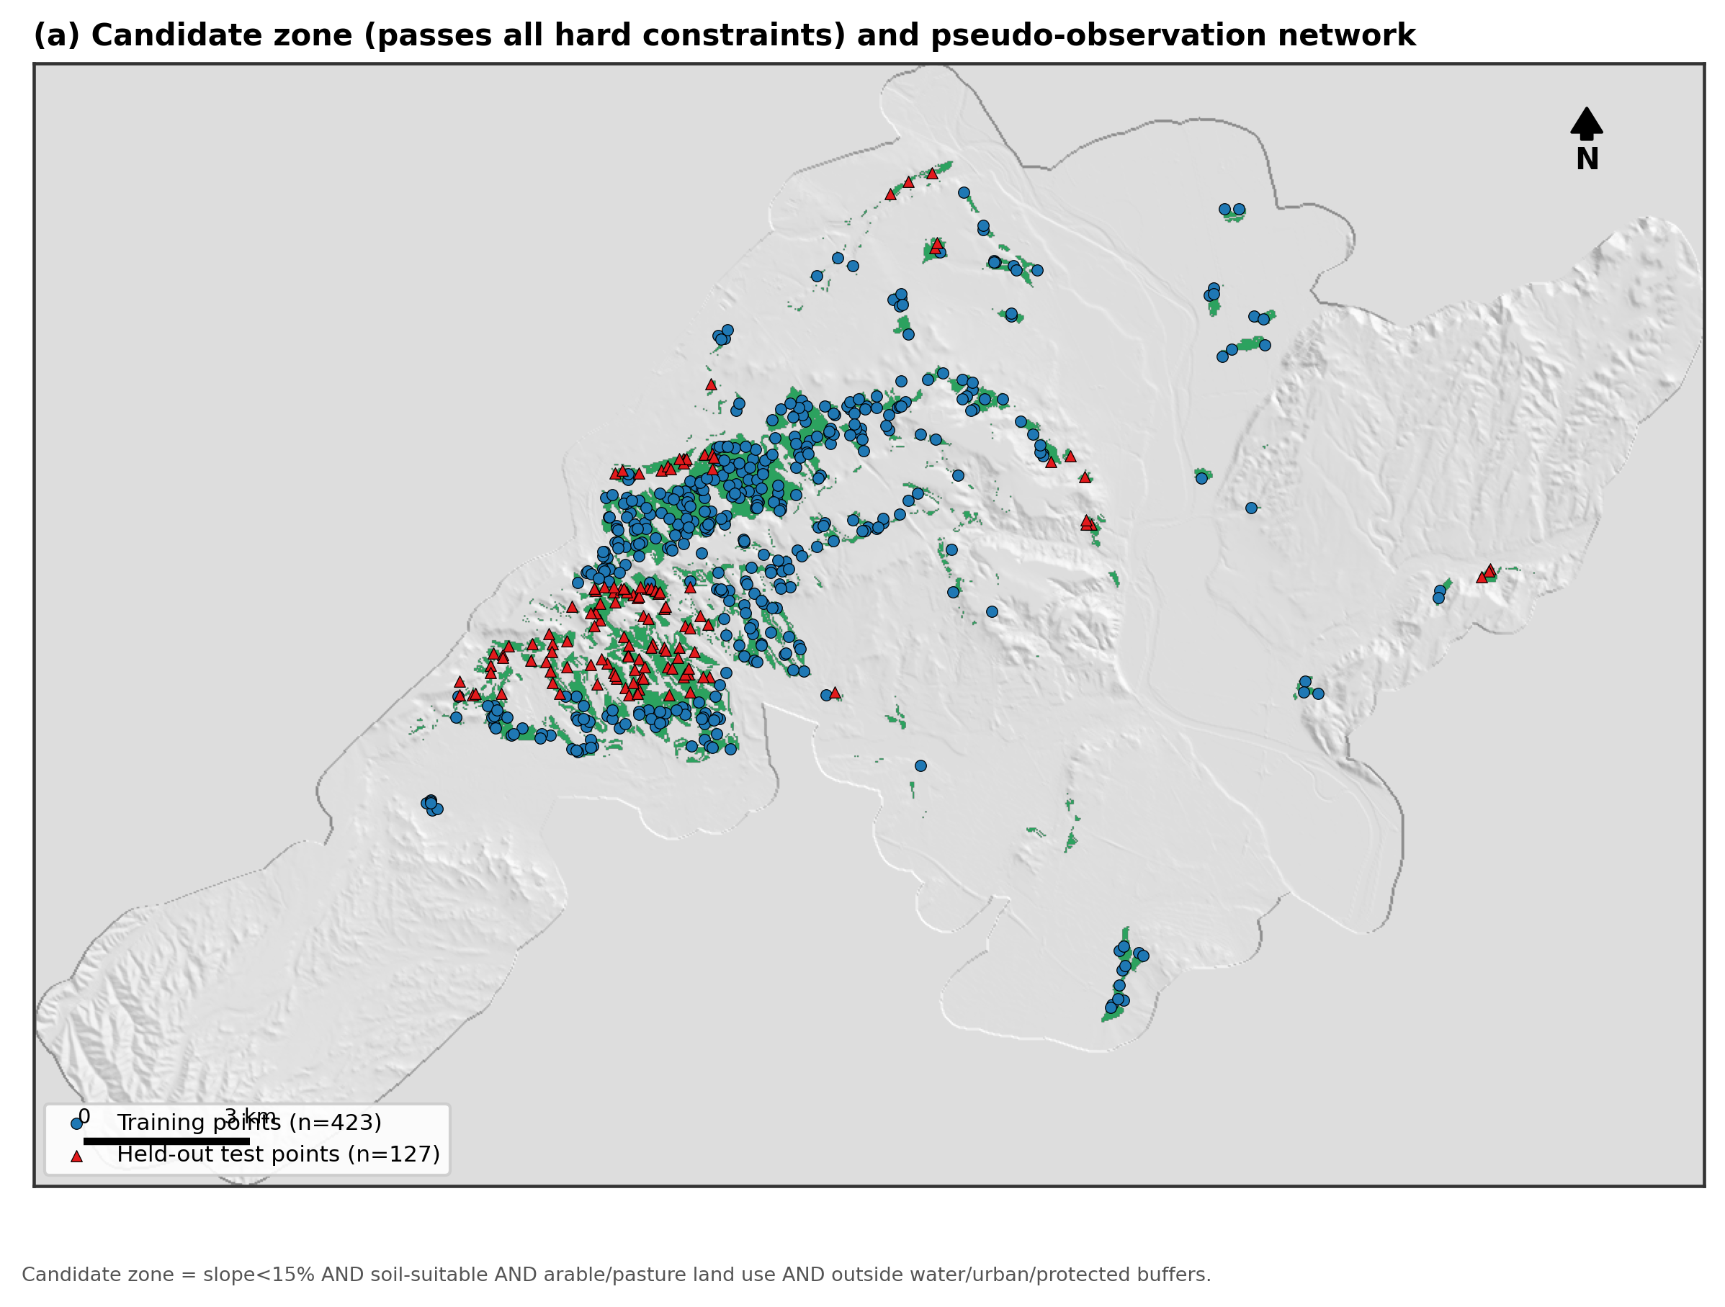
Fig. 13. Candidate zone and the spatially block-split pseudo-observation network (423 training, 127 held-out test points).

4.6 Regression kriging
Regression kriging (RK) combines a deterministic regression trend on auxiliary covariates with ordinary kriging of the trend's residuals. Two trend models were compared: RK-LM, an ordinary-least-squares linear trend, and RK-RF, a random-forest trend (300 trees, maximum depth 8) capturing non-linear and interaction effects. Both used the same six covariates — slope, distance to water, distance to urban land, distance to protected areas, NVZ indicator, and elevation — and both kriged the trend residuals by ordinary kriging with a spherical variogram model (12 lag bins, up to 12 nearest neighbours), implemented with the PyKrige RegressionKriging class.

4.7 Deep-learning surrogates
DL-MLP is a fully connected feed-forward network (64–32–16–1 units, ReLU, batch normalisation, dropout 0.2) trained on eight standardised inputs: the six RK covariates plus the projected x/y coordinates. DL-CNN is a small convolutional network reading a 9×9-cell (225×225 m), six-channel neighbourhood centred on each sample, through two convolutional blocks (16, 32 then 32 filters, 3×3 kernels, one 2×2 max-pooling layer), global-average pooling and a 32-unit dense head. Both were trained with Adam (learning rate 10⁻³) to minimise mean squared error, with an 80/20 train/validation split and early stopping (patience 40 epochs); DL-MLP stopped at epoch 160, DL-CNN at epoch 234 (Fig. 14).
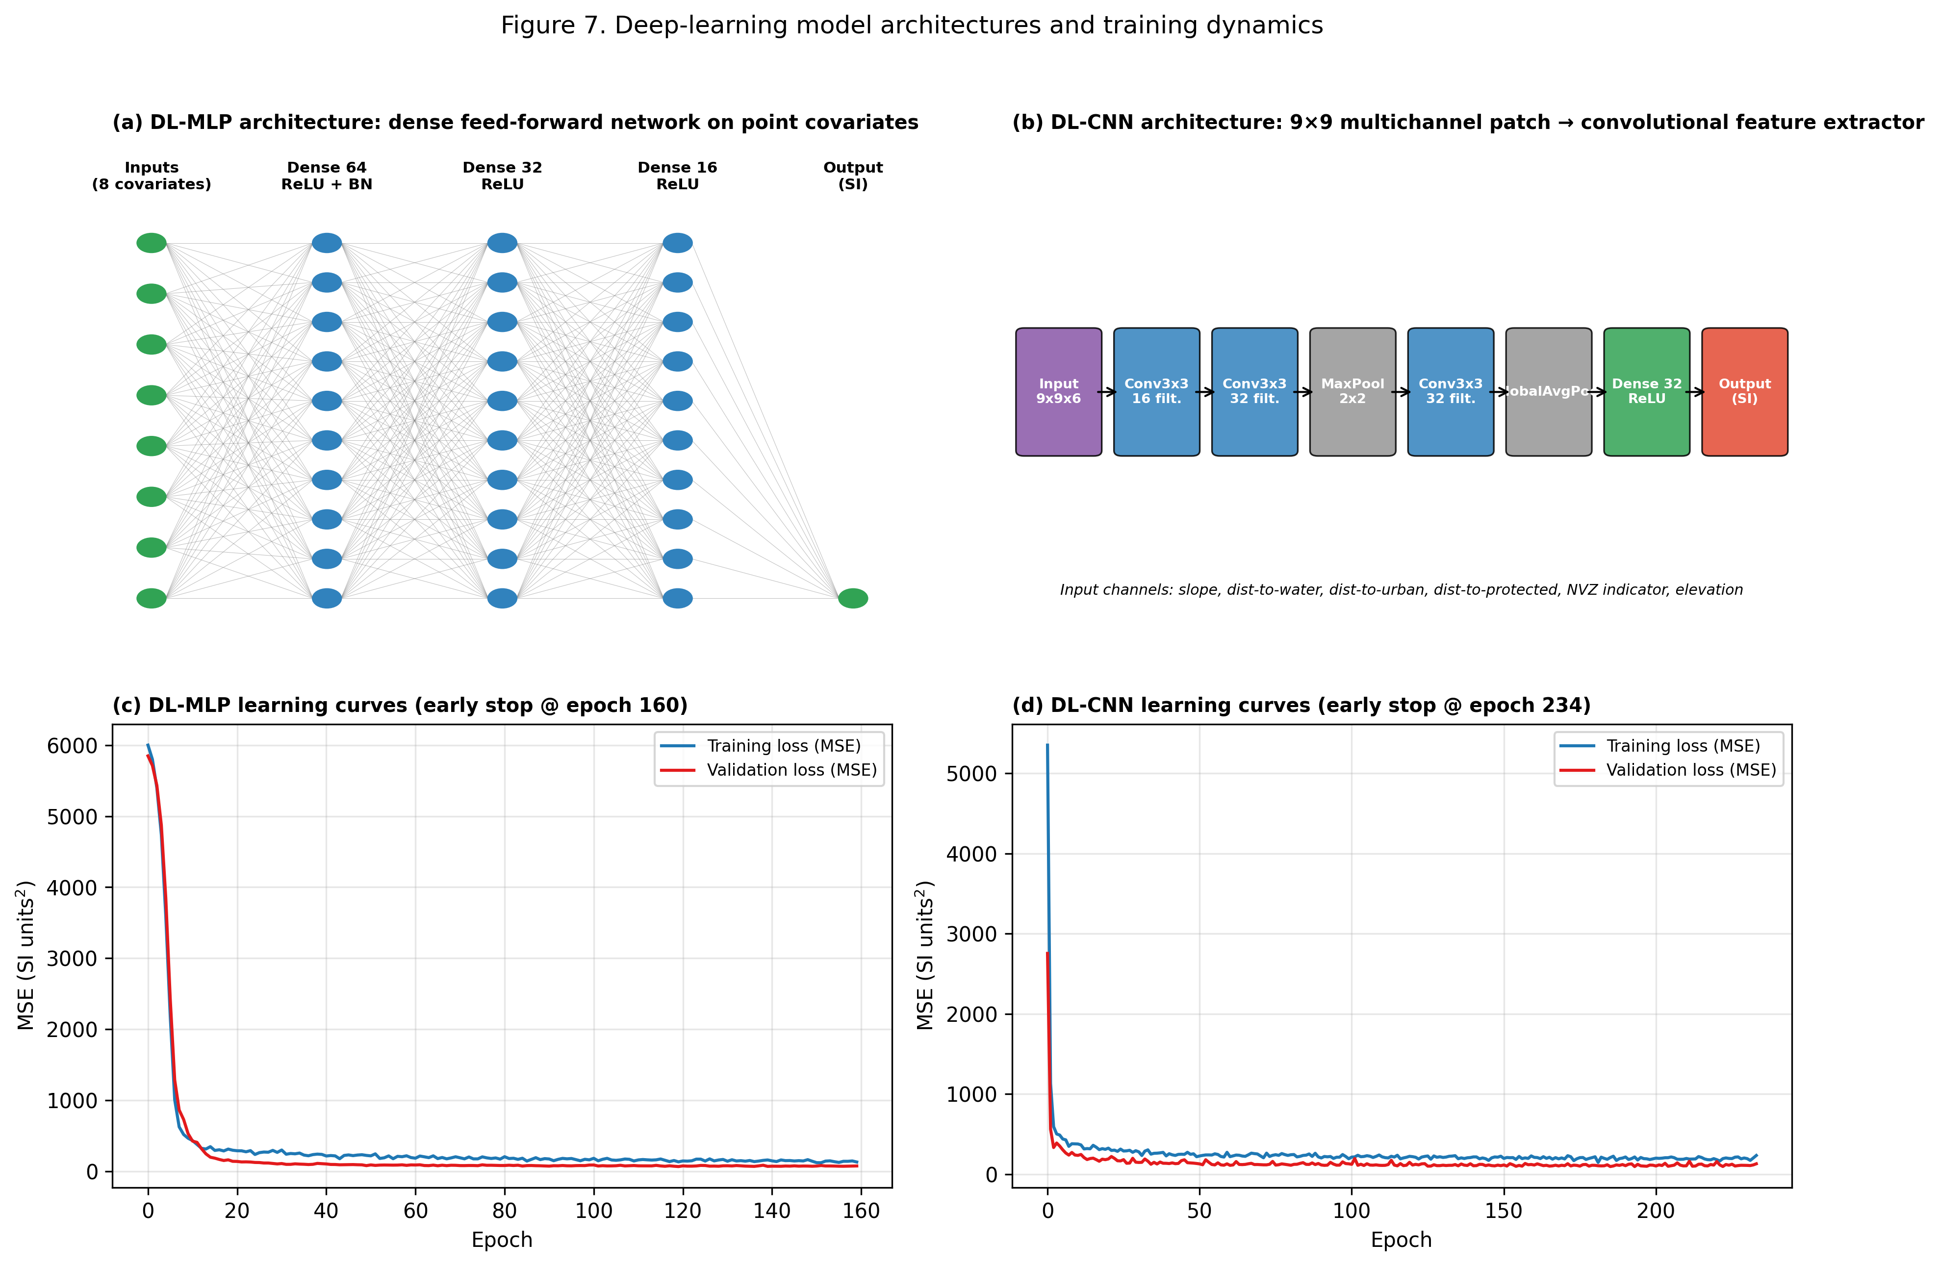
Fig. 14. Deep-learning architectures — (a) DL-MLP, (b) DL-CNN — and their training/validation loss curves (c, d).

4.8 Model validation
All four continuous-surface models (RK-LM, RK-RF, DL-MLP, DL-CNN) were evaluated on the identical 127 spatially held-out test points using RMSE, MAE and R². Overall pattern agreement was summarised with a Taylor diagram. Residual spatial autocorrelation was quantified with Moran's I over an 8-nearest-neighbour spatial weights matrix. The relative contribution of each covariate to the random-forest trend model was assessed by permutation importance (30 repeats).

5. Results

5.1 Individual constraint layers (whole municipality)
Fig. 15 and Fig. 16 map the two continuous physical criteria (slope and soil/lithology) after reclassification into three suitability tiers. 16.4% of the municipality (35.2 km²) has a slope of 15% or more and is excluded on runoff-risk grounds, concentrated in the hilly south-western third of the municipality; the Ebro river terraces in the north-east are almost entirely below 10% slope. Soils/lithology exclude a further 34.3% (73.8 km²), reflecting permeable gypsum, sandstone and coarse alluvial/terrace deposits.
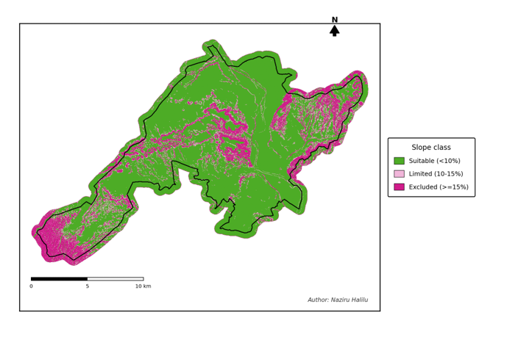
Fig. 15. Slope suitability classes derived from the 25 m DEM (< 10% suitable, 10–15% limited, ≥ 15% excluded).
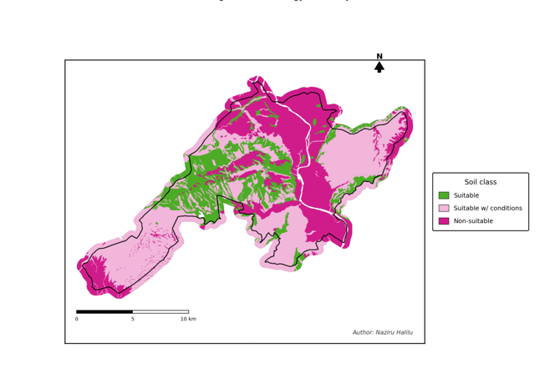
Fig. 16. Soil / lithology suitability classes (pre-assigned Suit_Class attribute of the geological units).
Fig. 17 shows the four regulatory/environmental exclusion layers individually. Water protection affects 5.3% (11.5 km²), concentrated along the Ebro and Queiles river corridors. The 100 m urban buffer removes 18.9% (40.6 km²). Protected natural areas are comparatively small, 2.0% (4.2 km²). The Nitrate Vulnerable Zone is by far the largest single regulatory constraint, 40.8% (87.8 km²), covering the entire northern half of the municipality along the Ebro valley floor — precisely the flattest, most intensively irrigated cropland, which illustrates the fundamental tension this report is designed to surface: the land that is agronomically best suited to slurry spreading is also the land the Nitrates Directive specifically flags as vulnerable.
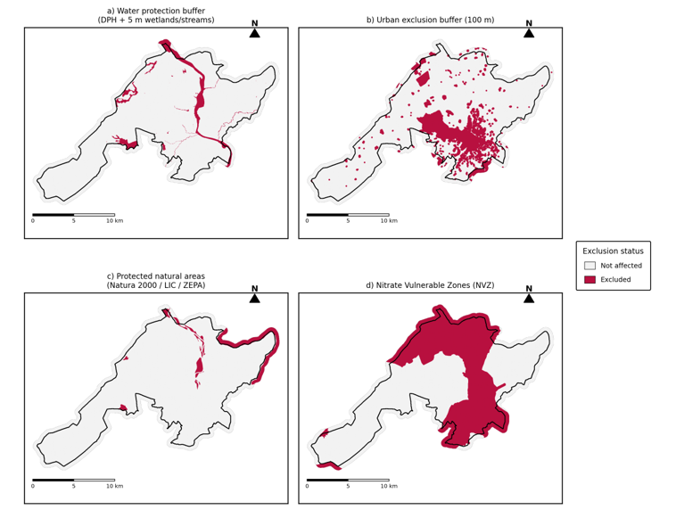
Fig. 17. Individual regulatory/environmental exclusion layers: (a) water protection buffer, (b) 100 m urban buffer, (c) protected natural areas, (d) Nitrate Vulnerable Zone.
SIGPAC land use excludes the largest share of territory: 44.0% (94.6 km²) is not classified as arable land (TA) or pasture (PS), including forest, permanent crops, greenhouses, urban fabric, unproductive land and open water (Fig. 18).
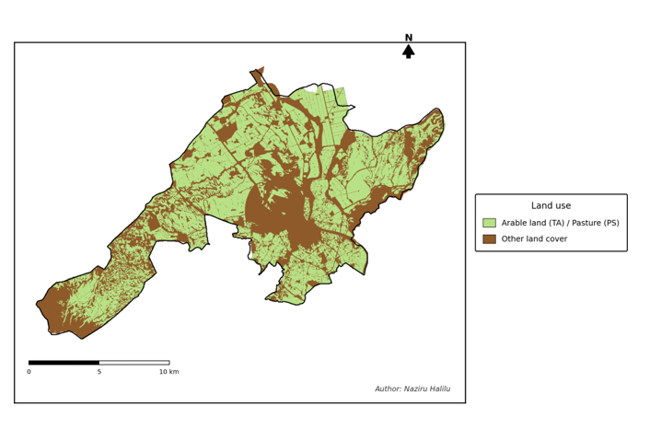
Fig. 18. SIGPAC land-use eligibility for slurry spreading (arable land / pasture vs. all other cover types).

5.2 Combined Boolean suitability
Merging criteria 3–7 (Fig. 19) leaves 21.6% of the AOI passing every regulatory and land-use filter before slope and soil are considered. Once slope and soil/lithology are folded in through the raster-calculator expression (Section 4.2), the final four-class result (Fig. 20, Table 2) shows that only 19.5% of the municipality (41.8 km²) is suitable with no more than partial constraints, and just 4.5% (9.6 km²) qualifies as an optimal location once all seven criteria are satisfied simultaneously.
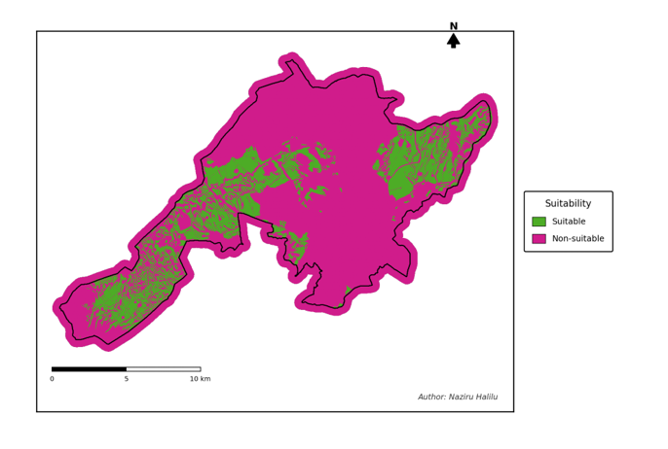
Fig. 19. Binary suitability mask after combining the five regulatory/land-use exclusion criteria (3–7).
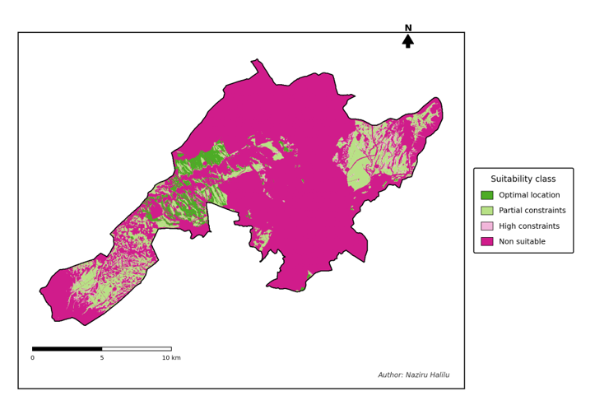
Fig. 20. Final four-class slurry-application suitability map for the municipality of Tudela (Part I, Boolean overlay).

Area summary
Suitability class | Value | Area (km²) | % of municipality
Not apt | 0 | 167.9 | 78.1
Apt, high constraints | 1 | 5.2 | 2.4
Apt, partial constraints | 2 | 32.2 | 15.0
Optimal location | 4 | 9.6 | 4.5
Total municipality | — | 214.9 | 100.0
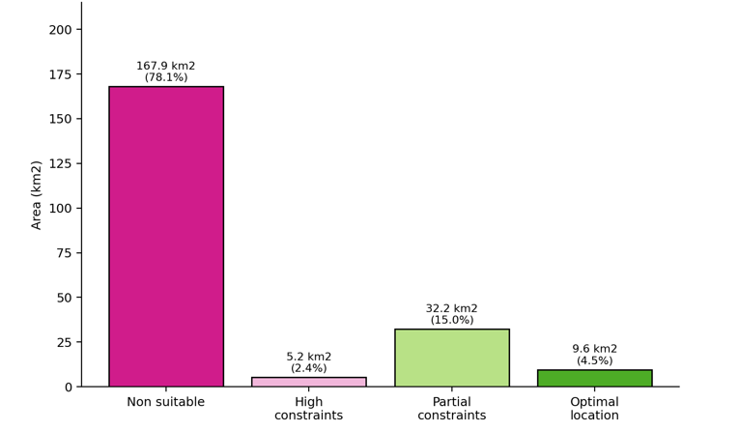
Fig. 21. Land area by final Boolean suitability class.
Table 3 and Fig. 22 quantify how much of the municipality each individual criterion affects on its own; these areas overlap, since most excluded land fails more than one criterion at once.
Criterion | Area affected (km²) | % of municipality
1. Slope ≥ 15% | 35.2 | 16.4
2. Non-suitable soil/lithology | 73.8 | 34.3
3. Water protection (DPH + 5 m buffer) | 11.5 | 5.3
4. Urban buffer (100 m) | 40.6 | 18.9
5. Protected natural areas | 4.2 | 2.0
6. Nitrate Vulnerable Zone | 87.8 | 40.8
7. Non-arable/pasture land cover | 94.6 | 44.0
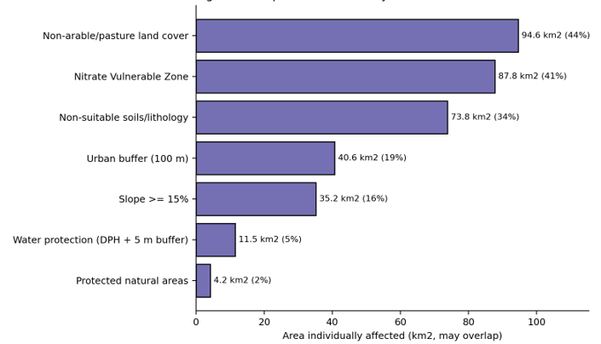
Fig. 22. Municipal area individually affected by each exclusion criterion (bars overlap; a given hectare can be counted under several criteria).

5.3 Parcel-level results
Zonal statistics were computed for 9,116 individual SIGPAC parcels classified as arable land or pasture (out of 24,921 parcels of all land-use types), giving each parcel a mean suitability score between 0 and 4. Fig. 23 shows the distribution of these parcel-level scores: most arable/pasture parcels have a low mean score, consistent with the high proportion of the arable land base that sits inside the NVZ or within the urban/water buffers, while a smaller but agronomically significant subset of parcels (concentrated in the south-western dry-farming area and along terraces away from the main urban centres) scores consistently in the “optimal” range.
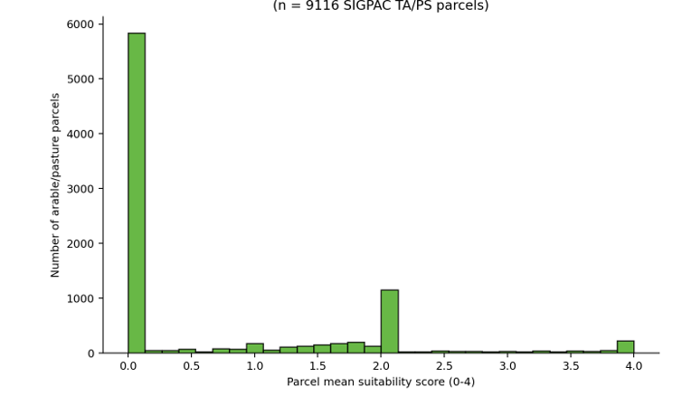
Fig. 23. Distribution of parcel-level mean suitability scores for SIGPAC arable-land and pasture parcels.

5.4 Hard-constraint criteria and the candidate zone (Part II recomputation)
Recomputing the six hard constraints under Part II's independent pipeline (excluding the NVZ, which is folded into the continuous index instead) gives closely consistent, though not identical, figures to Part I — an expected result of two independent re-implementations of similar buffering logic on the same source layers: the water-protection buffer affects 5.14%, the 100 m urban buffer 17.09%, protected natural areas 4.65%, soil/lithology excludes 81.65% of the AOI, and SIGPAC eligibility restricts 54.61% to non-arable/pasture uses. Once combined by Boolean AND, only 5.35% of the AOI (14.35 km², 22,953 cells) passes every hard constraint simultaneously — illustrating how strongly conjunctive constraints compound even when each individual criterion is comparatively permissive.

5.5 Regression kriging
The random-forest trend clearly outperformed the linear trend on the spatially held-out test blocks: RK-RF achieved RMSE = 7.78, MAE = 6.53 and R² = 0.765, compared with RMSE = 11.01, MAE = 8.44 and R² = 0.531 for RK-LM (Table 4). The empirical variogram of the OLS-trend residuals (Fig. 24a) was well described by a spherical model with an effective range of ≈ 839 m and a very high nugget-to-sill ratio (0.99), indicating that most spatial variability in the trend residuals is unresolved at 25 m grid spacing. The RK-RF prediction surface (Fig. 25a) reproduces the broad spatial pattern of the reference SI, with the highest predicted suitability concentrated in the flatter, better-drained western part of the candidate zone; the corresponding kriging prediction-variance surface (Fig. 25b) is highest at the edges of the candidate zone and in its more fragmented eastern parcels, where the pseudo-observation network is sparsest.
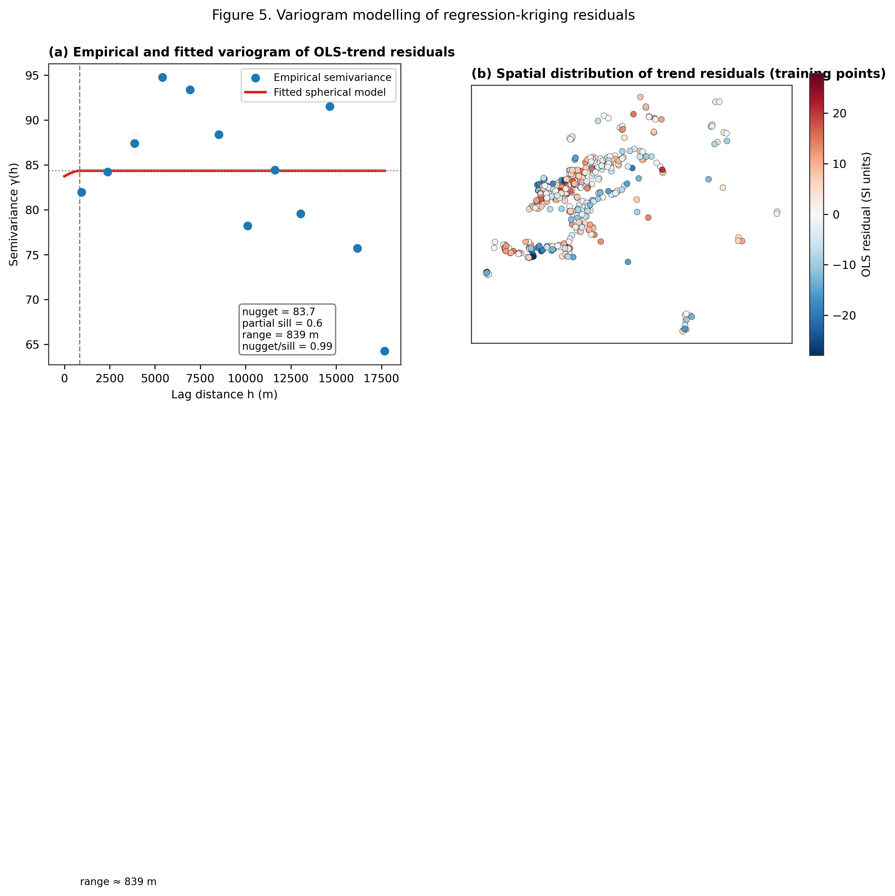
Fig. 24. (a) Empirical and fitted spherical variogram of the OLS-trend residuals. (b) Spatial distribution of the trend residuals at the training points.
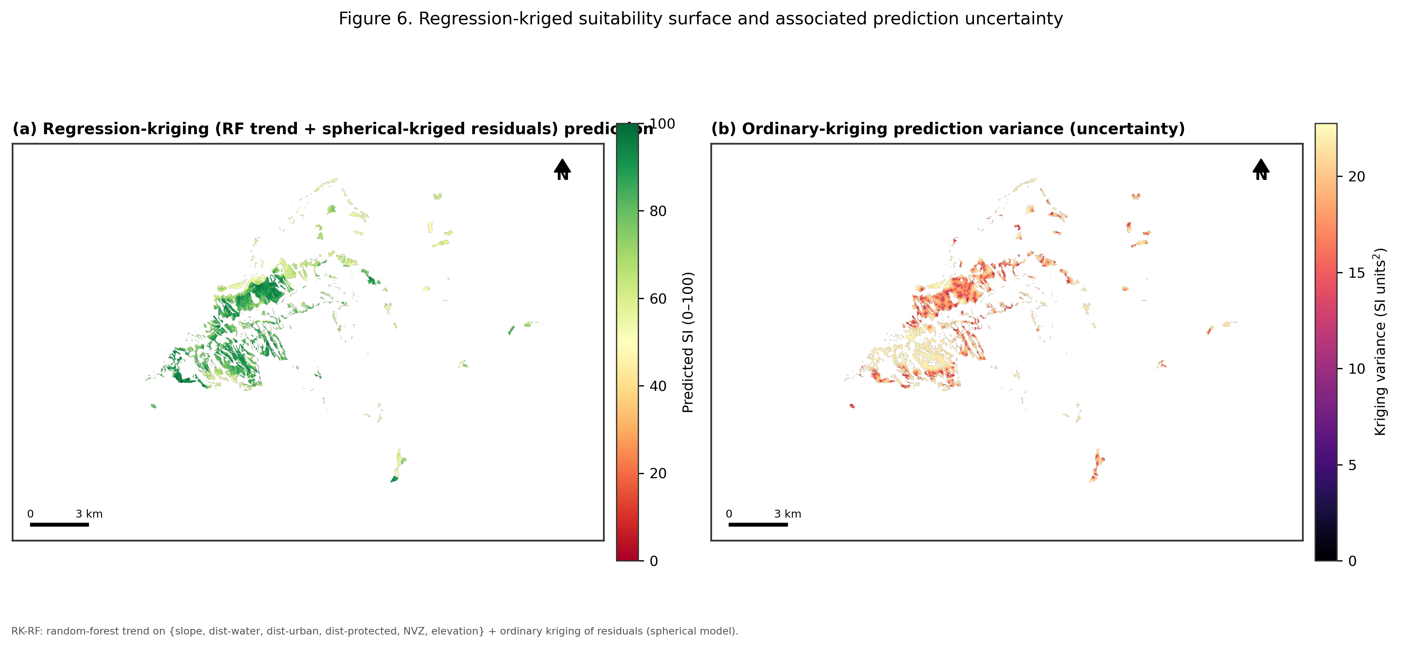
Fig. 25. (a) Regression-kriging (random-forest trend) prediction of the suitability index. (b) Ordinary-kriging prediction variance (interpolation uncertainty).

5.6 Deep-learning surrogates
Both deep-learning models converged smoothly, with validation loss tracking training loss closely and no evidence of overfitting before early stopping (Fig. 14c–d). On the held-out test blocks, DL-MLP achieved RMSE = 9.92, MAE = 7.49, R² = 0.619, and DL-CNN achieved a near-identical RMSE = 9.90, MAE = 7.82, R² = 0.620 — that is, reading a 9×9 spatial neighbourhood rather than point covariates alone did not materially improve predictive accuracy for this problem, although the two architectures make visibly different local errors. Both deep-learning surrogates outperformed the classical RK-LM model but remained clearly behind RK-RF.

5.7 Model comparison and validation
Model | RMSE | MAE | R² | Correlation (r) | Residual Moran's I
RK-LM | 11.01 | 8.44 | 0.531 | 0.82 | 0.043
RK-RF | 7.78 | 6.53 | 0.765 | 0.89 | 0.017
DL-MLP | 9.92 | 7.49 | 0.619 | 0.83 | 0.038
DL-CNN | 9.90 | 7.82 | 0.620 | 0.87 | 0.061
The observed-vs-predicted scatter plots (Fig. 26) confirm the ranking suggested by RMSE: RK-RF shows the tightest scatter around the 1:1 line, while RK-LM shows the most pronounced bias. The Taylor diagram (Fig. 27) summarises the same result geometrically — RK-RF sits closest to the observed reference point, with the highest correlation and lowest centred RMSE, while RK-LM, DL-MLP and DL-CNN cluster together at moderate correlation (0.82–0.87). Residual Moran's I was lowest for RK-RF (0.017, negligible residual spatial structure) and highest for DL-CNN (0.061).
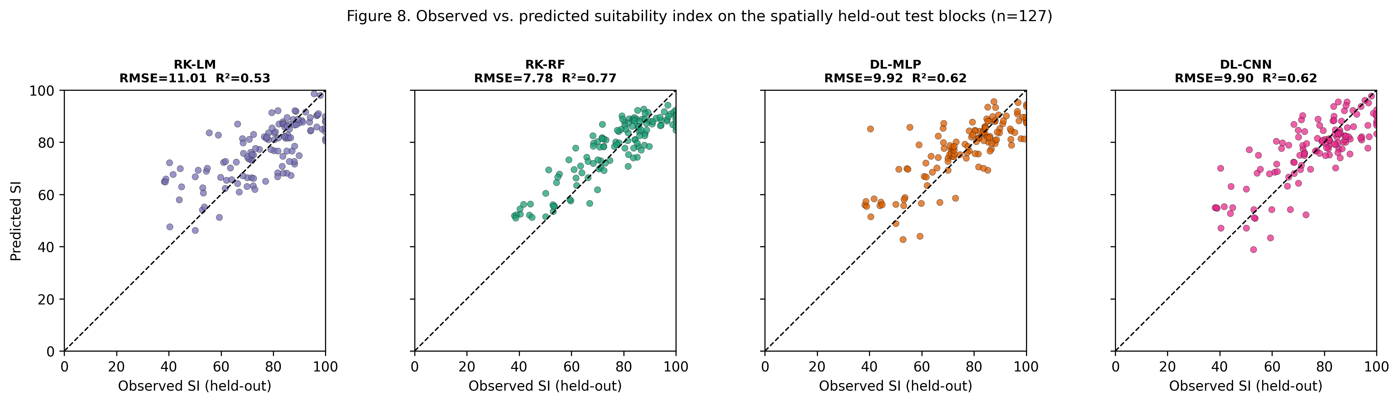
Fig. 26. Observed vs. predicted suitability index on the spatially held-out test blocks (n = 127) for all four models.
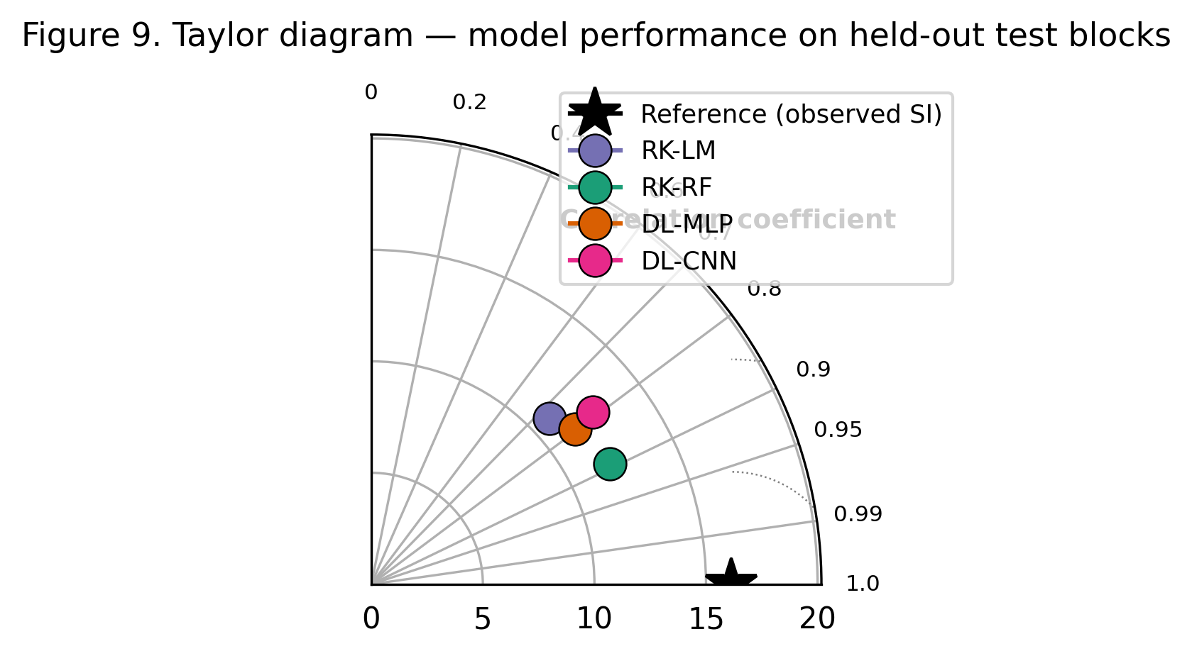
Fig. 27. Taylor diagram summarising correlation, standard deviation and centred RMSE for all four models against the observed reference.
Mapped across the full candidate zone (Fig. 28), the three best-performing models (RK-RF, DL-MLP, DL-CNN) agree closely on the overall spatial pattern of suitability, with the highest scores consistently in the flatter, better-drained western sector. The three-model ensemble mean and its inter-model standard deviation (Fig. 29) show that structural disagreement between the geostatistical and deep-learning approaches is concentrated in a narrow band along the edges of the candidate zone and in a small number of isolated eastern parcels — precisely the locations flagged as high-uncertainty by the kriging-variance surface, a useful cross-check between two structurally different uncertainty measures.
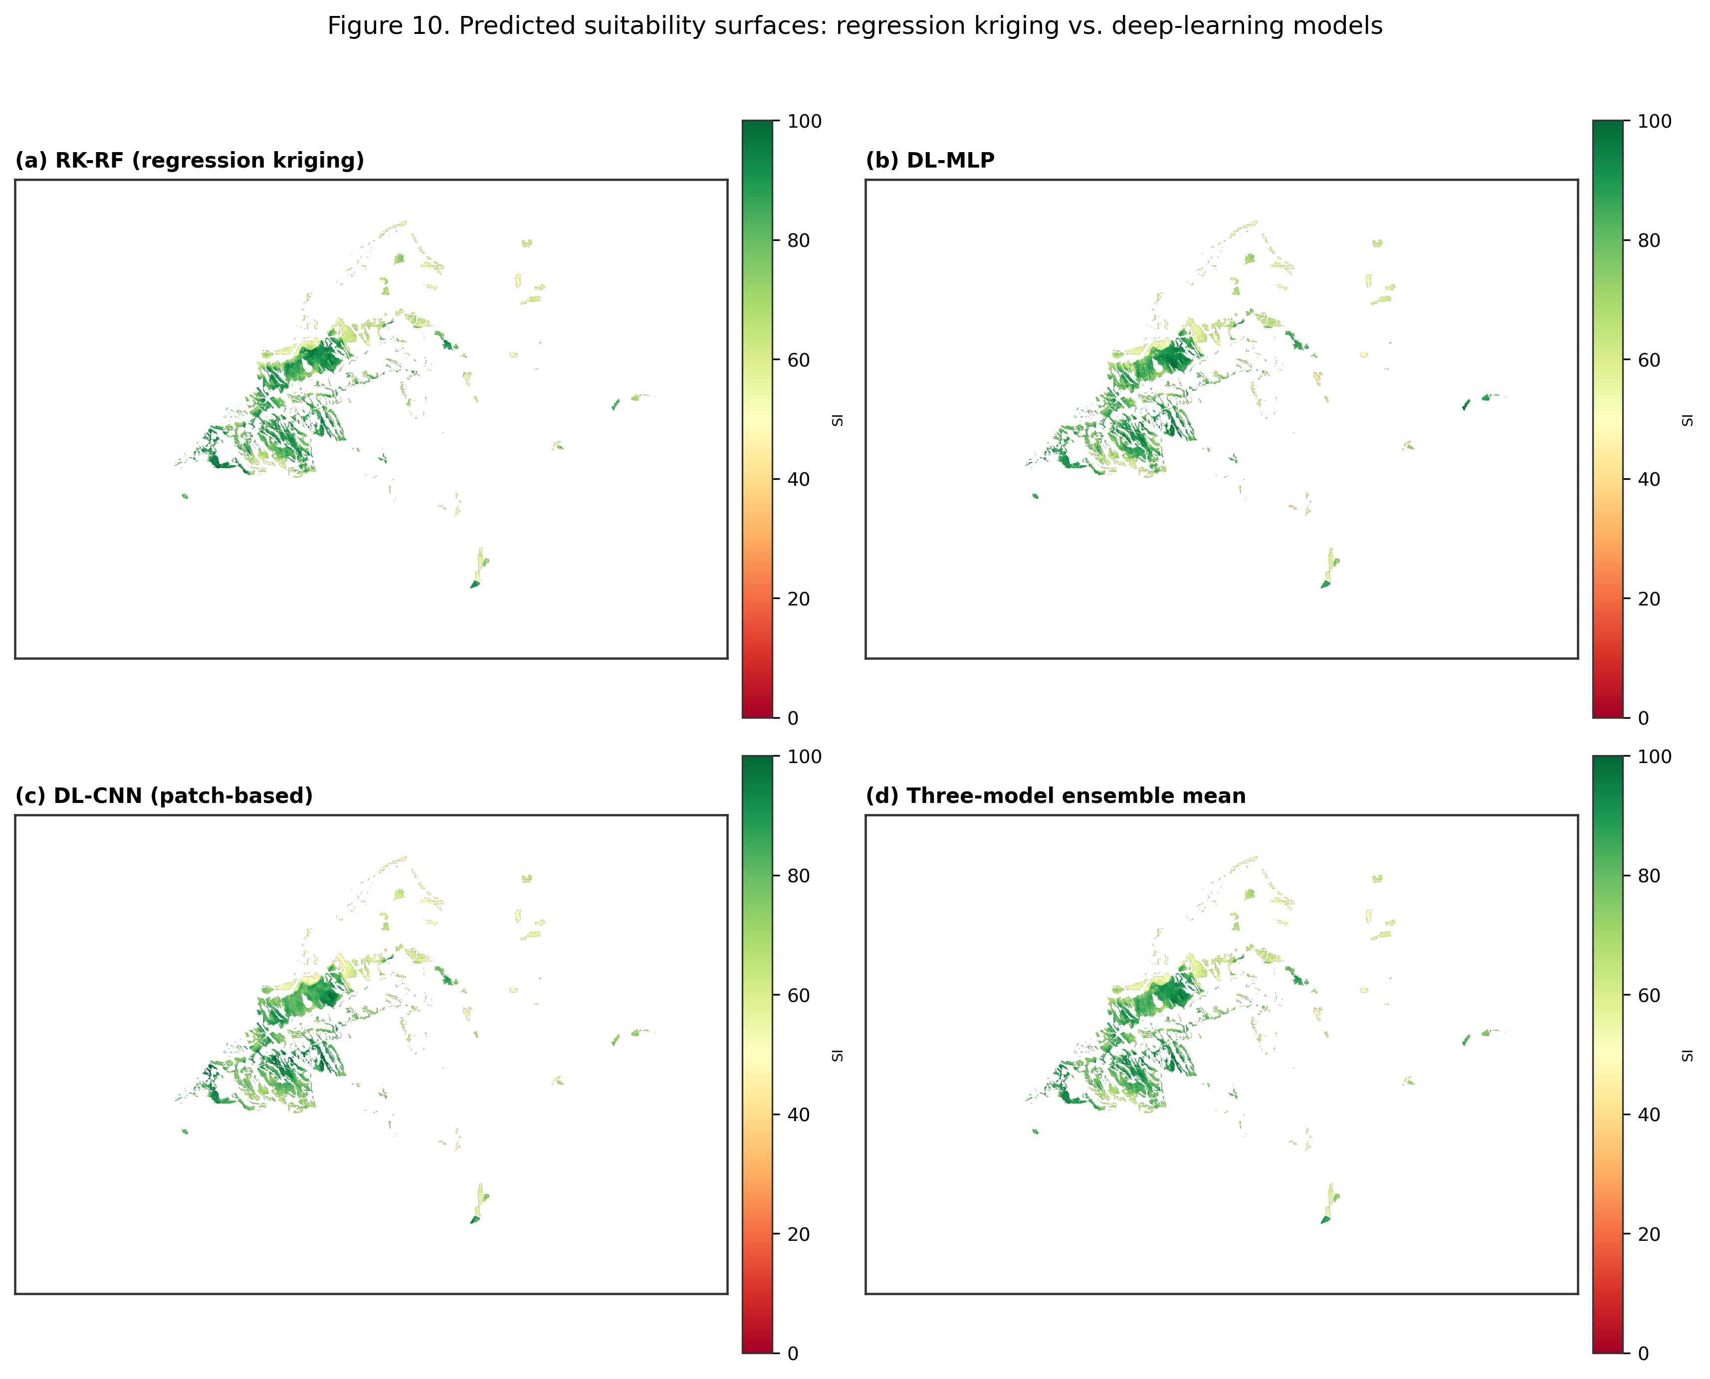
Fig. 28. Predicted suitability surfaces: (a) RK-RF, (b) DL-MLP, (c) DL-CNN, (d) three-model ensemble mean.
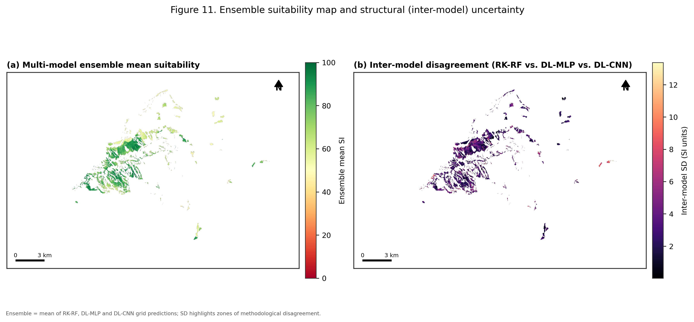
Fig. 29. (a) Multi-model ensemble mean suitability. (b) Inter-model disagreement (standard deviation across RK-RF, DL-MLP and DL-CNN).

5.8 Covariate importance
Permutation importance on the random-forest trend model (Fig. 30) identified NVZ status as by far the dominant covariate (ΔR² ≈ 0.57), consistent with its role in the continuous index as a multiplicative penalty applied to roughly 40% of the AOI — and directly consistent with Part I's independent finding, from a completely different methodology, that the NVZ is the single largest individual exclusion criterion at the whole-municipality scale (Section 5.2). Slope and distance to water contributed comparably (ΔR² ≈ 0.23–0.24 each), distance to urban land moderately (ΔR² ≈ 0.16), and distance to protected areas and elevation least (ΔR² ≤ 0.08).
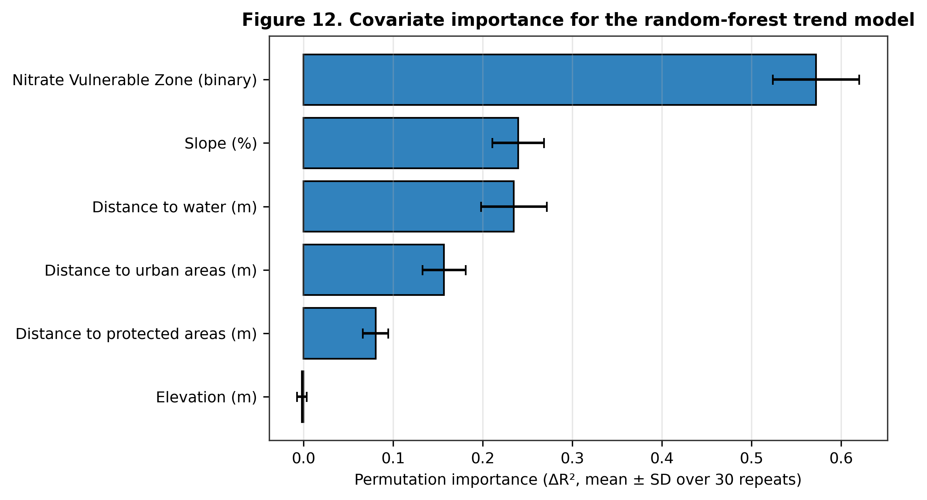
Fig. 30. Permutation importance (ΔR², mean ± SD over 30 repeats) of each covariate for the random-forest trend model.
Fig. 31, produced specifically for this merged report, examines these relationships directly at the level of the 550 individual pseudo-observations: SI correlates most strongly with slope and distance to water, both inside and outside the NVZ, and the boxplot confirms a clear downward shift in SI for points inside the NVZ relative to points outside it, consistent with the 0.70 penalty applied in Section 4.4.
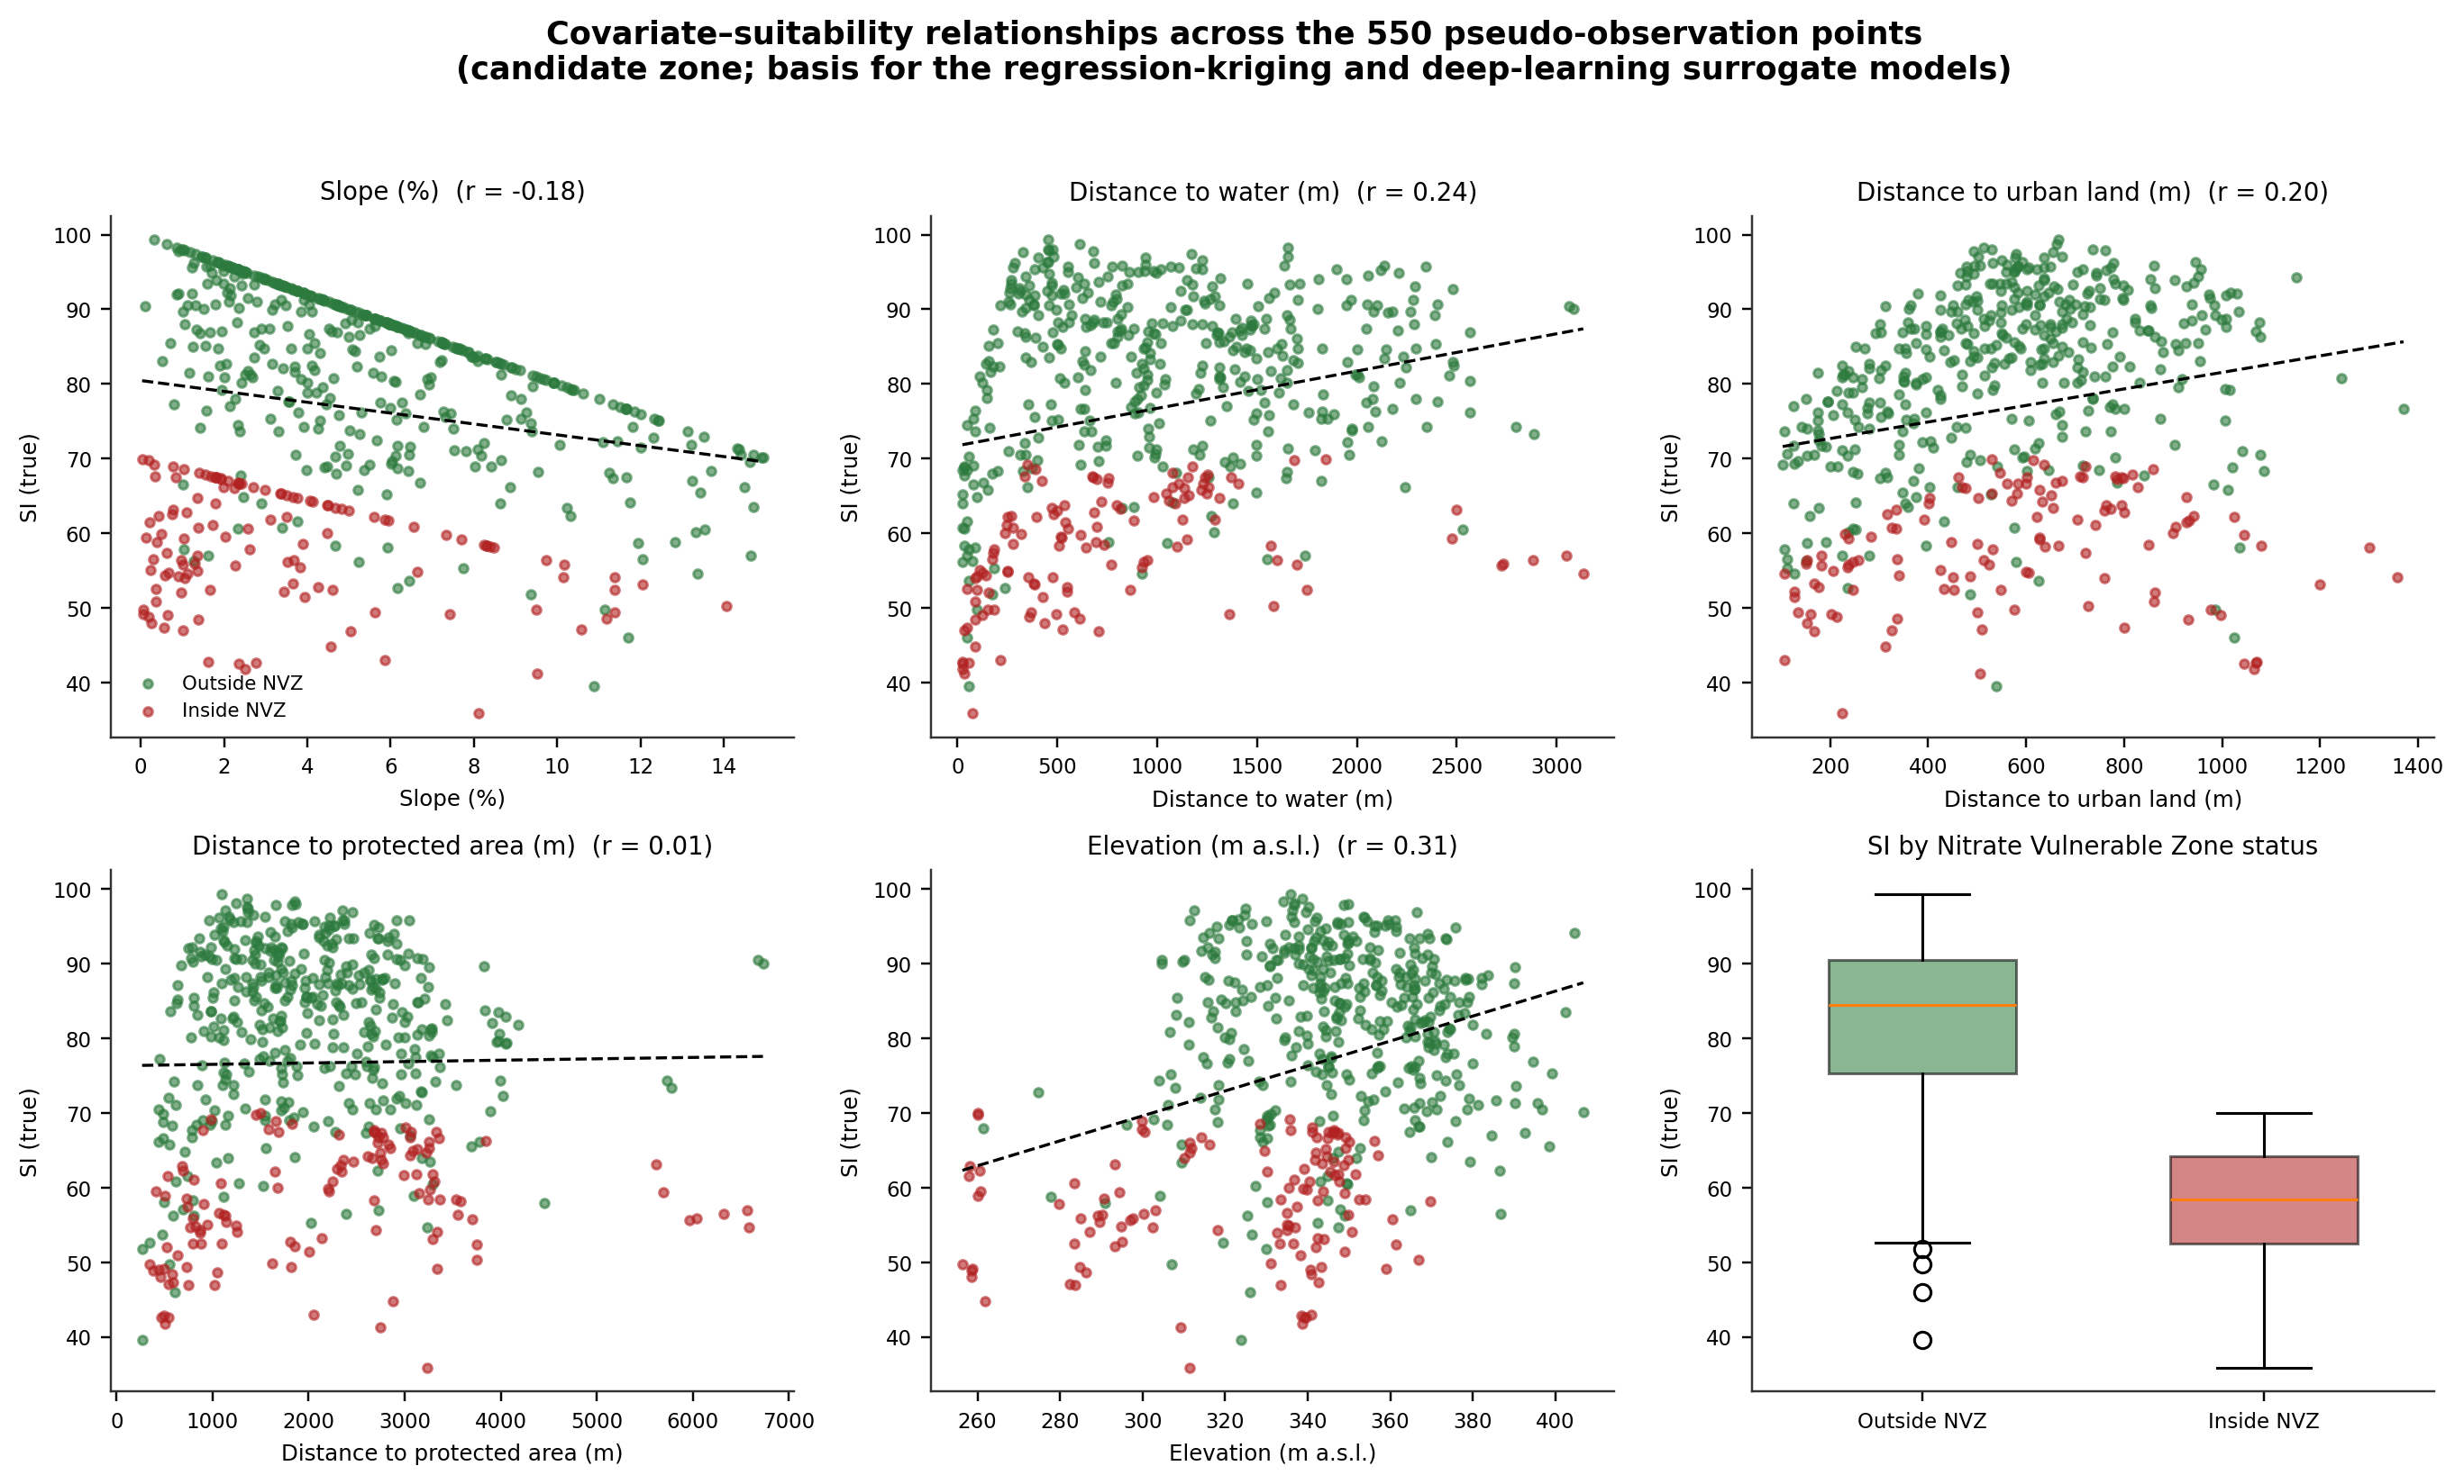
Fig. 31. Covariate–suitability relationships across the 550 pseudo-observation points (new figure produced for this merged report).

5.9 Final integrated suitability map
Fig. 32, also produced specifically for this merged report, brings Part I and Part II together on one page. Panel A maps the real coordinates of all 550 pseudo-observation points (training and held-out test), coloured by their continuous Suitability Index, over the Area of Interest and the candidate-zone envelope; Panel B shows the whole-municipality Boolean four-class breakdown (Section 5.2); Panel C shows how the candidate zone's continuous SI distribution splits between points inside and outside the NVZ. Read together, the three panels make the report's central integrative point directly visible: the 4.5% of the municipality the Boolean overlay calls “optimal” and the 15.0% it calls “apt with partial constraints” are a conservative, worst-case reading of the NVZ as a hard exclusion; within the (largely NVZ-overlapping) candidate zone, the continuous model shows that a meaningful share of NVZ-designated land still retains a moderate-to-high suitability index once only the rate-restriction (not a ban) is applied — exactly the refinement Part I's own discussion called for.
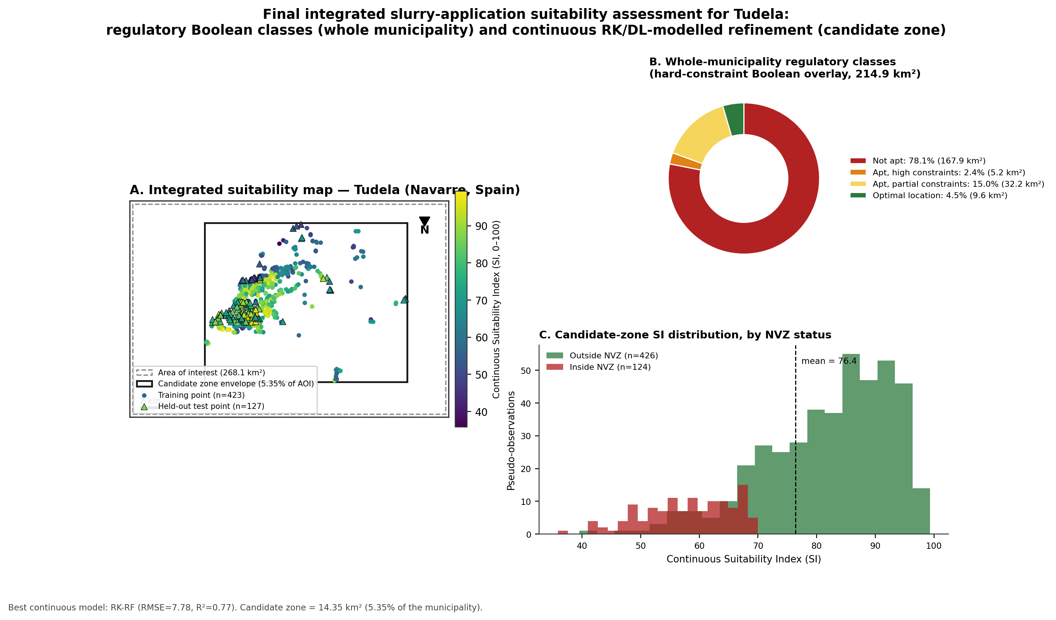
Fig. 32. Final integrated slurry-application suitability map for Tudela: whole-municipality regulatory Boolean classes (Panel B) and continuous RK/DL-modelled refinement within the candidate zone (Panels A, C). New figure produced for this merged report.

6. Discussion
The results confirm the pattern anticipated in the introduction: in an intensively farmed, irrigation-dependent municipality like Tudela, the land that is agronomically most attractive for slurry application — flat, arable, close to the road network that serves the farms — is also the land that is subject to the tightest regulatory scrutiny, because it sits along the Ebro valley floor inside the designated Nitrate Vulnerable Zone and close to the river's public hydraulic domain. This is why the NVZ (40.8% of the municipality) and non-arable land cover (44.0%) are individually the two largest constraints in Part I's Boolean overlay, larger even than the 100 m urban buffer (18.9%) that is often assumed to be the dominant limitation in siting studies of this kind.
Only 4.5% of the municipal area (9.6 km²) emerges as an optimal location in Part I once every criterion is applied simultaneously and without exception. That figure should be read as a conservative, worst-case scenario rather than a literal ceiling on how much slurry Tudela can absorb, and Part II quantifies exactly why: the Nitrates Directive and Foral Decree 148/2023 do not prohibit slurry spreading inside an NVZ outright, they impose caps on organic-nitrogen rates, closed spreading periods, low-emission methods and reinforced setbacks. Part II's continuous index, permutation-importance ranking and integrated map (Sections 4.3–4.4, 5.8–5.9) confirm, using an entirely independent geostatistical/deep-learning methodology, that NVZ status is the single most influential factor on the continuous suitability surface (ΔR² ≈ 0.57) — the same conclusion Part I reaches independently from Boolean overlay areas alone. This convergence between two structurally different methods, run on two different software stacks, is a meaningful form of cross-validation for the underlying finding, and it directly supports Part I's own recommendation that distinguishing “excluded” from “restricted-but-permissible-under-conditions” within the NVZ would substantially increase the usable area beyond the 4.5% headline figure.
The central empirical finding of Part II is that a random-forest trend combined with kriging of its residuals (RK-RF) outperformed both a classical linear-trend kriging and two deep-learning surrogates for reconstructing the continuous slurry-suitability surface from a modestly sized (n = 423 training) pseudo-observation network. This is broadly consistent with the wider regression-kriging literature, where non-linear trend models have repeatedly been shown to reduce residual variance relative to ordinary least squares. It is also consistent with the general expectation that deep-learning models, which are typically data-hungry, are not automatically advantaged over tree-based ensembles or hybrid geostatistical methods at sample sizes in the low hundreds. The patch-based CNN's failure to outperform the point-covariate MLP is a further, more specific observation: at the 25 m/9-pixel scale used here, the local neighbourhood evidently does not carry materially more information about suitability than the pre-computed distance covariates already provide.
The two structurally different uncertainty measures produced by Part II — ordinary-kriging prediction variance for RK-RF, and inter-model standard deviation across the three best models — agree on where predictions are least reliable (the candidate zone's edges and its smallest, most isolated eastern parcels), which is a useful form of triangulation for a regulatory application where false confidence in a suitability map carries an environmental cost. Any operational deployment of this workflow should treat both uncertainty layers as joint outputs, rather than relying on either alone, and fields flagged as high-uncertainty by both measures should be prioritised for field verification before slurry-application decisions are made.

7. Limitations

7.1 Part I (Boolean overlay)
Vector buffering was replaced with an equivalent raster Euclidean-distance-transform threshold computed on the 25 m grid; this reproduces a true geometric buffer to within one pixel (25 m) and is accurate for the 100 m and 5 m buffers used here, but it means all reported areas are quantised to 625 m² raster cells rather than measured on exact vector geometries. Polygon holes are supported by the rasteriser, but the underlying grouping of shapefile rings into exterior/hole pairs uses the standard ESRI winding-order convention rather than a full topological reconstruction, appropriate for the moderately simple polygons in this dataset but requiring revisiting for more complex multi-island geometries. The national municipal-boundary layer required a manual geographic-to-UTM reprojection in the absence of pyproj/PROJ; the resulting municipal area (214.9 km²) is within about 5% of the officially reported figure, a difference attributable to raster discretisation and the medium-detail source boundary rather than to a projection error.

7.2 Part II (continuous surface modelling)
No independently verified field observations of slurry suitability exist for Tudela; the pseudo-observation network was constructed by sampling, with added noise, from a deterministic continuous index built from the same covariates the predictive models subsequently use — a standard benchmarking design in methodological studies, but one that cannot fully substitute for genuine field validation (soil infiltration tests, nutrient-balance monitoring, or farmer-reported application outcomes). The continuous index's criterion weights were set by common convention rather than elicited from a structured weighting procedure such as the Analytic Hierarchy Process; a formal sensitivity analysis of these weights is an important direction for future work. The deep-learning models were trained on several hundred points, a realistic sample size for many regional suitability-mapping problems, but this does not test whether the CNN's spatial receptive field would begin to outperform point-covariate models at larger monitoring-network sizes. Finally, the NVZ penalty (0.70) was set as an illustrative constant rather than derived from the crop- and soil-specific permitted nitrogen loads defined in Tudela's Nitrates Directive action programme; operational use of this workflow should replace it with the locally applicable regulatory limit.
Despite these caveats, both parts of the analysis are fully reproducible: every raster and vector layer, processing step, and quoted number traces directly back to the source shapefiles/GeoTIFFs and to the code delivered alongside each part, with no manual editing of results.

8. Conclusion
This merged report delineates the areas of the municipality of Tudela (Navarre) suitable for livestock slurry application at two complementary scales. At the whole-municipality scale, a seven-criterion Boolean GIS-MCDA overlay — reproduced end-to-end in a purpose-built, dependency-light Python pipeline in place of QGIS/GDAL — finds that 78.1% of 214.9 km² is not apt for slurry spreading once every constraint is combined, 17.4% is apt with high or partial constraints, and 4.5% (9.6 km²) is an optimal location; the Nitrate Vulnerable Zone and non-arable land cover are the two most restrictive individual criteria, both larger than the urban buffer. Parcel-level zonal statistics were produced for 9,116 individual arable/pasture SIGPAC parcels so the result can be applied directly at the field scale.
Within the 5.35% of the municipality that passes every hard constraint except the NVZ exclusion, a continuous fuzzy suitability index, sampled by a spatially block-cross-validated pseudo-observation network, is reconstructed most accurately by a random-forest regression-kriging model (RMSE = 7.78, R² = 0.77, lowest residual Moran's I), outperforming both a classical linear-trend kriging model and two deep-learning surrogates, while confirming NVZ status, slope and distance to surface water as the dominant covariates governing suitability — independently corroborating the Boolean overlay's own finding that the NVZ is the single largest constraint on slurry management in Tudela.
The new integrated final map (Fig. 32) and covariate-relationship figure (Fig. 31) produced for this merged report tie the two analyses together directly, showing that the Boolean overlay's conservative 4.5% “optimal” figure is best read as a lower bound: a meaningful share of NVZ-designated land within the candidate zone retains moderate-to-high suitability once the NVZ is treated, correctly, as a rate restriction rather than a spreading ban. Future refinements should replace the illustrative 0.70 NVZ penalty with the locally applicable, crop- and soil-specific permitted nitrogen load, incorporate parcel size, distance to farm/storage facilities and irrigation status into the ranking of the “apt with partial constraints” class, and pursue genuine field validation of the continuous suitability surface before any operational deployment.

References
Basnet, B.B., Apan, A.A., Raine, S.R., 2001. Selecting suitable sites for animal waste application using a raster GIS. Environmental Management 28(4), 519–531.
Breiman, L., 2001. Random forests. Machine Learning 45(1), 5–32.
Centro Nacional de Información Geográfica (CNIG) — Instituto Geográfico Nacional: administrative boundaries, LiDAR digital elevation models and Nomenclator settlement dataset.
Council Directive 91/676/EEC of 12 December 1991 concerning the protection of waters against pollution caused by nitrates from agricultural sources. Official Journal of the European Communities L375, 1–8.
Decreto Foral 148/2023, de 6 de septiembre, por el que se designan las zonas vulnerables a la contaminación producida por nitratos de origen agrario en el ámbito de la Comunidad Foral de Navarra. Boletín Oficial de Navarra.
European Environment Agency (EEA): Nationally Designated Areas (CDDA) protected-areas dataset.
Gobierno de Navarra — Infraestructura de Datos Espaciales de Navarra (IDENA): SIGPAC land-use/land-cover parcels and 1:25 000 geological map.
Hengl, T., Heuvelink, G.B.M., Stein, A., 2004. A generic framework for spatial prediction of soil variables based on regression-kriging. Geoderma 120(1–2), 75–93.
Hengl, T., Heuvelink, G.B.M., Rossiter, D.G., 2007. About regression-kriging: from equations to case studies. Computers & Geosciences 33(10), 1301–1315.
Kamilaris, A., Engelbrecht, A., Pitsillides, A., Prenafeta-Boldu, F.X., 2020. Transfer of manure as fertilizer from livestock farms to crop fields: the case of Catalonia. arXiv:2006.09122.
LeCun, Y., Bengio, Y., Hinton, G., 2015. Deep learning. Nature 521, 436–444.
Malczewski, J., 2000. On the use of weighted linear combination method in GIS: common and best practice approaches. Transactions in GIS 4(1), 5–22.
Malczewski, J., 2004. GIS-based land-use suitability analysis: a critical overview. Progress in Planning 62(1), 3–65.
Malczewski, J., 2006. GIS-based multicriteria decision analysis: a survey of the literature. International Journal of Geographical Information Science 20(7), 703–726.
Ministerio para la Transición Ecológica y el Reto Demográfico (MITECO): Dominio Público Hidráulico and Nitrate Vulnerable Zones datasets.
Moran, P.A.P., 1950. Notes on continuous stochastic phenomena. Biometrika 37(1/2), 17–23.
Odeh, I.O.A., McBratney, A.B., Chittleborough, D.J., 1995. Further results on prediction of soil properties from terrain attributes: heterotopic cokriging and regression-kriging. Geoderma 67(3–4), 215–226.
Real Decreto 261/1996, de 16 de febrero, sobre protección de las aguas contra la contaminación producida por los nitratos procedentes de fuentes agrarias. Boletín Oficial del Estado (Spain).
Snyder, J.P. (1987). Map Projections — A Working Manual. U.S. Geological Survey Professional Paper 1395. U.S. Government Printing Office, Washington, D.C.
Taylor, K.E., 2001. Summarizing multiple aspects of model performance in a single diagram. Journal of Geophysical Research: Atmospheres 106(D7), 7183–7192.
Van Lanen, H.A.J., Wopereis, F.A., 1992. Computer-captured expert knowledge to evaluate possibilities for injection of slurry from animal manure in the Netherlands. Geoderma 54(1–4), 107–124.

