Beyond Boolean Overlay: Regression Kriging and Deep-Learning Surrogates for Continuous GIS-MCDA Suitability Mapping of Livestock Slurry Application
A case study of Tudela, Navarre, Spain
Author names withheld for review · Affiliation withheld for review

Abstract
Livestock slurry is a nutrient-rich by-product of intensive animal farming that can substitute mineral fertiliser when applied at the right place, time and rate, but that poses a diffuse pollution risk to soil and water when it is not. Geographic information system (GIS) multicriteria decision analysis (MCDA) is the conventional tool for delineating land suitable for slurry application, but its typical output — a small number of discrete Boolean or ordinal suitability classes produced by raster overlay — discards the continuous, spatially auto-correlated structure of the underlying agro-environmental gradients. This study extends a conventional seven-criterion GIS-MCDA overlay for the municipality of Tudela (Navarre, Spain) with two complementary continuous-surface modelling strategies: regression kriging (RK), applied with both a linear and a random-forest trend model, and two deep-learning (DL) surrogates — a multilayer perceptron (MLP) and a patch-based convolutional neural network (CNN) reading local 9×9 covariate neighbourhoods. All four models were trained on a spatially block-cross-validated network of 550 pseudo-observations drawn from a continuous fuzzy weighted-linear-combination suitability index computed within the hard-constraint-compliant candidate zone (5.4% of the municipality, 14.35 km²). The random-forest regression-kriging model achieved the best held-out performance (RMSE = 7.78, R² = 0.77), outperforming the deep-learning surrogates (RMSE ≈ 9.9, R² ≈ 0.62) and the classical linear-trend kriging (RMSE = 11.0, R² = 0.53), while also producing the lowest residual spatial autocorrelation. Permutation importance identified Nitrate Vulnerable Zone status, slope and distance to surface water as the dominant covariates. We discuss the trade-offs between geostatistical and deep-learning approaches for regulatory suitability mapping and provide a fully reproducible, open geoprocessing-to-manuscript pipeline.
Keywords: GIS multicriteria decision analysis; regression kriging; deep learning; convolutional neural network; livestock slurry management; nitrate vulnerable zone; land suitability mapping

1. Introduction
Livestock slurry is a liquid by-product of intensive animal farming, composed mainly of excreta diluted with wash water and bedding residues. It carries substantial amounts of nitrogen, phosphorus and organic matter and, applied at the right place, time and dose, can substitute mineral fertiliser, close on-farm nutrient loops and improve soil structure and biological activity. Applied on unsuitable land, the same nutrients readily leach to groundwater or run off to surface water, contributing to nitrate pollution and eutrophication — the concern that underlies the European Union’s Nitrates Directive and its system of Nitrate Vulnerable Zones (Council of the European Communities, 1991).
GIS provides a natural framework for this siting problem because it allows heterogeneous datasets — topography, land cover, soil, hydrology, protected areas and regulatory zoning — to be combined into a single suitability surface. The standard tool for doing so is GIS-based multicriteria decision analysis (GIS-MCDA): criteria are reclassified onto a common scale, combined by Boolean overlay, weighted linear combination (WLC) or an outranking procedure, and mapped as a small number of discrete suitability classes (Malczewski, 2000; 2004; 2006). Site-suitability studies specifically for manure and slurry application follow the same template: Van Lanen and Wopereis (1992) used expert-system reasoning over Dutch soil and terrain data to estimate that 40–60% of Dutch rural land was suitable for slurry injection, and Basnet et al. (2001) built a raster-GIS overlay of slope, soil, distance-to-water and land-use criteria to select 16% of a Louisiana study area as suitable for animal-waste application; more recently, Kamilaris et al. (2020) combined a similar GIS-derived suitability layer with logistics optimisation to route manure from livestock farms to eligible crop fields in Catalonia, Spain.
A structural limitation runs through this literature: the standard GIS-MCDA overlay collapses a continuous, spatially auto-correlated agro-environmental gradient into a handful of discrete classes at hard criterion thresholds, and it does not, by itself, quantify the uncertainty of the resulting map. Digital soil mapping addressed an analogous problem three decades ago with regression kriging (RK), a hybrid technique that fits a deterministic regression trend on auxiliary covariates and then krige-interpolates the regression residuals, exploiting whatever spatial autocorrelation the trend leaves unexplained (Odeh et al., 1995; Hengl et al., 2004; 2007). In parallel, deep-learning (DL) models — multilayer perceptrons and, increasingly, convolutional neural networks (CNNs) that read local spatial context rather than point covariates alone — have become a routine, if purely non-spatial-statistical, alternative for learning complex, non-linear covariate–response relationships (LeCun et al., 2015). To our knowledge, RK and DL surrogates have not previously been benchmarked against each other, nor against the conventional Boolean/WLC overlay, for the specific problem of livestock slurry application suitability.
This paper extends a conventional seven-criterion GIS-MCDA suitability overlay for Tudela (Navarre, Spain) in three ways. First, the hard regulatory and physical constraints of the original overlay (slope, soil, water protection, urban buffer, protected areas, Nitrate Vulnerable Zone and SIGPAC land-use eligibility) are used to delineate a candidate zone, inside which a continuous fuzzy weighted-linear-combination suitability index is defined. Second, this continuous index is sampled at a spatially block-cross-validated pseudo-observation network and reconstructed across the candidate zone by regression kriging (with both linear and random-forest trend models) and by two deep-learning surrogates (an MLP and a patch-based CNN). Third, all four continuous-surface models are benchmarked against one another using held-out spatial blocks, permutation importance, a Taylor diagram, and residual spatial autocorrelation (Moran’s I), to characterise the trade-offs between geostatistical and deep-learning approaches for regulatory suitability mapping.

2. Study area
The study area is the municipality of Tudela (Navarre, Spain), a 217 km² municipality in the middle Ebro valley extracted from the Spanish National Geographic Institute (CNIG) INSPIRE administrative-boundaries dataset. Elevation within the analysis area of interest ranges from 247 to 767 m a.s.l. (Fig. 1), spanning the irrigated valley floor of the Ebro and its tributaries to the dry, low hills that flank it to the south-west — a topographic gradient that, together with the surrounding irrigation and drainage network, largely governs the physical and regulatory suitability pattern described in Section 5. Tudela is representative of the intensively farmed, irrigated municipalities of the middle Ebro basin in which livestock density and arable/pasture land use co-occur closely enough that slurry-management siting is a live regulatory and agronomic problem; the whole municipality falls at least partly within a designated Nitrate Vulnerable Zone under the EU Nitrates Directive (Council of the European Communities, 1991).
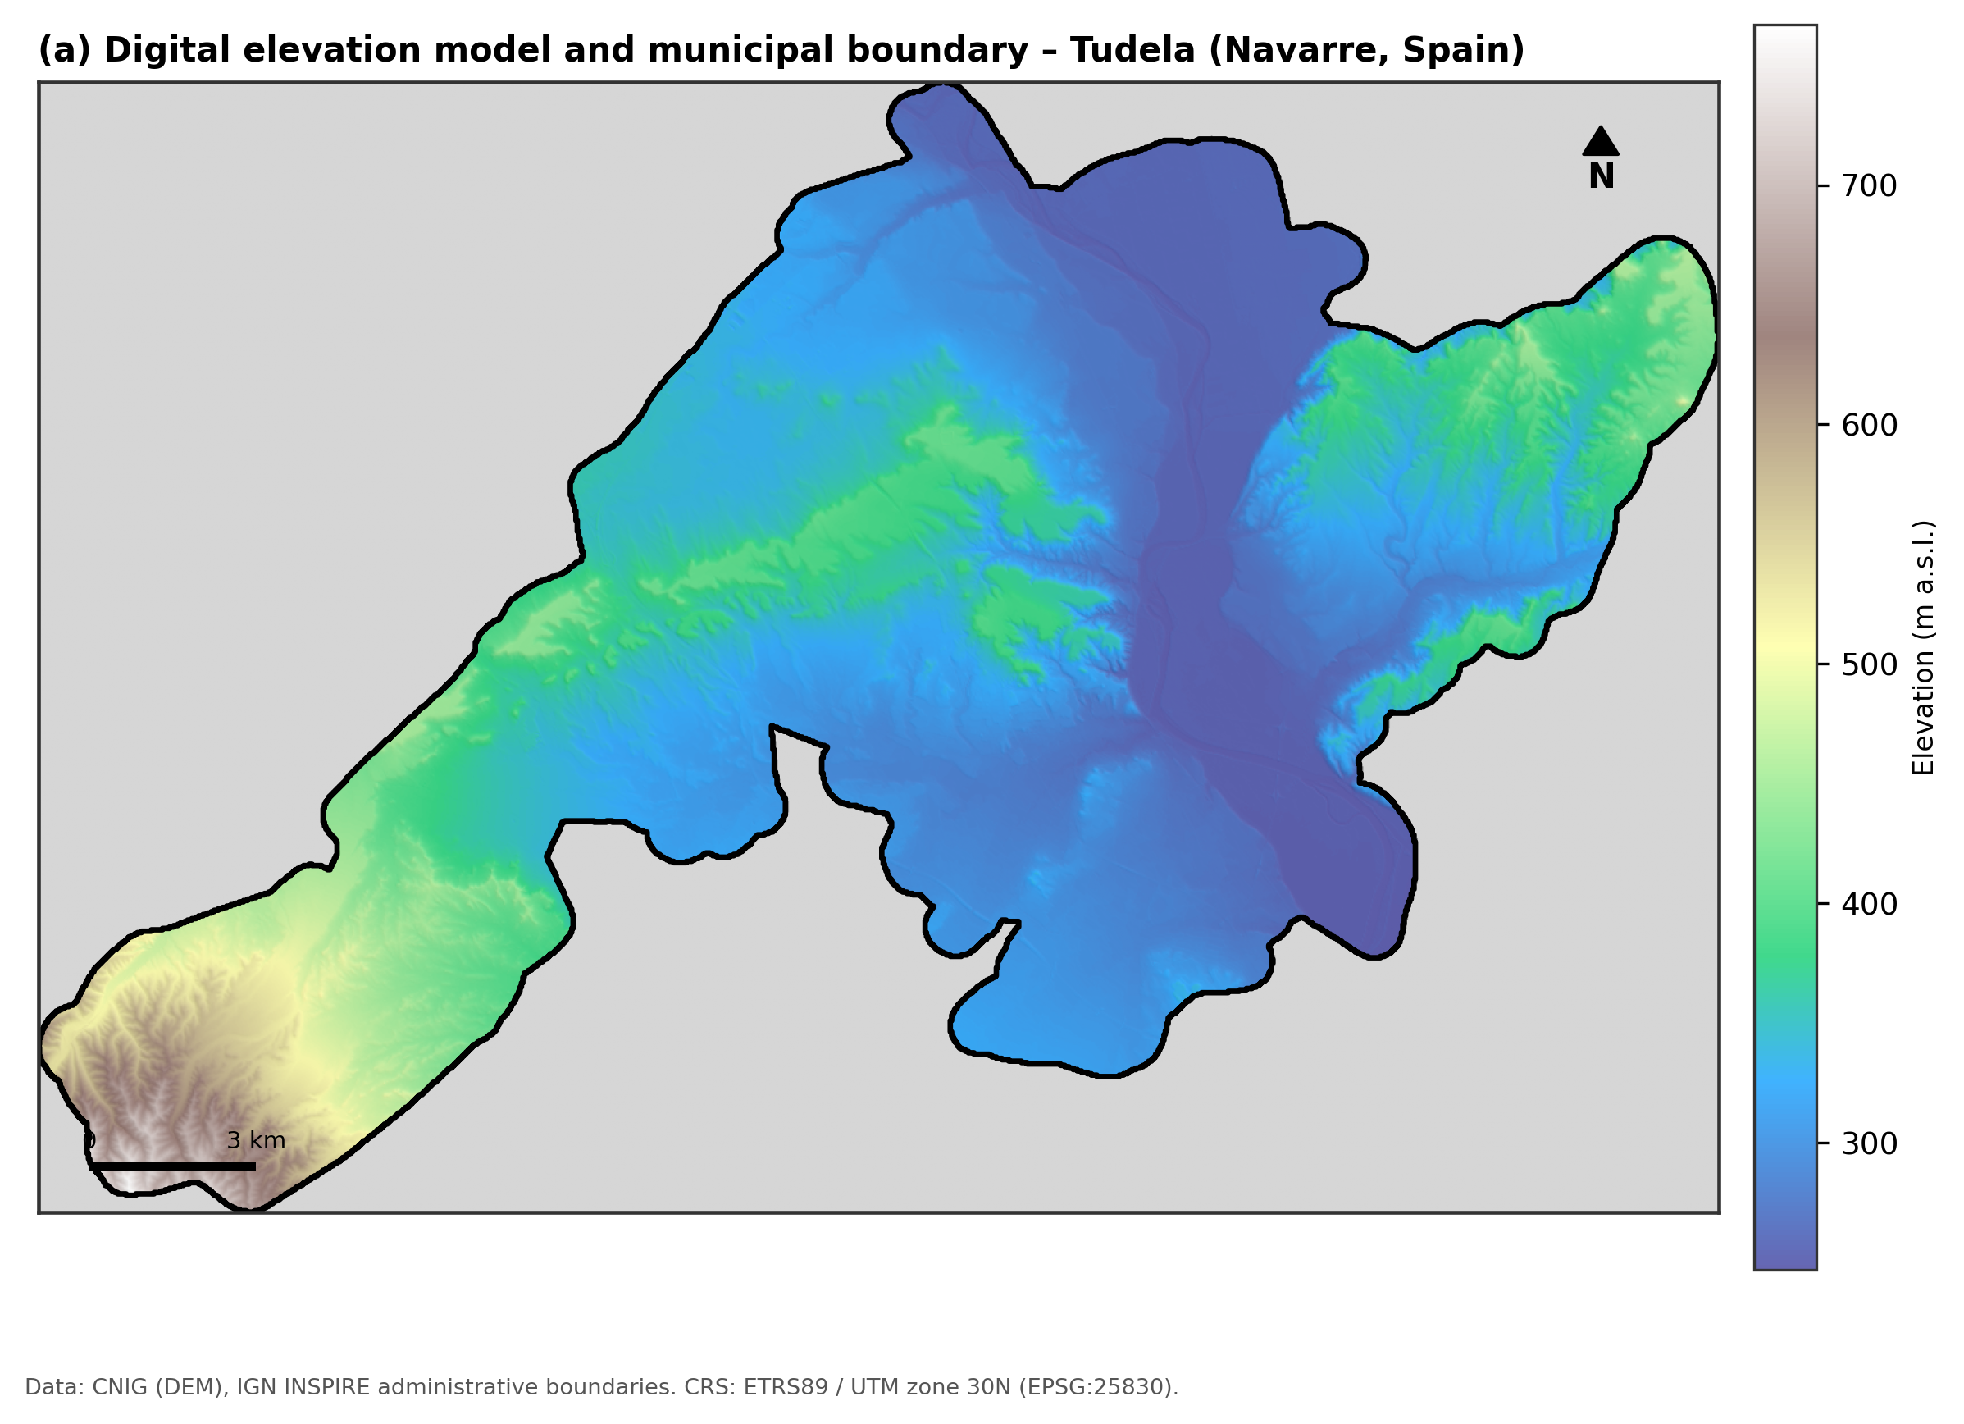
Fig. 1. Digital elevation model (25 m) of the Tudela area of interest, with the municipal boundary overlaid. CRS: ETRS89 / UTM zone 30N (EPSG:25830).

3. Data
Nine vector/raster datasets were used, all supplied pre-clipped to the area of interest and projected to ETRS89 / UTM zone 30N (EPSG:25830): (1) a 25 m digital elevation model (DEM); (2) the municipal administrative boundary; (3) SIGPAC (Sistema de Información Geográfica de Parcelas Agrícolas) land-use/land-cover parcels (24,921 parcels), with a pre-assigned suitability class distinguishing arable land and pasture from all other land uses; (4) lithology/soil-unit polygons with a pre-assigned soil suitability class; (5) the Public Hydraulic Domain (DPH) water-protection layer, comprising watercourses and their legal easements, plus (6) surface-water-body wetland and stream-buffer layers; (7) urban settlement footprints; (8) protected natural areas; and (9) the Nitrate Vulnerable Zone boundary. Table 1 summarises how each of the seven suitability criteria used in the hard-constraint overlay (Section 4.1) was derived from these layers.
Criterion | Threshold / treatment | Source layer / derivation
1. Slope | ≥ 15% excluded (continuous fuzzy ramp 0–15% inside candidate zone) | Central-difference gradient of the 25 m DEM
2. Soil / lithology | Binary: pre-assigned Suit_Class = 2 (suitable) vs. other | Rasterised lithology polygons
3. Water protection | DPH watercourses + legal easement; 5 m wetland/stream buffer | Distance transform from DPH + buffered wetlands/streams
4. Urban buffer | 100 m from urban settlement footprints | Distance transform from urban polygons
5. Protected natural areas | Excluded inside polygon boundary | Distance transform from PNA polygons
6. Nitrate Vulnerable Zone | Regulatory N-load penalty (×0.70), not exclusion | Rasterised NVZ boundary
7. Land-use eligibility | Binary: SIGPAC arable land / pasture vs. other uses | Rasterised SIGPAC parcels

Table 1. Suitability criteria used in the hard-constraint overlay and the continuous fuzzy index.

4. Methods

4.1 Hard-constraint overlay and candidate zone
Following standard GIS-MCDA practice (Malczewski, 2004; 2006), the seven criteria in Table 1 were first combined as hard (categorical/regulatory) constraints rather than continuously weighted factors, because slope, soil type, land-use eligibility, and the water/urban/protected-area buffers are legal or physical thresholds rather than gradational preferences. All layers were rasterised or distance-transformed onto the 25 m DEM grid (1203 × 809 cells) and combined by Boolean AND: a cell was retained in the candidate zone only if it had slope below 15%, suitable lithology, arable/pasture land use, and lay outside the water-protection, urban and protected-area buffers. The Nitrate Vulnerable Zone criterion was deliberately excluded from this hard overlay and instead folded into the continuous index (Section 4.2), because the Nitrates Directive constrains the permitted nitrogen load rather than prohibiting slurry application outright (Council of the European Communities, 1991); treating it as a further exclusion criterion, as some simplified overlays do, overstates its regulatory effect. The resulting candidate zone covers 5.35% of the area of interest (14.35 km², 22,953 cells) and forms the domain over which the continuous suitability index, the pseudo-observation network, and all four predictive models (Sections 4.2–4.5) are defined.

4.2 Continuous fuzzy suitability index
Within the candidate zone, a continuous Suitability Index (SI, range 0–100) was built as a weighted linear combination (WLC) of four fuzzy membership functions, the standard continuous-surface extension of Boolean GIS-MCDA (Malczewski, 2000):
SI = 100 × Pₘᵥᵣ × (0.30·fₛₗₒₚₑ + 0.25·fᴡₐₜₑᵣ + 0.20·fᵤᵣᵇₐₙ + 0.25·fₚᵣₒₜ),
where fₛₗₒₚₑ = clip(1 − slope(%)/15, 0, 1) is a linear fuzzy ramp that gives full membership to flat land and zero membership at the 15% hard threshold; fᴡₐₜₑᵣ = clip(distance-to-water/300 m, 0, 1) and fₚᵣₒₜ = clip(distance-to-protected-area/1000 m, 0, 1) increase with distance from the corresponding hard buffer and saturate at 300 m and 1000 m respectively; fᵤᵣᵇₐₙ = clip((distance-to-urban − 100 m)/400 m, 0, 1) increases beyond the 100 m hard buffer and saturates at 500 m; and Pₘᵥᵣ is a regulatory penalty factor equal to 0.70 inside the Nitrate Vulnerable Zone and 1.0 outside it, reflecting the reduced permissible nitrogen load rather than an outright prohibition. The criterion weights (0.30/0.25/0.20/0.25) follow the common practice of assigning the largest share to the criterion with the most direct agronomic and erosion-risk relevance (slope) while keeping the three buffer-distance criteria comparably weighted; a full sensitivity analysis of these weights, while a legitimate extension, is left to future work. The resulting SI surface (mean 76.4, SD 15.0 across the candidate zone) is treated in this study as the reference “latent” suitability surface that the pseudo-observation network (Section 4.3) samples and that regression kriging and the deep-learning models (Sections 4.4–4.5) attempt to reconstruct from covariates alone.
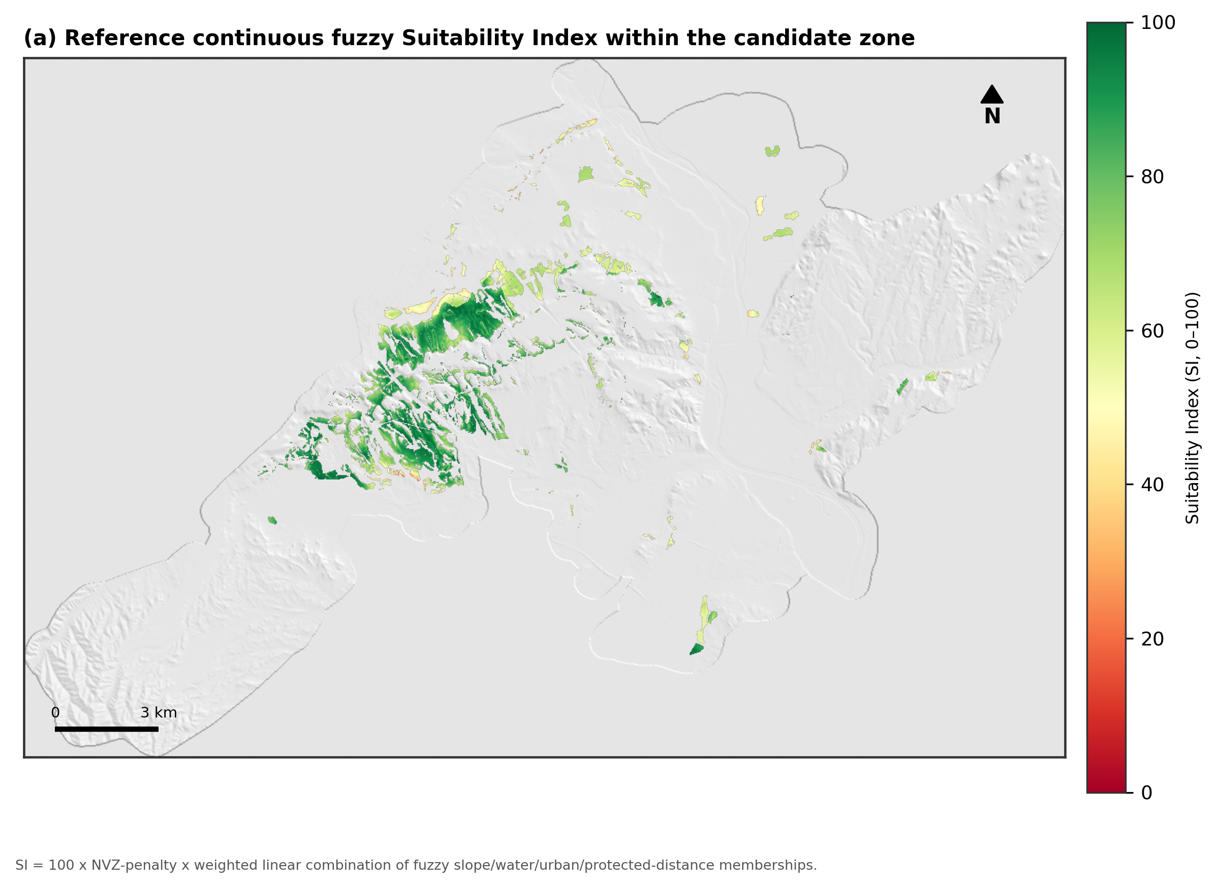
Fig. 2. Reference continuous fuzzy Suitability Index within the candidate (hard-constraint-compliant) zone.

4.3 Pseudo-observation network and spatial cross-validation
No physical monitoring network of field-verified slurry-suitability assessments exists for the study area. Following the benchmarking design used to validate spatial-interpolation and machine-learning methods when point observations are themselves the object of study (an approach directly analogous to synthetic validation designs in digital soil mapping; Hengl et al., 2004), 550 pseudo-observation points were drawn at random locations within the candidate zone. At each point, the reference SI value was sampled and heteroscedastic Gaussian noise (SD = 3.0 + 0.06×SI) was added to emulate realistic field- or expert-assessment error, growing with the magnitude of the suitability score. Points were then partitioned into training and held-out test sets using spatial blocking rather than random splitting: the study area was tiled into 2×2 km blocks, and 25% of blocks (selected at random) were withheld in their entirety as the test set (127 points, 35 blocks total, 9 withheld), so that spatial autocorrelation between nearby training and test points could not inflate the apparent accuracy of any model.
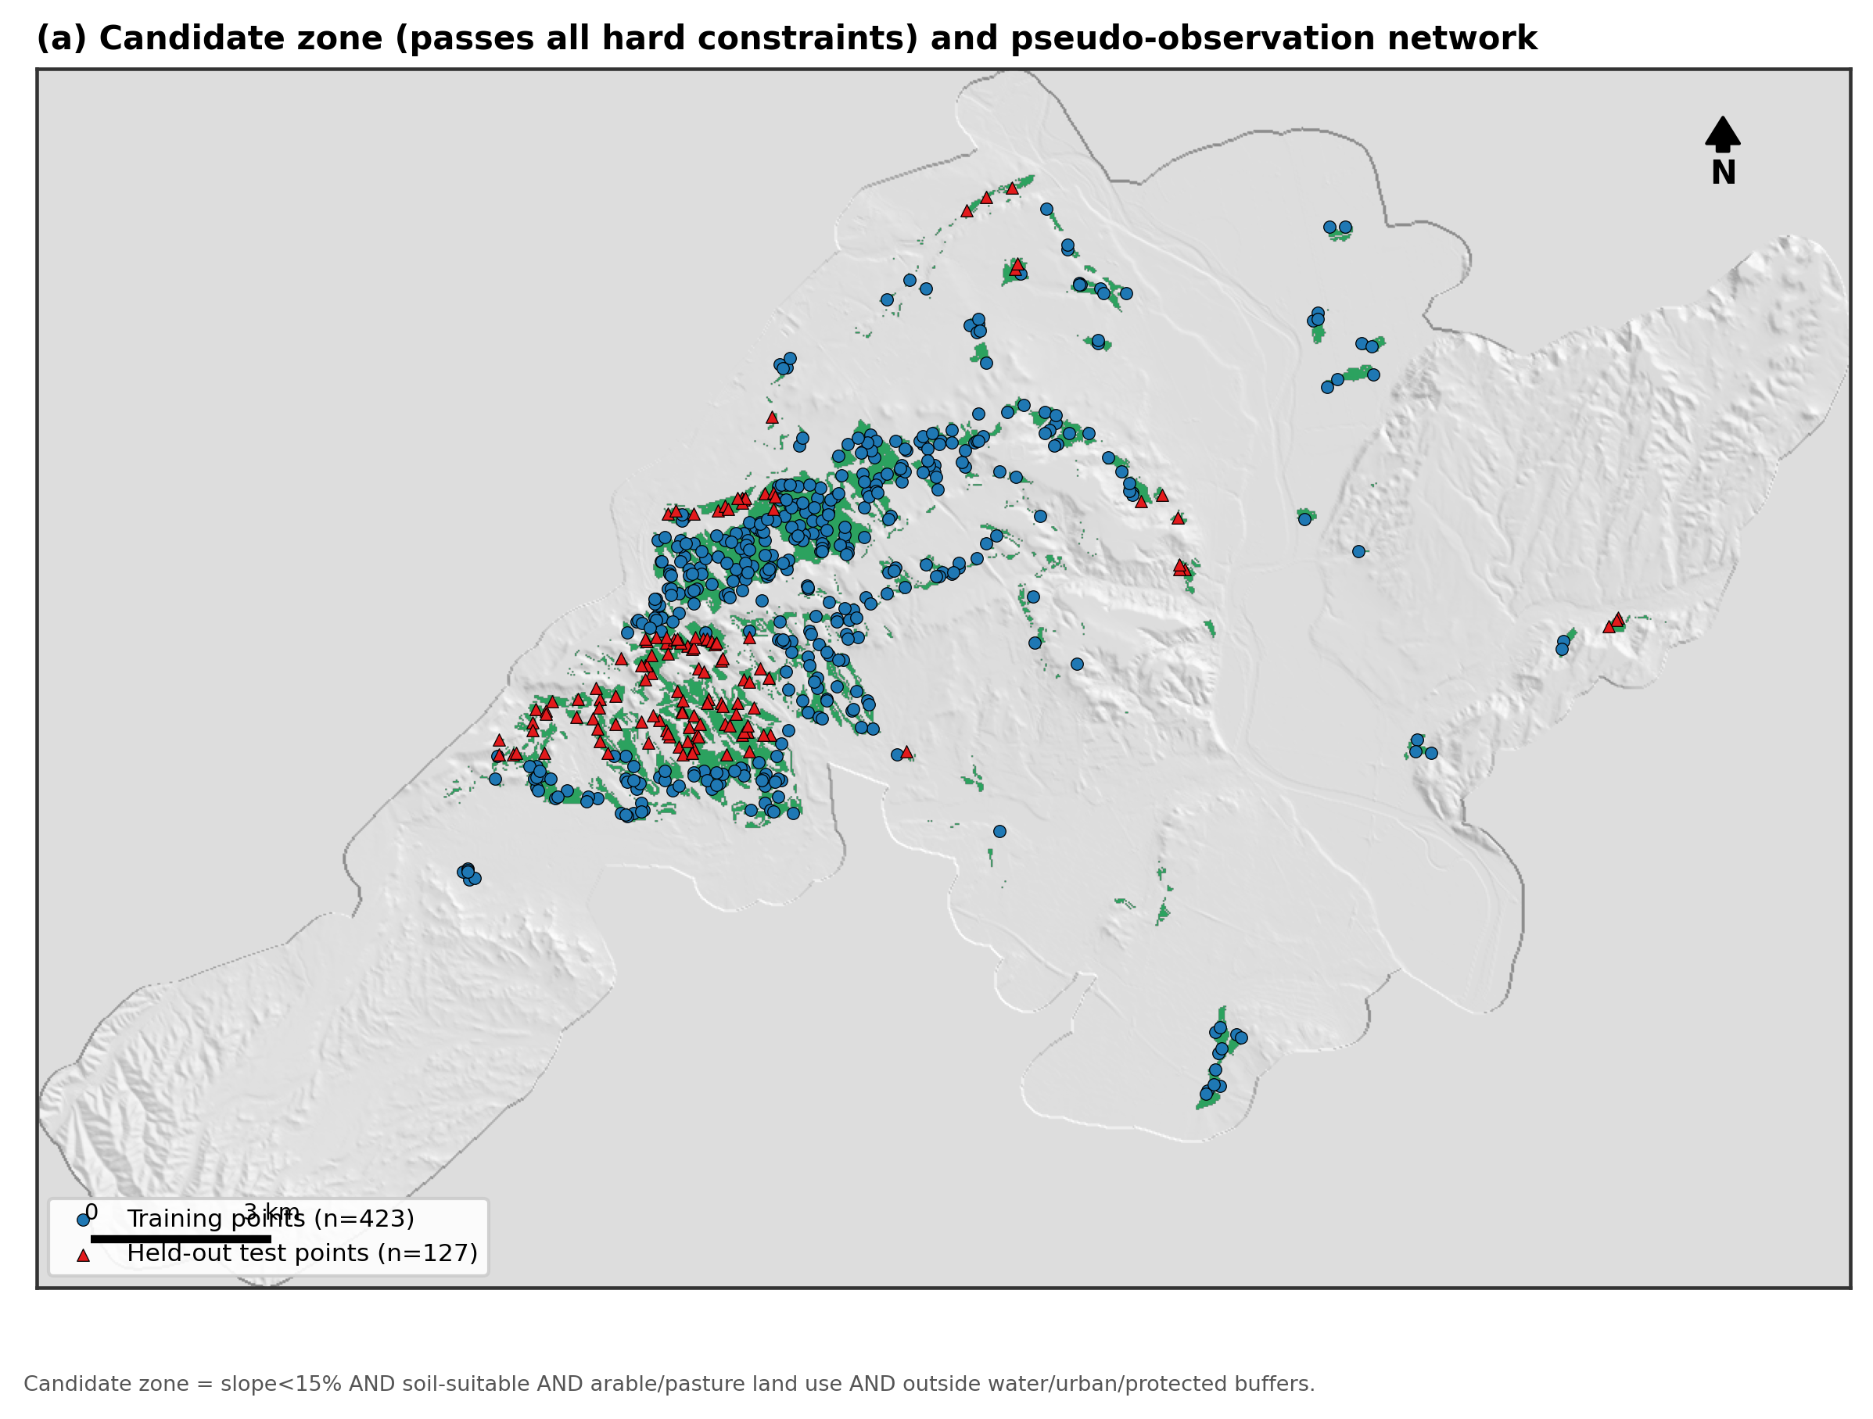
Fig. 3. Candidate zone and the spatially block-split pseudo-observation network (423 training, 127 held-out test points).

4.4 Regression kriging
Regression kriging (RK) combines a deterministic regression trend on auxiliary covariates with ordinary kriging of the trend’s residuals, exploiting whichever spatial autocorrelation the trend does not explain (Odeh et al., 1995; Hengl et al., 2004; Hengl et al., 2007). Two trend models were compared: RK-LM, the classical formulation with an ordinary-least-squares linear trend, and RK-RF, a random-forest trend (Breiman, 2001; 300 trees, maximum depth 8) that can capture non-linear and interaction effects among covariates. Both models used the same six covariates — slope, distance to water, distance to urban land, distance to protected areas, Nitrate Vulnerable Zone indicator, and elevation — and both kriged the trend residuals by ordinary kriging with a spherical variogram model (12 lag bins, up to 12 nearest neighbours, inverse-distance weighting of the fit). Model fitting, variogram estimation and prediction were implemented with the PyKrige RegressionKriging class. Both models were evaluated on the spatially held-out test blocks (Section 4.3), and the best-performing trend (by RMSE) was then applied to predict the continuous SI value at every cell of the candidate zone, together with the corresponding ordinary-kriging prediction variance as a spatially explicit measure of interpolation uncertainty.

4.5 Deep-learning surrogates
Two deep-learning architectures were trained on the same pseudo-observation network to provide a purely statistical-learning point of comparison to RK. DL-MLP is a fully connected feed-forward network (64–32–16–1 units, ReLU activations, batch normalisation after the first layer, dropout 0.2) trained on eight standardised inputs: the six RK covariates plus the projected x and y coordinates, allowing the network to learn spatial trend implicitly rather than through an explicit kriging step. DL-CNN is a small convolutional network that instead reads a 9×9-cell (225×225 m), six-channel neighbourhood centred on each sample — the same six covariate rasters used by RK-RF — through two convolutional blocks (16 and 32, then 32 filters, 3×3 kernels, one 2×2 max-pooling layer), a global-average-pooling layer, and a 32-unit dense head; this patch-based design lets the network learn local spatial texture and context (e.g. proximity gradients and terrain shape) directly from the raster rather than from pre-computed distance covariates alone. Both networks were trained with the Adam optimiser (learning rate 10⁻³) to minimise mean squared error, using an 80/20 train/validation split drawn from the training spatial blocks and early stopping on validation loss (patience 40 epochs); training curves are shown in Fig. 4. Both models were then applied to predict SI at every candidate-zone cell from the corresponding covariate vector (DL-MLP) or covariate patch (DL-CNN).
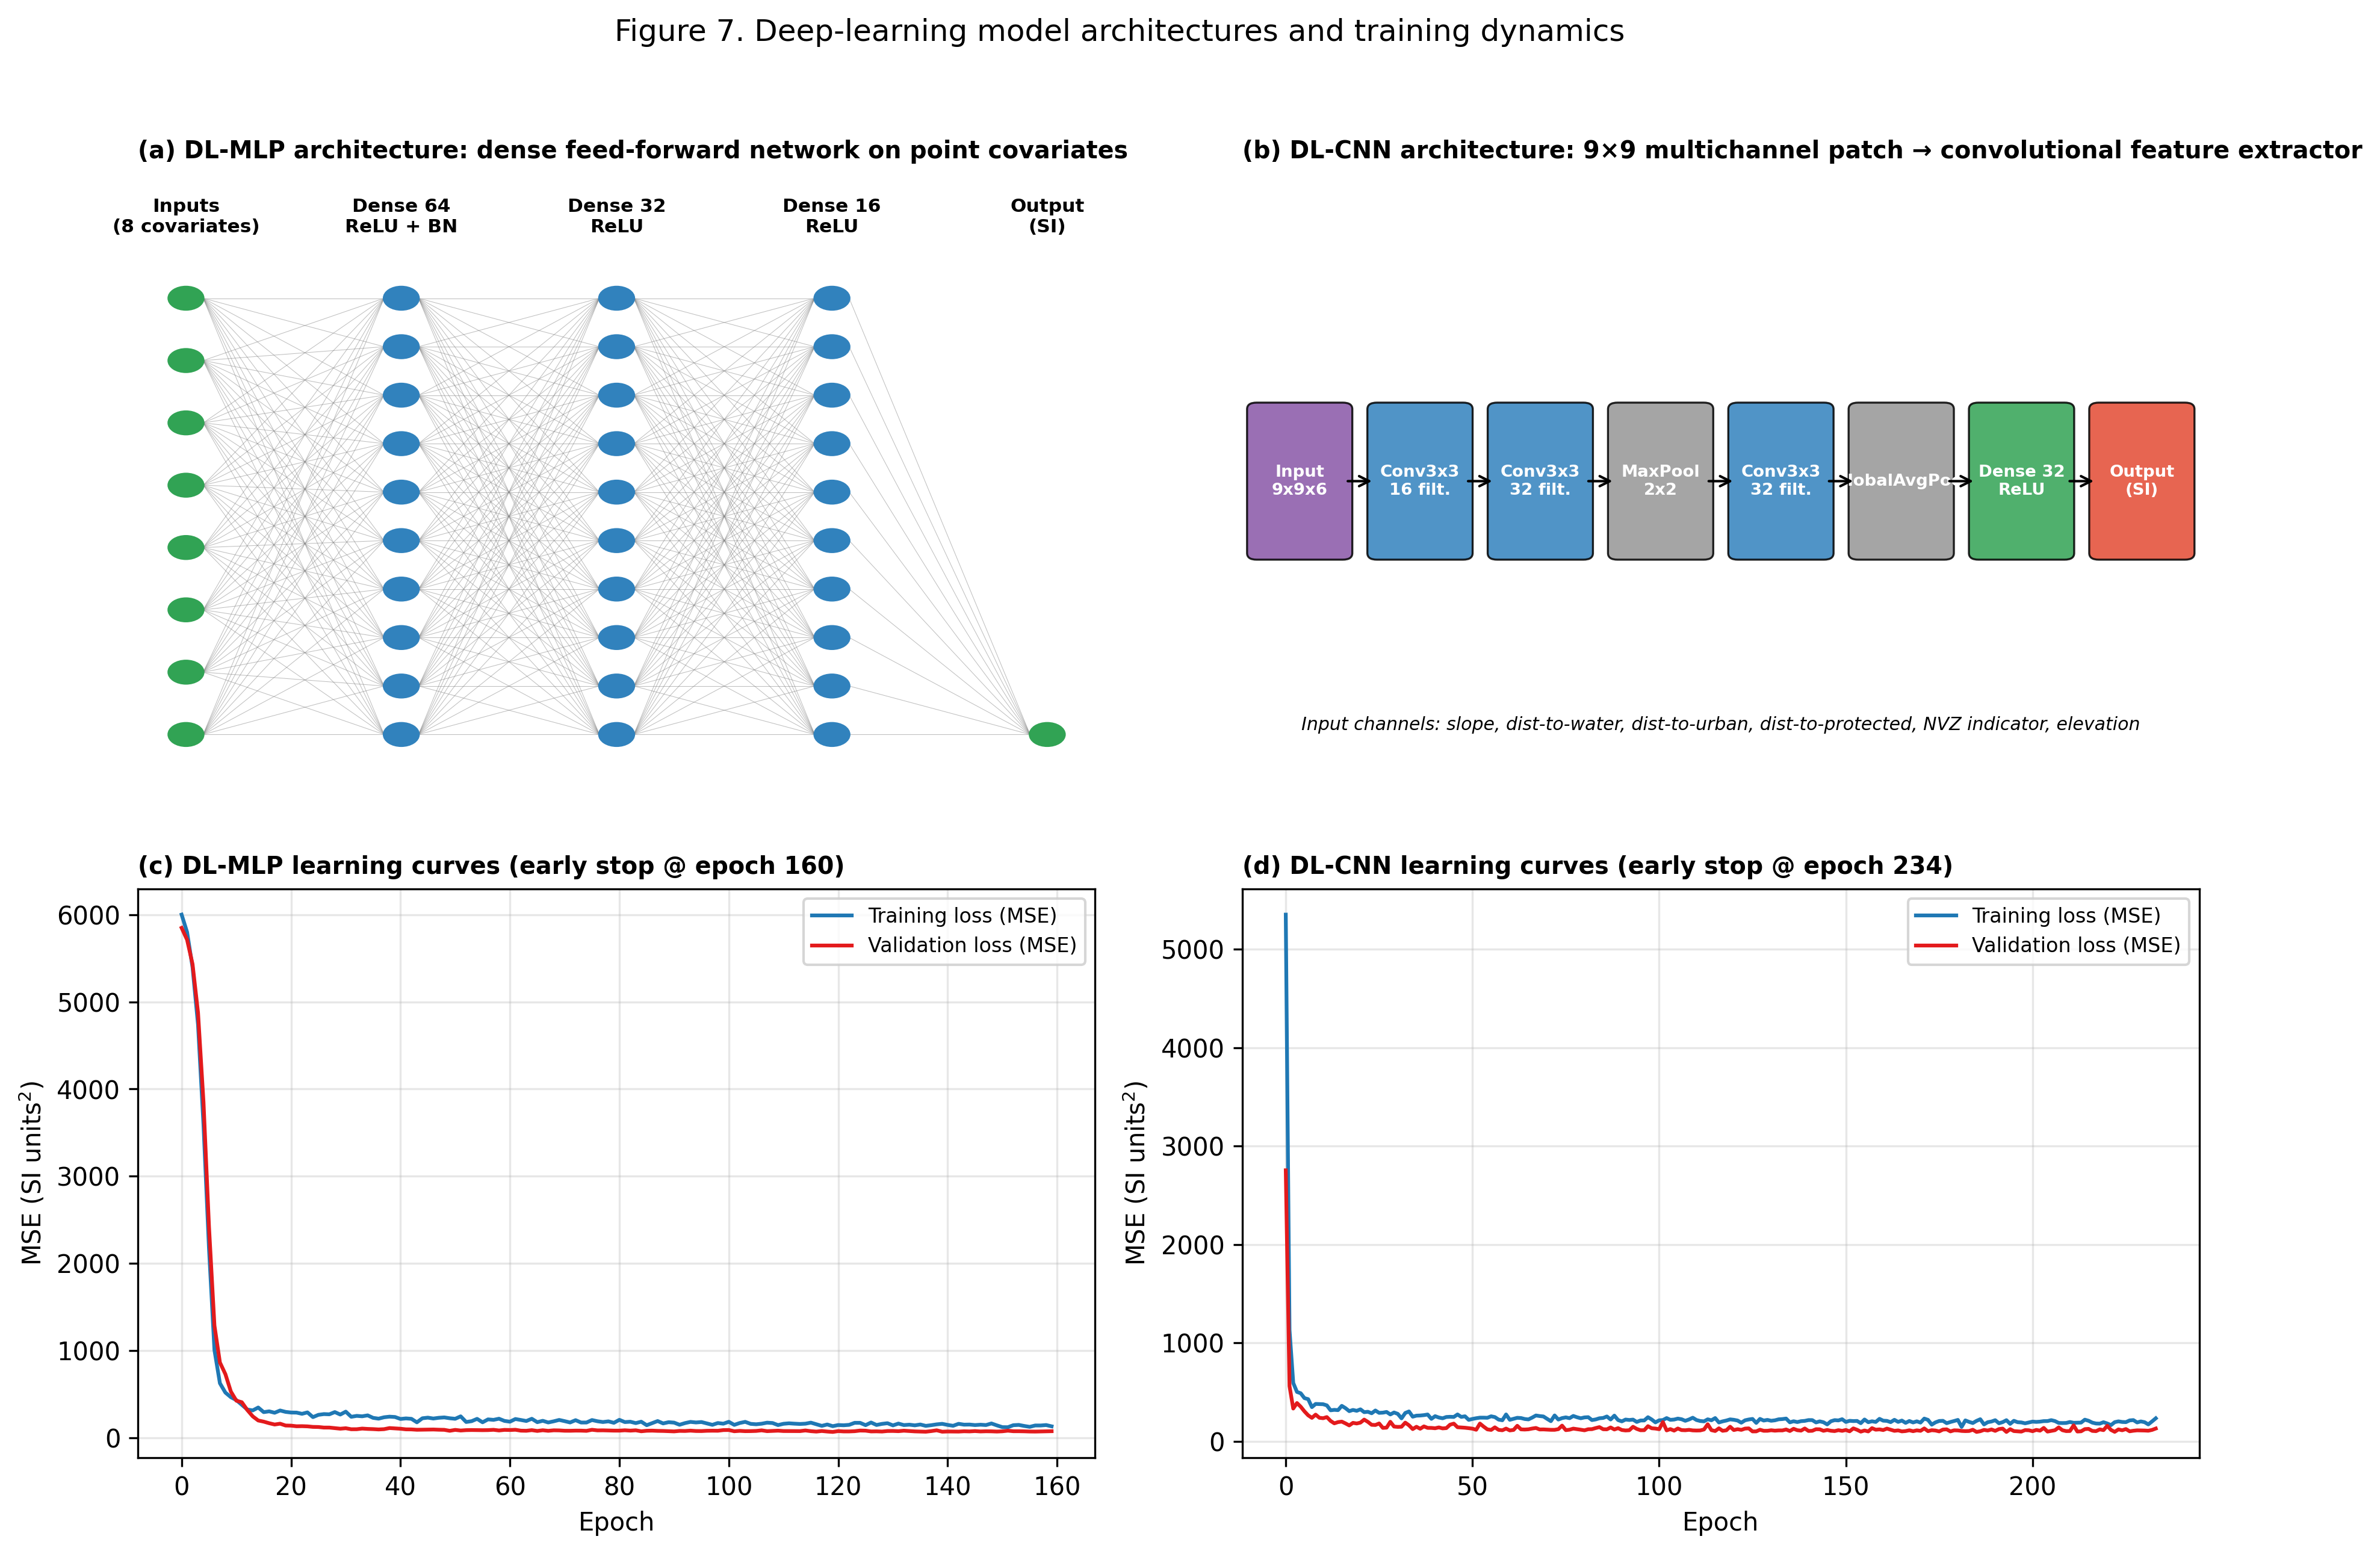
Fig. 4. Deep-learning architectures — (a) DL-MLP, (b) DL-CNN — and their training/validation loss curves (c, d).

4.6 Model validation
All four continuous-surface models (RK-LM, RK-RF, DL-MLP, DL-CNN) were evaluated on the identical set of 127 spatially held-out test points using root-mean-square error (RMSE), mean absolute error (MAE) and the coefficient of determination (R²). Overall pattern agreement was further summarised with a Taylor diagram (Taylor, 2001), which jointly displays each model’s standard deviation, correlation with the observed values, and centred RMSE relative to the observed reference. Residual spatial autocorrelation on the test set was quantified with Moran’s I (Moran, 1950) computed over an 8-nearest-neighbour spatial weights matrix, to check whether any model left systematic, spatially structured error unexplained. Finally, the relative contribution of each covariate to the random-forest trend model was assessed by permutation importance (30 repeats) on the held-out test set.

5. Results

5.1 Hard-constraint criteria and candidate zone
Individually, the six hard-constraint criteria affect very different shares of the area of interest (Fig. 5): the water-protection buffer affects 5.14%, the 100 m urban buffer 17.09%, protected natural areas 4.65%, and the Nitrate Vulnerable Zone 40.17% (retained in the continuous index rather than the hard overlay, Section 4.1). Soil/lithology suitability affects the largest share of physically unsuitable land (81.65% of the area of interest classified as unsuitable lithology), and SIGPAC land-use eligibility restricts 54.61% of the area to non-arable, non-pasture uses. Once combined by Boolean AND, only 5.35% of the area of interest (14.35 km², 22,953 cells) passes every hard constraint simultaneously — illustrating how strongly conjunctive (AND-combined) categorical constraints compound in a GIS-MCDA overlay even when each individual criterion is comparatively permissive.
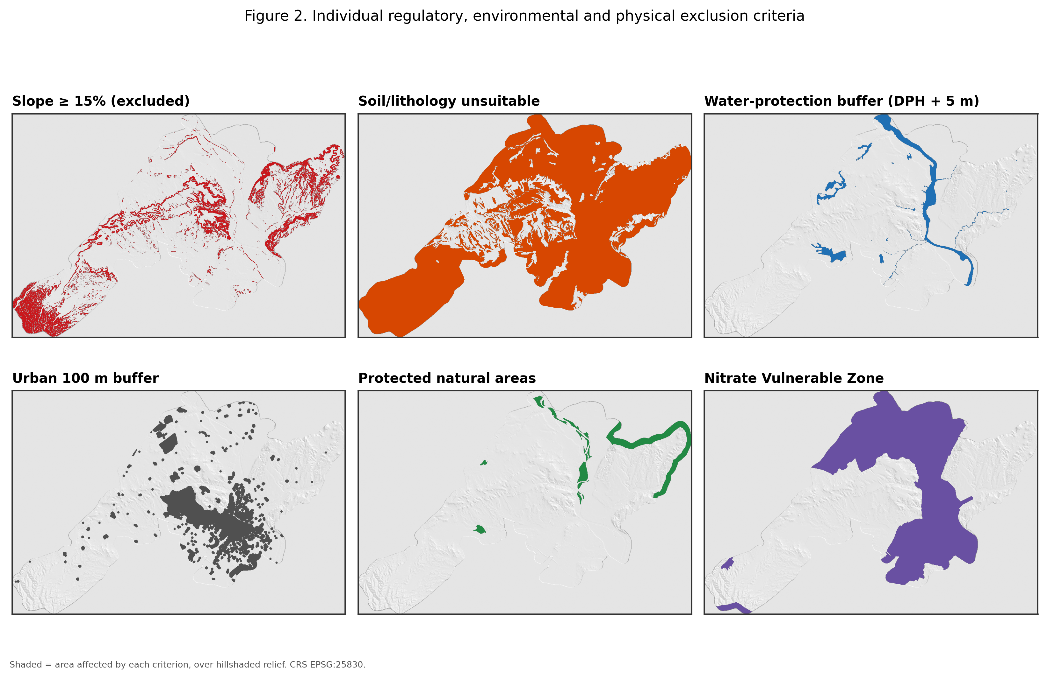
Fig. 5. Individual regulatory, environmental and physical exclusion criteria over hillshaded relief.

5.2 Regression kriging
The random-forest trend clearly outperformed the linear trend for regression kriging on the spatially held-out test blocks: RK-RF achieved RMSE = 7.78, MAE = 6.53 and R² = 0.765, compared with RMSE = 11.01, MAE = 8.44 and R² = 0.531 for RK-LM (Table 2). The empirical variogram of the OLS-trend residuals (Fig. 6a) was well described by a spherical model with an effective range of ≈839 m and a very high nugget-to-sill ratio (0.99), indicating that most of the spatial variability in the trend residuals is unresolved at the 25 m grid spacing and reinforcing the residual map’s patchy appearance (Fig. 6b). The RK-RF prediction surface (Fig. 7a) reproduces the broad spatial pattern of the reference SI (Fig. 2), with the highest predicted suitability concentrated in the flatter, better-drained western part of the candidate zone; the corresponding ordinary-kriging prediction-variance surface (Fig. 7b) is highest at the edges of the candidate zone and in its more fragmented eastern parcels, where the pseudo-observation network is sparsest.
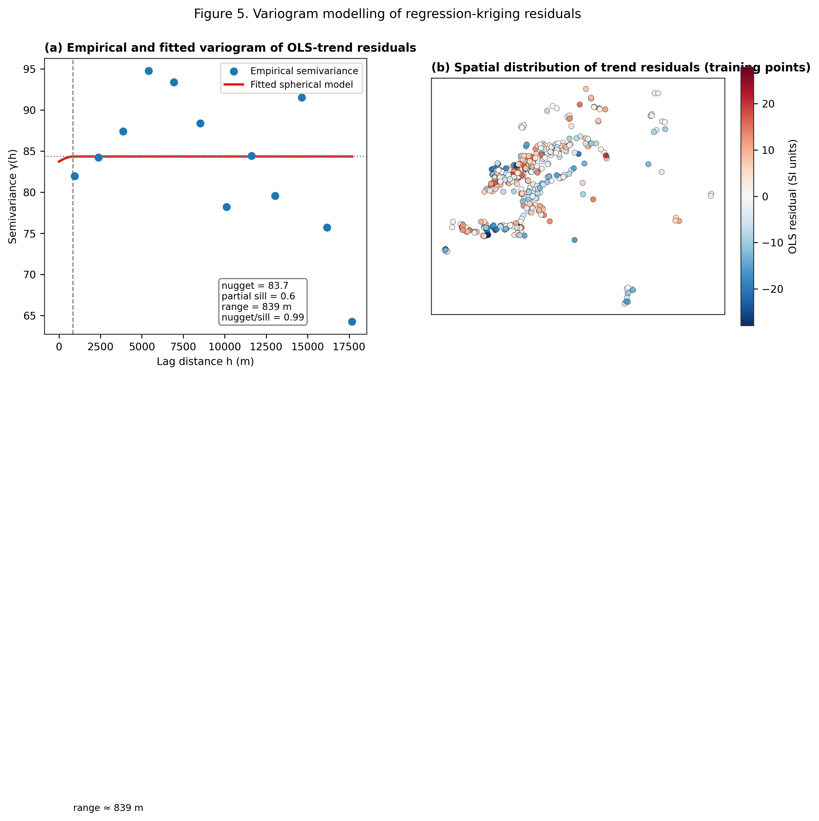
Fig. 6. (a) Empirical and fitted spherical variogram of the OLS-trend residuals. (b) Spatial distribution of the trend residuals at the training points.
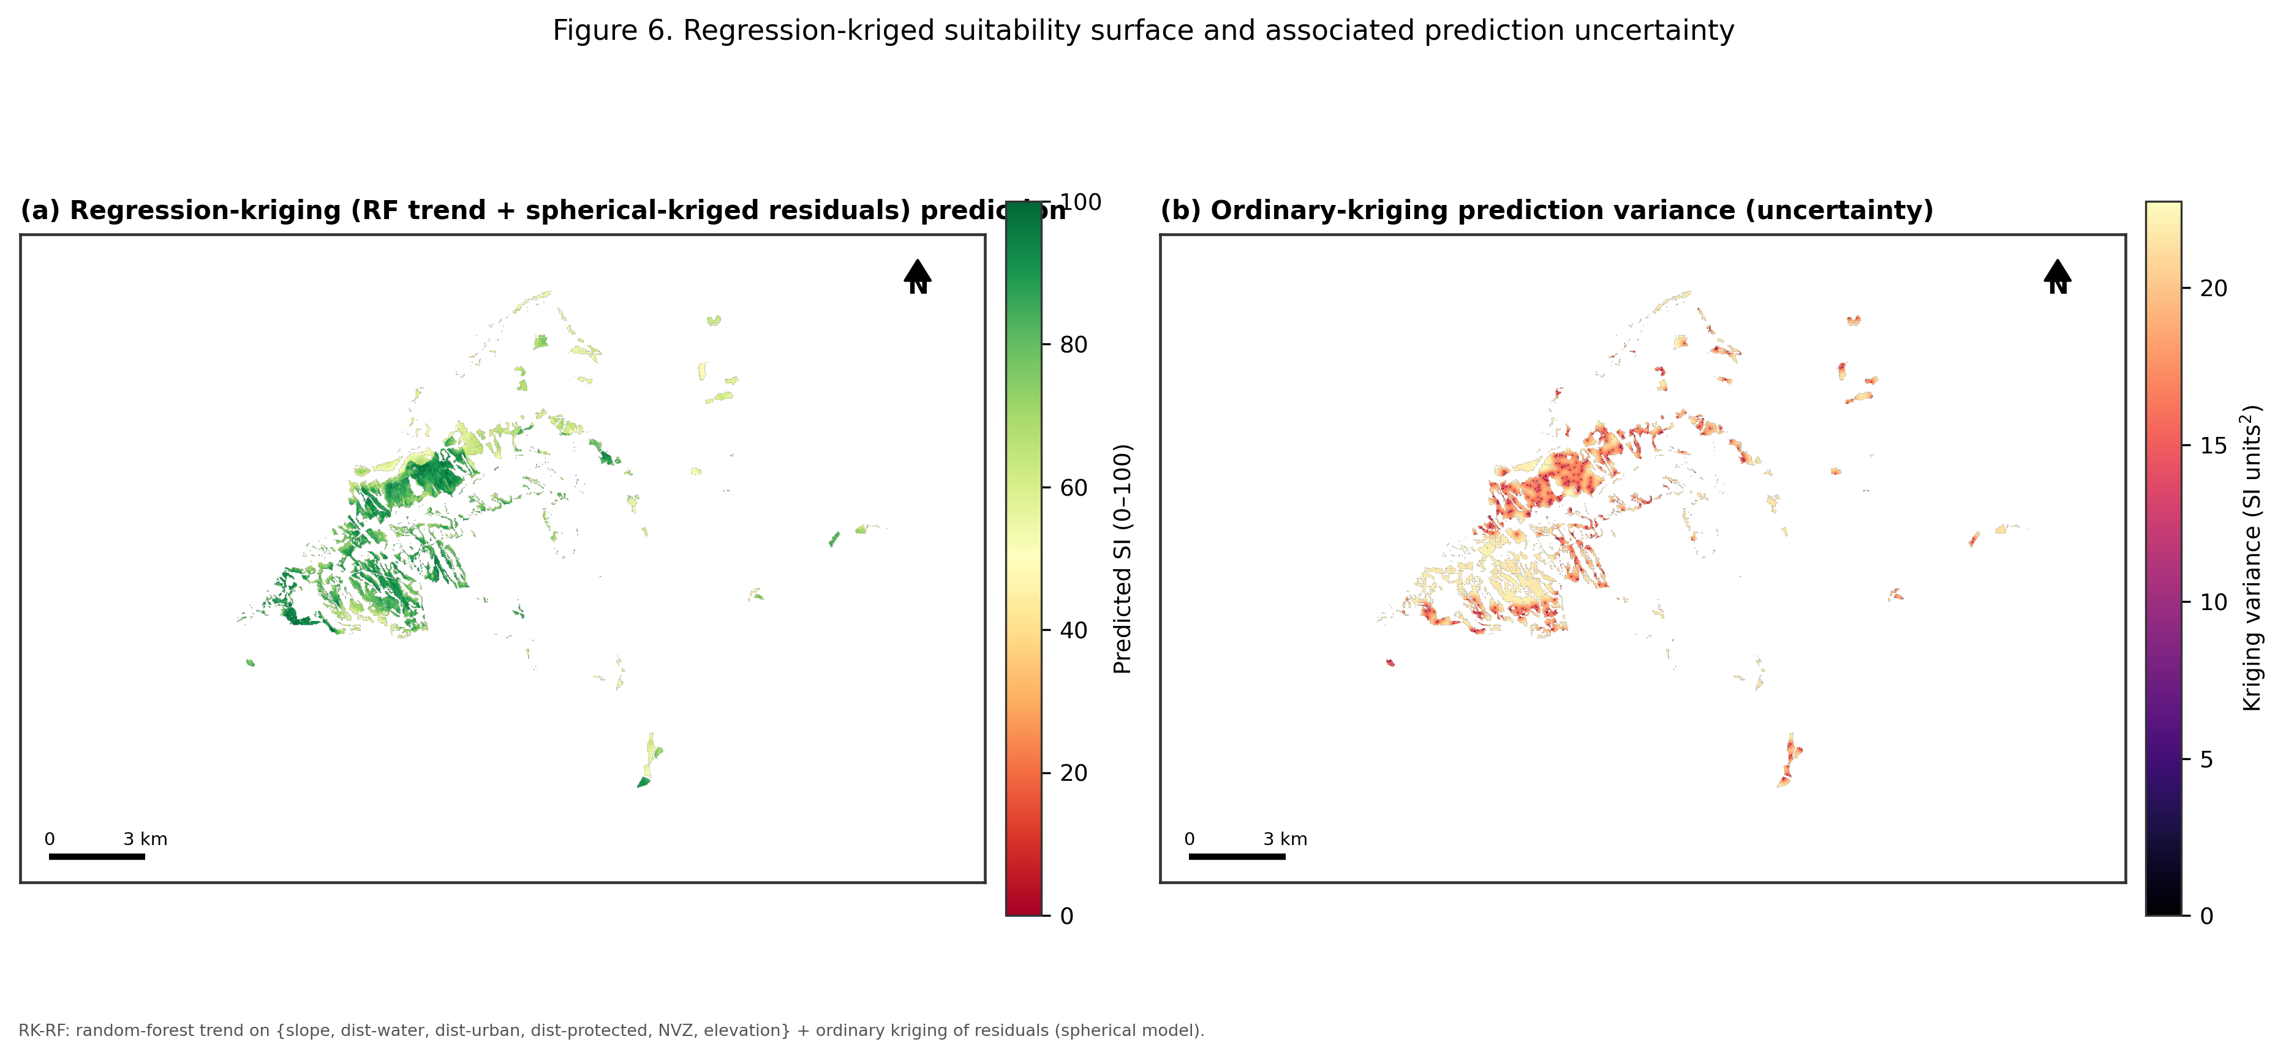
Fig. 7. (a) Regression-kriging (random-forest trend) prediction of the suitability index. (b) Ordinary-kriging prediction variance (interpolation uncertainty).

5.3 Deep-learning surrogates
Both deep-learning models converged smoothly, with validation loss tracking training loss closely and no evidence of overfitting before early stopping (Fig. 4c–d; DL-MLP stopped at epoch 160, DL-CNN at epoch 234). On the held-out test blocks, DL-MLP achieved RMSE = 9.92, MAE = 7.49, R² = 0.619, and DL-CNN achieved a near-identical RMSE = 9.90, MAE = 7.82, R² = 0.620 (Table 2) — that is, reading a 9×9 spatial neighbourhood rather than point covariates alone did not materially improve predictive accuracy for this problem, although the two architectures make visibly different local errors (Fig. 9). Both deep-learning surrogates outperformed the classical RK-LM model but remained clearly behind RK-RF.

5.4 Model comparison and validation
Model | RMSE | MAE | R² | Correlation (r) | Residual Moran's I
RK-LM | 11.01 | 8.44 | 0.531 | 0.82 | 0.043
RK-RF | 7.78 | 6.53 | 0.765 | 0.89 | 0.017
DL-MLP | 9.92 | 7.49 | 0.619 | 0.83 | 0.038
DL-CNN | 9.90 | 7.82 | 0.620 | 0.87 | 0.061

Table 2. Held-out spatial-block validation statistics for the four continuous-surface models (n = 127 test points).
The observed-vs-predicted scatter plots (Fig. 8) confirm the ranking suggested by RMSE: RK-RF shows the tightest scatter around the 1:1 line across the full range of the held-out observations, while RK-LM shows the most pronounced bias, over-predicting low-suitability locations and under-predicting the highest-suitability ones. The Taylor diagram (Fig. 9) summarises the same result geometrically — RK-RF sits closest to the observed reference point, with the highest correlation and lowest centred RMSE, while RK-LM, DL-MLP and DL-CNN cluster together at moderate correlation (0.82–0.87) and comparable standard deviation. Residual Moran’s I (Table 2) was lowest for RK-RF (0.017, negligible residual spatial structure) and highest for DL-CNN (0.061), suggesting that the explicit kriging step in RK-RF captures spatial autocorrelation that the patch-based CNN’s implicit spatial receptive field does not fully absorb at this sample size.
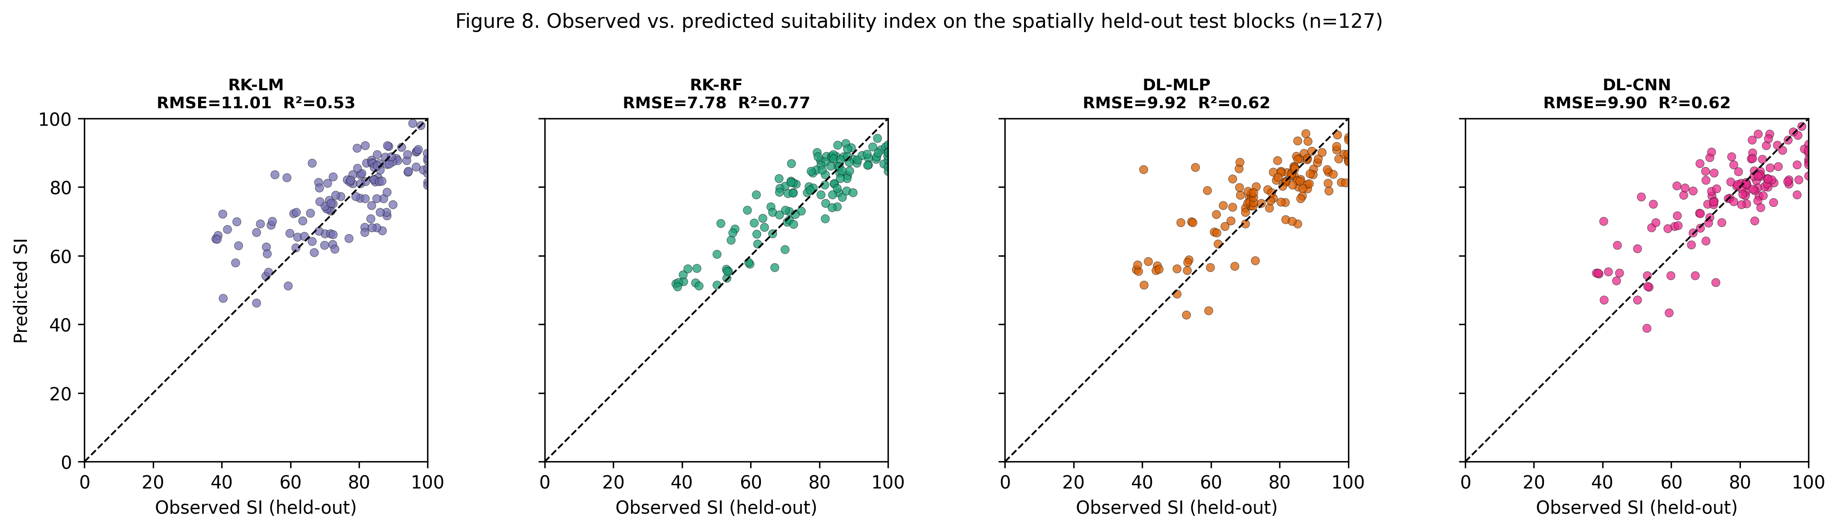
Fig. 8. Observed vs. predicted suitability index on the spatially held-out test blocks (n = 127) for all four models.
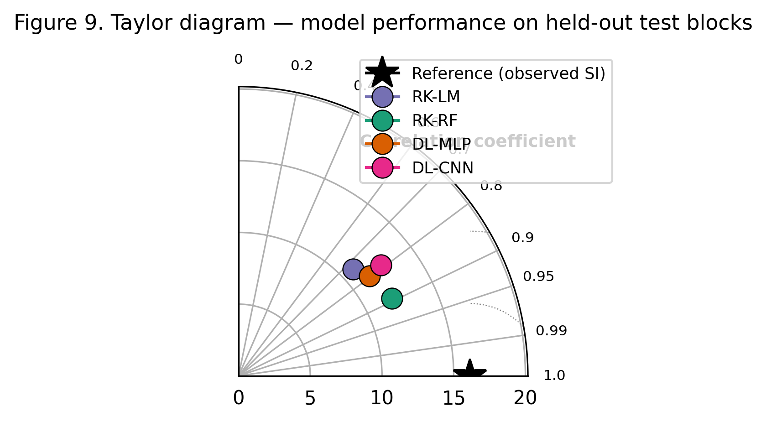
Fig. 9. Taylor diagram summarising correlation, standard deviation and centred RMSE for all four models against the observed reference.
Mapped across the full candidate zone (Fig. 10), the three best-performing models (RK-RF, DL-MLP, DL-CNN) agree closely on the overall spatial pattern of suitability, with the highest scores consistently located in the flatter, better-drained western sector. The three-model ensemble mean (Fig. 10d) and its inter-model standard deviation (Fig. 11b) show that structural disagreement between the geostatistical and deep-learning approaches is concentrated in a narrow band along the edges of the candidate zone and in a small number of isolated eastern parcels, rather than being distributed uniformly — precisely the locations flagged as high-uncertainty by the kriging-variance surface (Fig. 7b), which is a useful cross-check between structurally different uncertainty measures.
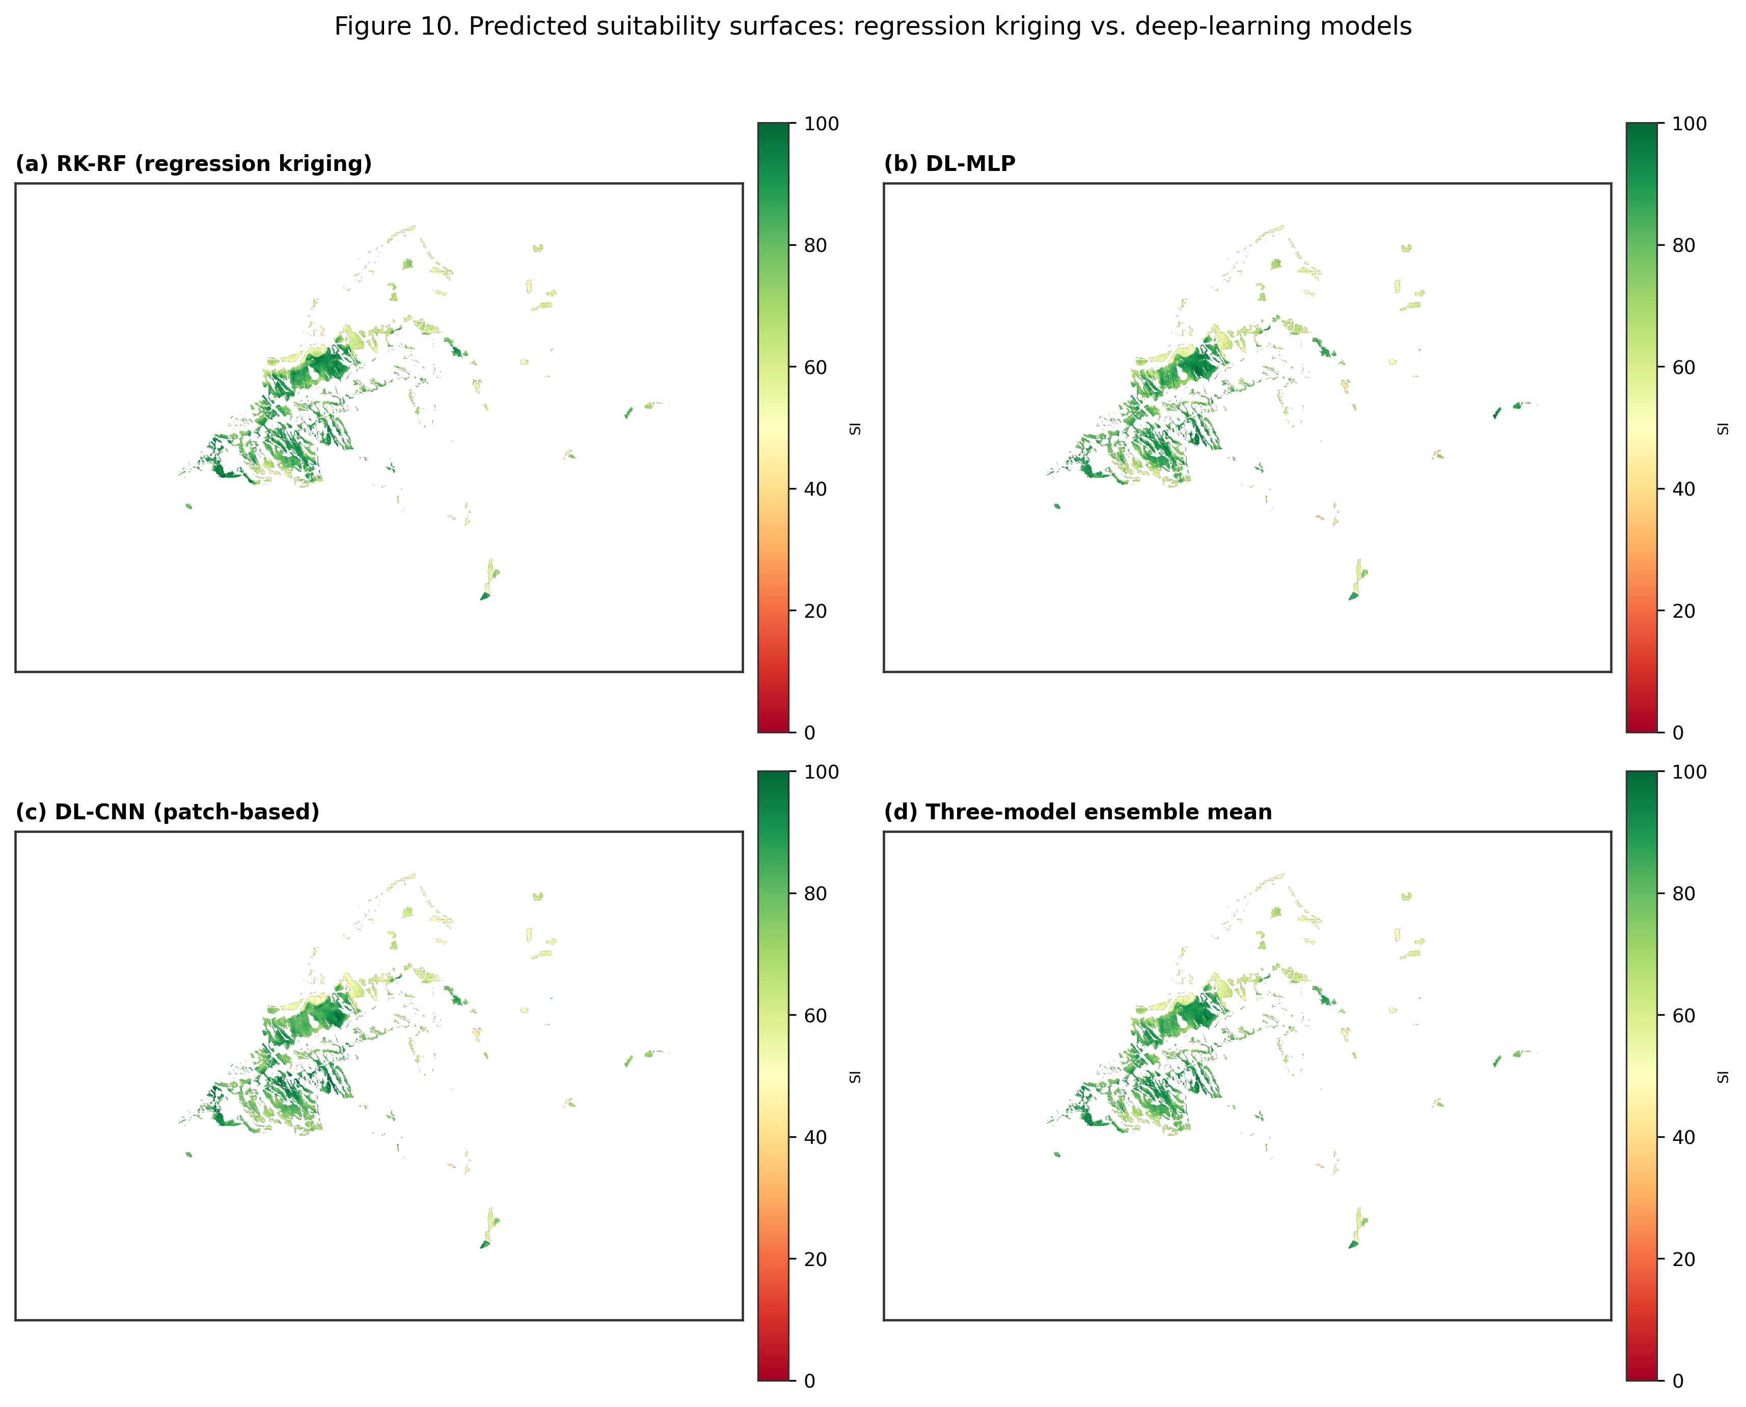
Fig. 10. Predicted suitability surfaces: (a) RK-RF, (b) DL-MLP, (c) DL-CNN, (d) three-model ensemble mean.
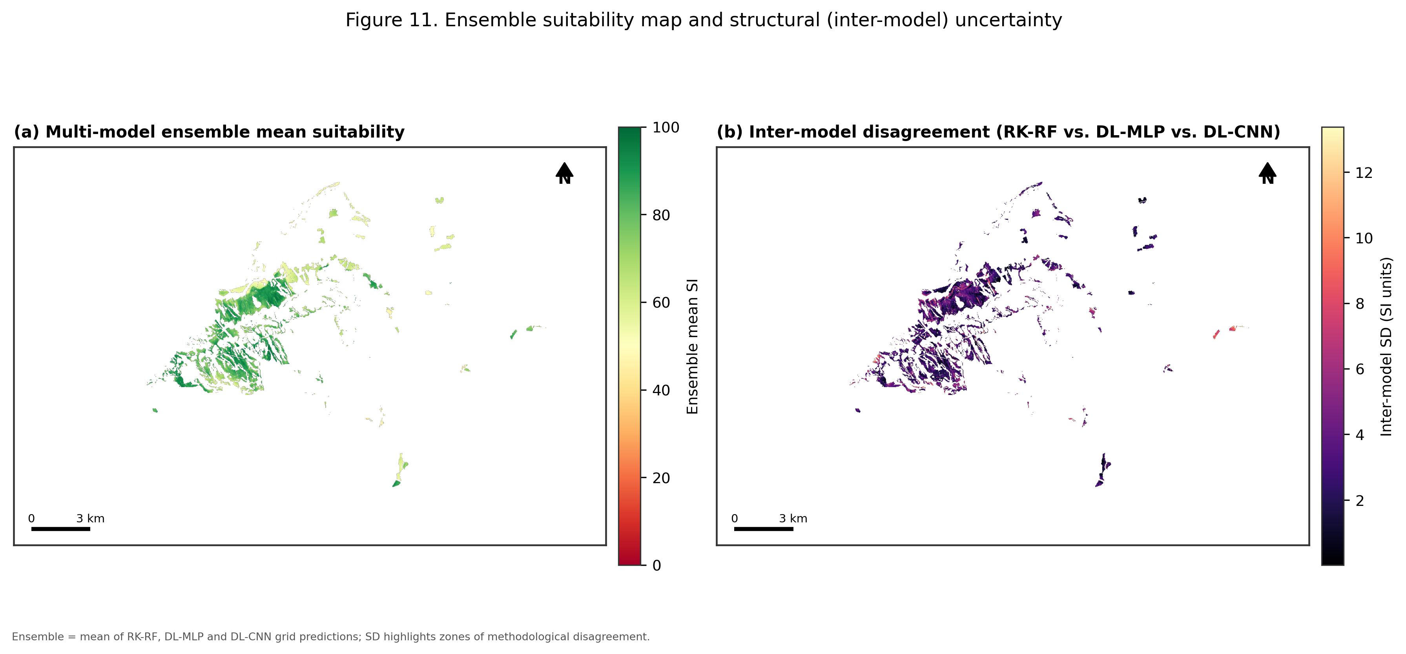
Fig. 11. (a) Multi-model ensemble mean suitability. (b) Inter-model disagreement (standard deviation across RK-RF, DL-MLP and DL-CNN).

5.5 Covariate importance
Permutation importance on the random-forest trend model (Fig. 12) identified Nitrate Vulnerable Zone status as by far the dominant covariate (ΔR² ≈ 0.57), consistent with its role in the continuous index as a multiplicative penalty applied to roughly 40% of the area of interest. Slope and distance to water contributed comparably (ΔR² ≈ 0.23–0.24 each), distance to urban land contributed moderately (ΔR² ≈ 0.16), and distance to protected areas and elevation contributed least (ΔR² ≤ 0.08), with elevation’s importance statistically indistinguishable from zero once slope and the distance covariates are accounted for — an expected result given that elevation and slope are strongly collinear at this scale.
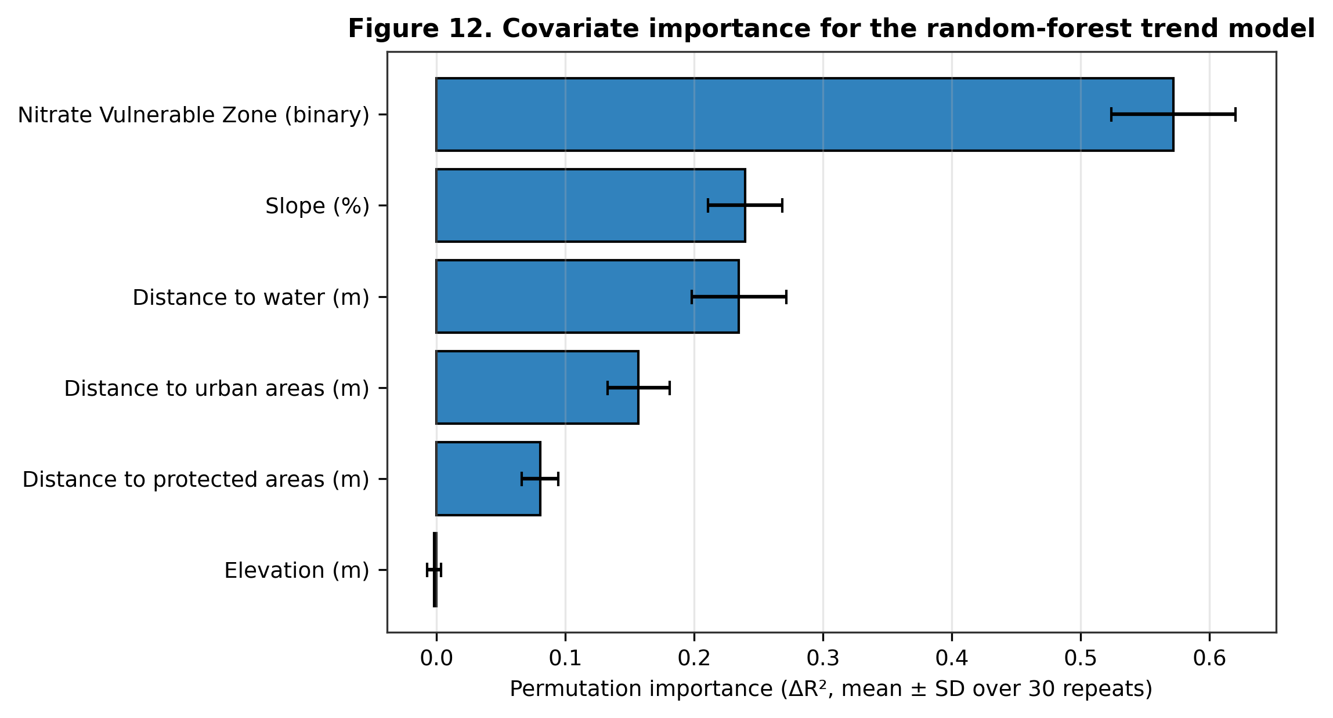
Fig. 12. Permutation importance (ΔR², mean ± SD over 30 repeats) of each covariate for the random-forest trend model.

6. Discussion
The central empirical finding is that a random-forest trend combined with kriging of its residuals (RK-RF) outperformed both a classical linear-trend RK and two deep-learning surrogates for reconstructing a continuous slurry-suitability surface from a modestly sized (n = 423 training) pseudo-observation network. This is broadly consistent with the wider regression-kriging literature, where non-linear trend models have repeatedly been shown to reduce residual variance — and hence the burden placed on the kriging step — relative to ordinary least squares (Hengl et al., 2007). It is also consistent with the general expectation that deep-learning models, which are typically data-hungry, are not automatically advantaged over tree-based ensembles or hybrid geostatistical methods at sample sizes in the low hundreds, even though they are routinely competitive or superior at the much larger sample sizes typical of remote-sensing classification tasks (LeCun et al., 2015). The patch-based CNN’s failure to outperform the point-covariate MLP is a further, more specific observation: at the 25 m/9-pixel scale used here, the local neighbourhood evidently does not carry materially more information about suitability than the pre-computed distance covariates already provide, though this may not generalise to covariate sets lacking explicit distance transforms, or to studies with denser training data able to support deeper architectures.
The two structurally different uncertainty measures produced by this study — ordinary-kriging prediction variance for RK-RF, and inter-model standard deviation across the three best models — agree on where predictions are least reliable (the candidate zone’s edges and its smallest, most isolated eastern parcels), which is a useful form of triangulation for a regulatory application where false confidence in a suitability map carries an environmental cost. We would recommend that any operational deployment of this workflow treat both uncertainty layers as joint outputs, rather than relying on either alone, and that fields flagged as high-uncertainty by both measures be prioritised for field verification before slurry application decisions are made.
This study necessarily inherits several limitations from its design. First, and most importantly, no independently verified field observations of slurry suitability exist for Tudela; the pseudo-observation network was therefore constructed by sampling, with added noise, from a deterministic continuous index built from the same covariates the predictive models subsequently use — a synthetic benchmarking design common in methodological studies (Hengl et al., 2004) but one that cannot fully substitute for genuine field validation (e.g. soil infiltration tests, nutrient-balance monitoring, or farmer-reported application outcomes). Second, the continuous index’s criterion weights (Section 4.2) were set by common convention rather than elicited from a structured weighting procedure such as the Analytic Hierarchy Process; a formal sensitivity analysis of these weights, and their comparison against stakeholder-elicited alternatives (Malczewski, 2006), is an important direction for future work. Third, the deep-learning models were trained on several hundred points; while this is a realistic sample size for many regional suitability-mapping problems, it does not test whether the CNN’s spatial receptive field would begin to outperform point-covariate models at larger monitoring-network sizes. Finally, the Nitrate Vulnerable Zone penalty (0.70) was set as an illustrative constant rather than derived from the crop- and soil-specific permitted nitrogen loads defined in Tudela’s Nitrates Directive action programme; operational use of this workflow should replace it with the locally applicable regulatory limit.

7. Conclusions
This study demonstrates that a conventional GIS-MCDA hard-constraint overlay for livestock slurry application suitability can be extended, within its own candidate zone, into a continuous suitability surface reconstructed by regression kriging and deep-learning surrogates, together with spatially explicit measures of predictive uncertainty. For the Tudela case study, a random-forest regression-kriging model provided the most accurate and best spatially behaved reconstruction (RMSE = 7.78, R² = 0.77, lowest residual Moran’s I), outperforming both a classical linear-trend kriging model and two deep-learning surrogates (a multilayer perceptron and a patch-based convolutional neural network), while Nitrate Vulnerable Zone status, slope and distance to surface water were confirmed as the dominant covariates governing suitability. The workflow — hard-constraint delineation, continuous fuzzy index construction, spatially block-cross-validated benchmarking of regression kriging against deep-learning surrogates, and joint reporting of kriging-variance and inter-model uncertainty — is fully reproducible and readily transferable to other municipalities and other diffuse-pollution siting problems where a Boolean or ordinal GIS-MCDA overlay is the current state of practice.

References
Basnet, B.B., Apan, A.A., Raine, S.R., 2001. Selecting suitable sites for animal waste application using a raster GIS. Environmental Management 28(4), 519–531.
Breiman, L., 2001. Random forests. Machine Learning 45(1), 5–32.
Council of the European Communities, 1991. Council Directive 91/676/EEC concerning the protection of waters against pollution caused by nitrates from agricultural sources. Official Journal of the European Communities L375, 1–8.
Hengl, T., Heuvelink, G.B.M., Stein, A., 2004. A generic framework for spatial prediction of soil variables based on regression-kriging. Geoderma 120(1–2), 75–93.
Hengl, T., Heuvelink, G.B.M., Rossiter, D.G., 2007. About regression-kriging: from equations to case studies. Computers & Geosciences 33(10), 1301–1315.
Kamilaris, A., Engelbrecht, A., Pitsillides, A., Prenafeta-Boldú, F.X., 2020. Transfer of manure as fertilizer from livestock farms to crop fields: the case of Catalonia. arXiv:2006.09122.
LeCun, Y., Bengio, Y., Hinton, G., 2015. Deep learning. Nature 521, 436–444.
Malczewski, J., 2000. On the use of weighted linear combination method in GIS: common and best practice approaches. Transactions in GIS 4(1), 5–22.
Malczewski, J., 2004. GIS-based land-use suitability analysis: a critical overview. Progress in Planning 62(1), 3–65.
Malczewski, J., 2006. GIS-based multicriteria decision analysis: a survey of the literature. International Journal of Geographical Information Science 20(7), 703–726.
Moran, P.A.P., 1950. Notes on continuous stochastic phenomena. Biometrika 37(1/2), 17–23.
Odeh, I.O.A., McBratney, A.B., Chittleborough, D.J., 1995. Further results on prediction of soil properties from terrain attributes: heterotopic cokriging and regression-kriging. Geoderma 67(3–4), 215–226.
Taylor, K.E., 2001. Summarizing multiple aspects of model performance in a single diagram. Journal of Geophysical Research: Atmospheres 106(D7), 7183–7192.
Van Lanen, H.A.J., Wopereis, F.A., 1992. Computer-captured expert knowledge to evaluate possibilities for injection of slurry from animal manure in the Netherlands. Geoderma 54(1–4), 107–124.

