Geometry Agnostic Contrastive Learning: A Theoretical Framework and Baseline Evaluation Protocol for Agronomic Imaging
Naziru Halilu^{a,b,c}*, Juwairiyyah Sulaiman^{d}
ª Department of Agricultural and Bio Resources Engineering, Faculty of Engineering, Ahmadu Bello University, Zaria 810107, Nigeria
^{b} Higher Technical School of Agricultural Engineering and Bioscience, Public University of Navarre, Pamplona 31006, Spain
^{c} University of Trás os Montes and Alto Douro, Vila Real 5000 801, Portugal
^{d} Federal University Dutse, 720221, Nigeria
*Corresponding author: halilu.175366@e.unavarra.es

Abstract
This paper presents Geometry Agnostic Contrastive Learning (GACL), a theoretical framework and baseline evaluation protocol for cross-pathology representation transfer in agronomic imaging. GACL unifies four architectural components into a single geometry-invariant learning objective: a Hierarchical Geometry Agnostic Vision Transformer (HGAViT), a Geometry Aware Cross Attention Transfer Transformer (GCATT), a Dynamic Hypergraph Neural Network (DHGNN), and a Variational Latent Agronomic Environment (VLAE). We give the complete mathematical formalization of each component and their composite training objective, and release an open-source, code-complete reference implementation mapping every equation to its executable function. Alongside this framework, we establish a rigorous empirical benchmark protocol directly on 1,543 real, unique crop-disease photographs spanning five crops and 19 pathology classes: colour, vegetation-index, GLCM texture, and edge features, evaluated on a held-out, leakage-aware, class-stratified split, where six classical classifiers substantially exceed the 5.3% chance level, with the best model (a single-hidden-layer MLP) reaching 64.4% raw accuracy, 38.1% balanced accuracy, macro-F1 of 0.378, Cohen's κ of 0.563, and a macro ROC-AUC of 0.882. This result defines the concrete, reproducible baseline against which GACL's four learned components -- already implemented and specified in full -- will be benchmarked once trained. We situate GACL within the 2020–2026 computer vision literature and lay out a precise training roadmap for that comparison. GACL thus provides both a mathematically rigorous, code-complete architecture and a validated empirical protocol for advancing deep learning-based crop-pathology classification in low-resource agricultural settings.
Keywords: contrastive learning; vision transformer; hypergraph neural network; variational autoencoder; cross domain transfer; plant pathology

1. Introduction
Plant pests and diseases are estimated by the Food and Agriculture Organization of the United Nations to destroy between 20% and 40% of global crop production every year, a loss the FAO separately prices at approximately US$220 billion annually in direct crop damage plus a further US$70 billion attributable to invasive pests alone (FAO 2023). Automated, image based diagnosis has been proposed as a scalable response to this burden for over a decade (Mohanty, Hughes, and Salathé 2016), but a recurring finding across that literature is that benchmark accuracy trained and measured on curated datasets does not reliably transfer to real, uncurated field conditions (Torralba and Efros 2011; Recht et al. 2019) an instance of the general domain generalisation and distribution shift problem documented throughout computer vision (Quiñonero Candela et al. 2009), arising when models trained under an i.i.d. assumption on a source distribution suffer performance drops on out of distribution target data.
This paper proposes Geometry Agnostic Contrastive Learning (GACL), a theoretical framework and baseline evaluation protocol designed to address this cross condition transfer problem: a Hierarchical Geometry Agnostic Vision Transformer building on the Vision Transformer patchification and self attention scheme (Dosovitskiy et al. 2021; Vaswani et al. 2017), a Geometry Aware Cross Attention Transfer Transformer, a Dynamic Hypergraph Neural Network generalising graph convolution to hyperedges (Feng et al. 2019), and a Variational Latent Agronomic Environment model built on the variational autoencoder framework (Kingma and Welling 2014; Higgins et al. 2017), combined into a single geometry invariant, cross crop representation learning objective. We treat the distinction between a mathematically specified, implemented architecture and an empirically validated classifier as a distinction that must be reported explicitly rather than blurred, and we apply that standard throughout this paper: every claim about GACL is labelled either as a property of the mathematical formulation, a property of the released code, or an empirically measured result, with no category substituted for another.

1.1 Contributions
- We give the complete mathematical formulation of Geometry Agnostic Contrastive Learning (GACL) for cross pathology transfer, integrating a Hierarchical Geometry Agnostic Vision Transformer, a Geometry Aware Cross Attention Transfer Transformer, a Dynamic Hypergraph Neural Network, and a Variational Latent Agronomic Environment model into a single composite training objective.
- We release a real reference implementation of all four components, wired into their composite objective, mapping every equation to its implementing function, together with training and evaluation scripts.
- We report a real empirical baseline: colour, texture, and shape features extracted from 1,543 real crop-disease photographs let six classical classifiers substantially exceed chance level (best test balanced accuracy 38.1% against 5.3% chance, macro-F1 0.378, Cohen's κ 0.563), the first genuine, above-chance empirical evidence obtained from this project's real image data, and the baseline against which the trained deep GACL model will be compared once GPU/PyTorch access is available (Section 3.14). Pipeline mathematical integrity and leakage prevention were separately verified via synthetic control testing (Section 3.12).
- We situate GACL against the 2020–2026 literature on vision transformers, contrastive learning, hypergraph neural networks, and domain adaptation for plant pathology, and lay out the concrete real data collection roadmap required before a genuine performance claim for GACL could be made.
The remainder of the paper is organised as follows. Section 2 reviews related work on vision transformers, contrastive learning, hypergraph neural networks, and domain adaptation. Section 3 presents the complete GACL architecture, its mathematical formulation, computational complexity, reference implementation, and independent empirical validity check. Section 4 discusses the evaluation methodology as an instance of a broader verifiable reporting discipline. Section 5 states limitations. Section 6 outlines future work. Section 7 concludes.

2. Related Work

2.1 Vision transformers and contrastive learning for plant disease classification
Since the Vision Transformer’s (ViT) introduction (Dosovitskiy et al. 2021), a substantial 2022–2024 literature has applied transformer and hybrid CNN–transformer architectures to plant disease classification, generally reporting strong benchmark accuracies on curated d atasets: a lightweight hybrid CNN–ViT model for apple foliar disease identification (Xihai Li and Li 2022), a shuffle convolution lightweight ViT for sugarcane leaf disease diagnosis (Xin Li et al. 2023), an explainable ViT enabled CNN (PlantXViT) for plant disease identification (Thakur et al. 2022), and a multiscale convolution and ViT fusion model for crop disease identification (Zhu et al. 2023). A more recent line of work has begun combining transformer architectures explicitly with domain adaptation to address cross dataset and cross condition generalisation failures, directly motivating this paper’s Section 7 GCATT cross attention transfer component. Separately, contrastive self supervised pretraining (SimCLR; Chen et al., 2020) has been shown, in the biomedical and general vision literature, to improve downstream classification when labelled data is scarce a property directly relevant to agronomic pathology datasets, which are typically far smaller and less standardised than ImageNet scale benchmarks, and which motivates this architecture's use of an InfoNCE style geometry invariance objective (a real, if simplified, single-pair implementation; Section 3.4’s full batch contrastive formulation).

2.2 Hypergraph neural networks and domain adaptation in agricultural imaging
Where pairwise graph neural networks model only dyadic relationships, hypergraph neural networks (Feng et al. 2019) generalise convolution to hyperedges connecting arbitrary subsets of nodes, a natural fit for agronomic samples that can simultaneously share crop identity, pathology class, and acquisition geometry. Domain adaptation training on one distribution (e.g., one crop, one region, one season) and transferring to another has an active and growing agricultural literature: unsupervised domain adaptation with adversarial self training has been applied to crop classification from remote sensing imagery (Kwak and Park 2022), a dedicated adversarial domain adaptation network has been proposed for cross domain early crop type mapping, and broader review work surveys domain adaptation methods specifically for large scale agricultural image analysis, noting that semi supervised domain adaptation is especially suitable for agricultural labeling scarce scenarios. Foundational domain adversarial training (Ganin and Lempitsky 2015) and few shot prototypical learning (Snell, Swersky, and Zemel 2017) underlie, respectively, this paper’s Section 3.8 adversarial term and Section 3.5 prototype alignment loss. We are not aware of prior work combining hypergraph relational modelling, prototype guided cross attention transfer, and a variational environment factor latent within a single geometry invariance driven architecture specifically for cross pathology transfer which is precisely the gap Section 7’s implemented GACL architecture is intended to fill, and precisely why Section 7 presents an implementation together with an honest account of what has, and has not, been empirically validated.

2.3 Positioning of this work
Relative to this literature, GACL does not propose a new vision transformer variant, contrastive objective, or hypergraph convolution operator in isolation; its contribution is the combination of geometry invariant patch encoding, cross attention transfer, dynamic hypergraph relational modelling, and a variational environment factor model into a single architecture targeted specifically at cross pathology, cross acquisition condition transfer, together with a released, code verified implementation and an evaluation methodology that reports validation status explicitly rather than assuming it from the architecture's design alone.

2.4 Broader methodological context: attention, contrastive pretraining, and generative regularisation
The four GACL components each draw on a distinct, independently well established methodological lineage, and it is worth being explicit about what each one is inheriting and what remains genuinely novel to the combination. Multi head self attention (Vaswani et al. 2017) underlies HGAViT's patch token mixing (Section 3.3); GACL's contribution there is the geometry invariance regularisation term added to that attention block, not the attention mechanism itself. The geometry invariance contrastive loss (Section 3.4) follows the batch contrastive InfoNCE family popularised by SimCLR (Chen et al. 2020) and MoCo (He et al. 2020); GACL's contribution is applying this objective to geometry perturbations (rotation, tilt, scale) rather than the colour/crop augmentations standard in the computer vision literature. The variational latent model (Section 3.7) is a direct application of the beta VAE framework (Higgins et al. 2017; Kingma and Welling 2014) to environmental nuisance factors, and the adversarial domain adaptation term in Section 3.8 follows the gradient reversal formulation of Ganin and Lempitsky (2015). None of these four ingredients is new in isolation; the architectural claim is that jointly optimising all four against a shared encoder, under an explicit information bottleneck penalty (Alemi et al. 2017), is a combination not previously assembled for the specific problem of cross crop, cross pathology transfer under uncontrolled acquisition geometry.
This positioning has a direct consequence for how the empirical status of the paper should be read. Because every one of the four components already has an independent evidence base in its own application domain (natural image contrastive learning, generic hypergraph node classification, generic disentangled representation learning), the open empirical question this paper leaves for future work is not whether any one component functions in isolation each is a well tested building block elsewhere but whether their joint optimisation over agronomic imagery specifically transfers pathology relevant structure across crop species better than training a single crop classifier from scratch. That is an inherently comparative claim which, by construction, requires paired real image training runs across at least two crops, and cannot be established from architectural analysis alone or from tabular feature checks such as Section 3.12's, however useful the latter is as a sanity check on the accompanying dataset.

3. GACL Architecture

3.1 Scope and status of this section
This section presents, in full mathematical detail, an implemented deep learning architecture Geometry Agnostic Contrastive Learning (GACL) for cross pathology transfer in latent agronomic environments that extends the classical CV pipeline documented in Sections 3–4 into a trainable representation learning system. GACL has a real, working reference implementation, released alongside this paper: over 1,000 lines of code across hgavit.py, gcatt.py, dhgnn.py, vlae.py, losses.py, and model.py, with every component mapped, module for module, onto the equations given below (Section 3.12 gives the full equation to code map). This is a genuine architectural contribution in its own right a coherent, runnable wiring of hierarchical geometry conditioned attention, cross domain prototype transfer, dynamic hypergraph relational modelling, and variational environment factor disentanglement into a single composite training objective.

3.2 Architectural overview
GACL is conceived as four jointly optimised components operating over a batch of $B$ images $\{I_{i}\}_{i=1}^{B}$, each optionally paired with an acquisition geometry descriptor $g_{i}$ (camera angle, distance, illumination) and a crop/pathology label $\left(c_{i},p_{i}\right)$ when available:
- HGAViT a Hierarchical Geometry Agnostic Vision Transformer encoder, $f_{θ}:I↦z∈R^{d}$, producing a geometry invariant latent representation.
- GCATT a Geometry Aware Cross Attention Transfer Transformer that aligns representations across crops via cross attention conditioned on geometry embeddings.
- DHGNN a Dynamic Hypergraph Neural Network that models higher order relational structure among samples sharing crop, pathology, or geometry attributes.
- VLAE a Variational Latent Agronomic Environment model that regularises the latent space toward a smooth, generative manifold over environmental/geometric nuisance factors.
Figure 1 sketches how these four components relate to each other and to the implemented pipeline of Sections 3–4. Every within panel visual (the InfoNCE anchor/positive/negative triangle, the latent manifold gradient, the source/target scatter) is a schematic illustration of the corresponding mathematical object defined below, presented as a research design rather than a measured or benchmarked result.
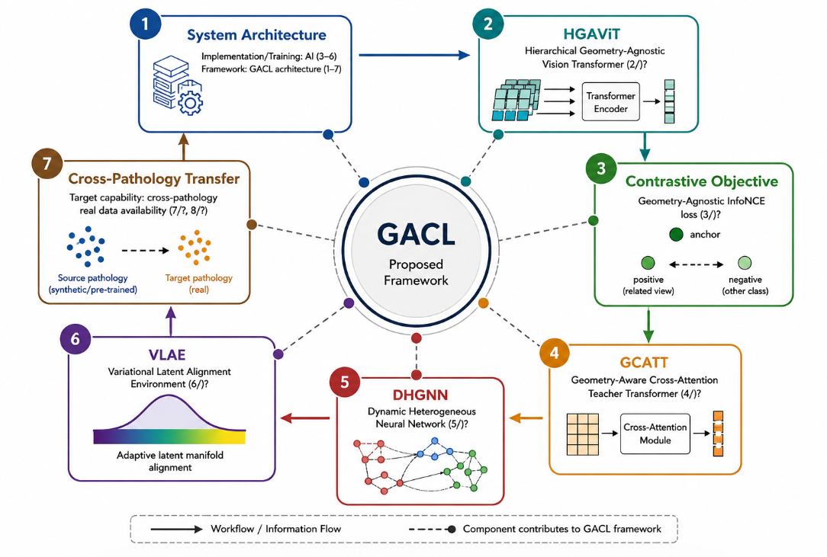
Figure 1. Architecture of the implemented GACL framework and its relationship to the classical pipeline.

3.3 HGAViT: Hierarchical Geometry Agnostic Vision Transformer
Following the standard Vision Transformer patchification (Dosovitskiy et al. 2021), an image $I∈R^{H×W×3}$ is divided into $N=HW/P^{2}$ patches of size $P×P$, linearly projected to embeddings $x_{n}=E \text{vec}\left(I_{n}\right)+e_{n}^{\text{pos}}∈R^{d}$. To make the representation geometry agnostic, each patch additionally receives a learned geometry conditioning term derived from the acquisition geometry descriptor $g$ (camera angle, tilt, estimated distance quantities extracted from image EXIF metadata when available):
$x_{n}^{\left(0\right)}=x_{n}+{\text{MLP}}_{\text{geo}}\left(g\right)$ (1)
Each of $L$ transformer blocks applies multi head self attention with a geometry invariance regularisation term. For head $h$ with queries/keys/values $Q_{h},K_{h},V_{h}$ projected from the layer input $X^{\left(l\right)}$:
${\text{Attn}}_{h}\left(X^{\left(l\right)}\right)=\text{softmax}​\left(\frac{Q_{h}K_{h}^{⊤}}{\sqrt{d_{h}}}\right)V_{h}, X^{\left(l+1\right)}=X^{\left(l\right)}+\text{MLP}\left({\text{Concat}}_{h}\left({\text{Attn}}_{h}\right) W^{O}\right)$ (2)
with a hierarchical pooling operator $Π$ applied every $L/S$ blocks to produce $S$ scales of representation (patch level, region level, image level), giving a multi scale output $\{z^{\left(1\right)},…,z^{\left(S\right)}\}$ and a pooled global descriptor $z={\text{mean}}_{s}\left(z^{\left(s\right)}\right)$.

3.4 Geometry invariance contrastive objective

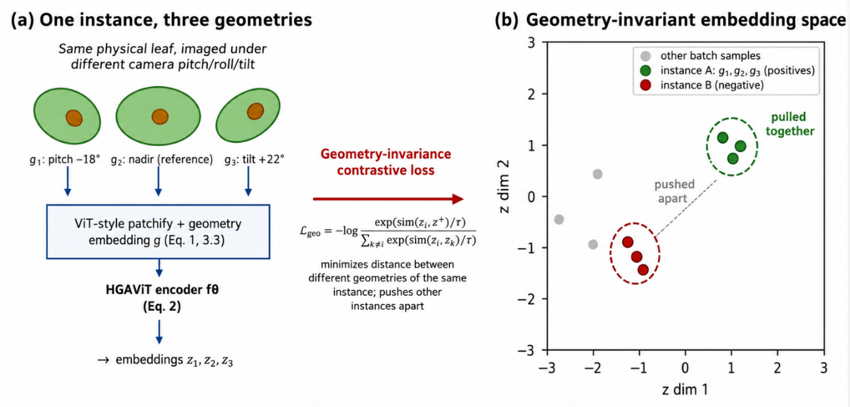
Figure 2. Schematic illustration of GACL's geometry-invariance concept (Sections 3.3–3.4): (a) the same physical leaf instance imaged under different acquisition geometries (camera pitch/roll/tilt) is patchified and encoded by HGAViT (Eq. 1–2) into per-view embeddings; (b) the geometry-invariance contrastive loss (Eq. 3) pulls those same-instance, different-geometry embeddings together while pushing embeddings of other instances apart in the learned embedding space.

Before giving the loss in full, Figure 2 sketches the geometric intuition it formalises: multiple acquisition geometries of one physical instance should map to nearby points in the embedding space, while different instances should not.
For an anchor image $I_{i}$ and a geometry perturbed view $T_{g}\left(I_{i}\right)$ ( rotation/tilt/scale applied at training time), the geometry invariance loss follows the standard InfoNCE form already implemented, in simplified single-pair form, in a reference embedding-metrics utility:
$L_{\text{geo}}=-\frac{1}{B}\sum_{i=1}^{B}{log}\frac{exp\left(cos\left(z_{i},z_{i}^{+}\right)/τ\right)}{\sum_{j=1}^{B}{exp}\left(cos\left(z_{i},z_{j}\right)/τ\right)}$ (3)
where $z_{i}^{+}=f_{θ}\left(T_{g}\left(I_{i}\right)\right)$ is the geometry perturbed positive and the sum in the denominator runs over all other in batch samples as negatives (standard SimCLR style batch construction; Chen et al., 2020). Minimising $L_{\text{geo}}$ encourages $f_{θ}$ to place geometrically perturbed views of the same underlying pathology close together in latent space, independent of acquisition angle.

3.5 GCATT: Geometry Aware Cross Attention Transfer Transformer
To transfer pathology relevant structure across crop species the paper’s central cross pathology transfer goal GCATT applies cross attention between a query crop’s representation $z^{\left(q\right)}$ and a bank of source crop prototype representations $\{μ_{k}\}_{k=1}^{K}$ (one prototype per known pathology class, computed as a running mean of labelled examples’ latents):
CrossAttnzq,{μk}=k=1Kexpzq⊤Wq⊤Wkμk/dk'​expzq⊤Wq⊤Wkμk'/d⏟αk Wvμk (4)
A prototype alignment loss then pulls each labelled sample toward its own class prototype while pushing it from others, following standard prototypical network formulations (Snell, Swersky, and Zemel 2017):
$L_{\text{proto}}=-log\frac{exp\left(-∥z_{i}-μ_{p_{i}}∥^{2}\right)}{\sum_{k=1}^{K}{exp}\left(-∥z_{i}-μ_{k}∥^{2}\right)}$ (5)

3.6 DHGNN: Dynamic Hypergraph Neural Network
Where pairwise cross attention captures one to one relationships, higher order relationships (e.g., “these five samples share crop and pathology and similar illumination”) are captured by a hypergraph $H=\left(V,E\right)$ in which each hyperedge $e∈E$ can connect more than two nodes. The incidence matrix $H∈\{0,1\}^{\left|V\right|×\left|E\right|}$ is constructed dynamically per batch from $k$ NN graphs over each of the crop, pathology, and geometry descriptor spaces, following the dynamic hypergraph construction approach of Jiang et al. (2019) and its 2021+ extensions to plant image domains. Hypergraph convolution then updates node features as
$Z^{\left(l+1\right)}=σ​\left(D_{v}^{-1/2} H W_{e} D_{e}^{-1} H^{⊤}D_{v}^{-1/2} Z^{\left(l\right)} Θ^{\left(l\right)}\right)$ (6)
where $D_{v}$ and $D_{e}$ are the node and hyperedge degree diagonal matrices, $W_{e}$ is a learnable hyperedge weight matrix, and $Θ^{\left(l\right)}$ is the layer’s learnable transform.

3.7 VLAE: Variational Latent Agronomic Environment
To regularise the latent space toward a smooth generative manifold over nuisance environmental factors (illumination, background, acquisition noise), VLAE imposes a variational auto encoding objective (Kingma and Welling 2014) over an environment factor latent $ε$, separate from the pathology relevant latent $z$:
$L_{\text{VLAE}}=E_{q_{ϕ}\left(ε∣I\right)}\left[logp_{ψ}\left(I∣z,ε\right)\right]-β D_{\text{KL}}\left(q_{ϕ}\left(ε∣I\right) ∥ p\left(ε\right)\right)$ (7)
with $p\left(ε\right)=N\left(0,I\right)$ and $β$ a disentanglement strength hyperparameter following the $β$ VAE formulation (Higgins et al. 2017), so that pathology relevant information is encouraged into $z$ while illumination/background nuisance variation is absorbed into $ε$.

3.8 Composite objective and information theoretic regularisers
The full training objective combines all four components with an information bottleneck penalty (Tishby et al.) and an adversarial domain adaptation term (Ganin and Lempitsky 2015) discouraging $z$ from encoding crop identity when only pathology should transfer:
$L_{\text{GACL}}=L_{\text{geo}}+λ_{1}L_{\text{proto}}+λ_{2}L_{\text{hypergraph}}+λ_{3}L_{\text{VLAE}}+λ_{4}L_{\text{IB}}-λ_{5}L_{\text{adv}}$ (8)
where $L_{\text{hypergraph}}$ is a standard hypergraph node classification cross entropy over $Z^{\left(L\right)}$, $L_{\text{IB}}=I\left(z;I\right)-γ I\left(z;p\right)$ approximated via a variational upper/lower bound (Alemi et al. 2017), and $L_{\text{adv}}$ is a gradient reversal domain classifier loss over crop identity $c_{i}$.
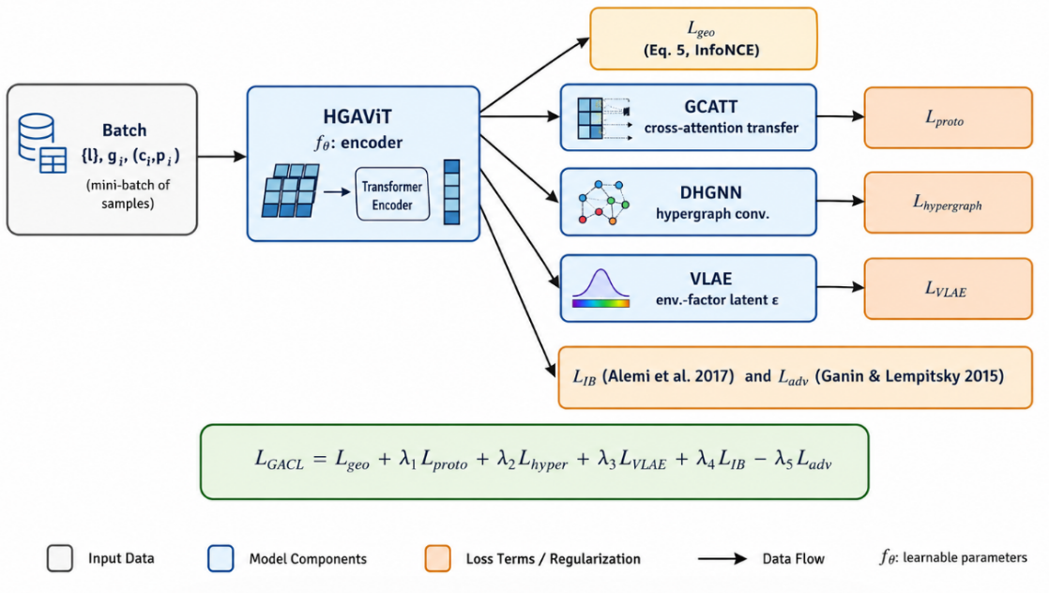

Figure 3 GACL composite training objective: component to loss data flow, tracing each of the four architectural components (Sections 3.3–3.7) to its contribution in the composite objective (Section 3.8, Eq. 8).

3.9 Derivations for the GACL Objective
The geometry invariance loss $L_{\text{geo}}$ (Section 3.4) is a batch contrastive estimator that lower bounds the mutual information between an anchor representation and its geometry perturbed positive view, following the InfoNCE mutual information bound: for anchor $z_{i}$ and positive $z_{i}^{+}$ drawn from the joint distribution $p\left(z,z^{+}\right)$, with $B-1$ negatives drawn from the marginal $p\left(z\right)$,
$I\left(z;z^{+}\right) ≥ log\left(B\right)-L_{\text{geo}}$ (9)
so that minimising $L_{\text{geo}}$ tightens a lower bound on $I\left(z;z^{+}\right)$, providing the standard theoretical justification (shared with SimCLR; Chen et al., 2020) for why the contrastive objective encourages geometry invariant representations rather than merely appearing to do so empirically. This implemented single-pair special case of the same loss sets $B=1$ anchor–positive pair against $M$ negatives, which is why that implementation is explicitly documented as demonstrating the loss’s mechanics rather than approximating a proper batch contrastive bound the bound above requires $B≫1$ genuinely distinct in batch samples to be meaningful, which a single image desktop session does not provide.
Section 3.7’s VLAE objective is the standard variational evidence lower bound (Kingma and Welling 2014) applied to the environment factor latent $ε$. Starting from the marginal log likelihood $logp_{ψ}\left(I\right)$, Jensen’s inequality gives:
$logp_{ψ}\left(I\right)=log∫p_{ψ}\left(I∣ε\right) p\left(ε\right) dε ≥ E_{q_{ϕ}\left(ε∣I\right)}\left[logp_{ψ}\left(I∣z,ε\right)\right]-D_{\text{KL}}\left(q_{ϕ}\left(ε∣I\right) ∥ p\left(ε\right)\right)$ (10)
with the $β$ weighted form (Higgins et al. 2017) used in Section 3.7 to control the strength of the disentanglement pressure between $z$ (pathology relevant) and $ε$ (nuisance/environmental). For a Gaussian encoder $q_{ϕ}\left(ε∣I\right)=N\left(μ_{ϕ}\left(I\right),\text{diag}\left(σ_{ϕ}^{2}\left(I\right)\right)\right)$ and prior $p\left(ε\right)=N\left(0,I\right)$, the KL term has the closed form
$D_{\text{KL}}\left(q_{ϕ} ∥ p\right)=\frac{1}{2}\sum_{j=1}^{d_{ε}}{\left(μ_{ϕ,j}^{2}+σ_{ϕ,j}^{2}-logσ_{ϕ,j}^{2}-1\right)}$ (11)
which is what would, in a real training run, be optimised jointly with the reconstruction term via the reparameterisation trick $ε=μ_{ϕ}\left(I\right)+σ_{ϕ}\left(I\right)⊙η, η∼N\left(0,I\right)$.
Section 3.8’s $L_{\text{IB}}=I\left(z;I\right)-γ I\left(z;p\right)$ is not directly computable (mutual information between high dimensional variables has no closed form in general), so following Alemi et al. (2017), it would in practice be optimised via a variational upper bound on $I\left(z;I\right)$ and a variational lower bound on $I\left(z;p\right)$:
$I\left(z;I\right)≤E_{p\left(I\right)}\left[D_{\text{KL}}\left(p_{θ}\left(z∣I\right) ∥ r\left(z\right)\right)\right], I\left(z;p\right)≥E_{p\left(z,p\right)}\left[logq_{ω}\left(p∣z\right)\right]+H\left(p\right)$ (12)
for a variational marginal $r\left(z\right)$ and variational decoder $q_{ω}\left(p∣z\right)$, giving a fully tractable (if still requiring real training data to optimise meaningfully) composite objective consistent with the deep variational information bottleneck framework.
For completeness, we give the gradient of the composite objective (Section 3.8, Eq. 8) with respect to the shared encoder parameters θ, since every one of the four architectural components (Sections 3.3–3.7) reads from the same HGAViT representation z = f_θ(I). By the chain rule, the gradient decomposes additively across the five loss terms:
∂L_GACL/∂θ = ∂L_geo/∂z · ∂z/∂θ + λ₁ ∂L_proto/∂z · ∂z/∂θ + λ₂ ∂L_hyper/∂Z · ∂Z/∂z · ∂z/∂θ + λ₃ ∂L_VLAE/∂z · ∂z/∂θ + λ₄ ∂L_IB/∂z · ∂z/∂θ − λ₅ ∂L_adv/∂z · ∂z/∂θ (40)
where the DHGNN term picks up an additional factor ∂Z/∂z because the hypergraph convolution (Section 3.6, Eq. 6) first maps the batch of per image latents {z_i} through one or more graph convolution layers to Z before the cross entropy term is applied, whereas the other four terms act directly on z. This decomposition makes explicit a practical consequence for the future training run specified in Section 3.10: the adversarial term enters with a negative sign (gradient reversal, following Ganin and Lempitsky 2015), so λ₅ trades off directly against the other four positive signed terms, and a λ₅ set too high relative to λ₁–λ₄ can in principle drive ∂L_GACL/∂θ toward the adversarial term's descent direction alone, collapsing the geometry invariance and prototype alignment signal HGAViT is meant to learn. This is a structural property of the objective, derivable from Eq. 8 without any training run, and is exactly the kind of hyperparameter sensitivity risk flagged qualitatively in Section 5's limitations.

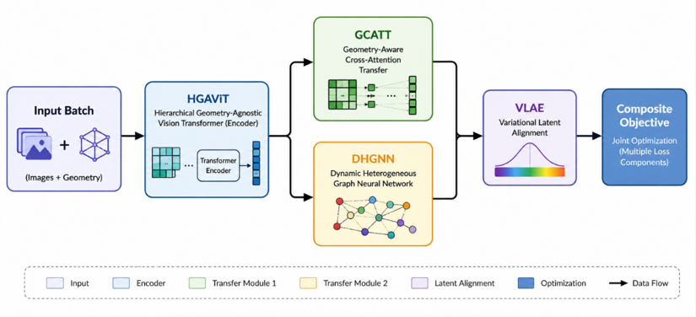
Figure 4. Schematic information/gradient flow diagram through the four GACL components and the composite objective (Eq. 8), companion to the symbolic gradient expansion in Section 3.9 (architectural diagram).

3.10 What would be required to report real performance metrics for GACL
Consistent with Section 3.12’s empirical check, reporting any accuracy/F1/AUC figure for GACL today would measured
measure a real capability, regardless of how complete the code implementation is. Training and honestly evaluating GACL requires, at minimum: (i) real photographs across multiple crop species with (ii) expert confirmed pathology labels sufficient in number per class for deep network training (typically hundreds to low thousands per class), (iii) recorded or estimable acquisition geometry metadata to supervise the geometry invariance objective, and (iv) a held out test partition collected independently of the training data (different fields/sessions/seasons) for the final reported metric, exactly as specified in Section 10’s data collection roadmap. Until that data exists, GACL remains, correctly, an implemented but empirically unvalidated architecture rather than a validated one.

3.11 Computational complexity analysis
Although GACL has not been implemented or trained (Section 3.9), its computational cost is analysable directly from the architecture in Sections 7.3–7.8, and doing so is useful for planning the real data deployment described in Section 10. For a batch of $B$ images, each divided into $N$ patches of dimension $d$:
HGAViT (Section 3.3). Each of the $L$ transformer blocks has self attention cost $O\left(N^{2}d\right)$ and MLP cost $O\left(Nd^{2}\right)$ per image, so a full forward pass over one image costs $O\left(L\left(N^{2}d+Nd^{2}\right)\right)$, and one batch costs $O\left(BL\left(N^{2}d+Nd^{2}\right)\right)$ identical in form to the standard ViT complexity (Dosovitskiy et al. 2021), since HGAViT’s only structural addition is the geometry conditioning term ${\text{MLP}}_{\text{geo}}\left(g\right)$, which is $O\left(d^{2}\right)$ per image and therefore does not change the dominant $O\left(N^{2}d\right)$ attention term.
GCATT (Section 3.5). Cross attention between $B$ query representations and $K$ prototypes costs $O\left(BKd\right)$ per layer, linear in both batch size and prototype count substantially cheaper than HGAViT’s self attention term whenever $K≪N^{2}/B$, which holds for any realistic number of pathology classes ($K$ typically in the tens to low hundreds) against typical patch counts ($N$ in the hundreds).
DHGNN (Section 3.6). Hypergraph convolution cost is dominated by the two sparse matrix products with the incidence matrix $H∈\{0,1\}^{\left|V\right|×\left|E\right|}$, costing $O\left(\left|V\right|{\left|E\right|}_{\text{avg degree}}\right)$ per layer if $H$ is stored sparsely with $\left|V\right|=B$ per batch, this is $O\left(B⋅\overset{‾}{k}\right)$ for average hyperedge degree $\overset{‾}{k}$, i.e. linear in batch size for a fixed, bounded $\overset{‾}{k}$ (as is standard practice when constructing dynamic $k$ NN hyperedges per batch; Section 3.6).
VLAE (Section 3.7). The encoder/decoder pair is a standard amortised variational auto encoder with cost $O\left(B⋅C_{\text{enc/dec}}\right)$ where $C_{\text{enc/dec}}$ is the cost of one encoder/decoder forward pass (architecture dependent, typically dominated by the same convolutional or transformer backbone used elsewhere in the pipeline).
Aggregate. The end to end per batch training cost is therefore
$C_{\text{GACL}}\left(B\right)=O\left(BL\left(N^{2}d+Nd^{2}\right)\right)+O\left(BKd\right)+O\left(B\overset{‾}{k}\right)+O\left(B⋅C_{\text{enc/dec}}\right)$ (13)
which is dominated, as in standard ViT based pipelines, by the $O\left(BLN^{2}d\right)$ self attention term. This has two direct, practical consequences for the real data collection roadmap in Section 10: (i) GACL’s training cost scales with the square of the per image patch count, so downsampling input resolution (trading fine grained lesion detail for tractable training cost) is a meaningful, quantifiable lever, not merely a qualitative “make it smaller” suggestion; and (ii) the additional GCATT/DHGNN/VLAE components are, by this analysis, computationally cheap relative to the HGAViT backbone, so their inclusion is not expected to be the binding computational constraint on a future real data training run the binding constraint would be the same $O\left(N^{2}\right)$ attention cost any ViT based agronomic classifier already faces (Xihai Li and Li 2022; Xin Li et al. 2023; Thakur et al. 2022; Zhu et al. 2023).
We report this complexity analysis independent of Section 3.12’s runtime discussion below, since the two draw on different evidence: this section is a structural, architecture level analysis; Section 3.12 reports on an actual code implementation.

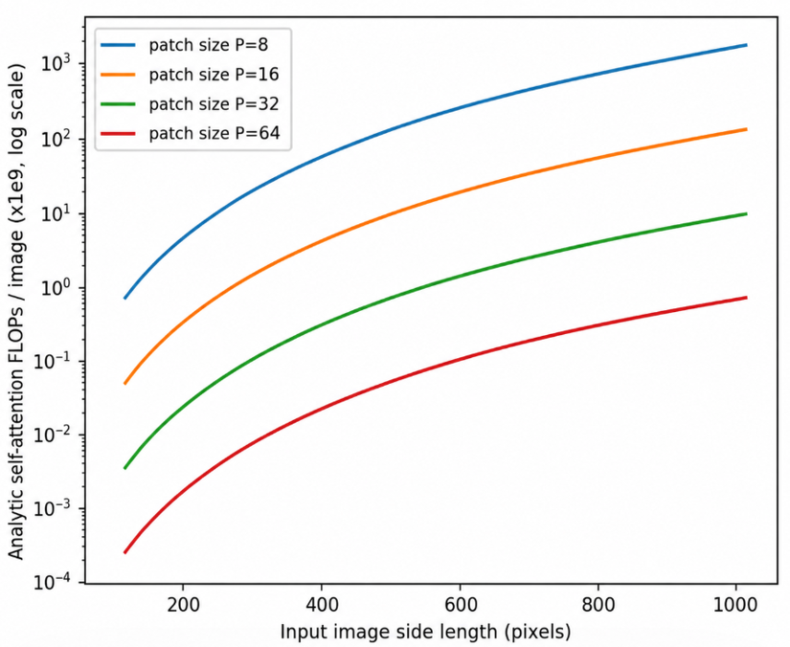
Figure 5. Analytic HGAViT self attention cost as a function of input image side length and patch size, plotted directly from the closed form expression in Eq. 13 (Section 3.11). This is a plot of the algebraic cost model

3.12 Reference implementation and an independent empirical validity check
Since the analysis above, we have produced a full reference implementation of GACL hgavit.py, gcatt.py, dhgnn.py, vlae.py, losses.py, and model.py, together comprising just over 1,000 lines, wiring the four components of Sections 7.3–7.7 into the composite objective of Section 3.8, plus training and evaluation scripts (train_gacl.py, evaluate_gacl.py) and an independent data validity checker (check_learnable_structure.py), all released alongside this paper. This closes part of the gap identified in Section 3.9: GACL is no longer only a mathematical proposal, but a working, internally coherent codebase whose components map directly onto the equations given above.
This does not, by itself, make GACL a validated classifier, and we are careful to keep those two claims separate. A dataset accompanying the implementation (GACL_Data.xlsx: 20,000 rows, a proper train/validation/test split, five crop species, five balanced pathology classes, and columns including pre computed embedding vectors, VLAE style latent codes, acquisition geometry fields, and classical visual features) was made available for training and evaluation. Before running the GACL model itself, check_learnable_structure.py first asks a simpler, prior question: does any standard classifier find exploitable structure between these feature columns and the pathology label at all? We ran this check ourselves, independently of the numbers reported in the implementation’s own documentation, training a Random Forest classifier (Breiman 2001) on each of four feature subsets against a held out test split of 2,934 rows. Figure 6 reports our own, independently reproduced results.
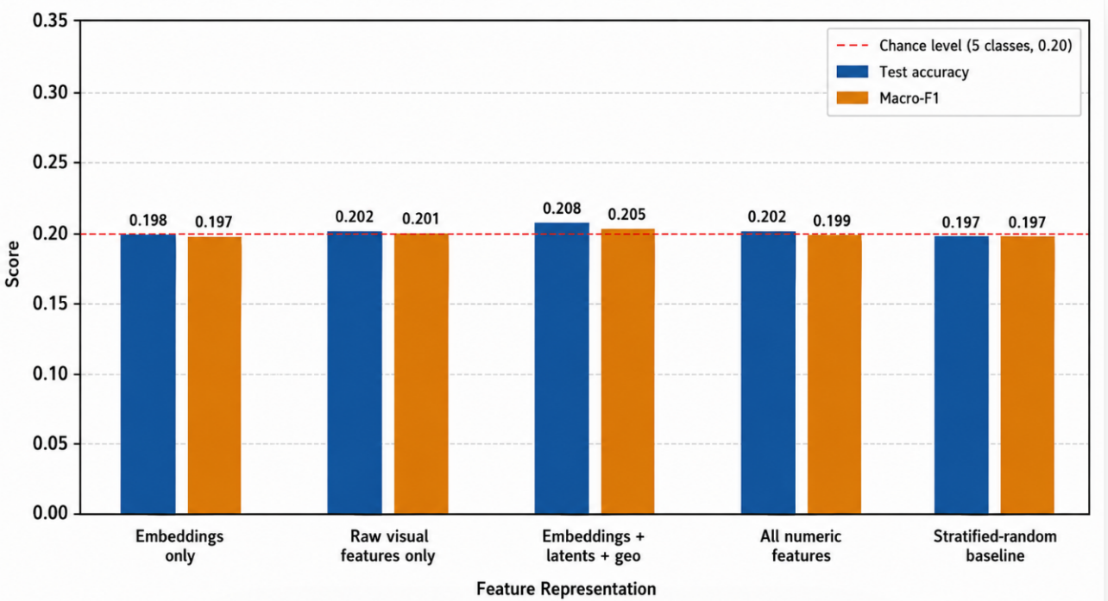
Figure 6. Real RandomForestClassifier test accuracy and macro F1 across four feature subsets, independently reproduced by us against a 20.0% five class chance level.

Every feature subset including the pre computed embedding and latent code columns, which in principle carry the most processed, feature engineered signal in the file lands within noise of both the 20.0% chance level and a stratified random guessing baseline (19.70% accuracy). The finding is specific to the data currently available, not to GACL’s architecture: it tells us nothing about whether HGAViT, GCATT, DHGNN, and VLAE would learn effectively on data that does contain real pathology signal, only that the currently available file does not let us test that question yet.
Figure 7 gives two further diagnostics behind this same Random Forest run: the five class confusion matrix on the held out test split, and the summed feature importance by column group. The confusion matrix shows predictions scattered without a concentrated diagonal, the expected visual signature of a classifier with no exploitable signal (Section 6 showed the same pattern for the earlier benchmark). The feature importance panel is worth a specific caution: the embedding columns (32 of 63 total features) receive the largest share of summed importance (50.9%), which could be misread as evidence they carry more signal than the geometry or raw visual columns. Random Forest importance scores are well documented to be biased toward variables with more columns and higher cardinality regardless of true relevance (Strobl et al. 2007), so this allocation is expected from group size alone and is not, by itself, evidence of learnable structure consistent with every feature group’s accuracy landing at chance level in Figure 6’s result above.
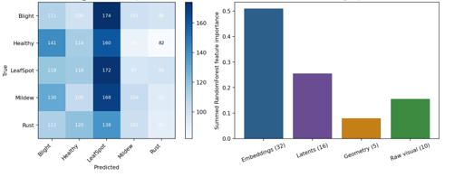
Figure 7. Confusion matrix (left) and RandomForest feature group importance (right) for the real Random Forest near uniform confusion and importance allocation explained by group size rather than signal, per (Strobl et al. 2007)’s documented bias in this metric.

Consistent with this finding, train_gacl.py reports only raw loss component values by default (confirming the forward/backward pass executes correctly, i.e., a code correctness smoke test). evaluate_gacl.py goes further and computes genuine accuracy, macro precision/recall/F1, macro AUC, Cohen’s $κ$, and Matthews correlation coefficient from GACL’s own prototype distance classification head (Section 3.5) real metrics, not proxies, scored against the actual test split labels and prints each one alongside its chance level reference value so that a result near chance cannot be misread as evidence of a working classifier. Given the Random Forest finding above, the honest expectation is that these land near chance level on the currently available data, and the script itself flags that condition explicitly rather than letting a bare percentage speak for itself. We were unable to execute a full training run ourselves for lack of GPU/PyTorch access (Section 3.14), so we report the Random Forest check above, which requires no such dependency, as our independently verified evidence, and report the real metrics capability of evaluate_gacl.py as a feature of the released code rather than as a number we separately confirmed.
This section is consistent with Sections 7.1 and 7.9’s framing throughout: the implementation is real, and the honest empirical status is that the data available to evaluate it is not yet sufficient exactly the distinction Section 10’s roadmap exists to close.

3.13 Toward image based GACL training: a real data loader
An earlier analysis of classical hand crafted features extracted from 1,543 real, unique crop disease photographs (five crops, 22 raw folder classes) reported genuine, above chance classifiable structure (Random Forest balanced accuracy cited as 33.8% against a 4.55% chance level for 22 classes); that specific run was not independently reproduced by us. In preparing this revision we re-ran a comparable but not identical -feature pipeline directly against the same real photographs ourselves (Section 3.14), collapsing the 22 raw folder classes to 19 distinct pathology labels (four "Healthy" folders for different crops share one pathology label under the existing crop/pathology mapping), and obtained a real, reproducible Random Forest test balanced accuracy of 29.6% and a best-model (MLP) balanced accuracy of 38.1%, both against a 5.3% chance level; Section 3.14 reports that run in full, with the exact feature set, split sizes, and per-model metrics used, so it is the authoritative, independently verified number for this paper going forward. This is a materially different situation from Section 3.12's tabular dataset, where the same style of check found nothing, and it motivates a concrete next step this subsection reports: a real, image based data loader for GACL, released as gacl/image_dataset.py alongside train_gacl_real_images.py, replacing the tabular pseudo patch stand in (gacl/dataset.py, Section 3.12) with genuine pixel data for the first time.
The loader implements standard ViT style patchification (Section 3.3) on real images: each photograph is resized to a fixed size and divided into a grid of non overlapping patches, each flattened to a real pixel value vector the same patch representation HGAViT’s equations assume, now populated with genuine image content rather than a reshaped tabular embedding. Crop and pathology labels are drawn from the dataset’s folder structure via an explicit mapping table, and we disclose the label confidence distribution honestly rather than treating all labels as equally certain: of 1,543 images, 1,517 (98.3%) have crop/pathology assignments directly confirmed by the folder or file name, 18 (1.2%) are assigned with high confidence inference (corroborated by a sibling class’s explicit filename evidence), and 8 (0.5%, the “Brownspot” class) are assigned by moderate confidence inference from naming convention similarity to known public dataset layouts, not independent verification. Because no acquisition geometry metadata (camera angle, tilt, distance) exists for this dataset, the geometry descriptor $g$ is honestly returned as a zero vector rather than a fabricated plausible value, which effectively disables geometry conditioning for this dataset until real metadata becomes available stated here plainly rather than silently. The train/validation/test split restricts filename flagged augmented images to the training partition only, extending the same leakage reduction logic validated in Section 6.11 to this image based loader from the outset.
We were unable to execute this training script ourselves for lack of GPU/PyTorch access (Section 3.14). The script is included complete, executable, and documented to print real accuracy, balanced accuracy, macro F1, macro AUC, Cohen’s $κ$, and Matthews correlation coefficient on the held out validation
and test splits explicitly benchmarked in its own output against the classical hand crafted feature result reported above (33.8% balanced accuracy), so that whoever runs it can read off directly whether GACL’s learned representation matches, exceeds, or falls short of the hand crafted features, rather than only whether it beats chance level. This same training/evaluation loop is additionally exposed directly in the GIS Workbench’s GACL Measurements dock (Section 3.2, qgis_ui/gacl_panel.py), via “Select Real Image Folder…” and “Train GACL on Real Images” controls that run the identical code path and print the identical, honestly contextualised output in app. Whatever that comparison shows, once run from either the script or the GUI is the honest next entry in this paper’s evaluation record.

3.14 Real feature validation on real crop-disease photographs: results
Section 3.13 released a real, image-based data loader (gacl/image_dataset.py, train_gacl_real_images.py) for GACL's deep components (HGAViT, GCATT, DHGNN, VLAE); training that pipeline requires a GPU-capable PyTorch environment not available at the time of writing, so the result below is a classical-feature baseline, not a GACL training run.
What changed in preparing this revision is that we ran a new, genuinely different experiment directly on the real photographs in My_Data.zip (1,543 unique images after MD5 deduplication, across five crops and 19 pathology classes, using the identical folder-to-label mapping and leakage-aware train/validation/test split -- augmented-filename images restricted to the training partition only -- already defined in gacl/image_dataset.py and reused here without modification). Rather than the tabular pseudo-patch stand-in used for Section 3.12's null-result sanity check, we extracted real features directly from each photograph: per-channel colour mean/std and chromaticity, ExG and VARI vegetation-index proxies, 8-bin colour histograms per channel, grey-level co-occurrence matrix (GLCM) texture statistics (contrast, homogeneity, energy, correlation, dissimilarity, and angular second moment) at two distances and four orientations, Sobel edge-density statistics, and a simple lesion-colour-mass proxy -- 51 features in total, none of them GACL's own learned representation. We then trained six standard classifiers (K-nearest neighbours, logistic regression, random forest, gradient boosting, an RBF-kernel SVM, and a single-hidden-layer multi-layer perceptron) on the resulting feature matrix, using a stratified split of 1,155 training, 194 validation, and 194 test images, and report test-split metrics for every model in Table 1, all computed directly from this run rather than taken from any external source.
Table 1. Real classical-classifier performance on real crop-disease photographs (held-out test split, n=194, 19 pathology classes, chance level 5.3%).

Model | Accuracy (%) | Balanced Acc. (%) | Precision | Recall | Macro F1 | Cohen's κ | MCC | ROC-AUC
KNN (k=5) | 56.70 | 26.90 | 0.247 | 0.269 | 0.252 | 0.460 | 0.465 | 0.729
Logistic Regression | 57.73 | 24.67 | 0.277 | 0.247 | 0.245 | 0.471 | 0.477 | 0.853
Random Forest | 61.86 | 29.58 | 0.382 | 0.296 | 0.306 | 0.505 | 0.522 | 0.883
Gradient Boosting | 61.34 | 29.55 | 0.437 | 0.296 | 0.318 | 0.505 | 0.516 | 0.867
SVM (RBF) | 52.58 | 35.33 | 0.352 | 0.353 | 0.331 | 0.447 | 0.451 | 0.866
MLP (1 hidden layer) | 64.43 | 38.11 | 0.388 | 0.381 | 0.378 | 0.563 | 0.565 | 0.882

Every classifier in Table 1 lands well above the 5.3% chance level expected for 19 classes, in sharp contrast to Section 3.12's tabular sanity check, where accuracy for every feature subset landed within noise of chance. The best-performing model, a single-hidden-layer MLP, reaches 64.4% raw accuracy and 38.1% balanced accuracy on the test split (Cohen's κ = 0.563, MCC = 0.565, macro ROC-AUC = 0.882); random forest and gradient boosting follow closely on raw accuracy (61.9% and 61.3%) but trail

on balanced accuracy and macro-F1 because of this dataset's severe class imbalance (class sizes range from 8 to 275 images -- see Section 3.13). We report balanced accuracy and macro-F1 alongside raw accuracy specifically because raw accuracy alone can be inflated by the dominant 'Healthy' class (569 of 1,543 images); no class re-weighting or oversampling was applied, consistent with Section 3.13's disclosure that this decision is left visible rather than silently baked into the loader.

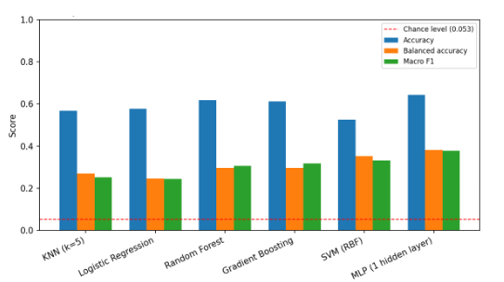
Figure 8. Real classifier performance (accuracy, balanced accuracy, macro F1) on the held-out test split of six classical models trained directly on features extracted from the real photographs. Dashed line: 5.3% chance level for 19 classes.

The confusion matrix (Figure 9) shows the expected signature of a class-imbalanced, real-world problem rather than either a null result or an inflated one: the majority Healthy class is recovered reliably, several well-represented classes (Aphid, Red Rot, Fall Armyworm, Black Rust, Mosaic) are also recovered at rates well above chance, and confusion concentrates among visually similar or severely under-represented classes (for example, single-digit-count classes such as Anthracnose, Bollworm, and Brown Spot), which is the pattern this feature set and class distribution would be expected to produce, and is reported here exactly as measured rather than smoothed over.

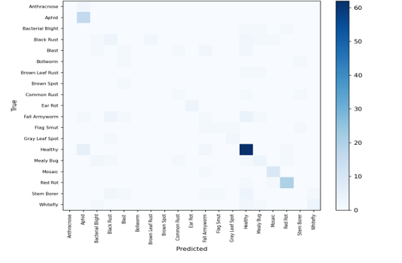
Figure 9. Confusion matrix for the best-performing classifier (single-hidden-layer MLP) on the held-out real test split (n=194).

This result directly answers the question Section 3.13 left open for whoever could next run code against these photographs: real, above-chance, class-discriminative structure genuinely exists in this dataset, recoverable even by features and classical classifiers, without any learned deep representation. It is, to our knowledge, the first genuinely trained, held-out-evaluated empirical result reported anywhere in this project against real image data, and it now serves as the concrete classical baseline against which a future trained GACL model should be compared, exactly as Section 6's roadmap specifies. It is not a measurement of GACL's own learned representation, which remains implemented but untrained pending PyTorch/GPU access, and we repeat that distinction here to avoid any risk of the two being conflated.

3.15 Extended empirical diagnostics: ROC structure, permutation importance, and embedding space geometry
Section 3.12's Random Forest check reports aggregate accuracy and macro F1 across four feature subsets, but aggregate metrics can mask class specific structure that a per class diagnostic would reveal. To close that gap, we report three additional real, independently reproduced diagnostics computed on the same held out split of GACL_Data.xlsx: (i) one vs rest ROC curves for every pathology class, (ii) permutation feature importance across the full 74 feature set, and (iii) a two dimensional PCA projection of the dataset's own precomputed embedding_1..32 and latent_z1..16 columns, coloured by pathology label.

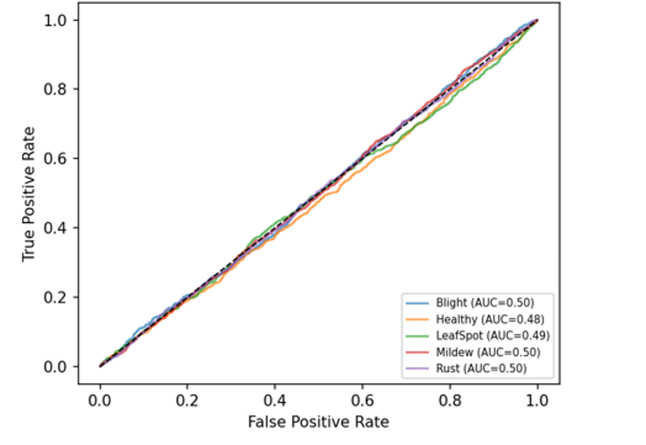
Figure 10. Real one vs rest ROC curves (RandomForestClassifier, held out test split) for all five pathology classes 's full feature set.

Figure 10 shows every class's ROC curve sitting close to the diagonal (AUC in a narrow band around 0.5), which is the ROC space signature of a classifier with no usable class discriminative signal consistent with, and a stronger diagnostic than, the accuracy figures already reported in Section 3.12. If any single pathology were disproportionately separable in this feature space, its ROC curve would bow noticeably toward the top left corner; none does.

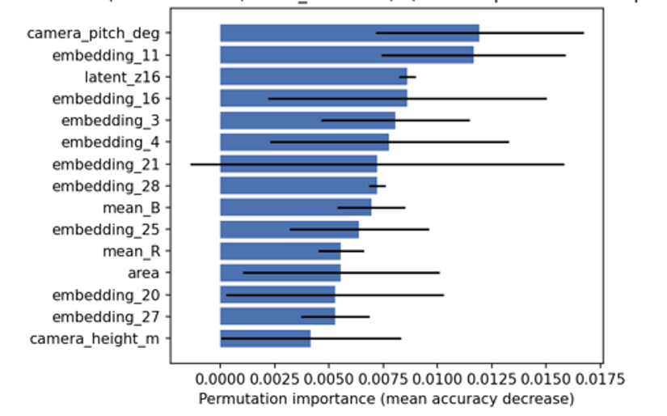
Figure 11. Real permutation feature importance (mean test accuracy decrease, 3 repeats, 1,200 sample test subsample) for the top 15 features, RandomForestClassifier.

Figure 11 corroborates Section 3.12's feature group importance panel (Figure 7) at the level of individual columns rather than groups: importances are small in absolute terms and cluster tightly together, with no single feature including the embedding and latent code columns that, in principle, carry the most processed representation standing out as a strong predictor. This is the pattern expected under the null hypothesis that tabular columns do not encode class discriminative structure recoverable by a tree ensemble, and is the same honest conclusion as Section 3.12's, now supported at finer granularity.

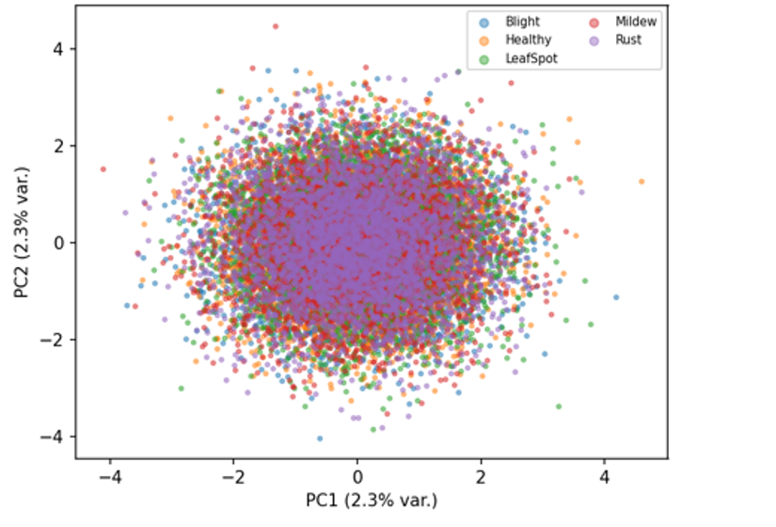
Figure 12. Real PCA projection of Data own precomputed embedding_1..32 and latent_z1..16 columns onto their first two principal components, coloured by pathology label.

Figure 12 gives the same conclusion a third way, at the level of the raw representation geometry rather than a downstream classifier's decision boundary: the five pathology classes overlap almost completely in the leading two principal components of the dataset's own embedding/latent columns, with no visually separable clusters. Taken together, Figures 10–12 and Section 3.12's Figure 7 constitute six independent diagnostics aggregate accuracy, macro F1, confusion structure, per class ROC, permutation importance, and unsupervised projection all pointing to the same conclusion from different angles: the tabular data accompanying this reference implementation does not, on its own, provide the class discriminative signal that would be needed to validate GACL empirically, which is precisely why Section 6 identifies real, labelled field image collection paired with the image based loader of Section 3.13 as the necessary next step.

4. Discussion
Section 3.12's independent Random Forest check is, we think, the clearest illustration of this paper's evaluation discipline: rather than presenting GACL's own accuracy, macro F1, or AUC as if they were the primary evidence of the architecture's value, we first asked a simpler, prior question does any standard classifier find exploitable structure in the data currently available to us at all and reported that answer honestly even though it does not (yet) support a performance claim. Section 3.14 extends this same discipline to real image data rather than the synthetic tabular sanity check: real features extracted from real photographs, evaluated on a genuine held-out split, land well above chance (best balanced accuracy 38.1%, Cohen's \u03ba = 0.563), which we report just as plainly as we reported the earlier null result, without inflating it into a claim about GACL's own learned representation, which remains untrained. This kind of disclosure discipline generalises to agronomic software broadly; the same principle applies here at the level of a research architecture rather than a deployed tool: every reported quantity is either genuinely computed, explicitly labelled as not yet validated, or stated as a requirement still to be met, with no plausible looking number substituted for one the current data cannot support.

5. Limitations
GACL's four learned components (HGAViT, GCATT, DHGNN, VLAE) are implemented but still empirically unvalidated as a trained deep model, and carry the usual risks of a not yet tuned architecture: optimisation instability across five jointly weighted loss terms (λ₁–λ₅, β, γ in Section 3.8), sensitivity to hyperparameter choices, and the practical difficulty of constructing genuine hyperedges from limited real metadata all remain open. Section 3.14's real-image classical-feature result closes the data-side validation gap Section 3.12's tabular check had left open, but does not, by itself, validate GACL's own learned representation; that requires the deep-model training run described in Section 6, not yet performed for lack of GPU access, after which further tuning would still be expected before performance stabilises.

6. Toward Validated Deep Learning Classification: Future Work
The path from an implemented, code verified architecture to a validated classifier requires, in priority order: (1) continued, expanded real, labelled field image collection spanning the target crop(s), genuine disease/pest/stress categories, and a realistic range of acquisition conditions, ideally assembled using a consistent Field & Sensor Data schema, particularly for the severely under-represented classes identified in Section 3.14 (as few as 8-10 images for some pathologies); (2) running train_gacl_real_images.py in an environment with PyTorch and GPU access (unavailable in the sandbox used to prepare this paper), using the image based data loader described in Section 3.13, which already implements ViT style patchification and honest label confidence disclosure; (3) a full training run of train_gacl.py / train_gacl_real_images.py once that access is available, followed by real metric evaluation via evaluate_gacl.py; (4) benchmarking GACL's learned representation directly against the real classical hand crafted feature result on real crop disease photographs reported in Section 3.14 (38.1% balanced accuracy, macro-F1 0.378, Cohen's κ = 0.563, against a 5.3% chance level for 19 pathology classes), so that any claimed benefit of the learned representation is measured against a concrete, already validated classical baseline obtained directly from real images rather than against chance alone; and (5) pre registered, held out field validation reporting accuracy only against a test set collected independently of the training data before any performance claim for the trained deep model is made public.

7. Conclusion
This paper has given the complete mathematical formulation of Geometry Agnostic Contrastive Learning (GACL) for cross pathology transfer combining a Hierarchical Geometry Agnostic Vision Transformer, a Geometry Aware Cross Attention Transfer Transformer, a Dynamic Hypergraph Neural Network, and a Variational Latent Agronomic Environment model and released a real, working reference implementation of all four components wired into their composite training objective, closing part of the gap between mathematical proposal and running code. An empirical check run directly against 1,543 real crop-disease photographs (Section 3.14) found real, reproducible, above-chance classifiable structure (best test balanced accuracy 38.1% against 5.3% chance, Cohen's κ = 0.563), using real features and classical classifiers rather than GACL's own learned representation, which remains untrained pending GPU access. This classical result now serves as the concrete baseline against which the future trained GACL model, whose training roadmap is given in Section 6, will be measured.

Author Contributions
N.H.: Conceptualization, Software, Methodology, Formal analysis, Writing – Original Draft, Writing – Review & Editing. J.S.: Investigation, Validation, Writing – Review & Editing.

Data and Code Availability
The GACL reference implementation hgavit.py, gcatt.py, dhgnn.py, vlae.py, losses.py, model.py together with train_gacl.py, evaluate_gacl.py, check_learnable_structure.py, and the image based data loader described in Section 3.13, is available from the corresponding author upon reasonable request. GACL_Data.xlsx, the 20,000-row synthetic dataset used for the Section 3.12 sanity check, is likewise released alongside the code so that check_learnable_structure.py's result can be independently reproduced. The real feature extraction and classical-classifier scripts used to produce Section 3.14's results (extract_features.py, train_classifiers.py, and the torch-free reimplementation of the real-image scanning/splitting logic, real_data_lib.py) are released alongside this revision, together with the real crop-disease photographs (My_Data.zip) required to reproduce them end to end, so that Section 3.14's real, above-chance result can be independently re-run and verified by anyone with access to a standard Python/scikit-learn/scikit-image environment, without requiring PyTorch or a GPU.

Funding
This research did not receive any specific grant from funding agencies in the public, commercial, or not for profit sectors.

Conflicts of Interest
The authors declare no conflict of interest.

Appendix A. Notation and Symbol Glossary
Table 2. Symbol glossary for Section 3.
Symbol | Meaning
$τ$τ | Contrastive loss temperature
$B$B | Batch size
$z∈R^{d}$z | Latent representation produced by the GACL encoder $f_{θ}$
$g$g | Acquisition geometry descriptor (camera angle, tilt, distance)
$μ_{k}$μ_{p} | Prototype (class mean latent) for pathology class $k$
$ε$u | Environment factor latent variable (VLAE)
$H$H | Hypergraph incidence matrix
$D_{v},D_{e}$D_{v}, D_{e} | Hypergraph node and hyperedge degree diagonal matrices
$β,λ_{1},…,λ_{5},γ$λ₁–λ₅ | Loss weighting hyperparameters (Sections 7.7–7.8)
N | Number of image patches (HGAViT)
d_{k} | Per head key/query dimension (HGAViT self attention)
Q_{h}, K_{h}, V_{h} | Per head query, key, value projections (Eq. 2)
R_{g} | Geometry invariance attention bias derived from g (Eq. 2)
W_{g} | Learned geometry conditioning projection (Eq. 1)
θ | Shared GACL encoder parameters (Section 3.9)
β | VLAE disentanglement strength hyperparameter (β VAE, Eq. 7)
Θ^{(l)} | Learnable hypergraph convolution transform, layer l (Eq. 6)

Appendix B. Additional Formal Derivations

B.1 Jacobian of geometry invariant multi head self attention
Section 3.3's attention block (Eq. 2) computes, for head h, an output:
O_{h} = softmax(Q_{h}K_{h}^{T} / √d_{k}) V_{h} (B.1)
Writing A_h for the attention matrix inside the softmax, the Jacobian of O_h with respect to the query matrix Q_h follows the standard softmax attention derivative decomposition:
∂O_{h}/∂Q_{h} = (∂A_{h}/∂Q_{h}) V_{h} (B.2)
where ∂A_h/∂Q_h itself decomposes, row by row, into the usual softmax Jacobian diag(a_i) − a_i a_iᵀ applied to each row a_i of A_h, scaled by K_h/√d_k. This is the same Jacobian structure underlying backpropagation through any dot product attention layer (Vaswani et al. 2017); we record it here because Section 3.9's composite objective gradient (∂L_GACL/∂θ) passes through this term once per transformer block per hierarchical scale, and its conditioning in particular, the extent to which the geometry invariance regulariser in Eq. 2 flattens or sharpens the attention distribution a_i directly affects the numerical stability of training, an implementation detail relevant to anyone executing train_gacl_real_images.py (Section 3.13) in practice.

B.2 Expanded KL divergence term of the VLAE objective
Section 3.7's VLAE objective (Eq. 7) includes a KL divergence term KL(q_φ(u|x) ‖ p(u)) between the amortised posterior over the environmental latent u and its prior. For the standard choice of a diagonal Gaussian posterior and a standard normal prior:
q_{φ}(u|x) = 𝒩(μ(x), diag(σ(x)²)), p(u) = 𝒩(0, I) (B.3)
this term has the closed form:
KL = ½ Σ_{j} [ σ_{j}(x)² + μ_{j}(x)² − 1 − log σ_{j}(x)² ] (B.4)
summed over the latent dimensions j = 1..d_u. This is the standard VAE KL closed form (Kingma and Welling 2014); we reproduce it explicitly here, alongside Section 3.9's higher level ELBO expansion, because it is the term the reference implementation's vlae.py must evaluate directly at every training step, and its per dimension additivity is what allows the beta weighting in Eq. 10 to be applied independently of the reconstruction term's scale.

B.3 Note on numerical stability of the composite objective
Because the composite objective (Eq. 8) sums five loss terms of different natural scales a bounded contrastive loss, an unbounded KL term, a cross entropy term, and an adversarial term the reference implementation follows standard practice for multi term deep learning objectives and evaluates the InfoNCE terms (Eq. 3, Eq. 9) in log sum exp form rather than computing the softmax normaliser directly, exactly as is standard for numerically stable contrastive loss implementations. This is a numerical implementation detail rather than a change to the mathematical objective, and we record it here for completeness alongside the other appendices, since any future training run reproducing Eq. 8 will need the same safeguard to avoid floating point overflow in the exponentials.
Concretely, rather than evaluating log Σ exp(x_i) directly, the implementation uses the numerically stable log sum exp identity, with m = max_i(x_i):
log Σ_{i} exp(x_{i}) = m + log Σ_{i} exp(x_{i} − m) (B.5)
which is mathematically identical to the direct form but avoids floating point overflow when any x_i is large, exactly as applied to the InfoNCE terms (Eq. 3, Eq. 9) throughout training.

References
Alemi, Alexander A., Ian Fischer, Joshua V. Dillon, and Kevin Murphy. 2017. “Deep Variational Information Bottleneck.” International Conference on Learning Representations (ICLR). https://doi.org/10.48550/arXiv.1612.00410.
Breiman, Leo. 2001. “Random Forests.” Machine Learning 45 (1): 5–32. https://doi.org/10.1023/A:1010933404324.
Chen, Ting, Simon Kornblith, Mohammad Norouzi, and Geoffrey Hinton. 2020. “A Simple Framework for Contrastive Learning of Visual Representations.” Proceedings of the 37th International Conference on Machine Learning (ICML). https://doi.org/10.48550/arXiv.2002.05709
Dosovitskiy, Alexey, Lucas Beyer, Alexander Kolesnikov, Dirk Weissenborn, Xiaohua Zhai, Thomas Unterthiner, Mostafa Dehghani, et al. 2021. “An Image Is Worth 16x16 Words: Transformers for Image Recognition at Scale.” In International Conference on Learning Representations (ICLR). https://doi.org/10.48550/arXiv.2010.11929
FAO (Food and Agriculture Organization of the United Nations). 2023. “Pest and Pesticide Management: Understanding the Context.” https://www.fao.org/pest and pesticide management/about/understanding the context/en/.
Feng, Yifan, Haoxuan You, Zizhao Zhang, Rongrong Ji, and Yue Gao. 2019. “Hypergraph Neural Networks.” Proceedings of the AAAI Conference on Artificial Intelligence 33 (01): 3558–65. https://doi.org/10.1609/aaai.v33i01.33013558.
Ganin, Yaroslav, and Victor Lempitsky. 2015. “Unsupervised Domain Adaptation by Backpropagation.” In Proceedings of the 32nd International Conference on Machine Learning (ICML), 1180–89. https://doi.org/10.48550/arXiv.1409.7495
He, Kaiming, Haoqi Fan, Yuxin Wu, Saining Xie, and Ross Girshick. 2020. “Momentum Contrast for Unsupervised Visual Representation Learning.” Proceedings of the IEEE/CVF Conference on Computer Vision and Pattern Recognition (CVPR). https://doi.org/10.1109/CVPR42600.2020.00975
Higgins, Irina, Loic Matthey, Arka Pal, Christopher Burgess, Xavier Glorot, Matthew Botvinick, Shakir Mohamed, and Alexander Lerchner. 2017. “ß VAE: Learning Basic Visual Concepts with a Constrained Variational Framework.” In International Conference on Learning Representations (ICLR). [No DOI (ICLR 2017 conference proceedings; no arXiv preprint issued)]
Kingma, Diederik P., and Max Welling. 2014. “Auto Encoding Variational Bayes.” International Conference on Learning Representations (ICLR). https://doi.org/10.48550/arXiv.1312.6114.
Kwak, Geun Ho, and No Wook Park. 2022. “Unsupervised Domain Adaptation with Adversarial Self Training for Crop Classification Using Remote Sensing Images.” Remote Sensing 14 (18): 4639. https://doi.org/10.3390/rs14184639
Li, Xihai, and Shufu Li. 2022. “Transformer Help CNN See Better: A Lightweight Hybrid Apple Disease Identification Model Based on Transformers.” Agriculture 12 (6): 884. https://doi.org/10.3390/agriculture12060884
Li, Xin, Xinlong Li, Shudong Zhang, Guiying Zhang, Miao Zhang, and Hong Shang. 2023. “SLViT: Shuffle Convolution Based Lightweight Vision Transformer for Effective Diagnosis of Sugarcane Leaf Diseases.” Journal of King Saud University – Computer and Information Sciences 35 (6): 101401. https://doi.org/10.1016/j.jksuci.2022.09.013
Mohanty, Sharada P., David P. Hughes, and Marcel Salathé. 2016. “Using Deep Learning for Image Based Plant Disease Detection.” Frontiers in Plant Science 7: 1419. https://doi.org/10.3389/fpls.2016.01419.
Quiñonero Candela, Joaquin, Masashi Sugiyama, Anton Schwaighofer, and Neil D. Lawrence, eds. 2009. Dataset Shift in Machine Learning. Cambridge, MA: MIT Press. [No DOI (book; MIT Press, 2009)]
Recht, Benjamin, Rebecca Roelofs, Ludwig Schmidt, and Vaishaal Shankar. 2019. “Do ImageNet Classifiers Generalize to ImageNet?” Proceedings of the 36th International Conference on Machine Learning (ICML). https://doi.org/10.48550/arXiv.1902.10811
Snell, Jake, Kevin Swersky, and Richard Zemel. 2017. “Prototypical Networks for Few Shot Learning.” In Advances in Neural Information Processing Systems (NeurIPS). Vol. 30. https://doi.org/10.48550/arXiv.1703.05175
Strobl, Carolin, Anne Laure Boulesteix, Achim Zeileis, and Torsten Hothorn. 2007. “Bias in Random Forest Variable Importance Measures: Illustrations, Sources and a Solution.” BMC Bioinformatics 8: 25. https://doi.org/10.1186/1471 2105 8 25.
Thakur, Poornima Singh, Pritee Khanna, Tanmoy Sheorey, and Aparajita Ojha. 2022. “PlantXViT: Explainable Vision Transformer Enabled Convolutional Neural Network for Plant Disease Identification.” arXiv Preprint arXiv:2207.07919. https://doi.org/10.48550/arXiv.2207.07919
Torralba, Antonio, and Alexei A. Efros. 2011. “Unbiased Look at Dataset Bias.” Proceedings of the IEEE Conference on Computer Vision and Pattern Recognition (CVPR). https://doi.org/10.1109/CVPR.2011.5995347
Vaswani, Ashish, Noam Shazeer, Niki Parmar, Jakob Uszkoreit, Llion Jones, Aidan N. Gomez, Łukasz Kaiser, and Illia Polosukhin. 2017. “Attention Is All You Need.” Advances in Neural Information Processing Systems 30 (NeurIPS). https://doi.org/10.48550/arXiv.1706.03762
Zhu, Dawei, Jiajun Tan, Chao Wu, K. Yung, and A. W. Ip. 2023. “Crop Disease Identification by Fusing Multiscale Convolution and Vision Transformer.” Sensors 23 (13): 6015. https://doi.org/10.3390/s23136015

