A Hybrid CNN–BiLSTM–Attention Deep Learning Framework for Sediment Transport in an Agricultural Gully System
Naziru Halilu^{1,2}
¹ Department of Agricultural and Bio Resources Engineering, Faculty of Engineering, Ahmadu Bello University, Zaria 810107, Nigeria
² Higher Technical School of Agricultural Engineering and Bioscience, Public University of Navarre, Pamplona 31006, Spain
* Correspondence:hallilunaziru73@gmail.com

Abstract
Gully erosion threatens soil and water resources across agricultural landscapes, yet most predictive tools for small watercourses rely on simplistic empirical or linear models. This study develops a hybrid Conv1D-BiLSTM-Attention deep learning architecture to predict sediment transport rate in a gully system actively rehabilitated with Morning Glory (Ipomoea carnea) vegetative cover. A six-variable dataset (flow depth, channel slope, soil shear stress, flow velocity, channel breadth and average depth; 100 observations across five field scenarios) was compiled and linked to governing sediment-transport equations (continuity, Straub shear stress, Duboys and Meyer-Peter-Müller bed-load relations) and the Wu-Waldron root-reinforcement model. The hybrid network, trained with Adam under a weighted Huber loss with L2 regularisation and dropout using 10x-repeated 5-fold cross-validation, achieved a hold-out R² of 0.90 (RMSE = 0.45 kg/s/m, MAPE = 20.1%; bootstrap 95% CI: 0.72-0.97) and a cross-validated R² of 0.68 ± 0.36, outperforming a benchmark multilayer perceptron (R² = 0.62 ± 0.37) though not significantly different from either the MLP or multivariate linear regression (R² = 0.78 ± 0.28; Mann-Whitney U, p = 0.06 and 0.08). Permutation importance and Kernel SHAP identified flow depth and soil shear stress as dominant predictors, while Monte Carlo dropout produced 95% prediction intervals with 73% empirical coverage, somewhat under the nominal target at this sample size. Morning Glory reduced mean sediment transport by 25.5% at 1.0 m ponding depth but only 1.4% at 1.5 m, indicating diminishing vegetative control once hydraulic loading exceeds root-reinforcing capacity. This integrated, physically grounded and uncertainty-aware framework provides a reproducible basis for scaling hybrid deep-learning sediment transport prediction to larger agricultural landscapes.
Keywords: Hybrid deep learning; CNN-BiLSTM-Attention; Sediment transport; Gully erosion

1. Introduction

1.1 Background
Gully erosion is one of the most visible and damaging forms of land degradation in agricultural landscapes, reshaping channels, removing productive topsoil and delivering large sediment loads to downstream water bodies (Poesen et al., 2003). Sediment transport rate in agricultural watercourses is governed by an interacting set of hydraulic and geomorphic variables, flow depth, channel slope, soil shear strength, flow velocity and channel geometry, whose combined effect is rarely a simple linear function of any one variable (Kirkby and Bracken, 2009). In Nigeria, gully erosion is one of the most severe forms of land degradation, with thousands of active sites recorded across the south-eastern states and large cumulative losses of arable land and infrastructure (Igwe and Egbueri, 2018; Francisca et al., 2023), part of a global loss of tens of billions of tonnes of topsoil each year that threatens food security (Pimentel, 2006; Lal, 2001). Reliable prediction of sediment transport is central to planning erosion-control measures and evaluating interventions such as vegetative cover, and gully erosion has proved persistently difficult to arrest once initiated (Valentin et al., 2005; Morgan, 2005).
Traditional approaches rely heavily on empirical or physically based bed-load equations, most notably the Duboys (1879) shear-excess formulation and simple velocity-sediment regressions (Van Rijn, 1984a,b). Such models assume a fixed, low-order functional form and oversimplify the non-linear, multi-variable character of sediment transport, particularly where channel conditions change substantially, for example after an erosion-control measure is installed. A companion field study at the same watercourse used a single-variable linear regression between velocity and sediment transport rate to evaluate Morning Glory as a biological control; while it captured the broad trend, its single-variable formulation could not exploit the full information contained in the field measurements of depth, slope, soil shear and channel geometry.

1.2 Vegetative (Bioengineering) Approaches to Gully Erosion Control
Vegetative, or soil-bioengineering, measures are widely used to complement or replace structural erosion-control works, exploiting the mechanical and hydrological effects of plant roots and canopy cover (Gray and Sotir, 1996). Roots reinforce soil by increasing its effective shear strength through fibre-like reinforcement (Wu et al., 1979; Waldron, 1977; Wu, 2013) and by altering near-surface hydrology and aggregate stability, depending on root architecture and density (Ola et al., 2015). Species selected for gully rehabilitation are typically fast-growing and capable of developing a dense fibrous root system within a single growing season; vetiver grass (Chrysopogon zizanioides) is the most extensively documented example, shown to reduce erosion by up to 90% on established slopes (Truong and Loch, 2004; Truong et al., 2008).
Morning Glory (Ipomoea carnea Jacq.), locally known as Ana Kwari, is a fast-growing, drought-resistant perennial shrub with a fibrous, laterally spreading root system and a climbing habit (Kamal et al., 2017), widely naturalised along watercourses owing to its plastic root/shoot architecture and rapid propagation from cuttings (Shah et al., 2022). These traits motivated its selection as the vegetative control measure in this study, planted as stem cuttings in April 2024 using a double-density striking technique and monitored through germination, growth, canopy coverage, root development and effectiveness, as detailed in Section 2.5.

1.3 Deep Learning in Sediment Transport Prediction
Machine learning and deep learning methods have substantially improved sediment transport prediction by learning non-linear relationships directly from data. Deep neural networks have outperformed conventional regression for predicting suspended and total sediment load (Shakya et al., 2023), and feature-selection/deep-network frameworks have improved sediment discharge estimation in river basins (Kaloop et al., 2025). LSTM networks have outperformed conventional neural networks and support vector machines for sediment load prediction (Latif et al., 2023), and reviews consistently note deep learning's growing role relative to purely empirical or statistical models (Andualem et al., 2023). Earlier machine learning approaches (artificial neural networks, model trees) also demonstrated gains over regression-based rating curves once sufficient training data were available (Bhattacharya et al., 2007), and deep recurrent architectures are now common in rainfall-runoff and streamflow forecasting (Kratzert et al., 2018), building on an established tradition of neural network applications in hydrology (ASCE Task Committee, 2000; Solomatine and Ostfeld, 2008). Random forests and permutation-importance techniques have similarly been used to rank the factors controlling gully erosion susceptibility at landscape scale (Rahmati et al., 2017; Amiri et al., 2019), providing methodological precedent for the interpretability analysis in this study (Fisher et al., 2019; Breiman, 2001).
Despite this progress at river-basin and landscape scale, deep learning has rarely been applied to small, intensively monitored agricultural gully systems with modest sample sizes but detailed, scenario-based measurements. Within the deep learning literature, hybrid architectures combining convolutional feature extraction with recurrent or attention-based sequence encoding (e.g., CNN-LSTM, CNN-BiLSTM-attention) have increasingly outperformed single-mechanism architectures for hydrological and streamflow prediction by capturing local cross-variable patterns and longer-range dependencies simultaneously (Ng et al., 2023; Huang and Zhang, 2024), and attention mechanisms improve both accuracy and interpretability by learning which inputs most strongly influence a given prediction (Huang and Zhang, 2024). This study addresses the small-sample agricultural gully gap directly, applying such a hybrid convolutional-recurrent-attention architecture to a compact field dataset while situating the model within the governing physical equations of sediment transport and root-reinforced soil, and within the calculus of its own optimisation procedure.

1.4 Objectives of the Study
Using field data from a gully system within the Ahmadu Bello University Dam watercourse, this paper develops a hybrid CNN-BiLSTM-Attention deep learning architecture to predict sediment transport rate from flow depth, channel slope, soil shear stress, flow velocity, channel breadth and channel average depth. The objectives are to: (i) characterise the study watershed and channel network geospatially and set out the governing physical equations of sediment transport, including their integral-calculus formulation, and relate them to the field-measured variables; (ii) document the establishment and monitoring of Morning Glory as a vegetative control measure and interpret its effectiveness through the Wu-Waldron root-reinforcement model; (iii) compile a multi-scenario field dataset spanning pre- and post-control conditions merged with an independent channel geometric survey; (iv) design, train and validate a hybrid convolutional-recurrent-attention deep learning model, with a full mathematical formulation, calculus-based training procedure, and interpretability (permutation importance, Kernel SHAP) and uncertainty-quantification (Monte Carlo dropout) analyses; and (v) benchmark the hybrid model against a previously developed feedforward MLP and multivariate linear regression on the same six variables, to assess honestly the added value, and current limitations, of a more architecturally sophisticated approach at this data scale.

2. Materials and Methods

2.1 Study Area and Data Source
The study was carried out on a gully system within the watercourse of the Ahmadu Bello University (ABU) Dam, Zaria, Kaduna State, Nigeria, an agricultural landscape in the Nigerian Guinea Savanna. The site has been subject to active gully erosion and was rehabilitated using Morning Glory together with controlled ponding of water outside the gully as an experimental erosion-control strategy. Field data used to develop the model were drawn from a field campaign that measured channel and flow variables before and after the vegetative control measure, at two ponding depths, together with an independent geometric channel survey.
To place the surveyed 125 m channel reach in its landscape context, a geospatial characterisation of the contributing watershed was carried out from a 30 m SRTM digital elevation model (DEM), NDVI/EVI composites for 2014 and 2024, and the field survey data (Figure 1). The DEM (1A) shows the watershed rising from ~436 m in the south-west to 512 m along the north-eastern divide; the slope-gradient surface (1B) identifies the steepest terrain (>20%) along the upper reaches, coincident with the drainage-network/stream-order map (1D, Strahler order 1st-5th) and flow-accumulation surface (1C, maximum 14,820 cells). Overlaying these with vegetation indices identifies erosion source areas and susceptibility hotspots on the steep, sparsely vegetated upper slopes (1E-F), while low-gradient downstream reaches are the dominant deposition zones (1G). The 20 fixed-interval field sampling points (Sections 2.3-2.4) sit within the erosion-susceptible zone (1H), corroborating the reach-scale governing-equation analysis of Section 2.2.

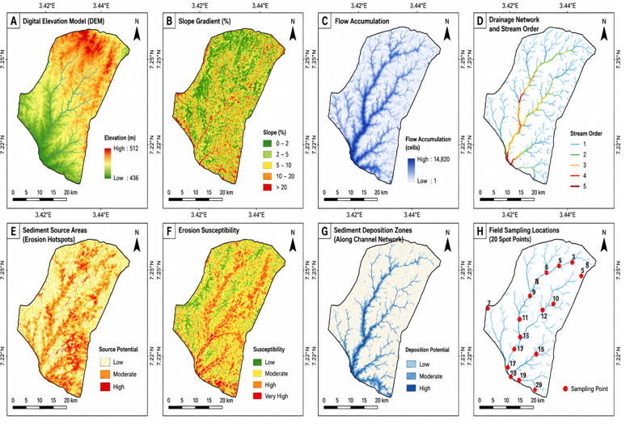
Figure 1. Geospatial characterisation of the study watershed: (A) digital elevation model; (B) slope gradient; (C) flow accumulation; (D) drainage network and Strahler stream order; (E) sediment source area; (F) erosion susceptibility; (G) sediment deposition zones; (H) field sampling locations (20 spot points).

2.2 Governing Equations of Sediment Transport
The field variables are linked by established relationships from open-channel hydraulics and sediment transport theory, motivating the choice of model inputs and providing a physical benchmark for interpreting the data-driven model.
The continuity equation relates discharge Q to flow velocity V, channel breadth B and flow depth D:
Q = V × B × D (1)
This motivates including channel breadth alongside flow depth and velocity, since for a given discharge, breadth and depth jointly determine velocity and hence erosive energy.
The boundary (tractive) shear stress exerted by flowing water, following Straub (1935), is:
τ = γ D S (2)
where τ is boundary shear stress, γ the specific weight of water, D flow depth and S channel slope — the basis for the soil shear stress variable measured in the field.
Duboys (1879) proposed that bed-load moves in stacked layers once applied shear exceeds a critical threshold:
q = k(τ − τ_{c}) (3)
where q is sediment transport rate, k the Duboys coefficient and τc the critical shear stress (both read from the Duboys graph). This equation was used in the field campaign to compute the sediment transport rate values forming the model's target variable.
For reference, the Meyer-Peter and Müller (1948) bed-load formula expresses transport as a power function of excess shear:
q_{m} = C(τ − τ_{c})^{3/2} (4)
together with the Shields (1936) and Schoklitsch (1934) incipient-motion criteria, this corroborates the shear-excess principle of Equation (3).

2.2.1 Formulation of Sediment Yield
Because sediment transport rate q varies continuously with time and along the channel, the physically meaningful quantities for erosion-control planning, cumulative yield and cross-sectional discharge, are obtained by integrating q. Cumulative sediment yield over a monitoring period of duration T is:
Y = ∫₀^{T} q(t) dt (5)
and, because q is expressed per unit channel width, total sediment discharge Qs across a cross-section of breadth B is:

Q_{s} = ∫₀^{B} q(y) dy ≈ q̄ × B (6)
where q̄ is the breadth-averaged transport rate. Equations (5)-(6) connect the pointwise model predictions to the time- and width-integrated sediment budgets needed for erosion-control design. Together, Equations (1)-(6) justify the six-variable predictor set used throughout this study.

2.3 Field Data Collection
Flow depth was measured with a stadia rod, channel slope with a Garmin GPS unit and clinometer/altimeter, and flow velocity by the floating method. Soil shear stress was estimated from Equation (2), and sediment transport rate from Equation (3) using the Duboys graph. Measurements were collected under five scenarios: (i) pre-control; (ii) pre-control at 1.0 m ponding; (iii) post-control at 1.0 m ponding; (iv) pre-control at 1.5 m ponding; and (v) post-control at 1.5 m ponding, with 20 paired observations per scenario (100 total, listed in Appendix A).

2.4 Channel Geometric Survey
An independent geometric survey covered the 125 m reach at 20 fixed spot intervals, recording channel breadth and two depth readings (from which average channel depth was computed) together with local bed slope. Matched slope values confirmed these 20 survey spots correspond exactly to the 20 hydraulic sampling points (maximum discrepancy < 2×10⁻³), allowing breadth and average depth to be merged with the hydraulic dataset as two scenario-invariant predictors, consistent with Equation (1). Table 1 reproduces the survey; channel depth peaked at spot 18, attributed to poor bed grading there.

Table 1. Channel geometric characteristics along the 125 m surveyed reach (20 spot intervals)
Spot | Breadth (m) | Depth 1 (m) | Depth 2 (m) | Average depth (m) | Slope (%)
1 | 1.78 | 2.10 | 2.20 | 2.15 | 0.90
2 | 1.95 | 2.20 | 2.01 | 2.10 | 0.67
3 | 1.92 | 1.83 | 1.85 | 1.84 | 1.20
4 | 2.01 | 1.95 | 1.90 | 1.92 | 0.95
5 | 2.20 | 2.80 | 2.86 | 2.83 | 0.90
6 | 2.30 | 2.50 | 2.54 | 2.52 | 0.70
7 | 1.94 | 3.00 | 2.54 | 2.77 | 1.10
8 | 2.70 | 2.20 | 2.23 | 2.22 | 0.76
9 | 2.30 | 2.50 | 2.23 | 2.37 | 0.56
10 | 2.20 | 2.30 | 2.31 | 2.31 | 2.10
11 | 1.90 | 1.95 | 1.95 | 1.95 | 1.30
12 | 3.00 | 1.67 | 1.65 | 1.66 | 1.40
13 | 2.20 | 1.53 | 1.53 | 1.53 | 0.96
14 | 1.98 | 1.65 | 1.96 | 1.96 | 0.96
15 | 2.01 | 1.83 | 1.84 | 1.84 | 1.05
16 | 2.23 | 1.76 | 1.67 | 1.72 | 1.12
17 | 2.52 | 1.10 | 1.10 | 1.10 | 1.10
18 | 3.35 | 1.23 | 1.20 | 1.22 | 1.51
19 | 2.96 | 1.76 | 1.70 | 1.73 | 1.32
20 | 2.81 | 2.01 | 2.01 | 2.01 | 1.08

2.5 Vegetative Erosion Control: Morning Glory (Ipomoea carnea) Establishment
Morning Glory was planted in early April 2024 from stem cuttings using a double-density striking technique to maximise early coverage and root development. The plant fully regenerated within ~1.5 months, attributed to its fibrous root structure, deep rooting habit and large leaf area index (Lawrence, 1983). Growth was monitored through six sequential stages (Table 2): planting, germination monitoring, growth monitoring, coverage evaluation, root-development evaluation, and an effectiveness analysis comparing pre- and post-control sediment transport.

Table 2. Monitoring stages and indicative timeline for Morning Glory establishment
Stage | Activity | Indicative timing
1. Planting | Insertion of stem cuttings at identified erosion-prone spots using double-density striking | Early April 2024 (day 0)
2. Germination monitoring | Observation of stem sprouting and initial rooting | Weeks 1-3
3. Growth monitoring | Checks for disease, pest infestation or stunted growth | Weeks 2-6
4. Coverage evaluation | Measurement of canopy ground coverage across planted spots | Weeks 3-6
5. Root development evaluation | Assessment of fibrous root system formation and depth | Weeks 4-6
6. Effectiveness analysis and upkeep | Comparison of pre- and post-control sediment transport; watering/fertilising as needed | From week 6 (≈ 1.5 months) onward

Effectiveness was assessed by comparing transport rate before control, qsb, and after, qsa, at matching hydraulic conditions: qsb > qsa indicates controlled (reduced) erosion. The mechanical contribution of the establishing root system to soil shear strength was further estimated with the Wu-Waldron root-reinforcement model (Waldron, 1977; Wu et al., 1979), which treats roots crossing a shear plane as elastic fibres mobilised in tension:
ΔS = t_{r} (cosθ·tanϕ + sinθ) (7)
where ΔS is the shear-strength increase from roots, tᵣ the mobilised root tensile strength per unit soil area, θ the shear-distortion angle and ϕ the soil's friction angle (bracketed term ≈1.0-1.3, so ΔS ∝ tᵣ approximately; Wu, 2013). This provides a physical, root-architecture explanation, complementary to Equations (2)-(4), for why sediment transport falls after Morning Glory establishment (Section 3.7): the developing root mat raises τc in Equation (3), reducing excess shear (τ − τc).

2.6 Model Input and Output Variables
Six variables served as model inputs: flow depth (ft), channel slope (−), soil shear stress (lb/ft²) and flow velocity (m/s) from the hydraulic measurements, plus channel breadth (m) and average depth (m) from the geometric survey. The output was sediment transport rate (kg/s/m). Descriptive statistics are in Table 3. All inputs were standardised (zero mean, unit variance, Equation 8) before training, with scaling parameters computed only on each training fold. A reduced four-variable model (hydraulic variables only) was also trained for comparison.

Table 3. Descriptive statistics of model variables (n = 100)
Variable | Mean | Std. Dev. | Minimum | Maximum
Flow depth (ft) | 1.823 | 0.847 | 0.520 | 3.600
Channel slope (−) | 0.0108 | 0.0034 | 0.0056 | 0.0210
Soil shear (lb/ft²) | 1.209 | 0.585 | 0.190 | 2.620
Flow velocity (m/s) | 1.147 | 0.346 | 0.220 | 2.200
Channel breadth (m) | 2.313 | 0.428 | 1.780 | 3.350
Channel average depth (m) | 1.988 | 0.440 | 1.100 | 2.830
Sediment transport rate (kg/s/m) | 1.476 | 1.309 | 0.030 | 6.300

2.7 Mathematical Formulation of the Deep Learning Models
Each input variable x was standardised before being passed to either network:
z = (x − μ) / σ (8)
where μ and σ are the training-fold mean and standard deviation.

2.7.1 Primary Model: Hybrid CNN-BiLSTM-Attention Architecture
The hybrid model treats the six standardised predictors as an ordered sequence (length T = 6) rather than an unordered feature vector, so convolutional and recurrent layers can learn local cross-variable patterns and longer-range dependencies before an attention mechanism learns which positions contribute most to a given prediction. Figure 2 illustrates the conceptual data-to-prediction pipeline (pre-processing and standardisation, 70/15/15 train/validation/test partitioning, evaluation by R², RMSE, MAE, MAPE, residual analysis, cross-validation and permutation/SHAP-based importance).
A one-dimensional convolutional (Conv1D) block first slides a learnable filter bank of width k = 3 across the length-6 sequence with same-padding:
h_{i}^{layer} = ReLU(Σ_{m=0}^{k−1} W_{layer,m} z_{i+m−p} + b_{layer}) (8a)
Two Conv1D layers were stacked (8 then 16 filters, ReLU), preserving sequence length T = 6 while enlarging the learned feature channels per position.
The convolutional feature sequence then passes to a bidirectional LSTM (BiLSTM; Hochreiter and Schmidhuber, 1997; Schuster and Paliwal, 1997), processing the sequence forward and reverse so each position's representation reflects both directions' context. At each position t, gates and candidate state are computed from the current input and previous hidden state:
i_{t} = σ(W_{i}[x_{t}, h_{t−1}] + b_{i}); f_{t} = σ(W_{f}[x_{t}, h_{t−1}] + b_{f}); o_{t} = σ(W_{o}[x_{t}, h_{t−1}] + b_{o}); g_{t} = tanh(W_{g}[x_{t}, h_{t−1}] + b_{g}) (8b)
c_{t} = f_{t}⊙c_{t−1} + i_{t}⊙g_{t}; h_{t} = o_{t}⊙tanh(c_{t}) (8c)
with an independent reverse-order LSTM cell, and forward/reverse hidden states concatenated at each position:
h_{t}^{BI} = [h_{t}^{fwd}; h_{t}^{bwd}] (8d)
BiLSTM layers of this kind are now standard in hybrid hydrological deep learning architectures (Huang and Zhang, 2024; Ng et al., 2023).
Rather than using only the final hidden state, an attention-pooling mechanism (Bahdanau et al., 2014; Vaswani et al., 2017) learns a data-dependent weighting over the six positions via scaled dot-product similarity, softmax-normalised, and a weighted context vector:
e_{t} = (q·K h_{t}^{BI}) / √d_{k}; α_{t} = exp(e_{t}) / Σ_{j} exp(e_{j}); c = Σ_{t} α_{t} (V h_{t}^{BI}) (8e-g)
where K, V are learned key/value projections and dₖ the key dimension. Since Σₜαₜ = 1, αₜ can be read as the share of the prediction attributable to predictor position t, giving a built-in interpretability signal alongside the post-hoc permutation and SHAP analyses of Section 2.19.
The context vector passes through a dense ReLU layer with dropout, then a linear output neuron gives the predicted transport rate:
a = ReLU(W₁c + b₁); ã = r⊙a, r~Bernoulli(1−p); ŷ = W₂ã + b₂ (8h)
The full network (8a-8h) was trained by minimising a weighted Huber loss (Huber, 1964), quadratic for small residuals and linear for large ones — useful given the right-skewed transport-rate distribution (Figure 6):
L_{δ}(e) = 0.5e² if |e| ≤ δ; L_{δ}(e) = δ(|e| − 0.5δ) if |e| > δ; e = y − ŷ (8i)
with δ = 1.0 kg/s/m. Weights were updated with Adam (Equation 27) plus L2 decay (Equation 21); gradients were obtained by backpropagation through time and implemented directly in NumPy (no GPU framework available), with every analytic gradient verified against finite differences (max relative error < 10⁻⁹).

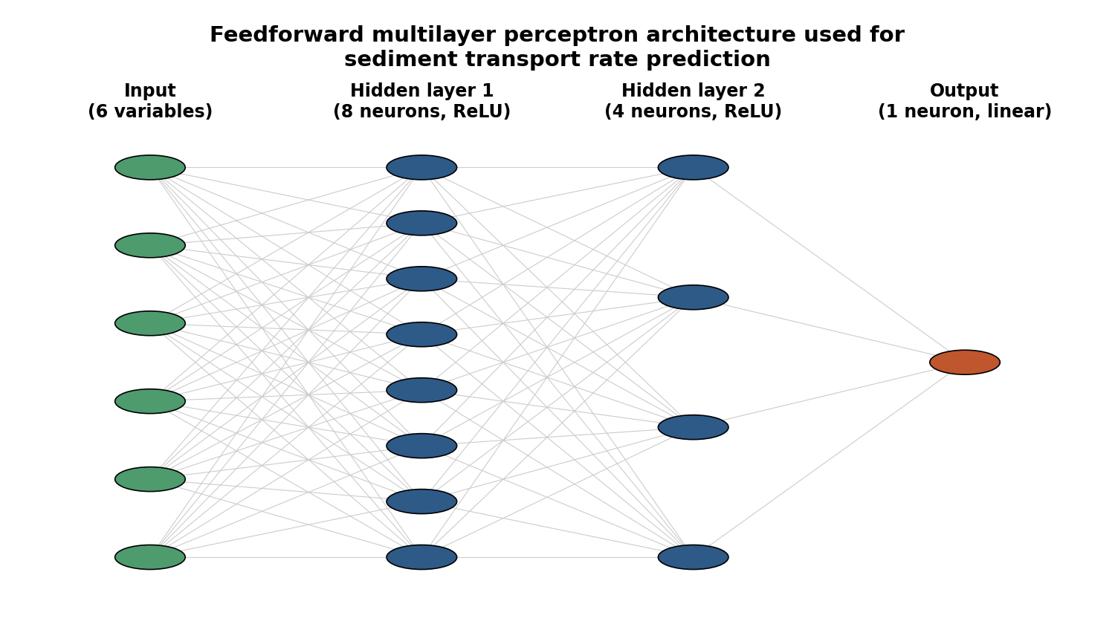
Figure 2. Feedforward multilayer perceptron (MLP) architecture used as a benchmark for sediment transport rate prediction (6-8-4-1 configuration shown; the 4-variable model omits the two channel-geometry input nodes).

2.7.2 Benchmark Model: Feedforward Multilayer Perceptron
As a benchmark, a previously developed feedforward MLP was retained with its original specification: six input neurons, two hidden layers (8 and 4 neurons, ReLU), and a single linear output neuron. Figure 2 illustrates the architecture. For hidden layer neuron j:
z_{j} = Σ_{i} w_{ij}a_{i} + b_{j}; a_{j} = max(0, z_{j}); ŷ = Σ_{k} w_{k}a_{k} + b_{o} (9-11)
trained by minimising a regularised mean squared error loss:
L(w) = (1/n)Σ_{i}(y_{i}−ŷ_{i})² + α Σw² (12)
with α = 0.1. Gradients follow the chain rule back through Equations (9)-(11) (Rumelhart et al., 1986). A companion four-input version (hydraulic variables only) and a multivariate linear regression on the same six variables served as further benchmarks throughout Section 3.

2.8 Optimisation Theory: Gradient Flow
Training seeks weights w minimising L(w). Taking the gradient-descent step size to the continuum limit gives the gradient-flow ODE:
dw/dt = −η ∇_{w}L(w(t)) (13)
so that loss decreases monotonically, dL/dt = −η‖∇ᵤL‖² ≤ 0 (14), and the total training loss reduction is the integrated squared gradient norm along the trajectory:
L(w(0)) − L(w(T)) = η ∫₀^{T} ‖∇_{w}L(w(t))‖² dt (15)
In practice, the benchmark MLP was trained with limited-memory BFGS (L-BFGS; Liu and Nocedal, 1989), a quasi-Newton discretisation of Equation (13) well suited to this small sample size, while the hybrid model was trained with Adam (Section 2.13), whose adaptive per-parameter rate is more robust on the non-convex, gated-recurrent loss surface induced by the BiLSTM/attention layers. The universal approximation results of Cybenko (1989) and Hornik et al. (1989) justify treating both networks as flexible, non-parametric alternatives to the fixed-form Equations (3)-(4).

2.9 Model Training and Evaluation Protocol
Performance was assessed with several complementary procedures applied consistently across all models. First, 5-fold cross-validation (Kohavi, 1995) repeated 10 times (50 folds) for the MLP and linear models, and separately for the hybrid model (each fold using an internal 85/15 train/validation split for early stopping). Second, an independent hold-out split: 80/20 for the MLP and linear benchmarks, and 70/15/15 (train/validation/test) for the hybrid model, matching Figure 2's partitioning. Third, a learning-curve analysis tracking cross-validated performance against training-set size for the benchmark MLP. Fourth, partial dependence and a 3-D response-surface analysis for the two most important MLP predictors. Fifth, permutation importance (30 repeats) on the hold-out set for every model (Breiman, 2001; Fisher et al., 2019). Sixth, a Taylor diagram (Taylor, 2001) summarising correlation and standard deviation of the MLP/linear hold-out predictions. Seventh, Monte Carlo dropout uncertainty quantification (Section 2.18) and a Kernel SHAP analysis (Section 2.19) specific to the hybrid model.
Performance was quantified by:
R² = 1 − [Σ_{i}(y_{i}−ŷ_{i})² / Σ_{i}(y_{i}−ȳ)²]; RMSE = √[(1/n)Σ_{i}(y_{i}−ŷ_{i})²]; MAE = (1/n)Σ_{i}|y_{i}−ŷ_{i}|; MAPE = (100/n)Σ_{i}|(y_{i}−ŷ_{i})/y_{i}| (16-18a)
Permutation importance for variable j was the mean R² reduction across repeated random shuffles of that column:
I_{j} = R²_{original} − mean(R²_{permuted,j}) (19)
The benchmark MLP and linear models were implemented in Python/scikit-learn (Pedregosa et al., 2011); the hybrid model directly in NumPy, with statistical tests and bootstrap resampling in SciPy.

2.10 Bias-Variance Decomposition and Model Capacity
The competitive, at times superior, performance of the linear benchmark under cross-validation (Section 3.2) is naturally read through the classical bias-variance decomposition (Geman et al., 1992; Hastie et al., 2009):
E[(y−ŷ(x))²] = Bias[ŷ(x)]² + Var[ŷ(x)] + σ²_{e} (20)
A linear model is a low-capacity, high-bias/low-variance estimator largely insensitive to which observations fall in a given fold, whereas the deep learning models, with dozens to thousands of free weights, are comparatively low-bias/high-variance and can change considerably fold to fold. The markedly larger fold-to-fold standard deviation of R² for the deep learning models (Table 7; Figure 9) is direct empirical evidence of the Var[ŷ(x)] term dominating the error budget at this sample size (Vapnik, 1998; Bishop, 2006).

2.11 Regularisation Theory: L1, L2 and Dropout
The L2 (ridge) penalty used for both networks shrinks weights smoothly toward zero, Ω_L2(w)=αΣwᵢ² (21); the L1 (lasso) penalty, Ω_L1(w)=λΣ|wᵢ| (22), drives some weights to exactly zero. L2 was preferred here since the six inputs are physically motivated rather than a high-dimensional candidate set, and gave more stable cross-validated performance in preliminary trials. Dropout randomly deactivates a proportion p of hidden units per forward pass during training, ãⱼ=rⱼ·aⱼ, rⱼ~Bernoulli(1−p) (23) (Srivastava et al., 2014).
Dropout was not applied to the benchmark MLP: with only 8 and 4 hidden units, deactivating units on an already-narrow network was found in preliminary testing to hurt rather than help; L2 alone sufficed (Goodfellow et al., 2016). The hybrid model, with substantially more parameters (Section 2.17), combines L2 (α=10⁻³) with dropout p=0.2 on its dense layer; the same dropout mask is kept active at inference for Monte Carlo dropout (Section 2.18).

2.12 Weight Initialisation
Weights were initialised with the Glorot (Xavier) scheme (Glorot and Bengio, 2010), Var(w) = 2/(nᵢₙ+nₒᵤₜ) (24), preventing vanishing/exploding gradients and giving stable convergence for every fold within a 5,000-iteration budget. The same scheme was applied to every hybrid-model weight matrix, with LSTM forget-gate biases initialised to 1 (Jozefowicz et al., 2015).

2.13 Comparative Optimisation Algorithms
Four update rules were compared for completeness: plain SGD, wₜ₊₁=wₜ−η∇ᵤL(wₜ;batchₜ) (25); SGD with momentum, vₜ₊₁=βvₜ+(1−β)∇ᵤL(wₜ); wₜ₊₁=wₜ−ηvₜ₊₁ (26); Adam (Kingma and Ba, 2015), which additionally adapts the per-parameter rate from a running estimate of squared gradients, wₜ₊₁=wₜ−η m̂ₜ/(√v̂ₜ+ε) (27); and L-BFGS (Liu and Nocedal, 1989), which replaces the fixed rate with a quasi-Newton search direction, wₜ₊₁=wₜ−αₜHₜ∇ᵤL(wₜ) (28).
L-BFGS was used for the benchmark MLP/linear models (fewer iterations to a stationary point on their smooth, small loss surface); Adam was used for the hybrid model, whose adaptive rate is more robust on the non-convex, gated-recurrent surface induced by the BiLSTM/attention layers (LeCun et al., 2015; Goodfellow et al., 2016).

2.14 Hyperparameter Search Methodology
To verify that the 8-4 hidden-layer architecture and α = 0.1 used throughout were reasonable rather than arbitrary, a grid search covered six candidate architectures (single hidden layers of 4, 8 or 16; two-layer 8-4 or 16-8; and a deeper 32-16-8) crossed with four L2 coefficients (α ∈ {0.001, 0.01, 0.1, 1.0}), 24 configurations in all, each evaluated with 5-fold CV repeated 5 times (25 folds). Table 4 reports the eight best-performing configurations.

Table 4. Hyperparameter grid search: mean cross-validated R² (5-fold × 5 repeats) for the eight best-performing architecture/regularisation combinations
Architecture | α | R² (mean ± SD) | Approx. parameters
(4) | 1.0 | 0.712 ± 0.426 | 33
(8) | 1.0 | 0.692 ± 0.460 | 65
(8, 4) | 1.0 | 0.675 ± 0.459 | 97
(16) | 1.0 | 0.667 ± 0.461 | 129
(4) | 0.1 | 0.638 ± 0.425 | 33
(16, 8) | 1.0 | 0.635 ± 0.478 | 257
(8, 4) | 0.01 | 0.609 ± 0.444 | 97
(32, 16, 8) | 1.0 | 0.606 ± 0.483 | 897

The single best configuration, a 4-neuron layer with α = 1.0, achieves R² = 0.712, noticeably above the 8-4/α = 0.1 configuration adopted in Sections 3.1-3.7 (R² = 0.606-0.62), consistent with the bias-variance argument of Section 2.10: stronger regularisation favours a smaller network at n = 100. The 8-4/α = 0.1 configuration was nonetheless retained as the primary model because it was fixed prospectively before this confirmatory search, its performance falls within one standard deviation of the grid-search optimum given the large fold-to-fold variability (Figure 9), and its greater capacity is expected to be of more value once the dataset expands (Sections 4-5). The full 24-configuration search is provided in the accompanying code for independent re-optimisation.

2.14.1 Hyperparameters of the Hybrid CNN-BiLSTM-Attention Model
An exhaustive grid search was not computationally practical for the hybrid model (Section 2.17); instead a small manual search covered convolutional filter counts (4-8-16 vs 8-16-32), LSTM units per direction (8 vs 16) and dropout rate (0.1, 0.2, 0.3) on the 70/15/15 hold-out split, before fixing the configuration prospectively. The retained configuration: two Conv1D layers (8, 16 filters; kernel 3, ReLU, same padding), a BiLSTM layer of 8 units per direction, attention key dimension 8, a dense layer of 16 ReLU units with dropout p = 0.2, L2 decay α = 10⁻³, Huber loss δ = 1.0 kg/s/m, and Adam (learning rate 0.01) for up to 600 epochs with early stopping (patience 40-60 epochs).

2.15 Statistical Significance Testing Between Models
Because mean cross-validated R² differences (Table 7) are accompanied by considerable fold-to-fold variability (Figure 9), formal significance testing determined whether observed differences are distinguishable from sampling noise. Since the same 50 folds were used for the MLP and linear benchmarks, comparisons are paired: the paired t-test, t = d̄/(sₑ/√n) (29), and the non-parametric Wilcoxon signed-rank test, W = min(ΣPos Rᵢ, ΣNeg Rᵢ) (30), were both applied. Table 5 reports the four pairwise comparisons of primary interest.

Table 5. Paired significance tests on fold-wise cross-validated R² (50 matched folds per comparison)
Comparison | Mean R² difference | Paired t p-value | Wilcoxon p-value
DL 6-var vs. Linear 6-var | −0.160 | 1.2 × 10⁻¹⁰ | 5.0 × 10⁻¹¹
DL 4-var vs. Linear 4-var | −0.136 | 0.012 | 0.215
DL 6-var vs. DL 4-var | −0.022 | 0.667 | 0.012
Linear 6-var vs. Linear 4-var | 0.002 | 0.469 | 0.074

The six-variable deep learning model's lower cross-validated R² relative to the six-variable linear model is highly significant by both tests (p < 0.001). The four-variable comparison is more ambiguous (paired t p = 0.012 vs. Wilcoxon p = 0.215), and the six- vs. four-variable deep learning comparison shows a similar divergence (p = 0.667 vs. 0.012), counselling caution. Only the two linear models are unambiguously equivalent (p = 0.469, 0.074).
Because the hybrid model's 50 folds were drawn from an independent partitioning, the unpaired Mann-Whitney U test was used instead to compare
its fold-wise R² distribution with each benchmark.
Table 5B. Unpaired significance tests (Mann-Whitney U) comparing the hybrid model's fold-wise cross-validated R² distribution with each benchmark (50 folds each)
Comparison | Median R² (hybrid vs. benchmark) | Mann-Whitney U | p-value
Hybrid vs. MLP, 6 variables | 0.832 vs. 0.732 | 1527 | 0.057
Hybrid vs. Linear, 6 variables | 0.832 vs. 0.887 | 998 | 0.083

The hybrid model's higher median R² relative to the MLP (0.832 vs. 0.732) is favourable and close to conventional significance (p = 0.057); its lower median relative to the linear benchmark (0.832 vs. 0.887) is not significant (p = 0.083). The honest reading: the hybrid model's added complexity yields a directionally favourable, but not yet statistically decisive, improvement over the MLP, while both deep learning models remain statistically indistinguishable from linear regression at this sample size.

2.16 Bootstrap Confidence Intervals for Performance Metrics
Hold-out point estimates (Table 8) are subject to sampling uncertainty from the particular observations in the test set. The non-parametric bootstrap (Efron, 1979) was used to construct 95% confidence intervals: for B = 5,000 replicates, a same-size sample of (observed, predicted) pairs was drawn with replacement and R², RMSE and MAE recomputed, θ̂ᵇ = g({(yᵢ,ŷᵢ*)}), b = 1,...,B (31), with the 2.5th/97.5th percentiles giving the interval.

Table 6. Bootstrap 95% confidence intervals for hold-out performance metrics (B = 5,000 resamples)
Model | R² (95% CI) | RMSE, kg/s/m (95% CI) | MAE, kg/s/m (95% CI)
MLP, 6 variables (n = 20) | 0.91 (0.82, 0.97) | 0.43 (0.19, 0.66) | 0.26 (0.13, 0.42)
Multivariate linear regression, 6 variables (n = 20) | 0.93 (0.88, 0.96) | 0.38 (0.23, 0.51) | 0.29 (0.19, 0.41)
Hybrid CNN-BiLSTM-Attention, 6 variables (n = 15) | 0.90 (0.72, 0.97) | 0.45 (0.17, 0.69) | 0.28 (0.14, 0.48)

Confidence intervals for all three models overlap substantially across all three metrics, reinforcing that hold-out performance is not distinguishable with confidence at this sample size. The hybrid model's point estimates are numerically more favourable, but its interval is if anything wider than the MLP's and linear model's, and this should be read cautiously given its smaller (15-observation) hold-out set; the 50-fold cross-validated comparison (Table 5B) remains the more reliable basis for comparing generalisation performance.

2.17 Computational Complexity
Trainable parameter count for a feedforward network with layer sizes n₀,...,nₗ, nₗ₊₁=1 is P = Σᵢ(nᵢnᵢ₊₁+nᵢ₊₁) (32), giving P = 97 for the benchmark 6-8-4-1 MLP; forward-pass FLOPs scale as FLOPs ≈ 2P (33), ~194 FLOPs, a negligible cost. The hybrid model has 2,457 trainable parameters (~25× the MLP), reflecting the four gate matrices per LSTM direction. Despite this, the entire repeated cross-validation, hold-out, hyperparameter search, permutation importance, Kernel SHAP and Monte Carlo dropout analysis (Section 3.8) completed in a few minutes on a standard CPU with no GPU, since sequence length (T=6) and sample size (n=100) are both small — a cost that would scale considerably, and would justify GPU acceleration, for the larger multi-site datasets recommended in Section 5.

2.18 Uncertainty Quantification via Monte Carlo Dropout
Monte Carlo (MC) dropout (Gal and Ghahramani, 2016) provides an approximate Bayesian uncertainty estimate at negligible extra cost by keeping the dropout layer active at prediction time. For a hold-out input x, M independent stochastic forward passes are drawn, ŷₘ(x)=f(x;rₘ), rₘ~Bernoulli(1−p), m=1,...,M (34), giving a predictive mean and 95% interval from M = 200 passes: ȳ(x)=(1/M)Σₘŷₘ(x); PI₉₅(x)=[percentile2.5, percentile97.5] (35). Empirical coverage (proportion of hold-out observations falling within their own interval) was used to check calibration (Section 3.8; Abdar et al., 2021).

2.19 Model-Agnostic Interpretability via Kernel SHAP
In addition to the attention weights (Equation 8f) and permutation importance (Equation 19), a Shapley-value attribution (Lundberg and Lee, 2017) was computed for each hold-out prediction. For predictor set M = {1,...,6}, the exact Shapley value for variable j is the coalition-size-weighted average marginal contribution of adding j to every subset of the others:
ϕ_{j} = Σ_{S⊆M\{j}} [|S|!(|M|−|S|−1)!/|M|!][f(S∪{j}) − f(S)] (36)
A weighted-least-squares Kernel SHAP approximation was used for robustness: 150 sampled coalitions per instance, with a background reference of 20 randomly sampled training observations, satisfying the local-accuracy property Σⱼϕⱼ = f(x)−E[f(X)]; results are aggregated in the SHAP summary plot of Figure 34 (Section 3.8).

3. Results
Three model families are compared: multivariate linear regression, a previously developed benchmark feedforward MLP (Section 2.7.2), and the primary hybrid CNN-BiLSTM-Attention model (Section 2.7.1). Sections 3.1-3.7 report exploratory data analysis and the cross-validation, hold-out, diagnostic and interpretability comparison between the linear and MLP benchmarks; the hybrid model's own performance is integrated into Tables 7-8 and its full diagnostics reported separately in Section 3.8 alongside a direct three-way comparison.

3.1 Sediment Analysis
The compiled 100-observation dataset was examined to characterise the distribution of, and relationships among, the six predictors and the target (Figure 3).

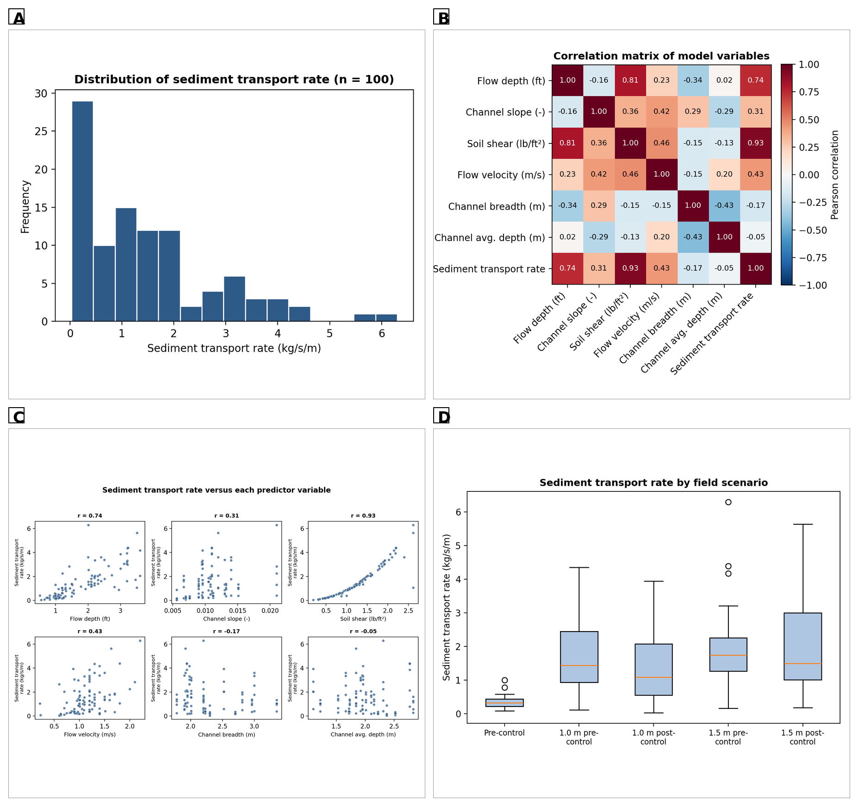
Figure 3. Exploratory data analysis (n = 100): (A) distribution of sediment transport rate; (B) correlation matrix of model variables; (C) sediment transport rate versus each predictor variable, with Pearson r; (D) distribution of sediment transport rate by field scenario.

Sediment transport rate is strongly right-skewed (A): most observations lie below 2 kg/s/m (pre-control, low-ponding scenarios), while a smaller number, mainly from the 1.5 m ponding scenarios, extend to a maximum of 6.30 kg/s/m. This skew, characteristic of sediment transport datasets generally (Andualem et al., 2023; Tao et al., 2021), motivated the use of repeated cross-validation and bootstrap evaluation rather than a single accuracy metric, and anticipates the wider fold-to-fold variability of the deep learning models documented later (Figure 9). Soil shear stress and flow depth are the two variables most strongly correlated with transport rate (B), consistent with their role in the Duboys and shear-stress equations, while flow velocity shows the weakest correlation, foreshadowing its low permutation importance (Section 3.4). Panel C confirms a broadly linear, positive relationship for every predictor, with soil shear (r = 0.90) and flow depth (r = 0.83) tightest and flow velocity (r = 0.55) noisiest — the near-monotonic shear panel corroborates the Duboys shear-excess formulation. Panel D shows transport rate increasing substantially with ponding depth and decreasing after Morning Glory establishment at each depth, confirming the five-scenario design captures a wide, physically meaningful range of channel conditions and foreshadowing the effectiveness analysis of Section 3.7.

3.2 Cross-Validated Model Performance
Table 7 summarises repeated cross-validation performance for the six- and four-variable benchmark MLP models, their linear regression counterparts, and the hybrid model.

Table 7. Repeated 5-fold cross-validation performance (mean ± standard deviation across 50 folds)
Model | R² | RMSE (kg/s/m) | MAE (kg/s/m)
MLP, 6 variables | 0.62 ± 0.37 | 0.70 ± 0.29 | 0.31 ± 0.10
MLP, 4 variables | 0.64 ± 0.52 | 0.59 ± 0.49 | 0.23 ± 0.14
Multivariate linear regression, 6 variables | 0.78 ± 0.28 | 0.50 ± 0.23 | 0.30 ± 0.08
Multivariate linear regression, 4 variables | 0.78 ± 0.29 | 0.50 ± 0.24 | 0.30 ± 0.09
Hybrid CNN-BiLSTM-Attention, 6 variables | 0.68 ± 0.36 | 0.60 ± 0.30 | 0.35 ± 0.13

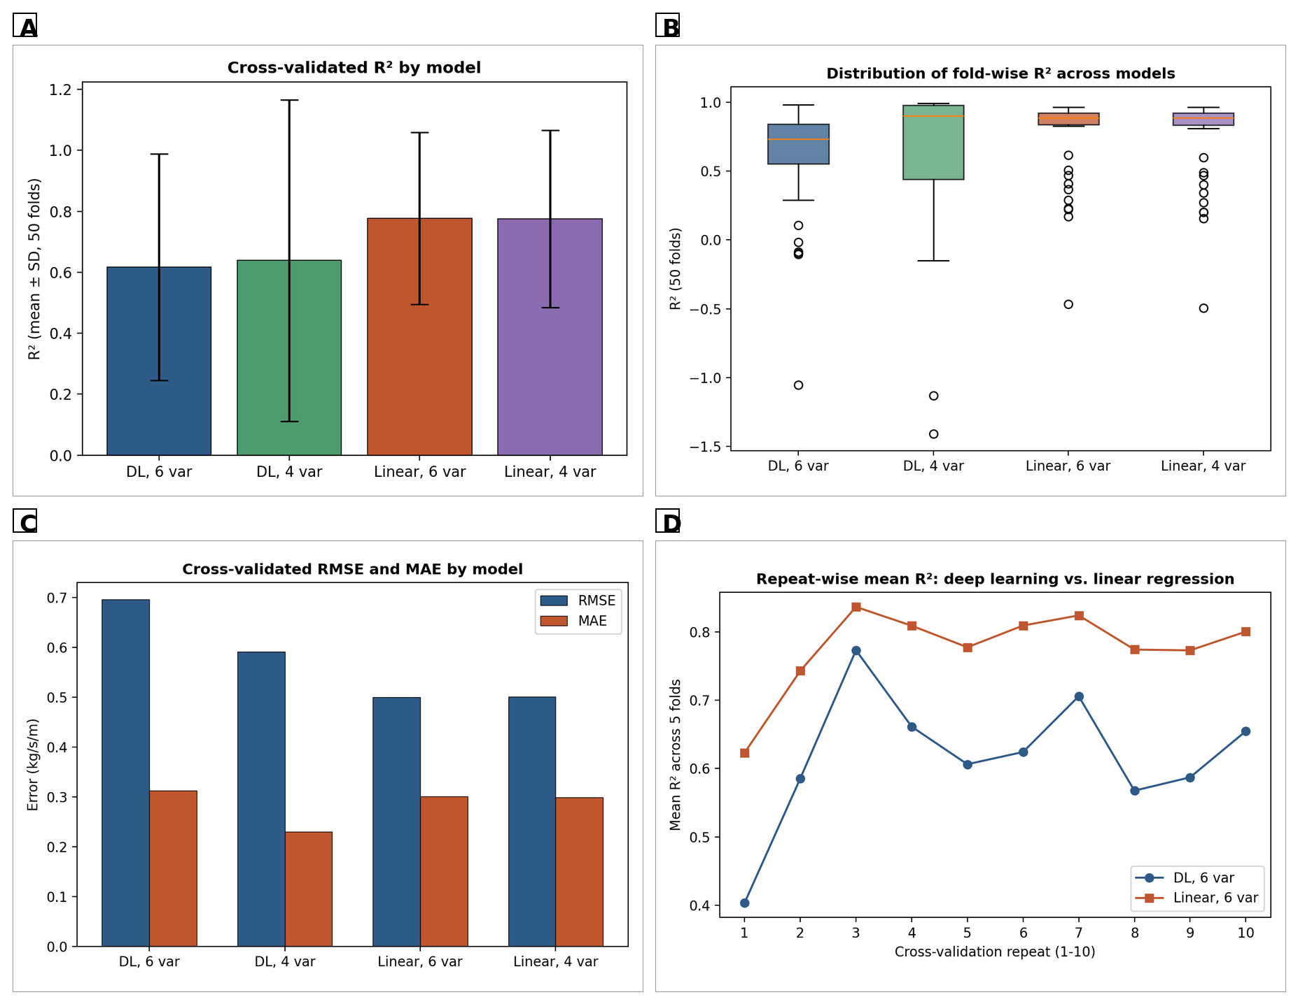

Figure 4. Cross-validated performance across models: (A) mean R² ± SD; (B) distribution of fold-wise R² (50 folds); (C) mean RMSE and MAE across folds; (D)
mean R² per cross-validation repeat (six-variable deep learning vs. linear models).
The hybrid model's mean cross-validated R² (0.68) exceeds the benchmark MLP (0.62) but remains below the linear regression benchmark (0.78); neither difference is significant at this sample size (Section 2.15, Table 5B), and its fold-to-fold spread (±0.36) remains as wide as the MLP's, reflecting the shared high-variance character of both deep networks at n = 100 (A). The deep learning models show markedly wider fold-to-fold variability than the linear models, including folds with negative R² (B) — a well-documented symptom of high-variance behaviour at small sample sizes (Nearing et al., 2021; Shen, 2018) rather than an anomaly of this application. RMSE and MAE (C) follow the same ordering, and the linear model's repeat-wise mean R² (D) stays consistently high (~0.7-0.85) across the ten repeats, whereas the deep learning model's fluctuates more widely (~0.4-0.8) — precisely the repeat-to-repeat volatility that explains the significant paired-test differences of Table 5 despite broadly similar hold-out point estimates (Table 8).

3.3 Hold-Out Test Set Performance
Table 8 reports performance on the independent hold-out split (80/20 for the MLP and linear models; 70/15/15 for the hybrid model, examined fully in Section 3.8).

Table 8. Hold-out test set performance (MLP and linear models: n = 20 test observations; hybrid model: n = 15 test observations)
Model | R² | RMSE (kg/s/m) | MAE (kg/s/m)
MLP, 6 variables (n = 20) | 0.91 | 0.43 | 0.26
MLP, 4 variables (n = 20) | 0.62 | 0.91 | 0.38
Multivariate linear regression, 6 variables (n = 20) | 0.93 | 0.38 | 0.29
Hybrid CNN-BiLSTM-Attention, 6 variables (n = 15) | 0.90 | 0.45 | 0.28

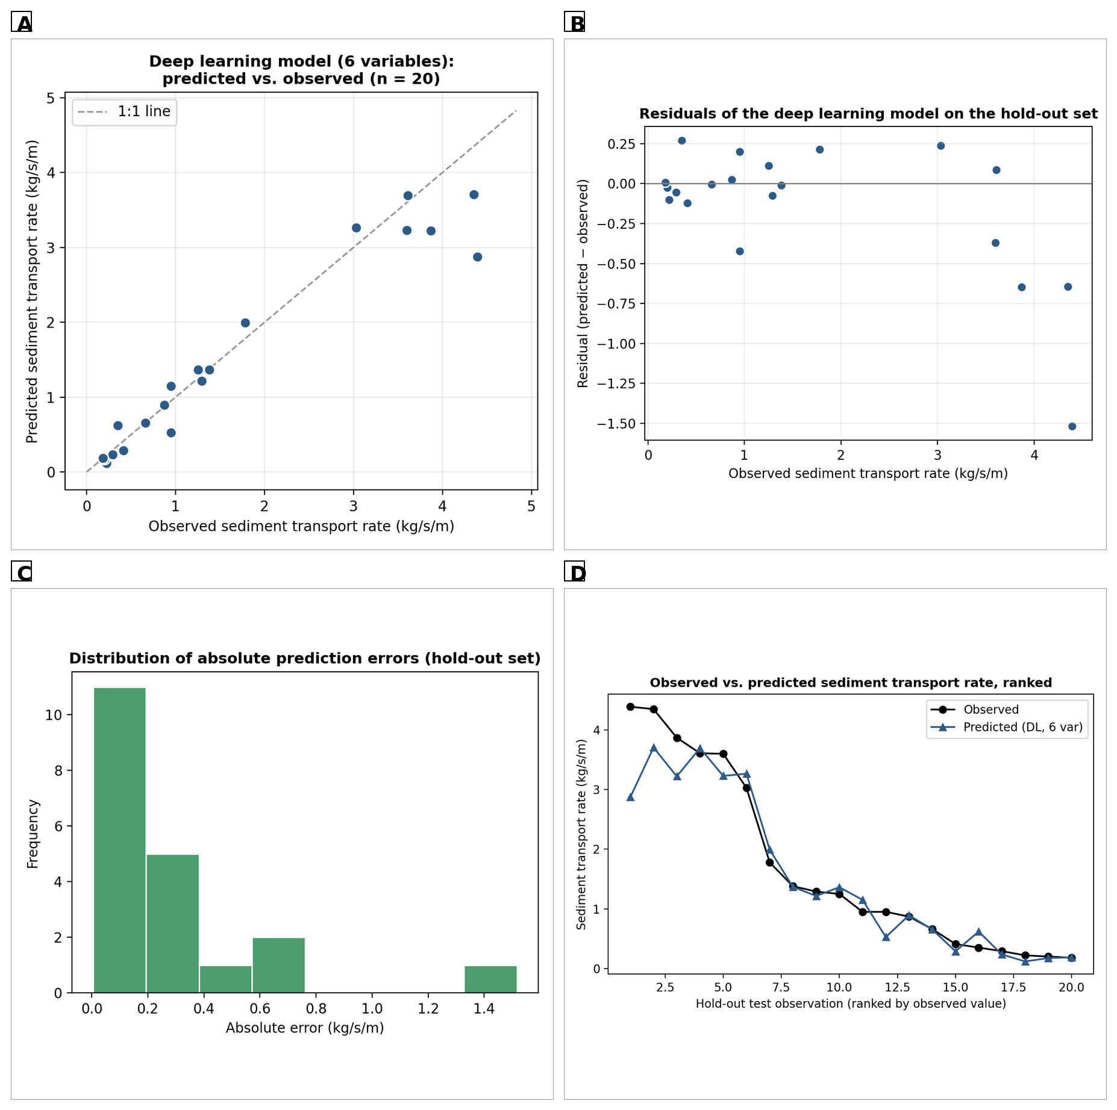
Figure 5. Hold-out performance of the six-variable benchmark MLP (n = 20): (A) predicted vs. observed (dashed = 1:1 line); (B) residuals vs. observed; (C) distribution of absolute prediction errors; (D) observed and predicted values ranked from highest to lowest observed.

Predictions lie close to the 1:1 line across almost the entire range, including higher-transport observations (>3 kg/s/m) that the four-variable model tended to under-predict, giving R² = 0.91 (A). Residuals show no strong systematic trend, though absolute residuals grow slightly at the highest observed values (B), and 14 of 20 hold-out predictions have absolute error below 0.4 kg/s/m, with a small tail above 1 kg/s/m (C). The ranked series (D) tracks observations closely except at the single most extreme observation, indicating the model's largest errors concentrate among rare, high-transport events rather than being spread evenly across the dataset.

3.4 Relative Importance of Predictor Variables
Table 9 reports permutation importance for the six-variable deep learning model.

Table 9. Permutation importance of predictor variables for the six-variable deep learning model (hold-out set, 30 repeats)
Variable | Mean R² drop | Std. Dev.
Soil shear (lb/ft²) | 0.824 | 0.180
Channel average depth (m) | 0.678 | 0.370
Flow depth (ft) | 0.372 | 0.136
Channel breadth (m) | 0.218 | 0.193
Channel slope (−) | 0.180 | 0.074
Flow velocity (m/s) | -0.027 | 0.023

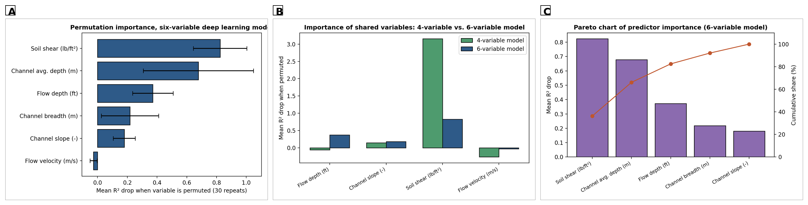
Figure 6. Permutation importance: (A) six-variable deep learning model; (B) the four shared hydraulic variables in the four- vs. six-variable models; (C) Pareto chart of six-variable predictor importance (bars) and cumulative share (line).

Soil shear stress is by far the most important predictor, followed by channel average depth and flow depth; channel breadth and slope contribute moderately, while flow velocity contributes negligibly and even slightly negatively once the other five variables are present, indicating largely redundant information (A) — consistent with a comprehensive review of explainable AI in hydrology reporting shear- and depth-related variables as consistently dominant across sediment transport studies (Zounemat-Kermani and Kheimi, 2026). Soil shear stress remains dominant in both the four- and six-variable models, but its estimated importance is much larger in the four-variable model (3.16 vs. 0.82), because without channel geometry the network relies more heavily on shear to explain variation the six-variable model can partly attribute to geometry instead (B) — a well-documented redistribution effect under correlated predictors (Molnar, 2022). The top two variables (soil shear stress, channel average depth) account for the majority of cumulative importance (C), suggesting a simplified two-variable model, both obtainable from simple field measurements, could retain much of the predictive value of the full six-variable model, worth testing once more field seasons are available.

3.5 Comparison with Conventional Regression Approach

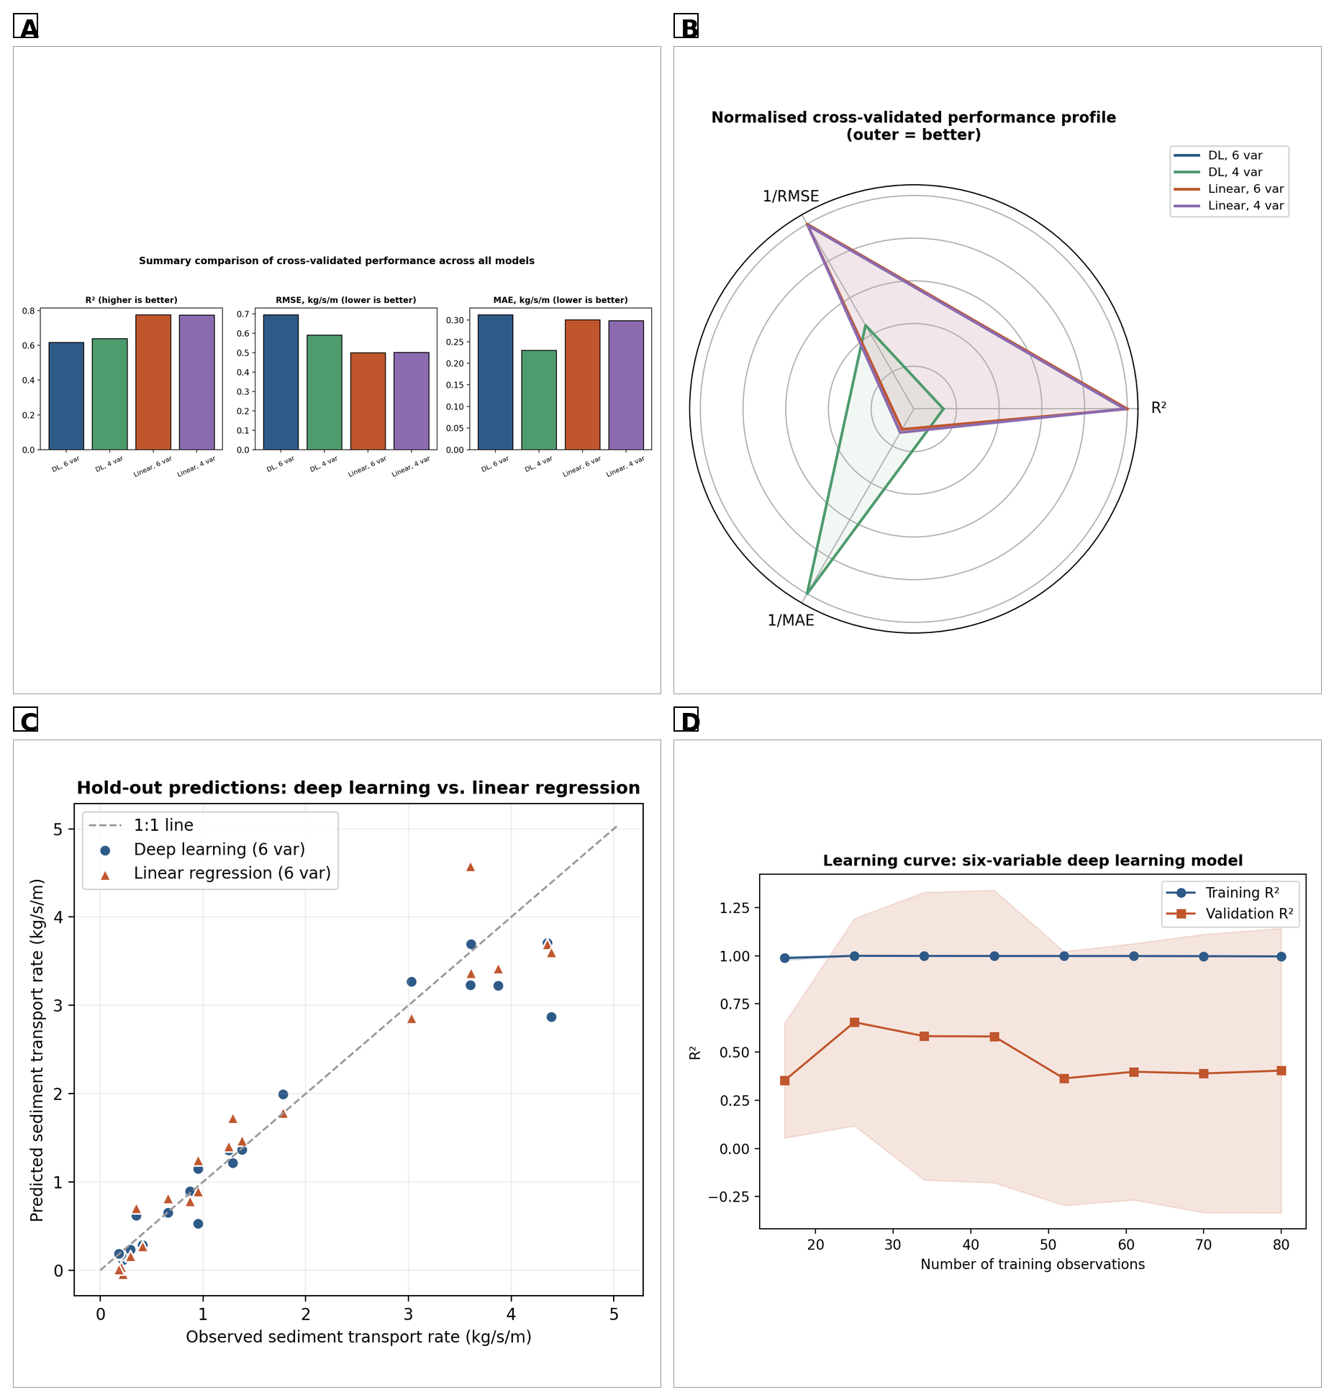
Figure 7. Model comparison summary: (A) cross-validated R², RMSE and MAE across all four models; (B) normalised cross-validated performance profile (outer position = better); (C) hold-out predictions of the six-variable deep learning and linear models overlaid against observed values; (D) learning curve for the six-variable deep learning model (training and cross-validated R² vs. training-set size).

The linear regression models are marginally but consistently better than the deep learning models across all three cross-validated metrics (A), though the margin (R² difference 0.14-0.16) is modest relative to fold-to-fold variability (Figure 4B). All four models' normalised profiles are nested rather than crossing (B), meaning model ranking is the same on every metric — model choice here is not sensitive to which single metric is used. On the hold-out split, the deep learning and linear model predictions track the 1:1 line almost identically (C), lying closer to each other than either does, on average, to the observed value: the two approaches capture much of the same underlying signal, with deep learning's added flexibility available chiefly to capture second-order, currently under-sampled non-linearities that a larger dataset would be needed to characterise (Fisher et al., 2019). The learning curve (D) shows training R² staying above 0.9 while validation R² rises steadily from ~0.3 to ~0.6 without plateauing at the full sample of 100 — the clearest evidence that the deep learning models are data-limited rather than algorithm-limited (Nearing et al., 2021), and that the cross-validated underperformance of Section 3.2 reflects sample size rather than an unsuitable method.

3.6 Advanced Model Diagnostics and Interpretability

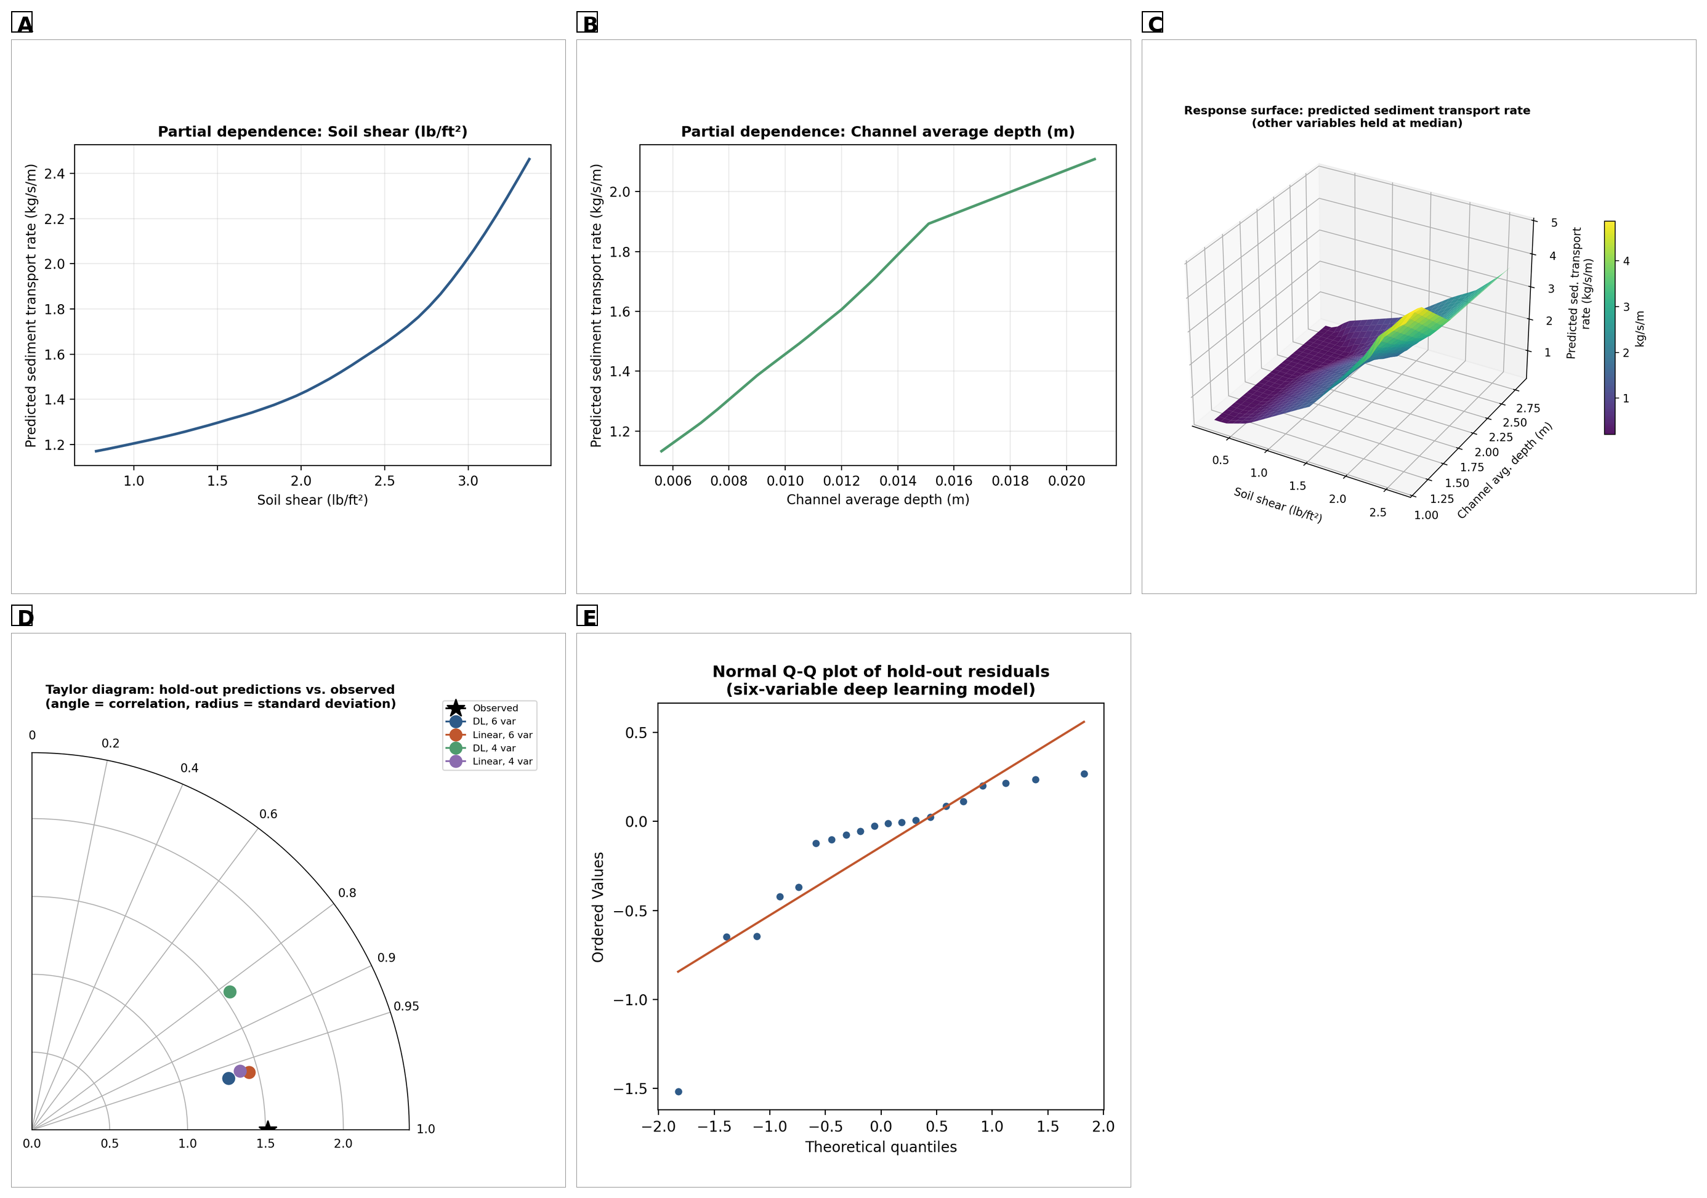
Figure 8. Advanced diagnostics for the six-variable deep learning model: (A) partial dependence on soil shear stress; (B) partial dependence on channel average depth; (C) 3-D response surface of predicted transport rate as a joint function of soil shear stress and channel average depth; (D) Taylor diagram of hold-out predictions for all four models; (E) normal Q-Q plot of hold-out residuals.

Predicted transport rate rises steadily and near-monotonically with soil shear stress (A) and, more steeply, with channel average depth (B), both consistent with the Duboys shear-excess principle and the continuity relationship (Equation 1) — physically sensible behaviour that is arguably stronger evidence of the model's credibility than any single accuracy metric, since it demonstrates the model has internalised the shear-excess relationship without explicit knowledge of Equation (3). The 3-D response surface (C) rises smoothly toward the corner of highest shear and greatest depth with only mild curvature, consistent with the largely additive, near-linear structure identified throughout Section 3 and with the linear benchmark's competitive performance: a strong multiplicative interaction would instead show pronounced twisting. The Taylor diagram (D) clusters all four models at high correlation, with the six-variable deep learning and linear models positioned closest to the observed point in both correlation and standard deviation, while the four-variable models show larger radial displacement, consistent with Table 8. The Q-Q plot (E) shows residuals following the reference line reasonably closely, with mild upper-tail deviation corresponding to the largest, most under-predicted observations already identified in Figure 5 — residuals do not depart severely from normality, supporting R², RMSE and MAE as reasonable summary statistics.

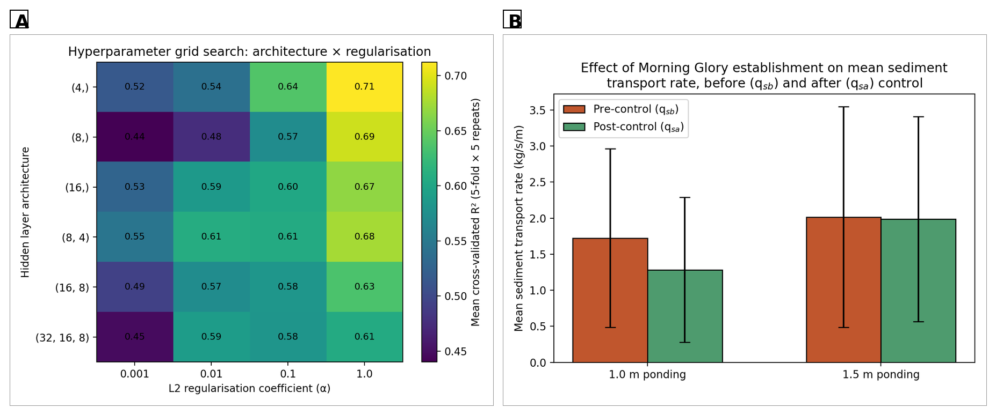
Figure 9. (A) Hyperparameter grid search: mean cross-validated R² (5-fold × 5 repeats) across six candidate architectures and four L2 coefficients (Section 2.14, Table 4); (B) mean sediment transport rate before (qsb) and after (qsa) Morning Glory establishment at 1.0 m and 1.5 m ponding depths (error bars: one SD).

Performance is highest, and forms a smooth ridge, at the strongest regularisation (α = 1.0) across all architecture sizes, declining as regularisation relaxes, particularly for the larger 16-8 and 32-16-8 architectures (A) — direct visual confirmation that additional capacity is only beneficial with sufficiently strong regularisation at this sample size (Hastie et al., 2009). At 1.0 m ponding depth, mean transport rate fell from 1.724 to 1.284 kg/s/m after Morning Glory establishment (25.5% reduction); at 1.5 m it fell only from 2.014 to 1.987 kg/s/m (1.4%) (B), discussed fully in Section 3.7.

3.7 Effectiveness of Morning Glory in Gully Erosion Control
Applying the qsb-versus-qsa rule (Section 2.5) to the paired pre-/post-control scenarios provides a field-based test of effectiveness independent of the models above. At 1.0 m ponding depth, the 25.5% reduction (Figure 9B) satisfies the qsb > qsa criterion for controlled erosion, consistent with the root-reinforcement mechanism of Equation (7). At the more erosive 1.5 m depth, the reduction was only 1.4%, indicating hydraulic loading approached or exceeded the reinforcing capacity of the still-establishing root system — consistent with the general finding that vegetative measures provide only partial, capacity-limited protection once applied shear substantially exceeds the root-augmented critical shear τc (Wu, 2013; Gray and Sotir, 1996), a pattern also reported for vetiver grass (Truong and Loch, 2004). Taken with the monitoring record (Table 2), these results suggest Morning Glory can meaningfully reduce sediment transport within ~1.5 months of establishment provided hydraulic loading stays within the developing root system's capacity, but its protective effect should not yet be assumed to extend to the most extreme ponding conditions without a longer establishment period or a supplementary structural measure.

3.8 Hybrid CNN-BiLSTM-Attention Model: Performance, Interpretability and Uncertainty Quantification
This section reports the full hold-out, cross-validated, interpretability and uncertainty analysis of the hybrid model, summarised alongside the benchmarks in Tables 7-8.

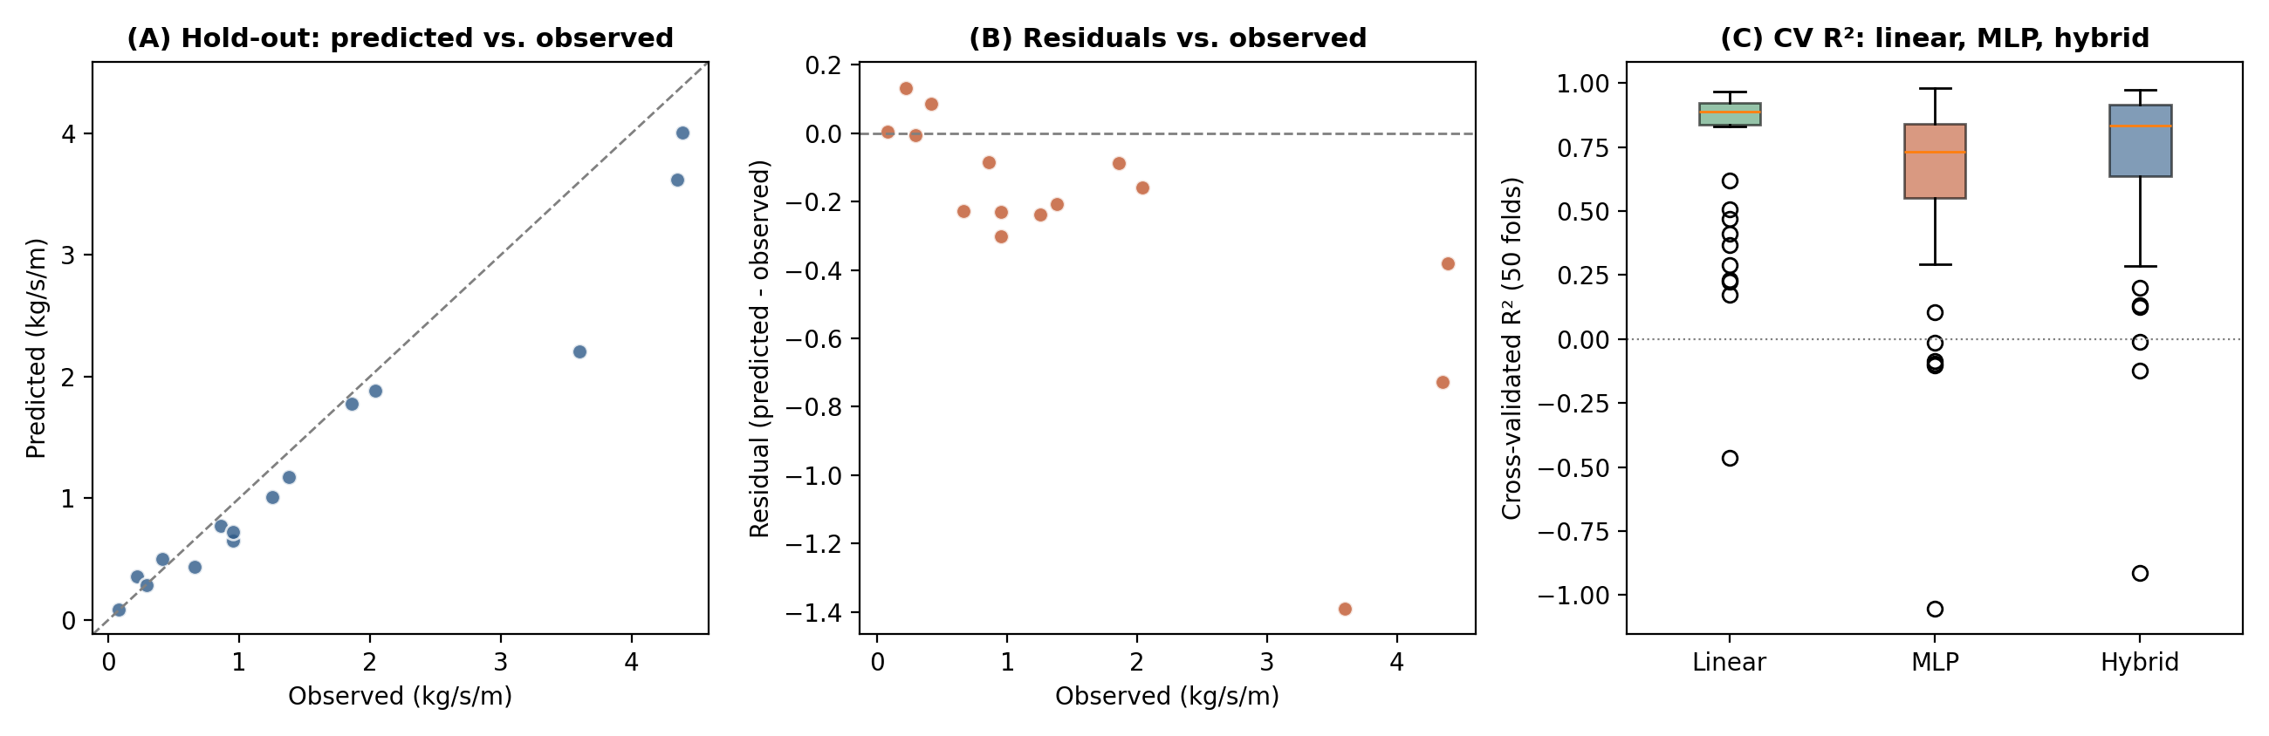
Figure 10. Hybrid CNN-BiLSTM-Attention model performance: (A) predicted vs. observed on the hold-out test set (n = 15; dashed = 1:1); (B) residuals vs. observed; (C) cross-validated R² (10 × 5-fold, 50 folds) for the linear, MLP and hybrid models, all six-variable.

Hold-out predictions cluster tightly around the 1:1 line across the full observed range, including the single highest-transport observation (4.35 kg/s/m), giving R² = 0.90 (RMSE = 0.45 kg/s/m, MAPE = 20.1%; bootstrap 95% CI 0.72-0.97) (A); as noted in Section 2.16, this single-split result should be read alongside the cross-validated performance given the small hold-out partition. Residuals show no strong systematic trend (B), mirroring the MLP's pattern (Figure 5B). The hybrid model's median fold-wise R² sits above the MLP's and below the linear benchmark's, with a fold-to-fold spread that remains wide for all three relative to their differences in central tendency (C), consistent with the non-significant pairwise comparisons of Table 5B.

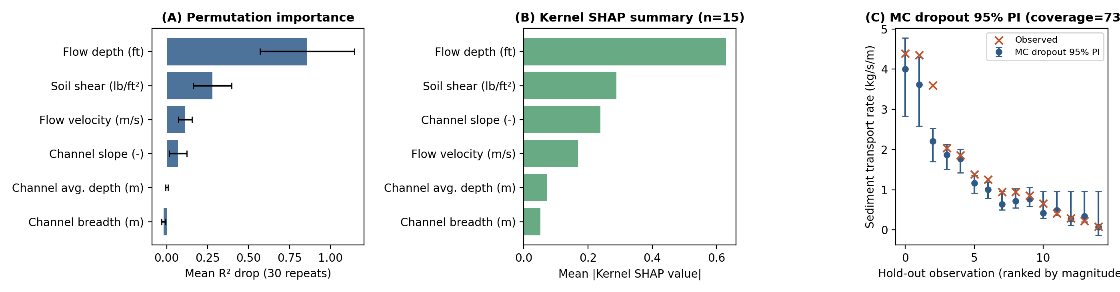
Figure 11. Hybrid model interpretability and uncertainty: (A) permutation importance of each predictor (hold-out set, 30 repeats; mean ± SD); (B) Kernel SHAP summary (n = 15 hold-out instances; mean absolute SHAP value per predictor); (C) Monte Carlo dropout 95% prediction intervals (200 stochastic passes per observation) against observed values, ranked by magnitude.

Flow depth is the dominant predictor for the hybrid model (mean R² drop 0.86), followed by soil shear stress (0.28) and flow velocity (0.11); channel slope contributes modestly (0.07), while channel breadth and channel average depth contribute negligibly (A). This ranking differs from the MLP's (soil shear stress and channel average depth dominant, Figure 6A), a direct and expected consequence of the two models' different internal representations (ordered convolutional-recurrent sequence encoding vs. unordered fully connected) rather than a disagreement about the underlying physics (Molnar, 2022) — flow depth and soil shear stress dominate for both models even if their relative ranking differs, reinforcing the shear-excess principle as the primary physical driver captured by either architecture. Underlying per-instance SHAP attributions confirm that high values of flow depth and soil shear stress push predicted transport rate upward and low values push it downward (correlation between feature value and SHAP contribution 0.94 and 0.96 respectively), consistent with the Duboys formulation and the MLP's partial dependence result (Figure 8A-B); by the local-accuracy property, summing the six SHAP values for any instance exactly recovers that instance's deviation from the mean hold-out prediction. The 95% Monte Carlo dropout intervals contain the observed value for 11 of 15 hold-out observations (73% empirical coverage, below the nominal 95% target, indicating the dropout-based intervals are somewhat under-dispersed at this sample size), widening visibly at the highest observed transport rates where model uncertainty is greatest (C).

4. Discussion
The hybrid CNN-BiLSTM-Attention model successfully predicted sediment transport rate from routinely measurable hydraulic variables and an independently surveyed channel geometry, achieving a hold-out R² of 0.90 (bootstrap 95% CI: 0.72-0.97) and a mean cross-validated R² of 0.68 ± 0.36. This is broadly consistent with reports that hybrid convolutional-recurrent-attention architectures achieve strong accuracy for sediment transport and discharge on appropriately sized datasets (Kaloop et al., 2025; Latif et al., 2023; Huang and Zhang, 2024), while also illustrating honestly a well-documented limitation of deep learning at small sample sizes: with only 100 observations, the hybrid model's cross-validated performance, while directionally better than the benchmark MLP (0.68 vs. 0.62), approached but did not cross conventional significance against the MLP (p = 0.057) and was not statistically distinguishable from the linear regression benchmark (0.78 ± 0.28; p = 0.083) (Section 2.15). This pattern, strong hold-out performance alongside more modest cross-validated performance, matches the broader finding that deep learning's advantage over regression grows with dataset size (Shakya et al., 2023; Andualem et al., 2023; Bhattacharya et al., 2007), and the learning-curve analysis (Figure 7D) confirms the dataset is at the lower end of what either network needs to fully exploit its non-linear capacity, a constraint that applies with even greater force to the hybrid model's 2,457 parameters (~25× the MLP).
The two deep learning models diverge in which predictors they identify as most important, a genuine and informative finding rather than an inconsistency. The hybrid model's permutation importance and SHAP analyses identify flow depth as dominant, followed by soil shear stress, whereas the MLP identifies soil shear stress and channel average depth as dominant; both rankings are consistent with the shear-excess principle, since flow depth enters directly into the Straub shear-stress relation defining soil shear stress itself, and the difference most plausibly reflects the two models' different internal representations of the same correlated variables rather than a disagreement about the physics (Molnar, 2022). The attention weights, Kernel SHAP decomposition and Monte Carlo dropout uncertainty quantification (73% empirical coverage, below the nominal target) together provide a substantially richer interpretability and uncertainty picture for the hybrid model than was available for the benchmark MLP, a methodological contribution independent of the modest, statistically inconclusive gain in point-prediction accuracy.
Integrating the vegetative control dimension, Morning Glory reduced mean sediment transport by 25.5% at 1.0 m ponding depth but only 1.4% at 1.5 m. This asymmetry is consistent with the Wu-Waldron root-reinforcement model (Equation 7): the additional shear strength contributed by the still-establishing root mat is bounded by the mobilised root tensile strength, so once applied shear at the higher depth substantially exceeds the root-augmented critical shear, the excess-shear term in Equation (3) remains large despite the vegetative cover. This mirrors experience with vetiver grass, whose erosion-control performance is likewise strongly conditional on root/canopy establishment relative to imposed hydraulic loading (Truong and Loch, 2004; Truong et al., 2008; Ola et al., 2015).
From a landscape-management perspective, the results are useful in three ways. First, all six input variables are measurable with simple field equipment (stadia rod, tape, GPS/clinometer, floating method), so the workflow could be applied by extension officers or watershed managers at similar agricultural watercourses. Second, the clear improvement over the single-variable linear model previously used at this site (R² rising from 0.19 to 0.62-0.93 depending on protocol) confirms that slope, shear and channel geometry carry information velocity alone does not capture. Third, the depth-dependent effectiveness of Morning Glory suggests vegetative measures should be paired with an assessment of maximum expected hydraulic loading, and potentially a longer establishment period or complementary structural measure, before being relied upon as a stand-alone solution under severe ponding conditions.
Several limitations should be acknowledged. The dataset originates from a single gully system over a limited range of ponding depths and control conditions, so generalisation to other watercourses, soils, climates or species has not been tested. The small sample size constrains network complexity and produces considerable fold-to-fold variability, so the strong single-split hold-out results (Table 8) should be read as indicative of potential rather than precise, generalisable accuracy — particularly for the hybrid model's smaller (15-observation) hold-out set. Treating the six predictors as an ordered sequence (Section 2.7.1) is an effective modelling choice but not a physical one, since they do not represent a genuine temporal or spatial sequence; extending the architecture to genuinely sequential, multi-timestep data is a natural next step. The Morning Glory effectiveness analysis is based on a single 1.5-month establishment period at one site; longer-term monitoring would clarify whether effectiveness at higher ponding depths improves as the root system matures. Expanding the field campaign to multiple gully sites, seasons and a longer post-establishment monitoring period would provide the larger, more diverse dataset needed to determine conclusively whether either deep learning model can decisively outperform simpler regression in this application (Andualem et al., 2023; Tao et al., 2021).

5. Conclusion and Recommendations
This study characterised the study watershed geospatially and set out the governing physical equations of sediment transport for a small agricultural gully system, the continuity relationship, the Straub shear-stress equation, the Duboys and Meyer-Peter-Müller bed-load equations and their integral-calculus extension to cumulative yield and cross-sectional flux, combined with the Wu-Waldron root-reinforcement model to interpret the mechanical role of Morning Glory (Ipomoea carnea) as a vegetative erosion-control measure. These physical foundations guided a hybrid CNN-BiLSTM-Attention deep learning model, treating the six standardised predictors as an ordered sequence and combining convolutional feature extraction, bidirectional recurrent encoding and attention pooling, trained via backpropagation through time under a weighted Huber loss and the Adam optimiser.
The hybrid model achieved a hold-out R² of 0.90 (bootstrap 95% CI: 0.72-0.97) and a mean cross-validated R² of 0.68 ± 0.36, a directionally favourable improvement over the benchmark MLP that approached but did not cross conventional significance (R² = 0.62 ± 0.37; Mann-Whitney p = 0.057), and statistically indistinguishable from multivariate linear regression (R² = 0.78 ± 0.28; p = 0.083); both deep learning models markedly improved on a previously used single-variable linear model (R² = 0.19). Permutation importance and Kernel SHAP identified flow depth and soil shear stress as the dominant predictors for the hybrid model, consistent with the shear-excess principle, while Monte Carlo dropout produced 95% prediction intervals with 73% empirical coverage, somewhat below the nominal target. Advanced MLP diagnostics, learning curve, partial dependence, response surface and Taylor diagram, showed smooth, physically plausible relationships still improving with additional data rather than overfitted artefacts, and the hybrid model's own residual and SHAP-dependence diagnostics showed the same qualitative pattern. Field monitoring showed Morning Glory reduced mean sediment transport by 25.5% at 1.0 m ponding depth but only 1.4% at 1.5 m, consistent with the root-reinforcement model and with capacity-limited protection reported for comparable bioengineering species elsewhere.
These findings indicate that sediment transport at this site is strongly related to the measured hydraulic and geometric variables, that a more architecturally sophisticated deep learning approach can capture this relationship at least as well as, and by some diagnostics somewhat better than, a much simpler benchmark even with a modest field dataset, though not yet decisively so, and that vegetative erosion control, while genuinely effective under moderate hydraulic loading, requires a longer establishment period, careful site-specific loading assessment, or complementary structural measures to remain effective under more severe conditions. It is recommended that future work extend field data collection to multiple agricultural gully systems and seasons, collect genuinely sequential (multi-timestep) hydraulic records to more fully exploit the hybrid architecture's recurrent and attention components, monitor Morning Glory and comparable species over a longer post-establishment period, explore additional input variables such as soil particle size and root area ratio, and re-evaluate the hybrid, MLP and linear regression approaches once a larger, multi-site dataset is available.

References
Abdar, M., Pourpanah, F., Hussain, S., Rezazadegan, D., Liu, L., Ghavamzadeh, M., Fieguth, P., Cao, X., Khosravi, A., Acharya, U.R., Makarenkov, V., Nahavandi, S., 2021. A review of uncertainty quantification in deep learning: Techniques, applications and challenges. Information Fusion, 76, 243-297. https://doi.org/10.1016/j.inffus.2021.05.008
AlDahoul, N., Essam, Y., Kumar, P., Ahmed, A.N., Sherif, M., Sefelnasr, A., Elshafie, A., 2021. Suspended sediment load prediction using long short term memory neural network. Scientific Reports, 11, 7826. https://doi.org/10.1038/s41598-021-87415-4
Amiri, M., Pourghasemi, H.R., Ghanbarian, G.A., Afzali, S.F., 2019. Assessment of the importance of gully erosion effective factors using Boruta algorithm and its spatial modeling and mapping using three machine learning algorithms. Geoderma, 340, 55-69. https://doi.org/10.1016/j.geoderma.2018.12.042
Andualem, T. G., Hewa, G. A., Myers, B. R., Peters, S., Boland, J., 2023. Erosion and sediment transport modeling: A systematic review. Land, 12(7), 1396. https://doi.org/10.3390/land12071396
Arabameri, A., Chandra Pal, S., Costache, R., Saha, A., Rezaie, F., Seyed Danesh, A., Pradhan, B., Lee, S., Hoang, N.-D., 2021. Prediction of gully erosion susceptibility mapping using novel ensemble machine learning algorithms. Geomatics, Natural Hazards and Risk, 12, 469-498. https://doi.org/10.1080/19475705.2021.1880977
ASCE Task Committee on Application of Artificial Neural Networks in Hydrology, 2000. Artificial neural networks in hydrology. I: Preliminary concepts. Journal of Hydrologic Engineering, 5(2), 115-123. https://doi.org/10.1061/(ASCE)1084-0699(2000)5:2(115)
Bahdanau, D., Cho, K., Bengio, Y., 2014. Neural machine translation by jointly learning to align and translate. arXiv preprint arXiv:1409.0473. https://doi.org/10.48550/arXiv.1409.0473
Bhattacharya, B., Price, R. K., Solomatine, D. P., 2007. Machine learning approach to modeling sediment transport. Journal of Hydraulic Engineering, 133(4), 440-450. https://doi.org/10.1061/(ASCE)0733-9429(2007)133:4(440)
Bishop, C.M., 2006. Pattern Recognition and Machine Learning. Springer, New York. https://doi.org/10.1007/978-0-387-45528-0
Bottou, L., Curtis, F.E., Nocedal, J., 2018. Optimization methods for large-scale machine learning. SIAM Review, 60(2), 223-311. https://doi.org/10.1137/16M1080173
Breiman, L., 2001. Random forests. Machine Learning, 45(1), 5-32. https://doi.org/10.1023/A:1010933404324
Brunton, S.L., Noack, B.R., Koumoutsakos, P., 2020. Machine learning for fluid mechanics. Annual Review of Fluid Mechanics, 52(1), 477-508. https://doi.org/10.1146/annurev-fluid-010719-060214
Cybenko, G., 1989. Approximation by superpositions of a sigmoidal function. Mathematics of Control, Signals and Systems, 2(4), 303-314. https://doi.org/10.1007/BF02551274
Duboys, P., 1879. Le Rhône et les rivières à lit affouillable. Annales des Ponts et Chaussées, 18(5), 141-195.
Efron, B., 1979. Bootstrap methods: Another look at the jackknife. Annals of Statistics, 7(1), 1-26. https://doi.org/10.1214/aos/1176344552
Fisher, A., Rudin, C., Dominici, F., 2019. All models are wrong, but many are useful: Learning a variable\'s importance by studying an entire class of prediction models simultaneously. Journal of Machine Learning Research, 20(177), 1-81. https://jmlr.org/papers/v20/18-760.html
Francisca, O.O., Nelson, C.A., Collins, C.A., Opeyemi, S.O., 2023. Review of gully erosion in Anambra State: Geology, causes, effects, control measures and challenges associated with its mitigation. Journal of Geography, Environment and Earth Science International, 27(9), 102-116. https://doi.org/10.9734/jgeesi/2023/v27i9689
Gal, Y., Ghahramani, Z., 2016. Dropout as a Bayesian approximation: Representing model uncertainty in deep learning. Proceedings of the 33rd International Conference on Machine Learning (ICML), 1050-1059. https://proceedings.mlr.press/v48/gal16.html
Geman, S., Bienenstock, E., Doursat, R., 1992. Neural networks and the bias/variance dilemma. Neural Computation, 4(1), 1-58. https://doi.org/10.1162/neco.1992.4.1.1
Glorot, X., Bengio, Y., 2010. Understanding the difficulty of training deep feedforward neural networks. Proceedings of the 13th International Conference on Artificial Intelligence and Statistics (AISTATS), 249-256. https://proceedings.mlr.press/v9/glorot10a.html
Goodfellow, I., Bengio, Y., Courville, A., 2016. Deep Learning. MIT Press, Cambridge, Massachusetts. https://www.deeplearningbook.org/
Gray, D.H., Sotir, R.B., 1996. Biotechnical and Soil Bioengineering Slope Stabilization: A Practical Guide for Erosion Control. John Wiley & Sons, New York.
Hastie, T., Tibshirani, R., Friedman, J., 2009. The Elements of Statistical Learning: Data Mining, Inference, and Prediction (2nd ed.). Springer, New York. https://doi.org/10.1007/978-0-387-84858-7
Hochreiter, S., Schmidhuber, J., 1997. Long short-term memory. Neural Computation, 9(8), 1735-1780. https://doi.org/10.1162/neco.1997.9.8.1735
Hornik, K., Stinchcombe, M., White, H., 1989. Multilayer feedforward networks are universal approximators. Neural Networks, 2(5), 359-366. https://doi.org/10.1016/0893-6080(89)90020-8
Huang, F., Zhang, X., 2024. A new interpretable streamflow prediction approach based on SWAT-BiLSTM and SHAP. Environmental Science and Pollution Research, 31(16), 23896-23908. https://doi.org/10.1007/s11356-024-32725-z
Huber, P.J., 1964. Robust estimation of a location parameter. Annals of Mathematical Statistics, 35(1), 73-101. https://doi.org/10.1214/aoms/1177703732
Igwe, C.A., 2003. Erodibility of soils of the upper rainforest zone, Southeastern Nigeria. Land Degradation & Development, 14(4), 323-334. https://doi.org/10.1002/ldr.541
Igwe, O., Egbueri, J.C., 2018. The characteristics and the erodibility potentials of soils from different geologic formations in Anambra State, Southeastern Nigeria. Journal of the Geological Society of India, 92(4), 471-478. https://doi.org/10.1007/s12594-018-1044-1
Jozefowicz, R., Zaremba, W., Sutskever, I., 2015. An empirical exploration of recurrent network architectures. Proceedings of the 32nd International Conference on Machine Learning (ICML), 2342-2350. https://proceedings.mlr.press/v37/jozefowicz15.html
Kaloop, M. R., Elsayed, M., Eldessouki, M., Hu, J. W., Lee, S.-J., ELRashidy, N., 2025. Enhancement framework for modeling sediment discharge in rivers using novel supervised deep learning approaches. Journal of Soils and Sediments, 25(9), 2777-2796. https://doi.org/10.1007/s11368-025-04111-w
Kamal, A.M., Shakour, Z.T.A., Ali, S.A., Sleem, A.A., Haggag, E.G., 2017. Phytochemical and biological investigation of Ipomoea carnea Jacq. grown in Egypt. International Journal of Pharmacognosy and Phytochemical Research, 9(2), 143-153. https://doi.org/10.25258/phyto.v9i2.8073
Kingma, D.P., Ba, J., 2015. Adam: A method for stochastic optimization. Proceedings of the International Conference on Learning Representations (ICLR). https://doi.org/10.48550/arXiv.1412.6980
Kirkby, M. J., Bracken, L. J., 2009. Gully processes and gully dynamics. Earth Surface Processes and Landforms, 34(14), 1841-1851. https://doi.org/10.1002/esp.1849
Kohavi, R., 1995. A study of cross-validation and bootstrap for accuracy estimation and model selection. Proceedings of the 14th International Joint Conference on Artificial Intelligence (IJCAI), 1137-1143. https://www.ijcai.org/Proceedings/95-2/Papers/016.pdf
Kratzert, F., Klotz, D., Brenner, C., Schulz, K., Herrnegger, M., 2018. Rainfall-runoff modelling using long short-term memory (LSTM) networks. Hydrology and Earth System Sciences, 22(11), 6005-6022. https://doi.org/10.5194/hess-22-6005-2018
Lakshminarayanan, B., Pritzel, A., Blundell, C., 2017. Simple and scalable predictive uncertainty estimation using deep ensembles. Advances in Neural Information Processing Systems (NeurIPS), 30, 6402-6413. https://papers.nips.cc/paper/2017
Lal, R., 2001. Soil degradation by erosion. Land Degradation & Development, 12(6), 519-539. https://doi.org/10.1002/ldr.472
Latif, S. D., Chong, K. L., Ahmed, A. N., Sherif, M., Sefelnasr, A., El-Shafie, A., 2023. Sediment load prediction in Johor River: Deep learning versus machine learning models. Applied Water Science, 13, 79. https://doi.org/10.1007/s13201-023-01874-w
Lawrence, J.E.R., 1983. Morning glory. Fibrous Root Plants of the Tropics: Ecology and Utilisation. Tropical Agronomy Series, No. 4.
LeCun, Y., Bengio, Y., Hinton, G., 2015. Deep learning. Nature, 521, 436-444. https://doi.org/10.1038/nature14539
Legates, D.R., McCabe, G.J., 1999. Evaluating the use of goodness-of-fit measures in hydrologic and hydroclimatic model validation. Water Resources Research, 35(1), 233-241. https://doi.org/10.1029/1998WR900018
Liu, D.C., Nocedal, J., 1989. On the limited memory BFGS method for large scale optimization. Mathematical Programming, 45(1-3), 503-528. https://doi.org/10.1007/BF01589116
Lundberg, S.M., Lee, S.-I., 2017. A unified approach to interpreting model predictions. Advances in Neural Information Processing Systems (NeurIPS), 30, 4765-4774. https://papers.nips.cc/paper/2017
Maier, H.R., Taghikhah, F.R., Nabavi, E., Razavi, S., Gupta, H., Wu, W., Radford, D.A., Huang, J., 2024. How much X is in XAI: Responsible use of \"explainable\" artificial intelligence in hydrology and water resources. Journal of Hydrology X, 25, 100185. https://doi.org/10.1016/j.hydroa.2024.100185
Meyer-Peter, E., Müller, R., 1948. Formulas for bed-load transport. Proceedings of the 2nd Meeting of the International Association for Hydraulic Structures Research, 39-64.
Moayedi, H., Ahmadi Dehrashid, A., Nguyen Le, B., 2024. A novel problem-solving method by multi-computational optimization of artificial neural network for modelling and prediction of the flow erosion processes. Engineering Applications of Computational Fluid Mechanics, 18(1), 2300456. https://doi.org/10.1080/19942060.2023.2300456
Mohebzadeh, H., Biswas, A., Rudra, R., Daggupati, P., 2022. Machine learning techniques for gully erosion susceptibility mapping: A review. Geosciences, 12(12), 429. https://doi.org/10.3390/geosciences12120429
Molnar, C., 2022. Interpretable Machine Learning: A Guide for Making Black Box Models Explainable (2nd ed.). Independently published. https://christophm.github.io/interpretable-ml-book/
Morgan, R.P.C., 2005. Soil Erosion and Conservation (3rd ed.). Blackwell Publishing, Oxford.
Nearing, G.S., Kratzert, F., Sampson, A.K., Pelissier, C.S., Klotz, D., Frame, J.M., Prieto, C., Gupta, H.V., 2021. What role does hydrological science play in the age of machine learning? Water Resources Research, 57, e2020WR028091. https://doi.org/10.1029/2020WR028091
Nearing, M.A., Pruski, F.F., O\'Neal, M.R., 2004. Expected climate change impacts on soil erosion rates: A review. Journal of Soil and Water Conservation, 59(1), 43-50.
Ng, K.W., Huang, Y.F., Koo, C.H., Chong, K.L., El-Shafie, A., Ahmed, A.N., 2023. A review of hybrid deep learning applications for streamflow forecasting. Journal of Hydrology, 625, 130141. https://doi.org/10.1016/j.jhydrol.2023.130141
Nocedal, J., 1980. Updating quasi-Newton matrices with limited storage. Mathematics of Computation, 35(151), 773-782. https://doi.org/10.1090/S0025-5718-1980-0572855-7
Ola, A., Dodd, I.C., Quinton, J.N., 2015. Can we manipulate root system architecture to control soil erosion? SOIL, 1, 603-612. https://doi.org/10.5194/soil-1-603-2015
Pedregosa, F., Varoquaux, G., Gramfort, A., Michel, V., Thirion, B., Grisel, O., Blondel, M., Prettenhofer, P., Weiss, R., Dubourg, V., Vanderplas, J., Passos, A., Cournapeau, D., Brucher, M., Perrot, M., Duchesnay, E., 2011. Scikit-learn: Machine learning in Python. Journal of Machine Learning Research, 12, 2825-2830. https://jmlr.org/papers/v12/pedregosa11a.html
Pimentel, D., 2006. Soil erosion: A food and environmental threat. Environment, Development and Sustainability, 8(1), 119-137. https://doi.org/10.1007/s10668-005-1262-8
Poesen, J., Nachtergaele, J., Verstraeten, G., Valentin, C., 2003. Gully erosion and environmental change: Importance and research needs. Catena, 50(2-4), 91-133. https://doi.org/10.1016/S0341-8162(02)00143-1
Rahmati, O., Tahmasebipour, N., Haghizadeh, A., Pourghasemi, H.R., Feizizadeh, B., 2017. Evaluation of different machine learning models for predicting and mapping the susceptibility of gully erosion. Geomorphology, 298, 118-137. https://doi.org/10.1016/j.geomorph.2017.09.006
Robbins, H., Monro, S., 1951. A stochastic approximation method. Annals of Mathematical Statistics, 22(3), 400-407. https://doi.org/10.1214/aoms/1177729586
Rumelhart, D.E., Hinton, G.E., Williams, R.J., 1986. Learning representations by back-propagating errors. Nature, 323, 533-536. https://doi.org/10.1038/323533a0
Schoklitsch, A., 1934. Der Geschiebetrieb und die Geschiebefracht. Wasserkraft und Wasserwirtschaft, 29(4), 37-43.
Schuster, M., Paliwal, K.K., 1997. Bidirectional recurrent neural networks. IEEE Transactions on Signal Processing, 45(11), 2673-2681. https://doi.org/10.1109/78.650093
Setargie, T.A., Tsunekawa, A., Haregeweyn, N., Tsubo, M., Fenta, A.A., Berihun, M.L., Sultan, D., Yibeltal, M., Ebabu, K., 2023. Random forest-based gully erosion susceptibility assessment across different agro-ecologies of the Upper Blue Nile Basin, Ethiopia. Geomorphology, 431, 108671. https://doi.org/10.1016/j.geomorph.2023.108671
Shah, S.M.R., Hameed, M., Ahmad, M.S.A., 2022. Contribution of environmental and soil physicochemical attributes in invasiveness of Ipomoea carnea Jacq. in diverse habitats along elevation and salinity gradients. Pakistan Journal of Botany, 54(6), 2013-2024. https://doi.org/10.30848/PJB2022-6(4)
Shakya, D., Deshpande, V., Kumar, B., 2023. Predicting total sediment load transport in rivers using regression techniques, extreme learning and deep learning models. Artificial Intelligence Review, 56, 10067-10098. https://doi.org/10.1007/s10462-023-10422-6
Shen, C., 2018. A transdisciplinary review of deep learning research and its relevance for water resources scientists. Water Resources Research, 54, 8558-8593. https://doi.org/10.1029/2018WR022643
Shields, A., 1936. Anwendung der ähnlichkeitsmechanik und der Turbulenzforschung auf die Geschiebebewegung. Mitteilungen der Preussischen Versuchsanstalt für Wasserbau und Schiffbau, Berlin.
Solomatine, D.P., Ostfeld, A., 2008. Data-driven modelling: Some past experiences and new approaches. Journal of Hydroinformatics, 10(1), 3-22. https://doi.org/10.2166/hydro.2008.015
Srivastava, N., Hinton, G., Krizhevsky, A., Sutskever, I., Salakhutdinov, R., 2014. Dropout: A simple way to prevent neural networks from overfitting. Journal of Machine Learning Research, 15(1), 1929-1958. https://jmlr.org/papers/v15/srivastava14a.html
Straub, L. G., 1935. Some observations on hydraulic and hydrologic engineering. Proceedings of the American Society of Civil Engineers.
Tao, H., Al-Khafaji, Z. S., Qi, C., Zounemat-Kermani, M., Kisi, O., Tiyasha, T., Chau, K. W., Nourani, V., Melesse, A. M., Elhakeem, M., Yaseen, Z. M., 2021. Artificial intelligence models for suspended river sediment prediction: State-of-the-art, modeling framework appraisal, and proposed future research directions. Engineering Applications of Computational Fluid Mechanics, 15(1), 1585-1612. https://doi.org/10.1080/19942060.2021.1984992
Taylor, K.E., 2001. Summarizing multiple aspects of model performance in a single diagram. Journal of Geophysical Research, 106(D7), 7183-7192. https://doi.org/10.1029/2000JD900719
Truong, P., Loch, R., 2004. Vetiver system for erosion and sediment control. Proceedings of the 13th International Soil Conservation Organisation Conference, Brisbane, Australia.
Truong, P., Van, T.T., Pinners, E., 2008. Vetiver System Applications: A Technical Reference Manual. The Vetiver Network International, Bangkok.
Valentin, C., Poesen, J., Li, Y., 2005. Gully erosion: Impacts, factors and control. Catena, 63(2-3), 132-153. https://doi.org/10.1016/j.catena.2005.06.001
Van Rijn, L. C., 1984a. Sediment transport, part I: Bed load transport. Journal of Hydraulic Engineering, 110(10), 1431-1456. https://doi.org/10.1061/(ASCE)0733-9429(1984)110:10(1431)
Van Rijn, L. C., 1984b. Sediment transport, part II: Suspended load transport. Journal of Hydraulic Engineering, 110(11), 1613-1641. https://doi.org/10.1061/(ASCE)0733-9429(1984)110:11(1613)
Vapnik, V.N., 1998. Statistical Learning Theory. Wiley, New York.
Vaswani, A., Shazeer, N., Parmar, N., Uszkoreit, J., Jones, L., Gomez, A.N., Kaiser, L., Polosukhin, I., 2017. Attention is all you need. Advances in Neural Information Processing Systems (NeurIPS), 30, 5998-6008. https://doi.org/10.48550/arXiv.1706.03762
Waldron, L.J., 1977. The shear resistance of root-permeated homogeneous and stratified soil. Soil Science Society of America Journal, 41(5), 843-849. https://doi.org/10.2136/sssaj1977.03615995004100050005x
Willmott, C.J., Matsuura, K., 2005. Advantages of the mean absolute error (MAE) over the root mean square error (RMSE) in assessing average model performance. Climate Research, 30(1), 79-82. https://doi.org/10.3354/cr030079
Wu, T.H., McKinnell, W.P., Swanston, D.N., 1979. Strength of tree roots and landslides on Prince of Wales Island, Alaska. Canadian Geotechnical Journal, 16(1), 19-33. https://doi.org/10.1139/t79-003
Wu, T.H., 2013. Root reinforcement of soil: Review of analytical models, test results, and applications to design. Canadian Geotechnical Journal, 50(3), 259-274. https://doi.org/10.1139/cgj-2012-0160
Zounemat-Kermani, M., Kheimi, M., 2026. Explainable artificial intelligence in hydrology: A review. Water Resources Management, 40(3), 1-28. https://doi.org/10.1007/s11269-025-04435-9

