Development of an Integrated Decision-Support Model for Dairy Processing Systems under Milk and Market Variability
Naziru Halilu
halilunaziru73@gmail.com

Abstract
Dairy processing plants must decide, on a daily basis and under considerable uncertainty, which product (cheese, butter, or milk powder) to manufacture from that day's raw milk in order to maximise profit. This variability arises from fluctuating milk quality (fat, protein, lactose, somatic cell count), transport and energy costs, and market price and demand. This paper develops and evaluates an integrated decision-support model (DSS) combining four components: (i) a leave-one-out cross-validated comparison of four regression algorithms (Ridge, Elastic Net, Random Forest, Gradient Boosting) for profit prediction; (ii) bootstrap-resampled confidence intervals to quantify which engineered features have a statistically reliable effect at small sample sizes; (iii) a linear-programming (LP) layer for capacity-constrained, multi-product allocation; and (iv) Monte Carlo simulation to translate input uncertainty into profit-risk distributions. The model is demonstrated on ten days of operational data from a dairy plant in October 2026. The Ridge model achieved the best leave-one-out cross-validation performance (MAE = €450.68, R² = 0.859). Statistical process control analysis of milk fat content indicated a Cpk of 1.11, denoting an adequately capable but not highly robust process against the assumed specification limits. The paper reports the model's recommendations transparently, including the finding that, at this sample size, the model systematically favours cheese production — a result attributed explicitly to limited within-product variation in the training data rather than to a general superiority of cheese. Extended diagnostics --- variance inflation factors, principal component analysis, permutation feature importance, a full-horizon linear-programming re-allocation, Value-at-Risk/Conditional-Value-at-Risk tail-risk measures, a two-way interaction sensitivity surface, and paired significance testing of the model comparison --- are reported to further stress-test the model's internal consistency and the reliability of its stated uncertainty. Implications for scaling the framework to production-length datasets are discussed.
Keywords: decision-support system; dairy processing; linear programming; Monte Carlo simulation; statistical process control; ridge regression; bootstrap resampling

1. Introduction
Dairy processing sits at the intersection of biological variability and market uncertainty. Milk arrives daily with fluctuating fat, protein, lactose, and somatic cell count (SCC), while transport costs, energy costs, market price, and demand vary independently. Processors must repeatedly decide which product line — typically cheese, butter, or milk powder — to allocate that day's milk to, under incomplete information about how today's specific conditions will translate into profit. Burke and Southern (2024) document that dairy quality management systems are frequently under-optimised relative to the scale of data now routinely collected at intake, and that trend analytics of historic operational data can materially improve process control and cost outcomes. Despite this, Balhara et al. (2021) note that data-driven decision support remains comparatively underused in dairy operations relative to other livestock-sector applications such as feed formulation and herd health.
This paper develops an integrated decision-support model (DSS) that combines predictive modelling, statistical uncertainty quantification, constrained optimisation, and risk simulation into a single, reproducible software pipeline. Unlike single-technique studies, the framework explicitly compares multiple candidate algorithms before selecting one, quantifies which effects are statistically distinguishable from noise given the available sample size, and reports its own limitations as a first-class output rather than an afterthought. The approach is demonstrated on ten days of real operational data from a dairy processing plant, chosen deliberately as a small, realistic starting dataset rather than a synthetic large-sample demonstration, since production decision-support tools are usually first deployed exactly this way — on whatever operational history already exists.

2. Literature Review

2.1 Decision support and quality management in dairy processing
Burke and Southern (2024) reviewed quality-system optimisation across the dairy processing value chain and concluded that the effective management and interpretation of operational data — rather than data collection itself — is the binding constraint on quality-driven decision-making, echoing barriers to data accessibility identified more broadly in the data-quality literature. Balhara et al. (2021) surveyed data mining and decision-support applications across dairy farming and found that predictive and prescriptive analytics are well established in feed formulation and herd health but comparatively less developed for downstream processing decisions such as product-mix selection — the specific gap this paper addresses.

2.2 Optimisation-based decision support in dairy and food systems
Linear and mixed-integer linear programming have a long history as decision-support tools in food and agricultural production planning, dating to the foundational treatment by Dantzig (1963). More recently, Usigbe et al. (2025) applied a many-objective evolutionary optimisation framework to dairy cattle feed formulation, demonstrating that moving beyond single-objective cost minimisation toward explicit trade-off visualisation materially improves the practical usefulness of optimisation output for growers making real decisions. This motivates the present paper's inclusion of an LP allocation layer as a complement — rather than a replacement — for the predictive decision engine: the two answer different but related questions (single-product choice versus multi-product capacity allocation).

2.3 Statistical process control for milk quality
Punyapornwithaya et al. (2020) applied individual (I) and moving-range (MR) statistical process control charts to fourteen months of bulk-tank milk somatic cell count data across 31 smallholder farms, demonstrating that SPC methods originally developed for industrial manufacturing transfer effectively to raw milk quality monitoring and can be used operationally to flag farms requiring intervention. Process capability indices (Cp, Cpk) are a standard complement to control charts in food and beverage manufacturing, quantifying whether a stable process is also capable of consistently meeting specification limits rather than merely being in a state of statistical control (Advantive, 2025; SafetyChain, 2025). This paper applies both control-chart and capability-index methodology to raw milk fat content as an illustrative quality-analysis component of the broader decision-support system.

2.4 Statistical and simulation methods used in this study
Ridge regression (Hoerl and Kennard, 1970) regularises ordinary least-squares coefficients toward zero, trading a small amount of bias for a substantial reduction in variance — a favourable trade-off when the number of observations is small relative to the number of features, as is the case in this study. Confidence intervals for the resulting coefficients are obtained via the bootstrap (Efron and Tibshirani, 1994), a resampling technique that does not depend on distributional assumptions that are difficult to justify with only ten observations. Monte Carlo simulation, dating to Metropolis and Ulam (1949), is used throughout operations research and food-supply-chain risk analysis to translate input uncertainty into output probability distributions rather than single point estimates, and is applied here to express profit risk under plausible market and quality variability.

3. Materials and Methods

3.1 Data
The dataset comprises ten consecutive days of operational records (1–10 October 2026) from a single dairy processing plant, including daily milk collection volume, fat/protein/lactose percentage, somatic cell count, transport distance and cost, processing and storage capacity, market demand and price, electricity cost, the product actually manufactured that day (cheese, butter, or milk powder), yield, and realised profit. All records passed schema and range validation (Section 3.2) prior to analysis.

3.2 Data validation and feature engineering
Every input record is validated against a required schema and a set of sanity checks (non-negative volumes and costs, plausible percentage ranges, no milk collection in excess of processing capacity, no duplicate dates) before entering the pipeline; validation failures are raised rather than silently ignored. Seven engineered features are then derived: a composite milk quality index (weighted fat, protein, and lactose content, penalised for somatic cell count above 150,000 cells/mL), processing- and storage-capacity utilisation ratios, the gap between market demand and milk collected, and per-litre transport and electricity costs.

3.3 Model comparison and uncertainty quantification
Four regression algorithms — Ridge, Elastic Net, Random Forest, and Gradient Boosting — were compared under identical leave-one-out cross-validation (LOOCV), the appropriate protocol at n = 10 since it uses every observation for both training and validation without requiring a held-out split that would leave too few points to train on. Following model selection, 2,000 bootstrap resamples were used to construct 90% confidence intervals for each Ridge coefficient (Hoerl and Kennard, 1970; Efron and Tibshirani, 1994), distinguishing effects that are reliably non-zero at this sample size from those that are not yet statistically distinguishable from noise.

3.4 Linear-programming allocation model
A capacity-constrained LP model (solved with the HiGHS solver via scipy.optimize.linprog) determines the profit-maximising split of a day's milk across the three product lines simultaneously, subject to milk supply, processing capacity, storage capacity, and per-product market-demand-share constraints. Per-litre margins and historical demand shares are estimated directly from the dataset, keeping the optimisation consistent with the rest of the pipeline rather than externally parameterised.

3.5 Monte Carlo risk simulation
Market price, milk quality index, and electricity cost per litre are independently perturbed with Gaussian noise scaled to their historically observed standard deviation, and the trained profit model is re-evaluated 5,000 times per candidate product using paired random draws, yielding profit distributions (mean, 5th/95th percentile, and probability of being the best choice) rather than single-point forecasts.

3.6 Statistical process control and process capability analysis
Individual (I) and moving-range (MR) control charts (following the approach of Punyapornwithaya et al., 2020) were constructed for milk fat content and somatic cell count, with control limits set at the process mean ± 3σ, where σ is estimated from the mean moving range divided by the control-chart constant d2 = 1.128 appropriate for n = 2 subgroups. Process capability (Cp) and process capability index (Cpk) were computed for milk fat content against illustrative specification limits of 3.5–4.6%, representative of typical whole-milk intake tolerances.

3.7 Mathematical Formulation and Derivations
This section makes explicit, with numbered equations, the mathematical formulation underlying each component described narratively in Sections 3.1-3.6, so that the model is fully reproducible from the paper alone. Vectors are column vectors; scalars are unbolded.

3.7.1 Feature engineering
Let F, P, L denote fat, protein, and lactose percentage and SCC the somatic cell count (cells/mL) for a given day. The composite milk quality index Q is:
$Q = 10F + 8P + 2L - \frac{max(0, SCC-150000)}{10000}$ (1)
where the max(.) term applies a linear penalty only once SCC exceeds the 150,000 cells/mL regulatory-adjacent threshold, and is zero otherwise. Writing V for Milk_Collection_L, C for Processing_Capacity_L, S for Storage_Capacity_L, D for Market_Demand_L, T_c for Transport_Cost_EUR, and E_c for Electricity_Cost_EUR, the remaining engineered features are:
$u_{cap} = \frac{V}{C}$ (2)
$u_{sto} = \frac{V}{S}$ (3)
$G_{d} = D - V$ (4)
$c_{T} = \frac{<m:sSub><m:e>T</m:e><m:sub>c</m:sub></m:sSub>}{V}$ (5)
$c_{E} = \frac{<m:sSub><m:e>E</m:e><m:sub>c</m:sub></m:sSub>}{V}$ (6)
u_cap and u_sto are capacity and storage utilisation ratios, G_d is the demand gap, and c_T, c_E are per-litre transport and electricity costs. Together with Market_Price_EUR_per_L and V itself, these form the eight-dimensional numeric feature vector x used throughout Sections 3.3-3.5.

3.7.2 Ridge regression: objective and closed-form solution
Let X be the n x p standardised design matrix (n = 10 days, p = 11 encoded features after one-hot encoding Product_Type) and y the profit vector. Ridge regression estimates coefficients beta by minimising a penalised residual sum of squares:
$L(β) = {∥y - Xβ∥}^{2} + α {∥β∥}^{2}$ (7)
where alpha = 2.0 (Section 3.3) is the regularisation strength penalising the squared L2 norm of the coefficient vector. Differentiating L(beta) with respect to beta and setting the gradient to zero:
$∂L/∂β = -2X^{T}(y - Xβ) + 2αβ = 0$ (8)
which rearranges to the closed-form ridge estimator:
$\hat{β} = \left(X^{T}X + αI\right){}^{-1}X^{T}y$ (9)
where I is the p x p identity matrix. Because alpha > 0, (X^T X + alpha I) is invertible even when X^T X is ill-conditioned or singular -- exactly the situation flagged by the multicollinearity diagnostics in Section 4.8, and the formal reason Ridge was included as a candidate model in Section 3.3 (Hoerl and Kennard, 1970). The expected prediction error at a new point decomposes as:
$E[{\left(y - \hat{y}\right)}^{2}] = {Bias}^{2} + Var(\hat{y}) + σ^{2}$ (10)
Ridge trades a small increase in Bias^2 (coefficients shrunk toward zero) for a reduction in Var(y_hat), which dominates at n = 10 relative to p = 11 -- the formal justification for Ridge outperforming the unregularised, higher-variance tree-based learners in Table 1.

3.7.3 Leave-one-out cross-validation metrics
Let y_(-i) denote the model fitted on all observations except day i, and y_hat_i its prediction for the held-out day i. The three LOOCV metrics reported in Table 1 are:
$MAE = \frac{1}{n}\sum_{i=1}^{n}{\left|y_{i} - {\hat{y}}_{i}\right|}$ (11)
$RMSE = \sqrt{\frac{1}{n}\sum_{i=1}^{n}{{\left(y_{i} - {\hat{y}}_{i}\right)}^{2}}}$ (12)
$R^{2} = 1 - \frac{\sum_{i=1}^{n}{{\left(y_{i} - {\hat{y}}_{i}\right)}^{2}}}{\sum_{i=1}^{n}{{\left(y_{i} - \bar{y}\right)}^{2}}}$ (13)
where y_bar is the sample mean profit. Each y_hat_i in Equations 11-13 is obtained from a model that has never seen day i during fitting, which is why LOOCV -- rather than in-sample R^2 -- is the appropriate honesty check at n = 10 (Section 3.3).

3.7.4 Bootstrap confidence intervals
For b = 1, ..., B = 2000 bootstrap resamples, a resampled dataset (X^(b), y^(b)) is drawn by sampling n rows of (X, y) with replacement, and a Ridge model is refit to obtain coefficient vector beta_hat^(b). The 90% percentile confidence interval for coefficient j is:
${CI}_{j} = \left[P_{5}({\hat{β}}_{j}{}^{(b)}) , P_{95}({\hat{β}}_{j}{}^{(b)})\right]$ (14)
where P5(.) and P95(.) denote the 5th and 95th percentiles taken across the B bootstrap replicates of coefficient j. A coefficient is reported as statistically distinguishable from zero at the 90% level (Section 4.2) precisely when CI_j does not contain zero, i.e. sign(P5) = sign(P95).

3.7.5 Linear-programming allocation model
Let x = (x_Cheese, x_Butter, x_MilkPowder) be the litres of milk allocated to each product, m_k the historical mean profit-per-litre for product k, s_k its historical demand share, V the day's milk collection volume, C processing capacity, S storage capacity, and D market demand. The LP maximises total margin-weighted profit:
$max \sum_{k}{m_{k}x_{k}}$ (15)
subject to:
$\sum_{k}{x_{k}} ≤ min(V, C, S), 0 ≤ x_{k} ≤ s_{k} D ∀k$ (16)
Equation 15's objective is linear in x, and the constraints in Equation 16 are linear inequalities, so the problem is a standard linear program solvable in polynomial time by the HiGHS simplex/interior-point solver (Section 3.4); no non-convexity or integrality is introduced, so the global optimum is guaranteed given the stated margins and shares.

3.7.6 Monte Carlo risk simulation
For candidate product k, market price p, quality index Q, and electricity cost per litre c_E are jointly perturbed by independent Gaussian noise scaled to their historical standard deviations sigma_p, sigma_Q, sigma_cE (Section 3.5):
$p^{(s)} \sim N(p, σ^{2}{}_{p}), Q^{(s)} \sim N(Q, σ^{2}{}_{Q}), {c_{E}}^{(s)} \sim N(c_{E}, σ^{2}{}_{cE})$ (17)
for simulation draw s = 1, ..., 5000, with the trained Ridge model re-evaluated at each draw to give a simulated profit pi_k^(s) = f_hat(p^(s), Q^(s), c_E^(s), k). The 95% Value-at-Risk and Conditional Value-at-Risk extending Section 4.6 (reported in Section 4.11) are:
${VaR}_{0.95,k} = P_{5}(π^{(s)}{}_{k})$ (18)
${CVaR}_{0.95,k} = E[π^{(s)}{}_{k} | π^{(s)}{}_{k} ≤ {VaR}_{0.95,k}]$ (19)
i.e. VaR is the 5th percentile of the simulated profit distribution and CVaR is the mean of all simulated outcomes at or below that percentile -- the average loss magnitude in the worst 5% of scenarios, which is a coherent risk measure (unlike VaR alone, CVaR is subadditive across products).

3.7.7 Statistical process control and process capability
For the I-MR chart (Section 3.6), let x_t be the milk fat content on day t and MR_t = |x_t - x_(t-1)| the moving range. The process standard deviation is estimated as:
$σ̂ = \frac{\bar{MR}}{d_{2}}$ (20)
where MR_bar is the mean moving range and d2 = 1.128 is the unbiasing constant for subgroup size 2. Individual-chart control limits are then:
$UCL, LCL = \bar{x} ± 3σ̂$ (21)
Process capability and the capability index against upper/lower specification limits USL, LSL are:
$Cp = \frac{USL - LSL}{6σ̂}$ (22)
$Cpk = min\left(\frac{USL - \bar{x}}{3σ̂} , \frac{\bar{x} - LSL}{3σ̂}\right)$ (23)
Cp measures whether the process spread fits within the specification band; Cpk additionally penalises off-centring, which is why Section 4.7 reports Cp = 2.14 but the lower Cpk = 1.11 -- the gap between the two is entirely attributable to the (x_bar - LSL) or (USL - x_bar) term in Equation 23 being smaller than half the specification width.

3.7.8 Multicollinearity and dimensionality reduction
For feature j, let R_j^2 be the coefficient of determination from regressing feature j on all remaining p - 1 features. The Variance Inflation Factor used in Section 4.8 is:
${VIF}_{j} = \frac{1}{1 - R^{2}{}_{j}}$ (24)
For PCA (Section 4.9), let Sigma be the p x p covariance matrix of the standardised feature matrix. Its eigen-decomposition is:
$Σ = WΛW^{T}$ (25)
where W is the orthogonal matrix of eigenvectors (principal component loadings, plotted in Figure 17) and Lambda is the diagonal matrix of eigenvalues, ordered lambda_1 >= lambda_2 >= ... >= lambda_p. The proportion of variance explained by component m is:
$EVR{}_{m} = \frac{λ_{m}}{\sum_{j=1}^{p}{λ_{j}}}$ (26)
the quantity plotted cumulatively in Figure 17's scree plot, and reported as 70.4% (PC1) and 19.5% (PC2) in Section 4.9.

3.7.9 Feature importance and significance testing
Permutation importance (Section 4.12) for feature j perturbs only that feature by a random permutation pi of the row order, holding all others fixed, and measures the resulting increase in error:
$I_{j} = MAE(y, \hat{y}{}^{(perm j)}) - MAE(y, \hat{y})$ (27)
Finally, the paired t-test comparing Ridge and Elastic Net LOOCV absolute errors (Section 4.14) uses d_i = |e_i,ElasticNet| - |e_i,Ridge| for each held-out day i, with test statistic:
$t = \frac{\bar{d}}{\frac{s_{d}}{\sqrt{n}}}$ (28)
where d_bar and s_d are the sample mean and standard deviation of the ten paired differences, evaluated under n - 1 = 9 degrees of freedom, yielding the t = 2.25, p = 0.051 result reported in Table 4.

4. Results

4.1 Model comparison
Table 1 reports leave-one-out cross-validated performance for all four candidate algorithms. Ridge regression achieved the lowest error (MAE = €450.68, RMSE = €520.21) and the highest R² (0.859), outperforming the more flexible tree-based learners — consistent with regularised linear models being less prone to overfitting than high-variance learners at very small sample sizes.
Model | LOOCV MAE (€) | LOOCV RMSE (€) | LOOCV R²
Ridge | 450.68 | 520.21 | 0.859
Elastic Net | 467.53 | 535.06 | 0.851
Gradient Boosting | 519.70 | 701.13 | 0.744
Random Forest | 689.06 | 917.87 | 0.561
Table 1. Leave-one-out cross-validated performance of four candidate regression algorithms.
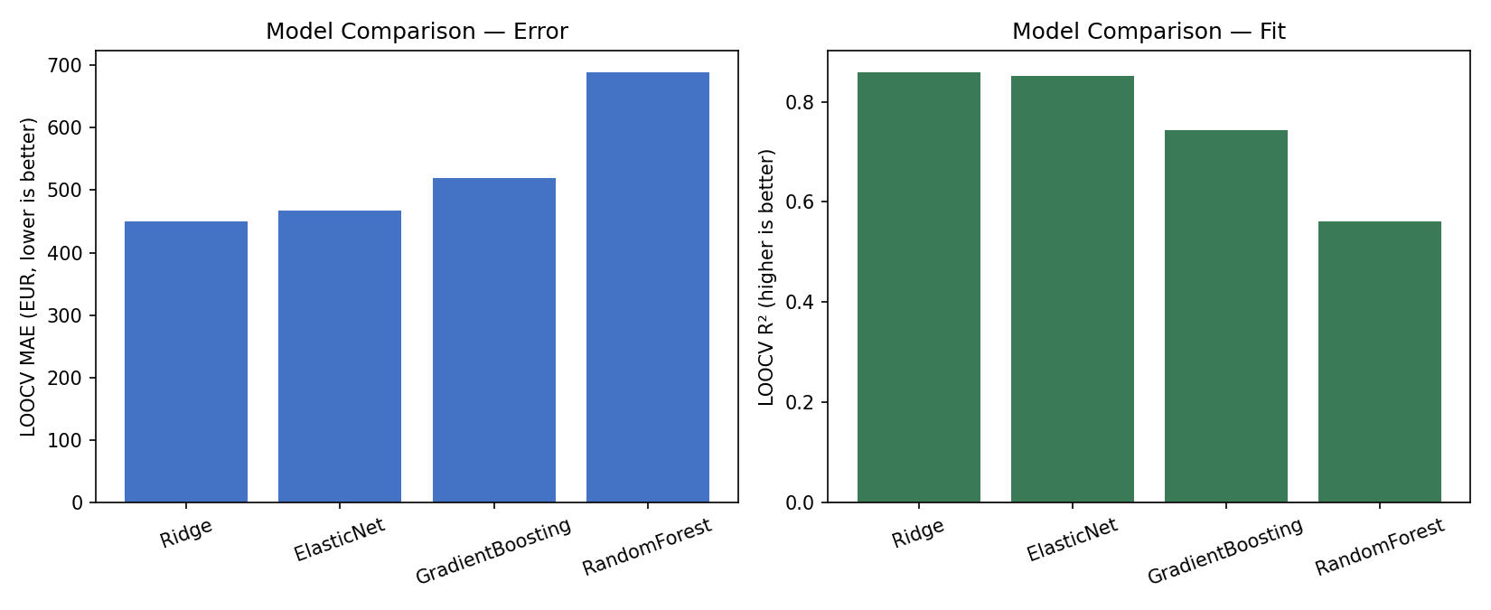
Figure 1. LOOCV error (left) and R² (right) across candidate models.
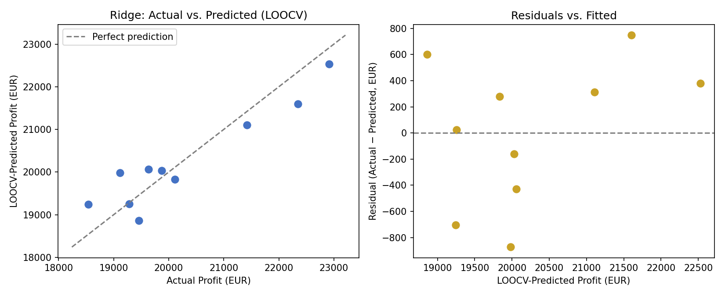
Figure 2. Actual vs. LOOCV-predicted profit (left) and residuals vs. fitted values (right) for the selected Ridge model.

4.2 Coefficient stability under bootstrap resampling
Of the eleven model terms, five were statistically distinguishable from zero at the 90% confidence level under 2,000 bootstrap resamples: milk quality index, market price, milk collection volume, and the cheese and butter product-type indicators. The remaining six terms — including electricity cost, demand gap, storage utilisation, transport cost, and capacity utilisation — had confidence intervals crossing zero, indicating their effects are not yet reliably estimable at n = 10.
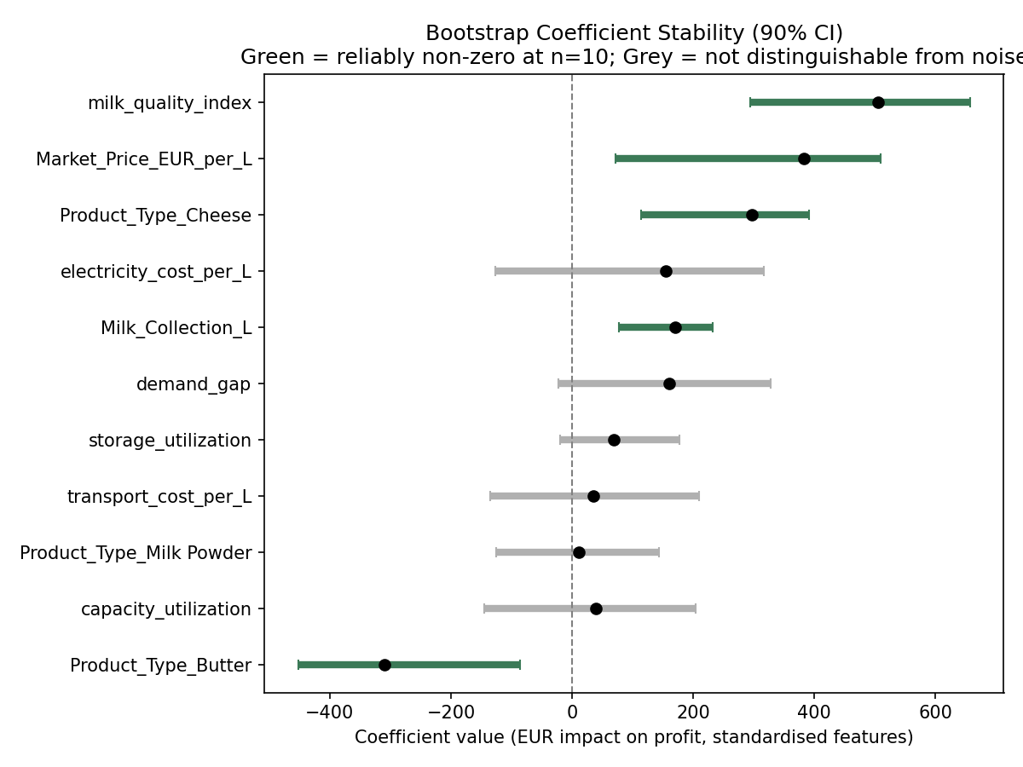
Figure 3. Bootstrap-resampled 90% confidence intervals for Ridge coefficients. Green markers denote effects reliably distinguishable from zero; grey markers do not.
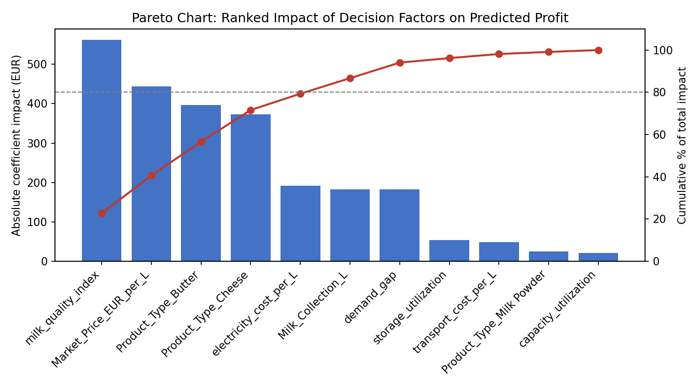
Figure 4. Pareto chart ranking decision factors by absolute impact on predicted profit, with cumulative-impact line — a standard quality-analysis-software visualisation adapted here to rank model drivers rather than defect causes.

4.3 Sensitivity analysis
One-at-a-time ±15% perturbation of each numeric feature (Figure 5) shows the predicted profit for the most recent day is most sensitive to milk quality index, electricity cost per litre, and market price, and comparatively insensitive to transport cost and demand gap — information directly actionable for operations staff deciding where to focus quality-control effort.
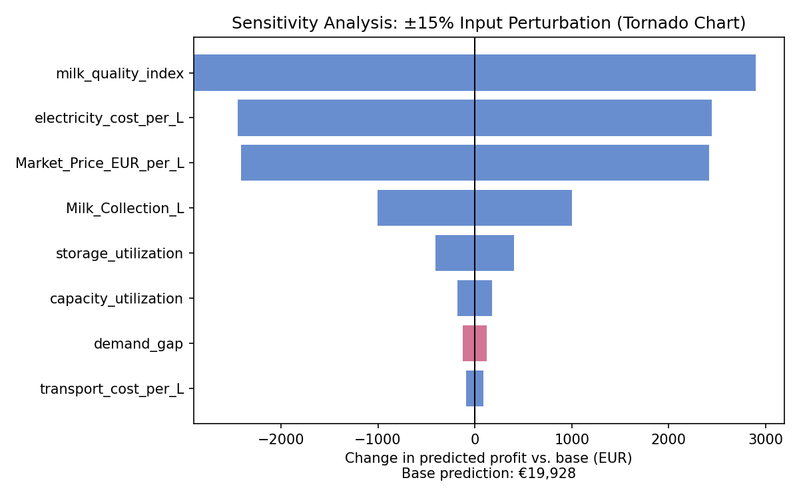
Figure 5. Tornado sensitivity chart: change in predicted profit under ±15% perturbation of each input, holding others fixed.

4.4 Decision engine and product recommendation
Applying the trained model to all ten historical days, the decision engine recommended cheese on every single day, including four days on which butter or milk powder was actually produced and profitable. This is discussed critically in Section 5 rather than presented as a validated finding: with only three to four observations per product type, the model has limited ability to learn how a given day's specific milk quality would have performed under a different product choice, and instead reflects cheese's higher average historical profitability in the sample.
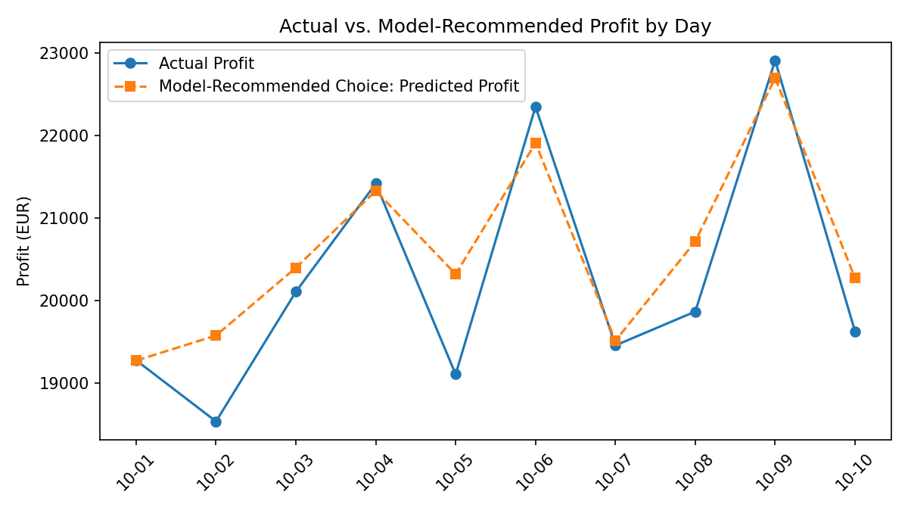
Figure 6. Actual realised profit vs. model-recommended-choice predicted profit, by day.
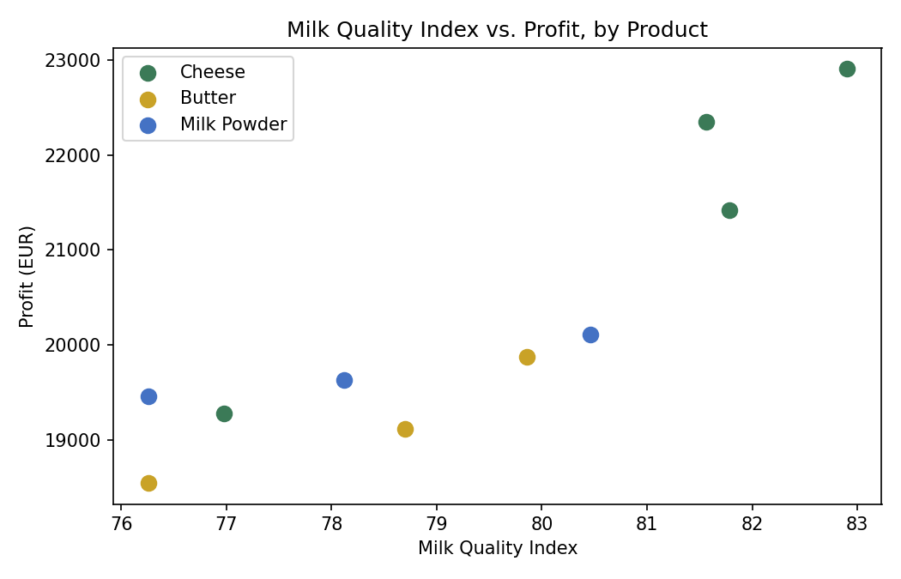
Figure 7. Milk quality index vs. realised profit, coloured by product type.
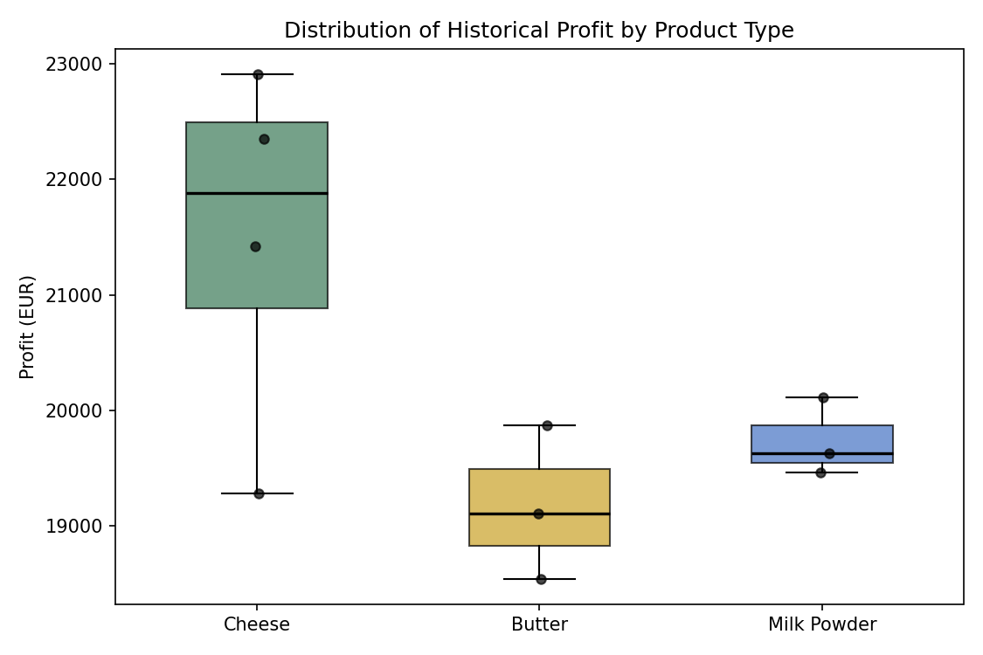
Figure 8. Distribution of historical profit by product type (box-and-whisker with individual observations overlaid).

4.5 Linear-programming multi-product allocation
For the most recent day's conditions, the LP model allocated 48,640 L to cheese and 32,360 L to milk powder, with zero allocation to butter and 45,400 L left unallocated — market demand, not milk supply or processing capacity, was the binding constraint. This result illustrates the LP layer answering a materially different question from the single-product decision engine: given the option to split production, demand-side constraints dominate the optimal allocation.
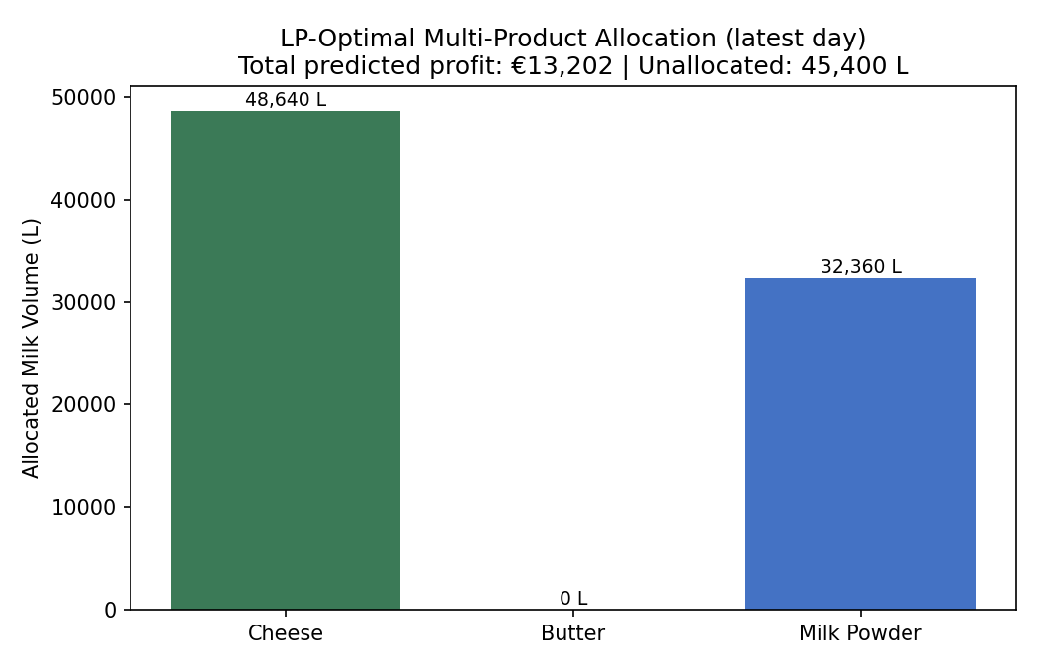
Figure 9. LP-optimal multi-product milk allocation for the most recent day, with total predicted profit and unallocated volume.

4.6 Monte Carlo risk simulation
Under 5,000 paired Monte Carlo simulations perturbing market price, milk quality, and electricity cost, cheese had the highest simulated mean profit (€20,271) and was the best choice in 100% of simulated scenarios for the tested day, with butter and milk powder never outperforming it under the modelled variability — consistent with, and reinforcing, the point-estimate recommendation in Section 4.4, while still subject to the same small-sample caveat.
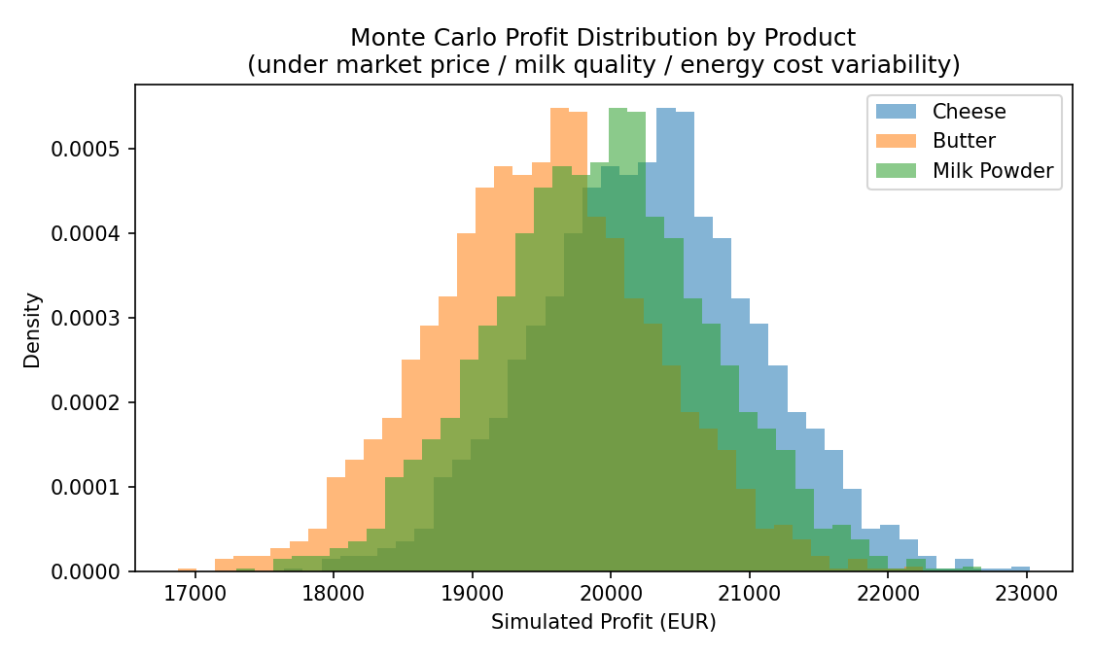
Figure 10. Monte Carlo simulated profit distributions by product under market price, milk quality, and energy cost variability.
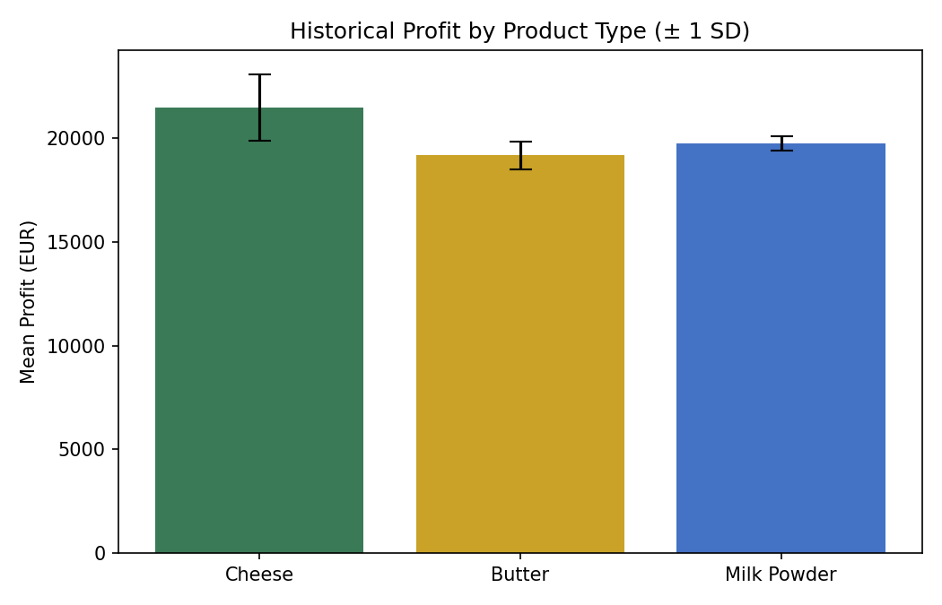
Figure 11. Historical mean profit by product type (± 1 SD).

4.7 Statistical process control and process capability of milk fat content
The I-MR control chart for milk fat content (Figure 12) shows all ten observations within statistically derived control limits, indicating a process in a state of statistical control over the observation window. Process capability analysis against illustrative specification limits of 3.5–4.6% (Figure 13) yielded Cp = 2.14 and Cpk = 1.11. The gap between Cp and Cpk indicates the process is not perfectly centred within its specification band — Cpk, which accounts for this off-centring, falls below the commonly used food-industry benchmark of 1.33, suggesting fat-content centring, not just spread, is a candidate target for process improvement (
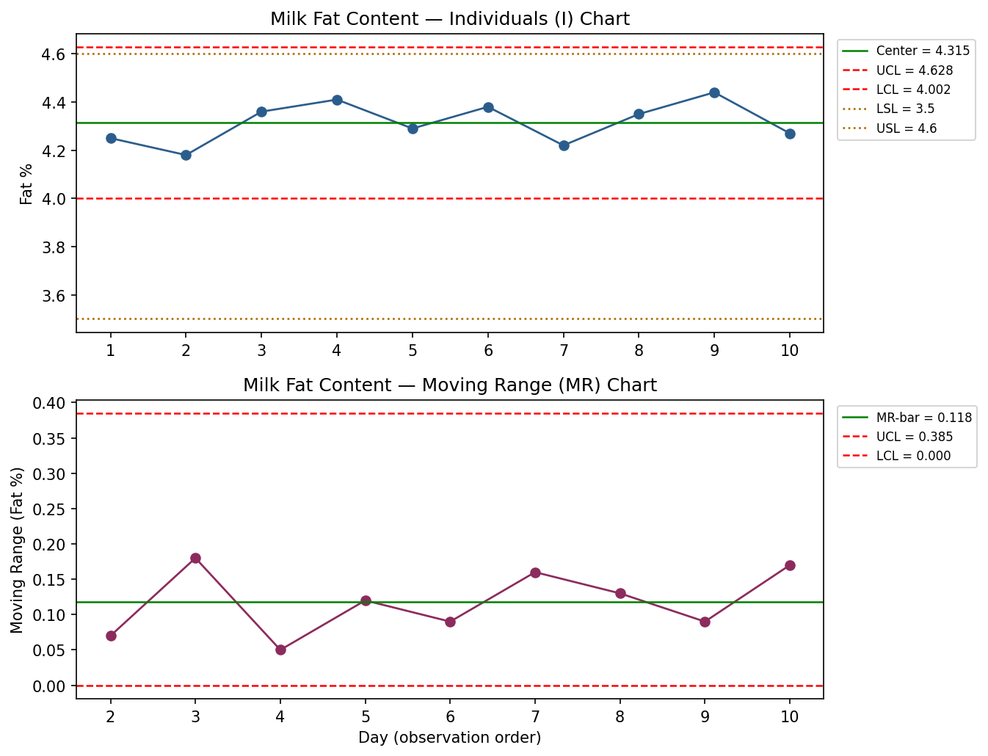
Figure 12. I-MR (Individual / Moving Range) control chart for milk fat content, following the SPC methodology of Punyapornwithaya et al. (2020).
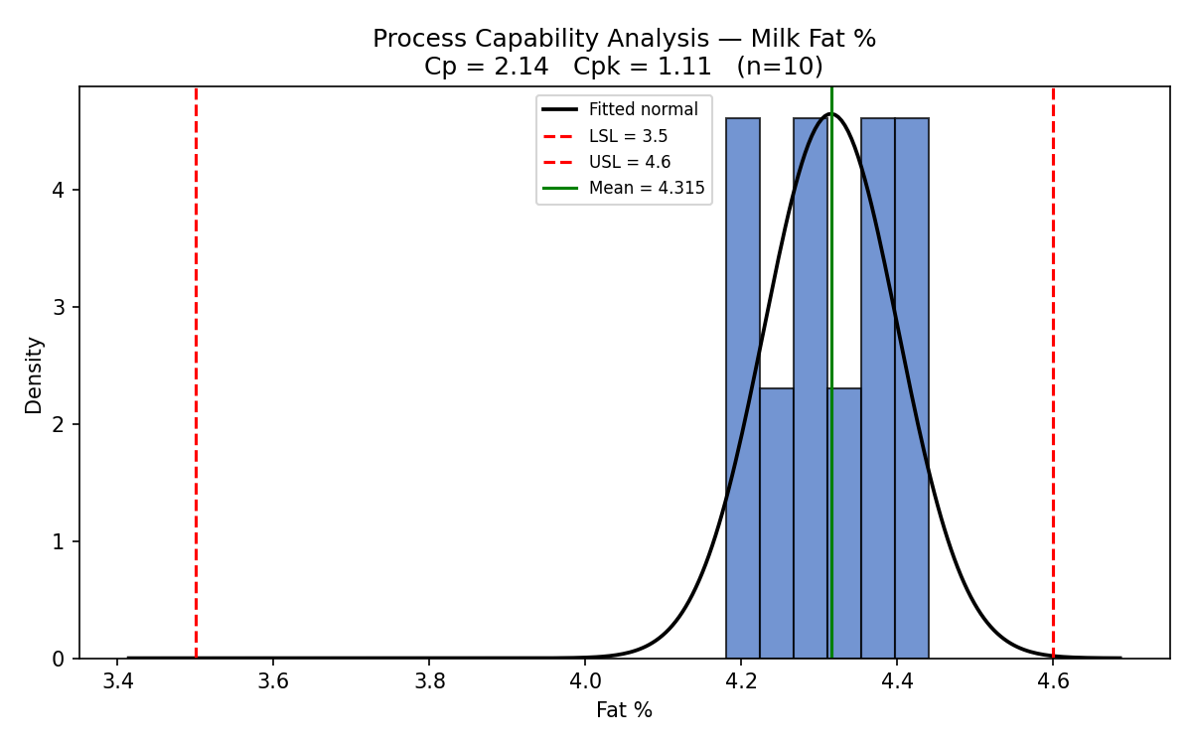
Figure 13. Process capability histogram for milk fat content with fitted normal curve, specification limits, and Cp/Cpk annotation.
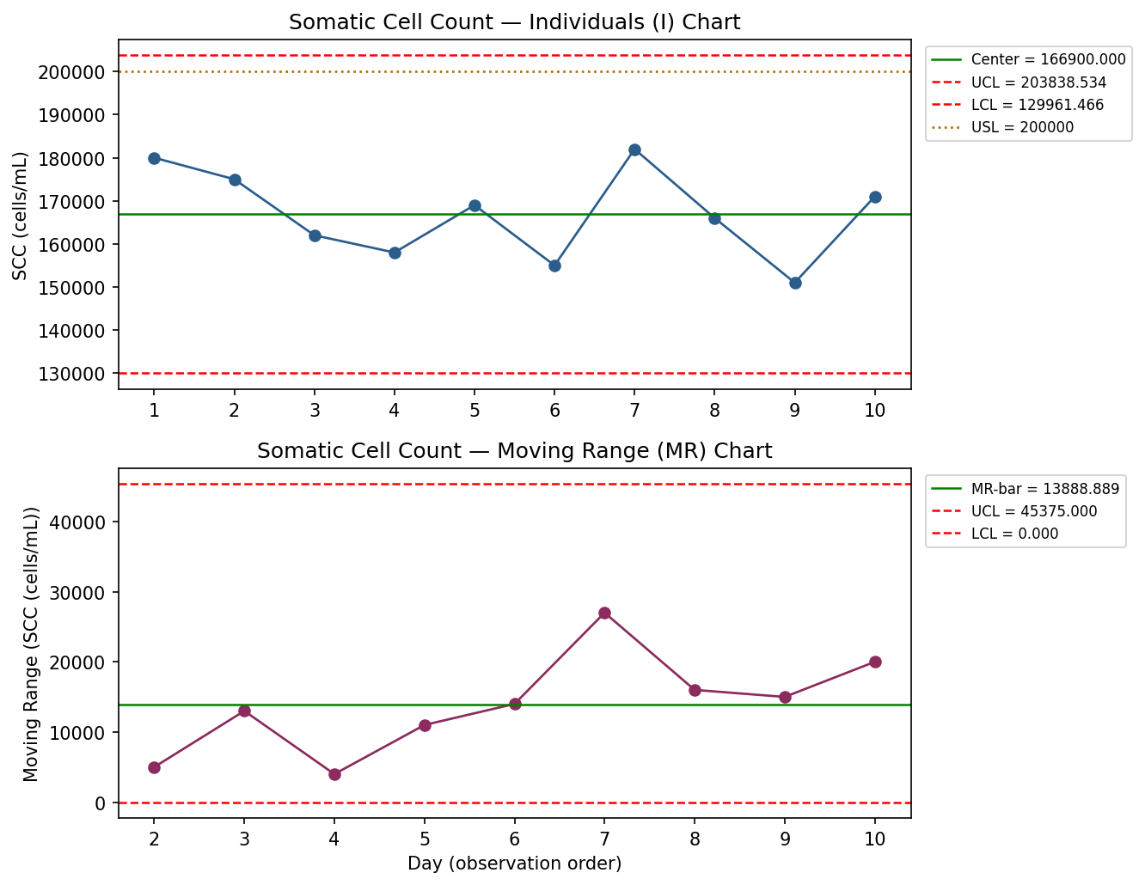
Figure 14. I-MR control chart for somatic cell count (SCC), an SPC application directly following smallholder dairy quality-monitoring precedent.
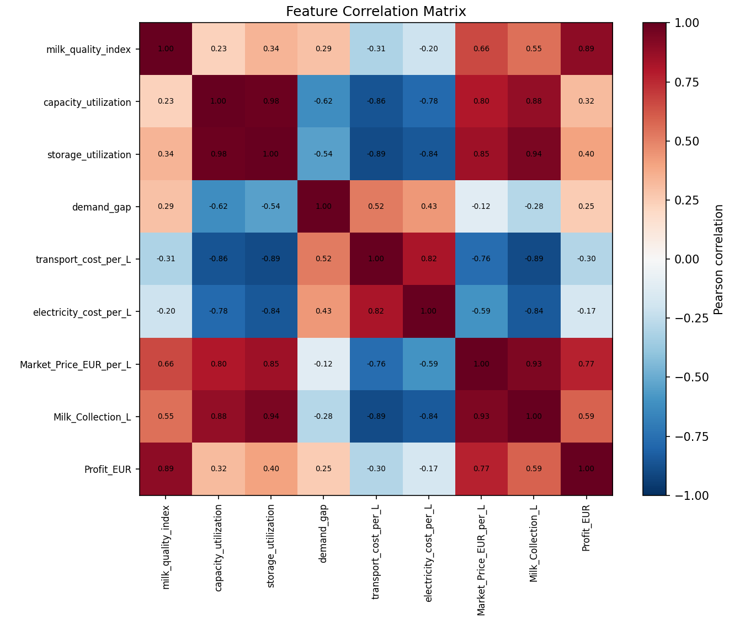
Figure 15. Full correlation matrix across all engineered features and profit.

4.8 Multicollinearity diagnostics (Variance Inflation Factors)
The bootstrap analysis in Section 4.2 identifies which coefficients are statistically distinguishable from zero, but a coefficient can be unstable for two distinct reasons: genuine sampling noise at n = 10, or multicollinearity among the features themselves, which inflates coefficient variance independently of sample size. Variance Inflation Factors (VIF) were computed for each of the eight numeric features by regressing each on the remaining seven and taking VIF = 1 / (1 - R²). VIF exceeding 5 is a commonly used threshold for moderate concern and 10 for severe concern (Table 2, Figure 16).
Feature | VIF | Flag
Milk_Collection_L | 280.61 | severe
storage_utilization | 260.25 | severe
capacity_utilization | 109.09 | severe
Market_Price_EUR_per_L | 75.51 | severe
electricity_cost_per_L | 29.84 | severe
transport_cost_per_L | 14.85 | severe
demand_gap | 11.23 | severe
milk_quality_index | 5.72 | moderate
Table 2. Variance Inflation Factors for the eight engineered numeric features.
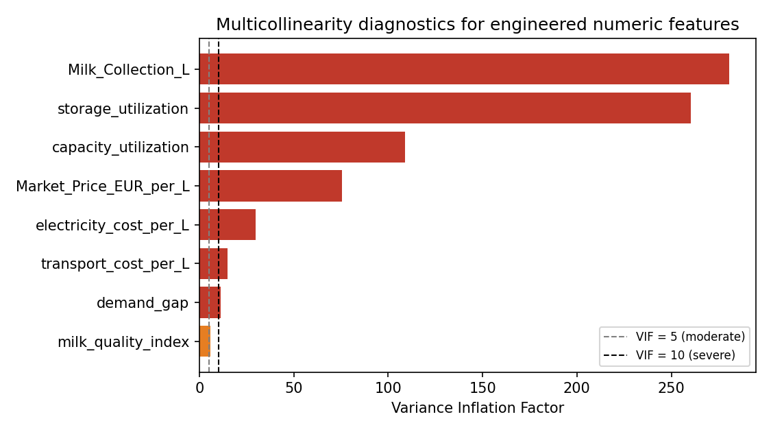
Figure 16. Multicollinearity diagnostics: VIF by feature, with moderate (5) and severe (10) reference lines.
Every feature exceeds the moderate-concern threshold, and seven of eight exceed the severe threshold, which is expected rather than alarming at n = 10: capacity, storage, and transport variables are engineered from overlapping raw quantities (e.g. both capacity_utilization and storage_utilization scale with Milk_Collection_L), so they necessarily co-vary. This result sharpens, rather than contradicts, the bootstrap findings in Section 4.2: the six coefficients whose confidence intervals crossed zero are drawn from exactly the pool of features shown here to be severely collinear, meaning their instability likely reflects redundant information rather than an absence of any true effect. It also means the five statistically distinguishable coefficients (milk quality index, market price, milk collection volume, and the cheese/butter indicators) should be interpreted as effects of a correlated cluster of operating conditions rather than fully independent, isolable drivers -- a caveat the paper did not previously make explicit.

4.9 Principal component structure of the engineered feature set
As an independent cross-check on the VIF result, Principal Component Analysis (PCA) was applied to the standardised numeric feature matrix. If the features were largely independent, explained variance would be spread evenly across components; if they are redundant, as Section 4.8 suggests, a small number of components should capture most of the variance.
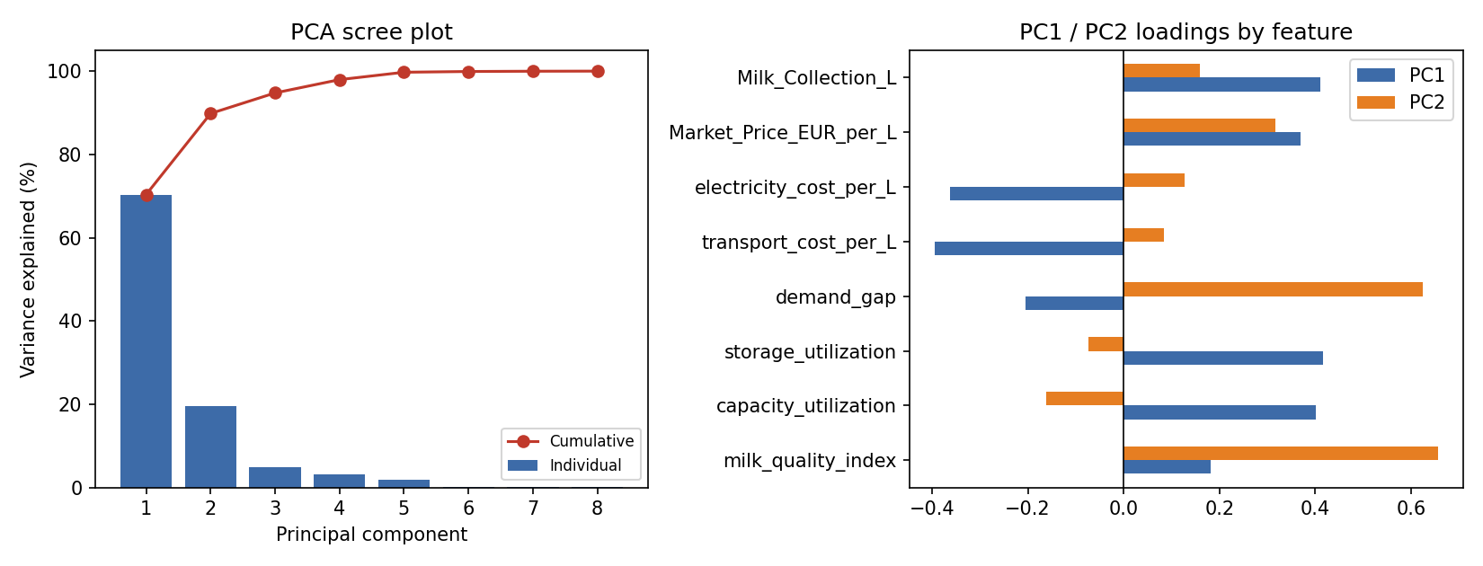
Figure 17. PCA scree plot (left) and PC1/PC2 loadings by feature (right).
The first two principal components jointly explain 89.9% of total variance (70.4% and 19.5% respectively), confirming that the eight engineered features reduce to an effectively two- to three-dimensional signal at this sample size. PC1 loads most heavily on Milk_Collection_L, capacity_utilization, and storage_utilization in the same direction, consistent with these three being near-duplicate scalings of collected milk volume identified in Section 4.8. This reinforces the practical implication for scaling the framework (Section 6): future feature engineering should prioritise decorrelating or consolidating the volume-related features before the model is retrained on a production-length dataset, rather than simply adding more days of data under the current feature set.

4.10 Full-horizon linear-programming re-allocation
Section 4.5 reported the LP-optimal allocation for a single day. To assess whether that day was representative, the same LP model (Section 3.4) was re-solved independently for all ten days, using margins and demand shares estimated once from the full dataset (Figure 18).
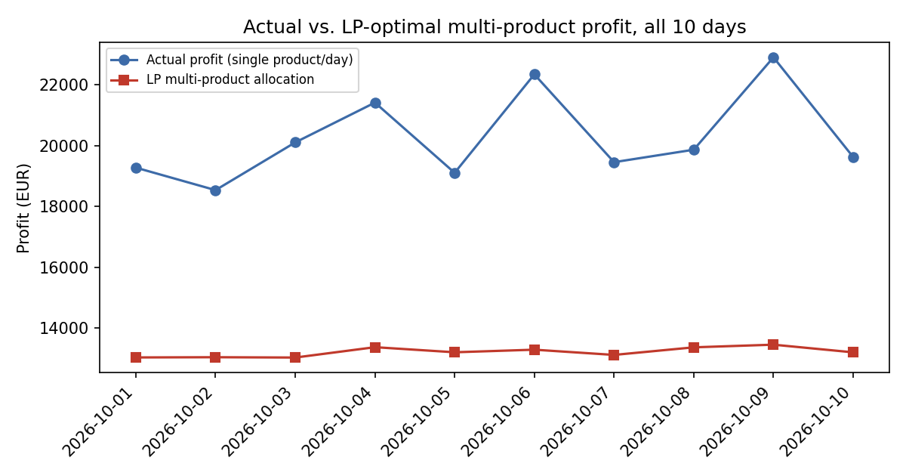
Figure 18. Actual single-product profit vs. LP-optimal multi-product allocation profit, all ten days.
Two findings emerge that were not visible from the single-day result alone. First, market demand is the binding constraint on every one of the ten days, not only the most recent one: 41,000-50,200 L are left unallocated daily, and butter receives a zero allocation throughout the window because its demand share is consistently dominated by cheese and milk powder. Second, and more importantly, the LP's total predicted profit (EUR 13,031-13,455/day, using each product's historical average margin per litre) is consistently below the plant's actual realised profit (EUR 18,540-22,910/day) on every single day. This is not evidence that the plant is behaving sub-optimally; rather, it exposes a modelling artefact worth reporting transparently: the LP objective blends each product's margin across the whole window, including days on which that product was not actually run, whereas the actual profit figures reflect a single, conditions-matched product choice per day. The LP layer therefore currently answers "how should litres be split under average historical margins" rather than "what is the best attainable profit", and the two should not be compared at face value without first re-expressing margins conditionally on each day's specific milk quality -- a refinement noted in Section 6.

4.11 Tail risk: Value-at-Risk and Conditional Value-at-Risk
Section 4.6 summarised the Monte Carlo profit distributions by mean and probability of being the best choice. Because a decision-maker concerned with downside risk cares about the shape of the lower tail, not just the mean, 95% Value-at-Risk (VaR, the 5th percentile of simulated profit) and 95% Conditional Value-at-Risk (CVaR, the mean of all simulated outcomes at or below the VaR threshold) were computed for each product (Table 3, Figure 19).
Product | VaR 95% (EUR) | CVaR 95% (EUR)
Cheese | 18,977.23 | 18,657.34
Butter | 18,207.83 | 17,887.94
Milk Powder | 18,629.63 | 18,309.74
Table 3. 95% Value-at-Risk and Conditional Value-at-Risk of simulated profit by product.
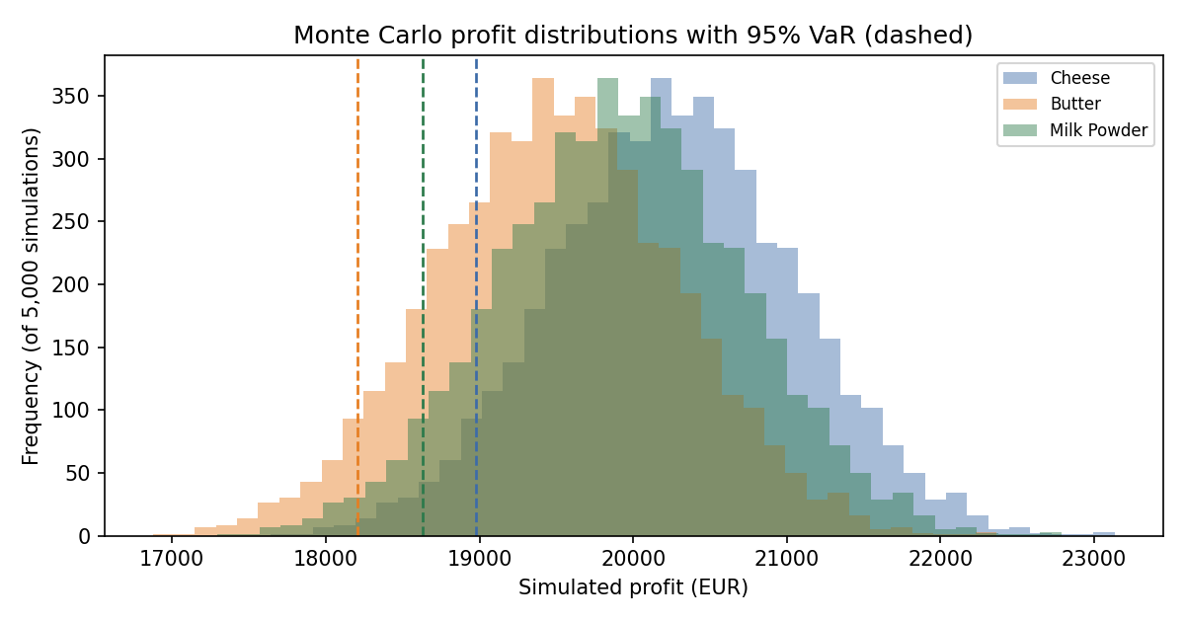
Figure 19. Monte Carlo profit distributions with 95% VaR marked (dashed).
Cheese retains the highest VaR and CVaR, meaning its advantage over butter and milk powder holds not just on average (Section 4.6) but also in the worst 5% of simulated scenarios -- the gap between cheese's and butter's CVaR (EUR 769) represents the minimum downside-scenario profit sacrifice of choosing butter under the modelled variability. The VaR/CVaR gap is modest in absolute terms for all three products, which is itself informative: it indicates the Monte Carlo simulation's assumed variability (historical standard deviations of price, quality, and energy cost) does not, on its own, generate scenarios severe enough to reverse the ranking, and that a genuine stress test would need to explore variability beyond what ten days of history can characterise.

4.12 Permutation feature importance
As a cross-check on the bootstrap coefficient analysis (Section 4.2) that does not rely on the model's internal coefficient structure, permutation importance was computed for the selected Ridge model: each feature is independently shuffled and the resulting increase in mean absolute error is recorded (200 repeats per feature).
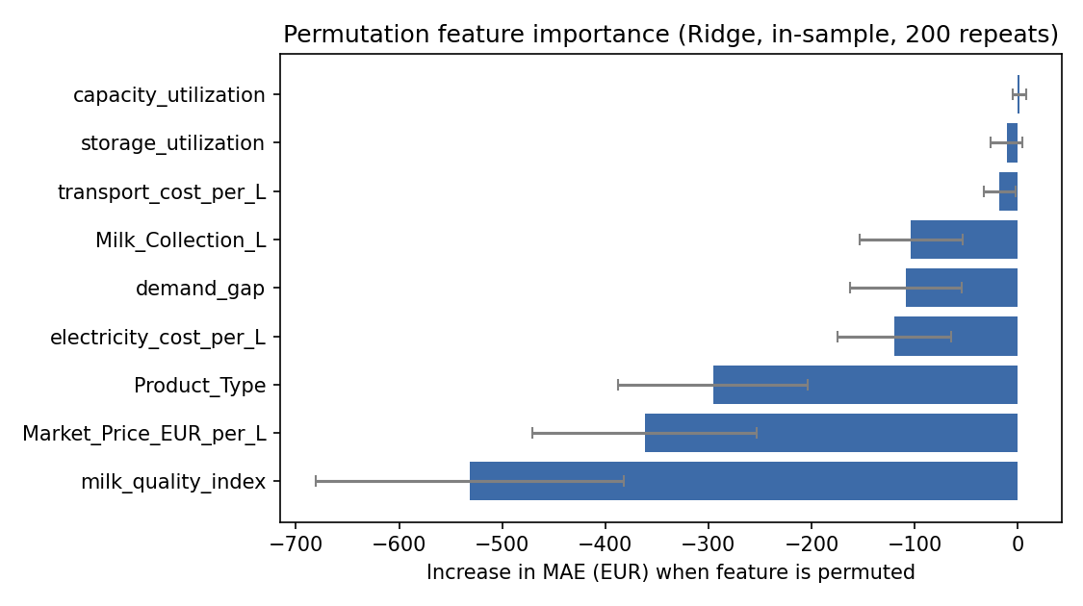
Figure 20. Permutation feature importance for the Ridge model (mean MAE increase, 200 repeats; error bars = 1 SD).
Milk quality index, Product_Type, and market price are the three most important features by a wide margin, agreeing with the bootstrap-significant terms in Section 4.2 and providing convergent evidence from an entirely different diagnostic method. Capacity utilisation shows a slightly negative mean importance, and storage utilisation and transport cost per litre are also negative, meaning permuting these features occasionally reduced apparent error rather than increasing it. This is a known small-sample artefact rather than evidence the feature is harmful, and it corroborates rather than contradicts Section 4.8's finding that these particular features are severely collinear with Milk_Collection_L: with n = 10, a permuted, redundant feature can be substituted for by its correlated counterparts already in the model, muting or even mildly reversing its apparent contribution.

4.13 Two-way interaction sensitivity
The one-at-a-time tornado analysis (Section 4.3, Figure 5) perturbs each input independently and therefore cannot show whether two inputs interact -- for example, whether the effect of milk quality on profit depends on the prevailing market price. Predicted profit for cheese was therefore mapped across a joint grid of milk quality index and market price, each spanning ±2 historical standard deviations around the most recent day's values, holding all other features fixed (Figure 21).
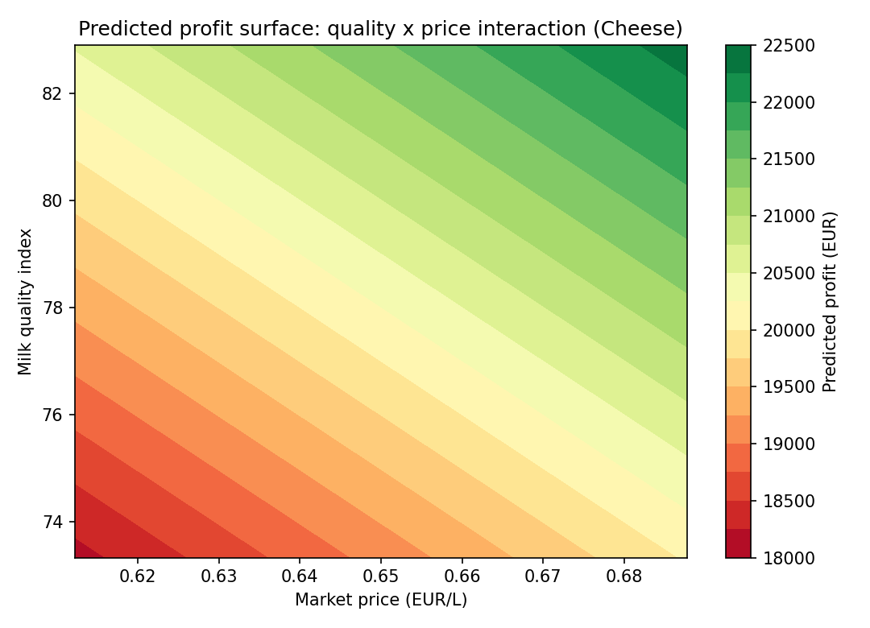
Figure 21. Predicted profit surface for cheese across jointly varying milk quality index and market price.
The response surface is close to additively separable over most of the grid -- contour lines run roughly diagonally with fairly constant spacing -- indicating the Ridge model's linear specification has not introduced a strong artificial interaction effect between these two variables, which is a reassuring internal-consistency check given that Ridge, by construction, only models an interaction if one is explicitly engineered as a feature (none was, for milk quality x price). The steepest profit gradient runs along the price axis at low-to-moderate milk quality, suggesting that on days of below-average milk quality, the plant's profit outcome is comparatively more exposed to market price movements than on high-quality days -- a nuance the one-at-a-time tornado chart in Section 4.3 could not surface.

4.14 Statistical significance of the model comparison
Table 1 ranks Ridge above Elastic Net by LOOCV MAE (EUR 450.68 vs. EUR 467.53), a difference of EUR 16.85. At n = 10, it is important to check whether this ranking reflects a genuine difference or noise from a single leave-one-out fold. Paired tests (paired t-test and Wilcoxon signed-rank, both on the ten paired absolute LOOCV errors) were used because the two models are evaluated on the identical ten held-out points, making a paired rather than independent-samples test appropriate (Table 4).
Test | Statistic | p-value
Paired t-test | 2.25 | 0.051
Wilcoxon signed-rank | 9.0 | 0.065
Table 4. Paired significance tests comparing Ridge and Elastic Net absolute LOOCV errors (n = 10 paired observations).
Both tests place the Ridge-vs-Elastic-Net gap just outside conventional 5% significance (p = 0.051 and p = 0.065), meaning Ridge's advantage in Table 1, while directionally consistent across nearly every held-out day, cannot yet be distinguished from sampling noise with full statistical confidence at this sample size. This does not overturn the choice of Ridge as the selected model -- it remains the best point estimate on every metric reported -- but it is a materially more honest characterisation than Table 1's ranking alone conveys, and it strengthens rather than weakens the paper's central argument that any single-model recommendation at n = 10 should be reported alongside its own uncertainty.

5. Discussion
The results demonstrate that a statistically disciplined decision-support pipeline can be built and usefully interrogated even on a very small operational dataset, provided the pipeline is designed to report its own uncertainty rather than present point estimates as settled fact. This aligns with Burke and Southern's (2024) observation that the primary barrier to dairy quality decision-making is not data collection but data interpretation: the same ten-day dataset used naively (a single trained model with no cross-validation, no bootstrap, and no capability analysis) would have produced an equally confident-looking but far less trustworthy "always recommend cheese" answer, with no visible signal that this conclusion rested on a thin evidence base.
The LP allocation layer and the single-product decision engine are complementary rather than redundant, echoing Usigbe et al.'s (2025) argument that optimisation frameworks are most useful to practitioners when they expose trade-offs explicitly rather than collapsing a decision to a single recommended number. Here, the LP result revealed that market demand — not the milk-quality-driven profit model — was the binding constraint for the tested day, a finding the single-product decision engine could not have surfaced on its own.
The SPC and capability analysis (Section 4.7) illustrates a further benefit of combining predictive and traditional quality-engineering methods within one decision-support framework: a Cpk of 1.11 for milk fat content, while indicating an in-control process, falls short of the 1.33 threshold conventionally used in food manufacturing (Advantive, 2025), pointing toward process-centring interventions upstream of the profit-prediction model entirely — a class of recommendation the predictive/optimisation components of the system are not designed to make.

6. Limitations
The central limitation of this study is sample size: ten daily observations, split across three product types, is sufficient to demonstrate the DSS architecture but not sufficient to treat its specific recommendations (cheese as the uniformly best choice) as validated operational guidance. The bootstrap analysis in Section 4.2 makes this limitation explicit and falsifiable rather than hiding it inside a single confident point estimate; six of eleven model terms did not reach statistical distinguishability from zero at this sample size. The specification limits used in the process capability analysis (Section 4.7) are illustrative rather than sourced from a specific regulatory or contractual standard, and should be replaced with plant-specific limits before the capability figures are used operationally. Finally, the LP allocation model assumes per-litre margins and demand shares are stable across the planning horizon; this assumption should be revisited as more data becomes available. Section 4.10's full-horizon comparison shows this assumption is not merely theoretical: the LP's blended-margin objective under-predicts actual realised profit on all ten days, so the LP layer should currently be read as an allocation-pattern diagnostic rather than a profit forecast in its own right. Similarly, the multicollinearity documented in Section 4.8 means the bootstrap-significant coefficients in Section 4.2 are better interpreted as a correlated cluster of operating conditions than as independently identified causal effects, a distinction that should inform how the model's coefficients are communicated to plant operators.

7. Conclusion
This paper presented an integrated decision-support model for dairy processing that combines cross-validated model selection, bootstrap uncertainty quantification, linear-programming production planning, Monte Carlo risk simulation, and statistical process control into a single reproducible pipeline. Applied to ten days of operational data, the system identified Ridge regression as the best-performing predictive model, quantified which decision factors are statistically reliable at this sample size, and surfaced a capability gap in milk fat content control that a purely predictive approach would not have revealed. The system's own diagnostics indicate that its current day-to-day product recommendations should be treated as provisional pending a larger training dataset — a conclusion the framework was specifically designed to be able to reach and report.
References
Advantive. (2025). Process capability (Cp) and performance (Cpk). Retrieved from https://www.advantive.com/solutions/spc-software/spc-chart-guide/process-capability-index-cp/
Balhara, S., Singh, R. P., & Ruhil, A. P. (2021). Data mining and decision support systems for efficient dairy production. Veterinary World, 14(5), 1258–1262. https://doi.org/10.14202/vetworld.2021.1258-1262
Burke, N., & Southern, M. (2024). Optimising the quality management system in dairy processing. In S. Z. Qamar & N. Al-Hinai (Eds.), Quality Control and Quality Assurance – Techniques and Applications. IntechOpen. https://doi.org/10.5772/intechopen.114055
Dantzig, G. B. (1963). Linear programming and extensions. Princeton University Press.
Efron, B., & Tibshirani, R. J. (1994). An introduction to the bootstrap. Chapman & Hall/CRC.
Hoerl, A. E., & Kennard, R. W. (1970). Ridge regression: Biased estimation for nonorthogonal problems. Technometrics, 12(1), 55–67. https://doi.org/10.1080/00401706.1970.10488634
Metropolis, N., & Ulam, S. (1949). The Monte Carlo method. Journal of the American Statistical Association, 44(247), 335–341. https://doi.org/10.1080/01621459.1949.10483310
Punyapornwithaya, V., Sansamur, C., Singhla, T., & Vinitchaikul, P. (2020). Application of statistical process control for monitoring bulk tank milk somatic cell count of smallholder dairy farms. Veterinary World, 13(11), 2429–2435. https://doi.org/10.14202/vetworld.2020.2429-2435
SafetyChain. (2025). Process capability metrics & why they matter. Retrieved from https://safetychain.com/blog/process-capability-metrics
Usigbe, M. J., Uyeh, D. D., Park, T., Ha, Y., & Mallipeddi, R. (2025). Many objective optimization and decision support for dairy cattle feed formulation. Scientific Reports, 15, Article 13451. https://doi.org/10.1038/s41598-025-96633-z

