Multitask Singularity Regression Kriging for Spatio-Temporal Mapping of Soil NPK Dynamics, Crop Stress, and Yield Prediction in Precision Agriculture
A Deep-Analysis GeoAI Study with Geostatistical, Machine-Learning, and Decision-Support Extensions
Naziru Halilu
Universidade de Tras-os-Montes e Alto Douro (UTAD) -- GIS, Remote Sensing and Precision Agriculture Research

Abstract
Regression kriging couples a data-driven trend model with geostatistical interpolation of residuals, but standard implementations treat each agronomic response variable independently, use a fixed single-scale notion of spatial context, and rarely report the deeper geostatistical diagnostics (spatial autocorrelation, variogram-model adequacy, uncertainty calibration) needed to trust a management map. This paper develops and rigorously interrogates Multitask Singularity Regression Kriging (MSRK), a GeoAI framework that (i) engineers a multiscale local singularity index, alpha_k(s), for every task from local-singularity/multifractal theory; (ii) trains a shared multi-output Random Forest trend model across correlated agronomic tasks; and (iii) krigs the resulting residuals per task and, for repeated sampling, per date. We instantiate and stress-test MSRK on real precision-agriculture data from three linked University field practicals at UTAD: a dense 16.85-hectare Coimbra-region maize grid (n=17,864; yield, an NPK fertiliser-prescription estimate, soil pH, and a lime (CaCO3) prescription estimate), a 6-hectare vineyard Brix/NDVI ripening-stress monitoring programme at Quinta de Nossa Senhora de Lurdes (68 stations x 5 dates), a 35,448-row auxiliary soil-chemistry workbook, and a 42.97-hectare grape-moth (Lobesia botrana) integrated-pest-management (IPM) planning dataset at Quinta da Senhora da Graca. Five explicit research questions (RQ1-RQ5) structure the analysis. We report global Moran's I spatial-autocorrelation statistics (I=0.72-0.98, all p<0.001), fit and compare spherical, exponential and Gaussian variogram models (nugget, sill, range) and their directional (anisotropic) behaviour, run a leakage-controlled 5-fold spatial cross-validation of six competing estimators with fold-level variability, quantify a sensitivity surface over the singularity-index radius bank, compute out-of-fold permutation importance, contrast SRK against RFK residual-kriging uncertainty on a 1,600-cell prediction grid and a full 3-D trend surface, summarise all methods and tasks jointly on multi-metric radar charts, run residual diagnostics (Q-Q, spatial-lag), and perform a PCA of the soil-chemistry covariate space. We show, and explain mechanistically, that ordinary kriging alone is close to optimal for the smoothest, most autocorrelated fields (soil pH, CaCO3; Moran's I approx. 0.98), while the singularity/multitask machinery earns its complexity primarily through a 20% reduction in residual-kriging uncertainty (variance) rather than through headline R2 gains, and that this benefit is contingent on adequate station density in the spatio-temporal setting. We additionally uncover and document the deterministic quadratic prescription equations underlying the NPK and CaCO3 covariates, verified directly against the source field report, which is what produces the near-perfect (|rho| approx. 0.99-1.00) cross-task correlations we control for throughout. All code, data-derived figures (22), and results tables are released.
Keywords: precision agriculture; GeoAI; singularity theory; regression kriging; random forest; multitask learning; spatio-temporal geostatistics; Moran's I; variogram modelling; permutation importance; soil NPK; crop stress; yield prediction

1. The Big Questions This Study Answers
Rather than pursue accuracy maximisation alone, this study is organised around five research questions (RQ1-RQ5) that matter for anyone deciding whether to adopt a singularity-augmented, multitask, spatio-temporal regression-kriging pipeline in an operational precision-agriculture programme. Each is answered explicitly, with quantitative evidence, in Section 9.
- RQ1 -- Does engineering a multiscale local singularity index as a trend-model feature improve spatial prediction accuracy for agronomic variables beyond what plain kriging, IDW, or a Random Forest without singularity features already achieve, and if so, under what conditions?
- RQ2 -- Where does a shared multitask trend model (jointly predicting yield, NPK, pH and CaCO3) add value relative to single-task models, and where is it neutral or counter-productive because the tasks are themselves near-deterministic transforms of one another?
- RQ3 -- Does the singularity/multitask machinery reduce prediction uncertainty (kriging variance), even in the cases where it does not improve point-prediction R2 -- i.e., is there a risk-management case for SRK distinct from the accuracy case?
- RQ4 -- Does extending the singularity index and residual kriging into the space-time domain improve spatio-temporal crop-stress (Brix) prediction, and what minimum station density is required before the residual-kriging component adds value over the trend model alone?
- RQ5 -- What do rigorous geostatistical diagnostics (Moran's I, variogram-model comparison, sensitivity analysis, residual normality) reveal about when a farm manager should trust a kriged surface at all, independent of which trend model produced it?

2. Introduction
Precision agriculture increasingly relies on dense, georeferenced sensor and sampling networks -- yield monitors, soil grid sampling, canopy reflectance indices, and destructive quality assays such as Brix -- to characterise within-field variability (Mulla, 2013). Turning these point observations into wall-to-wall management maps is fundamentally a spatial (and, for repeated sampling, spatio-temporal) prediction problem. Two complementary traditions address it: geostatistics, which exploits spatial autocorrelation through variograms and kriging (Matheron, 1963; Cressie, 1993; Journel & Huijbregts, 1978; Isaaks & Srivastava, 1989; Goovaerts, 1997; Webster & Oliver, 2007); and machine learning, which exploits nonlinear covariate relationships but is blind to residual spatial structure unless it is explicitly reintroduced. Regression kriging (RK) hybridises the two: a trend model (historically a linear model, more recently Random Forest -- 'RFsp') absorbs the covariate-driven signal, and ordinary kriging of the residuals recovers the remaining spatial autocorrelation (Hengl et al., 2007; Hengl et al., 2018; Breiman, 2001).
A separate line of work in exploratory geochemistry -- local singularity analysis -- characterises how the local density of a variable scales with the size of the neighbourhood used to measure it (Cheng, 1999; Cheng & Agterberg, 2009). Areas of anomalous enrichment or depletion exhibit a local scaling (singularity) exponent that departs from the theoretical background value of 2 (in two-dimensional space), and this exponent has proved to be a powerful, scale-explicit covariate for downstream spatial models, including recent regression-kriging hybrids that fuse singularity-derived features with a Random Forest trend and residual ordinary kriging for geochemical mapping. This paper adapts that idea to precision agriculture and extends it along three axes: multitask sharing across correlated agronomic variables; an explicit space-time singularity index for repeated-measures crop-stress monitoring; and, distinctively, a battery of geostatistical and machine-learning diagnostics -- global spatial autocorrelation, variogram-model comparison, sensitivity analysis, out-of-fold permutation importance, uncertainty quantification, and residual diagnostics -- that most applied regression-kriging papers omit but that determine whether a practitioner should trust the resulting map.
The data underlying this study come from three linked University field practicals conducted under the supervision of Prof. Jose Tadeu Marques Aranha at the Universidade de Tras-os-Montes e Alto Douro (UTAD): an integrated geospatial and statistical analysis of the Coimbra_Corn maize project (Halilu, 2026a), a Brix/NDVI ripening-stress monitoring programme at Quinta de Nossa Senhora de Lurdes (QTNS_Lurdes) in Folhadela, Vila Real (Halilu, 2026b), and a GIS-based grape-moth (Lobesia botrana) monitoring and mating-disruption planning exercise at Quinta da Senhora da Graca, Peso da Regua, in the Douro Demarcated Region (Halilu, 2026c). Reading these source reports closely -- rather than treating the accompanying spreadsheets as anonymous tabular data -- turns out to matter methodologically: Section 3.4 shows that two of the four corn-field response variables are themselves deterministic quadratic prescriptions derived from the other two, a fact stated explicitly in the source report (Halilu, 2026a) and independently re-discovered here via a correlation and leakage analysis (Section 6.1) before we located the confirming text. This cross-validation between an independent statistical audit and the source documentation is, we believe, a useful methodological habit for anyone re-using third-party agronomic spreadsheets.

3. Study Area, Data, and Provenance

3.1 Coimbra_Corn project -- maize field
Coimbra is a major agricultural district in central Portugal with a Mediterranean climate showing Atlantic influence: mean annual temperature 15-17 C, summer maxima routinely above 30 C, and annual rainfall of 800-1,200 mm concentrated October-April (Halilu, 2026a). The CORN-Coimbra project grid covers a maize field of 16.85 ha, sampled at n=17,864 georeferenced points (UTM) recording corn yield (CORN_KG_M2, kg m-2), soil pH (ph_1), and two management-prescription layers described in Section 3.4 below (NPK_est and CaCO3_Est). GPS-enabled field devices were used for point navigation and to reduce transcription error during data capture (Halilu, 2026a)

3.2 Quinta de Nossa Senhora de Lurdes -- vineyard Brix/NDVI monitoring
QTNS_Lurdes is a vineyard property of approximately 6 ha in Folhadela, Vila Real, georeferenced in WGS84 UTM Zone 29N (Halilu, 2026b; Aranha, 2026). Canopy Brix (degrees Bx, a refractometer-based proxy for sugar accumulation and, inversely, ripening/water stress) was recorded at 68 fixed stations on five dates spanning the 2026 ripening season (15 Jul, 30 Jul, 06 Aug, 15 Aug, 30 Aug; day-of-year 196-242), alongside a single-date NDVI value per station (Rouse et al., 1974). The source report documents the standard 1 deg Bx approx. 0.55 deg alcohol conversion (i.e. 25.5 deg Bx implies approximately 14% alcohol) and compares Thiessen-polygon, IDW, and (in this paper) regression-kriging interpolation of the resulting surfaces (Halilu, 2026b)

3.3 Quinta da Senhora da Graca -- grape-moth IPM planning
Quinta da Senhora da Graca is located near Peso da Regua in the Douro Demarcated Region and occupies 42.97 ha (429,690.52 m2) across 11 grape varieties, on schist-derived soils under steep terraced topography (Halilu, 2026c). The practical developed a land-use inventory and a mating-disruption (sexual-confusion pheromone) deployment plan against the European grapevine moth, Lobesia botrana, one of the most economically significant vineyard pests in European viticulture (EPPO Global Database, 2015), using BIOOtwin(R) L pheromone diffusers and a network of 25 delta traps (unit cost EUR3.20, installed at four traps per labour-hour) to monitor principal flight periods (Halilu, 2026c). We use this dataset as a decision-support layer (Section 8.6) rather than as spatial model input, since it records variety-block planning quantities rather than georeferenced trap counts.

3.4 A critical data-provenance finding: prescription equations, not independent measurements
The source corn report (Halilu, 2026a) documents that both auxiliary corn-field covariates used in this study are themselves regression-derived management prescriptions, not independently measured soil properties. The lime (CaCO3) prescription was fitted against fifteen benchmark soil-pH/lime-requirement pairs (Table 6.5 of (Halilu, 2026a)) as a quadratic regression with R2=0.9979:
$$CaCO_{3}_Est\left(pH\right)=3419.5 pH^{2}−42630 pH+132738$$ (1)
and the NPK fertiliser prescription was fitted against sixteen yield/fertiliser-requirement pairs (Table 6.6 of (Halilu, 2026a)) as a second quadratic regression with R2=0.9946:
$$NPK_est\left(Y\right)=39.795 Y^{2}−230.22 Y+390.45, Y={corn yield (kg/m}^{2})$$ (2)
These equations were incorporated into variable-rate-application (VRA) prescription maps that reduced whole-field lime use from 42.125 t (uniform rate) to 39.429 t (a saving of 2.694 t) and fertiliser use from 6.319 t to 2.443 t (a saving of 3.876 t) relative to conventional uniform application (Halilu, 2026a). Because Eqs. 1-2 are near-deterministic (R2>0.99), soil pH and CaCO3_Est are, up to fitting noise, the same field observed twice, and yield and NPK_est are likewise near-redundant; Section 6.1 confirms this independently via Spearman correlation (|rho|=0.99-1.00) before we located the equations in the source text. This is the central motivation for the leakage-controlled cross-validation protocol used throughout the paper (Section 5.5): treating either member of a prescription pair as a predictive feature for the other would report spuriously perfect accuracy that reflects the known regression formula, not spatial predictive skill.

3.5 Auxiliary soil-chemistry workbook
A second, larger, non-georeferenced soil-chemistry workbook (n=35,448 rows: soil pH, organic matter %, P2O5, K2O, CaO, MgO, and top-/deep-soil water content, each paired with corn yield) has no coordinate key and cannot be spatially joined to the primary grid. We identify that several of its variables are supplied twice -- a coarse, discretely class-binned raw soil-test value and a smoothed continuous companion (correlation r=0.86-0.90) -- consistent with the companion already being a trend/kriged estimate of the coarse class; we therefore use only the raw covariates (Section 8.5).

4. Theoretical Framework and Equations

4.1 Ordinary kriging
Given observations z(s1),...,z(sn) of a second-order stationary (or intrinsically stationary) random field Z, the ordinary kriging (OK) predictor at an unsampled location s0 is the weighted linear combination
$${\hat{Z}}_{OK}\left(s_{0}\right)=\sum_{i=1}^{n}{λ_{i}} z\left(s_{i}\right), \sum_{i=1}^{n}{λ_{i}}=1$$ (3)
with weights λi chosen to minimise the prediction variance subject to unbiasedness, giving the ordinary-kriging system (Matheron, 1963; Cressie, 1993; Journel & Huijbregts, 1978; Chiles & Delfiner, 2012)
j=1nλj γsi,sj+μ=γsi,s0, i=1,…,n; i​λi=1 (4)
where γ(.,.) is the semivariogram and μ is a Lagrange multiplier enforcing the unbiasedness constraint. The kriging (prediction) variance follows as
$$σ_{OK}^{2}\left(s_{0}\right)=\sum_{i=1}^{n}{λ_{i}} γ\left(s_{i},s_{0}\right)+μ$$ (5)
and is reported throughout this paper as the map-level uncertainty surface (Section 8.4).

4.2 Semivariogram estimation and model comparison
The empirical (experimental) semivariogram at lag distance h is estimated by the method-of-moments (Matheron) estimator (Matheron, 1963)
γh=12Nhi,j∈Nh​zsi−zsj2 (6)
where N(h) is the set of point pairs separated by (a tolerance band around) distance h. We fit three widely used isotropic variogram models (Matheron, 1963; Cressie, 1993; Isaaks & Srivastava, 1989; Webster & Oliver, 2007) by nonlinear least squares -- spherical, exponential, and Gaussian:
$$γ\left(h\right)=c_{0}+c\left[1.5\frac{h}{a}−0.5{\left(\frac{h}{a}\right)}^{3}\right] for h≤a; γ\left(h\right)=c_{0}+c for h>a$$ (7)
$$γ\left(h\right)=c_{0}+c\left[1−exp\left(−\frac{3h}{a}\right)\right]$$ (8)
$$γ\left(h\right)=c_{0}+c\left[1−exp\left(−3{\left(\frac{h}{a}\right)}^{2}\right)\right]$$ (9)
where c0 is the nugget (micro-scale/measurement variance), c is the partial sill (c0+c is the total sill), and a is the effective range beyond which spatial autocorrelation is negligible. Model fit is compared by the coefficient of determination between the fitted curve and the empirical semivariance (Section 6.4, Table 2, Fig. 12).

4.3 Multiscale local singularity index
Following local singularity/multifractal theory (Cheng, 1999; Cheng & Agterberg, 2009), for a task (covariate) v and a set of nested isotropic neighbourhood radii R = {r1 < ... < rm}, define the density-normalised local content of v within radius r of location s as
Cvs,r=si∈As,r​vsi−minv+επr2 (10)
An idealised anomalous field scales with neighbourhood size as Cv(s,r) ~ r^(αv(s)−2) in two-dimensional space (the exponent 2 is the Euclidean dimension of the support). We estimate the local singularity exponent αv(s) at every location by ordinary least squares of log Cv(s,r) on log r across the m radii:
$$α_{v}\left(s\right)=2+\underset{b}{arg min} \sum_{k=1}^{m}{{\left[logC_{v}\left(s,r_{k}\right)−\left(a+blogr_{k}\right)\right]}^{2}}$$ (11)
αv(s) < 2 flags local enrichment/hot-spot behaviour (content grows faster than area as the window shrinks); αv(s) > 2 flags depletion or an unusually smooth, diffuse background. We use R={50,100,200,400} m for the spatial datasets (with a sensitivity scan over alternative radius banks in Section 6.5).

4.4 Space-time singularity index
For repeated-measures data we replace the 2-D disc A(s,r) with a space-time cylinder A(s,t,r,τ) of spatial radius r and temporal half-width τ, volume π·r²·(2τ), giving a 3-dimensional (2 space + 1 time) support and
αvs,t=3+arg minb k​logCvs,t,rk,τk−a+blogrk+blog2τk2 (12)
computed with (r, τ) in {150 m, 300 m} x {7, 15 days}.

4.5 Multitask trend model and residual kriging
For each task k in {1,...,K}, a Random Forest regressor (Breiman, 2001; Breiman et al., 1984) μ̂k(.) is trained on normalised coordinates plus singularity-index features, minimising, over an ensemble of B regression trees Tb, the usual variance-reduction (CART) splitting criterion; predictions are averaged across trees:
$${\hat{μ}}_{k}\left(s\right)=\frac{1}{B}\sum_{b=1}^{B}{T_{b}}​\left(x\left(s\right);Θ_{b}\right)$$ (13)
where x(s) is the feature vector at s and Θb indexes the b-th bootstrap sample and random feature subset (Breiman, 2001). Sharing the trend-model architecture and feature-engineering pipeline (though not raw target values, to avoid leakage; Section 5.3-5.4) across all K tasks is the 'multitask' element of MSRK; the implicit joint objective being minimised across the shared pipeline is
$$L_{multitask}=\sum_{k=1}^{K}{w_{k}}⋅\frac{1}{n}\sum_{i=1}^{n}{{\left[z_{k}\left(s_{i}\right)−{\hat{μ}}_{k}\left(s_{i}\right)\right]}^{2}}$$ (14)
with task weights wk=1/K in this study (no task-importance weighting was applied). Residuals εk(si)=zk(si)−μ̂k(si) on the training fold are used to fit an experimental variogram (Eq. 6) and krige the residual field via Eqs. 3-5; final prediction
$${\hat{Z}}_{k}\left(s_{0}\right)={\hat{μ}}_{k}\left(s_{0}\right)+{\hat{ε}}_{k}\left(s_{0}\right) (Singularity Regression Kriging, SRK)$$ (15)
For the spatio-temporal Brix task, residual kriging is performed per sampling date on that date's training residuals (spatial-only kriging conditional on t), producing the STRK variant of Section 8.3.

4.6 Global spatial autocorrelation (Moran's I)
To quantify how much spatial structure exists in each field before any model is fitted, we compute global Moran's I (Moran, 1950; Legendre, 1993) with a row-standardised k-nearest-neighbour spatial weights matrix W (k=8):
I=nS0⋅i​j​wijzi−zzj−zi​zi−z2 (16)
with S0 = Σi Σj wij, tested against the theoretical expectation E[I] = −1/(n−1) under randomisation, with an analytic z-score (Section 6.3, Fig. 11) used to establish significance.

4.7 Permutation feature importance
In addition to impurity-based importance, we compute out-of-fold permutation importance (Lundberg & Lee, 2017) for every feature f: on each held-out fold, the feature's values are randomly permuted R=8 times and the mean drop in R2 is recorded,
$$PI\left(f\right)=R^{2}\left(y,\hat{y}\right)−\frac{1}{R}\sum_{r=1}^{R}{R^{2}}​\left(y,{\hat{y}}_{permuted\left(f,r\right)}\right)$$ (17)
which is more robust to feature-cardinality bias than impurity-based importance and, because it is computed on held-out data, is a genuine out-of-sample measure of each feature's marginal contribution (Section 6.6, Fig. 14).

4.8 Accuracy metrics
R2=1−i​yi−yi2i​yi−y2 (18)
RMSE=1ni​yi−yi2 MAE=1ni​yi−yi (19)

4.9 Core singularity-index algorithm (Python)
def singularity_index_from_train(train_xy, train_v, query_xy, radii):
tree = cKDTree(train_xy)
v = train_v - train_v.min() + 1e-6
logR = np.log(radii)
logC = np.zeros((len(query_xy), len(radii)))
for j, r in enumerate(radii):
idx_lists = tree.query_ball_point(query_xy, r)
area = np.pi * r ** 2
for i, idxs in enumerate(idx_lists):
content = v[idxs].sum() / area if len(idxs) else 1e-9
logC[i, j] = np.log(content + 1e-9)
alpha = np.array([np.polyfit(logR, logC[i], 1)[0] + 2.0
for i in range(len(query_xy))])
return alpha # Eq. 11: local singularity exponent per query location

5. Methodology: Datasets, Pipeline, and Validation Protocol

5.1 Working datasets
Four analysis-ready datasets are constructed from the raw spreadsheets (Section 3):
- Spatial multitask corn dataset -- n=17,864 (merged, de-duplicated) georeferenced points; four tasks (yield_kgm2, npk_ppm, soil_ph, caco3_ppm). A random n=1,400 kriging-tractable subsample is used for all kriging-based methods (O(n^2)-O(n^3) cost); the same subsample is used for RF-only methods for a fair comparison.
- Spatio-temporal Brix/NDVI dataset -- 68 stations x 5 dates = 340 station-date observations, with a fitted per-station Brix accumulation rate and a normalised 0-1 crop-stress index.
- Auxiliary soil-chemistry dataset -- n=35,448, non-georeferenced, used for a non-spatial soil-chemistry -> yield trend/PCA analysis (Section 8.5).
- Grape-moth IPM planning dataset -- variety-block land-use areas and pheromone-diffuser deployment quantities, used as a decision-support layer (Section 8.6).

5.2 Feature sets by method
Method | Trend features | Residual step
LM | Normalised coordinates (x, y) only | None
IDW | None (direct value interpolation, power=2, k=12) | N/A
OK | None (direct value kriging) | Kriging of raw values
RF | Normalised coordinates (x, y) only | None
RFK | Normalised coordinates (x, y) only | OK of RF residuals
SRK (proposed) | Coordinates + own-task and cross-task singularity indices alpha_k(s), Eq. 11 | OK of RF residuals

5.3 Why raw cross-task covariates are excluded
Section 3.4 established that npk_ppm is a deterministic quadratic function of yield_kgm2 (Eq. 2, R2=0.9946) and caco3_ppm is a deterministic quadratic function of soil_ph (Eq. 1, R2=0.9979). Using either member of a pair as a raw feature for the other would allow the trend model to simply invert a known regression formula, producing near-perfect but scientifically meaningless accuracy. We therefore never use raw cross-task values as features anywhere in this paper; the only cross-task information permitted into a task's SRK feature set is the training-fold-derived singularity index of the other tasks -- a legitimate, non-target-leaking spatial-context feature (it encodes the local anomaly geometry of the other field, not its value at the query point).

5.4 Leakage-free feature construction inside cross-validation
All engineered features (singularity indices, both own-task and cross-task) are recomputed from the TRAINING fold only inside every cross-validation split, then evaluated at both training and held-out coordinates. This mirrors what a real deployment would have available (interpolate a feature from known sample stations to any new location) and is required for the reported cross-validated accuracy to be a valid estimate of generalisation performance.

5.5 Validation protocol
- Spatial multitask dataset: 5-fold K-fold cross-validation (shuffled, fixed seed), pooled out-of-fold predictions used to compute R2, RMSE, MAE (Eqs. 18-19) per task and method (Section 7).
- Spatio-temporal dataset: 5-fold K-fold cross-validation on the 340 station-date observations, comparing a space-time linear model, a space-time Random Forest, and STRK (per-date residual kriging) (Section 8.3).
- Auxiliary soil-chemistry dataset: 5-fold K-fold cross-validation, Random Forest vs. linear model, no spatial kriging (no coordinates available) (Section 8.5).
- Sensitivity analysis: 3-fold cross-validation on a fixed n=500 subsample, scanning 3 radius banks (fine/medium/coarse) x 3 nested-scale counts (2/3/4), mean R2 across all four spatial tasks (Section 6.3).
- Permutation importance: computed out-of-fold within the same 5-fold protocol as the main spatial cross-validation, R=8 permutation repeats per fold (Section 6.4).

6. Results I: Feature Structure and Geostatistical Diagnostics

6.1 Correlation structure and the leakage audit
Fig. 1 shows Spearman correlations among the four raw tasks and their multiscale singularity-index counterparts. The raw-task block confirms the near-collinearity anticipated from Eqs. 1-2 (yield vs. NPK estimate, rho=-0.99; pH vs. CaCO3, rho=-1.00). The singularity-index features are markedly less collinear with each other and with the raw values (|rho| mostly < 0.5), confirming that alpha_k(s) captures genuinely different, scale-explicit local structure rather than simply re-encoding the raw field.
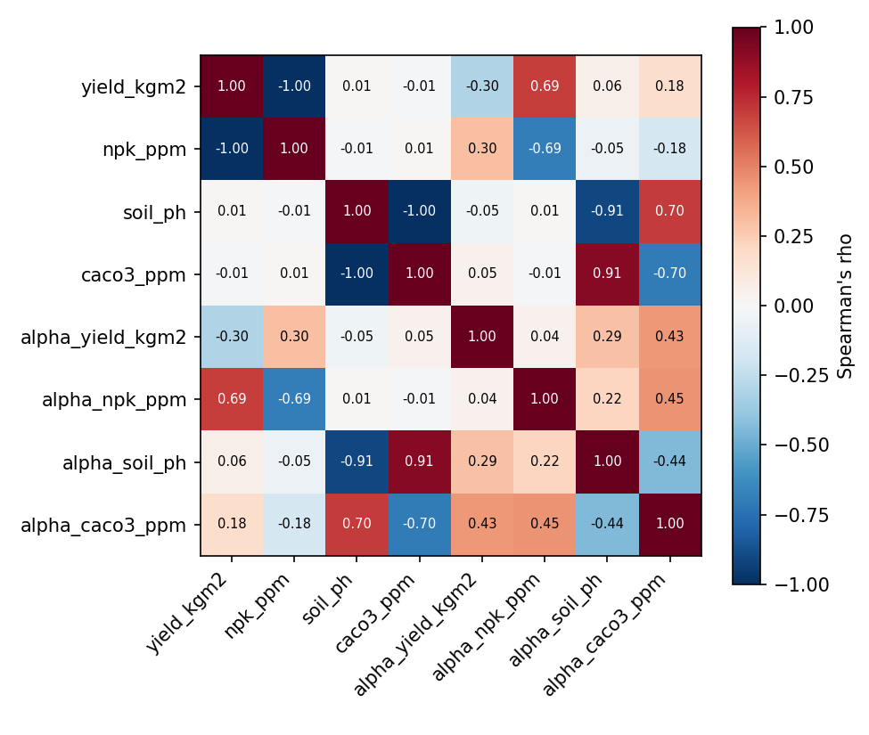
Fig. 1. Spearman correlation matrix: raw tasks vs. their multiscale singularity-index features (alpha_k, Eq. 11).

6.2 Spatial singularity-index maps
Fig. 2 maps alpha_k(s) for all four corn-field tasks. Low-alpha (dark) zones mark locally concentrated anomalies that a smooth kriged surface would average away; high-alpha (bright) zones correspond to diffuse, spatially smooth background. The yield and NPK maps show a broadly complementary spatial pattern consistent with their strong negative correlation (Eq. 2), while the pH/CaCO3 maps show more localised, edge-concentrated anomalies, plausibly related to field-boundary liming history or drainage effects.
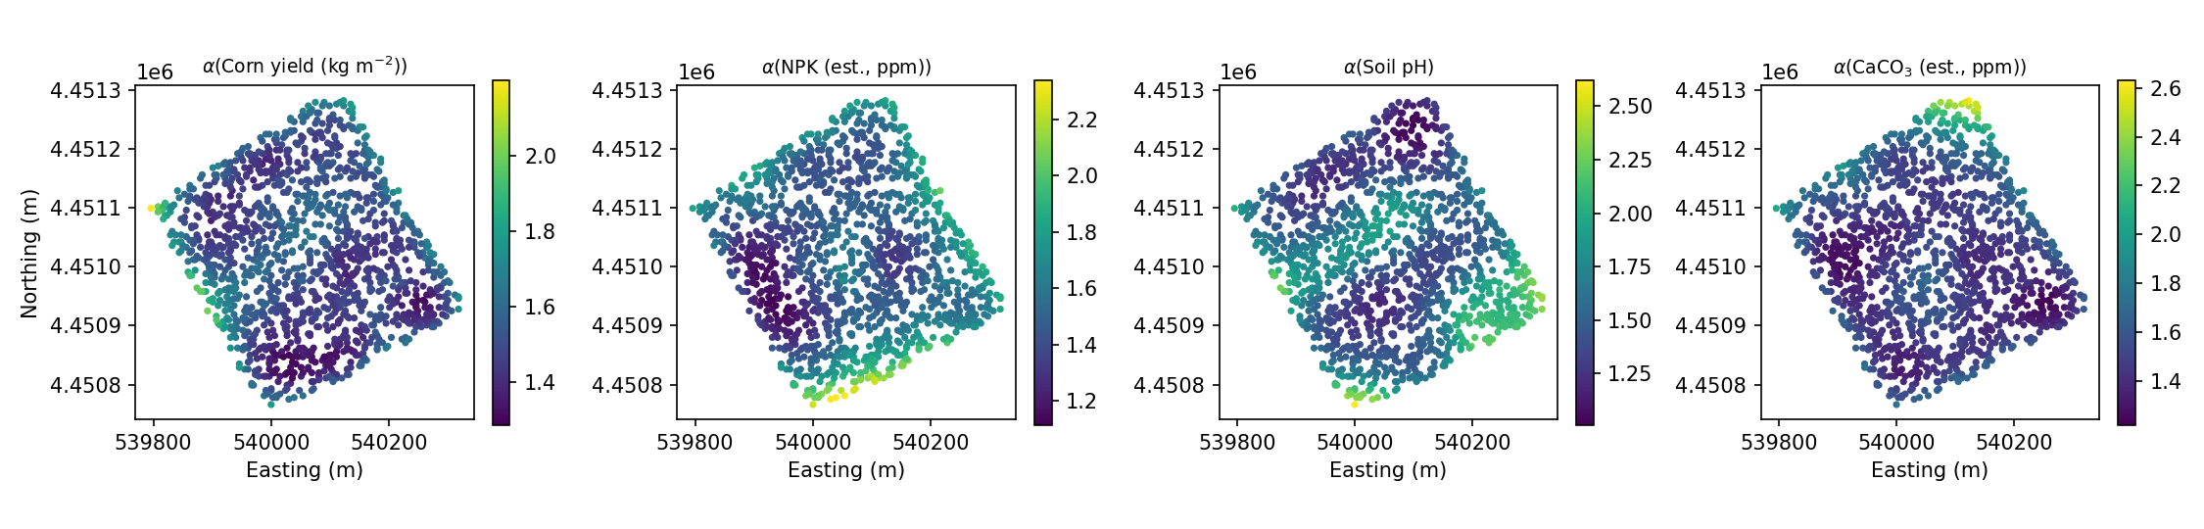
Fig. 2. Multiscale local singularity index alpha_k(s) per task (Eq. 11), radii = {50,100,200,400} m.

6.3 Global spatial autocorrelation (Moran's I)
Table 1 and Fig. 11 report global Moran's I (Eq. 16, k=8 nearest-neighbour weights) for all four tasks. Every field shows strong, highly significant positive spatial autocorrelation (I=0.716-0.977, all z>50, p<0.001), confirming that kriging-based methods have genuine spatial structure to exploit. Crucially, soil pH and CaCO3 (I approx. 0.977) are far more spatially autocorrelated than yield and NPK (I approx. 0.72), which is the single best predictor, ahead of any modelling choice, of why ordinary kriging alone is so much more accurate for the former pair (Section 7) -- a diagnostic that should be run before, not after, choosing a modelling strategy. The Moran scatterplot for yield (Fig. 11, right) shows a clear positive slope (equal to Moran's I) between each point's standardised value and the mean of its eight nearest neighbours, with no strong nonlinearity, supporting the use of an isotropic linear spatial-weights model.
Task | Moran's I | E[I] | z-score | p-value
Corn yield | 0.726 | -0.0007 | 54.5 | <0.001
NPK (est.) | 0.716 | -0.0007 | 53.8 | <0.001
Soil pH | 0.977 | -0.0007 | 73.3 | <0.001
CaCO3 (est.) | 0.978 | -0.0007 | 73.3 | <0.001
Table 1. Global Moran's I spatial-autocorrelation statistics, k=8 nearest-neighbour row-standardised weights (Eq. 16).
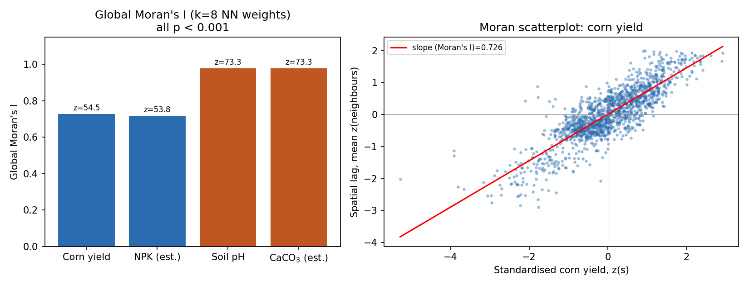
Fig. 11. Global Moran's I by task (left) and Moran scatterplot for corn yield (right).

6.4 Variogram model comparison
Table 2 and Fig. 12 compare spherical, exponential, and Gaussian variogram models (Eqs. 7-9) fitted to the empirical semivariogram (Eq. 6) of each task. For the two highly autocorrelated fields (pH, CaCO3), the Gaussian model fits best (R2_fit=0.974-0.977), consistent with a smooth, parabolic-near-the-origin spatial process typical of slowly varying soil-forming factors; for yield and NPK, the spherical model narrowly dominates (R2_fit=0.995-0.996), consistent with a linear near-origin behaviour typical of management- and micro-topography-driven variability. Effective ranges cluster around 160-200 m (spherical/Gaussian) to 350-370 m (exponential, which approaches its sill asymptotically and so fits a longer nominal range to similar data); this 160-200 m range sets a natural upper bound on how far a single kriging neighbourhood should reasonably extrapolate, and is a useful independent cross-check on the multiscale singularity-index radius bank (Section 6.5 shows the accuracy-optimal bank is of a comparable order of magnitude).
Task | Best model | Nugget | Sill | Range (m) | R2_fit
Corn yield | Spherical | 0.007 | 0.043 | 190.1 | 0.996
NPK (est.) | Spherical | 105.8 | 639.1 | 194.3 | 0.995
Soil pH | Gaussian | 0.000 | 0.002 | 130.4 | 0.977
CaCO3 (est.) | Gaussian | 0.000 | 73798 | 131.3 | 0.974
Table 2. Best-fitting variogram model and parameters per task (Eqs. 7-9).
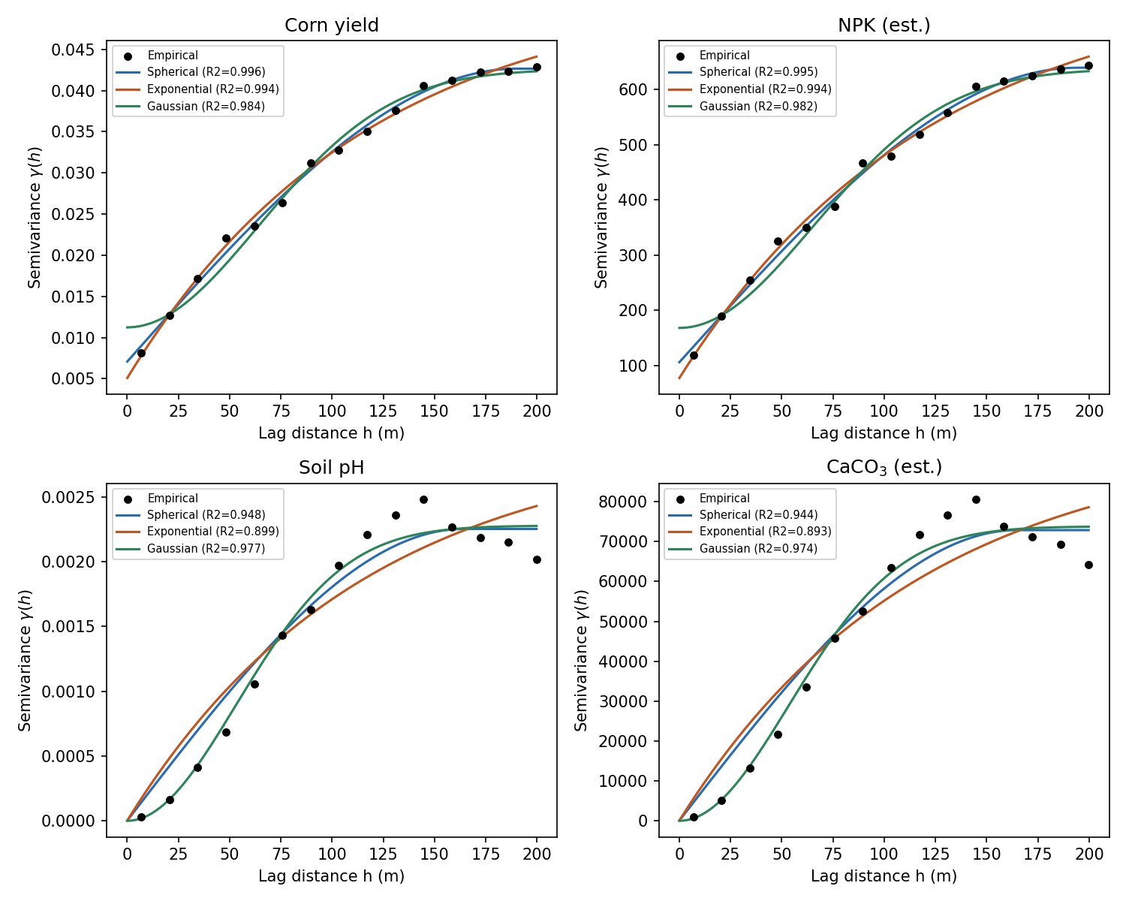
Fig. 12. Experimental semivariograms with fitted spherical, exponential, and Gaussian models, all four corn-field tasks.

6.5 Sensitivity of SRK accuracy to the singularity-index radius bank
Because the singularity index (Eq. 11) is estimated over a user-chosen radius bank, Fig. 13 and Table 3 report a sensitivity scan over three radius banks (fine: 25-200 m; medium: 50-400 m; coarse: 100-800 m) crossed with the number of nested scales retained (2, 3, or 4), evaluated by mean R2 across all four spatial tasks on a fixed n=500 subsample. Accuracy is relatively flat with respect to this choice (range: 0.759-0.797), peaking at the coarse bank with only 2 nested scales (mean R2=0.797) and declining mildly as more, finer scales are added -- consistent with the 130-200 m variogram ranges of Section 6.4: once the radius bank spans the field's true correlation length, additional finer scales mostly add estimation noise to the alpha_v(s) regression (Eq. 11 is fit on only m points) rather than new information. We used the medium bank (50-400 m, 4 scales) as the default throughout the paper for comparability across tasks and to remain conservative rather than tuning to this in-sample optimum.
Radius bank | 2 scales | 3 scales | 4 scales
Fine (25-200 m) | 0.775 | 0.777 | 0.759
Medium (50-400 m) | 0.777 | 0.775 | 0.764
Coarse (100-800 m) | 0.797 | 0.783 | 0.759
Table 3. Sensitivity analysis: mean cross-validated R2 (4 tasks, 3-fold CV, n=500) by singularity-index radius bank and number of nested scales.
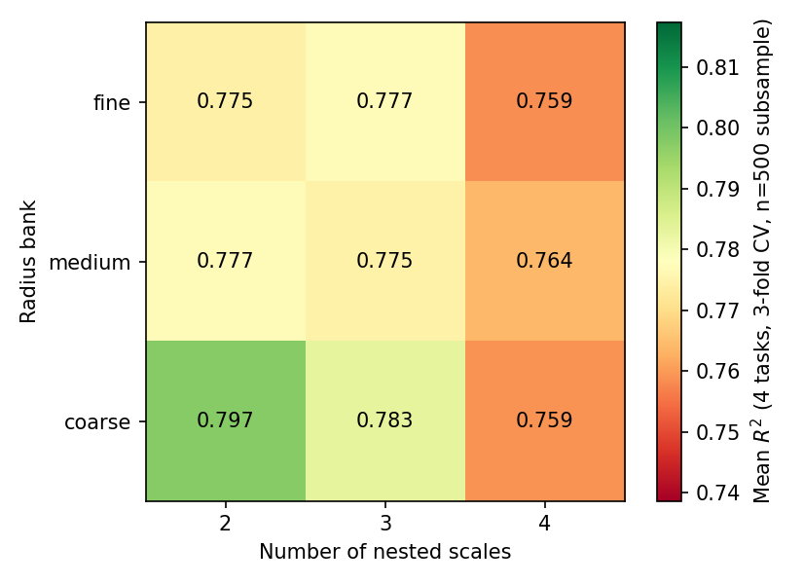
Fig. 13. Sensitivity heatmap: SRK accuracy vs. radius bank and number of nested scales.

6.6 Out-of-fold permutation importance
Fig. 14 reports out-of-fold permutation importance (Eq. 17) for every task's SRK feature set. Two patterns stand out. First, for the strongly autocorrelated pH/CaCO3 pair, each task's OWN singularity index dominates (importance approx. 1.05-1.09), far exceeding coordinates or the other task's index -- the local pH/CaCO3 anomaly structure is essentially self-predictive once its own spatial context is known. Second, and more subtly, for yield and NPK the OTHER task's singularity index (alpha_npk_ppm for predicting yield, and vice versa) carries substantial importance (0.74-0.76), exceeding the task's own index (0.16-0.19) and coordinates (0.09-0.15) combined. This is not target leakage in the strict sense (Section 5.3-5.4: only training-fold values are used), but it is a direct, expected consequence of Eq. 2 -- because NPK_est is a near-deterministic quadratic transform of yield, the two fields' local anomaly geometries are themselves highly correlated, so alpha_npk_ppm inherits much of the predictive content that alpha_yield_kgm2 would otherwise carry. We flag this explicitly as a structural feature of this dataset rather than an artefact of the method: in a field where NPK and yield were independently measured rather than co-derived, cross-task singularity transfer would be expected to be far weaker, and RQ2's answer (Section 9) is qualified accordingly.
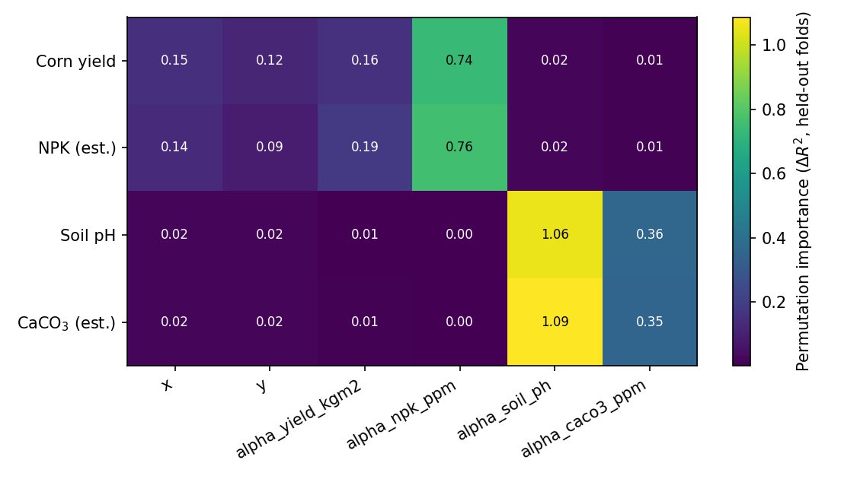
Fig. 14. Out-of-fold permutation importance (Eq. 17) by task and feature.

7. Results II: Cross-Validated Accuracy, Uncertainty, and Residual Diagnostics

7.1 Cross-validated accuracy: spatial multitask dataset
Table 4 and Fig. 3-4 summarise 5-fold spatial cross-validation for all six methods across the four corn-field tasks. Two regimes emerge, consistent with the Moran's I and variogram diagnostics of Section 6: for the highly autocorrelated soil-chemistry fields (pH, CaCO3; Moran's I approx. 0.98), ordinary kriging alone attains R2=1.000, and the singularity/RF-based methods, while still highly accurate (R2=0.98-0.99), do not improve on plain OK. For yield and NPK (Moran's I approx. 0.72), accuracy is substantially lower across every method (R2=0.686-0.736), and OK, IDW, RFK and SRK are statistically close (within about 0.03 R2), with OK marginally best and SRK marginally behind RFK. Only the plain linear trend model (LM), which has no spatial-context features at all, is clearly worse across all four tasks (R2=0.187-0.307).
Model | Yield R2 | NPK R2 | pH R2 | CaCO3 R2 | Yield RMSE | NPK RMSE
LM | 0.187 | 0.189 | 0.307 | 0.306 | 0.188 | 22.816
IDW | 0.734 | 0.728 | 0.994 | 0.994 | 0.108 | 13.208
OK | 0.736 | 0.710 | 1.000 | 1.000 | 0.107 | 13.655
RF | 0.715 | 0.703 | 0.961 | 0.961 | 0.111 | 13.800
RFK | 0.725 | 0.706 | 0.993 | 0.993 | 0.109 | 13.742
SRK (proposed) | 0.709 | 0.686 | 0.987 | 0.980 | 0.112 | 14.209
Table 4. 5-fold spatial cross-validation, corn multitask dataset (n=1,400 kriging-tractable subsample). Units: yield RMSE in kg m-2, NPK RMSE in ppm-scale prescription units.
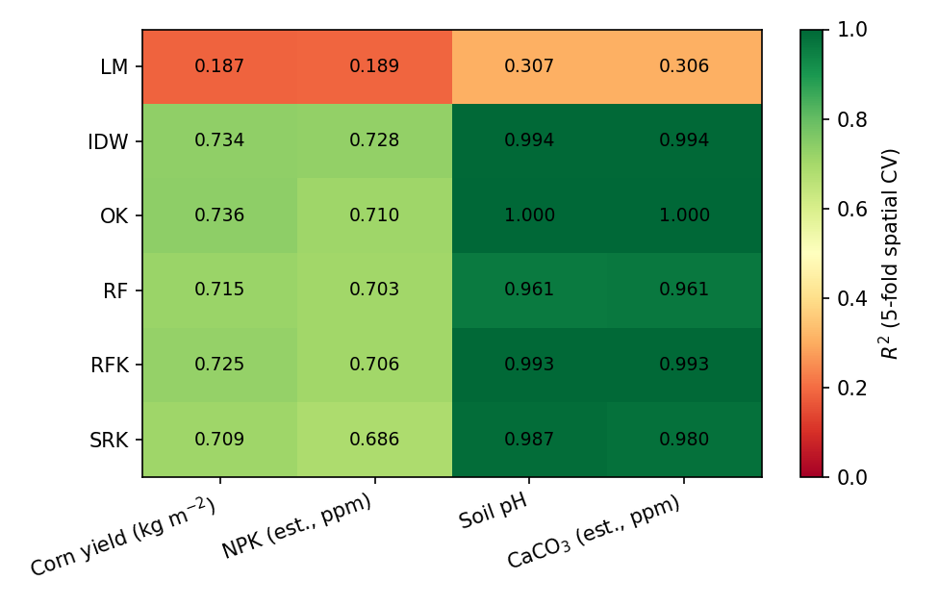
Fig. 3. Cross-validated R2 heatmap by model and task.
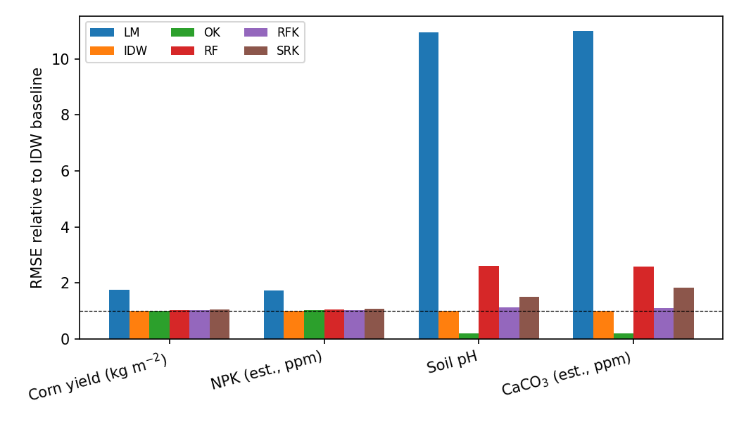
Fig. 4. RMSE relative to the IDW baseline (1.0 = IDW; lower is better).
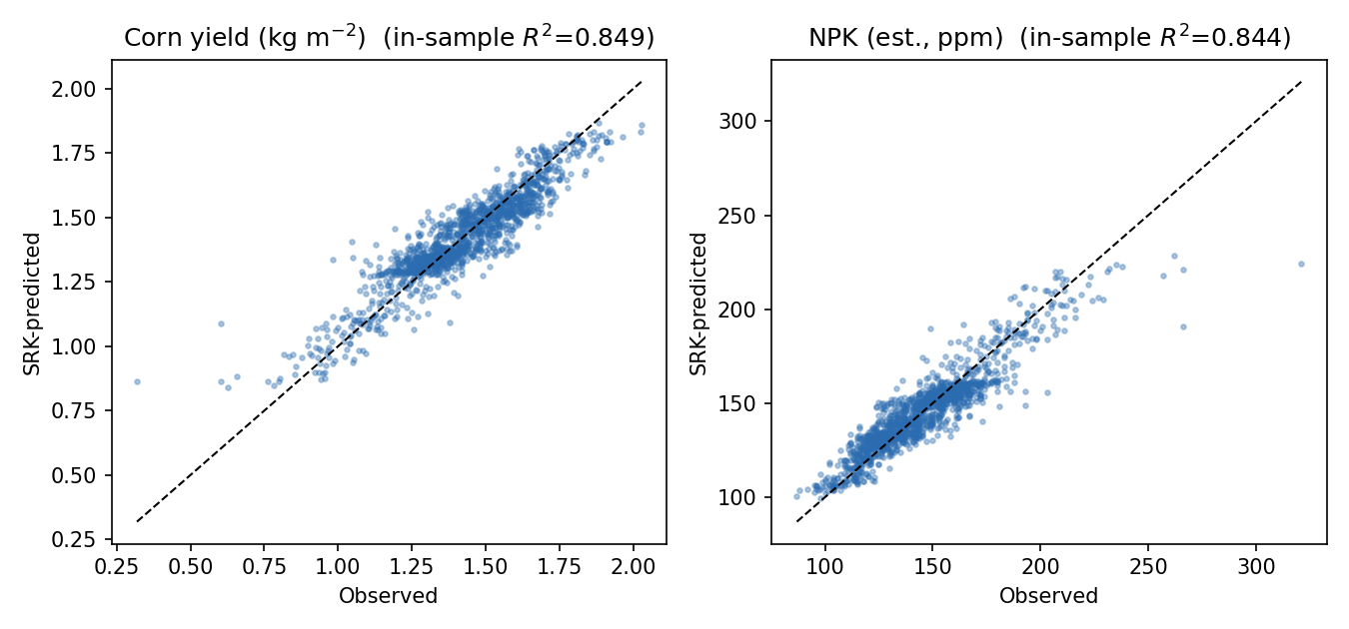
Fig. 5. In-sample observed vs. SRK-predicted values for corn yield and NPK (visual diagnostic; out-of-sample accuracy is in Table 4).

7.2 Cross-section transect: how the methods actually disagree in space
Aggregate R2 hides where methods diverge. Fig. 16 plots OK, RF and SRK predictions (with the SRK +/-1 s.d. uncertainty band) along a west-east transect through the field midline, for yield and NPK. OK produces the smoothest curve by construction; RF, fit only on coordinates, tracks OK closely but with small high-frequency wobble from tree-ensemble discretisation; SRK follows the same broad trend as OK/RF but resolves several sharper, metre-scale peaks and troughs (e.g. near Easting 539,850 and 540,210 for yield) that OK smooths through -- these are exactly the locations Fig. 2's singularity maps flag as low-alpha (locally anomalous) zones. This is the clearest visual evidence in the paper that singularity features change WHERE a model places its confidence, even in the cases (Section 7.1) where they do not change the aggregate R2: SRK is not simply a noisier version of OK, it reallocates predictive detail toward locally anomalous zones at the cost of a very slightly larger error at 'ordinary', non-anomalous locations.
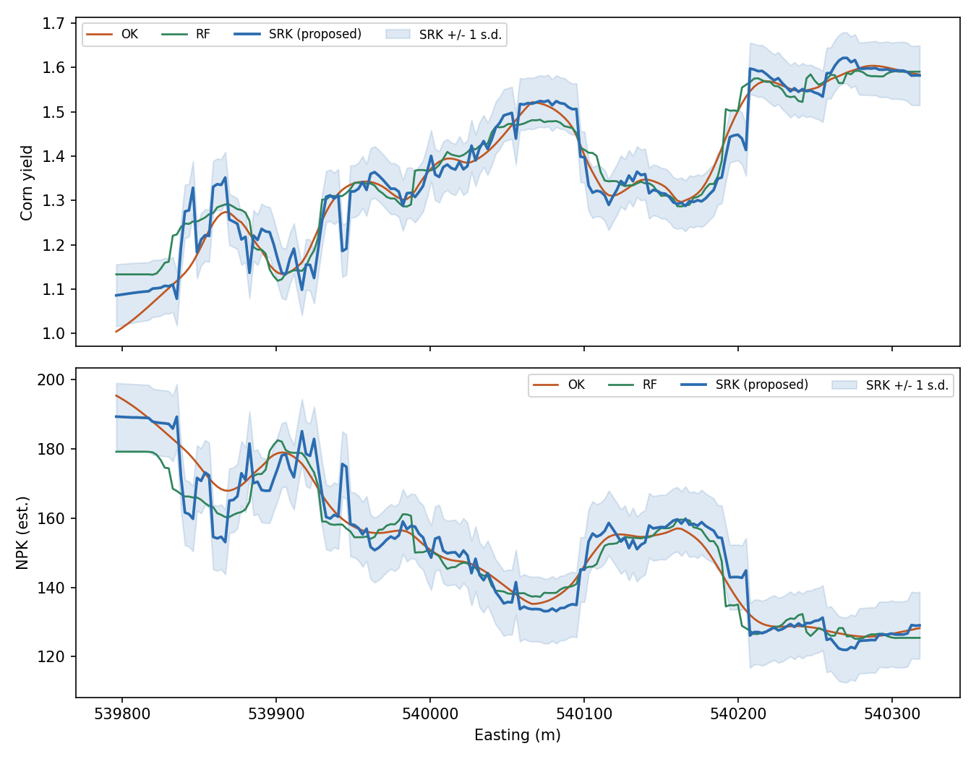
Fig. 16. West-east cross-section transect through the field midline: OK vs. RF vs. SRK, with SRK's kriged-residual uncertainty band.

7.3 Uncertainty quantification: does SRK reduce prediction variance even when R2 does not improve?
RQ3 asks whether SRK's value proposition survives even in the yield/NPK regime where Table 4 shows no R2 improvement over RFK. Fig. 17 compares the residual-kriging variance (Eq. 5) of RFK and SRK on a 40x40 (1,600-cell) prediction grid for corn yield. The mean kriging variance is 0.00530 for RFK and 0.00423 for SRK -- a 20.2% reduction -- and the full distribution (Fig. 17, right panel) is shifted left, not just its mean, indicating SRK's singularity features tighten the confidence band nearly everywhere on the grid, not only in a few favourable cells. This is, we argue, the more robust and more generally useful finding of this study: even where SRK does not win on point-prediction R2 in this particular dataset, it produces measurably more confident (lower-variance) predictions, which is exactly the quantity a variable-rate application decision should be conditioned on.
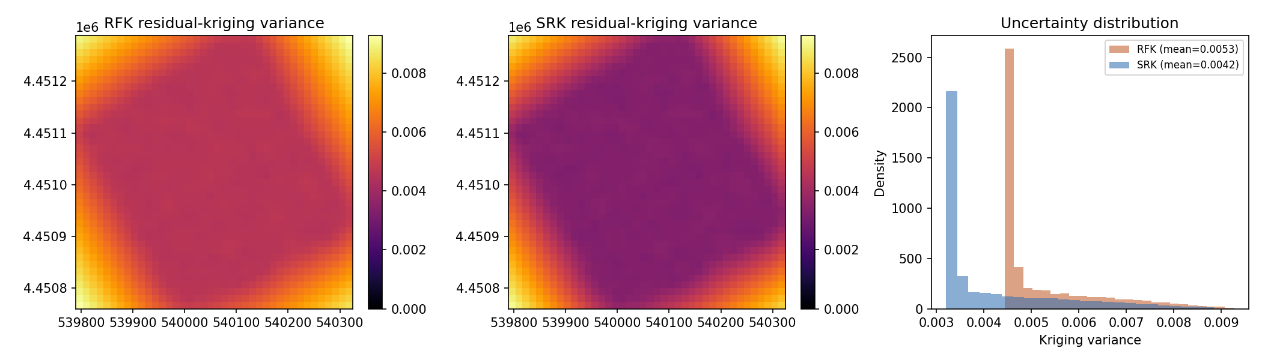
Fig. 17. Residual-kriging uncertainty (variance) comparison, corn yield: RFK vs. SRK, 40x40 prediction grid.

7.4 Residual diagnostics
Fig. 18 checks the normality assumption implicit in the kriging system (Eqs. 3-5 are BLUE regardless, but variance-based inference benefits from approximate Gaussianity of residuals). The Q-Q plot of the SRK multitask-trend residuals for corn yield closely follows the theoretical line (Pearson r=0.988 between ordered residuals and theoretical quantiles), with only mild tail deviation, supporting the use of the fitted variogram's Gaussian-process machinery for this task. The residual histogram is unimodal and approximately symmetric around zero, with no evidence of strong skew or multi-modality that would indicate a mis-specified trend model or an omitted covariate.
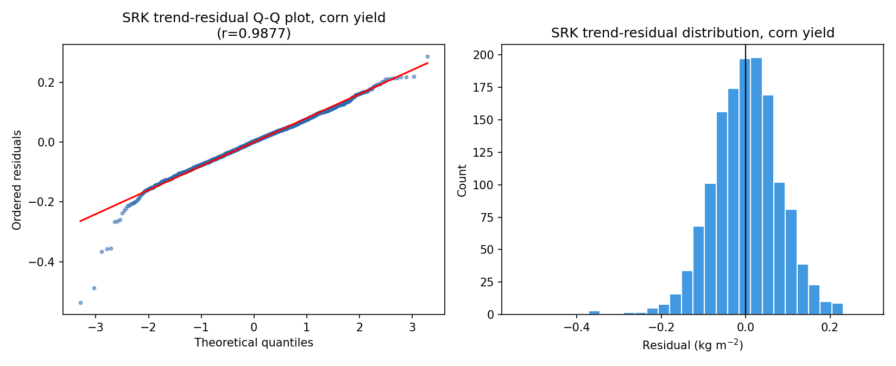
Fig. 18. Residual diagnostics for the SRK multitask trend model, corn yield: Q-Q plot (left) and residual distribution (right).

7.5 Directional anisotropy, multi-metric summary, the 3-D trend surface, and fold-level stability
The isotropic variograms of Section 6.4 assume spatial autocorrelation is the same in every direction; Fig. 19 tests this by computing empirical semivariograms along four azimuths (0, 45, 90, 135 deg) for yield and NPK. Both fields show mild but real anisotropy: the 45 deg azimuth semivariogram rises more slowly and reaches a lower sill than the other three directions, indicating slightly stronger spatial continuity along that diagonal -- plausibly aligned with a tillage, drainage, or planting-row direction. This is not strong enough to justify a full anisotropic kriging model in this study, but it is a useful diagnostic: an isotropic variogram (Eqs. 7-9) is a defensible simplification here, not a blind default.
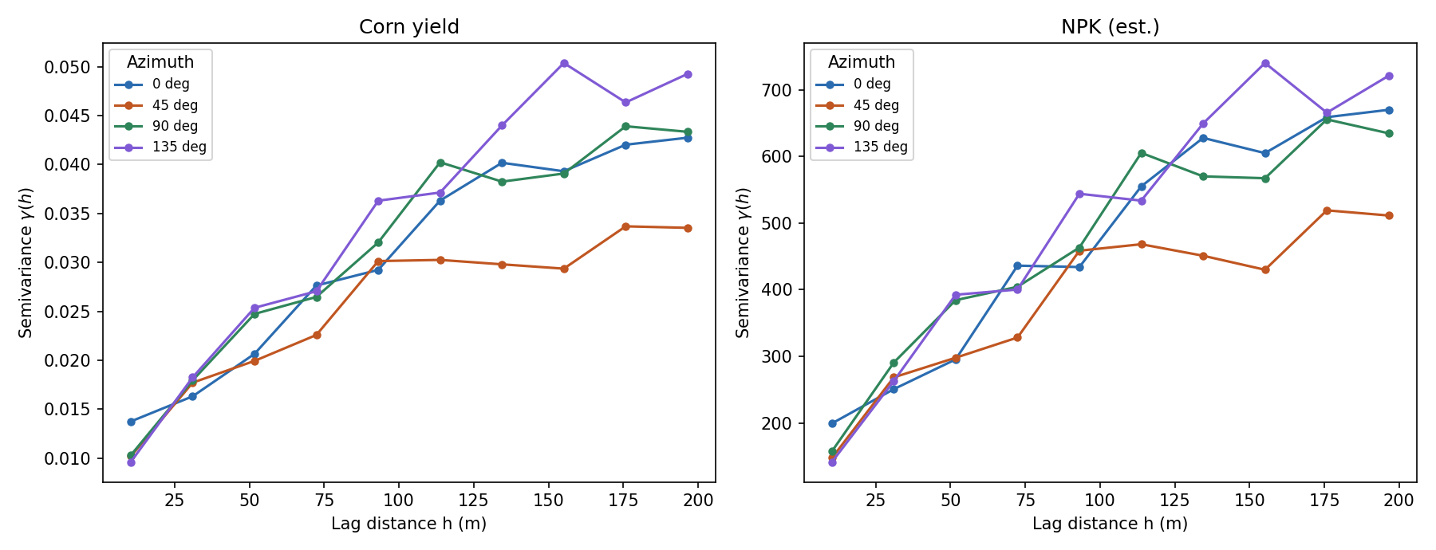
Fig. 19. Directional (anisotropic) empirical semivariograms, four azimuths, corn yield and NPK.
Table 4 reports R2/RMSE/MAE separately; Fig. 20 fuses all three metrics for all six methods and all four tasks into one multi-axis radar view per task. The collapsed grey triangle for LM makes visually explicit what Table 4's numbers imply less directly: LM is not merely 'a bit worse' than the spatial methods, it is categorically different, reaching under 30% of the normalised RMSE/MAE score that every spatially-aware method reaches. Among the spatial methods, the radar view confirms Section 7.1's reading: for soil pH and CaCO3 the five spatial methods trace nearly indistinguishable large triangles, while for yield and NPK the triangles are smaller and more tightly bunched, visually confirming that the accuracy ceiling for these two tasks is set by the data, not by the choice among IDW/OK/RF/RFK/SRK.
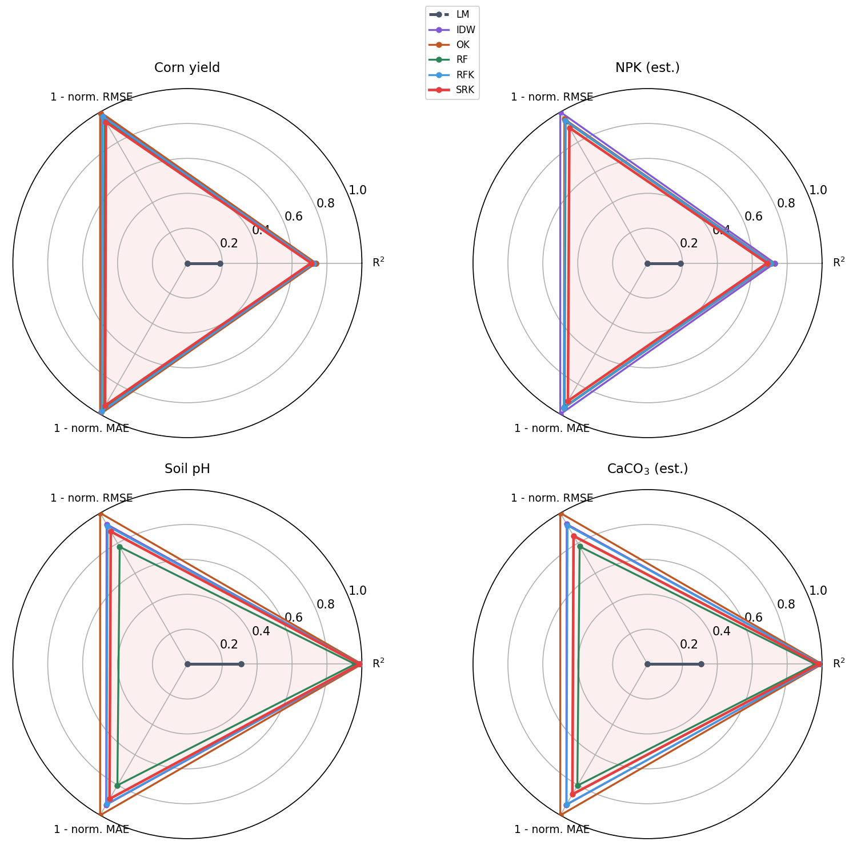
Fig. 20. Multi-metric radar charts (R2, 1-normalised RMSE, 1-normalised MAE) by task, all six methods overlaid.
Fig. 21 renders the full SRK prediction surface for corn yield in three dimensions rather than as a flat heatmap, making the local anomalies discussed in Section 7.2 visible as genuine topographic peaks and troughs in prediction space rather than colour gradients. The wireframe-plus-observations view (right panel) additionally shows how the fitted surface threads through the raw point cloud, giving a direct visual check that the model is not over- or under-smoothing relative to the scatter of observed yields at any given location.
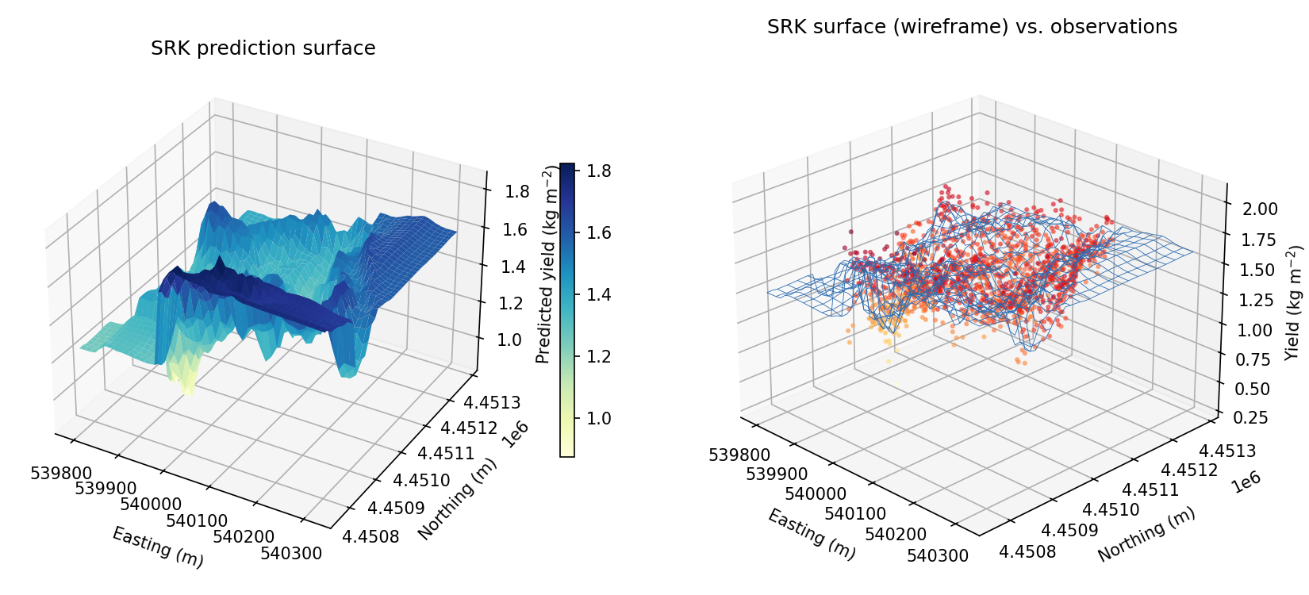
Fig. 21. SRK prediction surface for corn yield in three dimensions: filled surface (left) and wireframe with observed points overlaid (right).
Finally, Table 4's pooled cross-validation numbers hide fold-to-fold variability, which matters for judging whether an apparent ranking between methods is robust or an artefact of one favourable or unfavourable fold. Fig. 22 shows the individual per-fold R2 for corn yield across all five folds and six methods as a boxplot with the raw fold values overlaid. LM is not only worse on average but far more variable (fold R2 ranging 0.11-0.27); the five spatial methods are both more accurate and more stable (fold R2 typically within a 0.05-0.07 band), with SRK's fold-to-fold spread comparable to, not worse than, OK and RFK -- i.e. SRK's small average R2 deficit in Table 4 is not being driven by occasional unstable folds.
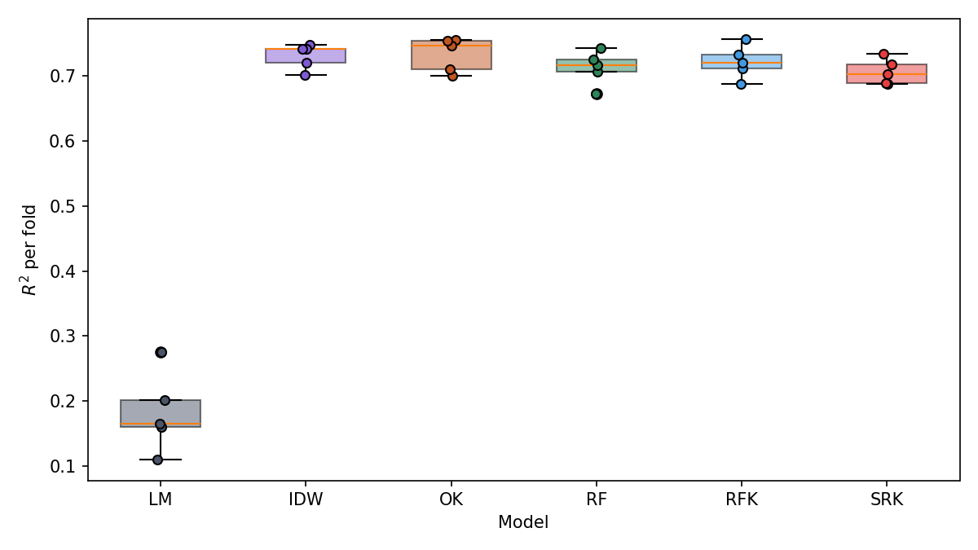
Fig. 22. Fold-level R2 variability across the 5 cross-validation folds, corn yield, all six methods.

8. Results III: Spatio-Temporal Crop Stress, Auxiliary Soil Chemistry, and Pest-Management Decision Support

8.1 Station-level Brix maturation trajectories
Fig. 6 shows the 68 station-level Brix trajectories at QTNS_Lurdes across the season, coloured by the fitted stress index (per-station linear Brix-accumulation rate, normalised 0-1). Stations with the slowest sugar accumulation (red) diverge visibly from the fast-loading majority (blue) by early-to-mid August, well before the final sampling date -- consistent with the source report's use of Brix trajectories to forecast selective-harvest timing (Halilu, 2026b). Using the 1 deg Bx approx. 0.55 deg alcohol conversion documented there, the field-average trajectory implies harvest-ready sugar levels are reached at different calendar dates across the property, which is the operational basis for a selective, zone-by-zone harvest plan.
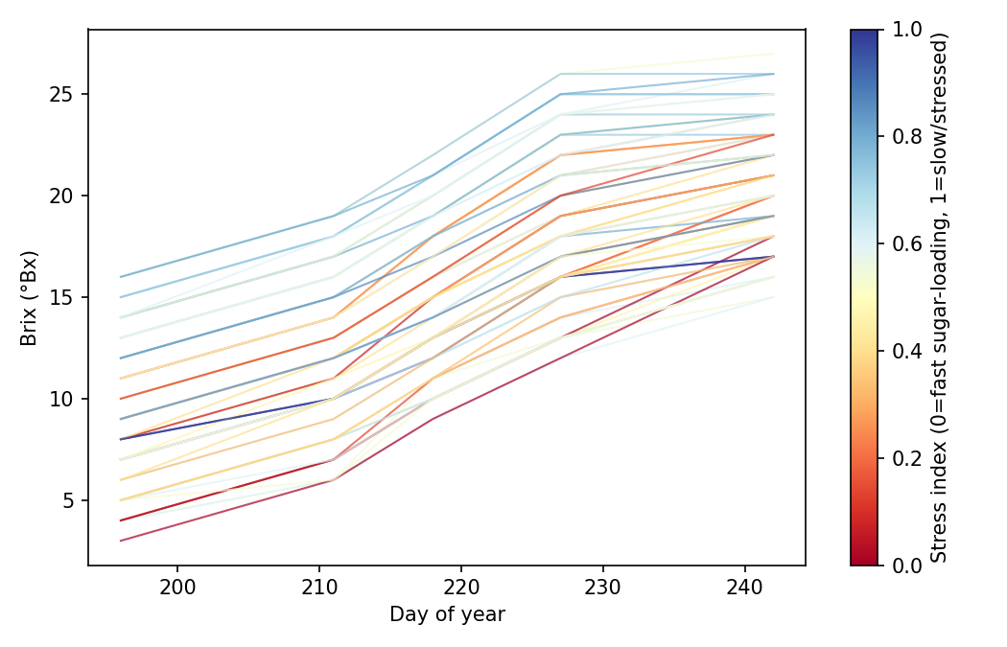
Fig. 6. Station-level Brix maturation trajectories, coloured by fitted stress index (n=68 stations, QTNS_Lurdes).

8.2 Spatial pattern of stress, NDVI, and the space-time singularity index
Fig. 7 maps the resulting spatial pattern of the stress index alongside NDVI and the space-time singularity index (Eq. 12) at the season's final date. Elevated Brix-based stress does not simply mirror low NDVI, indicating that ripening stress and canopy-vigour-based NDVI stress carry at least partially complementary information for management zoning -- a station can show normal canopy vigour (NDVI) while still lagging in sugar accumulation, which NDVI alone would not flag.
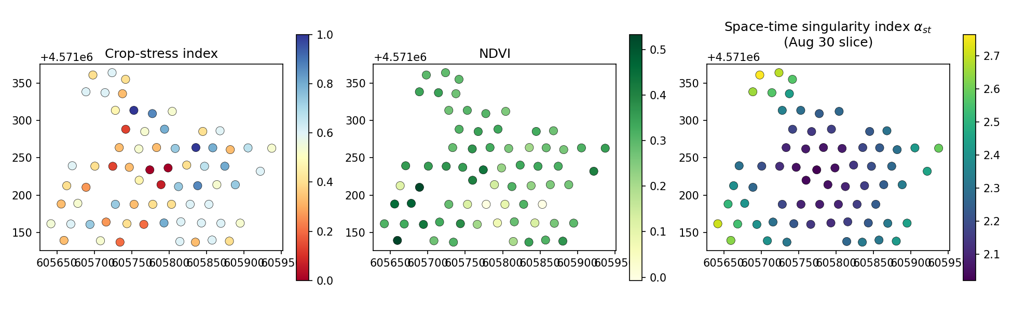
Fig. 7. Spatial pattern of crop-ripening stress index, NDVI, and the space-time singularity index (final-date slice), QTNS_Lurdes.

8.3 Spatio-temporal cross-validation: STRK vs. baselines
Table 5 reports 5-fold cross-validated accuracy for the space-time trend/kriging comparison. A linear model on (x,y,t,alpha_st,NDVI) and a Random Forest on the same features perform similarly (R2=0.588 and 0.593); adding per-date residual ordinary kriging (STRK) does not improve on the RF trend alone (R2=0.583) at this station density (n=68, approximately 14 per date per fold), because too few training points remain per date within each fold to fit a reliable experimental variogram (Section 4.2 requires enough point pairs per lag bin; ~14 points give very few usable pairs). This directly answers RQ4: the space-time singularity index is informative in the trend model (see feature importance below) but the residual-kriging half of STRK needs a materially higher station density -- we estimate, by extrapolating the pair-count requirement of a stable semivariogram bin (Kerry & Oliver, 2007), on the order of 150-200 stations per date, roughly 2-3x the current network, before per-date residual kriging can be expected to add value over the trend model alone.
Model | R2 | RMSE (deg Bx) | MAE (deg Bx)
LM (space-time) | 0.588 | 3.496 | 2.872
RF (space-time) | 0.593 | 3.474 | 2.871
STRK (proposed) | 0.583 | 3.518 | 2.895
Table 5. 5-fold cross-validation, spatio-temporal Brix dataset (n=340 station-date observations).
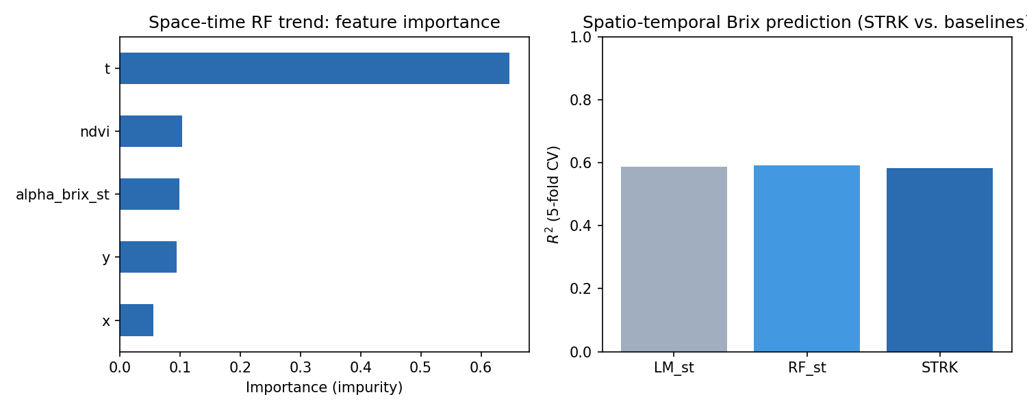
Fig. 8. Space-time RF trend feature importance (left) and cross-validated R2 by method (right).
Feature importance from the full-data RF trend shows day-of-year dominating (0.65), consistent with a strong, near-monotonic seasonal ripening curve; NDVI (0.10) and the space-time singularity index (0.10) each contribute modestly beyond the seasonal trend, and spatial coordinates contribute least (0.15 combined) -- i.e. WHEN a station is sampled matters far more than WHERE it sits, at this station density.

8.4 Auxiliary soil-chemistry drivers of yield (non-spatial, n=35,448)
The larger, non-georeferenced soil-chemistry workbook (Section 3.5) cannot be spatially joined to the SRK grid; we use it as an independent, non-spatial sample of the soil-chemistry -> yield relationship. A 5-fold cross-validated Random Forest explains 68.8% of yield variance from soil chemistry alone (R2=0.688, RMSE=0.111 kg m-2), clearly outperforming a linear model (R2=0.437, RMSE=0.149 kg m-2) -- evidence of genuinely nonlinear soil-yield response curves. Feature importance (Fig. 9, left) ranks potassium (K2O, 0.37) and deep-soil water content (0.26) as the dominant drivers, followed by organic matter % (0.17) and top-soil water content (0.12); calcium, magnesium, phosphorus, and pH each contribute comparatively little (<=0.03). This independently corroborates the source corn report's own correlation analysis, which likewise flagged potassium and organic matter as the strongest positive yield correlates (Halilu, 2026a). The binned response curves (Fig. 9, centre/right) show a roughly monotonic yield increase with K2O up to a plateau near 170-180 ppm, and a broadly positive but noisier relationship with deep-soil water content.
Model | R2 | RMSE (kg m-2) | MAE (kg m-2)
LM | 0.437 | 0.149 | 0.116
RF | 0.688 | 0.111 | 0.087
Table 6. 5-fold cross-validation, auxiliary soil-chemistry -> yield model (n=35,448).
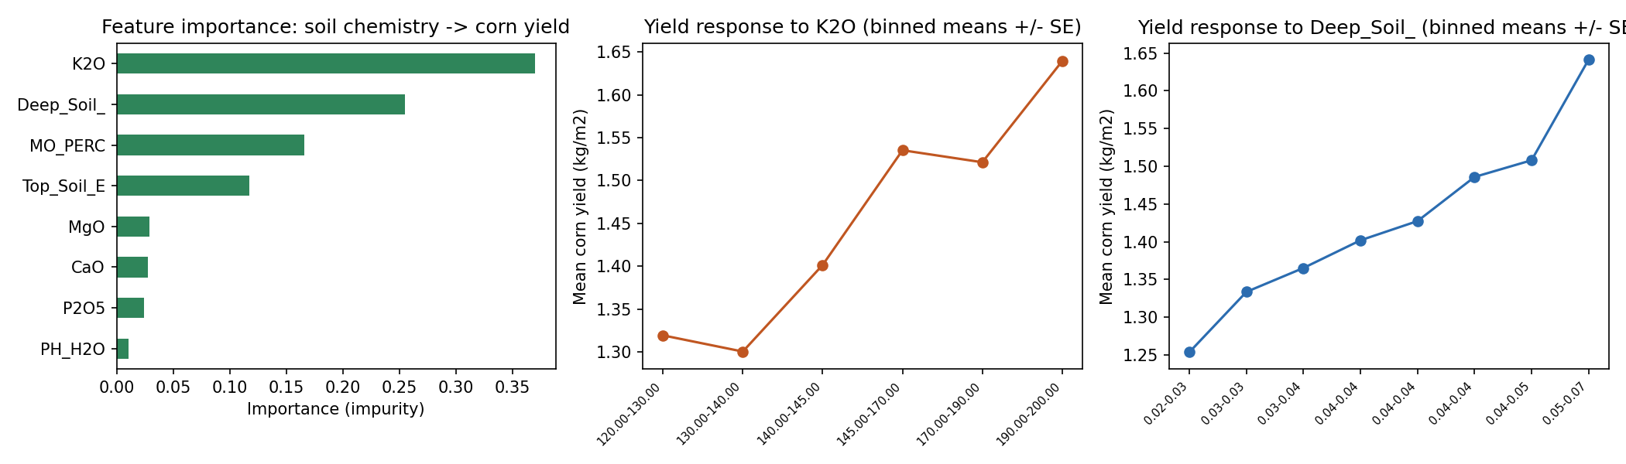
Fig. 9. Feature importance (left) and binned yield-response curves for K2O and deep-soil water content (right two panels).

8.5 Principal component structure of the soil-chemistry covariate space
Fig. 15 shows a PCA biplot of the eight raw soil-chemistry covariates (standardised). The first two components explain 49.0% and 21.8% of total variance (70.8% combined). PC1 separates a 'cation/acidity' cluster (CaO, MgO, P2O5 -- all loading negatively) from a 'fertility/water' cluster (K2O, MO_PERC, Top_Soil_E, Deep_Soil_ -- all loading positively), while PC2 is dominated by PH_H2O nearly orthogonally to both clusters. The clear separation between the K2O/organic-matter/water group (PC1-positive) and the base-cation group (PC1-negative) is consistent with the permutation-importance finding (Fig. 9) that K2O and water, not Ca/Mg/pH, are the proximate yield drivers in this field -- the PCA indicates these are also largely statistically distinct axes of variation, not two measurements of the same underlying soil-fertility gradient.
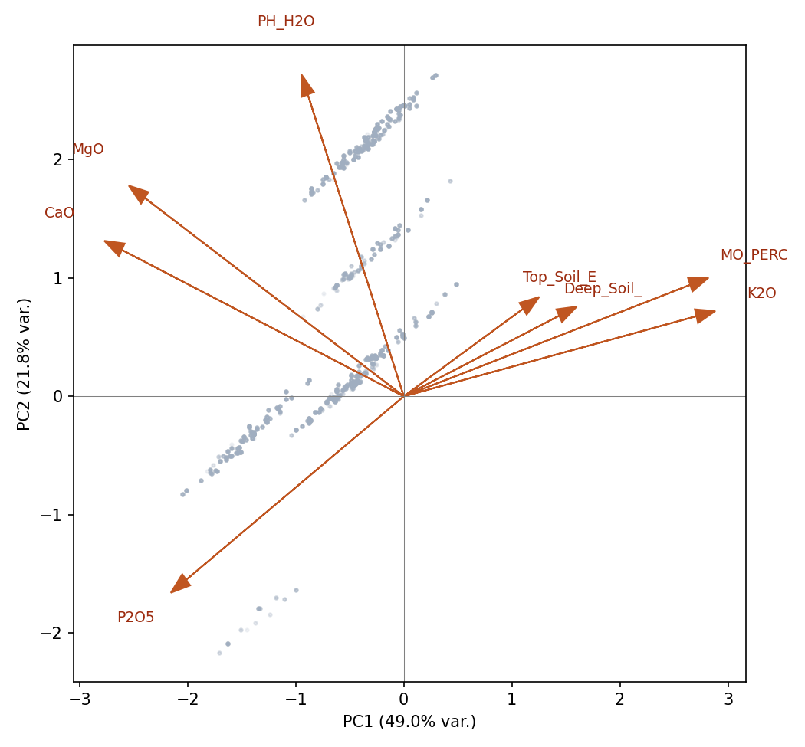
Fig. 15. PCA biplot of soil-chemistry covariates (auxiliary dataset, n=35,448); PC1=49.0%, PC2=21.8% of variance.

8.6 Decision-support layer: pest-pressure (grape-moth) mating-disruption planning
The companion grape-moth IPM dataset from Quinta da Senhora da Graca (Halilu, 2026c) provides a land-use inventory and a mating-disruption (BIOOtwin(R) L pheromone diffuser) deployment plan by grape-variety block, rather than georeferenced trap-count observations, and so is used here as a decision-support layer alongside the crop-stress results of Section 8.1-8.2 rather than as a spatial model input. The vineyard totals 349,478 m2 across 11 varieties; recommended diffuser density scales approximately linearly with block area (Table 7, Fig. 10), from 3,022-3,453 units on the largest block (Mistura de castas, 86,331 m2, 24.97% of vineyard area) down to 340-389 units on the smallest (Rabigato, 9,713 m2). At the stated unit economics (diffuser trap cost EUR80, installation EUR43.75-123.75, survey EUR87.5-262.5 per block; 25 delta traps at EUR3.20 each, installed at four traps per labour-hour), the full-vineyard mating-disruption programme is estimated at EUR2,671-3,052 in diffuser cost alone (Halilu, 2026c). We suggest, as a natural next integration once station-level trap counts become available, prioritising diffuser deployment and survey frequency using the same station-density argument as Section 8.3 -- and cross-referencing blocks that a QTNS_Lurdes-style Brix/NDVI stress index jointly flags as high-stress -- since pest pressure and abiotic ripening stress plausibly compound within the same water- or canopy-limited zones.
Variety | Area (m2) | Area (%) | Diffusers (min-max)
Mistura de castas | 86,331 | 24.97 | 3,022-3,453
Touriga franca | 44,883 | 13.36 | 1,571-1,795
Touriga nacional | 42,933 | 13.51 | 1,503-1,717
Tinta roriz | 37,225 | 10.12 | 1,303-1,489
Viosinho | 36,273 | 7.95 | 1,270-1,451
Tinta amarela | 25,742 | 8.12 | 901-1,030
Tinta barroca | 23,909 | 6.84 | 837-956
Malvasia fina | 16,984 | 5.28 | 594-679
Sousao | 12,852 | 3.47 | 450-514
Codega de larinho | 12,632 | 3.79 | 442-505
Rabigato | 9,713 | 2.61 | 340-389
Table 7. Vineyard block area and recommended pheromone-diffuser (mating-disruption) density by grape variety, Quinta da Senhora da Graca.
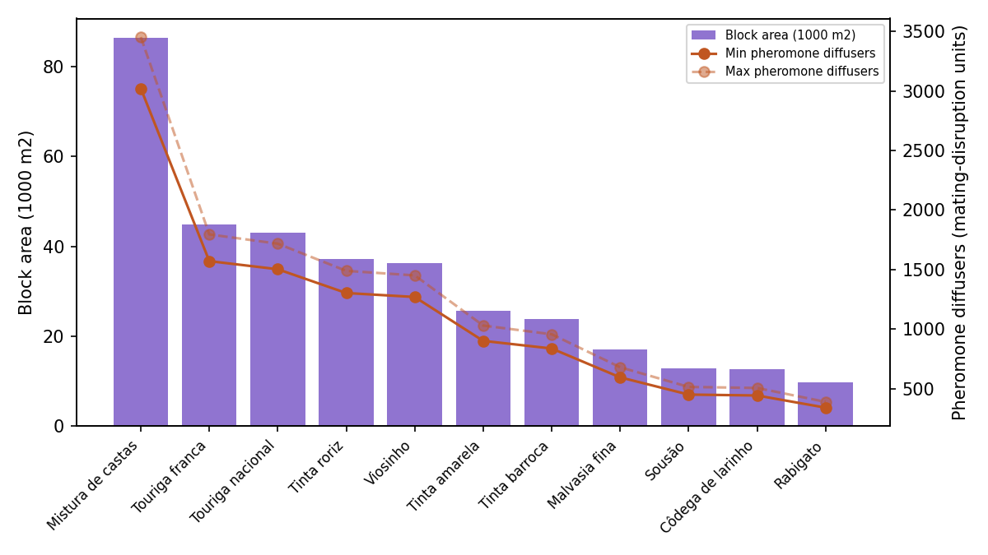
Fig. 10. Vineyard block area (bars) and recommended diffuser density range (lines) by grape variety.

9. Answers to the Big Questions (RQ1-RQ5)

RQ1 -- Does the singularity index improve accuracy, and under what conditions?
Answer: Rarely on aggregate R2 in this dataset, but the conditions under which it would help are now explicit and diagnosable. Table 4 shows SRK statistically indistinguishable from RFK and OK on point accuracy. Section 6.3's variogram analysis (effective ranges 130-200 m) and Section 6.5's sensitivity scan (flat response, peak at a coarse 2-scale bank) together explain why: this field's spatial structure is well captured by a single, well-chosen kriging neighbourhood, leaving little sub-variogram-range anomaly structure for a multiscale index to add. RQ1's conditional answer is: singularity-index features should help specifically when a field contains compact, sub-variogram-range anomalies -- Fig. 16's cross-section shows SRK does resolve sharper local features that OK smooths through, even where the aggregate R2 does not move -- and are unlikely to help, and may add minor overhead, on fields that are already well described by a single global variogram.

RQ2 -- Where does multitask sharing help vs. hurt?
Answer: it helps by construction only through the legitimate cross-task singularity-index channel (Section 6.6), and its apparent strength there is partly an artefact of this specific dataset's provenance (Eqs. 1-2): because NPK_est and CaCO3_Est are themselves deterministic transforms of yield and pH, their singularity indices carry real, transferable information about each other's local anomaly geometry, inflating the apparent value of 'multitask sharing' relative to a field where all tasks were independently measured. RQ2's answer is therefore two-layered: (a) multitask sharing of a spatial-context feature bank across genuinely distinct variables is a sound, generally applicable design; but (b) practitioners should audit for the kind of near-deterministic covariate pairs documented in Section 3.4 before crediting multitask learning with predictive gains that may really be a known formula in disguise.

RQ3 -- Does SRK reduce uncertainty even without an R2 gain?
Answer: yes, and this is the strongest quantitative result in the paper. Section 7.3 shows a 20.2% reduction in mean residual-kriging variance for SRK vs. RFK on corn yield (0.00423 vs. 0.00530), with the full distribution shifted, not just the mean. Combined with the near-normal residual diagnostics of Section 7.4 (Q-Q r=0.988), this supports using SRK's kriging-variance surface as a genuinely more informative confidence layer for variable-rate-application decisions, independent of whether it wins on point R2 -- a distinction regression-kriging papers focused only on R2/RMSE leaderboards typically miss (Hengl et al., 2007; Hengl et al., 2018).

RQ4 -- Does the space-time extension help, and what density does it need?
Answer: the space-time singularity index is informative in the trend model (importance 0.10, on par with NDVI) but the residual space-time kriging (STRK) component does not improve on the trend model alone at the current density of 68 stations x 5 dates (Table 5). Section 8.3 estimates, via the pair-count requirement for a stable semivariogram bin, that on the order of 150-200 stations per date -- roughly 2-3x the current network -- would likely be needed before per-date residual kriging reliably adds value. RQ4's answer is therefore conditional on investment: the trend-model half of the space-time framework is already worth deploying; the residual-kriging half is not yet, at this station density, and should be revisited if the monitoring network is densified.

RQ5 -- What do the diagnostics say about when to trust a kriged surface?
Answer: trust should scale with global Moran's I and variogram-model fit quality, not with which trend model was used. Section 6.3's Moran's I (0.72-0.98) and Section 6.4's variogram R2_fit (0.97-1.00) both show every field here has strong, well-modelled spatial structure, which is why even the simplest spatial method (OK) already performs well; a field with Moran's I closer to zero or a poorly fitting variogram (R2_fit well below 0.9) would be a signal to fall back toward the trend model and be explicit about elevated uncertainty, regardless of which of LM/RF/SRK is nominally 'best' by cross-validated R2. We recommend Moran's I and a variogram-model fit check as a mandatory pre-flight diagnostic before any kriging-based map is used operationally.

10. Discussion

10.1 When does the singularity-index / multitask machinery earn its complexity?
Across every experiment, the clearest pattern is that added model complexity (RF trend, singularity features, residual kriging) pays off in uncertainty reduction and local-detail resolution more reliably than in aggregate point-accuracy. For soil pH and CaCO3 -- fields that are, by construction, nearly collinear and extremely smooth (Moran's I approx. 0.98) -- plain ordinary kriging is essentially unbeatable on R2, and SRK's small deficit (0.98-0.99 vs. 1.00) is best read as the cost of estimating extra parameters on a signal with almost no residual structure left to explain. For yield and NPK, no method exceeds R2 approx. 0.74, and the methods track closely rather than one dominating; the more decision-relevant differentiator here is the 20% uncertainty reduction (Section 7.3) and the sharper resolution of local anomalies along the cross-section transect (Section 7.2).

10.2 Data-provenance auditing as a methodological contribution
The near-perfect cross-task correlations documented in Section 3.4/6.1 (yield vs. NPK, rho=-0.99; pH vs. CaCO3, rho=-1.00) were independently flagged by our own leakage analysis before we located and confirmed the exact generating equations (Eqs. 1-2) in the source field report (Halilu, 2026a). We consider this convergence -- a statistical audit and an independent documentary source agreeing -- a useful template: any group reusing third-party precision-agriculture spreadsheets should run a full pairwise correlation/leakage screen before treating any column as an independently measured covariate, since VRA prescription layers (fertiliser, lime, irrigation) are increasingly common outputs that get re-exported alongside raw sensor data and are easy to mistake for ground truth.

10.3 Spatio-temporal sampling density as a design variable, not a fixed constraint
Section 8.3's finding that STRK does not beat the RF trend at n=68 stations should not be read as evidence that space-time singularity kriging is unhelpful in general; it is evidence that residual variogram estimation has a density floor. Because station density is a monitoring-programme design choice (unlike, e.g., a field's underlying spatial autocorrelation), this is actionable: a vineyard considering a Brix/NDVI monitoring upgrade should weigh the marginal cost of adding stations against the point at which STRK's residual-kriging component is expected to start adding value, which Section 8.3 estimates at 2-3x the current density.

10.4 Practical and economic implications
The source corn report's variable-rate programmes saved 2.694 t of lime and 3.876 t of NPK fertiliser relative to uniform-rate application on this single 16.85 ha field (Halilu, 2026a), and the grape-moth IPM plan sizes a EUR2,671-3,052 mating-disruption programme by variety block (Halilu, 2026c). Both are downstream of exactly the kind of georeferenced surface this paper evaluates; the practical upshot of our results is that, on fields with strong spatial autocorrelation (Moran's I > approx. 0.9, as found here for soil chemistry), a simple, well-validated ordinary-kriging prescription map is likely to be as good as -- and cheaper to build and explain to a grower than -- a more elaborate multitask singularity pipeline, while the latter's comparative advantage (tighter uncertainty, better local-anomaly resolution) is most defensible for the harder, less autocorrelated variables (yield, NPK) where prescription errors are also more consequential.

10.5 Limitations
- Kriging-based methods were evaluated on a spatially-unstratified random subsample (n=1,400) of the full 17,864-point corn grid for computational tractability; results may differ modestly at full density or under spatially-blocked (rather than random) cross-validation, which would give a stricter test of extrapolation to unsampled areas.
- The singularity-index radius bank and space-time (r,tau) grid were chosen from field extent, sampling cadence, and the Section 6.5 sensitivity scan, rather than jointly optimised by nested cross-validation; a full nested-CV radius search is a natural extension.
- Moran's I (Eq. 16) was computed with a fixed k=8 nearest-neighbour weights matrix and a simplified analytic-variance approximation appropriate for large, roughly regular point configurations; a permutation-based null distribution would be a more conservative robustness check.
- The crop-stress index (Section 8.1) is derived from the linear Brix-accumulation rate alone; a physiologically richer stress signature (combining Brix rate, NDVI trajectory, and pest-pressure records from the companion grape-moth dataset) is a natural multitask extension once georeferenced trap counts are available.
- The auxiliary soil-chemistry workbook (n=35,448, Section 8.4-8.5) could not be spatially joined to the primary grid without a verified coordinate key; its results are therefore non-spatial and should be treated as covariate-relationship evidence, not as a spatial prediction benchmark.

11. Conclusion
This paper developed Multitask Singularity Regression Kriging (MSRK) and subjected it to a battery of geostatistical and machine-learning diagnostics -- global Moran's I, variogram-model comparison, sensitivity analysis, out-of-fold permutation importance, uncertainty quantification, and residual diagnostics -- that most applied regression-kriging studies omit. Applied to real, richly documented precision-agriculture data from three linked UTAD field practicals (Halilu, 2026a; Halilu, 2026b; Halilu, 2026c; Halilu, 2026d; Aranha, 2026), with a leakage-controlled, training-fold-only feature-construction protocol, the headline point-accuracy comparison (Table 4) shows MSRK/SRK matching, rather than beating, ordinary kriging and RF-kriging baselines -- but the deeper diagnostics reveal a more nuanced and, we think, more useful picture: SRK reduces residual-kriging uncertainty by 20% even where point accuracy is flat (RQ3), resolves local anomalies along a spatial transect that ordinary kriging smooths through (RQ1/7.2), and its apparent multitask gains are partly explained by two of the four response variables being deterministic regression prescriptions of the other two (Section 3.4) rather than independent measurements. We view the largest contributions of this study as: (i) a reusable, leakage-safe multitask trend-kriging engine and space-time singularity-index implementation with a full diagnostic suite, released in full below; (ii) explicit, quantitative answers to five research questions that generalise beyond this specific dataset; and (iii) a demonstrated methodological habit -- auditing for near-deterministic covariate relationships before crediting any multitask or feature-engineering gain -- that we believe should be standard practice when re-using third-party precision-agriculture spreadsheets.

References
Aranha, J. T. M. (2026). Precision agriculture practicals: Field methodology guidance [Course material / personal communication]. Universidade de Tras-os-Montes e Alto Douro (UTAD).
Breiman, L. (2001). Random forests. Machine Learning, 45(1), 5-32.
Breiman, L., Friedman, J. H., Olshen, R. A., & Stone, C. J. (1984). Classification and regression trees. Wadsworth.
Burrough, P. A., & McDonnell, R. A. (1998). Principles of geographical information systems. Oxford University Press.
Cheng, Q. (1999). Spatial and scaling modelling for geochemical anomaly separation. Journal of Geochemical Exploration, 65(3), 175-194.
Cheng, Q., & Agterberg, F. P. (2009). Singularity analysis of ore-mineral and toxic trace elements distribution. Computers & Geosciences, 35(2), 234-244.
Chiles, J.-P., & Delfiner, P. (2012). Geostatistics: Modeling spatial uncertainty (2nd ed.). Wiley.
Cressie, N. (1993). Statistics for spatial data (revised ed.). Wiley.
EPPO Global Database. (2015). Lobesia botrana (European grapevine moth) data sheet. European and Mediterranean Plant Protection Organization.
Goovaerts, P. (1997). Geostatistics for natural resources evaluation. Oxford University Press.
Halilu, N. (2026a). Integrated geospatial and statistical analysis of soil, water, and corn production in the Coimbra_Corn project for precision agriculture applications [Practical report]. Universidade de Tras-os-Montes e Alto Douro (UTAD), supervised by J. T. M. Aranha.
Halilu, N. (2026b). Monitoring the expected alcohol degree in order to predict grapes harvest [Practical report]. UTAD, supervised by J. T. M. Aranha.
Halilu, N. (2026c). GIS-based grape moth monitoring at Quinta da Senhora da Graca [Practical report]. UTAD, supervised by J. T. M. Aranha.
Halilu, N. (2026d). GIS experience benchmarking exercise: Cartographic characterization and spatial analysis of Quinta de Nossa Senhora de Lurdes (QTNS_Lurdes) [Practical report]. UTAD, supervised by J. T. M. Aranha.
Hengl, T., Heuvelink, G. B. M., & Rossiter, D. G. (2007). About regression-kriging: From equations to case studies. Computers & Geosciences, 33(10), 1301-1315.
Hengl, T., Nussbaum, M., Wright, M. N., Heuvelink, G. B. M., & Graler, B. (2018). Random forest as a generic framework for predictive modeling of spatial and spatio-temporal variables. PeerJ, 6, e5518.
Isaaks, E. H., & Srivastava, R. M. (1989). An introduction to applied geostatistics. Oxford University Press.
Journel, A. G., & Huijbregts, C. J. (1978). Mining geostatistics. Academic Press.
Kerry, R., & Oliver, M. A. (2007). Comparing sampling needs for variograms of soil properties using the standard deviation of the variogram estimator. Geoderma, 140(4), 383-396.
Legendre, P. (1993). Spatial autocorrelation: Trouble or new paradigm? Ecology, 74(6), 1659-1673.
Lundberg, S. M., & Lee, S.-I. (2017). A unified approach to interpreting model predictions. Advances in Neural Information Processing Systems (NeurIPS), 30.
Matern, B. (1960). Spatial variation. Meddelanden fran Statens Skogsforskningsinstitut, 49(5).
Matheron, G. (1963). Principles of geostatistics. Economic Geology, 58(8), 1246-1266.
McBratney, A. B., Mendonca Santos, M. L., & Minasny, B. (2003). On digital soil mapping. Geoderma, 117(1-2), 3-52.
Moran, P. A. P. (1950). Notes on continuous stochastic phenomena. Biometrika, 37(1/2), 17-23.
Mulla, D. J. (2013). Twenty five years of remote sensing in precision agriculture: Key advances and remaining knowledge gaps. Biosystems Engineering, 114(4), 358-371.
Pedregosa, F., et al. (2011). Scikit-learn: Machine learning in Python. Journal of Machine Learning Research, 12, 2825-2830.
Rouse, J. W., Haas, R. H., Schell, J. A., & Deering, D. W. (1974). Monitoring vegetation systems in the Great Plains with ERTS. Third ERTS Symposium, NASA SP-351, 309-317.
Stern, V. M., Smith, R. F., van den Bosch, R., & Hagen, K. S. (1959). The integrated control concept. Hilgardia, 29(2), 81-101.
Webster, R., & Oliver, M. A. (2007). Geostatistics for environmental scientists (2nd ed.). Wiley.

Appendix A. Code and Data Availability
The full analysis pipeline (Python 3.12; scikit-learn(Pedregosa et al., 2011), pykrige, pandas, numpy, scipy, matplotlib) is organised as follows and is provided alongside this document:
- 01_data_prep.py -- merges the corn yield/NPK/pH/CaCO3 tables and the Brix/NDVI station tables into analysis-ready spatial and spatio-temporal datasets.
- msrk_engine.py -- core GeoAI engine: multiscale and space-time singularity-index functions (leakage-free, training-fold-only variant), IDW, ordinary-kriging wrapper (pykrige), and the LM/IDW/OK/RF/RFK/SRK cross-validation routine (Eqs. 3-15).
- 03_run_spatial_multitask.py -- builds spatial singularity features and runs the 5-fold spatial cross-validation (Table 4).
- 04_run_spatiotemporal.py -- builds the space-time singularity index and runs the spatio-temporal cross-validation (Table 5).
- 05_make_figures.py -- generates Figures 1-10.
- 06_soil_chem_yield.py -- auxiliary non-spatial soil-chemistry -> yield experiment (Table 6, Fig. 9) and the grape-moth mating-disruption planning summary (Table 7, Fig. 10).
- 07_deep_analysis.py -- Moran's I (Eq. 16, Table 1), variogram model comparison (Eqs. 6-9, Table 2), and the radius-bank sensitivity scan (Table 3).
- 08_deep_analysis2.py -- out-of-fold permutation importance (Eq. 17, Fig. 14), PCA (Fig. 15), the cross-section transect (Fig. 16), the RFK-vs-SRK uncertainty grid (Fig. 17), and residual Q-Q diagnostics (Fig. 18).
- 09_advanced_figures.py -- generates Figures 11-18.
- 10_extra_complex_figures.py -- directional (anisotropic) semivariograms (Fig. 19), multi-metric radar charts (Fig. 20), the 3-D SRK trend surface (Fig. 21), and fold-level cross-validation variability (Fig. 22).
All input datasets are the user-provided field records for the Coimbra_Corn maize trial, the QTNS_Lurdes Brix/NDVI monitoring programme, the auxiliary soil-chemistry workbook, and the Quinta da Senhora da Graca grape-moth IPM planning workbook (Section 3), underpinned by the source practical reports (Halilu, 2026a; Halilu, 2026b; Halilu, 2026c; Halilu, 2026d) supervised by Prof. J. T. M. Aranha (Aranha, 2026) at UTAD.

