From point samples to management maps: a validation-tiered evaluation of GIS, spatial interpolation and machine learning in three Portuguese precision-agriculture case studies
Naziru Halilu^{1,2,3*}, Juwairiyyah Sulaiman⁴
¹Public University of Navarre, 31006 Pamplona, Spain; ²Agricultural University of Athens, 118 55 Athens, Greece; ³University of Trás-os-Montes e Alto Douro, 5000-801 Vila Real, Portugal; ⁴Federal University Dutse, 720221, Nigeria
Corresponding author: halilunaziru73@gmail.com; halilu.175366@e.unavarra.es

Abstract
Geographic information systems (GIS) are routinely used to turn sparse field observations into management maps, but published precision-agriculture case studies rarely state which level of evidence each map actually carries. We re-analysed three Portuguese field campaigns within an explicit validation-tier framework (T0 computational reproducibility, T1 descriptive mapping, T2 in-sample association, T3 out-of-sample predictive validity, T4 agronomic/decision validity, T5 transferability), using predefined comparison criteria rather than crop type as the basis for synthesis. Case I (maize, Coimbra, 16.85 ha; 17,724 yield-monitor points, 1,613 soil-water points, 16 composite soil samples) showed that the yield–deep-soil-water correlation depended strongly on the spatial support of analysis (r = 0.97 for 16 Thiessen-zone means, 95% CI 0.92–0.99; r = 0.57 at point level), and that lime and NPK prescription equations reproduced a reference recommendation table (R² ≥ 0.97) without constituting independent agronomic validation; recalculated input totals varied by 7–15% with the choice of model form. Case II (Lobesia botrana, 25 delta traps under mating disruption, 42.97 ha) supported descriptive mapping of captures and damage (T1) but not inferences about pest origin, dispersal or optimal treatment timing, which are reframed as testable hypotheses. In Case III (grape ripening, 68 fixed locations × 5 dates), sampling date explained 57% and persistent location effects 42% of Brix variance (intraclass correlation 0.975), yet Brix showed no spatial autocorrelation (Moran's I, all p > 0.09) and point-level NDVI explained ≤6% of Brix variance (the original R² = 0.88 was an uncentred R² from a no-intercept fit). Power simulations showed that the design could detect structure with ranges ≥ 50 m (power 0.75–0.94). Consequently, no interpolator or machine-learning model (inverse distance weighting, random forest, gradient boosting, neural network, stacking, regression-kriging) predicted Brix at unsampled locations better than a date-mean null model (cross-validated R² 0.32–0.55 vs. 0.55; per-date spatial R² ≤ 0.01), whereas a location-anchored forecast issued 15 days before the last sampling reduced error from 3.40 to 1.59 °Brix. Harvest-date forecasts for a 25.5 °Brix threshold ranged from 16 September to beyond the end of September depending on the growth function, showing that structural model uncertainty exceeded sampling uncertainty. The framework clarifies which outputs are exploratory demonstrations and which are validated predictions, and identifies the decision-relevant data each workflow still requires.
Keywords: precision agriculture; spatial interpolation; spatial cross-validation; change of support; variable-rate application; Lobesia botrana; grape ripening; machine learning.

1. Introduction

1.1. The common technical problem: from point observations to management decisions
Precision agriculture rests on the premise that fields are spatially heterogeneous and that inputs or interventions matched to that heterogeneity can improve economic or environmental outcomes relative to uniform management (Pierce and Nowak, 1999; Zhang et al., 2002; Gebbers and Adamchuk, 2010). The premise contains two distinct claims. The first is empirical: that within-field variation exists, is large enough to matter, and is structured at a scale that machinery or labour can address (Pringle et al., 2003; Tisseyre and McBratney, 2008). The second is decisional: that a particular map, once acted upon, produces a better outcome than the reference practice (Bramley, 2009; Lowenberg-DeBoer and Erickson, 2019). Three decades of research show that the first claim is easily demonstrated with yield monitors, soil sampling and remote sensing, whereas the second requires on-farm experimentation or response data that are much less often collected (McBratney et al., 2005; Bullock et al., 2019; Lacoste et al., 2022).
Between raw observations and a management decision lies a common engineering workflow: georeferenced point samples (soil cores, yield-monitor records, insect traps, berry samples) are converted into continuous or zonal surfaces by interpolation or tessellation, sometimes combined with remotely sensed covariates, and the surfaces are then translated into prescriptions, risk maps or harvest schedules (Chuvieco, 2020; Jensen, 2015; Lillesand et al., 2015; Mulla, 2013; Weiss et al., 2020; Kerry et al., 2010). Deterministic interpolators, particularly inverse distance weighting (IDW) (Shepard, 1968; Wong, 2017) and Thiessen (Voronoi) tessellation (Thiessen, 1911), are frequently used in such workflows because they are simple, assumption-light and implemented in all common GIS software, including open-source QGIS (QGIS Development Team, 2024); comparative reviews nevertheless show that no interpolator is universally best and that accuracy depends on sampling density, spatial structure and data distribution (Trangmar et al., 1985; Li and Heap, 2011; Li and Heap, 2014; Robinson and Metternicht, 2006; Kravchenko, 2003; Shaddad et al., 2016). Geostatistical and machine-learning (ML) alternatives, including regression-kriging and random-forest spatial prediction, can exploit auxiliary covariates and spatial correlation (Hengl et al., 2004; Hengl et al., 2007; Hengl et al., 2018; Sekulić et al., 2020; Wadoux et al., 2020), but their advantage is conditional on the existence of spatial structure and on sample sizes adequate for variogram or model estimation (Webster and Oliver, 1992; Oliver and Webster, 2014).
A recurring weakness of applied studies is that the evidential status of the final map is left implicit. A map may be computationally reproducible without being predictive; an association may be strong in-sample but vanish under spatially independent validation (Roberts et al., 2017; Ploton et al., 2020; Meyer et al., 2018); and a prediction may be accurate without the derived decision being agronomically appropriate (Oreskes et al., 1994; Scharf et al., 2006). Transferability to other seasons or sites is a further, separate property (Wenger and Olden, 2012; Yates et al., 2018). Agricultural ML reviews repeatedly note that reported performance is inflated when validation ignores spatial or temporal dependence and that model gains are sensitive to sample size (Chlingaryan et al., 2018; Liakos et al., 2018; van Klompenburg et al., 2020; Benos et al., 2021).

1.2. Why three case studies, and what is compared
We use three field campaigns conducted within the same GIS training and research programme in Portugal to examine this problem. The campaigns were not designed as a factorial comparison of cropping systems, and we do not claim that they sample 'contrasting cropping systems' along controlled dimensions. Instead, they represent three different decision problems that share the same technical chain (point sampling → GIS integration → interpolation/zoning → decision output) but differ in the observational unit, the type of response variable and the decision that the map is meant to support: (I) a fertility and variable-rate input problem in an irrigated maize field, where the response (yield) is measured densely and the drivers (soil properties) sparsely; (II) a pest-surveillance problem in a Douro vineyard, where the observations are insect counts and damage records from a fixed trap network operating under mating disruption; and (III) a ripening-monitoring and harvest-scheduling problem in a second vineyard, where the response (total soluble solids, °Brix) is repeatedly measured at fixed locations and a single canopy-vigour image is available as a covariate.
The synthesis is therefore organised not by crop but by predefined, decision-oriented criteria (Pringle et al., 2003; Bramley, 2009): (a) data requirements and the observational unit; (b) the prediction task that the map is supposed to perform; (c) the validation tier reached (T0–T5; Figure 2); (d) the quantitative uncertainty that can be attached to the output; and (e) the implementation constraints and missing information that prevent the output from being used as a validated management protocol. This structure responds directly to the risk, highlighted in the precision-agriculture and environmental-modelling literature, of treating reproducible software operations as evidence of predictive or agronomic validity (Oreskes et al., 1994; Peng, 2011; Wadoux et al., 2021).
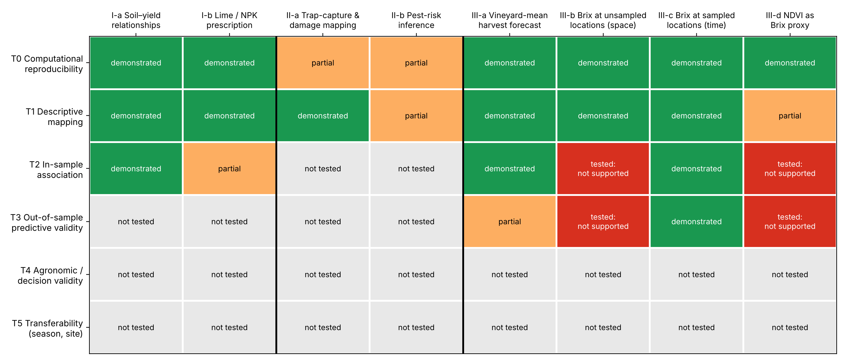
Figure 2. Validation-tier framework used to synthesise the three case studies. Columns are the GIS outputs (tasks) produced in each case (I, maize; II, grapevine moth; III, grape ripening); rows are the evidence tiers. 'Demonstrated' indicates that the tier was formally reached with the available data; 'partial' that it was reached with important qualifications (e.g., the prescription equations reproduce a reference table rather than a measured crop response; capture maps are reproducible but raw counts are reported only as classes); 'tested: not supported' that an appropriate test was performed and was negative; 'not tested' that the design does not allow the tier to be assessed. No output reached tiers T4 (agronomic or decision validity) or T5 (transferability across seasons or sites).

1.3. Objectives and contribution
The overarching question is: for each GIS output generated in the three campaigns, what level of evidence does the available sampling design actually support, and what additional information would be needed to move it to the next level? The specific objectives are to: (i) document, for each case, the agronomic question, observational unit, sampling design, measured variables and intended management decision (Table 1); (ii) re-analyse the original data with appropriate statistical units, uncertainty estimates and spatial diagnostics; (iii) explicitly separate three prediction tasks that are often conflated in ripening studies, namely mapping at a sampled date, prediction at unsampled locations, and forecasting at sampled locations, and validate each with an appropriate design; and (iv) synthesise the cases with the validation-tier framework.
The contribution is methodological and diagnostic rather than a claim of operational superiority. Three findings are, to our knowledge, not commonly reported together for farm-scale precision-agriculture datasets and are generalisable as checks rather than as results: the strong dependence of soil–yield correlations on the spatial support of analysis (the modifiable areal unit problem) (Openshaw, 1984; Gotway and Young, 2002); the combination of very high temporal persistence and absent spatial autocorrelation in grape ripening, which makes spatial interpolation uninformative while making location-anchored forecasting skilful; and the dominance of structural (model-form) over sampling uncertainty in harvest-date extrapolation.

2. Materials and Methods

2.1. Overview of study sites and campaigns
The three campaigns were conducted at different sites by the same instructing team at the University of Trás-os-Montes e Alto Douro (UTAD) (Aranha, 2026) and were analysed with the same open-source GIS toolchain (QGIS with QField for georeferenced field data collection) (QGIS Development Team, 2024). Table 1 summarises, for each case, the agronomic question, observational unit, sampling design, variables, intended decision and validation design. All spatial data were processed in WGS84 / UTM zone 29N (EPSG:32629); geographic coordinates on maps are shown for orientation only. The campaign datasets were supplied by the course instructor and analysed during the spring semester of the 2025/26 academic year within the UTAD precision-agriculture curriculum; the seasons in which the field data were originally collected are not recorded in the course documentation, so every analysis is treated as single-season. Figure 1 summarises the workflow shared by the three cases: the observations collected above the 'field' line, the GIS and analytical steps below it, the decision points at which the validation design is chosen, and the seven feedback loops that the re-analysis showed to control the strength of each conclusion.
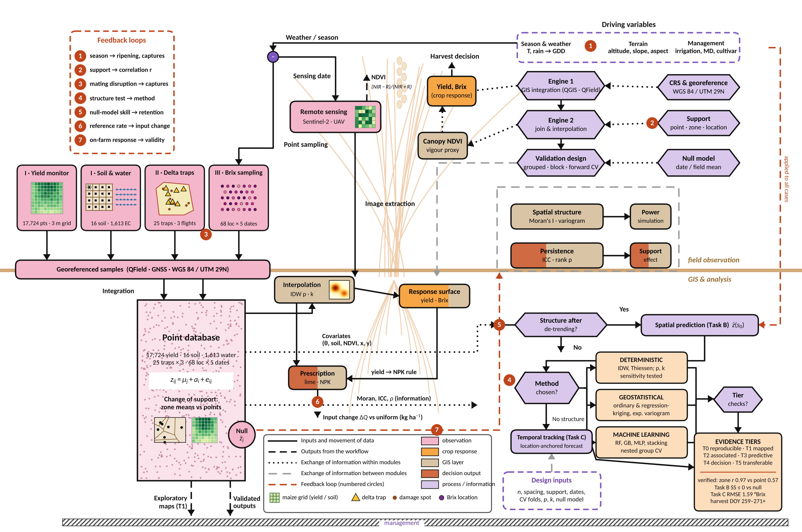
Figure 1. Common workflow of the three case studies, from field observation to evidence tier. The pink tiles at upper left carry glyphs that reproduce the sampling geometry of each project: the 3 m yield-monitor grid and the 4 × 4 soil grid with seven-core composites and EC transects (Case I, maize), the network of delta traps (yellow triangles) and damage spots (brown dots) (Case II, grapevine moth), the 68-location Brix grid (Case III) and the image pixels used for NDVI; the same glyphs mark the Thiessen, IDW and point-support layers below the field line. Boxes are coloured by role (pink, field observations; orange, crop response; tan, GIS layers and diagnostics; dark orange, decision outputs; lavender, processes and information) and shapes distinguish data stores (rounded boxes) from processes and decisions (hexagons). Solid lines show inputs and the movement of data; black dashed lines, outputs of the workflow; dotted lines, exchange of information within a module; grey dashed lines, exchange of information between modules; and orange dashed lines with numbered circles, the seven feedback loops listed top left: (1) season and weather → ripening and captures; (2) spatial support → correlation strength; (3) mating disruption → trap captures; (4) spatial-structure test → choice of method; (5) null-model skill → retention of a model; (6) uniform reference rate → computed input change; (7) on-farm response → validity of prescriptions. The horizontal line separates field observation (above) from GIS integration and analysis (below); the hatched bar represents the management decision. z_{ij} = μ_{j} + a_{i} + e_{ij} denotes the decomposition of an observation at location i and date j into a date mean, a persistent location effect and a residual.
Case I is a 16.85-ha irrigated maize (Zea mays L.) field in the lower Mondego valley west of Coimbra (approx. 40°12′N, 8°31′W), on alluvial soils under a Mediterranean climate with Atlantic influence (Köppen Csb; mean annual temperature approx. 15–17 °C and annual precipitation approx. 800–1,200 mm concentrated between October and April) (Kottek et al., 2006; AEMET and IM, 2011). Case II is the 42.97-ha Quinta da Senhora da Graça estate on the right bank of the Corgo River near Peso da Régua, in the Douro Demarcated Region, where vineyards occupy 34.95 ha (81% of the estate) on steep schist slopes (slope 0–111%, altitude 61–400 m) bordered by riparian forest and groves (Andresen et al., 2004; Jones and Alves, 2012; Fraga et al., 2018). Case III is the approx. 6-ha UTAD vineyard of Quinta de Nossa Senhora de Lurdes, Vila Real, also in the Douro wine-growing context (Fraga et al., 2012), in which Touriga Nacional is the dominant cultivar (approx. 38% of the vineyard area). Site maps are provided in Supplementary Figures S1–S3; Figure 3 maps the sampling designs of the two cases with point data.
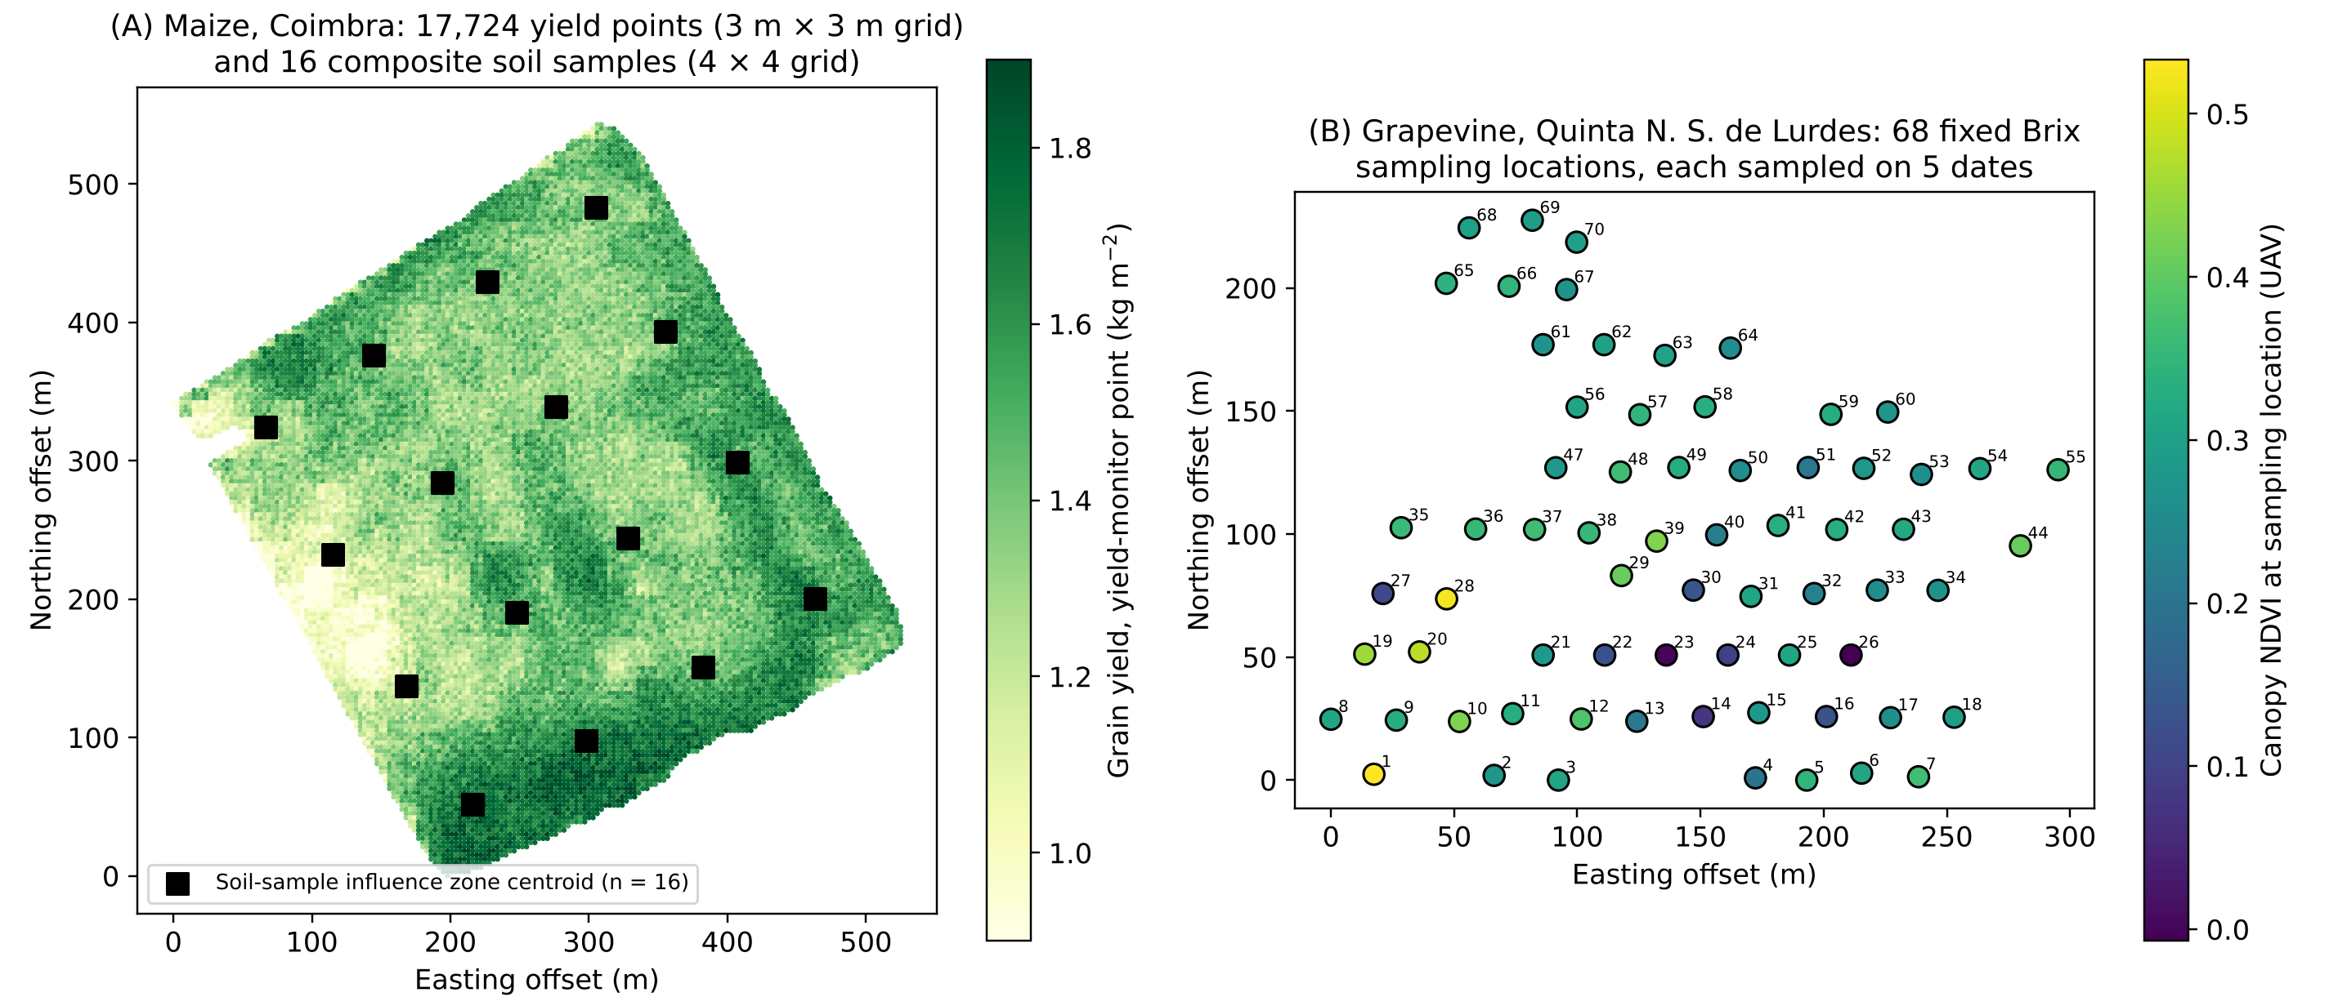
Figure 3. Sampling designs of the two case studies with point data. (A) Case I, maize: 17,724 yield-monitor points on a 3 m × 3 m grid coloured by grain yield (kg m⁻²), and the centroids of the 16 Thiessen influence zones of the composite soil samples (4 × 4 systematic design; seven sub-samples per composite). Soil-water points (1,613, approx. 10 m spacing) are not shown for legibility. (B) Case III, grapevine: the 68 fixed Brix sampling locations (numbers are sample identifiers), each sampled on five dates, coloured by canopy NDVI from the UAV orthomosaic. Coordinates are offsets (m) from the minimum easting and northing in WGS84 / UTM 29N. This figure replaces the former Figure 1, whose three panels showed the same field without the sampling design.

2.2. Case Study I: Maize soil fertility, yield and variable-rate prescription

2.2.1. Agronomic question and decision
The agronomic question was whether within-field yield variation is associated with soil chemical properties and soil water, and how such information could be translated into variable-rate lime and fertiliser maps. The intended decision is the allocation of lime and compound fertiliser in a subsequent season. Because yield and soil observations come from the same season, prescriptions derived from yield are necessarily retrospective and their use for the next season assumes that the yield pattern persists (Blackmore et al., 2003); this assumption is not tested here (Section 4.2).

2.2.2. Crop management
Detailed crop-management records (hybrid, sowing date, fertiliser rates and timing, irrigation volumes, harvest date) were not part of the supplied dataset, which limits the agronomic interpretation of yield variation (Section 4.6). The field was irrigated (irrigation starting at the rapid vegetative growth stage, approximately July) and harvested for grain.

2.2.3. Yield data
Grain yield was recorded by a combine yield monitor and supplied as a cleaned point dataset on a regular 3 m × 3 m grid (17,864 points; 17,724 inside the field boundary after clipping), each point representing 9 m². Yield is expressed as kg m⁻² (1 kg m⁻² = 10 t ha⁻¹). The moisture basis of the yield values is not recorded, so yields are interpreted as within-field contrasts rather than against regional yield levels. Yield-monitor data contain known sources of error (flow delay, header width, speed changes) (Arslan and Colvin, 2002; Sudduth and Drummond, 2007), so point-level values were used for spatial-structure analysis and zone means for comparison with soil samples. Mean yield was 1.42 kg m⁻² (SD 0.20; range 0.27–2.09 kg m⁻²).

2.2.4. Soil sampling and analysis
Soil sampling followed a systematic design of 16 sampling plots arranged as a 4 × 4 grid generated in QGIS from the field boundary (approx. one plot per 1.05 ha). At each plot a composite sample was formed from seven sub-samples, one at a georeferenced master point and six around it, and navigated to with QField on a GNSS-enabled device. Sampling depth, sampling date and laboratory are not documented in the supplied dataset. Soil pH was measured in water (1:2.5), organic matter (OM) as % and phosphorus and potassium as P₂O₅ and K₂O (mg kg⁻¹); the extraction method is not specified in the dataset (Egnér–Riehm ammonium-lactate extraction is the routine method in Portugal, but this cannot be confirmed for these samples); exchangeable calcium and magnesium were reported as CaO and MgO (mg kg⁻¹). Expressing P and K as oxides is a reporting convention and does not change the extracted fraction; their agronomic interpretation depends on the extraction method, soil texture and pH, because P availability is controlled by pH-dependent sorption and precipitation and K availability by exchange and fixation on clay minerals (Hinsinger, 2001; Penn and Camberato, 2019; Sparks, 1987). Soil texture was not measured, so P and K values are interpreted only as relative within-field indicators.

2.2.5. Soil-water measurements
The variable previously labelled 'water quality' is volumetric soil-water content (m³ m⁻³) estimated from apparent electrical conductivity, measured continuously along planting lines and summarised at 1,613 georeferenced points spaced approximately 10 m apart, for a near-surface layer ('top', 0.16–0.44 m³ m⁻³) and a deeper layer ('deep', 0.24–0.41 m³ m⁻³) (Corwin and Lesch, 2005). The sensor model, effective depths of the two layers and measurement date are not documented in the dataset. Because apparent electrical conductivity integrates water content, texture, and salinity, the derived water content should be interpreted as an index of soil-water storage rather than a direct gravimetric measurement (Corwin and Lesch, 2005). The term 'water quality' has been removed throughout.

2.2.6. Spatial integration and interpolation
Each soil sample was assigned an influence zone by Thiessen tessellation (Thiessen, 1911), and each yield point inherited the attributes of its enclosing soil polygon and of its nearest soil-water point (Thiessen join). The 16 soil zones have a median area of 1.02 ha (range 0.80–1.12 ha) and contain 892–1,239 yield points each. Thiessen assignment assumes that a composite sample represents the whole polygon; it was used because it preserves the observed values and makes the statistical unit explicit, whereas continuous soil surfaces for display were produced by IDW. IDW surfaces (Equation 1) were computed in QGIS with power p = 2 using all points, on a 1 m × 1 m raster clipped to the field boundary:
Z(s₀) = Σ_{i=1}^{n} w_{i} Z(s_{i}) / Σ_{i=1}^{n} w_{i}, w_{i} = d_{i}^{−p} (1)
where Z(s₀) is the estimate at location s₀, Z(sᵢ) the value at sample i, dᵢ the Euclidean distance and p the power parameter. The value p = 2 is the common default of Shepard's original formulation and of most GIS implementations (Shepard, 1968; Li and Heap, 2014); it is not optimal in general, so the sensitivity of IDW accuracy to p (1, 2, 3) and to neighbourhood size (all points vs. 8 nearest) was evaluated by cross-validation in Case III, where repeated point data allow it. With 16 composite samples, an experimental variogram of soil properties cannot be estimated reliably (fewer than the 100–150 points generally recommended, although the required number also depends on spatial extent, configuration and range) (Webster and Oliver, 1992; Kerry et al., 2010); kriging was therefore not applied to the soil data. The interpolated soil surfaces are displayed in Supplementary Figure S4 and are not used in any statistical test.

2.2.7. Statistical analysis
Pearson correlations between yield and the eight soil/water covariates (pH, OM, P₂O₅, K₂O, CaO, MgO, top and deep water content) were computed with the Thiessen zone as statistical unit (n = 16), i.e., zone-mean yield and zone-mean water content against the single soil value of the zone. For each coefficient we report the two-sided p-value, a 95% confidence interval (Fisher z transformation), the Holm-adjusted p-value for eight tests (Holm, 1979) and Spearman's ρ as a check against non-linearity and outliers. To quantify the effect of the spatial support, correlations between yield and water content were also computed at point level (n = 17,724) (Openshaw, 1984; Gotway and Young, 2002). Because neighbouring zones are not independent, nominal p-values should be read as approximate; Moran's I of zone means is reported to show the degree of spatial dependence (Clifford et al., 1989; Dutilleul, 1993). Spatial structure of yield itself was tested with global Moran's I on a random subsample of 4,000 yield points (k = 8 nearest-neighbour binary weights, 999 permutations) and summarised by an empirical semivariogram; the share of point-level yield variance lying between soil zones was quantified by η² from a one-way decomposition. The interpolated rasters were not used as statistical units, avoiding the inflation of significance that results from treating neighbouring cells as independent (Dormann et al., 2007).
r = Σ(x_{i} − x̄)(y_{i} − ȳ) / √[Σ(x_{i} − x̄)² Σ(y_{i} − ȳ)²] (2)
Three additional analyses address the small number of zones and the spatial dependence of the data. First, the effective sample size of each zone-level correlation was estimated with the method of Clifford et al. (1989), in which the variance of r under spatial autocorrelation is approximated from the product of the spatial correlograms of the two variables (five distance classes for zones; 15 classes for a random subsample of 3,000 yield points), and the significance of r was re-evaluated with the effective rather than the nominal degrees of freedom. Second, partial correlations were computed to separate the effects of the inter-correlated predictors (deep water, K₂O and OM). Third, to test whether the soil and water covariates can predict yield at unsampled places, a spatial block cross-validation was run at point level (n = 17,694 yield points with complete covariates): the field was divided into square blocks of 30, 60 or 120 m, blocks were assigned at random to five folds, and five predictors were compared on held-out blocks: the training mean, IDW of yield (12 nearest training points, p = 2), linear regression on near-surface and deep water content, random forest on the eight soil and water covariates (200 trees, minimum leaf size 5), and random forest on covariates plus coordinates (Roberts et al., 2017; Ploton et al., 2020). Finally, k-means clustering (k = 2–6) of the standardised covariate surfaces was used to delineate candidate management zones, and their usefulness was measured as the share of point-level yield variance between zones (Fridgen et al., 2004).

2.2.8. Prescription equations: origin, calibration domain and model form
The lime and NPK equations were not fitted to measured crop responses. They are smooth approximations of reference recommendation tables supplied in the course material (Aranha, 2026): (i) a lime table giving the CaCO₃ dose (kg ha⁻¹) required to raise soil pH (H₂O) from values between 5.30 and 6.00 to a target of approximately 6.0 (15 tabulated pairs), and (ii) an NPK table giving a compound-fertiliser dose (kg ha⁻¹) as a decreasing function of yield level between 0.14 and 2.18 kg m⁻² (16 tabulated pairs). The high R² of these fits therefore measures numerical agreement with the reference tables, not agronomic validity. Because the lime table does not specify soil buffer capacity or liming material, and the NPK table does not separate N, P and K or specify the product grade, both are treated here as illustrative rule sets that demonstrate the GIS mechanics of variable-rate mapping; agronomically defensible prescriptions would require buffer-pH-based lime requirement (Adams and Evans, 1962; Sikora, 2006; Goulding, 2016) and nutrient-specific recommendations based on soil-test calibration and crop response (Morris et al., 2018; Scharf et al., 2006) (the reference table does not state the nutrient grade of the compound product).
For both tables, linear, quadratic and cubic polynomials were compared by R², root-mean-square error (RMSE), leave-one-out cross-validated RMSE (LOOCV) and the small-sample Akaike information criterion (AICc) (Burnham and Anderson, 2002). Prescriptions were applied only within the calibration domain (all interpolated pH values lay between 5.30 and 5.60 and all yields between 0.27 and 2.09 kg m⁻²) and truncated at zero. Field totals were obtained by averaging the point-level prescription over the 17,724 yield points (equal 9 m² support) and multiplying by 16.85 ha. The uniform reference rates were the tabulated doses for the least favourable condition in the field, i.e., 2.5 t ha⁻¹ CaCO₃ (dose for pH 5.30, the most acidic sample) and 375 kg ha⁻¹ NPK (dose for the lowest tabulated yield level); this reference corresponds to a uniform application sufficient for the most demanding part of the field and therefore maximises apparent savings. Differences between variable-rate and uniform totals are described as potential changes in input quantity, not as measured savings or efficiency gains.
The uncertainty of the lime total was propagated by Monte Carlo simulation (500 realisations). In each realisation, the 16 measured pH values were perturbed with independent normal errors whose standard deviation equalled the leave-one-out IDW error of pH (0.09 pH units), re-interpolated to the yield points by IDW, and converted to doses with one of the linear, quadratic or cubic lime equations chosen at random, so that both interpolation and model-form uncertainty contribute to the spread of the total.
CaCO₃ = β₀ + β₁(pH) + β₂(pH)² ; NPK = γ₀ + γ₁Y + γ₂Y² (3)

2.2.9. Role of remote sensing in Case I
Sentinel-2 MSI imagery (bands B2, B3, B4 at 10 m and B8 at 10 m) (Drusch et al., 2012) from the Copernicus Data Space Ecosystem was acquired for 28 February, 28 July and 6 October, i.e., near land preparation, peak vegetative growth under irrigation and maturity/harvest. The processing level and acquisition year are not recorded; band values of approximately 1,000–5,500 are consistent with Sentinel-2 reflectance scaled by 10,000. The original submission erroneously described these images as Landsat; this has been corrected. NDVI = (ρ_{NIR} − ρ_{RED})/(ρ_{NIR} + ρ_{RED}) (Rouse et al., 1974; Tucker, 1979) was computed from B8 and B4 after a simple dark-object subtraction (Chavez, 1988; Chavez, 1996), in which the minimum value over a deep-water target was subtracted from each band at each date. In this study NDVI was used only to confirm the crop boundary and to document the crop's seasonal trajectory; it was not used as a predictor of yield or in the prescriptions (although multispectral indices can explain part of maize yield variability when acquisitions are well timed and co-registered (Burglewski et al., 2024)), because a single July image at 10 m resolution was not co-registered with yield-monitor data. The spectral-signature comparison with built-up, bare-soil and water classes served only as a radiometric consistency check of the dark-object correction and has been moved to the Supplementary Material (Figure S6).

2.3. Case Study II: Monitoring of the European grapevine moth

2.3.1. Agronomic question and decision
Lobesia botrana (Denis & Schiffermüller) (Lepidoptera: Tortricidae) is a key pest of European vineyards, completing two to four generations per year depending on temperature; larval feeding on flowers and berries and the associated Botrytis infections cause yield and quality losses (Ioriatti et al., 2011; Thiéry et al., 2018; Fermaud and Le Menn, 1989). Male flight is commonly monitored with sex-pheromone traps, and mating disruption is widely used as a non-insecticidal control method (Witzgall et al., 2010; Benelli et al., 2023; Ricciardi et al., 2024). The agronomic question of this case was descriptive: where in the estate were captures and damage concentrated during each flight, and could GIS organise these observations to support targeted field inspection?

2.3.2. Monitoring protocol
The vineyard (34.95 ha) was under mating disruption with BIOOtwin® L dispensers at 350–400 dispensers ha⁻¹. Twenty-five delta traps baited with L. botrana sex-pheromone lures (0.72 traps ha⁻¹) were installed at bunch height inside vineyard blocks, distributed to cover white, red and mixed-variety blocks while avoiding immediate proximity to roads and borders, and georeferenced with GNSS. Male captures were counted in April, June and August, corresponding to the first, second and third flights; flights were identified from the calendar of regional flight activity (Gallardo et al., 2009). Exact inspection dates within April, June and August, lure type and replacement interval are not recorded; chromotropic (sticky) traps were also installed, but their counts were not part of the dataset. Damage (larval nests on inflorescences in May; perforated or infested berries in July and September) was recorded at georeferenced observation points in QField as a numeric damage value chosen from a predefined list in the QField form (attributes: spot, damage, variety, photograph, date) in layers dated 15 May, 15 July and 10 September. Damage points were placed where damage was found (non-fixed locations), so damage absence was not recorded systematically, and the numeric scale (values 0–14 in the dataset) is not defined in the course documentation; it is therefore treated as an ordinal intensity index. Insecticide applications during the season were not recorded in the dataset.
Two features of this design limit inference. First, under mating disruption trap catches are strongly suppressed ('trap shutdown'), so they indicate where disruption is incomplete rather than providing a proportional estimate of population density (Witzgall et al., 2010; Ioriatti et al., 2011; Lucchi et al., 2018). Second, captures are available as classes of counts per trap (0–2 … 16–18) and only three inspections were made; therefore no formal spatial statistic (e.g., distance-to-edge regression or SADIE (Perry, 1995)) and no relationship with terrain variables could be estimated with adequate power. Terrain variables (altitude, slope, aspect) were taken from the course digital elevation model (raster ALT_SR_GRACA_V2) and its derived slope (DEC_SR_GRACA) and aspect (EXPOS_SR_GRACA) rasters, whose source and resolution are not documented; they are presented as site context (Supplementary Figure S2), not as explanatory variables. Statements about forest-edge origin, directional dispersal and intervention windows are treated in this revision as hypotheses (Section 4.3).

2.4. Case Study III: Brix monitoring, spatial prediction and harvest forecasting

2.4.1. Agronomic question, observational unit and sampling
The agronomic question was how sugar accumulation varies in space and time within the vineyard and when the vineyard would reach a target sugar concentration. Total soluble solids were measured at 68 fixed georeferenced sampling locations on five dates (15 July, 30 July, 6 August, 15 August and 30 August; days of year 196, 211, 218, 227 and 242), giving 340 sample-date observations. The 68 locations, not the 340 observations, are the independent spatial units. Locations form an approximately regular grid with 25 m row spacing (mean nearest-neighbour distance 24 m, range 20–34 m) over a convex hull of 4.7 ha (Figure 3B), and the same locations were resampled on every date. Following the course protocol, a technician walked along the vine row at each location, picked a few berries, squeezed them into a container and read the juice on a hand-held optical refractometer. The number of berries and vines per location and the refractometer model are not recorded, and the cultivar at each location was not attached to the data (Touriga Nacional dominates the vineyard). Total soluble solids (°Brix, g sucrose per 100 g solution) were converted to probable alcohol only for illustration, using the commonly cited approximation of 0.55–0.59% v/v per °Brix, which corresponds to approximately 16.8–17.0 g L⁻¹ sugar per 1% v/v ethanol and varies with yeast, must density and fermentation conditions (Ribéreau-Gayon et al., 2006).

2.4.2. Remote-sensing data
Canopy NDVI was obtained from unmanned aerial vehicle (UAV) multispectral imagery processed into an orthomosaic in Agisoft photogrammetry software and clipped to the vineyard boundary. Imagery was acquired with a DJI Phantom 4 RTK multispectral UAV (blue, green, red, red-edge and near-infrared bands with RTK georeferencing); flight date, altitude and ground sampling distance are not recorded in the course material. A single NDVI value per sampling location was extracted (mean NDVI = 0.30, SD = 0.10, range 0.00–0.53). Because only one acquisition was available, NDVI is a static descriptor of canopy vigour, not a time-varying predictor. Separation of vine canopy from inter-row vegetation, soil and shadow is essential for interpreting vineyard NDVI (Hall et al., 2002; Matese and Di Gennaro, 2015; Matese et al., 2015; Pádua et al., 2018; Kasimati et al., 2023); no separate canopy/inter-row masking step is described in the processing workflow, so extracted values may mix canopy and inter-row pixels.
The agronomic rationale for relating NDVI to Brix is indirect. NDVI is mainly sensitive to canopy size and leaf area (Tucker, 1979; Huang et al., 2021), whereas sugar accumulation depends on the source–sink balance, canopy microclimate and water status (Coombe, 1992; Keller, 2020). Higher vigour can either increase sugar supply or delay ripening through shading and excessive crop growth (Smart, 1985), so the expected sign of the relationship is not fixed, and published vineyard studies report vigour–composition associations that are inconsistent across seasons, even when the spatial pattern of yield is stable between vintages (Bramley and Hamilton, 2004; Lamb et al., 2004; Bramley, 2005; Trought and Bramley, 2011). In this revision, NDVI is therefore tested as a candidate covariate under the explicit hypothesis H₁: locations with higher canopy NDVI have systematically different Brix, rather than assumed to be a proxy.

2.4.3. Three distinct prediction tasks
Following the reviewers' recommendation, three tasks that differ in the information available at prediction time were separated and validated differently (Roberts et al., 2017; Wadoux et al., 2021): Task A – mapping Brix at a sampled date (descriptive IDW/Thiessen maps; T1); Task B – predicting Brix at unsampled locations for a sampled date (spatial prediction; validated by holding out whole locations); and Task C – forecasting future Brix at sampled locations, and the vineyard-mean date at which a sugar threshold is reached (temporal forecasting; validated by withholding later dates).

2.4.4. Temporal model and harvest-date forecast (Task C)
The vineyard-mean Brix at the five dates (n = 5 means of 68 locations) was fitted by four growth functions: linear, logarithmic [a + b ln(t)], three-parameter logistic and Gompertz. The logarithmic form, used in the original submission, increases at a continuously decreasing rate and has no finite plateau; it is therefore retained only as an empirical approximation over the observed interval, whereas the logistic and Gompertz forms have an explicit asymptote consistent with the slowing of sugar accumulation late in ripening (Coombe, 1992; Parker et al., 2020). Each model was evaluated in-sample (R², RMSE), by leave-one-date-out cross-validation and by a forward test (fit on the first four dates, predict 30 August). The day on which each fitted curve reached 25.5 °Brix was computed, and its sampling uncertainty was estimated by a cluster bootstrap that resampled the 68 locations with replacement (1,000 resamples) and refitted the curve. The course protocol defines 25.5 °Brix (≈ 14.0% v/v potential alcohol) as the level at which picking can start, and the practical guide uses 24 °Brix (≈ 13.2% v/v) as the earliest acceptable level and 27 °Brix as an upper reference (Aranha, 2026); the 25.5–27 °Brix band was therefore used as the target; it is a sugar threshold, not a definition of harvest maturity, which also depends on acidity, pH, phenolic and aromatic maturity and logistics (Ribéreau-Gayon et al., 2006; Jones and Davis, 2000; Keller, 2020).
For forecasting at sampled locations, each location's mean deviation from the vineyard mean over the first four dates (its 'location anomaly') was added to the vineyard-mean value for 30 August predicted by the logarithmic curve fitted to the first four means. This location-anchored forecast was compared with the vineyard-mean forecast alone. Calendar time was used because no temperature series co-located with the vineyard was available; thermal-time (growing degree-day) models are preferable for transfer between seasons (Parker et al., 2020; Jones and Davis, 2000).

2.4.5. Variance decomposition and spatial autocorrelation
The 68 × 5 Brix matrix was decomposed into date, location and residual sums of squares (two-way decomposition without replication), and the intraclass correlation (ICC) of locations was computed; rank persistence between dates was measured with Spearman's ρ. Global Moran's I (Moran, 1950; Cliff and Ord, 1981) (Equation 4) was computed (a) on raw Brix at each date, (b) on the location anomaly, i.e., Brix after removal of the date means (the temporal trend), (c) on the location anomaly after regression on NDVI, (d) on out-of-fold random-forest residuals and (e) on NDVI. To assess sensitivity to the neighbourhood definition, binary k-nearest-neighbour weights with k = 4, 6, 8 and 12 and a 40-m distance band were used. Significance was assessed by 1,999 random permutations (one-sided, positive autocorrelation); the expectation under no autocorrelation is E[I] = −1/(n−1) = −0.015.
I = (n/S₀) Σ_{i}Σ_{j} w_{ij}(z_{i} − z̄)(z_{j} − z̄) / Σ_{i}(z_{i} − z̄)² (4)

2.4.6. Spatial prediction models and validation (Task B)
Two validation designs were used (Roberts et al., 2017; Meyer et al., 2018; Ploton et al., 2020). In the pooled design, all 340 observations were used with predictors easting, northing, day of year and NDVI, and five-fold GroupKFold cross-validation with the location as group (all five dates of a held-out location removed together) was repeated six times with different random allocations of locations to folds (30 folds). In the per-date spatial-only design, each date was analysed separately with predictors easting, northing and NDVI only (no temporal information), using five-fold cross-validation over locations repeated four times; this design isolates the spatial and NDVI signal from the ripening trend. In both designs, all model fitting, tuning, variogram estimation and stacking were performed within the training folds only.
Models were: (i) a date-mean null model, predicting each held-out observation by the mean of training locations on the same date (pooled) or by the training mean (per date); (ii) IDW with p = 1, 2, 3 using all training locations of the same date, and p = 2 with the 8 nearest neighbours; (iii) date mean plus IDW-interpolated location anomaly; (iv) ordinary kriging (per-date design); (v) linear regression on ln(day) and NDVI; (vi) random forest (RF; 400 trees, minimum leaf size 2) (Breiman, 2001); (vii) gradient boosting (GB; 300 trees, learning rate 0.05, maximum depth 3, subsample 0.8) (Friedman, 2001), implemented with scikit-learn's GradientBoostingRegressor rather than XGBoost (Chen and Guestrin, 2016); (viii) a multilayer perceptron (MLP; two hidden layers of 32 and 16 ReLU units, Adam optimiser, learning rate 10⁻³, batch size 32, L2 penalty 10⁻³, maximum 2,000 epochs, early stopping with 15% internal validation and patience 30); (ix) a stacking ensemble (Wolpert, 1992; Breiman, 1996); and (x) regression-kriging (RF-RK and GB-RK) (Hengl et al., 2004; Hengl et al., 2007). Random seeds were fixed per fold, and all ML models were run in scikit-learn 1.9 (Pedregosa et al., 2011).
Leakage control in stacking and regression-kriging. Within each outer training fold, an inner five-fold GroupKFold (by location, on training locations only) generated out-of-fold predictions of RF, GB and MLP. A ridge meta-learner (regularisation strength selected from 10⁻³–10³ by internal cross-validation) was fitted to these inner out-of-fold predictions; the base learners were then refitted to the complete outer training fold and their predictions for the held-out locations combined with the fitted meta-weights. The meta-learner thus never saw observations from held-out locations. For regression-kriging, the same inner out-of-fold residuals (rather than in-sample residuals, which are shrunk towards zero by tree ensembles) were kriged separately for each date by ordinary kriging with an exponential variogram (Equation 5) fitted by bounded non-linear least squares to 10 equal-width lag bins up to the 60th percentile of pair distances, retaining bins with ≥ 30 pairs (nugget, partial sill ∈ [0, 3·var], range ∈ [1, 500] m); kriged residuals were added to the trend prediction.
γ(h) = c₀ + c[1 − exp(−h/a)] (5)
Performance on held-out data was summarised by RMSE, mean absolute error (MAE) and R² = 1 − Σ(yᵢ − ŷᵢ)²/Σ(yᵢ − ȳ)², which can be negative out of sample, and by a skill score relative to the null model, SS = 1 − MSE_{model}/MSE_{null}. Impurity-based and permutation importance (30 repeats) were computed for RF fitted to all data, recognising that impurity importance is biased towards continuous high-cardinality variables (Strobl et al., 2007). A learning curve was obtained by randomly selecting 10–60 training locations (200 replicates per size) and predicting the location anomaly at the remaining locations by IDW and by the training mean. The number of locations needed to estimate the vineyard mean within ±E °Brix (95% confidence) was computed as n = (1.96·SD/E)².
Four further analyses were added to quantify the strength of evidence. (i) A linear mixed model with fixed effects of centred day of year (linear and quadratic) and a random intercept for location was fitted by maximum likelihood with and without NDVI, and NDVI was tested by a likelihood-ratio test; the reduction of the location variance when NDVI is added measures the share of persistent between-location differences explained by canopy vigour. (ii) Because a non-significant Moran's I may reflect low power rather than absence of structure, the power of the test (k = 8, one-sided α = 0.05) on the actual 68-location design was estimated by simulating Gaussian fields with an exponential covariance (range 15, 25, 50 or 100 m) in which 25%, 50% or 75% of the variance was spatially structured and the remainder was nugget (800 simulations per combination; critical value from 4,000 simulations of pure noise). (iii) The empirical semivariogram of the location anomaly (20 m lags; lags with ≥ 30 pairs) was compared with a 95% envelope obtained from 999 random permutations of the anomalies among locations (Oliver and Webster, 2014). (iv) A split-conformal prediction interval for the location component of the 30 August forecast was calibrated on the analogous one-step-ahead forecast of 15 August (anomaly over the first three dates) with nominal 90% coverage, and its empirical coverage on 30 August was recorded.
All analyses were run in Python 3.13 (NumPy, SciPy, pandas, scikit-learn, statsmodels); GIS processing was done in QGIS. The full code and the Brix/NDVI and maize yield–soil–water datasets are provided as Supplementary Material.

3. Results

3.1. Case I: soil–yield relationships depend on the spatial support
Yield was strongly spatially structured at point level (Moran's I = 0.78 for 4,000 randomly selected yield points, k = 8, p = 0.001). The semivariogram increased steadily from 0.009 (kg m⁻²)² at lags < 15 m to 0.042 (kg m⁻²)² at approximately 250 m without a clear sill within the field (Supplementary Figure S7), indicating both short-range structure and a field-scale trend. The 16 soil zones accounted for 46% of point-level yield variance (η² = 0.46), and zone-mean yield ranged from 1.11 to 1.66 kg m⁻². Zone means were themselves moderately autocorrelated (Moran's I = 0.22, k = 4, p = 0.04). These results replace the earlier statement that yield variability was spatially structured, which had been based only on differences between zone means.
Soil pH varied little (5.3–5.6; mean 5.39), whereas OM (1.8–2.5%), P₂O₅ (60–90 mg kg⁻¹), K₂O (120–200 mg kg⁻¹), CaO (350–750 mg kg⁻¹) and MgO (40–80 mg kg⁻¹) varied more widely (Supplementary Table S2). At the zone level (n = 16; Table 2), yield was most strongly correlated with deep-layer soil-water content (r = 0.973, 95% CI 0.921–0.991, Holm-adjusted p < 0.001), followed by K₂O (r = 0.753, CI 0.410–0.909, adjusted p = 0.005) and OM (r = 0.712, CI 0.334–0.893, adjusted p = 0.012). The negative correlation with P₂O₅ (r = −0.594) was nominally significant (p = 0.015) but not after Holm adjustment (p = 0.077), and correlations with CaO, MgO, pH and near-surface water were not significant. Spearman coefficients were of similar magnitude and sign (Table 2). OM, K₂O and deep water were strongly inter-correlated (r = 0.74–0.84), so the individual coefficients cannot be interpreted as independent effects. CaO and MgO were strongly collinear (r = 0.956, p < 0.001); this collinearity indicates co-variation of the two base cations and does not allow conclusions about whether either limits yield.
The same deep-water relationship was much weaker at point level (r = 0.575, n = 17,724; Figure 4), and the near-surface water correlation decreased from 0.398 to 0.254. Aggregation to zones removes within-zone noise (including yield-monitor error and micro-scale variation) and therefore inflates correlation coefficients; the zone-level r describes association between field-scale patterns and cannot be interpreted as the strength of the relationship at any given location (Robinson, 1950; Openshaw, 1984; Gotway and Young, 2002).
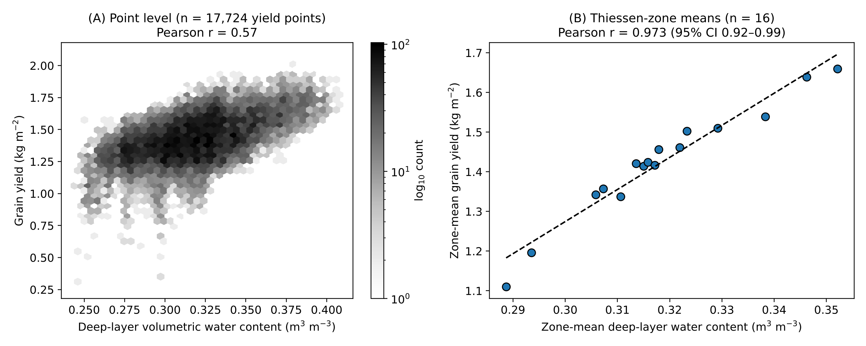
Figure 4. Effect of the spatial support on the yield–soil-water correlation in Case I. (A) Point level: grain yield against deep-layer volumetric water content at the nearest soil-water point (hexagonal bins, n = 17,724). (B) Zone level: means of the same variables over the 16 Thiessen soil zones (n = 16), with ordinary least-squares line.
Accounting for spatial dependence reduced the effective sample size of the zone-level correlations from 16 to 7.9–9.9. The deep-water correlation remained significant (effective n = 9.9; p < 0.001), as did those of K₂O (effective n = 8.4; p = 0.026) and OM (effective n = 9.2; p = 0.029), whereas the P₂O₅ correlation did not (effective n = 7.9; p = 0.13). At point level, the effective sample size of the yield–deep-water correlation was only about 78 (of 3,000 subsampled points), although the correlation remained significant (p < 0.001). Partial correlations showed that, once deep water was accounted for, neither K₂O (partial r = −0.14, p = 0.63) nor OM (partial r = −0.02, p = 0.95) retained any association with yield, whereas deep water remained strongly associated after controlling for both (partial r = 0.93, p < 0.001). The apparent K₂O and OM effects are therefore best interpreted as co-variation with soil-water storage.
In the spatial block cross-validation (Figure 9A; Supplementary Table S6), IDW of yield itself was the best predictor at every block size (cross-validated R² = 0.72, 0.61 and 0.47 for 30, 60 and 120 m blocks); random forest on covariates plus coordinates performed similarly at 30–60 m (0.70 and 0.62) but worse at 120 m (0.39); random forest on covariates alone reached 0.63, 0.51 and 0.31; and linear regression on water content was stable at 0.32–0.34. The training mean had no skill (R² ≈ 0). Predictive skill declined with distance to the training data for every spatial method, so maps extrapolated far from observations should be treated with caution (Meyer and Pebesma, 2021). Covariate-based management zones from k-means clustering explained 21% (k = 2) to 31% (k = 6) of point-level yield variance, less than the 46% captured by the 16 Thiessen zones of the soil samples.
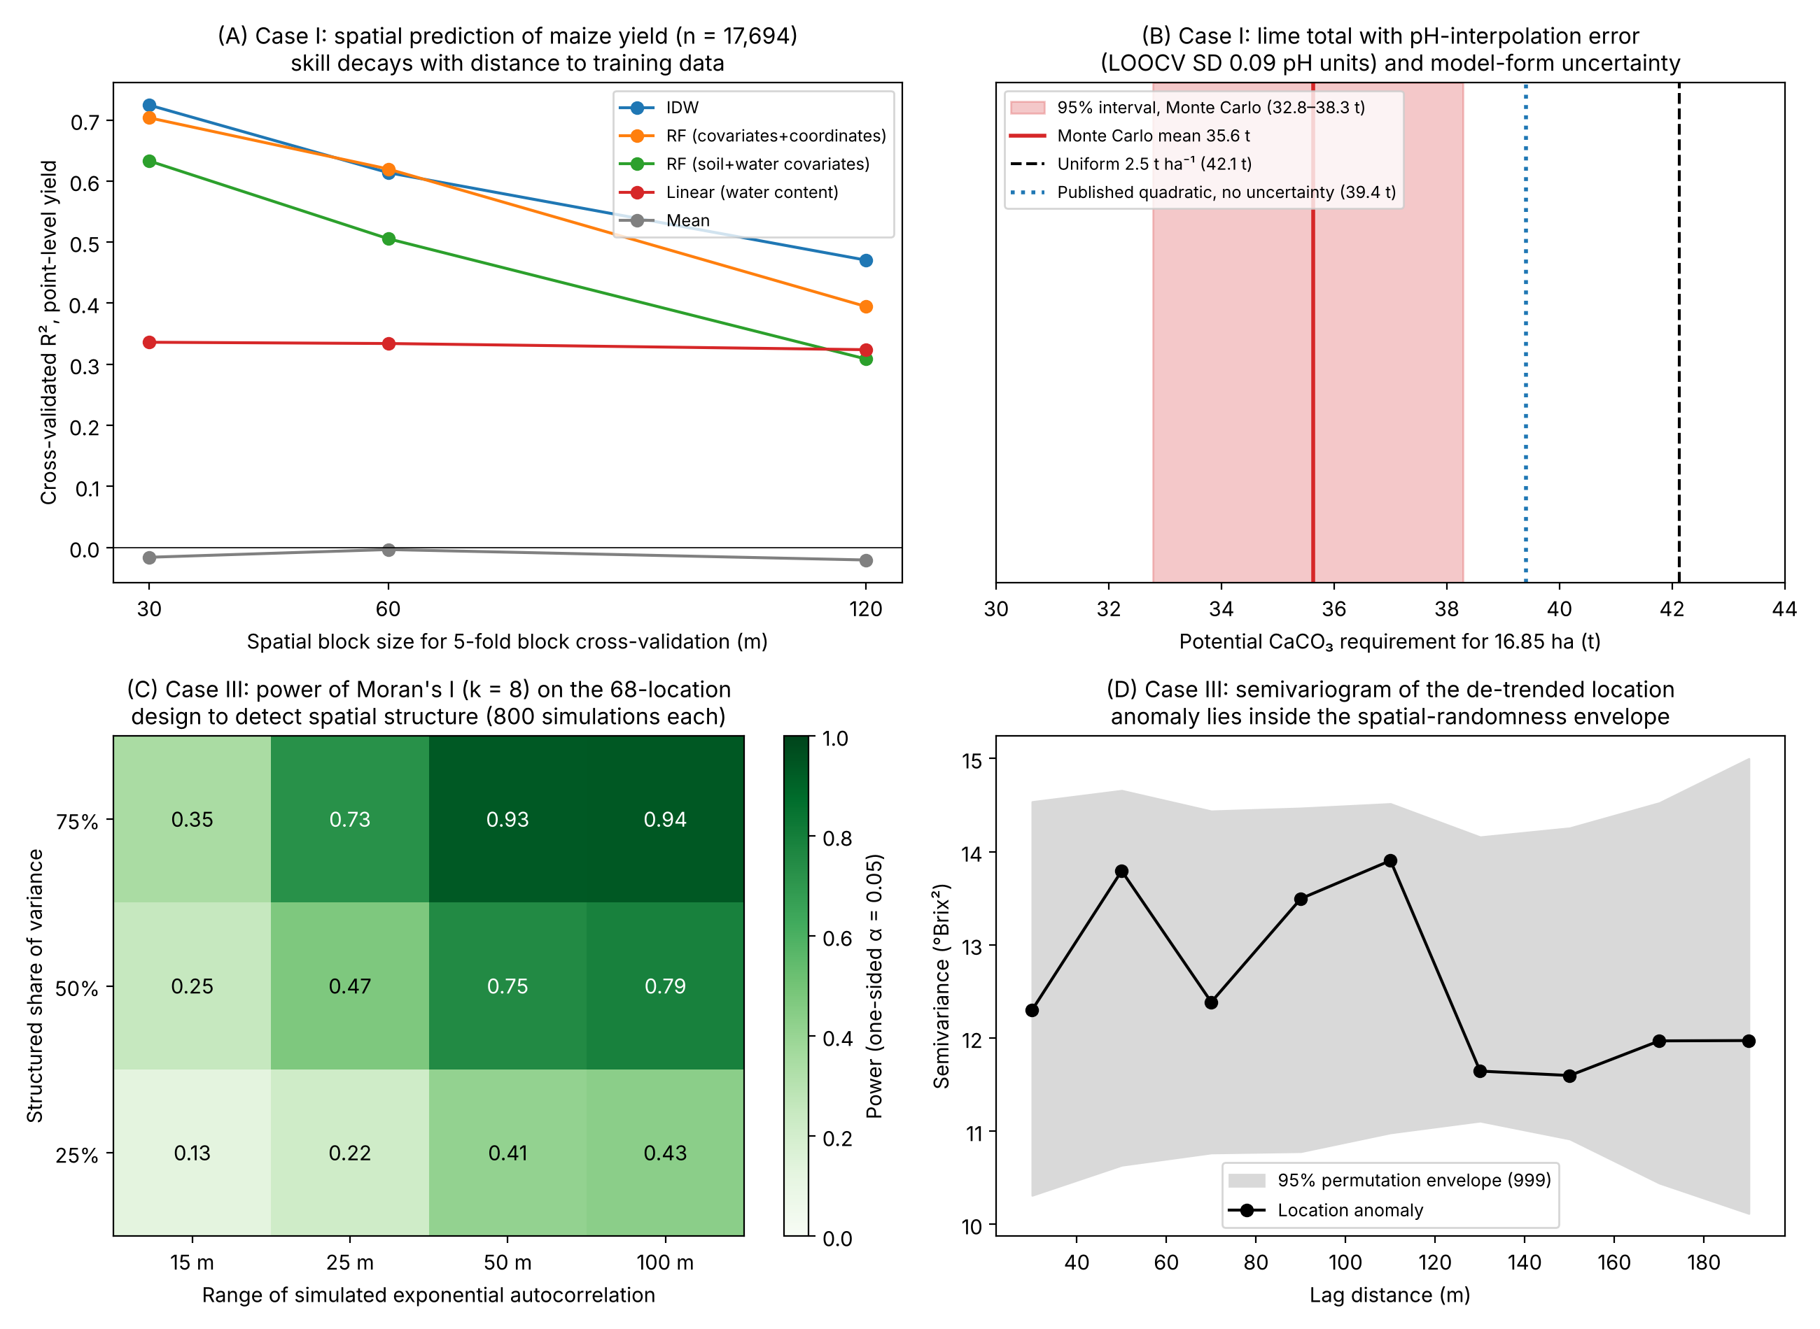
Figure 9. Additional analyses of the strength of evidence. (A) Case I: point-level spatial block cross-validation of maize yield for 30, 60 and 120 m blocks (five folds): IDW of yield, random forest (RF) on soil and water covariates with and without coordinates, linear regression on soil-water content, and the training mean. (B) Case I: Monte Carlo 95% interval (500 realisations) of the potential lime total when pH interpolation error (LOOCV SD 0.09) and model form (linear, quadratic or cubic) are propagated, compared with the published single value and the uniform rate. (C) Case III: power of Moran's I (k = 8, α = 0.05) on the 68-location design for simulated exponential fields with different ranges and structured shares of variance. (D) Case III: semivariogram of the de-trended location anomaly with the 95% envelope from 999 random permutations.

3.1.1. Prescription equations
Refitting the reference tables showed that the quadratic lime equation reported in the original submission (CaCO₃ = 3419.5 pH² − 42630 pH + 132738) reproduces a smoothed version of the table rather than the tabulated values themselves; refitting the tabulated values gave linear, quadratic and cubic fits with R² = 0.995, 0.997 and 0.997 and LOOCV RMSE = 65, 49 and 55 kg ha⁻¹, respectively (Table 3; Figure 5A). For NPK, the linear, quadratic and cubic fits gave R² = 0.970, 0.995 and 0.998 and LOOCV RMSE = 18.8, 9.5 and 8.3 kg ha⁻¹; the cubic had the lowest AICc, but all three forms lie within ±20 kg ha⁻¹ of the table over the yield range observed in the field (Figure 5B). Because the tables are monotonic and smooth, all polynomial forms describe them almost equally well, and the choice cannot be made on goodness of fit alone.
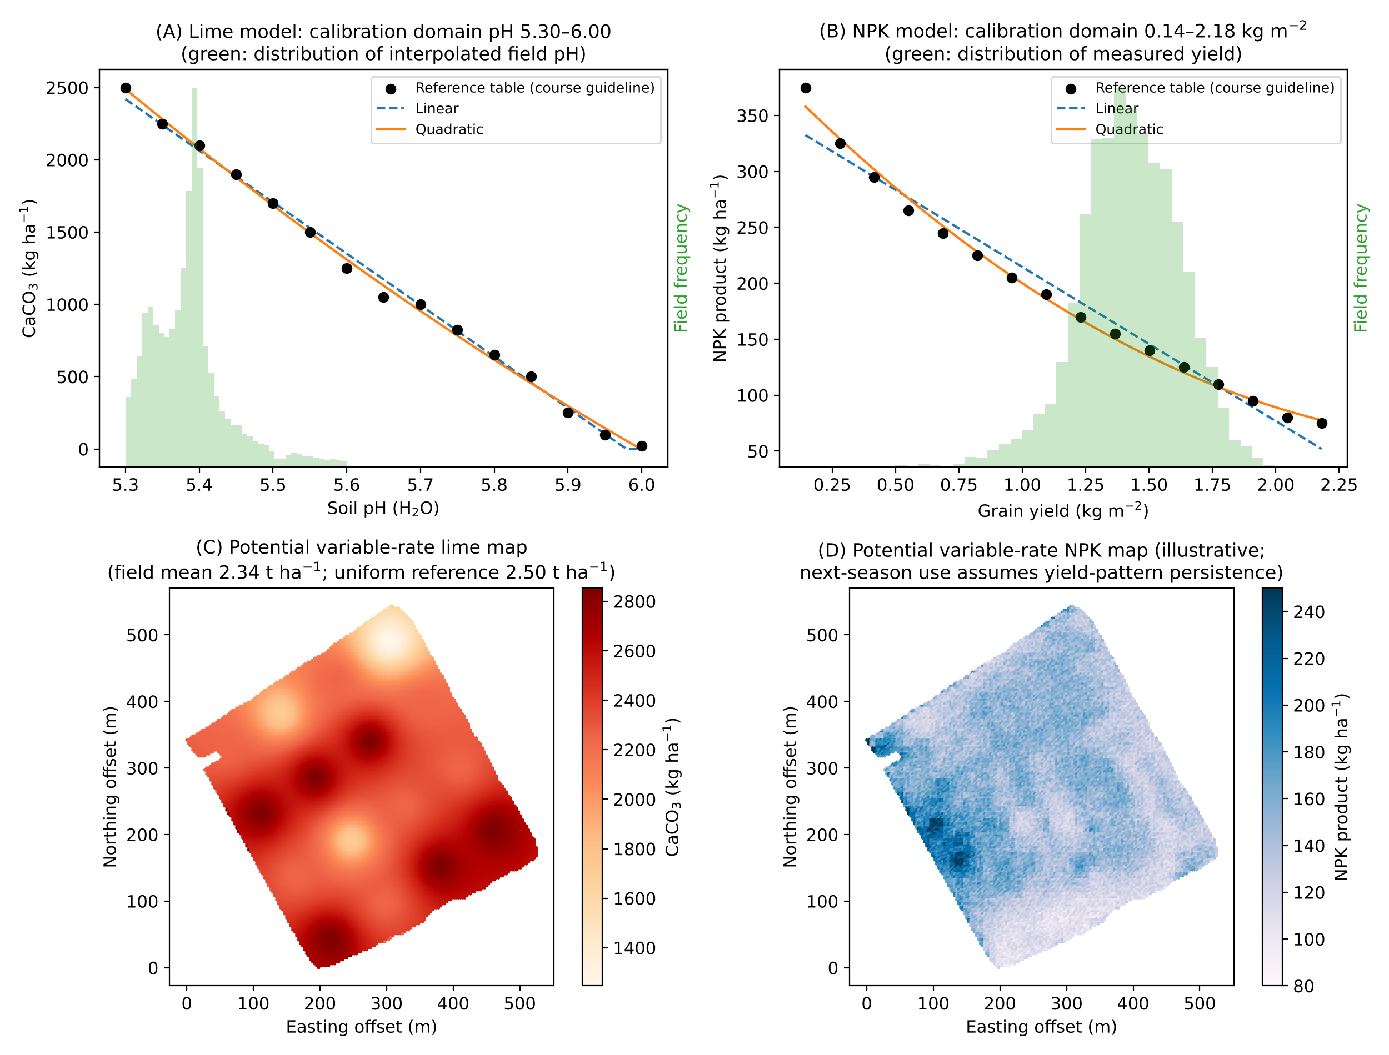
Figure 5. Prescription equations and potential variable-rate maps in Case I. (A) Lime table (points; CaCO₃ dose to raise pH to approx. 6.0) with linear and quadratic fits; the shaded histogram shows the distribution of interpolated field pH, which lies within the calibration domain. (B) NPK table (points) with linear and quadratic fits and the distribution of measured yield. (C) Potential lime prescription from the published quadratic equation applied to the IDW pH surface. (D) Potential NPK prescription from the quadratic equation applied to point yield. Both maps are illustrative; their use in a following season assumes temporal persistence of the patterns, which was not tested.
Applied to the interpolated pH surface, the published quadratic lime equation gave a mean potential dose of 2.34 t ha⁻¹ (39.4 t for 16.85 ha) against 42.1 t for the uniform 2.5 t ha⁻¹ reference (−6.5%); the linear form gave 35.6 t (−15.5%). The NPK quadratic gave a mean of 145 kg ha⁻¹ (2.44 t) and the linear form 156 kg ha⁻¹ (2.64 t) against 6.32 t at the uniform 375 kg ha⁻¹ reference. Thus the direction of the change was robust to model form, but its magnitude varied by a factor of about two for lime, and the apparent NPK reduction is dominated by the choice of reference rate (the dose for the lowest yield level). The resulting maps (Figure 5C–D) are potential prescriptions; no field application, as-applied record or yield response was available to evaluate them.
When interpolation error of pH and the choice of model form were propagated together, the potential lime total was 35.6 t (95% interval 32.8–38.3 t), i.e., 9–22% below the uniform reference of 42.1 t; every realisation was below the uniform total (Figure 9B). The direction of the potential change is therefore robust, but its size is uncertain by a factor of more than two.

3.2. Case II: spatio-temporal distribution of captures and damage
Captures during the first flight (April) were low (0–8 males per trap) and occurred mainly in traps along the south-eastern and upper-central margins of the vineyard, where the vineyard adjoins riparian forest and groves; damage recorded in May was in the lowest classes (2–4 and locally 6–8). The second flight (June) produced the highest captures (up to 16–18 males per trap) in the north-eastern and south-eastern sectors, and damage recorded in July was higher and more widespread (up to 12–14). During the third flight (August), captures fell to 0–6 males per trap, while damage recorded in September (classes up to 6–8) occurred at more locations than in May (Figure 6). These are direct observations. Because captures under mating disruption reflect incomplete disruption rather than proportional density, because only three inspections were made and because no statistical test of association with distance to forest, terrain or variety was possible, the patterns do not by themselves demonstrate an edge effect, a forest origin of the population, directional dispersal or re-invasion; nor did the study assess Botrytis infection.
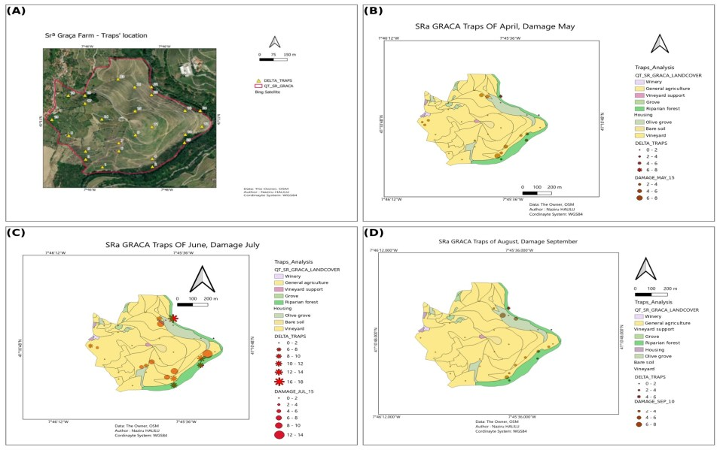
Figure 6. Pheromone-trap network and observed captures and damage of Lobesia botrana at Quinta da Senhora da Graça (vineyard under mating disruption). (A) Locations of the 25 delta traps (yellow triangles) on a satellite base map with the estate boundary. (B–D) Male captures per trap (red symbols; classes of counts) during the first (April), second (June) and third (August) flights, and damage recorded at georeferenced observation points one month later (brown circles; May, July, September), on the land-use map of the estate (vineyard, olive grove, riparian forest, grove, general agriculture, bare soil, housing, winery and vineyard-support buildings). Damage classes are numeric damage values recorded in QField (ordinal index; scale not defined in the course documentation). The maps show observations only; no interpolated risk surface is implied.

3.3. Case III: Brix is persistent in time but not structured in space

3.3.1. Temporal trend and harvest-date forecast
Mean Brix increased from 9.19 °Brix (SD 3.55) on 15 July to 20.54 °Brix (SD 3.16) on 30 August (Figure 7A). Locations differed little in their rate of increase (linear slope 0.26 ± 0.02 °Brix d⁻¹), so differences among locations persisted through the season: Spearman correlations between dates were 0.96–0.99, the date explained 57.3% and the location 41.8% of total variance, with only 0.8% residual, and the ICC of locations was 0.975.
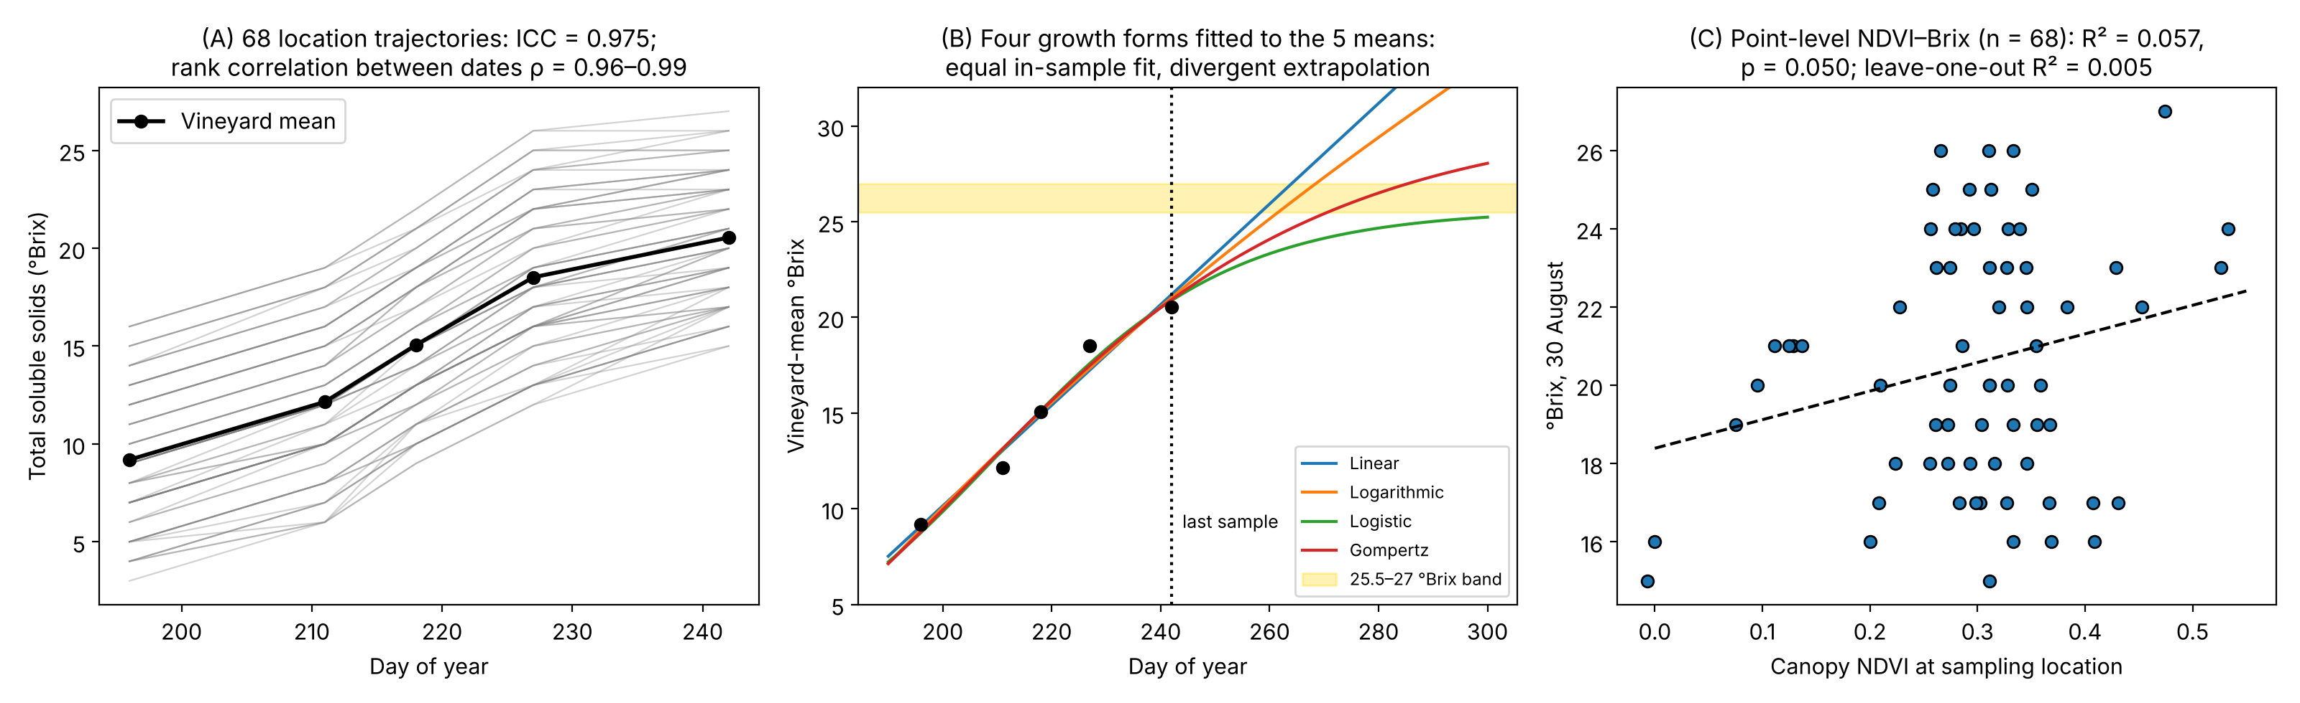
Figure 7. Case III, temporal behaviour and NDVI association of Brix. (A) Trajectories of the 68 locations (grey) and the vineyard mean (black). (B) Linear, logarithmic, logistic and Gompertz curves fitted to the five vineyard means and extrapolated; the shaded band is the 25.5–27 °Brix target. (C) Brix on 30 August against canopy NDVI at the 68 locations, with least-squares line.
All four growth functions fitted the five means closely (R² = 0.966–0.976; RMSE 0.63–0.76 °Brix; Table 4), but they diverged when extrapolated (Figure 7B). Refitting the logarithmic model gave Brix = 57.45 ln(t) − 294.34 (R² = 0.969); the coefficients reported in the original submission (65.139 and −335.44) could not be reproduced from the five means and have been replaced. The refitted logarithmic curve reached 25.5 °Brix on day 262 (19 September; bootstrap 95% interval 16–23 September), the linear curve on day 259 (16 September), and the Gompertz curve on day 271 (28 September); the logistic curve approached an asymptote of 25.6 °Brix and reached the threshold within the period considered (to day 300) in only 27% of bootstrap resamples. The forward test (fit to four dates, predict 30 August) gave errors of +1.29 °Brix (logarithmic), +1.87 (linear) and +5.68 (logistic). Hence the uncertainty due to model form (≥ 12 days) was considerably larger than the sampling uncertainty of any single model (approx. ±3–6 days), and the forecast of 13 September in the original submission is withdrawn in favour of this range.

3.3.2. NDVI–Brix association
At the level of the 68 locations, NDVI was weakly and not significantly associated with Brix on each date (r = 0.19–0.24; R² = 0.036–0.057; p = 0.05–0.12; Figure 7C; Supplementary Table S3), and the leave-one-out R² was ≈ 0 (−0.017 to 0.005). The source of the R² = 0.88 reported in the original submission was traced to the course worked example, which fitted a cubic polynomial forced through the origin (Brix = −116.5 NDVI³ + 104.84 NDVI² + 10.869 NDVI) to the 15 July values (Aranha, 2026). When the intercept is fixed at zero, spreadsheet software reports the uncentred coefficient of determination, 1 − SSR/Σy², which measures departure from zero rather than from the mean and is therefore inflated whenever the response is far from zero. Refitting the same no-intercept cubic to the 68 locations reproduced the uncentred value (R² = 0.877), whereas the conventional centred R² of the same fit was 0.042. Aggregation to NDVI classes does not rescue the relationship either: class-mean Brix on class-mean NDVI gives R² = 0.51 (n = 5), and class means are non-monotonic (the 'high' class has lower Brix than the 'moderate' class). The earlier statement that NDVI explained 88% of Brix variance and that high-vigour parcels consistently had the highest Brix has been removed.
The linear mixed model confirmed this result while accounting for repeated measurements. The location variance was 12.2 °Brix² against a residual variance of 0.97 °Brix²; adding NDVI reduced the location variance by only 4.5% (to 11.7 °Brix²), the NDVI coefficient was 7.2 ± 4.1 °Brix per NDVI unit, and the likelihood-ratio test was not significant (χ² = 3.06, p = 0.080; AIC 1246.3 vs. 1245.3).

3.3.3. Spatial autocorrelation
Raw Brix showed no significant positive spatial autocorrelation on any date with any neighbourhood definition (Moran's I between −0.058 and 0.061; all permutation p ≥ 0.09; Figure 8C; Supplementary Table S4). The same held for the location anomaly after removing the temporal trend (I = −0.024 to 0.038; p ≥ 0.13), for the anomaly after regression on NDVI (p ≥ 0.15) and for out-of-fold RF residuals (I = −0.06 to −0.04; p ≥ 0.65). In contrast, NDVI itself was clearly autocorrelated (I = 0.20–0.29, p < 0.001). Thus, the persistent differences between locations (ICC = 0.975) are not organised in space at the 20–35 m sampling interval: neighbouring locations are no more similar than distant ones. Consequently, the date-wise IDW and Thiessen maps of Brix (Task A; Supplementary Figure S9) are valid displays of the observed point values, but the smooth transitions they show between points carry no predictive information and should not be used to delineate harvest zones.
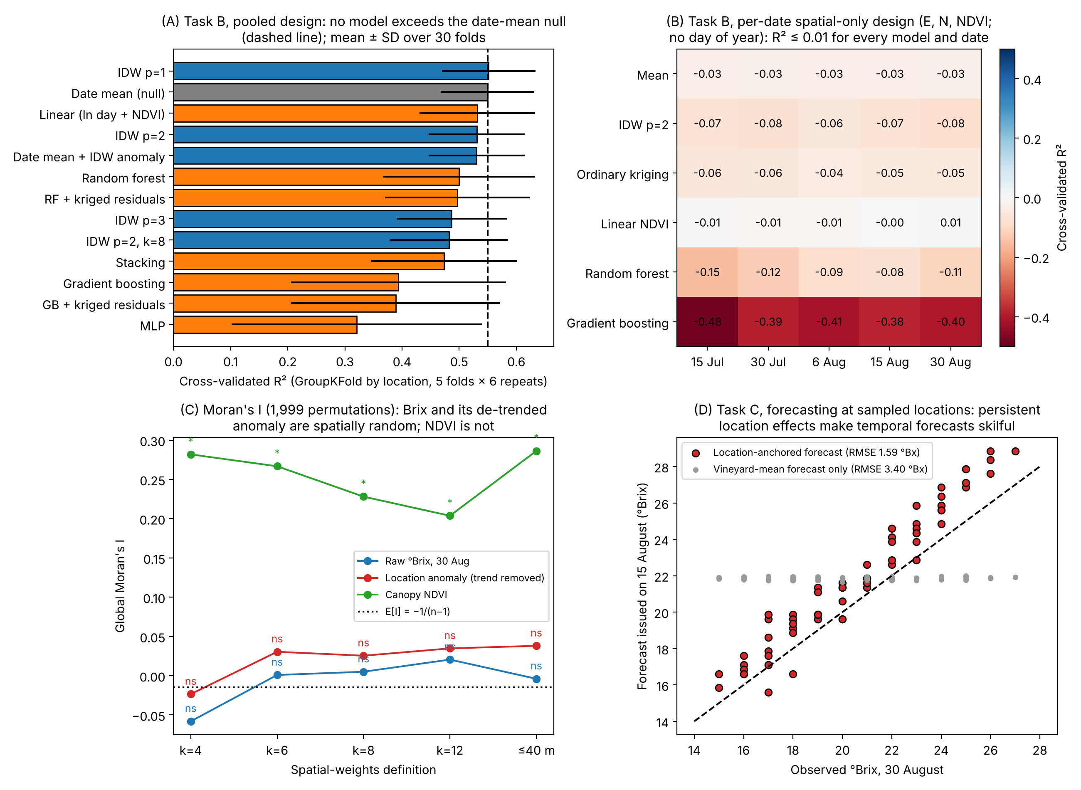
Figure 8. Case III, validation of spatial prediction and forecasting. (A) Pooled spatio-temporal cross-validation (GroupKFold by location, 5 folds × 6 repeats; predictors easting, northing, day of year, NDVI): mean ± SD of R²; the dashed line is the date-mean null model. (B) Per-date spatial-only cross-validation (predictors easting, northing, NDVI; 5 folds × 4 repeats). (C) Global Moran's I of raw Brix on 30 August, of the de-trended location anomaly and of NDVI for five spatial-weight definitions (ns, not significant; *, p < 0.05; 1,999 permutations); the dotted line is E[I]. (D) Forecast of 30 August Brix issued with data up to 15 August: location-anchored forecast vs. vineyard-mean forecast.
Power simulations show what this negative result can and cannot exclude (Figure 9C). With the 68-location design, Moran's I (k = 8) would have detected spatial structure with a range of ≥ 50 m and ≥ 50% structured variance with a probability of 0.75–0.94, but its power was low for short-range structure (0.13–0.35 for a 15-m range; 0.22–0.73 for 25 m). Consistently, the semivariogram of the location anomaly lay inside the permutation envelope at all lags from 20 to 200 m (Figure 9D). The data therefore exclude moderate- to long-range spatial organisation of ripening, but not structure at the scale of a few vines or rows, below the 20–35 m sampling interval.

3.3.4. Spatial prediction at unsampled locations (Task B)
In the pooled design (Table 5; Figure 8A), the date-mean null model achieved a cross-validated R² of 0.550 (RMSE 3.59 °Brix). IDW with p = 1 performed equivalently (R² = 0.552; skill score vs. null 0.004), whereas IDW with p = 2 (0.531), p = 3 (0.487), 8 neighbours (0.482), linear ln(day)+NDVI regression (0.532), RF (0.500), RF-RK (0.497), stacking (0.474), GB (0.394), GB-RK (0.389) and the MLP (0.321) all had negative skill relative to the null model. The previously reported IDW R² of 0.538 is therefore almost entirely explained by the date mean, i.e., by the ripening trend rather than by spatial information. Stacking weights were dominated by RF (mean ridge coefficients 0.88 for RF, −0.05 for GB and 0.05 for MLP). Regression-kriging did not improve on its trend models, as expected given the absence of residual autocorrelation.
The per-date spatial-only design (Figure 8B; Supplementary Table S5), which the original submission described but did not report, confirmed this: on every date, the cross-validated R² was between −0.08 and −0.03 for IDW, ordinary kriging and the training mean, between −0.01 and 0.01 for linear NDVI regression and between −0.48 and −0.08 for RF and GB. Neither coordinates nor NDVI contained transferable information about Brix at unsampled locations. In the learning-curve analysis, IDW prediction of the location anomaly was worse than the training mean at every training size from 10 to 60 locations (RMSE 3.99 vs. 3.72 °Brix at n = 10; 3.59 vs. 3.52 at n = 60), so additional locations at the same spacing would not be expected to produce skill unless spatial structure exists at a finer scale.
Feature importance agreed with these results: day of year dominated both impurity importance (0.61 RF; 0.55 GB) and permutation importance (mean decrease in R² = 1.12, vs. 0.24 for northing, 0.23 for NDVI and 0.11 for easting). Because permutation importance was computed on training data of a model that overfits location-specific values, the non-zero importance of coordinates and NDVI reflects their use to identify individual locations rather than generalisable spatial information, as shown by the cross-validation (Strobl et al., 2007).

3.3.5. Forecasting at sampled locations (Task C)
Because location effects are persistent, past observations at a location were informative about its future Brix. A forecast for 30 August issued with data up to 15 August (location anomaly + logarithmic extrapolation of the mean) had RMSE = 1.59 °Brix (MAE 1.40; R² = 0.74), compared with 3.40 °Brix for the vineyard-mean forecast alone (Figure 8D); most of the remaining error was a common bias of +1.29 °Brix from the extrapolated mean. With data up to 30 July only, the error increased to 3.07 °Brix because the mean trajectory could not be extrapolated reliably from two dates. Estimating the vineyard mean within ±1 °Brix (95% confidence) requires approximately 39 locations, and within ±0.5 °Brix approximately 154 locations, given the between-location SD of 3.16 °Brix on 30 August.
Decomposing the error of the 15-August forecast showed that the location component was predicted with RMSE 0.93 °Brix, whereas the vineyard-mean extrapolation contributed a bias of +1.29 °Brix. A split-conformal interval for the location component calibrated one step earlier (±1.05 °Brix, nominal 90%) covered only 74% of locations on 30 August, because location anomalies drifted more between 15 and 30 August than between 6 and 15 August. Forecast intervals calibrated on earlier ripening stages therefore under-cover near harvest and should be widened or recalibrated as sampling continues.

4. Discussion

4.1. What the three cases jointly show: evidence tiers, not crop contrasts
Organising the synthesis by validation tier (Figure 2; Table 6) rather than by crop makes the common result explicit: every case reached T0–T1 (reproducible, descriptive maps), only some outputs reached T2–T3, and none reached T4 (decision validity) or T5 (transferability). The coefficients obtained in the three cases (a zone-level correlation in maize, descriptive capture classes for the moth, cross-validated errors for Brix) are not comparable measures of explanatory power, and we no longer pool them. What is comparable across cases is the relation between the observational unit, the scale of variation and the decision. In maize, the response was measured densely and was strongly structured at field scale, so maps were informative and the limiting step was the agronomic link between maps and doses. In the moth case, the observation process itself (traps under mating disruption, three counts) limited inference before any spatial analysis. In the ripening case, the response was precisely and repeatedly measured, but its spatial variation was unstructured at the sampling scale, so the limiting factor was the spatial scale of variation rather than model choice. This is consistent with the opportunity-index view of site-specific management, which holds that variation must be both large and spatially structured at a manageable scale to justify differential management (Pringle et al., 2003; Tisseyre and McBratney, 2008).

4.2. Case I: the map is robust, the prescription is not yet validated
The yield map and its structure are robust (T1–T2): yield was strongly autocorrelated, and zones derived from only 16 soil samples captured nearly half of its variance, in line with management-zone approaches that partition fields into a few relatively homogeneous units (Fridgen et al., 2004). The strong zone-level association with deep soil water is agronomically plausible, because water storage in the deeper root zone sustains maize during flowering and grain filling in irrigated Mediterranean systems and is linked to texture and OM (Kravchenko and Bullock, 2000; Corwin and Lesch, 2005). However, the four-fold difference between zone-level and point-level correlation is a reminder that correlations in precision-agriculture studies must always be reported with their support and sample size; correlations of r > 0.95 between zone means are not evidence that a variable 'drives' yield at every location (Robinson, 1950; Gotway and Young, 2002). Because water content was estimated from apparent electrical conductivity, the association may partly reflect texture or salinity patterns co-varying with water (Corwin and Lesch, 2005).
The prescription maps reach only T1–T2. Three issues prevent them from being agronomically validated. First, the lime equation ignores buffer capacity and liming material, so the same pH can require very different doses on soils of different texture and OM (Adams and Evans, 1962; Sikora, 2006; Holland et al., 2018); the variable-rate approach itself is well established, but its benefit depends on adequate sampling density and calibrated lime requirement (Bianchini and Mallarino, 2002). Second, the NPK rule assigns higher doses to lower-yielding areas. For nitrogen, field studies have shown that spatially variable yield is a weak predictor of the economically optimal N rate (Scharf et al., 2006; Morris et al., 2018); for P and K, low yield can result from water limitation rather than nutrient deficiency, as suggested here by the deep-water association, in which case extra fertiliser would not correct the yield gap. Third, the uniform reference rates correspond to the least favourable sample, which maximises apparent savings. A defensible engineering test of these maps would be an on-farm precision experiment comparing strip-applied variable and uniform rates and measuring yield response and nutrient balance (Bullock et al., 2019; Lacoste et al., 2022). Until then, the computed differences (−6.5% to −15.5% lime; −58% to −62% NPK relative to the most demanding uniform rate) are potential changes in input quantity, not savings.

4.3. Case II: from descriptive maps to testable pest-risk hypotheses
The value of GIS in the moth case lies in organising georeferenced captures, damage records, land use and terrain in a common, revisitable spatial database, which supports targeted inspection of sectors with repeated captures (T1). The observed concentration of first-flight captures near riparian forest and groves is consistent with the hypothesis that semi-natural margins host overwintering pupae or alternative hosts, but landscape studies have shown that L. botrana density depends more on local vineyard management than on landscape composition, and that semi-natural habitat can also enhance natural enemies (Rusch et al., 2017; Thiéry et al., 2018). The observation that second-generation captures and damage were highest is consistent with the generally greater economic importance of the second and third generations in southern Europe (Ioriatti et al., 2011; Thiéry et al., 2018), but identifying a 'critical control window' requires phenological models driven by temperature, action thresholds and treatment–response data (Gallardo et al., 2009; Ioriatti et al., 2011), none of which were collected. For the Douro, the regional advisory service ADVID times interventions with growing degree-days (base temperature 11 °C), the first flight starting after about 64 °C·d in the Baixo Corgo and 77 °C·d in the Cima Corgo, as summarised in the course material (Aranha, 2026); pairing the trap network with a local temperature record would place every count on this phenological scale. The same material notes that mating disruption does not prevent females mated outside the treated area from laying eggs inside it, and that alternative hosts such as Daphne gnidium, Rubus fruticosus and Olea europaea occur around Douro vineyards (Aranha, 2026), which makes H₂ biologically plausible but still untested. We therefore reformulate the original conclusions as three hypotheses that a future design could test: H₂ – first-flight captures decline with distance from forest edges (testable with exact counts, ≥ 2 seasons and distance-to-edge regression or SADIE (Perry, 1995)); H₃ – damage is spatially associated with captures in the preceding flight (testable with a standardised damage index and spatial association statistics); and H₄ – areas with repeated captures under mating disruption require supplementary control (testable with paired treated/untreated sectors). A trap density of 0.72 traps ha⁻¹ with spacing adequate to limit interference between pheromone sources (Wall and Perry, 1987) is suitable for such tests if counts and damage are recorded on a standard scale.

4.4. Case III: why machine learning cannot help when space carries no signal
The central methodological result of this revision is that ripening heterogeneity at Quinta de Nossa Senhora de Lurdes was large and highly persistent (ICC 0.975), yet spatially random at the 20–35 m sampling interval. Under these conditions, every spatial predictor, from IDW to stacking and regression-kriging, can at best reproduce the date mean, which is what the cross-validation showed. The original interpretation, in which ML failed because of 'weak residual autocorrelation' inferred from Moran's I on raw data, is now supported directly: Moran's I was computed on the de-trended anomalies and on model residuals and was not significant for any neighbourhood definition. The ranking among ML models (RF ≥ stacking > GB > MLP) is consistent with benchmarks showing that tree ensembles are more robust than neural networks on small tabular data (Grinsztajn et al., 2022), but in this dataset the ranking is immaterial because none had positive skill. This illustrates why spatial ML studies should report a null or trend-only baseline and skill relative to it, not only R² (Meyer et al., 2018; Ploton et al., 2020; Wadoux et al., 2020). The maize block cross-validation tests the hypothesis, made in the original submission, that richer covariates would allow ML to outperform interpolation. It did not: where the response itself is densely observed, IDW of the response remains the strongest predictor, and covariates add value mainly far from observations, where all methods lose skill.
The power analysis qualifies this conclusion: the design could detect ripening structure at ranges of 50 m or more, but not at the scale of a few vines. Two non-exclusive explanations are plausible. Ripening differences may be organised at the scale of individual vines or rows (cultivar, clone, rootstock, crop load, row orientation), which a 25-m grid cannot resolve; or each 'location' value may contain a persistent sampling component (the same vines resampled on each date). Both explanations predict temporal persistence without spatial autocorrelation and cannot be separated without metadata on vine identity and cultivar per location, which were not attached to the Brix records. The practical corollary is positive: a fixed network of sampling locations is valuable for tracking ripening (Task C skill, RMSE 1.59 °Brix) even if it is useless for interpolating it (Task B). Recommendations to sample more densely before applying ML, made in the original submission, are therefore withdrawn; densification is justified only if pilot data show spatial structure at a finer scale, and stratifying sampling by a vigour map (Meyers et al., 2020) is useful only where vigour is related to ripening, which it was not here.
The weak NDVI–Brix relationship is consistent with the indirect and season-dependent link between canopy size and fruit composition (Smart, 1985; Lamb et al., 2004; Bramley, 2005; Trought and Bramley, 2011). Several factors could have weakened it further: the single UAV acquisition, possible mixing of canopy and inter-row pixels, and the low NDVI range (mostly 0.2–0.4) typical of vertically shoot-positioned canopies viewed from above (Hall et al., 2002; Matese et al., 2015; Kasimati et al., 2023). Multi-temporal canopy-only indices or thermal data would be needed to test H₁ properly (Pádua et al., 2018).
For harvest forecasting, the result that model form alters the predicted date by more than two weeks, while bootstrap uncertainty is about ±3–6 days, generalises beyond this dataset: with five calendar-time observations, extrapolation beyond the sampling period is controlled by the assumed curve shape. A thermal-time model calibrated on multi-season data (e.g., the grapevine sugar ripeness model of Parker et al. (2020)), combined with continued weekly sampling at a fixed subset of about 40 locations, would provide a transferable alternative. Reaching a sugar threshold is only one component of harvest decisions, which also consider acidity, pH, phenolic and aromatic maturity and winery logistics (Ribéreau-Gayon et al., 2006; Keller, 2020).

4.5. Implications for the design of precision-agriculture case studies
Across the cases, the decisive limitations were in the design of the observations, not in the analysis software. We therefore propose four design checks that follow directly from the results and can be applied before any modelling: (1) state the support – report the statistical unit and sample size of every coefficient, and compare zone- and point-level relationships when data allow; (2) test for spatial structure first – compute de-trended Moran's I or a variogram before investing in interpolation or ML, because without structure no spatial predictor can outperform the mean (Webster and Oliver, 2007; Oliver and Webster, 2014); (3) match validation to the task – mapping, spatial prediction and temporal forecasting require different hold-out designs and a null-model reference (Roberts et al., 2017; Wadoux et al., 2021; Meyer and Pebesma, 2021); and (4) close the decision loop – variable-rate or pest-control recommendations require response data from on-farm experiments before they can be called efficient (Bullock et al., 2019; Lacoste et al., 2022). Sample-size thresholds for variograms or ML cannot be prescribed universally, because they depend on spatial extent, configuration, range of autocorrelation, predictor dimensionality and validation design (Webster and Oliver, 1992; Kerry et al., 2010); the learning-curve approach used here offers a data-driven alternative to fixed thresholds.

4.6. Limitations
Each campaign covers a single season at a single site, so no conclusion about transferability (T5) can be drawn (Wenger and Olden, 2012; Yates et al., 2018). Several field details are not documented in the course datasets (original acquisition season, crop-management records, laboratory extraction methods, refractometer model and UAV flight metadata), so the agronomic interpretation of each case is necessarily limited. The prescription rules are illustrative and were not field-tested. Moth captures are available only as classes and under mating disruption. For Brix, NDVI was available for a single date, and calendar time rather than thermal time was used. Computational reproducibility (code and data provided) does not imply predictive, agronomic or transferable validity (Peng, 2011; Oreskes et al., 1994).

5. Conclusions
Re-analysing three Portuguese precision-agriculture campaigns within a validation-tier framework showed that the same GIS toolchain produced outputs with very different levels of evidence. (i) In maize, yield was strongly spatially structured and associated with deep soil-water storage, but the strength of the association depended on the spatial support (r = 0.97 for zone means vs. 0.57 at point level), and the lime and NPK maps reproduce reference tables rather than validated crop responses; the computed input reductions are potential, not demonstrated. (ii) In the vineyard-moth case, GIS organised trap captures and damage observations effectively, but the design under mating disruption with three counts does not support inferences about pest origin, dispersal or intervention timing, which are reformulated as testable hypotheses. (iii) In grape ripening, Brix differences between locations were highly persistent but spatially random; consequently, neither interpolation nor any of the machine-learning or regression-kriging models predicted Brix at unsampled locations better than the date mean, whereas location-anchored temporal forecasting was skilful (RMSE 1.59 vs. 3.40 °Brix); the design had adequate power to detect ripening structure at ranges of 50 m or more, so the conclusion applies to moderate- and long-range structure, not to vine-scale variation. The reported NDVI–Brix R² of 0.88 was an uncentred statistic, and point-level NDVI explained less than 6% of Brix variance. Harvest-date estimates for a 25.5 °Brix threshold spanned 16 September to the end of September depending on the growth function, so the earlier single-date forecast is replaced by this range. None of the outputs has yet been validated for decisions or across seasons; on-farm experiments, standardised pest-damage records and multi-season thermal-time ripening models are the next steps required to move them from exploratory demonstrations to management protocols.

Declarations

CRediT author statement
Naziru Halilu: Conceptualization, Methodology, Software, Formal analysis, Investigation, Data curation, Writing – original draft, Writing – review & editing, Visualization. Juwairiyyah Sulaiman: Writing – review & editing, Visualization.

Data availability statement
The Brix/NDVI dataset (68 locations × 5 dates), the maize yield–soil–water dataset (17,724 yield points with joined soil-zone and soil-water attributes) and the complete Python code for all analyses reported in this revision (correlations with confidence intervals, Moran's I with permutation tests, prescription-model comparison, growth-curve fitting and bootstrap, nested stacking, regression-kriging, both cross-validation designs, learning curves and figure generation) are provided as Supplementary Material with a README. The moth trap and damage records are available from the corresponding author on reasonable request.

Declaration of competing interest
The authors declare no known competing financial interests or personal relationships that could have appeared to influence the work reported in this paper.

Funding
This research received no specific grant from any funding agency in the public, commercial, or not-for-profit sectors. Field data collection was conducted as part of coursework and practical training activities at the University of Trás-os-Montes e Alto Douro (UTAD), Portugal.

Acknowledgements
The authors thank Prof. José Aranha (UTAD) for supervising the field campaigns and providing the course datasets, and the two anonymous reviewers whose comments substantially improved the manuscript.

References
Adams F, Evans CE, 1962. A rapid method for measuring lime requirement of red-yellow podzolic soils. Soil Sci. Soc. Am. J. 26:355-7. https://doi.org/10.2136/sssaj1962.03615995002600040014x
AEMET, IM (Agencia Estatal de Meteorología; Instituto de Meteorologia de Portugal), 2011. Iberian climate atlas: air temperature and precipitation (1971-2000). AEMET, Madrid; IM, Lisboa.
Andresen T, de Aguiar FB, Curado MJ, 2004. The Alto Douro Wine Region greenway. Landscape Urban Plan. 68:289-303. https://doi.org/10.1016/S0169-2046(03)00156-6
Aranha JTM, 2026. Lecture and practical notes: remote sensing and GIS applications in environmental and viticultural analysis. University of Trás-os-Montes e Alto Douro (UTAD), Vila Real, Portugal. [Unpublished course material].
Arslan S, Colvin TS, 2002. Grain yield mapping: yield sensing, yield reconstruction, and errors. Precis. Agric. 3:135-54. https://doi.org/10.1023/A:1013819502827
Benelli G, Ricciardi R, Cosci F, Iodice A, Ladurner E, Savino F, Lucchi A, 2023. Sex pheromone aerosol emitters for Lobesia botrana mating disruption in Italian vineyards. Insects 14:270. https://doi.org/10.3390/insects14030270
Benos L, Tagarakis AC, Dolias G, Berruto R, Kateris D, Bochtis D, 2021. Machine learning in agriculture: a comprehensive updated review. Sensors 21:3758. https://doi.org/10.3390/s21113758
Bianchini AA, Mallarino AP, 2002. Soil-sampling alternatives and variable-rate liming for a soybean-corn rotation. Agron. J. 94:1355-66. https://doi.org/10.2134/agronj2002.1355
Blackmore S, Godwin RJ, Fountas S, 2003. The analysis of spatial and temporal trends in yield map data over six years. Biosyst. Eng. 84:455-66. https://doi.org/10.1016/S1537-5110(03)00038-2
Bramley RGV, 2005. Understanding variability in winegrape production systems. 2. Within vineyard variation in quality over several vintages. Aust. J. Grape Wine Res. 11:33-42. https://doi.org/10.1111/j.1755-0238.2005.tb00277.x
Bramley RGV, 2009. Lessons from nearly 20 years of precision agriculture research, development, and adoption as a guide to its appropriate application. Crop Pasture Sci. 60:197-217. https://doi.org/10.1071/CP08304
Bramley RGV, Hamilton RP, 2004. Understanding variability in winegrape production systems. 1. Within vineyard variation in yield over several vintages. Aust. J. Grape Wine Res. 10:32-45. https://doi.org/10.1111/j.1755-0238.2004.tb00006.x
Breiman L, 1996. Stacked regressions. Mach. Learn. 24:49-64. https://doi.org/10.1007/BF00117832
Breiman L, 2001. Random forests. Mach. Learn. 45:5-32. https://doi.org/10.1023/A:1010933404324
Bullock DS, Boerngen M, Tao H, Maxwell B, Luck JD, Shiratsuchi L, Puntel L, Martin NF, 2019. The data-intensive farm management project: changing agronomic research through on-farm precision experimentation. Agron. J. 111:2736-46. https://doi.org/10.2134/agronj2019.03.0165
Burglewski N, Srinivasagan S, Ketterings Q, van Aardt J, 2024. Spatial and spectral dependencies of maize yield estimation using remote sensing. Sensors 24:3958. https://doi.org/10.3390/s24123958
Burnham KP, Anderson DR, 2002. Model selection and multimodel inference: a practical information-theoretic approach. 2nd ed. Springer, New York, NY, USA. https://doi.org/10.1007/b97636
Chavez PS, 1988. An improved dark-object subtraction technique for atmospheric scattering correction of multispectral data. Remote Sens. Environ. 24:459-79. https://doi.org/10.1016/0034-4257(88)90019-3
Chavez PS, 1996. Image-based atmospheric corrections—revisited and improved. Photogramm. Eng. Remote Sens. 62:1025-36.
Chen T, Guestrin C, 2016. XGBoost: a scalable tree boosting system. Proc. 22nd ACM SIGKDD Int. Conf. Knowledge Discovery and Data Mining, pp. 785-94. https://doi.org/10.1145/2939672.2939785
Chlingaryan A, Sukkarieh S, Whelan B, 2018. Machine learning approaches for crop yield prediction and nitrogen status estimation in precision agriculture: a review. Comput. Electron. Agric. 151:61-9. https://doi.org/10.1016/j.compag.2018.05.012
Chuvieco E, 2020. Fundamentals of satellite remote sensing: an environmental approach. 3rd ed. CRC Press, Boca Raton, FL, USA.
Cliff AD, Ord JK, 1981. Spatial processes: models and applications. Pion, London, UK.
Clifford P, Richardson S, Hémon D, 1989. Assessing the significance of the correlation between two spatial processes. Biometrics 45:123-34. https://doi.org/10.2307/2531997
Coombe BG, 1992. Research on development and ripening of the grape berry. Am. J. Enol. Vitic. 43:101-10. https://doi.org/10.5344/ajev.1992.43.1.101
Corwin DL, Lesch SM, 2005. Apparent soil electrical conductivity measurements in agriculture. Comput. Electron. Agric. 46:11-43. https://doi.org/10.1016/j.compag.2004.10.005
Dormann CF, McPherson JM, Araújo MB, Bivand R, Bolliger J, Carl G, et al., 2007. Methods to account for spatial autocorrelation in the analysis of species distributional data: a review. Ecography 30:609-28. https://doi.org/10.1111/j.2007.0906-7590.05171.x
Drusch M, Del Bello U, Carlier S, Colin O, Fernandez V, Gascon F, et al., 2012. Sentinel-2: ESA's optical high-resolution mission for GMES operational services. Remote Sens. Environ. 120:25-36. https://doi.org/10.1016/j.rse.2011.11.026
Dutilleul P, 1993. Modifying the t test for assessing the correlation between two spatial processes. Biometrics 49:305-14. https://doi.org/10.2307/2532625
Fermaud M, Le Menn R, 1989. Association of Botrytis cinerea with grape berry moth larvae. Phytopathology 79:651-6. https://doi.org/10.1094/Phyto-79-651
Fraga H, Costa R, Santos JA, 2018. Modelling the terroir of the Douro Demarcated Region, Portugal. E3S Web Conf. 50:02009. https://doi.org/10.1051/e3sconf/20185002009
Fraga H, Malheiro AC, Moutinho-Pereira J, Santos JA, 2012. An overview of climate change impacts on European viticulture. Food Energy Secur. 1:94-110. https://doi.org/10.1002/fes3.14
Fridgen JJ, Kitchen NR, Sudduth KA, Drummond ST, Wiebold WJ, Fraisse CW, 2004. Management zone analyst (MZA): software for subfield management zone delineation. Agron. J. 96:100-8. https://doi.org/10.2134/agronj2004.1000
Friedman JH, 2001. Greedy function approximation: a gradient boosting machine. Ann. Stat. 29:1189-232. https://doi.org/10.1214/aos/1013203451
Gallardo A, Ocete R, López MA, Maistrello L, Ortega F, Semedo A, Soria FJ, 2009. Forecasting the flight activity of Lobesia botrana (Denis & Schiffermüller) (Lepidoptera, Tortricidae) in southwestern Spain. J. Appl. Entomol. 133:626-32. https://doi.org/10.1111/j.1439-0418.2009.01417.x
Gebbers R, Adamchuk VI, 2010. Precision agriculture and food security. Science 327:828-31. https://doi.org/10.1126/science.1183899
Gotway CA, Young LJ, 2002. Combining incompatible spatial data. J. Am. Stat. Assoc. 97:632-48. https://doi.org/10.1198/016214502760047140
Goulding KWT, 2016. Soil acidification and the importance of liming agricultural soils with particular reference to the United Kingdom. Soil Use Manage. 32:390-9. https://doi.org/10.1111/sum.12270
Grinsztajn L, Oyallon E, Varoquaux G, 2022. Why do tree-based models still outperform deep learning on typical tabular data? Adv. Neural Inf. Process. Syst. 35 (Datasets and Benchmarks Track), pp. 507-20.
Hall A, Lamb DW, Holzapfel B, Louis J, 2002. Optical remote sensing applications in viticulture—a review. Aust. J. Grape Wine Res. 8:36-47. https://doi.org/10.1111/j.1755-0238.2002.tb00209.x
Hengl T, Heuvelink GBM, Rossiter DG, 2007. About regression-kriging: from equations to case studies. Comput. Geosci. 33:1301-15. https://doi.org/10.1016/j.cageo.2007.05.001
Hengl T, Heuvelink GBM, Stein A, 2004. A generic framework for spatial prediction of soil variables based on regression-kriging. Geoderma 120:75-93. https://doi.org/10.1016/j.geoderma.2003.08.018
Hengl T, Nussbaum M, Wright MN, Heuvelink GBM, Gräler B, 2018. Random forest as a generic framework for predictive modeling of spatial and spatio-temporal variables. PeerJ 6:e5518. https://doi.org/10.7717/peerj.5518
Hinsinger P, 2001. Bioavailability of soil inorganic P in the rhizosphere as affected by root-induced chemical changes: a review. Plant Soil 237:173-95. https://doi.org/10.1023/A:1013351617532
Holland JE, Bennett AE, Newton AC, White PJ, McKenzie BM, George TS, et al., 2018. Liming impacts on soils, crops and biodiversity in the UK: a review. Sci. Total Environ. 610-611:316-32. https://doi.org/10.1016/j.scitotenv.2017.08.020
Holm S, 1979. A simple sequentially rejective multiple test procedure. Scand. J. Stat. 6:65-70.
Huang S, Tang L, Hupy JP, Wang Y, Shao G, 2021. A commentary review on the use of normalized difference vegetation index (NDVI) in the era of popular remote sensing. J. For. Res. 32:1-6. https://doi.org/10.1007/s11676-020-01155-1
Ioriatti C, Anfora G, Tasin M, De Cristofaro A, Witzgall P, Lucchi A, 2011. Chemical ecology and management of Lobesia botrana (Lepidoptera: Tortricidae). J. Econ. Entomol. 104:1125-37. https://doi.org/10.1603/EC10443
Jensen JR, 2015. Introductory digital image processing: a remote sensing perspective. 4th ed. Pearson, Glenview, IL, USA.
Jones GV, Alves F, 2012. Impact of climate change on wine production: a global overview and regional assessment in the Douro Valley of Portugal. Int. J. Global Warming 4:383-406. https://doi.org/10.1504/IJGW.2012.049448
Jones GV, Davis RE, 2000. Climate influences on grapevine phenology, grape composition, and wine production and quality for Bordeaux, France. Am. J. Enol. Vitic. 51:249-61. https://doi.org/10.5344/ajev.2000.51.3.249
Kasimati A, Psiroukis V, Darra N, Kalogrias A, Kalivas D, Taylor JA, Fountas S, 2023. Investigation of the similarities between NDVI maps from different proximal and remote sensing platforms in explaining vineyard variability. Precis. Agric. 24:1220-40. https://doi.org/10.1007/s11119-022-09984-2
Keller M, 2020. The science of grapevines. 3rd ed. Academic Press, London, UK.
Kerry R, Oliver MA, Frogbrook ZL, 2010. Sampling in precision agriculture. In: Oliver MA (ed.), Geostatistical applications for precision agriculture. Springer, Dordrecht, The Netherlands, pp. 35-63. https://doi.org/10.1007/978-90-481-9133-8_2
Kottek M, Grieser J, Beck C, Rudolf B, Rubel F, 2006. World map of the Köppen-Geiger climate classification updated. Meteorol. Z. 15:259-63. https://doi.org/10.1127/0941-2948/2006/0130
Kravchenko AN, 2003. Influence of spatial structure on accuracy of interpolation methods. Soil Sci. Soc. Am. J. 67:1564-71. https://doi.org/10.2136/sssaj2003.1564
Kravchenko AN, Bullock DG, 2000. Correlation of corn and soybean grain yield with topography and soil properties. Agron. J. 92:75-83. https://doi.org/10.2134/agronj2000.92175x
Lacoste M, Cook S, McNee M, Gale D, Ingram J, Bellon-Maurel V, et al., 2022. On-farm experimentation to transform global agriculture. Nat. Food 3:11-8. https://doi.org/10.1038/s43016-021-00424-4
Lamb DW, Weedon MM, Bramley RGV, 2004. Using remote sensing to predict grape phenolics and colour at harvest in a Cabernet Sauvignon vineyard: timing observations against vine phenology and optimising image resolution. Aust. J. Grape Wine Res. 10:46-54. https://doi.org/10.1111/j.1755-0238.2004.tb00007.x
Li J, Heap AD, 2011. A review of comparative studies of spatial interpolation methods in environmental sciences: performance and impact factors. Ecol. Inform. 6:228-41. https://doi.org/10.1016/j.ecoinf.2010.12.003
Li J, Heap AD, 2014. Spatial interpolation methods applied in the environmental sciences: a review. Environ. Model. Softw. 53:173-89. https://doi.org/10.1016/j.envsoft.2013.12.008
Liakos KG, Busato P, Moshou D, Pearson S, Bochtis D, 2018. Machine learning in agriculture: a review. Sensors 18:2674. https://doi.org/10.3390/s18082674
Lillesand T, Kiefer RW, Chipman J, 2015. Remote sensing and image interpretation. 7th ed. Wiley, Hoboken, NJ, USA.
Lowenberg-DeBoer J, Erickson B, 2019. Setting the record straight on precision agriculture adoption. Agron. J. 111:1552-69. https://doi.org/10.2134/agronj2018.12.0779
Lucchi A, Sambado P, Juan Royo AB, Bagnoli B, Conte G, Benelli G, 2018. Disrupting mating of Lobesia botrana using sex pheromone aerosol devices. Environ. Sci. Pollut. Res. 25:22196-204. https://doi.org/10.1007/s11356-018-2341-3
Matese A, Di Gennaro SF, 2015. Technology in precision viticulture: a state of the art review. Int. J. Wine Res. 7:69-81. https://doi.org/10.2147/IJWR.S69405
Matese A, Toscano P, Di Gennaro SF, Genesio L, Vaccari FP, Primicerio J, et al., 2015. Intercomparison of UAV, aircraft and satellite remote sensing platforms for precision viticulture. Remote Sens. 7:2971-90. https://doi.org/10.3390/rs70302971
McBratney A, Whelan B, Ancev T, Bouma J, 2005. Future directions of precision agriculture. Precis. Agric. 6:7-23. https://doi.org/10.1007/s11119-005-0681-8
Meyer H, Pebesma E, 2021. Predicting into unknown space? Estimating the area of applicability of spatial prediction models. Methods Ecol. Evol. 12:1620-33. https://doi.org/10.1111/2041-210X.13650
Meyer H, Reudenbach C, Hengl T, Katurji M, Nauss T, 2018. Improving performance of spatio-temporal machine learning models using forward feature selection and target-oriented validation. Environ. Model. Softw. 101:1-9. https://doi.org/10.1016/j.envsoft.2017.12.001
Meyers JM, Dokoozlian N, Ryan C, Bioni C, Vanden Heuvel JE, 2020. A new, satellite NDVI-based sampling protocol for grape maturation monitoring. Remote Sens. 12:1159. https://doi.org/10.3390/rs12071159
Moran PAP, 1950. Notes on continuous stochastic phenomena. Biometrika 37:17-23. https://doi.org/10.1093/biomet/37.1-2.17
Morris TF, Murrell TS, Beegle DB, Camberato JJ, Ferguson RB, Grove J, et al., 2018. Strengths and limitations of nitrogen rate recommendations for corn and opportunities for improvement. Agron. J. 110:1-37. https://doi.org/10.2134/agronj2017.02.0112
Mulla DJ, 2013. Twenty five years of remote sensing in precision agriculture: key advances and remaining knowledge gaps. Biosyst. Eng. 114:358-71. https://doi.org/10.1016/j.biosystemseng.2012.08.009
Oliver MA, Webster R, 2014. A tutorial guide to geostatistics: computing and modelling variograms and kriging. Catena 113:56-69. https://doi.org/10.1016/j.catena.2013.09.006
Openshaw S, 1984. The modifiable areal unit problem. Concepts and Techniques in Modern Geography 38. Geo Books, Norwich, UK.
Oreskes N, Shrader-Frechette K, Belitz K, 1994. Verification, validation, and confirmation of numerical models in the earth sciences. Science 263:641-6. https://doi.org/10.1126/science.263.5147.641
Parker AK, García de Cortázar-Atauri I, Gény L, Spring J-L, Destrac A, Schultz H, et al., 2020. Temperature-based grapevine sugar ripeness modelling for a wide range of Vitis vinifera L. cultivars. Agric. For. Meteorol. 285-286:107902. https://doi.org/10.1016/j.agrformet.2020.107902
Pedregosa F, Varoquaux G, Gramfort A, Michel V, Thirion B, Grisel O, et al., 2011. Scikit-learn: machine learning in Python. J. Mach. Learn. Res. 12:2825-30.
Peng RD, 2011. Reproducible research in computational science. Science 334:1226-7. https://doi.org/10.1126/science.1213847
Penn CJ, Camberato JJ, 2019. A critical review on soil chemical processes that control how soil pH affects phosphorus availability to plants. Agriculture 9:120. https://doi.org/10.3390/agriculture9060120
Perry JN, 1995. Spatial analysis by distance indices. J. Anim. Ecol. 64:303-14. https://doi.org/10.2307/5892
Pierce FJ, Nowak P, 1999. Aspects of precision agriculture. Adv. Agron. 67:1-85. https://doi.org/10.1016/S0065-2113(08)60513-1
Ploton P, Mortier F, Réjou-Méchain M, Barbier N, Picard N, Rossi V, et al., 2020. Spatial validation reveals poor predictive performance of large-scale ecological mapping models. Nat. Commun. 11:4540. https://doi.org/10.1038/s41467-020-18321-y
Pringle MJ, McBratney AB, Whelan BM, Taylor JA, 2003. A preliminary approach to assessing the opportunity for site-specific crop management in a field, using yield monitor data. Agric. Syst. 76:273-92. https://doi.org/10.1016/S0308-521X(02)00005-7
Pádua L, Marques P, Hruška J, Adão T, Peres E, Morais R, Sousa JJ, 2018. Multi-temporal vineyard monitoring through UAV-based RGB imagery. Remote Sens. 10:1907. https://doi.org/10.3390/rs10121907
QGIS Development Team, 2024. QGIS geographic information system. Open Source Geospatial Foundation Project. Available from: https://qgis.org
Ribéreau-Gayon P, Dubourdieu D, Donèche B, Lonvaud A, 2006. Handbook of enology. Volume 1: the microbiology of wine and vinifications. 2nd ed. Wiley, Chichester, UK. https://doi.org/10.1002/0470010363
Ricciardi R, De Fazi L, D'Anna G, Savino F, Ladurner E, Iodice A, et al., 2024. Simultaneous mating disruption of two moth pests of the vineyard (Lobesia botrana and Cryptoblabes gnidiella) through a biodegradable sex pheromone dispenser. Environ. Sci. Pollut. Res. https://doi.org/10.1007/s11356-024-33980-w
Roberts DR, Bahn V, Ciuti S, Boyce MS, Elith J, Guillera-Arroita G, et al., 2017. Cross-validation strategies for data with temporal, spatial, hierarchical, or phylogenetic structure. Ecography 40:913-29. https://doi.org/10.1111/ecog.02881
Robinson TP, Metternicht G, 2006. Testing the performance of spatial interpolation techniques for mapping soil properties. Comput. Electron. Agric. 50:97-108. https://doi.org/10.1016/j.compag.2005.07.003
Robinson WS, 1950. Ecological correlations and the behavior of individuals. Am. Sociol. Rev. 15:351-7. https://doi.org/10.2307/2087176
Rouse JW, Haas RH, Schell JA, Deering DW, 1974. Monitoring vegetation systems in the Great Plains with ERTS. NASA Spec. Publ. SP-351, pp. 309-17.
Rusch A, Delbac L, Thiéry D, 2017. Grape moth density in Bordeaux vineyards depends on local habitat management despite effects of landscape heterogeneity on their biological control. J. Appl. Ecol. 54:1794-803. https://doi.org/10.1111/1365-2664.12858
Scharf PC, Kitchen NR, Sudduth KA, Davis JG, 2006. Spatially variable corn yield is a weak predictor of optimal nitrogen rate. Soil Sci. Soc. Am. J. 70:2154-60. https://doi.org/10.2136/sssaj2005.0244
Sekulić A, Kilibarda M, Heuvelink GBM, Nikolić M, Bajat B, 2020. Random forest spatial interpolation. Remote Sens. 12:1687. https://doi.org/10.3390/rs12101687
Shaddad SM, Madrau S, Castrignanò A, Mouazen AM, 2016. Data fusion techniques for delineation of site-specific management zones in a field in UK. Precis. Agric. 17:200-17. https://doi.org/10.1007/s11119-015-9417-6
Shepard D, 1968. A two-dimensional interpolation function for irregularly-spaced data. Proc. 23rd ACM National Conference, pp. 517-24. https://doi.org/10.1145/800186.810616
Sikora FJ, 2006. A buffer that mimics the SMP buffer for determining lime requirement of soil. Soil Sci. Soc. Am. J. 70:474-86. https://doi.org/10.2136/sssaj2005.0164
Smart RE, 1985. Principles of grapevine canopy microclimate manipulation with implications for yield and quality. A review. Am. J. Enol. Vitic. 36:230-9. https://doi.org/10.5344/ajev.1985.36.3.230
Sparks DL, 1987. Potassium dynamics in soils. Adv. Soil Sci. 6:1-63. https://doi.org/10.1007/978-1-4612-4682-4_1
Strobl C, Boulesteix A-L, Zeileis A, Hothorn T, 2007. Bias in random forest variable importance measures: illustrations, sources and a solution. BMC Bioinformatics 8:25. https://doi.org/10.1186/1471-2105-8-25
Sudduth KA, Drummond ST, 2007. Yield Editor: software for removing errors from crop yield maps. Agron. J. 99:1471-82. https://doi.org/10.2134/agronj2006.0326
Thiessen AH, 1911. Precipitation averages for large areas. Mon. Weather Rev. 39:1082-4. https://doi.org/10.1175/1520-0493(1911)39<1082b:PAFLA>2.0.CO;2
Thiéry D, Louâpre P, Muneret L, Rusch A, Sentenac G, Vogelweith F, et al., 2018. Biological protection against grape berry moths. A review. Agron. Sustain. Dev. 38:15. https://doi.org/10.1007/s13593-018-0493-7
Tisseyre B, McBratney AB, 2008. A technical opportunity index based on mathematical morphology for site-specific management: an application to viticulture. Precis. Agric. 9:101-13. https://doi.org/10.1007/s11119-008-9053-5
Trangmar BB, Yost RS, Uehara G, 1985. Application of geostatistics to spatial studies of soil properties. Adv. Agron. 38:45-94. https://doi.org/10.1016/S0065-2113(08)60673-2
Trought MCT, Bramley RGV, 2011. Vineyard variability in Marlborough, New Zealand: characterising spatial and temporal changes in fruit composition and juice quality in the vineyard. Aust. J. Grape Wine Res. 17:79-89. https://doi.org/10.1111/j.1755-0238.2010.00120.x
Tucker CJ, 1979. Red and photographic infrared linear combinations for monitoring vegetation. Remote Sens. Environ. 8:127-50. https://doi.org/10.1016/0034-4257(79)90013-0
van Klompenburg T, Kassahun A, Catal C, 2020. Crop yield prediction using machine learning: a systematic literature review. Comput. Electron. Agric. 177:105709. https://doi.org/10.1016/j.compag.2020.105709
Wadoux AMJ-C, Heuvelink GBM, de Bruin S, Brus DJ, 2021. Spatial cross-validation is not the right way to evaluate map accuracy. Ecol. Model. 457:109692. https://doi.org/10.1016/j.ecolmodel.2021.109692
Wadoux AMJ-C, Minasny B, McBratney AB, 2020. Machine learning for digital soil mapping: applications, challenges and suggested solutions. Earth-Sci. Rev. 210:103359. https://doi.org/10.1016/j.earscirev.2020.103359
Wall C, Perry JN, 1987. Range of action of moth sex-attractant sources. Entomol. Exp. Appl. 44:5-14. https://doi.org/10.1111/j.1570-7458.1987.tb02232.x
Webster R, Oliver MA, 1992. Sample adequately to estimate variograms of soil properties. J. Soil Sci. 43:177-92. https://doi.org/10.1111/j.1365-2389.1992.tb00128.x
Webster R, Oliver MA, 2007. Geostatistics for environmental scientists. 2nd ed. Wiley, Chichester, UK. https://doi.org/10.1002/9780470517277
Weiss M, Jacob F, Duveiller G, 2020. Remote sensing for agricultural applications: a meta-review. Remote Sens. Environ. 236:111402. https://doi.org/10.1016/j.rse.2019.111402
Wenger SJ, Olden JD, 2012. Assessing transferability of ecological models: an underappreciated aspect of statistical validation. Methods Ecol. Evol. 3:260-7. https://doi.org/10.1111/j.2041-210X.2011.00170.x
Witzgall P, Kirsch P, Cork A, 2010. Sex pheromones and their impact on pest management. J. Chem. Ecol. 36:80-100. https://doi.org/10.1007/s10886-009-9737-y
Wolpert DH, 1992. Stacked generalization. Neural Netw. 5:241-59. https://doi.org/10.1016/S0893-6080(05)80023-1
Wong DWS, 2017. Interpolation: inverse-distance weighting. In: Richardson D, et al. (eds.), International encyclopedia of geography: people, the earth, environment and technology. Wiley, Hoboken, NJ, USA. https://doi.org/10.1002/9781118786352.wbieg0066
Yates KL, Bouchet PJ, Caley MJ, Mengersen K, Randin CF, Parnell S, et al., 2018. Outstanding challenges in the transferability of ecological models. Trends Ecol. Evol. 33:790-802. https://doi.org/10.1016/j.tree.2018.08.001
Zhang N, Wang M, Wang N, 2002. Precision agriculture—a worldwide overview. Comput. Electron. Agric. 36:113-32. https://doi.org/10.1016/S0168-1699(02)00096-0

Tables
Table 1. Design of the three case studies, organised by the agronomic question, the observational unit and the intended decision (replaces the former Table 1). Abbreviations: OM, organic matter; IDW, inverse distance weighting; NDVI, normalised difference vegetation index; UAV, unmanned aerial vehicle; CV, cross-validation; T0–T5, validation tiers (Figure 1).
Attribute | Case I – Maize (Coimbra) | Case II – Grapevine moth (Q.ta Sr.ª da Graça) | Case III – Grape ripening (Q.ta N. S. de Lurdes)
Agronomic question | Is within-field yield variation associated with soil chemistry and soil water? | Where were moth captures and damage concentrated in each flight? | How does sugar accumulation vary in space and time; when is a sugar target reached?
Intended decision | Variable-rate lime and NPK in the following season | Targeted inspection / supplementary control of sectors | Selective harvest and harvest scheduling
Area; season | 16.85 ha irrigated grain maize; season not recorded (course dataset) | 42.97 ha estate, 34.95 ha vineyard under mating disruption; season not recorded (course dataset) | ≈ 6 ha vineyard (hull of samples 4.7 ha); season not recorded (course dataset)
Observational unit | Yield-monitor point (9 m²); composite soil sample (7 cores); soil-water point | Delta trap (male captures per flight); damage observation point | Fixed sampling location resampled on 5 dates
Sampling design and n | 17,724 yield points (3 m grid); 16 soil composites (4 × 4 grid); 1,613 water points (≈10 m) | 25 traps (0.72 ha⁻¹); 3 counts (Apr, Jun, Aug); damage in May, Jul, Sep | 68 locations (≈25 m grid) × 5 dates = 340 observations
Variables | Grain yield; pH(H₂O), OM, P₂O₅, K₂O, CaO, MgO; top and deep volumetric water content | Male captures (count classes); damage classes; land use; terrain (DEM) | Total soluble solids (°Brix); canopy NDVI (single UAV date)
Spatial methods | Thiessen join; IDW (p = 2) for display | Point mapping of observations | IDW, Thiessen (mapping); IDW, kriging, RF, GB, MLP, stacking, regression-kriging (prediction)
Validation design | Zone-level correlations with CI and Holm adjustment; point-level comparison; Moran's I; LOOCV of prescription equations | Descriptive only (no statistical test possible) | Location-grouped CV (pooled), per-date spatial CV, forward and leave-one-date-out tests, cluster bootstrap
Highest tier reached | T2 (maps and associations); prescriptions T1–T2 | T1 | T3 for temporal forecasting; spatial prediction tested and not supported

Table 2. Pearson correlation between maize grain yield and soil/soil-water variables at the Thiessen-zone level (n = 16 zones), with 95% confidence intervals (Fisher z), nominal and Holm-adjusted p-values (8 tests), Spearman's ρ, and the point-level Pearson r for the two water variables measured at point support (n = 17,724). CaO–MgO: r = 0.956 (p < 0.001). Zone values are zone means of yield and water content and the single composite-sample value of soil properties.
Variable | r (zone) | 95% CI | p | p (Holm) | Spearman ρ | r (point)
Deep-layer water content (m³ m⁻³) | 0.973 | 0.92 to 0.99 | <0.001 | <0.001 | 0.976 | 0.575
K₂O (mg kg⁻¹) | 0.753 | 0.41 to 0.91 | <0.001 | 0.005 | 0.792 | —
Organic matter (%) | 0.712 | 0.33 to 0.89 | 0.002 | 0.012 | 0.687 | —
P₂O₅ (mg kg⁻¹) | -0.594 | -0.84 to -0.14 | 0.015 | 0.077 | -0.703 | —
CaO (mg kg⁻¹) | -0.493 | -0.79 to 0.00 | 0.052 | 0.208 | -0.408 | —
Near-surface water content (m³ m⁻³) | 0.398 | -0.12 to 0.75 | 0.127 | 0.380 | 0.285 | 0.254
MgO (mg kg⁻¹) | -0.368 | -0.73 to 0.16 | 0.161 | 0.380 | -0.298 | —
pH (H₂O) | 0.027 | -0.47 to 0.52 | 0.920 | 0.920 | -0.021 | —

Table 3. Comparison of polynomial forms fitted to the reference recommendation tables used for the prescriptions (lime: 15 pH–dose pairs, pH 5.30–6.00; NPK: 16 yield–dose pairs, 0.14–2.18 kg m⁻²). RMSE and leave-one-out cross-validated RMSE (LOOCV) in kg ha⁻¹; AICc, small-sample Akaike information criterion. Potential field totals (16.85 ha): lime 39.4 t (published quadratic) or 35.6 t (linear) vs. 42.1 t uniform at 2.5 t ha⁻¹; NPK 2.44 t (quadratic) or 2.64 t (linear) vs. 6.32 t uniform at 375 kg ha⁻¹. The fits measure agreement with the reference tables, not crop response.
Prescription | Model | R² | RMSE | LOOCV RMSE | AICc
Lime (kg ha⁻¹ CaCO₃) | Linear | 0.995 | 55.3 | 64.7 | 125.4
 | Quadratic | 0.997 | 40.1 | 48.9 | 118.9
 | Cubic | 0.997 | 39.8 | 54.5 | 122.5
NPK (kg ha⁻¹ product) | Linear | 0.970 | 15.3 | 18.8 | 92.1
 | Quadratic | 0.995 | 6.4 | 9.5 | 67.4
 | Cubic | 0.998 | 4.0 | 8.3 | 56.3

Table 4. Growth functions fitted to the five vineyard-mean Brix values (each the mean of 68 locations) and the resulting date for 25.5 °Brix. LODO, leave-one-date-out cross-validated RMSE (°Brix); forward error, prediction for 30 August from a fit to the first four dates minus observed (°Brix); bootstrap, 2.5–97.5 percentiles of the day of year (DOY) reaching 25.5 °Brix over 1,000 location-cluster resamples, with the percentage of resamples that reached the threshold by DOY 300. Gompertz forward fit did not converge with four points.
Model | R² | RMSE | LODO RMSE | Forward error | Date of 25.5 °Brix | Bootstrap DOY (% reached)
Linear | 0.966 | 0.76 | 1.26 | +1.87 | 16 Sep (DOY 259) | 256–262 (100%)
Logarithmic | 0.969 | 0.73 | 1.15 | +1.29 | 19 Sep (DOY 262) | 259–266 (100%)
Logistic (3 par.) | 0.976 | 0.63 | 3.27 | +5.68 | not reached (asymptote 25.6) | 277–300 (27%)
Gompertz (3 par.) | 0.973 | 0.68 | 3.04 | — | 28 Sep (DOY 271) | 266–278 (100%)

Table 5. Prediction of Brix at unsampled locations (Task B), pooled spatio-temporal design: GroupKFold by location (5 folds × 6 repeats; 68 locations, 340 observations); predictors easting, northing, day of year and NDVI (IDW uses coordinates of same-date training locations only). Mean ± SD over the 30 folds. SS, skill score relative to the date-mean null model (positive = better than null). RMSE and MAE in °Brix. All tuning, stacking and variogram fitting were nested within training folds.
Model | RMSE | MAE | R² (CV) | SS vs. null
IDW, p = 1 | 3.58 ± 0.48 | 3.03 | 0.552 ± 0.082 | +0.004
Date-mean null | 3.59 ± 0.48 | 3.07 | 0.550 ± 0.082 | +0.000
Linear: ln(day) + NDVI | 3.66 ± 0.51 | 3.09 | 0.532 ± 0.101 | -0.036
IDW, p = 2 | 3.66 ± 0.47 | 3.06 | 0.531 ± 0.084 | -0.038
Date mean + IDW anomaly | 3.66 ± 0.47 | 3.06 | 0.531 ± 0.084 | -0.039
Random forest (RF) | 3.76 ± 0.53 | 3.17 | 0.500 ± 0.133 | -0.096
RF + kriged residuals | 3.77 ± 0.52 | 3.18 | 0.497 ± 0.127 | -0.103
IDW, p = 3 | 3.82 ± 0.46 | 3.17 | 0.487 ± 0.096 | -0.130
IDW, p = 2, 8 neighbours | 3.84 ± 0.49 | 3.15 | 0.482 ± 0.103 | -0.140
Stacking (RF, GB, MLP; ridge) | 3.86 ± 0.50 | 3.26 | 0.474 ± 0.128 | -0.153
Gradient boosting (GB) | 4.12 ± 0.60 | 3.38 | 0.394 ± 0.188 | -0.317
GB + kriged residuals | 4.14 ± 0.60 | 3.39 | 0.389 ± 0.183 | -0.329
Multilayer perceptron | 4.35 ± 0.73 | 3.59 | 0.321 ± 0.219 | -0.484

Table 6. Cross-case synthesis according to predefined comparison criteria. VRA, variable-rate application; MD, mating disruption; OFPE, on-farm precision experimentation.
Criterion | Case I – Maize | Case II – Grapevine moth | Case III – Grape ripening
(a) Data requirement / unit | Dense response (yield monitor), sparse drivers (16 soil samples) | Sparse counts (25 traps × 3), class-valued | Repeated measures at 68 fixed locations; one NDVI image
(b) Prediction task | Explain yield pattern; derive input map | Describe where pest pressure occurred | (A) map, (B) predict at unsampled locations, (C) forecast in time
(c) Tier reached | T2 for associations; T1–T2 for prescriptions | T1 | T3 for (C); (B) tested and not supported
(d) Quantified uncertainty | CI of r; support effect (0.97 vs 0.57); prescription total ±7–15% by model form | None possible with class data | CV RMSE; bootstrap and model-form spread of harvest date (16 Sep to >30 Sep)
(e) Main constraint on use | No crop-response data; retrospective yield; lime table lacks buffer capacity | Trap shutdown under MD; no standard damage scale; single season | No spatial structure at 25 m; single NDVI date; calendar time
Next step to raise tier | OFPE strips of variable vs uniform rates; buffer-pH lime requirement | Exact counts, standard damage index, ≥2 seasons, distance-to-edge tests | Thermal-time model, multi-season data, vine-level metadata

Supplementary Material
The following tables and figures support the main text. The analysis code (Python) and datasets are supplied as separate Supplementary files with a README.
Table S1. Nomenclature of the principal symbols (updated to the revised equation numbering).
Symbol | Meaning
Z(s₀), Z(sᵢ) | Estimated value at target location s₀; observed value at sample i (Eq. 1)
dᵢ, p | Distance to sample i; IDW power parameter (Eq. 1)
r, ρ, R² | Pearson and Spearman correlation; coefficient of determination (Eq. 2)
β, γ | Polynomial coefficients of lime and NPK equations (Eq. 3)
I, wᵢⱼ, S₀ | Moran's I, spatial weight, sum of weights (Eq. 4)
γ(h), c₀, c, a | Semivariance at lag h; nugget; partial sill; range (Eq. 5)
ICC | Intraclass correlation of locations
RMSE, MAE, SS | Root-mean-square error; mean absolute error; skill score vs. null
T0–T5 | Validation tiers (Figure 1)

Table S2. Maize soil zones (Thiessen polygons of the 16 composite soil samples), ordered by mean yield: number of yield points, area, mean grain yield (kg m⁻²), soil values of the composite sample and zone-mean volumetric water content (m³ m⁻³).
Zone | Yield points | Area (ha) | Yield | pH | OM % | P₂O₅ | K₂O | CaO | MgO | W top | W deep
1 | 1107 | 1.00 | 1.11 | 5.3 | 1.8 | 85 | 120 | 550 | 55 | 0.262 | 0.289
2 | 1130 | 1.02 | 1.20 | 5.4 | 2.1 | 70 | 140 | 650 | 70 | 0.262 | 0.293
3 | 981 | 0.88 | 1.34 | 5.4 | 2.1 | 75 | 145 | 550 | 55 | 0.324 | 0.311
4 | 1187 | 1.07 | 1.34 | 5.3 | 1.9 | 90 | 130 | 600 | 60 | 0.246 | 0.306
5 | 1172 | 1.05 | 1.36 | 5.3 | 2.0 | 90 | 120 | 550 | 55 | 0.268 | 0.307
6 | 1070 | 0.96 | 1.41 | 5.4 | 2.2 | 80 | 145 | 600 | 60 | 0.320 | 0.315
7 | 1011 | 0.91 | 1.42 | 5.6 | 2.3 | 75 | 140 | 550 | 65 | 0.352 | 0.317
8 | 1163 | 1.05 | 1.42 | 5.4 | 2.1 | 70 | 145 | 575 | 60 | 0.244 | 0.314
9 | 1155 | 1.04 | 1.42 | 5.5 | 2.0 | 65 | 145 | 750 | 80 | 0.243 | 0.316
10 | 1063 | 0.96 | 1.46 | 5.5 | 2.2 | 75 | 150 | 600 | 60 | 0.304 | 0.318
11 | 1120 | 1.01 | 1.46 | 5.4 | 1.9 | 85 | 130 | 550 | 65 | 0.325 | 0.322
12 | 1183 | 1.06 | 1.50 | 5.3 | 2.4 | 60 | 180 | 350 | 40 | 0.305 | 0.323
13 | 1118 | 1.01 | 1.51 | 5.4 | 2.2 | 65 | 150 | 700 | 75 | 0.306 | 0.329
14 | 1239 | 1.12 | 1.54 | 5.3 | 2.5 | 65 | 190 | 350 | 40 | 0.347 | 0.338
15 | 1133 | 1.02 | 1.64 | 5.4 | 2.3 | 65 | 200 | 425 | 50 | 0.303 | 0.346
16 | 892 | 0.80 | 1.66 | 5.3 | 2.4 | 60 | 170 | 350 | 40 | 0.290 | 0.352

Table S3. Point-level association between canopy NDVI and Brix (n = 68 locations) on each date and for the location mean over dates: Pearson r, R², p-value, slope (°Brix per NDVI unit), in-sample RMSE (°Brix) and leave-one-out cross-validated R².
Date | n | r | R² | p | Slope | RMSE | LOO R²
Jul 15 | 68 | 0.192 | 0.037 | 0.116 | 6.61 | 3.45 | -0.015
Jul 30 | 68 | 0.190 | 0.036 | 0.120 | 6.77 | 3.58 | -0.017
Aug 06 | 68 | 0.211 | 0.045 | 0.084 | 7.38 | 3.50 | -0.008
Aug 15 | 68 | 0.211 | 0.045 | 0.084 | 7.98 | 3.78 | -0.009
Aug 30 | 68 | 0.238 | 0.057 | 0.050 | 7.31 | 3.05 | 0.005
mean | 68 | 0.210 | 0.044 | 0.086 | 7.21 | 3.44 | -0.009

Table S4. Global Moran's I (one-sided permutation p-value, 1,999 permutations) of Brix on each date, of the de-trended location anomaly and of NDVI, for five spatial-weight definitions (n = 68; E[I] = −0.015). Moran's I of out-of-fold random-forest residuals (k = 8) ranged from −0.062 to −0.042 (p ≥ 0.65).
Weights | 15 Jul | 30 Jul | 6 Aug | 15 Aug | 30 Aug | Anomaly | NDVI
k = 4 | -0.002 (0.41) | -0.025 (0.52) | -0.004 (0.42) | -0.023 (0.52) | -0.058 (0.68) | -0.024 (0.51) | 0.282 (0.00)
k = 6 | 0.049 (0.17) | 0.029 (0.25) | 0.047 (0.17) | 0.026 (0.26) | 0.001 (0.39) | 0.030 (0.25) | 0.267 (0.00)
k = 8 | 0.039 (0.17) | 0.023 (0.23) | 0.040 (0.16) | 0.021 (0.25) | 0.005 (0.35) | 0.025 (0.22) | 0.228 (0.00)
k = 12 | 0.043 (0.10) | 0.033 (0.14) | 0.046 (0.09) | 0.031 (0.14) | 0.020 (0.20) | 0.035 (0.13) | 0.204 (0.00)
≤ 40 m | 0.061 (0.17) | 0.041 (0.23) | 0.059 (0.18) | 0.032 (0.28) | -0.004 (0.43) | 0.038 (0.25) | 0.286 (0.00)

Table S5. Per-date spatial-only cross-validation of Brix (Task B without temporal information; predictors easting, northing, NDVI; 5 folds × 4 repeats). Values are cross-validated R² / RMSE (°Brix).
Model | 15 Jul | 30 Jul | 6 Aug | 15 Aug | 30 Aug
Training mean | -0.033 / 3.51 | -0.031 / 3.64 | -0.035 / 3.57 | -0.033 / 3.86 | -0.029 / 3.13
IDW, p = 2 | -0.070 / 3.56 | -0.078 / 3.71 | -0.058 / 3.59 | -0.067 / 3.91 | -0.083 / 3.21
Ordinary kriging | -0.062 / 3.55 | -0.058 / 3.68 | -0.042 / 3.57 | -0.048 / 3.88 | -0.051 / 3.17
Linear NDVI | -0.007 / 3.47 | -0.009 / 3.60 | -0.008 / 3.52 | -0.001 / 3.80 | 0.012 / 3.07
Random forest | -0.153 / 3.68 | -0.122 / 3.77 | -0.090 / 3.61 | -0.075 / 3.90 | -0.111 / 3.23
Gradient boosting | -0.483 / 4.15 | -0.387 / 4.16 | -0.414 / 4.08 | -0.382 / 4.39 | -0.400 / 3.60

Table S6. Summary of the additional analyses added in this revision (Sections 2.2.7, 2.2.8, 2.4.6; Figure 9).
Case | Analysis | Result | Comparison / test
Case I | Effective n, zone r (Clifford) | deep water 9.9; K₂O 8.4; OM 9.2; P₂O₅ 7.9 (of 16) | corrected p: <0.001; 0.026; 0.029; 0.125
Case I | Effective n, point r (yield–deep water) | 78 of 3,000 subsampled points | r = 0.57, p < 0.001
Case I | Partial r with yield | K₂O | water −0.14; OM | water −0.02; water | K₂O, OM 0.93 | p = 0.63; 0.95; <0.001
Case I | Block CV R² (30 / 60 / 120 m) | IDW 0.72 / 0.61 / 0.47; RF cov+xy 0.70 / 0.62 / 0.39 | RF cov 0.63 / 0.51 / 0.31; linear water 0.34 / 0.33 / 0.32
Case I | k-means zones: share of yield variance | k = 2: 0.21; k = 3: 0.29; k = 6: 0.31 | 16 Thiessen soil zones: 0.46
Case I | Lime total, Monte Carlo (t) | mean 35.6; 95% 32.8–38.3 | uniform 42.1; P(below uniform) = 1.00
Case III | Uncentred vs centred R² (no-intercept cubic, 15 Jul) | 0.877 vs 0.042 | explains reported 0.88
Case III | Mixed model, NDVI effect | 7.2 ± 4.1 °Brix per NDVI unit | LRT χ² = 3.06, p = 0.080; location variance −4.5%
Case III | Power of Moran's I (range 15/25/50/100 m; 50% structured) | 0.25 / 0.47 / 0.75 / 0.79 | 75% structured: 0.35 / 0.73 / 0.93 / 0.94
Case III | Conformal interval, location anomaly (30 Aug) | ±1.05 °Brix (nominal 90%) | empirical coverage 74%; anomaly RMSE 0.93

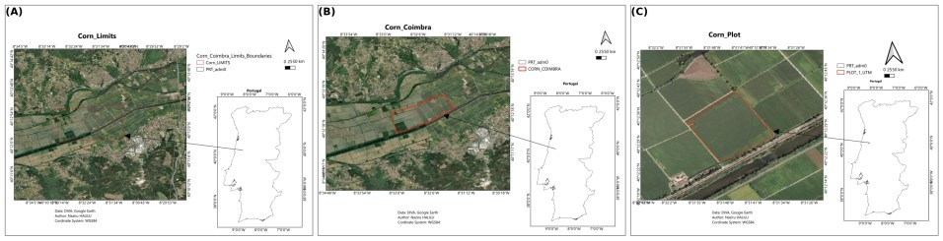
Figure S1. Case I site: maize field boundary (A), cadastral/orthophoto context (B) and field plot (C), Coimbra; WGS84. (Former Figure 1.)
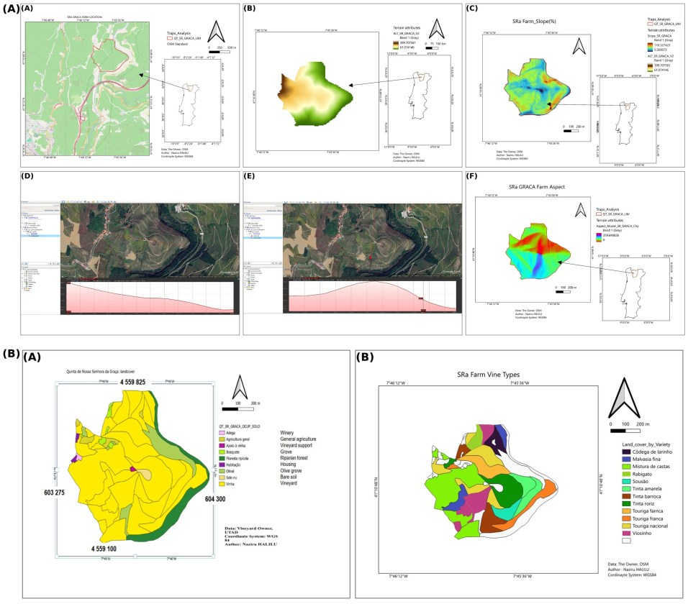
Figure S2. Case II site context, Quinta da Senhora da Graça: (A) location, altitude, slope, west–east and north–south topographic profiles and slope aspect (exposure) derived from a digital elevation model; (B) land use and grape-variety (cultivar) composition. Terrain is shown as context; it was not used as an explanatory variable. (Former Figure 3.)
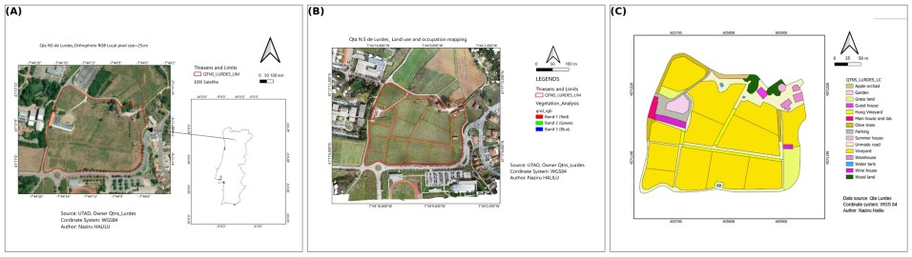
Figure S3. Case III site, Quinta de Nossa Senhora de Lurdes: (A) location on an RGB orthophoto; (B) land use and occupation; (C) detailed parcel land-use classes. (Former Figure 5.)
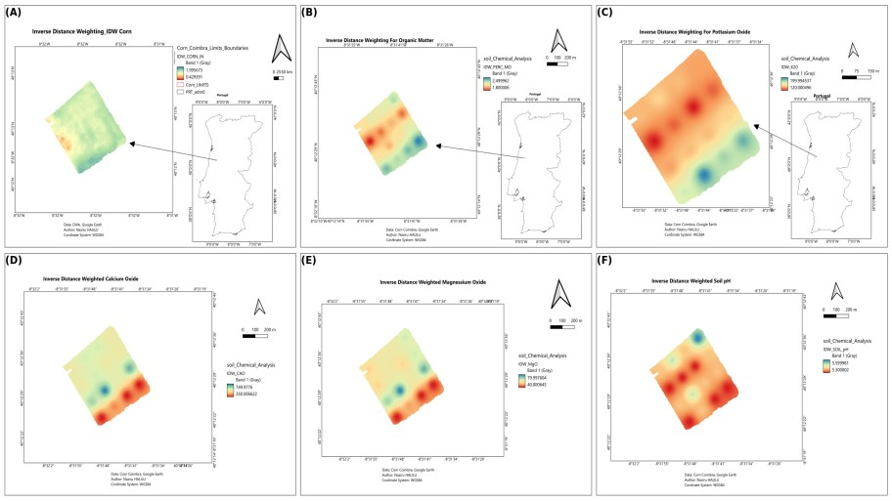
Figure S4. Case I IDW surfaces (p = 2, 1 m raster, clipped to the field) for display only: (A) yield; (B) organic matter; (C) K₂O; (D) CaO; (E) MgO; (F) pH (H₂O). These surfaces were not used in statistical tests. (Former Figure S1.)
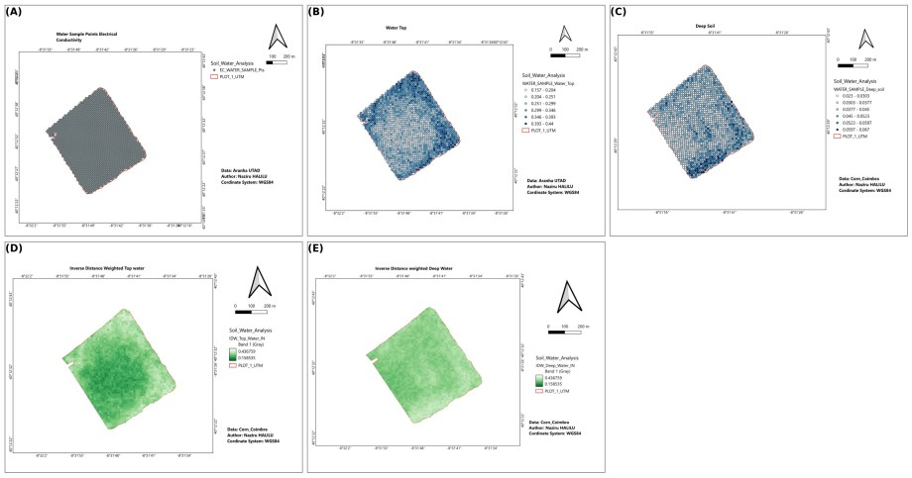
Figure S5. Case I soil-water points and surfaces: (A) the 1,613 measurement points; (B) near-surface and (C) deep-layer volumetric water content at points; (D, E) corresponding IDW surfaces. (Former Figure S2.)
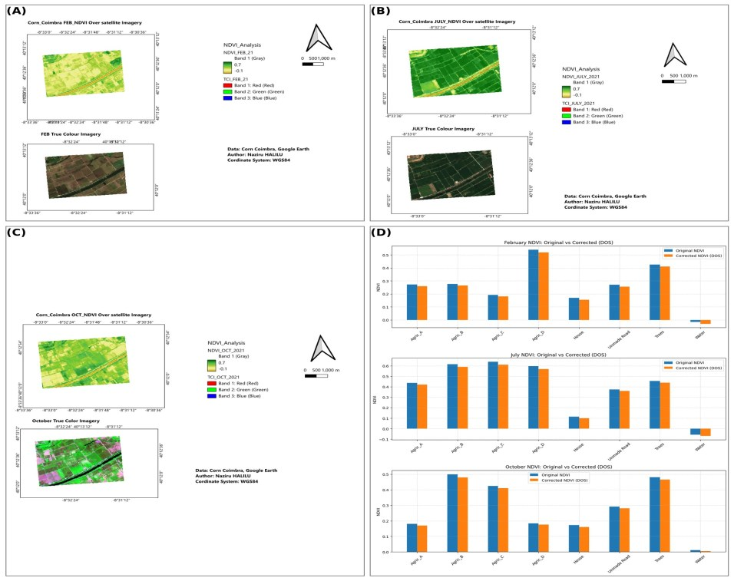
Figure S6. Case I Sentinel-2 NDVI on 28 February (A), 28 July (B) and 6 October (C), and NDVI of reference land-cover classes before and after dark-object subtraction (D), used as a radiometric consistency check only. (Former Figure 2; Landsat label corrected to Sentinel-2.)
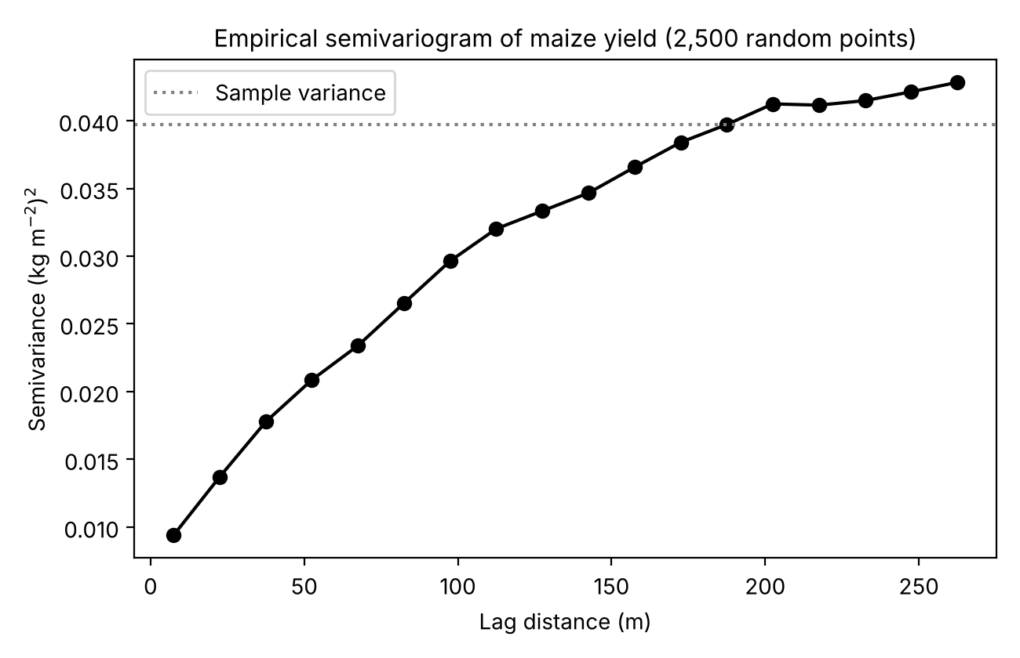
Figure S7. Empirical semivariogram of maize grain yield (2,500 randomly selected yield-monitor points; 15 m lag bins); dotted line, sample variance.
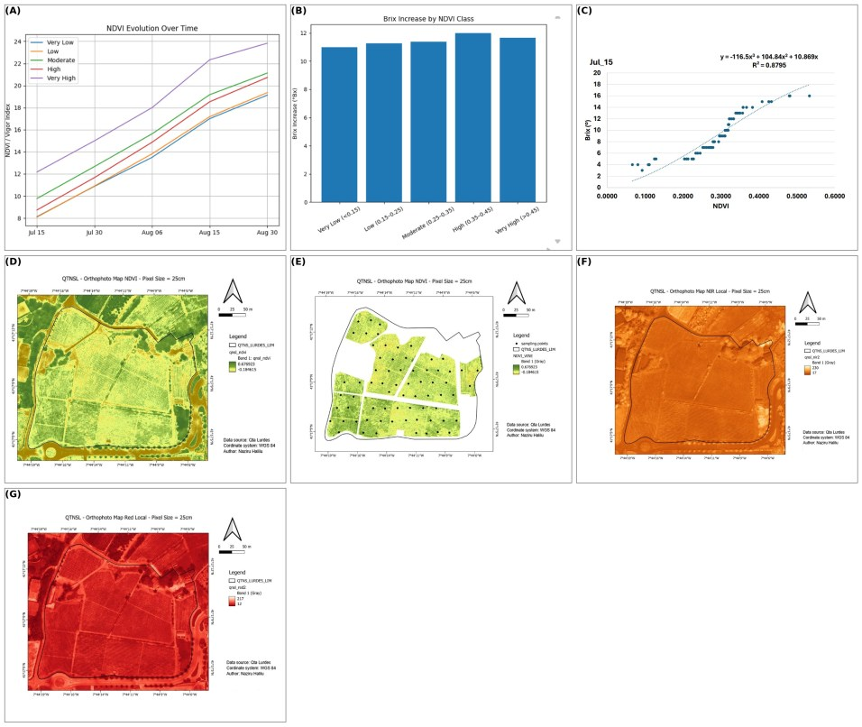
Figure S8. Case III UAV products: (A–C) original regression diagnostics; (D) NDVI; (E) NDVI clipped to the vineyard; (F) near-infrared orthomosaic; (G) near-infrared composite of the vineyard block. (Former Figure S3.)
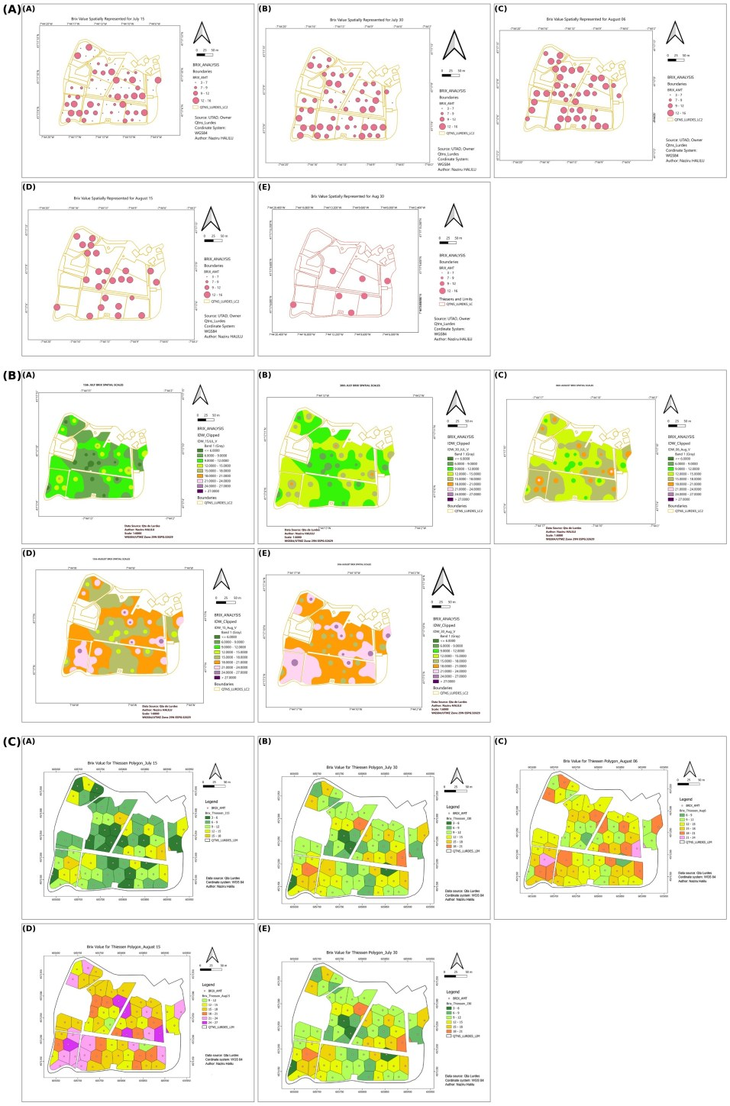
Figure S9. Case III, Task A: Brix at the 68 locations on 15 July, 30 July, 6 August, 15 August and 30 August displayed by (A) traditional field-sampling symbology, (B) IDW interpolation (p = 2) and (C) Thiessen polygons. Because Brix showed no spatial autocorrelation (Table S4), the continuous surfaces are displays of point values, not predictions. (Former Figure 7.)

