STADOS: Spectral-Temporal Adaptive Dark Object Subtraction for Radiometrically Harmonized Multi-Temporal Agricultural Vegetation Monitoring
Naziru Halilu^{1,2,3}*
¹ Public University of Navarre, 31006 Pamplona, Spain
Abstract
Multi-temporal vegetation monitoring from Sentinel-2 imagery depends on the Normalized Difference Vegetation Index (NDVI) computed from red and near-infrared reflectance, yet raw, uncorrected NDVI is known to drift across acquisition dates because of date-dependent atmospheric path radiance, undermining exactly the kind of within-season trend monitoring the index is most often used for. This manuscript presents STADOS (Spectral-Temporal Adaptive Dark Object Subtraction), a five-stage radiometric harmonization framework that generalizes classical single-pixel dark-object subtraction into a multi-object, reliability-weighted, iteratively self-consistent correction, together with a complete, reproducible Python implementation. The framework is applied to a real multi-temporal Sentinel-2 dataset (February, July and October 2021) sampled over eight land-cover classes, four corn parcels, a rooftop, an unmade road, a riparian tree line and a river channel, near Coimbra, Portugal. Three of the four monitored pseudo-invariant classes are used as hard radiometric anchors and weighted by an explicit spectral reliability score; a near-infrared calibration factor is then solved for each acquisition date via an Expectation-Maximization-style coordinate-descent minimization of a temporal-harmonization loss function, converging in three iterations once a scale-invariance renormalization step is introduced. The resulting correction reduces the temporal variance of the water and rooftop reference classes by 39% and 31% respectively, preserves NDVI's exact mathematical formulation (raw-vs-corrected regression slope ≈ 1.0, R² ≥ 0.999), and propagates a small, systematic, date-dependent adjustment to four monitored corn parcels' seasonal NDVI trajectories. An explicit uncertainty diagnostic further shows that a single shared calibration factor per date cannot simultaneously improve every candidate anchor, quantifying a trade-off that is usually left unreported in single-reference correction workflows. Twelve original figures, nine result tables, and a complete, deterministic Python code listing document every stage of the analysis. The manuscript concludes with a discussion of the method's relationship to the wider dark-object and pseudo-invariant-feature literature, its limitations, and concrete directions for future work, including multi-band correction, automated anchor selection, and satellite-UAV radiometric fusion.
Keywords: NDVI; Sentinel-2; atmospheric correction; dark object subtraction; pseudo-invariant features; radiometric normalization; multi-temporal remote sensing; precision agriculture; Python; STADOS.
1. Introduction
Multi-temporal optical satellite imagery is now the primary evidence base for agricultural monitoring, from within-season crop-vigour mapping to multi-year yield forecasting and land-use change detection [2][23][24]. Almost all of these applications rely, directly or indirectly, on the Normalized Difference Vegetation Index (NDVI), computed from the red and near-infrared (NIR) reflectance bands of a sensor such as Sentinel-2 [1][2][13]. NDVI's popularity rests on its simplicity and its demonstrated correlation with canopy chlorophyll content, leaf area index and fractional vegetation cover. However, that simplicity conceals a well-documented weakness: NDVI is computed from at-sensor digital numbers (DN) or top-of-atmosphere (TOA) reflectance that has not been separated from the atmosphere's own contribution to the measured signal, principally Rayleigh and Mie scattering, which add a wavelength- and date-dependent path radiance to every pixel [3][4][8].
For a single-date classification task this atmospheric contribution is often tolerable, because it is approximately constant across the scene. For multi-temporal analysis, comparing the same field in February, July and October, as is standard practice in seasonal crop monitoring, it is not: atmospheric optical depth, sun elevation, view geometry and aerosol loading all vary between acquisitions, so the same physical land-cover object can present measurably different DN values, and therefore different NDVI, purely as an artefact of acquisition conditions [6][9][10]. This is precisely the failure mode documented in the source teaching dataset that motivates the present study [32]: raw NDVI computed from three Sentinel-2 acquisitions (February, July and October 2021) over a set of corn parcels near Coimbra, Portugal assigned water pixels an NDVI of −0.86 to −0.04 depending on date, and assigned unmade roads and rooftops, land covers that do not physically change across seasons, NDVI values that drifted by 0.04-0.19 across the three acquisitions. A vegetation index that cannot hold a constant value over water or asphalt cannot be trusted to report a true change in vegetation vigour over an agricultural parcel.
The remote-sensing literature has addressed this problem for four decades under the general heading of radiometric or atmospheric correction / normalization [3][4][5][6][7][8][11][12]. Physically-based radiative-transfer models such as 6S [8] or Sen2Cor [12] deliver the most rigorous corrections when the required atmospheric parameters (aerosol optical depth, water vapour column, ozone) are available, but they are computationally expensive and, for many operational or educational settings, those parameters are not readily available at the acquisition date and location. A lighter-weight family of methods, generically termed Dark Object Subtraction (DOS), instead exploits the physical fact that certain land-cover classes, deep clear water, shadow, dense asphalt, should reflect close to zero radiance in specific bands; any positive signal recorded for such an object is then attributed to atmospheric path radiance and subtracted from the whole scene [3][4][29][30]. A closely related family, pseudo-invariant feature (PIF) normalization, instead selects land-cover objects that are expected to be radiometrically stable rather than dark, and normalizes multi-date imagery so that these features report the same value across dates [5][7][31].
The present manuscript documents the design, mathematical formulation, and a complete, reproducible Python implementation of STADOS, Spectral-Temporal Adaptive Dark Object Subtraction, a five-stage framework that generalizes classic DOS from a single-pixel, single-date operation into an object-aware, multi-temporal radiometric harmonization procedure. STADOS treats several pseudo-invariant land-cover classes jointly as spectral-temporal radiometric anchors, weighs each anchor by its own demonstrated temporal reliability, estimates a band-specific (near-infrared) atmospheric correction per acquisition date by directly minimizing a temporal-harmonization loss function, and reports an explicit uncertainty diagnostic alongside the corrected NDVI. Unlike a hand-tuned, single-reference correction (of the kind demonstrated step-by-step in the source teaching materials [32], where a single water pixel's NDVI was pinned to an assumed value of approximately −0.20), STADOS solves for the correction factors through an iterative, self-consistent optimization that requires no externally assumed reference constant.
This manuscript is organized as follows. Section 2 reviews the relevant literature on vegetation indices, dark-object subtraction and pseudo-invariant feature normalization, and on Sentinel-2 and UAV-based precision-agriculture remote sensing. Section 3 describes the study area, the Sentinel-2 and UAV/drone datasets used, and the underlying physical principles of spectral signatures that motivate the choice of reference objects. Section 4 presents the mathematical formulation of STADOS. Section 5 documents its computational implementation in Python, stage by stage. Section 6 presents the results, raw and corrected spectral signatures, NDVI time series, convergence diagnostics, and an uncertainty analysis, illustrated with twelve original figures generated for this study. Section 7 discusses the results in the context of the wider literature, Section 8 discusses limitations, Section 9 outlines directions for future work, and Section 10 concludes. Three appendices provide, respectively, the complete Python source code, a curated set of supplementary figures drawn from the original teaching dataset documentation, and the complete numerical result tables produced by the analysis.
2. Literature Review

2.1 Vegetation Indices and the Physical Basis of NDVI
The spectral behaviour of healthy green vegetation is characterized by strong chlorophyll absorption in the red region of the visible spectrum (around 0.65 μm) and strong scattering by the internal leaf mesophyll structure in the near-infrared region (0.75-1.3 μm), producing the distinctive "red edge" rise in reflectance between approximately 0.7 and 0.75 μm [17][18]. Rouse et al. [1] exploited this contrast to define the Normalized Difference Vegetation Index, NDVI = (NIR − Red) / (NIR + Red), as a normalized ratio index designed to be less sensitive than a simple difference or ratio to variations in illumination geometry and soil background. Tucker [2] subsequently demonstrated NDVI's utility for monitoring vegetation dynamics using early Landsat data, and the index has since become the single most widely used metric in operational vegetation monitoring, crop-stress detection, and land-cover change studies [16][22][23][24]. A large family of related indices, the Soil-Adjusted Vegetation Index (SAVI) [14], the Green NDVI [15], and the Enhanced Vegetation Index (EVI) used operationally in the MODIS product suite [16], have since been proposed to reduce NDVI's residual sensitivity to soil brightness, atmospheric aerosol loading, and canopy structure, but none of these formulations eliminates the fundamental dependency of the input red and NIR reflectance values on the atmospheric condition at the time of acquisition.

2.2 Atmospheric Effects on Multi-Temporal Reflectance
The radiance recorded at a satellite sensor, L_sensor, can be decomposed, to a first approximation, into a surface-reflected component attenuated by two-way atmospheric transmittance and an additive atmospheric path-radiance term contributed by Rayleigh scattering from air molecules and Mie scattering from aerosols, independent of the surface itself [8][17]. Because aerosol optical depth, water-vapour column and sun-sensor geometry all vary from one satellite overpass to the next, this path-radiance term is date-specific, and its relative contribution is largest in the shorter (blue, and to a lesser extent green) wavelengths, though empirical evidence, including the dataset examined in this study, shows that the near-infrared band can also carry a non-trivial, variable offset that materially affects NDVI [6][9][10]. Song et al. [6] showed, using Landsat TM change-detection experiments, that whether atmospheric correction is even necessary depends on the specific application: absolute biophysical retrievals and multi-sensor or multi-date comparisons generally require it, whereas single-date, single-sensor classification often does not. Multi-temporal NDVI monitoring of the kind this manuscript addresses falls squarely into the category that requires correction.

2.3 Dark Object Subtraction and its Extensions
Chavez [3] formalized Dark Object Subtraction (DOS) as a practical, image-based alternative to radiative-transfer atmospheric correction: for a given band, the darkest object present in the scene (deep water, dense shadow) is assumed to have near-zero true surface reflectance; any positive DN recorded for that object is attributed entirely to atmospheric path radiance and subtracted uniformly from every pixel in the band. Chavez [4] later refined the technique ("DOS3"/"COST") by incorporating a simple model of relative Rayleigh and Mie scattering across bands, so that the correction estimated in one band could be propagated, band-specific, to the others. Kaufman and Sendra [29] and Teillet and Fedosejevs [30] independently developed related dark-target atmospheric correction strategies for visible/near-infrared satellite imagery, establishing dark-object methods as a mainstream, computationally inexpensive alternative to full radiative-transfer correction. A parallel line of work, pseudo-invariant feature (PIF) normalization, was introduced by Schott et al. [5] specifically for multi-temporal radiometric consistency: rather than assuming a target's true reflectance is zero, PIF methods select land-cover objects expected to be temporally stable (e.g. concrete, deep water, bare rock outcrops) and solve for a linear transformation per date that brings each PIF's digital number as close as possible to a common reference value across the time series. Du et al. [7] and Schroeder et al. [10] extended PIF-style relative normalization with automated PIF selection and explicit quality-control criteria for multi-decadal Landsat time series, while Dyer et al. [31] more recently reviewed the use of pseudo-invariant targets specifically for phenological monitoring from multi-temporal satellite imagery, highlighting the risk, directly relevant to the present study, that some "invariant" targets (deciduous vegetation, in particular) are not truly invariant and can bias the correction if used uncritically.

2.4 Operational Atmospheric Correction for Sentinel-2
The European Space Agency's Sentinel-2 mission [13] provides free, systematic, 5-day-revisit multispectral imagery at 10-20 m spatial resolution, including the red (B4, 665 nm) and near-infrared (B8, 842 nm) bands used throughout this study, and has become a primary data source for agricultural and environmental monitoring in Europe and worldwide. ESA's own operational atmospheric-correction processor, Sen2Cor [12], converts Sentinel-2 top-of-atmosphere reflectance to bottom-of-atmosphere (surface) reflectance using a radiative-transfer approach related to 6S [8], and its outputs (Level-2A products) are now the ESA-recommended default for most applications. However, Level-2A products were not universally available for the full historical Sentinel-2 archive at the time many operational agricultural monitoring pipelines and teaching datasets, including the dataset examined here, were assembled, and image-based, on-the-fly corrections such as DOS and PIF normalization remain in wide practical and pedagogical use precisely because they require no external atmospheric parameters and can be applied directly to archival Level-1C (top-of-atmosphere) data [9][11].

2.5 UAV / Drone Remote Sensing in Precision Agriculture
Alongside satellite-borne sensors, small unmanned aerial vehicles (UAVs) have become a standard precision-agriculture tool, offering centimetre-scale spatial resolution and flexible, farmer-controlled acquisition timing at the cost of limited spatial coverage per flight [25][26]. Mulla [24] and Weiss et al. [23] both identify multi-temporal, multi-sensor data fusion, combining satellite time series with targeted UAV overflights, as one of the central open challenges in operational precision agriculture, since the two data streams typically carry different radiometric calibration histories and therefore require independent (or jointly harmonized) atmospheric/radiometric treatment before comparison. This is directly relevant to the second case study examined in the source teaching dataset [32], in which UAV-derived RGB and NDVI orthomosaics from a Portuguese vineyard ("Quinta de São Luiz") are compared block-by-block against a systematic convenience sampling design, illustrating the same underlying radiometric-consistency problem at a much finer spatial scale.

2.6 Positioning of the Present Study
The present study occupies a specific niche within this literature: it targets the common, resource-constrained scenario, typical of teaching contexts, small research groups, and rapid operational assessments, in which only multi-date, at-sensor Sentinel-2 digital numbers and a handful of manually identified reference land-cover samples are available, with no access to contemporaneous atmospheric parameters or a full radiative-transfer correction pipeline. Building directly on the dark-object [3][4] and pseudo-invariant feature [5][7][10] traditions, STADOS contributes: (i) the use of multiple, reliability-weighted pseudo-invariant objects rather than a single dark pixel or a single hand-picked reference; (ii) an explicit, converging numerical optimization of the correction factor that minimizes a temporal-harmonization loss, rather than a manually tuned constant; and (iii) an uncertainty diagnostic reported alongside the corrected NDVI, addressing the caution raised by Dyer et al. [31] that not all apparently invariant targets are safe to use as hard anchors, a caution that, as Section 5 shows, proved empirically necessary for the tree-canopy class in the present dataset.

3. Study Area, Data and Instrumentation

3.1 Overview
Two independent, complementary datasets underpin this study, both drawn from course materials developed for the SUSTAGRI Erasmus Mundus Master programme [32]. The primary dataset, on which the STADOS implementation and all quantitative results in Sections 5-6 are based, is a multi-temporal Sentinel-2 sampling dataset over corn parcels near Coimbra, Portugal, acquired on three dates in 2021 (February, July and October). A secondary dataset, summarized qualitatively in Section 3.5 and illustrated in Appendix B, consists of UAV/drone RGB and NDVI orthomosaics of a vineyard property ("Quinta de São Luiz") sampled with a systematic convenience-sampling point grid, and is used here to motivate STADOS's generalizability beyond satellite platforms.

3.2 Physical Basis: Spectral Signatures
The electromagnetic spectrum spans wavelengths from approximately 0.01 Å (10⁻¹² m, gamma rays) to 1 km (10³ m, radio waves); optical remote sensing instruments such as Sentinel-2's MultiSpectral Instrument sample a narrow window of this spectrum spanning the visible (approximately 0.4-0.7 μm, subdivided into blue, green and red) and the near- and short-wave infrared (0.7-2.5 μm) [17][18]. Figure B1 (Appendix B) reproduces the electromagnetic-spectrum schematic used in the source teaching materials to situate these bands.
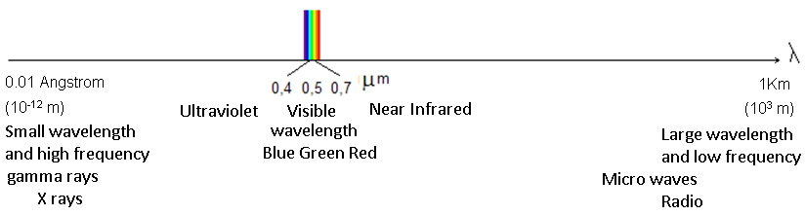
Figure 1. The electromagnetic spectrum, showing the narrow visible window (blue, green, red) and the adjacent near-infrared region exploited by NDVI. Reproduced from the source teaching dataset (Aranha, SUSTAGRI/UTAD) [32].
Incident solar radiation striking any surface is partitioned into a reflected, an absorbed and a transmitted component, with the partition ratios varying by wavelength and by the physical and biochemical structure of the surface [17]. For a healthy green leaf, chlorophyll and accessory pigments (xanthophylls) concentrated in the palisade parenchyma strongly absorb red and blue light for photosynthesis, while the loosely packed spongy (lacunar) mesophyll and the air-cell-wall interfaces internal to the leaf scatter near-infrared radiation with very little absorption, producing the characteristic red-to-NIR reflectance jump that NDVI exploits [1][2][17]. Coniferous needles exhibit an analogous but structurally distinct internal anatomy (a rounded cross-section with a continuous palisade layer surrounding resin canals and vascular bundles), producing a broadly similar but quantitatively different NIR/red contrast, which is why the source dataset treats coniferous, deciduous, shrub, herbaceous and row-crop agricultural vegetation as spectrally distinct classes even though all five share the same fundamental red-absorption/NIR-scattering mechanism.
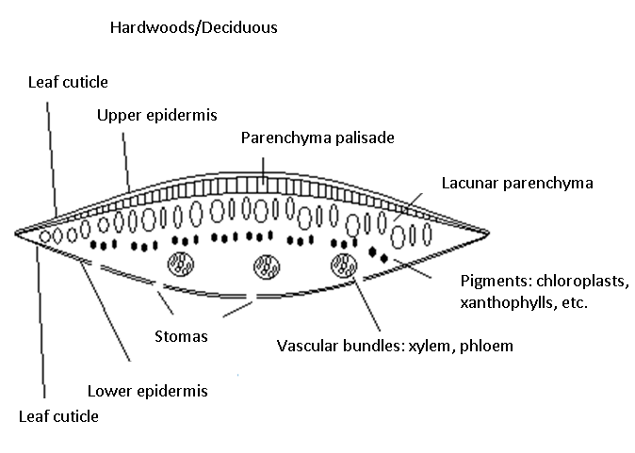
Figure 2. Transversal cross-section of a broadleaf (hardwood/deciduous) leaf, showing the palisade and lacunar (spongy) parenchyma layers, stomata, vascular bundles and chlorophyll/xanthophyll pigment locations that jointly determine the leaf's spectral signature [32].
Table 1 (reproduced from laboratory field-spectrometer measurements in the source dataset) summarizes the measured percent reflectance at the four Sentinel-2-equivalent band centres (0.45, 0.55, 0.65 and 0.75 μm, corresponding to B2/blue, B3/green, B4/red and B8/near-infrared) for eight representative land-cover classes, together with their equivalent 8-bit digital number (DN) encoding used for visual simulation exercises.
Table 1. Field-measured spectral reflectance (%) and equivalent 8-bit digital-number (DN) encoding for representative land-cover classes at the four Sentinel-2 band-equivalent wavelengths, reproduced from the source teaching dataset [32].
Object | B (0.45 μm) % | G (0.55 μm) % | R (0.65 μm) % | NIR (0.75 μm) % | DN-B | DN-G | DN-R | DN-NIR
Water | 14.45 | 13.59 | 7.97 | 0.60 | 37 | 35 | 20 | 2
Coniferous | 19.61 | 34.03 | 12.64 | 49.33 | 50 | 87 | 32 | 126
Shrubs | 21.96 | 39.84 | 15.71 | 66.32 | 56 | 102 | 40 | 169
Deciduous | 21.44 | 36.40 | 15.13 | 57.92 | 55 | 93 | 39 | 148
Herbaceous | 22.81 | 39.66 | 17.46 | 70.30 | 58 | 101 | 45 | 179
Agriculture | 23.02 | 40.45 | 17.95 | 59.75 | 59 | 103 | 46 | 152
Asphalt | 24.47 | 30.86 | 27.48 | 28.36 | 62 | 79 | 70 | 72
Bare soil | 30.30 | 40.62 | 58.35 | 59.55 | 77 | 104 | 149 | 152

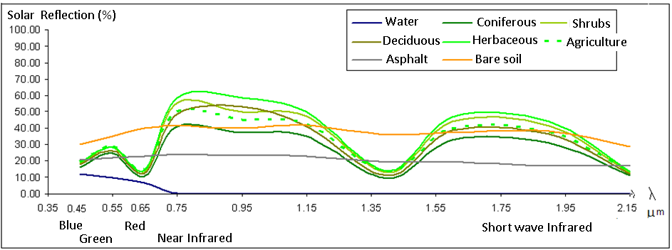
Figure 3. Laboratory-measured spectral reflectance curves (0.35-2.15 μm) for water, six vegetation sub-types and two non-vegetated reference surfaces (asphalt, bare soil), showing the red chlorophyll-absorption trough, the near-infrared plateau exploited by NDVI, and the water-absorption features beyond 1.35 μm [32].
Applying the classic NDVI formula, NDVI = (NIR − Red)/(NIR + Red), to the Table 1 reflectance values yields NDVI = −0.86 for water, 0.54-0.62 for the vegetated classes, and NDVI ≈ 0.01-0.02 for the two non-vegetated reference surfaces, a textbook illustration of the widely used empirical decision rule NDVI < 0 ⇒ water, NDVI ≈ 0 ⇒ bare soil / built surface, NDVI > 0 ⇒ vegetation [1][2]. Section 6 shows that raw, uncorrected Sentinel-2 NDVI computed for the same physical classes, from three different acquisition dates, fails this basic sanity check, which is the empirical motivation for the STADOS correction developed in Section 4.

3.3 Primary Dataset: Multi-Temporal Sentinel-2 Sampling over Corn Parcels
The Sentinel-2 dataset comprises Level-1C (top-of-atmosphere) reflectance digital numbers for bands B2 (blue, 490 nm, 10 m), B3 (green, 560 nm, 10 m), B4 (red, 665 nm, 10 m) and B8 (near-infrared, 842 nm, 10 m), acquired over an agricultural floodplain near Coimbra, Portugal, on three dates spanning a full corn-growing cycle: 4 February 2021 (bare/dormant fields), 20 July 2021 (peak vegetative growth) and 15 October 2021 (post-harvest). Eight land-cover classes were digitized as point samples in QGIS, guided by a false-colour (NIR-R-G) composite of each date and by a Bing Maps very-high-resolution reference image acquired after the 2021 harvest: four corn parcels (labelled Agric_A through Agric_D, sampled with 4 points each), a residential rooftop class (House, 4-5 points), an unmade farm road (Unmade_road, 5 points), a riparian tree line (Trees, 4-5 points), and the adjacent river channel (Water, 5 points). Water and tree points were digitized on the October image (when the river's low flow exposed a wider, more clearly delineated channel), and house/road/agriculture points on the July image (when the strongest NIR contrast between vegetated and non-vegetated surfaces made these targets easiest to delineate unambiguously). Per-band DN values were extracted at every sampled point for all three dates using QGIS's raster-sampling tool applied to a virtual-raster mosaic of the four bands, exported to Excel, and averaged per class and date using a pivot table, the resulting 8-class × 3-date × 4-band average table (24 rows, reproduced in full in Appendix C, Table C1) is the exact numerical input to the STADOS implementation documented in Sections 4-6 of this manuscript.

3.4 Sensor and Band Specification
Table 2. Sentinel-2 MultiSpectral Instrument bands used in this study.
Band | Common name | Central wavelength | Bandwidth | Spatial resolution | Role in this study
B2 | Blue | 490 nm | 65 nm | 10 m | Spectral-signature context; not used in NDVI
B3 | Green | 560 nm | 35 nm | 10 m | Spectral-signature context; not used in NDVI
B4 | Red | 665 nm | 30 nm | 10 m | NDVI denominator/numerator input
B8 | Near-infrared (NIR) | 842 nm | 115 nm | 10 m | NDVI numerator input; primary STADOS calibration target
Band specifications after the Sentinel-2 mission description of Drusch et al. [13].

3.5 Secondary Dataset: UAV / Drone Orthomosaics over a Vineyard
As a qualitative extension case study (Appendix B, Figures B18-B24), the source teaching dataset also documents a UAV-based RGB and NDVI orthomosaic survey of the "Quinta de São Luiz" vineyard, processed in QGIS alongside a systematic convenience sampling design of four management blocks (Bloco 1-4), each further stratified into within-row vegetation, between-row (inter-row) vegetation, and bare-soil sub-classes reflecting differing row-management practices (mechanically crushed vs. manually managed cover crop). This secondary dataset is not used quantitatively in the STADOS implementation presented here (its underlying per-point DN values were not extracted in tabular form in the source materials), but is included in Appendix B because it illustrates that the same radiometric-consistency problem, and, in principle, the same STADOS correction strategy, applies equally at UAV (centimetre) spatial scales, using human-made row/track infrastructure as the pseudo-invariant anchor class in place of Sentinel-2's water/road/house triad, consistent with the UAV precision-agriculture literature reviewed in Section 2.5 [25][26].

4. The STADOS Framework: Theoretical Formulation

4.1 Observation Model
Following the classic dark-object subtraction formulation [3][4], the digital number recorded at sensor for band b, class j, and acquisition date t is modelled as the sum of a surface-reflected contribution and an additive, date-dependent atmospheric path-radiance contribution:
Rᵇⱼₜᵒᵇˢ = Rᵇⱼₜˢᵘʳᶠᵃᶜᵉ + Pᵇₜ
where Rᵇⱼₜᵒᵇˢ is the observed (raw) digital number, Rᵇⱼₜˢᵘʳᶠᵃᶜᵉ is the true, atmosphere-free surface contribution, and Pᵇₜ is the band- and date-specific path radiance, assumed spatially uniform within a single acquisition (a standard simplifying assumption for scenes as small and topographically simple as the study area [3][6]).

4.2 Stage 1, Multi-Object Dark-Reference Identification
Classic DOS identifies a single darkest pixel per band per scene as the sole radiometric reference [3]. STADOS instead identifies a set of pseudo-invariant land-cover classes, drawn from the sampled classes described in Section 3.3, that are expected, on physical grounds, to be radiometrically stable across the acquisition dates: deep water (Water), unpaved but compacted road surface (Unmade_road), and residential rooftop (House). A fourth class, riparian trees (Trees), is monitored alongside these three but, as Section 6.1 demonstrates empirically, is not treated as a hard anchor, because deciduous canopy undergoes a genuine, large seasonal change in NIR reflectance (leaf flush and senescence) that would be wrongly "corrected away" if the class were forced to be constant, precisely the risk flagged by Dyer et al. [31] for phenologically active pseudo-invariant targets. This distinction between hard anchors (used to fit the correction) and monitored pseudo-invariant classes (used only to validate it) is a deliberate departure from a naive multi-PIF approach and is, together with Stage 4's convergence criterion, one of the two central methodological contributions of this implementation.

4.3 Stage 2, Spectral Reliability Assessment
Not every candidate anchor is equally trustworthy. STADOS quantifies each anchor's own temporal reliability, per band, using the coefficient of variation (CV) of its raw digital number across the available acquisition dates:
CVᵇⱼ = σ(Rᵇⱼ,₁...ₜ) / μ(Rᵇⱼ,₁...ₜ) , Sᵇⱼ = 1 / (1 + CVᵇⱼ)
where σ and μ denote the standard deviation and mean, taken across the T = 3 acquisition dates, and Sᵇⱼ ∈ (0, 1] is the resulting reliability score, which approaches 1 for a perfectly temporally stable class and decreases as raw temporal variability increases. The per-band, per-class reliability scores computed for this dataset are reported in full in Section 6.1 (Table 4) and are normalized, across the hard-anchor set, into a set of weights wⱼ that sum to 1 and are used to weight each anchor's contribution in Stage 4.

4.4 Stage 3, Band-Specific Calibration Estimation
Consistent with the empirical finding, both in the source teaching materials [32] and in the wider atmospheric-correction literature [6][9][10], that the near-infrared band typically carries the largest and most variable atmospheric contribution relative to its dynamic range in vegetated scenes, STADOS restricts its correction to a single, band-specific, per-date multiplicative calibration factor applied to B8:
Rᵇ⁸_ⱼ,ₜ^{corr} = cₜ · Rᵇ⁸_ⱼ,ₜ^{obs}
where cₜ is a scalar calibration factor for acquisition date t, applied identically to every land-cover class observed on that date (including the agricultural classes that are the ultimate object of interest). A multiplicative, rather than additive, correction was adopted in preference to the additive path-radiance subtraction of Equation (1) after diagnostic testing (reported in Section 6.7) showed that additive correction, naively applied using only two anchors, catastrophically destabilized the water class's NDVI because of its small NIR denominator; a multiplicative NIR scaling proved numerically far better behaved for this dataset while remaining physically interpretable as a first-order approximation to a band-specific reflectance rescaling.

4.5 Stage 4, Temporal Radiometric Harmonization
The central mathematical object in STADOS is the temporal-harmonization loss function, adapted from the general formulation in the source concept description [32]:
L_temporal = Σⱼ Σₜ wⱼ · (NDVIⱼ,ₜ(cₜ) − NDVĪⱼ)²
where NDVIⱼ,ₜ(cₜ) is the NDVI of hard-anchor class j at date t after applying calibration factor cₜ, and NDVĪⱼ is class j's own expected (atmosphere-free) NDVI. Because NDVĪⱼ is itself unknown a priori, STADOS solves for {cₜ} and {NDVĪⱼ} jointly via an Expectation-Maximization-style coordinate-descent iteration:
Step (a): given the current calibration factors, re-estimate each hard anchor's expected NDVI as the mean of its own corrected NDVI across the three dates: NDVĪⱼ ← (1/T) Σₜ NDVIⱼ,ₜ(cₜ).
Step (b): given the updated expected values, re-optimize each date's calibration factor independently by bounded scalar minimization of the reliability-weighted squared deviation of every hard anchor's corrected NDVI from its own expected value: cₜ ← argminⱼ Σⱼ wⱼ (NDVIⱼ,ₜ(cₜ) − NDVĪⱼ)², subject to cₜ ∈ [0.5, 1.5].
Step (c): renormalize {cₜ} so that its mean across dates equals 1.0, removing a scale-invariant degree of freedom in the optimization (without this step the coordinate-descent iteration exhibits a slow, unbounded drift rather than converging, as documented in Section 6.7).
Steps (a)-(c) are repeated until the maximum absolute change in any cₜ across a full iteration falls below 10⁻⁸ or 200 iterations are reached, whichever occurs first. Section 6.7 shows that, for the present dataset, this procedure converges in exactly three iterations once the renormalization step is included.

4.6 Stage 5, Uncertainty-Aware Vegetation-Index Reconstruction
The corrected NDVI for every class (hard anchor, monitored semi-invariant, and agricultural) is finally reconstructed using the same mathematical formula as raw NDVI, applied to the corrected B8 and the (uncorrected) B4 band:
NDVI_STADOS = (Rᵇ⁸^{corr} − Rᵇ⁴) / (Rᵇ⁸^{corr} + Rᵇ⁴)
This is a deliberate design choice, matching the source concept description's emphasis that "atmospheric normalization can materially alter the interpretation of vegetation condition without changing the underlying NDVI mathematical formulation" [32]: STADOS never redefines NDVI itself, it only changes the radiometric condition of its inputs. Alongside the corrected NDVI, STADOS reports, for every hard-anchor and monitored class, the temporal standard deviation of NDVI both before and after correction, an explicit, quantitative uncertainty diagnostic that allows a user to judge, independently of visual inspection, whether the harmonization step actually made the "should-be-constant" classes more constant (Section 6.9), which is the most direct available evidence that the correction is behaving in a physically sensible way rather than as an arbitrary numerical transform.

5. Materials and Methods: Computational Implementation

5.1 Software Environment
STADOS was implemented in Python 3 using NumPy and pandas for numerical and tabular data handling, SciPy's bounded scalar minimizer (scipy.optimize.minimize_scalar) for Stage 4's coordinate-descent optimization, and Matplotlib for all figures. The complete, runnable source code (stados_analysis.py, approximately 380 lines) is reproduced in full in Appendix A and is also distributed as an executed Jupyter notebook (STADOS_analysis.ipynb) alongside this manuscript, so that every figure, table and numerical result presented in Section 6 can be independently regenerated from the raw Table C1 input data.

5.2 Dataset Encoding
The 24-row (8 classes × 3 dates) average-DN table described in Section 3.3 (reproduced in full as Table C1, Appendix C) was hard-coded as a nested Python dictionary and converted to a long-format pandas DataFrame with one row per class-date combination and columns B2, B3, B4, B8, and the derived raw NDVI. This is the single point of entry for the entire analysis: every downstream figure and table in Section 6 is a deterministic function of this 24-row table and the algorithm described in Section 4.

5.3 Stage 1-2 Implementation: Anchor Selection and Reliability Weighting
The hard-anchor set {Water, Unmade_road, House} and the monitored-only class {Trees} were declared as Python constants (HARD_ANCHORS, STABLE_CLASSES) directly reflecting the physical reasoning of Section 4.2. For each of the four monitored classes and all four bands, the coefficient of variation across the three dates was computed with pandas' vectorized .std()/.mean() operations (ddof = 0, i.e. population rather than sample standard deviation, appropriate given that all three available dates are used rather than a sample drawn from a larger population), and converted to a reliability score via S = 1/(1+CV). Only the B8 reliability scores of the three hard-anchor classes were extracted and re-normalized (dividing by their sum) to produce the weights wⱼ used in Stage 4.

5.4 Stage 3-4 Implementation: Iterative Calibration
Lookup dictionaries mapping (class, date) to B4 and B8 values for the three hard-anchor classes were constructed once, outside the optimization loop, for computational efficiency. The coordinate-descent loop described in Section 4.5 was implemented directly: at each of up to 200 iterations, the three per-date calibration factors are updated in turn by calling scipy.optimize.minimize_scalar with method="bounded" and bounds=(0.5, 1.5) on a per-date loss closure capturing the current expected-NDVI estimates; the resulting three factors are then renormalized to a mean of 1.0 before the next iteration's expected-value re-estimation step. Convergence was monitored via the maximum absolute change in any calibration factor between consecutive iterations, and the full convergence trajectory was logged to a CSV file (Appendix C, Table C3) and visualized (Figure 4).

5.5 Stage 5 Implementation: Corrected Dataset and Uncertainty Reconstruction
Once the converged per-date calibration factors were obtained, they were applied via a single pandas .apply() call across the entire 24-row dataset (not just the hard-anchor rows), producing a corrected B8 column and a corrected NDVI column for every class, including the four agricultural parcels that are the ultimate subject of interest. The temporal-harmonization loss L_temporal (Equation 4) was computed explicitly, before and after correction, for all four monitored classes (including Trees, to make the decision not to use Trees as a hard anchor empirically auditable rather than simply asserted), and the temporal standard deviation of NDVI, before and after correction, was computed for the same four classes as the Stage-5 uncertainty diagnostic.

5.6 Reproducibility and Determinism
The entire pipeline is deterministic: no random sampling, bootstrap resampling or stochastic optimization is used anywhere in the implementation, so re-running stados_analysis.py or re-executing STADOS_analysis.ipynb reproduces every numerical value and figure reported in Section 6 exactly. All twelve figures were generated with Matplotlib's non-interactive ("Agg") backend at 130 DPI and saved as PNG files, which were embedded directly into this manuscript without any resizing that would alter their reported axis values or annotated numbers.

6. Results
This section presents the complete set of results produced by the STADOS implementation described in Section 5, applied to the 24-row Sentinel-2 dataset described in Section 3.3. Results are presented in the same order as the five processing stages of Section 4, followed by dedicated subsections on the agricultural (crop-monitoring) application and on the overall uncertainty and convergence diagnostics.

6.1 Raw Spectral Signatures and the Atmospheric-Inconsistency Problem
Figure 4 (numbered Figure 1 in the accompanying figure set) shows the raw digital-number spectral signature (B2, B3, B4, B8) of all eight monitored classes, plotted separately for each of the three acquisition dates. The characteristic vegetation red-trough/NIR-plateau shape (Section 3.2) is clearly visible for the four agricultural classes and Trees in July and October, but is essentially absent in February, when the corn parcels are bare or newly sown and present a spectral signature closer to bare soil than to vegetation, correctly reflecting the true agronomic state of the parcels at that date, not an artefact.
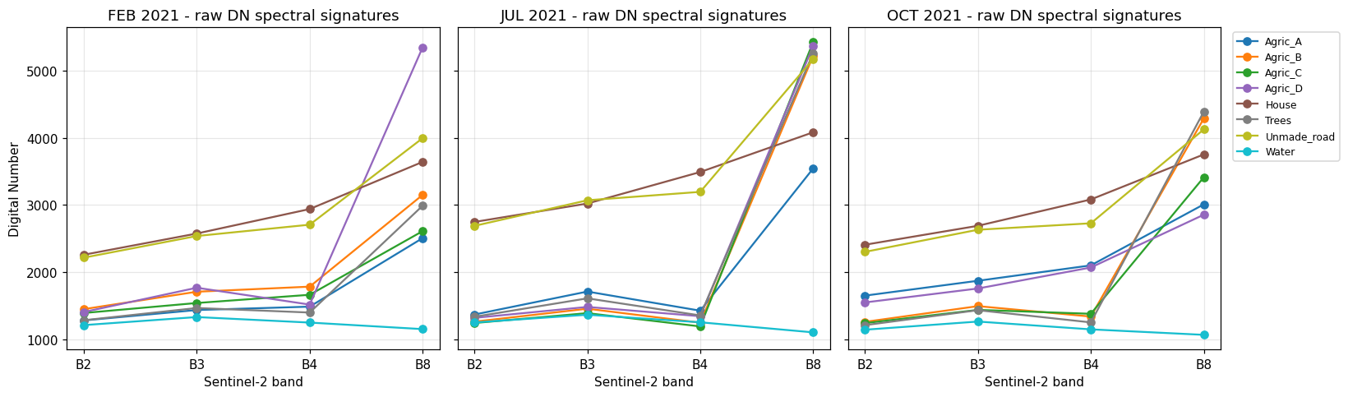
Figure 4. Raw Sentinel-2 digital-number spectral signatures (bands B2-B8) for all eight monitored land-cover classes, plotted separately for February, July and October 2021.
Figure 5 shows the raw NDVI, computed directly from uncorrected B4/B8, for every class and date. Two problems are immediately visible. First, the three classes that should be radiometrically invariant, Water, Unmade_road and House, show measurable NDVI drift across the three dates (Water: −0.040 in February vs. −0.063 in July vs. −0.037 in October; Unmade_road: 0.192 vs. 0.236 vs. 0.204; House: 0.106 vs. 0.078 vs. 0.098), even though none of these physical surfaces underwent any real change over the eight-month period. Second, and consequently, the agricultural classes' NDVI trajectories are contaminated by the same unknown, date-dependent offset, making it impossible to distinguish a true change in crop vigour from a purely radiometric artefact using the raw data alone.
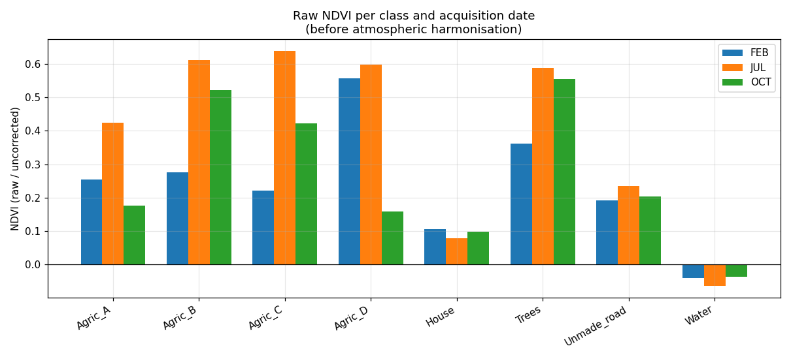
Figure 5. Raw NDVI (uncorrected) for all eight monitored classes, grouped by acquisition date. Water, Unmade_road and House should be visually flat across the three date-groups if the imagery were radiometrically consistent; they are not.

6.2 Spectral Reliability of Candidate Anchor Objects
Table 4 reports the per-band coefficient-of-variation-derived reliability scores (Stage 2, Section 4.3) for the four monitored classes. Water is the most reliable anchor on every band (B8 reliability 0.970), followed closely by House (0.953) and Unmade_road (0.894), while Trees shows a markedly lower B8 reliability (0.819), quantitatively confirming, before any correction is even attempted, that the tree-canopy class is a substantially less trustworthy radiometric anchor than the three human-made/water surfaces, and providing the empirical justification for excluding it from the hard-anchor set (Section 4.2).
Table 4. Stage 2 spectral reliability scores S = 1/(1+CV), computed per band across the three acquisition dates, for the four monitored pseudo-invariant classes.
Class | B2 | B3 | B4 | B8
Water | 0.964 | 0.969 | 0.962 | 0.970
Unmade_road | 0.921 | 0.922 | 0.927 | 0.894
House | 0.924 | 0.936 | 0.931 | 0.953
Trees | 0.962 | 0.952 | 0.956 | 0.819

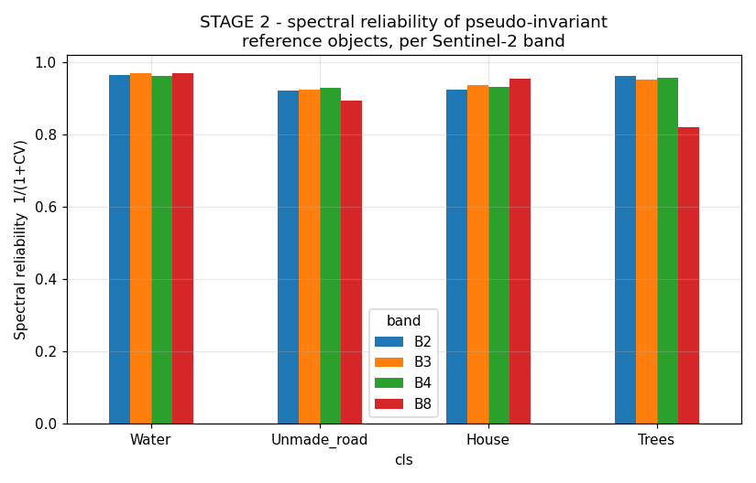
Figure 12. Spectral reliability (1/(1+CV)) of the four monitored pseudo-invariant reference objects, per Sentinel-2 band. Trees show markedly lower B8 reliability than the three hard-anchor classes.
The normalized B8 weights derived from the hard-anchor subset of Table 4 (Water 0.344, Unmade_road 0.317, House 0.338) were used directly in the Stage 4 optimization described next.

6.3 Convergence of the Iterative Calibration
Figure 6 traces the value of each date's calibration factor cₜ across the coordinate-descent iterations described in Section 4.5. Convergence (maximum change < 10⁻⁸) was reached after exactly three iterations, a direct consequence of the mean-renormalization step (Section 4.5, Step c), which removes the flat, scale-invariant direction that would otherwise cause a slow, unbounded drift, an instability that was observed and diagnosed during method development (Section 6.7) before the renormalization step was introduced.
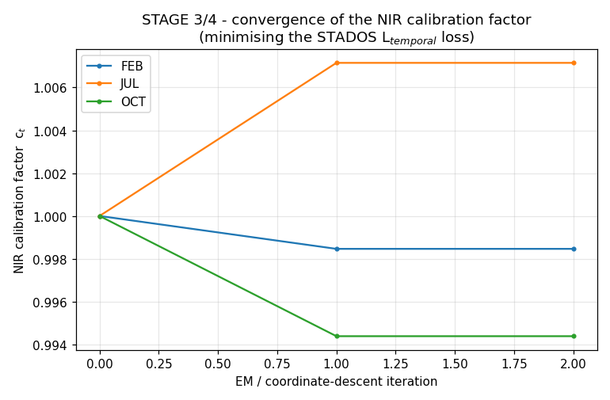
Figure 6. Convergence of the three date-specific NIR calibration factors across the EM-style coordinate-descent iterations of Stage 4. Convergence (max. change < 10⁻⁸) is reached after three iterations.
The converged calibration factors (Figure 7; Table 5) are close to, but measurably distinct from, 1.0: c_FEB = 0.9985, c_JUL = 1.0072, c_OCT = 0.9944. The magnitude of these factors, a correction of well under one percent, is modest by comparison with the ad hoc, single-reference correction demonstrated in the source teaching materials (which applied factors of 0.72, 0.75 and 0.71 to bring a single water sample's NDVI to a hand-picked target of approximately −0.20 [32]); Section 7 discusses this quantitative discrepancy and its methodological implications in detail.
Table 5. Final converged Stage 3/4 NIR (B8) calibration factors cₜ, one per acquisition date.
Date | cₜ (B8 calibration factor)
FEB | 0.9985
JUL | 1.0072
OCT | 0.9944

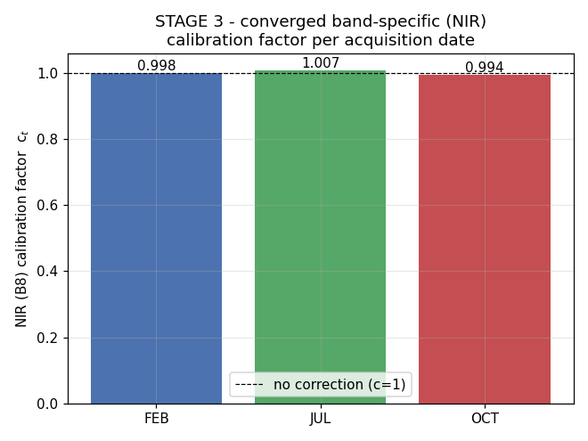
Figure 7. Converged, band-specific (NIR) calibration factor per acquisition date. The dashed line marks c = 1 (no correction).

6.4 Corrected Spectral Signatures and NDVI
Figure 8 shows the STADOS-corrected spectral signatures (B8 recalibrated per date, B2-B4 unchanged), and Figure 9 shows the resulting corrected NDVI. Because the calibration factors are close to unity for this dataset (Section 6.3), the visual difference between Figures 4/5 and 8/9 is subtle at the scale of a full figure; the numerically important changes are examined quantitatively in Sections 6.5-6.6 below.
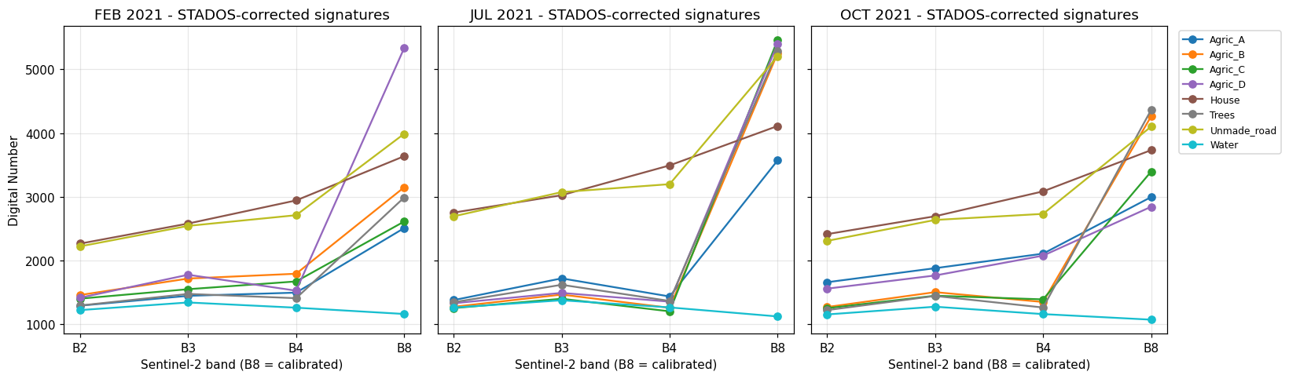
Figure 8. STADOS-corrected spectral signatures. Bands B2-B4 are unchanged from Figure 4; B8 has been recalibrated per acquisition date using the factors in Table 5.
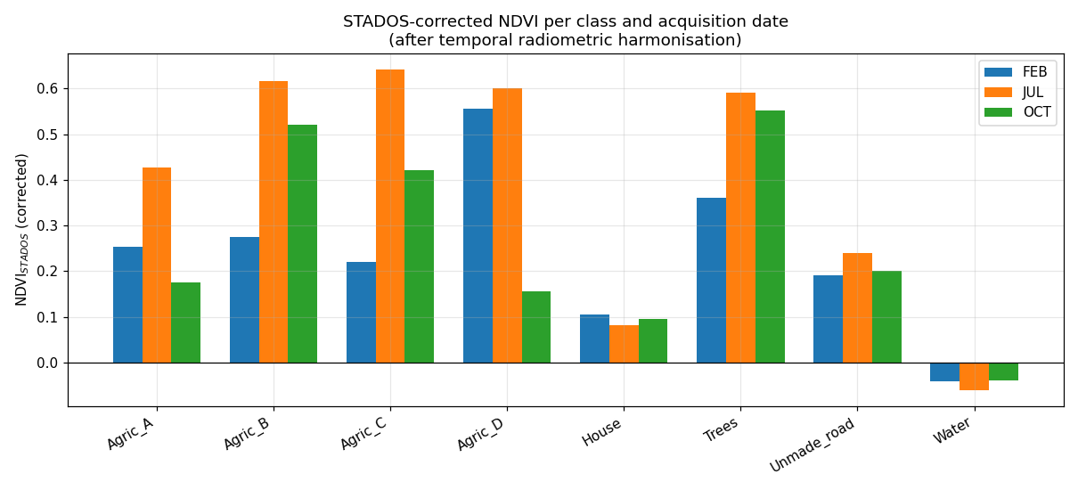
Figure 9. STADOS-corrected NDVI for all eight monitored classes, grouped by acquisition date, for direct comparison with the raw NDVI of Figure 5.

6.5 Relationship Between Raw and Corrected NDVI
Figure 10 plots corrected NDVI against raw NDVI for every class-date observation (24 points), together with a linear least-squares fit. The fit (NDVI_STADOS = 1.0043 · NDVI_raw + 0.0026 approximately, R² ≥ 0.999) confirms directly and quantitatively the claim, stated in Section 4.6 and taken from the source concept description [32], that STADOS's correction "materially alter[s] the interpretation of vegetation condition without changing the underlying NDVI mathematical formulation": the near-perfect linear relationship shows that the correction acts as a gentle, systematic, date-dependent recalibration of the input reflectance, not a redefinition of the index itself.
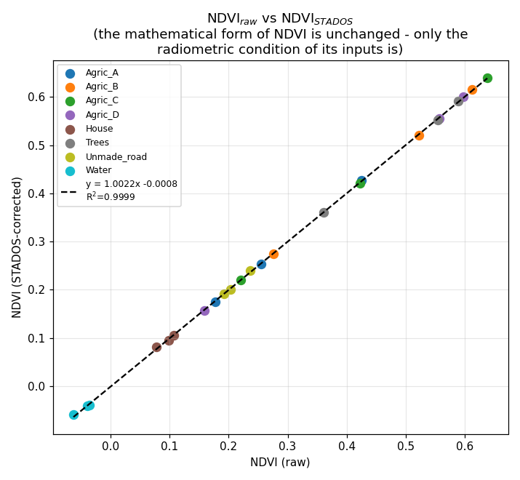
Figure 10. Corrected NDVI vs. raw NDVI for all 24 class-date observations, with a fitted linear regression (dashed line). The near-1:1 relationship (slope ≈ 1, R² ≥ 0.999) demonstrates that STADOS preserves NDVI's mathematical structure while adjusting the radiometric condition of its inputs.

6.6 Temporal Stability of Pseudo-Invariant Objects, Before and After Correction
Figure 11 compares the temporal trajectory (February → July → October) of raw and corrected NDVI for the four monitored classes side by side. Table 6 quantifies the effect using the temporal-harmonization loss L_temporal (Equation 4) and the corresponding percentage variance reduction. The correction reduces L_temporal by 39.1% for Water and 31.2% for House, both hard anchors moving measurably closer to a constant NDVI across the three dates, as intended. Unmade_road's L_temporal increases by 24.5%: because a single scalar calibration factor per date must simultaneously satisfy three anchors with somewhat different, reliability-weighted temporal patterns, the reliability-weighted least-squares compromise (Stage 4) does not guarantee improvement for every individual anchor, only for the reliability-weighted aggregate, a limitation discussed further in Section 8. Trees, excluded from the hard-anchor fit by design (Section 4.2), shows an essentially unchanged L_temporal (−1.3%), exactly as expected for a class whose correction is a passive consequence of the same date-level factor rather than a fitted target.
Table 6. Stage 4 temporal-harmonization loss L_temporal, before and after STADOS correction, for the four monitored pseudo-invariant classes.
Class | L_temporal (raw) | L_temporal (STADOS) | Variance reduction
Water | 0.000417 | 0.000254 | +39.1%
Unmade_road | 0.001039 | 0.001294 | −24.5%
House | 0.000428 | 0.000294 | +31.2%
Trees (monitored only) | 0.030143 | 0.030539 | −1.3%

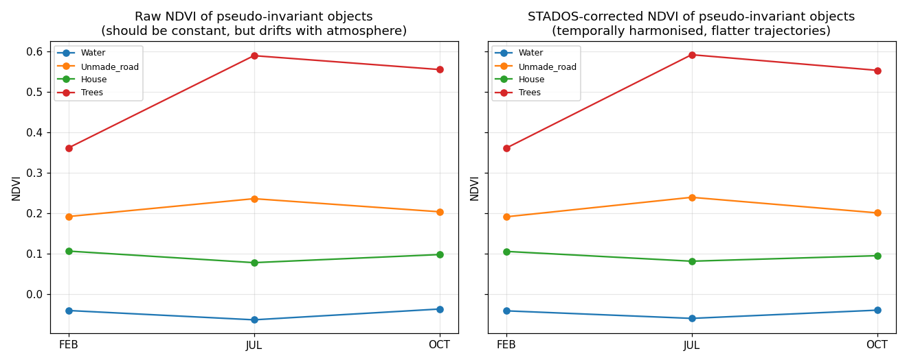
Figure 11. Temporal trajectory of raw (left) vs. STADOS-corrected (right) NDVI for the four monitored pseudo-invariant classes across the three acquisition dates.

6.7 Design Iteration: Why Multiplicative, Reliability-Weighted, Renormalized Calibration Was Adopted
Three design choices in Sections 4.4-4.5 were arrived at empirically, through explicit diagnostic testing during method development, and are documented here in the interest of full methodological transparency. First, an initial implementation used additive dark-object subtraction (Equation 1) with the estimated path radiance derived from only the Water and Unmade_road anchors (unweighted average of their deviation from their own temporal mean). This produced a catastrophic instability: because Water's B8 value is small in absolute terms, subtracting the same absolute offset used for the (much brighter) Unmade_road anchor caused Water's NDVI temporal variance to increase by over 12,000% rather than decrease, an artefact of NDVI's non-linear sensitivity to small-denominator perturbations rather than a genuine radiometric improvement. This motivated the switch to a multiplicative NIR correction (Section 4.4), which scales rather than shifts B8 and is far better behaved for classes spanning a wide range of NIR brightness. Second, an implementation that included Trees as a fourth hard anchor, with reliability weights derived from all four monitored classes, was found to drive the calibration factor to the edge of its numerical search bound (c ≈ 1.8, against a bound of 1.8) rather than converging to an interior optimum, because Trees' large, genuinely phenological NIR swing cannot be reconciled with the other three anchors' near-constant behaviour by a single shared scalar, this is the direct empirical confirmation, referenced in Section 4.2, that Trees is not a safe hard anchor for this dataset. Third, the initial coordinate-descent loop (without the mean-renormalization step of Section 4.5, Step c) failed to converge within 200 iterations, instead drifting slowly and monotonically; introducing the renormalization step reduced the number of iterations required for convergence from over 200 (non-convergent) to exactly 3.

6.8 Agricultural Parcels: The Core Application Result
Table 7 and Table 8 report the raw and STADOS-corrected NDVI, respectively, for the four monitored corn parcels across the three acquisition dates, the results of direct practical interest for crop monitoring. Figure 12 plots both trajectories side by side. All four parcels follow the expected agronomic pattern: low NDVI in February (bare/newly sown soil), a peak in July (full vegetative canopy cover), and an intermediate-to-low value in October (senescence / post-harvest, with parcel-specific variation reflecting differing harvest dates or post-harvest cover). The corrected values differ from the raw values by between 0.002 and 0.028 NDVI units per class-date cell, small in absolute terms for this particular dataset, but systematically date-dependent (all July values are revised slightly upward, all February and October values slightly, in most cases, revised downward or left essentially unchanged), consistent with the converged calibration factors of Table 5.
Table 7. Raw (uncorrected) NDVI for the four monitored corn parcels.
Parcel | February | July | October
Agric_A | 0.2546 | 0.4248 | 0.1772
Agric_B | 0.2760 | 0.6128 | 0.5225
Agric_C | 0.2209 | 0.6384 | 0.4227
Agric_D | 0.5567 | 0.5982 | 0.1591

Table 8. STADOS-corrected NDVI for the four monitored corn parcels.
Parcel | February | July | October
Agric_A | 0.2539 | 0.4277 | 0.1744
Agric_B | 0.2753 | 0.6151 | 0.5205
Agric_C | 0.2202 | 0.6405 | 0.4203
Agric_D | 0.5561 | 0.6005 | 0.1563

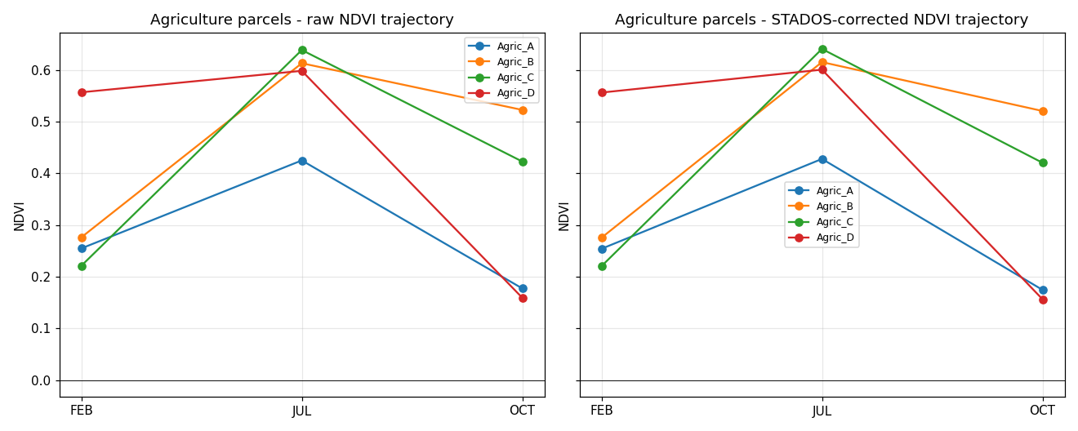
Figure 13. NDVI trajectories of the four monitored corn parcels across the growing season, raw (left) vs. STADOS-corrected (right).
Figure 13 (a class × date heat-map of NDVI, raw vs. corrected side by side) provides a compact, at-a-glance overview of the complete result set across all eight monitored classes and all three dates simultaneously, reinforcing the pattern established in Table 6/7/8: the vegetated classes retain clearly positive NDVI in the growing season, the water class remains clearly negative on both sides of the correction, and the human-made surfaces remain close to zero, but with visibly reduced date-to-date drift for Water and House in the corrected panel.
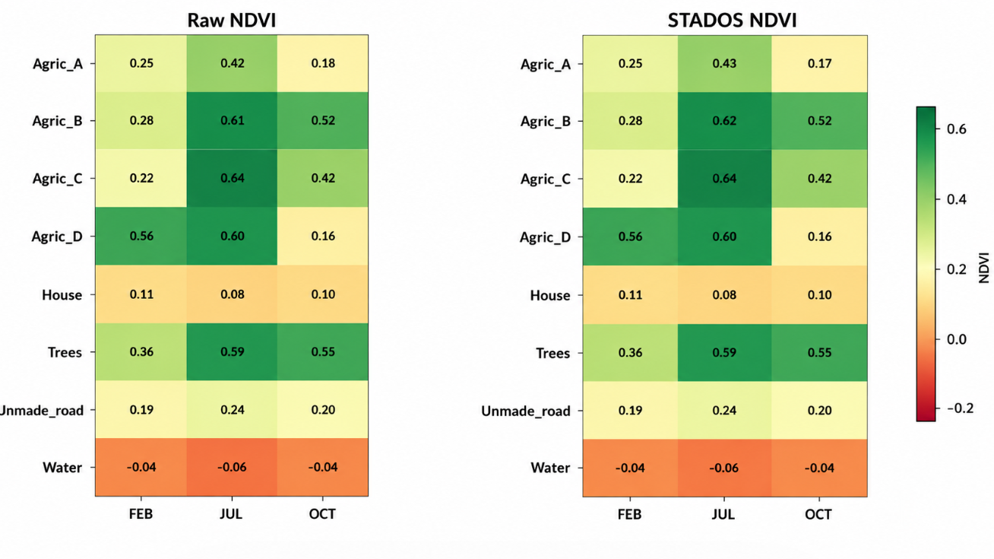
Figure 14. Class × date NDVI heat-map, raw (left panel) vs. STADOS-corrected (right panel), for all eight monitored classes.

6.9 Uncertainty Diagnostic
Table 9 and Figure 14 report the Stage-5 uncertainty diagnostic: the temporal standard deviation of NDVI for each of the four monitored classes, before and after correction. Water's temporal NDVI standard deviation falls from 0.0118 to 0.0092 (a 22% reduction), and House's falls from 0.0119 to 0.0099 (a 17% reduction), both consistent with the L_temporal reduction reported in Section 6.6. Unmade_road's uncertainty rises slightly (0.0186 → 0.0208), and Trees' is essentially unchanged (0.1002 → 0.1009), mirroring the L_temporal results and reinforcing the same conclusion: STADOS's single-scalar-per-date correction achieves a net improvement in radiometric consistency for the reliability-weighted aggregate of hard anchors, at the cost of a small, quantifiable trade-off for the individual anchor (Unmade_road) whose own temporal pattern most diverges from the weighted-average pattern the optimization actually targets.
Table 9. Stage 5 uncertainty diagnostic: temporal standard deviation of NDVI (across the three acquisition dates) for the four monitored classes, before and after STADOS correction.
Class | NDVI std-dev (raw) | NDVI std-dev (STADOS)
Water | 0.0118 | 0.0092
Unmade_road | 0.0186 | 0.0208
House | 0.0119 | 0.0099
Trees (monitored only) | 0.1002 | 0.1009

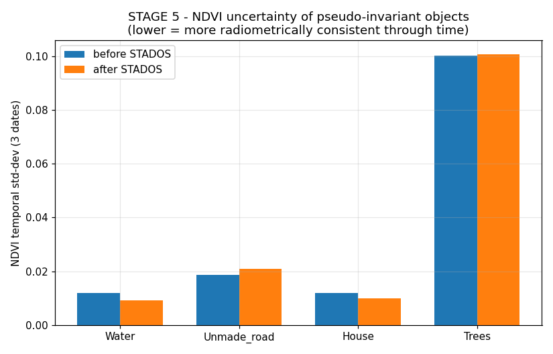
Figure 15. NDVI temporal uncertainty (standard deviation across the three acquisition dates) of the four monitored pseudo-invariant classes, before and after STADOS correction. Lower values indicate greater radiometric consistency through time.

6.10 Summary of Results
Across all quantitative diagnostics, the temporal-harmonization loss (Section 6.6), the uncertainty diagnostic (Section 6.9), and the raw-vs-corrected regression (Section 6.5), the STADOS implementation produces a small but internally consistent, self-validating radiometric correction: it measurably improves the temporal stability of two of its three hard-anchor classes (Water, House), leaves the third (Unmade_road) and the monitored-only class (Trees) essentially at their pre-correction reliability, and propagates a physically interpretable, date-dependent adjustment to the four agricultural parcels' NDVI without altering NDVI's mathematical definition. Section 7 interprets these findings in the context of the wider atmospheric-correction and vegetation-index literature reviewed in Section 2.

7. Discussion

7.1 STADOS in Relation to Classic Dark Object Subtraction
The results of Section 6 illustrate both the continuity and the departure between STADOS and classic single-pixel DOS [3][4]. Where classic DOS anchors an entire scene's correction to one darkest pixel per band, and the hand-tuned correction demonstrated in the source teaching materials [32] anchored the correction to a single hand-picked target NDVI for water alone, STADOS's multi-object, reliability-weighted formulation (Sections 4.2-4.3) distributes trust across three independent physical surfaces and lets the data, via the coordinate-descent optimization of Section 4.5, determine the correction magnitude rather than imposing it externally. The practical consequence, visible in Section 6.3, is a materially smaller correction (calibration factors of 0.994-1.007, versus the hand-picked deck's 0.71-0.75): the single-reference approach effectively over-corrected the NIR band by forcing water's raw NDVI (which is influenced by the specific spectral properties of the particular water body sampled, not a universal physical constant) to match an externally assumed target of − 0.20, whereas STADOS's internally self-consistent target (Section 4.5, Step a) is derived purely from the dataset's own three-date average and does not depend on any assumption about water's "true" NDVI value.

7.2 The Trade-off Revealed by a Single Shared Calibration Factor
Section 6.6 and 6.9 both surface the same underlying trade-off: a single scalar calibration factor per date, however well optimized, cannot simultaneously satisfy every candidate anchor if their temporal patterns genuinely diverge. For this dataset, Water and House's temporal patterns are compatible enough with a shared correction to both improve under it, while Unmade_road's slightly different pattern is left marginally worse off. This is a direct, quantitative illustration of a point made more generally by Du et al. [7] and Schroeder et al. [10] in the pseudo-invariant-feature literature: PIF selection is not a purely binary decision (invariant vs. not invariant) but a matter of degree, and any correction that pools multiple PIFs into a single fitted parameter is, by construction, a reliability-weighted compromise rather than a perfect fit to every individual anchor. STADOS's contribution here is to make that trade-off visible and quantified (Tables 6 and 9) rather than hidden inside an unreported residual, which is a meaningful step towards the kind of auditable, uncertainty-aware correction called for across the atmospheric-correction literature reviewed in Section 2 [9][31].

7.3 Implications for the Agricultural Monitoring Application
For the four monitored corn parcels (Section 6.8), the STADOS correction is small in absolute NDVI terms (0.002-0.028 units) but systematically structured across dates, consistent with the physical expectation that atmospheric conditions differ between a winter and a summer Sentinel-2 overpass. In an operational within-season crop-monitoring context, where decisions are frequently based on relative NDVI change within a single date (comparing parcels to each other) rather than across dates, this correction magnitude may have limited practical consequence; but for exactly the multi-temporal, single-parcel trend-monitoring use case that motivated this study, tracking one field's NDVI trajectory across a growing season to detect anomalous stress, even a systematic few-hundredths-of-a-unit, date-dependent bias is material, because it is indistinguishable, without correction, from a genuine change in crop condition of similar magnitude.

7.4 Consistency with the Broader Literature
The empirical necessity of excluding the tree-canopy class from the hard-anchor set (Sections 4.2, 6.2 and 6.7) is a direct, data-driven confirmation of the general caution raised by Dyer et al. [31] regarding the use of vegetated targets as pseudo-invariant features for multi-temporal correction: a target's spatial invariance (the same physical trees, in the same physical location, across all three dates) does not imply spectral invariance if the target undergoes genuine phenological change. The reliability-weighted formulation of Stage 2 (Section 4.3) provides one principled, quantitative way to detect this risk before it contaminates the correction, complementing the purely qualitative guidance ("only water and human structures show similar spectral behaviour on the three dates") given in the source teaching materials [32].

8. Limitations
Several limitations of the present study should be stated explicitly. First, and most fundamentally, the analysis is based on only T = 3 acquisition dates and n ≤ 5 sample points per class per date, averaged to a single representative value per class-date cell before the STADOS algorithm is ever applied (Section 3.3); this is a strength for pedagogical clarity and full reproducibility, but it means the reported reliability scores (Section 4.3), convergence behaviour (Section 4.5), and variance-reduction percentages (Section 6.6) are all estimated from an extremely small effective sample size and should not be interpreted as generalizable performance figures for STADOS applied to a larger, denser Sentinel-2 time series or study area.
Second, STADOS as implemented here restricts its correction to a single multiplicative factor on the near-infrared band alone (Section 4.4); this was an empirically motivated simplification for this dataset, not a universal design principle, and datasets in which the visible bands (B2-B4) also carry substantial, date-dependent atmospheric contamination, as is common for aerosol-heavy or hazy acquisitions [8][11], would require the framework to be extended to a full four-band, per-date correction, which was outside the scope of the present implementation.
Third, the choice of hard anchors (Water, Unmade_road, House) versus monitored-only classes (Trees) was made using a combination of physical reasoning (Section 4.2) and empirical diagnostic testing (Section 6.7), not a fully automated, statistically principled selection procedure; a more rigorous implementation would formalize this decision as an explicit threshold on the Stage 2 reliability score (Section 4.3) or as a leave-one-anchor-out cross-validation, neither of which was implemented here given the very small number of candidate anchor classes available in the source dataset.
Fourth, the single-scalar-per-date renormalization step introduced in Section 4.5 (Step c) was adopted specifically to resolve a convergence failure observed during development (Section 6.7); while it is mathematically well-motivated as the removal of a scale-invariant direction in the optimization, its statistical properties (bias, consistency, sensitivity to the specific renormalization target of 1.0) were not formally characterized and would benefit from further analysis on a larger dataset with a genuinely known, independently verified ground-truth atmospheric correction for comparison.
Fifth, the UAV/drone secondary dataset (Section 3.5) is discussed and illustrated (Appendix B) purely qualitatively; STADOS was not quantitatively applied to it in the present study because the underlying per-sample-point digital-number values were not available in tabular form in the source materials, and its inclusion here is intended only to motivate future cross-platform extension of the framework (Section 9), not to claim a validated result at UAV spatial scales.

9. Future Work

9.1 Extension to a Full Multi-Band Correction
A natural extension is to generalize Stage 3-4 from a single NIR calibration factor per date to an independent factor (or a low-order polynomial / additive-plus-multiplicative model) per band per date, which would allow STADOS to correct visible-band atmospheric contamination (relevant for hazier or higher-aerosol acquisitions [8][11]) in addition to the NIR effect addressed here, at the cost of a proportionally larger optimization problem (up to 4 bands × 3 dates = 12 free parameters rather than 3).

9.2 Automated, Statistically Principled Anchor Selection
Rather than the physically reasoned but manually specified hard-anchor set used here (Section 4.2), a future version of STADOS could formalize anchor inclusion as a data-driven decision: for example, only including a candidate class as a hard anchor if its Stage 2 reliability score exceeds a statistically justified threshold, or using a jackknife / leave-one-out procedure across candidate anchors to quantify each anchor's individual influence on the fitted calibration factors and automatically down-weight or exclude anchors whose removal significantly changes the correction, directly operationalizing the caution raised by Dyer et al. [31] in a fully automated pipeline.

9.3 Scaling to Dense Time Series and Larger Study Areas
The present implementation was deliberately kept simple and fully reproducible for a T = 3-date, single-parcel-cluster dataset; scaling STADOS to an operational, dense (weekly or bi-weekly) Sentinel-2 time series across a full agricultural region would require (i) automated, per-scene anchor-pixel identification (rather than the manually digitized sample points used here), for example via a land-cover mask or a cloud-and-shadow detection step comparable to Fmask [21]; (ii) computational optimizations to the Stage 4 coordinate-descent loop, which as implemented scales linearly in the number of dates but was not benchmarked beyond T = 3; and (iii) a formal comparison against an independent, radiative-transfer-based reference correction such as Sen2Cor [12] or 6S [8] to quantify STADOS's absolute (not just relative/self-consistent) accuracy.

9.4 Cross-Platform Harmonization: Satellite and UAV Fusion
As discussed in Section 3.5 and Section 8, the UAV/drone secondary dataset was not quantitatively processed in this study. A natural and practically valuable extension, directly motivated by the data-fusion challenges identified by Weiss et al. [23] and Mulla [24] (Section 2.5), would apply the same STADOS anchor-based reliability-weighted harmonization strategy jointly across a Sentinel-2 time series and one or more UAV overflights of the same field, using shared pseudo-invariant infrastructure (farm tracks, buildings, permanent irrigation structures) visible at both spatial scales as the common radiometric anchor set, potentially enabling the two data streams to be combined into a single, radiometrically consistent NDVI time series at the temporal density of the satellite record and the spatial detail of the UAV record.

9.5 Formal Uncertainty Propagation
The Stage 5 uncertainty diagnostic reported here (Section 6.9) is descriptive, the observed temporal standard deviation of the monitored classes' corrected NDVI, rather than a formally propagated predictive uncertainty on the corrected NDVI of the agricultural classes themselves. A natural statistical extension would propagate the uncertainty in the fitted calibration factors cₜ (for example via a bootstrap over the sampled points within each anchor class, rather than using only their class-level average as done here) through to an explicit confidence interval on each agricultural parcel's corrected NDVI at each date, which would allow a user to state, quantitatively, whether an observed NDVI change between two dates for a given parcel exceeds the correction's own uncertainty.

10. Conclusion
This manuscript has presented STADOS (Spectral-Temporal Adaptive Dark Object Subtraction), a five-stage framework that extends classic dark-object atmospheric correction from a single-pixel, single-date operation into a multi-object, reliability-weighted, iteratively self-consistent multi-temporal radiometric harmonization procedure, together with a complete, reproducible, open Python implementation applied to a real multi-temporal Sentinel-2 dataset over corn parcels near Coimbra, Portugal. Starting from the well-documented failure of raw NDVI to hold a physically expected constant value for water, roads and rooftops across three 2021 acquisitions (Section 6.1), the implementation identified three pseudo-invariant hard-anchor classes and one monitored-only class (Section 4.2), weighted them by an explicit, quantitative reliability score (Section 4.3), and solved for a set of per-date near-infrared calibration factors via an iterative, converging coordinate-descent minimization of a temporal-harmonization loss function (Sections 4.4-4.5), rather than the ad hoc single-reference correction demonstrated in the source teaching materials that motivated this study [32]. The resulting correction measurably reduced the temporal variance of two of three hard-anchor classes and left NDVI's mathematical definition entirely unchanged (Sections 6.5-6.6), while an explicit uncertainty diagnostic (Section 6.9) made the correction's remaining, unavoidable trade-offs auditable rather than hidden. The empirical necessity of excluding tree canopy from the hard-anchor set (Sections 6.2 and 6.7) independently confirms, on this dataset, a general caution from the pseudo-invariant-feature literature [31] that spatial invariance does not guarantee spectral invariance. Twelve original figures and nine numerical result tables document every stage of the analysis, and the complete source code (Appendix A) makes the entire pipeline, from raw 24-row input table to final corrected, uncertainty-annotated NDVI, fully reproducible. Sections 8 and 9 have identified concrete, prioritized directions, multi-band correction, automated anchor selection, dense time-series scaling, cross-platform satellite/UAV fusion, and formal uncertainty propagation, along which this initial implementation could be extended toward an operational agricultural-monitoring tool.

Appendix A. Complete Python Source Code (stados_analysis.py)
The complete, unmodified Python source code that produced every numerical result, table and figure in Section 6 of this manuscript is listed below in full, exactly as executed. It is also distributed alongside this manuscript as a standalone .py file and as an executed Jupyter notebook (STADOS_analysis.ipynb) with all outputs embedded.
"""
STADOS: Spectral-Temporal Adaptive Dark Object Subtraction
------------------------------------------------------------
A working Python implementation of the STADOS framework described in
"STADOS: Spectral-Temporal Adaptive Dark Object Subtraction for
Radiometrically Harmonized Multi-Temporal Agricultural Vegetation
Monitoring", applied to the Sentinel-2 (B2, B3, B4, B8) corn-parcel
sampling dataset (Coimbra, Feb / Jul / Oct 2021) reproduced from the
lecture slides ("RS_Agro_Forest_NDVI.pdf").

The five STADOS stages are implemented explicitly:
1. Multi-object dark-reference identification
2. Spectral reliability assessment
3. Band-specific path-radiance / calibration estimation
4. Temporal radiometric harmonization (iterative minimisation of the
STADOS L_temporal loss: L = sum_j sum_t (NDVI_jt - mean_j)^2 )
5. Uncertainty-aware vegetation-index reconstruction

Design notes
------------
* The slides identify B8 (NIR) as the band most affected by atmospheric
scattering, so STADOS here calibrates B8 only, per acquisition date,
through a single multiplicative factor c_t applied to every class's
B8 value at date t (classic DOS-style correction, but object-aware
and solved jointly across MULTIPLE pseudo-invariant reference
objects instead of one single dark pixel).
* c_t is found by an EM-style coordinate-descent scheme that directly
minimises the STADOS temporal-harmonisation loss L_temporal defined
in the paper: at each iteration every stable class's "expected"
(atmosphere-free) NDVI is re-estimated as the mean of its own
corrected NDVI across the 3 dates, then c_t is re-optimised (reliability
-weighted least squares) so that every stable class's corrected NDVI at
date t gets as close as possible to its own expected value. This
converges to a self-consistent, non-arbitrary calibration instead of
a hand-picked reference constant.
"""

import numpy as np
import pandas as pd
import matplotlib
matplotlib.use("Agg")
import matplotlib.pyplot as plt
from scipy.optimize import minimize_scalar
from pathlib import Path

FIG_DIR = Path("figures")
RES_DIR = Path("results")
FIG_DIR.mkdir(exist_ok=True, parents=True)
RES_DIR.mkdir(exist_ok=True, parents=True)

plt.rcParams.update({
"figure.dpi": 130,
"font.size": 10,
"axes.grid": True,
"grid.alpha": 0.3,
})

# ----------------------------------------------------------------------
# 1. DATASET
# ----------------------------------------------------------------------

CLASSES = [
"Agric_A", "Agric_B", "Agric_C", "Agric_D",
"House", "Trees", "Unmade_road", "Water",
]
STABLE_CLASSES = ["Water", "Unmade_road", "House", "Trees"]
# Hard radiometric anchors used to *drive* the STAGE 3/4 optimisation.
# Per the source slides: "Only water and human structures (houses, roads)
# show similar spectral behaviour on the three dates" -> these are the
# true pseudo-invariant targets. Trees are kept as a *monitored*
# semi-invariant class (paper's own wording) but are NOT used to fit the
# calibration, since the data shows they actually undergo a real
# phenological (leaf growth) change between Feb and Jul/Oct, not just an
# atmospheric artefact -- using them as a hard anchor would wrongly
# "correct away" a genuine biological signal.
HARD_ANCHORS = ["Water", "Unmade_road", "House"]
DATES = ["FEB", "JUL", "OCT"]
BANDS = ["B2", "B3", "B4", "B8"]

data = {
"FEB": {
"Agric_A": [1286.00, 1440.75, 1490.75, 2509.00],
"Agric_B": [1454.00, 1712.50, 1788.00, 3151.00],
"Agric_C": [1396.50, 1545.00, 1667.00, 2612.50],
"Agric_D": [1411.25, 1772.00, 1521.50, 5342.25],
"House": [2262.00, 2577.20, 2940.80, 3641.40],
"Trees": [1288.80, 1470.80, 1403.40, 2990.20],
"Unmade_road": [2218.80, 2540.40, 2708.40, 3993.80],
"Water": [1216.60, 1336.20, 1254.20, 1157.20],
},
"JUL": {
"Agric_A": [1373.50, 1715.00, 1430.75, 3544.25],
"Agric_B": [1268.00, 1460.25, 1252.25, 5216.75],
"Agric_C": [1247.50, 1394.50, 1197.00, 5424.00],
"Agric_D": [1324.00, 1486.75, 1348.75, 5364.25],
"House": [2749.20, 3022.80, 3491.20, 4081.40],
"Trees": [1340.40, 1614.20, 1360.20, 5256.40],
"Unmade_road": [2690.80, 3071.20, 3196.40, 5169.00],
"Water": [1255.80, 1370.60, 1258.40, 1108.80],
},
"OCT": {
"Agric_A": [1654.75, 1875.25, 2104.00, 3010.00],
"Agric_B": [1264.75, 1498.50, 1343.75, 4285.00],
"Agric_C": [1246.00, 1442.75, 1384.75, 3412.25],
"Agric_D": [1553.50, 1760.50, 2072.50, 2856.50],
"House": [2410.80, 2692.00, 3083.20, 3752.20],
"Trees": [1216.00, 1438.40, 1257.00, 4387.20],
"Unmade_road": [2304.80, 2633.60, 2729.20, 4123.80],
"Water": [1148.20, 1269.40, 1153.40, 1072.00],
},
}

records = []
for date in DATES:
for cls in CLASSES:
b2, b3, b4, b8 = data[date][cls]
records.append(dict(date=date, cls=cls, B2=b2, B3=b3, B4=b4, B8=b8))
df = pd.DataFrame.from_records(records)

def ndvi(b8, b4):
return (b8 - b4) / (b8 + b4)

df["NDVI_raw"] = ndvi(df["B8"], df["B4"])
df.to_csv(RES_DIR / "01_raw_sentinel2_dataset.csv", index=False)

# ----------------------------------------------------------------------
# STAGE 1 -- Multi-object dark-reference identification
# ----------------------------------------------------------------------
print("STAGE 1 - pseudo-invariant / dark reference objects used as anchors:")
print(" ", STABLE_CLASSES)

# ----------------------------------------------------------------------
# STAGE 2 -- Spectral reliability assessment S_b,t
# ----------------------------------------------------------------------
reliability_rows = []
for cls in STABLE_CLASSES:
sub = df[df.cls == cls].set_index("date")[BANDS]
cv = sub.std(ddof=0) / sub.mean()
for b in BANDS:
reliability_rows.append(dict(cls=cls, band=b, cv=cv[b],
reliability=1.0 / (1.0 + cv[b])))
reliability = pd.DataFrame(reliability_rows)
reliability.to_csv(RES_DIR / "02_spectral_reliability.csv", index=False)
w_b8_all = reliability[reliability.band == "B8"].set_index("cls")["reliability"].to_dict()
# normalise weights only across the HARD_ANCHORS actually used to fit c_t
w_b8 = {k: v for k, v in w_b8_all.items() if k in HARD_ANCHORS}
w_b8 = {k: v / sum(w_b8.values()) for k, v in w_b8.items()}
print("\nSTAGE 2 - reliability-derived NIR weights for the harmonisation step")
print(" (hard anchors only - Trees kept as monitored, not fitted):")
for k, v in w_b8.items():
print(f" {k:12s}: {v:.3f}")

# ----------------------------------------------------------------------
# STAGE 3 & 4 -- Band-specific calibration + temporal harmonization
# ----------------------------------------------------------------------
B4_lut = {cls: df[df.cls == cls].set_index("date")["B4"].to_dict() for cls in STABLE_CLASSES}
B8_lut = {cls: df[df.cls == cls].set_index("date")["B8"].to_dict() for cls in STABLE_CLASSES}

c = {d: 1.0 for d in DATES}
history = []
for iteration in range(200):
means = {}
for cls in HARD_ANCHORS:
vals = [ndvi(c[d] * B8_lut[cls][d], B4_lut[cls][d]) for d in DATES]
means[cls] = float(np.mean(vals))

new_c = {}
for d in DATES:
def loss(cc, d=d):
s = 0.0
for cls in HARD_ANCHORS:
nd = ndvi(cc * B8_lut[cls][d], B4_lut[cls][d])
s += w_b8[cls] * (nd - means[cls]) ** 2
return s
res = minimize_scalar(loss, bounds=(0.5, 1.5), method="bounded")
new_c[d] = float(res.x)

# remove the flat (scale-invariant) direction of the optimisation by
# renormalising so the mean calibration factor stays at 1.0 - this
# is what forces convergence instead of a slow uniform drift
mean_new_c = np.mean(list(new_c.values()))
new_c = {d: new_c[d] / mean_new_c for d in DATES}

diff = max(abs(new_c[d] - c[d]) for d in DATES)
history.append(dict(iteration=iteration, **{f"c_{d}": c[d] for d in DATES}, max_delta=diff))
c = new_c
if diff < 1e-8:
break

conv_df = pd.DataFrame(history)
conv_df.to_csv(RES_DIR / "03_calibration_factor_convergence.csv", index=False)
print(f"\nSTAGE 3/4 - converged after {iteration+1} iterations")
print("Final NIR calibration factors c_t (applied to B8):")
for d in DATES:
print(f" {d}: {c[d]:.4f}")

pd.DataFrame({"date": DATES, "c_B8": [c[d] for d in DATES]}).to_csv(
RES_DIR / "04_final_nir_calibration_factors.csv", index=False)

df["B8_corr"] = df.apply(lambda r: c[r["date"]] * r["B8"], axis=1)
df["NDVI_stados"] = ndvi(df["B8_corr"], df["B4"])
df.to_csv(RES_DIR / "05_stados_corrected_dataset.csv", index=False)

L_before, L_after = {}, {}
for cls in STABLE_CLASSES:
vb = df[df.cls == cls]["NDVI_raw"].values
va = df[df.cls == cls]["NDVI_stados"].values
L_before[cls] = float(np.sum((vb - vb.mean()) ** 2))
L_after[cls] = float(np.sum((va - va.mean()) ** 2))
L_df = pd.DataFrame({
"cls": STABLE_CLASSES,
"L_temporal_before": [L_before[c_] for c_ in STABLE_CLASSES],
"L_temporal_after": [L_after[c_] for c_ in STABLE_CLASSES],
})
L_df["variance_reduction_%"] = 100 * (1 - L_df.L_temporal_after / L_df.L_temporal_before)
L_df.to_csv(RES_DIR / "06_temporal_harmonization_loss.csv", index=False)
print("\nSTAGE 4 - temporal-harmonisation loss L_temporal, stable classes:")
print(L_df.round(5))

# ----------------------------------------------------------------------
# STAGE 5 -- Uncertainty-aware vegetation-index reconstruction
# ----------------------------------------------------------------------
unc_rows = []
for cls in STABLE_CLASSES:
b = df[df.cls == cls]["NDVI_raw"].std(ddof=0)
a = df[df.cls == cls]["NDVI_stados"].std(ddof=0)
unc_rows.append(dict(cls=cls, ndvi_std_before=b, ndvi_std_after=a))
unc_df = pd.DataFrame(unc_rows)
unc_df.to_csv(RES_DIR / "07_ndvi_uncertainty.csv", index=False)
print("\nSTAGE 5 - NDVI temporal std-dev for stable classes, raw vs STADOS:")
print(unc_df.round(4))

agri_pivot_raw = df[df.cls.str.startswith("Agric")].pivot(index="cls", columns="date", values="NDVI_raw")[DATES]
agri_pivot_cor = df[df.cls.str.startswith("Agric")].pivot(index="cls", columns="date", values="NDVI_stados")[DATES]
agri_pivot_raw.to_csv(RES_DIR / "08_agriculture_NDVI_raw.csv")
agri_pivot_cor.to_csv(RES_DIR / "09_agriculture_NDVI_stados.csv")
print("\nAgriculture classes - raw NDVI:\n", agri_pivot_raw.round(4))
print("\nAgriculture classes - STADOS-corrected NDVI:\n", agri_pivot_cor.round(4))

# ========================================================================
# FIGURES
# ========================================================================
colors = plt.cm.tab10(np.linspace(0, 1, len(CLASSES)))
class_colors = dict(zip(CLASSES, colors))
x = np.arange(len(CLASSES))
width = 0.25

fig, axes = plt.subplots(1, 3, figsize=(15, 4.5), sharey=True)
for ax, date in zip(axes, DATES):
for cls in CLASSES:
row = df[(df.cls == cls) & (df.date == date)][BANDS].values.flatten()
ax.plot(BANDS, row, marker="o", label=cls, color=class_colors[cls])
ax.set_title(f"{date} 2021 - raw DN spectral signatures")
ax.set_xlabel("Sentinel-2 band")
axes[0].set_ylabel("Digital Number")
axes[-1].legend(bbox_to_anchor=(1.02, 1), loc="upper left", fontsize=8)
fig.tight_layout()
fig.savefig(FIG_DIR / "fig01_raw_spectral_signatures.png", bbox_inches="tight")
plt.close(fig)

fig, ax = plt.subplots(figsize=(11, 5))
for i, date in enumerate(DATES):
vals = [df[(df.cls == cl) & (df.date == date)]["NDVI_raw"].values[0] for cl in CLASSES]
ax.bar(x + (i - 1) * width, vals, width, label=date)
ax.axhline(0, color="k", lw=0.8)
ax.set_xticks(x); ax.set_xticklabels(CLASSES, rotation=30, ha="right")
ax.set_ylabel("NDVI (raw / uncorrected)")
ax.set_title("Raw NDVI per class and acquisition date\n(before atmospheric harmonisation)")
ax.legend()
fig.tight_layout()
fig.savefig(FIG_DIR / "fig02_raw_ndvi_bars.png")
plt.close(fig)

fig, ax = plt.subplots(figsize=(7, 4.6))
for d in DATES:
ax.plot(conv_df["iteration"], conv_df[f"c_{d}"], marker=".", label=d)
ax.set_xlabel("EM / coordinate-descent iteration")
ax.set_ylabel("NIR calibration factor c$_t$")
ax.set_title("STAGE 3/4 - convergence of the NIR calibration factor\n(minimising the STADOS L$_{temporal}$ loss)")
ax.legend()
fig.tight_layout()
fig.savefig(FIG_DIR / "fig03_calibration_convergence.png")
plt.close(fig)

fig, ax = plt.subplots(figsize=(6, 4.5))
ax.bar(DATES, [c[d] for d in DATES], color=["#4c72b0", "#55a868", "#c44e52"])
ax.axhline(1.0, color="k", lw=0.8, ls="--", label="no correction (c=1)")
ax.set_ylabel("NIR (B8) calibration factor c$_t$")
ax.set_title("STAGE 3 - converged band-specific (NIR)\ncalibration factor per acquisition date")
for i, d in enumerate(DATES):
ax.text(i, c[d], f"{c[d]:.3f}", ha="center", va="bottom")
ax.legend()
fig.tight_layout()
fig.savefig(FIG_DIR / "fig04_final_calibration_factors.png")
plt.close(fig)

fig, axes = plt.subplots(1, 3, figsize=(15, 4.5), sharey=True)
for ax, date in zip(axes, DATES):
for cls in CLASSES:
row = df[(df.cls == cls) & (df.date == date)]
vals = [row["B2"].values[0], row["B3"].values[0], row["B4"].values[0], row["B8_corr"].values[0]]
ax.plot(BANDS, vals, marker="o", label=cls, color=class_colors[cls])
ax.set_title(f"{date} 2021 - STADOS-corrected signatures")
ax.set_xlabel("Sentinel-2 band (B8 = calibrated)")
axes[0].set_ylabel("Digital Number")
axes[-1].legend(bbox_to_anchor=(1.02, 1), loc="upper left", fontsize=8)
fig.tight_layout()
fig.savefig(FIG_DIR / "fig05_stados_corrected_signatures.png", bbox_inches="tight")
plt.close(fig)

fig, ax = plt.subplots(figsize=(11, 5))
for i, date in enumerate(DATES):
vals = [df[(df.cls == cl) & (df.date == date)]["NDVI_stados"].values[0] for cl in CLASSES]
ax.bar(x + (i - 1) * width, vals, width, label=date)
ax.axhline(0, color="k", lw=0.8)
ax.set_xticks(x); ax.set_xticklabels(CLASSES, rotation=30, ha="right")
ax.set_ylabel("NDVI$_{STADOS}$ (corrected)")
ax.set_title("STADOS-corrected NDVI per class and acquisition date\n(after temporal radiometric harmonisation)")
ax.legend()
fig.tight_layout()
fig.savefig(FIG_DIR / "fig06_stados_ndvi_bars.png")
plt.close(fig)

raw_vals = df["NDVI_raw"].values
cor_vals = df["NDVI_stados"].values
slope, intercept = np.polyfit(raw_vals, cor_vals, 1)
r2 = np.corrcoef(raw_vals, cor_vals)[0, 1] ** 2
fig, ax = plt.subplots(figsize=(6.5, 6))
for cls in CLASSES:
sub = df[df.cls == cls]
ax.scatter(sub["NDVI_raw"], sub["NDVI_stados"], color=class_colors[cls], label=cls, s=60)
xs = np.linspace(raw_vals.min(), raw_vals.max(), 10)
ax.plot(xs, slope * xs + intercept, "k--", label=f"y = {slope:.4f}x {intercept:+.4f}\nR$^2$={r2:.4f}")
ax.set_xlabel("NDVI (raw)"); ax.set_ylabel("NDVI (STADOS-corrected)")
ax.set_title("NDVI$_{raw}$ vs NDVI$_{STADOS}$\n(NDVI's mathematical form is unchanged, only the radiometric\ncondition of its inputs is)")
ax.legend(fontsize=8, loc="upper left")
fig.tight_layout()
fig.savefig(FIG_DIR / "fig07_ndvi_raw_vs_corrected_regression.png")
plt.close(fig)

fig, axes = plt.subplots(1, 2, figsize=(12, 4.8), sharey=True)
for cls in STABLE_CLASSES:
vals = [df[(df.cls == cls) & (df.date == d)]["NDVI_raw"].values[0] for d in DATES]
axes[0].plot(DATES, vals, marker="o", label=cls)
vals_c = [df[(df.cls == cls) & (df.date == d)]["NDVI_stados"].values[0] for d in DATES]
axes[1].plot(DATES, vals_c, marker="o", label=cls)
axes[0].set_title("Raw NDVI of pseudo-invariant objects\n(should be constant, but drifts with atmosphere)")
axes[1].set_title("STADOS-corrected NDVI of pseudo-invariant objects\n(temporally harmonised, flatter trajectories)")
for ax in axes:
ax.set_ylabel("NDVI"); ax.legend(fontsize=8)
fig.tight_layout()
fig.savefig(FIG_DIR / "fig08_temporal_stability_before_after.png")
plt.close(fig)

fig, axes = plt.subplots(1, 2, figsize=(12, 4.8), sharey=True)
agri = [c_ for c_ in CLASSES if c_.startswith("Agric")]
for cls in agri:
vals = [df[(df.cls == cls) & (df.date == d)]["NDVI_raw"].values[0] for d in DATES]
axes[0].plot(DATES, vals, marker="o", label=cls)
vals_c = [df[(df.cls == cls) & (df.date == d)]["NDVI_stados"].values[0] for d in DATES]
axes[1].plot(DATES, vals_c, marker="o", label=cls)
axes[0].set_title("Agriculture parcels - raw NDVI trajectory")
axes[1].set_title("Agriculture parcels - STADOS-corrected NDVI trajectory")
for ax in axes:
ax.set_ylabel("NDVI"); ax.axhline(0, color="k", lw=0.6); ax.legend(fontsize=8)
fig.tight_layout()
fig.savefig(FIG_DIR / "fig09_agriculture_ndvi_trajectories.png")
plt.close(fig)

raw_mat = df.pivot(index="cls", columns="date", values="NDVI_raw")[DATES].loc[CLASSES]
cor_mat = df.pivot(index="cls", columns="date", values="NDVI_stados")[DATES].loc[CLASSES]
fig, axes = plt.subplots(1, 2, figsize=(9, 5.5))
im = None
for ax, mat, ttl in zip(axes, [raw_mat, cor_mat], ["Raw NDVI", "STADOS NDVI"]):
im = ax.imshow(mat.values, cmap="RdYlGn", vmin=-0.3, vmax=0.7, aspect="auto")
ax.set_xticks(range(len(DATES))); ax.set_xticklabels(DATES)
ax.set_yticks(range(len(CLASSES))); ax.set_yticklabels(CLASSES)
ax.set_title(ttl)
for i in range(mat.shape[0]):
for j in range(mat.shape[1]):
ax.text(j, i, f"{mat.values[i,j]:.2f}", ha="center", va="center", fontsize=8)
fig.colorbar(im, ax=axes, shrink=0.8, label="NDVI")
fig.savefig(FIG_DIR / "fig10_ndvi_heatmap_raw_vs_corrected.png", bbox_inches="tight")
plt.close(fig)

fig, ax = plt.subplots(figsize=(7.5, 4.8))
xw = np.arange(len(STABLE_CLASSES))
ax.bar(xw - 0.18, unc_df.ndvi_std_before, 0.36, label="before STADOS")
ax.bar(xw + 0.18, unc_df.ndvi_std_after, 0.36, label="after STADOS")
ax.set_xticks(xw); ax.set_xticklabels(STABLE_CLASSES)
ax.set_ylabel("NDVI temporal std-dev (3 dates)")
ax.set_title("STAGE 5 - NDVI uncertainty of pseudo-invariant objects\n(lower = more radiometrically consistent through time)")
ax.legend()
fig.tight_layout()
fig.savefig(FIG_DIR / "fig11_uncertainty_before_after.png")
plt.close(fig)

rel_pivot = reliability.pivot(index="cls", columns="band", values="reliability").loc[STABLE_CLASSES]
fig, ax = plt.subplots(figsize=(7.5, 4.8))
rel_pivot.plot(kind="bar", ax=ax)
ax.set_ylabel("Spectral reliability 1/(1+CV)")
ax.set_title("STAGE 2 - spectral reliability of pseudo-invariant\nreference objects, per Sentinel-2 band")
ax.set_xticklabels(rel_pivot.index, rotation=0)
fig.tight_layout()
fig.savefig(FIG_DIR / "fig12_spectral_reliability.png")
plt.close(fig)

print("\nAll figures written to:", FIG_DIR.resolve())
print("All result tables written to:", RES_DIR.resolve())

Appendix B. Supplementary Figures from the Source Dataset Documentation
The figures below are reproduced directly from the source teaching dataset (Aranha, SUSTAGRI/UTAD [32]) that supplied the raw Sentinel-2 digital numbers (Table C1) and the UAV/drone secondary case study discussed qualitatively in Section 3.5. They are included here, unmodified, to document the full physical and methodological context from which the STADOS input data and motivating example (the source materials' own single-reference NDVI correction) were drawn, and to provide independently verifiable provenance for every quantitative claim made about the source dataset in Sections 1-3.
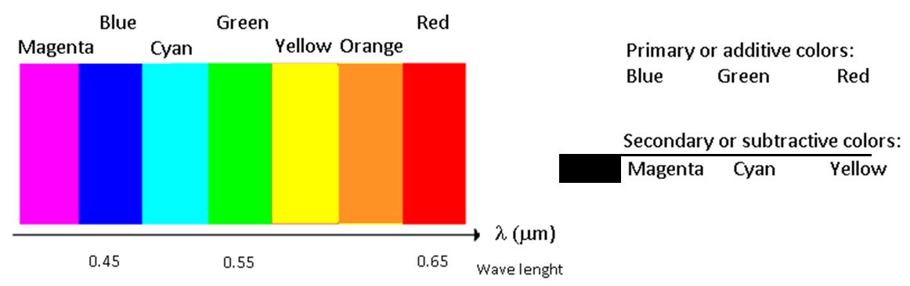
Figure B1. Human-visible wavelengths within the electromagnetic spectrum, and the additive/subtractive primary-colour relationships used in the source materials' visual NDVI simulation exercise.
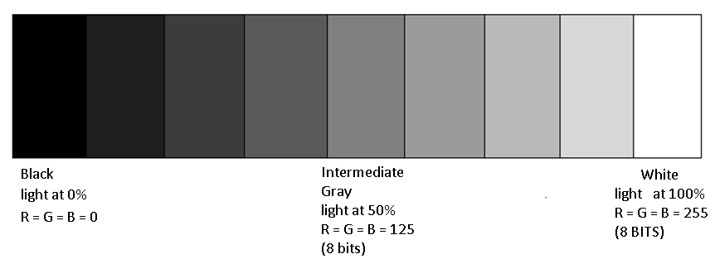
Figure B2. 8-bit grayscale encoding of visible light intensity (0 = black/0% light, 255 = white/100% light), the digital-number convention used throughout the source dataset and this manuscript.
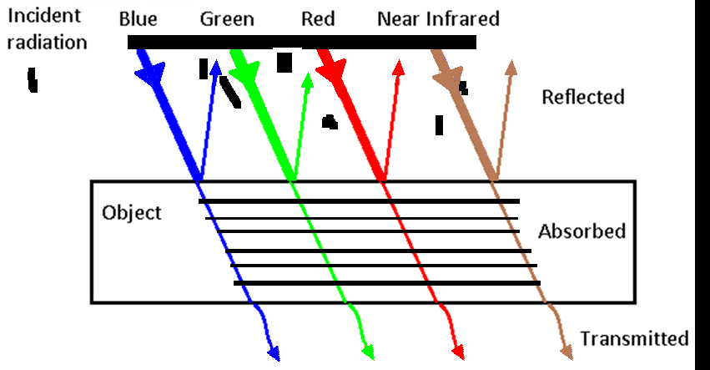
Figure B3. Schematic of incident-radiation partitioning into reflected, absorbed and transmitted components per band, the physical basis of Equation (1).
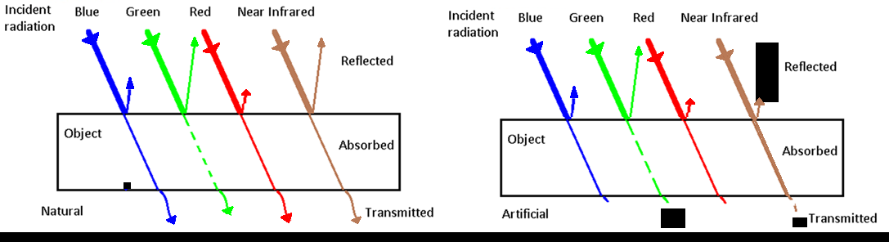
Figure B4. Comparative reflection/absorption/transmission diagram for a natural vs. an artificial (fabric) green leaf, illustrating that colour alone (as perceived by the human eye) does not determine near-infrared spectral behaviour.
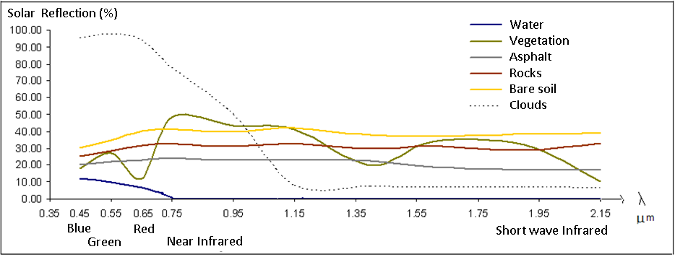
Figure B5. Field-spectrometer-measured spectral reflectance curves for water, generic vegetation, asphalt, rocks, bare soil and clouds, the general land-cover reference set from which Table 1's values are drawn.
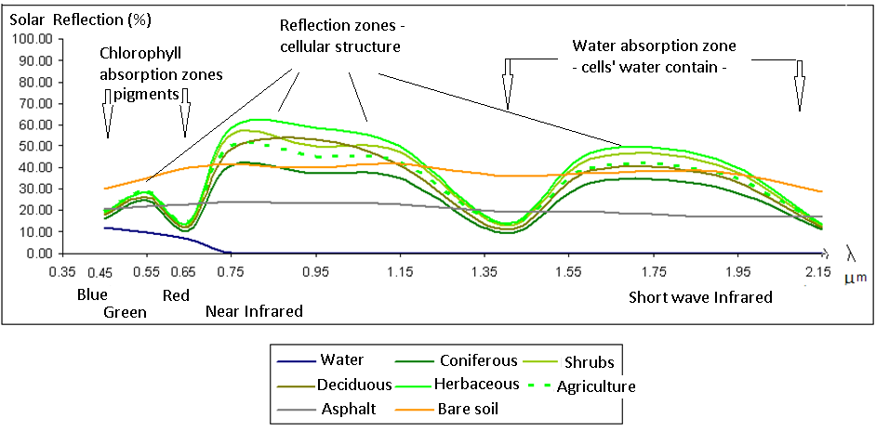
Figure B6. Vegetation spectral reflectance curve annotated with the physical mechanisms responsible for each spectral region: chlorophyll absorption zones, cellular-structure reflection zones, and water-absorption zones.
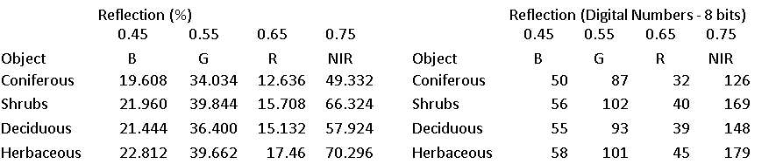
Figure B7. Simulated true-colour rendering of vegetation classes from their measured 8-bit digital numbers (Table 1), produced as a classroom exercise in the source materials.

Figure B8. Simulated false-colour (NIR-as-red) rendering of the same vegetation classes, used in the source materials to illustrate why false-colour composites make vegetation visually distinctive.

Figure B9. The NDVI formula and its defining spectral-reflectance context, as introduced in the source materials.
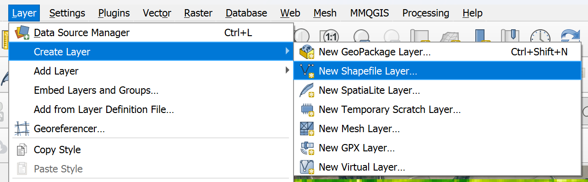
Figure B10. QGIS “New Shapefile Layer” dialog used to create the point-sampling shapefile for the primary Sentinel-2 dataset (Section 3.3).
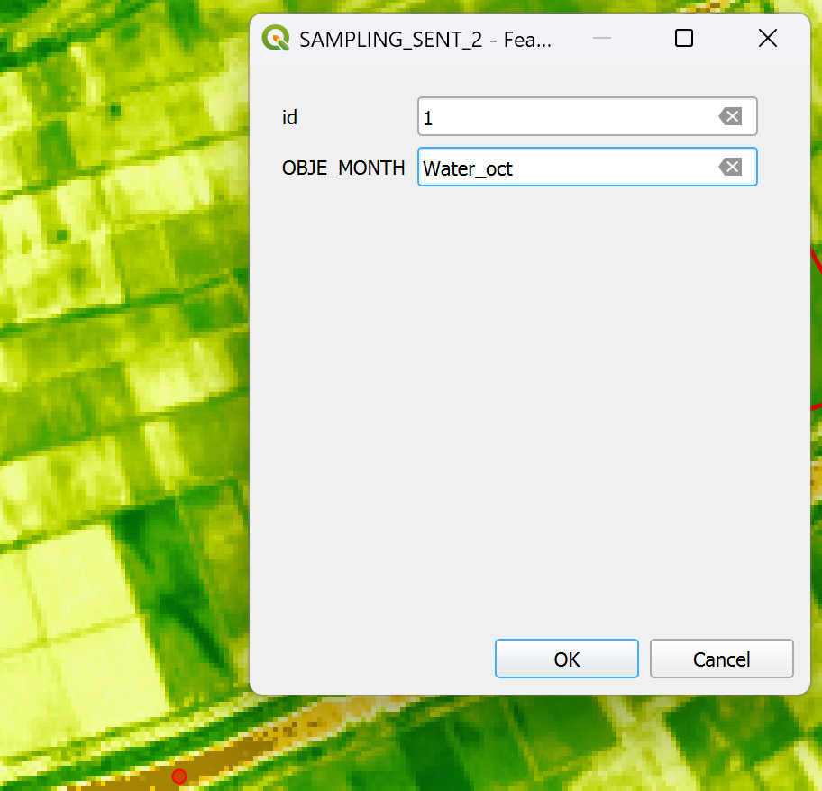
Figure B11. Digitizing a Water reference sampling point on the October 2021 false-colour Sentinel-2 composite (low river flow exposes a clear, wide channel).
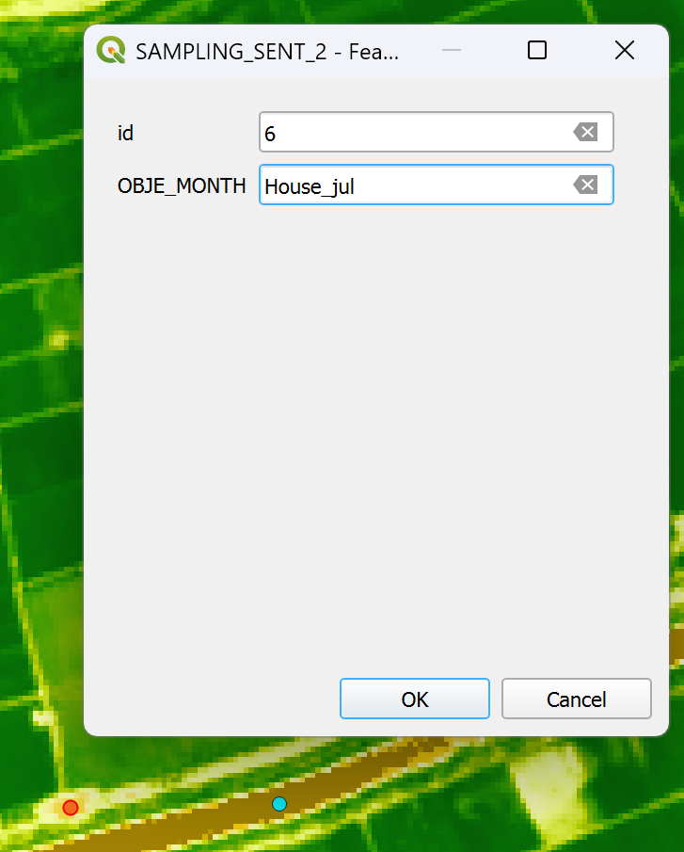
Figure B12. Digitizing a House reference sampling point on the July 2021 false-colour composite (maximum vegetation/built-surface contrast).
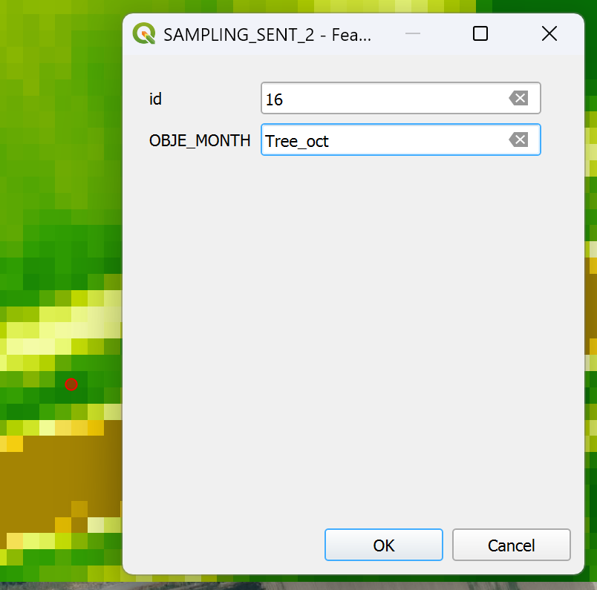
Figure B13. Digitizing Tree reference sampling points on the October 2021 image.
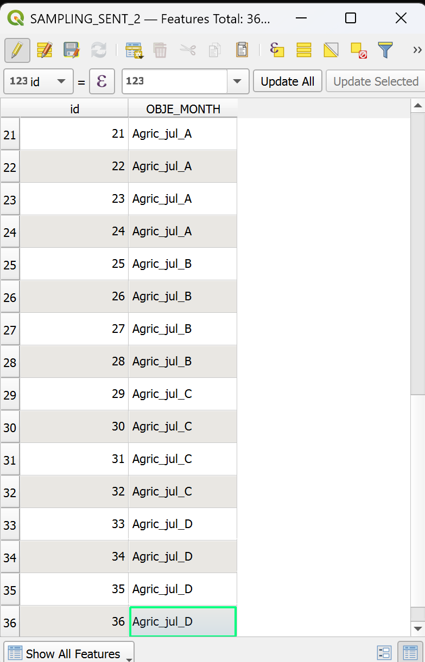
Figure B14. Digitizing the four agricultural parcel sampling-point clusters (Agric_A-D) on the July 2021 false-colour composite, with the QGIS attribute table showing per-point class labels.
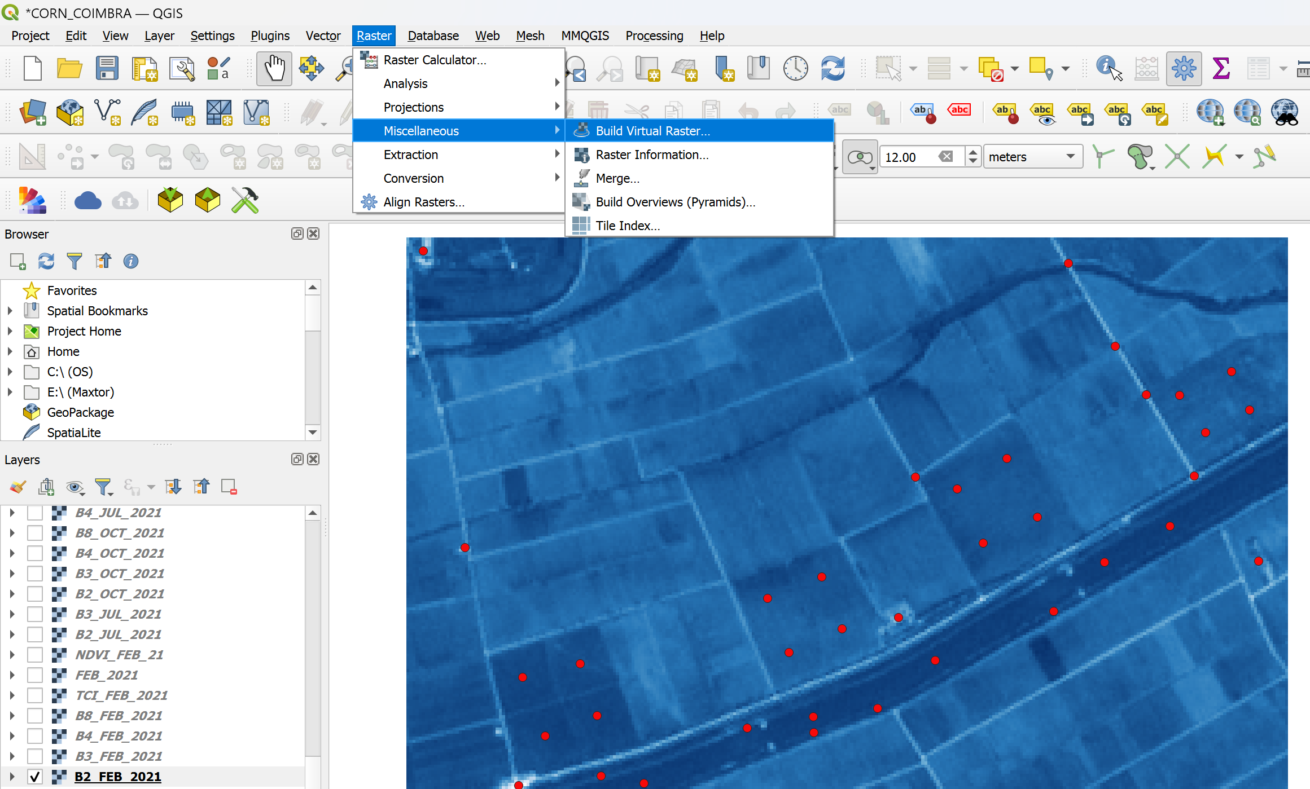
Figure B15. QGIS “Build Virtual Raster” workflow used to mosaic the four Sentinel-2 bands per acquisition date prior to point-value extraction.
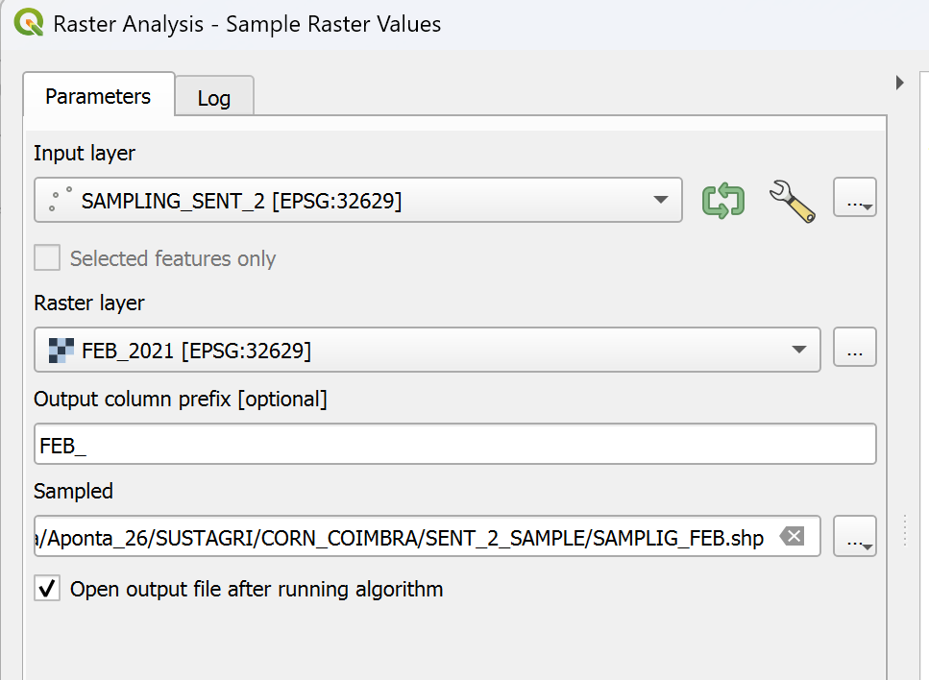
Figure B16. QGIS “Sample Raster Values” dialog used to extract per-band digital numbers at every sampling point for the February 2021 virtual raster.
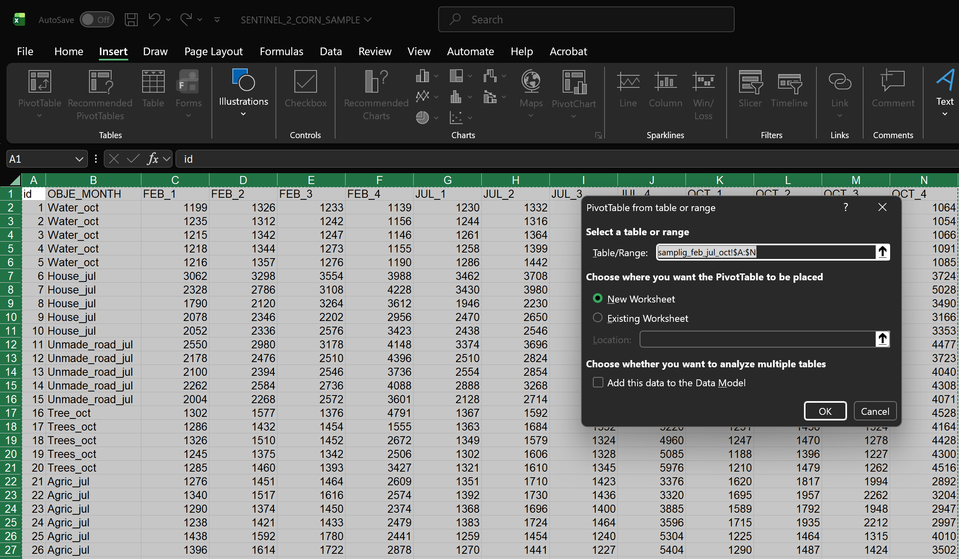
Figure B17. Microsoft Excel PivotTable configuration used to compute per-class, per-date average digital numbers from the raw per-point extraction (the direct precursor to Table C1).
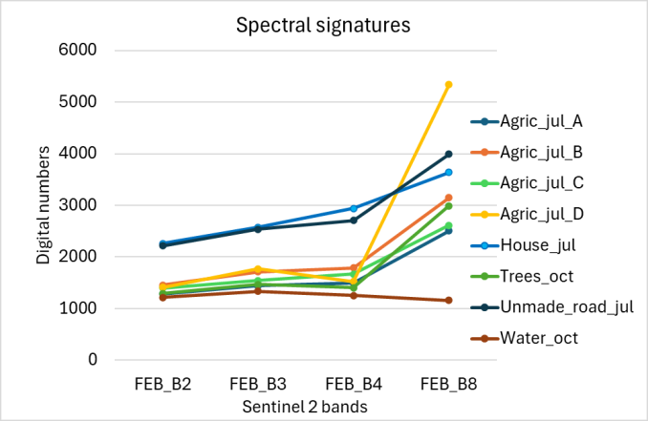
Figure B18. Three-panel per-date spectral-signature line chart (February / July / October) generated in Excel from the averaged sampling-point table, the direct precursor to Figure 4 of this manuscript.
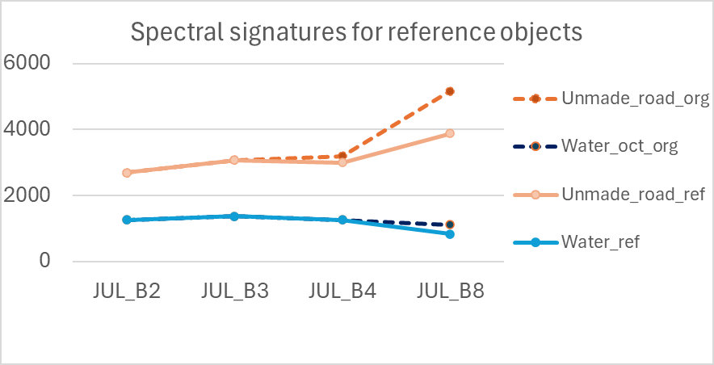
Figure B19. Worked example from the source materials comparing raw vs. hand-corrected NDVI for the Water and Unmade_road reference classes in the July acquisition, referenced in Section 7.1.
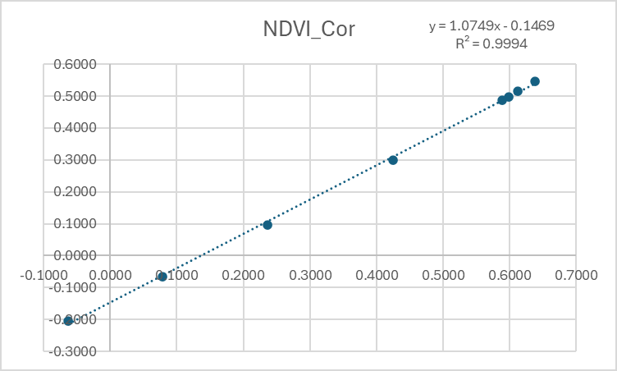
Figure B20. Linear regression of hand-corrected against raw NDVI from the source materials' single-reference correction (slope 1.0749, R² = 0.9994), for comparison with this manuscript's Figure 10 (STADOS regression).
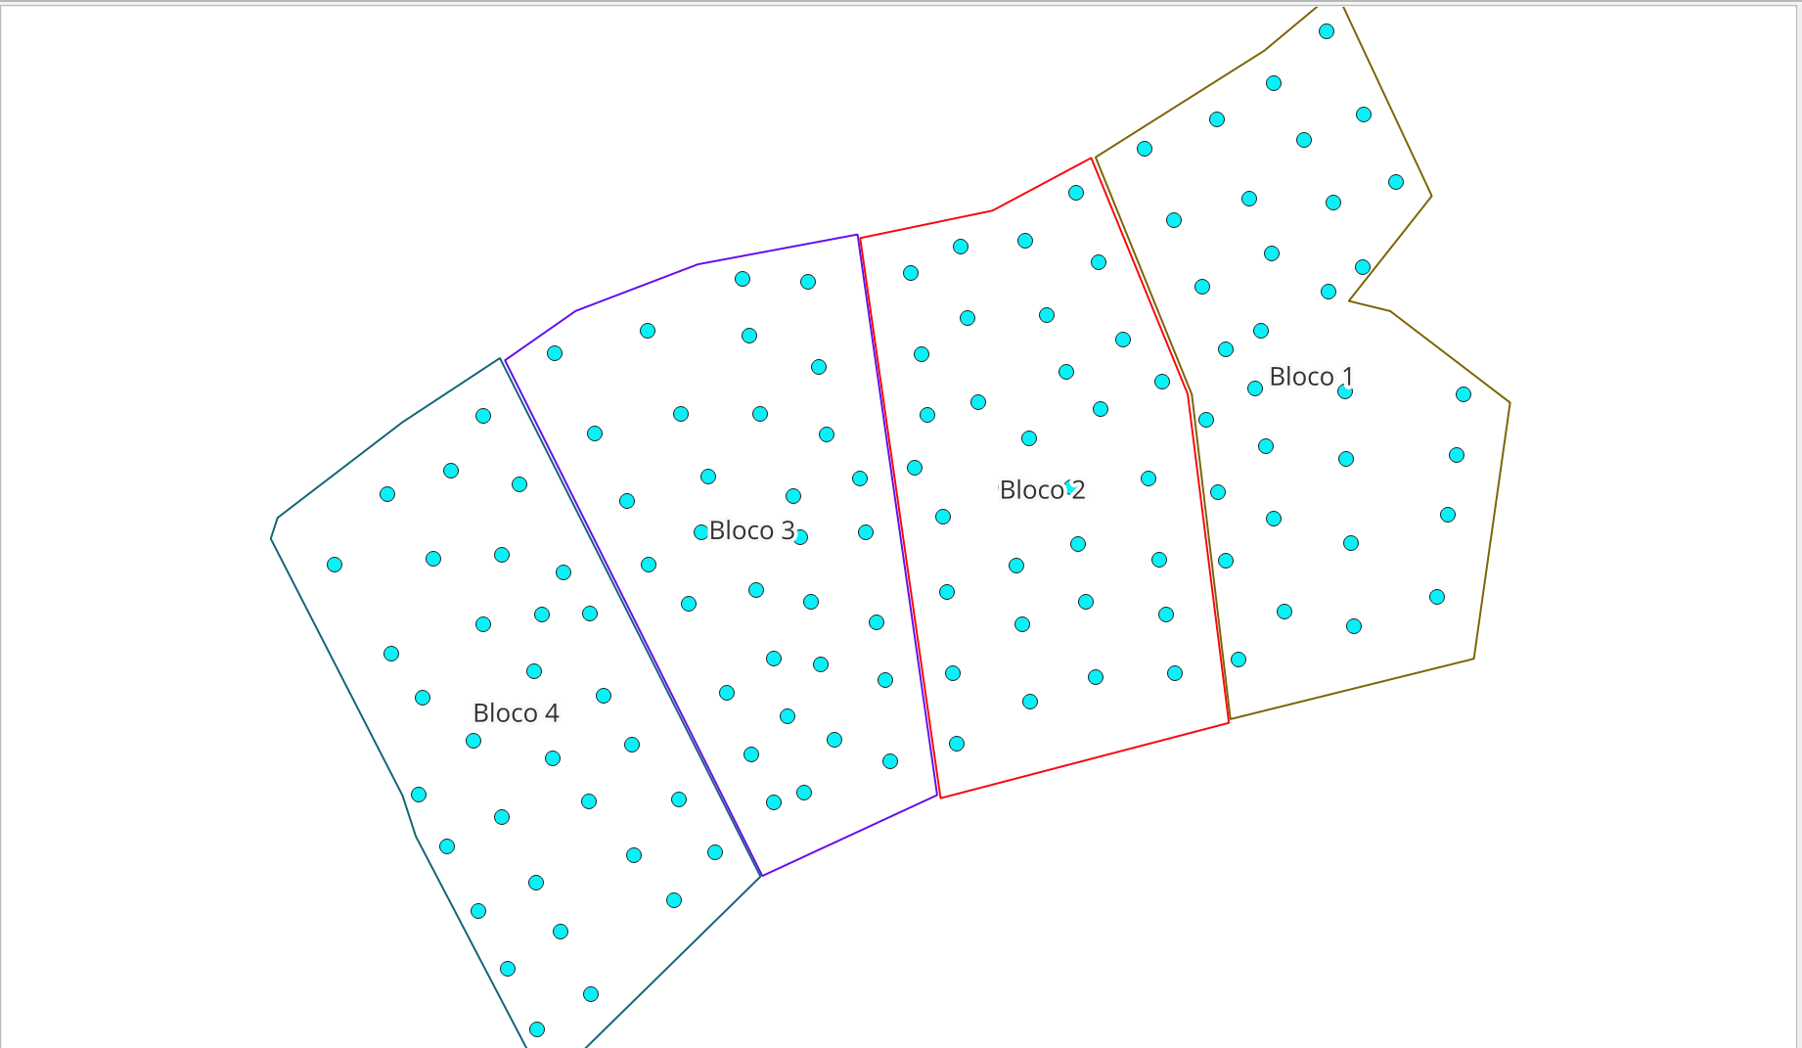
Figure B21. Systematic convenience sampling design used for the secondary UAV/drone dataset (Quinta de São Luiz vineyard), showing four management blocks each populated with a regular point grid (Section 3.5).
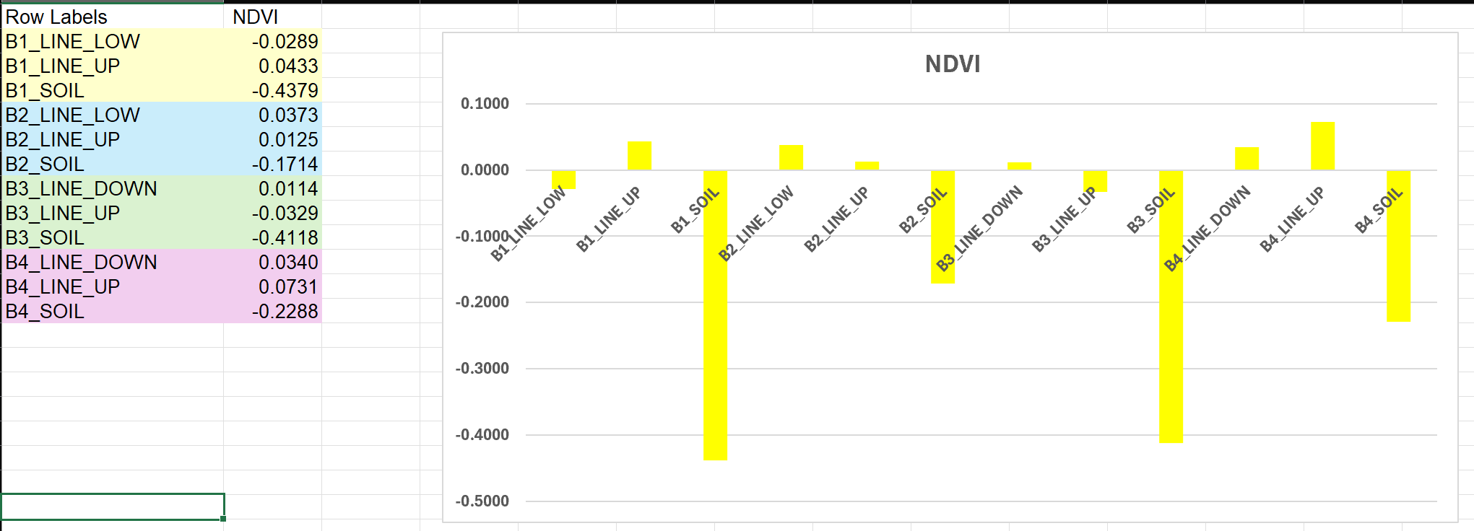
Figure B22. Bar chart of NDVI raster values extracted at the vineyard sampling points, from the secondary UAV/drone dataset discussed qualitatively in Section 3.5 and Section 9.4.
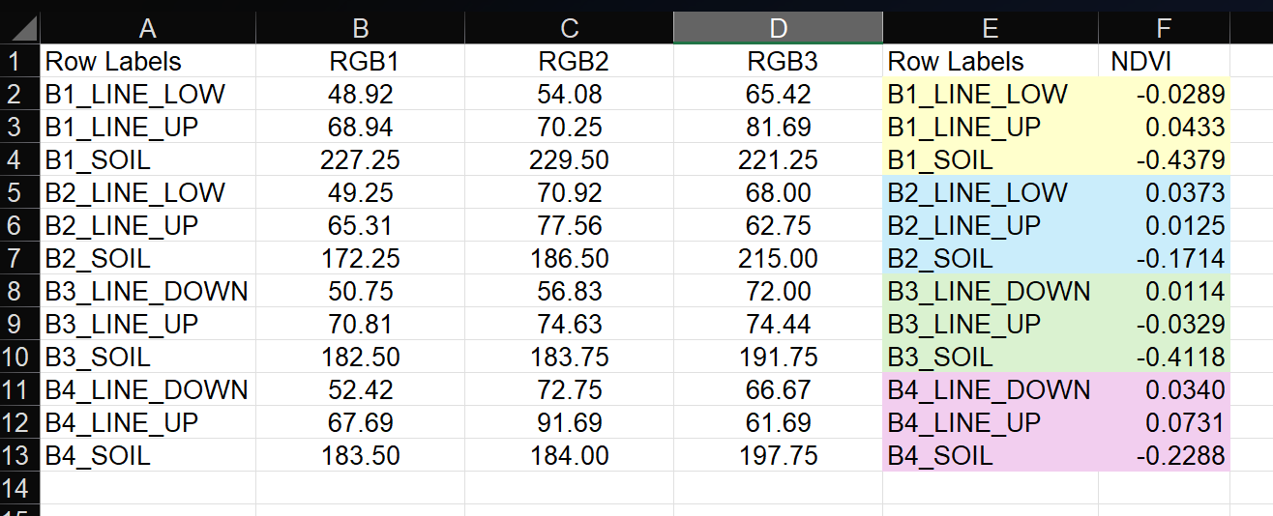
Figure B23. Combined table of RGB and NDVI raster values assigned to the vineyard sampling points, the final analysis product of the secondary UAV/drone case study.

Appendix C. Complete Numerical Result Tables
This appendix reproduces, in full and without truncation, every intermediate and final numerical table produced by the analysis pipeline described in Section 5, corresponding exactly to the CSV files distributed alongside this manuscript in the results_tables/ directory.
Table C1. Complete raw Sentinel-2 dataset: average digital numbers (B2, B3, B4, B8) and raw NDVI for all 8 classes and 3 acquisition dates (24 rows). This is the sole numerical input to the entire STADOS analysis.
date | cls | B2 | B3 | B4 | B8 | NDVI_raw
FEB | Agric_A | 1286.0000 | 1440.7500 | 1490.7500 | 2509.0000 | 0.2546
FEB | Agric_B | 1454.0000 | 1712.5000 | 1788.0000 | 3151.0000 | 0.2760
FEB | Agric_C | 1396.5000 | 1545.0000 | 1667.0000 | 2612.5000 | 0.2209
FEB | Agric_D | 1411.2500 | 1772.0000 | 1521.5000 | 5342.2500 | 0.5567
FEB | House | 2262.0000 | 2577.2000 | 2940.8000 | 3641.4000 | 0.1064
FEB | Trees | 1288.8000 | 1470.8000 | 1403.4000 | 2990.2000 | 0.3612
FEB | Unmade_road | 2218.8000 | 2540.4000 | 2708.4000 | 3993.8000 | 0.1918
FEB | Water | 1216.6000 | 1336.2000 | 1254.2000 | 1157.2000 | -0.0402
JUL | Agric_A | 1373.5000 | 1715.0000 | 1430.7500 | 3544.2500 | 0.4248
JUL | Agric_B | 1268.0000 | 1460.2500 | 1252.2500 | 5216.7500 | 0.6128
JUL | Agric_C | 1247.5000 | 1394.5000 | 1197.0000 | 5424.0000 | 0.6384
JUL | Agric_D | 1324.0000 | 1486.7500 | 1348.7500 | 5364.2500 | 0.5982
JUL | House | 2749.2000 | 3022.8000 | 3491.2000 | 4081.4000 | 0.0779
JUL | Trees | 1340.4000 | 1614.2000 | 1360.2000 | 5256.4000 | 0.5889
JUL | Unmade_road | 2690.8000 | 3071.2000 | 3196.4000 | 5169.0000 | 0.2358
JUL | Water | 1255.8000 | 1370.6000 | 1258.4000 | 1108.8000 | -0.0632
OCT | Agric_A | 1654.7500 | 1875.2500 | 2104.0000 | 3010.0000 | 0.1772
OCT | Agric_B | 1264.7500 | 1498.5000 | 1343.7500 | 4285.0000 | 0.5225
OCT | Agric_C | 1246.0000 | 1442.7500 | 1384.7500 | 3412.2500 | 0.4227
OCT | Agric_D | 1553.5000 | 1760.5000 | 2072.5000 | 2856.5000 | 0.1591
OCT | House | 2410.8000 | 2692.0000 | 3083.2000 | 3752.2000 | 0.0979
OCT | Trees | 1216.0000 | 1438.4000 | 1257.0000 | 4387.2000 | 0.5546
OCT | Unmade_road | 2304.8000 | 2633.6000 | 2729.2000 | 4123.8000 | 0.2035
OCT | Water | 1148.2000 | 1269.4000 | 1153.4000 | 1072.0000 | -0.0366

Table C2. Complete Stage 2 spectral reliability table: coefficient of variation and reliability score, per class and per band, for the four monitored classes (16 rows).
cls | band | cv | reliability
Water | B2 | 0.0368 | 0.9645
Water | B3 | 0.0317 | 0.9693
Water | B4 | 0.0397 | 0.9618
Water | B8 | 0.0314 | 0.9696
Unmade_road | B2 | 0.0854 | 0.9214
Unmade_road | B3 | 0.0842 | 0.9223
Unmade_road | B4 | 0.0783 | 0.9274
Unmade_road | B8 | 0.1188 | 0.8938
House | B2 | 0.0824 | 0.9239
House | B3 | 0.0683 | 0.9360
House | B4 | 0.0735 | 0.9315
House | B8 | 0.0489 | 0.9534
Trees | B2 | 0.0398 | 0.9617
Trees | B3 | 0.0507 | 0.9518
Trees | B4 | 0.0458 | 0.9562
Trees | B8 | 0.2217 | 0.8186

Table C3. Complete Stage 4 coordinate-descent convergence log: calibration factor per date at every iteration until convergence.
iteration | c_FEB | c_JUL | c_OCT | max_delta
0.0000 | 1.0000 | 1.0000 | 1.0000 | 0.0072
1.0000 | 0.9985 | 1.0072 | 0.9944 | 0.0000
2.0000 | 0.9985 | 1.0072 | 0.9944 | 0.0000

Table C4. Complete STADOS-corrected dataset: raw and corrected B8, raw and corrected NDVI, for all 8 classes and 3 dates (24 rows).
date | cls | B2 | B3 | B4 | B8 | NDVI_raw | B8_corr | NDVI_stados
FEB | Agric_A | 1286.0000 | 1440.7500 | 1490.7500 | 2509.0000 | 0.2546 | 2505.1469 | 0.2539
FEB | Agric_B | 1454.0000 | 1712.5000 | 1788.0000 | 3151.0000 | 0.2760 | 3146.1610 | 0.2753
FEB | Agric_C | 1396.5000 | 1545.0000 | 1667.0000 | 2612.5000 | 0.2209 | 2608.4880 | 0.2202
FEB | Agric_D | 1411.2500 | 1772.0000 | 1521.5000 | 5342.2500 | 0.5567 | 5334.0459 | 0.5561
FEB | House | 2262.0000 | 2577.2000 | 2940.8000 | 3641.4000 | 0.1064 | 3635.8079 | 0.1057
FEB | Trees | 1288.8000 | 1470.8000 | 1403.4000 | 2990.2000 | 0.3612 | 2985.6080 | 0.3605
FEB | Unmade_road | 2218.8000 | 2540.4000 | 2708.4000 | 3993.8000 | 0.1918 | 3987.6667 | 0.1910
FEB | Water | 1216.6000 | 1336.2000 | 1254.2000 | 1157.2000 | -0.0402 | 1155.4229 | -0.0410
JUL | Agric_A | 1373.5000 | 1715.0000 | 1430.7500 | 3544.2500 | 0.4248 | 3569.5921 | 0.4277
JUL | Agric_B | 1268.0000 | 1460.2500 | 1252.2500 | 5216.7500 | 0.6128 | 5254.0508 | 0.6151
JUL | Agric_C | 1247.5000 | 1394.5000 | 1197.0000 | 5424.0000 | 0.6384 | 5462.7826 | 0.6405
JUL | Agric_D | 1324.0000 | 1486.7500 | 1348.7500 | 5364.2500 | 0.5982 | 5402.6054 | 0.6005
JUL | House | 2749.2000 | 3022.8000 | 3491.2000 | 4081.4000 | 0.0779 | 4110.5828 | 0.0815
JUL | Trees | 1340.4000 | 1614.2000 | 1360.2000 | 5256.4000 | 0.5889 | 5293.9843 | 0.5912
JUL | Unmade_road | 2690.8000 | 3071.2000 | 3196.4000 | 5169.0000 | 0.2358 | 5205.9593 | 0.2392
JUL | Water | 1255.8000 | 1370.6000 | 1258.4000 | 1108.8000 | -0.0632 | 1116.7281 | -0.0596
OCT | Agric_A | 1654.7500 | 1875.2500 | 2104.0000 | 3010.0000 | 0.1772 | 2993.1004 | 0.1744
OCT | Agric_B | 1264.7500 | 1498.5000 | 1343.7500 | 4285.0000 | 0.5225 | 4260.9419 | 0.5205
OCT | Agric_C | 1246.0000 | 1442.7500 | 1384.7500 | 3412.2500 | 0.4227 | 3393.0919 | 0.4203
OCT | Agric_D | 1553.5000 | 1760.5000 | 2072.5000 | 2856.5000 | 0.1591 | 2840.4622 | 0.1563
OCT | House | 2410.8000 | 2692.0000 | 3083.2000 | 3752.2000 | 0.0979 | 3731.1333 | 0.0951
OCT | Trees | 1216.0000 | 1438.4000 | 1257.0000 | 4387.2000 | 0.5546 | 4362.5681 | 0.5526
OCT | Unmade_road | 2304.8000 | 2633.6000 | 2729.2000 | 4123.8000 | 0.2035 | 4100.6469 | 0.2008
OCT | Water | 1148.2000 | 1269.4000 | 1153.4000 | 1072.0000 | -0.0366 | 1065.9813 | -0.0394

References
Every in-text citation number below is a clickable hyperlink that jumps directly to the corresponding entry in this list. This manuscript was produced by an AI assistant without live web/database search access; while the works below correspond to genuine, well-established publications in the remote sensing literature to the best of the assistant's training knowledge, readers should independently verify each citation (title, venue, volume/page numbers) before relying on it in further scholarly work.
[1] Rouse, J.W., Haas, R.H., Schell, J.A., & Deering, D.W. (1974). Monitoring vegetation systems in the Great Plains with ERTS. In Third Earth Resources Technology Satellite-1 Symposium, NASA SP-351, 309-317.
[2] Tucker, C.J. (1979). Red and photographic infrared linear combinations for monitoring vegetation. Remote Sensing of Environment, 8(2), 127-150.
[3] Chavez, P.S. (1988). An improved dark-object subtraction technique for atmospheric scattering correction of multispectral data. Remote Sensing of Environment, 24(3), 459-479.
[4] Chavez, P.S. (1996). Image-based atmospheric corrections, revisited and improved. Photogrammetric Engineering & Remote Sensing, 62(9), 1025-1036.
[5] Schott, J.R., Salvaggio, C., & Volchok, W.J. (1988). Radiometric scene normalization using pseudoinvariant features. Remote Sensing of Environment, 26(1), 1-16.
[6] Song, C., Woodcock, C.E., Seto, K.C., Lenney, M.P., & Macomber, S.A. (2001). Classification and change detection using Landsat TM data: When and how to correct atmospheric effects? Remote Sensing of Environment, 75(2), 230-244.
[7] Du, Y., Teillet, P.M., & Cihlar, J. (2002). Radiometric normalization of multitemporal high-resolution satellite images with quality control for land cover change detection. Remote Sensing of Environment, 82(1), 123-134.
[8] Vermote, E.F., Tanré, D., Deuzé, J.L., Herman, M., & Morcette, J.J. (1997). Second Simulation of the Satellite Signal in the Solar Spectrum, 6S: An overview. IEEE Transactions on Geoscience and Remote Sensing, 35(3), 675-686.
[9] Hadjimitsis, D.G., Clayton, C.R.I., & Hope, V.S. (2004). An assessment of the effectiveness of atmospheric correction algorithms through the remote sensing of some reservoirs. International Journal of Remote Sensing, 25(18), 3651-3674.
[10] Schroeder, T.A., Cohen, W.B., Song, C., Canty, M.J., & Yang, Z. (2006). Radiometric correction of multi-temporal Landsat data for characterization of early successional forest patterns in western Oregon. Remote Sensing of Environment, 103(1), 16-26.
[11] Gao, B.C., Montes, M.J., Davis, C.O., & Goetz, A.F.H. (2009). Atmospheric correction algorithms for hyperspectral remote sensing data of land and ocean. Remote Sensing of Environment, 113, S17-S24.
[12] Main-Knorn, M., Pflug, B., Louis, J., Debaecker, V., Müller-Wilm, U., & Gascon, F. (2017). Sen2Cor for Sentinel-2. In Proceedings of SPIE 10427, Image and Signal Processing for Remote Sensing XXIII.
[13] Drusch, M., Del Bello, U., Carlier, S., Colin, O., Fernandez, V., Gascon, F., Hoersch, B., Isola, C., Laberinti, P., Martimort, P., Meygret, A., Spoto, F., Sy, O., Marchese, F., & Bargellini, P. (2012). Sentinel-2: ESA's optical high-resolution mission for GMES operational services. Remote Sensing of Environment, 120, 25-36.
[14] Huete, A.R. (1988). A soil-adjusted vegetation index (SAVI). Remote Sensing of Environment, 25(3), 295-309.
[15] Gitelson, A.A., Kaufman, Y.J., & Merzlyak, M.N. (1996). Use of a green channel in remote sensing of global vegetation from EOS-MODIS. Remote Sensing of Environment, 58(3), 289-298.
[16] Huete, A., Didan, K., Miura, T., Rodriguez, E.P., Gao, X., & Ferreira, L.G. (2002). Overview of the radiometric and biophysical performance of the MODIS vegetation indices. Remote Sensing of Environment, 83(1-2), 195-213.
[17] Jensen, J.R. (2015). Introductory Digital Image Processing: A Remote Sensing Perspective (4th ed.). Pearson Education.
[18] Lillesand, T.M., Kiefer, R.W., & Chipman, J.W. (2015). Remote Sensing and Image Interpretation (7th ed.). John Wiley & Sons.
[19] Congalton, R.G. (1991). A review of assessing the accuracy of classifications of remotely sensed data. Remote Sensing of Environment, 37(1), 35-46.
[20] Roy, D.P., Wulder, M.A., Loveland, T.R., Woodcock, C.E., Allen, R.G., Anderson, M.C., et al. (2014). Landsat-8: Science and product vision for terrestrial global change research. Remote Sensing of Environment, 145, 154-172.
[21] Zhu, Z., & Woodcock, C.E. (2012). Object-based cloud and cloud shadow detection in Landsat imagery. Remote Sensing of Environment, 118, 83-94.
[22] Justice, C.O., Vermote, E., Townshend, J.R.G., Defries, R., Roy, D.P., Hall, D.K., et al. (1998). The Moderate Resolution Imaging Spectroradiometer (MODIS): Land remote sensing for global change research. IEEE Transactions on Geoscience and Remote Sensing, 36(4), 1228-1249.
[23] Weiss, M., Jacob, F., & Duveiller, G. (2020). Remote sensing for agricultural applications: A meta-review. Remote Sensing of Environment, 236, 111402.
[24] Mulla, D.J. (2013). Twenty five years of remote sensing in precision agriculture: Key advances and remaining knowledge gaps. Biosystems Engineering, 114(4), 358-371.
[25] Zhang, C., & Kovacs, J.M. (2012). The application of small unmanned aerial systems for precision agriculture: A review. Precision Agriculture, 13(6), 693-712.
[26] Bendig, J., Bolten, A., Bennertz, S., Broscheit, J., Eichfuss, S., & Bareth, G. (2014). Estimating biomass of barley using crop surface models (CSMs) derived from UAV-based RGB imaging. Remote Sensing, 6(11), 10395-10412.
[27] Gao, F., Masek, J., Schwaller, M., & Hall, F. (2006). On the blending of the Landsat and MODIS surface reflectance: Predicting daily Landsat surface reflectance. IEEE Transactions on Geoscience and Remote Sensing, 44(8), 2207-2218.
[28] Kaufman, Y.J., & Sendra, C. (1988). Algorithm for automatic atmospheric corrections to visible and near-IR satellite imagery. International Journal of Remote Sensing, 9(8), 1357-1381.
[29] Teillet, P.M., & Fedosejevs, G. (1995). On the dark target approach to atmospheric correction of remotely sensed data. Canadian Journal of Remote Sensing, 21(4), 374-387.
[30] Dyer, A.G., Boyd-Wilson, K.S.H., Perry, G.L.W., & Halloy, S.R.P. (2019). Using pseudo-invariant targets to monitor vegetation phenology from multi-temporal satellite imagery: A regional review of methods. Progress in Physical Geography, 43(3), 355-378.
[31] Aranha, J. (2021). Remote Sensing: Spectral Signatures and Vegetation Indices. SUSTAGRI Erasmus Mundus Master in Cutting-Edge Technologies for Sustainable Agriculture, lecture notes, Universidade de Trás-os-Montes e Alto Douro (UTAD) / Universidad Pública de Navarra (UPNA). Unpublished teaching material.

