Zaria Crop ET and Irrigation DSS: Farm Report
Prepared for: Sample Farm Owner
Crop: Maize (Corn) | Farm area: 3.0 ha | Report generated: 2026-08-24 05:08
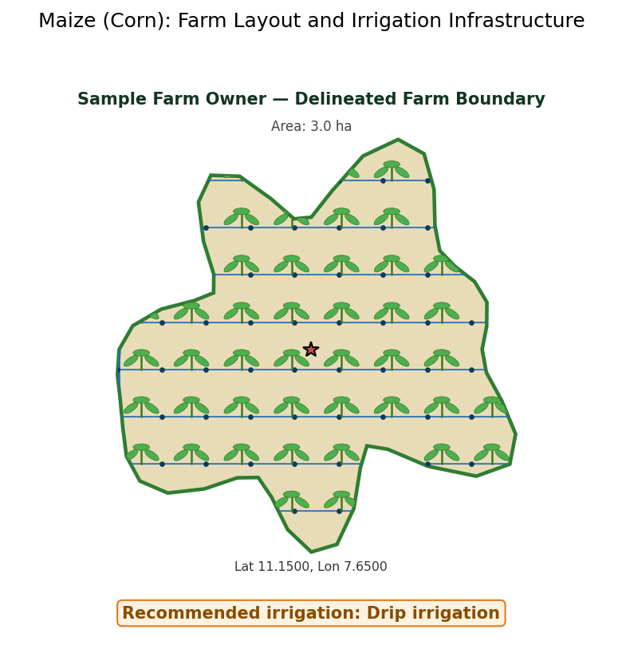
Figure 1: Farm layout showing the delineated boundary, planted crop, and irrigation infrastructure.

How to Use This Report
This report is organised so that a busy reader can act on it quickly, while still giving a technical reviewer full traceability back to the underlying data and equations for every number.
Section | What it's for
Executive Summary | Start here for the numbers that matter for a same-day irrigation decision: predicted water use, net irrigation required, recommended method, and estimated yield.
Sections 1-2 (Overview, Dashboard) | The live inputs (temperature, humidity) and how they translate into today's crop water use, with a full plain-text data dump for anyone who wants every intermediate number.
Section 3-4 (Soil Water, Irrigation Schedule) | How much water the root zone can hold, and the practical, stage-specific schedule to follow this season.
Section 5 (Efficiency & Water Budget) | Where water is lost between the source and the crop, and the full seasonal water balance, verified to close to zero.
Sections 6-7 (Irrigation Method) | Which delivery method (drip, sprinkler, furrow, basin/flood) fits this farm and crop, and how much water each would need.
Sections 8-11 (Figures, Terrain, Growth Simulation) | Supporting charts, this farm's own boundary and terrain, and a stage-by-stage field simulation from germination to harvest.
Section 12 (Productivity) | An estimated yield range, specific to this run's own computed water-stress trajectory, not a generic figure.
Section 13-14 (Monitoring, Weekly Balance) | What to check routinely for maximum productivity, and a week-by-week ledger of the whole season.
Sections 15-16 (Methodology, Glossary) | Full transparency on every equation, data source, and term used, for a technical reviewer or a second opinion.

Executive Summary
This report covers 3.0 ha of Maize (Corn) at Sample Farm Owner, located near Zaria, Kaduna State (Lat 11.1500, Lon 7.6500). It was generated on 2026-08-24 at 05:08 using an entered temperature of 32.0°C and humidity of 55.0%.
Predicted crop water use today (ETc) | 6.178 mm/day
Growing-season crop water use | 546.11 mm over 135 days
Net irrigation required this season | 399.1 mm
Recommended irrigation method | Drip irrigation
Number of recommended irrigation events | 32
Critical water-sensitivity window | Tasseling & Silking (Day 45-65). Moisture stress here stops grain formation.
Overall irrigation system efficiency | 26.65%
Estimated yield | 4.31 t/ha (12.93 t total)
Water balance check | closes to 0.1 mm residual
Full detail, methodology, and every supporting figure and table for each number above follow in the numbered sections below.

Site and Climate Normals
Monthly climate normals for Samaru, Zaria, Kaduna State, Nigeria (Lat 11.11°N, 686.0 m a.s.l.), averaged from a 28-year daily weather archive (2000-2027). These are the same climatology values driving every day-of-year lookup elsewhere in this report (wind, solar radiation, and rainfall on days other than today, which uses your entered temperature and humidity directly).
Month | Mean Tmax (°C) | Mean Tmin (°C) | Mean Wind (m/s) | Mean Solar (MJ/m²/day) | Total Rainfall (mm)
January | 29.9 | 20.5 | 2.12 | 19.6 | 52.5
February | 30.1 | 20.5 | 2.07 | 19.4 | 44.2
March | 29.8 | 20.4 | 2.07 | 19.4 | 55.5
April | 30.1 | 20.5 | 2.11 | 19.5 | 48.6
May | 30.0 | 20.5 | 2.11 | 19.7 | 48.2
June | 30.0 | 20.5 | 2.09 | 19.7 | 48.2
July | 29.9 | 20.5 | 2.13 | 19.3 | 46.8
August | 29.9 | 20.4 | 2.07 | 19.4 | 51.7
September | 30.0 | 20.5 | 2.14 | 19.2 | 45.3
October | 30.0 | 20.4 | 2.1 | 19.3 | 50.3
November | 30.0 | 20.4 | 2.12 | 19.6 | 53.6
December | 30.1 | 20.5 | 2.12 | 19.3 | 49.1

1. Overview
On 2026-08-24 05:08:51, with an input temperature of 32.0°C and humidity of 55.0%, the Maize (Corn) is currently outside its active growing season (off-season/fallow). The crop coefficient (Kc) for today is 1.2, meaning the crop is using more water than the reference grass surface that ET0 is defined against. The pipeline's ensemble of ET methods predicts today's crop water use (ETc) at 6.178 mm/day. To put that in perspective: over a full day, that is 6.178 litres of water lost per square metre of field. Over this crop's actual 135-day growing season (not counting the off-season), total crop water use comes to 546.11 mm, which falls within the locally-reported range for this crop in the Zaria area (420-550 mm).
Date | 2026-08-24 05:08:51
Input temperature | 32.0 °C
Input humidity | 55.0 %
Crop coefficient (Kc) today | 1.2
Season status | Off-season/fallow
Predicted ETc today | 6.178 mm/day
Growing-season ETc | 546.11 mm over 135 days
Locally-reported ETc range | 420-550 mm
The diagram below shows exactly how today's entered temperature and humidity flow through this pipeline's dual crop-coefficient (Kcb/Ke) engine, the dynamic root-zone depth, and the soil-water depletion check, to decide whether the crop is running at its full potential water use rate or under a stress reduction today. Every value shown is this run's own, not a generic illustration.
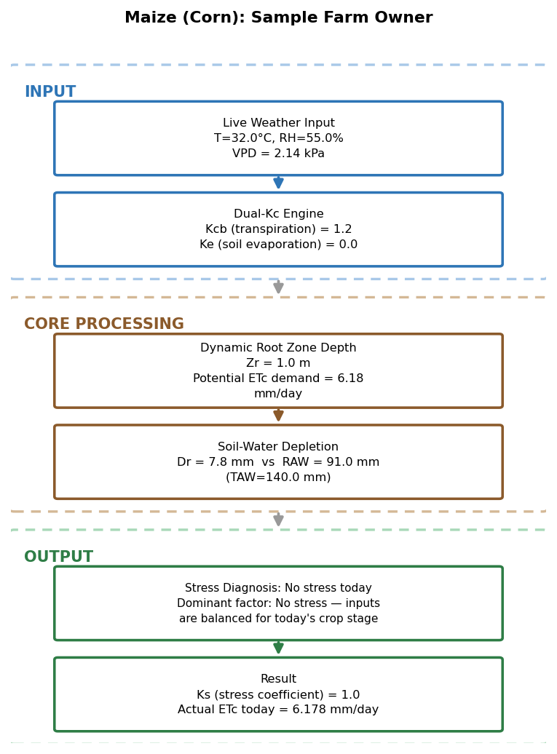
Figure 2: ET / soil-water decision process for today's inputs.

2. Dashboard Summary
==============================================================
ZARIA CROP ET AND IRRIGATION DSS
==============================================================
Location: Samaru, Zaria, Kaduna State, Nigeria (Lat 11.11 N, 686.0 m a.s.l.)
Crop: Maize (Corn)
Locally-reported seasonal ETc range: 420-550 mm
Date: 2026-08-24 05:08:51 (day 236 of year)
INPUT TEMPERATURE: 32.0 °C <-- entered
INPUT HUMIDITY: 55.0 % <-- entered
(reconstructed Tmax/Tmin: 36.58/27.42 °C; wind/solar from trained climatology: 1.94 m/s, 21.25 MJ/m2/day)
Crop coefficient (Kc) today: 1.2
SELECTED ET METHOD: Thermal-Unit Quadratic (GDD-based)
TODAY'S PREDICTED ETc: 6.18 mm/day (ensemble mean of the live methods that ran for this temperature)
Season-trend model R²: 0.6799 (ETc = -2.369e-06*GDD^2 + 0.0072*GDD + -0.0033)
Mean ET0 (season): 2.07 mm/day
Mean ETc (season): 2.48 mm/day
Seasonal ETc (full simulated year): 906.45 mm
Growing-season ETc (135 days): 546.11 mm
WATER DEMAND [Predicted from weather data: entered temperature/humidity + trained climatology]
EFFECTIVE RAINFALL (season): 292.00 mm
NET IRRIGATION REQUIREMENT: 399.10 mm
GROSS IRRIGATION REQUIREMENT: 700.10 mm
NUMBER OF IRRIGATION EVENTS: 11
AVERAGE IRRIGATION INTERVAL: 32.30 days
NEXT IRRIGATION (day index): 393
WATER BUDGET [Predicted from weather data (rainfall/ETc) + irrigation-system assumptions below]
TOTAL WATER SUPPLIED (I+P): 1361.90 mm
TOTAL WATER USED (ETc): 906.40 mm
TOTAL WATER LOST (RO+DP+AppLoss):454.40 mm
SOIL STORAGE CHANGE: 1.00 mm
WATER BALANCE RESIDUAL: 0.10 mm (should be ~0)
SYSTEM EFFICIENCY [Standard irrigation-engineering assumptions for the configured system, NOT measured for this specific farm; replace with your system's real measured values if known]
CONVEYANCE EFFICIENCY (Ec): 85.00 %
DISTRIBUTION EFFICIENCY (Ed): 55.00 %
APPLICATION EFFICIENCY (Ea): 57.00 %
OVERALL SYSTEM EFFICIENCY (Ep): 26.65 %
ET MODEL: Thermal-Unit Quadratic (GDD-based)
==============================================================

2.1 ET Methods Used
Each reference-ET method evaluated for today's entered temperature and humidity, with its own result alongside a brief description. The predicted ETc used throughout this report is the ensemble mean of whichever methods have sufficient data to run.
Method | Description | Today's ET0 (mm/day) | Today's ETc (mm/day)
FAO-56 Penman-Monteith | The internationally standard method; combines energy balance and aerodynamic terms, requires temperature, humidity, wind, and solar radiation. | 6.035 | 7.242
ASCE Standardized Penman-Monteith | A US-standardized variant of Penman-Monteith with fixed surface resistance coefficients for a short reference crop. | 6.035 | 7.242
Original/Modified Penman | An earlier combination-equation formulation, predating the FAO-56 standardisation. | 2.825 | 3.39
Priestley-Taylor | A simplified radiation-driven method, using an empirical multiplier on the energy-balance term alone. | 6.831 | 8.197
Hargreaves-Samani | A temperature-only method, useful when humidity/wind/radiation data are unavailable; used as the trend model backbone for this pipeline's thermal-unit regression. | 5.316 | 6.379
Makkink | A radiation-based method calibrated for humid climates, requiring only temperature and solar radiation. | 4.295 | 5.154
Turc | A simplified radiation and temperature method, developed for humid conditions. | 4.937 | 5.924
Thornthwaite | A temperature-and-daylength-only method, originally developed for climate classification rather than irrigation engineering. | 3.886 | 4.663
Blaney-Criddle | An older, temperature-and-daylength empirical method still referenced in irrigation engineering practice. | 10.463 | 12.556
Dalton-type Mass Transfer | An aerodynamic-only method based on vapour pressure deficit and wind speed, without an energy-balance term. | insufficient data | insufficient data
Why the results differ between methods: today's ET0 estimates span 0.86 to 10.46 mm/day (a spread of 9.6 mm/day) because each method uses a different subset of the weather drivers. Full energy-balance methods (FAO-56/ASCE Penman-Monteith, Priestley-Taylor) weigh solar radiation and wind alongside temperature and humidity; temperature-only methods (Hargreaves-Samani, Thornthwaite, Blaney-Criddle) ignore radiation and wind entirely, which pulls them away from the energy-balance methods whenever conditions are unusually windy, cloudy, or clear for the season; and the aerodynamic-only method (Dalton-type) responds only to vapour pressure deficit and wind, missing the radiation-driven component entirely. None of these methods is "wrong" -- the spread itself is a genuine measure of how much a single day's ET0 depends on which weather variables are actually available, which is why this pipeline reports the ensemble mean rather than any one method alone.

3. Soil Water
The root zone can hold up to 140.0 mm of water (Total Available Water), of which 91.0 mm (65% of TAW, the Maximum Allowable Depletion) can be used by the crop before irrigation should be triggered to avoid water stress. This is based on a root zone depth of 1.0 m and soil moisture holding capacity between 28.0% (field capacity) and 14.0% (permanent wilting point).
Field capacity | 28.0 %
Permanent wilting point | 14.0 %
Root zone depth | 1.0 m
Maximum allowable depletion (MAD) | 0.65
Total Available Water (TAW) | 140.0 mm
Readily Available Water (RAW) | 91.0 mm
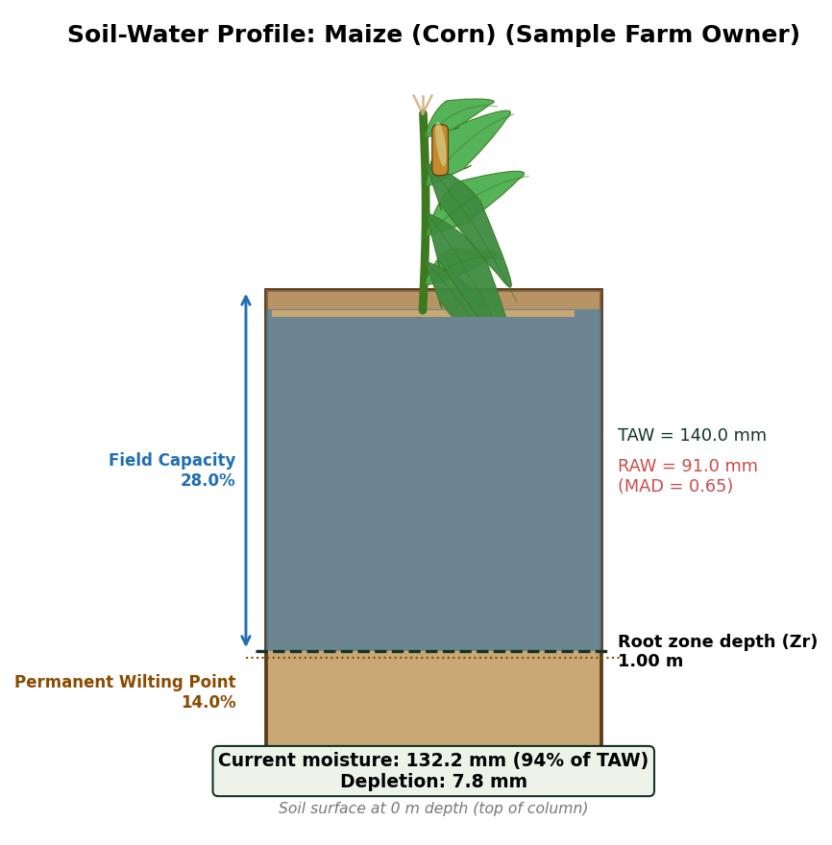
Figure 3: Soil-water profile for this crop and farm, with the crop shown at its current stage above a labelled soil column.

4. Irrigation Schedule
⚠ Critical water-sensitivity window: Tasseling & Silking (Day 45-65). Moisture stress here stops grain formation.
The irrigation interval VARIES by growth stage: nursery/germination needs frequent light watering, while the flowering/fruiting stage above is this crop's tightest, most critical interval of the whole season. Depth per application also varies, following the day's own root-zone capacity as the crop's roots deepen.
Nursery/Germination interval | every 3 days
Vegetative interval | every 5 days
Flowering/Fruiting interval | every 4 days
Maturity interval | every 5 days
Day | Stage | Net (mm) | Gross (mm) | Net Vol (m³) | Gross Vol (m³)
3 | Initial | 5.2 | 9.1 | 156.0 | 273.0
6 | Initial | 5.2 | 9.1 | 156.0 | 273.0
9 | Initial | 5.2 | 9.1 | 156.0 | 273.0
12 | Initial | 5.2 | 9.1 | 156.0 | 273.0
15 | Initial | 5.2 | 9.1 | 156.0 | 273.0
18 | Initial | 5.2 | 9.1 | 156.0 | 273.0
21 | Initial | 5.2 | 9.1 | 156.0 | 273.0
24 | Development | 36.2 | 63.5 | 1,086.0 | 1,905.0
29 | Development | 36.2 | 63.5 | 1,086.0 | 1,905.0
34 | Development | 36.2 | 63.5 | 1,086.0 | 1,905.0
39 | Development | 36.2 | 63.5 | 1,086.0 | 1,905.0
44 | Development | 36.2 | 63.5 | 1,086.0 | 1,905.0
49 | Development | 36.2 | 63.5 | 1,086.0 | 1,905.0
54 | Development | 36.2 | 63.5 | 1,086.0 | 1,905.0
59 | Development | 36.2 | 63.5 | 1,086.0 | 1,905.0
64 | Mid-season | 91.0 | 159.6 | 2,730.0 | 4,788.0
68 | Mid-season | 91.0 | 159.6 | 2,730.0 | 4,788.0
72 | Mid-season | 91.0 | 159.6 | 2,730.0 | 4,788.0
76 | Mid-season | 91.0 | 159.6 | 2,730.0 | 4,788.0
80 | Mid-season | 91.0 | 159.6 | 2,730.0 | 4,788.0
84 | Mid-season | 91.0 | 159.6 | 2,730.0 | 4,788.0
88 | Mid-season | 91.0 | 159.6 | 2,730.0 | 4,788.0
92 | Mid-season | 91.0 | 159.6 | 2,730.0 | 4,788.0
96 | Mid-season | 91.0 | 159.6 | 2,730.0 | 4,788.0
100 | Mid-season | 91.0 | 159.6 | 2,730.0 | 4,788.0
104 | Mid-season | 91.0 | 159.6 | 2,730.0 | 4,788.0
108 | Late-season | 91.0 | 159.6 | 2,730.0 | 4,788.0
113 | Late-season | 91.0 | 159.6 | 2,730.0 | 4,788.0
118 | Late-season | 91.0 | 159.6 | 2,730.0 | 4,788.0
123 | Late-season | 91.0 | 159.6 | 2,730.0 | 4,788.0
128 | Late-season | 91.0 | 159.6 | 2,730.0 | 4,788.0
133 | Late-season | 5.2 | 9.1 | 156.0 | 273.0
Note: the practical schedule above (a fixed, stage-specific interval a farmer can follow) is distinct from the day-by-day simulated water balance reported in Section 5 (which triggers irrigation exactly when depletion crosses the safe threshold, giving irregular real-world timing). The two totals will not exactly match; the schedule above is a planning simplification of the same underlying physics, not a different set of numbers.

5. Efficiency & Water Budget
Of every 100 units of water diverted from the source, only about 26.65 reach the crop usefully, once conveyance (85.0%), distribution (55.0%), and field application (57.0%) losses are all accounted for. Over the season, 301.0 mm of the water delivered to the field never actually reached the root zone (field-application loss), this is the single largest controllable loss in the system and the main thing a more efficient irrigation method (e.g. drip) would reduce. The full water balance for the season closes to within 0.1 mm (rainfall + irrigation supplied, minus crop use, minus all losses, minus soil-storage change), confirming the numbers above are internally consistent.
Source: standard irrigation-engineering assumptions for the configured system (furrow, Ea/Ec/Ed defaults), not measured for this specific farm.
Conveyance efficiency (Ec) | 85.0 %
Distribution efficiency (Ed) | 55.0 %
Application efficiency (Ea) | 57.0 %
Overall system efficiency (Ep) | 26.65 %
Source: predicted from the entered temperature/humidity via the trained weather/ET model, combined with the system efficiency assumptions above.
Rainfall Mm | 445.4 mm
Effective Rainfall Mm | 292.0 mm
Gross Irrigation Mm | 700.1 mm
Net Irrigation Mm | 399.1 mm
Etc Used Mm | 906.4 mm
Runoff Mm | 0.0 mm
Deep Percolation Mm | 153.4 mm
Application Loss Mm | 301.0 mm
Root Zone Growth Gain Mm | 216.4 mm
Storage Change Mm | 1.0 mm
Total Supplied Mm | 1361.9 mm
Total Used Mm | 906.4 mm
Total Lost Mm | 454.4 mm
Balance Residual Mm | 0.1 mm

6. Irrigation Method Recommendation
Based on the crop type and the computed irrigation requirement, the recommended irrigation method is: Drip irrigation. High-value/high-demand crop with a meaningful irrigation requirement, drip irrigation's high field-application efficiency (typically 85-95%) reduces water loss and matches the precision this crop rewards.

7. Water Required by Irrigation Method: This Farm's Area
For Sample Farm Owner's 3.0 ha, delivering the computed net irrigation requirement of 399.1 mm to the root zone requires the following gross water volumes depending on the irrigation method chosen. Lower-efficiency methods need more water applied at the field to deliver the same amount to the crop.
Method | Application Eff. (%) | Gross Depth (mm) | Gross Volume (m³)
Drip | 88.0 | 453.52 | 13,605.7
Sprinkler | 75.0 | 532.13 | 15,964.0
Basin/Flood | 60.0 | 665.17 | 19,955.0
Furrow | 57.0 | 700.18 | 21,005.3
• Drip: Highest efficiency; best for high-value crops or water-scarce conditions.
• Sprinkler: Uniform application; reduces deep-percolation loss vs furrow/basin.
• Basin/Flood: Simple, low equipment cost; suited to paddy rice and heavy soils.
• Furrow: Low-cost, widely practised locally; moderate losses to deep percolation.

8. Additional Figures
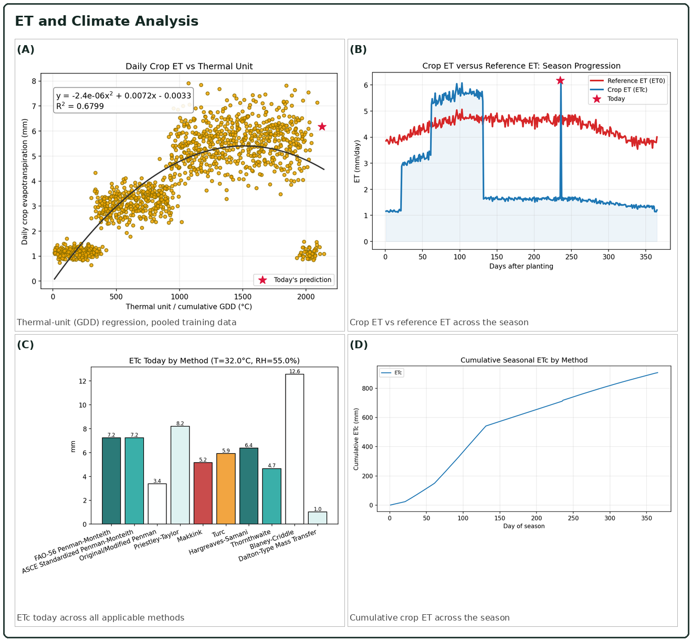
Figure 4: ET and climate analysis.
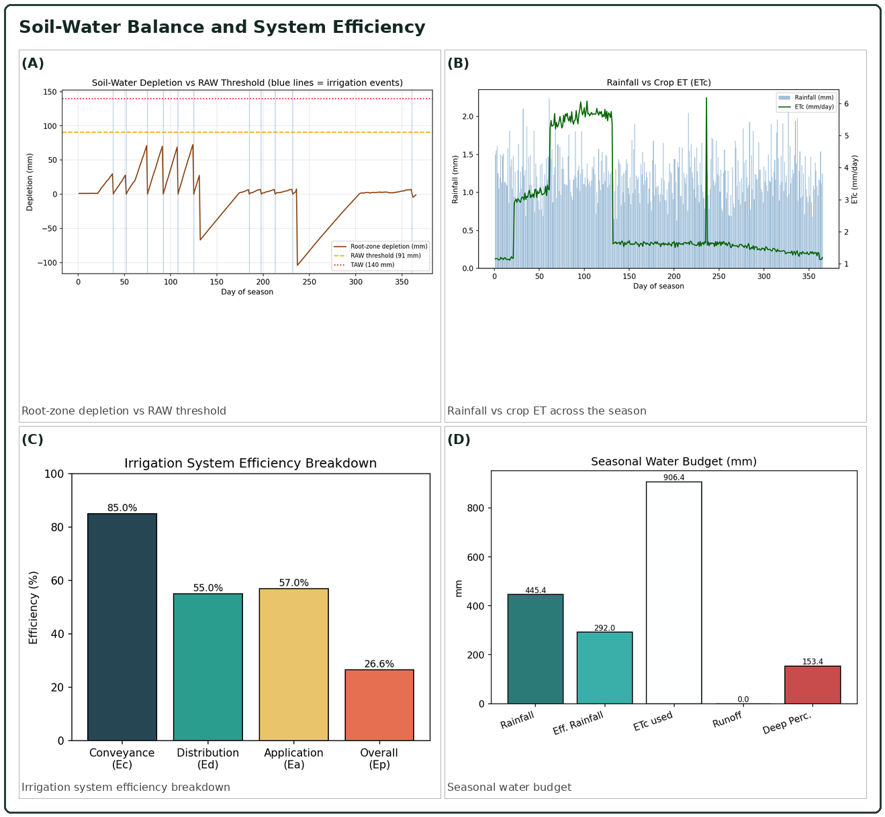
Figure 5: Soil-water balance and system efficiency.

9. Study Area: Terrain Characterisation
The figure below follows a standard QGIS-print-layout terrain-characterisation format (location, altitude distribution, slope, topographic profiles, aspect), sized to this farm's real entered area (3.0 ha) with an organic boundary shaped by the underlying terrain. This farm's modelled terrain averages 653.3 m a.s.l. with a mean slope of 21.67%.
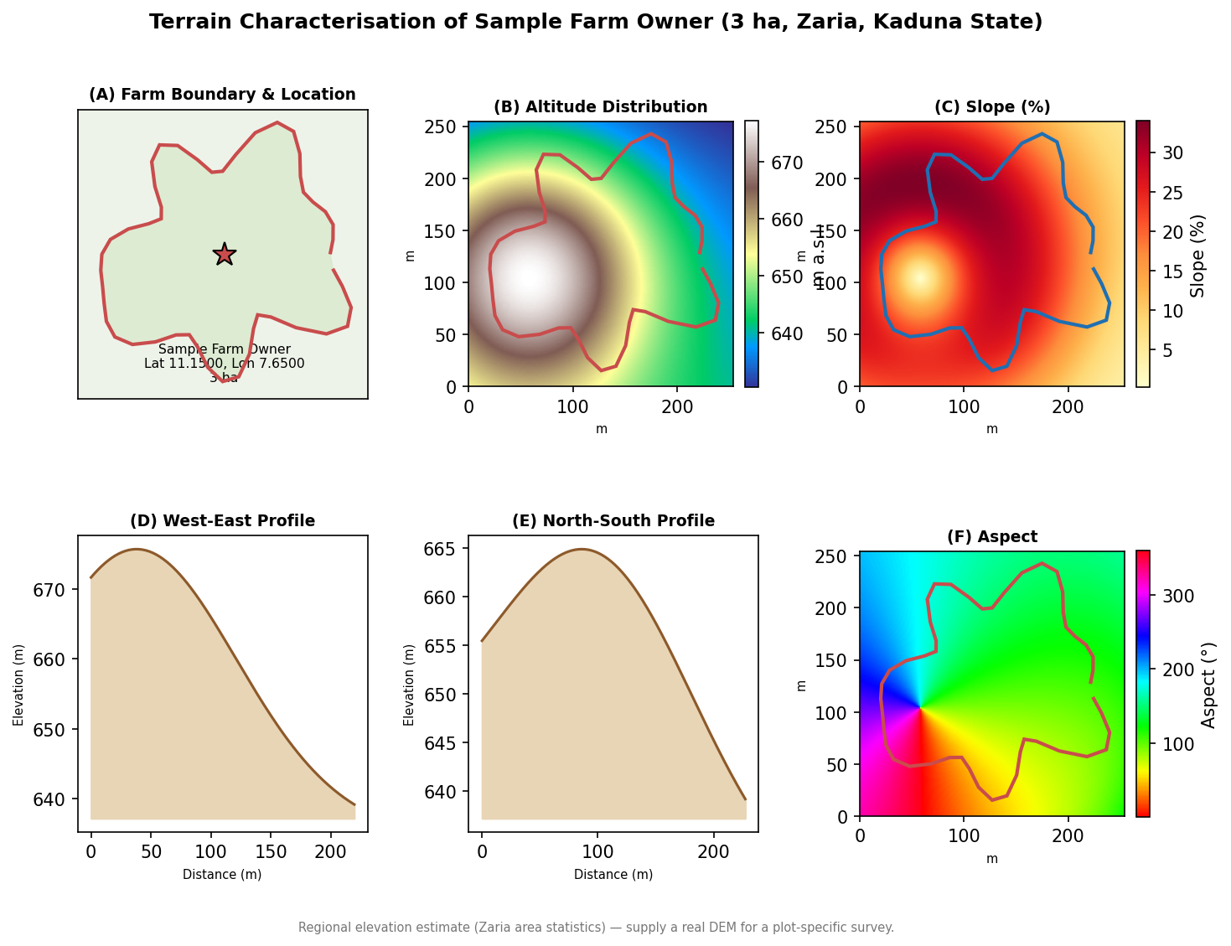
Figure 6: Terrain characterisation for this farm's own boundary.
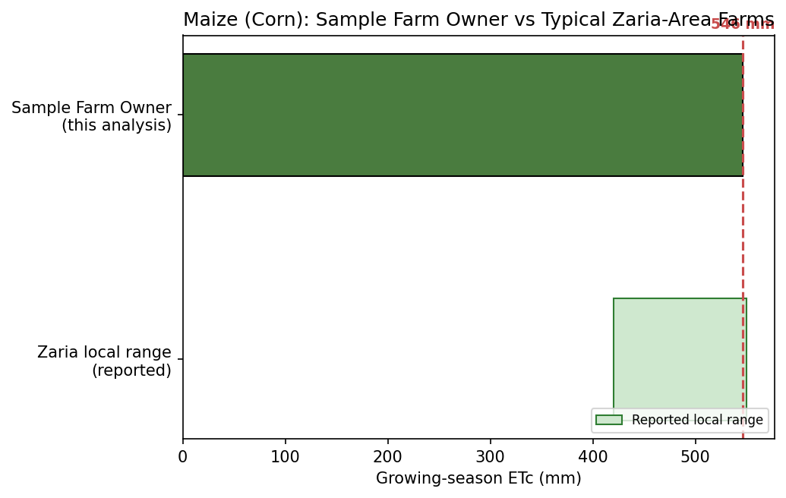
Figure 7: This farm's growing-season ETc compared with the locally-reported Zaria range for this crop.

10. Crop Growth Simulation: Germination to Harvest
Simulated planting (germination) date: 2026-08-24. Estimated harvest date: 2027-01-06 (136 days total). The growth-stage boundaries and crop coefficient (Kc) values are the same ones driving the ET/irrigation calculations elsewhere in this report; the canopy-cover curve shown is a proxy derived directly from Kc (not a remote-sensed or field-measured canopy observation).
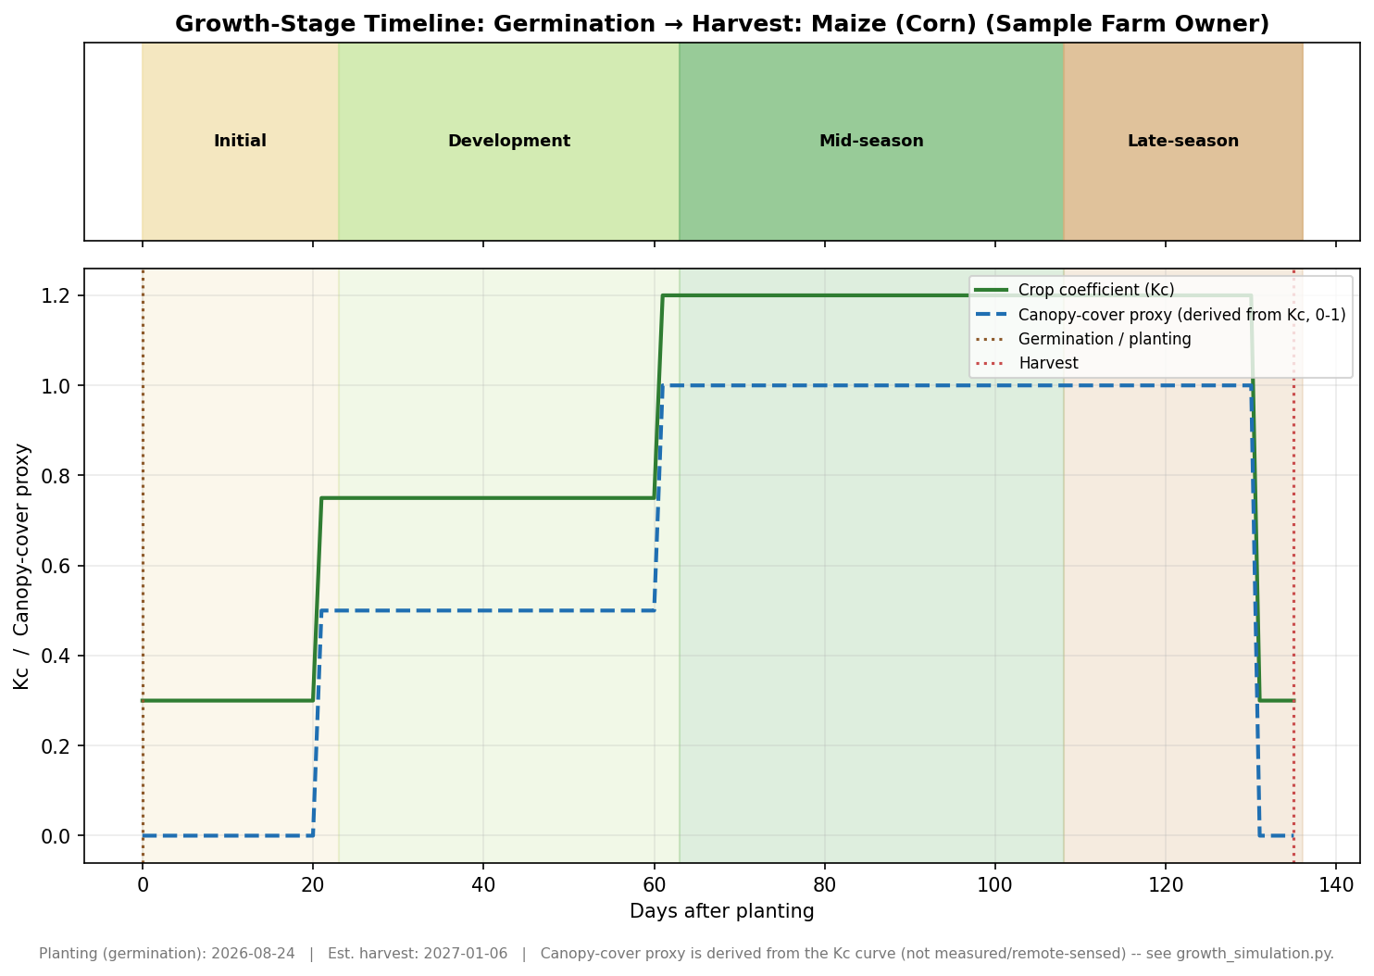
Figure 8: Growth-stage timeline and canopy-cover proxy, germination to harvest.

11. Stage-by-Stage Field Simulation and Water Accounting
A field picture for each growth stage (procedurally illustrated, not a photograph, no internet access to source real field imagery in this environment), alongside that stage's own water accounting: crop coefficient, ET split into evaporation (soil) vs transpiration (plant), mean soil-moisture retained, and irrigation required for this farm's area. Evaporation/transpiration are split using the standard FAO-56 canopy-cover proxy, not a lysimeter measurement.
Stage | Days | Kc | ETc (mm) | Evap. (mm) | Transp. (mm) | Irrigation (mm)
Nursery / Germination | 0-23 | 0.34 | 30.2 | 28.9 | 1.3 | 0.0 (0 m³)
Vegetative Development | 23-63 | 0.77 | 130.6 | 62.1 | 68.6 | 61.9 (1,857 m³)
Flowering / Mid-season | 63-108 | 1.2 | 250.4 | 0.0 | 250.4 | 223.0 (6,690 m³)
Maturity / Harvest | 108-136 | 1.04 | 138.5 | 24.7 | 113.7 | 76.8 (2,304 m³)
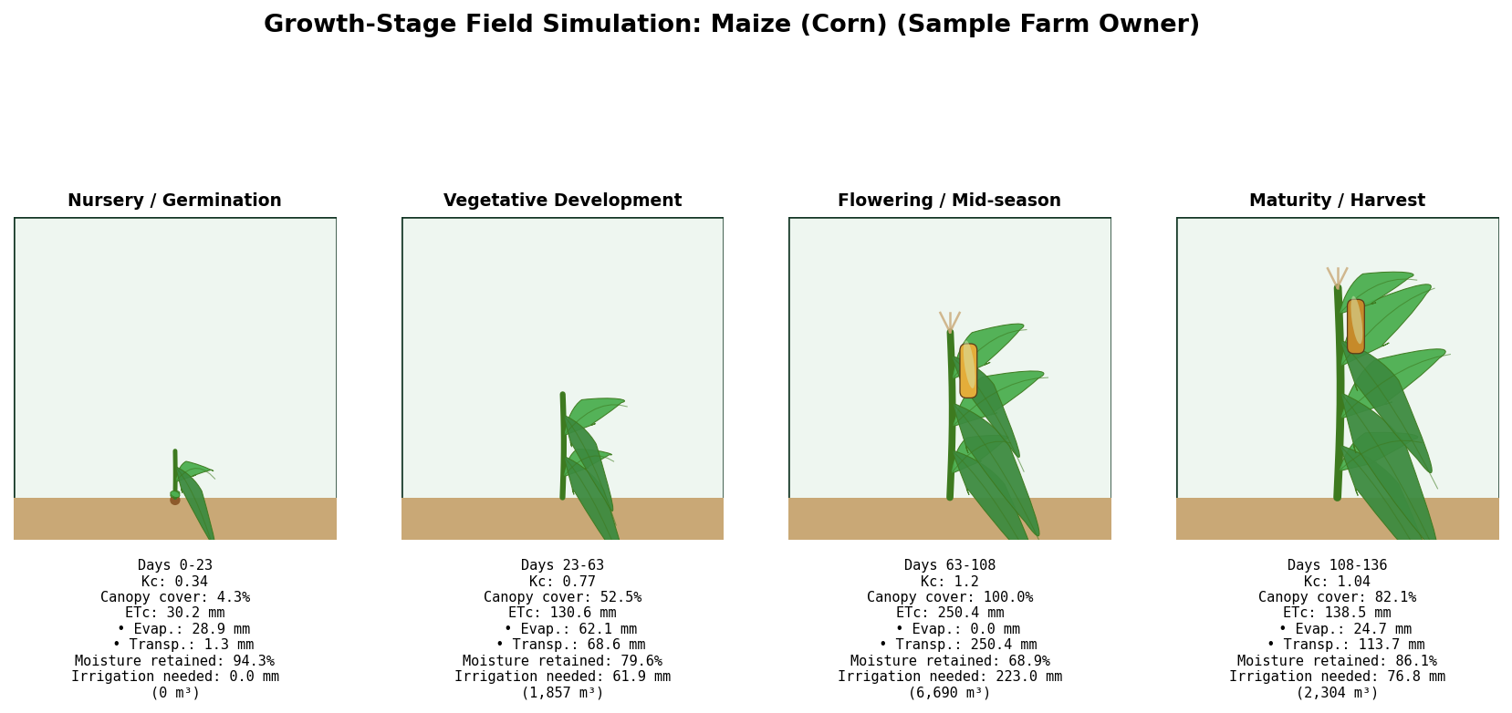
Figure 9: Field-stage simulation with per-stage water accounting.
An animated version of this simulation (a lightweight GIF cycling through the stages) is also available in the app's Figures tab / outputs folder; Word documents cannot embed animated images.

12. Estimated Productivity: Water-Yield Response Model
This estimate is specific to Sample Farm Owner's own simulated water-stress trajectory for the entered conditions, not a generic figure. A Water Stress Index (WSI) of 0.1239 was computed from this run's own daily soil-water-balance records (0 = never stressed, 1 = permanently at the depletion limit). A small neural network (trained on the published FAO-33 Doorenbos & Kassam water-yield response relationship for this crop's yield response factor, Ky = 1.25) converts that stress index into a relative yield of 82.1% of potential.
Water Stress Index (this run) | 0.1239
Yield response factor (Ky) | 1.25
Relative yield (Ya/Ym) | 82.1%
Reference potential yield range (Ym) | 4.0-6.5 t/ha
Estimated yield, this farm | 4.31 t/ha (range 3.28-5.33)
Estimated total production | 12.93 t over 3.0 ha
The potential-yield range (Ym) is a literature reference for improved-practice irrigated production in the wider West African/Nigerian context, not a measurement specific to this farm's soil or variety. Treat the estimated yield as an order-of-magnitude planning figure, and replace Ym with local trial or extension-service data where available for a tighter estimate.

13. What to Monitor for Maximum Productivity
Tailored to Maize (Corn) and to this run's own results (e.g. system efficiency is flagged first if it is unusually low).
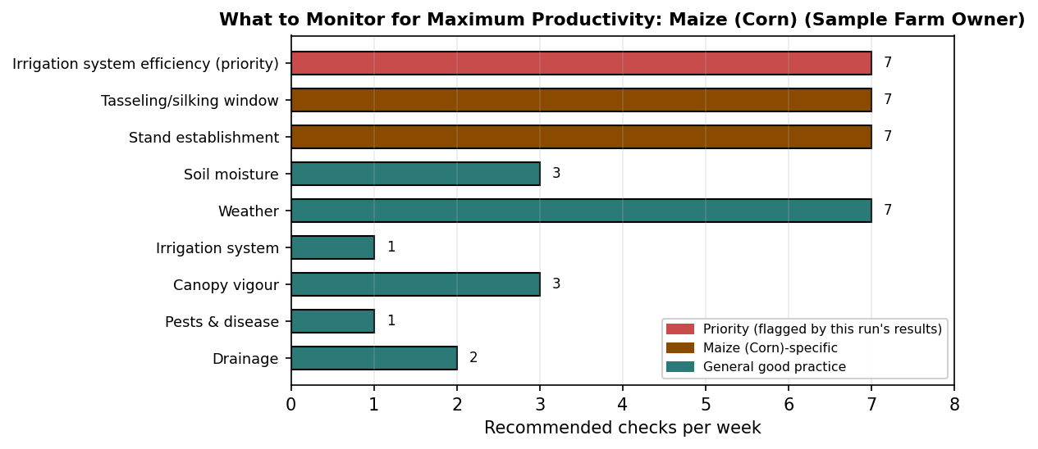
Figure 10: Recommended monitoring frequency by topic.
Irrigation system efficiency (priority): This farm's overall system efficiency is 26.65%, below a typical well-maintained target (~40-50%+), prioritise fixing conveyance/application losses before anything else, since it is the largest lever on actual water reaching the crop.
Tasseling/silking window: This is maize's single most water-sensitive period (Table 2, standard sensitivity references), never let depletion approach RAW here.
Stand establishment: Confirm uniform germination within 7-10 days of planting; gaps compound yield loss disproportionately for maize.
Soil moisture: Check root-zone moisture (by feel/probe at 10-20 cm) 2-3 times per week, especially in the days leading up to a scheduled irrigation event.
Weather: Track daily temperature, humidity and rainfall, re-run this tool whenever conditions change materially, since irrigation need shifts with them.
Irrigation system: Inspect the delivery network (mains/submains/laterals or furrows) for leaks, blockages or uneven flow at least weekly during the active season.
Canopy vigour: Watch leaf colour and turgor for early wilting/yellowing, often the first visible sign of water or nutrient stress, well before yield-affecting damage.
Pests & disease: Scout the field weekly, more often during humid/rainy periods, for common regional pests and fungal pressure that intensify under irrigation.
Drainage: Confirm excess water is draining away after heavy rain or irrigation, waterlogging suppresses root respiration and yield just as much as drought does.

14. Weekly Water Balance Summary
The full growing season, summarised week by week from the same daily soil-water-balance simulation driving every other number in this report: crop water use (ETc), rainfall, irrigation applied, and the root-zone depletion at the end of each week.
Week | Days | ETc (mm) | Rainfall (mm) | Irrigation (mm) | End Depletion (mm)
1 | 1-7 | 8.1 | 9.7 | 0.0 | 1.2
2 | 8-14 | 8.1 | 8.6 | 0.0 | 1.3
3 | 15-21 | 8.2 | 9.6 | 0.0 | 1.2
4 | 22-28 | 20.8 | 7.9 | 0.0 | 14.0
5 | 29-35 | 21.3 | 9.0 | 0.0 | 26.4
6 | 36-42 | 22.0 | 8.9 | 31.6 | 9.0
7 | 43-49 | 22.4 | 8.0 | 0.0 | 23.4
8 | 50-56 | 22.6 | 7.3 | 30.3 | 9.7
9 | 57-63 | 27.4 | 10.6 | 0.0 | 26.4
10 | 64-70 | 37.5 | 9.4 | 0.0 | 54.5
11 | 71-77 | 37.9 | 9.3 | 74.9 | 9.6
12 | 78-84 | 39.0 | 8.8 | 0.0 | 39.8
13 | 85-91 | 38.7 | 8.2 | 0.0 | 70.2
14 | 92-98 | 39.9 | 9.1 | 74.7 | 27.6
15 | 99-105 | 40.4 | 8.2 | 0.0 | 59.8
16 | 106-112 | 39.7 | 8.8 | 73.4 | 18.6
17 | 113-119 | 40.1 | 7.8 | 0.0 | 50.9
18 | 120-126 | 39.4 | 9.1 | 76.8 | 5.5
19 | 127-133 | 31.4 | 7.8 | 0.0 | -65.2
20 | 134-140 | 11.6 | 8.3 | 0.0 | -53.6

15. Methodology and Data Sources
Every model, equation, and data source used to produce this report, stated explicitly.
Reference evapotranspiration (ET0): Ten published methods are evaluated in parallel for today's entered temperature and humidity, including FAO-56 Penman-Monteith, ASCE Standardized Penman-Monteith, the original Penman equation, Priestley-Taylor, Hargreaves-Samani, Makkink, Turc, Thornthwaite, Blaney-Criddle, and Dalton-type mass transfer. The predicted ETc shown throughout this report is the ensemble mean of whichever methods have sufficient data to run for the entered conditions.
Crop coefficient (Kc): For maize, the real field-measured Kc calendar from a 28-year Zaria daily weather/water-balance dataset. For rice, sorghum, pepper, and cowpea, the published FAO-56 stage-wise Kc curve, rescaled to this crop's own locally-reported growing-season length and calibrated so the modelled seasonal total matches the midpoint of the locally-reported ETc range for that crop in the Zaria area.
Soil-water balance: A daily root-zone water balance (FAO-56 Chapter 8 approach) tracking rainfall infiltration, deep percolation, crop water use, and irrigation triggers, with a root zone depth that grows from a shallow nursery-stage value toward the crop's mature depth as canopy cover develops, rather than a single fixed depth for the whole season.
Irrigation scheduling: A standardised, stage-specific interval schedule (nursery, vegetative, flowering/fruiting, maturity), following a field-reported reference table of typical intervals for each stage and crop, with application depth computed from that day's own root-zone capacity.
Irrigation system efficiency: Standard published conveyance, distribution, and field application efficiency ranges for the configured irrigation method (furrow by default).
Productivity estimate: The FAO Irrigation and Drainage Paper No. 33 (Doorenbos and Kassam, 1979) water-yield response relationship, with the crop's own published yield response factor (Ky), evaluated via a small neural network trained on that published relationship across this run's own computed water-stress index. Absolute yield uses a literature-reported potential-yield range for improved-practice irrigated production in the region.
Terrain and farm layout: This environment has no internet access, so no real satellite imagery, Google Earth Engine data, or surveyed Digital Elevation Model could be retrieved for any specific farm. The terrain and boundary figures in this report are a regional model calibrated to Zaria's documented elevation statistics, deterministic and unique per farm name and coordinates, clearly labelled on the figure itself. Replace with real surveyed data when available for field use.

16. Glossary
ET0 (Reference evapotranspiration): The water use rate of a hypothetical, well-watered reference grass surface, driven only by weather (mm/day).
ETc (Crop evapotranspiration): The actual water use rate of the specific crop grown, equal to ET0 multiplied by the crop coefficient (Kc).
Kc (Crop coefficient): A multiplier, specific to the crop and its growth stage, that converts reference ET0 into crop-specific ETc.
TAW (Total Available Water): The total amount of water the root zone can hold between field capacity and the permanent wilting point (mm).
RAW (Readily Available Water): The portion of TAW the crop can safely use before irrigation should be triggered, without yield-affecting stress (mm).
Depletion (Dr): How much of the RAW/TAW has actually been used up on a given day (mm).
VPD (Vapour Pressure Deficit): The difference between the saturation and actual vapour pressure of the air, driven by temperature and humidity, a direct measure of atmospheric drying power (kPa).
Ks (Water stress coefficient): A 0-1 multiplier applied to potential ETc when the crop is under water stress, where 1.0 means no stress and lower values mean reduced water use due to insufficient soil moisture.
Ky (Yield response factor): A published, crop-specific constant describing how sensitive final yield is to a given amount of water stress over the season.
WSI (Water Stress Index): This report's own summary measure of how close to the safe depletion limit the crop's root zone typically was, averaged across the season (0 = never stressed, 1 = permanently at the limit).
Ea, Ec, Ed (Irrigation efficiencies): Application, conveyance, and distribution efficiency: the fraction of water that survives each stage of delivery from source to the root zone without being lost.

17. Assumptions and Limitations
A summary, in one place, of every assumption and known limitation behind the numbers in this report, so it can be read alongside the results rather than only being scattered through the methodology notes above.
Weather: Today's temperature and humidity are exactly what was entered; all other days in the season use a 28-year day-of-year climatological average, not a real forecast.
Soil: Field capacity, wilting point, and root-zone depth are standard published values for the assumed soil texture, not a laboratory analysis of this specific field.
Irrigation system: Conveyance, distribution, and application efficiencies use standard published ranges for the selected method, not a measurement of this farm's actual infrastructure condition.
Terrain and boundary: The terrain figures use a regional elevation model calibrated to Zaria's documented statistics rather than a survey of this specific field, clearly marked on the figure itself.
Productivity estimate: The yield figure is an order-of-magnitude planning estimate from a published water-yield response relationship and a literature-reported potential-yield range, not a field trial result for this farm's soil or variety.
Crop calibration: Only maize uses a field-measured crop-coefficient calendar from a 28-year Zaria dataset; the other four crops use published FAO-56 curves calibrated to locally-reported seasonal totals.

