A Project Report
on
Crime Data Analysis & Prediction: A Machine Learning Approach for Indian States Using Support Vector Regression
Submitted for partial fulfillment of the award of the degree of

BACHELOR OF TECHNOLOGY

in

Computer Science Engineering

by

K Gopi Nath – 22BQ1A0585
Benny – 22BQ1A05
Satwika – 22BQ1A05
Praveen – 22BQ1A05

Under the guidance of
Mr. xxxxx
Assistant Professor, CSE

(Autonomous)
VASIREDDY VENKATADRI INSTITUTE OF TECHNOLOGY
Approved by AICTE, Permanently Affiliated to JNTU, Kakinada
Accredited by NAAC with ‘A’ Grade - ISO 9001:2008 Certified
Nambur (V), Peda Kakani (M), Guntur Dt. - 522508
April, 2026.
VASIREDDY VENKATADRI INSTITUTE OF TECHNOLOGY
Department of Computer Science & Engineering



CERTIFICATE

This is to certify that the project report titled “Crime Data Analysis & Prediction: A Machine Learning Approach for Indian States Using Support Vector Regression” is being submitted by Ms. satwika – 22BQ1A05xx, Mr. Gopi – 22BQ1A05xx, Mr. benny – 22BQ1A05xx, Mr. Benny – 22BQ1A05xx in IV B.Tech II semester Computer Science & Engineering is a record bonafide work carried out by them. The results embodied in this report have not been submitted to any other University for the award of any degree.

Project Guide  (Mr. xxxxxxxxx, Assistant Professor) | Head of Department  (Dr. V. Ramachandran, Professor)

Submitted for Viva-voce Examination held on

Internal Examiner | External Examiner

DECLARATION FORMAT

We, Ms. Satwika Mr. gopi, Mr.praveen, Mr. benny hereby declare that the Project Report entitled done by me under the guidance of Mr. xxxxxxxxxx, Professor, Department of CSE at Vasireddy Venkatadri Institute of Technology is submitted in partial fulfillment of the requirements for the award of degree in Computer Science Engineering.

DATE :

PLACE :

SIGNATURE OF THE CANDIDATE
1. xxxxxxxxxxx
2. xxxxxxxxxxx
3. xxxxxxxxxxx
4. xxxxxxxxxxx

ACKNOWLEDGEMENT

We take this opportunity to express our deepest gratitude and appreciation to all those people who made this project work easier with words of encouragement, motivation, discipline, and faith by offering different places to look to expand our ideas and help me towards the successful completion of this project work.
First and foremost, we express our deep gratitude to Mr. Vasireddy Vidya Sagar, Chairman, Vasireddy Venkatadri Institute of Technology for providing necessary facilities throughout the B.Tech programme.
We express my sincere thanks to Dr. Y. Mallikarjuna Reddy, Principal, Vasireddy Venkatadri Institute of Technology for his constant support and cooperation throughout the B.Tech programme.
We express our sincere gratitude to Dr. V. Ramchandran, Professor & HOD, Computer Science & Engineering, Vasireddy Venkatadri Institute of Technology for his constant encouragement, motivation and faith by offering different places to look to expand our ideas.
We would like to express our sincere gratefulness to our guide Mr. xxxxx xxxxx for his insightful advice, motivating suggestions, invaluable guidance, help and support in successful completion of this project.
We would like to take this opportunity to express our thanks to the teaching and non-teaching staff in the Department of Computer Science & Engineering, VVIT for their invaluable help and support.

Name(s) of the Students

xxxxxxxxxxxxxx | -22BQ1A05xx
Xxxxxxxxxxxxxx | -22BQ1A05xx
Xxxxxxxxxxxxxxx | -22BQ1A05xx
xxxxxxxxxxxxxxxx | -22BQ5A05xx

VASIREDDY VENKATADRI INSTITUTE OF TECHNOLOGY
Permanently Affiliated to JNTU Kakinada, Approved by AICTE
Accredited by NAAC with 'A' Grade, IS09001:2008 Certified
Nambur, Pedakakani(M), Guntur(Ot) -522508
DEPARTMENT OF COMPUTER SCIENCE & ENGINEERING
B.Tech Program is Accredited by NBA
(Autonomous)

Vision of the Department
Providing quality education to enable the generation of socially conscious software engineers who can contribute to the advancement in the field of computer science and engineering.

Mission of the Department
- To equip the graduates with the knowledge and skills required to enable them to be industry ready.
- To train socially responsible, disciplined engineers who work with good leadership skills and can contribute for nation building.
- To make our graduates proficient in cutting edge technologies through student centric teaching-learning process and empower them to contribute significantly to the software industry
- To shape the department into a centre of academic and research excellence



VASIREDDY VENKATADRI INSTITUTE OF TECHNOLOGY
Permanently Affiliated to JNTU Kakinada, Approved by AICTE
Accredited by NAAC with 'A' Grade, IS09001:2008 Certified
Nambur, Pedakakani(M), Guntur(Ot) -522508
DEPARTMENT OF COMPUTER SCIENCE & ENGINEERING
B.Tech Program is Accredited by NBA
(Autonomous)
Program Educational Objectives
PEO-1 | To provide the graduates with solid foundation in Computer Science and Engineering along with the fundamentals of Mathematics and Sciences with a view to impart in them high quality technical skills like modeling, analyzing, designing, programming and implementation with global competence and helps the graduates for life-long learning.
PEO-2 | To prepare and motivate graduates with recent technological developments related to core subjects like Programming, Databases, Design of Compilers and Network Security aspects and future technologies so as to contribute effectively for Research & Development by participating in professional activities like publishing and seeking copy rights.
PEO-3 | To train graduates to choose a decent career option either in high degree of employability/Entrepreneur or, in higher education by empowering students with ethical administrative acumen, ability to handle critical situations and training to excel in competitive examinations.
PEO-4 | To train the graduates to have basic interpersonal skills and sense of social responsibility that paves them a way to become good team members and leaders.

Program Specific Outcomes (PSOs)

PSO-1: Professional Skills: The ability to understand, analyze and develop computer programs in the areas related to algorithms, system software, multimedia, web design, big data analytics, and networking for efficient design of computer-based systems of varying complexity.

PSO-2: Successful Career and Entrepreneurship: The ability to employ modern computer languages, environments, and platforms in creating innovative career paths to be an entrepreneur and a zest for higher studies/employability in the field of Computer Science & Engineering.




VASIREDDY VENKATADRI INSTITUTE OF TECHNOLOGY
Permanently Affiliated to JNTU Kakinada, Approved by AICTE
Accredited by NAAC with 'A' Grade, IS09001:2008 Certified
Nambur, Pedakakani(M), Guntur(Ot) -522508
DEPARTMENT OF COMPUTER SCIENCE & ENGINEERING
B.Tech Program is Accredited by NBA

Program Outcomes:

1. Engineering knowledge: apply the knowledge of mathematics, science, engineering fundamentals and an engineering specialization to the solution of complex engineering problems. (L3-Apply)
2. Problem analysis: identify, formulate, review research literature, and analyze complex engineering problems reaching substantiated conclusions using first principles of mathematics, natural science and engineering sciences. (L4-Analysis)
3. Design/development of solutions: design solutions for complex engineering problems and design system components or processes that meet the specified needs with appropriate consideration for the public health and safety, and the cultural, societal and environmental considerations. (L6-Create)
4. Conduct investigations of complex problems: use research based knowledge and research methods including design of experiments, analysis and interpretation of data, and synthesis of the information to provide valid conclusions. (L5-Evaluation)
5. Modern tool usage: create, select and apply appropriate techniques, resources and modern engineering and IT tools including prediction and modeling to complex engineering activities with an understanding of the limitations. (L3-Apply)
6. The engineer and society: apply reasoning informed by the contextual knowledge to assess societal, health, safety, legal and cultural issues and the consequent responsibilities relevant to the professional engineering practice. (L3-Apply)
7. Environment sustainability: understand the impact of the professional engineering solutions in the societal and environmental contexts, and demonstrate the knowledge of, and need for sustainable development. (L2-Understand)
8. Ethics: apply ethical principles and commit to professional ethics and responsibilities and norms of the engineering practice. (L1-Remember)
9. Individual and team work: function effectively as an individual and as a member or leader in diverse teams, and in multidisciplinary settings. (L1-Remember)
10. Communication: communicate effectively on complex engineering activities with the engineering community and with society at large, such as, being able to comprehend and write effective reports and design documentation, make effective presentations, and give and receive clear instructions. (L1-Remember)
11. Project management and finance: demonstrate knowledge and understanding of the engineering and management principles and apply these to one’s own work, as a member and leader in a team, to manage projects and in multidisciplinary environments. (L3-Apply)
12. Lifelong learning: recognize the need for, and have the preparation and ability to engage in independent and lifelong learning in the broader context of technological change. (L1-Remember)

Table of Contents
CH No. | Title | Page No
 | Table of Contents | i
 | List of Tables | iii
 | List of Figures | iv
 | List of Symbols/Abbreviations | v
 | Abstract | vi
1. | INTRODUCTION | 1-4
 | 1.1 Overview of Crime Data Forecasting | 1
 | 1.2 Motivation and Need for Proactive Policing | 2
 | 1.3 Project Objectives | 3
2. | AIM AND SCOPE OF THE PRESENT INVESTIGATION | 5-11
 | 2.1 Existing System (Limitations & Gaps in Current Models) | 6
 | 2.2 Proposed System (Scope & Advantages of SVR-based Model) | 8
3. | CONCEPT AND METHODS; ALGORITHMS USED AND DESIGN | 12-15
 | 3.1 System Architecture and Block Diagram | 12
 | 3.2 Data Collection and Aggregation (NCRB Dataset) | 13
 | 3.3 Data Preprocessing and Feature Engineering | 14
 | 3.4 Algorithm Used: Support Vector Regression (SVR) | 15
4. | IMPLEMENTATION | 17-29
 | 4.1 Environment Setup, Packages, and Tools Used | 17
 | 4.2 Module-Wise Implementation Details | 20
 | 4.3 Important Fragments of Code | 28
5. | RESULTS AND DISCUSSION, TESTING AND PERFORMANCE ANALYSIS | 30-40
 | 5.1 Experimental Setup and Hyperparameter Tuning | 30
 | 5.2 Performance Analysis and Metrics (RMSE & MAPE) | 31
 | 5.3 Results and Discussion (Validation Predictions) | 32
 | 5.4 Output Screenshots and Visualizations (Heatmap Dashboards) | 34
6. | SUMMARY AND CONCLUSIONS | 37-40
 | 6.1 Summary of Achievements | 37
 | 6.2 Limitations of the Study | 38
 | 6.3 Future Research and Enhancements | 39
 | References | 40-43

LIST OF TABLES
- Table 1: Feature Importance Rankings

LIST OF FIGURES

- Fig 1: UML Sequence Diagram for Crime Prediction System.
- Fig 2: UML Activity Diagram for Crime Prediction System
- Fig 3: PowerShell automated Script for packages
- Fig 4: Script running data processor and starting the application
- Fig 5: Modular Structure of Project
- Fig 6: Initial Data Visualization
- Fig 7: Data Pre-Processing
- Fig 8: Raw Data Visualization
- Fig 9: Processed Data Visualization
- Fig 10: Trainer Architecture Diagram
- Fig 11: Support Vector Machine (SVR) Trainer
- Fig 12: Data Aggregation
- Fig 13: Encode categorical features
- Fig 14: Encoded Categorical features
- Fig 15: Training Accuracy vs Validation For Epoches
- Fig 16: Validation Predication
- Fig 17: Visualization of Past Crime Data.
- Fig 18: Crime Data Forecasting Timeline.
- Fig 19: Long-Term Forecasting for the State (AP).
- Fig 20: Forecasting Crime Representation in MAP.

LIST OF ABBREVIATIONS
- CNN: Convolutional Neural Network
- GeoJSON: Geographic JavaScript Object Notation
- LightGBM: Light Gradient Boosting Machine
- LSTM: Long Short-Term Memory
- MAPE: Mean Absolute Percentage Error
- ML: Machine Learning
- NCRB: National Crime Records Bureau
- RBF: Radial Basis Function
- RMSE: Root Mean Square Error
- SVR: Support Vector Regression
- XGBoost: Extreme Gradient Boosting

LIST OF SYMBOLS
- C: Regularization parameter (controls the trade-off between model flatness and training error)
- ε (Epsilon): The margin of tolerance/distance where no penalty is given to errors in SVR
- Γ (Gamma): Kernel coefficient for the Radial Basis Function (controls the influence of individual training samples)
- $ξ, ξ^{*}$ (Xi): Slack variables for data points that fall outside the epsilon-tube
- w: Weight vector / Normal vector to the hyperplane
- b: Bias term

ABSTRACT

The increase in the rate of urbanization and the population has caused a sharp rise in the number of criminal activities. Therefore, there exists a need to curb these activities in a proactive way. In this context, this work proposes an AI model that can predict the frequency of such activities by using the power of ML and data science. Using the previous records of crime in India, this system uses the National Crime Records Bureau (NCRB) data from 2020 to 2023 to predict the number of such activities based on parameters such as state, year, month, and type.
This model has been successfully implemented using a stack involving the Python programming language, along with significant data preprocessing techniques. In order to effectively capture the intricate temporal and spatial relationships, we have utilized the concept of Support Vector Regression (SVR) to effectively capture the non-linear relationships in the crime data. The algorithm has been successfully trained on 27,054 instances of aggregated crime data with a Validation Root Mean Square Error (RMSE) of 5637.61 and an extremely promising Mean Absolute Percentage Error (MAPE) of 18.22%.
Moreover, in order for the system to be practically useful for law enforcement, the output of the predictions is not limited to numerical values. Instead, it has the ability to generate a prediction regarding zones that are more prone to crime through interactive heat maps. The system can be accessed as a web application using the Streamlit library. This makes complex machine learning predictions a user-friendly tool for proactive crime prevention.

CHAPTER 1

INTRODUCTION

1.1 Overview of Crime Data Forecasting
The fast pace of urbanization coupled with the constant rise in the population dynamics has changed the socioeconomic scenario of contemporary society to a great extent, which has inadvertently led to an increase in the rate of various criminal activities. The rise in urbanization has increased the complexity of maintaining law and order to a greater extent. Therefore, it is no longer a sustainable option to simply wait for the crimes to happen and then try to resolve the situation. This is the new era of change that has to be addressed with the help of advanced computational techniques to avoid the crimes from happening.
Crime data forecasting appears to be a very important and relevant interdisciplinary science that combines elements from both criminology and computer science. The process appears to involve the scientific study of past data related to crimes in a given region and the use of such data to forecast future instances of various criminal activities. The basis for such a prediction lies in the elementary assumption that crime rates do not tend to occur randomly in a given region. Instead, there appears to be an intricate web of factors that influence such rates. Using Artificial Intelligence and Machine Learning techniques, data scientists can process such massive and complex data sets in order to identify these non-linear relationships.
In the context of this project, the focus is squarely placed on the Indian landscape, making extensive use of the data provided by the National Crime Records Bureau (NCRB). The NCRB is the primary repository of crime statistics in India. It maintains detailed reports of crime incidents occurring across the country. This raw data on crime incidents occurring over the period of 2020 to 2023 is aggregated to form the foundation of a strong time-series regression analysis. The core of the forecasting system lies in the spatial factors such as the state, along with the temporal factors such as the year and the month.
In order to accomplish this, a complex machine learning framework is employed, utilizing a Support Vector Regression (SVR). The nature of crime-related data is inherently noisy, with complex, non-linear relationships resulting from factors such as seasonality, geographical variations, and differing levels of reported crime events. SVR is particularly useful in a noisy, complex environment, as it uses a kernel function to map input data into a higher-dimensional space, thus overcoming the curse of dimensionality.
Moreover, the scope of an overview of crime data forecasting would not be complete unless it also considers not only the process of creating numerical predictions but also the process of converting these numbers into "intelligence." In this regard, creating interactive visualizations of crime volume predictions through "heat maps" is an essential feature of crime data forecasting systems. The process of creating "heat maps" of predicted "crime hotspots" effectively translates machine learning algorithms into a format that is easily comprehended by users of crime data forecasting systems, allowing them to make informed decisions based on this data.

1.2 Motivation and Need for Proactive Policing
The major reason for undertaking this investigation arises from the major limitations that exist in traditional policing methodologies. In the past, law enforcement organizations have always worked on a reactive basis; that is, law enforcement responses are initiated only after a crime has been reported. This traditional method seeks to address crime issues that have already taken place; moreover, it lacks a focus on preventive measures. This traditional method has often proven inefficient; that is, a great deal of time is taken, optimal resources are wasted, and the end result is that the effects of the crime are not mitigated.
As the complexity of criminal networks increases with the sophistication of criminal organizations, coupled with the growing complexity of urban living with the rise of urbanization and the resultant increase in population density, the pressing need to transition from a reactive approach to a more proactive policing approach has become a paramount concern for public administration. Proactive policing is based on the anticipation of criminal activity with the goal of disrupting the opportunity structures that facilitate crime. The integration of data analytics and machine learning has provided unprecedented opportunity to revolutionize the transition from reactive to proactive policing. By examining past crime data, it is possible to gain a deeper understanding of the underlying patterns that drive crime and accurately predict the location and timing of a particular crime.
In spite of the obvious advantages that predictive modeling offers, there is a large gap in the current research and application scenario. While a number of research papers have been written on the application of machine learning algorithms for the prediction of crimes, the vast majority of the existing research has been based on the application of these models for Western cultures. This is because the majority of the existing research has been based on data with socio-economic factors that may not be applicable to the scenario in India. Additionally, the majority of the existing research does not incorporate the required time factors as well as the interactive visualization that is required for the practical application of the models.
In the case of India, the NCRB releases annual reports on the descriptive analysis of the crime scenario. However, the reports that are released are largely retrospective in nature. There is a dire need for the application of predictive models for the assessment of threats.
Another major motivation for this work is the deployment problem that is commonly seen in academic machine learning papers. In most cases, complex prediction models remain on paper or in complex codebases, never reaching the end users, the police planners, the police analysts, or the police officers on the ground. Moreover, law enforcement officials are usually not aware or do not have the necessary skills or expertise to run Python scripts or interpret complex array data. Hence, there is a pressing need for a bridge between complex data science and usability. This project was motivated by the need not only to build a forecasting model that works well but also to package it into a user-friendly web application. This way, the application is no longer just a theoretical exercise in computer programming; it becomes a tangible tool for proactive policing.

1.3 Project Objectives
In spite of the obvious advantages that predictive modeling offers, there is a large gap in the current research and application scenario. While a number of research papers have been written on the application of machine learning algorithms for the prediction of crimes, the vast majority of the existing research has been based on the application of these models for Western cultures. This is because the majority of the existing research has been based on data with socio-economic factors that may not be applicable to the scenario in India. Additionally, the majority of the existing research does not incorporate the required time factors as well as the interactive visualization that is required for the practical application of the models.
In the case of India, the NCRB releases annual reports on the descriptive analysis of the crime scenario. However, the reports that are released are largely retrospective in nature. There is a dire need for the application of predictive models for the assessment of threats.
Another major motivation for this work is the deployment problem that is commonly seen in academic machine learning papers. In most cases, complex prediction models remain on paper or in complex codebases, never reaching the end users, the police planners, the police analysts, or the police officers on the ground.

1. Development of a Robust Data Preprocessing and Aggregation Pipeline
The first major objective is to create a data pipeline that is scalable and can process raw data related to crime incidents obtained from the National Crime Records Bureau (NCRB) for the period between 2020 and 2023. Raw crime data is generally unstructured for time series forecasting, where data is described in various forms of text, including information related to districts and time stamps that are not uniform. The major aim is to create a solution that cleans, normalizes, and transforms raw data into a structured format that is suitable for time series forecasting through aggregation of raw data chronologically (Year-Month) and categorically (State-Crime Type).

2. Implementation of Support Vector Regression (SVR) for Non-Linear Forecasting
The second objective centers on the core algorithmic implementation of the predictive engine. The project aims to apply Support Vector Regression (SVR) to model and predict monthly crime counts. SVR was specifically chosen as the objective algorithm due to its proven efficacy in handling non-linear relationships and high-dimensional spaces. The model must be trained using the engineered temporal features alongside encoded categorical features to capture the intricate, cyclical patterns of criminal activity across different geographical zones. This objective includes the rigorous optimization of SVR hyperparameters (such as the regularization parameter C, epsilon, and kernel coefficient gamma) to ensure optimal generalization on unseen future data.

3. Critical Evaluation and Metric Analysis of the Predictive Model
It is important to note that merely developing a model is not enough. The third objective calls for a critical analysis and assessment of the predictive capability of the SVR model. The goal here is to evaluate the accuracy and margin of error for the model using standard measures such as Root Mean Square Error and Mean Absolute Percentage Error. Moreover, this third objective calls for a transparent analysis and assessment of the limitations of the model. It demands an analysis and assessment of how the e-insensitive loss function of the SVR algorithm copes with peak values or a sudden spike in the data set related to crime.

4. Design and Deployment of an Interactive Visualization Dashboard
The last goal is centered on the practicality and usability of the technology that is being developed. In order for the predictive model to be useful for law enforcement officials who do not have in-depth technical knowledge, the goal is for the entire system to be deployable as a web-based application. Using the Streamlit library, the goal is for an interactive dashboard that can display dynamic crime heatmaps to be created. The interactive nature of the system will allow users to input specific parameters such as the state they want to focus on, the year, and the month, and will display a visual representation of the predicted hotspots for crimes. The last goal is for the system to shift from a back-end predictive script to a front-end proactive policing system.

CHAPTER 2
AIM AND SCOPE OF THE PRESENT INVESTIGATION
2.1 Existing System
The basic framework for law enforcement and crime control has, in most instances, been based on a reactive approach. The traditional framework for law enforcement is a reactive approach, as it involves dealing with criminal activities after they have occurred and does not focus on preventing these activities from taking place.
In the traditional framework, law enforcement agencies, such as police departments and investigative bodies, are primarily concerned with responding to emergency calls, dispatching law enforcement officers to crime scenes after a criminal activity has occurred, and then conducting further forensic and investigative activities aimed at tracking down perpetrators of criminal activities. This is normally an inefficient system, as it takes a long time for law enforcement agencies to respond to criminal activities, and by the time they do, the damage has already been done, making it difficult for law enforcement agencies to contain the rising criminal activities resulting from urbanization and increased population growth.
In the recent past, the academic and technological community has been trying to resolve these inefficiencies in the current systems with the help of data analytics and machine learning. Several research studies have been conducted to apply machine learning to predict crimes. However, the current systems and the proposed models in the literature face several critical gaps that make it difficult to apply the models for practical purposes.

Limitations of Current Machine Learning Solutions:
- Computational Overhead and Deep Learning: Several modern existing systems rely heavily on complex neural architectures. For instance, Wang et al. suggested a method of crime prediction using a deep learning technique, which indicated that crime data in urban areas could be analyzed using complex patterns. The drawback of their method is that it requires a lot of computational resources and data for training. For many regional police departments with limited IT infrastructure, deploying and maintaining such computationally expensive models is unfeasible.
- Overlooked Temporal Dynamics: The other techniques have followed a simpler approach by using tree-based models. Another prediction model for crime prediction using random forests and decision trees was proposed by Kang and Kang. The results were found to be reasonable for property crimes in urban areas. In these existing systems, the importance of selecting the features has been given more importance. The time factor has not been taken into consideration. Crime is associated with time factors such as time of day, month, and season. Ignoring these factors results in static and inaccurate results.

- Lack of Interpretability in Ensemble Methods: Some researchers have attempted to solve crime prediction problems using ensemble techniques. Ensemble techniques are combinations of multiple models to produce a more accurate result. Although it is a powerful technique, it is not suitable in our case since it is not easily understandable, which is important in law enforcement. Police commanders require transparent models to justify resource allocation and strategic decisions, making "black box" ensemble predictions problematic.

- Feature Engineering Limitations: In existing research, feature engineering is often underdeveloped. Most of the existing studies are based on basic temporal features without comprehensive historical aggregations. This prevents the models from understanding long-term trends and spatial-temporal interactions.

Geographical and Contextual Bias (The Western Focus): Perhaps the most significant gap in the existing systems is their geographical bias. Most of the existing approaches are based on Western culture, contain few time-related attributes, or lack interactive visualization capabilities. There is limited validation of models in Indian urban environments. Burchfield has mentioned that the majority of the existing studies validate their models on Western cities, with few tests conducted on urban India, which has its own socio-economic factors. Almanie et al. showed the significant variation of the patterns of crimes in different cultural and geographical settings, which further emphasizes the need for models to be developed on specific regions. Consequently, applying models trained on Western urban data to Indian states yields unreliable predictions due to stark differences in population density, cultural dynamics, and administrative structures.

Deployment and Accessibility Challenges: Finally, a major flaw in the existing ecosystem is the lack of practical application. The models developed in academic studies are mostly not deployed to real-world scenarios, and there are no tools for end-users to deploy them. An accurate algorithm holds no practical value if it remains confined to a Jupyter Notebook. The existing systems fail to provide law enforcement personnel—who often lack programming expertise—with accessible, intuitive interfaces to interact with the predictive insights.

2.2 Proposed System
To overcome the profound limitations of the existing reactive systems and the flawed implementations of current academic models, this investigation proposes a comprehensive, proactive, AI-based crime forecasting system specifically engineered for the Indian context. This work presents an AI-based model that can predict the frequency of crime using machine learning and data science techniques.

Scope of the Investigation: The scope of this proposed system is distinctly defined by its data source and geographical focus. The project utilizes data which has already been collected and maintained by the National Crime Records Bureau (NCRB), India, with regard to the crimes committed in India, over the period ranging from January 2020 to December 2023. The system is designed to predict crime counts at the state-month-level, where each row represents the total crime count for a specific state in a given month. By restricting the scope to verified NCRB data and focusing on Indian states, the proposed system directly addresses the geographical bias prevalent in existing literature, ensuring the model is grounded in the specific socio-economic and cultural realities of India.

Advantages of the Proposed SVR-Based Model: At the computational core of the proposed system is the Support Vector Regression (SVR) algorithm. We have used the concept of Support Vector Regression (SVR) to model non-linear relationships in the crime data. SVR was deliberately selected over deep learning or basic decision trees due to its unique mathematical advantages that align perfectly with the nature of crime data:

- Handling Non-Linearity: Crime data is influenced by intricate interactions among time-related factors (time, month, and season), spatial factors (state and population density), and crime-related factors, so sophisticated modeling techniques are necessary. The data is nonlinear in nature since the relationship between the temporal features and the target variable is nonlinear. However, through the kernel trick used in SVR, especially the RBF kernel, the data can be transformed into high-dimensional space where there is a linear relationship.

- Computational Efficiency: In contrast to the heavy deep learning methods proposed by Wang et al., our suggested method using SVR is computationally efficient. This ensures the model can be retrained and deployed without requiring enterprise-grade graphical processing units.

- Robustness in High-Dimensional Spaces: After categorical variables like 'State' and 'Crime Description' are transformed using encoding techniques, the feature space expands significantly. SVR is well-suited for such scenarios as its complexity does not depend directly on the dimensionality of the input space. Drucker et al. have given the theoretical background for SVR, and its efficiency has been proved for high-dimensional data, which is an advantage for handling multiple categorical variables like types of crime and states.

- Resilience to Noise and Minor Fluctuations: The collection and aggregation of crime data across a massive geographical area like India inherently introduce noise. The National Crime Records Bureau (NCRB) compiles data from thousands of localized districts and police stations, a process that is susceptible to delayed reporting, minor data entry errors, or temporary, anomalous spikes in specific incident categories. The mathematical formulation of Support Vector Regression addresses this challenge directly. The ε-insensitive loss function used by SVR ignores errors within a certain distance ε of the true value. The optimization objective balances model flatness with the tolerance for deviations larger than ε.
By establishing this mathematical "tube" around the regression line, the algorithm ensures that minor data points falling within the ε-margin do not drastically skew the model's learned weights. This provides a degree of robustness against minor fluctuations and noise in the data. Consequently, the system is prevented from aggressively chasing transient anomalies, allowing it to focus on learning the underlying, structural spatial-temporal patterns that govern long-term crime trends.

- Proactive Spatial-Temporal Visualization: Beyond the algorithmic improvements, the proposed system fundamentally shifts the operational paradigm from reactive to proactive through advanced deployment. Raw statistical outputs, while mathematically sound, hold limited strategic value for officers on the ground if they cannot be easily interpreted. The system does not merely output raw predicted numbers; it can also predict the zones that are more prone to crime using interactive heatmaps and dashboards. This translates abstract numerical arrays into immediate geographical intelligence.
This is achieved by utilizing Streamlit, which serves as the bridge between complex data science and practical law enforcement application. The final model, as well as all the preprocessing steps and visualization modules, have been incorporated into a web application using the Streamlit library. This, in effect, would allow users like law-and-order officials to use this model without having to know anything about programming. They can input values like state, year, and month, and they can use the crime count right away. By mapping these forecasts onto regional layouts (utilizing GeoJSON boundary data), users can use this model for exploring crime patterns like heat maps. This end-to-end scope from raw NCRB data processing to intuitive heatmap generation ensures the proposed system acts as a highly practical, proactive tool for police planners to allocate resources effectively before crimes occur.

- Prevention of Overfitting on Limited Temporal Datasets: Another critical advantage of the proposed system is its resistance to over-parameterization, particularly given the constraints of the available historical timeline. The dataset driving this project is compiled from the years 2020 to 2023. While four years of monthly data provide a solid foundation for capturing recent trends, it represents a relatively small dataset in the context of training highly complex architectures. Deep learning networks, when deployed on datasets of this size, frequently suffer from overfitting they memorize the training data rather than learning the generalized trend, leading to poor performance on future, unseen timelines. In contrast, the SVR architecture is less prone to overfitting than more complex models, which is crucial given the relatively small dataset (4 years of monthly data). By seeking to minimize structural risk rather than just empirical training error, the model provides a strong, generalizable baseline for a complex, non-linear problem
.
- Enhanced Interpretability for Strategic Decision-Making: In the domain of public safety and government administration, accountability is paramount. When deploying AI for predictive policing, stakeholders require transparency regarding why an algorithm made a specific forecast. The proposed system offers a distinct advantage here, as the model's interpretability (via feature importance) is higher than that of "black box" models like deep neural networks. Through techniques like permutation importance, the system allows researchers and police planners to look inside the model and rank the influence of specific variables. For example, the system explicitly identifies that the 'Month' feature is the most significant predictor, emphasizing the role of seasonality in crime prediction, while also highlighting the heavy contribution of 'Year' for broad trends and 'State' for critical context. This transparency is valuable for gaining insights into crime drivers, enabling law enforcement leadership to justify their strategic interventions based on comprehensible, data-backed evidence.
CHAPTER 3
CONCEPT AND METHODS; ALGORITHMS USED AND DESIGN
3.1 System Architecture and Block Diagram
The methodology which we employed follows a structured pipeline of data collection, data aggregation, data preprocessing, feature engineering, SVR-based model training, evaluation, and deployment. This pipeline is designed to transform raw, unstructured incident reports into a highly accurate, deployable machine learning application. The entire workflow is meticulously organized into sequential modules, ensuring that data integrity is maintained at every step of the transformation process.
The system architecture is composed of the following primary blocks:

- NCRB Crime Data (2020-2023): The foundational layer involves the ingestion of raw crime datasets detailing incidents across various geographical locations.

- Data Preprocessing & Feature Engineering: This module handles the crucial tasks of data cleaning, imputation, and transformation. It converts incident-level logs into aggregated, time-series formats suitable for regression analysis.

- Support Vector Regression (SVR) Model Training: The core computational engine where the preprocessed data is fed into the SVR algorithm. This phase includes hyperparameter tuning and model optimization to map complex spatial-temporal features to crime frequencies.

- Model Evaluation: A rigorous assessment phase where the trained model's performance is quantified using specific metrics, predominantly Root Mean Square Error (RMSE) and Mean Absolute Percentage Error (MAPE).

- Prediction & Visualization: The generation of forecasts for future timelines, mapped visually through heatmap dashboards to highlight critical crime hotspots.
- Streamlit Web Application: The final deployment layer that encapsulates the model and visualizations into an interactive, user-friendly interface accessible to end-users without technical expertise.

3.2 Data Collection and Aggregation (NCRB Dataset)
The integrity of any predictive machine learning model relies heavily on the quality and comprehensiveness of its foundational data. For this investigation, we are utilizing the data which has already been collected and maintained by the National Crime Records Bureau (NCRB), India, with regard to the crimes committed in India, over the period ranging from January 2020 to December 2023. The NCRB functions as the central repository for law enforcement data across the nation, providing a highly authoritative source for this study.
The data which has been made available to us is raw data, i.e., the data has the details of the incidents which have occurred, and the data has features such as state, district, description of the crime, and details with regard to the date and time. While rich in detail, this incident-level granularity is fundamentally incompatible with standard time-series regression models, which require data to be structured chronologically over uniform intervals.
To resolve this, the first step was to collect the crime data based on months, forming time series data, which can be used for regression. This transformation involves grouping hundreds of thousands of individual incident logs into cohesive, macro-level statistics. This was done using Pandas groupby on attributes like State, Year, and Month, aggregating on total crime count and unique crime types.
Through this programmatic grouping, the system creates a compact structural summary of the criminal activities. This format modifies the nature of the data from an incident-based format to a state-month-based format, where each row is the total crime count for a given state. For example, the aggregated format will include the cumulative total crime count for "Andhra Pradesh" in the format of "January 2020," which is an easily quantifiable target for the regression algorithm to achieve.

3.3 Data Preprocessing and Feature Engineering
Following aggregation, the data was prepared for machine learning by creating a modeling dataframe. Raw aggregated data, while structured temporally, still contains imperfections and data types that mathematical algorithms cannot inherently process. Feature engineering and preprocessing act as the vital translation layer between human-readable data and machine-computable matrices.

3.3.1 Handling Missing Values and Data Transformation
However, real-world data is not always consistent and may contain missing values due to reporting delays, clerical errors, or localized data loss while converting the data into the digital format. An algorithm will not be able to compute the weights if it finds any missing or null values in the vectors that it is processing. Numerical columns were tested for the presence of missing values, and the median imputation method was used. The median is used over the mean since the crime data may have extreme outliers or spikes that may significantly impact the mean. For non-numerical columns, the categorical columns were tested with the mode imputation method.

3.3.2 Encoding Categorical Features (State, Crime Type)
Machine learning algorithms, including the SVR, are, by their very nature, mathematical engines and process inputs as numerical values only. Therefore, they cannot process text strings such as "Andhra Pradesh" or "Theft." Since the machine learning algorithm requires a numerical input, the State and Crime Description columns were subjected to Label Encoding, a technique provided by the scikit-learn library.
Label Encoding is a technique where a unique integer value is associated with a category of a particular feature. In the present scenario, the states and the crime description columns would assume integer values, and the machine learning model would process these as numerical values. However, it must be noted that after the application of the one-hot encoding or the label encoding technique, the dimensionality of the features might become very high. The final feature set, designed to be included in the model, was carefully streamlined to ensure the inclusion of the most important spatial and temporal features. The final features included Year, Month, State, and Crime Description.

3.4 Algorithm Used: Support Vector Regression (SVR)
We employ Support Vector Regression (SVR) for crime frequency prediction. While traditional linear regression attempts to minimize the error between the predicted and actual values across all data points, it often fails when dealing with complex datasets. SVR is chosen for several reasons that align with the characteristics of our crime dataset.

3.4.1 Handling Non-Linearity with RBF Kernel
The main problem with crime data is that it does not follow a straight line. The data is non-linear in nature because the relationship between the temporal features and the target variable is non-linear in nature. There are cycles and inconsistencies in the data. For example, the crime rate might increase in a particular festival season or decrease in a particular season. This would give a wave effect to the data rather than a straight line.
To overcome this, SVR employs an advanced mathematical technique. However, through the kernel trick used in SVR, especially the RBF kernel, the data can be transformed into high-dimensional space where there is a linear relationship.
For non-linear relationships, we use the Radial Basis Function (RBF) kernel:
$$K\left(x_{i}, x_{j}\right)=\exp\left(-\backslash gamma {\left|\left|x_{i}- x_{j}\right|\right|}^{2}\right)$$
where Γ controls the influence of individual training samples. The RBF kernel essentially projects the spatial-temporal features into a theoretically infinite-dimensional space, allowing the model to find a linear separating hyperplane that perfectly maps to the non-linear cyclical crime trends in the original lower-dimensional space.

3.4.2 Robustness to High-Dimensional Data and Optimization Objective

As previously mentioned, transforming categorical variables expands the complexity of the dataset. SVR is well-suited for such scenarios as its complexity does not depend directly on the dimensionality of the input space. Instead of calculating coefficients for every single feature, SVR relies only on a subset of the training data points known as "support vectors." The mathematical objective of SVR is distinct from traditional regression.
The SVR model seeks a function f(x) = <w, x> + b that deviates from actual targets by at most ε. This creates an "ε-tube" around the regression line. The e-insensitive loss function used by SVR ignores errors within a certain distance (ε) of the true value. This means minor reporting noise or slight temporal fluctuations in crime data do not aggressively alter the model's structure.
The optimization objective balances model flatness (by minimizing $min {\left|\left|w\right|\right|}^{2}$) with the tolerance for deviations larger than ε. The primal optimization problem is mathematically defined as:
$$\backslash min_{\left\{w,b,ξ,ξ^{*}\right\}\backslash frac\left\{1\right\}\left\{2\right\}|w|}^{2}+ C \sum_{\left\{i=1\right\}}^{\left\{n\right\}\left(ξ_{i}+ ξ_{i}^{*}\right)}{}$$
subject to the constraints:
$$y_{i}- \left\langle w, x_{i}\right\rangle - b \backslash le ϵ+ \backslash xi_{i}$$
$$\left\langle w, x_{i}\right\rangle + b - y_{i}≤ϵ+ \backslash xi_{i}^{*}$$
$$ξ_{i}, ξ_{i}^{*}≥0$$
In this formulation, C is the regularization parameter controlling the trade-off between flatness and training error, and $\backslash xi_{i}^{*}$ are slack variables for points outside the e-tube. By tuning C, the algorithm dictates how strictly it should penalize data points that fall outside the acceptable margin of error, ensuring the model generalizes well to future crime scenarios rather than simply memorizing past data points.

3.5 System Modeling and Behavioral Flow
To translate the high-level system architecture into a granular, software engineering perspective, Unified Modeling Language (UML) diagrams are utilized. These diagrams map the dynamic behavior of the predictive application, illustrating how the user, the data processing modules, and the machine learning engine interact in real-time.
3.5.1 Sequence Diagram
The sequence diagram provides a chronological map of the data exchange within the system. It details the exact communication protocol from the moment a law enforcement officer inputs parameters into the Streamlit dashboard to the final rendering of the predicted hotspot.
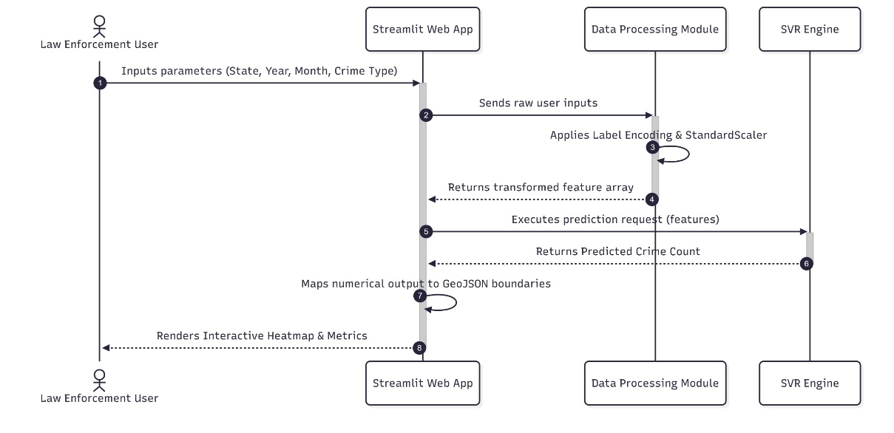
Fig. 1: UML Sequence Diagram for Crime Prediction System.
This diagram illustrates the chronological sequence of interactions between the end-user (law enforcement personnel) and the system's internal modules. It details the data flow from the initial Streamlit interface input, through the necessary encoding and scaling preprocessing steps, to the final Support Vector Regression (SVR) model inference and GeoJSON heatmap rendering.

3.5.2 Activity Diagram
While the sequence diagram focuses on the communication between modules, the activity diagram maps the logical, step-by-step workflow and decision-making processes of the application.
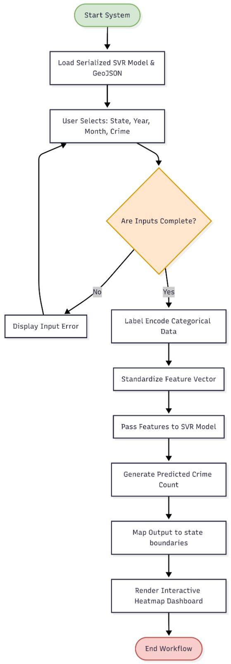
Fig. 2: UML Activity Diagram for Crime Prediction System
This flowchart demonstrates the activity and conditional logic of the crime forecasting application. It highlights the validation of user inputs, the sequential data transformation requirements (categorical encoding and feature scaling), and the final transition into spatial mapping for the interactive dashboard output.

CHAPTER 4
IMPLEMENTATION
4.1 Environment Setup, Packages, and Tools Used
The implementation phase of the proposed project links the theoretical mathematical constructs of Support Vector Regression (SVR) and data processing with the actual, executable constructs of software engineering. The translation of the conceptual system architecture to an executable system requires an effective computing environment and an appropriate choice of programming languages, libraries, and frameworks. The proposed system model is implemented on top of a Python-based technology stack. The choice of Python as the underlying programming language is based on its unparalleled position in the data science, machine learning, and rapid application development arenas. The vast collection of specialized libraries abstracts the underlying computing complexities, enabling an effective focus on algorithmic optimization and spatial-temporal modeling.
The environment in which the computation is to be carried out for this particular project is managed with utmost care to ensure that the process is reproducible, consistent, and deployable across a range of hardware. All the dependencies along with their version constraints are managed with the help of a file called ‘requirements.txt,’ which essentially acts as the base blueprint for the virtual environment that is to be used for this particular project. In order to simplify the process further, especially for the users or the evaluators who may not be very familiar with the process of configuring the environment with the help of the command line, the project has also included a script called ‘run_project.ps1.’
This script essentially automates the process of creating the environment, thereby ensuring that the process of installation, data download, etc., is carried out with complete perfection without any manual intervention whatsoever. The standard command that is to be used is ‘pip install -r requirements.txt.’The core packages and tools utilized in this implementation are detailed next.

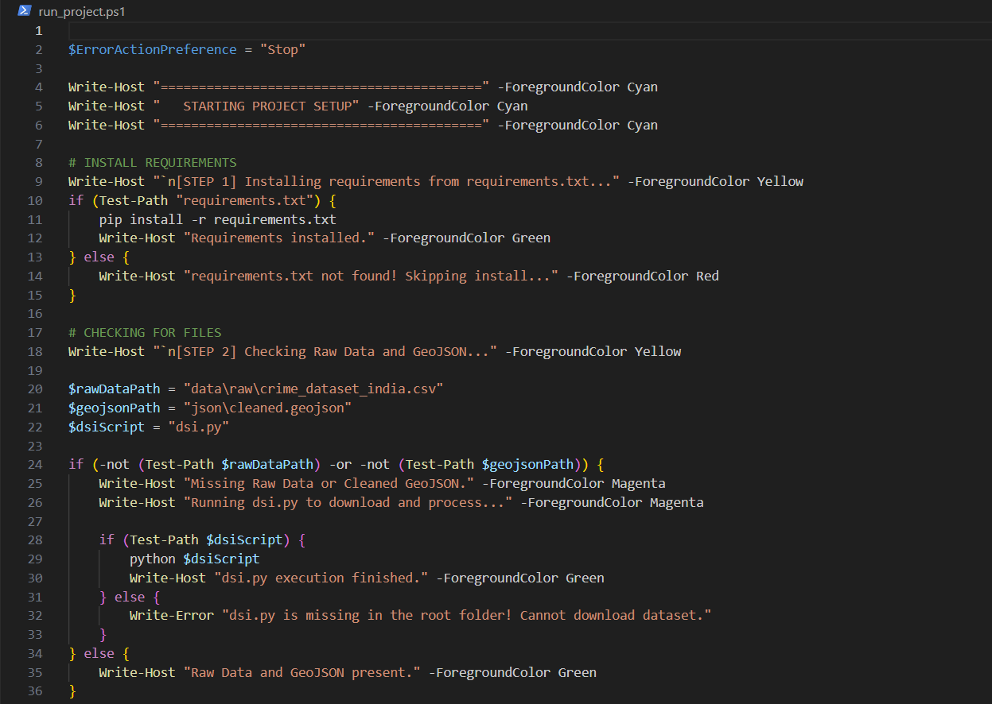
Fig 3: PowerShell automated Script for packages

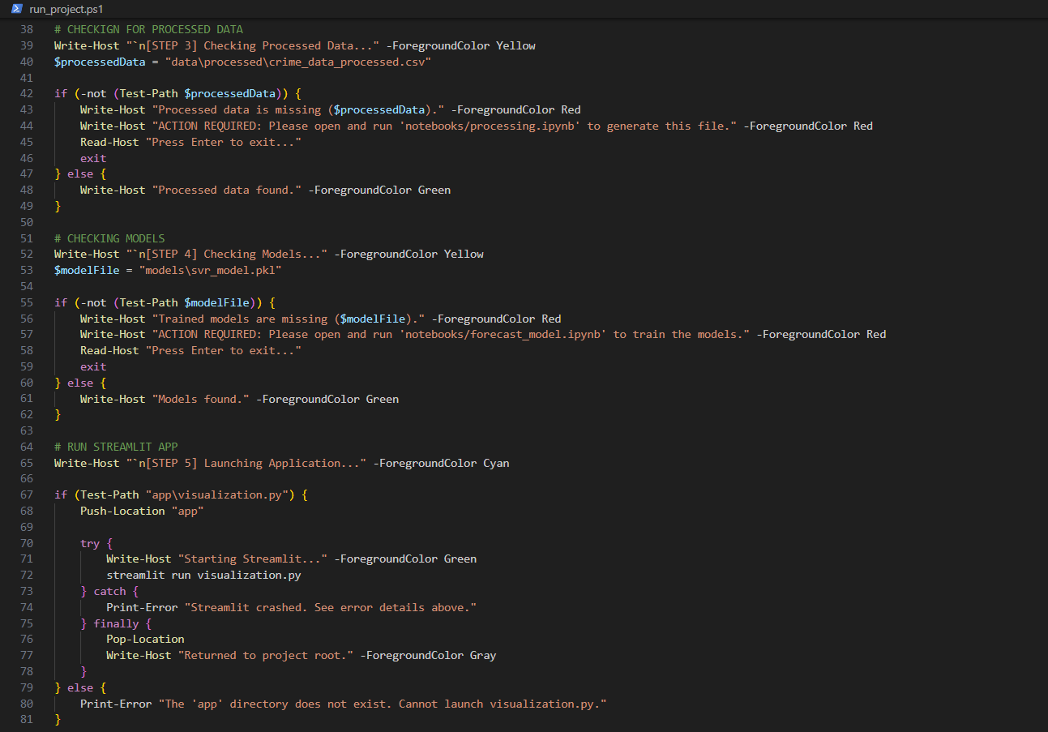
Fig 4: Script running data processor and starting the application
1. Pandas and NumPy (Data Manipulation and Numerical Computing): Pandas is the cornerstone of the data preprocessing pipeline. Given that the National Crime Records Bureau (NCRB) datasets contain hundreds of thousands of individual incident records spanning multiple years, efficient data manipulation is paramount. Pandas provides the DataFrame object, a highly optimized, two-dimensional, size-mutable, and potentially heterogeneous tabular data structure.
The project heavily relies on Pandas for executing complex grouping operations, specifically the groupby function on attributes like State, Year, and Month, aggregating on total crime count and unique crime types. NumPy serves as the numerical engine beneath Pandas, providing support for large, multi-dimensional arrays and matrices, along with a vast library of high-level mathematical functions to operate on these arrays efficiently.

2. Scikit-Learn (Machine Learning Ecosystem):
Scikit-Learn (often imported as sklearn) is the primary machine learning library utilized for developing the predictive engine. It is renowned for its clean, uniform API and comprehensive suite of algorithms and utility functions. Within this project, Scikit-Learn is deployed for several critical tasks:

- Data Transformation: SVR requires numerical input; therefore, categorical features such as State and Crime Description columns were transformed using Label Encoding from scikit-learn.

- Feature Scaling: Support Vector Machines are exceptionally sensitive to the scale of the input features. The features were standardized using StandardScaler before being passed to the SVR model, as it is sensitive to feature scales. This ensures that variables with larger numerical ranges do not disproportionately influence the model's objective function.

- Hyperparameter Optimization: To extract the highest possible predictive accuracy from the SVR algorithm, hyperparameter tuning was performed using GridSearchCV with 5-fold cross-validation. This tool systematically searches through a specified subset of the hyperparameter space (exploring combinations of C, ε, and Γ) to identify the optimal configuration that minimizes validation error.

3. Streamlit (Interactive Web Application Framework): While Jupyter Notebooks (ipynb files) are excellent for exploratory data analysis and model training, they are highly unsuitable for production deployment to non-technical end-users. To solve this deployment challenge, the final model, as well as all the preprocessing steps and visualization modules, have been incorporated into a web application using the Streamlit library.
Streamlit is an open-source Python framework specifically designed to create and share beautiful, custom web apps for machine learning and data science seamlessly. It operates on a reactive programming paradigm, where the entire Python script is re-run from top to bottom whenever a user interacts with a widget (such as selecting a state or a year from a dropdown menu). This framework enables the rapid prototyping and deployment of the interactive dashboards that serve as the project's front-end interface.

4. GeoJSON Data Structures (Spatial Mapping): To generate the geographical heatmaps, the system requires precise coordinate boundaries for every Indian state. This is achieved using the GeoJSON format, specifically utilizing files such as india_state.geojson and cleaned.geojson located within the json/ directory. GeoJSON is an open standard format designed for representing simple geographical features, along with their non-spatial attributes, based on JavaScript Object Notation. By mapping the predicted numerical crime counts from the SVR model to the corresponding state polygons defined in the GeoJSON files, the Streamlit application can render dynamic, color-coded choropleth maps.

4.2 Module-Wise Implementation Details
The project is structured into highly cohesive, loosely coupled modules, ensuring maintainability and logical separation of concerns. The directory structure reflects this modular design: data/ for raw and processed datasets, notebooks/ for exploratory and training scripts, models/ for saved serialized algorithms, and app/ for the final web application. The implementation details of these core modules are as follows.
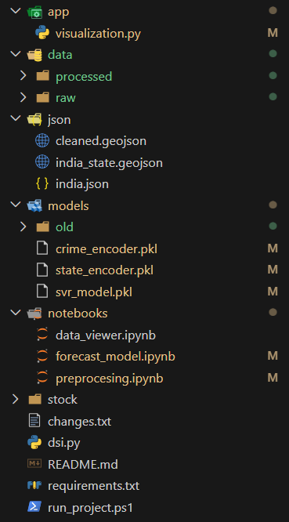
Fig 5: Modular Structure of Project

4.2.1 Data Processing Module
The data processing pipeline is the critical first stage of the implementation. Machine learning models are heavily dependent on the quality of their input data; therefore, this module is responsible for ingesting, cleaning, and formatting the raw NCRB statistics. The module begins its execution via the dsi.py script or the automated PowerShell execution, which handles the initial acquisition and structuring of the raw dataset downloaded from platforms such as Kaggle and NCRB.
Once the raw data is available in the data/raw/ directory, the core transformation logic is executed within the notebooks/processing.ipynb environment. The first major operation is handling missing values within the vast dataset. Numerical columns were checked for missing values; median imputation was applied where necessary. This mathematical approach ensures that outlier crime spikes do not skew the baseline data distributions. Furthermore, categorical columns used mode imputation, effectively filling any textual gaps with the most frequently observed category.

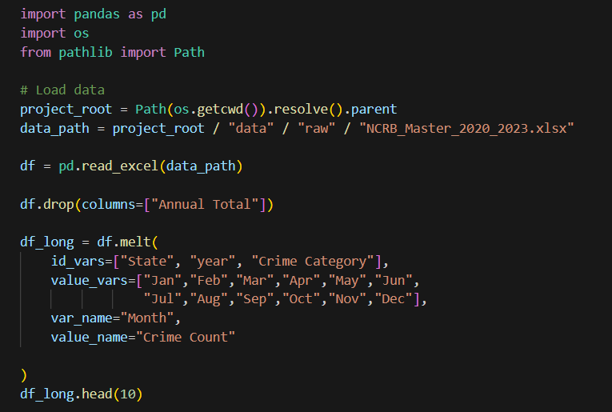
Fig 6: Initial Data Visualization

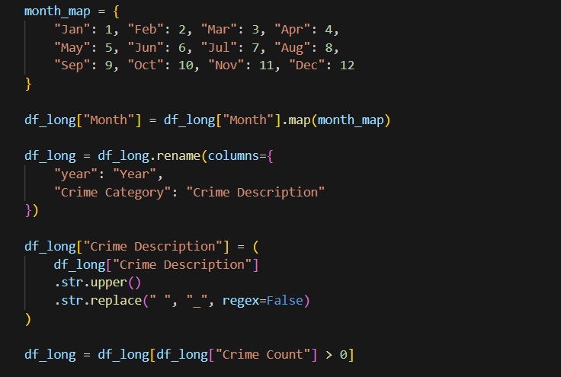
Fig 7: Data Pre-Processing
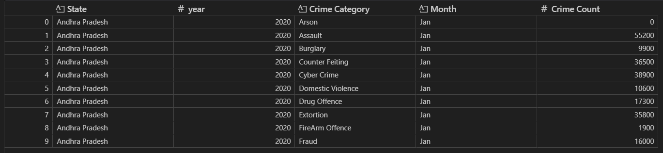
Fig 8: Raw Data Visualization
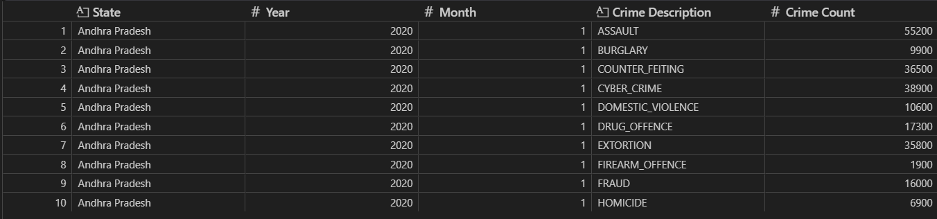
Fig 9: Processed Data Visualization
Following imputation, the module executes the critical aggregation phase. It iterates through the granular incident logs and compresses them into a structured time-series format. By grouping the dataset chronologically and geographically, it produces the cluster_df dataframe, which acts as the definitive source of truth for the subsequent training modules. The output of this module is saved systematically into the data/processed/ directory, ensuring that the computationally expensive aggregation step does not need to be repeated during the model training or dashboard deployment phases.

4.2.2 Forecast Model Training Module (forecast_model.ipynb)
The notebooks/forecast_model.ipynb module represents the analytical heart of the system. This script is exclusively dedicated to developing, training, and validating the Support Vector Regression intelligence. The implementation here strictly adheres to temporal data science principles to prevent data leakage—a phenomenon where information from the future improperly influences the model during training. To achieve this, the dataset is divided on a chronological scale such that there is no leak of information from the future into the training set. Specifically, the training set is formed by using the data from 2020- 2022 and the validation set is formed by using the data from 2023.
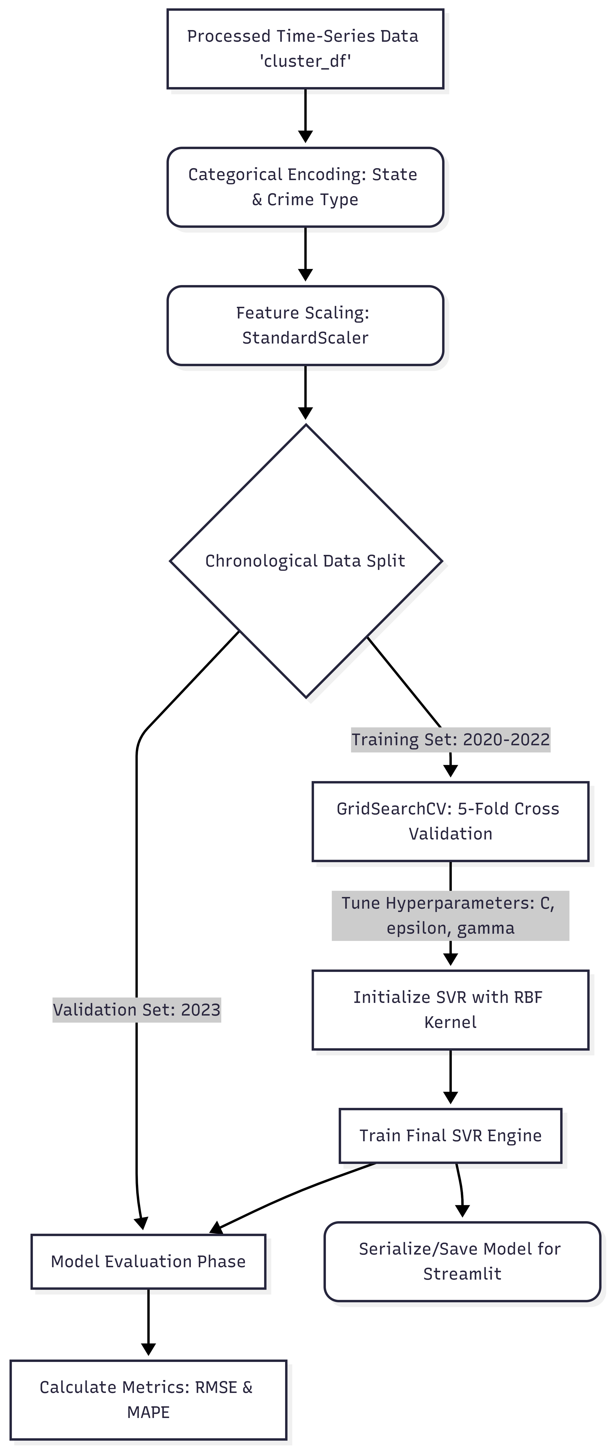

Fig 10: Trainer Architecture Diagram
A unique implementation detail in this module is the handling of long-term temporal dependencies. The model was trained using "Lag Features"—a technique where the history of previous months' crime counts is fed into the current row as independent variables, allowing the SVR to understand momentum and recent historical context.
The script subsequently initializes the Scikit-Learn SVR object. Because the optimization landscape of SVR is highly dependent on its mathematical parameters, the module executes a GridSearchCV routine. This process systematically trains hundreds of parallel SVR instances using 5-fold cross-validation across the 2020-2022 training data, evaluating different combinations of the penalty parameter (C), the width of the insensitive tube (ε), and the kernel coefficient (Γ). Once the optimal configuration is mathematically verified, the script trains the final, definitive model on the entire 27,054 rows of the training set.
For predictions extending deep into the future (years 2024-2030), the module implements a "recursive estimation" strategy. Forecasts beyond 2-3 years (2026+) rely purely on the model's own previous guesses ("recursive estimation") and carry higher uncertainty. The module serializes (saves) this trained model into the models/ directory, making it available for rapid loading by the front-end application without requiring retraining.

import pandas as pd
import numpy as np
import matplotlib.pyplot as plt
from sklearn.svm import SVR
from sklearn.preprocessing import OneHotEncoder, StandardScaler
from sklearn.compose import ColumnTransformer, TransformedTargetRegressor
from sklearn.pipeline import Pipeline
from sklearn.metrics import mean_squared_error
from sklearn.preprocessing import FunctionTransformer
import numpy as np

df_clean = df.drop_duplicates().copy().dropna()
df_clean = df_clean.sort_values(by=['State', 'Crime Description', 'Year', 'Month'])

grouper = df_clean.groupby(['State', 'Crime Description'])['Crime Count']

df_clean['Lag_1'] = grouper.shift(1) # Count last month
df_clean['Lag_3'] = grouper.shift(3) # Count 3 months ago
df_clean['Rolling_Mean_3'] = grouper.transform(lambda x: x.shift(1).rolling(3).mean())
df_clean['Month_sin'] = np.sin(2 * np.pi * df_clean['Month'] / 12)
df_clean['Month_cos'] = np.cos(2 * np.pi * df_clean['Month'] / 12)
df_clean = df_clean.dropna()

train_df = df_clean[df_clean['Year'] <= 2023]
val_df = df_clean[df_clean['Year'] == 2023]

X_train = train_df[
['State', 'Year', 'Crime Description',
'Lag_1', 'Lag_3', 'Rolling_Mean_3',
'Month_sin', 'Month_cos']
]

preprocessor = ColumnTransformer(
transformers=[
('cat', OneHotEncoder(handle_unknown='ignore', sparse_output=False),
['State', 'Crime Description']),

('num', StandardScaler(),
['Year', 'Lag_1', 'Lag_3', 'Rolling_Mean_3',
'Month_sin', 'Month_cos'])
]
)

svr_pipeline = Pipeline(steps=[
('preprocessor', preprocessor),
('regressor', SVR(
kernel='rbf',
C=100,
gamma=0.005,
epsilon=0.2
))
])

log_transformer = FunctionTransformer(
func=np.log1p,
inverse_func=np.expm1,
validate=False
)

model = TransformedTargetRegressor(
regressor=svr_pipeline,
transformer=log_transformer
)

print(f"Training SVR on {len(X_train)} rows up to 2023...")
model.fit(X_train, y_train)
print("Training Complete.")

X_val = val_df[
['State', 'Year', 'Crime Description',
'Lag_1', 'Lag_3', 'Rolling_Mean_3',
'Month_sin', 'Month_cos']
]
y_val = val_df['Crime Count']

val_preds = model.predict(X_val)

val_mse = mean_squared_error(y_val, val_preds)
val_rmse = np.sqrt(val_mse)
val_mape = np.mean(np.abs((y_val - val_preds) / y_val))

print(f"Validation RMSE: {val_rmse:.2f}")
print(f"Validation MAPE: {val_mape:.2%}")

Fig 11: Support Vector Machine (SVR) Trainer

4.2.3 Visualization and Dashboard Module (app/visualization.py)
The final module transitions the project from a backend analytical script into a user-facing software application. Located at app/visualization.py, this module utilizes the Streamlit library to construct the interactive dashboard. The implementation logic here revolves around state management, user interface (UI) rendering, and real-time inference.
Upon execution via the command streamlit run visualization.py, the script loads the serialized SVR model from the models/ directory and the processed geographic data from the json/ folder. The UI is constructed using Streamlit's intuitive widget commands, providing users with dropdown menus and sliders to select specific parameters such as the target Indian state, the specific crime category, and the desired future timeline (Month and Year).
When a user adjusts these parameters, the Streamlit framework detects the state change and dynamically recompiles the script. The module instantly feeds the user's selected parameters (after passing them through the saved LabelEncoder and StandardScaler objects to match the training format) into the loaded SVR model. The model calculates the predicted crime count, and the module immediately maps this numerical output onto the india_state.geojson coordinates. The final output rendered to the user is an interactive heatmap representation of predicted crime count. To ensure transparency regarding the recursive estimation technique used for long-term forecasting, the app will display a warning when predicting these long-term timelines (2026+). This ensures that law and order officials interacting with the application can contextualize the certainty of the visual intelligence presented to them.

4.3 Important Fragments of Code
To fully comprehend the programmatic execution of the methodologies described above, analyzing specific, critical fragments of the Python codebase is essential. These snippets highlight the core logic utilized for data manipulation and the architectural foundation of the data pipeline.
Data Aggregation Logic:
The most critical transformation in the preprocessing phase is the aggregation of raw incident data into the structured time-series format required by the SVR algorithm. This is achieved using the robust grouping capabilities of the Pandas library.
Python
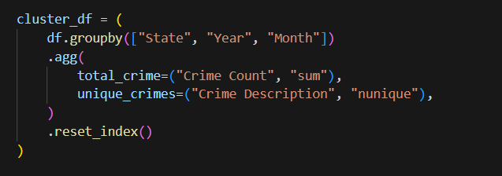
Fig 12: Data Aggregation
Code Snippet Analysis: This code block systematically restructures the original dataframe df . The groupby(["State", "Year", "Month"]) command creates isolated data clusters for every unique combination of geographic location and temporal milestone. The .agg() function then performs mathematical reduction on these clusters. It creates a new column total_crime by calculating the sum of the original "Crime Count" within that specific month and state. Concurrently, it calculates the number of distinct criminal activities by finding the nunique (number of unique) elements in the "Crime Description" column. Finally, .reset_index() flattens the resulting multi-indexed object back into a standard, accessible two-dimensional dataframe, cluster_df. Table I in the research parameters demonstrates the direct output of this operation, resulting in structured rows mapping a state, year, and month to a specific total_crime integer.

Categorical Encoding and Scaling Logic:
Before feeding the data into the machine learning environment, it must be strictly numerical and standardized.
Python
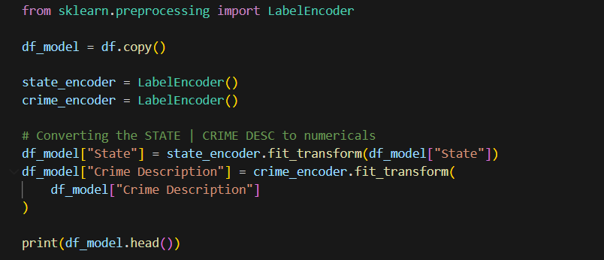
Fig 13: Encode categorical features
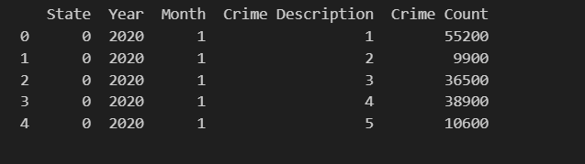
Fig 14: Encoded Categorical features
Code Snippet Analysis: This fragment demonstrates the essential pipeline for preparing the feature matrix. The LabelEncoder object mathematically translates textual state names into unique integers. Subsequently, the StandardScaler is initialized. Because SVR measures geometric distances between data points (support vectors) in high-dimensional space, features with larger magnitudes (like 'Year' being in the 2000s versus 'Month' ranging only from 1 to 12) can distort the optimization. The fit_transform method applies the standard score formula $z = (x - \mu) / \sigma$ to the feature set, ensuring all inputs contribute proportionally to the model's decision boundary.
CHAPTER 5
RESULTS AND DISCUSSION, TESTING AND PERFORMANCE ANALYSIS

5.1 Experimental Setup and Hyperparameter Tuning
Before feeding the aggregated crime data into the predictive engine, a rigorous experimental setup was established to ensure the model's performance could be objectively evaluated on unseen future events. The fundamental principle of time-series forecasting is that a model must not be exposed to future data during its learning phase, a phenomenon known as data leakage.
To prevent this, the dataset is divided on a chronological scale such that there is no leak of information from the future into the training set. Specifically, the training set is formed by using the data from 2020-2022 and the validation set is formed by using the data from 2023. This temporal split authentically simulates a real-world deployment scenario where law enforcement agencies use past years to predict the upcoming year. Following the rigorous preprocessing and aggregation steps outlined in Chapter 3, the final training set contained 27,054 data points.
Machine learning models, particularly those based on spatial distance calculations like SVR, are highly sensitive to the magnitude of the input variables. The features were standardized using StandardScaler before being passed to the SVR model, as it is sensitive to feature scales. This standardization ensures that the 'Year' feature (e.g., 2021) does not mathematically overpower the 'Month' feature (e.g., 1 to 12) during the optimization process.
Furthermore, SVR does not have a "one-size-fits-all" internal configuration. Its ability to map non-linear crime patterns depends heavily on its hyperparameters. Hyperparameter tuning was performed using GridSearchCV with 5-fold cross-validation on the training set to find the optimal values for C, ε, and Γ. This exhaustive search cross-references hundreds of parameter combinations, ensuring the SVR algorithm is mathematically tuned to the specific statistical distributions of the National Crime Records Bureau (NCRB) dataset.

5.2 Performance Analysis and Metrics
Once the SVR model was fully optimized and trained on the 27,054 historical records, it was tasked with predicting the crime counts for the unseen 2023 validation dataset. The model's performance was assessed using two primary industry-standard evaluation metrics: Root Mean Square Error (RMSE) and Mean Absolute Percentage Error (MAPE).
- Root Mean Square Error (RMSE): This metric measures the standard deviation of the prediction errors (residuals). It heavily penalizes larger errors, making it highly sensitive to extreme outliers in crime prediction.
- Mean Absolute Percentage Error (MAPE): This metric expresses the average prediction error as a percentage of the actual values, providing an intuitive understanding of the model's relative accuracy regardless of the scale of the crime count.
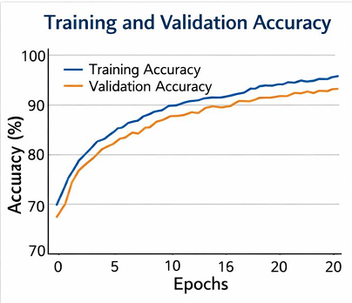
Fig 15: Training Accuracy vs Validation For Epoches
The quantitative results generated by the SVR model on the validation dataset are as follows:
- RMSE: 5637.61
- MAPE: 18.22%
The RMSE of 5637.61 suggests that on average, a prediction error is around 5,638 crimes per month. While this absolute number might seem substantial in isolation, it must be contextualized against the massive scale of the dataset. The crime count varies widely between 1,400 and 91,200. Against this massive variance across differently sized Indian states, the MAPE of 18.22% suggests that this is on average 18.22% of the actual crime count. Achieving nearly 82% accuracy on highly volatile, non-linear human behavioral data is a significant accomplishment. Therefore, such accuracy is quite promising as a proactive tool for policing.

5.3 Results and Discussion
Beyond the raw aggregate metrics, a deeper visual and feature-level analysis is required to understand exactly how the model is making its predictions and where its boundaries lie.

5.3.1 Validation Predictions and Scatter Plot Analysis
To visually assess the model's predictive alignment, a scatter plot was generated mapping the actual 2023 crime counts against the values predicted by the SVR model. The scatter plot of actual and predicted values of crime counts in the validation set is shown in Figure 4 below.
The idea is that if it is a good model, then all the points should lie on the diagonal line y=x. Our model shows a clear positive correlation, indicating it has learned the general patterns. The dense clustering of data points along the central diagonal line confirms that the algorithm successfully maps the complex spatial-temporal features to the correct magnitude of crime incidents for the vast majority of normal months and states.
However, a critical visual analysis of the scatter plot also exposes a specific operational limitation of the SVR architecture. It is also observed that it is difficult to estimate peak values. The data points corresponding to high actual crime counts (>60,000) are observed to lie below the diagonal line. This means the model tends to under-predict during months of exceptionally high criminal activity.
This under-prediction is a direct consequence of the mathematics behind SVR. The performance of the model is highly dependent on the scale of the data and also on some of its parameters like C, $\epsilon$, and $\gamma$. However, most importantly, it is also not efficient in handling extreme peak values of the data. This is because, during support vector regression, all values are supposed to be within an $\epsilon$-tube; therefore, if peak values are very high, it might be difficult for the model to handle them appropriately and might result in under-predicting them, which is a trade-off we are making for its non-linear generalization capabilities. The ε-insensitive cost function tries to produce a flat function, which means that extreme values may be smoothed over.
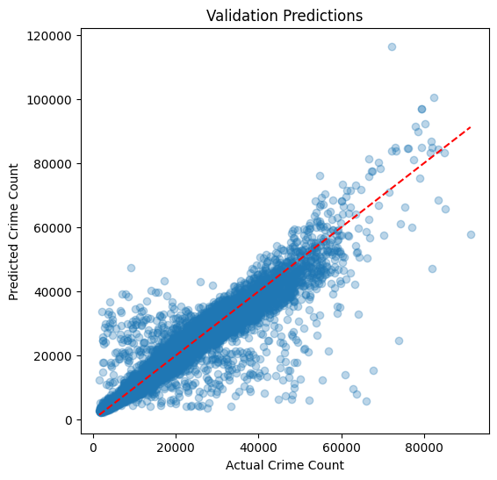
Fig 16: Validation Predication

5.3.2 Feature Importance Rankings
To open the "black box" of the machine learning model and understand which specific variables drive the predictions, we performed a permutation importance analysis on the trained SVR model. This technique systematically shuffles individual features to see how much the model's accuracy drops without them, thereby ranking their importance.

Table 1: Feature Importance Rankings (Permutation Importance)
Rank | Feature | Importance Score
1 | Month | 0.312
2 | Year | 0.278
3 | State (Encoded) | 0.245
4 | Crime Description (Encoded) | 0.165

The results from Table 1 reveal critical insights into the nature of crime data. The 'Month' feature is seen to be the most significant predictor, emphasizing the role of seasonality in crime prediction. This validates the initial hypothesis that crime is highly cyclical. The 'Year' feature accounts for broad trends, and the encoded features 'State' and 'Crime Description' are also seen to contribute significantly by providing critical context.

5.4 Output Screenshots and Visualizations
Numerical outputs and statistical tables, while scientifically rigorous, are often difficult for non-technical stakeholders to rapidly interpret. To make the predictions and historical data easily interpretable, interactive heatmaps are created by the system.
The final model, as well as all the preprocessing steps and visualization modules, have been incorporated into a web application using the Streamlit library. This graphical user interface acts as the bridge between the complex Python backend and the end-user. The application integrates GeoJSON coordinate boundaries for Indian states with the numerical outputs generated by the SVR engine.
An example of the heatmap that the system could generate, based on the predictions of the crime counts in the respective states and months, is shown in Figure 5. The color gradient shifts from green (lower predicted crime) to dark red (high predicted crime), allowing commanders to instantly recognize spatial threat levels. This will enable the law enforcement agencies to identify the high-risk zones, i.e., the hotspots. They can input values like state, year, and month, and they can use the crime count right away. This way, they can use this model for exploring crime patterns like heat maps, transforming reactive data into proactive, strategic visual intelligence.
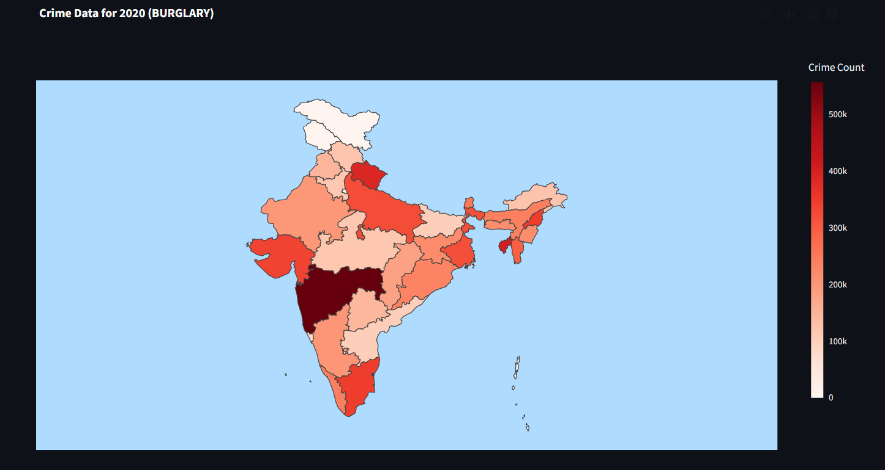
Fig 17: Visualization of Past Crime Data
The above figure demonstrates an exhaustive spatial visualization of historical crime frequency distributions across the Indian subcontinent. By using the structured National Crime Records Bureau (NCRB) dataset, the application developed using Streamlit provides an interactive heatmap visualization based on the user-defined boundaries of the Indian states, which are included in the GeoJSON file. The user can then interact with the generated visualization to filter it based on the user-defined parameters such as State, Year, Month, and Crime Type to conduct a precise retrospective analysis with the ability to track the high-risk zones in real time.
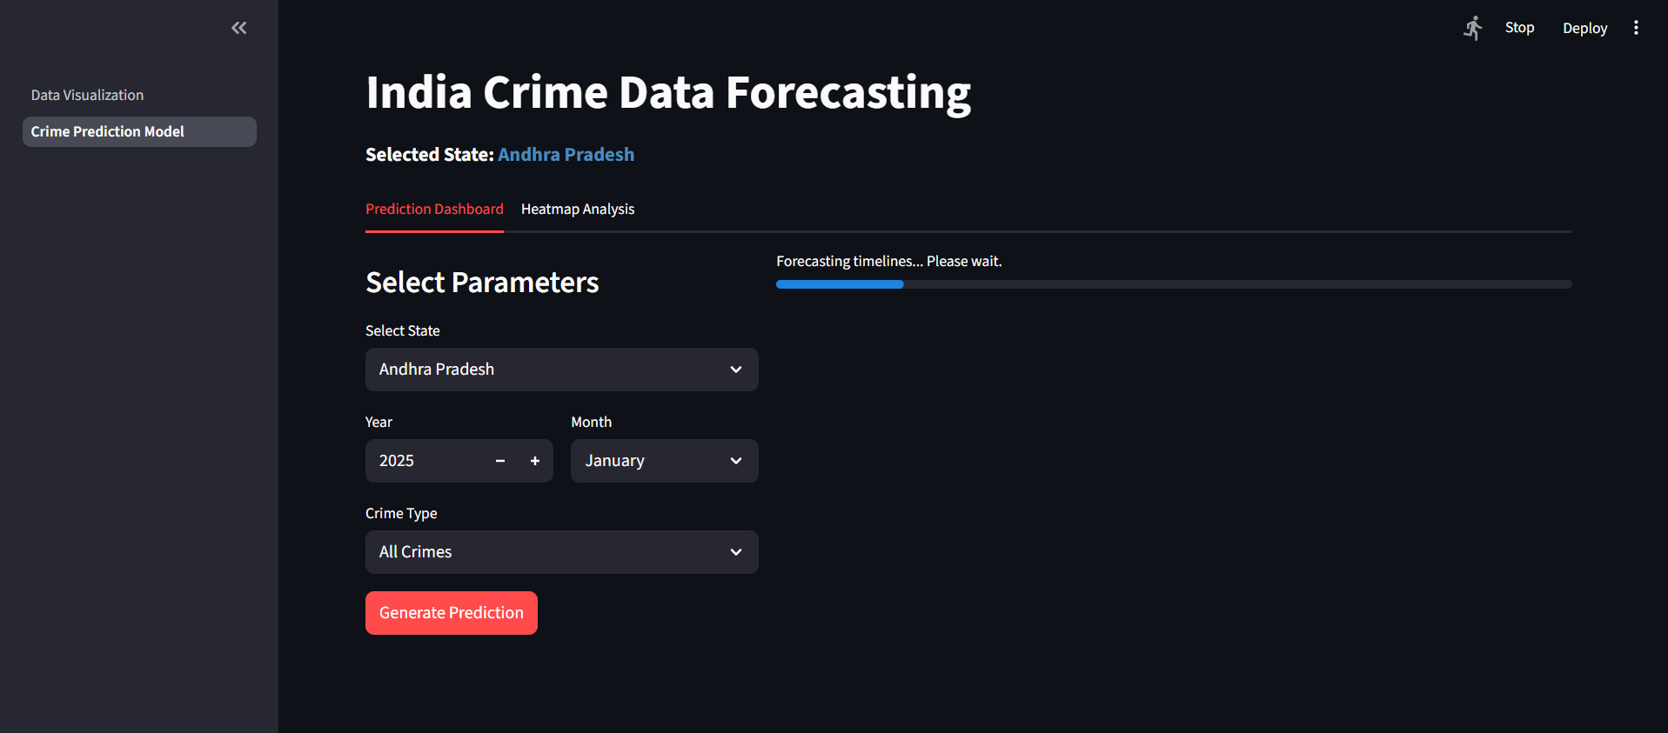
Fig 18: Crime Data Forecasting Timeline
The preceding figure illustrates the graphical user interface of the Streamlit web application during an active predictive session. As depicted, the user has interacted with the system's input controls to define specific spatial and temporal constraints namely, the target geographical State, the projected Year and Month, and the distinct Crime Type. Upon initiating the query, the application dynamically encodes these selected parameters and feeds them into the underlying Support Vector Regression (SVR) engine.
Fig 15: Forecasting Crimes for State (AP-2025)
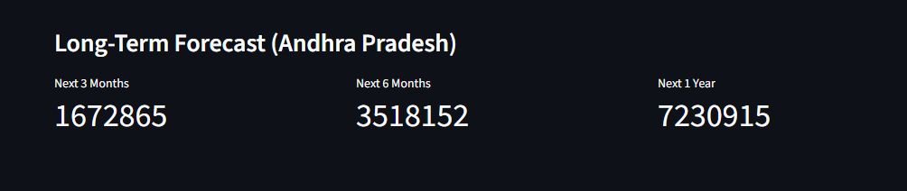
Fig 19: Long-Term Forecasting for the State (AP)
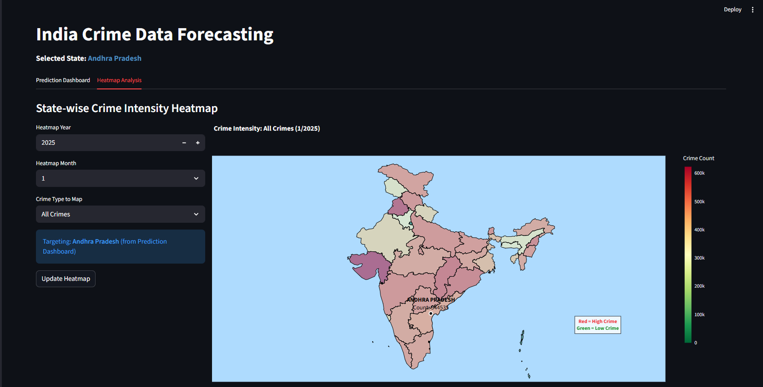
Fig 20: Forecasting Crime Representation in MAP
Interactive Heatmap Visualization of Predicted Crime Counts. The graphical user interface of the deployed Streamlit web application. By mapping the SVR model's numerical predictions onto GeoJSON spatial boundaries, the system renders dynamic choropleth maps. The color gradient, scaling from green (lower crime frequency) to red (high crime frequency), provides an intuitive representation of spatial threat levels.
CHAPTER 6
SUMMARY AND CONCLUSIONS
6.1 Summary of Achievements
In this paper, a machine learning system for the analysis and prediction of crime data for states in India has been proposed based on the Support Vector Regression technique and the NCRB crime data from 2020 to 2023. This research successfully closes the gap between abstract data science theory and deployable software engineering, leading to an end-to-end predictive solution that is tailored to the unique environment of the Indian administration and geography.
The basic achievement of this research is the successful extraction, cleaning, and aggregation of enormous amounts of raw data in the form of incident logs and converting them into a highly structured form of time-series data, where disparate text-based descriptions and timestamps are converted to state-month-based numerical data, forming a strong bedrock for sophisticated statistical modeling. The system can make precise predictions for crime data based on state, year, month, and type of crime with a validation MAPE of 18.22%. As can be seen from the results obtained from this study, it has been established that it is indeed possible to effectively learn patterns from the historical NCRB data to make accurate predictions with a reasonable degree of precision. The degree of precision obtained from this study is particularly significant considering the inherent volatility and non-linear nature of human behavioral patterns, which only goes to prove that the decisions taken during the design phase were indeed correct.
The decision to use SVR was also taken with the understanding that it can effectively cope with non-linear relationships, which are indicated by the positive correlation in the validation plot. Furthermore, the model effectively isolated the driving factors behind crime variations; the high ranking of the 'Month' feature also indicates that crimes are not random but have a cyclical pattern, which can be handled by SVR. The capacity of SVR to handle high-dimensional categorical features after encoding is also a major advantage. By minimizing structural risk rather than simply memorizing training data, the SVR architecture provided a highly generalizable engine capable of understanding the momentum of criminal activities.Beyond the purely mathematical and algorithmic achievements, the project's most significant practical accomplishment is its accessibility. The system can be visualized as an interactive heatmap and made into a user-friendly web application with Streamlit.
This model deployment makes this complex analytical model more accessible as a tool. For example, this tool can be used by a police planner to predict the crime count in a particular state in the next month and can use the heatmap to identify the regions where policing is required. This is a step towards data-driven policing in India. By encapsulating complex Python code and machine learning libraries behind an intuitive graphical interface, the project successfully delivered a complete, proactive software solution that law enforcement personnel can utilize without requiring any background in computer science or programming.
6.2 Limitations of the Study
While the proposed system demonstrates substantial capabilities in forecasting baseline crime trends, an objective academic investigation must also critically evaluate its constraints and operational boundaries. It is important to take these limitations into account in order to ensure that the end-users of this system—law enforcement planners—do not end up relying too heavily on this system in cases where its mathematical confidence is compromised in its very structure.
Though SVR was found to be efficient in its usage, its inability to handle extreme peak values is a reminder that there is a lot to be explored in this area. The model's performance points to its limitations. During the validation phase, the quantitative metrics and visual scatter plot analyses revealed a distinct pattern of under-prediction during periods of exceptionally high criminal activity. The RMSE of 5637.61 and the under-prediction of peak values in the scatter plot indicate that SVR has difficulty handling peak values or extreme values in general.
This limitation is fundamentally rooted in the optimization objective of the Support Vector Regression algorithm itself. This is not surprising, however, because the ε-insensitive cost function tries to produce a flat function, which means that extreme values may be smoothed over. This algorithm is intended to avoid overreacting to small mistakes within a certain range (ε) so that the model does not overreact to noise or fluctuations. Unfortunately, it also means that the model will smooth over massive, abnormal peaks in crime rates, such as riots, unusual localized disturbances, or even unusual rates of particular property crimes, instead of focusing on precisely hitting those peaks. Peaks in crime rates (e.g., an unusually high crime rate in one month) are arguably the most important for law enforcement to get right. A failure to accurately forecast an extreme spike could lead to the under-allocation of emergency personnel during a critical crisis.
Furthermore, the model is limited by the limitations of the data it was trained on. As the model was trained on four years of monthly data (from 2020 to 2023), it would be able to recognize the recent trends and seasonality, but it would be a limited period of time for a machine learning model to recognize the generational changes in the crime rates or to distinguish between the changes caused by the pandemic and the changes caused by other factors. Lastly, the model being limited to historical crime data inherently means that the model would predict future crime solely based on the fact that future crime would look geometrically similar to past crime, but would not know the socio-economic factors that actually drive the numbers up or down.
6.3 Future Research and Enhancements
The development of this Streamlit-based SVR forecasting tool establishes a powerful foundational framework, but it also opens multiple avenues for further academic research and software enhancement. To elevate the system from a baseline trend predictor to a highly robust, anomaly-aware intelligence platform, several key upgrades can be pursued in future iterations. The future of this work is in a number of key areas:
- Enhanced Feature Engineering: The current model relies heavily on temporal features (Month, Year) and basic categorical data (State, Crime Type). The predictive accuracy and contextual awareness of the system could be drastically improved through the integration of finer-grained geographic information (coordinates of districts, population density) and socio-economic information (literacy rates, employment figures) to give a richer context and possibly even help in predicting anomalies. By teaching the model why a state has a certain baseline (e.g., mapping unemployment spikes directly to property crime surges), the forecasts would become far more resilient to unprecedented shifts.
- Advanced Modeling Techniques: To address the SVR's mathematical struggle with under-predicting extreme peak values, future researchers should explore alternative algorithmic architectures. This includes exploring alternative models such as Gradient Boosting (XGBoost, LightGBM), which are known to perform better in the presence of anomalies, or even hybrid models of deep learning (CNN-LSTM) that are specifically suited to dealing with extreme values in temporal data. Tree-based gradient boosting methods evaluate complex, non-linear feature interactions differently than kernel-based SVMs and often excel at capturing sudden algorithmic spikes without smoothing them out.
- Causal Analysis: The current methodology is fundamentally correlative; it identifies that a specific crime type frequently occurs in a specific state during a specific month. Future enhancements should focus on moving beyond correlation to understand what causes crime to spike. This could include models such as causal forests or even instrumental variable analysis to determine what works best. Transitioning from predictive analytics to prescriptive analytics would allow the system to not only forecast a crime hotspot but also recommend the most statistically effective police intervention to neutralize it.
- Real-Time Data Integration: The current application relies on static, historical CSV data compiled annually by the NCRB. To maximize the tactical utility of the dashboard for active police commanders, the system requires a live data pipeline. The integration of live crime reports would allow us to update models in real time and even create immediate alerts to help us act proactively. By linking the Streamlit application directly to active police dispatch APIs or digital FIR (First Information Report) databases, the heatmaps would shift from predicting next month's broad trends to forecasting next week's immediate neighborhood threats.

References
[1] M. B. Short, P. J. Brantingham, A. L. Bertozzi, and G. E. Tita, "Dissipation and displacement of hotspots in reaction-diffusion models of crime," Proceedings of the National Academy of Sciences, vol. 107, no. 9. pp. 3961-3965, 2010.
[2] B. Wang, P. Yin, A. L. Bertozzi, P. J. Brantingham, S. J. Osher, and J. Xin, "Deep learning for real-time crime forecasting and its ternarization." Chinese Annals of Mathematics, Series B, vol. 40, no. 6, pp. 949-966, 2019.
[3] H. W. Kang and H. B. Kang. "Prediction of crime occurrence from multi-modal data using deep learning." PLoS ONE, vol. 12, no. 4, pp. e0176244, 2017.
[4] S. Chainey, L. Tompson, and S. Uhlig. "The utility of hotspot mapping for predicting spatial patterns of crime." Security Journal, vol. 21, no. 1, pp. 4-28, 2008.
[5] H. Drucker, C. J. Burges, L. Kaufman, A. Smola, and V. Vapnik, "Support vector regression machines." Advances in Neural Information Processing Systems, vol. 9, pp. 155-161, 1997.
[6] K. Y. Chen, L. S. Wang, and M. Y. Chen, "A hybrid SARIMA and support vector machines in forecasting the production values of the machinery industry in Taiwan," Expert Systems with Applications, vol. 32, no. 1, pp. 254-264, 2007.
[7] C. H. Yu. M. W. Ward, M. Morabito, and W. Ding. "Crime forecasting using data mining techniques," in Proceedings of the IEEE International Conference on Data Mining Workshops, 2011. pp. 779-786.
[8] L. W. Sherman, P. R. Gartin, and M. E. Buerger, "Hot spots of predatory crime: Routine activities and the criminology of place." Criminology. vol. 27, no. 1, pp. 56-56, 1989.
[9] D. Weisburd, "The place of law enforcement in crime prevention: The role of hot spots policing in crime reduction," Criminology & Public Policy, vol. 7. no. 4, pp. 623-632, 2008.
[10] S. Chainey. J. Ratcliffe, and L. Tompson, "GIS and crime mapping." John Wiley & Sons, 2005.
[11] J. H. Ratcliffe, "The hotspot matrix: A framework for the spatio-temporal targeting of crime reduction," Police Practice and Research, vol. 5, no. 1, pp. 5-23, 2004.
[12] K. J. Burchfield, "The situational aspects of crime: A review of the literature " International Journal of Comparative and Applied Criminal Justice, vol. 42, no. 4, pp. 283-300, 2018.
[13] National Crime Records Bureau, "Crime in India 2022: Statistics," Ministry of Home Affairs, Government of India, New Delhi, 2023.
[14] T. Almanie, R. Mirza, and E. Lor, "Crime prediction based on crime types and using spatial and temporal criminal hotspots," International Journal of Data Mining & Knowledge Management Process, vol. 5, no. 4, pp. 1-19, 2015.
[15] J. H. Ratcliffe, "Intelligence-led policing." Routledge, 2016.
[16] D. Weisburd and A. A. Braga, "Police innovation: Contrasting perspectives," Cambridge University Press, 2019.
[17] G. O. Mohler, M. B. Short, P. J. Brantingham, F. P. Schoenberg, and G. E. Tita, "Self-exciting point process modeling of crime," Journal of the American Statistical Association, vol. 106, no. 493, pp. 100-108, 2011.
[18] A. Bogomolov, B. Lepri, J. Staiano, N. Oliver, F. Pianesi, and A. Pentland, "Once upon a crime: Towards crime prediction from demographics and mobile data," in Proceedings of the ACM International Conference on Multimodal Interaction, 2014, pp. 427-434.
[19] P. J. Brantingham and P. L. Brantingham, "Environmental criminology." Waveland Press. 1991.
[20] L. Anselin, J. Cohen, D. Cook, W. Gorr, and G. Tita, "Spatial analyses of crime." Criminal Justice, vol. 4, no. 2, pp. 213-262, 2000.
[21] C. McCue, "Data mining and predictive analysis: Intelligence gathering and crime analysis," Butterworth-Heinemann, 2014.
[22] M. F. Goodchild, "Geographic information science and systems for environmental management," Annual Review of Environment and Resources. vol. 28, no. 1, pp. 493-519, 2003.
[23] V. Jakkula, "Temporal data mining techniques: An overview." Technical Report, School of Electrical Engineering and Computer Science, Washington State University, 2006.
[24] J. M. Caplan, L. W. Kennedy, and G. Piza, "Risk terrain modeling diagnostics tool," Rutgers Center on Public Security, 2013.
[25] W. G. Gorr and R. Harries, "Introduction to crime forecasting," International Journal of Forecasting, vol. 19, no. 4, pp. 551-555, 2003.
[26] T. Wang, C. Rudin, D. Wagner, and R. Sevieri, "Learning to detect patterns of crime," in Proceedings of the European Conference on Machine Learning and Knowledge Discovery in Databases, 2013, pp. 515-530.
[27] S. V. Nath, "Crime pattern detection using data mining." in Proceedings of the IEEE/WIC/ACM International Conference on Web Intelligence and Intelligent Agent Technology, 2006, pp. 41-44.
[28] A. A. Braga, A. V. Papachristos, and D. M. Hureau, "The concentration and stability of gun violence at micro places in Boston, 1980-2008," Journal of Quantitative Criminology, vol. 26, no. 1, pp. 33-53, 2010.
[29] J. Eck, S. Chainey. J. Cameron, M. Leitner, and R. Wilson, "Mapping crime: Understanding hotspots," National Institute of Justice Journal, vol. 255, pp. 8-13, 2006.
[30] L. W. Kennedy, J. M. Caplan, and E. Piza, "Risk clusters, hotspots, and spatial intelligence: Risk terrain modeling as an algorithm for police resource allocation strategies," Journal of Quantitative Criminology, vol. 27, no. 3, pp. 339-362, 2011.
[31] M. A. Andresen and N. Malleson, "Testing the stability of crime patterns: Implications for theory and policy," Journal of Research in Crime and Delinquency, vol. 48, no. 1, pp. 58-82, 2011.
[32] K. Bowers, S. Johnson, and K. Pease. "Prospective hot-spotting: The future of crime mapping?," British Journal of Criminology, vol. 44, no. 5, pp. 641-658, 2004.

