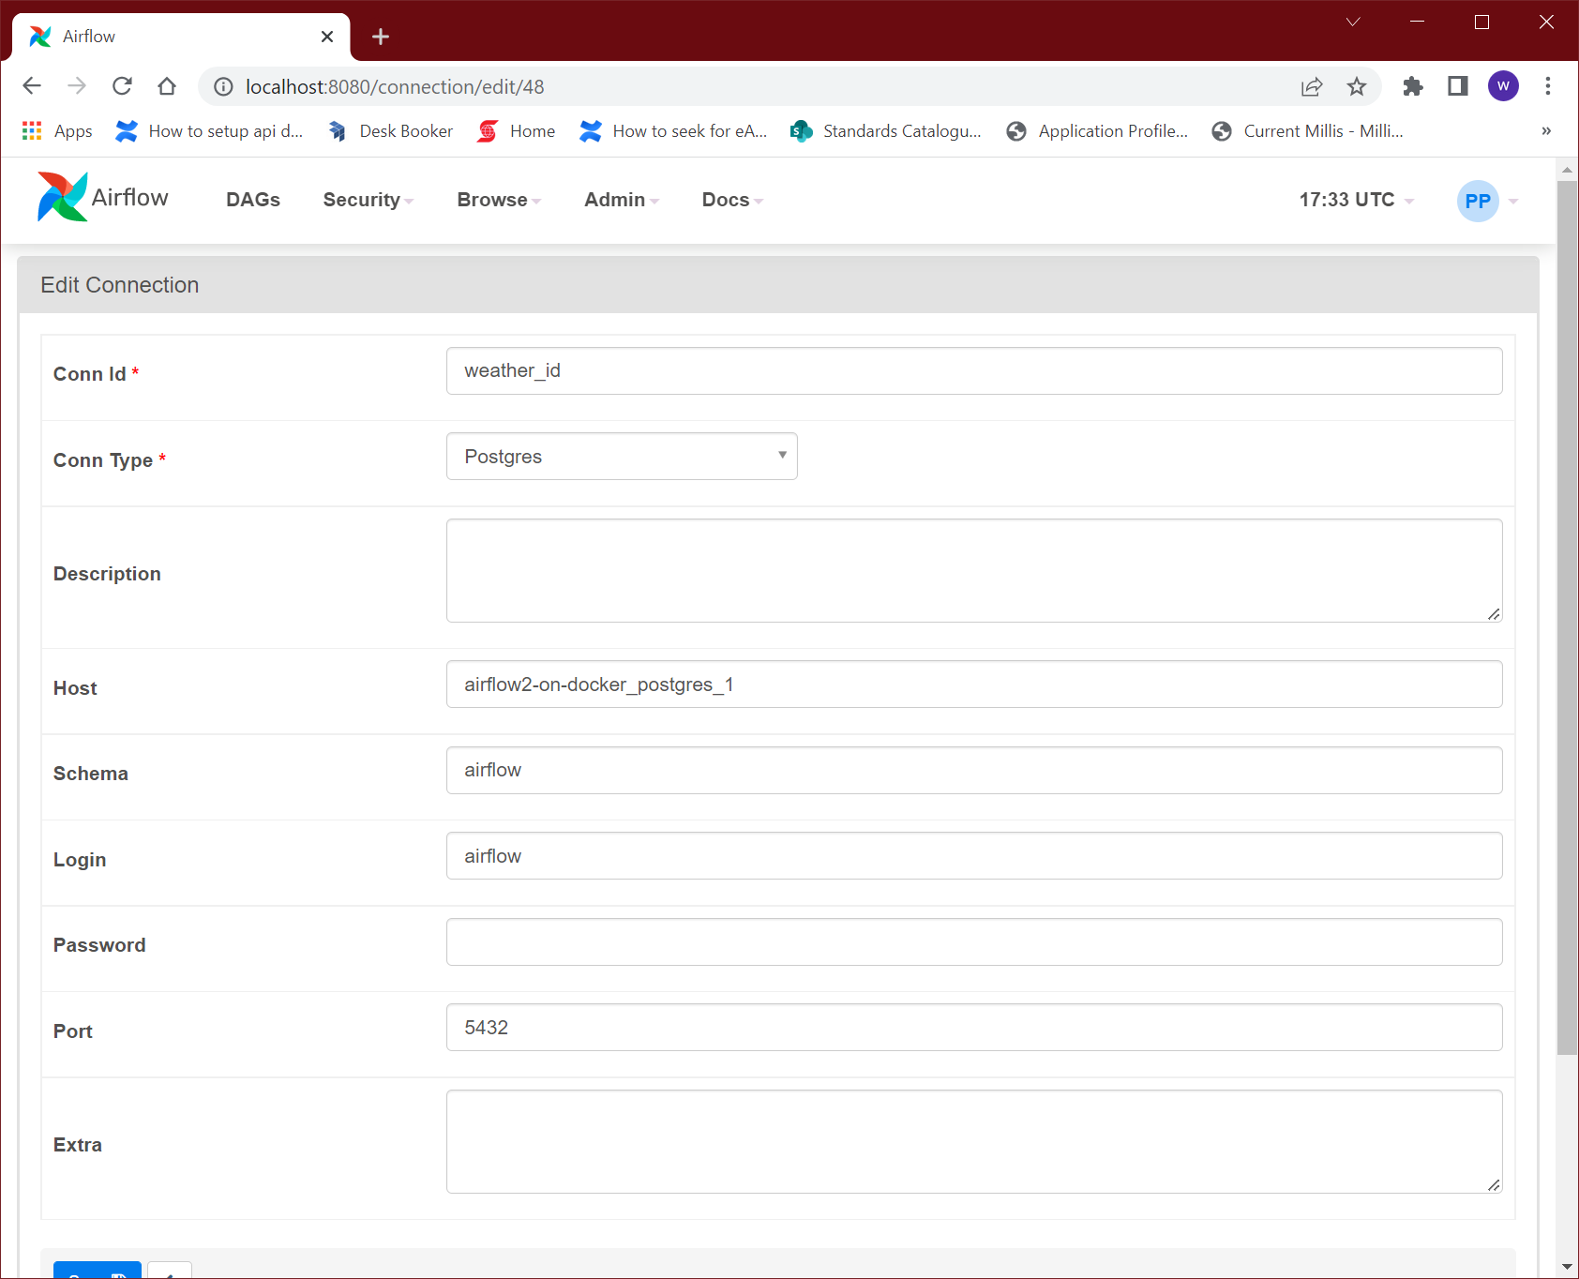

def loaddata(*args, **kwargs):

    pg_hook = PostgresHook(postgres_conn_id='weather_id')

    file_name = str(datetime.now().date())+'.json'

    tot_name = os.path.join(os.path.dirname(__file__),  file_name)

    print(tot_name)

    with open(tot_name, 'r') as inputfile:

        doc = json.load(inputfile)

    city = str(doc['name'])

    country = str(doc['sys']['country'])

    lat = float(doc['coord']['lat'])

    lon = float(doc['coord']['lon'])

    humid = float(doc['main']['humidity'])

    press = float(doc['main']['pressure'])

    min_temp = float(doc['main']['temp_min'])

    max_temp = float(doc['main']['temp_max'])

    temp = float(doc['main']['temp'])

    weather = str(doc['weather'][0]['description'])

    todays_date = datetime.now().date()

    valid_data = True

    for valid in np.isnan([lat, lon, humid, press, min_temp, max_temp, temp]):

        if valid is False:

            valid_date = False

            break;

    row = (city, country, lat, lon, todays_date, humid, press, min_temp, max_temp, temp, weather)

    insert_cmd = """ INSERT INTO weather

                    (city, country, latitude, longitude, todays_date, humidity, pressure, min_temp, max_temp, temp, weather)

                    VALUES

                    (%s, %s, %s, %s, %s, %s, %s, %s, %s, %s,%s);"""

    if valid_data is True:

        pg_hook.run(insert_cmd, parameters = row)

